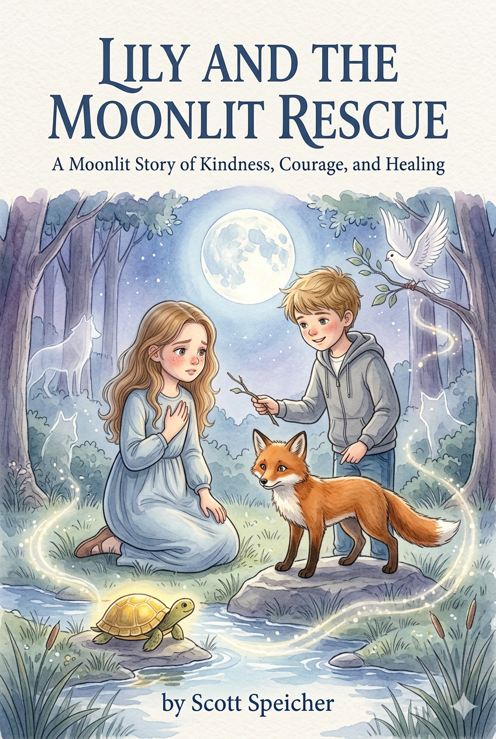
LILY AND THE MOONLIT RESCUE
A Moonlit Story of Kindness, Courage, and Healing

by
Scott Speicher

Copyright © 2026
Author: Scott M. Speicher
Portions of this book have been optimized by the program Grammarly
Edited by Grammarly and the Editorial team of Digital Scribblers
No part of this book may be reproduced or used, in any form or by any means, electronic or mechanical, without permission in writing from the author.
Some of the images are AI-generated with prompting and full control from the author.

Table of Contents

- Preface
- Chapter One: The Window and the Moon
- Chapter Two: The Fox in the Brambles
- Chapter Three: The Bird with the Bent Wing
- Chapter Four: Across the Fallen Log
- Chapter Five: The Lantern Turtle
- Chapter Six: The Garden Above the Clouds
- Chapter Seven: The Wolf at the Edge of the Trees
- Chapter Eight: The Broken Nest
- Chapter Nine: Morning Light
- Chapter Ten: The Dream That Stayed
- Epilogue
- Your Moonlit Rescue List (Interactive Page)

For every child learning how to carry love forward
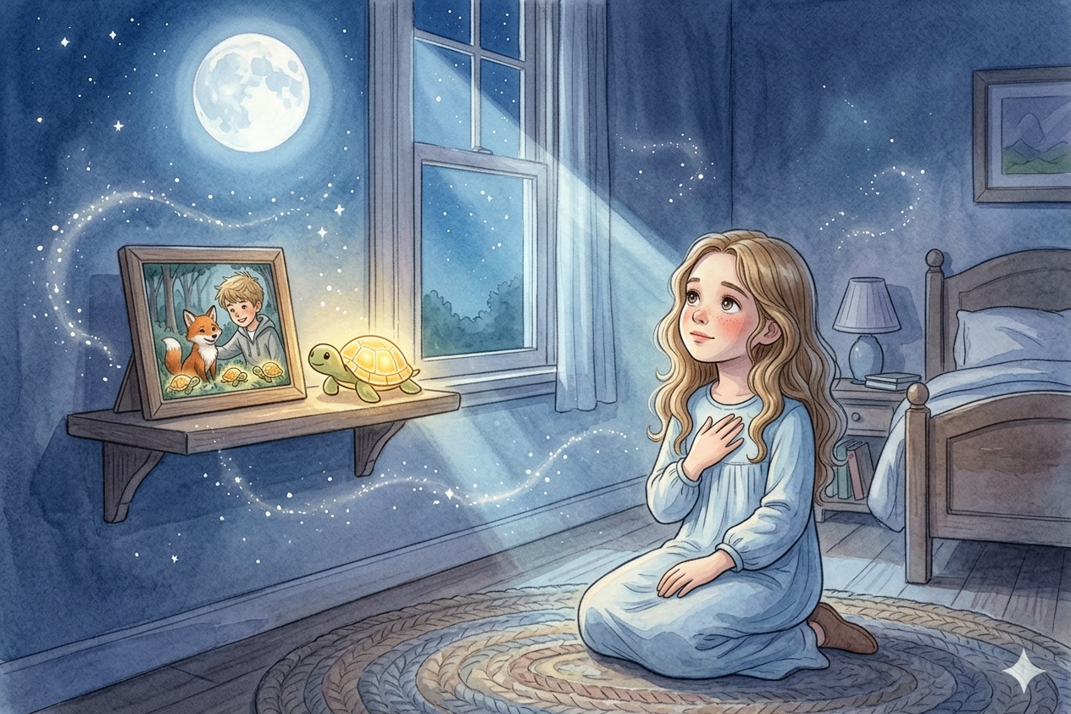
Preface
Some stories begin with adventure. Others begin with a quiet ache.
Lily and the Moonlit Rescue is a story about a girl who misses someone she loves very much. After losing Ben, Lily finds herself carrying a sadness she does not always know how to explain. The world around her still moves forward, but inside, she feels changed. Then, one moonlit night, Lily is given a dreamlike journey—one filled with wounded animals, gentle rescues, quiet courage, and lessons that help her understand what love can become after loss.
This book was written for children learning to hold both sadness and hope in the same heart. Through Lily’s journey, young readers are reminded that grief does not mean love has ended. It means love is still present, still teaching, and still looking for places to go. Each act of kindness Lily offers becomes a small lantern in the dark, helping her discover that healing is not forgetting. Healing is carrying love forward.
May this story bring comfort to children, families, teachers, and caregivers who read it together. May it open gentle conversations about missing someone, helping others, and finding courage one small step at a time. And may every reader remember that even the smallest kindness can become a light for someone else.

Chapter One
The Window and the Moon
Lily had started sleeping with her curtains open.
She never used to. Before, she liked her room tucked away from the world—dark, still, and private. But lately she wanted the moonlight. She wanted something soft in the room with her when the house grew quiet, and nighttime began to feel too large.
Tonight the moon was full and bright, hanging above the trees like a silver lantern. Its light spilled across Lily’s quilt, across the floorboards, and across the little turtle figurine on her bookshelf. Under that pale glow, everything looked gentler.
Lily lay awake and stared at the ceiling.
She had tried reading. She had tried counting backward from one hundred. She had even tried listening to the sounds outside her window—the crickets in the grass, the leaves brushing together, the bark of a dog somewhere far away. But none of it eased the ache inside her.
She missed Ben most at night.
In the daytime, she could answer questions, sit through school, and smile when needed, even if the smile felt thin. But nighttime made space for remembering.
She remembered Ben’s laugh first. It always sounded a little surprising, as if joy had reached him before he expected it. She remembered how he noticed things other people passed by without seeing—a beetle crossing a sidewalk, a feather caught in the grass, a turtle inching toward the edge of a road.
Ben had a way of making small things feel important.
Lily thought it might be one of the things she missed most.
She turned onto her side and pulled the blanket to her chin.
On her bedside table sat a smooth gray stone Ben had given her one afternoon by the creek. He had picked it up from the mud, rubbed it clean on his shirt, and dropped it into her hand with a thoughtful smile.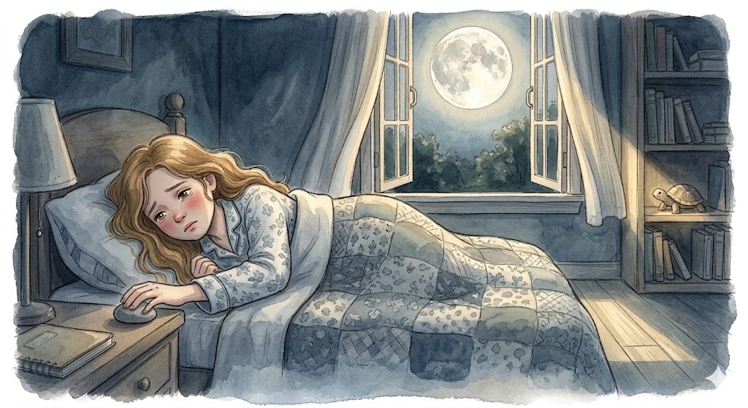
“Not every treasure shines,” he had said.
At the time, Lily laughed. But she had kept the stone.
Now she reached for it in the dark and curled her fingers around its cool shape.
“I still miss you,” she whispered.
The room stayed quiet.
Then the moonlight changed.
At first, Lily thought a cloud had moved. But this was different. The light did not simply brighten. It deepened and warmed, and a glowing path seemed to stretch from the window to the foot of her bed.
Lily pushed herself up on her elbows.
The house was still. The room was still. Yet something had shifted, as if the night itself were listening.

Then she heard it.
A voice she knew as surely as her own name.
“Lily?”
Her breath caught.
At the foot of her bed stood Ben.
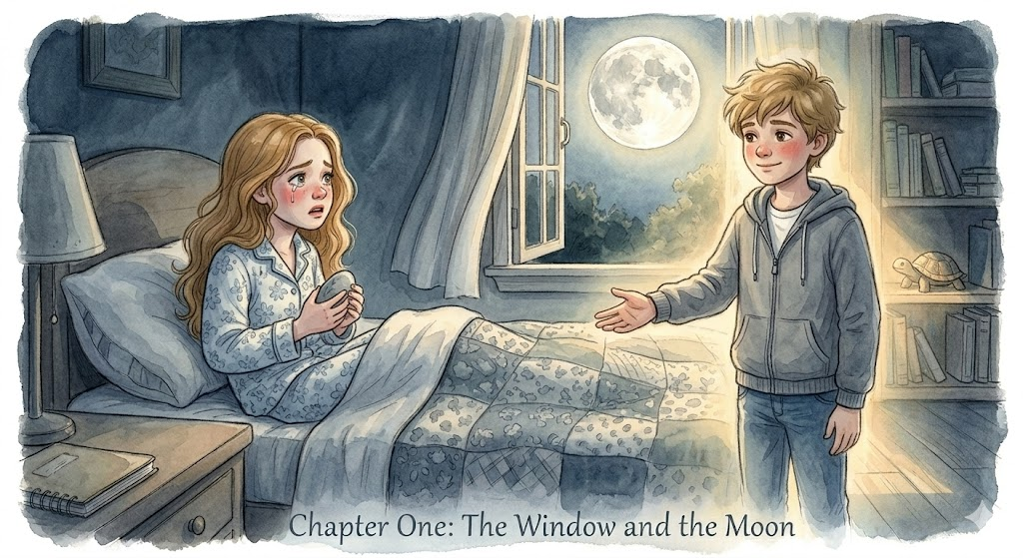
He did not look ghostly or shadowy. He simply looked like Ben—steady, kind-eyed, and calm, as though he had stepped into the room from somewhere just beyond sight. His smile was soft and familiar.
Lily sat up all the way, clutching the stone in her hand.
“Ben?”
“Hi, Lily,” he said.
Tears rushed to her eyes. A hundred questions filled her mind, but only one made it out.
“Are you really here?”
Ben tilted his head, thinking.
“I’m here with you.”
It was not exactly the answer she expected, but somehow it was enough.
He held out his hand.
“Come on,” he said. “There’s something I want to show you.”
Lily looked at the ribbon of light across her floorboards, then back at him. Inside her, fear and hope rose together.
Hope to step forward first.
She slipped out of bed and placed her hand in his.
It was warm.
The moment their fingers touched, the room shimmered. The walls blurred. The air brightened. The floor seemed to disappear beneath her feet.
And then she was somewhere else.
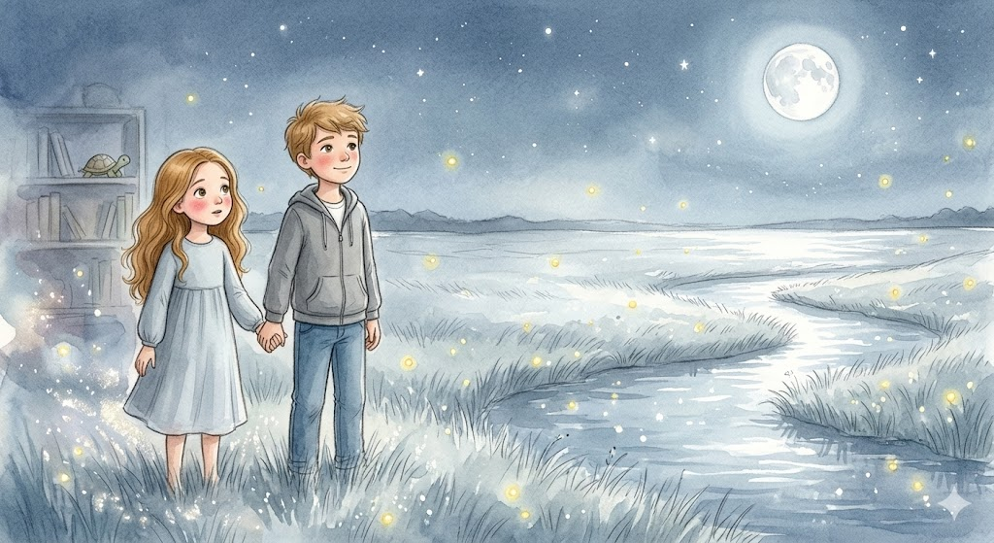
A wide silver meadow stretched before them, glowing under the moon. Grass bent in slow waves. Fireflies drifted through the air like tiny lanterns. A stream curved through the field, reflecting the night sky so clearly it looked as though the stars had fallen into it.
Lily stopped, staring.
“It’s beautiful.”
Ben smiled. “I know.”
“Where are we?”
He looked across the meadow.
“Somewhere your heart can still learn things,” he said.
Lily did not fully understand. But for the first time in many nights, the ache inside her loosened.
Just a little.
Ben gave her hand a gentle squeeze.
“Come on,” he said again. “Someone needs help.”
And beneath the wide, listening moon, Lily went with him.

Chapter Two
The Fox in the Brambles
Lily walked beside Ben along a winding path bordered by silver grass and low shrubs blooming with tiny white flowers.
Soon, a rustling sound rose from the brush ahead.
Ben slowed. “Do you hear that?”
Lily nodded.
They stepped off the path and found a young fox tangled in a patch of thorny brambles. Its russet fur flashed red-gold in the moonlight. One hind leg was caught between twisting vines, and every time it pulled, the branches tightened around it.
“Oh no,” Lily whispered.
The fox let out a frightened cry. Its golden eyes were wide with panic.
Lily stepped forward, then stopped. “What if it bites?”
Ben crouched near the brambles, calm and unhurried. “Maybe it will,” he said. Sometimes, “Scared things lash out. But that doesn’t mean they don’t need help.”
Lily knelt beside him, her heart pounding.
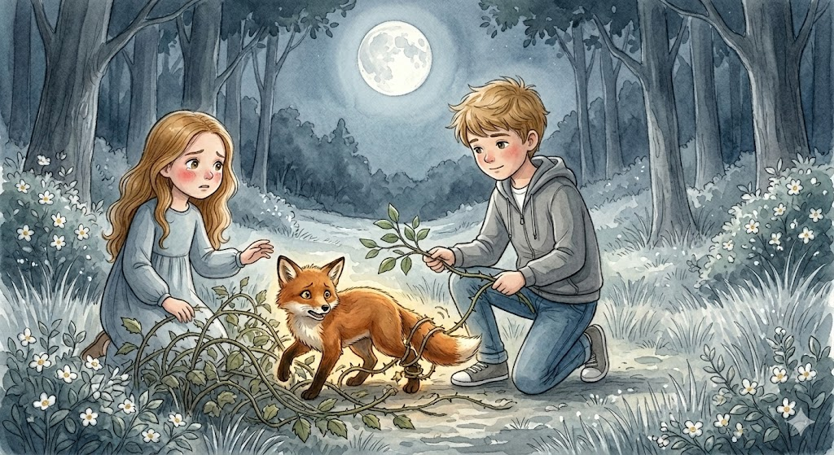
“How do we help?” she asked.
“Slowly,” Ben said. “Gently. Kindness works best when it doesn’t force its way in.”
He used a leafy branch to ease one thorny vine aside. Lily took hold of another with her hands. The thorns scratched her skin. She flinched but kept going.
“That’s it,” Ben said softly.
Together they worked the brambles apart, one careful inch at a time. The fox kept trembling, but gradually it stopped struggling. At last, Lily lifted the final loop of vine away from its leg.
The fox sprang backward, stumbled, then steadied itself.
For one moment, it stood there, panting and unsure. Then it tested its leg, looked straight at Lily, and slipped back into the moonlit brush.
Lily let out the breath she had been holding.
“We did it.”
Ben smiled. “You did.”
She looked down at the thin scratches on her fingers. “I was scared.”
“You still helped.”
Lily stared at the place where the fox had vanished.
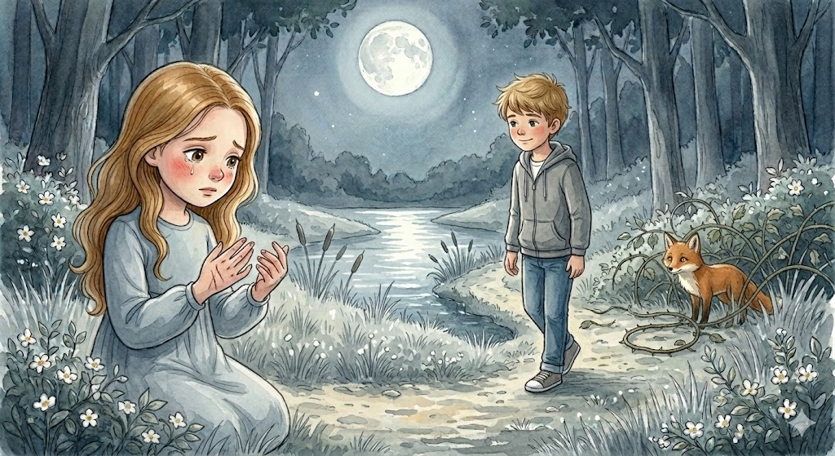
“I thought being brave meant not being afraid.”
Ben shook his head. “No. Being brave means you’re afraid, and you still choose kindness anyway.”
They rose and continued along the path.
After a while, Lily said quietly, “I’ve been scared a lot.”
“I know,” Ben said.
“Scared that I’ll always miss you this much. Scared that if I start feeling normal again, I’ll feel guilty. Scared that I won’t know what to do with all of this.”
Ben was quiet for a moment.
Then he said, “You don’t have to stop missing me. You just have to keep your heart open while you do.”
Ahead, the path curved toward the sound of water. And Lily began to sense that this strange shining place was not only asking her to help.
It was teaching her how.
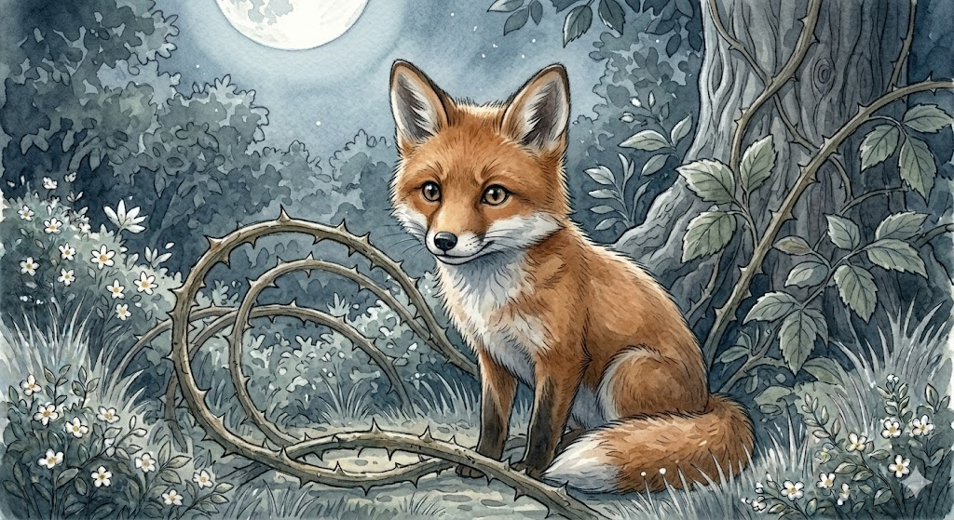

Chapter Three
The Bird with the Bent Wing
The path led to a quiet pond surrounded by reeds. Moonlight lay across the water in pale ribbons. Frogs murmured from the grassy edges, and a breeze moved softly through the cattails.
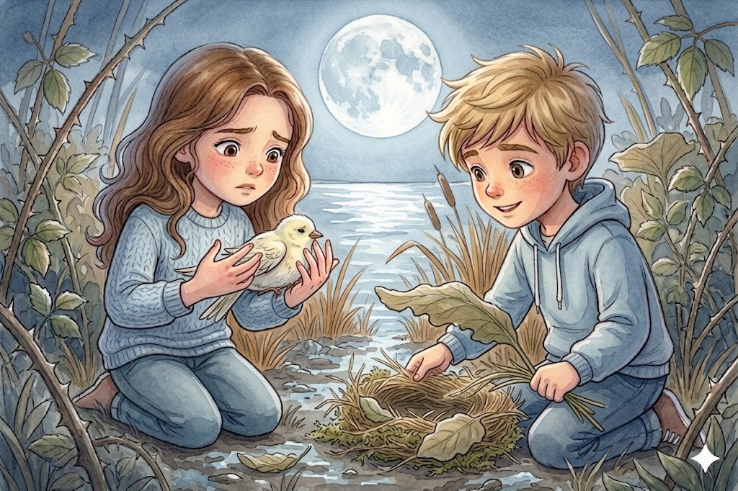
Near the muddy bank, something fluttered weakly.
Lily hurried closer and found a small white bird lying half-hidden among the reeds. One wing bent at an awkward angle, and every time it tried to rise, the damaged wing tipped it sideways.
“It’s hurt,” Lily said.
Ben knelt beside her. “Looks like it was caught in the wind. Or flew into something hard.”
The bird gave a frightened chirp and beat its good wing against the mud.
Lily felt that familiar ache rise in her throat.
“What do we do?” she asked.
Ben looked around, then pointed toward a patch of broad leaves and long soft grass nearby. “We make it safe.”
Together they gathered grass, moss, and leaves, building a little nest in the shelter of the reeds. Ben showed her how to cup her hands around the bird—firm enough to hold it, gentle enough not to frighten it. Lily lifted it carefully. It was so light she could hardly believe it. Warmth pulsed through its tiny body.
She set it into the nest they had made.
The bird blinked up at her, still frightened, but no longer thrashing.
“Will it be okay?” Lily asked.
Ben’s answer was quiet. “I think so. But even when we can’t fix something right away, comfort still matters.”
Lily tucked one more leaf around the bird’s side.
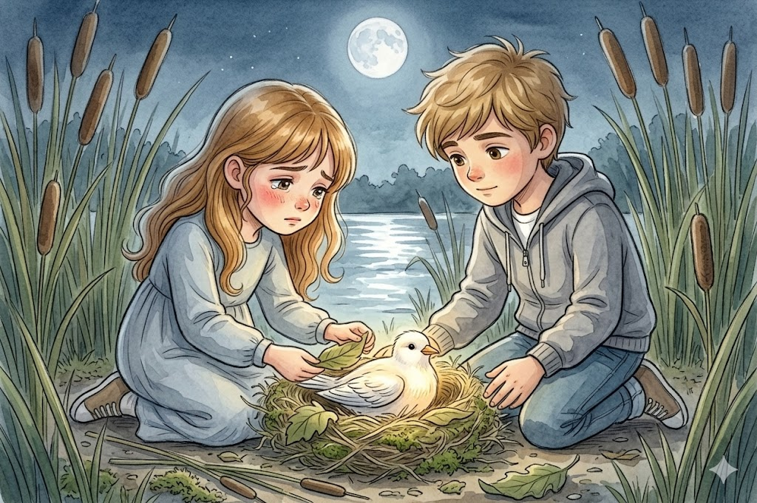
Comfort still matters.
At once, she thought of hospital blankets, chairs pulled close to the bedside, dim rooms, and all the moments she had sat beside Ben, not knowing how to make anything better.
“I used to think I should have done more,” she said.
Ben turned to her. “More?”
“When you were sick. When things were hard. I kept thinking maybe I should’ve said better things. Or somehow made it easier.”
Ben’s expression softened.
“You were there,” he said. “You stayed. Do you know how much that matters?”
She did not answer.
“You cared when things were hard,” he continued. “You brought your whole heart into the room. That matters more than perfect words.”
The little bird gave a tiny chirp and tucked its head beneath its good wing.
Lily sat very still.
Maybe love was not always measured by what it fixed.
Maybe sometimes it was measured by what it refused to leave.
When they finally stood to go, the bird was sleeping.

Chapter Four
Across the Fallen Log
They walked deeper into the woods, where the trees rose pale beneath the moon.
At last, they came to a rushing stream. Water hurried over stones, bright and restless. Spanning the stream was a fallen log, broad enough to cross but slick with moss.
On the far bank stood a small fawn, trapped against a rocky ledge. It shifted from one trembling leg to another and let out a thin, uncertain bleat.
Lily frowned. “It can’t get back.”
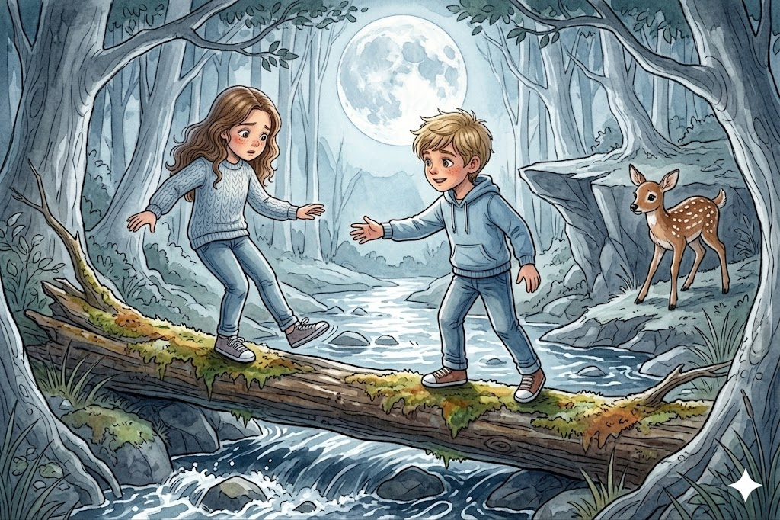
“Not alone,” Ben said.
Lily looked at the log, then at the dark water below.
“I don’t think I can do that.”
Ben stood beside her. “You don’t have to feel ready before you begin.”
“What if I fall?”
“Then I help you up.”
Ben stepped onto the log first and turned, holding out his hand.
“One step at a time.”
Lily placed one foot on the mossy wood. The stream rushed beneath her. She wobbled, caught herself, then took another step.
“Don’t look down,” Ben said. “Look at me.”
So, she did.
Step by step, she crossed.
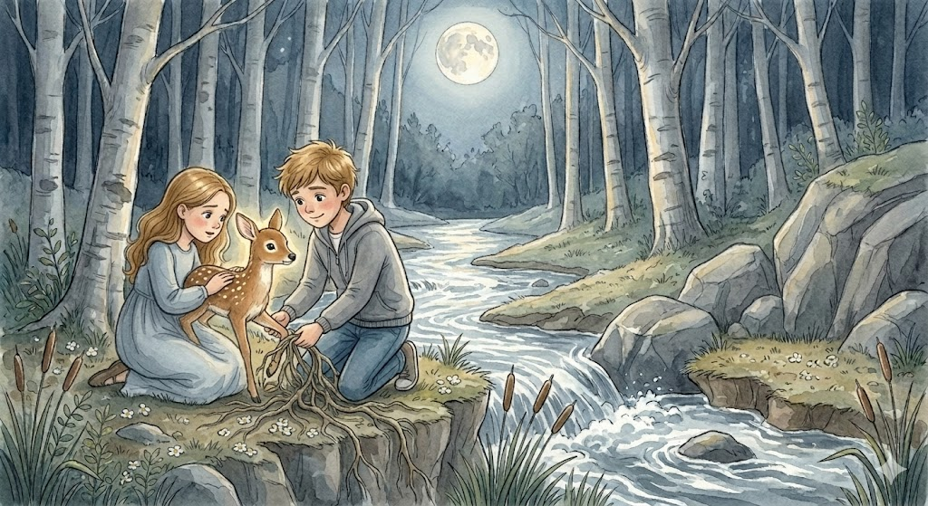
When her shoes touched the far bank, she let out a shaky laugh.
I did it.”
Ben grinned. “You sure did.”
The fawn had one front leg trapped between roots beneath the rocky ledge. Lily crouched beside it and spoke softly while Ben loosened the roots.
“It’s okay,” she whispered. “We’ve got you.”
The fawn stilled at the sound of her voice.
A moment later, the trapped leg slid free.
The fawn sprang back, tested its footing, then bounded into the trees. It paused once beneath the moonlit branches before vanishing.
Lily stood there on the bank, breathing hard.
A quiet kind of pride spread through her.
Ben watched her with a small smile.
“You know,” he said, “grief can feel a lot like standing at the edge of something you don’t know how to cross.”
Lily looked at the stream.
“But you cross it the same way,” he said. “One step at a time. Not all at once. Just by keeping going.”
Maybe healing was not a leap.
Maybe it was a crossing.
Slow. Unsteady. Brave
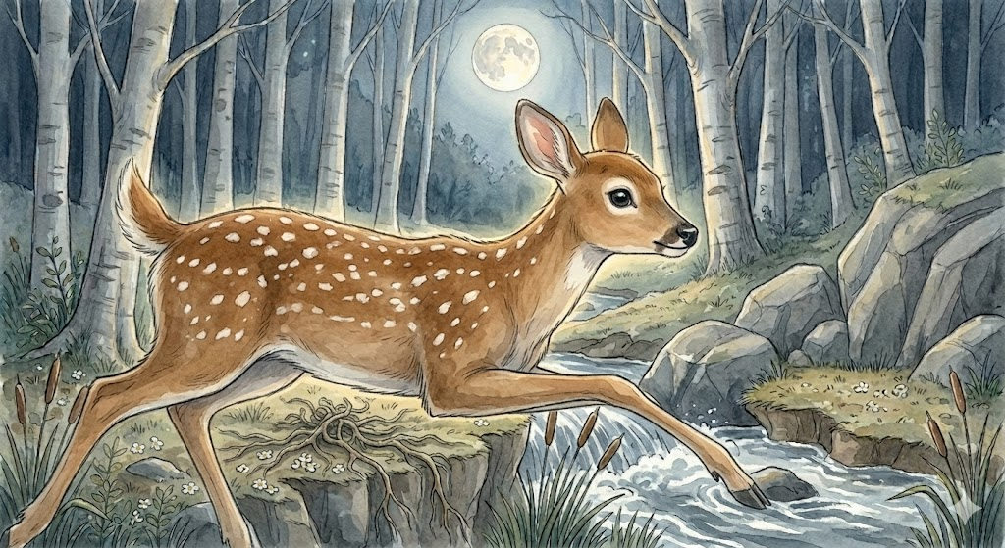

Chapter Five
The Lantern Turtle
The woods opened into a quiet clearing, and at its center lay a pond smooth as glass.
Lily stopped at once.
Tiny lights floated across the water.
“What are those?” she whispered.
Ben smiled. “Look closer.”
Lily knelt near the bank. Then she saw them clearly.
Turtles.
Dozens of them, each carrying a soft golden glow beneath its shell, as though a lantern had been lit inside.
“They’re beautiful,” Lily said.
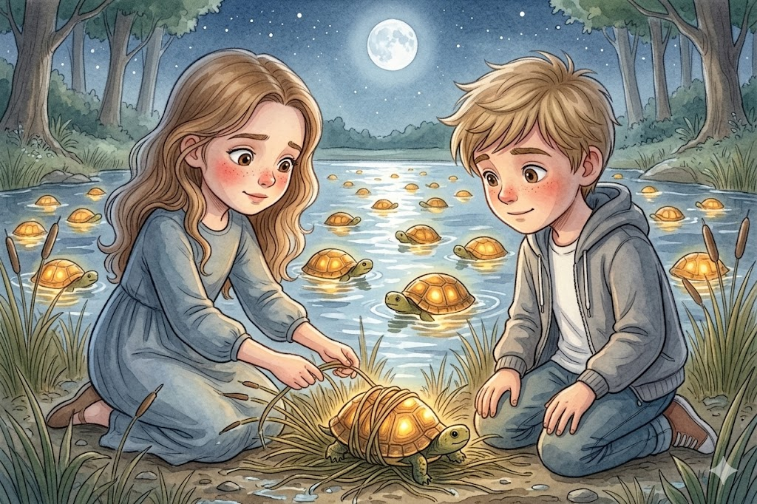
One of the turtles, smaller than the others, had drifted into a tangle of reeds near the shore. Its light flickered weakly every time it struggled.
“That one’s stuck,” Lily said.
She reached into the reeds, but the strands were wound tightly around the turtle’s shell.
Ben knelt beside her. “This one doesn’t need speed. It needs patience.”
Lily nodded.
Together they began freeing it, one wet reed at a time. The strands clung stubbornly. More than once Lily thought she had loosened the turtle completely, only to find one more ribbon of grass caught beneath its shell.
“This is taking forever,” she said.
Ben gave a half smile. “Some good things do.”
At last the final strand slipped loose.
The little turtle paddled forward into the open water. As it did, the glow inside its shell brightened, steady and warm. It circled once near the shore, then drifted away to join the others.
For a while, Lily and Ben sat side by side on the grassy bank, watching the lantern turtles move across the pond like stars that had chosen water instead of sky.
Lily thought of Ben’s notebook. Of all the turtles he had cared about. In the way he believed that small lives mattered.
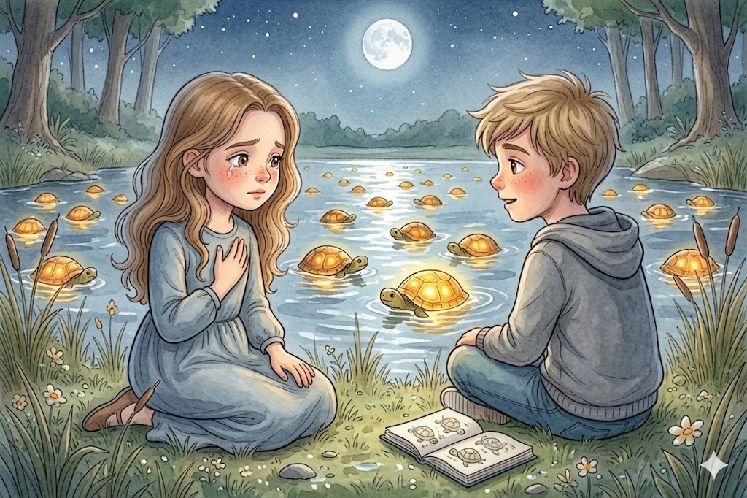
“Did you ever get tired?” she asked quietly.
“Of caring so much?”
Ben looked out over the pond. “Sometimes caring hurts,” he said. “But it also lights things up.”
Maybe love did not only leave pain behind.
Maybe it left light too.
Ben turned toward her.
“You don’t have to carry sadness like it’s the only way to remember me,” he said. “You can carry what mattered. The kindness. The courage. The way we tried to help.”
All across the pond, the lantern turtles shimmered.
Lily pressed her hand over her heart.
Perhaps memory could warm as well as ache.
A lantern, not only a wound.

Chapter Six
The Garden Above the Clouds
The clearing softened and blurred around them, and suddenly Lily found herself standing in a place so beautiful it made her go still.
They were in a garden above the clouds.
Mist drifted below shining paths. Arches wrapped in silver vines curved overhead. Flowers in shades of pearl, gold, and pale blue bloomed everywhere, their petals lit from within.
Lily turned in a slow circle.
“It’s like a secret.”
Ben smiled. “Maybe it is.”
At the center of the garden stood a stone bench beneath a flowering tree. The branches bowed overhead, and whenever the breeze stirred, petals drifted down around them.
Lily sat. Ben sat beside her.
For the first time that night, no frightened creature waited to be rescued. The stillness did not feel empty.
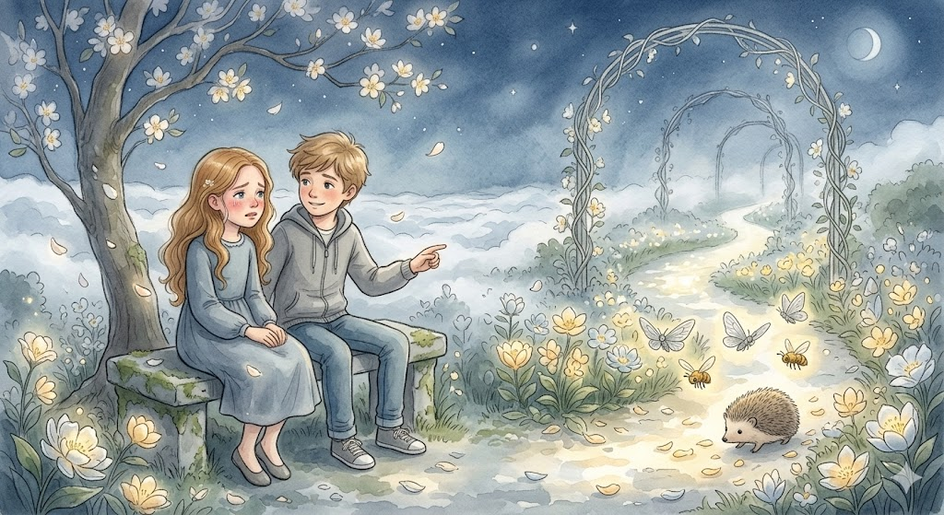
It felt purposeful.
“I don’t want to forget you,” Lily said.
“You won’t,” Ben answered.
“But what if things change?” she asked. “What if I laugh more again? What if I have normal days? What if one day I don’t think about you every second?”
Ben turned toward her.
“That won’t mean you loved me less.”
Lily looked at him, stunned by how badly she had needed those words.
“It will mean love is doing what love is supposed to do,” he said. “It stays with you while helping you live.”
Something inside Lily opened then.
She had been afraid of healing because she thought healing might take Ben farther away. But Ben was telling her something different.
Healing would not erase him.
It would carry him forward.
Tears slid down Lily’s cheeks. Ben did not rush them away. He simply sat beside her while petals drifted through the glowing air.
After a while, he pointed toward the garden path. Tiny creatures moved among the flowers—silver-winged moths, golden bees, even a small hedgehog shuffling through fallen petals.

Look,” he said. “Everything here keeps growing. Even after storms.”
Flowers after winter.
Morning after night.
Love after loss.
Lily wiped her eyes and drew a slow breath.
“I think I understand,” she whispered.
Ben smiled. “You’re beginning to.”

Chapter Seven
The Wolf at the Edge of the Trees
The garden path descended into a shadowed glade at the edge of a forest.
There, between the trees, stood a great gray wolf.
Lily froze.
Moonlight silvered its thick fur. Its pale eyes shone like glass. One front paw was lifted off the ground, and from it jutted a long black thorn.
The wolf did not snarl. It did not bare its teeth. Still, pain stood around it like a fence.
“I can’t do this,” Lily whispered.
Ben’s voice stayed calm. “You can.”
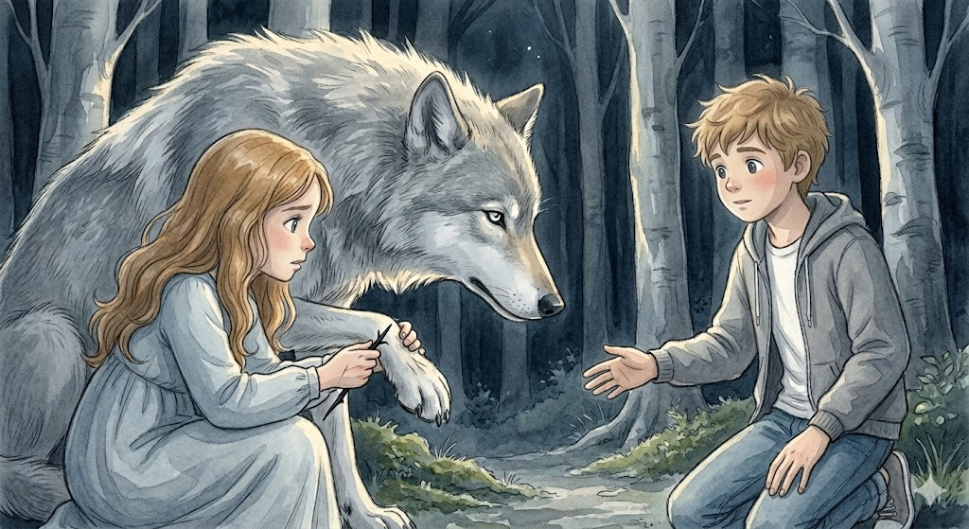
“It’s a wolf.”
“It’s hurt.”
Those words changed something.
Lily looked again.
Not at its size. Not at its teeth.
At the wound.
Ben knelt a few feet away from the animal and spoke in a low, steady tone. Lily could not make out the words, but she understood what the tone carried.
Peace. Patience. Permission.
The wolf’s ears lowered. Its breathing eased.
“Your turn,” Ben said softly.
Lily moved closer and knelt beside him.
“Quick and gentle,” Ben murmured.
She nodded, wrapped trembling fingers around the thorn, and pulled. The wolf flinched. A low sound rumbled in its chest.
Then the thorn came free.
For one long moment, nobody moved.
The wolf lowered its paw to the ground. Tested it once. Twice. Then it lifted its head and looked directly at Lily.
Its eyes no longer seemed frightening.
Only tired.
Only wounded.
Then it turned and slipped into the trees.
Lily sat back on her heels, breathing fast.
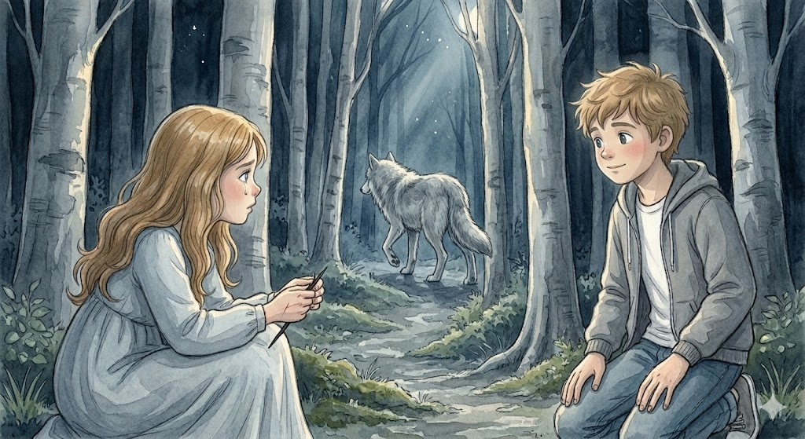
“I thought it would hurt us.”
Ben stood. “Sometimes what looks frightening is really just pain wearing a sharp shape.”
Lily looked at the thorn in her hand.
Not everything sharp is cruel, she thought.
Some things are wounded.
Compassion, she realized, often begins the moment we stop assuming the worst and start looking for what hurts.
She carried the thorn a little way down the path before laying it gently among the roots of a tree.
Some things, once removed, no longer need to be carried.

Chapter Eight
The Broken Nest
The sky beyond the willow branches had begun to soften.
The deep, velvety blue of the long night was receding, replaced by a delicate wash of lavender—the very first hint of the approaching dawn.
Lily felt the cool morning air move through the leaves, smelling of damp earth and hidden things.
She climbed onto a massive willow root that curved out over the water like a wooden bridge.
“Look, Ben,” she said, her voice a quiet whisper.
Ben stood on the mossy ground below, looking in the direction she pointed.
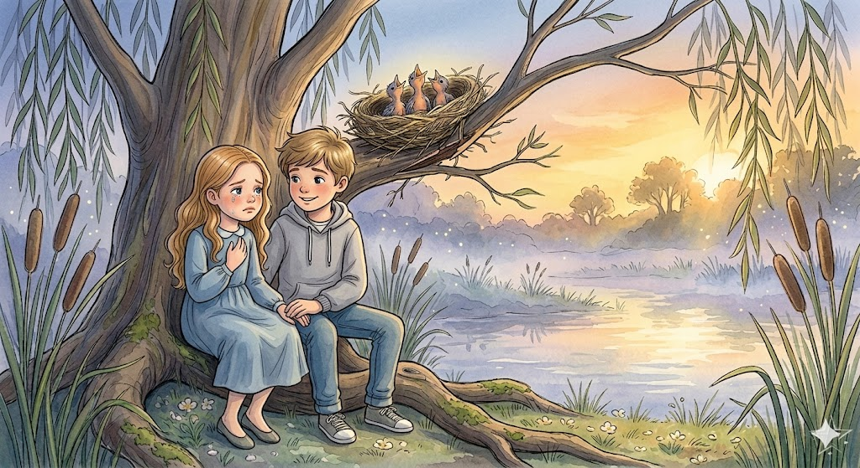
High on a low-hanging branch, a small bird’s nest tilted dangerously. The wood beneath it had split, and the home was sliding toward the rushing water below.
Inside, three tiny hatchlings huddled together, their soft gray down trembling in the breeze.
They opened their orange beaks toward the paling sky, letting out high, thin peeps that carried the weight of fear.
“If it falls…” Lily’s voice trailed off.
Ben moved toward the muddy edge of the water where the tall cattails grew.
“Then we support it,” he said.
He began pulling long, strong reeds from the bank and brought a bundle back to her.
Lily sat on the root and took the stems from his hand. Her fingers felt quick and sure, remembering the lessons of the fox and the turtle.
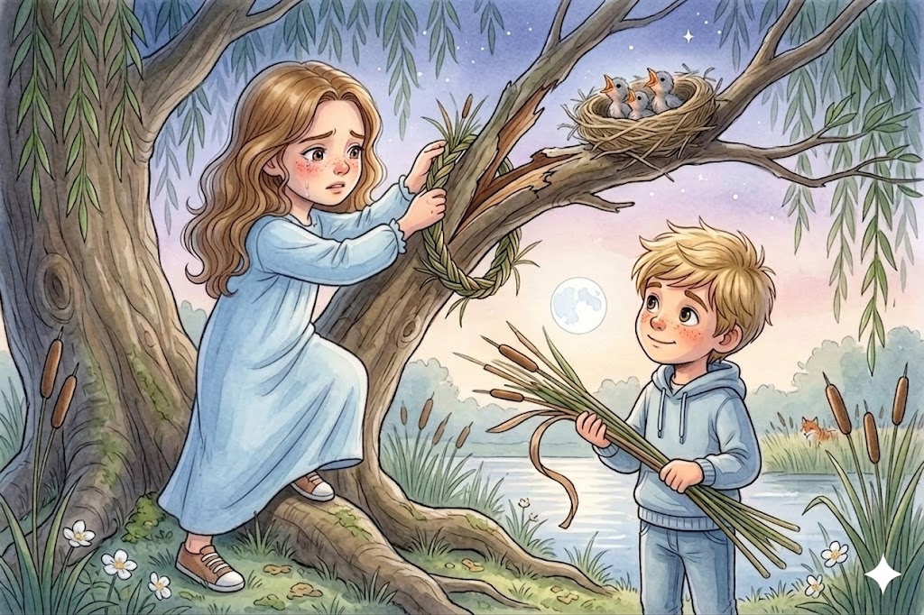
Together, they wove the damp grasses into a thick, sturdy band. They didn’t need many words; the rhythm of the work was enough.
Lily felt a strange focus take hold of her, a patience she hadn't known she possessed.
When the braid was long enough, Lily reached up toward the tilting branch.
“Easy, easy,” she murmured.
She looped the braided reeds around the branch, binding the split wood securely to the main trunk of the tree.
The branch swayed, then held firm.
The hatchlings quieted. As the warm light of dawn began to seep into the nest, their peeps turned into small, reassured chirps.
Lily sat back on her heels and let out a long breath.
She looked down at Ben, who was watching her with a half-smile.
“We fixed it,” she said softly.
“We supported it,” Ben corrected gently.
Tears slid down Lily’s cheeks, but they didn't feel sharp or heavy.
They felt like the mist rising off the pond—something that was simply part of the morning.
She realized then that Ben’s lessons were not just about saving animals. They were about her.
She had been afraid that healing meant leaving him behind in the dark, but here, in the lavender light, she saw the truth.
Healing did not take Ben farther away. It did not erase the love she had for him; it gave that love a way to keep moving.
They sat together on the willow root while the world began to wake up.
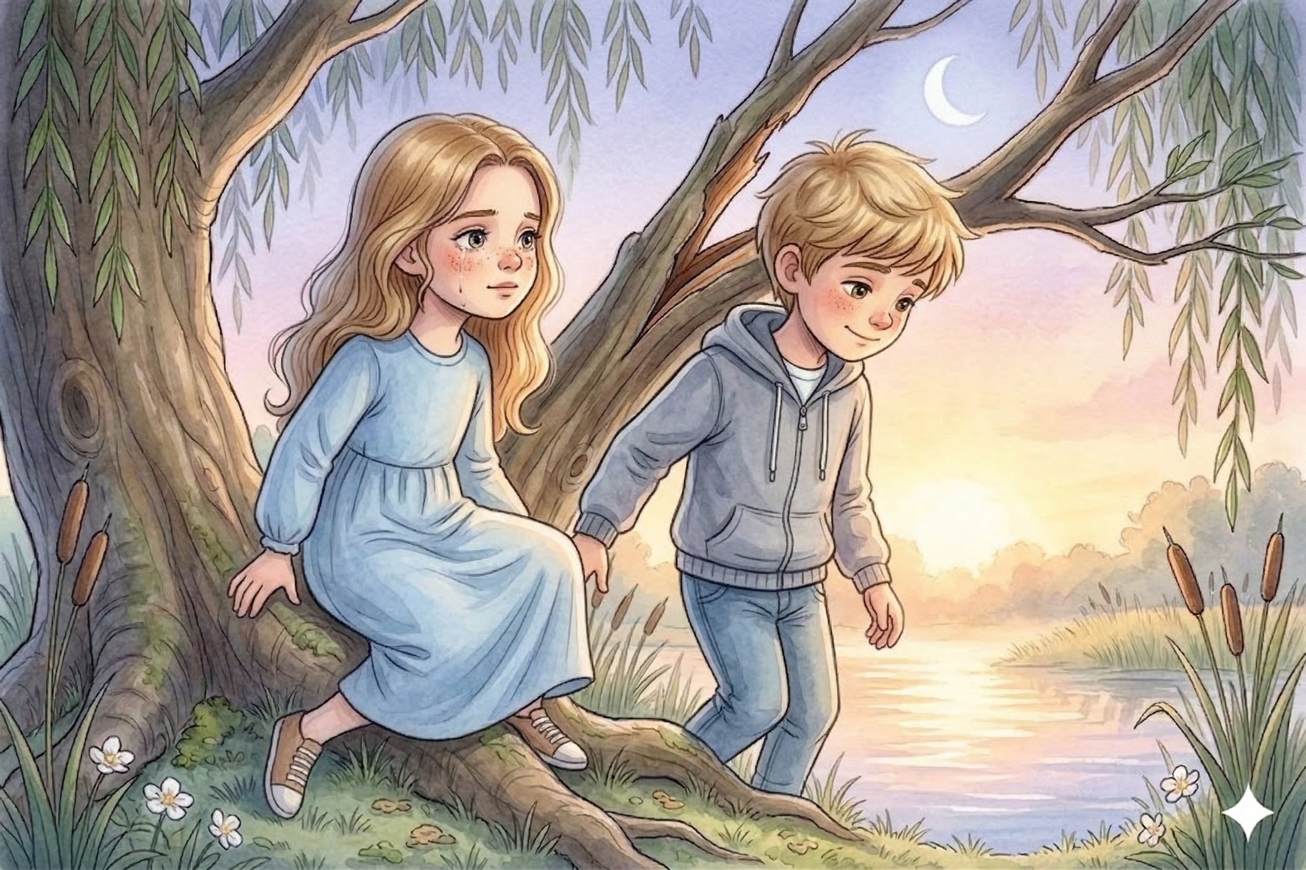
The last of the moonlight lifted like a fading dream.
It was morning here, and it felt new and full of light.
Lily stood up, her heart feeling steady.
They rose together, ready for the next chapter, wherever it might lead.
They sat together on the willow root while the world began to wake up. The last of the moonlight lifted like a fading dream, leaving behind a morning that felt new and full of light.
Lily climbed down. They had answered hurt with love. They had fixed what could be fixed.
Lily started to say, looking at Ben.
Ben gave a half-smile, looking at the safe nest. “Not every ending needs to be written in a book, Lil. Some stay in the heart.”
Tears slid down Lily’s cheeks, but they were no longer sharp tears. Ben did not brush them away or rush her to stop. He simply sat beside her while the lavender-blue morning became gold, and the world began to wake up.
He didn't need to ask if she understood. Healing did not take Ben farther away. Healing would not erase him.
It would carry him forward.
They rose together as the last of the moonlight lifted like mist, ready for the next chapter, wherever it might lead.

Chapter Nine
Morning Light
Lily woke with damp cheeks and sunlight resting across her bed.
For a moment, she did not move.
She was afraid the dream might scatter if she reached for it too quickly. But it did not scatter.
It stayed.
Ben’s hand in hers. The fox in the brambles. The bird with the bent wing. The fallen log. The lantern turtle pond. The garden above the clouds. The wolf. The nest.
The dream was not fading.
It was settling.
Lily sat up slowly and pressed her hand to her chest.
The ache was still there.
But it no longer felt empty.
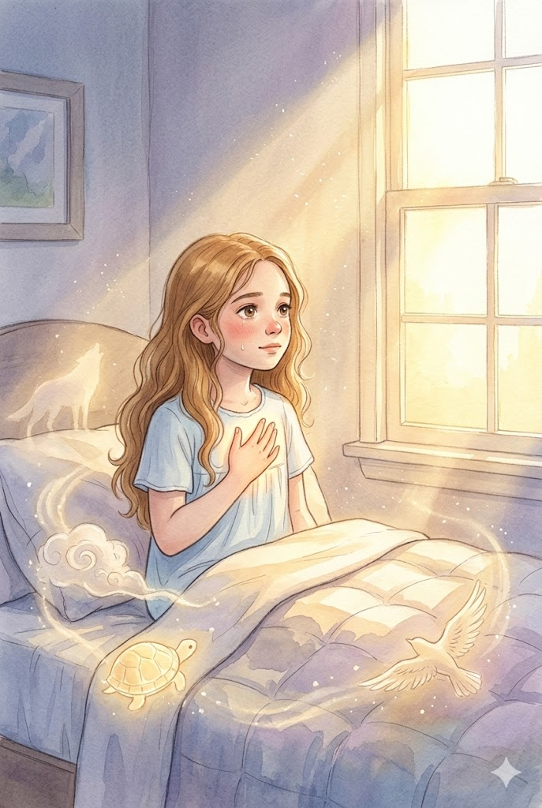
It felt lit from within.
At breakfast, her mother looked at her and paused.
“You seem different this morning.”
Lily lowered her spoon. “I had a dream about Ben.”
mother’s expression softened. “A good one?”
Lily nodded. “A very important one.”
She did not yet know how to explain it all. But when breakfast was over, and she stepped outside into the cool morning, the world looked like she had changed.
Not because the trees were different.
Not because the sky was different.
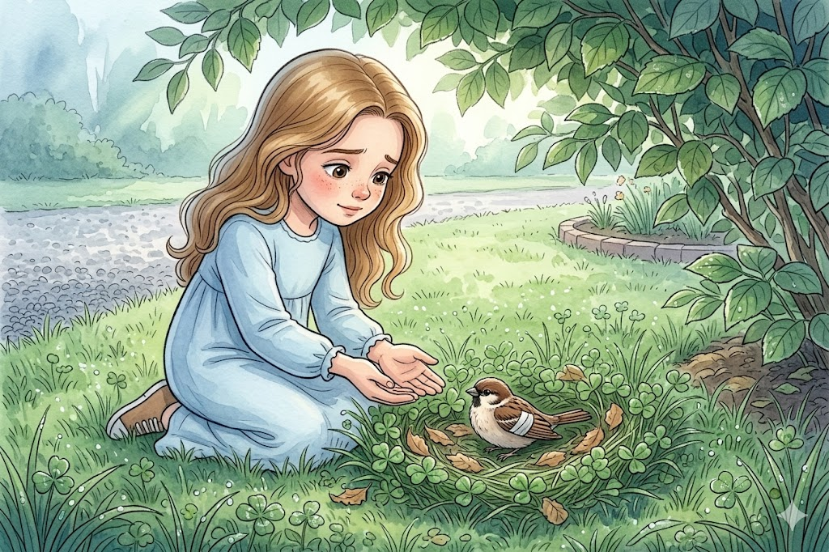
Because she was. Near the edge of the driveway, a small bird fluttered awkwardly in the grass. One wing dragged slightly. It did not hurt badly—perhaps only stunned—but it could not right itself.
Without thinking, Lily moved toward it slowly.
“Easy,” she whispered.
She lifted it gently, just as she had in the dream, and carried it to the shade beneath a bush. There she lined a small hollow in the grass with leaves and soft clover.
Comfort still matters.
Later that day at school, Lily noticed a younger girl sitting alone on a bench at recess. Her lunchbox sat unopened beside her. Her shoulders were curled inward.
Lily hesitated.
Then she remembered the fox. The fawn. The wolf.
Scared things do not need us to be perfect. They need us to be gentle. So, Lily walked over and sat beside her.
“Hi,” she said.
The girl looked up, startled. “Hi.”
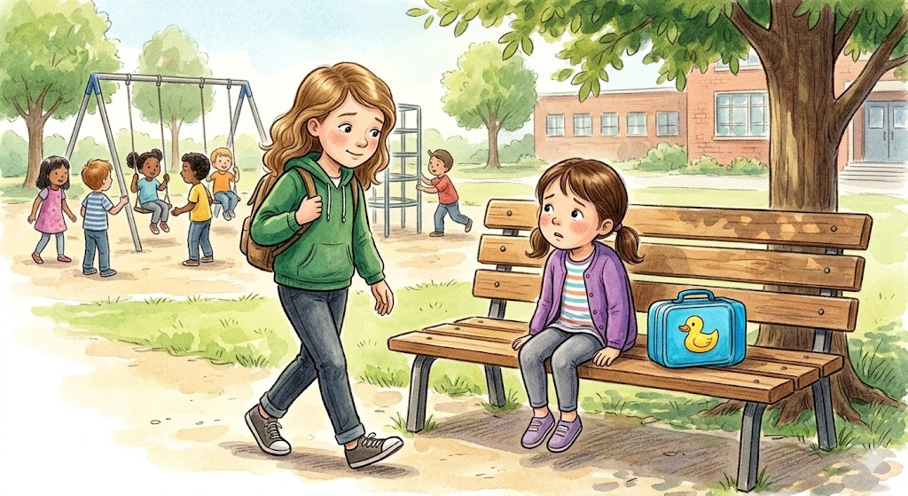
Their conversation was simple. Just a few words, then a few more. But by the time the bell rang, the girl was smiling.
That evening Lily pulled a notebook from the back of her desk drawer.
She opened to the first page and wrote, in careful letters:
Moonlit Rescue List
Then, beneath it, she wrote:
Help gently.
Stay when comfort matters.
Carry love forward.
She stared at the words for a long time.
Then she added one more line.
Ben still shines.
When she closed the notebook, her hands were steady.
The dream had not come to keep her asleep in her memory.
It had come to teach her how to wake up.

Chapter Ten
The Dream That Stayed
In the days that followed, Lily began noticing chances to help everywhere.
A stack of books dropped in the hallway.
A neighbor’s gate is swinging open in the wind.
A frightened kitten is beneath a porch step.
A classmate whose laugh sounded too bright because it was covering tears.
Before, Lily might have seen those moments and felt too tired inside to step towards them. Grief had made the world feel far away.
Now she understood something Ben had known all along:
Small acts mattered.
Not because they fixed everything.
Because they changed something real.
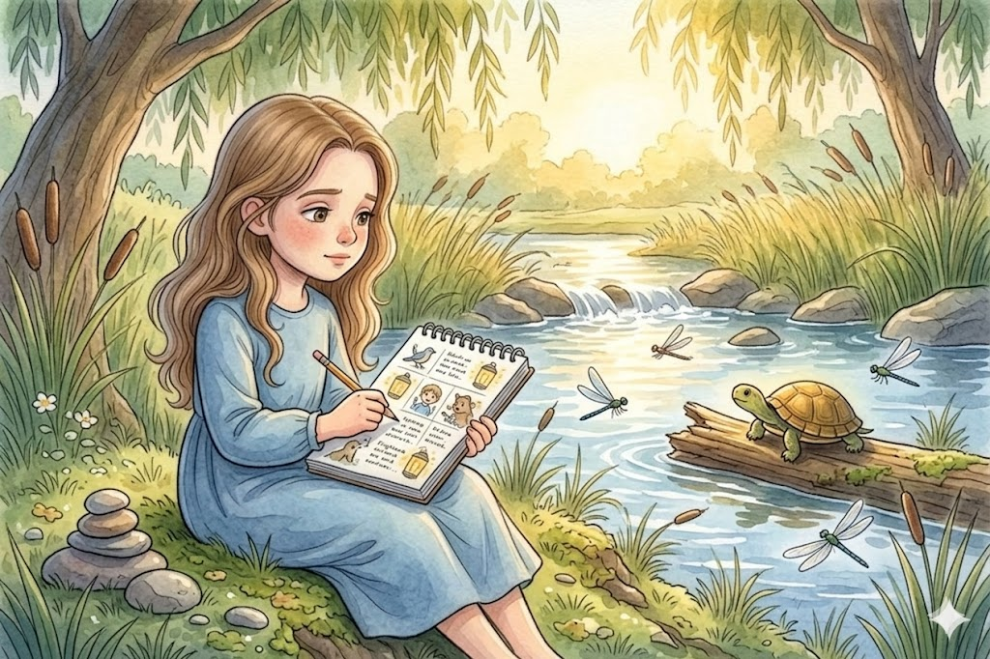
One afternoon after school, Lily walked to the creek where she and Ben had spent a spring day searching for smooth stones and watching turtles sun themselves on warm logs. The water slipped over the rocks with a soft rushing sound. Tall grass bent in the breeze. Dragonflies skimmed across the surface.
The place was full of memories.
But it no longer tightened her chest in the same way.
She sat on the bank and opened her notebook.
The pages were beginning to fill—not like points in a game, but like lanterns in the dark. A bird moved to safety. A lonely child was invited into conversation. A frightened animal treated him gently. A kindness offered without needing anyone to notice.
Lily touched her pencil to the paper and wrote:
Today I remembered that helping does not make love smaller. It gives love somewhere to go.
She paused and looked out over the creek. Sunlight lay scattered on the water.
For a long moment, she thought of Ben.
Not only as someone she had lost.
But as someone whose goodness was still moving through the world—through her hands, her choices, her courage, one moment at a time.
Then, from the edge of the grass, came a rustling sound.
Lily looked over and smiled at once.
A tiny turtle was making its determined way toward the creek.
“Well,” Lily said softly, “hello there.”
The turtle paused, as if considering her.
Lily looked around. A few sticks and bits of litter lay scattered in its path. She bent and gently cleared the way.
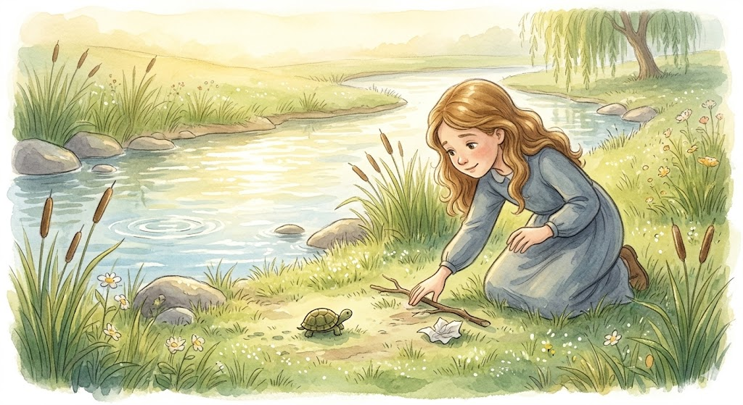
She did not pick it up.
It did not need saving from everything.
It only needed a little help reaching what came next.
The turtle continued until it slipped into the water and disappeared beneath the shining surface.
Lily watched the ripples widen.
Then she lifted her face to the sky.
It was still daytime, but she thought of the moon. Of silver meadows. Of lantern turtles drifting over dark water. Of a warm hand reaching toward her through sorrow and saying, Come on. There’s something I want to show you.
“I’m trying,” she whispered.
A breeze moved through the trees, light as a breath.
And somewhere deep inside, Lily felt the answer.
You already are.
She closed the notebook and held it against her chest.
The dream had stayed.
Not as something fragile.
Not as a memory that would fade if touched too often.
But as something living.
And as Lily rose from the creek bank and began walking home through the gold of late afternoon, she understood at last:
Love does not end when someone is gone.
If it is true love, it keeps teaching us how to live.
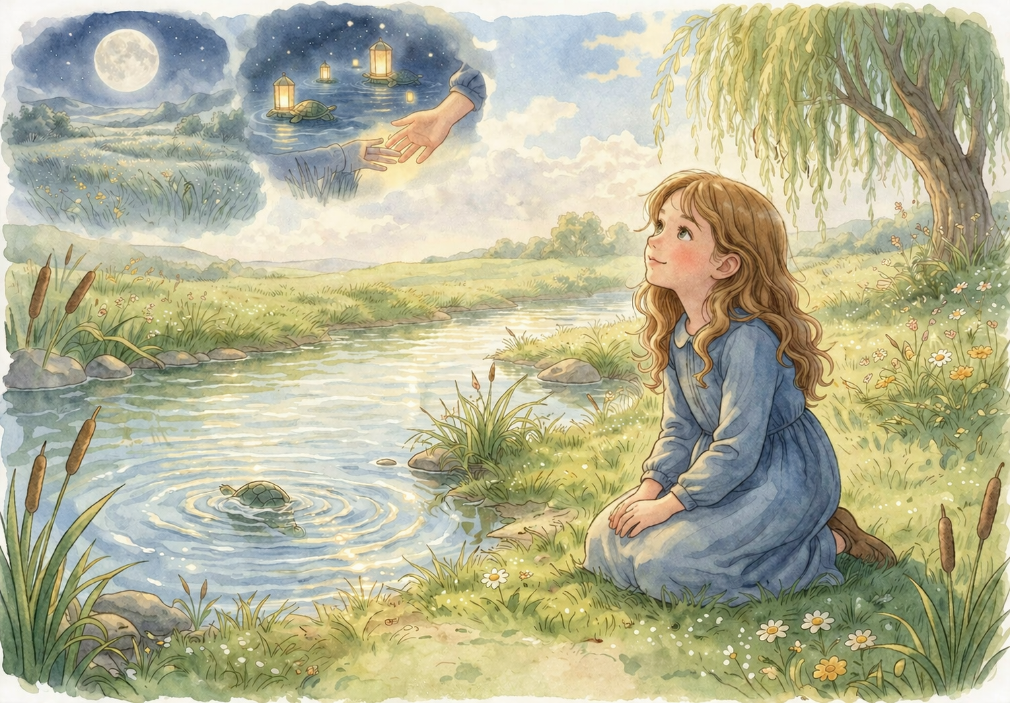
Epilogue
Long after the dream, Lily kept the notebook.
She carried it in her backpack. She left it on her desk. At night, she sometimes tucked it beneath the moonlit window beside her bed. There were days she wrote in it often, and days she hardly opened it at all. But it stayed close—not because she feared forgetting, but because it helped her remember in the right way.
Its pages slowly filled.
Some entries were about kindnesses Lily offered: helping a classmate, comforting an animal, and choosing patience when it would have been easier to turn away. Some were about the kindness she received: a hand on her shoulder, a friend waiting beside her, the quiet mercy of being understood without needing to explain. Some pages held letters to Ben—small, honest paragraphs about school, about missing him, and about the things she was trying to carry well.
As the seasons changed, Lily changed too.
She laughed more easily. She joined things again. She still missed Ben, and perhaps some part of her always would. But missing him no longer felt like standing still in the cold.
It felt more like carrying a lantern through the dark.
A light lit by love.
A light bright enough to share.
Sometimes, on clear nights, Lily still slept with her curtains open.
Moonlight would drift across her room, silver and tender, touching the turtle figurine on her shelf and the worn cover of the notebook by her bed. On those nights, she would lie quietly and think of all she had learned: that bravery can tremble, that comfort matters, that patience can free what time cannot, and that healing is not the same as forgetting.
Healing, she now understood, is loving forward.
And now and then, just before sleep found her, Lily would smile into the moonlight.
Because somewhere deep in her heart she knew this was true:
The most beautiful dreams are not the ones we leave behind in the night.
They are the ones we carry with us into the morning.
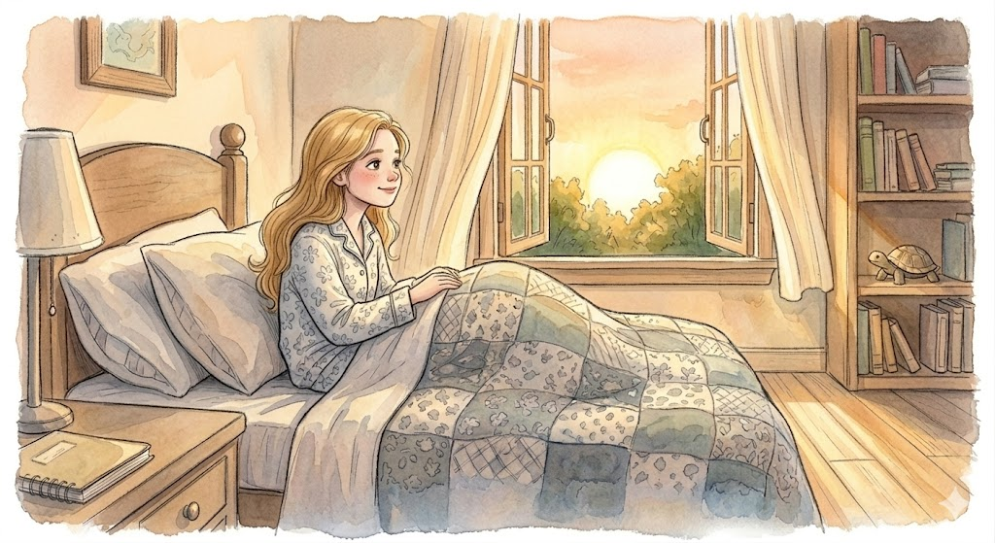

The Moonlit Rescue List is a special space designed to help you begin your own journey of "loving forward". Just like Lily, you can use these lines to record small acts of kindness that give your love somewhere to go. Your rescues do not have to be big to be important; they can be as simple as helping a classmate, choosing patience, or comforting an animal in need. Each entry you write is not just a note—it is a lantern in the dark that changes something real. By helping gently and staying when comfort matters, you are learning how to carry the light of those you miss into every new morning.
Rescue List
________________________________________________________________________________________________________________________________________________________________________________________________________________________________________________________________________________________________________________________________
Rescue List

________________________________________________________________________________________________________________________________________________________________________________________________________________________________________________________________________________________________________________________________________________________________________________________________________________________________________________________________________________________________

About the Author
www.scottMbooks.com


Scott Speicher brings a unique blend of life experiences to his writing. A U.S. military veteran, he carries the discipline, resilience, and perspective gained through service into every story he tells. After his military career, Scott built a successful path in marketing, where he developed a deep understanding of communication, storytelling, and audience engagement. For more than 15 years, he has also worked as a professional website designer, helping businesses and individuals create meaningful online presences.
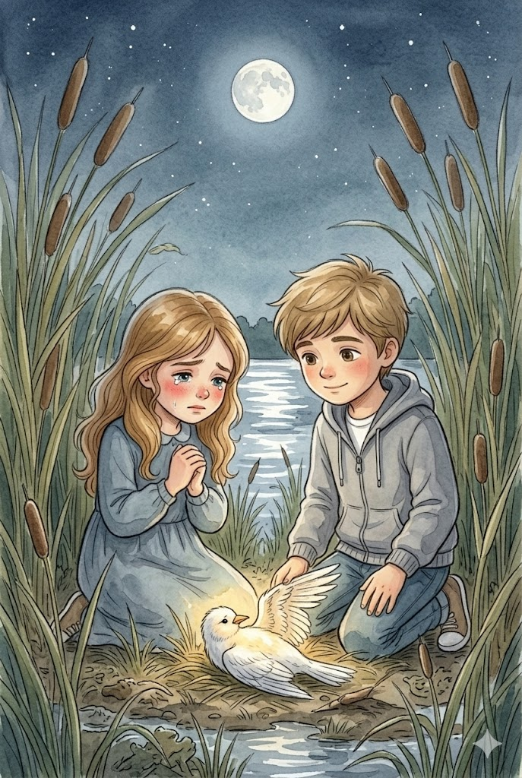
Scott Speicher is a storyteller who enjoys creating gentle, heartfelt stories that help children notice the small moments that make life meaningful. Through warm characters and simple adventures, his books encourage young readers to slow down, care for others, and appreciate the quiet joys of everyday life. Scott believes that some of the most important lessons children learn come not from grand events, but from the ordinary moments shared with family, friends, and the animals they love.

This is a story about a girl named Lily and the love she carries for someone she misses very much. It is a story about grief, yes, but even more than that, it is a story about what grief can become when it is gently shaped by memory, kindness, and hope.
When loss first enters life, it can make the world feel quieter, heavier, and unfamiliar. Ordinary things can suddenly seem changed—a window, a moonbeam, or a favorite object on a shelf. Even bedtime can feel different when someone you love is no longer where they used to be.
Suitable for readers aged 4-10 and for family read-aloud sessions. Ideal for SEL, guidance, and service-learning.

