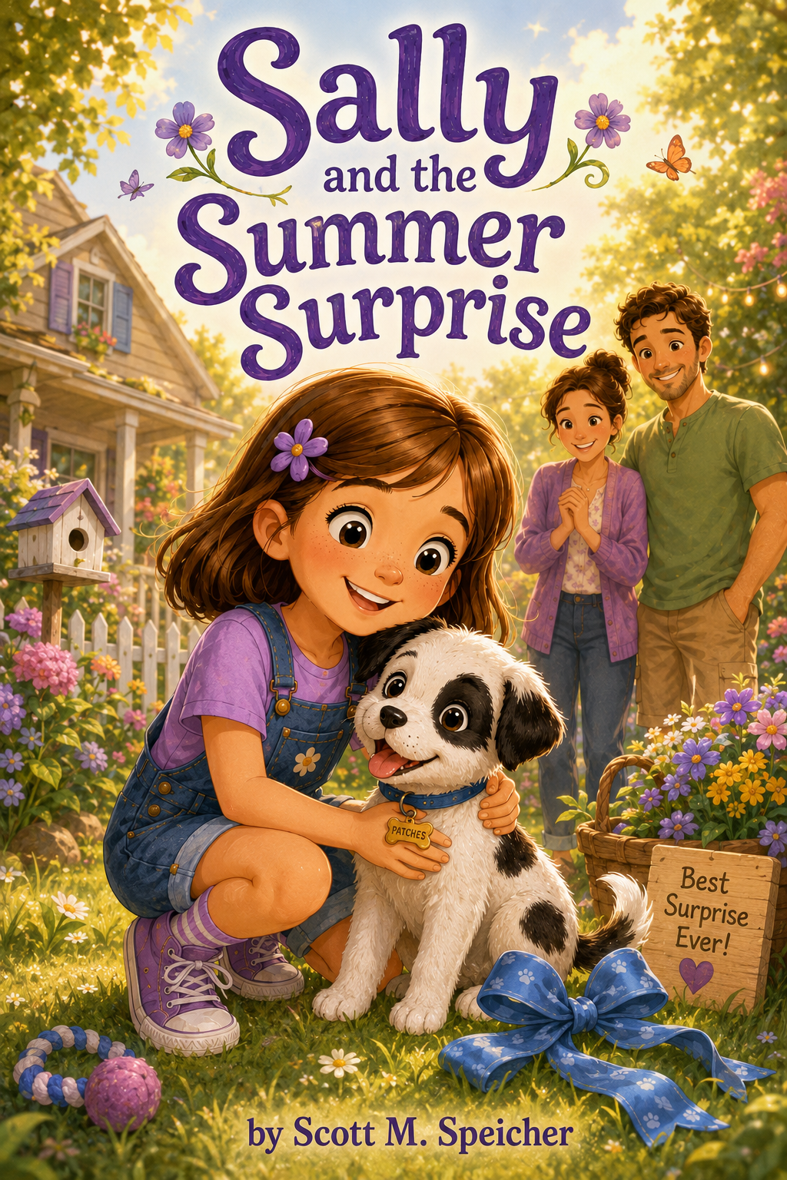Sally and the Summer Surprise
By
Scott M. Speicher

Copyright © 2026
Author: Scott M. Speicher
Portions of this book have been perfected by the program Grammarly
Edited by Grammarly and the Editorial team of Digital Scribblers
No part of this book may be reproduced or used, in any form or by any means, electronic or mechanical, without permission in writing from the author.
AI generated some images under the author's direction.

Preface
Every summer begins with a little bit of wonder.
For Sally, this summer begins with pride, excitement, and one very special surprise. After working hard all school year and earning a place on the Honor Roll, Sally discovers that her effort, kindness, and determination have not gone unnoticed. But the gift waiting for her at home is more than a reward. It is the beginning of a brand-new responsibility.
His name is Patches.
With soft white fur, black spots, a wagging tail, and a curious little heart, Patches quickly turns Sally’s summer into an adventure she will never forget. From chewed shoelaces and backyard training courses to rainy-day blanket forts, neighborhood greetings, reading picnics, and a community pet show, Sally learns that caring for a puppy is full of surprises. Some are funny. Some are messy. Some require patience. And some teach lessons that stay with her long after the moment has passed.
Sally and the Summer Surprise is a story about growing up one small step at a time. Through her bond with Patches, Sally discovers that responsibility is not just about doing the easy parts. It means showing up with love, even when things are inconvenient. It means staying calm when problems happen, trying again after mistakes, and remembering that progress matters more than perfection.
This book also celebrates the quiet values children build through everyday experiences: kindness, patience, courage, teamwork, creativity, and joy. Sally’s summer reminds young readers that learning does not always happen at a desk. Sometimes it happens in the backyard, on a walk to the park, during a stormy afternoon, or beside a sleepy puppy under the evening sky.
May Sally and Patches’ story encourage children to be proud of their efforts, gentle with others, brave in new situations, and open to the unexpected gifts that life brings.
Because sometimes the best surprises are not just presents.
Sometimes they are new beginnings.

Descriptive Table of Contents
Sally and the Summer Surprise
Preface
An introduction to Sally’s newest summer adventure. After a year of hard work, kindness, and determination, Sally discovers that her Honor Roll achievement leads to a very special surprise—one that will teach her about responsibility, patience, and love.
Chapter One: The Last Report Card
The school year comes to an end, and Sally waits nervously to receive her final report card. When Mrs. Carter congratulated her for making the Honor Roll, Sally realized that her hard work, kindness, and determination truly mattered. She learns that success often grows one small effort at a time.
Chapter Two: A Surprise at Home
Mom and Mark tell Sally they have a very special surprise waiting for her at home. Sally imagines all kinds of possibilities, but nothing prepares her for the tiny white-and-black puppy wagging his tail inside a basket with a blue ribbon. Sally instantly falls in love and names him Patches.
Chapter Three: Patches Finds His Paws
Patches is playful, curious, and full of puppy energy. Sally quickly discovers that having a puppy is exciting—but also a big responsibility. Between little accidents, chewed shoelaces, and zooming around the house, Sally learns that caring for someone means patience, gentleness, and consistency.
Chapter Four: The Backyard Adventure Course
Wanting to help Patches learn new tricks, Sally creates a backyard obstacle course using cones, boxes, tunnels, and chalk arrows. Patches stumbles, tumbles, and gets distracted by butterflies, but Sally keeps encouraging him. Together, they learn that progress takes practice and positivity.
Chapter Five: The Lost Leash Mystery
During a family walk to the park, Sally accidentally leaves Patches’s leash behind after stopping for ice cream. Determined to find it, Sally retraces her steps carefully and asks others for help. Along the way, she learns that staying calm and thinking clearly can solve problems better than panicking.
Chapter Six: Patches Meets the Neighborhood
Sally introduces Patches to neighbors, friends, and other dogs in the community. At first, Patches feels shy in loud environments and around unfamiliar faces, but Sally patiently helps him feel safe. Sally realizes that friendship sometimes grows slowly and that kindness helps others feel welcome.
Chapter Seven: The Rainy-Day Puppy Problem
A stormy afternoon leaves Sally and Patches stuck inside the house with too much energy and nowhere to run. Instead of feeling bored, Sally invents indoor puppy games, story time, and a blanket fort adventure. She learns that creativity can turn ordinary days into unforgettable memories.
Chapter Eight: Patches and the School Reading Day
Sally’s school hosts a summer reading event, and students are invited to share books they love. When Sally brings Patches along for the outdoor reading picnic, the puppy becomes an unexpected star. Sally discovers that stories—and even pets—can help bring people together.
Chapter Nine: The Big Dog Show Surprise
The town holds a small community pet show, and Sally nervously enters Patches in the “Best Trick” category. Patches does not perform perfectly, but his playful personality and Sally’s encouragement win over the crowd. Sally learns that doing your best matters more than being perfect.
Chapter Ten: Sally’s Summer Promise
As summer winds down, Sally looks back on everything she and Patches have learned together: responsibility, patience, teamwork, kindness, courage, and joy. Sitting beside Patches under the evening sky, Sally promises to keep growing, learning, and caring for others—one adventure at a time.
Epilogue
The new school year begins, and Sally carries the lessons of her summer with her. With Patches waiting faithfully at home, Sally steps into a new year with confidence, compassion, and the understanding that every day offers another chance to learn, care, and grow.

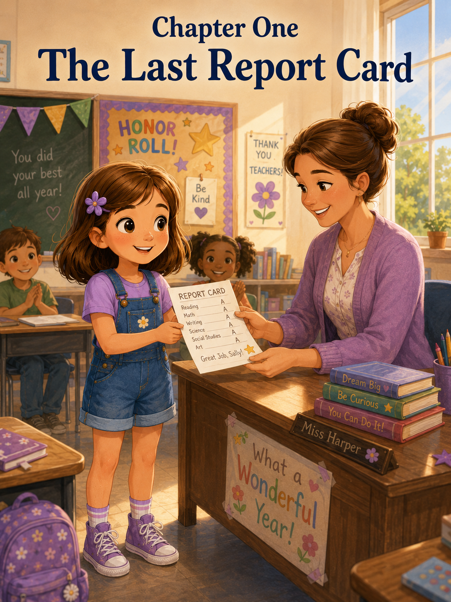Chapter One: The Last Report Card
Sally could feel the end of the school year before she even reached her classroom.
It was in the warm sunshine that spilled across the sidewalk. It was in the way children hurried through the hallway, laughing louder than usual, their backpacks bouncing as if they were already full of summer. It was on the colorful paper chain hanging near the classroom door, where only one loop remained.
One loop.
One day.
The last day of school.
Sally walked into Mrs. Carter’s classroom with her purple backpack over one shoulder, her brown hair brushed neatly, and her purple flower clip tucked just above her ear. She wore her favorite purple shirt, denim shorts, and her purple sneakers with the white laces that always came untied at the worst possible times.
Today, even her sneakers seemed excited.
But Sally’s stomach felt fluttery.
Not the bad kind of fluttery.
Not exactly.
It was the kind that came when something important was about to happen, and Sally was not sure whether she wanted time to hurry forward or slow down.
Today was report card day.
Sally slid into her seat and placed both hands on top of her desk. Around her, the classroom buzzed with last-day energy. Emma was showing Ava the friendship bracelet she had finished the night before. Marcus was trying to fit three library books, a water bottle, and a crumpled paper hat into his backpack. Someone near the window was whispering about popsicles at recess.
Sally tried to smile.
She was excited about summer. She really was.
There would be long mornings, bike rides, sidewalk chalk, sprinklers, library visits, and maybe even trips to the beach. But before summer could truly begin, Sally had to open the white envelope Mrs. Carter would give her.
The envelope with her final report card inside.
Sally had worked hard all year. She had practiced spelling words even when she would rather have been drawing seashells. She had read extra pages at night, even when her eyes felt sleepy. She had tried her best on math problems that seemed to grow more confusing the longer she stared at them.
She had also tried to be kind.
That mattered too.
She had helped Olivia pick up spilled crayons. She had invited a new student named Mia to sit beside her at lunch. She had shared her purple marker during poster day, even though purple was her best and most important marker.
Still, waiting made everything feel uncertain.
What if her grades were not as good as she hoped?
What if she had made mistakes she did not remember?
What if Mom and Mark were proud of her, but not as proud as they would have been if she had done just a little better?
Sally looked down at her desk and traced one finger along a tiny scratch in the wood.
Mrs. Carter stood near the whiteboard, smiling in the soft, shiny-eyed way teachers sometimes smiled on the last day of school.
“Good morning, class,” she said.
“Good morning, Mrs. Carter!” everyone called back.
Some voices were cheerful. Some were sleepy. One voice sounded like it still had breakfast in it.
Mrs. Carter laughed. “Today is a special day. We are going to clean out our desks, share a few favorite memories, celebrate the hard work you have done, and then…” She paused while the class leaned forward. “Begin summer vacation.”
The classroom burst into cheers.
Sally cheered too, but quietly.
Mrs. Carter held up a neat stack of envelopes.
Sally’s eyes went straight to them.
Report cards.
White envelopes.
Names were written carefully across the front.
Important papers tucked inside.
Mrs. Carter placed them on her desk. “We will pass these out later this morning,” she said. “But first, I want everyone to think about something.”
The room settled.
“What is one thing you are proud of from this school year?”
Sally blinked.
One thing?
That should have been easy. But suddenly her mind felt as full as her desk, which still held old worksheets, a dried-up glue stick, two pencil-top erasers, and one mysterious button.
Emma raised her hand. “I’m proud that I learned multiplication.”
“Wonderful,” Mrs. Carter said.
Marcus raised his hand. “I’m proud that I got better at reading out loud.”
“That took courage,” Mrs. Carter said.
Ava said she was proud of her science fair project. Liam said he was proud that he finally remembered to bring his folder back every Friday. That made everyone laugh, including Liam.
Then Mrs. Carter looked at Sally.
“Sally,” she said gently, “what about you?”
Sally sat up a little straighter.
She thought about spelling tests. She thought about math pages with tiny numbers lined up like ants. She thought about reading her book report in front of the class, even as her knees felt wobbly. She thought about Mia sitting alone at lunch on her first day.
“I’m proud…” Sally began.
Everyone looked at her.
She swallowed.
“I’m proud that I kept trying,” she said. “Even when something was hard.”
Mrs. Carter’s smile warmed. “That is a very important thing to be proud of.”
Sally felt her cheeks turn pink.
“And,” Sally added, because suddenly the words were easier, “I’m proud that I helped Mia feel welcome.”
Across the room, Mia smiled.
“That was kindness in action,” Mrs. Carter said.
Sally looked down, but she was smiling now, too.
After morning sharing, the class began cleaning out their desks. Sally found many things she had forgotten about. A spelling list from October. A drawing of a crab wearing sunglasses. A worksheet with a gold star on top. A note from Emma that said, “Do you want to play at recess?” with three check boxes underneath.
Yes.
Maybe.
Ask me after having a snack.
Sally folded the note and put it in her keep pile.
By the time the desks were clean, the classroom looked both tidy and strange. Empty desks made everything feel almost finished. The cubbies looked bare. The bulletin board where student artwork had hung all year now had little squares of faded paper where the sun had not reached.
Mrs. Carter clapped her hands softly.
“Class, please come sit on the rug.”
Everyone gathered near the front of the room.
Sally sat cross-legged beside Emma. Her sneaker lace was untied again, but she decided to worry about that later.
Mrs. Carter picked up the stack of envelopes.
Sally’s stomach fluttered harder.
“One at a time, I will call your name,” Mrs. Carter said. “You will receive your report card, along with a small certificate celebrating something special I noticed about you this year.”
Sally squeezed her hands together in her lap.
Mrs. Carter called Emma first.
Emma received her envelope and a certificate for Outstanding Teamwork.
Marcus received Most Improved Reader.
Ava received the Creative Science Thinker.
Mia received the Kind and Courageous Friend.
Each student smiled. Some looked embarrassed. Some looked proud. Some tried very hard to pretend certificates weren't exciting, even though they clearly were.
Then Mrs. Carter looked down at the next envelope.
“Sally.”
Sally stood.
The rug suddenly felt much larger than it had a moment ago. She walked carefully to the front of the room, remembering not to trip over her shoelace.
Mrs. Carter held out the envelope first.
Sally took it with both hands.
Then Mrs. Carter picked up a certificate bordered with tiny purple stars.
“Sally,” she said, “this year, you showed determination, curiosity, kindness, and a willingness to keep going even when something was difficult. You asked thoughtful questions. You helped others. You took your work seriously. And I am very proud to say that you have earned a place on the Honor Roll.”
For a second, Sally did not move.
Honor Roll.
The words seemed to float in the air like bubbles.
The class began clapping.
Emma whispered, “Sally! You did it!”
Sally looked at Mrs. Carter. “Really?”
Mrs. Carter nodded. “Really.”
Sally’s smile started small, then spread across her whole face.
She had made the Honor Roll.
All those spelling words.
All those math problems.
All those nights when Mom said, “Just try one more,” and Sally had sighed dramatically but tried anyway.
All the time, Mark had sat beside her at the kitchen table and made up silly word problems about squirrels buying blueberries.
All the times Sally had wanted to rush, but slowed down instead.
It had mattered.
Mrs. Carter handed her the certificate.
The top read:
Honor Roll Achievement Award
Underneath, in Mrs. Carter’s neat handwriting, it said:
For hard work, kindness, determination, and a curious heart.
Sally held the certificate carefully against her chest.
“Thank you,” she said.
Her voice came out quiet, but happy.
When Sally sat down again, Emma leaned close. “Your mom is going to be so excited.”
“And Mark,” Sally said.
She looked at the envelope in her lap.
For the first time that morning, she was not afraid to open it.
Later, after cupcakes with blue frosting, after a last-day read-aloud, after everyone signed each other’s memory pages, the final bell rang.
Brrrrrrrrring!
The sound filled the school like a burst of sunshine.
Children cheered. Chairs scraped. Backpacks zipped. Someone shouted, “Summer!” as if summer had been waiting right outside the door and needed to be invited in.
Sally hugged Mrs. Carter goodbye.
“I’m proud of you,” Mrs. Carter said.
Sally hugged her certificate closer. “Thank you for helping me.”
“You did the work,” Mrs. Carter said. “Remember that. Big successes usually grow from small efforts repeated again and again.”
Sally thought about that.
Small efforts.
One spelling word.
One math problem.
One kind choice.
One more try.
Outside, Mom and Mark were waiting near the school walkway. Mom wore a soft green shirt and had sunglasses pushed up on her head. Mark stood beside her, smiling, with his hands tucked into his pockets.
Sally tried to walk calmly toward them.
She lasted exactly three steps.
Then she ran.
“Mom!” she shouted. “Mark!”
Mom opened her arms, and Sally crashed into her hug.
“How was the last day?” Mom asked.
Sally stepped back, holding up her certificate.
“I made the Honor Roll!”
Mom’s eyes widened. “Sally!”
Mark leaned closer. “Honor Roll? That sounds very official.”
“It is official,” Sally said, lifting her chin. “There is a certificate.”
Mom took the certificate and read it aloud. Her voice softened when she reached the words hard work, kindness, determination, and a curious heart.
“Oh, sweetheart,” Mom said. “I am so proud of you.”
Mark smiled. “I knew you worked hard, but this is wonderful.”
Sally rocked on her heels. “Mrs. Carter said big successes grow from small efforts.”
“She is right,” Mom said.
Mark nodded. “That is true for almost everything important.”
Sally looked from Mom to Mark.
Something about the way they smiled made her pause.
They looked proud.
But they also looked like they were holding a secret.
Sally narrowed her eyes just a little.
“Why are you both smiling like that?”
Mom blinked innocently. “Like what?”
“Like you know something,” Sally said.
Mark looked at Mom. Mom looked at Mark.
Sally pointed at them. “That. That is the look.”
Mark tried not to laugh. He failed.
Mom slipped Sally’s report card envelope safely into her backpack. “We may have a little celebration planned.”
Sally’s eyes grew round. “A celebration?”
“A very special one,” Mark said.
“What kind of special?”
“If we told you,” Mom said, “it would not be very special anymore.”
Sally made her think face.
“Is it cake?”
“No,” Mom said.
“Is it ice cream?”
“Not exactly,” Mark said.
“Is it a trip to the bookstore?”
“That is always a good idea,” Mom said, “but no.”
“Is it something I can wear?”
“No,” Mark said.
“Is it something I can read?”
Mom smiled. “Not really.”
Sally frowned. “That is not enough information.”
Mark opened the car door for her. “Some surprises need patience.”
Sally climbed into the back seat. “I am very patient.”
Mom turned and raised one eyebrow.
Sally sighed. “I am sometimes patient.”
Mark laughed as he started the car. “That is more accurate.”
On the drive home, Sally asked fourteen questions.
Mom answered almost none of them.
Mark answered some of them incorrectly on purpose.
“Is the surprise a canoe?” Sally asked.
“No,” Mom said.
“Is it a lifetime supply of purple markers?”
“I wish,” Mark said.
“Is it a robot that cleans my room?”
“That would be a surprise for all of us,” Mom said.
“Is it a pony?”
“No,” Mom and Mark said together.
Sally folded her arms. “You did not even think about that one.”
“At this house,” Mark said, “we do not have enough room for a pony.”
“We have a backyard,” Sally pointed out.
“We have a small backyard,” Mom said.
“A very pony-unfriendly backyard,” Mark added.
Sally leaned back in her seat, smiling despite herself.
The streets outside looked brighter than usual, as if summer had painted everything extra yellow. Kids rode bikes. A sprinkler clicked back and forth across a patch of grass. A man walked past with a dog on a leash, and the dog’s tail wagged so hard its whole body wiggled.
Sally watched it until the car turned the corner.
Dogs always make her smile.
She had wanted a dog for a long time. Not just because puppies were cute, though they certainly were. Sally liked the idea of having a little friend who would follow her from room to room, sit beside her while she drew pictures, and listen carefully when she read stories out loud.
But dogs were a big responsibility.
Mom had said that many times.
They needed food, water, walks, training, patience, and love. They needed someone who would care for them even when it was raining, even when they were muddy, even when they chewed something they were not supposed to chew.
Sally knew that.
She had once made a list called:
Reasons I Would Be Excellent at Having a Dog
It had fourteen reasons, plus a drawing of a puppy wearing a crown.
Mom had smiled when she read it, but she had said, “We will talk about it when the time is right.”
Sally wondered when the time would be right.
Maybe someday.
When they got home, Mom made Sally’s favorite snack: apple slices with peanut butter and a few chocolate chips sprinkled on the side. Mark placed a small purple gift bag on the kitchen table.
Sally stared at it.
The bag was not very big.
So, the surprise was not a pony.
That seemed unfair, but understandable.
“Go ahead,” Mom said.
Sally reached inside and pulled out a folded piece of paper tied with a ribbon. She untied it carefully.
At the top, written in Mom’s handwriting, were the words:
Summer Celebration Promise
Sally read the list beneath it.
I promise to keep trying.
I promise to be patient.
I promise to help when I am needed.
I promise to be kind even when things are messy.
I promise to remember that love and responsibility go together.
Sally looked up slowly.
“What is this for?”
Mom sat beside her. “You worked hard this year, Sally. You earned the Honor Roll, but more than that, you showed us that you can keep trying even when something takes effort.”
Mark leaned against the counter. “You also showed kindness, patience, and responsibility.”
Sally looked at the paper again.
The words felt important.
Very important.
“Is this part of the surprise?” she asked.
“Yes,” Mom said.
“But not all of it,” Mark added.
Sally’s eyes widened. “There is more?”
Mom smiled gently. “There is more.”
“When?”
“Tomorrow,” Mark said.
Sally nearly dropped the paper. “Tomorrow? I must wait until tomorrow?”
“Waiting is part of many important surprises,” Mom said.
Sally groaned, but she was smiling too much for it to sound serious.
That night, Sally placed her Honor Roll certificate on her desk where she could see it. Beside it, she placed the Summer Celebration Promise.
Then she opened her notebook to a fresh page.
At the top, she wrote:
Sally and the Summer Surprise
Underneath, she added:
Question #1: What is the surprise?
She tapped her pencil against the page.
Then she wrote:
Possible answer: Something important.
She paused.
Then she added:
Possible answer #2: Something that needs patience.
Sally looked at the words and smiled.
That was how she had made the Honor Roll.
One small effort at a time.
One spelling word.
One math problem.
One kind choice.
One careful try.
Maybe the surprise would be like that, too.
Something she would grow into.
Something she would learn.
Something that would make this summer different from all the summers before.
Sally climbed into bed, but sleep did not come right away. She thought about her certificate. She thought about Mrs. Carter’s words. She thought about Mom and Mark smiling like they had swallowed a secret and were trying very hard not to let it out.
Downstairs, she heard them talking softly.
Sally hugged her pillow.
The school year is over.
Her report card was finished.
Summer had begun.
And somewhere inside tomorrow, a surprise was waiting.
Sally closed her eyes and whispered to herself, “One small step at a time.”
The words felt brave.
The words felt true.
And finally, Sally drifted to sleep, dreaming of sunshine, purple ribbons, and a summer she had not yet discovered.

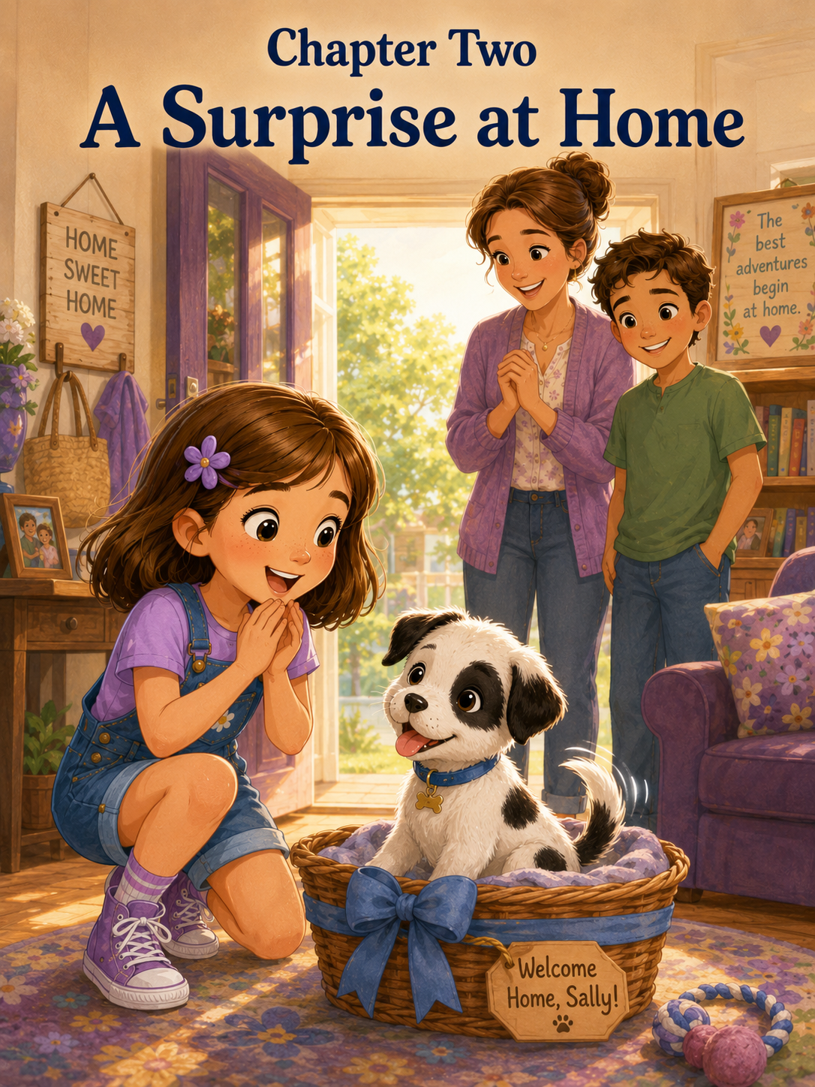Chapter Two: A Surprise at Home
Sally woke up the next morning before the sun had fully climbed over the trees.
For a moment, she lay still under her blanket, blinking at the soft gray light around her bedroom. Her purple flower clip sat on her nightstand. Her Honor Roll certificate rested proudly on her desk, right beside the paper Mom and Mark had given her the day before.
Summer Celebration Promise
Sally looked at it from across the room.
Then she remembered.
The surprise.
She sat up so quickly, and her blanket slid to the floor.
“Today,” she whispered.
Yesterday had been report card day. Yesterday, Mrs. Carter had congratulated her in front of the whole class. Yesterday, Sally made the Honor Roll.
And yesterday, Mom and Mark had smiled in that suspicious grown-up way that meant they knew something very important and were trying very hard not to tell.
They had said there was a special surprise.
Not cake.
Not ice cream.
Not a trip to the bookstore.
Not a pony.
Sally still thought the pony had been rejected much too quickly.
She climbed out of bed and hurried to her desk. Her certificate looked even more official in the morning light. The purple stars around the border seemed to sparkle.
Sally touched the edge of it carefully.
She felt proud.
Not the loud, jumping-up-and-down kind of proud.
The quiet kind.
The kind that sat warmly inside her chest reminded her of all the times she had tried when trying was hard.
She had earned this.
One spelling word at a time.
One math problem at a time.
One kind choice at a time.
One small effort at a time.
Sally picked up the Summer Celebration Promise and read it again.
I promise to keep trying.
I promise to be patient.
I promise to help when I am needed.
I promise to be kind even when things are messy.
I promise to remember that love and responsibility go together.
The last line made Sally pause.
Love and responsibility.
That sounded bigger than a regular surprise.
A book could be loved, but it did not need much responsibility except keeping sticky fingers away from the pages.
A new bike could be loved, but it mostly needed a helmet and careful riding.
A plant needed love and responsibility.
The fish did too.
A puppy definitely did.
Sally pressed the paper against her chest.
“Do not think puppy too loudly,” she told herself.
But it was too late.
The thought had already appeared.
A puppy.
A soft little puppy.
A wiggly little puppy.
A puppy with floppy ears and paws are too big for its body.
Sally shook her head.
“Maybe it is not a puppy,” she whispered.
The word puppy kept wagging around in her mind anyway.
Downstairs, Sally could hear Mom moving dishes in the kitchen. She smelled toast. She smelled scrambled eggs. She smelled coffee, which Sally did not drink because Mom said coffee was for grown-ups and people who used phrases like “early meeting” and “where are my keys?”
Sally changed into a purple T-shirt, denim shorts, and her purple sneakers. She brushed her hair, clipped her purple flower above her ear, and gave herself a serious look in the mirror.
“Be patient,” she said.
Then she ran downstairs.
Mom was standing at the counter, spreading butter on toast. Mark sat at the kitchen table with his coffee mug and a folded newspaper he was mostly not reading.
“Good morning,” Mom said.
Sally looked at them both.
“Good morning,” she said carefully.
Mark took a sip of coffee. “You seem very calm.”
“I am calm,” Sally said.
Mom smiled. “Very impressive.”
“I am being patient.”
“That is also impressive,” Mark said.
Sally sat at the table and folded her hands.
She waited.
Mom set a plate in front of her.
Sally looked at the eggs. She looked at the toast. She looked at Mom. She looked at Mark.
Nobody said anything.
Sally lasted seven seconds.
“What time is the surprise?”
Mark coughed into his coffee.
Mom laughed softly. “After breakfast.”
Sally picked up her fork immediately.
“Not that fast,” Mom said. “Chew.”
Sally chewed.
Slowly.
Or at least, slower than she wanted to.
Breakfast felt like the longest meal of her life. Mark talked about the weather. Mom asked if Sally had slept well. Sally answered, but half of her brain was busy making a list of possible surprises.
Maybe it was a new art set.
Maybe it was a backyard tent.
Maybe it was a trip to the aquarium.
Maybe it was a goldfish.
Maybe it was a hamster.
Maybe it was a kitten.
Maybe it was a puppy.
There was that word again.
Puppy.
When breakfast was finally over, Sally carried her plate to the sink without being asked. Then she turned around quickly.
“I helped,” she said.
Mom smiled. “Yes, you did.”
“I am ready to be helpful.”
“So, I see,” Mark said.
Sally narrowed her eyes. “Is helpfulness related to the surprise?”
“Possibly,” Mark said.
Mom gave him a look.
Mark lifted both hands. “What? I said possibly.”
Sally bounced once on her toes.
Mom dried her hands on a towel and walked toward the living room. “Before we show you anything, we want to talk for a minute.”
Sally’s bouncing stopped.
Talk for a minute sounded serious.
She followed Mom and Mark into the living room. Sunlight came through the windows, making bright squares on the floor. Sally sat on the couch. Mom sat beside her. Mark sat in the chair across from them.
Mom took Sally’s hands gently.
“Sally, yesterday was a very special day,” Mom said. “Making the Honor Roll showed how hard you worked this year.”
Sally smiled a little.
“But what made us even prouder,” Mom continued, “was how you kept trying, how you showed kindness, and how you learned to be responsible with your work.”
Mark leaned forward. “You did not become responsible in one day. You practiced. You remembered your reading. You have finished your homework. You helped in the classroom. You kept going even when you felt frustrated.”
Sally looked down at her hands.
She liked hearing those things, but it also warmed her cheeks.
Mom squeezed her fingers. “The surprise we planned is something wonderful. But it is also something that will need patience, gentleness, and responsibility.”
Sally’s heart began to thump.
Patience.
Gentleness.
Responsibility.
Those were very puppy-shaped words.
Sally tried not to gasp.
Mark smiled. “We believe you are ready to learn.”
“Ready to learn what?” Sally whispered.
Mom looked toward the hallway. “Why don’t you come see?”
Sally stood slowly.
Her knees felt a little wobbly.
Mom led the way down the hall toward the small sunroom at the back of the house. Usually, the sunroom had plants, a rocking chair, and a basket of blankets. Sally liked to sit there on rainy days and draw.
But today the door was mostly closed.
Sally stopped in front of it.
She heard something.
A tiny sound.
Not a bark exactly.
More like a squeaky little question.
Sally’s eyes widened.
Mom looked at Mark.
Mark nodded.
“Go ahead,” Mom said gently.
Sally pushed the door open.
At first, all she saw was sunlight.
Then she saw the basket.
It sat on a soft blue blanket in the middle of the room. Around it were a few new things Sally had never seen before: a small silver water bowl, a little chew toy shaped like a bone, and a folded puppy bed with tiny paw prints on it.
Inside the basket, tied loosely around the handle, was a bright blue ribbon.
And in the basket was the surprise.
A puppy.
A tiny white puppy with black spots.
One black patch covered part of one ear. Another spot sat on his back, where someone had gently painted it. His nose was shiny and black. His paws were small and round. His tail wagged so quickly it made the whole basket wiggle.
For a moment, Sally forgot how to speak.
The puppy looked up at her.
He tilted his head.
Then he gave one tiny, excited yip.
Sally’s hands flew to her mouth.
“Oh,” she whispered.
The puppy scrambled forward, his little paws slipping on the blanket. His tail wagged harder.
Sally turned to Mom and Mark with wide eyes.
“Is he…?”
Mom nodded. “He’s yours.”
“And ours,” Mark added gently. “A family puppy. But you will have a very important part in helping care for him.”
Sally turned back to the basket.
The puppy stared at her as if he had been waiting for her his whole life.
Sally’s eyes filled with happy tears.
“A real puppy,” she whispered.
Mom knelt beside her. “A real puppy.”
Sally took one careful step closer.
“Can I touch him?”
“Yes,” Mark said. “Slowly. Let him sniff your hand first.”
Sally crouched near the basket and held out her hand, palm down, just like Mark showed her. The puppy leaned forward, sniffed her fingers, and then licked them with a quick pink tongue.
Sally giggled.
“That tickles.”
The puppy wagged approvingly.
“He likes you,” Mom said.
“I like him,” Sally said immediately. “I love him.”
The puppy tried to climb over the edge of the basket. Mark reached down and gently lifted him out, placing him on the soft blanket in front of Sally.
The puppy waddled toward her.
He did not walk in a straight line. He wiggled. He tumbled slightly. One paw stepped on the edge of the blanket, and he looked surprised, as if the blanket had done something unexpected.
Sally laughed softly.
“Hi,” she said.
The puppy looked up at her.
“Hi, little one.”
He climbed into her lap like that was where he belonged.
Sally held very still.
He was warm.
He was soft.
He smelled like clean blankets, puppy breath, and something new.
Something like the beginning of a story.
His tail tapped against her arm.
Thump-thump-thump-thump.
Sally looked down at his black spots.
“He looks like someone dropped little patches of paint on him,” she said.
Mom smiled.
Mark raised his eyebrows. “Patches of paint?”
Sally looked from Mom to Mark, then back at the puppy.
The puppy licked her chin.
Sally laughed.
“Patches,” she said.
The puppy wagged.
“That should be his name.”
Mom’s face softened. “Patches.”
Mark smiled. “I think it fits.”
Sally looked at the puppy seriously. “Do you like the name Patches?”
The puppy sneezed.
Sally nodded. “That means yes.”
Mark chuckled. “Very scientific.”
“It is puppy science,” Sally said.
Patches curled against her and chewed gently on the edge of her shirt sleeve.
“Not my shirt,” Sally said, carefully moving the fabric away.
Patches immediately tried to chew her shoelace instead.
“Oh no,” Sally said. “You are already trouble.”
Mom laughed. “Puppies are sweet, but they are also a lot of work.”
Sally nodded, still watching Patches. “I know.”
“Do you?” Mark asked kindly.
Sally looked up.
Mom sat beside her on the floor. “He will need to eat at certain times. He will need fresh water. He will need to go outside often. He will have accidents while he is learning. He may chew things. He may cry at night. He will need patience.”
Sally listened carefully.
Patches was now trying to pounce on his own tail.
“I can help,” Sally said.
“We know you can,” Mom said. “But helping with a puppy means helping even when it is not exciting. Even when you are tired. Even when you would rather keep playing.”
Sally thought about her report card. She thought about her homework. She thought about all the small efforts that had added up to something important.
“I can learn,” she said.
Mark nodded. “That is the right answer.”
Patches tumbled sideways, then popped back up, looking very proud of himself.
Sally gently stroked his soft head.
“Do we know what kind of dog he is?” she asked.
“The rescue thinks he may be part terrier,” Mom said. “Maybe a little of something else too.”
“Part terrier and part surprise,” Mark said.
Sally smiled. “Mostly surprise.”
Mom reached for a folder on the small table. “We have his adoption papers, feeding instructions, and the name of the veterinarian. We also have a list of puppy rules.”
Sally made a face. “There are rules already?”
“Many rules,” Mark said.
Patches barked once.
“Even Patches agrees,” Mom said.
Sally looked at the puppy. “You agree with the rules?”
Patches chewed the corner of the blanket.
“I do not think he agrees,” Sally said.
Mom handed Sally a small sheet titled:
Puppy Rules
Sally read aloud.
“Number one: Patches eats puppy food, not people food.”
Patches looked interested in the word food.
“Number two: Patches goes outside after eating, after waking up, and after playing.”
“That one is important,” Mark said.
“Number three: Shoes, books, socks, and homework are not chew toys.”
Sally looked at Patches, who had returned to her shoelace.
“Did you hear that?”
Patches wagged.
“Number four: Always be gentle.”
Sally nodded. “That one is easy.”
“Number five,” Mom said softly, “love him with patience.”
Sally looked at the puppy curled in her lap.
Love him with patience.
She understood that one, even though she had only known Patches for a few minutes.
Patches was tiny. He did not know the rules yet. He did not know where to sleep or when to bark or which things belonged in his mouth and which things absolutely did not.
He would have to learn.
And Sally would have to learn too.
She kissed the top of his head.
“I will be patient,” she whispered.
Patches responded by licking her nose.
After a while, Mom showed Sally how to fill the water bowl. Mark showed her where the puppy food was kept. They walked through the backyard together while Patches explored the grass.
At first, Patches sniffed everything.
One leaf.
One stick.
One pebble.
One patch of dirt.
Another leaf.
Sally followed him closely.
“He is very interested in leaves,” she said.
“He has never seen our leaves before,” Mark said.
Patches pounced at a butterfly shadow, missed it completely, and rolled onto his back.
Sally laughed so hard she had to sit down in the grass.
Patches ran to her and climbed into her lap again, as if laughing together was already part of their routine.
Mom stood on the patio watching them.
“I think he knows who his person is,” she said.
Sally looked up. “I’m his person?”
“You can be one of his people,” Mom said. “And I think he will be one of yours.”
Sally hugged Patches gently.
The words made her heart feel full.
That afternoon, Sally made a list in her notebook.
At the top, she wrote:
Things I Know About Patches So Far
- He is white with black spots.
- He has a black ear patch.
- He likes shoelaces.
- He thinks leaves are fascinating.
- He sneezes when asked important questions.
- He is very wiggly.
- He is perfect.
Then she added another heading:
Things I Need to Learn
- How much food does he eat?
- How to help him learn where to potty.
- How to teach him not to chew shoes.
- How to be patient when he makes mistakes.
- How to be the best puppy friend I can be.
Patches was asleep beside her by then, curled into a small spotted circle on his blue blanket.
His paws twitched.
“Do puppies dream?” Sally asked.
“I think so,” Mom said from the doorway.
“What do they dream about?”
Mark looked over from the kitchen. “Probably snacks.”
“Or leaves,” Sally said.
“Or shoelaces,” Mom added.
Sally covered her shoes with one hand. “He can dream about shoelaces, but he may not eat them.”
Patches sighed in his sleep.
Sally watched his little chest rise and fall.
That morning, she had imagined all kinds of surprises. She had imagined art supplies, books, trips, and maybe a few impossible things like ponies and room-cleaning robots.
But she had not imagined this exact feeling.
She had not imagined how quickly her heart could make room for something so small.
Patches opened one eye, saw Sally, and wagged his tail without getting up.
Sally smiled.
Yesterday, her report card showed what hard work could become.
Today, Patches showed her something else.
Sometimes the best surprises were not just gifts.
Sometimes they were beginnings.
Sally opened her notebook again and wrote one final sentence at the bottom of the page.
Patches came home today, and summer officially became an adventure.
Then she rested her hand gently beside him.
Patches placed one tiny paw on her fingers.
And Sally knew, with all her heart, that this was going to be the most surprising summer of all.

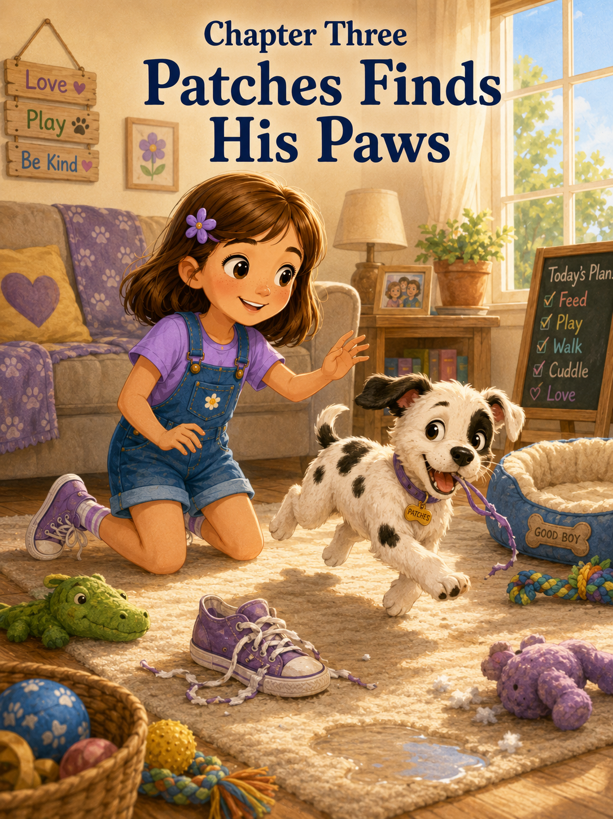Chapter Three: Patches Finds His Paws
The first sound Sally heard the next morning was not her alarm clock.
It was not Mom making coffee.
It was not Mark opening the back door to get the newspaper.
It was a tiny, squeaky sound from somewhere near the foot of her bed.
“Yip.”
Sally’s eyes opened.
For one confused second, she forgot why there was a soft blue puppy bed beside her dresser.
Then she remembered everything at once.
Patches.
Sally sat up quickly.
Inside the little puppy bed, a small white-and-black puppy looked back at her with bright, curious eyes. One black patch covered part of his ear, and another spot sat on his back like a painted thumbprint. His tail thumped against the side of the bed.
Thump-thump-thump.
“Good morning, Patches,” Sally whispered.
Patches answered by climbing out of the bed, stepping on the corner of his blanket, tripping over it, and rolling gently onto his side.
Sally gasped. “Oh!”
Patches popped back up immediately, as if falling over had been part of his plan.
Then he sneezed.
Sally giggled.
“You are very dramatic.”
Patches wagged harder.
Sally slipped out of bed and knelt beside him. She held out her hand, just like Mark had taught her the day before. Patches sniffed her fingers, licked them, and then began chewing gently on the edge of her pajama sleeve.
“No, no,” Sally said softly. “Pajamas are not breakfast.”
Patches looked at her.
Then he chewed again.
Sally gently moved her sleeve away and handed him his little rope toy. Patches grabbed it with his tiny teeth and shook his head proudly.
“That’s better,” Sally said.
She felt very grown-up saying that.
For about three seconds.
Then Patches dropped the rope toy and pounced on her purple sneaker.
“Patches!”
He tugged at the shoelace with great excitement.
Sally carefully pulled the shoe away. “Shoelaces are not breakfast either.”
Patches gave her a look that seemed to say, Are you sure?
From the hallway, Mom called, “Sally? Is Patches awake?”
“Yes!” Sally called back. “And he is already trying to eat my shoe.”
Mom appeared in the doorway wearing her robe and a sleepy smile. “Then our puppy day has officially begun.”
Patches spotted Mom and bounced toward her, his paws sliding a little on the wooden floor. He tried to run, but his feet did not seem completely sure how running worked yet. His back legs went one direction, his front legs went another, and his ears flopped with every wiggly step.
Sally laughed. “He doesn’t know where all his paws go yet.”
“That’s because he is still learning,” Mom said. “Puppies have to figure out their bodies just like children have to figure out new skills.”
Patches reached Mom’s slipper and immediately began sniffing it.
Mom lifted her foot. “And some skills involve learning not to chew slippers.”
Patches wagged as if slippers sounded like a wonderful subject.
Mark walked past the doorway holding a coffee mug. His hair was still messy from sleep.
“Good morning, puppy patrol,” he said.
Patches turned so fast he almost tipped over again.
Mark crouched down. “Hello, Patches.”
Patches ran to him, climbed onto one of Mark’s knees, and licked his hand.
Mark laughed. “Well, that’s a friendly start.”
Sally stood proudly. “He woke me up.”
“I believe puppies are very good at that,” Mark said.
Mom glanced at the clock. “First thing we need to do is take him outside.”
Sally nodded seriously. “Because puppies go outside after waking up.”
“That’s right,” Mom said.
Sally remembered the puppy rules. She had read them four times the night before.
Patches eats puppy food, not people’s food.
Patches goes outside after eating, after waking up, and after playing.
Shoes, books, socks, and homework are not chew toys.
Always be gentle.
Love him with patience.
Sally picked up Patches’ tiny leash from the hook near her door. It was blue, just like the ribbon that had been tied around his basket.
“Come on, Patches,” she said. “Outside.”
Patches sat down.
Sally blinked. “Outside.”
Patches tilted his head.
“He doesn’t know the word yet,” Mark said gently.
“Oh.” Sally looked at Patches. “You don’t speak people yet.”
“Not much,” Mom said. “But he will learn if we teach him the same way each time.”
“The same way each time,” Sally repeated.
Consistency.
That was another word Mom had used the night before. It meant doing something repeatedly steadily, even when it felt easier to forget.
Sally clipped the leash carefully onto Patches’ little collar. The collar was blue with tiny white stars.
Patches immediately tried to chew the leash.
“No, Patches,” Sally said, gently moving it away. “We walk with the leash. We do not eat the leash.”
Patches wagged, clearly delighted by this new game.
Outside, the morning grass sparkled with dew. The air smelled like sunshine, damp leaves, and summer. Birds chirped in the trees, and somewhere down the street a lawn mower hummed.
Patches stepped onto the grass and froze.
He looked down.
He lifted one paw.
Then another.
Sally watched him carefully. “Does he not like grass?”
“He may just be figuring it out,” Mom said.
Patches sniffed the grass. Then he sniffed a clover. Then he sniffed one patch of dirt as if it contained the answer to every question in the world.
Sally waited.
And waited.
And waited.
Patches sat down.
“Is he done?” Sally asked.
“Not yet,” Mom said.
“How do you know?”
“Because sitting and looking adorable is not the same thing as going potty.”
Sally sighed. “This takes longer than I thought.”
Mark smiled from the patio. “Responsibility often does.”
Patches suddenly jumped up, trotted three steps, and did exactly what he was supposed to do.
Mom clapped softly. “Good boy, Patches!”
Sally beamed. “Good boy!”
Patches looked surprised by all the praise, then wagged so hard his whole body wiggled.
“He did it!” Sally said.
“He did,” Mom said. “And now we praise him right away, so he begins to understand.”
Sally bent down and patted him gently. “You are a very smart puppy.”
Patches rewarded her by licking her chin.
Sally giggled.
So far, puppy responsibility felt wonderful.
It felt like sunshine and wagging tails.
It felt like being chosen.
It felt like the beginning of the best summer ever.
Then they went inside.
And Patches found his paws.
At first, he trotted calmly through the kitchen while Mom prepared his breakfast. He sniffed the bottom cabinet. He sniffed the chair legs. He sniffed the rug by the sink.
Then Mom poured a small scoop of puppy food into his bowl.
The sound of the kibble hitting the bowl changed everything.
Patches’ ears perked up.
His eyes widened.
His entire body seemed to wake up at once.
He ran toward the bowl, slid on the kitchen floor, bumped gently into the cabinet, shook it off, and kept going.
“Slow down!” Sally cried.
Patches did not slow down.
He tumbled into his food bowl with his front paws, scattering several pieces of kibble across the floor.
Mark leaned against the counter. “That was an enthusiastic breakfast entrance.”
Mom picked up the bowl and set it back on the mat. “Puppies are not known for perfect manners right away.”
Patches began eating as if he had not eaten in days, even though Mom said he had eaten dinner the night before.
Sally crouched nearby. “Should I help him?”
“No,” Mom said gently. “Let him eat. But when he finishes, we take him outside again.”
“After eating,” Sally said.
“That’s right.”
Patches finished breakfast, licked the bowl, licked the floor near the bowl, licked one kibble he had missed, and then looked around as if wondering whether breakfast might continue somewhere else.
“Outside,” Sally said.
This time, Patches followed her to the back door.
For one proud moment, Sally thought he had learned the word already.
Then he grabbed the leash in his mouth again.
“Not chew,” Sally said gently. “Walk.”
Patches wagged.
They went outside. Patches sniffed. He wandered. He pounced on a leaf. He tried to follow a butterfly. He inspected the leg of a patio chair. He sat on Sally’s foot.
Sally tried to wait patiently.
But patience was easier in her notebook than in real life.
“Is he going to go again?” she asked.
“He might,” Mom said. “Or he might not. Puppies are still learning their bodies.”
Patches looked up at Sally and wagged.
Sally smiled despite herself. “You are lucky you are cute.”
After several minutes, Patches did what he needed to do. Sally praised him, and Patches looked deeply pleased.
Back inside, Sally decided she would teach Patches how to sit.
She had seen dogs do it on videos. It looked simple.
“Sit,” Sally said.
Patches stood.
“Sit,” she repeated.
Patches wagged.
Sally pointed to the floor. “Sit.”
Patches jumped toward her hand and licked her finger.
Sally frowned. “That is not sitting.”
Mark walked in carrying a laundry basket. “Training takes time.”
“I said sit three times,” Sally said.
“And he has been a puppy for all of his life,” Mark replied. “But he has only been your puppy since yesterday.”
Sally looked at Patches.
Patches looked back at her with happy, empty confidence.
“He doesn’t know anything yet,” Sally said.
“He knows how to be friendly,” Mark said. “That’s a good start.”
Sally sat on the kitchen floor. “How do I teach him?”
“One small thing at a time,” Mark said.
Sally remembered Mrs. Carter’s words.
Big successes grow from small efforts repeated again and again.
That worked for report cards.
Maybe it worked for puppies too.
Mark showed Sally how to hold a tiny puppy treat near Patches’ nose and move it slowly upward. Patches followed the treat with his eyes. His nose lifted. His bottom lowered.
The moment he sat, Mark said, “Sit. Good boy.”
Sally gasped. “He did it!”
Patches ate the treat and immediately stood up again.
“Now again,” Mark said.
Sally tried.
The first time, Patches jumped.
The second time, he licked her hand.
The third time, he sat crookedly with one paw in the air.
“Good boy!” Sally said.
Patches wagged as he had just won an award.
Sally clapped. “He’s learning!”
“So are you,” Mark said.
That made Sally feel proud.
For a while, everything went beautifully.
Patches sat three times.
He chased his rope toy.
He drank water without putting both front paws in the bowl.
He followed Sally from the kitchen to the living room like a tiny spotted shadow.
Then Mom said, “I need to put laundry in the dryer. Sally, can you watch Patches for a few minutes?”
Sally stood straighter. “Yes.”
Watching Patches sounded easy.
Patches was in the living room with his toys. Sally sat on the rug beside him. He chewed his rope toy. She smiled.
Easy.
Then Patches stopped chewing.
His head lifted.
His ears perked.
His whole body became very still.
Sally remembered something Mom had said.
If Patches starts sniffing the floor or walking in circles, take him outside.
Patches sniffed the rug.
Then he walked in a tiny circle.
Sally jumped up. “Outside!”
But she had forgotten where the leash was.
Patches sniffed again.
Sally ran to the hook by the back door.
The leash was not there.
It was on the kitchen chair.
She grabbed it and hurried back.
Patches was now crouching on the living room rug.
“No, no, no!” Sally cried.
But it was too late.
Patches had an accident.
Right there.
On the rug.
Sally froze.
Patches looked up at her, wagging gently, completely unaware that something terrible had happened.
Mom came in from the hallway. “Oh.”
Sally’s face crumpled. “I’m sorry! I was watching him, but then he sniffed, and I remembered, and I tried to get the leash, but I wasn’t fast enough.”
Mom put a hand on Sally’s shoulder. “It’s okay.”
“It’s not okay,” Sally said. “I was supposed to help.”
“You did try to help,” Mom said. “Accidents happen when puppies are learning.”
Sally looked at the rug. “Are you mad?”
“No,” Mom said. “But we do need to clean it up. And next time, we move a little faster.”
Patches sat down beside Sally’s foot.
Sally looked at him. “You were supposed to tell me sooner.”
Patches wagged.
Mark came in with paper towels and cleaner. “He did tell you. Puppy language is just very quick.”
Sally sighed. “I missed it.”
“That’s how we learn,” Mark said.
Sally helped clean the rug. Mom showed her where the special cleaner was kept and explained that accidents had to be cleaned carefully so Patches would not smell the same spot and think it was the right place.
Patches tried to help by grabbing a paper towel.
“No,” Sally said.
Patches tugged.
“Patches.”
He tugged harder.
For such a tiny puppy, he had very strong opinions about paper towels.
Mark traded him the paper towel for his rope toy.
Patches accepted the trade happily.
Sally sat back on her heels. “This is harder than I thought.”
Mom smiled gently. “Most important things are.”
Sally wanted to say that puppies should come with instructions.
Then she remembered they did.
Mom had given her a whole list.
The problem was that Patches had not read it.
By lunchtime, Sally was tired.
Patches had chewed one shoelace, stolen one sock from the laundry basket, barked at his reflection in the oven door, and tried to climb into the dishwasher.
He had also fallen asleep twice in the middle of playing.
Each time, Sally thought, Now he will sleep for a long time.
Each time, Patches woke up full of new energy after only a short nap.
After lunch, Sally sat at the kitchen table coloring a picture of Patches. She drew him white with black spots and added a blue collar with tiny stars. Patches slept under the table, curled near her foot.
Sally smiled.
Sleeping Patches was very peaceful.
Sleeping Patches did not chew anything.
Sleeping Patches did not have accidents.
Sleeping Patches did not bark at other puppies.
She carefully colored one black patch around his ear.
Then Patches woke up.
At first, he yawned.
Then he stretched his front paws forward and his back legs backward.
Then, without warning, he began to run.
He raced from the kitchen to the living room. Then from the living room to the hallway. Then from the hallway back to the kitchen. His ears flopped. His paws tapped against the floor.
Tap-tap-tap-tap-tap!
Sally jumped up. “Patches!”
Patches zoomed past her.
He circled the table.
He slid near the rug.
He grabbed his rope toy and shook it like a tiny wild animal.
Mom looked up from the counter. “He has the zoomies.”
“The what?”
“Zoomies,” Mark said from the doorway. “That means he has a burst of puppy energy.”
Patches zoomed under a chair and came out on the other side with a sock.
“My sock!” Sally cried.
She chased him.
Patches thought this was the best game ever.
He ran faster.
“Don’t chase him,” Mark said. “He’ll think it’s a game.”
Sally stopped, breathing hard. “But he has my sock.”
Mark picked up Patches’ squeaky toy. “Try trading.”
He squeaked the toy.
Patches stopped.
His ears perked.
Mark squeaked it again.
Patches dropped the sock and bounded over.
Sally grabbed the sock. “Trade. That’s smart.”
“Puppies need to learn what they can have,” Mark said. “We don’t just take things away. We teach them what is better.”
Sally looked at Patches chewing happily on the squeaky toy.
Patience.
Gentleness.
Consistency.
Those words were getting bigger every hour.
That afternoon, Sally opened her notebook.
At the top of a new page, she wrote:
Patches Training Notes
Then she made a list.
- Take him outside after sleeping.
- Take him outside after eating.
- Take him outside after playing.
- Watch for sniffing and circles.
- Trade socks for toys.
- Shoelaces are still a problem.
- Patches has zoomies.
- Zoomies are real.
She paused and added:
- Accidents do not mean failure.
- Puppies need practice.
Sally looked at number ten for a long time.
Puppies need practice.
So did people.
When she had learned multiplication, she had not understood everything right away. She had mixed up numbers. She had erased holes in her paper. She needed Mom to explain things more than once.
No one had said, “Sally, you should already know this.”
They had helped her practice.
Maybe Patches needed the same kindness.
That evening, after dinner, Sally and Mark took Patches into the backyard. The sky had turned soft and golden, and the grass was cool beneath Sally’s sneakers.
Patches chased his ball, but he did not always bring it back. Sometimes he ran to it, sniffed it, and then came back without it.
“That is not fetch,” Sally said.
Mark laughed. “It is the beginning of fetch.”
Patches pounced on the ball and rolled sideways.
Sally smiled. “He is not very good at being a dog yet.”
“He is excellent at being a puppy,” Mark said.
Sally thought that was probably true.
When Patches finally grew tired, he came to Sally and flopped across her feet.
She sat down on the grass and gently stroked his soft fur.
“You are a lot of work,” she told him.
Patches sighed.
“You chew things you should not chew. You run too fast. You had an accident on the rug. You think socks are toys. You do not understand. Sit unless snacks are involved.”
Patches rested his chin on her knee.
Sally’s voice softened.
“But you are also sweet. And funny. And warm. And when you look at me, I feel like you already trust me.”
Patches blinked sleepy eyes.
Sally looked toward Mom, who stood on the patio watching them.
“I think I understand responsibility better now,” Sally said.
Mom smiled. “What do you understand?”
Sally thought for a moment.
“It means doing the caring part even when it is not the fun part.”
Mom’s face softened. “That is a very good way to say it.”
Mark nodded. “A very grown-up way.”
Sally smiled, but she kept her eyes on Patches.
“I still like the fun part,” she said.
“So does Patches,” Mark said.
As the sun slipped lower behind the trees, Sally carried Patches inside. He was getting sleepy and heavy in her arms, even though he was still small. His head rested against her shoulder.
At bedtime, Sally placed him carefully in his puppy bed. She tucked the blue blanket around him, but not too tightly. Patches circled once, twice, three times, then curled into a spotted ball.
Sally knelt beside him.
“Tomorrow we will practice again,” she whispered. “I will try to be patient. You try not to eat my shoelaces.”
Patches opened one eye.
Sally pointed at him gently. “That is a fair agreement.”
Patches closed his eye again.
Sally climbed into bed and opened her notebook one last time.
Under Patches Training Notes, she wrote:
What I learned today:
Caring for someone means helping them learn, even when they make mistakes. Puppies need patience, gentle hands, and the same lesson more than once. So do people sometimes.
She set the notebook on her nightstand and looked over at Patches.
His little paws twitched in his sleep.
Maybe he was dreaming about leaves.
Or socks.
Or zooming through the house as fast as his new paws could carry him.
Sally smiled in the darkness.
Patches was finding his paws.
And Sally, she realized, was finding something too.
She was finding out that love was not only cuddles and wagging tails.
Love was cleaning up accidents.
Love was saving shoelaces.
Love was saying “good boy” at the right moment.
Love was trying again tomorrow.
Sally closed her eyes.
From the puppy bed, Patches gave a tiny sleepy sigh.
And for the first time since he came home, the room grew quiet.
Not perfectly quiet.
Puppy quiet.
Which meant there was probably another adventure waiting in the morning.

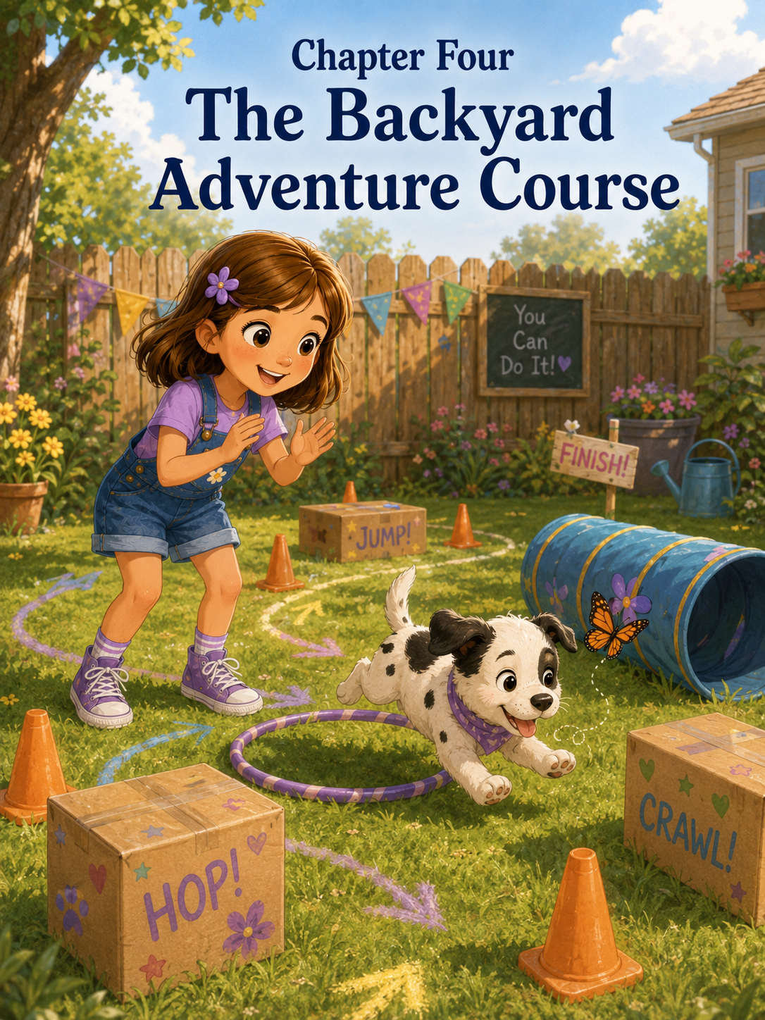Chapter Four: The Backyard Adventure Course
By the third day of having Patches, Sally had learned several important things.
First, puppies woke up with more energy than seemed possible for something so small.
Second, puppies could turn almost anything into a toy.
A sock.
A shoelace.
A napkin.
A fallen leaf.
A spoon that had somehow slipped from the dishwasher and landed on the kitchen floor.
Third, Patches did not always walk in a straight line. Sometimes he bounced. Sometimes he wiggled. Sometimes his front paws moved faster than his back paws, which made him look like he was trying to catch up with himself.
And fourth, Sally had learned that being responsible for a puppy meant paying attention even when Patches looked like he was doing nothing.
Because Patches was almost never doing nothing.
He was thinking.
Usually about trouble.
That morning, Sally sat on the living room rug with her notebook open in front of her. Patches lay beside her, chewing his blue rope toy with great seriousness.
Sally had written a new heading at the top of the page.
Things Patches Can Do
Underneath, she had started a list.
- Wag his tail.
- Chew his rope toy.
- Sit sometimes.
- Run very fast.
- Trip over his own paws.
- Find socks.
- Look innocent after finding socks.
She tapped her pencil against her chin.
Patches rolled onto his back and waved all four paws in the air.
Sally added:
- Be adorable.
Patches sneezed.
“And sneeze during important moments,” Sally said.
Patches wagged, still upside down.
Sally smiled and turned to a new page.
Things Patches Needs to Learn
This list was much longer.
- Come when called.
- Stay.
- Leave shoelaces alone.
- Walk without eating the leash.
- Follow directions.
- Bring back the ball during fetch.
- Not chase butterflies forever.
She paused.
Patches had only chased one butterfly so far, but he had done it with such dedication that Sally felt it deserved a place on the list.
Mom walked into the living room carrying a laundry basket.
“What are you working on?” she asked.
“A training plan,” Sally said.
Mom raised her eyebrows. “For Patches?”
“Yes. He knows sit a little bit, but he does not know many other things yet.”
Patches looked up at the sound of his name.
Then he went back to chewing.
Sally lowered her voice. “He especially does not know about shoelaces.”
Mom laughed softly. “Training takes time.”
“I know,” Sally said. “That is why I am making a plan.”
Mark stepped in from the kitchen, holding a mug of coffee. “A plan sounds promising.”
Sally sat up straighter. She liked when Mark said her ideas sounded promising. It made them feel official.
“I think Patches needs an adventure course.”
Mark leaned against the doorway. “An adventure course?”
“Yes,” Sally said. “Like an obstacle course, but more fun. He can learn to go around things and through things and follow arrows. It will help him practice.”
Mom looked amused. “And where will this adventure course be?”
“The backyard,” Sally said. “There is plenty of room.”
Mark looked out the window toward the yard. “There is room for a small course.”
“A puppy-sized course,” Mom added.
“Exactly,” Sally said.
Patches stood up and shook his rope toy. His ears flopped from side to side.
“He is excited,” Sally said.
“I think he is chewing,” Mark said.
“He can be excited and chewing,” Sally replied.
After breakfast, Sally gathered supplies.
She found four orange cones in the garage from when Mark had helped her practice riding her bike around turns. She found two empty cardboard boxes from the recycling bin. Mom gave her an old blue blanket that could become a pretend tunnel if they draped it over two chairs. Mark found a short pool noodle, three plastic rings, and a roll of sidewalk chalk.
Sally carried everything into the backyard.
The grass was bright green from summer rain. The sky was blue with fluffy white clouds. Birds hopped along the fence, and butterflies fluttered near Mom’s flowers by the patio.
Patches trotted beside Sally, sniffing every object as if he were the official inspector.
He sniffed a cone.
He sniffed a box.
He sniffed the chalk.
Then he tried to lick the chalk.
“No, Patches,” Sally said gently, moving it away. “Chalk is for drawing, not eating.”
Patches wagged.
Sally looked at Mom. “He thinks everything is food.”
“Not everything,” Mom said. “Sometimes he thinks things are chew toys.”
“That is not better,” Sally said.
Mark helped Sally set up the course.
First, they placed the orange cones in a curving line so Patches could weave around them.
Next, they set one cardboard box on its side so Patches could walk through it.
Then they used the two patio chairs and the blue blanket to create a low tunnel.
After that, Sally placed the plastic rings flat on the grass like stepping spots.
Finally, she used sidewalk chalk to draw purple arrows along the patio and onto the walkway.
At the end of the course, she drew a big yellow star.
Inside the star she wrote:
Finish!
Then she added a tiny drawing of Patches with extra-large ears.
Mark studied the drawing. “Very accurate.”
Sally looked at Patches.
Patches was lying in the grass chewing a stick.
“Patches,” Sally said. “That is not part of the course.”
Patches lifted his head.
A small piece of leaf stuck to his nose.
Sally sighed. “We have a lot of work to do.”
Mom sat in a patio chair with a glass of iced tea. “Remember, Sally, this should be fun for both of you.”
“It will be,” Sally said. “I am going to be very encouraging.”
“That is a good plan,” Mom said.
Sally picked up Patches’ blue leash. “Ready, Patches?”
Patches ran toward her, stepped on the leash, and tumbled gently into the grass.
Sally gasped.
Patches popped back up and wagged his tail.
Mark chuckled. “He seems ready.”
Sally clipped the leash onto his collar. “First, we go around the cones.”
She stood near the first cone and held a small puppy treat in her hand.
“Come on, Patches. This way.”
Patches followed the treat.
For two whole cones, everything went perfectly.
He walked beside Sally. He looked at the treat. He stepped around the first cone, then the second.
Sally’s eyes lit up.
“He’s doing it!”
Then Patches noticed a butterfly.
It was a small yellow butterfly floating above the grass.
Patches froze.
The butterfly fluttered.
Patches’ ears perked.
“Patches,” Sally said carefully.
The butterfly drifted toward the flowers.
Patches forgot the treat.
He forgot the cones.
He forgot Sally.
He bounded after the butterfly, tugging the leash so suddenly that Sally had to jog behind him.
“Patches! That is not the course!”
The butterfly fluttered higher.
Patches jumped.
He missed.
He jumped again.
He missed again.
Then he sneezed, as if the butterfly had personally offended him.
Sally gently guided him back. “Butterflies are not part of training.”
Mark smiled. “They are part of backyard life.”
Mom added, “Distractions happen.”
Sally looked at Patches, who was still watching the butterfly.
“Distractions are very distracting,” she said.
She led Patches back to the beginning.
“Again,” Sally said.
Patches sat down.
“Not sit. Come.”
Patches lay down.
Sally closed her eyes for a second.
Patience.
Gentleness.
Consistency.
She opened her eyes and tried again.
“Come on, Patches. This way.”
She used a cheerful voice this time. Not a bossy voice. Not a frustrated voice. A voice that sounded like she believed Patches could do it.
Patches stood.
He followed her around the first cone.
Then the second.
Then the third.
He bumped the fourth cone with his shoulder and knocked it over.
The cone rolled across the grass.
Patches pounced on it.
“No, no, no!” Sally said, laughing despite herself. “We do not wrestle the cones.”
Patches put one paw on the cone and looked proud.
Mark clapped. “He defeated it.”
“Cones are not enemies,” Sally said.
Patches wagged.
Sally set the cone upright again.
“Let’s try the box.”
The cardboard box sat on its side like a little doorway. Sally crouched at one end and held out a treat.
“Come through, Patches.”
Patches sniffed the box.
He sniffed the outside.
He sniffed the corner.
He sniffed the grass near the box.
Then he tried to climb on top of it.
“No,” Sally said gently. “Through.”
Patches stepped onto the box.
The cardboard wobbled.
Patches slid off into the grass, then looked at the box as if it had betrayed him.
Mom covered her smile with her hand.
Sally patted the ground. “It’s okay. Try again.”
Patches walked around the box instead.
“That is not through,” Sally said.
Mark stepped closer. “Maybe make it easier. Start with the box wider and shorter.”
He adjusted the box so the opening looked less shadowy.
Sally held the treat at the far side. “Come on, Patches. You can do it.”
Patches lowered his head.
He put one paw inside.
Then another.
Then he stopped halfway through and sat down inside the box.
Sally blinked. “Why is he sitting?”
“Maybe he likes it in there,” Mom said.
Patches’ tail thumped against the cardboard.
Thump. Thump. Thump.
The box wiggled.
Sally leaned down and peeked through the opening. “Patches, this is not your new house.”
Patches licked her nose.
Sally giggled and gently encouraged him forward. “Come on. Just a few more steps.”
Patches crawled out of the box and received his treat.
Sally threw both arms up. “He did it!”
Patches jumped as if he had surprised himself.
Mom clapped. “Good job, Patches.”
Mark nodded. “Good job, Sally.”
Sally looked up. “Me?”
“You stayed patient,” Mark said. “That matters.”
Sally smiled.
She had not thought of patience as something she could practice too.
Next came the blanket tunnel.
This was the part Sally had been most excited about. The blue blanket stretched over the chairs, creating a soft little tunnel that looked cozy and mysterious.
“It is like a secret cave,” Sally said.
Patches sniffed the entrance.
Then he backed away.
“It is okay,” Sally said. “It is just a blanket.”
Patches did not seem convinced.
Sally crawled to the other side and looked through the tunnel at him. “See? I am over here.”
Patches wagged but did not move.
Mark knelt beside him. “Some puppies need extra encouragement with new things.”
Sally held a treat near the opening. “Come on, Patches. You are brave.”
Patches took one step.
Then another.
Then he turned around and tried to leave.
Sally did not pull him. She remembered what Mom had said.
Gentle.
Instead, she used her happiest voice.
“Good try! That was a good try.”
Patches looked at her.
“You do not have to do it all at once,” Sally said.
Mom smiled from the chair. “That is exactly right.”
Sally thought about school. She had not learned to read whole chapter books in one day. She had started with letters. Then words. Then sentences. Then pages.
Maybe tunnels worked the same way.
“First, just put your paws in,” Sally said.
Patches put his front paws inside the tunnel.
“Good boy!”
Patches wagged.
“Now one more step.”
He moved forward.
The blanket brushed his back.
Patches stopped.
Sally waited.
The butterfly returned.
Patches turned his head.
“Oh no,” Sally whispered.
The butterfly floated past the tunnel.
Patches burst forward.
He flew through the tunnel, out the other side, and into the yard after the butterfly.
Sally jumped up. “He did the tunnel!”
Mark laughed. “With butterfly assistance.”
“I will count it,” Sally said.
Patches chased the butterfly in a wiggly circle, then stopped suddenly when he saw his ball.
He chased the ball instead.
Then he forgot both the butterfly and the ball because a leaf moved.
Sally put her hands on her hips. “He has a very busy brain.”
“Yes,” Mom said. “And he is still very young.”
Sally nodded. “Young brains need practice.”
“So do curious brains,” Mark said.
Sally was almost sure he meant her.
The next part of the course was the stepping rings.
Sally had imagined Patches gracefully stepping from ring to ring like a circus dog.
Patches had a different idea.
He picked up the first ring in his mouth and ran away with it.
“Patches!” Sally cried.
Patches raced across the yard, the plastic ring bouncing awkwardly against his chest.
Sally started to chase him, then stopped.
Do not chase.
Trade.
She grabbed his squeaky toy and squeezed it.
Squeak!
Patches stopped.
Squeak!
Patches dropped the ring and bounded toward the toy.
Sally smiled proudly. “Trade works.”
Mark gave her a thumbs-up. “Excellent thinking.”
Sally reset the ring.
This time, she guided Patches slowly.
“Step here.”
Patches stepped beside the ring.
“Close.”
She tried again.
Patches stepped inside the first ring, then hopped over the second, then sat on the third.
Sally laughed. “You are making your own rules.”
Patches looked pleased.
They practiced for several more minutes. Patches did not become graceful. He did not become a circus dog. But he did step inside two rings in a row once, and Sally celebrated as if he had won a trophy.
“Good boy, Patches! You did it!”
Patches wagged and jumped into her lap, nearly knocking her backward.
Sally hugged him gently. “You are getting better.”
Patches licked her cheek.
By then, the sun had climbed higher, and Patches’ tongue hung out a little.
Mom stood. “Time for a water break.”
“But we haven’t finished the whole course yet,” Sally said.
“Patches needs rest,” Mom said. “Training should be short and positive.”
Sally looked at Patches. He was sitting beside the water bowl, drinking noisily and dripping water onto the patio.
He did look tired.
And happy.
And damp.
“Okay,” Sally said. “A break.”
She sat in the shade beside him and opened her notebook.
Backyard Adventure Course Notes
- Patches can go around two cones before noticing butterflies.
- Patches thinks cones can be wrestled.
- Patches can go through a box if it is not too scary.
- Patches sat inside the box like it was his office.
- Patches went through the tunnel because of a butterfly.
- Patches likes carrying rings better than stepping in them.
- Squeaky toy trades work.
- Training is harder than it looks.
- Patches needs breaks.
- I need breaks too.
Sally looked at number ten.
She had not planned to write that.
But it was true.
Her voice had started to feel tired from saying “this way” and “come on” and “not that” and “good boy.” Her arms were tired from resetting cones and boxes. Her patience felt a little tired too.
Patches flopped down beside her, resting his chin on the grass.
Sally gently stroked the black patch near his ear.
“You are not perfect at the course,” she said.
Patches blinked.
“But I am not perfect at teaching yet.”
Patches sighed.
“So we are both practicing.”
Mom sat beside Sally on the patio step. “That is a good lesson.”
Sally leaned against her. “I wanted him to learn faster.”
“That is normal,” Mom said. “But learning does not usually happen all at once.”
“I know,” Sally said. “It happens one small effort at a time.”
Mom smiled. “That sounds familiar.”
Sally smiled too.
After Patches rested, Sally decided to try the whole course one more time.
Not perfectly.
Just positively.
That was the new rule.
Progress, not perfect.
She stood at the starting chalk arrow with Patches beside her.
“Ready?” she asked.
Patches wagged.
“Go!”
They began with the cones.
Patches went around the first cone.
Then the second.
He bumped the third but did not wrestle it.
Sally cheered. “Good job!”
They reached the box.
Patches hesitated.
Sally crouched at the other side. “You can do it.”
Patches stepped in.
He paused.
Then he came out.
“Yes!”
Next came the tunnel.
The butterfly was gone, so Sally thought this might be difficult.
She held the treat low. “Come on, brave boy.”
Patches sniffed the tunnel.
He lowered his head.
Then, slowly, he walked through.
All by himself.
Sally gasped. “Patches!”
Patches came out the other side and jumped into her arms.
“You did it!” she cried. “You really did it!”
Mom clapped.
Mark whistled.
Patches barked once, startled by his own success.
They moved to the rings.
Patches stepped in the first ring.
Then beside the second.
Then he picked up the third.
Sally started to say no, then laughed.
“Okay. Not perfect. Progress.”
She traded the ring for the squeaky toy and guided him to the final chalk arrow.
At the yellow star, Patches sat down.
He sat without Sally even asking.
For a second, nobody moved.
Then Sally whispered, “Sit.”
Patches stayed sitting.
Sally’s face lit up. “He finished!”
Mom clapped again. “Wonderful!”
Mark smiled. “The Backyard Adventure Course has its first champion.”
Sally hugged Patches carefully. “You are the champion.”
Patches licked her chin.
“And I am the coach,” Sally said.
“A very patient coach,” Mom said.
Sally thought about the morning. Patches had stumbled, tumbled, chased butterflies, wrestled a cone, sat inside a box, stolen a ring, and turned the course into something much sillier than she had planned.
But he had also learned.
A little.
And she had learned too.
A lot.
That afternoon, Mark helped Sally make a small sign from cardboard. Sally decorated it with purple chalk, yellow stars, and tiny paw prints.
At the top she wrote:
Patches’ Backyard Adventure Course
Underneath, she added:
Practice + Positivity = Progress
Mark read it aloud. “That is a very good motto.”
Sally nodded. “Because if you only care about perfect, you miss all the getting-better parts.”
Mom smiled. “Exactly.”
Patches wandered over and sniffed the sign.
Then he tried to chew the corner.
“Patches!” Sally laughed, pulling it gently away. “This is not part of the course either.”
Patches wagged, completely unashamed.
That evening, when the sun turned the backyard golden, Sally sat in the grass with Patches curled beside her. The cones were stacked near the fence. The boxes were slightly bent. The blue blanket had grass on it. The chalk arrows had smudged from puppy paws.
The course looked messy.
But it also looked wonderful.
Sally opened her notebook and wrote:
What I learned today:
Progress does not always look neat. Sometimes it looks like knocked-over cones, crooked steps, muddy paws, and trying again. Patches learns best when I am kind, patient, and cheerful. I think people do too.
Patches rested his head on her knee.
His eyes were sleepy.
His paws twitched.
Maybe he was dreaming about tunnels.
Or butterflies.
Or being the first champion of the Backyard Adventure Course.
Sally gently rubbed the soft spot between his ears.
“You did good today,” she whispered.
Patches gave a tiny sigh.
Sally smiled.
She had wanted to teach Patches tricks.
Instead, Patches had taught her something too.
Practice mattered.
Positivity mattered.
And sometimes, the best kind of progress came with a wagging tail, a few wrong turns, and someone cheering you on all the way to the finish star.

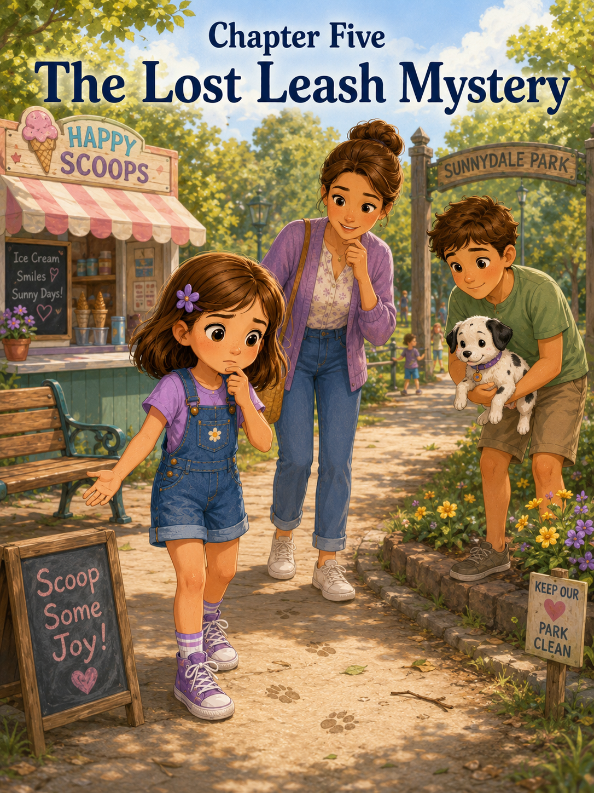Chapter Five: The Lost Leash Mystery
Saturday morning arrived bright and warm, with sunshine spilling through Sally’s bedroom curtains in golden stripes.
Sally opened her eyes and listened.
For three whole seconds, everything was quiet.
Then came the sound she knew very well now.
Tap-tap-tap-tap.
Tiny paws hurried across the floor.
Patches appeared beside her bed with his white fur, black spots, floppy ears, and cheerful tail. He looked up at Sally as if he had been waiting all morning for her to wake up, even though it was barely seven o’clock.
“Good morning, Patches,” Sally said sleepily.
Patches gave one excited little bark.
Then he grabbed the edge of her blanket and tugged.
“No,” Sally said, sitting up. “Blankets are not toys.”
Patches wagged.
Sally reached for his blue rope toy and traded it for the blanket. Patches accepted the trade proudly, as if this had been his idea all along.
“You are getting better,” Sally told him.
Patches shook the rope toy with his whole body.
Sally laughed. “Mostly better.”
Downstairs, Mom was making pancakes. The kitchen smelled like butter, syrup, and warm blueberries. Mark stood near the counter, pouring coffee into a mug, while Patches sniffed every inch of the floor in case breakfast had already dropped something important.
“Good morning,” Mom said. “How are my two early risers?”
“I am awake,” Sally said. “Patches is very awake.”
Patches bounded toward Mark and sat down.
Sally gasped. “He sat!”
Mark looked down. “So he did.”
Patches looked from Mark to Sally, waiting.
Sally pointed. “He wants a treat.”
“He may be learning how this works,” Mom said.
Sally crouched beside Patches and gave him a tiny puppy treat from the jar. “Good boy.”
Patches chewed happily, then immediately searched for more.
After breakfast, Mark looked out the kitchen window. “It’s a beautiful day. What do you think about a family walk to the park?”
Sally’s eyes brightened. “With Patches?”
“Especially with Patches,” Mark said.
Patches barked, though Sally was not sure he understood the word park.
Mom smiled. “A walk would be good for him. And for us.”
Sally hurried to get ready. She changed into her purple shirt, denim shorts, and purple sneakers. She clipped her purple flower into her hair and filled Patches’ collapsible water bowl. Mom packed a small bag with dog treats, cleanup bags, a water bottle, and napkins.
Mark picked up Patches’ blue leash from the hook by the back door.
Patches saw the leash and started bouncing.
“Walk,” Sally said.
Patches bounced harder.
“He knows that word,” Mark said.
“He knows the exciting words,” Sally said. “He does not always know the useful words.”
Mom laughed. “That is true for many puppies.”
Before they left, Sally checked everything.
Patches’ collar was clipped.
The leash was attached.
The water bowl was packed.
The treats were packed.
The cleanup bags were packed.
Her sneakers were tied twice.
Patches tried to chew the leash once, but Sally gently moved it away.
“We walk with the leash,” she reminded him. “We do not eat the leash.”
Patches wagged as if he still believed the question was open for discussion.
The sidewalk outside felt warm beneath Sally’s sneakers. The neighborhood was full of summer sounds. A lawn mower buzzed in the distance. A sprinkler clicked across someone’s front yard. Birds called from the trees. A bicycle bell rang as a boy rode past with streamers flying from his handlebars.
Patches walked with his nose close to the ground.
He sniffed the sidewalk.
He sniffed a mailbox post.
He sniffed a dandelion.
He sniffed a crack in the pavement with such concentration that Sally had to stop and wait.
“What do you smell?” she asked.
Patches sneezed.
“Very informative,” Mark said.
Sally giggled.
Walking with Patches was not like regular walking. Regular walking meant moving forward. Walking with Patches meant moving forward, stopping, sniffing, turning around, looking at a bird, sniffing again, and occasionally trying to follow a leaf.
Still, Sally loved it.
She loved the way Patches trotted beside her with his spotted tail wagging. She loved how people smiled when they passed him. She loved how Patches made ordinary things feel exciting, as if every tree and curb and patch of grass was a brand-new discovery.
At the corner, an older woman watering flowers waved at them.
“What a sweet puppy,” she called.
Sally smiled proudly. “His name is Patches.”
“Well, hello, Patches,” the woman said.
Patches sat down and wagged.
“He is learning manners,” Sally said.
The woman smiled. “He looks like a very good learner.”
Sally stood a little taller.
They continued toward the park. The walk took longer than usual because Patches had many investigations to complete. When they finally reached the park entrance, Sally saw the big oak trees, the playground, the picnic tables, the open grassy field, and the walking path that curved around a small pond.
Patches saw a squirrel.
Everything changed.
His ears shot up.
His body went still.
The squirrel flicked its tail.
Patches lunged forward.
“Whoa!” Sally said, gripping the leash with both hands.
Patches pulled toward the tree, his paws skittering on the path.
Mark stepped closer. “Hold firm, but do not yank.”
Sally planted her feet. “Patches, no. We do not chase squirrels.”
Patches looked at her.
Then at the squirrel.
Then at Sally.
Then at the squirrel.
The squirrel climbed higher into the tree and disappeared into the leaves.
Patches stared after it, deeply disappointed.
Mom knelt beside him. “Good try, little guy. Squirrels are not for chasing.”
Patches sighed.
Sally patted him gently. “I understand. It was a very interesting squirrel.”
They walked around the pond, stopping once so Patches could drink water from his little blue bowl. Ducks floated near the reeds, and Sally had to remind Patches that ducks were also not for chasing.
“Are any animals for chasing?” Sally asked.
“Not while he is on a family walk,” Mom said.
Patches sniffed a clover patch and looked innocent.
After circling the pond, they stopped near the playground. Sally watched children climb, slide, and swing. Patches watched a tennis ball roll past.
He tried to follow it.
Sally held the leash carefully.
“No, Patches,” she said. “That ball belongs to someone else.”
Patches looked personally betrayed.
Mark checked his watch. “How about we stop for ice cream before we head home?”
Sally turned quickly. “Ice cream?”
Mom smiled. “I thought that might get your attention.”
The ice cream stand sat near the edge of the park, under a striped awning. A small line of families waited in front. The menu listed vanilla, chocolate, strawberry, mint chip, cookie swirl, and something called Blue Moon Blast, which Sally thought sounded suspiciously like a flavor invented by someone who could not decide what color dessert should be.
Patches was not allowed inside the ordering area, so Mark held him near a picnic table while Mom and Sally went to the window.
“What are you getting?” Mom asked.
“Strawberry,” Sally said. “In a cup. With rainbow sprinkles.”
“Classic,” Mom said.
“What are you getting?”
“Vanilla cone.”
“For you or for Mark?”
“For me,” Mom said. “Mark can order his own.”
Sally grinned.
When they returned to the picnic table, Mark had ordered chocolate in a cup. Patches sat beside his foot, staring hopefully at every person who passed with ice cream.
“Patches cannot have ice cream,” Mom said before Sally could ask.
“I was not going to ask,” Sally said.
Mom raised an eyebrow.
“I was only thinking of asking.”
Mark chuckled.
They sat at the picnic table in the shade. Sally placed Patches’ leash handle over the bench beside her while she carefully balanced her cup of strawberry ice cream. Patches had already gone potty and had walked a long way, so Mom said he could rest beside them.
Sally dipped her spoon into the pink ice cream.
Cold sweetness filled her mouth.
“This tastes like summer,” she said.
Patches sniffed the air.
“This is not for puppies,” Sally told him.
Patches wagged anyway.
While they ate, Mom and Mark talked about what they might make for dinner. Sally watched children running in the park and imagined bringing Patches here when he was older. Maybe someday he would learn to fetch properly. Maybe he would run across the grass and come back when called. Maybe he would stop trying to chase squirrels.
Maybe.
When Sally finished her ice cream, she carried the empty cup to the trash can. Mom wiped the table with a napkin, and Mark gathered the water bottle and treat bag.
“Ready?” Mark asked.
“Ready,” Sally said.
Patches jumped up, as if he had been waiting for the next adventure.
They started down the sidewalk toward home.
For the first few minutes, everything seemed normal. The sun shone. The trees rustled. Patches trotted beside Sally, a little slower now because his puppy legs were tired.
Then they reached the crosswalk at the edge of the park.
Mark stopped.
“Wait,” he said.
Mom turned. “What?”
Mark looked at Patches.
Then at Sally.
Then at Patches again.
“Sally,” he said carefully, “where is Patches’ leash?”
Sally looked down.
Her hand was empty.
Patches stood beside her, wearing his collar.
But the blue leash was not attached.
For a second, Sally could not understand what she was seeing.
No leash.
No blue handle in her hand.
No clip attached to Patches’ collar.
No leash anywhere.
Her stomach dropped.
“The leash,” she whispered.
Mom stepped closer and gently picked Patches up before he could wander. “It’s okay. I’ve got him.”
Sally’s cheeks went hot. “I lost it.”
Mark looked back toward the park. “We must have left it somewhere.”
Sally’s eyes filled with panic. “I lost Patches’ leash! What if someone took it? What if we can’t find it? What if Patches runs away because we don’t have it? What if—”
“Sally,” Mom said gently.
But Sally’s thoughts were already racing faster than Patches with the zoomies.
“It was blue. It was his first leash. It matched his collar. I was supposed to be responsible. I forgot it. I forgot something important!”
Mark knelt so he was eye level with her. “Take a breath.”
Sally did not want to take a breath. She wanted the leash to magically appear in her hand.
“Breathe first,” Mark said.
Sally breathed in.
It came in shaky.
“Again,” Mom said softly.
Sally breathed in again, slower this time.
Patches licked Mom’s chin.
That helped a little.
Mark said, “Panicking will not find the leash faster. Thinking clearly will.”
Sally wiped her eyes with the back of her hand. “But I lost it.”
“Yes,” Mark said. “Something got misplaced. That happens. Now we solve the problem.”
Mom nodded. “What is the first thing we should do?”
Sally sniffed. “Go back?”
“Good,” Mark said. “But before we go back, we think. Where did we last know we had the leash?”
Sally looked towards the park.
She tried to remember.
The walk around the pond.
The squirrel.
The ducks.
The playground.
The ice cream stand.
The picnic table.
“I had it when we walked to the ice cream stand,” Sally said slowly. “I remember holding it near the line.”
“Good,” Mom said. “What happened next?”
“We sat at the picnic table.” Sally’s eyes widened. “I put the handle on the bench while I ate my ice cream.”
Mark nodded. “That is a strong clue.”
“It might still be there!” Sally said.
“Then let’s retrace our steps,” Mom said.
Because Mom was holding Patches, they walked carefully back into the park. Sally stayed close beside her, feeling worried and embarrassed. She kept looking at Patches.
“I’m sorry,” she whispered.
Patches wagged from Mom’s arms, completely forgiving her because he did not know there was anything to forgive.
They reached the ice cream stand first.
Sally hurried to the picnic table where they had sat.
The table was empty.
The bench was empty.
The ground underneath was empty except for a napkin and one tiny leaf.
The leash was gone.
Sally’s heart sank.
“It’s not here.”
Mark looked around carefully. “Someone may have picked it up.”
“Or moved it,” Mom said. “What should we do next?”
Sally wanted to say, “Cry.”
But she knew that would not help.
She pressed her hands together and thought.
“If someone found it, they might have brought it to the ice cream stand.”
“That’s a good idea,” Mark said.
Sally walked to the ice cream window. A teenager in a blue apron was wiping the counter.
“Excuse me,” Sally said.
Her voice came out small.
The teenager smiled. “Hi. Did you need something?”
Sally swallowed. “We lost my puppy’s leash. It’s blue, and I think I left it at that picnic table. Did anyone bring one here?”
The teenager looked behind the counter. “Let me check.”
Sally waited.
Patches wiggled in Mom’s arms.
The teenager returned, shaking her head. “Sorry. No leash back here.”
“Oh,” Sally said.
“But I can ask my manager,” the teenager added.
A woman came over from the side door. “A blue dog leash? I don’t think anyone brought one in, but sometimes people take found things to the park office near the playground.”
Sally looked at Mom.
“The park office,” Mom said. “That’s worth checking.”
“Thank you,” Sally said.
The woman smiled. “I hope you find it.”
They walked toward the playground. Sally felt a little better now that they had a next step. Not much better. But a little.
Near the playground was a small building with a green roof and a sign that said Park Information. Inside the open window sat an older man wearing a park volunteer badge.
Mark stepped forward. “Hello. We’re looking for a lost dog leash. Blue. Possibly left near the ice cream tables.”
The man reached under the counter and pulled out a cardboard box labeled Lost and Found.
Sally held her breath.
Inside were sunglasses, a red baseball cap, two water bottles, a toy truck, and one sparkly hair clip.
No leash.
Sally’s shoulders dropped.
The man looked kindly at her. “Not here yet. When did you lose it?”
“Just a little while ago,” Sally said.
“Then it may still be somewhere nearby,” he said. “You could check the path from the ice cream stand to the pond. Sometimes things get carried or moved.”
“Thank you,” Sally said, though her voice sounded disappointed.
They stepped away from the office.
“I don’t understand,” Sally said. “I know I left it at the table.”
“Maybe someone moved it so it would not get stepped on,” Mom said.
“Maybe another dog owner picked it up by mistake,” Mark added.
Sally frowned. “By mistake?”
“It happens,” Mark said. “Especially if someone has their hands full.”
Sally looked at Patches, who was now trying to lick Mom’s necklace.
“My hands were full too,” Sally said softly. “With ice cream.”
Mom smiled gently. “And now you will remember to check before we leave places.”
Sally sighed. “I will remember forever.”
They walked slowly back along the path. Sally looked under benches. Mark checked near trash cans. Mom scanned the grass while holding Patches. Sally asked a family sitting near the pond if they had seen a blue leash.
They had not.
She asked a man walking a big golden dog.
He had not.
She asked two children playing near the oak tree.
They had seen a squirrel, a duck, and a green frisbee, but no leash.
Sally thanked them anyway.
The more they searched, the more worried Sally felt.
Without the leash, they could not safely let Patches walk home. Mom could carry him, but Sally knew puppies needed leashes. Good dog owners did not lose important things.
Good dog owners remembered.
Good dog owners paid attention.
Sally’s eyes burned again.
Mark noticed. “What are you thinking?”
Sally stared at the path. “I’m thinking I’m not responsible enough.”
Mom stopped walking. “Sally.”
“It was my job,” Sally said. “I was holding it.”
Mark shifted the bag on his shoulder. “Responsible people still make mistakes.”
Sally looked up.
“They do?”
“All the time,” Mark said. “Responsibility does not mean never making a mistake. It means being honest, staying calm, and doing what you can to fix it.”
Mom nodded. “And that is exactly what you are doing.”
Sally looked at Patches.
He looked back at her, tail wagging.
“You are not mad?” she asked him.
Patches sneezed.
Sally smiled a little. “I will take that as no.”
They returned to the ice cream stand one more time. The line was longer now. A family with two small children sat at the table they had used earlier.
Sally watched them for a moment.
Then she noticed something.
Under the table, hooked around the far bench leg, was something blue.
Her heart jumped.
“There!”
She hurried forward, then remembered her manners.
“Excuse me,” she said to the family.
The dad looked up. “Yes?”
“I think my puppy’s leash might be under your table.”
He leaned down and reached beneath the bench. When he stood, he held up the blue leash.
“This?”
Sally gasped. “Yes!”
The little girl at the table smiled. “We found it on the bench, so Dad wrapped it there so nobody would trip.”
Sally took the leash carefully. “Thank you so much.”
The dad smiled. “Glad you found it.”
Sally turned to the little girl. “Thank you for keeping it safe.”
The girl looked proud. “Your puppy is cute.”
“His name is Patches,” Sally said.
Mom knelt down and let the girl gently pet Patches while she held him securely. Patches wagged and licked the girl’s fingers.
“He’s soft,” the girl said.
“He is also a lot of work,” Sally said.
Mark laughed. “True.”
Sally clipped the leash onto Patches’ collar. The little metal click sounded wonderful.
Safe.
Found.
Solved.
She held the handle tightly this time.
Very tightly.
Maybe too tightly, because Mark said, “You do not have to squeeze the life out of it.”
Sally loosened her grip a little. “I am never losing it again.”
Mom smiled. “That is a good goal.”
They started home once more. This time, Sally checked the leash every few steps.
Still there.
Blue handle in hand.
Clip on collar.
Patches trotting beside her.
Still there.
As they walked, Mark said, “You handled that well.”
Sally looked surprised. “I panicked.”
“At first,” Mark said. “Then you breathed. You remembered where you had been. You asked for help. You checked the right places.”
Mom added, “That is problem-solving.”
Sally looked down at Patches. “I did solve it.”
“With help,” Mark said. “Help is allowed.”
Sally thought about that.
Sometimes she liked solving things by herself. It made her feel capable. But the lost leash had been too much for one person, especially when panic made her thoughts feel tangled.
Asking for help had not made her less responsible.
It had helped her become more responsible.
Patches stopped to sniff a flower growing near the sidewalk.
Sally waited patiently.
“Come on, Patches,” she said after a moment.
Patches looked up and followed.
When they reached home, Sally hung the blue leash on its hook by the back door.
Then she checked to make sure it was really there.
Then she checked again.
Mom noticed and smiled but did not say anything.
After Patches drank water and flopped down on his blanket for a nap, Sally opened her notebook.
At the top of a fresh page, she wrote:
The Lost Leash Mystery
Underneath, she made a list.
Clues:
- I had the leash at the ice cream stand.
- I put it on the bench.
- It was not on the bench when we came back.
- Someone moved it so no one would trip.
- It was under the table.
Then she wrote:
What helped:
- Breathing.
- Thinking about where I last had it.
- Asking the ice cream worker.
- Checking Lost and Found.
- Asking people nicely.
- Not giving up.
Patches slept on his side, one paw twitching.
Sally watched him for a moment.
Then she added one more line.
What I learned:
Panicking makes a problem feel bigger. Staying calm helps your brain find the next clue.
She tapped her pencil against the page.
Then she wrote:
Also: always check the leash before leaving an ice cream table.
That seemed very important.
Later that evening, Sally sat in the backyard with Patches beside her. The sun was low, and the sky had turned soft pink and gold. Patches chewed his rope toy, tired from his big park adventure.
Sally reached over and touched the blue leash, which lay beside her on the grass.
“I’m glad we found it,” she said.
Patches wagged.
“I was scared,” she admitted.
Patches chewed.
“But Mom and Mark were right. I did not need to panic. I needed to think.”
Patches rolled onto his back.
Sally smiled and rubbed his belly.
“You are lucky you do not worry about things.”
Patches sneezed.
“Or maybe you do,” Sally said. “Maybe you worry about squirrels.”
Patches perked up at the word squirrels.
“No squirrels right now,” Sally said quickly.
Patches settled again.
Sally looked toward the back door, where the leash hook waited inside.
Tomorrow, there will probably be another puppy problem.
Maybe a chewed sock.
Maybe a muddy paw.
Maybe Patches would discover something new and strange and decide it belonged in his mouth.
But Sally felt a little more ready now.
She had solved a mystery.
Not because she had been perfect.
Not because she had remembered everything.
But because she had calmed down, retraced her steps, asked for help, and kept looking.
Patches rested his head on her knee.
Sally scratched behind his black-patched ear.
“Good walk today,” she whispered.
Patches sighed happily.
“And next time,” Sally added, “we are checking the leash before we leave the ice cream stand.”
Patches gave one sleepy wag.
Sally smiled.
The case of the lost leash was closed.
And for a puppy detective and her spotted assistant, that felt like a very good ending.

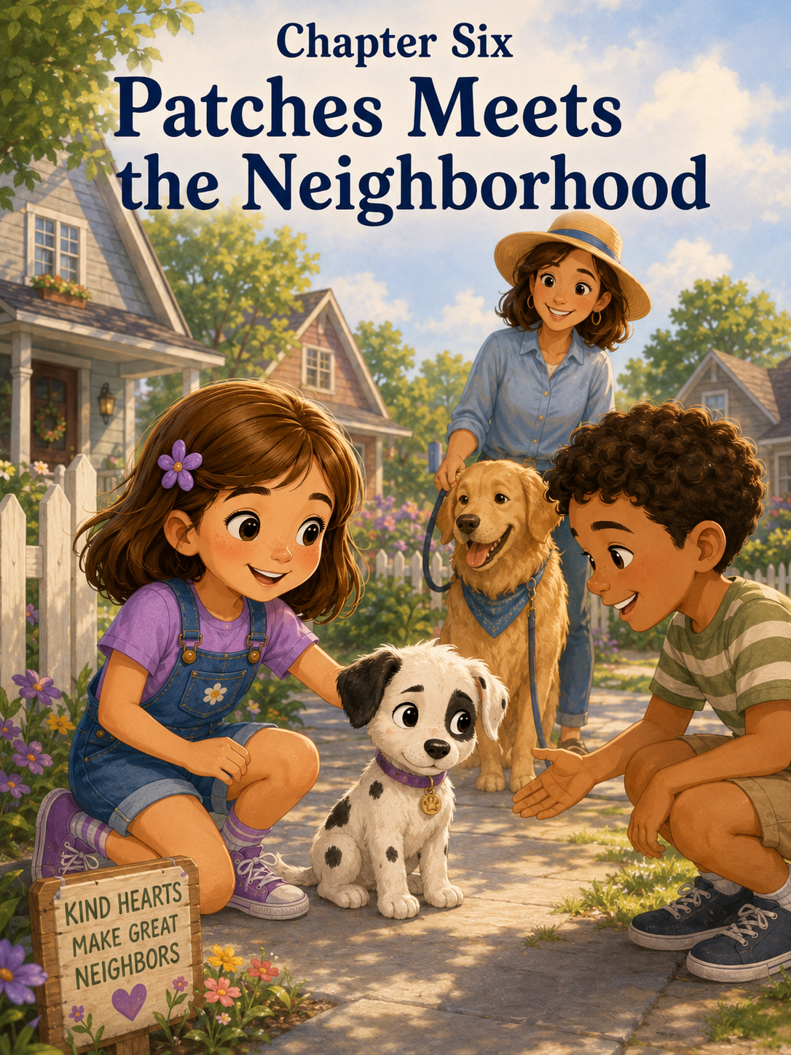Chapter Six: Patches Meets the Neighborhood
By the end of the week, Patches had become very familiar with Sally’s house.
He knew the kitchen was where the interesting smells lived.
He knew the hallway rug was not for chewing, even though he still checked sometimes to make sure the rule had not changed.
He knew the back door meant outside.
He knew the blue leash meant walk.
He knew Sally’s room had the purple shoelaces, which were still his favorite forbidden treasure.
And he knew that when Sally said, “Patches, come,” in her happiest voice, something good usually happened.
Usually a treat.
Sometimes a hug.
Sometimes both.
But there was one thing Patches did not know very well yet.
The neighborhood.
He had walked to the park once, solved the Lost Leash Mystery with Sally, and met a few people along the way. But Mom said meeting the neighborhood was different from simply walking through it.
“Patches needs to learn that the world is bigger than our house,” Mom explained on Saturday morning.
Sally sat at the kitchen table, eating toast with strawberry jam. Patches sat beside her chair, looking hopeful even though Mom had already told him three times that toast was not puppy food.
“He already knows the backyard,” Sally said. “And the park. And the ice cream stand.”
“He knows the ice cream stand exists,” Mark said. “Mostly because he stared at everyone’s cones.”
Patches wagged at the word cones, though Sally was almost sure he was thinking about the orange cones from his Backyard Adventure Course.
Mom poured herself a cup of tea. “He needs to meet more people, hear different sounds, and learn how to stay calm when things are new.”
Sally looked down at Patches. He was sitting nicely, which made him look very responsible.
Then he leaned sideways and tried to lick a crumb from the floor.
Mostly responsible.
“So we are going to introduce him to everyone?” Sally asked.
“Not everyone at once,” Mom said. “That would be too much.”
“Small steps,” Mark added.
Sally smiled. “Like training.”
“Exactly,” Mom said. “New places and new people can feel exciting, but they can also feel overwhelming. We want Patches to feel safe.”
Sally understood that.
She remembered her first day at Camp Pinecone, when everything had felt new: the cabins, the trails, the counselors, the lunch tables, the children she did not know yet. She had wanted to be brave, but her stomach had felt fluttery.
Maybe puppies had fluttery stomachs too.
Patches flopped onto his side and chewed his rope toy.
Or maybe puppies mostly had chewy thoughts.
After breakfast, Sally packed Patches’ little walking bag. She included puppy treats, cleanup bags, his collapsible water bowl, a small water bottle, and one squeaky toy in case they needed to trade for something he should not have.
Then she clipped his blue leash onto his starry collar.
Patches bounced once.
“Walk,” Sally said.
Patches bounced again.
“But a calm walk,” Mom reminded her.
Sally looked at Patches, who was now spinning in a small circle.
“We will work on calm,” Sally said.
Mark laughed. “That seems fair.”
They stepped outside into a bright summer morning. The air smelled like fresh grass, warm sidewalks, and flowers from Mrs. Henderson’s garden next door. A bird hopped along the curb, and Patches noticed it immediately.
His ears perked.
His body leaned forward.
“Patches,” Sally said gently. “Leave it.”
Patches looked at the bird.
Then at Sally.
Then at the bird again.
Sally reached into the treat pouch. “Patches, look.”
Patches looked.
She gave him a tiny treat. “Good boy.”
The bird flew away.
Patches seemed surprised, but not heartbroken.
“That was good,” Mom said.
Sally stood taller. “He almost chased it, but then he didn’t.”
“That counts,” Mark said.
Their first stop was next door at Mrs. Henderson’s house.
Mrs. Henderson had silver hair, bright blue glasses, and the most colorful garden on the street. Her front yard was full of yellow marigolds, purple petunias, red roses, and pink flowers Sally did not know the names of yet. There were also three ceramic frogs sitting near the walkway, each one wearing a painted smile.
Patches noticed the frogs right away.
He stopped.
He stared.
One frog wore a tiny blue hat.
Patches gave a quiet little bark.
“It’s okay,” Sally said. “That is not a real frog.”
Patches barked again, just in case the frog needed to know he was watching.
Mrs. Henderson came outside wearing garden gloves and a wide sunhat.
“Well, hello there!” she said cheerfully. “This must be Patches.”
Patches took one step backward.
Sally looked down.
His tail was still wagging, but lower than usual. His ears were slightly back. He leaned against Sally’s sneaker.
“He’s shy,” Sally said softly.
Mrs. Henderson immediately stopped walking closer. “That’s perfectly all right. I can say hello from here.”
Sally felt grateful that Mrs. Henderson understood.
Mom had told her that not everyone should rush up to a puppy, even a cute one. Especially acute one. Puppies needed space to decide if they felt safe.
Sally knelt beside Patches. “Do you want to say hello?”
Patches looked at Mrs. Henderson.
Mrs. Henderson held out her hand low and still, but she did not reach for him.
“Hello, Patches,” she said in a gentle voice.
Patches sniffed the air.
Then he took one careful step.
Then another.
Finally, he reached for Mrs. Henderson’s hand and sniffed her glove.
His tail lifted.
Mrs. Henderson smiled. “What a polite young gentleman.”
Patches licked her glove.
Sally beamed. “He likes you.”
“I like him too,” Mrs. Henderson said. “Would he like to smell a flower?”
Mom smiled. “Just smelling. No eating.”
Mrs. Henderson pointed to a low patch of marigolds. Sally guided Patches closer. He sniffed one flower, then another. Then he sneezed.
Mrs. Henderson laughed. “Marigolds do have a strong opinion.”
Sally giggled. “Patches sneezes during important moments.”
Mrs. Henderson looked at Sally. “So do I sometimes.”
Patches sat beside Sally’s foot, looking much more comfortable now.
Sally gave him a small treat. “Good boy. You were brave.”
They said goodbye to Mrs. Henderson and continued down the sidewalk.
“That went well,” Mark said.
“He was nervous at first,” Sally said.
“And you helped him feel safe,” Mom said. “You did not pull him or rush him.”
Sally looked down at Patches.
“I think he needed a minute.”
“Most of us do sometimes,” Mom said.
The next neighbor was Mr. Alvarez, who lived two houses down and always washed his red truck on Saturdays. Sally liked Mr. Alvarez because he waved at everyone and sometimes let the neighborhood kids use his driveway basketball hoop.
Today, he was rinsing soap off the truck with a hose.
The water sprayed loudly.
Patches stopped.
His paws planted on the sidewalk.
The hose hissed.
The water splashed against the truck.
Patches backed up quickly until he bumped into Sally’s legs.
“Oh,” Sally said. “The hose is scary.”
Mr. Alvarez turned off the water as soon as he saw them. “Sorry about that. Did I startle him?”
“A little,” Sally said.
Patches looked at the hose suspiciously.
“It’s just water,” Mark said gently.
Patches was not convinced.
Mr. Alvarez set the hose down and walked closer, but only a few steps. “Is this your new puppy?”
“Yes,” Sally said. “His name is Patches.”
“He is a handsome fellow,” Mr. Alvarez said.
Patches peeked around Sally’s leg.
Sally knelt again. “The hose was loud, but you are okay.”
Patches sniffed her hand.
Mr. Alvarez crouched, keeping a little distance. “I can stay right here.”
Sally liked that. Grown-ups who understood puppy feelings were very helpful.
Patches took one step forward.
Then the truck dripped water from the bumper.
Plink.
Patches jumped backward.
Sally stroked his back gently. “It’s okay. That was just a drip.”
Mr. Alvarez smiled kindly. “New things make funny sounds.”
“They do,” Sally said.
She thought about the first time she had heard thunder at summer camp. Even though she knew storms were normal, the sudden sound had made her jump.
Patches sniffed the sidewalk. Then he slowly walked toward Mr. Alvarez.
Mr. Alvarez held out one hand.
Patches sniffed it.
Then Patches licked his finger.
“Official approval,” Mark said.
Mr. Alvarez laughed. “I feel honored.”
Sally gave Patches a treat. “Good boy. You met a hose and a truck.”
Patches wagged, though he still kept one eye on the hose.
Their next stop was Emma’s house.
Sally had been excited for this one all morning. Emma was her school friend, and she had been asking to meet Patches since Sally had called her with the news.
Emma came running out before they even reached the driveway.
“Patches!” she cried.
Patches startled.
His ears flattened.
He tucked himself behind Sally’s legs.
Emma stopped immediately.
“Oh,” she said. “I was too loud.”
Sally felt protective and a little proud at the same time.
“He gets nervous when people rush,” Sally explained. “You have to let him come to you.”
Emma nodded seriously. “I can do that.”
She sat down on the grass near the walkway and folded her hands in her lap. “Hi, Patches. I’m Emma.”
Patches peeked out.
Emma smiled, but she stayed still.
Sally crouched beside him. “It’s okay. Emma is nice.”
Patches sniffed the air.
Emma did not move.
Patches stepped around Sally’s sneaker.
Then he took another step.
Then another.
When he reached Emma, he sniffed her knee, her hand, and the purple bracelet on her wrist.
Emma whispered, “He’s so cute.”
Patches wagged.
Then he climbed halfway into Emma’s lap.
Emma’s face lit up. “He likes me!”
Sally laughed. “He really likes you.”
Patches licked Emma’s chin, and Emma giggled so hard she almost fell backward.
Mom smiled. “That is why calm greetings help.”
Emma gently stroked Patches’ back. “I wanted to hug him right away.”
“I know,” Sally said. “I did too when I first saw him.”
“But he needed time?”
Sally nodded. “He needed to feel safe first.”
Emma scratched behind Patches’ black-patched ear. “That makes sense.”
Sally watched Patches relax in Emma’s lap.
It did make sense.
Friendship did not always begin with big hugs and loud excitement. Sometimes it began with sitting quietly on the grass and waiting.
After Emma’s house, they walked toward the corner where the Petersons lived. The Petersons had a dog named Daisy, a golden retriever with a fluffy tail and a happy face. Sally had seen Daisy many times, but Patches had never met another dog up close except for one dog at the park, and that had been from far away.
Mom stopped before they reached the yard.
“We need to be careful with this meeting,” she said.
Sally looked at Patches. He was trotting happily now, his confidence growing with every neighbor.
“How do dogs say hello?” Sally asked.
“Slowly,” Mark said. “And calmly. We ask first.”
Mrs. Peterson was outside watering a hanging plant while Daisy lay in the shade near the porch.
“Good morning!” Mrs. Peterson called.
“Good morning,” Mom said. “Would Daisy be comfortable meeting Patches?”
Mrs. Peterson smiled. “Daisy is very gentle. But we can go slowly.”
Daisy lifted her head at the sound of her name.
Patches saw her.
He froze.
Daisy was much bigger than Patches.
Much, much bigger.
Patches took one step backward.
Daisy stood up and wagged her tail.
Patches gave a tiny uncertain bark.
Sally knelt beside him. “It’s okay. That’s Daisy.”
Daisy looked at Patches with a calm, friendly expression.
Mrs. Peterson clipped a leash onto Daisy’s collar and walked her slowly to the edge of the yard. Daisy sat when Mrs. Peterson asked.
Sally’s eyes widened. “She listens so well.”
“She has had a lot of practice,” Mrs. Peterson said.
Sally looked down at Patches. “You will have a lot of practice too.”
Patches was still staring at Daisy.
Mom said, “Let’s keep some space at first.”
They stood a few feet apart. Daisy wagged softly. Patches sniffed the air. Daisy sniffed the air too.
Nothing happened for a moment.
Then Patches wagged once.
Then twice.
Sally smiled. “He’s interested.”
“Good,” Mark said. “Let him decide.”
Patches took one small step forward.
Daisy stayed sitting.
Patches took another step.
Then he suddenly hid behind Sally’s legs again.
“That is okay,” Mom said. “He can take a break.”
Mrs. Peterson nodded. “Daisy understands.”
Daisy, who looked very wise to Sally, simply wagged and waited.
After a few minutes, Patches came out again. This time, he walked closer. Daisy lowered her head a little so she would not seem too tall.
Patches sniffed Daisy’s nose.
Daisy sniffed Patches.
Then Patches sneezed.
Daisy wagged.
Sally grinned. “That means they are friends.”
Mark smiled. “Maybe beginning friends.”
Patches bounced once, as if inviting Daisy to play.
Daisy wagged gently but stayed calm.
Mrs. Peterson laughed. “Daisy is patient with puppies.”
“I am learning to be patient too,” Sally said.
“That is a wonderful thing to learn,” Mrs. Peterson replied.
By the time they left Daisy’s yard, Patches seemed very proud of himself. His tail curled upward, and he walked with a little bounce.
“You met a big dog,” Sally told him. “And you were brave.”
Patches looked up at her.
“You hid behind me a little, but that is allowed.”
Patches wagged.
The final stop was the small neighborhood playground where a few families had gathered. Children climbed on the jungle gym, someone bounced a basketball on the court, and a little boy rode a scooter in circles around the path.
The scooter made a rattling sound.
Rrrrrrattle-click-click.
Patches stopped again.
His ears went back.
A basketball bounced loudly.
Thump. Thump. Thump.
Patches moved close to Sally.
This time, Sally recognized the signs more quickly.
“Too much?” she asked softly.
Patches leaned against her foot.
Mom nodded. “The playground may be too noisy right now.”
Sally looked toward the children. She had wanted to show everyone how cute Patches was. She had wanted people to pet him and say how wonderful he was. She had wanted Patches to love the playground as much as she did.
But Patches was not ready.
Not yet.
Sally picked up his water bowl and sat with him on a quiet patch of grass under a tree, a little distance away from the noise.
“We can watch from here,” she said.
Patches sat beside her.
Mark sat on the other side. Mom stood nearby, smiling.
For a while, they simply watched.
The scooter circled.
The basketball bounced.
Children laughed.
Patches stayed close, but slowly his ears lifted again.
A small boy came over with his dad.
“Can I pet your puppy?” the boy asked.
Sally looked at Patches first.
Patches looked calm now, but she remembered what Mom had said.
Ask first.
Go slowly.
Let Patches decide.
“He is a little shy,” Sally said. “You can sit down and hold out your hand. Let him come to you.”
The boy looked at his dad.
His dad nodded. “That is a good way to meet a puppy.”
The boy sat in the grass and held out one hand.
Patches sniffed the air.
Then he walked forward.
He sniffed the boy’s fingers.
The boy stayed very still.
Patches wagged and licked him.
The boy laughed softly. “He tickles.”
Sally smiled. “That means he likes you.”
Soon, two more children came over. Sally explained the rules again.
“Quiet voices. Hands low. Let him sniff first. Don’t crowd him.”
The children listened.
Patches met them one at a time.
By the end, he was wagging more than hiding.
Sally felt proud, but not in the same way she had felt proud about her report card. This was a different kind of proud.
It was the kind that came from noticing what someone else needed and helping them through it.
As they walked home, Patches was tired. His steps were slower now, and his tail wagged lazily instead of bouncing.
Sally held the leash carefully.
The blue handle stayed wrapped around her wrist, just like Mark had shown her after the Lost Leash Mystery.
Mom glanced down at Patches. “He did very well today.”
“He was scared a few times,” Sally said.
“Being scared does not mean he did badly,” Mark said. “It just means something felt new.”
Sally thought about Mrs. Henderson’s garden frogs, Mr. Alvarez’s noisy hose, Emma’s excited greeting, Daisy’s big golden face, and the playground sounds.
“He met a lot,” Sally said.
“He did,” Mom said. “And so did you.”
Sally looked up. “Me?”
“You learned how to help him meet the world,” Mom said. “That is important.”
Sally thought about that the whole way home.
When they reached the house, Patches walked inside, drank water, and flopped down on his blue blanket. He fell asleep almost immediately, one paw resting over his nose.
Sally sat beside him with her notebook.
At the top of a new page, she wrote:
Patches Meets the Neighborhood
Underneath, she made a list.
- Mrs. Henderson’s garden frogs are not real frogs.
- Patches is unsure about hoses.
- Emma is good at sitting still for shy puppies.
- Daisy is very large and very polite.
- Playgrounds are noisy.
- Quiet greetings are best.
- Patches needs time.
- Friendship can start slowly.
She paused and looked at Patches.
His black spots rose and fell as he breathed.
Then she added:
- Helping someone feel welcome is more important than showing them off.
Sally tapped her pencil thoughtfully.
That was true.
At first, she had wanted everyone to meet Patches because she was excited. She wanted neighbors and friends to see how cute he was, how soft he was, how perfect his black spots looked against his white fur.
But Patches was not a toy to show people.
He was a living little puppy with feelings.
He could feel shy.
He could feel unsure.
He could need a break.
Sally understood that now.
She wrote one more sentence:
What I learned today:
Kindness means noticing when someone feels nervous and helping them feel safe, even if that means slowing down.
That evening, Sally sat on the porch with Mom and Mark while Patches slept in her lap. The neighborhood looked peaceful in the golden light. Mrs. Henderson watered her flowers. Mr. Alvarez’s red truck gleamed in the driveway. Emma rode past on her bike and waved. Farther down the street, Daisy barked once, then settled again.
Patches lifted his head at the bark.
His ears perked.
Then he relaxed against Sally.
“You know Daisy now,” Sally whispered.
Patches sighed.
Mark looked over. “Big day?”
“Very big,” Sally said. “He met almost the whole neighborhood.”
“Not the whole neighborhood,” Mom said. “But enough for one day.”
Sally nodded.
Enough for one day was a good phrase.
Patches did not have to meet everyone at once.
He did not have to love every sound right away.
He did not have to be brave every second.
He only had to try, little by little.
Sally rested her hand gently on his back.
“You did good today, Patches,” she whispered. “And tomorrow, we can keep practicing.”
Patches gave one sleepy wag.
The porch grew quiet except for crickets, distant laughter, and the soft rustle of leaves.
Sally smiled.
Friendship, she decided, was a lot like puppy training.
It grew best with patience.
It grew best with kindness.
And sometimes, the nicest way to welcome someone was not to pull them into the noise, but to sit beside them quietly until they were ready to step forward on their own.

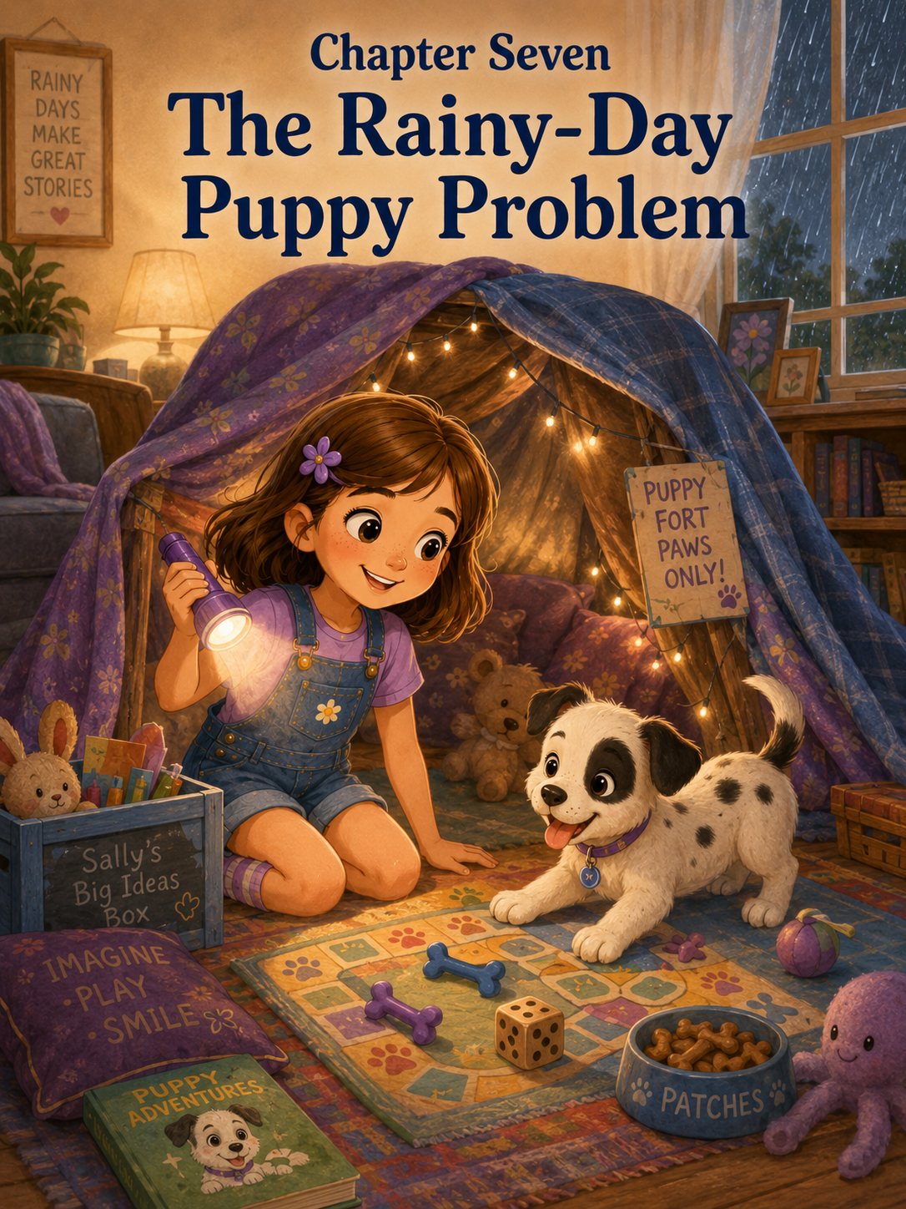Chapter Seven: The Rainy-Day Puppy Problem
The rain began just after lunch.
At first, it was only a soft tapping against the kitchen windows.
Tap.
Tap.
Tap.
Sally looked up from the table, where she was drawing a picture of Patches wearing a superhero cape. Patches was curled under her chair, chewing his blue rope toy and occasionally bumping her sneaker with his paw.
Mom stood at the sink rinsing a mug. “Looks like the rain finally arrived.”
Sally turned toward the window.
Gray clouds covered the sky. The trees in the backyard swayed gently, and tiny raindrops dotted the glass.
“That’s okay,” Sally said. “Patches and I can still play outside after it stops.”
As if the weather had heard her, the rain suddenly grew heavier.
Tap-tap-tap-tap-tap.
Then came a low rumble of thunder.
Patches froze.
His rope toy slipped from his mouth.
Sally slid down from her chair and knelt beside him. “It’s okay, Patches. That was just thunder.”
Patches looked toward the window with wide eyes.
Another rumble rolled across the sky.
This one was louder.
Patches scrambled into Sally’s lap, even though he was getting a little too big to fit there neatly. His paws pressed against her knees, and his spotted body trembled just a tiny bit.
Sally wrapped her arms gently around him.
“You’re safe,” she whispered. “We’re inside.”
Mom dried her hands and came over. “Storms can feel scary to puppies. New sounds are still a lot for him.”
Sally stroked the black patch near Patches’ ear. “He was brave with Mrs. Henderson’s garden frogs and Mr. Alvarez’s hose.”
“He was,” Mom said. “And he can learn to be brave with thunder too. But we help him calmly.”
Sally nodded.
Calmly was important.
Patches always seemed to notice when Sally felt worried. If she got nervous, he got more nervous. If she spoke softly, he usually settled faster.
Sally took a slow breath, the way Mark had taught her during the Lost Leash Mystery.
“It’s okay, Patches,” she said again, this time in her calmest voice. “Rain is just water from the sky.”
Patches did not look convinced.
Outside, the rain came down harder, turning the patio shiny and dark. Water dripped from the gutters. The flowers along the fence bent under the weight of the storm.
Sally looked at the backyard.
No adventure course today.
No walks to the park.
No meeting neighbors.
No chasing butterflies.
The entire outside world had become wet, gray, and splashy.
Patches lifted his head and gave one tiny bark toward the window.
Sally sighed. “This could be a problem.”
Mom raised her eyebrows. “A rainy-day puppy problem?”
Sally looked down at Patches, who was now trying to climb higher into her lap.
“Yes,” Sally said. “A big one.”
After the thunder quieted, Patches seemed less scared.
Unfortunately, less scared did not mean calm.
It meant full of energy.
Too much energy.
He started by chasing his rope toy across the living room rug. Then he chased his ball. Then he chased nothing at all, running from the couch to the hallway and back again with his ears flopping wildly.
Tap-tap-tap-tap!
“Patches!” Sally called.
Patches zoomed past her.
He slid near the coffee table, spun in a circle, and dashed toward the kitchen.
Mark stepped into the hallway just as Patches raced by.
“Well,” Mark said, watching the puppy streak past like a spotted blur, “somebody has the indoor zoomies.”
Sally hurried after him. “He has nowhere to run!”
Patches grabbed one of Mark’s socks from the laundry basket and raced away with it.
“My sock,” Mark said.
Sally stopped herself before chasing him.
Do not chase.
Trade.
She grabbed the squeaky toy from the floor and squeezed it.
Squeak!
Patches stopped near the hallway.
Squeak!
His ears perked.
He dropped the sock and bounded back toward Sally.
“Trade,” Sally said proudly, handing him the squeaky toy.
Mark retrieved his sock. “Nicely done.”
Patches squeaked the toy twice, shook it, then abandoned it under the chair and began sniffing the rug.
Sally’s eyes widened.
“Outside?” she said.
Mom looked toward the window. Rain poured down in sheets.
“Quick potty break,” Mom said. “Raincoat time.”
Sally put on her yellow raincoat. Mark clipped the leash onto Patches’ collar. Mom opened the back door.
Patches stepped onto the wet patio.
Then he stopped.
A raindrop landed on his nose.
He blinked.
Another drop landed on his ear.
Patches backed up immediately.
“Nope,” Mark said, laughing softly. “He is not impressed.”
Sally crouched beside him. “Come on, Patches. You go outside after playing. That is the rule.”
Patches looked at the rain.
Then at Sally.
Then he sat down inside the doorway.
Mom smiled. “This may take patience.”
Sally pulled her hood over her hair. “Everything with puppies takes patience.”
They carried Patches onto the grass. He stood there with his paws spread wide, looking offended by the entire weather situation.
Sally tried not to laugh.
“You are okay,” she said. “Just hurry.”
Patches sniffed one wet patch of grass.
Then another.
Then he shook himself, even though he was barely wet.
Rain sprinkled everywhere.
“Sally!” Mark said, laughing.
Patches finally did what he needed to do, and everyone cheered softly.
“Good boy!” Sally said.
Patches seemed very pleased with himself and hurried back toward the house as fast as his little legs could carry him.
Inside, Mom dried him with a towel. Patches wiggled and tried to bite the corner of it.
“No towel chewing,” Sally said, but she was smiling.
Once dry, Patches had even more energy.
Sally stared at him.
Patches stared back.
His tail wagged.
The rain tapped the windows. The thunder rumbled far away. The backyard was off-limits. The park was impossible. The adventure course was soaked.
Sally crossed her arms and thought.
Patches needed something to do.
She did too.
Then an idea appeared.
A very Sally kind of idea.
“What if,” she said slowly, “we make inside into an adventure?”
Mom looked over from the couch, where she had opened a book. “What kind of adventure?”
“A puppy adventure,” Sally said. “A rainy-day puppy adventure.”
Mark looked interested. “That sounds promising.”
Patches barked once.
Sally pointed at him. “He agrees.”
She ran to get her notebook and wrote at the top of a fresh page:
Rainy-Day Puppy Plan
Underneath, she made a list.
- Indoor puppy games.
- Story time.
- Blanket fort.
- No chewing socks.
- No running into furniture.
- Make the day special.
Sally looked at number six and smiled.
A rainy day did not have to be a ruined day.
It could become something else.
First came indoor puppy games.
Sally chose the hallway because it was long enough for gentle rolling but not wide enough for wild zooming. Mark helped move a small basket and a pair of shoes out of the way. Mom reminded Sally to keep the games calm, not too rowdy.
“Patches is already excited,” Mom said. “We do not need to turn him into a thunderstorm with paws.”
Sally nodded seriously. “Calm games.”
Patches grabbed his rope toy and shook it like he was preparing for battle.
“Mostly calm games,” Mark said.
The first game was called Find the Treat.
Sally asked Patches to sit.
Patches sat.
Then stood.
Then sat again when he saw the treat.
“Close enough,” Sally said.
She placed one tiny puppy treat under a plastic cup and set two empty cups beside it.
Patches watched carefully.
“Find it,” Sally said.
Patches sniffed the first cup.
Then the second.
Then he knocked over the third cup and found the treat.
Sally clapped. “You did it!”
Patches ate the treat and licked the cup.
They played again. This time, Patches knocked over all three cups before finding the treat.
“That is not exactly the careful way,” Sally said.
“But he solved it,” Mark said.
Patches wagged proudly.
The next game was Toy Rescue.
Sally placed Patches’ rope toy, ball, and squeaky bone in different corners of the living room. Then she called out which one to bring.
“Get your ball!”
Patches ran to the rope toy.
“Ball,” Sally repeated.
Patches picked up the rope toy and brought it to her.
Sally looked at it. “That is not the ball.”
Patches wagged, very pleased.
Mom smiled. “He may not know the names yet.”
Sally thought about that. “Then we will practice.”
She held up the ball. “Ball.”
Patches sniffed it.
“Ball,” Sally said again.
He licked it.
Then she held up the rope. “Rope.”
Patches grabbed the rope.
Sally laughed. “Okay, you know rope.”
They practiced for several minutes. Patches still brought the wrong toy most of the time, but Sally gave him cheerful praise for trying.
“Good effort,” she said when he brought the squeaky bone instead of the ball.
Patches wagged.
“Almost,” she said when he brought the ball halfway and dropped it on Mom’s slipper.
Patches wagged again.
“Progress,” Mark said from the chair.
Sally smiled. “Not perfect.”
“Exactly,” Mom said.
After games, Patches flopped on the rug, panting happily.
Sally flopped beside him.
Rain still tapped the windows.
The house felt cozy now instead of boring.
“Story time next,” Sally announced.
She ran upstairs and returned with three books: one about a lost kitten, one about a brave rabbit, and one about a dog who learned to share.
“That one seems appropriate,” Mark said.
Sally sat on the couch with Patches curled beside her. At first, Patches tried to chew the corner of the book.
“No,” Sally said gently, moving it away. “Books are for reading.”
Patches licked the cover.
“Also not for licking.”
She began to read.
Patches did not understand every word. Sally was almost sure of that. But he liked her voice. Each time she spoke softly, his ears relaxed. His head lowered onto her knee.
The rain made a quiet rhythm behind the story.
Tap-tap.
Tap-tap.
Tap-tap.
Sally read about the dog who did not want to share his blanket. In the story, the dog learned that sharing made room for friendship.
Patches sighed and closed his eyes.
Sally looked down at him.
“You share your blanket sometimes,” she whispered. “Mostly because you drag it everywhere.”
Patches opened one eye.
Then closed it again.
When the story ended, Mom said, “That was lovely.”
Sally looked toward the window. “The rain sounds like page-turning.”
Mark smiled. “That is a good writerly observation.”
Sally liked that.
Patches slept for fourteen peaceful minutes.
Then he woke up.
And immediately tried to chew the pillow.
Sally gently traded the pillow for his rope toy.
“Blanket fort time,” she said.
Mark helped gather two kitchen chairs, one large blanket, three couch pillows, and a flashlight. Mom added a soft quilt to the floor so Patches would not slip.
Together, they built the fort between the couch and the coffee table. The blanket made a low roof. The pillows made walls. The flashlight made the inside glow softly.
Sally crawled in first.
Patches stood outside, sniffing the entrance.
“Come on,” Sally said. “It’s our rainy-day puppy cave.”
Patches put one paw inside.
Then another.
Then he crawled in, turned around twice, stepped on Sally’s knee, bumped the flashlight with his nose, and flopped onto the quilt.
Sally giggled. “Welcome to the fort.”
Mom peeked in. “Room for one more?”
“Yes,” Sally said.
Mom crawled partway in, and Mark sat just outside the entrance because he said grown-up knees had different opinions about blanket forts.
Inside the fort, the rain sounded softer. The living room felt farther away. The flashlight glow made everything seem secret and special.
Sally brought her notebook inside and began drawing a map.
“This is Fort Patches,” she said. “Here is the entrance. Here is the pillow wall. Here is the toy corner. Here is the emergency treat station.”
Patches perked up at the word treat.
“Not yet,” Mom said.
Patches put his head down again.
Sally added a tiny flag to the map. On the flag she wrote:
Rainy-Day Puppy Club
Mark leaned closer from outside. “Do I get to be in the club?”
Sally thought about it. “Yes, but you are outside security.”
“An honor,” Mark said.
Mom smiled. “What am I?”
“You are comfort captain.”
Mom touched her hand to her chest. “I accept.”
“What am I?” Sally asked herself.
Mark said, “The creative director.”
Sally liked that very much.
“And Patches?” Mom asked.
Sally looked at the puppy sprawled on the quilt, chewing gently on his rope toy.
“Patches is the official fort explorer.”
Patches rolled onto his back.
“And snack inspector,” Mark added.
Sally laughed. “Definitely snack inspector.”
For the next hour, the rainy afternoon turned into something wonderful.
They played quiet hide-and-seek with Patches’ toys. Sally hid the squeaky bone behind a pillow, and Patches found it after sniffing under Mom’s elbow first.
They made up a story about a brave spotted puppy who sailed across a pillow ocean to rescue a lost sock from a thunder dragon.
Mark made the thunder dragon voice from outside the fort.
It was very growly.
Patches barked once.
Sally patted him. “Do not worry. The thunder dragon is friendly.”
Mark growled, “Mostly.”
Mom laughed so hard the blanket roof shook.
Then Sally drew a picture of the brave spotted puppy with a cape, standing on top of a mountain of pillows. She gave him a blue collar and one black ear patch.
“That looks like Patches,” Mom said.
“It is Patches,” Sally said. “But heroic.”
Patches yawned.
“Heroic and sleepy,” Mark said.
When the storm rumbled again, Patches lifted his head, but he did not scramble away this time. Sally placed one hand gently on his back.
“You’re safe,” she said.
Patches listened to the rain.
Then he settled again.
Sally felt a warm little glow of pride.
Not because the storm had stopped.
It had not.
Not because Patches was suddenly fearless.
He was not.
But because the storm did not seem as big anymore.
They had made the house feel safe.
They had made the day feel fun.
They had made something out of almost nothing.
By late afternoon, the rain slowed. The clouds were still gray, but a thin line of sunlight peeked through near the fence. Water dripped from the leaves. The patio shone.
Mom looked out the window. “The worst of it has passed.”
Sally crawled out of the fort and stretched. “Already?”
Mark looked at the blanket fort, the scattered toys, the notebook pages, the pillows, the flashlight, and Patches sleeping halfway inside the fort entrance.
“Already?” he repeated. “It looks like an entire kingdom happened in here.”
Sally grinned. “It did.”
Patches opened his eyes and wagged weakly, too tired to stand.
Mom smiled. “I think the Rainy-Day Puppy Club was a success.”
Sally looked around the living room.
The day had started with thunder, a scared puppy, too much energy, and nowhere to go. She had thought being stuck inside would be boring. She had thought the rain would ruin everything.
But it had not ruined everything.
It had changed everything.
And then Sally had changed it again.
That evening, after dinner, Sally helped fold the blankets and put the pillows back. She returned the cups to the kitchen and collected Patches’ toys from under the table, behind the couch, and inside one of Mark’s shoes.
Patches followed sleepily.
He tried to help by carrying his rope toy.
It was not very useful, but it was adorable.
Before bed, Sally opened her notebook to a fresh page.
At the top, she wrote:
The Rainy-Day Puppy Problem
Then she added:
Problem:
Rain outside. Puppy energy inside.
Things that helped:
- Find the Treat game.
- Toy Rescue.
- Story time.
- Blanket fort.
- Calm voices during thunder.
- Making something fun instead of complaining.
She paused and looked at Patches.
He was curled in his bed, one paw over his nose. The blue blanket was tucked around him, and his rope toy lay beside his head.
Sally wrote one more line.
What I learned today:
Creativity can turn an ordinary day into an unforgettable memory. Sometimes a problem is really an invitation to imagine something new.
She closed the notebook and climbed into bed.
Outside, the last drops of rain fell from the roof.
Drip.
Drip.
Drip.
The house was quiet.
Patches sighed in his sleep.
Sally smiled into the darkness.
Tomorrow might bring sunshine.
It might bring puddles.
It might bring mud, which would probably bring another puppy problem.
But today had brought a blanket fort, a thunder dragon, a toy rescue, and a rainy-day puppy club.
Sally pulled her blanket under her chin.
The storm had kept them inside.
But imagination had taken them everywhere.

Chapter Eight: Patches and the School Reading Day
The next morning, Sally found a flyer tucked inside her mailbox.
It was folded in half and printed on bright yellow paper. Across the top, in big cheerful letters, it said:
Summer Reading Day Picnic
Sally carried it into the kitchen, where Mom was cutting strawberries, and Mark was pouring cereal into a bowl.
“Mom!” Sally said. “Look!”
Mom wiped her hands on a towel and took the flyer. “Oh, this is from your school.”
Mark leaned over her shoulder. “A summer reading event?”
Sally nodded quickly. “It says students can bring a favorite book and read outside on the school lawn. There will be blankets, snacks, story circles, and a book-sharing table.”
“That sounds perfect for you,” Mom said.
Sally loved books. She loved the way a story could open a door to somewhere else. A beach. A forest. A castle. A secret garden. A summer camp. Even a backyard with a brave spotted puppy.
Patches, who had been sitting near Sally’s feet, looked up when he heard the word puppy in her thoughts, or maybe just because Mark had dropped one cereal flake.
“Can Patches come?” Sally asked.
Mom looked at the flyer again. “It says families are welcome. Let me check the note at the bottom.”
She read carefully.
Then she smiled. “Pets are allowed if they are friendly, leashed, and comfortable around children.”
Sally gasped. “Patches is friendly!”
Patches wagged.
“He is leashed,” Mark said.
Patches tried to nibble the edge of his blue leash, which was hanging from the hook by the back door.
“Usually leashed,” Mark corrected.
“And comfortable around children?” Mom asked.
Sally looked at Patches.
Patches had met Emma. He had met children at the playground. He had even met Daisy, the large golden retriever down the street, though he had hidden behind Sally’s legs at first.
“He is learning,” Sally said.
Mom nodded. “That means we will need to be thoughtful. If we bring him, we make sure he has shade, water, space, and breaks.”
“And treats,” Mark added.
Patches wagged at that word.
Sally crouched beside him and stroked the black patch near his ear. “Would you like to go to School Reading Day?”
Patches licked her chin.
“I think that means yes,” Sally said.
Mark smiled. “Puppy science?”
“Very advanced puppy science,” Sally replied.
After breakfast, Sally hurried to her room to choose a book.
That should have been easy.
It was not.
Her bookshelf was full of possibilities. There was the book about the girl who found a secret garden. There was the ocean adventure book she had read after visiting the seashore. There was the funny book about a raccoon who thought he was a detective. There was the story about a little bird who learned to fly after many wobbly tries.
Sally pulled out one book.
Then another.
Then three more.
Soon, her bed was covered with books.
Patches trotted into her room, saw the books, and immediately placed one paw on the secret garden story.
“Do you like that one?” Sally asked.
Patches sniffed the cover.
Then he tried to chew the corner.
“No, Patches,” Sally said, gently moving the book away. “Books are for reading, not chewing.”
Patches sat down and looked innocent.
Sally sighed. “You still need reminders.”
She picked up the little bird book and turned it over in her hands. The cover showed a small bird sitting on the edge of a branch, looking nervous but hopeful.
Sally remembered how Patches had looked when he first met Daisy.
She remembered how she had felt waiting for her report card.
She remembered Camp Pinecone and the first-day feeling of not knowing anyone yet.
“This one,” she said.
Patches wagged.
“It is about trying even when you feel scared,” Sally explained. “That is a good story for both of us.”
Patches sneezed.
“Important moment,” Sally said.
She packed the book in her purple backpack along with her notebook, two pencils, and a small blanket with purple flowers on it. Mom packed snacks, sunscreen, Patches’ water bowl, cleanup bags, and a folded towel for him to rest on. Mark checked the leash twice.
Sally checked it three times.
After the Lost Leash Mystery, she trusted checking.
By late morning, they arrived at Sally’s school.
The building looked different in summer. During the school year, the sidewalks were crowded with rushing children, ringing bells, and teachers holding clipboards. Today, the school lawn was spread with colorful picnic blankets. A folding table held baskets of books. Another table had cups of lemonade, apple slices, crackers, and little bags of pretzels.
A banner hung between two trees.
Welcome to Summer Reading Day!
Sally smiled.
Mrs. Carter stood near the book table, wearing a blue dress and a sunhat. When she saw Sally, she waved.
“Sally! I’m so glad you came.”
Sally ran a few steps, then remembered Patches and slowed down so she would not pull him.
“Hi, Mrs. Carter,” she said. “This is Patches.”
Patches stood partly behind Sally’s leg and looked up at Mrs. Carter.
Mrs. Carter crouched a little, but she did not reach for him. “Hello, Patches. I have heard about you.”
Sally looked surprised. “You have?”
“Your mother may have told me a little,” Mrs. Carter said, smiling.
Mom gave an innocent shrug.
Patches sniffed Mrs. Carter’s hand. Then he wagged.
“He approves,” Sally said.
“I’m honored,” Mrs. Carter replied.
Emma hurried across the grass holding a book in one hand and a juice box in the other.
“Sally! Patches!”
Patches wagged harder when he saw Emma. Emma stopped before she reached him, sat down on the grass, and held out her hand just like Sally had taught her.
“Hi, Patches,” she said softly.
Patches went straight to her and licked her fingers.
Emma beamed. “He remembers me.”
Sally felt proud. “He remembers calm friends.”
Soon, a few more children gathered nearby. Mia came over with a book about dolphins. Marcus had a mystery book tucked under his arm. Ava carried a book about volcanoes and looked very serious about it.
“Can we pet him?” Marcus asked.
Sally looked at Patches first.
He seemed happy, but his ears moved back and forth as more children came closer.
“One at a time,” Sally said. “And quiet voices. Let him sniff your hand first.”
The children listened.
Mia sat on the blanket and held out her hand.
Patches sniffed.
Then he licked her wrist.
Mia giggled. “His tongue is tiny.”
Marcus tried next. Patches sniffed his fingers and then nosed the mystery book.
“He likes mysteries,” Marcus said.
“He helped solve the Lost Leash Mystery,” Sally said.
Mrs. Carter laughed. “That sounds like a story all by itself.”
“It was,” Sally said. “A very serious one.”
Patches settled on the towel Mom had brought, still wagging as children admired him.
For a little while, Sally forgot to feel nervous.
She had been excited about Reading Day, but she had also wondered if Patches might bark too much, or get shy, or try to eat someone’s bookmark. But so far, he was doing well.
Mostly.
Then a little boy from another class ran past holding a cracker.
Patches stood immediately.
His nose twitched.
His body leaned forward.
“Patches,” Sally said gently. “Leave it.”
Patches looked at the cracker.
Sally reached into the treat pouch. “Look.”
Patches turned his head.
She gave him a tiny treat. “Good boy.”
Mark, standing nearby, gave her a thumbs-up.
Sally smiled.
Patches may have been the puppy, but Sally was learning too.
Mrs. Carter clapped her hands. “Readers, please gather on your blankets. We are going to begin our first story circle.”
Children settled across the lawn. Some sat with parents. Some stretched out on their stomachs. Some leaned against backpacks. A few younger brothers and sisters wandered between blankets until grown-ups gently guided them back.
Sally sat on her purple flower blanket. Patches curled beside her, his leash looped safely around her wrist. Mom sat behind them, and Mark lowered himself carefully onto the grass with a small groan.
Sally looked at him. “Are you okay?”
“I am discovering that school lawns are lower than regular chairs,” Mark said.
Mom laughed.
Mrs. Carter began by reading a short poem about summer. Her voice was calm and bright, and everyone listened as the words floated over the lawn.
Then students took turns sharing their favorite books.
Emma shared a story about friendship bracelets. Marcus talked about his mystery book and said the best part was “when the detective noticed the muddy footprint.” Ava explained three facts about volcanoes before Mrs. Carter gently reminded her to save some for science club.
Then Mrs. Carter looked at Sally.
“Sally, would you like to share?”
Sally’s stomach gave one small flutter.
She had known her turn would come. She had practiced what she wanted to say in the car. But now, with everyone looking, the words felt harder to catch.
Patches lifted his head and looked at her.
His little tail tapped once against the blanket.
Sally took a breath.
“Yes,” she said.
She stood, holding her book against her chest.
“This book is called The Little Bird Who Tried Again,” Sally began. “It is about a bird who wants to fly, but every time she tries, she gets scared or wobbly.”
A younger child whispered, “Like a baby bird.”
Sally nodded. “Yes. But she keeps practicing. She learns that being brave does not mean everything is easy. It means trying again.”
She glanced down at Patches.
He was watching a butterfly, but he stayed lying down.
Sally smiled.
“I picked this book because this summer I learned that puppies have to practice too. Patches had to practice walking on a leash, meeting neighbors, and not eating shoelaces.”
The children laughed.
Patches wagged when he heard his name.
“And I had to practice being patient,” Sally continued. “Because when someone is learning, they need encouragement. Not yelling. Not rushing. Encouragement.”
Mrs. Carter’s eyes warmed.
Sally opened the book and read one short page. Her voice was quiet at first, but it grew stronger as she continued. The story told about the little bird standing on a branch, feeling the wind lift her feathers. The bird was afraid, but she listened to her mother’s gentle voice.
Try one wingbeat.
Then another.
Sally finished the page and looked up.
Everyone was listening.
Even Patches.
At least, mostly.
He had stopped watching the butterfly.
When Sally sat back down, Emma whispered, “That was good.”
Sally whispered back, “Thanks.”
Patches climbed into Sally’s lap, even though he was not as tiny as he used to be. Sally stroked his back.
“You listened,” she whispered.
Patches licked the edge of her book.
“Mostly listened.”
After the story circle, Mrs. Carter announced free reading time. Children could choose a spot on the lawn, read with a friend, visit the book table, or listen to a volunteer read aloud under the oak tree.
That was when Patches became the unexpected star.
At first, one child asked if she could read beside him.
Then another asked if Patches liked dog stories.
Then Marcus wondered if Patches could help solve mysteries by sniffing clues.
Soon, a small circle formed around Sally’s blanket.
“Can I read him a page?” Mia asked.
Sally looked at Mom.
Mom looked at Patches.
Patches was stretched happily on his towel, calm and comfortable.
“One at a time,” Mom said. “And if Patches gets tired, he takes a break.”
Sally nodded. “Patches has reading rules.”
Mrs. Carter came over with a small smile. “Reading rules sound useful.”
Sally sat up importantly. “Rule one: quiet voices. Rule two: gentle hands. Rule three: Patches does not eat the books. Rule four: if Patches falls asleep, that means he is still listening.”
Mrs. Carter laughed softly. “Excellent rules.”
Mia read first. She sat beside Patches and opened her dolphin book. She read slowly, pointing to a picture of a dolphin leaping out of blue water.
Patches rested his chin on his paws.
“He likes it,” Mia whispered.
Next, Marcus read a paragraph from his mystery book. When he reached the part about the muddy footprint, Patches lifted his head and sniffed the page.
“See?” Marcus said. “He is checking for clues.”
Ava read from her volcano book. Patches fell asleep halfway through the second fact about lava.
Ava looked worried. “Is he bored?”
“No,” Sally said. “He is listening with his eyes closed.”
Ava seemed satisfied.
One little boy who had been standing alone near the snack table came closer. He held a picture book tightly against his chest.
Sally recognized him from the hallway at school, but she did not know his name.
“Can I read to the puppy?” he asked softly.
Sally noticed that he looked nervous. His voice was small, and he did not come too close.
She remembered how Patches had felt when meeting new people.
Sometimes friendship grew slowly.
“Sure,” Sally said. “You can sit here.”
The boy sat at the edge of the blanket.
“My name is Noah,” he said.
“I’m Sally,” she said. “And this is Patches.”
Noah smiled a tiny smile. “I know. Everybody is talking about him.”
Patches opened one eye.
Noah held out his hand. Patches sniffed it, then gave one sleepy wag.
Noah opened his book. It was about a bear who did not want to go to school.
“I get nervous reading out loud,” Noah admitted.
Sally nodded. “Sometimes I do too.”
“You do?”
“Yes,” Sally said. “But Patches is a good listener. He does not correct people.”
Noah looked at Patches.
Patches yawned.
Sally added, “He also does not know if you skip a word.”
Noah laughed quietly.
Then he began to read.
At first, his voice was barely louder than the rustle of leaves. But Patches stayed beside him, calm and soft and patient. Sally listened too, not interrupting when Noah paused or sounded out a word.
Little by little, Noah’s voice grew stronger.
When he finished the page, Sally smiled. “You read that really well.”
Noah looked pleased.
Patches rolled onto his side, showing his spotted belly.
Noah giggled. “I think he liked it.”
“I think he did,” Sally said.
Soon, Emma joined them. Then Mia. Then Marcus, who wanted to know if the bear story had any clues. Noah smiled more. He read another page.
Sally looked around the blanket.
Books were scattered everywhere. Children who did not usually sit together were leaning close to see pictures. Patches lay in the middle like a soft, sleepy bridge between everyone.
Sally thought about stories.
A story could give people something to talk about.
A puppy could give people something to smile about.
Together, they made the blanket feel like a place where everyone belonged.
After a while, Mom gently touched Sally’s shoulder. “Patches needs a break.”
Sally looked down. Patches was panting a little, and his eyes looked tired.
“Oh,” Sally said. “Right.”
She stood. “Patches is going to have a quiet break now.”
Noah looked disappointed but nodded. “Bye, Patches.”
Patches wagged weakly.
Sally and Mom walked him to a shady spot near the side of the school building, away from the crowd. Mark brought the water bowl.
Patches drank noisily, then flopped on the towel.
“You did a good job noticing,” Mom said.
Sally sat beside him. “I almost forgot. Everyone was having so much fun.”
“That happens,” Mom said. “But part of caring for him is noticing when he has had enough.”
Sally stroked Patches’ back. “He helped everyone read.”
“He did,” Mark said. “But even stars need rest.”
Sally smiled. “Patches is a reading star.”
Patches closed his eyes.
For the next few minutes, they sat quietly in the shade. Sally could still hear children laughing and pages turning. Mrs. Carter’s voice drifted across the lawn as she helped someone choose a book.
When Patches seemed rested, they returned to the picnic. This time, Sally made sure he stayed beside her in the shade.
Mrs. Carter came over near the end of the event.
“Sally,” she said, “I think Patches helped make today very special.”
Sally smiled proudly. “He likes stories.”
“And he helped some students feel comfortable reading,” Mrs. Carter said. “That is a wonderful gift.”
Sally looked at Noah, who was now sitting with Emma and Mia, showing them a picture in his bear book.
“He helped Noah,” Sally said.
“Yes,” Mrs. Carter said. “Sometimes a friendly listener makes a big difference.”
Sally looked down at Patches.
He was chewing gently on his rope toy, unaware of his own importance.
On the way home, Patches was so tired that Mark had to carry him the last block. His spotted head rested on Mark’s arm, and his eyes blinked slowly.
“He had a big day,” Mom said.
“So did I,” Sally replied.
“What was your favorite part?” Mark asked.
Sally thought about the story circle. She thought about reading from The Little Bird Who Tried Again. She thought about Mia reading dolphins, Marcus looking for clues, Ava explaining volcanoes, and Noah finding his reading voice beside Patches.
“I liked when everyone started reading together,” Sally said. “Even kids who did not know each other.”
Mom smiled. “Books can do that.”
“And puppies,” Mark added.
Sally nodded. “Books and puppies.”
When they got home, Patches went straight to his blue blanket and fell asleep with his nose tucked under one paw.
Sally opened her notebook and wrote:
Patches and the School Reading Day
Underneath, she made a list.
- Patches can be calm at school if he has shade and water.
- Children like reading to puppies.
- Patches is interested in mystery books.
- Volcano facts make him sleepy.
- Noah read louder when Patches listened.
- Stories help people sit together.
- Pets can help people feel welcome.
- Reading outside is better with snacks.
She paused, then added:
- Even reading stars need breaks.
Sally smiled at that.
Then she wrote one final sentence.
What I learned today:
Stories bring people together because they give us something to share. Sometimes a book, a blanket, and a sleepy puppy are enough to help someone feel brave.
That evening, Sally sat beside Patches and opened her little bird book again. Patches was too tired to lift his head, but his tail tapped once when she began reading.
“Try one wingbeat,” Sally read softly. “Then another.”
Patches sighed.
Sally looked at him and smiled.
He had not read a single word that day.
He had not told a story.
He had not understood dolphins, volcanoes, bears, or brave little birds.
But somehow, Patches had helped children read.
He had helped Noah feel welcome.
He had helped Sally understand that stories were not only made of pages and words.
Sometimes stories were made of shared blankets, kind voices, wagging tails, and the quiet courage to read one sentence at a time.
Sally turned the page.
Patches slept beside her.
And for the rest of the evening, the house felt full of stories.

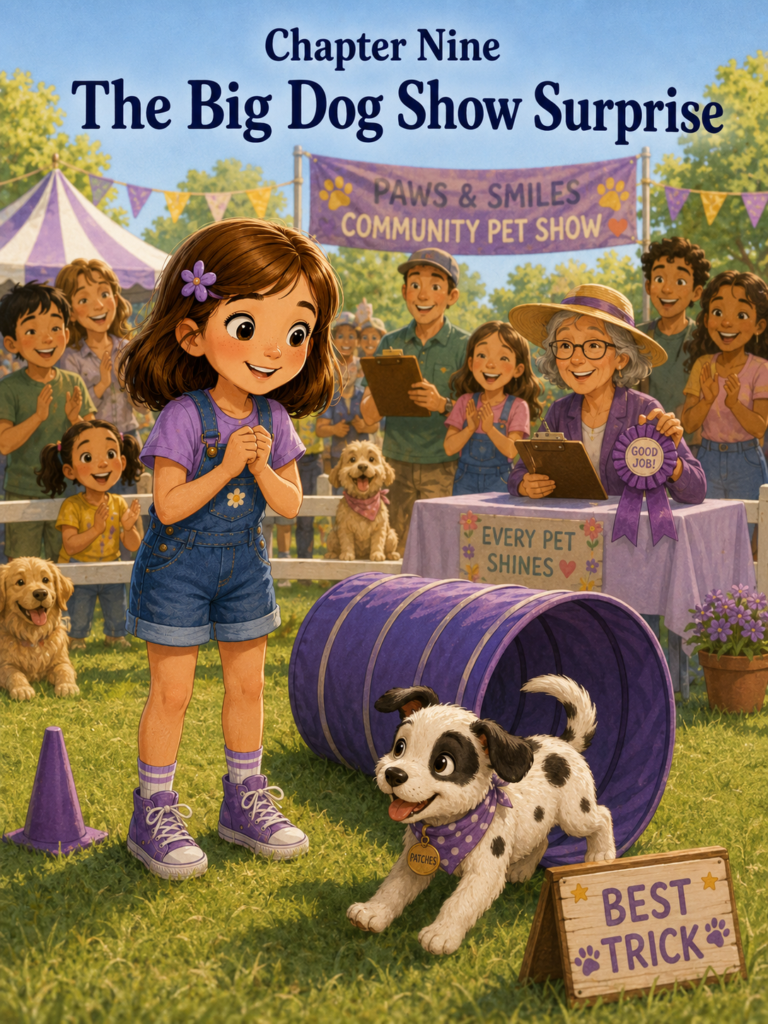Chapter Nine: The Big Dog Show Surprise
The poster appeared on the bulletin board outside the library on Tuesday morning.
Sally noticed it because it had a picture of a smiling dog wearing a blue ribbon.
Patches noticed it because someone had dropped a cracker on the sidewalk below it.
“Patches,” Sally said, gently moving him away. “Sidewalk crackers are not snacks.”
Patches looked disappointed.
Mom clipped the cleanup bag holder back onto the leash and smiled. “Good catch.”
Sally stood in front of the poster and read the large letters at the top.
Maple Street Community Pet Show
Saturday at the Town Green
Friendly pets welcome!
Underneath, smaller words listed the categories.
Fluffiest Friend
Best Costume
Waggiest Tail
Most Unusual Pet
Best Trick
Sweetest Smile
Sally’s eyes grew wider with every line.
“Mom,” she said slowly, “there is a dog show.”
Mom followed her gaze. “So there is.”
“It says friendly pets welcome.”
“It does.”
Sally looked down at Patches.
Patches was currently sniffing a fallen leaf as if it might contain secret information.
“He is friendly,” Sally said.
“Very friendly,” Mom agreed.
“He has a waggy tail.”
“Very waggy.”
“And a sweet smile.”
“When he is not chewing something.”
Sally ignored that part.
Patches looked up at her and wagged.
A dog show.
A real community pet show.
Sally imagined Patches trotting proudly across the town green, his black spots shining, his blue collar neat, his ears bouncing, everyone smiling and clapping.
Then she imagined the categories again.
Best Trick.
Patches knew sit.
Sometimes.
He knew come.
Usually when treats were involved.
He knew stay.
For about two seconds.
He knew how to find socks, chase butterflies, bark at garden frogs, and crawl into blanket forts.
Sally frowned thoughtfully.
“Do you think Patches could enter Best Trick?”
Mom looked at her carefully. “Do you think he is ready?”
Sally looked at Patches.
Patches had found a stick and was trying to decide if it belonged to him.
“I think he could be ready by Saturday,” Sally said.
Mom smiled gently. “That gives you a few days to practice. But remember, this should be fun. Pet shows are not about making him perfect.”
Sally nodded, though the word perfect was already sneaking into her thoughts.
What if Patches forgot everything?
What if he ran in circles?
What if he barked at a poodle?
What if he sat at the wrong time?
What if everyone else’s dogs knew amazing tricks, like rolling over, jumping through hoops, or balancing treats on their noses?
Sally looked down at Patches again.
He had successfully claimed the stick.
“Patches,” she said, “we may need to train.”
Patches wagged, carrying the stick in his mouth.
Mom laughed softly. “He seems ready for something.”
When they got home, Sally hurried to the kitchen table and opened her notebook.
At the top of a new page, she wrote:
Dog Show Training Plan
Then she added:
Category: Best Trick
Underneath, she made a list of tricks Patches knew.
- Sit.
- Come.
- Maybe stay.
- Find treats under cups.
- Go through the blanket tunnel.
- Look adorable.
She tapped her pencil against the page.
“Does looking adorable count as a trick?” she asked.
Mark looked up from the counter, where he was slicing an apple. “For Patches, it appears to be a natural talent.”
Patches sat beside him, waiting hopefully.
Mark held up one finger. “Not for dogs.”
Patches wagged anyway.
Sally looked back at her list. “I think we should do sit, then tunnel, then come.”
“That sounds like a routine,” Mark said.
“A routine?”
“Like a little performance,” he explained. “You show him what to do in order.”
Sally’s eyes brightened. “A performance routine.”
Mom set a glass of water on the table. “Keep it simple. Three small things done happily are better than ten things done with stress.”
Sally wrote that down.
Simple is better. Happy is important.
Patches looked at her notebook.
Then tried to lick the corner.
“No,” Sally said. “This is the official training plan.”
Patches sneezed.
“Exactly,” Sally said. “Very official.”
That afternoon, Sally set up a small practice area in the backyard. She used the blue blanket tunnel from the Rainy-Day Puppy Club, two orange cones from the adventure course, and a yellow chalk star at the finish line.
Mark helped her tape a small paper sign to the fence.
Patches’ Best Trick Practice
Mom sat on the patio with iced tea.
Patches sat in the grass.
Sally stood in front of him with a tiny puppy treat in her hand.
“Ready, Patches?”
Patches’ tail thumped.
“Sit.”
Patches sat immediately.
Sally gasped. “Perfect!”
Mom raised one eyebrow.
Sally corrected herself. “I mean, very good.”
Patches received a treat.
Then Sally led him to the tunnel.
“Through.”
Patches sniffed the blanket tunnel.
He looked at Sally.
He looked at the tunnel again.
Then a butterfly fluttered across the yard.
Patches turned his head.
“No butterfly,” Sally said quickly. “Tunnel.”
The butterfly drifted toward the flowers.
Patches took one step after it.
“Patches,” Sally said.
He looked back at her.
She held up the treat.
Patches made a very difficult puppy decision.
Treat won.
He ran through the tunnel and came out the other side, ears flopping.
“Yes!” Sally cheered.
Patches wagged so hard he almost knocked into the cone.
“Now come,” Sally called.
Patches ran to her.
He jumped up and placed both front paws on her knees.
Sally laughed. “Good come. Maybe not the jumping part.”
Mark clapped from the patio. “That was a strong first practice.”
Sally hugged Patches. “He can do it!”
Patches licked her cheek.
For the next few days, Sally practiced with Patches every morning and afternoon.
Not for too long.
Mom insisted on breaks.
“Puppies learn better when they are not tired,” she said.
Sally learned that she learned better when she was not tired too.
On Wednesday, Patches sat, went through the tunnel, and came when called.
Then he grabbed the paper sign from the fence and ran across the yard with it.
“Patches!” Sally cried.
Patches shook the sign proudly.
Mark laughed so hard he had to sit down.
On Thursday, Patches sat, went through the tunnel, and came.
Then he noticed Mrs. Henderson’s cat sitting on the fence.
Patches forgot the routine completely.
The cat blinked at him.
Patches barked once.
The cat flicked its tail and walked away, looking unimpressed.
Sally put her hands on her hips. “Cats are not part of the dog show.”
Patches looked like he disagreed.
On Friday morning, the routine went almost perfectly.
Sit.
Tunnel.
Come.
Patches even sat on the yellow finish star afterward.
Sally threw both arms into the air. “He’s ready!”
Patches barked.
Mom clapped. “That was wonderful.”
Mark nodded. “Very impressive.”
Sally beamed.
For the rest of the day, she imagined Saturday.
Patches would sit.
He would go through the tunnel.
He would come.
Everyone would clap.
Maybe he would win a ribbon.
Maybe the ribbon would be blue, just like his leash.
Maybe Mrs. Carter would somehow hear about it and say, “Sally, you and Patches showed excellent teamwork.”
By bedtime, Sally had packed everything for the dog show.
Leash.
Water bowl.
Treats.
Cleanup bags.
Blue bandana.
Brush.
Notebook.
Extra treats.
Backup extra treats.
Mom peeked into her room. “That is a lot of treats.”
“What if we need them?” Sally asked.
“For one small puppy?”
“He is very motivated,” Sally said.
Patches, who was lying on his blanket, wagged at the sound of treats.
Mom smiled. “Try to sleep. Tomorrow will be a big day.”
Sally climbed into bed, but sleep did not come right away.
She looked at Patches, curled into his spotted little circle.
“What if you forget everything?” she whispered.
Patches sighed.
“What if I forget everything?”
Patches opened one eye.
Sally smiled softly. “You are right. We will do our best.”
Patches closed his eye again.
The next morning, the town green was already busy when Sally, Mom, Mark, and Patches arrived.
Colorful tents stood around the grass. A table near the front had registration papers and ribbons. Children carried pet carriers. Grown-ups held leashes. Dogs of every size sniffed the air.
There was a tiny brown dog wearing a yellow bow.
There was a fluffy white dog that looked like a cloud with feet.
There was a sleepy old bulldog in a red bandana.
There was a tall spotted dog that made Patches look even smaller.
Someone had brought a rabbit in a basket. Someone else had a turtle in a clear carrier with lettuce inside.
Sally stopped and stared. “This is bigger than I thought.”
Patches stopped too.
His ears moved back and forth.
A dog barked nearby.
Then another dog answered.
Patches stepped closer to Sally’s legs.
Mom touched Sally’s shoulder. “Remember what you learned when Patches met the neighborhood.”
Sally nodded. “Go slow. Help him feel safe.”
Mark crouched beside Patches. “Big day, buddy.”
Patches sniffed Mark’s hand and wagged, but his tail was lower than usual.
Sally knelt beside him. “It’s okay. We do not have to rush.”
A volunteer at the registration table smiled as they approached.
“What’s this little one’s name?”
“Patches,” Sally said. “We’re entering Best Trick.”
The volunteer wrote his name on a tag. “Best Trick will be after Waggiest Tail.”
Sally clipped the tag to Patches’ leash. It had his name written in black marker.
Patches
Seeing his name made everything feel real.
Sally’s stomach fluttered.
They found a shady spot under a tree to wait. Mom gave Patches water. Mark helped Sally tie the blue bandana loosely around Patches’ neck. The bandana had tiny white stars on it, just like his collar.
“You look very handsome,” Sally said.
Patches tried to chew the bandana.
“Handsome does not mean edible.”
A woman walking a poodle stopped nearby. “What a darling puppy.”
Sally smiled. “Thank you. His name is Patches.”
The poodle wore a pink bow and looked very calm.
Very practiced.
Very professional.
Sally’s confidence shrank a little.
The poodle’s owner smiled. “Is this his first show?”
“Yes,” Sally said.
“How exciting. First shows are always special.”
Sally looked at the poodle. “Does your dog know tricks?”
“Oh yes,” the woman said. “Duchess can spin, bow, and wave.”
Sally swallowed. “Wow.”
Patches could not spin.
He could bow only when stretching after a nap.
He could wave if lifting one paw accidentally counted.
When the woman walked away, Sally sat down beside Patches.
“Maybe we picked the wrong category,” she whispered.
Mark heard her. “Why do you say that?”
“Other dogs know better tricks.”
“Maybe,” Mark said. “But this is not only about the trick.”
Sally frowned. “The category is called Best Trick.”
“Yes,” Mark said. “But people also notice teamwork. Joy. Effort.”
Mom sat beside her. “And remember, Patches is still a puppy.”
Sally looked at him.
Patches was rolling in the grass.
His blue bandana was now slightly crooked.
“He is very still-a-puppy,” Sally said.
Mom smiled. “Exactly.”
The first category was Fluffiest Friend. The fluffy white dog won, which Sally thought was fair because it looked like someone had brushed a cloud. Then came Waggiest Tail. A small brown dog wagged so hard its whole body shook, and the crowd laughed and cheered.
Patches wagged along from the shade.
Then the announcer called, “Best Trick contestants, please line up near the stage area.”
Sally’s heart jumped.
“That’s us,” she said.
Patches stood, then sat, then stood again.
Sally took a breath.
Mom handed her the treat pouch. “You know what to do.”
Mark smiled. “And if it does not go perfectly?”
Sally looked at him.
She knew the answer.
“We keep going.”
“That’s right,” Mark said.
Sally led Patches to the line.
There were five dogs ahead of him.
Duchess the poodle spun in a perfect circle, bowed, and lifted one paw as the crowd clapped.
A golden retriever caught a soft frisbee.
A small terrier jumped through a hoop.
A dachshund rolled over, then refused to get up, which made everyone laugh.
Sally’s stomach twisted tighter.
Patches sniffed a dandelion near the stage.
“Patches,” Sally whispered. “Please remember.”
Then it was their turn.
The announcer smiled. “Next we have Sally and Patches.”
The crowd clapped.
Sally walked to the center of the small grassy area. Mark set the little blue blanket tunnel nearby, just like they had practiced. Mom stood at the edge, smiling encouragement.
Sally looked at the crowd.
There were so many faces.
Mrs. Henderson was there, wearing her blue glasses. Emma waved from beside her mom. Mr. Alvarez stood near the lemonade table. Mrs. Peterson held Daisy’s leash.
Everyone seemed friendly.
Still, Sally’s mouth felt dry.
She looked down at Patches.
Patches looked up at her.
His tail wagged once.
Sally remembered the little bird book from Reading Day.
Try one wingbeat.
Then another.
She smiled at Patches.
“Ready, boy?”
Patches wagged.
Sally held up her hand.
“Sit.”
Patches sat.
The crowd clapped lightly.
Sally smiled. “Good boy.”
She led him to the tunnel.
“Through.”
Patches lowered his head.
He put one paw inside.
Then he stopped.
A butterfly fluttered near the edge of the grass.
Of course.
Sally saw it at the same moment Patches did.
Patches turned his head.
The crowd waited.
Sally’s heart pounded.
“No butterfly,” she whispered. “Tunnel.”
Patches looked at the butterfly.
Sally held up a treat.
“Patches, look.”
Patches looked back at her.
For one wonderful second, Sally thought the treat would win.
Then the butterfly fluttered closer.
Patches bounced toward it.
The crowd laughed softly.
Sally felt her cheeks turn hot.
“Patches,” she called, trying to keep her voice cheerful.
Patches hopped once after the butterfly, missed it, and sneezed.
The crowd laughed again, but not meanly.
They sounded delighted.
Patches turned around as if he had suddenly remembered he was in a show.
Sally knelt near the tunnel. “Come on, Patches. You can do it.”
Her voice was not perfect.
It trembled a little.
But it was kind.
Patches trotted back to her.
He sniffed the tunnel.
Then, with his blue bandana crooked and one ear flopped sideways, he ran straight through it.
The crowd clapped.
Sally gasped. “Yes!”
Patches came out the other side and kept running.
Not to Sally.
Toward Mark.
Mark’s eyes widened. “Oh!”
Patches ran to Mark, jumped at his shoe, then spun around and ran back toward Sally when she called, “Come!”
The crowd cheered louder.
Sally laughed now.
She could not help it.
Patches reached her and sat directly on the yellow star they had chalked onto a small mat.
Only the mat had shifted, and he sat halfway off it.
Still, he sat.
Sally threw both arms around him. “Good boy!”
Patches licked her chin.
The crowd clapped and laughed and cheered all at once.
The announcer grinned. “Well, that was certainly full of personality!”
Sally stood, holding Patches’ leash carefully.
Her routine had not gone perfectly.
Not even close.
There had been a butterfly interruption, a sneezing pause, a quick detour to Mark, and a crooked finish.
But people were smiling.
Emma was clapping wildly.
Mrs. Henderson dabbed at her eyes like Patches had performed something very important.
Daisy barked once.
Patches barked back.
Sally laughed again.
When all the contestants had performed, the judges whispered together near the ribbon table. Sally stood beside Mom and Mark, stroking Patches’ head.
“I messed up,” she said quietly.
Mom looked surprised. “You did?”
“He chased the butterfly.”
“Briefly,” Mark said.
“And he ran to you.”
“Also briefly.”
“And he did not finish perfectly.”
Mom knelt beside her. “Did he try?”
Sally looked down at Patches.
Patches was sitting now, panting happily, tongue slightly out.
“Yes.”
“Did you encourage him?”
“Yes.”
“Did you keep going?”
Sally nodded.
Mom smiled. “Then I do not think you messed up.”
The announcer returned with the ribbons.
“Thank you to all our Best Trick contestants,” she said. “We saw spins, jumps, catches, rolls, and one very memorable butterfly chase.”
People laughed.
Sally’s cheeks warmed, but this time she smiled.
“The Best Trick ribbon goes to Duchess!”
The poodle’s owner stepped forward proudly as Duchess received a blue ribbon. Sally clapped because Duchess really had been excellent.
“And we have a special ribbon today,” the announcer continued. “The judges would like to award Best Personality to Patches!”
For a second, Sally did not understand.
Then Emma shouted, “Patches!”
The crowd clapped and cheered.
Sally’s eyes widened. “Patches won something?”
Mark grinned. “Best Personality.”
Mom squeezed her shoulder. “That sounds exactly right.”
Sally walked forward with Patches.
The announcer handed her a yellow ribbon with green letters.
Best Personality
Patches sniffed it.
Then tried to nibble the edge.
“No,” Sally whispered, laughing. “Ribbons are not snacks.”
The crowd laughed again.
Sally held the ribbon up carefully.
Patches wagged.
Back under the tree, Emma came running over. “That was amazing!”
“He chased a butterfly,” Sally said.
“That was the best part,” Emma replied.
Mrs. Henderson joined them. “I have never seen such a joyful little performance.”
Mr. Alvarez smiled. “He has style.”
Mrs. Peterson looked down at Daisy. “Daisy says congratulations.”
Daisy wagged.
Patches wagged back.
Sally looked at the yellow ribbon.
It was not Best Trick.
It was not the blue ribbon.
But somehow, it felt perfect.
Because Patches had been Patches.
Playful.
Curious.
A little distracted.
Very cheerful.
And completely himself.
That evening, after the pet show, Sally taped Patches’ yellow ribbon above his puppy bed.
Patches sat beneath it, looking proud without knowing why.
Mark took a picture.
Mom smiled. “That ribbon suits him.”
Sally nodded. “It does.”
She opened her notebook and wrote:
The Big Dog Show Surprise
Underneath, she made a list.
- Duchess the poodle knows many tricks.
- Patches knows some tricks.
- Butterflies are still very distracting.
- Crowds are not as scary when people are kind.
- Patches did not win Best Trick.
- Patches did win Best Personality.
- Doing your best can look different for every dog.
- A crooked finish still counts if you keep trying.
She paused and looked at Patches.
He was lying on his back beneath the ribbon, paws in the air, one ear flipped inside out.
Sally smiled and added:
- Patches is very good at being Patches.
Then she wrote one final sentence.
What I learned today:
Being perfect is not the same as doing your best. Sometimes the most wonderful moments happen when things do not go exactly as planned.
Sally closed the notebook and sat beside Patches.
“You did your best today,” she told him.
Patches rolled over and rested his head on her knee.
“And I did too,” Sally added.
Patches wagged.
The yellow ribbon fluttered slightly above his bed as the ceiling fan turned.
Sally looked at it and felt happy.
Not because everything had gone perfectly.
But because it had not needed to.
Patches had stumbled through his routine with joy, and Sally had cheered him on anyway.
That, she decided, was better than perfect.
It was real.
It was theirs.
And it was exactly the kind of surprise summer seemed to bring when you were brave enough to try.

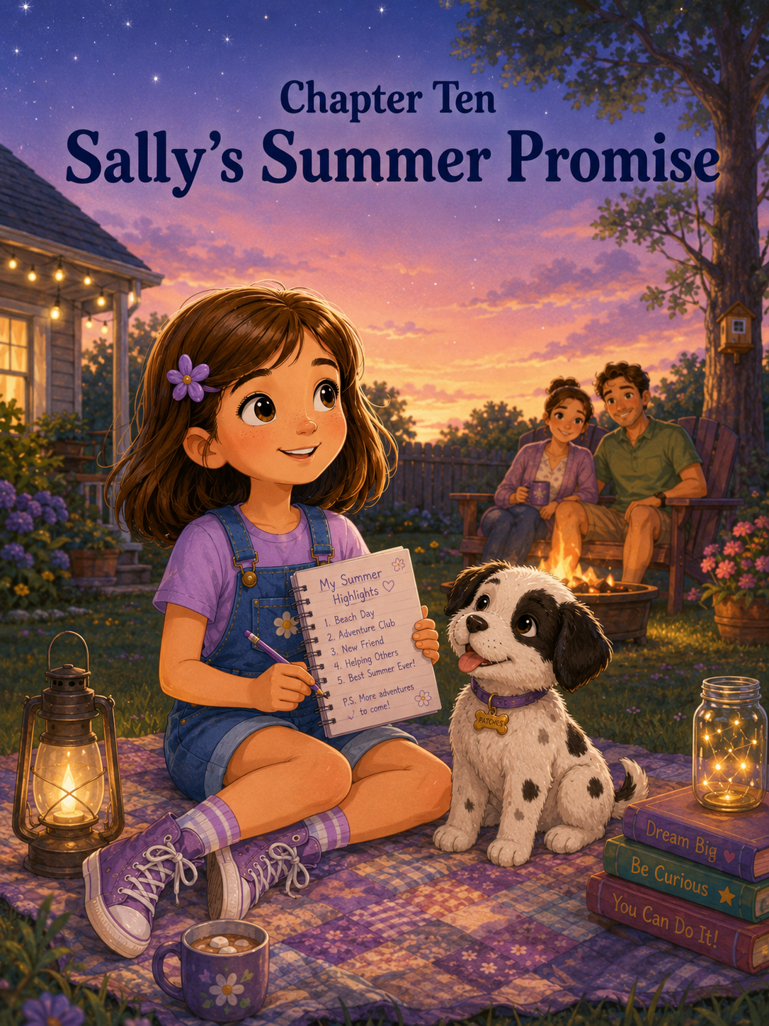Chapter Ten: Sally’s Summer Promise
The first sign that summer was beginning to change came from the tree in the backyard.
One tiny yellow leaf floated down from a branch, twirled once in the air, and landed right beside Patches’ nose.
Patches lifted his head from the grass.
He stared at the leaf.
The leaf did not move.
Patches sniffed it.
The leaf still did not move.
Then a breeze pushed it across the grass, and Patches sprang up as if the leaf had challenged him to a race.
“Patches!” Sally laughed.
He pounced.
The leaf skipped away.
Patches pounced again.
The leaf flipped over.
Patches barked once, then wagged proudly, as if he had protected the yard from a very suspicious intruder.
Sally sat on the patio step with her notebook in her lap, watching him.
“You are very brave against leaves,” she said.
Patches picked up the leaf in his mouth and carried it to her.
“No, thank you,” Sally said gently. “I do not need a soggy leaf.”
Patches dropped it beside her sneaker anyway.
A gift.
A damp, crinkly, puppy-approved gift.
Sally smiled and scratched behind his black-patched ear. “Thank you.”
Patches leaned against her leg, tail thumping softly.
The morning was warm, but not as hot as it had been in June. The air felt softer now. The backyard flowers were still blooming, but some of them drooped a little at the edges. The grass had lost some of its bright summer green, and the shadows stretched longer across the yard.
Summer was not over yet.
But it was beginning to wind down.
Sally could feel it.
A few weeks ago, summer had felt wide open, like a path that could lead anywhere. Now school supplies were appearing in store windows. Mom had started checking the calendar more often. Mark had mentioned getting Sally’s backpack ready for the new school year.
And Patches, who had come home as Sally’s big summer surprise, was not quite the same tiny puppy he had been on the day she first saw him in the basket with the blue ribbon.
He was still little.
He was still wiggly.
He still believed shoelaces were secretly meant for him.
But he had grown.
His legs were a little longer. His bark was a little stronger. His spotted body no longer fit completely in Sally’s lap, though he still tried. His paws had become steadier, and he could sit almost every time Sally asked.
Almost.
Progress, Sally had learned, did not always mean perfect.
Patches sneezed and nudged the leaf again.
Sally opened her notebook to the first page she had written after Patches came home.
Things I Know About Patches So Far
She read the old list quietly.
- He is white with black spots.
- He has one black ear patch.
- He likes shoelaces.
- He thinks leaves are fascinating.
- He sneezes when asked important questions.
- He is very wiggly.
- He is perfect.
Sally smiled.
Then she looked at Patches, who was now rolling on his back in the grass with all four paws in the air.
“Well,” she said, “mostly perfect.”
Patches wagged without getting up.
Mom stepped onto the patio carrying a basket of clean towels.
“What are you two doing?” she asked.
“Remembering,” Sally said.
Mom smiled. “That sounds important.”
“It is,” Sally said. “Summer is almost over.”
Mom set the basket on the table and sat beside Sally on the step. “Almost. But not quite.”
Sally leaned into her. “It went fast.”
“It did.”
“When Patches first came home, he was so tiny.”
Mom looked at the puppy in the grass. “He has grown.”
“So have I,” Sally said, then felt a little shy after saying it.
Mom’s face softened. “Yes, you have.”
Sally looked down at her notebook. “Not taller, I don’t think.”
“Maybe a little,” Mom said. “But I meant in other ways.”
Sally knew what Mom meant.
She thought about the first morning with Patches, when everything had felt new and exciting and much harder than she expected. She thought about the accident on the living room rug and how upset she had been. She thought about the backyard adventure course, the lost leash, the neighborhood walk, the rainy-day blanket fort, the school reading picnic, and the big dog show surprise.
Each adventure had taught her something.
Not always right away.
Sometimes the lesson came after the mess.
Sometimes it came after the worry.
Sometimes it came after Patches chased a butterfly in front of a crowd.
Sally turned to a fresh page in her notebook and wrote:
Things Patches and I Learned This Summer
Mom watched quietly.
Sally tapped her pencil against the page. “There are a lot.”
“Good summers usually leave a lot behind,” Mom said.
Sally began to write.
Responsibility — caring for someone means helping even when it is not the fun part.
She paused.
That one had come early.
Puppies were fun, but they were also bowls to fill, accidents to clean, walks to take, and rules to repeat again and again. Responsibility was not only holding a cute puppy. It was remembering that the cute puppy needed you.
Sally wrote the next word.
Patience — puppies do not learn everything right away.
She looked at Patches.
Patches was trying to catch his tail.
He had not yet learned that his tail was attached to him.
“Some lessons take extra time,” Sally said.
Mom laughed softly. “That is true.”
Sally wrote:
Teamwork — Patches and I do better when we practice together.
She thought about the backyard course. Patches had stumbled through cones, sat inside a cardboard box, chased butterflies, and carried the plastic ring instead of stepping through it. Sally had wanted him to learn faster. But once she stopped expecting perfect, they both had more fun.
Then she wrote:
Kindness — helping someone feel safe is more important than showing them off.
That lesson had come when Patches met the neighborhood. Sally had wanted everyone to love him immediately. But Patches had needed quiet voices, slow greetings, and space to decide.
Kindness, Sally had learned, sometimes meant slowing down.
Next came:
Courage — being brave can mean trying even when you feel nervous.
She thought about Patches meeting Daisy, the big golden retriever. She thought about Noah reading aloud beside Patches at the school picnic. She thought about herself standing in front of everyone with her book, feeling her stomach flutter.
Courage was not always loud.
Sometimes it was a soft voice reading one sentence.
Sometimes it was one tiny puppy step toward a new friend.
Then Sally wrote:
Joy — the best memories are not always planned.
That one made her smile.
The rainy-day puppy club had not been planned. The blanket fort had not been planned. Patches’ butterfly chase during the dog show definitely had not been planned.
But those moments had become some of Sally’s favorites.
Patches got up from the grass and trotted back to the patio. He placed his front paws on Sally’s knee and tried to see her notebook.
“No chewing,” Sally said automatically.
Patches wagged.
Mom smiled. “He knows that sentence very well.”
“He hears it very often,” Sally said.
Patches licked her hand.
Sally scratched his head, then added one more lesson to the page.
Love — love means trying again tomorrow.
She looked at that sentence for a long time.
It felt important.
Because love was not only the first happy moment when Patches had looked up from the basket with the blue ribbon. Love was not only cuddles, puppy kisses, and soft ears.
Love was morning walks.
Love was cleaning muddy paws.
Love was saying “leave it” for the hundredth time.
Love was forgiving mistakes.
Love was learning what someone needed and caring enough to remember.
Mom kissed the top of Sally’s head. “That is a beautiful list.”
Sally smiled. “It feels like a promise list.”
“What kind of promise?”
Sally looked out at the yard.
The cones from Patches’ adventure course were stacked near the fence. The blue tunnel blanket was folded in the storage box. The yellow chalk star on the patio had faded, but Sally could still see the ghost of its shape if she looked closely.
So much had happened here.
“I think,” Sally said slowly, “I want to make a summer promise.”
Mom’s eyes warmed. “That sounds like something worth writing down.”
Sally turned to another clean page.
At the top, she wrote:
Sally’s Summer Promise
She stared at the blank page.
Promises were serious.
Not scary serious.
But important serious.
The kind that should be made carefully.
“What do you want to promise?” Mom asked.
Sally thought.
She wanted to promise to take care of Patches.
But that was only part of it.
She wanted to promise to keep trying at school.
But that was only part of it too.
She wanted to promise to be patient, kind, brave, helpful, and curious.
That was a lot of promises.
Maybe too many.
Mark stepped out onto the patio carrying a glass of lemonade. “What are we working on?”
“A summer promise,” Mom said.
Mark sat in the patio chair. “That sounds official.”
“It is,” Sally said.
Patches trotted over to Mark and sat beside him.
Mark looked down. “Good sit.”
Patches wagged.
Sally smiled. “He did that without a treat.”
“Progress,” Mark said.
That word helped.
Progress.
Sally did not have to promise to be perfect.
She only had to promise to keep growing.
She touched her pencil to the page and began to write.
I promise to keep learning, even when something feels hard.
She thought about spelling words, puppy training, reading aloud, and the way Patches had taken days to learn what the tunnel was for.
Then she wrote:
I promise to be patient with myself and with others.
That meant Patches.
It also meant Mom.
And Mark.
And friends.
And maybe even people who needed extra time to feel welcome.
She wrote:
I promise to notice when someone feels nervous, left out, or unsure.
Sally remembered Noah at Reading Day, standing with his book held tightly against his chest. She remembered how Patches had helped him feel brave. She wanted to be that kind of helper too.
Next:
I promise to ask for help instead of panicking.
The Lost Leash Mystery had taught her that one.
Then:
I promise to care for Patches with love, responsibility, and gentle hands.
Patches rolled onto his side, waiting for a belly rub.
Sally reached down and rubbed his soft spotted belly.
“Gentle hands,” she whispered.
Finally, she wrote:
I promise to remember that every adventure teaches me something, even when it does not go the way I planned.
She sat back and read the promise from the beginning.
It sounded like Sally.
Not perfect.
Not finished.
But growing.
Mark leaned over. “That is a very good promise.”
Mom nodded. “One worth keeping.”
Sally looked at Patches. “Do you want to make a promise?”
Patches opened his mouth in a puppy grin.
Sally spoke for him in a squeaky puppy voice.
“I promise to keep being adorable, finding leaves, loving snacks, and trying very hard not to eat shoelaces.”
Mark laughed. “Very realistic.”
Mom added, “Especially the trying part.”
Patches wagged, pleased with his official statement.
Later that afternoon, Sally helped Mom organize her school supplies. Her new pencils went into a purple pencil case. Her folders were stacked by color. Her backpack was cleaned out, which meant Sally found three old notes, a sticker, one smooth rock from Camp Pinecone, and a leaf Patches immediately tried to steal.
“Patches,” Sally said. “That is a memory leaf.”
Patches did not understand memory leaves.
He only understood leaves.
After dinner, the sky turned soft and golden. Mom suggested they sit outside for a while before bedtime.
Sally carried her notebook to the backyard. Mark brought lemonade. Mom brought a blanket. Patches carried his rope toy, dropped it halfway, returned to get it, then carried it proudly to the grass.
The evening air felt warm but gentle. Crickets chirped near the fence. A few fireflies blinked near the bushes. The first stars appeared faintly above the trees.
Sally sat on the blanket with Patches curled beside her. He was sleepy from the day, his head resting on her leg.
Mom and Mark sat nearby, talking quietly.
Sally looked up at the sky.
At the beginning of summer, she had been proud of her report card and excited about a surprise she did not understand yet. Then Patches had come home in a basket with a blue ribbon, white fur, black spots, and a wagging tail.
Since then, everything had changed.
The house had become louder.
The floors had become less safe for socks.
The backyard had become a training course.
Walks had become slower.
Books had gained a puppy listener.
Rainy days had become adventures.
Mistakes had become lessons.
Sally looked down at Patches.
He was not only the summer surprise anymore.
He was family.
She opened her notebook to the promise page and read it once more.
Then she added a final line at the bottom:
One adventure at a time.
That felt right.
She did not have to learn everything at once.
Neither did Patches.
They could keep growing together.
One walk.
One book.
One mistake.
One try.
One apology.
One laugh.
One brave step.
One adventure at a time.
Patches shifted in his sleep and placed one paw across Sally’s hand.
Sally smiled.
“I promise,” she whispered.
Patches’ tail gave one sleepy thump.
Mark looked over. “Did Patches just agree?”
“I think so,” Sally said.
Mom smiled. “Then it is official.”
The sky deepened from gold to lavender. The fireflies blinked softly. Somewhere down the street, Daisy barked once, and Patches lifted his head.
“Easy,” Sally whispered.
Patches listened.
He did not bark back.
He simply settled down again.
Sally’s eyes widened. “Mom, did you see that?”
“I did,” Mom said.
“He stayed calm.”
“He did.”
Sally stroked his back. “Progress.”
Mark raised his glass of lemonade slightly. “To progress.”
Mom smiled. “To promises.”
Sally looked down at Patches. “To Patches.”
Patches wagged in his sleep.
Sally laughed softly.
Summer was winding down, but it did not feel like an ending.
Not really.
It felt like a beginning that had grown roots.
Soon there would be new school mornings, new books, new homework, and new routines. There would be busy days and maybe hard days. There would be times when Sally forgot to be patient and times when Patches forgot that shoes were not chew toys.
But there would also be chances to try again.
That was the best part.
Sally leaned back on her hands and looked up at the stars.
She thought about her Honor Roll certificate, the basket with the blue ribbon, the first puppy accident, the adventure course, the lost leash, the neighborhood greetings, the blanket fort, Reading Day, and the dog show ribbon still hanging above Patches’ bed.
Each memory felt like a small light.
Together, they made a whole summer sky.
Sally rested one hand gently on Patches’ back.
“Thank you for being my surprise,” she whispered.
Patches sighed happily.
The evening settled around them, soft and quiet.
And under the first stars of the almost-autumn sky, Sally kept her promise in the simplest way she could.
She stayed.
She listened.
She loved.
And she waited for the next adventure to begin.

Epilogue
The first morning of the new school year felt different from the last morning of the old one.
Sally stood in front of her bedroom mirror with her purple backpack on her shoulders, her brown hair brushed neatly, and her purple flower clip tucked just above her ear. Her new pencils were sharpened. Her folders were packed. Her lunchbox sat by the front door.
Everything was ready.
Mostly.
Patches sat on the rug beside her, looking up with his bright eyes and wagging tail. He had grown a little bigger over the summer, though he still had the same soft white fur, the same black spots, and the same way of making Sally smile even when she was trying to be serious.
“You cannot come to school with me,” Sally told him gently.
Patches wagged.
“I know you came to Reading Day,” Sally said. “But regular school is different.”
Patches tilted his head.
Sally knelt and wrapped her arms around him. “I’ll tell you all about it when I get home.”
Patches licked her cheek.
Downstairs, Mom called, “Sally, breakfast is ready!”
Sally stood, but before she left her room, she looked at the yellow ribbon hanging above Patches’ bed.
Best Personality
Beside it was a photo from the dog show: Sally laughing, Patches wearing his blue bandana crookedly, and everyone clapping after his very imperfect but very wonderful routine.
On her desk sat her summer notebook.
The pages were full now.
There were notes about Patches’ first days at home, his backyard adventure course, the lost leash mystery, neighborhood greetings, rainy-day games, Reading Day, and Sally’s summer promise. Some pages had paw-print smudges. One corner had been gently chewed before Sally rescued it.
It was not a perfect notebook.
But it was full of memories.
At breakfast, Mark slid a plate of toast in front of her. “Big day.”
Sally nodded. “First day back.”
“How do you feel?” Mom asked.
Sally thought about it.
“A little nervous,” she said. “And excited.”
Mom smiled. “Both can be true.”
Sally smiled back. She had heard that before, and it still helped.
Patches sat beside her chair, waiting hopefully.
“No toast,” Sally said. “Puppy food only.”
Patches sighed as if this was deeply unfair.
After breakfast, Sally clipped Patches’ leash onto his collar for a quick morning walk before school. The air felt fresh and bright. Mrs. Henderson waved from her garden. Mr. Alvarez lifted a hand from beside his red truck. Down the street, Daisy barked once from her porch.
Patches looked toward Daisy.
For a second, Sally wondered if he would bark back.
But Patches only wagged.
“Good boy,” Sally whispered.
Progress.
When they returned home, Mom handed Sally her backpack. Mark opened the front door, and the warm morning light spilled inside.
Sally looked down at Patches.
He looked back at her.
“I’ll be home soon,” she promised.
Patches sat.
A real sit.
No treat needed.
Sally’s eyes widened. “Mom, Mark—look!”
They both looked.
Patches wagged proudly from his sitting position.
Mark smiled. “That’s a strong school-year sendoff.”
Mom’s voice softened. “He learned a lot this summer.”
Sally nodded. “We both did.”
She gave Patches one last gentle pat, then stepped outside with Mom and Mark.
As they walked toward the car, Sally thought about the summer behind her. At the beginning, she had thought the surprise was simply getting a puppy. But Patches had become much more than a gift.
He had become a teacher.
He had taught her that responsibility meant showing up every day.
That patience mattered when learning took time.
That mistakes could be cleaned up, solved, or tried again.
That kindness helped nervous hearts feel safe.
That stories brought people together.
That doing your best mattered more than doing something perfectly.
And most of all, Patches had taught Sally that love was not only something you felt.
Love was something you practiced.
One small effort at a time.
When Sally arrived at school, the sidewalk was full of children and families. Some students ran toward friends. Some held new lunchboxes. Some looked excited. Some looked nervous.
Near the front steps, Sally saw a younger girl standing alone, clutching her backpack straps tightly. Her eyes moved across the busy crowd as if she was not sure where to go.
Sally paused.
Last year, she might have walked past without noticing.
But this summer had taught her to notice.
She turned to Mom. “I’ll be okay.”
Mom smiled. “I know you will.”
Sally walked over to the younger girl.
“Hi,” Sally said gently. “Are you looking for your classroom?”
The girl nodded.
“I can help,” Sally said. “I know where the office is. They can show you.”
The girl’s shoulders relaxed a little. “Thank you.”
Sally smiled.
As they walked together toward the school doors, Sally thought about her summer promise.
Keep learning.
Be patient.
Notice when someone feels nervous.
Ask for help.
Care for others.
Take life one adventure at a time.
Behind her, Mom and Mark watched from the sidewalk.
At home, Patches was probably curled on his blue blanket or sniffing one of his toys or waiting for the sound of Sally’s footsteps after school.
There would be more walks.
More books.
More training.
More mistakes.
More laughter.
More surprises.
Sally stepped through the school doors with the younger girl beside her.
The new year had begun.
And Sally was ready.
Not because she knew everything.
Not because she would always get it right.
But because she had learned how to try, how to care, and how to keep going.
One kind choice.
One brave step.
One wagging tail waiting at home.
One adventure at a time.

About the Author
www.scottMbooks.com


Scott Speicher brings a unique blend of life experiences to his writing. A U.S. military veteran, he carries the discipline, resilience, and perspective gained through service into every story he tells. After his military career, Scott built a successful path in marketing, where he developed a deep understanding of communication, storytelling, and audience engagement. For more than 15 years, he has also worked as a professional website designer, helping businesses and individuals create meaningful online presences.
Scott Speicher is a storyteller who enjoys creating gentle, heartfelt stories that help children notice the small moments that make life meaningful. Through warm characters and simple adventures, his books encourage young readers to slow down, care for others, and appreciate the quiet joys of everyday life. Scott believes that some of the most important lessons children learn come not from grand events, but from the ordinary moments shared with family, friends, and the animals they love.
Sally and the Summer Surprise is a heartwarming children’s book about hard work, responsibility, and the joy of unexpected new beginnings. After Sally earns Honor Roll for her effort and determination throughout the school year, she receives the best summer surprise of all—a playful white puppy with black spots named Patches. As Sally learns to care for him, their summer becomes filled with backyard adventures, rainy-day games, neighborhood walks, reading picnics, and a community dog show. Along the way, Sally discovers that love means patience, kindness, teamwork, and trying your best, even when things do not go perfectly. This gentle, uplifting story encourages young readers to celebrate small victories, care for others, and find joy in every new adventure.
Suitable for readers aged 4-10 and for family read-aloud sessions. Ideal for SEL, guidance, and service-learning.
