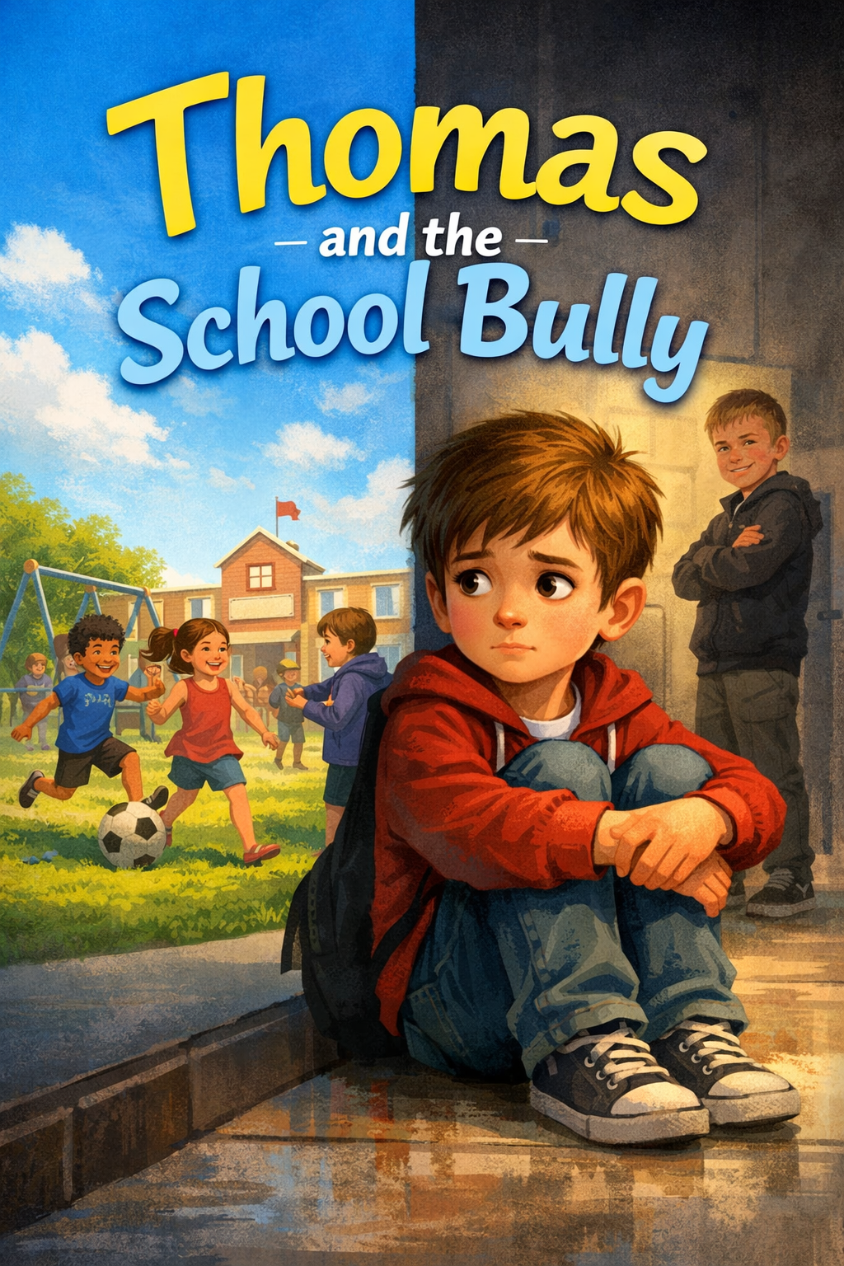
Thomas and The School Bully
By
Scott M. Speicher

Copyright © 2026
Author: Scott M. Speicher
Portions of this book have been perfected by the program Grammarly
Edited by Grammarly and the Editorial team of Digital Scribblers
No part of this book may be reproduced or used, in any form or by any means, electronic or mechanical, without permission in writing from the author.
AI generated some images under the author's direction.
About the Book
Every child deserves to feel safe, valued, and accepted at school. Yet sometimes kids face moments that make the day feel heavy, moments when hurtful words or actions appear. It might be whispers in the hallway, laughter that doesn’t feel kind, or sitting alone at lunch while everyone else seems to have a place to belong.
Thomas and the School Bully is a story about those moments.
But more than anything, it’s a story about courage.
Not the loud, heroic kind we often see in movies, but the quiet courage children show every day. The courage to speak up, to ask for help, or to show kindness when staying silent might feel easier.
It’s a story about a child discovering that even small actions can make a difference. It reminds us that people are often more complicated than they seem, and that those who act cruelly may be struggling with something of their own.
Most of all, it’s a story about the power a child has to change the world around them. A single word, an open seat at the lunch table, or a small act of compassion can transform someone’s day—and even an entire school.
If this book helps just one child feel a little less alone…
If it inspires one child to stand up for another…
Or if it helps a child realize that their voice truly matters…
Then Thomas’s story will have done exactly what it was meant to do.
Because sometimes the smallest acts of courage and kindness can change everything. 🌟

Thomas and the School Bully
A Story About Courage, Kindness, and Standing Up for Others

Table of Contents

- The First Day Suprise
- Words That Hurt
- The Quiet Kid in The Corner
- Talking to Someone Who Helps
- Standing a Little Taler
- The Lunch Table Choice
- When Standing Up Feels Scary
- Friends Make You Stronger
- Understanding The Bully
10. The Kindness That Changed the School

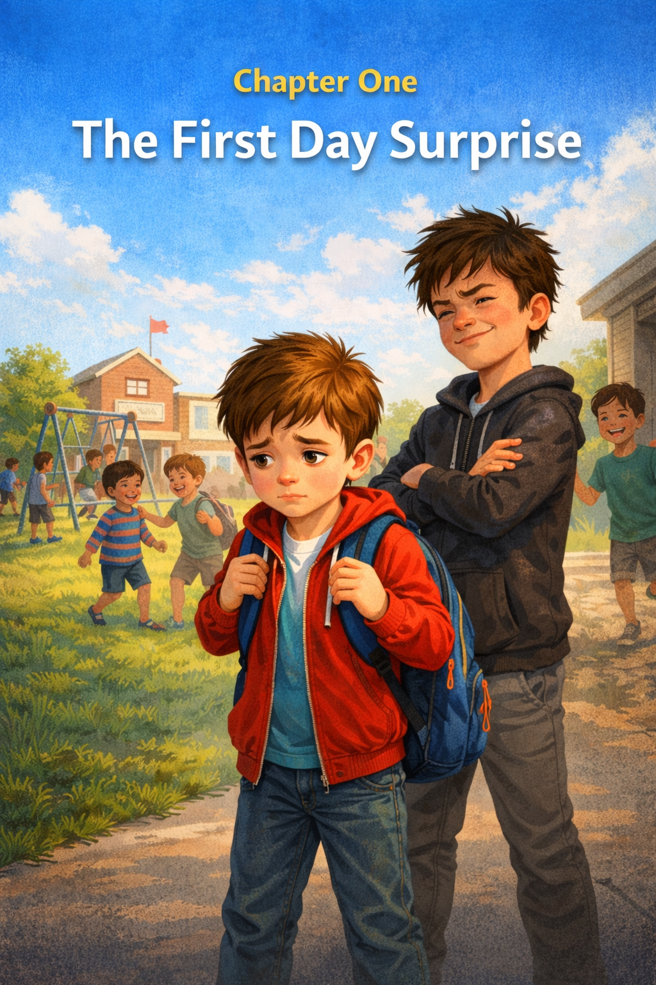
Chapter One
The First Day Surprise
The morning sun slipped through Thomas’s bedroom window, painting warm stripes across the floor. It was the first day of school, and Thomas had already been awake for a while, staring at the ceiling and thinking about all the things that might happen.
Would his teacher be nice?
Would he make new friends?
Would he remember where his classroom was?
Thomas rolled out of bed and stretched. At the foot of the bed, a soft gray blur lifted its head. “Good morning, Whiskers,” Thomas whispered. Whiskers blinked slowly and padded across the blanket, rubbing against Thomas’s arm as if to say hello. His fluffy tail swished back and forth while he purred.
“I think today’s going to be a big day,” Thomas told him.
Downstairs, the kitchen smelled like toast and warm pancakes. Thomas’s mom set a plate on the table and smiled.
“First-day jitters?” she asked. Thomas shrugged. “Maybe just a few.” His mom gave him a gentle hug. “That’s normal. New beginnings can feel a little wobbly at first.”
After breakfast, Thomas grabbed his bright blue backpack and headed for the door. Whiskers followed him all the way to the front hallway. “Guard the house while I’m gone,” Thomas said with a grin. Whiskers sat down proudly, like a tiny, fluffy security guard.
When Thomas arrived at school, the playground buzzed with noise. Children ran across the grass, laughing and chasing one another. Others climbed the jungle gym or waited in line for the tall silver slide.
Thomas took a deep breath. Everything felt bigger than he remembered.
He spotted a few kids from last year and waved. Then he walked toward the slide and joined the line. A tall boy with messy dark hair stood ahead of him. The boy glanced back and looked Thomas up and down.
“That backpack looks like it belongs in kindergarten,” the boy said with a smirk. A couple of kids nearby giggled. Thomas blinked, surprised. “My mom picked it,” he said quietly.
“Well, it looks silly,” the boy replied. “And you’re standing too close.”
The boy stepped backward, bumping into Thomas on purpose. Thomas stumbled but caught his balance. For a moment, he didn’t know what to say. He hadn’t done anything wrong.
A whistle blew across the playground, and the children began climbing down from the slide. Thomas stepped forward in line again.
The boy rolled his eyes and turned away.
Thomas felt a strange knot twist in his stomach.
It wasn’t the kind of hurt you feel when you trip and scrape your knee.
It was quieter than that.
But it still hurt.
Later that morning, Thomas sat at his desk while the teacher wrote math problems on the board. Pencils scratched softly across paper.
But Thomas’s thoughts kept drifting back to the playground.
Why had that boy said those things?
The boy sat two rows away now, leaning back in his chair. Thomas didn’t know his name yet. He only knew that something about the day felt different from what he expected.
School was supposed to feel exciting. Now it also felt… confusing.
When the final bell rang, Thomas walked home slowly. The front door opened before he reached it.
Whiskers burst outside like a furry rocket and wrapped himself around Thomas’s legs.
“Whoa—easy!” Thomas laughed.
The cat meowed loudly, as if demanding a full report of the day.
“Well,” Thomas said softly, scratching behind Whisker’s ears, “school was… interesting.”
Inside the house, the warm smell of dinner filled the air.
Maybe tomorrow will feel easier.
But even though the day had started with excitement and ended with questions, Thomas knew one thing for sure:
Every new beginning holds surprises.
Some are wonderful.
And some are harder than we expect.
But every surprise is part of a story still being written.
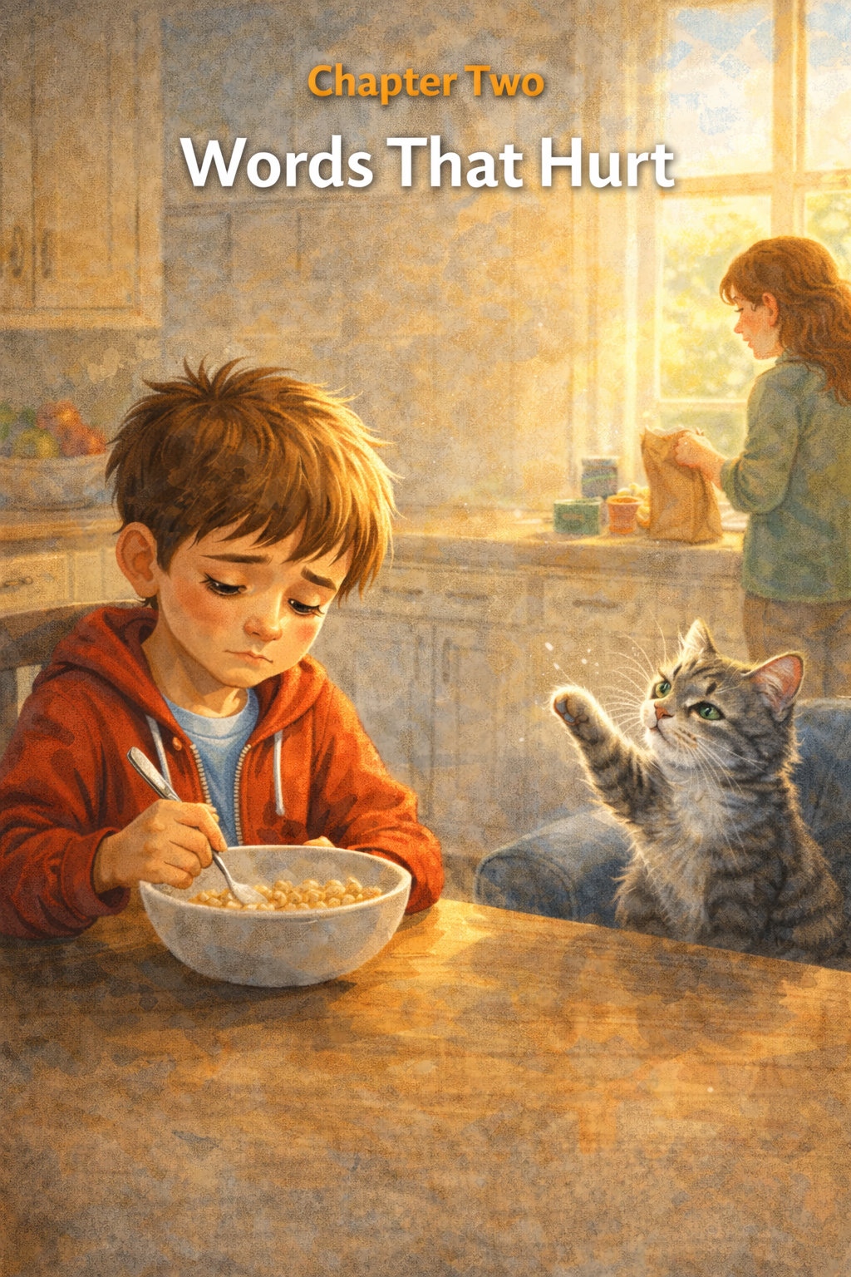
Chapter Two
Words That Hurt
The next morning felt quieter.
Thomas sat at the kitchen table, stirring his cereal slowly. The spoon clinked softly against the bowl while sunlight poured through the window.
Across the room, Whiskers watched a dust speck float through the air, batting at it as it might suddenly turn into something exciting.
Thomas wished his thoughts were that simple.
“Big plans for today?” his mom asked as she packed his lunch.
Thomas shrugged.
“I guess.”
He didn’t tell her about the boy at recess. Not yet. He wasn’t sure how to explain it.
After all, the boy had only said a few words.
Words weren’t supposed to hurt that much.
Right?

The school hallway buzzed with voices when Thomas arrived. Lockers slammed. Backpacks rustled. Kids hurried to their classrooms.
Thomas slipped into his seat just before the bell rang.
For a while, the morning went smoothly. The class read a story together and worked on spelling words. Thomas even raised his hand to answer a question.
But when recess came, the knot in his stomach returned.
The playground felt different today.
Louder.
Busier.
Thomas joined a group of kids kicking a soccer ball across the grass. For a few minutes, he forgot about yesterday.
Until a voice cut through the game.
“Well, look who’s back.”
Thomas turned.
The same tall boy from the day before stood nearby, arms crossed.
“You run like a turtle,” the boy said, shaking his head. “Slow and wobbly.”
A few kids nearby laughed.
Thomas felt his cheeks grow warm.
“I’m trying,” he said quietly.
“Trying isn’t the same as being good,” the boy replied.
The ball rolled past Thomas, but suddenly, he didn’t want to chase it anymore.
He stepped away from the game and sat on a bench near the edge of the playground.
The laughter faded behind him, but the words stayed.
Slow.
Wobbly.
Not good.
They echoed in his mind like a song he couldn’t turn off.

Thomas had heard jokes before.
Sometimes his dad teased him about leaving socks on the floor.
Sometimes his friends joked about silly things during games.
Those kinds of jokes usually ended with laughter.
But this felt different.
Those words didn’t feel playful.
They felt sharp.
Like stepping on a tiny rock inside your shoes, something small that kept bothering you with every step.
Thomas stared down at the dirt beneath his sneakers.
The boy was just joking.
Thomas was being too sensitive.
But deep inside, he knew something didn’t feel right.

After school, Thomas walked home slowly again.
The front door opened, and Whiskers trotted toward him, meowing happily.
Thomas dropped his backpack by the door and sat on the couch.
Whiskers jumped up beside him and curled into a fluffy ball.
“You don’t call people names,” Thomas said, scratching behind the cat’s ears.
Whiskers blinked calmly.
“Even when you steal my chair,” Thomas added.
The cat purred louder.
Thomas leaned back against the couch cushions and stared at the ceiling.
For the first time, he began to understand something important.
Not all teasing is harmless.
Some words are meant to make people laugh.
But some words are meant to make someone feel small.
And when words are used that way, that isn’t just joking anymore.
That’s bullying.
Thomas didn’t know yet what he was going to do about it.
But he knew one thing for certain.
Those words hurt.
And no one should have to carry hurt like that alone.
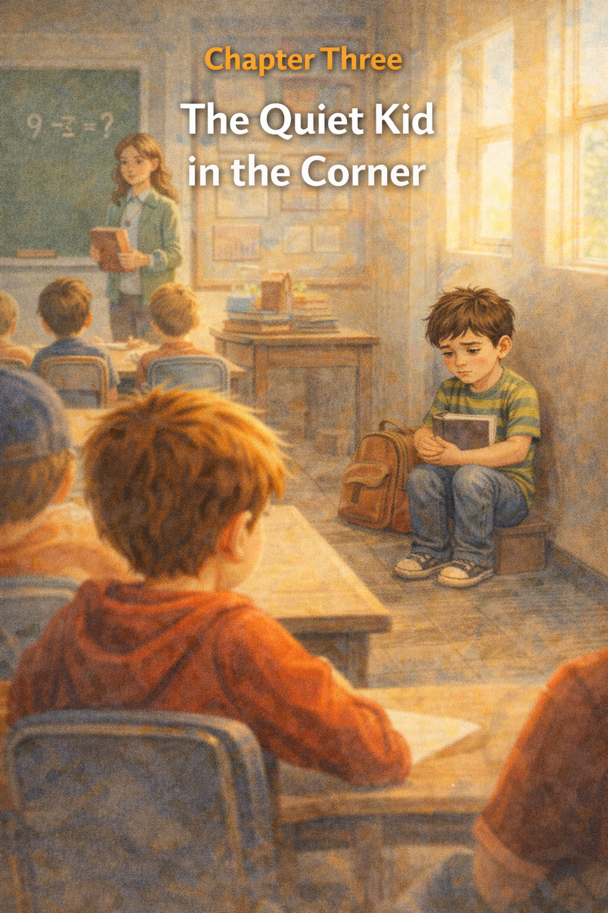
Chapter Three
The Quiet Kid in the Corner
The next morning, the sky looked soft and pale, as if it were still waking up.
Thomas tied his shoes by the front door while Whiskers circled his feet, brushing his fluffy tail against Thomas’s ankles.
“You’re going to trip me,” Thomas laughed quietly.
Whiskers meowed as if to say he didn’t believe that for a second.
Thomas grabbed his backpack and headed out the door.
The walk to school felt longer today.
Not because the distance had changed—but because his thoughts were heavy.
He kept remembering the playground.
The teasing.
The laughter.
And the strange feeling that came afterward, like a small stone sitting inside his chest.

At school, the morning passed slowly.
Thomas listened to the teacher read a story and tried to focus on his worksheet. But occasionally, his eyes drifted across the room.
Max sat two desks away.
Thomas knew his name now.
Max leaned back in his chair, tapping his pencil against the desk like he was bored with everything.
When recess came, Thomas stepped outside and took a deep breath of the cool air.
The playground buzzed with energy. Kids ran across the field, climbed the jungle gym, and shouted during games of tag.
Thomas wandered toward the swings.
But before he reached them, he heard a familiar voice.
“Well, look who it is.”
Thomas turned.
Max stood near the basketball court with two other kids.
But this time, they weren’t looking at Thomas.
They were looking at someone else.
A smaller boy stood near the fence, clutching a book against his chest. His shoulders were hunched like he was trying to shrink.
“Why do you always carry that dumb book around?” Max said.
The boy didn’t answer.
One of the other kids snickered.
“Maybe he thinks reading makes him smarter than everyone.”
Max reached out and tapped the book with two fingers.
“Or maybe he just doesn’t have any friends.”
The boy’s face turned red, but he still didn’t say anything.
Thomas felt something twist inside him.
The same tight feeling as yesterday.
Except now he wasn’t the one standing there.
He was watching it happen to someone else.

The boy slowly stepped away and walked toward the far corner of the playground.
He sat down on the grass near the fence, opened his book, and pretended to read.
Thomas stood frozen for a moment.
Then, without thinking, he walked over.
The boy glanced up when Thomas approached.
His eyes looked surprised, like he didn’t expect anyone to come near.
“Hi,” Thomas said.
The boy nodded slightly.
Thomas sat down beside him.
“I’m Thomas.”
The boy hesitated for a moment.
“Eli,” he said quietly.
They sat in silence for a few seconds while the sounds of the playground filled the air.
Thomas looked at the book in Eli’s hands.
“What are you reading?” he asked.
Eli held up the cover.
“It’s about space.”
Thomas’s eyes brightened.
“Really? I like space.”
Eli gave a small smile.
For the first time that morning, Thomas felt the tight knot in his chest loosen just a little.

Across the playground, Max and the other kids had already moved on to something else.
But Thomas wasn’t thinking about them anymore.
He was thinking about something new.
Yesterday, he thought he was the only one being picked on.
The only one who felt embarrassed.
The only one who didn’t know what to do.
But now he understood something important.
Sometimes bullying doesn’t just happen to one person.
Sometimes another kid sits quietly in the corner.
Someone who feels just as small.
Just as lonely.
Just as unsure.
Thomas looked over at Eli.
“Do you want to come play after recess?” he asked.
Eli blinked.
“Really?”
“Yeah,” Thomas said with a small smile. “Really.”
Eli closed his book slowly.
And for the first time that day, he didn’t look like the quiet kid in the corner anymore.

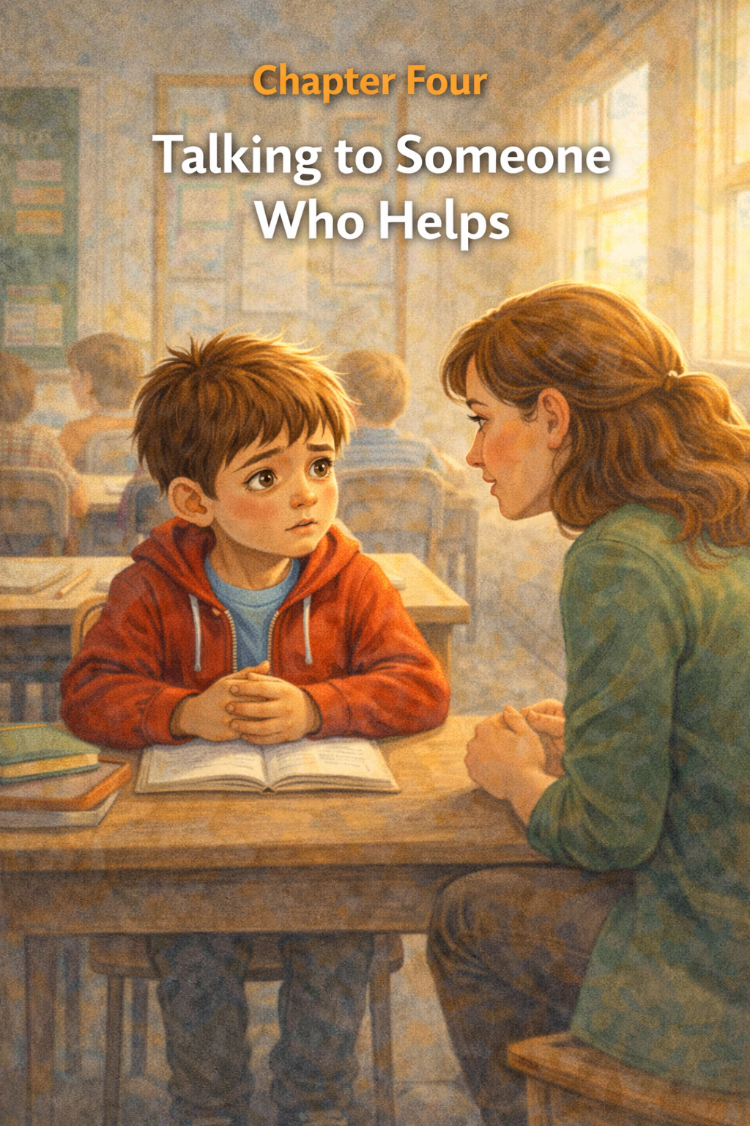
Chapter Four
Talking to Someone Who Helps
The playground was quiet again the next morning.
Not because there were fewer children, but there were just as many as always. Kids ran across the grass, swings creaked back and forth, and laughter floated through the air.
But for Thomas, everything felt a little different.
He noticed things now.
The way some kids stayed close to their friends.
Eli sometimes stood near the fence before deciding where to go.
The way Max’s voice could suddenly make a happy moment feel uncomfortable.
Thomas walked toward the swings where Eli was standing.
“Hey,” Thomas said.
“Hey,” Eli replied.
They pushed the swings slowly at first, letting the cool morning air rush past their faces.
After a few minutes, Eli asked quietly, “Do you think Max will bother us today?”
Thomas didn’t know the answer.
“I’m not sure,” he said honestly.
They swung in silence for a moment.
Then Thomas remembered something his mom always said.
If something feels too big to carry alone, share it.
Thomas slowed his swing until his feet touched the ground.
“I think we should tell someone, “He said.
Eli looked nervous.
“Like who?”
“A teacher,” Thomas said. “Or my mom. Or your parents.”
Eli stared at the ground.
“I don’t want to get anyone in trouble.”
Thomas understood that feeling.
He didn’t want to cause problems either.
But he also knew something else now.
Bullying doesn’t stop just because you ignore it.
Sometimes it stops because someone helps.

Later that morning, Thomas raised his hand in class.
“Yes, Thomas?” the teacher said.
“Can I talk to you for a minute?” he asked.
His teacher nodded kindly.
“Of course.”
After the class began working quietly, she knelt beside Thomas’s desk.
“What’s on your mind?”
Thomas hesitated.
It felt strange saying the words aloud.
But he remembered Eli sitting alone by the fence.
He remembered the teasing.
The laughter.
The way those words stayed with him long after the playground was empty.
So, Thomas took a breath.
“Something is happening at recess,” he said.
His teacher listened carefully as Thomas explained what had been going on.
He told her about the teasing.
About Max.
About Eli.
He even told her how the words made him feel.
When Thomas finished, the room was quiet for a moment.
Then his teacher gave him a gentle smile.
“Thomas,” she said softly, “I’m really glad you told me.”
Thomas blinked.
“You’re not mad?”
“Mad?” she said kindly. “Not at all. Talking about a problem is one of the bravest things a person can do.”
Thomas hadn’t thought of it that way.
He thought bravery meant standing up to someone bigger.
Or doing something loud and dramatic.
But bravery could also be something quieter.
Like asking for help.

The teacher stood and looked across the classroom.
“Sometimes kids think they have to solve everything on their own,” she said. “But that’s not how schools—or families—are supposed to work.”
She crouched down beside Thomas again.
“When adults know what’s happening, we can help make things better.”
Thomas felt a small wave of relief wash through him.
Like taking off a heavy backpack after carrying it for too long.
“You did the right thing,” she said.
Thomas nodded slowly.
For the first time since the teasing had started, he didn’t feel like he was carrying the problem alone.

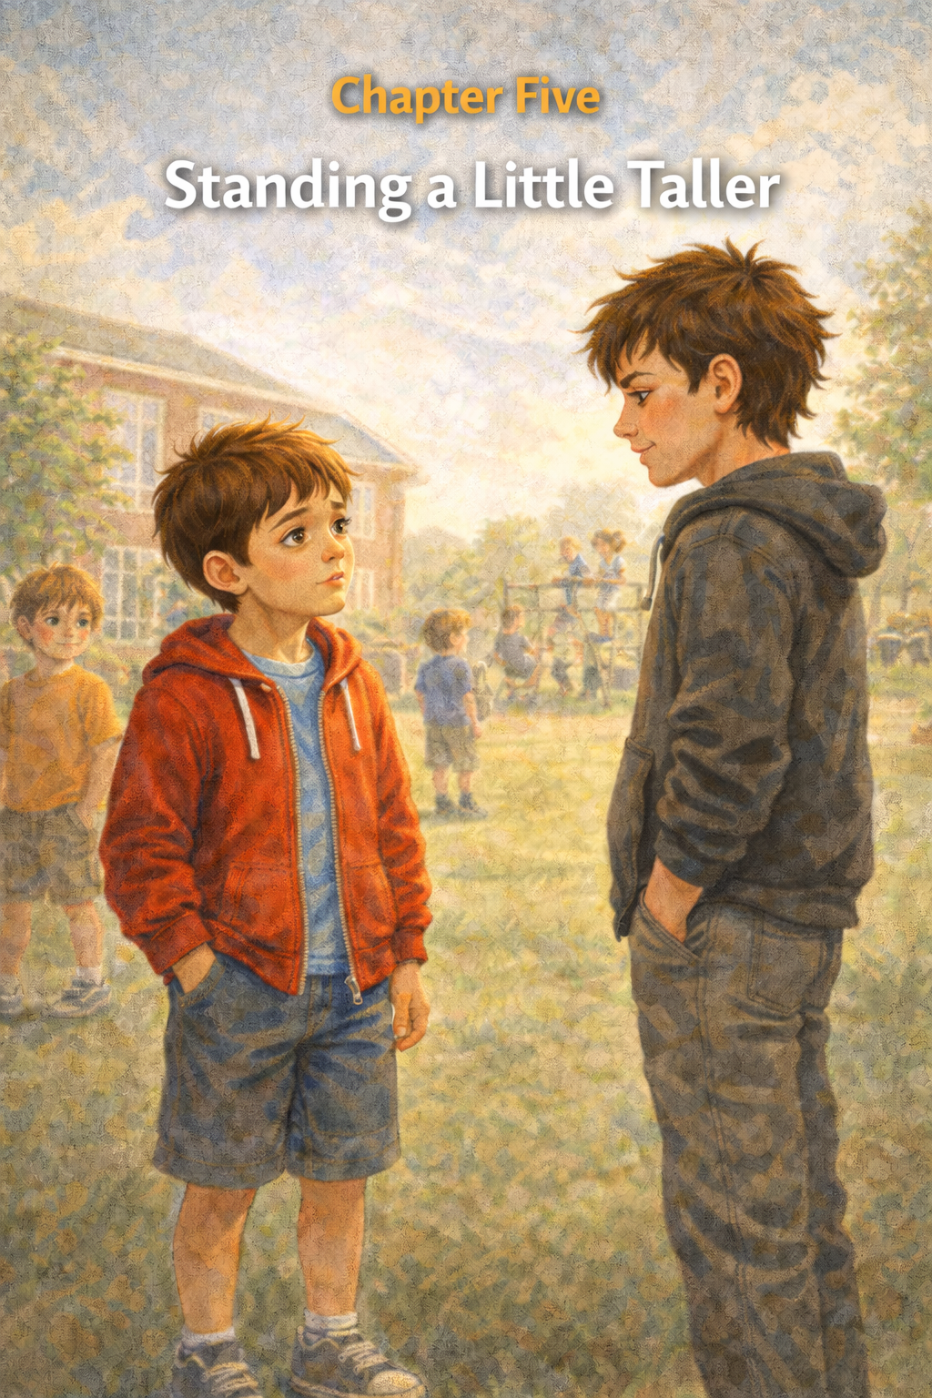
Chapter Five
Standing a Little Taller
The next morning felt different.
Thomas could not explain why, but something inside him felt steadier—like when the wind finally stopped shaking the branches of a tree.
He walked to school with his backpack bouncing gently against his shoulders. The air smelled like fresh grass, and the sun peeked through the clouds in soft golden patches.
At the front door of the school, Thomas paused for a moment.
Yesterday, he talked to his teacher.
Just saying the words aloud had made him feel lighter.
He took a deep breath and stepped inside.

The morning lessons passed quickly. Thomas answered a question during reading time and even helped pass out papers for the class.
But when the recess bell rang, his stomach gave a small nervous flip.
He knew Max would be outside.
Still, Thomas remembered something his teacher had said the day before.
Standing up for yourself doesn’t mean being mean back. It means being calm and clear about what is and is not okay.
Thomas repeated those words quietly in his head as he walked toward the playground.

The playground buzzed with noise.
Children ran across the grass chasing a soccer ball. The swings creaked back and forth in the breeze. Laughter floated through the air.
Thomas spotted Eli near the monkey bars.
“Hey,” Thomas said.
“Hey,” Eli replied with a small smile.
They started climbing the bars together, swinging from one rung to the next.
For a while, everything felt normal.
Until a familiar voice drifted across the playground.
“Well, if it isn’t the turtle runner.”
Thomas turned.
Max stood a few steps away, hands in his pockets.
Thomas felt the old nervous feeling rise in his chest.
But this time, something else rose with it.
Confidence.
Not loud confidence.
Not the kind that shouts.
The quiet kind.
The kind that stands steady.
Max smirked. “You still move slow.”
Thomas climbed down from the bars and brushed his hands on his shorts.
Then he looked Max straight in the eye.
“Please stop,” Thomas said calmly.
Max blinked.
“I don’t like being called names.”
For a moment, the playground felt strangely quiet.
Max shifted his feet.
“You’re just joking, right?” he said.
Thomas shook his head.
“No.”
His voice wasn’t angry.
It wasn’t loud.
But it was firm.
Max looked around, noticing a few kids nearby watching the conversation.
He shrugged.
“Whatever,” he muttered.
Then he turned and wandered toward the basketball court.

Thomas stood there for a moment, surprised.
His heart thumped fast in his chest.
Eli looked at him wide-eyed.
Eli leaned in and murmured, "Did you really say that?"
Thomas nodded slowly.
“Yeah,” he said.
Then he realized something.
His shoulders were no longer hunched.
His hands were no longer clenched.
He felt… taller.
Not because he had grown.
But because he had stood up for himself.

Later that afternoon, Thomas walked home with a small smile on his face.
Whiskers greeted him at the door as usual, rubbing against his legs like a fluffy welcome committee.
Thomas scooped him up and sat on the couch.
“You know something?” Thomas said.
Whiskers blinked slowly.
“I stood up for myself today.”
The cat purred loudly, clearly impressed.
Thomas leaned back against the couch cushions.
Standing up for himself felt scary at first.
But it had also felt strong.
Because sometimes courage isn’t about fighting.
Sometimes courage is simply standing a little taller…
and remembering that you deserve kindness.
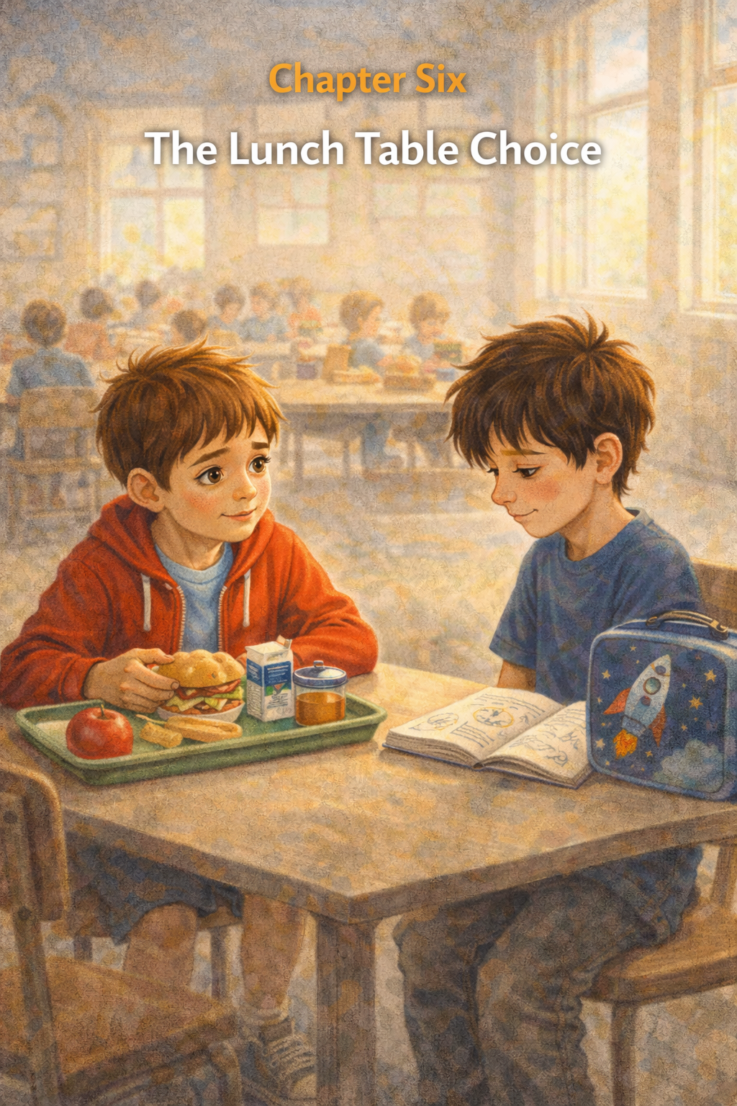
Chapter Six:
The Lunch Table Choice
The cafeteria was a sea of noise and movement. To Thomas, it always felt like a different kind of classroom—one where the lessons weren’t found in textbooks, but in the shifting geography of the lunch tables. There were the "Loud Tables" near the windows, the "Quiet Corners" by the back exit, and the vast, bustling center where most people congregated in familiar circles.
Thomas carried his tray, the scent of lukewarm pizza and apple slices wafting up. He scanned the room for his usual spot, but as he turned the corner, he saw him.
Sitting at the very end of a long, empty table was Leo. Leo was the quiet child who rarely spoke in class, the one who always seemed to be looking at something just over everyone’s shoulder. Today, he sat with his head bowed over a brown paper bag, his shoulders hunched as if trying to make himself invisible.
A group of older boys walked past, their laughter echoing. One of them nudged another, pointing at Leo’s solitary figure and whispering something that made them both snicker. Leo didn't look up, but his grip tightened on his sandwich.
Thomas felt a familiar tug in his chest. He knew where his friends were; they were calling his name from the center of the room, waving him over to a table filled with jokes and energy. It was an easy choice. It was the "safe" choice.
But then he looked back at Leo. He saw the invisible wall that isolation had built around the boy, a cycle of loneliness that seemed to grow stronger every time someone walked past him without a word.
Thomas took a breath and changed his course.
"Hey, Leo," Thomas said, his voice steady despite the sudden flutter of nerves. "Is anyone sitting here?"
Leo looked up, his eyes wide with genuine surprise. He blinked, as if to make sure he wasn't imagining it. "No," he whispered. "No one."
"Cool. Do you mind if I join you? This spot has a great view of the courtyard," Thomas said, sliding his tray onto the table and sitting down.
For a few minutes, they ate in silence. It wasn't the heavy, awkward silence of before, but something lighter. Thomas noticed Leo’s shoulders began to relax.
"I like your notebook," Thomas said, pointing to the spiral-bound book sitting next to Leo’s bag. The cover was covered in intricate, hand-drawn gears and clockwork patterns.
Leo’s face transformed. A small, tentative smile appeared. "Thanks. I... I like to design things. Mechanical things."
For the rest of the lunch period, the "isolated" boy vanished. In his place was an artist and an engineer. Leo talked about his dream of building a clock that never needed winding, and Thomas listened, realizing that by simply pulling up a chair, he had opened a door that had been locked for a long time.
As the bell rang, Thomas stood up. "See you in science, Leo?"
"Yeah," Leo said, his voice stronger than it had been all year. "See you then, Thomas."
Walking away, Thomas realized that the cafeteria didn't feel so loud anymore. He hadn't changed the world, but he had changed the world for one person. He realized that inclusion wasn't just about being nice; it was about recognizing that no one should have to be an island in a room full of people. Small acts of kindness were the bridge that brought people back to the shore.

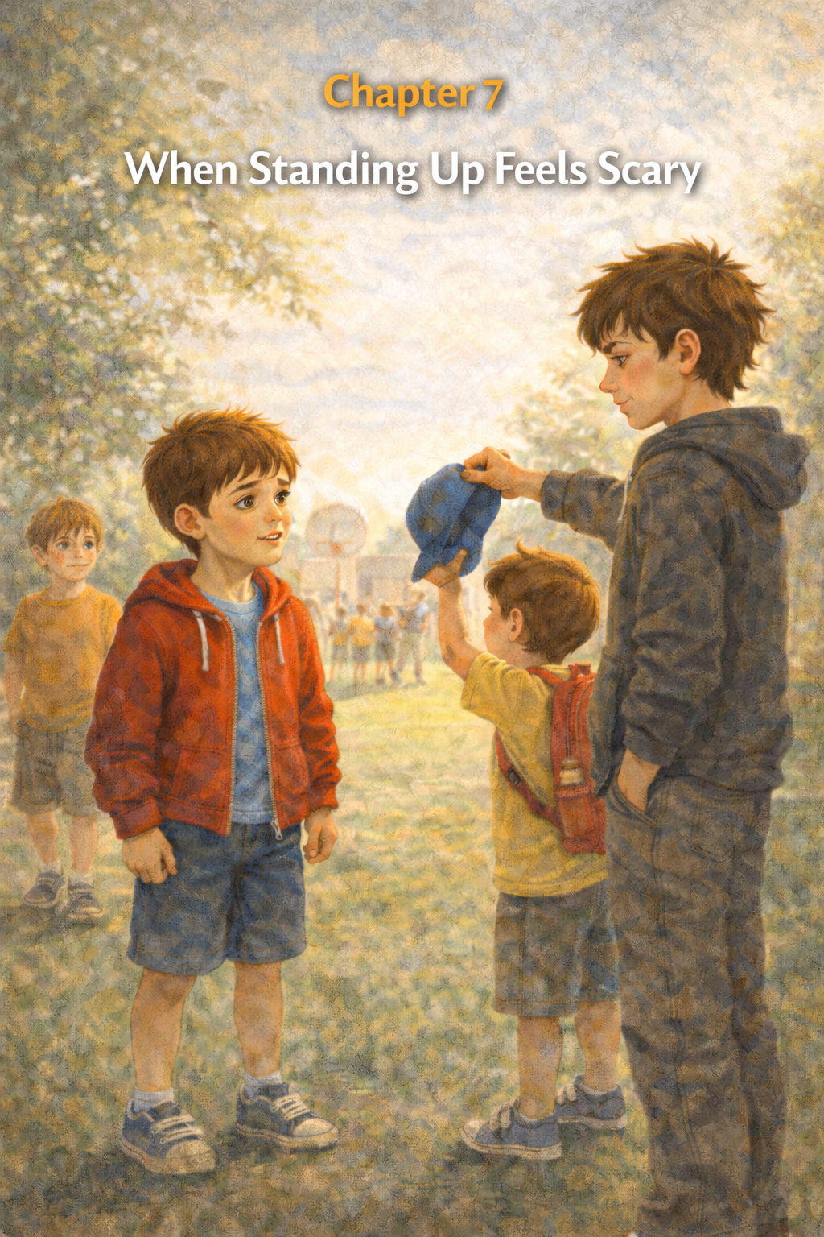
Chapter Seven
When Standing Up Feels Scary
The playground was bright with afternoon sunlight. Leaves rustled gently in the trees, and the air carried the happy noise of children running, laughing, and calling to one another.
Thomas and Eli were sitting on the grass near the edge of the field, drawing pictures in the dirt with small sticks.
Eli had drawn a rocket ship.
Thomas was trying to draw a turtle.
“It looks more like a potato,” Eli said with a grin.
Thomas laughed. “It’s a very fast potato.”
For a moment, everything felt easy.
Then a shout cut across the playground.
“Hey! Give that back!”
Thomas looked up.
Near the basketball court, a small boy stood clutching the straps of his backpack. His face looked worried, and his shoulders were pulled tight like he was trying to disappear.
Max stood in front of him.
Max held the boy’s baseball cap just out of reach.
“You want it?” Max said, raising it higher. “Come get it.”
The younger boy jumped, but he couldn’t reach it.
Some kids nearby laughed.
Thomas felt the familiar knot twist in his stomach.
He had seen this before.
He had felt this before.
For a moment, he stayed where he was.
It would be easier not to get involved.
He could pretend he didn’t notice.
He could keep drawing turtles in the dirt.
But the boy’s voice trembled again.
“Please give it back.”
Thomas’s chest tightened.
He remembered how it felt when Max teased him.
He remembered sitting on the bench alone.
He remembered how much it mattered when someone finally noticed.
Thomas glanced at Eli.
Eli had stopped drawing, too.
“Should we… do something?” Eli whispered.
Thomas didn’t answer right away.
His heartbeat is faster.
Standing up for himself had been hard enough.
Standing up for someone else felt even scarier.
What if Max laughed at him again?
What if the other kids joined in?
Thomas stared at the younger boy, still reaching helplessly for his cap.
Then he took a slow breath.
Sometimes doing the right thing feels scary.
But that doesn’t mean it’s the wrong thing.
Thomas stood up.
His legs felt a little shaky as he walked toward the basketball court.
Max was still holding the cap above the boy’s head.
Thomas stopped a few steps away.
“That’s not nice,” he said.
Max turned.
“Oh, look,” he said with a smirk. “The turtle runner is back.”
Thomas felt the heat rise in his cheeks.
But he didn’t step back.
“Give him his hat,” Thomas said calmly.
The younger boy looked at Thomas with wide eyes.
Max rolled his eyes.
“Why do you care?”
Thomas thought about that for a moment.
Because someone should.
Because it matters.
Because no one deserves to feel small.
“He asked for it back,” Thomas said.
For a moment, Max said nothing.
Then he shrugged and dropped the cap onto the grass.
“Whatever,” he muttered.
The younger boy quickly grabbed it and pulled it onto his head.
“Thank you,” he whispered to Thomas before hurrying toward the swings.
Max kicked a pebble across the pavement and walked away toward the far side of the playground.
Thomas stood still for a moment, his heart still pounding.
Then Eli ran up beside him.
“You did it,” Eli said.
Thomas let out a breath he didn’t realize he’d been holding.
“Yeah,” he said quietly.
His hands were still a little shaky.
But inside, something felt strong.
Because courage doesn’t mean you aren’t afraid.
Sometimes courage means you are afraid—
And you choose to do the right thing anyway.

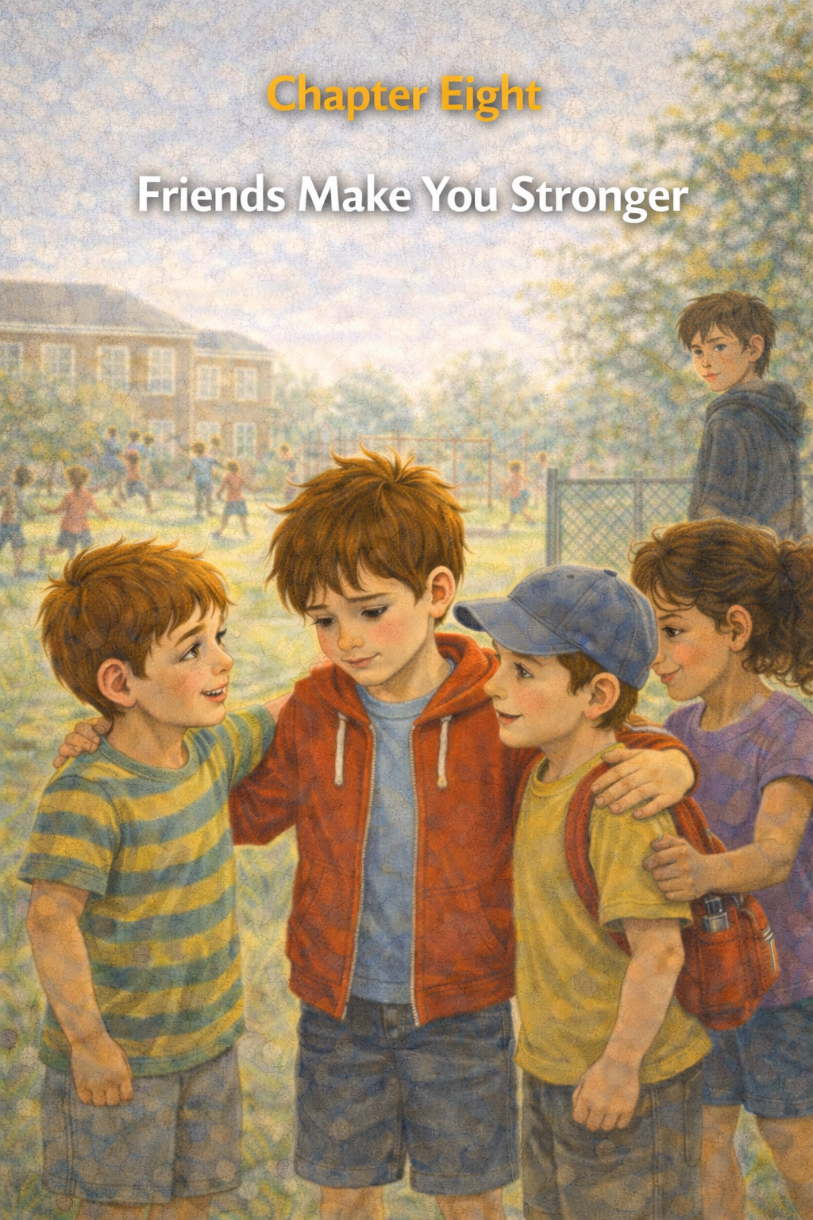
Chapter Eight
Friends Make You Stronger
The next day at school, the playground felt brighter than usual.
Not because the sun was shining—although it was—but because something had changed.
Thomas noticed it the moment recess began.
Kids were gathering in small groups across the grass. Some were kicking a soccer ball. Others were racing toward the swings.
Thomas spotted Eli near the monkey bars, and the younger boy from yesterday—the one whose hat had been taken—stood beside him.
When they saw Thomas walking toward them, both boys smiled.
“Hey, Thomas!” Eli called.
Thomas jogged over.
The younger boy adjusted his baseball cap and gave a small wave.
“My name’s Sam,” he said. “Thanks again for yesterday.”
Thomas shrugged a little, feeling shy. “It was no big deal.”
But Sam shook his head. “It was to me.”
The three of them stood quietly for a moment.
Then Eli grinned.
“Want to play soccer?”
Thomas nodded.
Soon the ball was rolling across the grass again, and more kids wandered over to join the game. A girl named Maya joined first. Then two brothers from Thomas’s class ran over to play.
Before long, a whole group of kids was laughing and running together.
Thomas passed the ball to Eli, who kicked it toward Sam. Sam nearly missed it but managed to tap it toward the goal with a big grin.
“Nice!” Thomas cheered.
The game grew louder and more cheerful as the minutes passed.
For the first time in days, Thomas forgot about worrying.
He was playing.

Across the playground, Max leaned against the fence watching the game.
He walked toward the field slowly.
“Looks crowded,” he said.
A few kids glanced his way.
But this time, something was different.
No one stepped away.
No one laughed nervously.
The group kept playing.
Eli passed the ball to Maya.
Maya kicked it toward Thomas.
Thomas ran forward and tapped it into the goal.
“Score!” Sam shouted.
Everyone cheered.
Max stood there for a moment, clearly expecting something else to happen.
But nothing did.
The game continued.
The laughter continued.
Finally, Max shrugged and wandered back toward the basketball court.
Thomas noticed Eli watching him leave.
“That was weird,” Eli said.
Thomas nodded.
But inside, he understood what had happened.
Bullies often look for someone standing alone.
Someone quiet.
Someone easy to push around.
But today, no one was alone.

When the recess bell rang, the kids slowly headed back toward the school doors.
Sam walked beside Thomas and Eli.
“Can we sit together at lunch today?” Sam asked.
“Of course,” Thomas said.
Eli nodded. “The more the better.”
As they walked inside, Thomas felt something warm spread through his chest.
Yesterday, he stood up for someone.
Today, something even better happened.
People had started standing up for each other.

That afternoon, Thomas walked home with a light step.
When he opened the front door, Whiskers came running as usual.
Thomas scooped the cat into his arms.
“You know what?” Thomas said.
Whiskers blinked slowly.
“I think things are getting better.”
The cat purred softly, clearly pleased with this news.
Thomas sat down on the couch and scratched behind Whisker’s ears.
Sometimes problems feel huge when you face them alone.
But when friends stand beside you—
when kindness spreads from one person to another—
The problem doesn’t seem so big anymore.
Because when people help each other,
when they laugh together,
when they stand side by side—
Friends make you stronger.

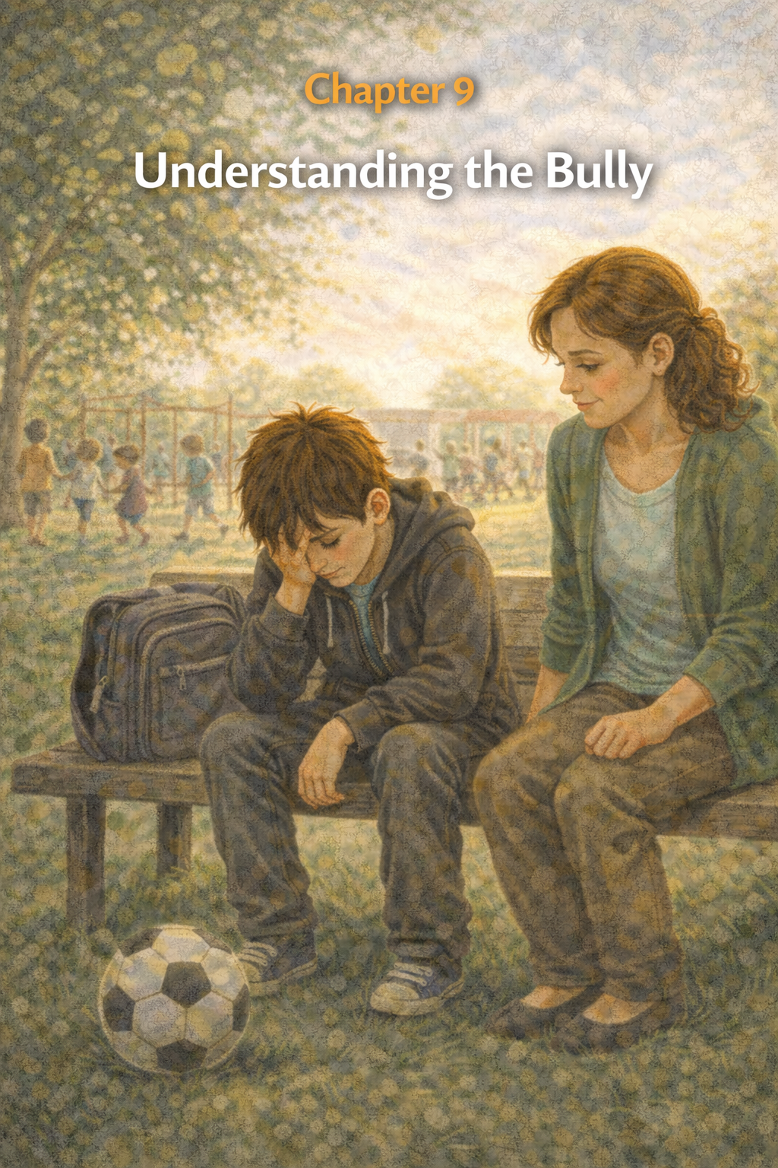
Chapter Nine
Understanding the Bully
The playground felt peaceful that afternoon.
A cool breeze rustled the leaves, and the sunlight stretched long shadows across the grass. Thomas sat with Eli and Sam near the swings, sharing a bag of crackers during recess.
Nearby, kids were laughing while they played tag.
For the first time in a long while, the playground felt like a friendly place.
Thomas kicked at the dirt with the tip of his shoe.
Then he noticed something unusual.
Max was sitting alone on a bench near the basketball court.
No teasing.
No loud voice.
No smirking.
Just sitting.
Thomas watched him for a moment.
Max stared down at the ground, slowly scraping his sneaker across the pavement.
He looked… different.
Quiet.
Eli noticed too.
“That’s weird,” Eli said softly.
“Yeah,” Sam added. “He’s usually bothering someone.”
Thomas didn’t say anything.
He just kept watching.
After a moment, their teacher walked over to the bench and sat beside Max.
They talked quietly.
Max didn’t look angry like he usually did.
Instead, he looked tired.
Thomas couldn’t hear what they were saying, but he could see Max rubbing his eyes and staring at the ground again.
The teacher nodded and spoke gently.
Max listened.
For a long moment, neither of them moved.

Later that afternoon, when recess ended, and the class returned inside, the teacher gathered everyone on the reading rug.
“I want to talk about something important,” she said.
The room grew quiet.
“Sometimes people make unkind choices,” she continued. “Sometimes they hurt others with their words or actions.”
Thomas shifted slightly on the rug.
He knew exactly what she meant.
“But,” the teacher said softly, “sometimes the people who hurt others are hurting inside, too.”
The class stayed quiet.
“That doesn’t make bullying okay,” she added. “Everyone is responsible for treating others with respect.”
She paused.
“But understanding what someone is going through can help us respond with kindness instead of anger.”
Thomas thought about Max sitting on the bench.
Looking tired.
Looking sad.
Looking quite different from the boy who liked to tease people.

After school, Thomas slowly packed his backpack.
As he stepped into the hallway, he noticed Max standing near the lockers.
Max looked up for a moment.
For the first time, he didn’t smirk.
He just nodded once and looked away.
Thomas walked outside, thinking about what the teacher had said.
People who hurt others are sometimes hurting themselves.
That didn’t mean the teasing was okay.
It wasn’t.
But there was more to Max’s story than Thomas understood.

When Thomas arrived home, Whiskers greeted him at the door like usual, weaving between his legs and meowing loudly.
Thomas picked him up and carried him to the couch.
“You know,” Thomas said, scratching behind the cat’s ears, “people are complicated.”
Whiskers blinked slowly.
Thomas leaned back and stared at the ceiling.
Max had made some unkind choices.
That was true.
But Max was dealing with problems Thomas couldn’t see.
Something in Max’s world felt broken.
That didn’t excuse the bullying.
But it helped Thomas understand something important.
You can stand up for what’s right…
and still care about people.
Because kindness doesn’t mean letting someone hurt others.
It means believing people can learn to do better.
And sometimes, the first step toward change is understanding that everyone has a story—even the bully.

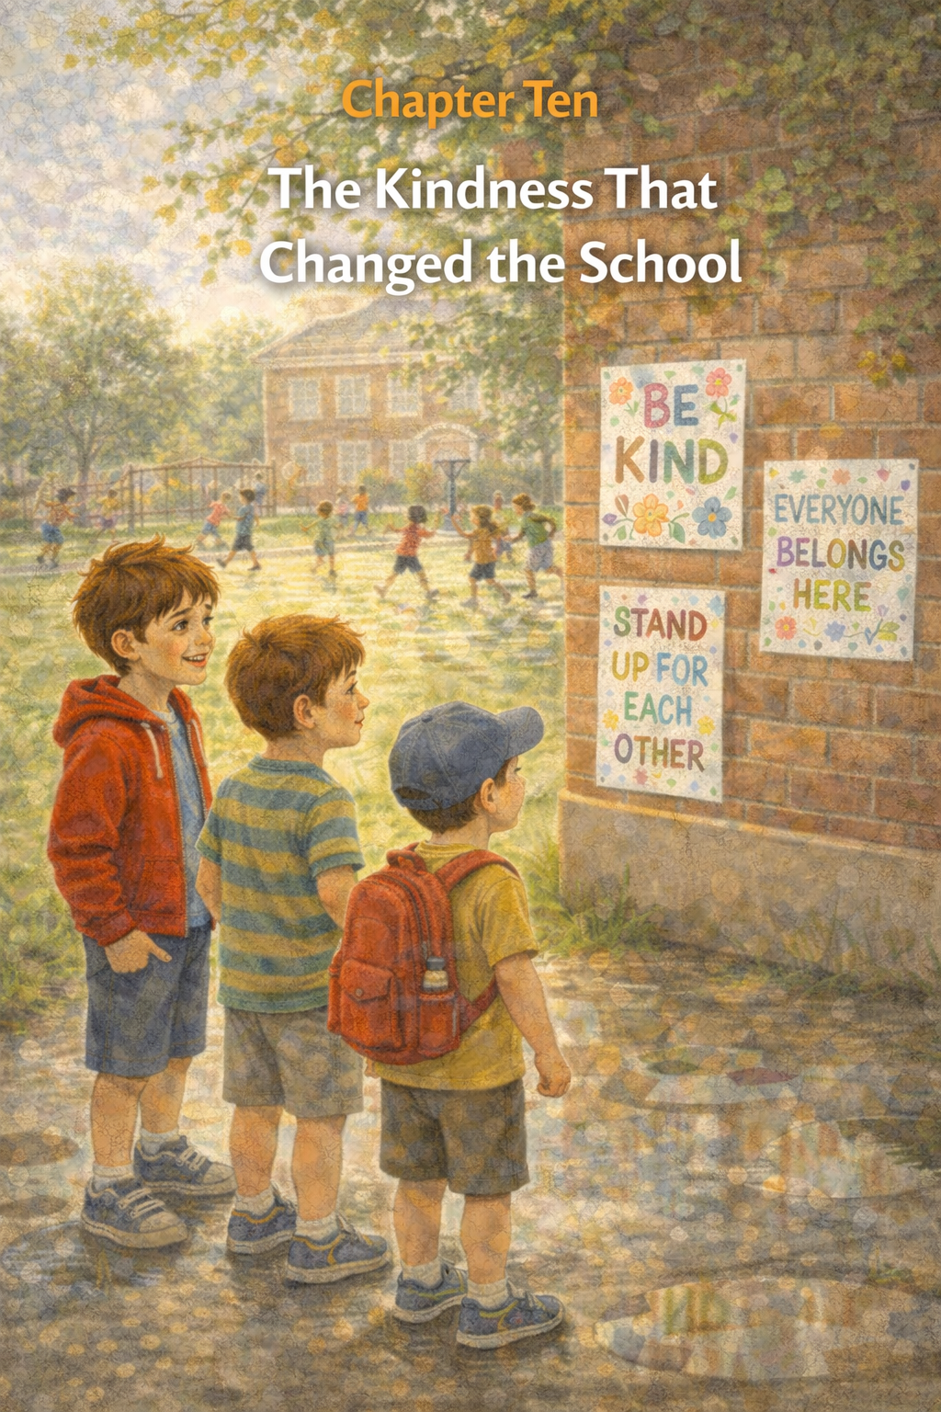
Chapter Ten
The Kindness That Changed the School
Spring had begun to arrive at Thomas’s school.
The trees along the playground were starting to grow bright green leaves again, and the air smelled fresh after a light morning rain. Puddles shimmered on the black top, and children carefully stepped around them as they hurried outside for recess.
Thomas walked across the playground with Eli and Sam beside him.
They were laughing about a silly story Sam had told during lunch when Eli suddenly pointed toward the school wall.
“Hey… what’s that?”
Thomas looked up.
Colorful posters were taped along the brick wall near the playground doors.
Some were written in bright markers. Others were decorated with drawings and stickers.
Thomas walked closer to read one.
BE KIND.
Another one said:
EVERYONE BELONGS HERE.
And another read:
STAND UP FOR EACH OTHER.
Thomas smiled.
“Did the teachers make these?” Sam asked.
Just then, Maya ran up to them.
“Nope,” she said proudly. “Our class did.”
She pointed toward the classroom windows.
“The teacher said if we want a kinder school, we all have to help build it.”
Thomas looked at the posters again.
The messages were simple.
But they felt powerful.

Later that afternoon, during class, the teacher gathered everyone on the reading rug.
“I’ve been very proud of the way many of you have treated each other lately,” she said.
Thomas glanced around the room.
Some kids were smiling.
Some looked thoughtful.
The teacher continued, “Kindness spreads when people choose to show it. One small action can inspire many others.”
She paused and looked around the class.
“Standing up for someone who is being treated unfairly takes courage.”
Thomas felt Eli nudge his shoulder gently.
The teacher smiled.
“And when one person is brave enough to do that,” she said, “others often find their courage too.”

At recess, the soccer field filled quickly.
Thomas passed the ball to Eli, who kicked it toward Maya.
Sam ran beside them, laughing when he nearly tripped over his own feet.
Kids from different classes joined the game now.
The field buzzed with energy and happy shouts.
Across the playground, Max stood near the basketball court.
For a moment, Thomas wondered if Max might walk over.
But Max watched the game.
Then, after a minute, he slowly picked up a ball and began shooting hoops.
No teasing.
No shouting.
Just playing.
Thomas noticed something important.
The playground felt different now.
Not perfect.
But, better, Kinder, Safer.
When the final bell rang that afternoon, Thomas walked home beneath the warm afternoon sun.
Whiskers was waiting at the door when he arrived, as usual, tail flicking with excitement.
Thomas knelt to pet him.
“You should’ve seen the playground today,” he said.
Whiskers purred loudly.
“Everyone was playing together,” Thomas continued. “And nobody was being picked on.”
The cat blinked slowly, clearly approving of this development.
Thomas sat on the couch, smiling as Whiskers curled beside him.
A few weeks ago, Thomas had felt small and unsure.
He had wondered if anything could change.
But something had changed.
Not because of a big speech.
Not because of a rule.
Because someone chose kindness.
Because someone chose courage.
And then someone else did too.
And then another.
Until kindness spread across the playground like sunshine after the rain.
Thomas scratched Whiskers behind the ears.
Sometimes people think one small act can’t make much difference.
But Thomas knew better now.
Because one small act of courage…
one small moment of kindness…
can change far more than anyone expects.
Sometimes,
It can even change the entire school.
Epilogue: The Power of One
The school year ended with the same gentle sunlight that had greeted Thomas on his very first morning. As he walked across the playground one last time before summer break, he noticed how different the school's "geography" felt.
Near the basketball court, Max was playing a game of horse with a group of younger students. There were no smirks or sharp words, just the steady rhythm of the ball hitting the pavement. While Max was still quiet, the "broken" feeling Thomas had sensed before seemed to be healing, one respectful interaction at a time.
By the oak tree, Eli and Sam were huddled over a new book about deep-sea exploration. They looked up and waved Thomas over, their faces bright with the kind of confidence that only grows when you know you aren't alone.
Thomas paused by the school wall, where the "BE KIND" posters from the spring were still taped firmly to the brick. He thought back to the knot in his stomach on that first day and the heavy silence of sitting alone. He realized then that courage hadn't been about winning a fight; it had been about changing the conversation.
When he finally reached home, Whiskers was waiting on the porch, his fluffy tail swishing a rhythmic welcome. Thomas sat on the steps and scooped the cat into his lap.
"We did it, Whiskers," Thomas whispered. "The school stayed different."
As he looked out at his neighborhood, Thomas knew that the lessons of this year would stay with him long after the school doors locked for the summer. He had learned that a single voice—even a quiet one—could break a cycle of isolation. He now understood that while the world can sometimes be a place of "sharp" words and heavy moments, it is also a place where a single open seat at a lunch table can serve as a bridge.
Thomas stood a little taller, not just for himself, but for every "quiet kid in the corner" who was still finding their way. He knew that if there was kindness and the courage to share a burden, no one ever had to carry their hurt alone.
The story of the school had changed, and Thomas was ready to see what the next chapter would bring.
What do you think is next for Thomas? Would you like to explore his summer adventures with Whiskers or perhaps his transition into the next grade?

About the Author
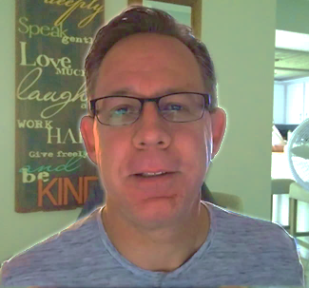
www.scottMbooks.com
Scott Speicher brings a unique blend of life experiences to his writing. A U.S. military veteran, he carries the discipline, resilience, and perspective gained through service into every story he tells. After his military career, Scott built a successful path in marketing, where he developed a deep understanding of communication, storytelling, and audience engagement. For more than 15 years, he has also worked as a professional website designer, helping businesses and individuals create meaningful online presences.
Scott Speicher is a storyteller who enjoys creating gentle, heartfelt stories that help children notice the small moments that make life meaningful. Through warm characters and simple adventures, his books encourage young readers to slow down, care for others, and appreciate the quiet joys of everyday life. Scott believes that some of the most important lessons children learn come not from grand events, but from the ordinary moments shared with family, friends, and the animals they love.
It’s a story about a child discovering that even small actions can make a difference. It reminds us that people are often more complicated than they seem, and that those who act cruelly may be struggling with something of their own.
Most of all, it’s a story about the power a child has to change the world around them. A single word, an open seat at the lunch table, or a small act of compassion can transform someone’s day—and even an entire school.

