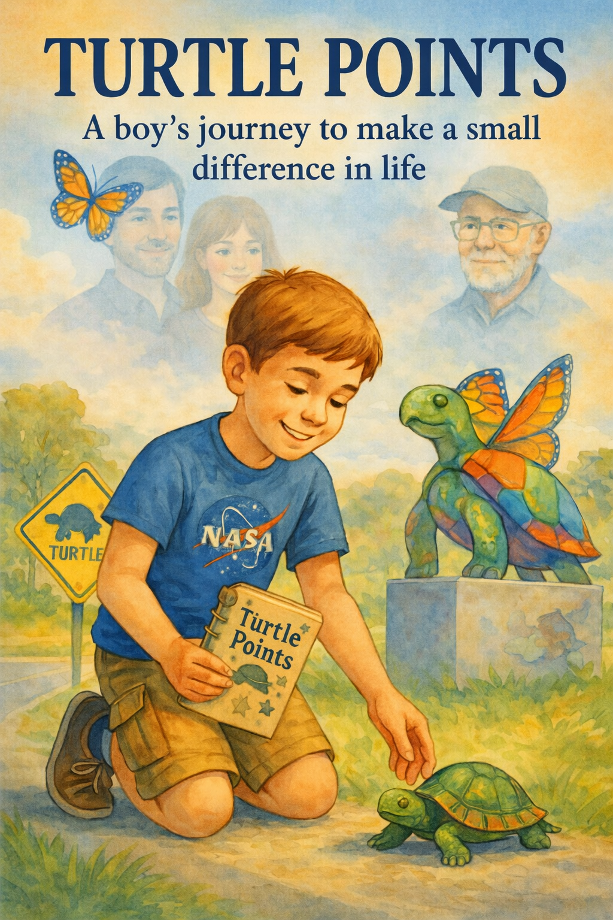
Turtle Points: One Boy’s Journey
Table of Contents
- The first Turtle
- Bad News and brave faces.
- . Mom’s Map to Heaven
- Roadside Rescue
- Turtle Points Explained
- The Boy with the Logbook
- Ben’s Story Comes to Class
- The Boy Who Counted Kindness
- Lily’s Quiet Strength
- The Space Between Words
- Angels Wear Backpacks
- Grandpa’s Secret Mission
- The Creek Mission
- The Ghost Turtle
- The One That Got Away
- Hospitals and Halo Talks
- The Weight He Carried
- A Turtle Named Hope
- Rainy Day Miracles
- The Night Sky Promise
- When the Road Gets Long
- Shells, Stars, and Prayers
- A Visit from Mr. Finch
- The Last Rescue
- The Letter Under His Pillow
- Turtle Points Redeemed
- Heaven Smells Like Grass
- The Road Keeps Going
- Epilogue

Copyright © 2026
Author: Scott M. Speicher
Portions of this book have been optimized by the program Grammarly
Edited by Grammarly and the Editorial team of Digital Scribblers
No part of this book may be reproduced or used, in any form or by any means, electronic or mechanical, without permission in writing from the author.
Some of the images are AI-generated with prompting and full control from the author


Preface

Some journeys are measured in miles. Ben's journey was measured in kindness. From the first moment he knelt in the dust to help a frightened turtle cross a busy road, he showed everyone—his family, friends, and even strangers with his shy smile—how powerful one small act of care can be. Turtle Points does not record heroic feats or big victories; it is the gentle story of a boy's life, told through logbook pages, slow rescues, and the steady rhythm of a hopeful heart. Many supported his mission: a caring grandfather who always stopped to help, and a friend who transformed loss into optimism. A community that learned to pause to help life's most vulnerable travelers. This book collects those moments like smooth stones, honoring both the laughter that fluttered like butterflies and the tears that watered new compassion. May Ben's story reminds each of us that the smallest gesture, one slow step toward helping something smaller than ourselves, can resonate farther than we can imagine.
Disclaimer
The stories, descriptions, and illustrations in this book are intended solely for inspiration and entertainment. Children should never attempt to rescue turtles or any wild animals from a roadway or other dangerous situation without direct, in-person supervision from a responsible adult. Roadways pose serious hazards—including fast-moving traffic and poor visibility—that could result in severe injury or death. The author, publisher, and any involved parties explicitly disclaim all responsibility and liability for any harm, loss, or damage—whether to person, property, or otherwise—that occurs from disregarding this warning. Always seek adult help and follow local wildlife and traffic safety laws before interacting with turtles or other wildlife.

- The First Turtle
Nine-year-old Ben finds a turtle in the middle of the road and insists on saving it. It’s his first small act of kindness—and it sparks a mission he does not yet understand.
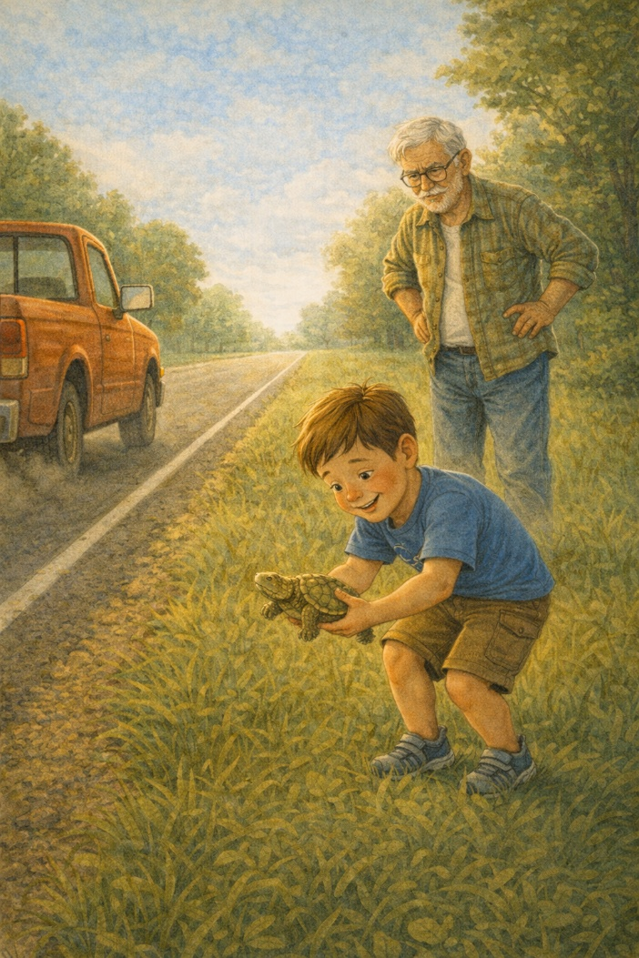
The summer sun shimmered against the asphalt, making the road seem to ripple slightly as Ben leaned against the passenger side of Grandpa’s pickup truck, humming along to a song on the radio and watching the trees blur past. At nine years old, he had a knack for noticing things others missed. His eyes scanned the road like a quiet detective, half-lost in daydreams and half-searching for something he couldn’t quite name. Then he saw it.
A dark lump, barely moving, was halfway across the road just ahead. “Grandpa! Stop! Stop the truck!” Ben shouted, nearly leaping across the dashboard. Grandpa hit the brakes with a grunt, sending a spray of gravel behind them as the truck skidded to a gentle stop on the roadside. “What is it, buddy?” Grandpa asked, confused and a little startled. “There’s a turtle. On the road. He’s gonna get squished!" Sure enough, sitting still on the hot pavement was a small turtle, slowly inching its way across the wide, dangerous expanse. There were few cars on the quiet country road, but that didn’t make it safe.
Without waiting for a reply, Ben swung the door open, checked for oncoming cars, and ran toward the turtle, his arms slightly out to balance as he moved. Grandpa shouted and chased after him, but Ben had already crouched down in front of the creature, whispering as if to introduce himself. He gently scooped up the turtle with both hands, holding it out in front of him as if it were a treasure.
“He’s heavy,” Ben said with a grin, “and muddy. But I think he’s okay.”
Grandpa, with his hands on his hips, shook his head in a mix of disbelief and pride. “You’ve got a soft heart, kid,” he said.
Ben smiled shyly and walked to the far side of the road, gently placing the turtle in the tall grass facing the woods. “There. Now he’s going the right way.”
They paused silently for a moment as they watched the turtle vanish into the brush like a slow-motion miracle. The air felt still for a second, as if the world had paused with them. Ben wiped his hands on his shorts and looked up.
“Do you think that counts?” he asked suddenly.
“Counts for what?”
“I don’t know,” Ben said, furrowing his brow slightly. “Just... counts. Like for something good.”
Grandpa looked at him with curiosity. “I think saving anything that can’t save itself counts for a lot.”
Ben nodded slowly, but the question lingered in his mind, like the fading roar of a passing truck. It stayed with him longer than he expected. He hadn’t realized yet, but those few minutes on a forgotten road had just planted a seed.
It was his first turtle.
And it wouldn’t be his last.

2. Bad News and Brave Faces
Ben’s parents take him to the doctor, where they learn his cancer has returned. While the adults struggle, Ben tries to stay strong, pretending everything’s fine.
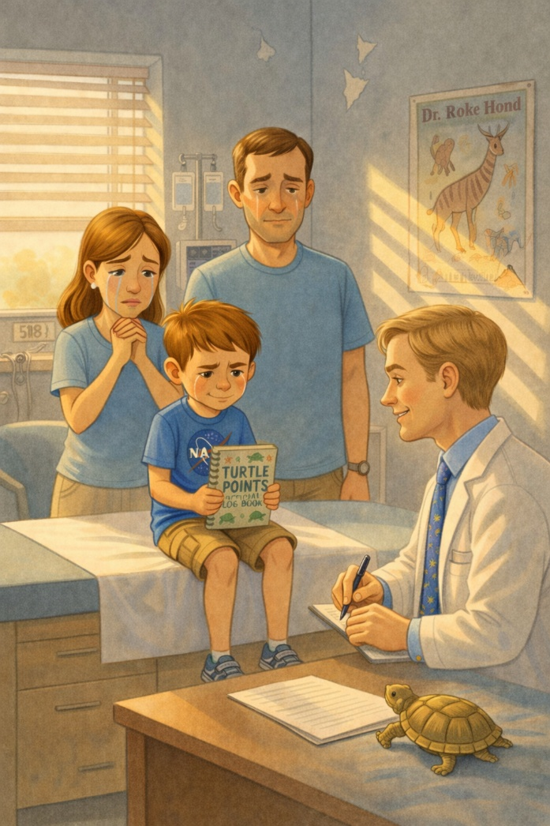
The doctor's office smelled like lemon disinfectant and quiet fear. Ben swung his legs beneath the exam table, the paper crinkling loudly with each move. He fiddled with the string on his hoodie, pretending not to notice how pale his mom looked or how his dad kept checking his watch without really seeing the time.
They had been here before.
Two years ago, when Ben was just seven, they sat in this same room—same gray walls, same faded animal poster peeling slightly in the corner. Back then, the doctor’s words had changed everything. Chemo. Blood counts. Time off from school. Weakness. Recovery.
Now they were back.
The knock on the door made everyone flinch. Dr. Hawley entered with a quiet nod, his smile not quite reaching his eyes. He looked at Ben, then at Ben’s parents, and something shifted in the air—like the room was holding its breath just before something broke.
“Ben, how are you feeling these days?” the doctor asked softly, settling onto the small stool.
Ben shrugged. “Fine, I guess. Just a little tired.”
His mom gave him a look, half-proud, half-breaking.
The doctor nodded slowly and turned the file in his hands. "The test results are in. I know this isn’t what we hoped for." He paused, choosing his words carefully. "The leukemia is back."
Silence fell. Heavy and thick. It didn’t just fill the room; it seemed to press in from all sides. Ben’s mother blinked rapidly, pressing her lips together. His dad stared straight ahead, jaw clenched as if he was holding something inside that didn’t want to stay there.
Ben sat up straighter. “So... I gotta do the treatments again?” he asked, looking directly at Dr. Hawley. His voice was steady, almost rehearsed.
Dr. Hawley nodded. “Yes. We’ll need to start soon. We’ll go over the plan together.”
Ben nodded along, nearly matching the rhythm. “Okay,” he said. “I can do that.”
He said it simply, as if it were just another plan, another step. Something manageable.
His mother finally let a tear fall down her cheek. She reached over and took his hand. Ben didn’t look at her; he just kept staring at the corner of the room where the animal poster curled like a fallen leaf.
On the way home, the car ride was quiet except for the hum of the air conditioner and the distant sound of the highway. Ben stared out the window, watching power lines rise and fall like the heartbeat of the road.
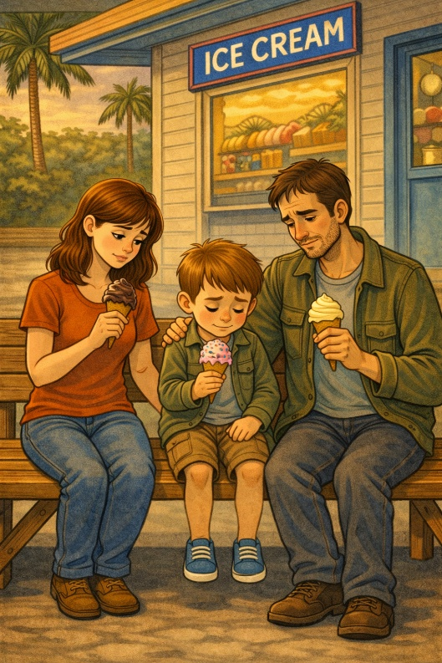
His dad’s hand gripped the steering wheel tightly, and his mom’s knuckles were white as she clutched her phone, unread messages glowing in her lap. No one said anything for a long time. The quiet felt different now. Heavier.
Ben cleared his throat. “Can we stop and get ice cream?”
Neither parent spoke for a moment, then his mom let out a teary laugh. “Of course,” she whispered.
When they pulled into the small creamery off the highway, Ben jumped out of the car and grinned at the cashier as if nothing had changed. He ordered a bubblegum swirl with sprinkles—extra sprinkles—and sat on a bench outside, licking it slowly while the Florida heat tried to melt it too quickly. The sweetness hit first. Cold, bright, almost distracting. For a moment, it worked.
He acted like everything was okay. Just another hot afternoon. Just another scoop of ice cream.
But inside, he knew. This time, it felt a little closer. A little harder to ignore.
Something big had returned. Something dark. Something he had beaten once but now had to face again. He didn’t really know what to do about it. So instead, he did what he could.
He stayed brave.
And he smiled because he knew his mom needed to see it.

3. Mom’s Map to Heaven
His mom comforts Ben with a story: every kind thing we do earns us “points” in heaven. Ben takes it to heart, turning his turtle rescue into a sacred mission.
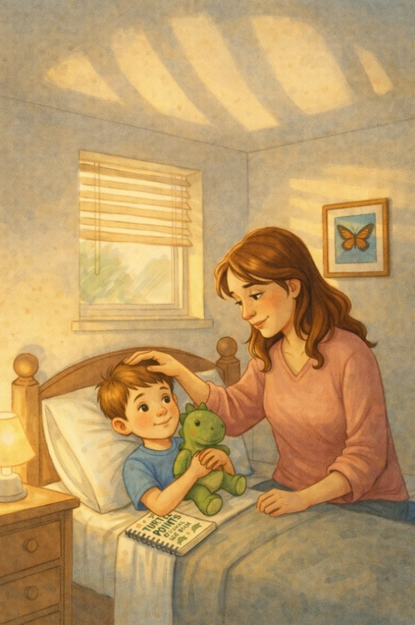
The rain fell gently that night—just a soft tapping on the roof, like someone drumming their fingers in thought. Ben lay in bed with his stuffed dinosaur held under one arm and his turtle logbook tucked beneath the pillow on the other side. The room was dark except for the warm glow of his nightlight, which cast slow-moving shadows across the ceiling, like waves. His mom sat beside him, gently brushing the hair away from his forehead with slow, comforting strokes. She had been quiet during dinner, but he could tell she was trying to stay strong. Her eyes looked tired, and her smile was fragile.
The house felt quieter than usual, as if it were listening.
"Mom?" Ben whispered.
"Yeah, sweetie?"
He hesitated. “When you die… how do you know if you get to go to heaven?”
She looked down at him, startled, then sighed softly. “That’s a big question,” she said, sliding her hand into his. “Why are you asking? “Ben shrugged. “Just wondering.”
He kept his eyes on the ceiling, like the answer might be written somewhere up there.
She didn’t press him. Instead, she leaned back and looked at the ceiling with him. “Well,” she began slowly, “when I was your age, I thought heaven kept a point system.”
Ben turned his head toward her, eyebrows raised. “Like a game?”
She smiled. “Sort of. My grandma told me that every time you do something kind, it adds a little point to your name. Not real points, like in a video game—just the kind you feel in your heart. And when you help someone, forgive someone, or make someone feel less alone, you earn more. Enough of those… and the gates of heaven open wide.”
Ben was quiet for a moment. “So, like… if you help a turtle cross the road?”
His mom laughed softly. “Exactly like that.”
“Do turtles get points too?”
“I think turtles don’t need points. I think they get in.”
Ben nodded, clearly thinking hard. “How many points do you think I have?”
She gently kissed his forehead. “More than most grown-ups I know.”
He didn’t smile right away. He just held onto that answer for a second, like it mattered more than he expected.
That night, after she turned off the light and closed the door, Ben slipped the logbook out from beneath his pillow. In the top corner of the first page, he drew a small box and wrote:
Turtle Points = #1
(Saved: 1 turtle today. No name yet. I'll ask next time.)
He paused after writing, tapping the pencil lightly against the page, thinking.
He closed the logbook and set it down beside the dinosaur. Then he looked up at the ceiling and whispered, “I’m coming. Slowly. But I’m coming.”

4. Roadside Rescue
Ben and his grandfather often drove country roads together, searching for turtles to save. They shared a deep bond through this quiet, meaningful routine. Ben asked softly, 'When you were in World War II, were you scared?' His grandpa looked down and smiled. “Every day I was there.” Ben responded, “How did you get through the tough times?” He answered, “Just take one day at a time and make the best of it.”
It was the kind of answer that stayed with Ben, even after the conversation ended.
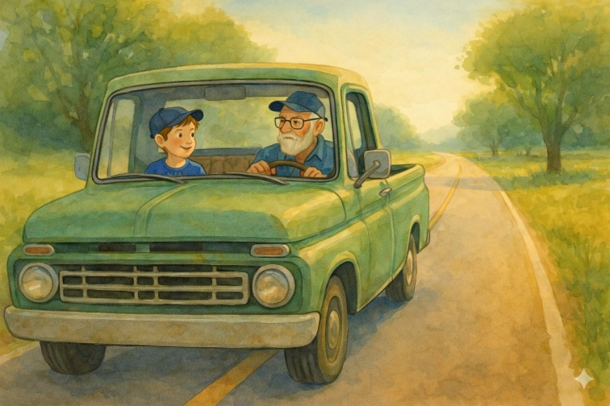
The next day was a Saturday morning that smelled like cut grass and pancakes, a kind of morning that made the world feel simple again.
Ben was already dressed when Grandpa pulled into the driveway—cargo shorts, a faded NASA T-shirt, and a baseball cap that had seen better days. He clutched his logbook and tucked it into his backpack as if it were a sacred object.
“You ready for patrol?” Grandpa called from the truck window.
Ben nodded seriously. “Let’s roll.”
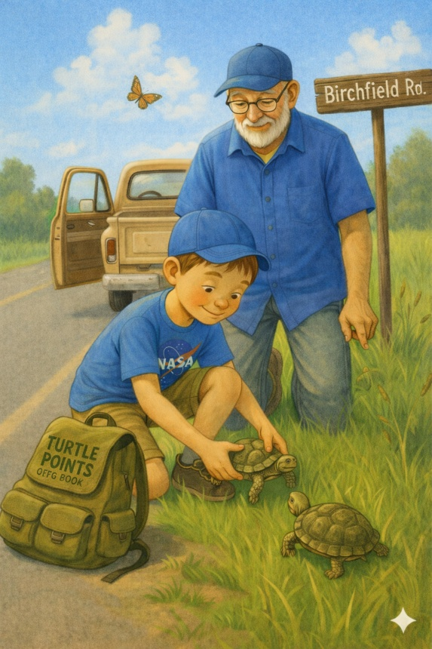
They had a routine now. Every weekend, Grandpa and Ben drove the back roads outside town, looking for turtles on the pavement and shoulders. The mission was simple: spot, stop, save. Ben called it their “Turtle Patrol.” Grandpa just said it was time well spent. The truck rumbled along the country roads, tall grasses swaying in the wind on either side. Ben kept his eyes sharp, scanning for bumps or shapes in the road that didn’t belong. Occasionally, he’d tap the dash with his finger like a radar operator.
“There!” he shouted, pointing ahead. “Left side, by the white line!”
Grandpa eased the truck to a stop, careful not to scare the creature. Sure enough, a small box turtle was starting to cross the road, looking confused by the sudden intrusion of tires and noise.
Ben and his grandpa jumped out of the truck, checked for oncoming traffic, and then crossed the road. Ben crouched low in front of the turtle, speaking to it as if it were a nervous friend. “Hey, buddy. Don’t worry. I got you.”
He carefully lifted the turtle, keeping it steady as it retracted its limbs with a gentle hiss. “This one’s smaller,” he said, showing it to Grandpa.
“She’s a lady turtle,” Grandpa said with a grin. “See the flat bottom on the shell? Female.”
Ben looked amazed. “Cool. What should we name her?”
“How about... Miss Maple?”
Ben nodded. “Miss Maple, it is.”
Checking for traffic, he gently carried the turtle across the road and placed her in the tall grass on the far side. “There you go. Keep going that way, okay? No more roads for a while.”
He lingered for a second, watching to make sure she didn’t turn back.
Ben returned to the truck and opened his logbook carefully, writing:
#2 – Miss Maple
Spotted near Birchfield Road. Saved and released. Calm. Maybe shy.

As they drove on, Grandpa looked at him out of the corner of his eye. “You think these turtles know what you’re doing for them?"
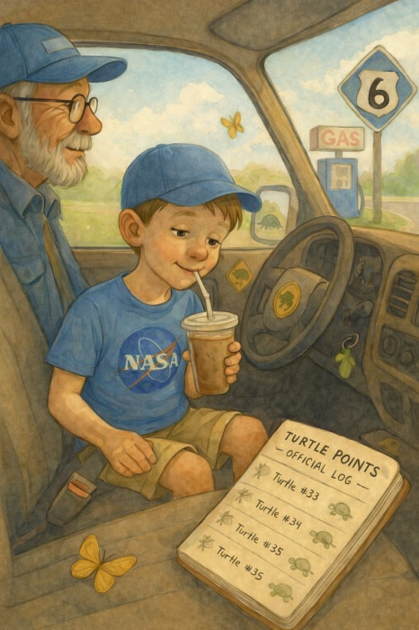
Ben paused for a moment. “Maybe not the way people do,” he said. “But I think… maybe they just feel safe. Like something kind happened.”
Grandpa nodded slowly. “That’s a good answer.”
He didn’t say it out loud, but he was proud of the way Ben saw the world.
Ben turned back to the window, letting the breeze flow through the open crack. “How many turtles do you think it’ll take to get into heaven?"
Grandpa chuckled. “Well, if you ask me, I think you’re already in. But keep going. It won’t hurt your chances.”
They wrapped up the morning with two more rescues and a chocolate milkshake from the gas station on Route 6. Ben sipped his slowly, a smile on his face. He looked down at the open logbook in his lap—three names, three turtles, three points.
Each one is a quiet promise.
He traced one of the names lightly with his finger, as if it mattered more than just a number.
He didn’t talk much about his illness. He didn’t cry over the hospital visits, the pills, or the side effects. But when he was on Turtle Patrol, none of that mattered. Out here, on winding roads and grassy shoulders, he wasn’t a sick kid. He was a rescuer. A helper. A boy on a mission.
And somewhere, in a place he couldn’t yet see, he believed a gate was slowly opening.
5. Turtle Points Explained
Ben begins logging his rescues in a notebook. Each turtle receives a name, a tally mark, and a blessing. He thinks every point moves him closer to heaven.
Ben sat cross-legged on his bedroom floor, surrounded by crayons, colored pencils, and a small pile of paper turtles he had drawn and cut out himself. The floor fan buzzed in the corner, pushing warm air around the room as the late-afternoon sun slanted through the blinds.
At the center of it all was his logbook.
The front cover was decorated with turtle stickers, hand-drawn stars, and a bold phrase in green marker:
TURTLE POINTS – OFFICIAL LOGBOOK.
Inside, each rescued turtle had its own page. Their names were written at the top—Miss Maple, Captain Crusty, Speedy Shelldon. Below were details: the road they were found on, the direction they were heading, how scared they seemed, and how long Ben had to wait to make sure they were safe.
There was space on each page for “Turtle Thoughts,” where Ben wrote a few words imagining what the turtle might be feeling. He believed each turtle had a story — he just had to help them finish it. To him, it didn’t feel like a notebook. It felt like something important. Like proof that small things mattered.

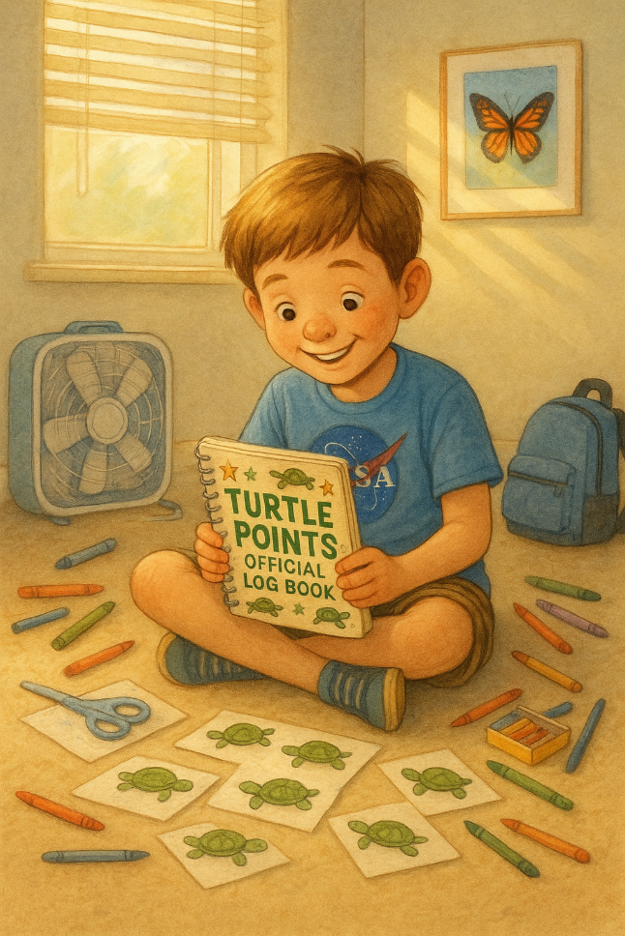
That evening, his mom peeked into his room, drying her hands on a dish towel. “You’ve been in here for hours,” she said. “What are you working on?” Ben grinned and held up the logbook. “I’m making the official point system.” “Oh yeah?” she said, sitting on the edge of his bed. “Let me see.” Ben flipped to a new page he had titled in bold letters:
HOW TURTLE POINTS WORK.
He cleared his throat and read aloud like a professor at a scientific conference.
“Saving a turtle from the road = 1 point.
If it’s a really big turtle or it looked super scared = 2 points.
If you stop traffic or make someone else help = 3 points.
Bonus points if you talk to the turtle and make it feel better.”
His mom tried not to cry. She nodded with a smile. “I like the bonus points.”
“Yeah,” Ben said thoughtfully, “because kindness counts extra.”
She looked over the drawings scattered across the carpet—turtles with speech bubbles saying things like "Thank you!" and "Slow and safe wins the race."
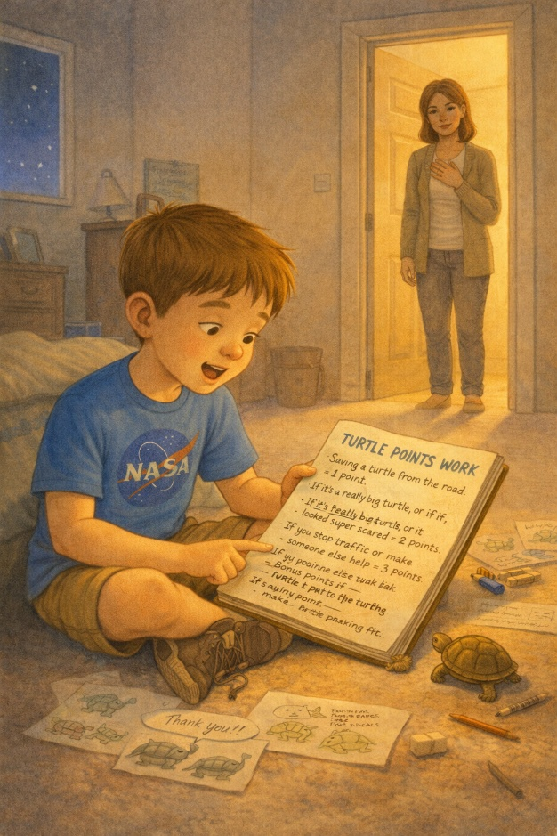
“You know, Ben,” she said, brushing a bit of eraser dust off his logbook, “this whole thing you’re doing... It’s special.”
“I’m keeping track,” he said. “In case… You know, in case I need proof.”
He said it quietly, like it wasn’t something he had said out loud before.
“Proof of what?”
“That I earned my spot.”
She didn’t say anything at first. Just reached out and cupped his cheek. “Ben, honey… You were born with a spot in heaven. You don’t need to earn” it.”
He considered that for a long moment, then looked down at his pages. “I know. But I still want to help. Just in case someone else needs my spot more. I can share it.”
Her breath caught in her throat, but she kept it together. “You are one in a million, Ben. One in a million.”
For a moment, neither of them said anything. The room felt full in a way that was hard to explain.
Later that night, when the house was quiet and the stars started to show through his window, Ben added a new section to the log.
He titled it:
People Points
- Gave my Jell-O to a nurse at the hospital = 1
- Made Grandpa laugh so hard he cried = 2
- Told Mom I love her before bed = +1 every time
He paused after writing the last one, then underlined it twice.
Ben didn’t know how many points it would take or whether anyone was really counting, but keeping score helped him stay focused—helped him believe that no matter what happened, he had a purpose.
Saving turtles. Loving people. Keeping track of the good.
It was his way of making sense of things that didn’t always add up. His way of staying brave. One turtle. One act of kindness. One point closer to forever.
6. The Boy with the Logbook
At school and the hospital, Ben shares his “Turtle Points” logbook with others, inspiring classmates, nurses, and even his doctor to perform small acts of kindness. By the second week of his new treatment, Ben was back at the children’s hospital three days a week. The nurses knew him by name, as did the security guard at the front desk, the lady running the coffee cart in the lobby, and most of the other kids in the oncology wing.
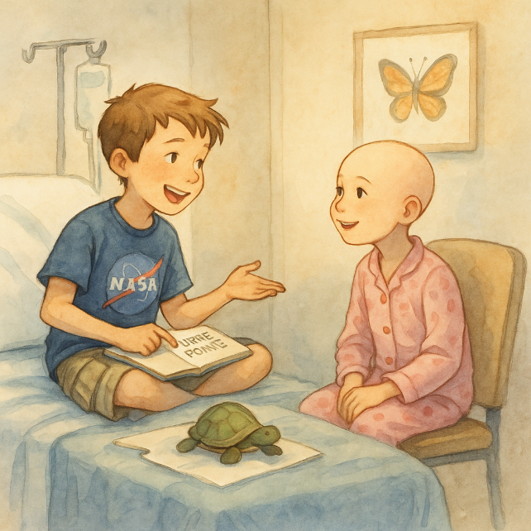
But no one knew him quite the way the staff on Floor 3 did—not just as Ben, the boy with leukemia—but as Ben, the boy with the logbook.
He brought it everywhere.
The same spiral-bound logbook, its corners soft from use, with “TURTLE POINTS – OFFICIAL LOGBOOK” written in bright green marker across the front. The pages were wrinkled and smudged, filled with neat writing, doodles, taped-in leaves, and turtle sketches. It wasn’t just a logbook—it was Ben’s compass.
It gave him something to hold onto when everything else felt uncertain.
One morning, while waiting for his bloodwork results, Ben sat in the hallway with his legs crossed, sketching a turtle with aviator goggles and a rocket strapped to its shell. “You're always drawing turtles,” said a voice beside him. Ben looked up. A little girl with a bald head and big eyes was watching him curiously. She had an IV cart beside her and wore a slightly too-big princess crown.
“Yeah,” Ben said. “I rescue them.”
She blinked. “From the hospital?”
“No, from roads. At home. I keep track of everyone I save. It’s for heaven points.”
The girl giggled. “Heaven has points?”
Ben nodded seriously. “Kindness counts. And turtles count extra.”
He said it like it was the most obvious thing in the world.
She sat down beside him without asking and watched him finish the rocket turtle. Then she pointed. “That one should be called Zoomer." "Zoomer,” Ben repeated, writing the name under the drawing. “Nice." Her name was Lily.
She was six, loved glitter, and hated pudding. She swung her legs lightly as she talked, like sitting still wasn’t really her thing. They sat there for an hour trading stories—her about the fairy garden in her hospital room, and him about the time he named a snapping turtle “Mad Max” because it snapped at him.
When Lily’s nurse came to take her for treatment, she leaned down and whispered, “I think you already have a million points.” Ben grinned and said, “I’m still adding,” more.
Later that week, during his check-in, Dr. Hawley saw the logbook tucked under Ben’s arm.
“What’s that you’re always writing in?” the doctor asked, making notes on his notepad chart.
“My turtle log,” Ben said without hesitation. “Each rescue gets one point. Big ones get two. Bonus points for style or bravery.”
Dr. Hawley raised an eyebrow, amused. “Style?”
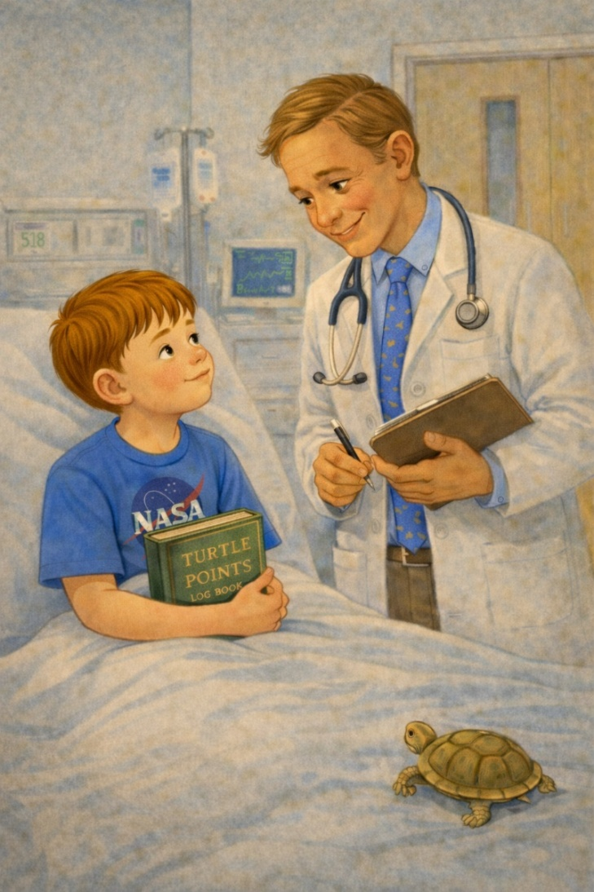
“Like if I do a slide across the grass or stop traffic with my hands. Grandpa says it’s theatrical." The doctor laughed. “I like that. What do you do with the points?” “I’m collecting them,” Ben said, “in case I need to prove I was good enough.”
The room fell quiet for a moment. Dr. Hawley leaned in gently. “Ben, I think it’s safe to say you’ve proven more than enough already.”
He said it casually, but he didn’t look up when he said it.
Ben shrugged. “Still. Doesn’t hurt to keep" score.”
By the end of the month, nurses began asking for updates on the turtles. “How many points today, Ben?” they’d ask when they saw him. “Seventeen,” he’d reply proudly. “One for Miss Maple, one for Zoomer, two for making Lily laugh, one for giving away my chocolate milk. And Grandpa says I get one just for being adorable.”
They laughed, but they also listened.
And after a while, some of them started keeping track of their own small kindnesses too.
Soon, the logbook became more than just a project—it served as a reminder to everyone around him. A quiet message written in turtle doodles and kindness tallies, saying: even small acts matter. Even when you’re tired. Even when life isn’t fair.
One afternoon, the hospital's volunteer coordinator stopped by with a surprise: a box of blank logbooks and a sign that read “Start Your Own Turtle Points” in bold letters. Kids were encouraged to record their acts of kindness. Ben was asked to cut the ribbon.
He looked surprised for a second, like he wasn’t used to being the reason something started.
He didn’t say much—just smiled, held up his own logbook, and said, “If you write it down, you’ll start to see all the good you do.”
That day, ten new logbooks began. Ten kids started gathering kindness. And Ben? He added one more line to his own.
Turtle Points = 23.
Also helped others start their books.
Bonus: +2. He underlined it twice.
He underlined it twice, then paused for a second before closing the book, like he wanted to remember the moment.
7. Ben’s Story Comes to Class
The classroom felt different that morning, even before anything happened. Not in a way Ben could explain—just in the small details. The way the chairs scraped a little louder against the floor. The way the sunlight stretched across the desks in long, pale strips. The way everything felt normal… but not quite.
Ben sat in his seat near the middle of the room, his backpack resting against the side of his desk. Inside it, tucked carefully between his folders, was the notebook. He hadn’t planned on bringing it, but he hadn’t planned on leaving it behind either. It just felt like something that should come with him.
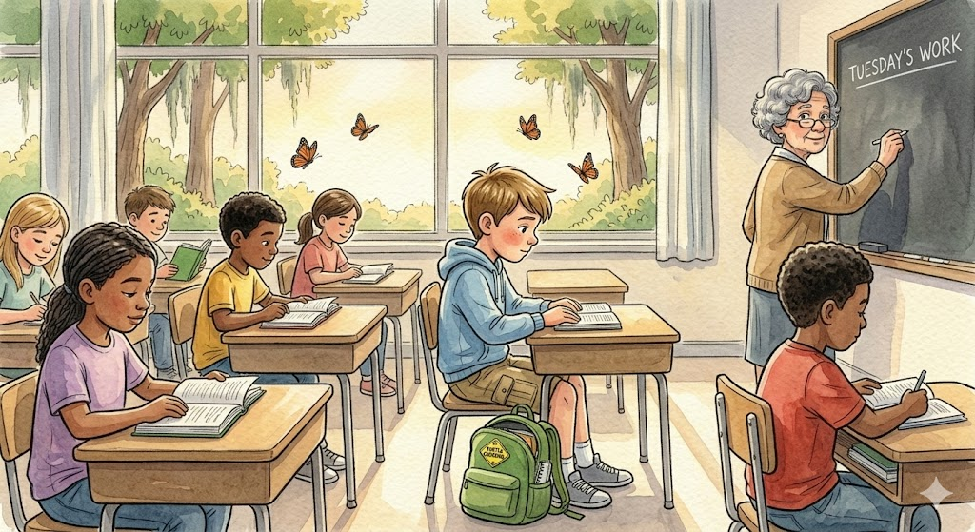
Mrs. Carter stood at the front of the room, writing the day’s lesson on the board in neat, careful letters. Her voice was calm as she explained the morning’s work, but every so often, her eyes drifted toward Ben. Not in a way that made him uncomfortable—just noticing.
For a while, everything moved the way it always did. Math problems. Reading time. The soft turning of pages. Pencils scratching against paper. Normal. But the notebook was still there. He could feel it sitting in his bag, like it was waiting.
It happened just before lunch. Ben reached into his backpack to grab his folder, but the notebook slipped out instead, landing softly against the side of his desk before sliding onto the floor. The sound wasn’t loud, but it was enough. A few heads turned. Then a few more.
“What’s that?” someone asked.
Ben hesitated. He could have picked it up, put it back, and said nothing. But something in him paused. He leaned down, picked up the notebook, and held it in his hands for a moment longer than usual. It felt different now that everyone was looking at it.
“It’s… just something I keep,” he said.
That might have been the end of it, but Mrs. Carter had already stepped closer.
“Would you like to share it?” she asked gently.
Her voice wasn’t pushing—just offering.
Ben looked down at the notebook, then back at her, then around the room. Everyone was watching now. Not in a mean way. Just curious.
He took a small breath. “Okay,” he said.
He stood at the front of the room, holding the notebook with both hands. It felt heavier now—not because of what it was, but because people were looking at it.
“It’s called my Turtle Points Logbook,” he said.
A few kids smiled at the name. One of them laughed softly, but not in a bad way.
“Every time I help a turtle… or do something good that counts… I write it down,” Ben continued.
“What counts?” someone asked from the back.
Ben thought about it. “Anything that helps,” he said. “Even small stuff.”
“Like what?” another voice asked.
Ben shrugged a little. “Like holding a door, or helping someone when they’re scared, or just being nice when you don’t have to be.” He spoke a little more quietly at the end, like it mattered more than he was trying to show.
The room grew quieter.
Mrs. Carter stepped a little closer, her expression thoughtful. “May I see it?” she asked.
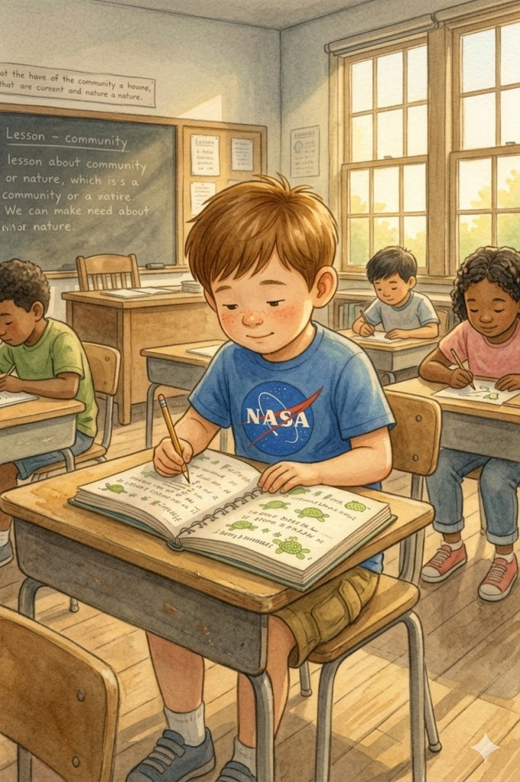
Ben nodded and handed her the notebook. She opened it carefully, turning a few pages. Her eyes moved slowly across the writing—the numbers, the notes, the small moments. She didn’t say anything at first. Then she looked up.
“This is important work,” she said.
Her voice was still gentle, but there was something else in it now. Something steady.
She turned back to the class. “What Ben is doing is noticing something we don’t always think about,” she said. “He’s paying attention to the small ways people help each other, and he’s choosing to believe those things matter.”
She closed the notebook gently and handed it back. “I think they do too.”
For a moment, no one spoke. Then, from the front row, a girl raised her hand.
“I helped my little brother tie his shoes this morning,” she said.
Ben looked at her. “That counts,” he said.
Another voice came from the side of the room. “I shared my snack yesterday.”
“That counts too.”
A boy near the back shifted in his seat. “I didn’t make fun of someone when everyone else did,” he said quietly.
The room went still for a second.
Ben nodded. “That really counts.”
He met the boy’s eyes for a second, like he understood what that took.
Mrs. Carter smiled slightly. “What if we tried something?” she said. The class looked at her. “What if, for today, we all kept track of one thing that counts?”
There were a few murmurs, a few nods, and a few uncertain looks—but no one said no.
By the time the lunch bell rang, the room felt different. Not louder. Not more exciting. Just… more aware.
As the students filed out, a few of them stopped by Ben’s desk.
“Can I see it again later?” someone asked.
“Do you always carry it?” another said.
Ben nodded. “Yeah.”
That afternoon, as the class settled back into their seats, Mrs. Carter wrote something new on the board:
Things That Count
Underneath it, she left space. A lot of space.
At the end of the day, Ben opened his notebook and turned to a new page. For a moment, he just looked at the blank paper, listening to the quiet sounds of backpacks zipping and chairs scraping across the floor.
Then he wrote:
School Day
Not just turtles.
Lots of points today.
He stared at the words for a second, then added one more line beneath them, slower this time:
Maybe helping is contagious.
He smiled a little after writing that, like he wasn’t entirely surprised.
When he closed the notebook, the room no longer felt like it had that morning. Something small had shifted. Something invisible, but real. It was in the way the kids had spoken. In the way they had listened. In the way, one simple idea had made them notice each other differently.
Ben slipped the notebook back into his backpack and stood.
As he walked out of the classroom, he glanced once more at the board.
Things That Count
The words were still there, waiting for tomorrow.
And for the first time, Ben understood that Turtle Points were never really just about turtles.
They were about leaving the world a little gentler than you found it.
And now, he wasn’t the only one keeping score.

8. The Boy Who Counted Kindness
The notebook wasn’t just something Ben carried. It had become part of how people saw him—
and part of how he saw himself.
At school and the hospital, Ben shows others his “Turtle Points” notebook, inspiring his classmates, nurses, and even his doctor to perform small acts of kindness.
By the second week of his new treatment, Ben was back in the children’s hospital three days a week. The nurses knew him by name. So did the security guard at the front desk, the lady who ran the coffee cart in the lobby, and most of the other kids in the oncology wing.
The security guard would give him a small salute each time he walked in, as if Ben were reporting for duty rather than treatment.
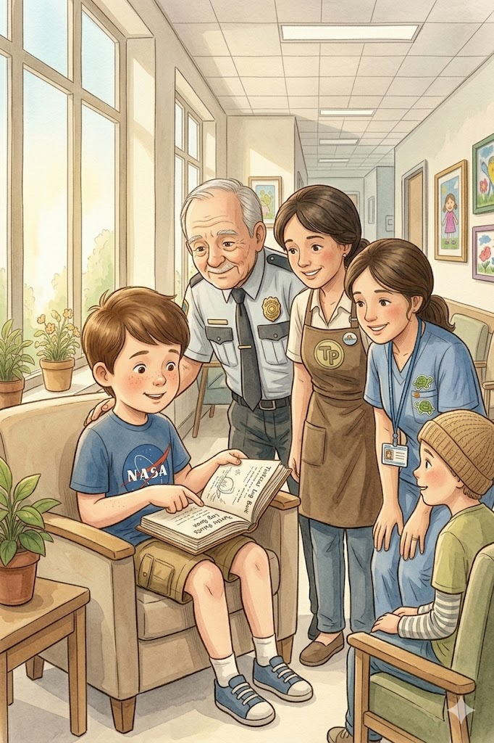
The woman at the coffee cart always asked, “How many points today?” even though she never wrote them down.
One of the nurses started keeping a handful of turtle stickers in her pocket, handing him one at the end of each visit as if it were part of the routine.
Even the quieter staff—the ones who didn’t say much—noticed him.
A janitor paused one afternoon just to watch Ben draw in his notebook, nodding to himself before moving on.
A nurse from another wing leaned in the doorway once, smiling softly as she read a page over his shoulder.
The hospital was full of people carrying heavy things—long shifts, difficult days, quiet worries—but somehow, Ben’s small notebook gave them something lighter to hold onto, even if only for a moment like a reminder that not everything had to feel heavy all the time.
But no one knew him quite the way the staff on Floor 3 did—not just as Ben, the boy with leukemia—but as Ben, the boy with the notebook.
On Floor 3, they didn’t just ask how he was feeling—they asked how the turtles were doing.
They remembered the numbers. They remembered the stories.
And on the hardest days, when Ben didn’t feel like talking much at all, they still treated him like someone who was doing something important.
Not just a patient.
But a boy with a mission.
He brought the notebook everywhere.
The same spiral-bound notebook, its corners soft from use, with “TURTLE POINTS – OFFICIAL LOGBOOK” written in bright green marker across the front. The pages were wrinkled and smudged, filled with neat printing, doodles, taped-in leaves, and turtle sketches. It wasn’t just a notebook—it was Ben’s compass. It gave him something steady to hold onto.
One morning, while waiting for his bloodwork results, Ben sat in the hallway with his legs crossed, sketching a turtle with aviator goggles and a rocket strapped to its shell.
“You're always drawing turtles,” said a voice beside him.
Ben looked up. A little girl with a bald head and big eyes was watching him curiously. She had an IV cart beside her and was wearing a princess crown that was slightly too big.
“Yeah,” Ben said. “I rescue them.”
She blinked. “From the hospital?”
“No, from roads. At home. I keep track of everyone I save. It’s for heaven points.”
The girl giggled. “Heaven has points?”
Ben nodded seriously. “Kindness counts. And turtles count extra.”
He said it like it was something simple and true.
She sat down beside him without asking and watched him finish the rocket turtle. Then she pointed. “That one should be called Zoomer.”
“Zoomer,” Ben repeated, writing the name under the drawing. “Nice.”
Her name was Lily.
She was six, loved glitter, and hated pudding. They sat there for an hour trading story—her about the fairy garden in her hospital room, and him about the time he named a snapping turtle “Mad Max” because it peed on his shoes.
When Lily’s nurse came to take her for treatment, she leaned down and whispered, “I think you already have a million points.”
Ben just grinned and said, “I’m still adding more.”
Each week, the nurses asked for updates on the turtles.
“How many points today, Ben?” they’d ask when they saw him.
“Seventeen,” he’d reply proudly. “One for Miss Maple, one for Zoomer, two for making Lily laugh, one for giving away my chocolate milk. And Grandpa says I get one just for being adorable.”
They laughed, but they also listened.
And after a while, some of them started keeping track of their own small moments too.
Soon, the notebook was more than just a project—it was a reminder to everyone around him. A quiet message written in turtle doodles and kindness tallies, saying: even small acts matter. Even when you’re tired. Even when life isn’t fair.
One afternoon, the volunteer coordinator at the hospital stopped by with a surprise: a box of blank notebooks and a sign that read “Start Your Own Turtle Points” in block letters. Kids were invited to track their own acts of kindness. Ben was asked to cut the ribbon. He looked a little surprised when they asked him.
He didn’t say much—just smiled, held up his own notebook, and said, “If you write it down, you’ll start to see all the good you do.”
That day, ten new notebooks were started. Ten kids began collecting kindness.
And Ben?
He added one more line to his own.
Turtle Points = 23
Also helped others start their books. Bonus: +2.
He underlined it twice.
He paused for a second after that, like he wanted to remember it.
What started as a simple notebook was becoming something more—something that reached beyond Ben himself.
And soon, it would bring someone into his life who would understand the mission in a way no one else could.

9. Lily’s Quiet Strength
The hospital had a rhythm to it. Not a loud one, not like music or footsteps or voices in a crowded room, but something quieter than that. It was the soft hum of machines, the slow roll of IV carts, and the whisper of nurses speaking in the hallway just outside the door. Lily knew that rhythm well.
She sat by the window in her room; her legs tucked beneath her, and a blanket draped over her lap even though it wasn’t cold. The light outside was pale that morning, filtered through thin clouds that made everything feel softer than usual. In her hands was a small piece of paper. Carefully, slowly, she folded it—one corner over another, pressing each crease down with her thumb. Another fold, then another. She had done this many times before, but today she took her time.
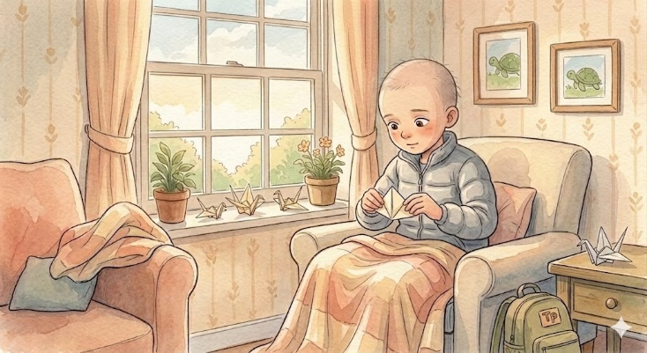
Because today, she was thinking about Ben.
She could still hear his voice in her head—calm and steady, like he already understood something the rest of the world was still trying to figure out. Kindness counts, he had said.
Lily looked down at the paper in her hands. The shape was starting to form now, a small turtle. It wasn’t perfect. One side was slightly uneven, but she didn’t fix it. Ben never fixed the turtles in his drawings either.
“They don’t have to be perfect,” he had told her once. “They just have to matter.”
A faint smile crossed her face at the memory.
Across the room, her IV machine beeped softly. A nurse stepped in, adjusted something, and gave her a gentle smile before leaving again. The door clicked shut, and the room returned to its quiet rhythm.
Lily held the paper turtle in her palm and stared at it. “What do you think?” she whispered. For a second, she almost expected an answer.
She imagined what Ben would say. He would probably give it a name right away—something brave, something a little funny.
“Wanda,” she said softly.
The name felt right. She nodded to herself. “Okay, Wanda,” she continued, her voice barely above a whisper. “You get one point.”
She reached over to her bedside table and pulled out a small notebook. It wasn’t as decorated as Ben’s—no stickers, no bold green title—but inside, it was starting to grow. She flipped it open to a page she had already begun.
People Points
• Shared crayons with the girl in Room 410
• Didn’t cry during my last treatment
• Made a nurse laugh
She hesitated, then added a new line:
• Made a turtle (Wanda) – for Ben = 1
She paused, staring at the words. Then, quietly, she added another line beneath it:
• Missed my friend today = still counts?
Her pencil hovered for a moment before she underlined it, because somehow it felt like it should count.
Like maybe feelings could count too.
She sat by the window in her room; her legs tucked beneath her, and a blanket draped over her lap even though it wasn’t cold. The light outside was pale that morning, filtered through thin clouds that made everything feel softer than usual. In her hands was a small piece of paper. Carefully, slowly, she folded it—one corner over another, pressing each crease down with her thumb. Another fold, then another. She had done this many times before, but today she took her time.
The words felt small, but they felt important.
That night, back in her room, Lily lay in bed with Wanda resting beside her pillow. The lights were dim, and the hallway outside had grown quiet again. She turned onto her side and looked at the small paper turtle.
“I think I get it now,” she said softly.
She didn’t mean the points, or the notebook, or even the turtles. She meant something deeper—something Ben had understood all along. It wasn’t about keeping score. It was about noticing. Helping. Trying. Even when it was hard. Especially when it was hard. Especially when no one was watching.
Lily pulled the blanket a little closer around her shoulders. “Okay,” she whispered. “Let’s keep going.”
She reached over, touched Wanda lightly, and closed her eyes.
And for the first time in a long while, she didn’t feel alone.

10. The Space Between Words
It was treatment day, and Ben sat in his usual spot with the notebook open on his lap, not writing, just looking. He flipped from one page to another as if he were deciding which moments mattered most.
Across the hall, Lily watched him. She had been there for a few minutes already, sitting in her chair with her hands folded loosely in her lap. She didn’t say anything right away, and she didn’t need to. Eventually, Ben glanced up.
“Hey,” he said.
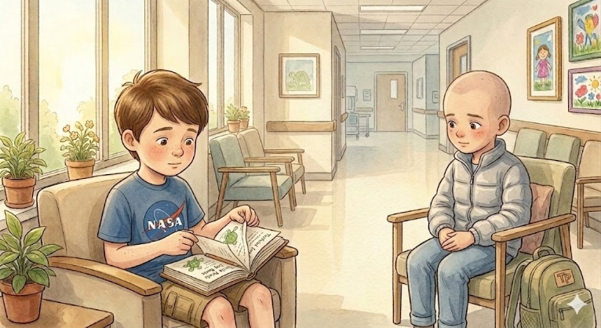
“Hey,” Lily replied.
That was enough to begin.
For a while, they sat without speaking, comfortable in the quiet. Ben tapped his pencil lightly against the edge of the notebook while Lily watched the motion, then looked down at her hands.
“You ever run out?” she asked after a moment.
Ben tilted his head. “Run out of what?”
“Things to write,” she said. “Points. Turtles. Stuff like that.”
Ben thought about it for a second. “Not really,” he said. “I just don’t always write them right away.”
“Sometimes I just keep them in here for a bit,” he added, tapping the notebook lightly.
Lily nodded. “Yeah,” she said softly. “Me too.”
Ben turned the notebook slightly so she could see. “There’s still a lot I didn’t put in here,” he added.
Lily leaned forward just enough to look. “What kind of stuff?”
Ben shrugged. “Little things. Like when someone holds a door, or when a nurse stays a few extra minutes, or when someone doesn’t feel as scared as they did before.”
Lily kept her eyes on the page. “That counts?” she asked.
Ben nodded. “Yeah,” he said. “It all counts.”
He said it simply, like there wasn’t really any doubt about it.
She sat back slowly. “Okay,” she said—not like she was agreeing, but like she was deciding.
A few minutes later, Lily reached into her pocket and pulled out a folded piece of paper. She didn’t say anything at first. She just held it out. Ben took it carefully.
It was a turtle—simple and slightly uneven, with one flipper a little bigger than the other. He looked at it for a moment, then smiled just a little.
“It’s good,” he said.
Lily made a face. “It’s not even.”
Ben shook his head. “It doesn’t have to be.”
He looked back down at the paper. “What’s its name?”
Lily hesitated. “Wanda.”
Ben nodded thoughtfully. “She looks like a ‘Wanda,’” he said.
Lily blinked. “Wanda”.
“Yeah,” he said. “She looks like she’s trying her best.”
He said it like that was the most important part.
Lily let out a small laugh. “Okay,” she said. “Wanda.”
Ben reached for his notebook and turned to a blank space near the bottom of a page. “Want to add it?” he asked.
Lily’s eyes widened slightly. “To your book?”
Ben nodded. “It’s your turtle, but it still counts.”
Lily looked at the notebook, then at the paper turtle, then back at Ben. “Okay,” she said again, softer this time.
Ben wrote carefully:
Turtle #24 – Wanda. Brave. Origami.
Lives in Lily’s backpack. Probably magical.
He paused, then added a small line underneath: Shared.
They sat with that for a moment, neither of them speaking, but something had shifted. Like the space between them felt a little smaller now.
Later, a nurse passed by and smiled when she saw them together. “You two look busy,” she said.
Ben shrugged. “Just working.”
Lily glanced at him, then nodded. “Yeah,” she added. “Working.”
The nurse laughed softly and continued down the hall.
The light in the hallway changed slowly as the afternoon moved on, shadows stretching longer and the noise fading even more. Ben closed the notebook gently while Lily held Wanda carefully in both hands.
“Hey,” she said after a while.
“Yeah?”
“If you stop writing,” she asked, “does it all stop too?”
Ben didn’t answer right away. He looked down at the notebook, then at the hallway, then back at Lily.
“I don’t think so,” he said finally.
“Why not?”
He shrugged. “Because it’s not really about the writing. It’s about doing it.”
“The writing just helps you remember,” he added quietly.
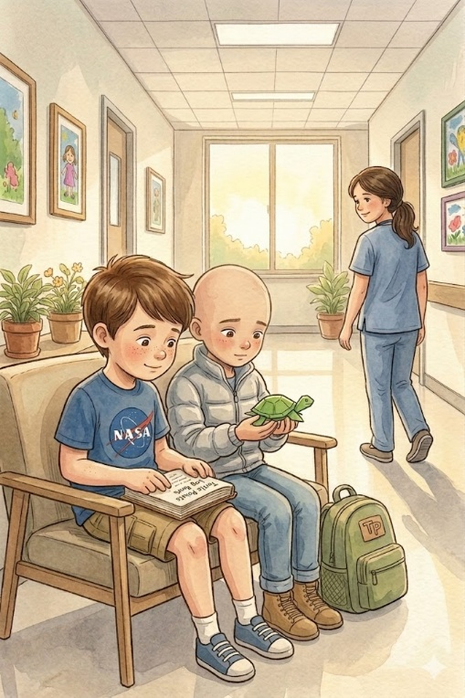
Lily thought about that, then nodded. “Okay.”
A little later, a nurse came to take Lily back to her room. She paused before leaving. “I’ll keep it?” she said, holding up Wanda.
Ben smiled. “Yeah,” he said. “But you’ve got to keep it going.”
Lily gave a small, serious nod. “I will.”
As she was wheeled down the hallway, Lily looked back once. Ben was already opening the notebook again, writing something she couldn’t see—but she didn’t need to.
Back in his chair, Ben added one more line under Wanda’s entry: Not just mine anymore.
He looked at those words a little longer than usual.
He looked at it for a moment, then closed the notebook.
The hallway was quiet again.
But it didn’t feel empty.

11. Angels Wear Backpacks
Ben didn’t believe in halos. He didn’t think they were the shiny, gold kind floating above people’s heads. If angels were real, he imagined they would wear baseball caps and carry backpacks stuffed with crayons and peanut butter crackers. At least, that’s how he envisioned his angel.
It was a Wednesday afternoon when Ben met Lily in the rooftop garden.
He sat in the hospital garden, bundled up in a hoodie even though it was warm outside. The treatments left him feeling cold sometimes. It was the kind of cold that didn’t really go away, even in the sun.
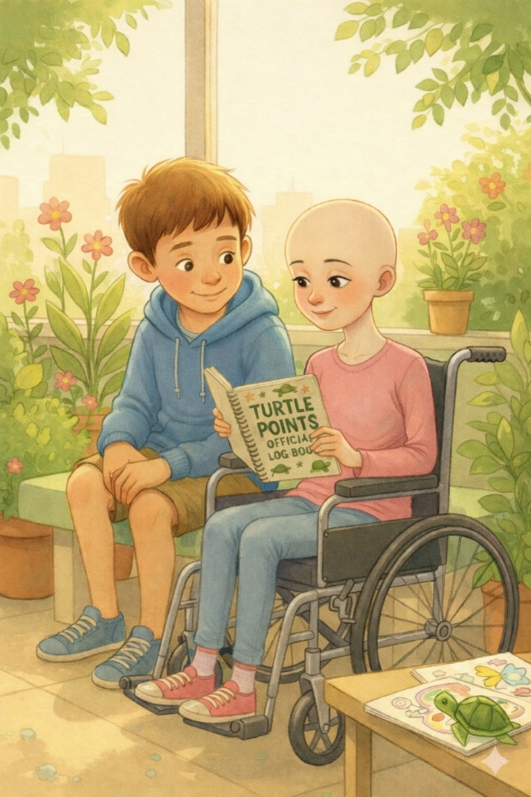
Lily was pushed into the garden by a nurse. She looked just as worn out as the paperback book she held in one hand. She was pale, thin, with long sleeves covering her arms and a quiet expression in her eyes, as if she had a whole world happening inside her head. She didn’t say anything at first. She just looked around, like she was deciding if she wanted to be there. Their eyes met. She raised an eyebrow. “Are you drawing turtles?” she asked flatly.
Ben looked up. “Yeah. And giving them points.”
He handed her the logbook carefully, as if passing a family heirloom. She flipped through it slowly, stopping on a page where a cartoon turtle was skydiving with a parachute shaped like angel wings. She looked up. “So… you’re, like, earning your way to heaven?”
Ben nodded. “Sort of. Or at least making sure I’ve done enough good stuff to deserve the ride.”
Lily studied him for a long moment. “You know,” she said, handing the logbook back, “most people think angels have' wings.”
Ben grinned. “Nah, I think they have backpacks. Angels must carry stuff—books, snacks, maybe extra Band-Aids for people who fall.”
He said it lightly, but like he had really thought about it.
Lily blinked. Then, just for a moment, she smiled. Not a wide smile, but a genuine one.
It was small, but it changed something.
Over the next few weeks, Lily and Ben became fixtures in the rooftop garden. They brought coloring books and shared secrets. She hated pickles. He hated needles. She had a stuffed owl named Edgar. He rescued spiders using a drinking glass and a piece of cardboard. Some days, they talked about video games or cartoons. Other days, they didn’t talk much at all—just sat in silence together, letting the sky do the speaking.
Those quiet days counted too, even if they didn’t say anything out loud.
One afternoon, Lily slid her hand into her pocket and took out a folded piece of paper.
“I made a turtle,” she said shyly.
Ben took it with both hands. It was origami—slightly crooked but full of charm. On its back was a scribbled smiley face and the name “Wanda” written in purple ink.
“She looks brave,” Ben said.
“She has to be,” Lily replied. “She lives in my backpack.”
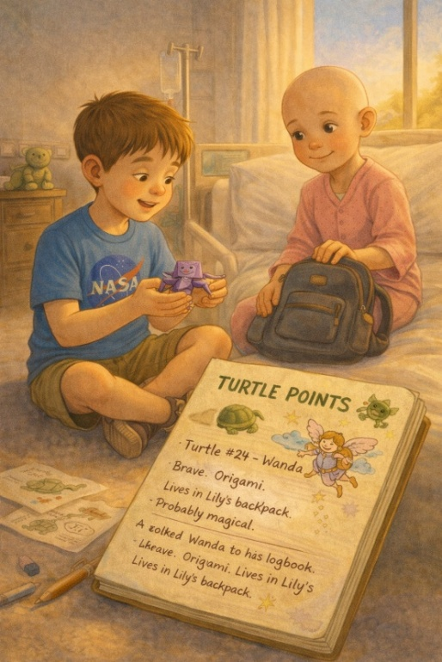
Ben nodded slowly. “Then she definitely gets a point.”
He wrote it down carefully, like it mattered just as much as the others.
He added Wanda to his logbook immediately.
Turtle #24 – Wanda. Brave. Origami. Lives in Lily’s backpack. Probably magical.
The next time Dr. Hawley saw Ben, he noticed the turtle logbook had a new decoration on its front cover—a hand-drawn sticker of a girl with wings and a backpack, flying through the clouds.
"What’s that?” he asked.
“That’s Lily,” Ben said proudly. “She said if I’m an angel, I’m one with a backpack. I told her she is, too. She carries brave, and I think she does turtles.”
He said it like it was a fact, not something that needed explaining.
In a place filled with IV poles, silent tears, and gentle voices, Ben and Lily became a small team. They didn’t have much control over what happened to their bodies. But in that logbook, they were heroes. Guardians. Turtle-saving, people-cheering, kindness-collecting angels.
And in that space between laughter and worry, between treatments and hope, Lily gave Ben something he didn’t even realize he needed.
A friend who didn’t pity him. Someone who believed in the mission. Someone who saw him—not as a sick kid or a charity case—but as a boy with purpose—an angel in a backpack.

12. Grandpa’s Secret Mission
Grandpa shares that he used to rescue turtles with Ben’s dad when he was a boy, long before Ben was born. The tradition now feels even more sacred.
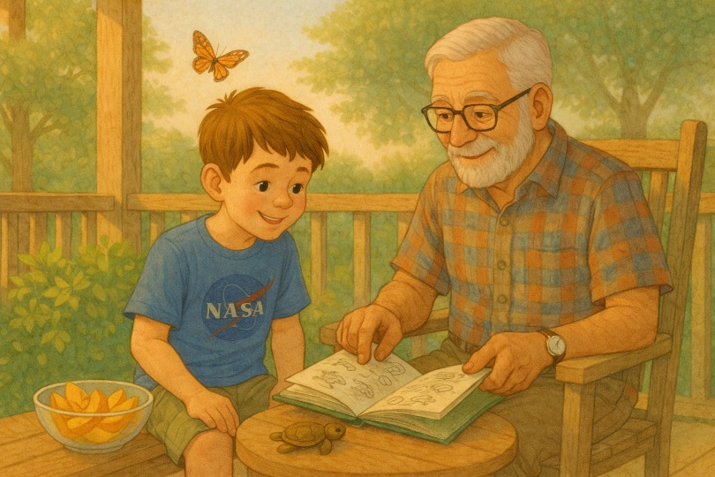
It was a peaceful Sunday morning, the kind where the sun rose slowly and golden, and everything felt wrapped in stillness. Ben and Grandpa Jim sat on the back porch, sharing a bowl of sliced peaches and watching the trees sway gently in the breeze. The hospital visits had slowed down for the week, and Ben was having a “good day”—what the nurses called a day with more energy than pain.
The turtle logbook sat open between them on the small patio table, filled with scribbles, sketches, and point tallies. Grandpa flipped through the pages, chuckling softly at the nicknames.
“‘Turtle #17 – Turbo. Tried to outrun a lawnmower.’” He tapped the page. “You’re giving these guys personality.”
“They have personality,” Ben said, popping a peach slice into his mouth. “You just have to look.”
Grandpa nodded, his rough fingers tracing the edge of the page. His smile dimmed a little, replaced by a distant look in his eyes.
“I want to tell you something,” he finally said.
Ben looked up.
Grandpa leaned back, folding his hands across his belly. “This isn’t the first time I’ve been on turtle patrol.”
Ben blinked. “Wait. What?”
Grandpa smiled. “Back when your dad was your age—maybe a little younger—he and I had a thing. Saturdays, early mornings. We’d get up before your grandma even had the coffee on. We’d drive the back roads, looking for turtles.”
“No way.”
Oh yeah. “Oh yeah,” Grandpa said with a soft laugh. We had our own system. A net, a pair of gloves, and even an old plastic laundry basket in the backseat to move the big ones safely.
Ben sat up straighter. “Dad never told me that.”
Grandpa shook his head slightly. He didn’t say much about it. But those mornings? They belonged to us. Just the two of us. And the turtles, of course. There was a quiet pause, like both of them were picturing it.

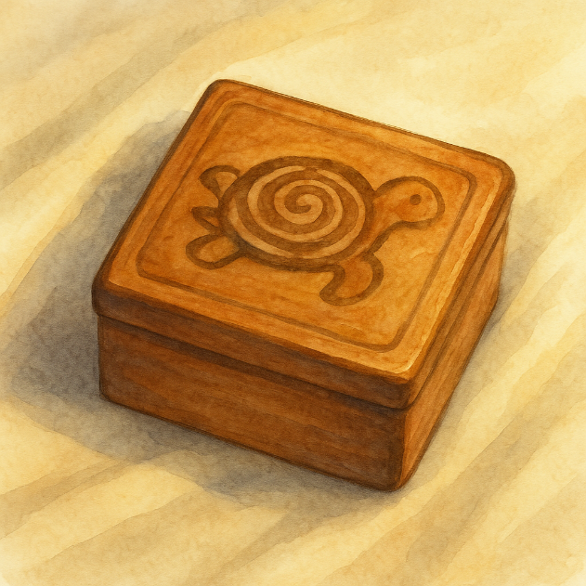
Later that day, Grandpa went into the garage. When he returned, he was holding something wrapped in an old beach towel. “I’ve been saving this,” he said.
Ben carefully opened the towel. Inside was a small wooden box. Carved into the lid was a faded image of a turtle—its shell a swirl of hand-cut spirals.
Ben lifted the lid.
Inside were photos—dozens of them. Grainy snapshots of his dad as a boy—grinning, holding turtles of all kinds and sizes. Some were wet from the rain. Others captured mid-stride in the grass. One photo showed Grandpa and Ben’s dad side by side, each holding a turtle like a trophy.
Ben couldn’t speak. He ran his fingers over the photos, as if they might dissolve if he pressed too hard. He lingered on one picture longer than the others, studying his dad’s face.
That night, he added a new entry to the logbook.
Turtle #26 – Ghost Turtle. Found in an old box. Not saved by me, but by my dad. Sacred points passed down. +10. Legacy unlocked.
Then, underneath in smaller handwriting:
“It always counts.”
Ben didn’t sleep much that night, but he didn’t need to. His heart felt full not just with grief or pain, but with something stronger and more connected.
He wasn’t walking this road alone.
He had never been.
And now, every turtle he saved felt like a little whisper from the past.
Like he was part of something that had started long before him.
A reminder that some missions never end.
They pass on.

13. The Creek Mission
By the time the sun had climbed above the trees, Ben had already looked out the front window at least ten times.
“She’ll be here,” his mother said from the kitchen, pouring orange juice into two mismatched glasses. “If you keep staring like that, you’re going to wear out the curtains.”
Ben turned from the window with a grin that tried and failed to look patient. “I know. I just don’t want to miss her.”
His backpack sat by the door, ready for the morning’s adventure. Inside were a notebook, two pencils, a bottle of water, a granola bar, a flashlight that barely worked, and Hope, the small carved turtle that came along on every mission that felt important.
And this one did.
Today Lily was coming.
Not for a hospital visit.
Not for rooftop garden time.
Not for a short ride in Grandpa’s truck before going back inside.
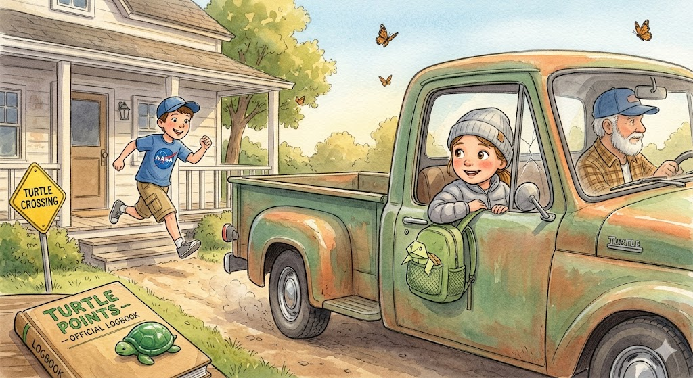
Today, she was strong enough for a real adventure.
When Grandpa’s truck finally rumbled into the driveway, Ben was out the door before the engine had fully settled. Lily sat in the passenger seat with the window cracked open, her hair pulled back, a light jacket zipped to her chin. Her cheeks were still pale, but her eyes looked brighter than they had in weeks. Wanda, the little origami turtle, peeked out from the front pocket of her backpack.
“You’re early,” Ben said, breathless with excitement.
Grandpa chuckled. “That’s rich, coming from the boy who’s been standing watch since breakfast.”
Lily smiled, and this time it was not one of her small, hidden smiles. It was fuller. Lighter.
“You ready?” she asked.
Ben nodded, his face suddenly serious. “We have to.”
The creek was just beyond the far edge of the neighborhood, tucked behind a stand of trees and a narrow path that bent through tall grass and brush. It was not the kind of place most people noticed. From the road, it looked like nothing much at all. But once you stepped beneath the trees, it became its own little world—cool and green and full of soft sounds.
To Ben, it felt like the beginning of a story.
They walked slowly, Grandpa a few steps behind in case Lily needed to rest. He carried a folding chair over one shoulder and a paper sack in one hand, because years of being a grandfather had taught him those adventures usually required more supplies than children expected.
Ben stayed close to Lily, careful not to rush ahead, though excitement seemed to buzz through him like sunlight.
The air smelled like wet earth and moss. Somewhere overhead, birds called to one another through the branches. Beneath it all ran the steady murmur of the creek itself, slipping over rocks as if whispering secrets to the roots below.
When they reached the bank, Lily stopped.
“It’s beautiful,” she said softly.
Ben looked at her, then back at the water. “Yeah,” he said. “It kind of hides until you come looking for it.”
Grandpa set the folding chair beneath a wide old tree. “I’ll stay right here,” he said. “You two explore but stay where I can see you.”
“We will,” Ben promised.
Then he lowered his voice and turned to Lily. “Ready for patrol?”
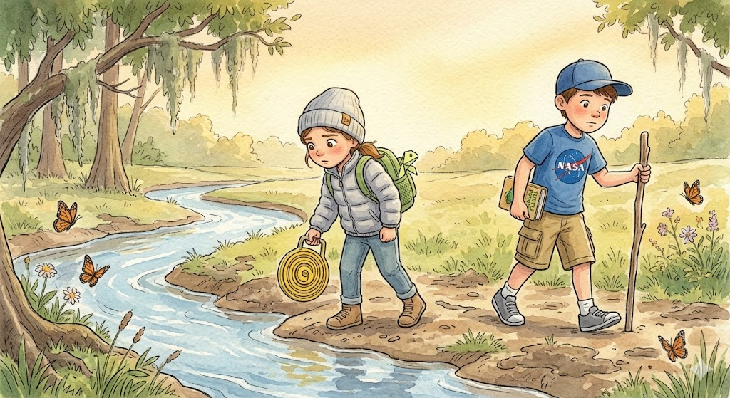
She adjusted the strap of her backpack and gave a solemn nod. “Ready.”
They followed the edge of the creek, stepping around muddy patches and low branches. Ben used a stick as a walking staff, tapping the ground ahead of him. Lily scanned the banks and the shallow water with careful eyes, as if she understood that a real mission meant paying attention.
At first, all they found were ordinary treasures: a smooth gray stone shaped like a heart, a dragonfly perched on a reed, a lost marble half-buried in the mud, and an empty soda can caught near the roots of a sycamore tree.
Lily held up the stone. “I’m keeping this.”
“For luck?” Ben asked.
“For proof,” she said. “That I came on the adventure.”
Ben nodded. “Good idea.”
They walked a little farther, into a narrower stretch where the creek curved around a clump of brush and fallen branches. The water moved faster there, tugging at leaves and twigs caught along the bank.
Ben was about to step over a log when Lily stopped suddenly.
“Wait.”
Something in her voice made him freeze at once.
“What is it?”
She pointed toward the tangled branches near the water’s edge.
At first, Ben saw only sticks and weeds and the flicker of moving water. Then he spotted it.
A duckling.
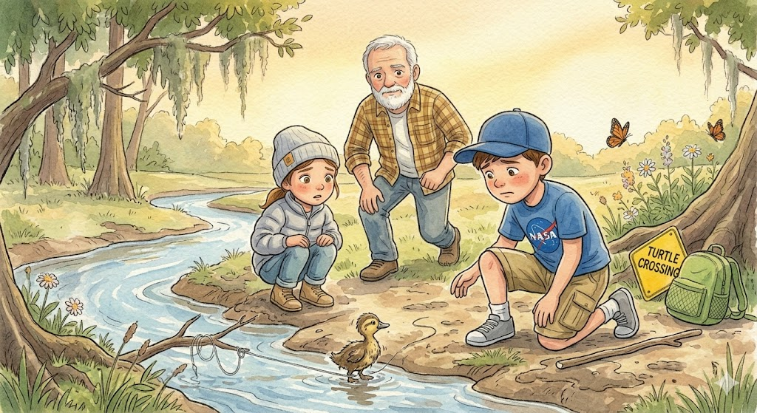
It was tiny, muddy, and trembling, caught in a loop of fishing line that had snagged on a branch. One small foot was tangled tight, and every time it struggled, the line pulled harder.
Ben dropped to his knees. “Oh no.” Lily crouched carefully beside him. “Can we help it?” Ben nodded, but his face had gone serious in an instant. “We have to.”
Grandpa was there a moment later, coming as quickly as his knees allowed. He took one look and let out a slow breath. “Well,” he said quietly, “looks like this little one found trouble before breakfast.”
Ben barely looked up. “What do we do?”
“First,” Grandpa said, kneeling beside them, “we don’t panic. Second, we make a plan.” Lily gave Ben a quick glance. “Mission mode.”
Ben nodded once. “Mission mode.”
Grandpa moved a branch aside so he could get a better look. “Ben, you’ll need to hold it gently but steadily. Lily, you help me keep these branches back.” Lily was already reaching forward. “Got it.”
The duckling fluttered weakly when Ben slipped his hands around it, but Lily spoke at once, her voice low and calm.
“It’s okay,” she whispered. “We’re helping. You’re okay.”
Ben held the little bird carefully against his palms. It was impossibly light, all heartbeat and fear. Grandpa worked at the line with patient fingers while Lily kept the brush from snapping back in his face.
“Almost there,” Grandpa murmured.
The duckling let out one thin, frightened peep. Ben swallowed hard. “You’re all right,” he said softly. “You’re all right.”
Then the line came loose.
Grandpa leaned back, the broken loop dangling from his hand. “There we go.”
For a second, nobody moved.
Ben lowered the duckling gently onto a patch of grass beside the creek. It stood there, shaky and stunned, then blinked once and took three uncertain steps toward the water.
Upstream, a mother duck who had been circling anxiously let out a soft call.
The duckling answered.
Then, with a tiny burst of determination, it scrambled into the shallow water and paddled toward her as fast as it could go.
Ben let out the breath he had been holding.
Lily’s face opened into a smile so bright it seemed to light the whole creek bank. “We did it,” she whispered.
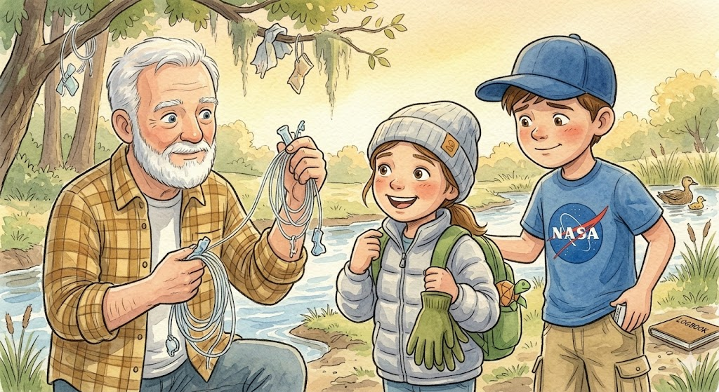
Ben nodded, still watching the duckling disappear safely into the reeds beside its mother. “Yeah,” he said. “We really did.”
Grandpa held up the fishing line. “And now we know what nearly got it.” Lily looked at the trash snagged in the branches along the bank. “There’s probably more.”
Ben turned to her. “You want to clean it up?” She lifted one shoulder. “I didn’t come all the way out here just to do half the job.” Grandpa smiled. “That’s the spirit.”
So, they kept going.
For the next half hour, the three of them worked their way along the creek. Grandpa handled the sharp and dangerous things.
Ben, wearing an old pair of garden gloves Grandpa had brought in the truck, pulled cans, wrappers, and bits of tangled string from the mud. Lily gathered bottle caps, scraps of plastic, and smaller bits of trash into the paper sack.
By the time they were done, the sack was heavy, Ben’s knees were muddy, and Lily looked tired.
But it was a different kind of tired than the hospital kind.
This tiredness had sunshine in it.
This tiredness had purpose.
When they finally sat beneath the tree to rest, Ben pulled out his notebook.
Lily leaned closer as he wrote:
Creek Mission
One duckling was freed from a fishing line.
One mother duck reunited with her baby.
One bag of trash was removed from the creek.
One excellent adventure was completed.
Then he paused and looked at Lily.
“What?” she asked.
He smiled and added one more line.
Points awarded to Agent Lily for bravery, sharp eyes, and official creek-side heroics.
Lily read it and gave a small nod. “Seems fair.”
Ben laughed.
After a moment, Lily reached into her backpack and pulled out Wanda, setting the little paper turtle carefully on the open notebook page.
“She helped too,” Lily said. Ben looked at Wanda with complete seriousness. “Of course she did.”
Grandpa tipped his cap lower over his eyes and smiled from the folding chair. “Sounds like a proper rescue team to me.”
Ben closed the notebook gently, making sure Wanda did not slide off.
By the time they started back toward the house, Lily walked more slowly than before, but something about her had changed. Her steps were careful, yet steady. Her shoulders were a little straighter. Her face held the quiet glow that comes when someone realizes they are stronger than they thought.
She was tired, yes.
But it was not the kind of tiredness that came from being worn down. It was the kind that came from doing something brave.
At the top of the path, Lily stopped and looked back at the creek, where the afternoon light shimmered across the water, and the reeds swayed gently in the breeze.
“Do you think,” she asked softly, “there’s always something that needs saving?”
Ben looked out at the creek. At the place where the duckling had been trapped. The water is moving steadily forward. At the paper sack of trash swinging from Grandpa’s hand. Then he looked at Lily standing beside him—strong enough to make the walk, brave enough to help, kind enough to notice what others might have passed by.
“Yeah,” he said. “I think there usually is.”
Lily was quiet for a moment. “I almost didn’t see it.”
“But you did,” Ben said.
Grandpa smiled and rested a gentle hand on her shoulder. “That’s how most good things begin,” he said. “Somebody chooses to notice.”
They stood there together for another second, listening to the soft rush of the creek.
Ben thought about the duckling, tangled and scared. He thought about how small it had looked, and how something so little still mattered enough to stop for. He thought about Lily spotting it first, about Grandpa helping, about how none of them could have done the whole thing alone.
Maybe that was part of the lesson, too.
Sometimes, making a difference did not mean doing something big.
Sometimes it just meant paying attention.
Sometimes it meant helping with what was right in front of you.
Sometimes it meant using whatever strength you had that day—even if it was only enough for one small rescue, one kind word, or one muddy paper sack full of trash.
Small things still count.
Sometimes they counted the most.
Ben smiled and shifted his backpack higher on his shoulders. “Today was a pretty good mission.”
Lily smiled back. “Yeah,” she said. “It was.”
And as they turned toward home, the creek whispered behind them, as if it already knew something they were still learning:
That bravery does not always roar.
That kindness is not measured by size.
And that even the smallest hands can help save something precious.

14. The Ghost Turtle
It was a quiet Sunday morning, the kind where the sun rose slowly and golden, and everything felt wrapped in stillness. Ben and Grandpa Jim were sitting on the back porch, sharing a bowl of sliced peaches and watching the trees sway gently in the breeze. The hospital visits had slowed for the week, and Ben was having a “good day”—what the nurses called a day with more energy than pain.
The turtle notebook sat open between them on the little patio table, filled with scribbles and sketches and point tallies. Grandpa flipped through the pages, chuckling softly at the nicknames.
“‘Turtle #17 – Turbo. Tried to outrun a lawnmower.’” He tapped the page. “You’re giving these guys personality.”
“They have personality,” Ben said, popping a peach slice into his mouth. “You just have to look.”
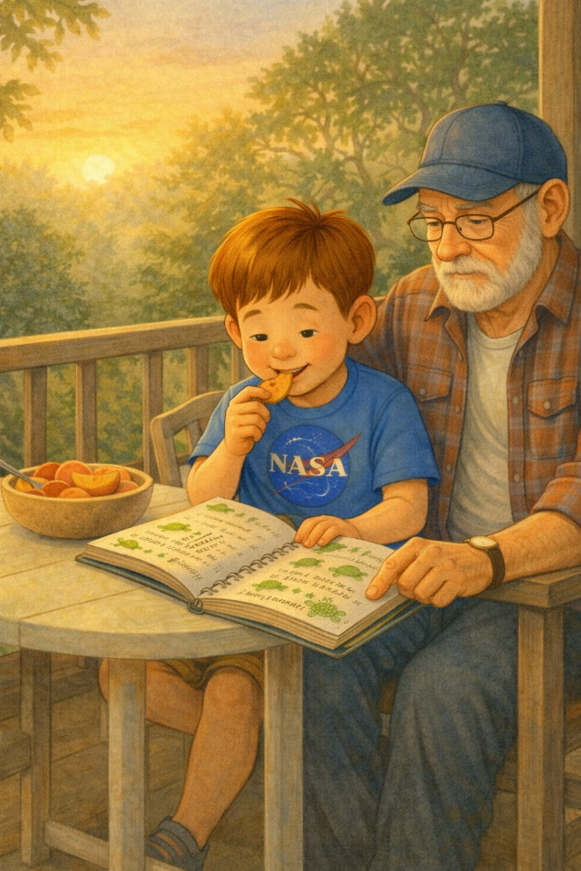
Grandpa nodded, his weathered fingers tracing the edge of the page. His smile faded slightly, replaced by a far-off look in his eyes.
“I want to tell you something,” he said finally.
Ben looked up.
Grandpa leaned back, folding his hands across his belly. “This isn’t the first time I’ve been on turtle patrol.”
Ben blinked. “Wait. What?”
Grandpa smiled. “Back when your dad was your age—maybe a little younger—he and I had a thing. Saturdays, early mornings. We’d get up before your grandma even had the coffee on. We’d drive the back roads, looking for turtles.”
“No way.”
“Oh yeah. We had our own system. A net, a pair of gloves, even an old plastic laundry basket in the backseat to move the big ones safely.”
Ben sat up straighter. “Dad never told me that.”
“He didn’t talk about it much. But those mornings? They were ours. Just the two of us. And the turtles, of course.”
Later that day, Grandpa disappeared into the garage. When he came back, he was holding something wrapped in an old beach towel.
“I’ve been saving this,” he said.
Ben opened the towel gently. Inside was a small wooden box. Carved into the lid was a faded image of a turtle—its shell a swirl of hand-cut spirals.
Ben lifted the lid.
Inside were photos. Dozens of them. Grainy snapshots of his dad as a boy—grinning, holding turtles of all shapes and sizes. Some were wet from the rain. Some were mid-stride in the grass. One showed Grandpa and Ben’s dad side by side, each holding a turtle like a trophy.
Ben couldn’t speak. He ran his fingers over the photos, as if they might disappear if he pressed too hard.
That night, he added a new entry to the notebook.
Turtle #26 – Ghost Turtle. Found in an old box.
Not saved by me, but by my dad.
Sacred points passed down. +10.
Legacy unlocked.
Then, underneath in smaller handwriting:
“It always counts.”
Ben didn’t sleep much that night, but he didn’t need to. His heart felt full. Not just with grief or pain, but with something stronger---- connection.
He wasn’t walking this road alone.
He had never been.
And now, every turtle he saved felt like a small whisper from the past.
A reminder that some missions never end.
They just pass on.

15. The One That Got Away
Ben fails to save a turtle in time and feels devastated. He learns an important lesson about effort, grief, and letting go.
The road stretched ahead of them, shimmering under the heat of the midday sun. It was one of those peaceful Sundays when the sky seemed endless and blue, and the world moved just a little slower.
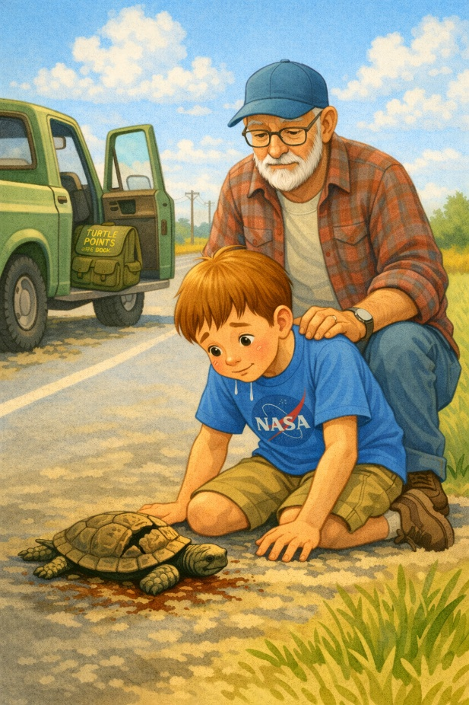
Ben sat in the passenger seat of Grandpa’s truck with his turtle logbook open in his lap. Twenty-eight turtles saved. Twenty-eight lives redirected to the wild. Twenty-eight points, by his own invisible tally.
He was determined to make it to thirty before his next round of chemo. Thirty felt like a real milestone. A sacred number. He hadn’t told anyone, but in his mind, thirty meant something—like a promise kept.
Like if he reached it, something would be okay.
So when he spotted the turtle ahead on the asphalt, he gasped.
“There! Right there!” he shouted, pointing so suddenly that Grandpa jerked the wheel.
The old truck pulled over, tires crunching gravel. Ben flew out the door, and the logbook was forgotten on the seat. The turtle was in the center of the lane, its shell dusty, its legs moving slowly and awkwardly.
A car was coming.
Ben moved to the side and waved his arms frantically.
“Stop!” he yelled.
The car didn’t slow down. Just honked. Swerved. And kept going.
Everything seemed to happen too fast and too slow at the same time.
When Ben reached the turtle, his breath caught in his throat.
The shell was cracked. The legs were still.
It was too late.
He dropped to his knees.
“No… no no no,” he whispered. “I was right here…”
His hands trembled. The turtle lay still, motionless in the heat. Ben’s throat tightened as Grandpa jogged over behind him, kneeling silently beside him.
“I should’ve run faster,” Ben said. “I saw it in time. I did.”
“It’s not your fault, buddy,” Grandpa said gently.
“I was right here!” Ben shouted, tears suddenly spilling down his cheeks. “I was right here…”
His voice cracked on the last word.
Grandpa placed a hand on his shoulder but said nothing. There was nothing to say.
The heat shimmered around them, the road suddenly quiet. The moment pressed into Ben’s heart like a stone. He stayed there longer than he needed to, like standing up would mean leaving it behind.

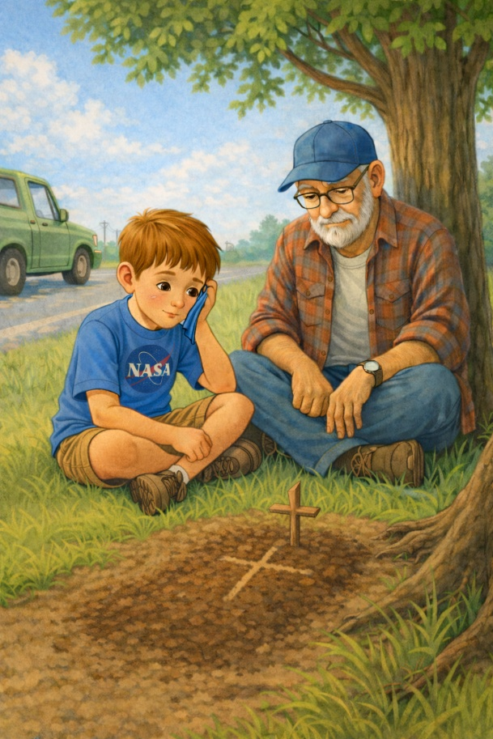
They buried the turtle beside a cypress tree just off the road.
Ben used a stick to scratch a cross in the soil. It wasn’t religious, not exactly—more like a mark of respect. A way of saying: You were here. You mattered.
Then he sat back, legs crossed, wiping at his face with the sleeve of his shirt.
“Do you think turtles go to heaven?” he asked softly. Grandpa looked at the tiny grave, then at Ben. “If there’s any justice in the world, they do.”
Ben nodded.
He kept his eyes on the small patch of dirt, like he didn’t want to forget where it was.
They sat in silence for a long time, until Grandpa added, “Your dad and I lost one once too.”
Ben looked up.
“He was devastated, just like you are now,” Grandpa said. “But then he asked me to take him to church. Said he needed to light a candle.”
Ben listened closely, like the story mattered more than usual.
That afternoon, they drove to the small mission-style chapel near the edge of town. It was quiet and cool inside; the air filled with wax and faint incense.
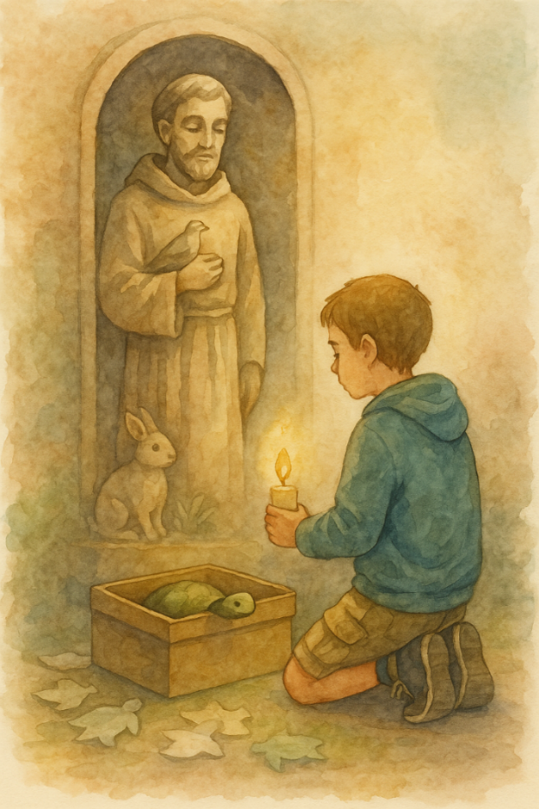
Ben wandered near the old statue in the corner—the one of the man with a kind face, holding a bird in one hand and a rabbit at his side.
“Who’s that?” Ben whispered.
“St. Francis,” Grandpa said. “He’s the patron saint of animals. Your dad used to talk to him like a friend.”
Ben stared at the statue. Something about it comforted him. The way the man’s eyes weren’t sad, just gentle—like he understood that loving anything meant sometimes losing it too.
He lit a candle and knelt.
“I tried,” he whispered to the statue. “I really tried.”
It didn’t feel lighter, exactly. Just… quieter.
And then, like a breath let out, something inside him eased. The ache didn’t go away—but it stopped resisting.
He realized something now: not every turtle could be saved. Not every moment turns out as hoped. But effort—that still matters.
Trying still mattered.
Love without guarantees was still love.
Back at home, Ben opened his logbook.
He turned to a fresh page and wrote slowly:
Turtle #29 – The One That Got Away. I did not make it. Tried. Ran. Failed.
Buried him near the cypress tree.
Points? Not sure. But maybe—just maybe—he matters more than all the rest.
He paused after writing the last line, his pencil hovering for a second before setting it down.
He closed the logbook and stared out the window.
And for the first time, he let go—not of the mission, but of the idea that success was the only thing that mattered.
The road outside was quiet again, like nothing had happened. But he knew better now.
Sometimes the lesson was the loss, and the strength came from trying again tomorrow.

16. Hospitals and Halo Talks
While undergoing treatment, Ben imagines what heaven might be like. He tells his mom he believes turtles have their own cloud to rest on.
Ben had grown used to the hospital.
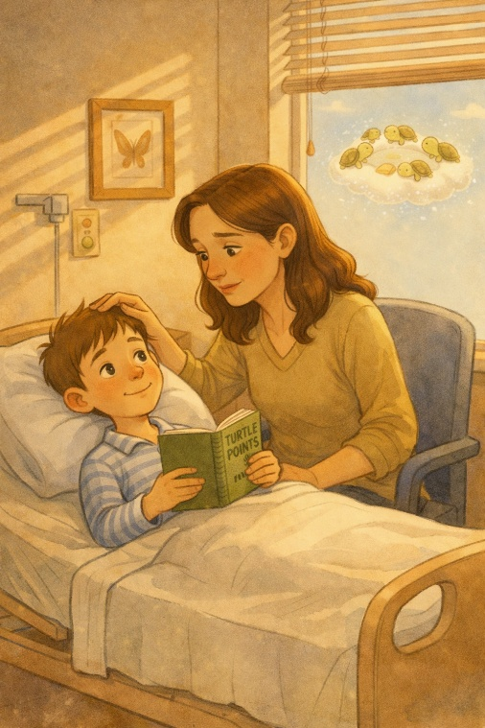
He knew which elevators squeaked, which nurses had the best stickers, and which pudding cups to avoid. He even had a favorite window in the children’s wing—a narrow one that overlooked the parking lot but also offered just a sliver of sky. The sky mattered. It reminded him there was something bigger than this.
Something beyond the walls and machines.
He was back in Room 412. The lights were dim, the IV machine was buzzing, and his mom sat nearby flipping through a magazine she wasn’t really reading. Ben lay still, exhausted from the last chemo session. His body felt heavy, but his mind drifted away, like a balloon gently tugging at its string.
“Mom?” he said softly.
She looked up right away. “Yeah, sweetie?”
“What do you think heaven’s like?”
She blinked, caught off guard. “Hmm… I don’t know. I think it’s beautiful. Peaceful. Full of love.”
Ben looked at the ceiling. “Do you think they let turtles in?” she smiled, soft and tired. “I think they especially let turtles in.”
He grinned, eyes barely open. “I hope they have their own cloud. Like… one just for turtles. With little ramps and soft grass. And maybe a pond that never dries up.”
“I bet they do,” she said.
She pictured it as he spoke, even if just for him.
Ben’s voice was quieter now. “I wonder if… when it’s time… if it hurts.” Her heart clenched as she stood and moved to the side of his bed, brushing his damp hair back from his forehead.
“What makes you ask that, honey?”
“I just… I don’t want to leave you if it’s gonna hurt,” he whispered.
He didn’t look at her when he said it.
Tears pricked her eyes, but she smiled. “You don’t have to worry about that. When that time comes—if it ever comes, it’ll be like falling asleep. Easy. Like floating.”
Ben closed his eyes. “Like resting on a turtle cloud?”
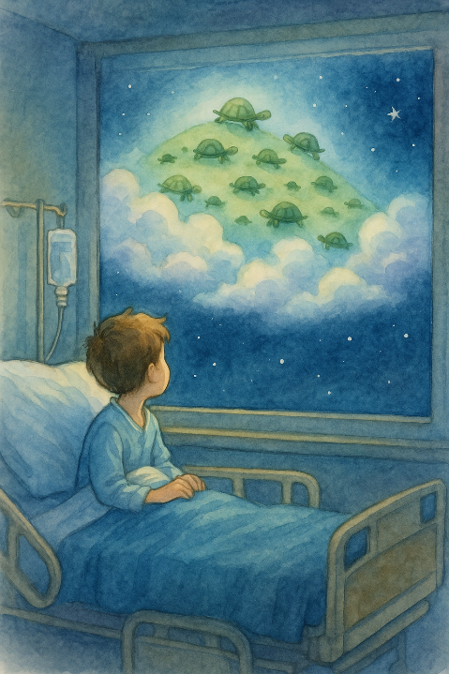
“Exactly,” she whispered.
The room remained silent for a long time, only the beep of the monitor breaking the quiet. The soft hum of machines filled the air. A mother watched her child’s chest rise and fall, taking in each breath. Counting them without meaning to. Then Ben spoke again, barely above a whisper.

I think... maybe when we get to heaven, someone will be there with a clipboard, like an angel with glasses, checking how many good things we did.
She smiled through her tears. “And what do they say to you?”
Ben let out a faint giggle. “They say, ‘Whoa, kid. You really loved turtles.’” His smile lingered for a moment after he said it.
Later, as night fell over the hospital and the world quieted outside, Ben watched the sky darken through his favorite window. He imagined that somewhere above the clouds, a gentle green hill was waiting, covered in tiny shells and slow-moving friends—a place where no one was afraid, where pain didn’t follow you, and where love stayed.
And where points still counted—just maybe in ways the world couldn’t see.
He didn’t know what tomorrow might bring. But tonight, in this small white room, Ben found peace in the question.
Not the answer. Just the question.
And that was enough.

17. The Weight He Carried
The hospital hallway was quieter at night.
It always seemed to soften after dark.
The hallway always seemed to soften after dark.
Not silent. Never completely silent.
But quieter in a way that made people speak more gently and walk a little slower. It was the kind of hush that made even ordinary moments feel important.
As Ben slept, Dad stood just inside the doorway, watching him.
The blanket had slipped down a little, and one of Ben’s hands rested on top of it, fingers curled loosely like he had been holding onto something and let go.
The notebook was still there.
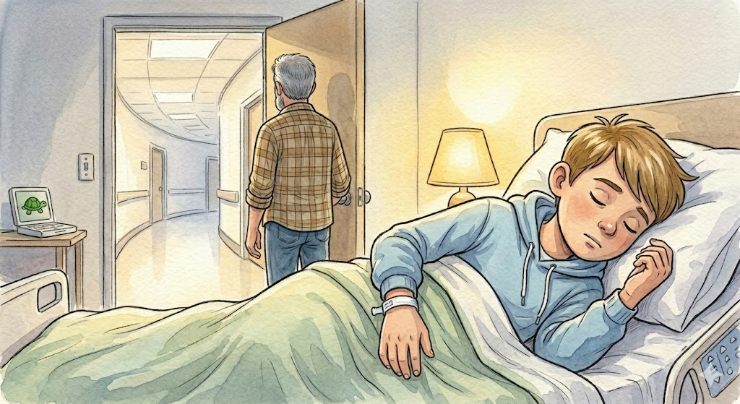
Always there. Tucked against his side.
Dad stepped closer. Carefully. Quietly.
He reached down and pulled the blanket back up over Ben’s shoulder, smoothing it the way he used to when Ben was much younger—before any of this, before hospitals and long days and words no parent ever wants to hear.
Ben stirred slightly but didn’t wake up. Dad waited a moment.
Then he sat down.
The chair beside the bed creaked softly under his weight.
For a while, he just watched.
Watched the quiet stillness of Ben resting.
He found himself noticing the smallest things—the way his fingers twitched now and then, like he was still doing something even in his dreams. Dad swallowed.
He reached for the notebook.
Hesitated. Then picked it up.
It felt lighter than he expected. He opened it slowly.
Page after page.
Turtles. Numbers. Notes.
Small handwriting. Careful. Intentional.
Dad traced one of the entries with his finger.
Turtle #1
He let out a quiet breath.
“That’s where it started, huh?” he whispered.
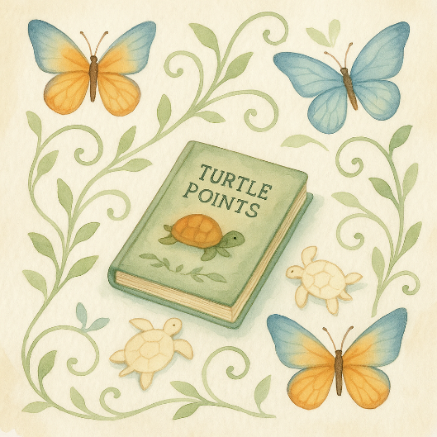
He flipped another page. And another.
Some entries were simple. Just a number. A place. A quick line.
Others… had more. Little comments. Little moments.
Little pieces of Ben.
Dad closed the notebook for a moment, pressing it gently between his hands.
He looked over at Ben again.
Still asleep. Still holding onto something invisible. “You really believed in this,” Dad said quietly.
Not a question. A realization.
He opened the notebook again. Near the back, there were fewer entries. The spacing between them was wider now, like time itself had started to stretch. But they were still there.
Still counted. Still mattered. Dad nodded slowly.
“Okay,” he murmured.
He didn’t say anything else for a while.
The room was quiet again.
Just the hum. Just breathing.
Just the space between moments.

Later, in the hallway, Dad stood with his hands in his pockets.
The doctor had already gone.
The words were still there, though.
They didn’t leave just because the conversation ended.
They stayed.
Echoed.
Settled somewhere deep in his chest, in a place he didn’t know how to reach.
Dad leaned back against the wall. Closed his eyes for a second.
Just one. Then he straightened again. Because that’s what he did.
He stayed steady.
Even when everything inside him wasn’t.
On the drive home that night, the road stretched out in front of him, quiet and empty.
No radio. No conversation.
Just the hum of the tires against the pavement.
Dad’s hands rested on the steering wheel.
Firm.
Controlled.
But his grip tightened slightly as he passed a familiar stretch of road. The kind where Ben would lean forward in his seat.
Watching. Looking. Ready.
Dad slowed the car without thinking.
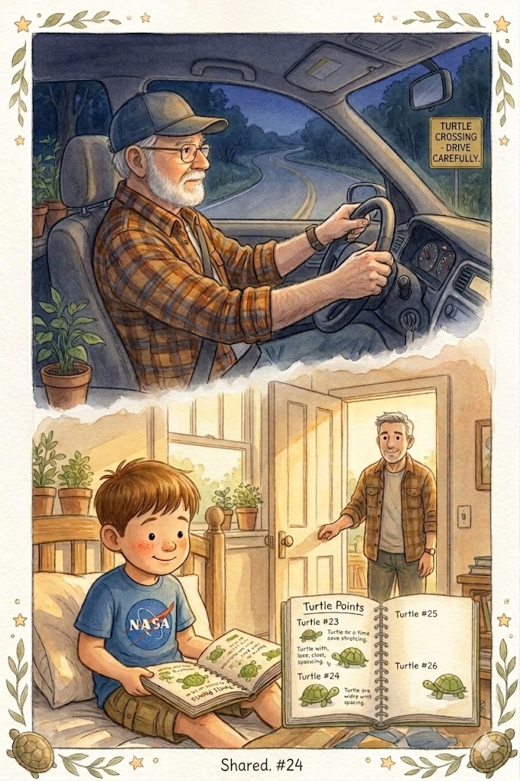
Just a little.
His eyes moved along the shoulder of the road. Grass. Gravel. Nothing there.
Still…
He kept looking, just in case for a moment longer than he needed to. Then he exhaled and pressed the gas again.
The car moved forward. But something had shifted.
The morning started with the sun dancing across the covers. Ben was awake.
Sitting up slightly. The notebook was open in his lap.
Dad walked in and paused at the door.
Ben looked up.
“Hey,” he said. “Hey,” Dad replied.
He stepped inside. Pulled the chair closer. Sat down. For a moment, neither of them spoke.
Then Dad nodded toward the notebook. “You still keeping track?”
Ben gave a small smile.
“Yeah.”
Dad nodded again. “Good.” He hesitated. Then added, a little softer:
“Someone should.”
Ben looked at him for a second longer than usual. Then he nodded too.
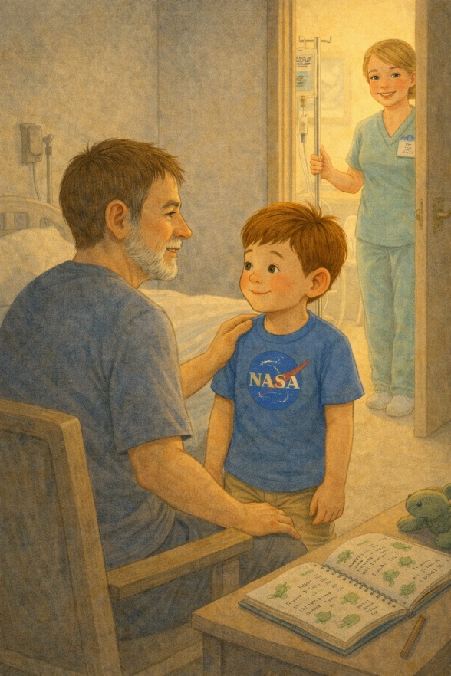
A nurse came in a little while later and smiled gently at Ben, letting him know it was time for his chemotherapy treatment. Dad stood up right away, smoothing a hand over Ben’s shoulder before walking with him to the doorway. Ben glanced back once, and Dad gave him the steady kind of smile that meant, “I’m right here. While Ben was gone, Dad stayed and waited, sitting quietly until his son came back. Dad picked up the notebook once more.
This time, he didn’t hesitate. He flipped to the next blank page.
Held the pen in his hand. Looked at it.
Then, slowly, he wrote:
Stayed.
Sat with him.
Didn’t leave.
He paused.
Then added:
Still learning how to be brave. He stared at the sentence for a moment, then gave a small, almost invisible nod. Then closed the notebook gently.
When Ben came back from treatment, he looked tired in the quiet way that made Dad’s heart ache. As he stood to leave the room, Dad rested his hand lightly on the edge of the bed. “I’ve got you,” he whispered. The words were quiet, but they held a certain peace and comfort. Ben looked up at him, and for a moment, the room felt a little steadier, as if those three words were enough to help carry some of the weight.

18. A Turtle Named Hope
Ben had never been a fan of hospital gift shops. Too many balloons, too many pink teddy bears, and everything felt fake. But Lily did.
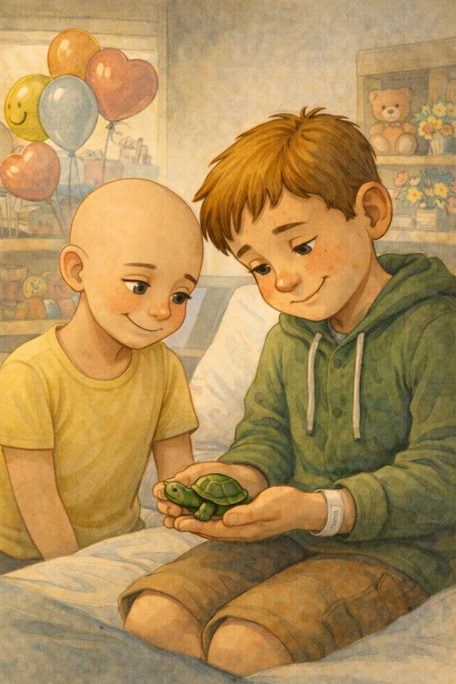
His best friend had a knack for making the dullest places feel magical. She said the gift shop was like a treasure cave if you looked long enough—and sure enough, during one of her visits while Ben was in recovery, she found something that made him forget everything for a moment.
It was smaller than a golf ball. A smooth, hand-carved turtle crafted from polished green stone. Its tiny head looked up with a calm, almost amused expression, and its small feet were tucked beneath its rounded shell as if it had nowhere to go and all the time in the world to get there.
“I saw this and knew he belonged to you,” Lily said, placing it in Ben’s open hand. “I named him Hope.”
Ben turned it over in his fingers. It was cool to the touch, smooth, and steady. Solid in a way everything else didn’t feel. The kind of object that one wants to hold.
“He’s good luck,” Lily added. “I made that up, but still. I believe it.”
Ben smiled. “He’s perfect.”
From that day forward, the little turtle accompanied him everywhere.
He kept it in his coat pocket or the side pouch of his backpack, on the dashboard of Grandpa’s truck, nestled in a soft circle of napkins.
Sometimes at night, when the hospital room felt too quiet, or the pain was too sharp, Ben would hold Hope in his hand, his thumb circling the little shell repeatedly.
The weight of it was comforting. Real. Something he could hold onto when everything else felt like it might slip away.
The first time he took Hope on a roadside rescue, they found a baby turtle no bigger than a cookie near the edge of a ditch. It was stuck, struggling to climb out, its tiny legs flailing uselessly in the mud. Ben crouched down, pulled Hope from his pocket, and whispered, “Let’s do this together.”
He cradled the baby turtle in one hand and held Hope in the other as he gently placed the creature back in the grass, away from the road, safe again. For a second, he looked at both of them, like they belonged to the same story. Hope had done her job.
As the days turned into weeks, Hope became more than just a lucky charm. She was a quiet friend. A small reminder. A symbol.
When Ben felt weak, she reminded him of his inner strength.
When he received bad news, she reminded him that good still exists. And when he wanted to give up, she reminded him that someone believed in him enough to give him her support. He didn’t say that out loud. But he felt it.
One afternoon, Grandpa asked, “So what’s with the turtle you always bring?”
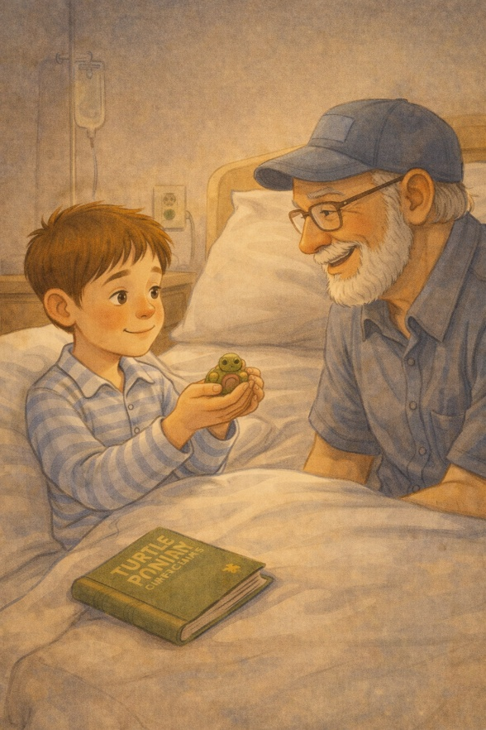
Ben held it up proudly. “Her name’s Hope. Lily gave her to me.”
“Hope, huh?” Grandpa grinned. “She looks like she knows some things.”
“She does,” Ben said seriously. “She’s been through a lot." That night, Ben added a new entry to his logbook.
Turtle #31 – Hope
Not saved, not wild. Just here. A reminder that small things matter.
Lucky charm. Best friend. Some turtles ride in pockets instead of ditches.
Maybe she counts double.
He underlined that last line once, then smiled to himself.
He closed the logbook and tucked it under his pillow, then slipped Hope into his palm.
The room fell silent again, but Ben wasn’t afraid. Not with Hope nearby. Not with so many turtles left to save.
Not when he still had something to believe in.

19. Rainy Day Miracles
Despite the bad weather and fatigue, Ben insists on saving one more turtle. That day, something unexpected and beautiful happened on the road. The rain started early that morning—gray, steady, and cold—one of those long, soaking rains that made everything feel heavier. On days like this, most people stayed inside, curled up under warm blankets and sipping hot drinks.
But not Ben.
He stood at the front door in his rain jacket and boots, with his backpack slung over his shoulder, and Hope, the carved turtle, zipped inside the outer pocket.
“You sure about this, kiddo?” Grandpa asked from behind, sipping his coffee and glancing out at the dull street. “Turtles don’t even like the rain that much.”
Ben nodded. “One more. Just one. I feel it.”
He didn’t try to explain what he meant. He just felt it.
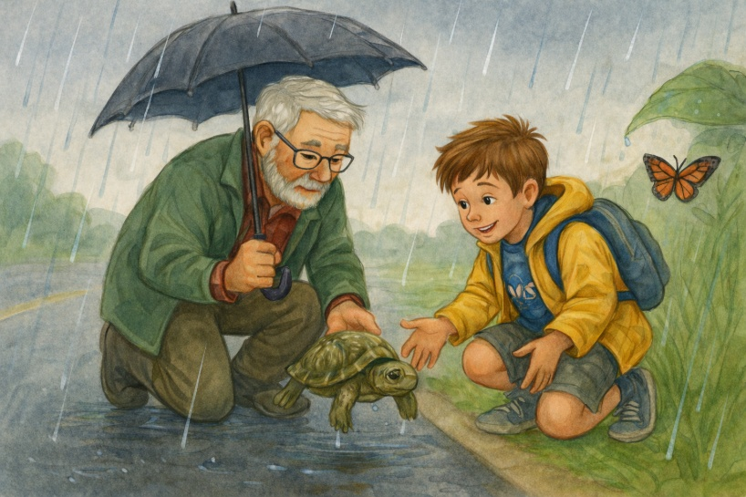
Grandpa studied him. His face looked pale, with shadows under his eyes darker than usual. But his expression was fierce and determined.
“All right,” Grandpa said. “Let’s go find your miracle.”
They drove slowly along the winding country roads, windshield wipers working overtime. The trees sagged under the weight of the rain, and the ditches were full of rushing water. The radio was off. Ben sat in silence, watching the blur of green and gray through the passenger window.
He didn’t know why he needed to go that day.
He just knew he did.
Maybe it was how he’d felt that morning—drained to his bones, weak in his legs, scared in a quiet way he hadn’t spoken aloud. The pain was worsening. The treatments were taking longer. His body had started to feel like it belonged to someone else. Like he was watching it from the outside sometimes.
But this sacred, simple act of helping still belonged to him. And he wasn’t ready to relinquish it. “There,” Ben said suddenly, pointing ahead. “Slow down!”
A dark shape shifted near the edge of the sidewalk.
Grandpa pulled over.
Ben stepped out into the rain. Cold water trickled down the back of his neck, soaking through his jacket collar. His shoes squished in the mud, but he didn’t mind.
The turtle was there.
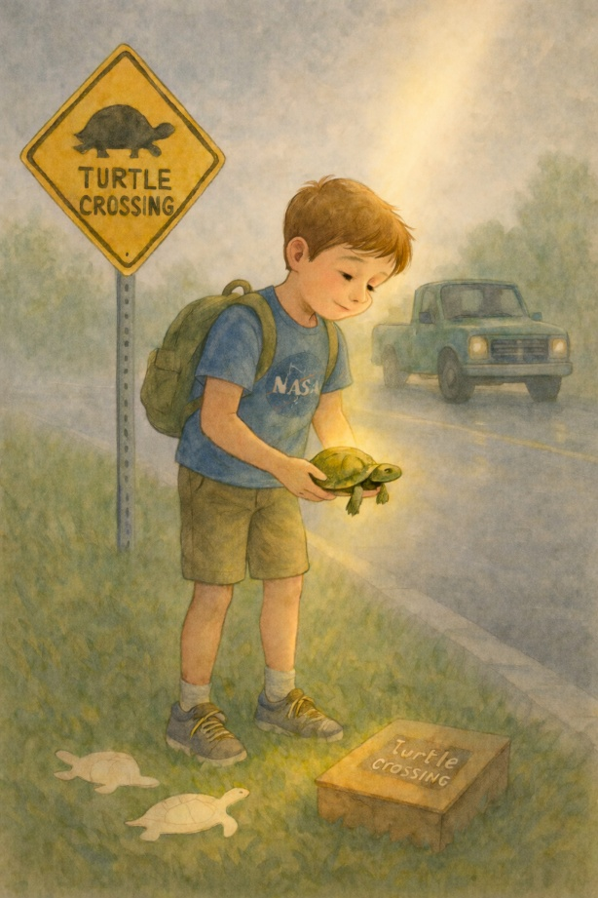
Not big. Not small. Just sitting, confused, in the middle of the road as if it wasn’t sure which way to go.
Ben knelt beside it.
“You picked the wrong day to travel, buddy,” he said softly, lifting the turtle with both hands.
And then, just as he turned to carry it to safety, something happened.
The clouds parted just slightly. A sliver of sunlight broke through, illuminating the wet pavement and casting a shimmering glow around Ben. The turtle in his hands seemed to glow, its damp shell reflecting gold for a moment.
From inside the truck, Grandpa caught his breath.
He would later swear it seemed like Ben was glowing as well.
Not bright. Not blinding.
Just… peaceful.
Like the world had gone quiet just to notice.
Like something in the world paused to say: This counts. Right now. This matters.
Ben didn’t notice the light. He was focused on the turtle, gently setting it down in the grass and whispering his usual farewell.
“Stay away from the road, okay? Go live your life. That’s an order.”
He paused for a moment in the misty clearing, inhaling the earthy scent as the rain slowed to a gentle whisper around him. Back in the truck, Grandpa handed him a towel. For a second, he just stood there, letting it all settle.
Ben smiled. “Told you I’d find one.” Grandpa smiled back. “You always do.”
Later that evening, Ben wrote slowly in his logbook, his fingers still damp from the rain.
Turtle #32 – Rainwalker
Rescued during a storm. Small, confused, golden for a moment.
Clouds opened. Sunlight hit the road.
Miracle? Maybe. Hope said yes.
Points: 2 for effort. +1 for magic.
He looked at the word “magic” for a second before closing the book.
He closed the logbook, pressed it to his chest, and leaned back against the pillows.
He was tired. Really tired.
But his heart was warm.
Sometimes, he realized, you had to go out into the storm to see the light.
20. The Night Sky Promise
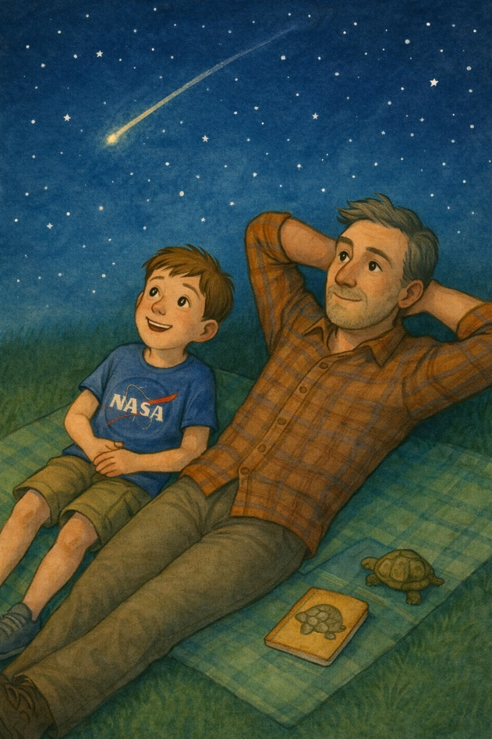
Ben and his dad lie under the stars and make a promise: whenever they see a turtle or a shooting star, they’ll think of each other.
The chemo hit harder this time.
Ben had barely spoken all day. His body ached, and his eyelids drooped. Even his usual brightness, the quiet spark he carried, seemed dimmed—like a firefly trapped in a jar with the lid screwed on too tight.
That evening, the house was silent. His mom had gone to bed early, and Grandpa was asleep in the recliner with a book on his chest. Only Ben and his dad stayed awake, lying on a blanket under the stars.
The sky was clear. Deep navy. Infinite.
“Wow,” Ben said softly, barely above a whisper. “It’s so big.”
His dad looked up. “It always feels bigger when it’s quiet, doesn’t it?”
Ben nodded. “It kind of makes me feel... small. But not in a bad way.”
His dad leaned back and crossed his arms behind his head. “Yeah,” Ben added softly, like he was finishing a thought. “Like the sky has a secret, and it’s okay that I don’t know what it is.”
They sat quietly for a few minutes, simply watching the stars. The stars blinked slowly, as if they were breathing. A gentle breeze rustled the trees. In the distance, a frog croaked once and then fell silent again.
Ben broke the silence.
“Dad… do you think you’ll remember me?”
His father slowly turned to him, eyes filled with emotion.
“What do you mean, buddy?”
“I mean… later. When I’m not here anymore.”
Ben didn’t say the word. He didn’t have to. It hung in the air anyway—gentle, inevitable.
His dad swallowed hard, then moved closer, placing a hand on Ben’s shoulder. “I will never forget you,” he said. “Not ever. Not in a million years. Not even after a hundred skies.”
Ben looked back at the stars.
“What if I forget you?”
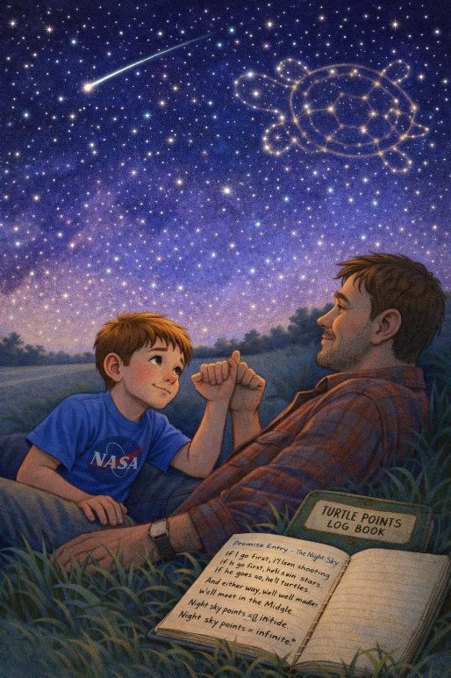
“You won’t.”
“But what if I do?” His voice cracked. “What if I forget everything... and I’m just... gone?”
He turned slightly toward his dad when he said it, like he needed the answer to be real.
His dad took a deep breath and exhaled slowly. “Then we’ll make a promise,” he said.
Ben looked at him.
“A night sky promise,” his dad continued. “Every time you see a turtle, a shooting star, or even just a really cool cloud, you’ll know I’m thinking about you. And I’ll do the same. If I see something beautiful, I’ll stop and think of you.”
Ben considered that.
“So no matter where we are…”
“We’ll still find each other,” his dad finished.
They locked pinkies, even though Ben was getting too old, because some promises deserve ceremony.
Neither of them let go right away.
Then they both leaned back and stared at the stars.
That night, before going to bed, Ben opened his logbook.
Under a new page, he wrote:
Promise Entry – The Night Sky
If I go first, I’ll send shooting stars. If he goes first, he’ll send turtles.
And either way, we’ll meet in the middle.
Night sky points = infinite. *
He traced the word “infinite” once with his finger before closing the page.
As he closed the logbook and turned off the light, he felt a strange peace settle into his chest.
Maybe he didn’t know how much time he had.
But he knew one thing now: he would never be lost.
He would always be seen.
And love—true love—was the kind that reached all the way across the sky.
21. When the Road Gets Long
Ben’s health worsens. Drives become more difficult. But he refuses to quit—his mission is too important.
The summer days felt different now.
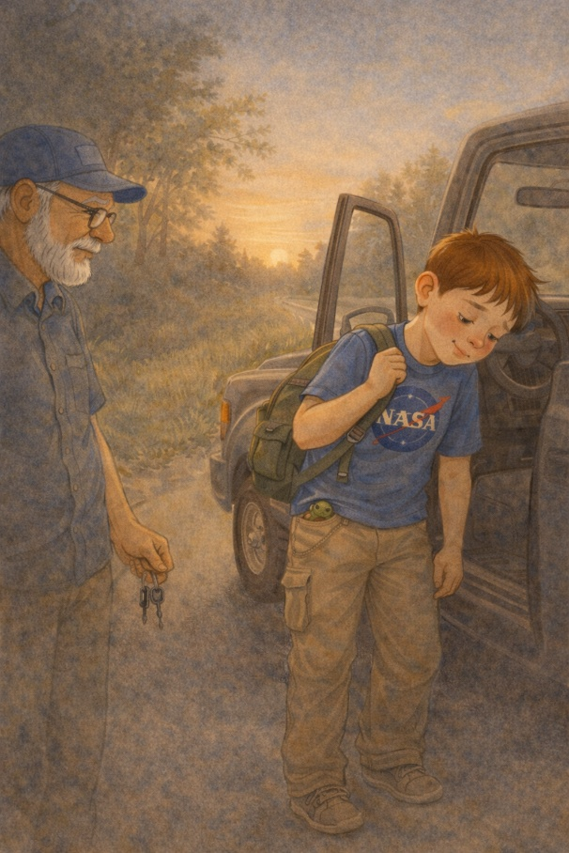
The sun still rose early, the birds still chirped outside the window, and the wind still moved through the trees like a whispered song — but Ben noticed the slowness in everything, especially in himself. He was tired.
Not just the usual tiredness that came after treatments or a long day at the hospital. This was deeper. Heavier. The kind of tiredness that sat in his bones made his thoughts cloudy, made his legs feel like wet sandbags.
Even his backpack felt heavier. The logbook, once light as a feather, now pulled at his shoulder. Hope, the tiny carved turtle felt like a stone in his pocket rather than a charm. Still, Ben wouldn’t stop.

“Just one road,” he told Grandpa. “Please. I can feel there’s one out there.”
Grandpa hesitated, hand on the truck keys. “We can wait until you’re feeling stronger.”
“No,” Ben said, voice thin but firm. “Today.”
There was no frustration in his voice. Just certainty.
Grandpa didn’t argue. He’d learned long ago that when Ben made up his mind, that was it.
They drove past the usual loops and highways, instead turning down an old back road neither of them had taken in years. The trees arched overhead like a green tunnel, and puddles from yesterday’s rain shimmered on the cracked pavement.
Ben gazed out the window, his head resting on his hand. The breeze felt cool against his face, and the world went by like a movie—trees, fences, sky, road. Trees, fences, sky, road.
Minutes passed.
Then he saw it.
“There,” he said, barely above a whisper.
Grandpa slowed the truck and pulled over. Ben reached for the door handle, but his arm was shaking.
“Let me go,” Grandpa offered gently. “You can stay and watch.”
Ben shook his head. “No. I have to go.”
He took a breath before opening the door, like he was preparing for something bigger than just stepping out.
He opened the door and stepped down slowly. His legs wobbled. He clenched his teeth and focused on the turtle a few yards away — a medium-sized one, just inching along the side of the road. No traffic in sight yet.
Ben moved cautiously, one step at a time, breathing shallowly through the pain.
Each step looked small, but it cost him.
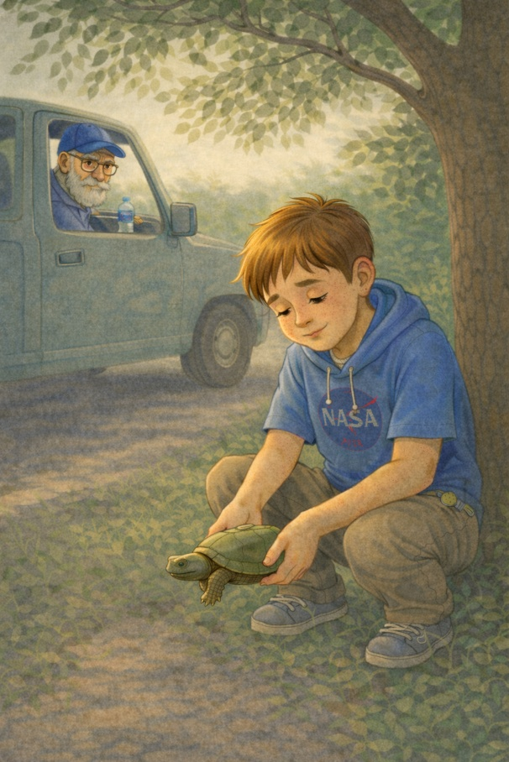
When he reached the turtle, he crouched down. Sweat streamed down his face, not from the heat but from the effort. “Hey, little guy,” he said softly. “I almost didn’t make it. But I’m here.”
He scooped the turtle up with both hands and walked it gently to the far side of the road. Once he set it down in the grass, he sat next to it for a long moment, both of them resting in the shade of a tree.
He didn’t say much.
Just sat there, exhausted and silent, letting the breeze pass over both of them.
Like they both needed the break
Back in the truck, Grandpa handed him a cold bottle of water and didn’t speak until Ben had taken a sip.
“That one took a lot out of you,” he said.
Ben nodded slowly. “The road’s getting long.”
Grandpa stared at the windshield, eyes misting. “You’re still walking it, though.”
Ben gave a weak smile. “Not alone.” He glanced down at his pocket, where Hope rested.
That night, Ben wrote with shaky hands:
Turtle #33 – Long Road Walker
This one challenged me. I could’ve stayed in the truck, but I didn’t.
Still moving, even when it’s tough.
Points = 3. One for the turtle. Two for the effort.
Getting harder, but the mission continues.
He drew a tiny sketch beside it: a boy and a turtle walking down a road, both small against a wide sky, but still moving.
Still together.
Ben didn’t know how many more roads he had in him.
But as long as he could walk, even if it was slow or with help, he would keep walking them.
Because the turtles still needed him.
And the points still counted.
22. Shells, Stars, and Prayers
His family holds a prayer circle for Ben. He sleeps with his turtles, his journal, and the carved one from Lily beside his pillow.
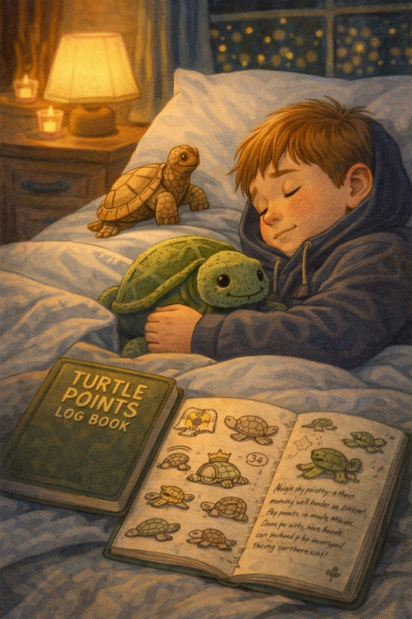
Ben didn’t go on a turtle run that week.
His legs wouldn’t let him.
Even walking from the living room to the kitchen left him breathless. The doctor said things were “progressing.” Everyone else avoided the word, but Ben knew what it meant.
He didn’t ask about it. He already understood enough.
Still, he didn’t stop keeping score.
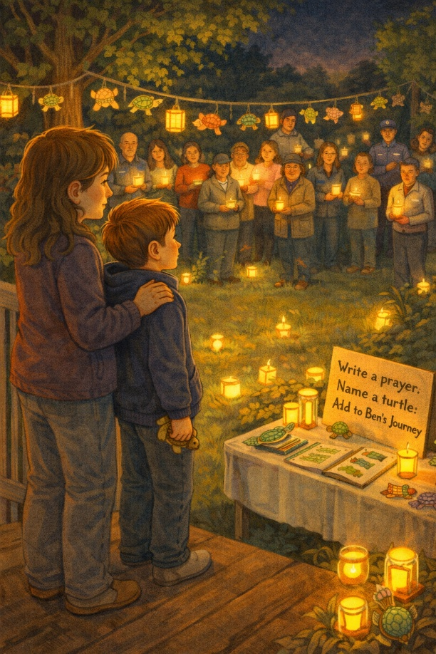
Every day, he opened his logbook, sometimes just to touch the pages, sometimes writing a little, sometimes to draw another turtle. One wore a cape. One wore a crown. One just sat under a tree, smiling. The logbook now had more than thirty turtles. But it held more than that, too—memories, promises, thoughts, prayers.
And it held hope.
One evening, as the sun dipped low and gold across the horizon, Ben’s mom gently knocked on his bedroom door.
“Can you come outside?” she asked. “There’s something we want to show you.”
Ben pulled on his hoodie and slippers, tucked Hope the carved turtle into his pocket, and let his mom help him onto the porch. The backyard glowed with candlelight.
Dozens of people stood scattered across the lawn—neighbors, friends, hospital staff, even the mailman. Some held candles, others small wooden turtles painted in bright colors. Some stood quietly with hands folded and eyes wet.
“Is this…” Ben started, his voice cracking.
“It’s for you,” his mom said, tears welling. “A prayer circle. And a turtle tribute.”
He looked around, stunned. For a moment, he didn’t move. He just took it in.
There was a long table set up with art supplies and stacks of paper turtle cutouts. A sign read:
Write a prayer. Name a turtle. Add to Ben’s Journey.
And they had.
All over the yard, turtle drawings hung from tree branches like ornaments. They were taped to fence posts, clipped to clotheslines, and arranged in circles in the grass. Each one had a name. Some were silly. Some were sweet. Some were scared.
- Braveheart
- Miss Wanda II
- Tiny Tim
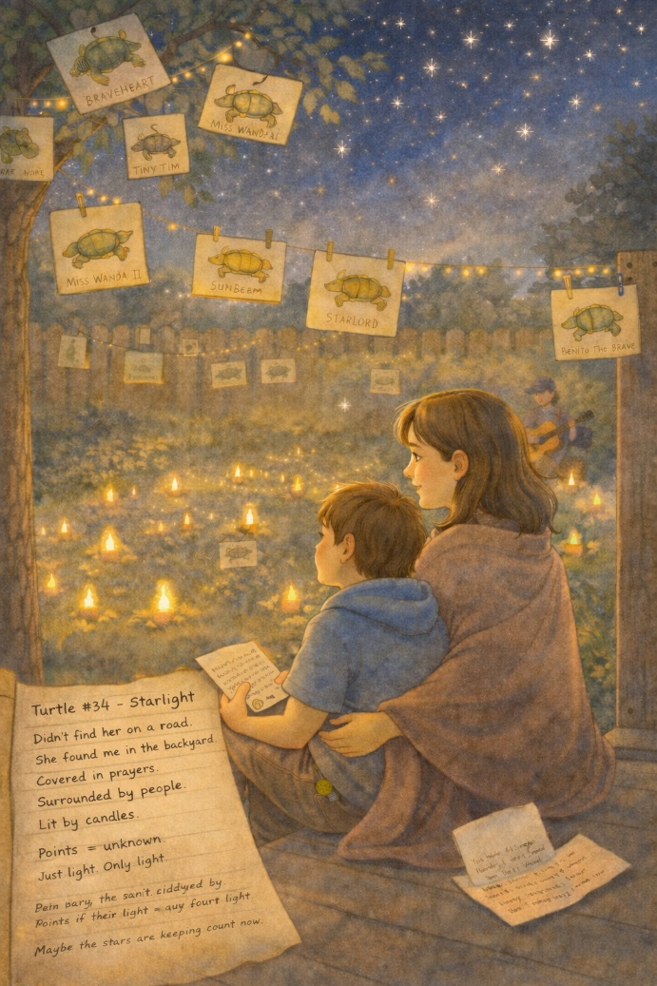
- Sunbeam
- Starlord
- Benito the Brave
Ben’s eyes welled up as he took it all in.
It felt bigger than he expected. Bigger than him.
Someone started playing soft guitar music. Grandpa walked over and handed him a folded note.
“Read it when you’re ready,” he said.
Ben opened it right there.
You saved more than turtles. You saved our hearts, too. We’ll keep the mission going. Just rest when you need to. You’ve done enough.
He read it twice before lowering the paper. Later that night, when the guests had gone, and the stars covered the sky, Ben sat on the porch wrapped in a blanket.
His mom walked with him, holding his hand. They didn’t speak much.
The candles still flickered in the yard, tiny lights swaying in the breeze.
Ben looked up.
“I think the stars are turtle shells,” he said softly.
His mom smiled. “Oh?”
“Yeah,” he said, a little more certain now. Like… maybe each one is a turtle I helped. Or someone else did. And now they shine.
She squeezed his hand. “That’s beautiful.”
Ben closed his eyes and whispered a quiet prayer—not the kind with a long list of words, just the kind that sits in the chest and floats upward without needing help.
He wasn’t afraid.
He felt seen. Loved. Wrapped in something greater than himself.
And for the first time in ages... he felt light.
Not better. Just lighter.
Later, he recorded a new entry in the logbook:
Turtle #34 – Starlight
Didn’t find her on the road. She found me in the backyard.
Covered in prayers. Surrounded by people. Lit by candles.
Points = unknown. Just light. Only light.
And then, in small letters at the bottom of the page:
Maybe the stars are keeping count now.

23. A Visit from Mr. Finch
Ben’s grumpy neighbor, Mr. Finch, tells Ben he saved a turtle for the first time. Even old hearts can be changed by small kindness.
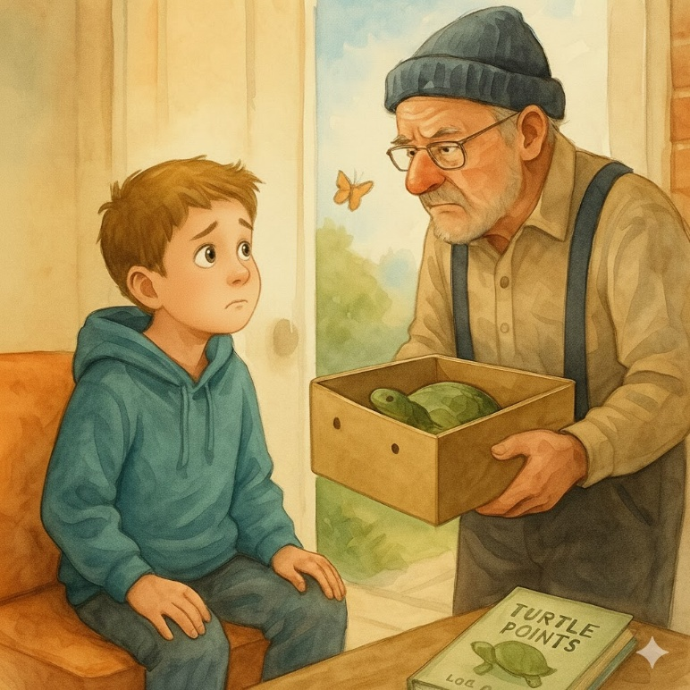
He was the neighbor across the street with over-trimmed bushes, the “Keep Off the Grass” sign, and a voice that made mailmen walk faster. He was rarely seen without his stiff hat and suspenders, and he had exactly one facial expression: annoyed.
Ben used to joke that if Mr. Finch smiled, the sky would fall.
So, when the doorbell rang on a gray Tuesday afternoon, and Mr. Finch was standing on the porch, holding something in both hands and shifting awkwardly from foot to foot, everyone in the house froze.
“Uh… hello, Mr. Finch,” Ben’s mom said cautiously, wiping her hands on a dish towel.
“Is the boy home?” Mr. Finch asked, his voice rough from disuse—or maybe just from being perpetually grumpy.
Ben’s mom blinked. “Ben is resting, but I’m sure he’d like to see you.”
Ben was already walking down the hall, wrapped in a blanket, with his carved turtle “Hope” poking out of the pocket.
When he saw Mr. Finch, he raised an eyebrow. “Am I in trouble?”
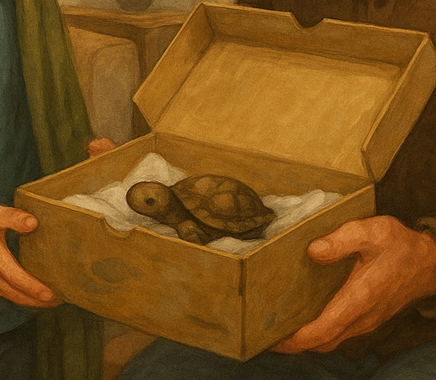
Mr. Finch huffed. “Course not.”
He held out a shoebox—old, worn, with a faded sneaker logo on the lid.
Ben took it gently. “What’s this?”
“Open it.”
Inside the box, on a bed of paper towels, was a small turtle. Mud still clung to its shell, and one leg was curled slightly as if it had been twisted.
“I found him on Palmer Road,” Mr. Finch muttered. “Would’ve run him over if I hadn’t been lookin’. Pulled the car over. First time I’ve stopped in years speaking in American dialect."
Ben’s mouth opened in surprise. "You… rescued a turtle?”
Mr. Finch shifted again. “Well, I did it wrong. Put him in the wrong direction. I had to turn back and fix it. My shoes got wet. But yeah. I did.”
Ben smiled so wide it hurt his cheeks.
“And I figured,” Mr. Finch continued, clearing his throat, “you’d know what to do with him.”
Ben softly touched the turtle’s shell. “He’s perfect.”
There was a prolonged silence. Then Mr. Finch quietly added, “I’ve been reading about you. The logbook. The Points. The kids at the hospital.”
Ben gazed up in surprise.
“I don’t know how much time you've got left, son,” Mr. Finch said softly. “But you’ve already done more good in this world than most folks do in eighty years.”
His voice softened at the end, almost like he didn’t mean to say it out loud.
Ben didn’t know what to say, so he hesitated and nodded.
Mr. Finch reached into his pocket and pulled out a folded slip of paper. “I drew a turtle. For your prayer tree out back.”
He handed it over. The drawing was crooked and childlike, done in shaky pencil, but it had a label at the top:
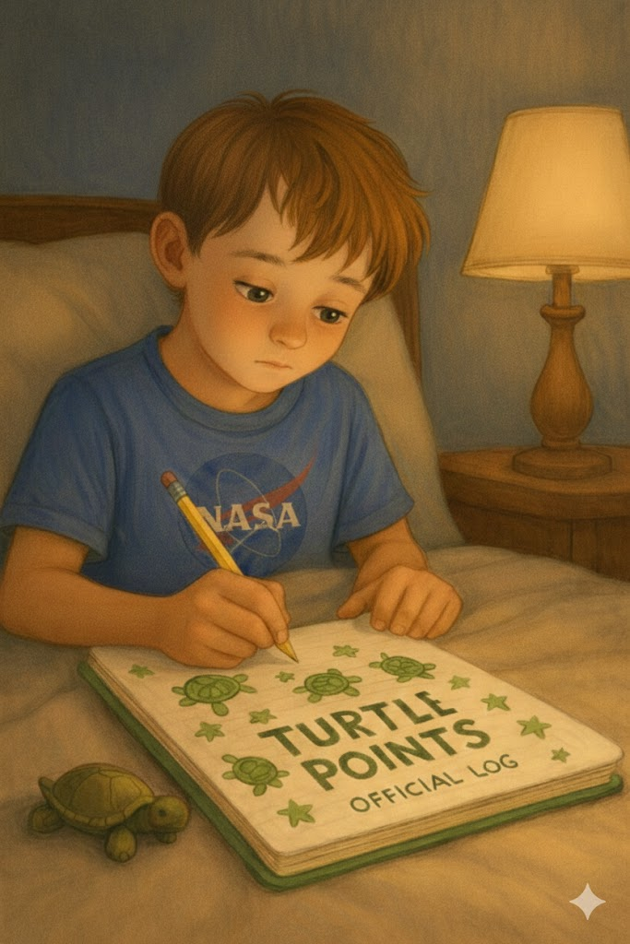
Turtle #1 for Mr. Finch – Lucky Harold. Found by accident. Saved on purpose.
Ben chuckled. “Welcome to the mission, Mr. Finch.”
Mr. Finch tipped his hat. “Guess there’s hope for old guys too.”
After Mr. Finch left, Ben turned to his mom, still holding the box with the turtle inside. "I didn’t know he could be kind." "Sometimes,” she replied, “people just need someone to show them how." Ben nodded slowly, like he was adding that to his list of things that counted. That night, Ben opened his logbook and wrote:
Turtle #35 – Lucky Harold. Found by Mr. Finch, who used to scare me.
Saved in the rain. Changed a man.
Points = shared. Mine and his. Maybe more for him.
Hope says we never know the full story.
Then, at the bottom:
People are turtles, too sometimes. Slow to change. Worth saving.

He paused after writing that, then smiled faintly.
Ben held Hope in his hand and gazed out the window, the porch light reflecting off the wet street. He didn’t rescue the turtle that day. But something else had been rescued.

And somehow, he knew that counted too.
24. The Last Rescue
Ben saves his last turtle, whispering, “You go on ahead.” He knows his journey is coming to an end. The morning was cool; the sky was painted in soft shades of blue and gold. One of those perfect days that seemed to hold its breath in anticipation. Ben had barely slept the night before. Not because of pain, but because of a feeling—something deep and certain in his chest, like a clock gently ticking toward a final moment.
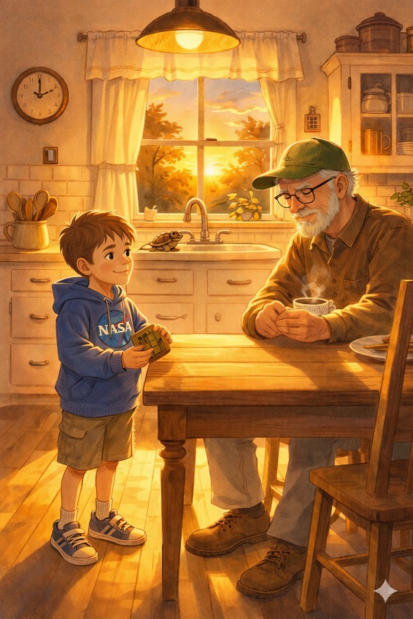
When he woke up, he didn’t speak right away. He just sat up slowly, reached for his hoodie, and tucked Hope, the tiny carved turtle, into his front pocket as he always did. Grandpa was already waiting in the kitchen, sipping his coffee. Ben looked up and said simply, “I think it’s time.” Grandpa nodded. “Yeah. I know.”
They didn’t say anything else. They didn’t need to.
They didn’t take the highway; instead, they chose the old winding road that passed by the orchard, through the fields, and along the stream. It was the same road where Ben had saved his very first turtle.
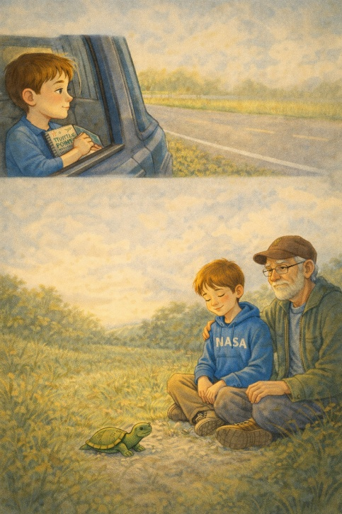
Everything seemed quieter that day, as if the world understood this trip was different. Ben rested his head against the window, logbook in his lap, hands gently folded. He wasn’t writing, just holding it—the way you might hold a friend’s hand on a long drive.
They drove for almost an hour before Ben slowly raised his hand and pointed. "There,” he whispered.
It was a small turtle, not dramatic or endangered, just sitting by the side of the road as if it had been waiting for him.
Grandpa pulled over and parked the truck in park.
“You want me to get it?” he asked.
Ben shook his head and said, "We can both go."
It took him an entire minute to climb down from the truck. His legs felt weak, and his breathing was shallow. But each step mattered.
He moved slowly, carefully, like he didn’t want to rush the moment.
He and his grandpa knelt beside the turtle, trembling. It didn’t move; it just watched them—calmly present.
“Hey, little guy,” Ben whispered. “I almost didn’t make it today, but I’m glad you waited.”
He scooped up the turtle and carried it across the road, gently placing it in the grass and brushing away a leaf from its shell. Then he sat down beside it, legs crossed, eyes closed. He stayed there for a moment, just breathing.
Ben sat quietly, a faint smile on his face, with faintly smiling with his grandpa beside him.
“Think that’s it?” Grandpa asked softly.
Ben nodded. “Yeah. That was the last one.”
Grandpa swallowed the lump in his throat and sat down beside him.
They sat in the quiet of the field, with the sun warming their backs and the wind whispering through the tall grass.
No words were needed.
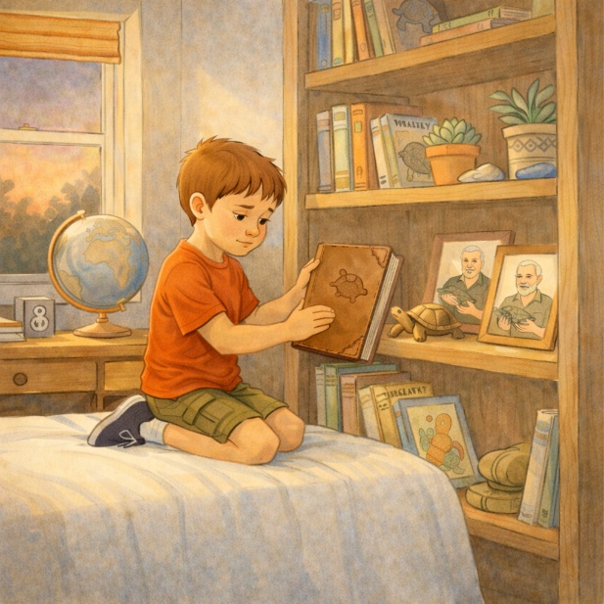
Back home, Ben made a final entry in his logbook:
Turtle #36 – The Last One
Not big. Not in danger. Just waiting.
I think it was meant for me.
Carried across gently. Rested beside it.
Points don’t matter. I think I’m done counting.
Then, underneath that, in handwriting a bit slower and softer:
I’m ready.
He looked at the page for a long moment before closing the book.
He closed the logbook for the last time and set it on his shelf next to Hope, beside a framed photo of his dad and Grandpa holding turtles long ago.
That evening, he sat on the porch with his family—watching the sky, holding hands, and saying very little. The stars began to appear one by one. Ben leaned his head on his mother’s shoulder.
“I hope someone keeps going,” he murmured. “They will,” she whispered. “Because of you.” He nodded and looked up at the stars. He stayed there a little longer, just watching. Later that night, quietly in his bed, Ben let go.

25. The Letter Under His Pillow
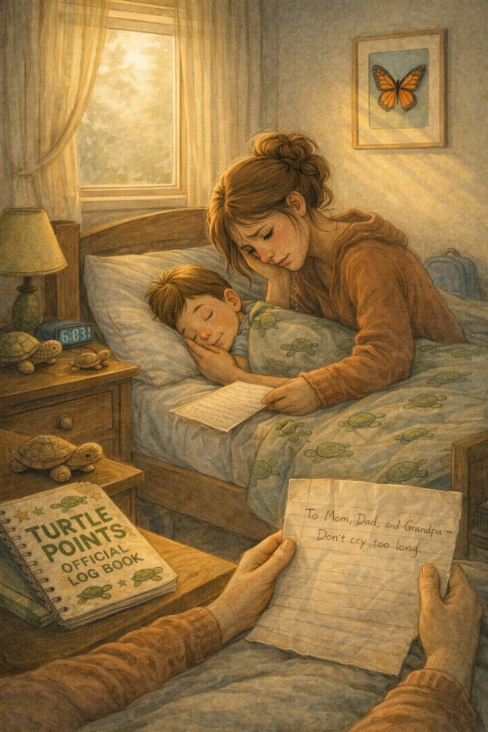
The morning light arrived softly, caressing the curtains like a whisper. Outside, the world was quiet—no birds, no traffic—just the stillness that follows something sacred.
Ben’s room felt different that day. Not empty, not cold. Just… still. As if time itself had paused to bow its head.
His mother was the first to enter.
She didn’t rush. She opened the door slowly, as if waking a sleeping child. She stepped inside and saw him there, lying peacefully under his favorite blanket, his turtle logbook resting on the nightstand, and the small carved turtle—Hope—beside his hand.
She sat down beside him and touched his cheek.
He was gone.
A soft sob escaped her, quiet and raw.
Then, as she lay her head next to his, she felt something under the pillow—something folded.
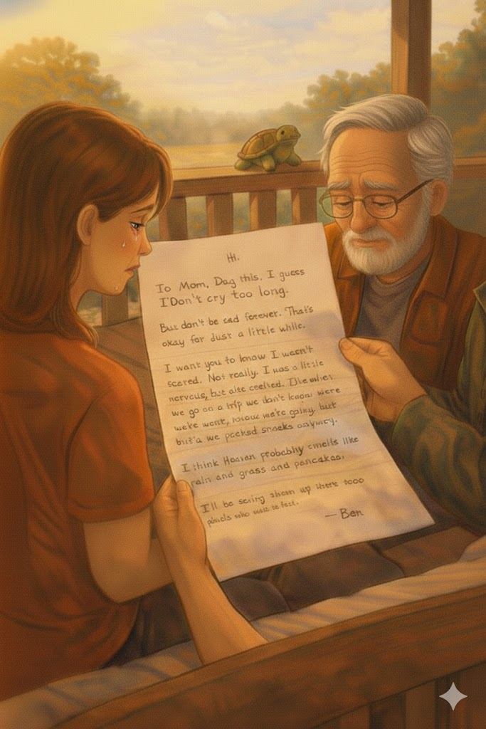
She reached underneath and pulled out a sheet of lined paper, creased at the corners, written in Ben’s unmistakable handwriting.
On the front, it simply said:
“To Mom, Dad, and Grandpa — Don’t cry too long.”
They read it together later that morning, sitting on the porch where Ben loved to be, the letter unfolding like a final conversation. His words were simple and honest, the way only a child can speak, and only a heart like his could understand.
Hi. If you’re reading this, I guess I’ve gone ahead. But don’t be sad forever. It’s okay for just a little while.
That's okay for just a little while. I want you to know I wasn’t scared. Not really. I was a little nervous, but also excited. Like when we don’t know where we’re going, but we still pack snacks. I think Heaven probably smells like rain, grass, and pancakes. I think they have a whole cloud just for turtles.
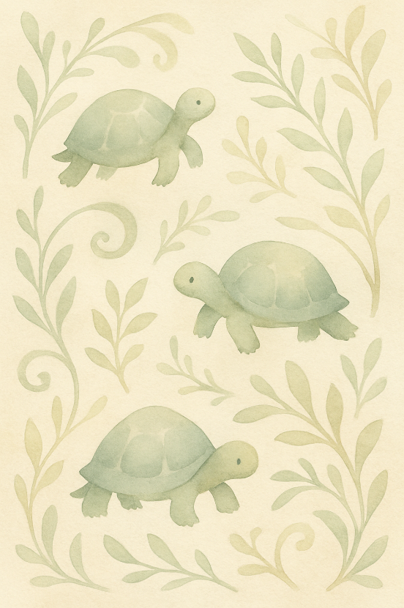
I’ll be saving them up there as well, maybe from angels who walk too fast. Mom, thanks for always holding my hand and my heart. Dad, thanks for teaching me to look up. Grandpa, thanks for never letting me feel small.
If people ask about me, say I was the kid who tried to save what was slow, small, and easily overlooked.
Also, keep watching the roads.
And the skies.
I’ll be there. I promise.
Love you forever,
Ben (aka: Turtle Boy)
Not a dry eye remained when the letter was finished.
But there were also no regrets.
Ben had expressed everything that mattered. Each word was a gift. Every sentence was a step across a final road.
And in those pages, he had done what he always did, made something better.
Even goodbye.
Later that week, they framed the letter and hung it above his bed. They also added a new section to the back of his logbook space for messages to Ben.
Friends and family started writing letters back—notes, drawings, prayers.
Someone said:
We saw a turtle today. We stopped, smiled, and remembered.

And someone else added:
We’re still counting.
And the mission carried on.

26. Turtle Points Redeemed
The town honors Ben’s life with a “Turtle Day.” Dozens of people share how his quiet mission inspired them. The town had never seen anything like it.
Two weeks after Ben’s passing, on what would’ve been his tenth birthday, a group of hospital nurses, neighbors, teachers, and friends gathered in the town square with one shared idea:
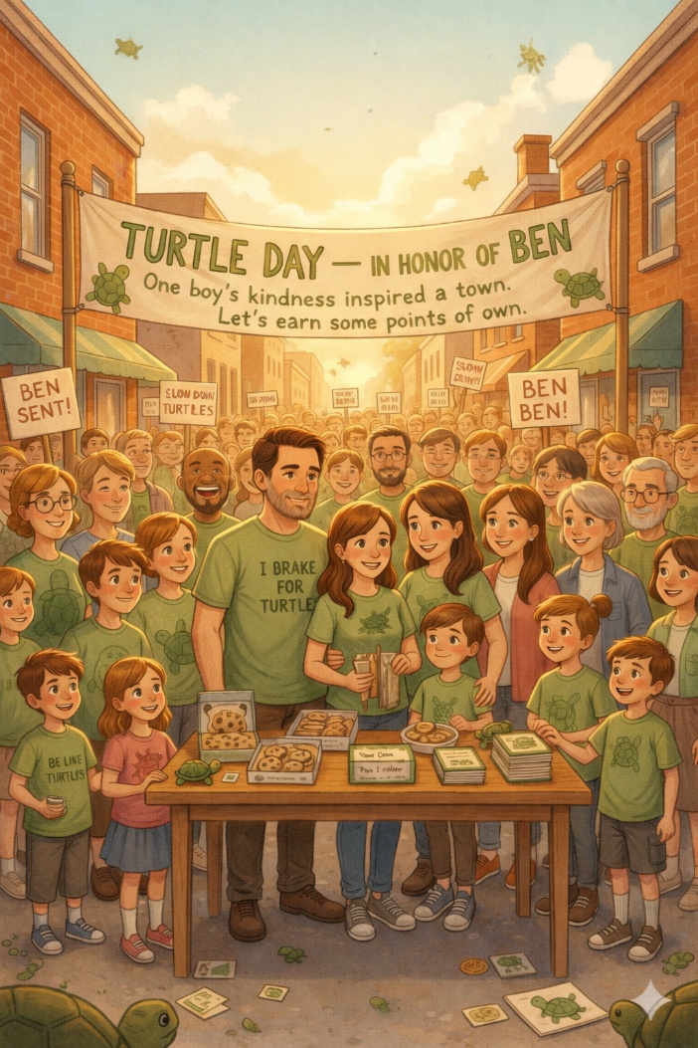
“Let’s keep it going.”
It began with a flyer:
“Turtle Day – In Honor of Ben”
One boy’s kindness inspired a town. Let’s earn some points of our own.
Then it grew.
On a warm Saturday morning, the streets buzzed with families dressed in green shirts that read:
“I Brake for Turtles.”
#TurtlePoints
Be Like Ben.
Kids held hand-painted signs:
🟢 “Slow down—turtles ahead!”
🟢 “Ben Sent Me!”
🟢 “Heaven Keeps Score.”
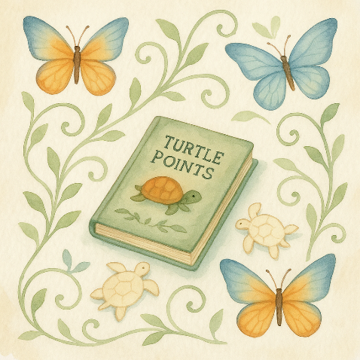
Even people who hadn’t met Ben personally showed up. The local paper ran a front-page story about him. Radio DJs mentioned him between songs. School counselors shared their logbook entries in classrooms. There were turtle cutouts taped to storefronts. Art contests in the park. Sidewalk chalk drawings of shells and stars. Everywhere you looked, there were reminders. And a long table near the center of town, piled high with turtle-shaped sugar cookies, where volunteers passed out blank logbooks labeled:
“Your Own Turtle Log – Track Kindness. It All Counts.”
Grandpa stood near the stage, holding Ben’s original turtle logbook in one hand and a copy of his letter in the other. He wasn’t much for speeches, but when the microphone was handed to him, he cleared his throat and found the words anyway.
“Ben didn’t start this to be remembered,” he said. “He started it because he saw something slow and small and decided it mattered. And then he decided people mattered too. That helping anything—even just a turtle—meant something.”
He held up the logbook.
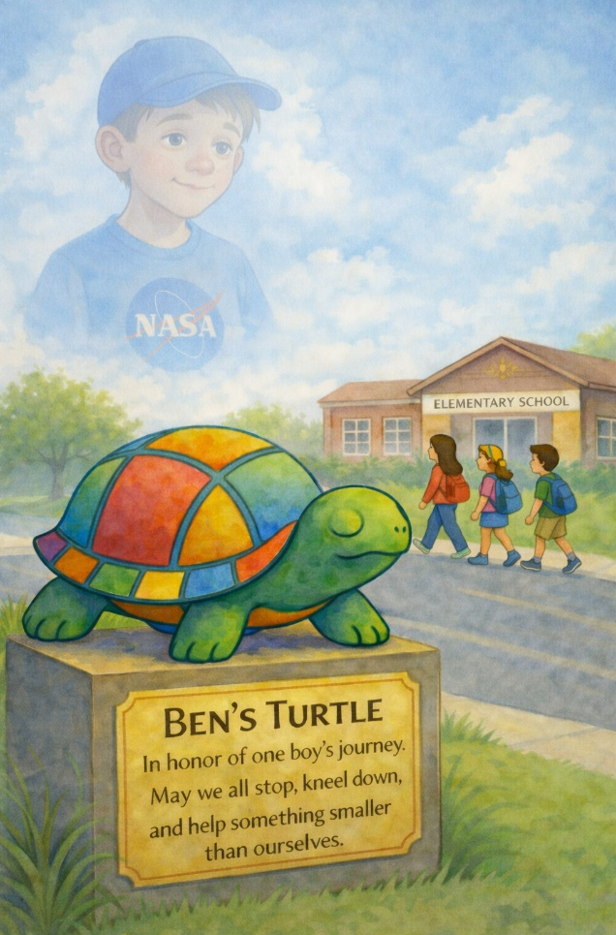
He believed you could earn points for kindness. And I don’t know how heaven keeps score—but I believe it’s filled with kids like him. Brave ones. Quiet ones. The ones who noticed the small stuff. There wasn’t a dry eye in the park.
Later that day, someone unveiled a surprise: a large metal sculpture of a turtle, painted in bright colors, with a plaque at the base.
Ben’s Turtle – In honor of one boy’s journey.
May we all stop, kneel, and help something smaller than ourselves.
It was located near the elementary school, where kids would pass it every day. Where someone would always remember.
That night, as the town gradually grew silent, Ben’s mom sat on the porch with a candle in her lap. She looked up at the stars and whispered, “They did it, baby. They’re still saving them.”
And just then—a shooting star streaked across the sky. She smiled through her tears, like she understood.
The next morning, someone discovered a small turtle near the edge of the playground by the sculpture. A child paused, gently picked it up, and carried it across to the other side.
When asked why she did it, she smiled and said, “Because Ben would have.”
And just like that, the mission kept going.

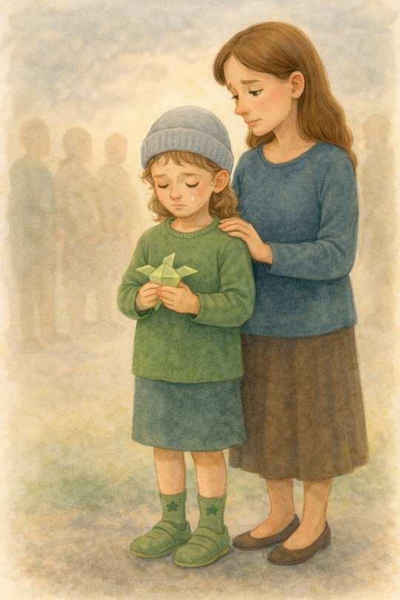
27. Heaven Smells Like Grass
Lily dreams of Ben sitting on a cloud, surrounded by turtles. She tells his mom, “He made it." Lily didn’t cry at the funeral, not in front of anyone. She stood quietly beside her mom, fingers tightly gripping the origami turtle Ben once called “Wanda,” her soft curls tucked beneath a gray beanie. She wore green socks with tiny turtles stitched into the heels—Ben’s favorite.
She didn’t speak during the service or walk up to the podium. She didn’t need to.
Everyone knew she was Ben’s best friend—the girl who sat with him on the hospital roof, the one who gave him Hope. The one who never stopped believing in him—even when things got hard.
The person who never ceased believing he would improve—even when he stopped believing in himself.
But after the crowd had left and the candles were out, Lily cried. Alone. In her room. With the lights off and the door shut. The tears came fiercely, hot and confusing, as if part of her had come loose and floated away, never to return.
She felt an ache for him that was too big for her small frame.
That night, as the moon rose over the quiet streets, Lily finally drifted to sleep with Wanda clutched in her hand and a question still lingering in her heart:
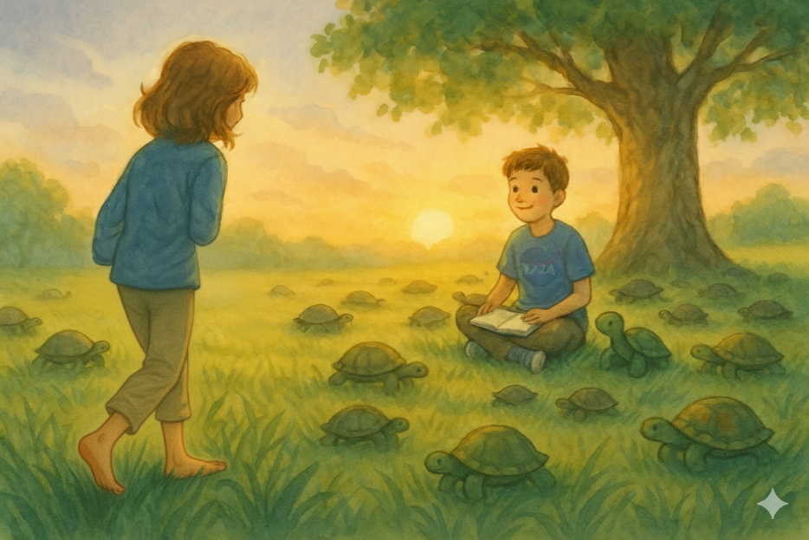
Where are you, Ben? Really?

She dreamt she was walking through a field—lush, green, as wide as the sky.
The sun was rising, casting everything in warm gold. The air was thick with the smell of morning dew and fresh-cut grass, rich, sweet, and clean.
She walked barefoot, the blades brushing her ankles, soft and supple, cool.
And then, she saw him ahead, Ben.
He sat cross-legged under a large tree, with his logbook in his lap and his carved turtle Hope resting beside him.
He looked up and smiled as if he had been waiting for her.
“Hey,” he said.
Lily hurried over to him, and when she reached him, she froze.
Turtles.
Dozens of them.
All around him. Slow, peaceful, and calm. They wandered across the grass and through the trees. Some rested in the sun, others napped under clouds, and some sat beside him, as if listening to an invisible story only Ben could tell.
“Are you okay?” she asked softly.
Ben nodded. “I’m perfect. It’s always morning here.”
“What is this place?”
He looked around and said, "I think it’s heaven.”
She frowned. “But it smells like grass.”
He smiled again. “Yeah. I think that’s the point.”
Lily sat down next to him. “Are you still keeping score?”
Ben laughed. “Not anymore. Turns out, you don’t need points up here. They already know who you are.”
She looked around once more. “Are these all the turtles you saved?”
“Some are mine. Some are yours. Some belong to everybody.”
Some are mine. Some are yours. Some belong to everybody.
He paused. “I think they just come here when they’re loved.”
Lily woke up in the middle of the night, her heart pounding softly, a smile on her lips. She didn’t need to cry anymore. Not that night.
She got up, walked to her desk, and opened her own turtle logbook, the one Ben had inspired her to start.
And on a new page, she wrote:
Dream Turtle – Morning Grass
Ben’s okay. Heaven smells like freshly cut grass.
Logbook still open. The mission is still ongoing.
I will keep going. I promise.
She paused after writing that last line, then nodded to herself.
She drew a tiny turtle with wings next to it and closed the book.
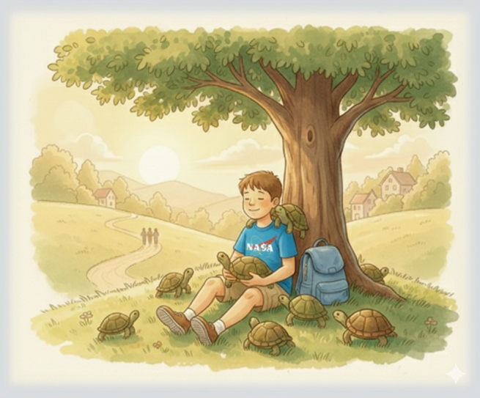
Outside, the stars watched silently. And somewhere beyond them, a boy was still sitting under a tree.
Still smiling.
Still surrounded by turtles.
Still reminding the world that love is slow and steady…
…and it always finds its way home
28. The Road Keeps Going
Ben’s grandpa keeps the tradition alive with neighborhood kids. Turtles continue to be saved, and so does kindness.
The seasons have shifted.
Summer transitioned into fall, with the green leaves of Ben’s world turning gold and red before gently drifting down like soft prayers from the sky.
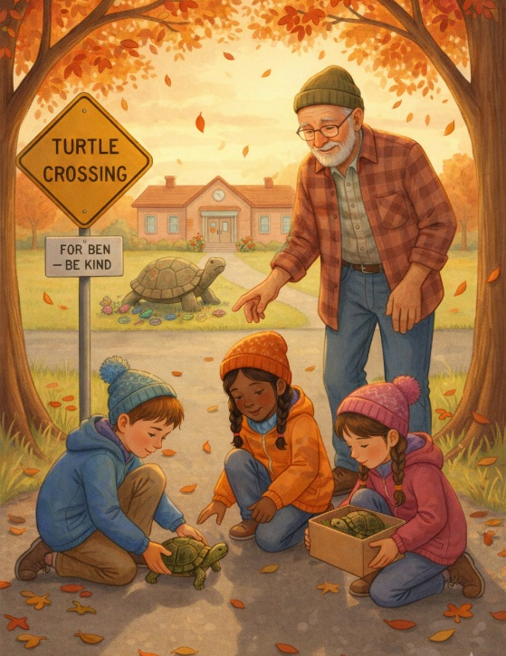
The porch swing still creaked in the evenings. The turtle sculpture in front of the elementary school stood proudly, weathered now but loved. People still brought flowers to it. Some left tiny painted turtles, while others left folded notes, bracelets, or photos of turtles they’d rescued.
Ben’s name had become a quiet anthem around town—not loud or shouted, just softly spoken in hearts and stories.
“Ben would’ve stopped." "Let’s help. For Ben."
"This one’s worth a Turtle Point.”
The mission wasn't over; it had merely changed hands.
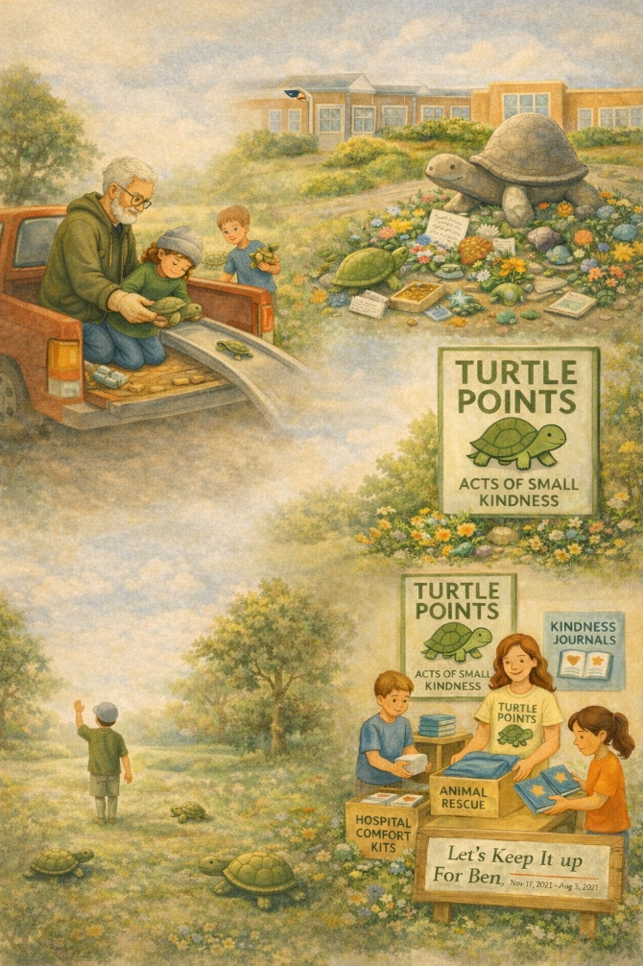
Grandpa Jim still mostly drove the back roads on weekends. He kept a pair of gloves in the glovebox, a small ramp in the bed of his truck for the bigger turtles, and a copy of Ben’s logbook on the dashboard—pages photocopied and laminated, a shrine of sorts.
He no longer always rescues alone.
Sometimes Lily would join him.
Sometimes Mason.
Sometimes, kids from the school who had read Ben’s Letter Under His Pillow and wanted to earn a point of their own.
Each time they saved one, they took a photo, wrote its name on a new logbook page, and always said, “That one’s for Ben.”
Ben’s mother started a nonprofit.
Turtle Points: Acts of Small Kindness”—an organization dedicated to teaching kids how to help in small but meaningful ways. Animal rescue programs, kindness journals, and hospital comfort kits. All inspired by a boy who believed even slow things were worth saving.
On the office wall was a quote:
“Even if you only help one, you’ve changed the world for that one.”
—Ben, Age 9
Ben’s logbook's last entry has never been updated.
It still ended with Turtle #36.
It still said, “I think I’m done counting.”
But the back pages were filled with letters, names, and drawings from people all across the state—and some from beyond the country.
A nurse in Oregon wrote to say her patients now earn "Turtle Stars" for acts of kindness.
A school in Indiana has created a “Ben Day” once a year, where everyone helps something smaller than themselves.
A young boy in Texas taped a turtle sticker to his bike helmet and told his parents he was part of "the rescue club."
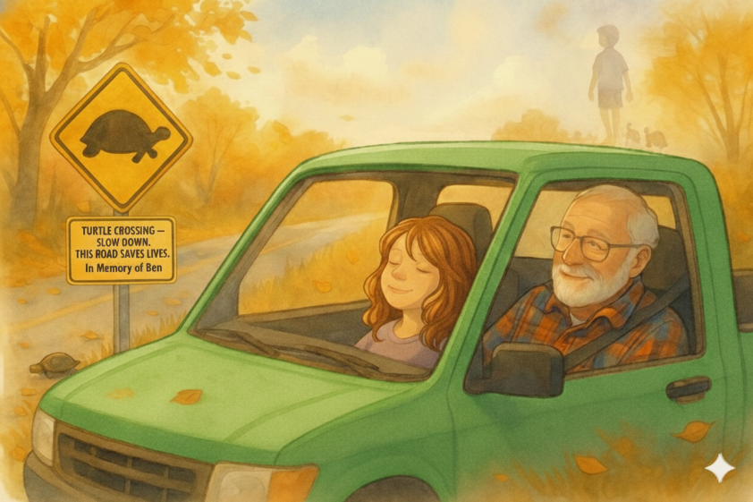
Back in Ben’s hometown, along the quiet winding road where it all began, they had made a sign in Ben’s honor. It read:

TURTLE CROSSING – SLOW DOWN. THIS ROAD SAVES LIVES.
In Memory of Ben.
On a cool fall afternoon, Grandpa pulled over by that sign with Lily beside him in the truck. They had just helped a young box turtle cross a gravel curve. No fanfare. No photos. Just one more rescue.
Lily leaned back in her seat with her eyes shut.
“You think he saw that?” she asked. Grandpa smiled. “I think he sees all of it.”
And somewhere—on a road not marked on any map, a boy walked barefoot through warm grass, holding his carved turtle in one hand, with a trail of slow-moving friends behind him.
He didn’t need to count anymore because the road kept going.
And so did the love.
The End
(But not really.)
29. Epilogue
Slow and Steady Forever
Ben never became famous in the way the world usually defines it. He didn’t win awards, break records, or stand in the spotlight.
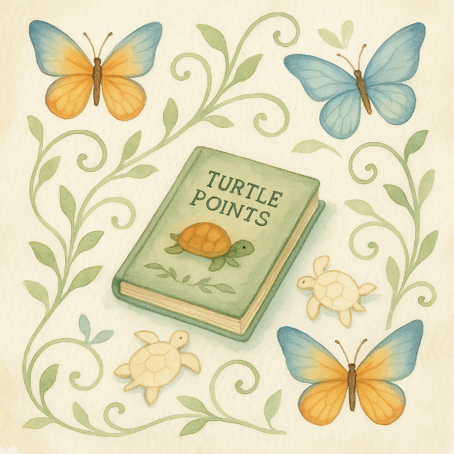
He didn’t live a long life, but he lived it deeply.
In just ten short years, Ben reminded everyone around him that purpose doesn’t wait for adulthood. That kindness doesn’t require permission, that the smallest act—stopping for a turtle—can ripple farther than we ever imagined.
He taught us that love sometimes moves slowly.
It waits in the grass and on the shoulder of abandoned roads.
It often asks for effort, gentleness, and bravery to kneel.
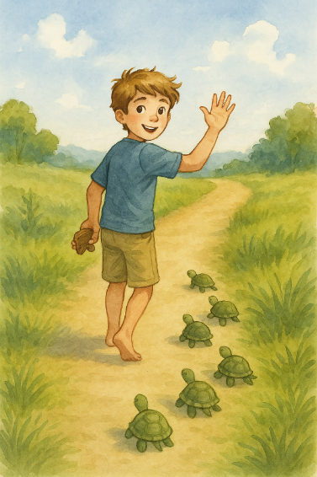
Ben didn’t save the world.
But he saved his world—one turtle at a time.
And that was enough.
If you’ve read this story and smiled…
If you’ve stopped your car for something small…
If you’ve comforted someone who's scared… If you’ve remembered Ben, even just for a moment — you've earned a Turtle Point, too.
There is no official log.
No master scorecard.
No golden gates with clipboards.
But maybe—just maybe—every act of kindness leaves a mark.
Maybe heaven smells like grass and pancakes.
Maybe there’s a field full of turtles waiting to say thank you.
And maybe, if you look closely at your own journey, you'll see a boy not far ahead, walking slowly but surely—and turning back just long enough to make sure you’re still coming.
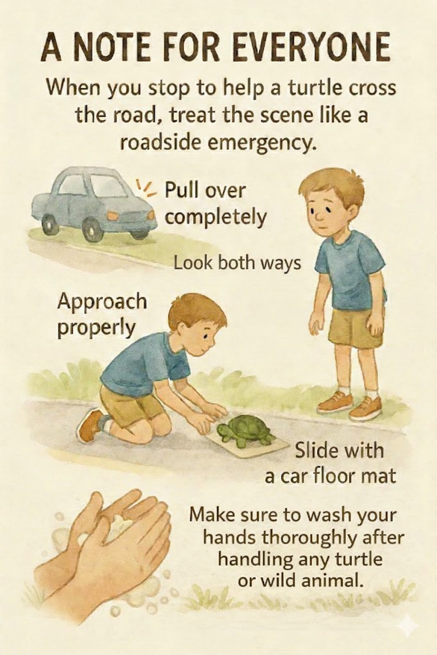
A Note for Everyone.
When you stop to help a turtle cross the road, treat the scene like any roadside emergency: pull fully off the pavement, turn on your hazard lights, have an adult with you, look both ways, and stay alert for oncoming traffic before exiting your vehicle. Approach the turtle calmly from the side, keep fingers away from its mouth and claws, and always move it in the direction it was already headed—never backward—so it doesn’t try to re-cross. If it’s a snapping turtle or another large, defensive species, use a sturdy object like a shovel or a car floor mat to gently guide or slide it across instead of lifting it by hand. Wash and sanitize your hands afterward, avoid lingering in traffic lanes, and if the animal appears injured, contact a licensed wildlife rehabilitator instead of trying to treat it yourself. By balancing traffic awareness with respect for the turtle’s well-being, you can perform a safe, responsible rescue that protects both wildlife and people on the road.

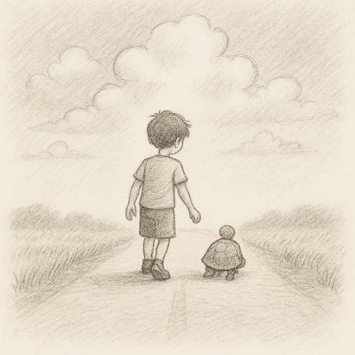
One small act of kindness can change the world.
Nine-year-old Ben keeps a logbook called his Turtle Points—Official Log, where he records every turtle he safely helps across the road. What starts as a quiet mission grows into something bigger, touching a caring grandpa, a grumpy neighbor, a brave new friend named Lily, and eventually an entire town that decides to “keep it,” going.”

If you believe a small act of kindness can spread and transform a community, Turtle Points deserves a place on your shelf. This memorable story follows a brave young boy who turns to saving turtles. Turtles become a symbol of hope, measuring life not in miles but in moments of compassion. Tender, inspiring, and deeply human, Turtle Points reminds readers of all ages that even the smallest life can make the biggest difference. It's perfect for families, classrooms, and anyone who needs a story that stays with them.
www.turtlepointsbook.com
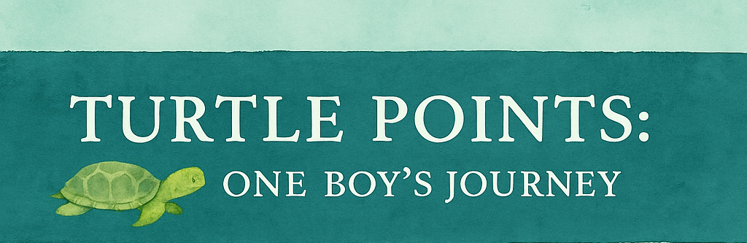



Scott Speicher brings a unique blend of life experiences to his writing. A U.S. military veteran, he carries the discipline, resilience, and perspective gained through service into every story he tells. After his military career, Scott built a successful path in marketing, where he developed a deep understanding of communication, storytelling, and audience engagement. For more than 15 years, he has also worked as a professional website designer, helping businesses and individuals create meaningful online presences. His debut children’s book, Turtle Points: One Boy’s Journey, reflects his passion for inspiring young readers with messages of compassion, perseverance, and hope.

When leukemia returns, Ben meets each day with curiosity, courage, and kindness. His log becomes more than a list—it’s a reminder that love moves slowly but never stops. After Ben’s final journey, the people who knew him (and many who didn’t) carry his work forward with Turtle Day, kindness journals, and a promise to help what’s small and worth saving.
Warm, lyrical, and deeply hopeful, Turtle Points: One Boy’s Journey provides families and classrooms with a gentle way to explore profound emotions—grief, gratitude, and everyday choices that can change a life.
Suitable for readers aged 8–12 and for family read-aloud sessions. Ideal for SEL, guidance, and service-learning.
Includes a brief note on safe turtle rescue and suggestions for tracking acts of kindness.

Turtle Points Log
__________________________________________________________________________________________________________________________________________________________________________________________________________________________________________________________________________________________________________________________________________________________________________________________________________________________________________________________________________________________________________________________________________________________________________________________________________________________________________________________________________________________________________________________________________________________________________________________________________________________________________________________________________________________________________________________________________________________________________________________________________________________________________________________________________________________________________________________________________________________________________________________________________________________________________________________________________________________________________________________________________________________________________________________________________________________________________________________________________________________________________________________________________________________________________________________________________________________________________________________________________________________________________________________________________________________________________________________________________________________________________________________________________________________________________________________________________________________________________________________________________________________________________________________________________________________________________________________________________________________________________________________________________________________________________________________________________________________________________________________________________________________________________________________________________________________________________________________________________________________________________________________________________________________________________________________________________________________________________________________________________________________________________________
copy for a class project
