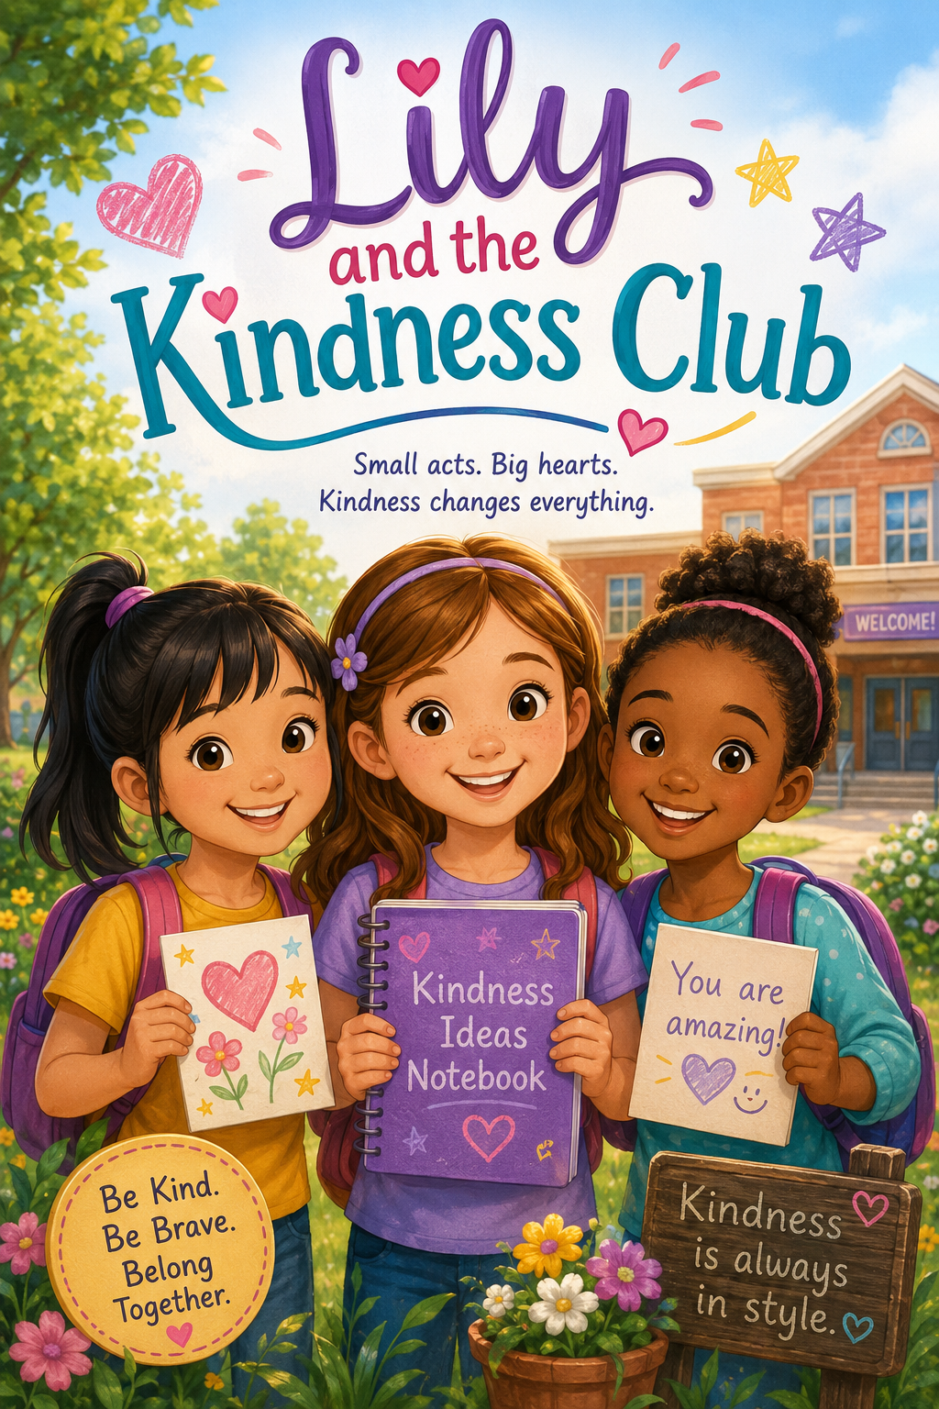
Lily and the Kindness Club
Small Acts. Big Hearts, Kindness Changes Everything.

by
Scott Speicher

Copyright © 2026
Author: Scott M. Speicher
Portions of this book have been optimized by the program Grammarly
Edited by Grammarly and ScottMBooks.com
No part of this book may be reproduced or used, in any form or by any means, electronic or mechanical, without permission in writing from the author.
Some of the images are AI-generated using prompts and under the author's full control.
Table of Contents
Chapter 1: The First Day Feeling
Lily feels nervous on the first day of school, but one kind hello helps her begin to feel brave.
Chapter 2: Two New Friends
Lily meets May and Mary and learns that friendship can begin with a simple invitation.
Chapter 3: A Lunch Table Promise
Lily, May, and Mary invite a lonely classmate to sit with them and discover that kindness grows when people work together.
Chapter 4: The Kindness Club Begins
Lily shares her idea for a Kindness Club, and the girls create their first rule: kindness must be safe, helpful, and from the heart.
Chapter 5: Notes That Make People Smile
The Kindness Club makes encouraging notes for classmates, teachers, and school helpers.
Chapter 6: The Playground Problem
When two younger students argue over a swing, the girls learn that kindness can mean asking an adult for help.
Chapter 7: A Community Kindness Day
Lily, May, and Mary help clean up a local park and learn that kindness belongs everywhere.
Chapter 8: The New Student
A new student joins the class, and the Kindness Club helps him feel welcome.
Chapter 9: When Kindness Is Hard
After someone laughs at their club, Lily learns that kindness matters most when it is not expected.
Chapter 10: The Kindness Club Grows
The girls share their idea with the class, and the Kindness Club grows into something bigger for everyone.

Preface
Starting something new can feel exciting, but it can also feel a little scary.
For Lily, the first day of school brings fluttery feelings, new faces, and questions she is not sure how to answer. Will she find her classroom? Will she know where to sit? Will she make friends? But as Lily takes one small brave step at a time, she discovers that kindness can make new places feel warmer and unfamiliar faces feel a little more like friends.
In Lily and the Kindness Club, Lily learns that kindness often begins with noticing. A lonely classmate, a nervous new student, a playground problem, or someone who needs encouragement can all become chances to help. With her new friends, May and Mary, Lily starts a Kindness Club to spread small acts of care at school and in the community.
This story is about friendship, courage, empathy, and the power of small choices. It reminds young readers that kindness does not have to be grand to matter. Sometimes it looks like sharing a crayon, inviting someone to play, writing a thoughtful note, or helping even when it is hard.
Most of all, this book encourages children to understand that they can make a difference right where they are. One kind hello can become a friendship. One thoughtful act can brighten a day. One small club can help a classroom remember that everyone belongs.
May Lily’s story inspire readers to be brave, be kind, and look for simple ways to make the world around them a little better.

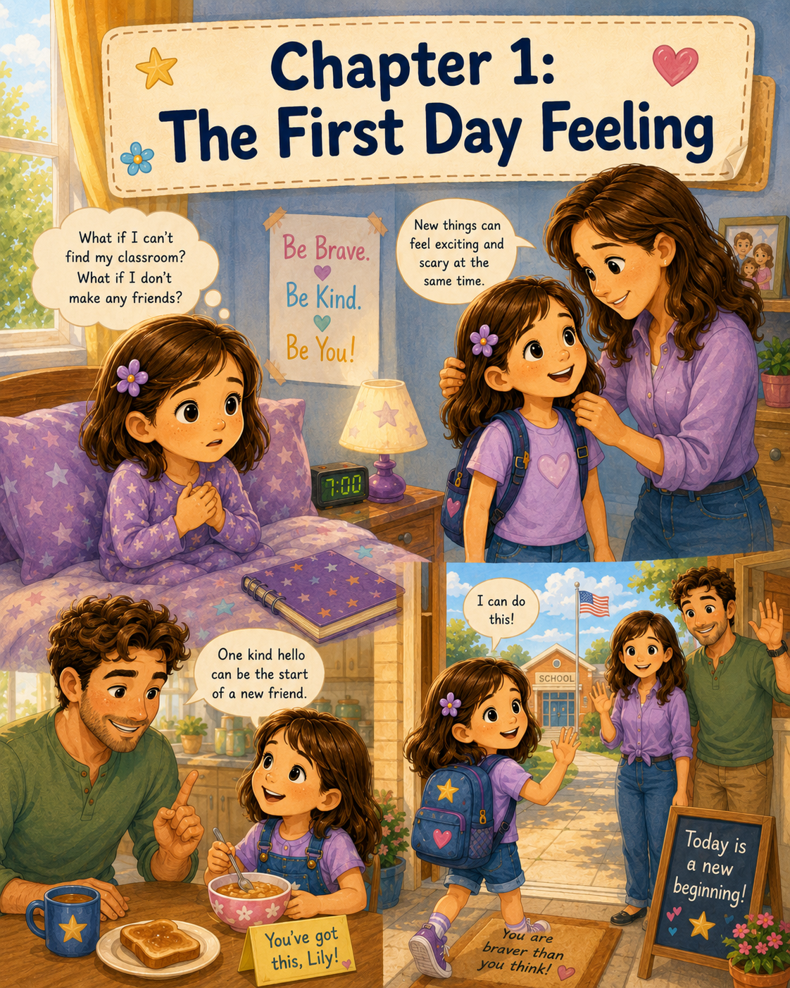

Chapter 1: The First Day Feeling
The morning sun peeked through Lily’s curtains in soft golden lines. It stretched across her blanket, touched the edge of her pillow, and finally landed right on her nose.
Lily opened one eye.
For a moment, she forgot what day it was. She listened to the quiet sounds of the house waking up. Somewhere down the hall, water ran in the bathroom sink. In the kitchen, a cabinet door opened and closed. A spoon clinked against a cereal bowl.
Then Lily remembered.
It was the first day of a brand-new school year.
Her eyes opened wide.
“Oh,” she whispered.
All at once, her stomach felt funny. It fluttered and flipped, almost like a jar full of butterflies had been set loose inside her.
Lily sat up slowly and looked at the outfit folded neatly on her chair. Her mom, Ann, had helped her choose it the night before. There was a soft blue shirt, a pair of comfortable jeans, and her favorite sweater in case the classroom felt cold. Beside the chair sat her new backpack. It was clean, bright, and still smelled a little like the store.
Inside the backpack were sharpened pencils, crayons, folders, glue sticks, a lunchbox, and a small notebook with a purple cover. Lily had picked the notebook herself because the cover had tiny stars on it.
She had been excited about school supplies.
She had been excited about seeing her classroom.
She had even been excited about learning new things.
But now that the first day was here, Lily did not feel quite as brave as she had the night before.
“What if I can’t find my classroom?” she whispered to herself. “What if I don’t know where to sit? What if everyone already has a friend?”
Just then, there was a gentle knock on her bedroom door.
“Good morning, Lily,” Mom called softly. “Are you awake?”
“Yes,” Lily answered, though her voice sounded smaller than usual.
Ann opened the door and smiled. She was already dressed for the day, and her warm smile made Lily feel a little better.
“There’s my big schoolgirl,” Mom said. “Happy first day.”
Lily tried to smile back, but her mouth only made a tiny curve.
Mom noticed right away. She sat beside Lily on the bed and brushed a loose strand of hair away from her face.
“Those first-day feelings are visiting, aren’t they?” Mom asked.
Lily nodded. “My stomach feels fluttery.”
“That happens sometimes when we are starting something new,” Mom said. “New things can feel exciting and scary at the same time.”
Lily looked down at her blanket. “What if I don’t make any friends?”
Mom put an arm around her. “Then you can start with a kind hello. Friendships often begin with small things.”
“A hello?” Lily asked.
“A hello,” Mom said. “Or a smile. Or ask someone if they want to sit with you. You don’t have to do everything all at once.”
Lily thought about that. One hello did not sound quite as hard as making a friend for the whole school year.
Mom stood up and clapped her hands gently. “Now, let’s get ready. Your backpack is almost packed, but we need to check it one more time.”
Lily climbed out of bed and got dressed. She brushed her teeth, combed her hair, and slipped on her shoes. Then she carried her backpack to the kitchen, where Dad was standing by the counter with two pieces of toast on a plate.
“Good morning, Lily!” Dad said cheerfully. “Ready for the big day?”
Lily set her backpack on a chair. “I think so.”
Gary raised his eyebrows kindly. “Only think so?”
Lily sat down at the table. “I’m a little nervous.”
Dad nodded as if this made perfect sense. “That means you care. I used to feel nervous on the first day of school too.”
“You did?” Lily asked.
“Oh yes,” Dad said. “Every year. I wondered where to go, who I would meet, and whether my teacher would be nice.”
“What helped?” Lily asked.
Dad placed the toast in front of her. “I remembered that new beginnings can bring wonderful surprises.”
Lily picked up a piece of toast but did not take a bite yet. “What kind of surprises?”
“Maybe a teacher who reads great stories,” Dad said. “Maybe a new favorite subject. Maybe a friend you haven’t met yet.”
Lily imagined a friend she had not met yet. She wondered what that friend might be like. Maybe she would like to draw. Maybe she would like animals. Maybe she would like reading books under a tree at recess.
Mom placed Lily’s lunchbox beside the backpack. “Let’s check everything before we go.”
Together, they opened the backpack.
“Pencils?” Mom asked.
“Pencils,” Lily said, pointing to the front pocket.
“Crayons?”
“Crayons!”
“Folders?”
“Folders!”
“Lunch?”
“Lunch!”
Dad leaned closer. “Brave heart?”
Lily looked at him.
Dad tapped his chest. “You’ll need to pack that too.”
Lily smiled a little more. “I don’t know if it fits in my backpack.”
“It doesn’t go in your backpack,” Dad said. “It goes with you.”
Lily touched her chest the way Dad had. Her heart was beating quickly, but it was there. Maybe a brave heart could beat quickly, too.
After breakfast, Mom helped Lily zip her backpack. Dad held the door open, and Lily stepped outside. The morning air was warm, and the neighborhood seemed busy with first-day energy. A yellow school bus rumbled down a nearby street. A few children walked with their parents, carrying backpacks in every color. Some children laughed. Some walked quietly. One boy held his father’s hand tightly.
Lily noticed that.
Maybe she was not the only one with butterflies.
At school, cars lined up near the front entrance. Teachers stood outside greeting students. The building looked bigger than Lily remembered. The windows shone in the sunlight, and the front doors opened and closed as children hurried inside.
Lily stood beside Mom and Dad for a moment.
“You’re going to do well,” Mom said.
“And remember,” Dad added, “one kind hello.”
Lily nodded, but her feet did not move right away.
Mom knelt down and gave her a hug. “It’s okay to feel nervous. You can feel nervous and still take the next step.”
Dad gave her a gentle hug too. “We love you, Lily. We’ll see you after school.”
Lily hugged them both tightly. Then she took a deep breath, held the straps of her backpack, and walked toward the front doors.
Inside, the hallway was full of sounds.
Shoes squeaked on the floor. Lockers clicked. Children talked all at once. Teachers called out room numbers and names. Somewhere nearby, someone laughed loudly. A little girl dropped a pencil box, and crayons rolled across the floor like tiny colorful logs.
Lily stepped to the side so she would not be in anyone’s way.
She looked at the paper Mom had tucked into her hand.
Room 12.
Lily looked up. The doors had numbers beside them. Room 8. Room 9. Room 10.
She kept walking.
Room 11.
Then she saw it.
Room 12.
A woman with kind eyes stood at the doorway. She wore a yellow scarf and held a clipboard.
“Good morning,” the teacher said. “You must be Lily.”
Lily blinked in surprise. “Yes.”
“I’m Mrs. Carter,” the teacher said. “Welcome to our class.”
Lily felt some of the tightness in her shoulders loosen. Mrs. Carter’s voice was calm and cheerful.
“Come on in,” Mrs. Carter said. “You can hang your backpack on one of the hooks and then choose a seat at any table.”
Lily walked into the classroom.
It smelled like new paper, crayons, and clean desks. Bright letters lined one wall. A calendar hung near the board. There was a reading corner with a soft rug and baskets of books. On a shelf near the window, a small plant leaned toward the sunlight.
Lily liked the reading corner right away.
Several children were already sitting at tables. Some talked to each other. Some looked around quietly. One boy was sharpening a pencil even though it already looked sharp. A girl with braids was arranging her crayons in rainbow order.
Lily hung up her backpack and held her purple notebook close to her chest.
Where should she sit?
There was an empty chair at a table near the window. Another empty chair was near the front. Two girls were sitting together at the middle table, but Lily did not know if they were saving seats for someone else.
Her butterflies came back.
Mrs. Carter noticed Lily looking around. “You may sit anywhere for now,” she said kindly. “We’ll learn everyone’s names this morning.”
Lily chose the seat near the window. She liked how the sunlight made a warm square on the table.
She sat down and placed her notebook in front of her.
Across the room, a boy sniffled and wiped his eyes. Mrs. Carter walked over and spoke to him softly. Near the door, another student held onto his backpack and looked unsure where to go. At the middle table, the girl with braids looked around the room with wide eyes.
Lily watched them quietly.
She had thought everyone else would know exactly what to do. But as she looked around, she realized something important.
Almost everyone looked a little nervous.
Some children were talking a lot because they were nervous. Some were quiet because they were nervous. Some smiled, some wiggled, and some stared at their shoes.
Maybe first-day feelings visited everyone in different ways.
Mrs. Carter rang a small bell. The classroom became quieter.
“Good morning, class,” she said. “Welcome to a brand-new school year. I am so happy you are here.”
Lily folded her hands on the table and listened.
“We are going to spend the morning getting to know one another,” Mrs. Carter continued. “You do not have to know everything today. You do not have to remember every rule today. Today is for learning where things are, meeting new friends, and discovering that this classroom belongs to all of us.”
Lily liked the way that sounded.
This classroom belongs to all of us.
Mrs. Carter passed around name tags. When she came to Lily’s table, she smiled.
“Would you like help writing your name, or would you like to do it yourself?” she asked.
“I can do it,” Lily said.
She carefully wrote L-I-L-Y on the name tag. Then she peeled off the back and pressed it onto her shirt.
A few minutes later, Mrs. Carter asked everyone to sit in a circle on the rug. Lily found a spot and sat cross-legged. The rug was soft beneath her knees.
“We’re going to share our names and one thing we like,” Mrs. Carter said. “I’ll begin. My name is Mrs. Carter, and I like reading stories aloud.”
Several students smiled.
The sharing began around the circle.
“My name is Ethan, and I like soccer.”
“My name is Grace, and I like painting.”
“My name is Noah, and I like dinosaurs.”
As each child spoke, Lily listened carefully. When it was almost her turn, her heart started thumping again.
What should she say?
She liked animals. She liked books. She liked helping Grandpa Jim in the garden. She liked drawing sometimes, but not as much as some people did.
Then it was her turn.
Lily swallowed.
“My name is Lily,” she said. Her voice was quiet at first, but then it grew a little stronger. “And I like animals and stories.”
Mrs. Carter smiled. “Thank you, Lily.”
That was all.
Nothing scary happened.
No one laughed. No one stared for too long. The circle simply moved on to the next student.
Lily let out a breath she did not know she had been holding.
After the circle time, Mrs. Carter gave the class a tour of the room. She showed them where to turn in papers, where to find pencils, where to place lunchboxes, and where the classroom library books belonged.
When Mrs. Carter showed the reading corner, Lily leaned forward.
“These books are for everyone,” Mrs. Carter said. “We will read many stories this year. Stories help us understand people, places, feelings, and choices.”
Lily liked that sentence so much that she hoped she would remember it.
Later that morning, the class drew pictures about their summer. Lily drew a small garden, a bird, and a path under the trees. As she colored, she noticed the girl at the table beside her looking for a green crayon.
The girl checked her crayon box, then looked under her paper.
Lily looked down at her own crayons. She had two green ones.
She remembered Dad’s words.
One kind hello.
Maybe a kind hello could come with a green crayon.
Lily picked up one of her green crayons and held it out.
“Would you like to use this?” she asked.
The girl looked surprised, then smiled. “Yes, please. Thank you.”
“I’m Lily,” Lily said.
“I’m May,” the girl replied.
Lily smiled. “Hi, May.”
It was not a long conversation. It was not a big moment. But it made Lily’s butterflies settle down just a little.
A few minutes later, another girl at their table dropped her eraser. It bounced once and landed near Lily’s shoe. Lily picked it up and handed it back.
“Thank you,” the girl said. “I’m Mary.”
“I’m Lily,” Lily said again, and this time it felt easier.
May looked over from her drawing. “I’m May.”
Mary smiled at both of them. “Hi.”
The three girls went back to their pictures, but something had changed. The table did not feel quite so quiet anymore. Lily noticed May’s drawing had a bright yellow sun in the corner. Mary was drawing a stack of books beside a tree.
“I like your tree,” Lily said to Mary.
“Thanks,” Mary said. “I like reading outside.”
“I like stories too,” Lily said.
May looked up. “I like drawing pictures for stories.”
Lily felt a small warm feeling in her chest.
Maybe Dad had been right. Maybe new beginnings could bring wonderful surprises.
When the morning was almost over, Mrs. Carter asked everyone to place their drawings on the back table. Then she gave the class a few minutes to stretch and talk quietly.
Lily stood near the window and looked out at the playground. It did not seem as strange now. The hallway did not seem as loud in her memory. Room 12 did not feel so big anymore.
May came to stand beside her. “Do you know where we go for recess?”
Lily shook her head. “Not yet. But Mrs. Carter said she’ll show us.”
Mary joined them, holding her purple folder. “I was worried I’d get lost today.”
Lily turned to her. “I was worried about that too.”
May nodded. “I was worried I wouldn’t know anyone.”
Lily looked at both girls.
“Me too,” she said.
For a moment, the three girls were quiet. Then they all smiled, because it felt funny and comforting to discover that they had been worried about almost the same things.
Mrs. Carter rang the bell again.
“Class,” she said, “you have done a wonderful job this morning. First days can feel big, but you have been brave, patient, and kind.”
Lily stood a little taller.
Brave.
Patient.
Kind.
Those were good words.
At lunchtime, Lily would still need to find where to sit. At recess, she would still need to learn the playground rules. There were many new things ahead. But the morning had taught her something she wanted to remember.
She was not the only one with butterflies.
Everyone had first-day feelings in one way or another.
And sometimes, the best way to feel a little braver was to offer kindness to someone else.
Lily touched the name tag on her shirt and smiled.
The first day was not over yet, but it had already become better than she expected.
She had found Room 12.
She had met Mrs. Carter.
She had said her name in front of the class.
And she had said one kind hello.
Actually, she had said two.
One to May.
And one to Mary.
Maybe this school year was going to be full of wonderful surprises after all.

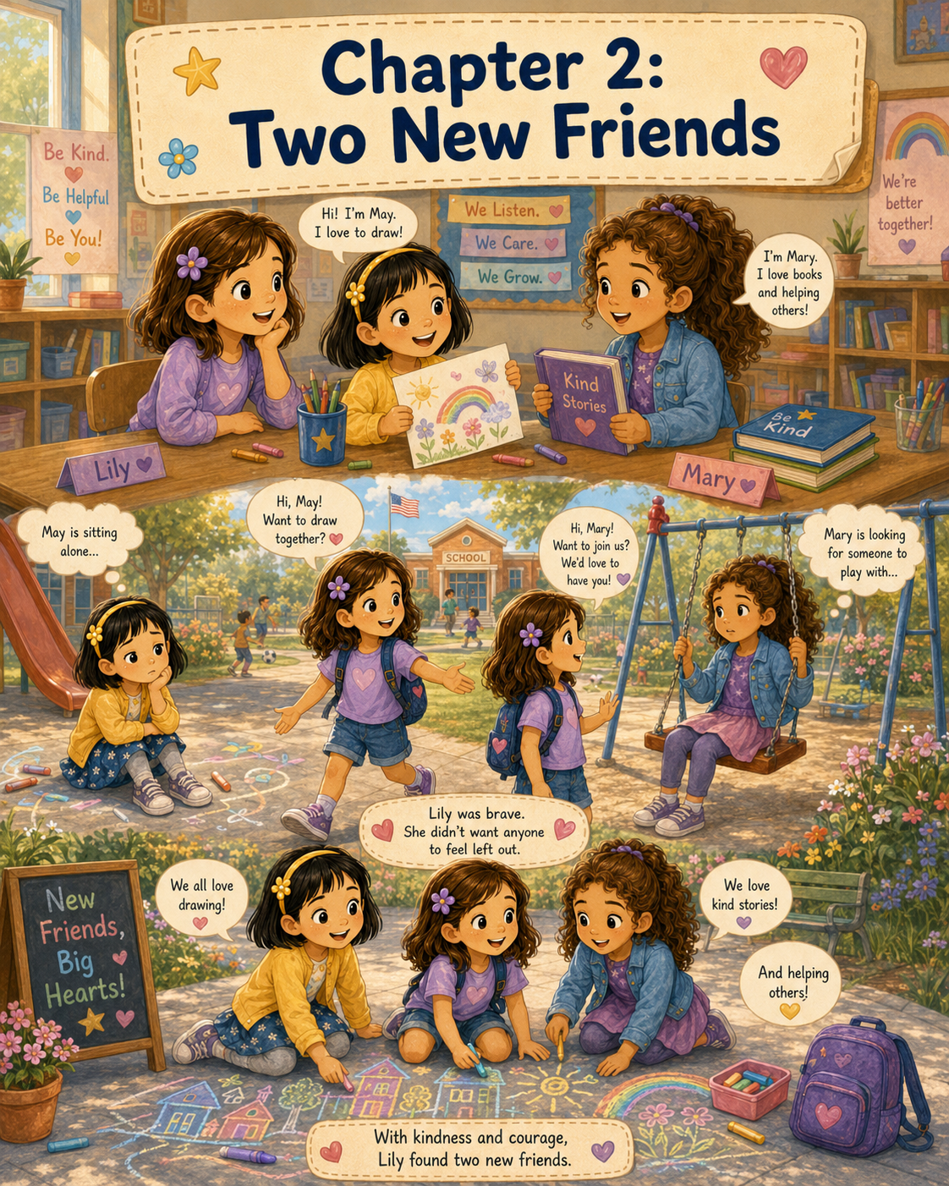

Chapter 2: Two New Friends
After the class finished sharing their names on the rug, Mrs. Carter asked everyone to return to their seats. Lily walked back to the table near the window, feeling a little more comfortable than she had when she first stepped into Room 12.
The classroom still felt new. The shelves were new to her. The desks were new to her. Even the sound of Mrs. Carter’s bell was new to her. But now there were two names that did not feel quite so strange.
May.
Mary.
Lily glanced at the two girls sitting near her table. May had bright eyes and a cheerful smile. She had already drawn three tiny flowers on the corner of her paper, even though Mrs. Carter had not asked the class to decorate anything yet. Mary sat with her hands folded neatly on top of her folder. She looked thoughtful and quiet, but when someone needed help picking up a pencil, she was the first one to reach down.
Mrs. Carter stood at the front of the room and held up a large sheet of paper.
“Class,” she said, “for our next activity, we are going to make an ‘All About Me’ page. This will help us learn more about one another.”
Several students smiled. A few whispered excitedly.
Mrs. Carter pointed to the paper. “You may write or draw your favorite things. You can include your favorite color, favorite animal, favorite book, favorite food, or something you like to do. There is no wrong answer because each page is about you.”
Lily liked that idea.
Mrs. Carter passed out papers. At the top, the words “All About Me” were written in big friendly letters. There were boxes for drawing and lines for writing.
Lily picked up her pencil and stared at the first box.
Favorite animal.
That was hard. She liked too many animals to choose just one. She liked turtles because they were gentle and patient. She liked birds because they sang in the morning. She liked rabbits because their noses twitched in such a funny way.
Across from her, May had already started drawing.
Lily watched as May’s pencil moved quickly across the page. In just a few minutes, May had drawn a smiling sun, a little house, and a dog with floppy ears.
“You draw really fast,” Lily said.
May looked up, surprised at first. Then she smiled. “I like drawing. Sometimes I draw before I know what I’m going to draw.”
Lily laughed softly. “That sounds fun.”
“It is,” May said. She turned her paper slightly so Lily could see it better. “This is supposed to be my dog, but his ears came out too big.”
“I like them,” Lily said. “They make him look friendly.”
May’s smile grew wider. “Thank you.”
Mary looked over from the next seat. “I think big ears are good for a dog. Then he can hear when someone opens a snack bag.”
May giggled. Lily giggled too.
Mary smiled shyly, as if she had not been sure whether her joke would be funny.
“What are you drawing?” Lily asked Mary.
Mary held up her page. In one box, she had drawn a book with a tree beside it. In another, she had written the word “helping.”
“Helping is one of your favorite things?” May asked.
Mary nodded. “I like it when people feel better because I helped them. At my old school, I helped the librarian put books back on the shelves.”
“You went to a different school before?” Lily asked.
“Last year,” Mary said. “We moved during the summer.”
Lily remembered how nervous she had felt that morning. She wondered if moving to a new school made the first day feel even bigger.
“That must feel new,” Lily said.
Mary nodded again. “It does. I don’t know where anything is yet.”
“I don’t either,” Lily admitted. “I was afraid I wouldn’t find this classroom.”
“Me too,” May said. “My mom walked me almost all the way to the door.”
“My dad said new beginnings can bring wonderful surprises,” Lily said.
Mary looked at Lily. “That’s a nice thing to say.”
“It helped a little,” Lily replied. “But I still had butterflies.”
“I had butterflies, too,” May said. “Mine felt like they were doing flips.”
“Mine felt like they were reading a map upside down,” Mary said.
The three girls laughed.
For the first time that day, Lily forgot to feel nervous.
Mrs. Carter walked around the classroom, stopping at each table to look at the students’ work.
“These are wonderful,” she said. “I see artists, readers, animal lovers, helpers, builders, soccer players, and very creative thinkers.”
When she reached Lily’s table, she looked at the girls’ pages.
“May, I can see you enjoy drawing,” Mrs. Carter said. “Your pictures have a lot of joy in them.”
May beamed.
“Mary, I like that you wrote helping as something important to you,” Mrs. Carter said. “That tells me something kind about your heart.”
Mary looked down, but Lily could see that she was pleased.
Mrs. Carter turned to Lily’s page. Lily had drawn a turtle, a book, and a small garden.
“Lily, I see animals, stories, and nature,” Mrs. Carter said. “Those are beautiful things to care about.”
“Thank you,” Lily said.
Then Mrs. Carter looked at all three girls. “It seems this table has many good ideas.”
After Mrs. Carter moved on, May leaned closer and whispered, “I like our table.”
“Me too,” Mary whispered.
Lily smiled. “Me three.”
The morning continued with classroom rules, a tour of the school, and a practice walk to the cafeteria. Mrs. Carter showed them the water fountain, the office, the nurse’s room, and the library.
When they reached the library, Mary’s eyes lit up.
“Oh,” she whispered.
Lily noticed right away. “You really do like books.”
Mary nodded. “A lot.”
May looked at the shelves. “I like books with pictures.”
“I like books with animals,” Lily said.
“I like books where someone learns something important,” Mary added.
May tilted her head. “Like what?”
“Like how to be brave,” Mary said. “Or how to be a good friend.”
Lily thought about that. She liked those kinds of stories, too.
After the tour, it was finally time for recess. Mrs. Carter lined up the class at the door.
“Remember,” she said, “recess is for playing, sharing, taking turns, and including others. If you need help, find a teacher.”
The class walked down the hallway and out to the playground.
The moment they stepped outside, the air felt bright and warm. Children hurried toward the swings, the slide, the climbing bars, and the open field. Some students already seemed to know exactly where to go.
Lily stood near the edge of the playground.
The playground was big.
Bigger than she remembered.
There were so many choices and so many children. A group of students ran toward the monkey bars. Another group began a game of tag. Two girls jumped rope near the fence. A boy sat on a bench, tying his shoe.
Lily looked for May and Mary.
May was standing near the sidewalk, holding her hands behind her back. She was watching some children draw with sidewalk chalk, but she had not joined them. Her smile was smaller now.
Mary was near the swings, looking from one group to another. She took a few steps toward the slide, then stopped. She seemed unsure where she belonged.
Lily felt the butterflies return, but this time they were different. They were not only nervous butterflies. They were the kind that came when Lily knew she had a choice to make.
She could stand by herself and wait for someone to invite her.
Or she could remember what Mom had said.
Friendships often begin with small things.
A hello.
A smile.
An invitation.
Lily took a deep breath and walked toward May first.
“Hi, May,” she said.
May turned around. “Hi, Lily.”
“Do you want to play?” Lily asked.
May looked relieved. “Yes. I was trying to decide what to do.”
“Me too,” Lily said.
Then Lily looked across the playground at Mary. “Let’s ask Mary too.”
May nodded. “Okay.”
Together, they walked over to Mary, who was still standing near the swings.
“Hi, Mary,” Lily said.
Mary smiled. “Hi.”
“Do you want to play with us?” Lily asked. “We haven’t decided what to do yet, but we can decide together.”
Mary’s face softened, as if Lily had handed her something she needed.
“Yes,” Mary said. “I’d like that.”
The three girls stood in a small circle.
“What should we play?” May asked.
“I like drawing,” Mary said. “But I don’t have paper outside.”
May pointed to the sidewalk chalk. “There’s chalk over there.”
Lily looked at the chalk area. A few children were drawing rainbows and stars. There was plenty of space on the sidewalk.
“We could draw a town,” Lily suggested. “With houses and roads and trees.”
“And a library,” Mary said quickly.
“And a dog park,” May added.
“And an animal rescue center,” Lily said.
May smiled. “Yes! With turtles and rabbits.”
The three girls hurried over to the sidewalk chalk. Lily picked a green piece, May chose yellow, and Mary selected blue. They found an empty section and began drawing.
May drew the sun first, big and bright in the corner of their town.
“Every town needs sunshine,” she said.
Mary drew a library with tall windows and a sign above the door.
“Every town needs books,” she said.
Lily drew a small pond with turtles sitting on rocks.
“Every town needs a place for animals,” she said.
Soon, their chalk town grew. There were houses, trees, flowers, a school, a playground, a library, a bakery, and a little park with benches. May added smiling people walking dogs. Mary drew a book cart outside the library. Lily added birds flying over the pond.
A boy from their class stopped to look. “That’s a big town.”
“It’s a kind town,” May said.
“What makes it kind?” he asked.
Lily looked at the drawing. “There are places for everyone.”
Mary nodded. “And people help each other.”
The boy thought about that for a moment. Then he said, “Can I draw a fire station?”
Lily looked at May and Mary.
“Sure,” Lily said. “There’s space right here.”
The boy knelt down and began drawing a fire station with a tall door and a red truck. Soon, another student added a garden. Someone else drew a music stage. The sidewalk town became bigger and brighter as more children joined in.
Lily felt happy watching it grow.
It had started with three girls who were not sure where to go at recess.
Now it was a town filled with ideas from many children.
When the whistle blew, everyone groaned.
“Recess is over,” a teacher called. “Line up, please.”
Lily, May, and Mary stood and brushed chalk dust from their hands.
May looked down at her yellow fingers and laughed. “I think I drew more on myself than on the sidewalk.”
Mary held up her blue fingertips. “Me too.”
Lily looked at her green hands. “We match our town.”
As they walked to the line, May moved closer to Lily. “Thank you for asking me to play.”
Mary nodded. “Thank you for asking me too.”
Lily felt shy for a second. “I’m glad you both said yes.”
May smiled. “I didn’t want to sit alone.”
“I didn’t know who to ask,” Mary said.
“I almost didn’t ask either,” Lily admitted. “I was nervous.”
May looked surprised. “You were?”
Lily nodded. “But my mom said friendships can begin with small things.”
“Like asking someone to play?” Mary said.
“Yes,” Lily said.
May looked thoughtful. “Then that was a small thing that felt big.”
Lily liked that. A small thing that felt big.
Back in the classroom, Mrs. Carter gave everyone time to wash their hands before lunch. Green, yellow, and blue chalk swirled down the sink as Lily washed her fingers.
At lunch, the three girls carried their trays together.
“Can we sit together?” May asked.
“I hope so,” Lily said.
Mary pointed to an empty table near the window. “There’s room over there.”
They sat side by side, opening lunchboxes and milk cartons. Lily had a sandwich, apple slices, and a small cookie shaped like a star. Mom must have tucked it inside as a first-day surprise. Lily smiled when she saw it.
“My mom packed me grapes,” May said. “She says grapes are good drawing snacks because they don’t make crumbs.”
Mary opened her lunchbox. “I have crackers and cheese. My dad packed extra in case I got hungry.”
“My dad always says snacks help brave hearts,” Lily said.
May giggled. “Your dad says funny things.”
“He does,” Lily said. “But sometimes they help.”
While they ate, the girls talked about their favorite things. May loved drawing animals with silly faces. Mary loved reading chapter books and helping her grandmother bake muffins. Lily loved stories, animals, and spending time outside.
“I like helping too,” Lily said. “Especially when someone needs a friend.”
Mary smiled. “That counts as helping.”
“It really does,” May said.
Lily looked from May to Mary. That morning, she had walked into school worried that everyone would already have a friend. She had worried that she might be left out. But now she was sitting at lunch with two girls who had felt the same way.
Maybe friendship was not always about finding someone who was already brave.
Maybe sometimes friendship was about helping each other become brave.
After lunch, Mrs. Carter asked the class to write one sentence about their first day so far. Lily opened her purple notebook and thought carefully.
Then she wrote:
Today I learned that a kind invitation can help someone feel included.
She looked at the sentence and smiled.
May leaned over. “What did you write?”
Lily showed her.
May grinned and wrote in her own notebook:
Today I made two new friends.
Mary read both sentences and then wrote hers:
Today I learned I was not the only one who felt nervous.
The girls looked at one another and smiled.
By the time the school day ended, Lily felt tired, but it was the good kind of tired. The kind that came after learning new hallways, new rules, new names, and new possibilities.
When the final bell rang, Lily packed her backpack carefully. May tucked her drawing into her folder. Mary placed her notebook beside her books.
“Will you sit with me tomorrow?” May asked.
“With us,” Mary added.
Lily smiled. “Yes.”
At pickup time, Lily saw Mom and Dad waiting near the front of the school. Mom waved, and Dad smiled as Lily hurried toward them.
“How was the first day?” Mom asked.
Lily hugged her. “It was good.”
Dad looked pleased. “Any wonderful surprises?”
Lily nodded. “Two.”
Mom tilted her head. “Two?”
“May and Mary,” Lily said. “They’re my new friends.”
Dad smiled. “That sounds like a very good beginning.”
Lily looked back at the school doors. She thought about May sitting alone near the playground. She thought about Mary looking for someone to play with. She thought about the chalk town that grew because one invitation turned into many.
“It started with asking them to play,” Lily said.
Mom squeezed her hand. “That was kind.”
Lily smiled as they walked toward the car.
The first day had begun with butterflies.
But it ended with friendship.
And Lily had a feeling that this was only the beginning of something special.

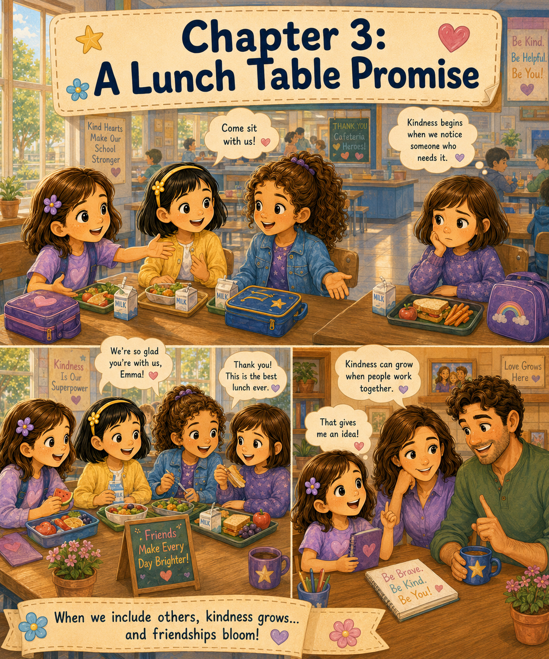

Chapter 3: A Lunch Table Promise
The next morning, Lily woke up before her alarm clock rang.
At first, she lay still under her blanket and listened to the house. She could hear Mom moving around in the kitchen and Dad opening a drawer down the hall. Outside her window, a bird chirped from a tree branch, bright and cheerful, as if it already knew the day would be a good one.
Lily smiled.
Yesterday had been the first day of school, and it had started with butterflies in her stomach. But it had ended with two new friends: May and Mary.
Today felt different.
Today, Lily knew where Room 12 was. She knew Mrs. Carter’s name. She knew where to hang her backpack and where the classroom library stood. Best of all, she knew that at least two people would be happy to see her.
That made getting ready feel much easier.
Lily climbed out of bed, dressed quickly, and carried her backpack to the kitchen. Mom, whose name was Ann, was packing Lily’s lunchbox at the counter.
“Good morning, sweetheart,” Mom said. “You look ready for day two.”
“I am,” Lily said.
Dad, Gary, looked up from the table and smiled. “No butterflies today?”
Lily thought about it. Her stomach still felt a little fluttery, but not like yesterday.
“Maybe one or two,” she said. “But they’re calmer butterflies.”
Dad laughed. “That sounds like progress.”
Mom placed a sandwich, apple slices, and a small container of carrots into Lily’s lunchbox. Then she added a napkin with a tiny heart drawn in the corner.
Lily noticed. “You drew on my napkin.”
“I did,” Mom said. “Just a little reminder.”
“Of what?”
Mom zipped the lunchbox and handed it to her. “That you carry kindness with you.”
Lily held the lunchbox against her chest and smiled. “I’ll remember.”
At school, Room 12 already felt friendlier. Mrs. Carter greeted Lily at the door, and May waved from the table near the window.
“Lily!” May called. “I saved you a seat.”
Mary looked up from a book and smiled. “Good morning.”
Lily felt a warm happiness spread through her. Yesterday, she had wondered if she would have anyone to sit with. Today, someone had saved her a chair.
“Good morning,” Lily said, sliding into her seat.
May had drawn a tiny picture on the corner of her morning worksheet. It showed three girls standing under a sun.
“Is that us?” Lily asked.
May nodded. “That’s you, me, and Mary. I made the sun extra big because yesterday turned into a sunny day.”
Mary looked at the drawing. “Even though it didn’t actually rain.”
“It rained nervous feelings,” May said.
Lily giggled. “Then the sun came out at recess.”
Mrs. Carter rang her small bell, and the class quieted down.
“Good morning, class,” she said. “Today we will continue learning our routines. We will also talk about what it means to build a kind classroom.”
Lily sat a little taller when she heard the word kind.
Mrs. Carter wrote three words on the board:
Notice.
Care.
Help.
“These are three important words,” Mrs. Carter said. “First, we notice what is happening around us. Then we care about how others feel. Finally, we help in a safe and respectful way.”
Lily looked at the words carefully.
Notice.
Care.
Help.
They sounded simple, but Lily had a feeling they were important.
Mrs. Carter gave an example. “If someone drops their crayons, what could you do?”
“Help pick them up,” Ethan said.
“Good,” Mrs. Carter replied. “If someone looks lonely at recess, what could you do?”
“Ask them to play,” May said.
Lily smiled because that was exactly what had happened yesterday.
“If someone seems sad,” Mary added, “you could ask if they are okay or tell a teacher.”
“Excellent,” Mrs. Carter said. “Kindness is not only about big things. Sometimes it begins with noticing.”
Lily thought about the heart on her lunch napkin. She thought about Mom’s words at breakfast.
You carry kindness with you.
The morning moved quickly after that. The class practiced spelling words, listened to a story, and worked on a math activity using counting cubes. Lily, May, and Mary helped one another when their cubes rolled across the table.
May turned two blue cubes and one yellow cube into a tiny pretend house before Mrs. Carter gently reminded her to use them for math.
Mary finished her work carefully and then helped Lily check her answers.
Lily liked learning with friends. It made even tricky things feel easier.
Soon, it was time for lunch.
The class lined up at the door, and Mrs. Carter reminded them to walk quietly through the hall.
“Remember,” she said, “we are practicing our school routines. Safe feet, quiet voices, kind hearts.”
The cafeteria was much louder than the classroom. Trays clattered. Children talked. Lunchboxes opened and closed. The smell of warm food mixed with peanut butter, fruit, and fresh bread.
Lily held her lunchbox tightly as she followed May and Mary to the table near the window.
“This is our table,” May said.
“Our day-two table,” Mary added.
Lily smiled and sat down between them. She opened her lunchbox and saw the napkin with the heart in the corner. Mom’s reminder looked small inside the lunchbox, but somehow it made Lily feel strong.
May opened her lunchbox and pulled out a sandwich wrapped in paper. “My mom packed a note today,” she said.
“What does it say?” Lily asked.
May unfolded it and read, “Have a bright day, my little artist.”
“That’s nice,” Mary said.
“My grandmother writes notes sometimes,” Mary said. “She always says, ‘Read something good and do something good.’”
“I like that,” Lily said.
The girls began eating and talking about the morning. May thought the counting cubes were fun. Mary liked Mrs. Carter’s story best. Lily liked the three words on the board.
“Notice, care, help,” Lily said.
Mary nodded. “Mrs. Carter made it sound like steps.”
May held up one finger. “First notice.” She held up a second finger. “Then care.” She held up a third finger. “Then help.”
Lily was about to take a bite of her sandwich when she noticed someone at the next table.
A girl from their class sat by herself at the far end. Lily remembered seeing her during circle time. Her name was Emma. She had short brown hair and wore a purple sweater. Her lunch tray sat in front of her, but she was not eating much. She looked down at her food and moved a carrot stick from one side of the tray to the other.
There were other children at the table, but they were sitting farther away, talking and laughing in a group. Emma was close to them, but not really with them.
Lily felt a small tug in her heart.
She looked at May and Mary. They were still talking about math cubes, but Lily kept glancing at Emma.
Then she remembered something Mom had told her once when they were at the grocery store.
Kindness begins when we notice someone who needs it.
At the time, Mom had been talking about helping an older woman pick up a dropped bag of apples. But now Lily understood that the words could mean many things.
Kindness begins when we notice someone who needs it.
Lily looked at Emma again.
Maybe Emma needed someone to notice.
“What are you looking at?” May asked.
Lily lowered her voice. “Emma is sitting by herself.”
Mary turned slightly and looked. “She looks lonely.”
May’s cheerful smile faded into a thoughtful expression. “Should we ask her to sit with us?”
Lily felt nervous again, but it was not the same as first-day butterflies. This nervous feeling came from wanting to do the right thing but not knowing exactly how.
“What if she says no?” Lily asked.
Mary shrugged gently. “Then we’ll still have asked kindly.”
May nodded. “Maybe asking is the important part.”
Lily looked down at the heart on her napkin.
Notice.
Care.
Help.
She took a deep breath. “Let’s invite her.”
The three girls stood up together. Lily carried her lunchbox, May carried her sandwich, and Mary carried her milk carton. They walked the few steps to Emma’s table.
Emma looked up when she saw them.
“Hi, Emma,” Lily said.
“Hi,” Emma answered quietly.
May smiled. “Do you want to sit with us?”
Mary added, “There’s room at our table.”
Emma looked surprised. “Really?”
Lily nodded. “Yes. We’d like you to.”
Emma glanced at the group of children farther down the table. Then she looked back at Lily, May, and Mary.
“Okay,” she said softly.
She picked up her tray and followed them to the window table.
May scooted over to make space. Mary moved her lunchbox. Lily placed Emma’s tray in the open spot.
“There,” Lily said. “Now there’s room.”
Emma sat down slowly, as if she was still deciding whether this was real.
For a moment, nobody spoke.
Then May pointed to Emma’s purple sweater. “I like your sweater. Purple is a good color.”
Emma looked down at it. “Thanks. It’s my favorite.”
“Mine is yellow,” May said. “But I like purple too, especially for flowers.”
“I like blue,” Lily said.
“Green,” Mary said. “Like trees.”
Emma smiled a tiny smile. “I like purple because it reminds me of violets. My aunt grows them.”
Mary leaned forward. “Do you like flowers?”
Emma nodded. “I like drawing them.”
May’s eyes brightened. “You draw?”
“A little,” Emma said.
“I draw a lot,” May said. “Yesterday we made a chalk town at recess.”
“With a library,” Mary said.
“And an animal rescue center,” Lily added.
Emma’s smile grew a little bigger. “That sounds fun.”
“It was,” Lily said. “Maybe today you can help us add a flower shop.”
Emma looked surprised again, but this time in a happy way. “I could draw violets in the window.”
May clapped her hands softly. “Yes! A violet shop.”
The lunch table became warmer after that. Emma began eating her lunch. She told them that she had moved to town near the end of summer. She liked flowers, puzzles, and quiet places to read. Mary was excited to hear that Emma liked reading too. May wanted to see Emma’s drawings. Lily listened and asked questions.
The cafeteria still sounded loud, but their table felt like a small, friendly place in the middle of all the noise.
After a while, Emma looked at Lily and said, “Thank you for asking me to sit here.”
Lily felt her cheeks grow warm. “You’re welcome.”
“I didn’t know where to sit,” Emma admitted. “Everyone seemed to already have someone.”
Lily looked at May and Mary.
“That’s how I felt yesterday,” Lily said.
“Me too,” May said.
“Me three,” Mary added.
Emma laughed a little. “Me four, then.”
The four girls smiled at one another.
Lily felt something important happening, though she did not have a name for it yet. It was more than sharing a table. It was more than talking about favorite colors. It was the feeling of making room for someone and discovering that the table became better because of it.
When lunch ended, Emma walked with them to line up.
At recess, she helped May draw a flower shop in the chalk town. She drew tiny purple violets in the windows, just as she had promised. Mary added a sign that said “Books and Blooms,” because she thought every flower shop should have a reading corner. Lily drew a bench outside where people could sit together.
By the end of recess, several children had joined again. The chalk town now had a library, a school, a fire station, a garden, a bakery, an animal rescue center, and a flower shop.
“It keeps growing,” May said.
“Because people keep adding to it,” Mary said.
Lily looked down at the colorful sidewalk. “Maybe kindness is like that too.”
Mary turned to her. “Like what?”
“Like the chalk town,” Lily said. “It gets bigger when more people join.”
May nodded slowly. “And everyone adds something different.”
Emma smiled. “Like violets.”
Lily laughed. “Yes. Like violets.”
The rest of the school day passed quickly. In the afternoon, Mrs. Carter asked the students to write or draw one kind thing they had noticed that day.
Lily thought about Emma sitting alone.
She thought about the empty space at their table.
She thought about how Emma’s smile had changed from small and unsure to bright and happy.
Lily wrote:
Today we made room at our lunch table.
Then she drew four lunchboxes sitting together.
When the final bell rang, Lily packed her backpack and said goodbye to May, Mary, and Emma.
“See you tomorrow,” May said.
“At our table,” Mary added.
Emma smiled. “Our table.”
Those words stayed with Lily all the way to the front of the school.
Mom and Dad were waiting near the pickup line. Mom waved when she saw Lily, and Dad opened his arms for a hug.
“How was day two?” Mom asked.
Lily hugged her tightly. “Good. Really good.”
Dad smiled. “Better than day one?”
“Different,” Lily said. “Day one was about finding friends. Day two was about helping someone else find friends.”
Mom looked at Dad, then back at Lily. “That sounds like an important day.”
As they walked to the car, Lily told them everything. She told them about Mrs. Carter’s three words: notice, care, help. She told them about Emma sitting by herself. She told them how she remembered Mom’s words about kindness beginning when we notice someone who needs it.
Mom listened with a soft smile.
“You noticed,” Mom said. “Then you cared. Then you helped.”
“That’s what Mrs. Carter said,” Lily replied.
Dad opened the car door but did not get in right away. “You know, kindness can grow even more when people work together.”
Lily paused. “What do you mean?”
“Well,” Dad said, “today you, May, and Mary worked together to help Emma feel included. One person can do something kind, but a group of people can help kindness spread.”
Lily climbed into the car and buckled her seat belt. Dad’s words seemed to settle beside her like a new idea waiting to be opened.
A group of people can help kindness spread.
Lily looked out the window as they drove home. She thought about the chalk town, growing bigger each day because more children added something. She thought about the lunch table, warmer and happier because they had made room. She thought about May’s drawings, Mary’s thoughtful ideas, and Emma’s violets.
Maybe Dad was right.
Maybe kindness could grow when people worked together.
At dinner that night, Lily was quieter than usual. She stirred her peas with her fork and kept thinking.
Mom noticed. “You have a thinking face.”
Lily looked up. “I’m thinking about what Dad said.”
Dad smiled. “That happens sometimes when I say wise things.”
Mom laughed. “Sometimes.”
Lily smiled, but her mind was still busy.
“What if,” Lily said slowly, “May, Mary, and I did kind things together on purpose?”
Mom tilted her head. “On purpose?”
“Yes,” Lily said. “Like noticing people who need help. Or making sure no one sits alone. Or helping at school. Maybe even helping in the community.”
Dad leaned forward. “That sounds like a very good idea.”
Lily’s eyes brightened.
“It could be like a team,” she said. “But for kindness.”
Mom smiled. “A kindness team.”
Lily sat up straighter.
“Or maybe,” she said, “a Kindness Club.”
The words felt right as soon as she said them.
A Kindness Club.
A club where small kind acts could grow bigger because friends worked together.
A club where no one had to feel left out.
A club that started with a lunch table promise.
Lily looked at Mom and Dad. “Do you think May and Mary would like that?”
“I think,” Mom said gently, “you should ask them.”
Dad nodded. “And I think this might be one of those wonderful surprises we talked about.”
Lily smiled.
That night, before bed, she opened her purple notebook with the tiny stars on the cover. On the first clean page, she wrote carefully:
Kindness Club Ideas
Underneath, she wrote:
- Make sure no one sits alone.
Then she added:
- Notice, care, help.
Lily looked at the page for a long time.
The school year had only just begun, but already something special was growing.
It had started with butterflies.
Then two new friends.
Then a girl named Emma.
Then a lunch table that had room for one more.
And now, maybe, it was becoming a club.
Lily closed her notebook and placed it beside her bed.
Tomorrow, she would talk to May and Mary.
Tomorrow, she would ask if they wanted to begin.
And maybe, just maybe, their Kindness Club would help make school and the community a little brighter, one small act at a time.

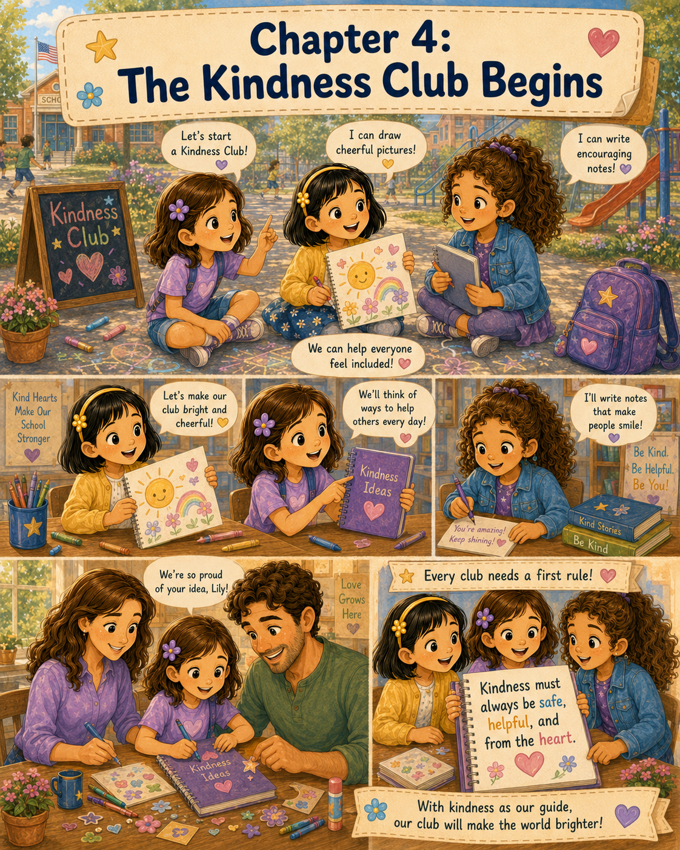

Chapter 4: The Kindness Club Begins
The next morning, Lily carried her purple notebook to school in the front pocket of her backpack.
She had checked three times to make sure it was there.
Before breakfast, she checked.
Before leaving the house, she checked again.
And just before stepping out of the car at school, she unzipped her backpack one more time and peeked inside.
Dad noticed from the driver’s seat.
“Important notebook?” Gary asked.
Lily nodded. “Very important.”
Mom smiled from the passenger seat. “Is that the notebook with your new idea?”
Lily zipped her backpack carefully. “Yes.”
Ann turned around and looked at her daughter with warm, proud eyes. “Then I hope it has a very good first day.”
Lily smiled, but she also felt a little nervous. Last night, writing the words Kindness Club Ideas had felt exciting. This morning, she had to ask May and Mary if they wanted to join. What if they thought it was silly? What if they were too busy? What if they liked being friends but did not want to start a club?
Dad seemed to understand Lily’s thinking face.
“Remember,” he said, “good ideas do not have to be perfect before you share them.”
Mom nodded. “And a kind idea is always worth saying out loud.”
Lily held the straps of her backpack. “I’m going to ask them today.”
“That sounds brave,” Mom said.
“And wonderful,” Dad added.
Lily gave them each a quick hug, then walked toward the school doors. The hallway was becoming more familiar now. She knew where to turn, where the water fountain stood, and which classroom had the paper apples on the door. Room 12 did not feel so far away anymore.
When Lily entered the classroom, May was already at their table, drawing on a scrap piece of paper. Mary was beside her, reading the back cover of a library book.
May looked up first. “Hi, Lily!”
Mary smiled. “Good morning.”
Lily smiled back. “Good morning.”
She hung her backpack on the hook, but before she sat down, she touched the front pocket. The purple notebook was still there.
During morning work, Lily tried to focus on her spelling sheet, but her eyes kept drifting toward May and Mary. May was drawing tiny stars around the edge of her paper. Mary was carefully writing each word in neat letters.
Lily wondered when she should ask them.
Not during Mrs. Carter’s lesson.
Not while they were walking in the hallway.
Maybe at recess.
Or maybe lunch.
Her idea felt as if it were bouncing gently inside her chest.
Mrs. Carter rang her small bell.
“Class,” she said, “today we are going to talk about classroom jobs and how everyone can help make Room 12 a good place to learn.”
Lily sat up straighter. Helping was exactly what she had been thinking about.
Mrs. Carter wrote the word responsibility on the board.
“Responsibility means taking care of something that matters,” Mrs. Carter explained. “In our classroom, we all share the responsibility of being kind, safe, and helpful.”
Lily glanced at May.
May glanced back and smiled.
Then Lily glanced at Mary.
Mary gave a tiny nod, as if she was listening carefully too.
Mrs. Carter listed classroom jobs: line leader, paper helper, library helper, plant helper, pencil helper, and kindness helper.
Lily’s eyes widened.
Kindness helper.
Mrs. Carter noticed the class looking curious.
“A kindness helper pays attention to classmates who may need encouragement,” she explained. “That does not mean solving every problem alone. It means noticing, caring, and asking an adult when help is needed.”
Lily thought about Emma sitting alone at lunch the day before. She thought about how the lunch table became happier when there was room for one more.
Maybe a Kindness Club could work the same way as a kindness helper, except with friends working together.
By recess, Lily knew she could not wait any longer.
The class lined up and walked outside. The sky was bright blue, and the playground buzzed with happy noise. Some children ran to the swings. Others hurried to the slide. A few gathered near the sidewalk chalk area, where pieces of yesterday’s chalk town were still faintly visible.
May shaded her eyes with one hand. “Should we draw again?”
Mary nodded. “Maybe we can add a school garden.”
Lily took a breath. “Can I ask you both something first?”
May turned toward her. “Sure.”
Mary closed her book, which she had carried outside in case she found a quiet reading spot. “What is it?”
Lily’s heart began to beat faster, but she remembered what Mom had said.
A kind idea is always worth saying out loud.
“I was thinking about yesterday,” Lily began. “When we invited Emma to sit with us.”
May smiled. “That was nice.”
“It made lunch better,” Mary said.
Lily nodded. “And I was thinking about what my dad said. He said kindness can grow when people work together.”
May tilted her head. “Like our chalk town?”
“Yes,” Lily said quickly. “Exactly like that. It started small, but then more people added things.”
Mary looked interested. “So what’s your idea?”
Lily swallowed, then said it.
“I think we should start a Kindness Club.”
May blinked. “A club?”
Lily nodded. “A club for doing kind things at school and in the community. We could notice when someone needs help. We could make people feel included. We could do small things that make the day better.”
Mary’s eyes grew thoughtful. “Like inviting someone to sit with us?”
“Yes,” Lily said. “And maybe helping new students. Or making notes for people. Or cleaning up places with grown-ups helping us.”
May’s face brightened. “Could we make drawings too?”
“Of course,” Lily said. “You’re really good at drawing.”
May smiled so wide that Lily knew she liked the idea. “I could draw cheerful pictures. Maybe suns and flowers and animals. We could give them to people who need smiles.”
Mary hugged her book to her chest. “I could write notes.”
“What kind of notes?” Lily asked.
“Encouraging ones,” Mary said. “Like, ‘You are a good friend,’ or ‘Thank you for helping,’ or ‘You are not alone.’”
Lily felt excitement rising. “That would be perfect.”
May pointed to Lily. “What would you do?”
Lily thought for a moment. “I want to help people feel included. I don’t want anyone to feel like they don’t belong.”
Mary nodded softly. “That sounds like you.”
“It does,” May agreed. “You asked us to play on the first day.”
“And Emma to sit with us,” Mary added.
Lily’s cheeks warmed. “I just remembered how it felt to be nervous.”
“That’s why you noticed,” Mary said.
The three girls stood together near the edge of the playground. Around them, children ran, laughed, climbed, and called out to one another. But to Lily, the moment felt quiet and important.
“So,” May said, “are we really starting it?”
Lily looked from May to Mary. “Do you want to?”
“Yes,” May said.
“Yes,” Mary said.
Lily smiled. “Then the Kindness Club begins today.”
May gave a little cheer and bounced on her toes. “We need a sign!”
Mary laughed. “And rules.”
“And ideas,” Lily added.
“A lot of ideas,” May said.
They hurried to the sidewalk chalk and found an open space. May picked up a yellow piece of chalk and carefully wrote:
KINDNESS CLUB
The letters were large and cheerful, though the S leaned a little sideways. Mary drew a book beside the words. Lily drew three small hearts underneath.
Then May added a sun.
“Because kindness feels sunny,” she said.
Mary added a pencil. “Because we need to write things down.”
Lily added three stick-figure girls holding hands.
“That’s us,” she said.
May looked at the drawing. “We need Emma too.”
“You’re right,” Lily said.
She added a fourth girl beside them.
Mary smiled. “Maybe Emma will want to help sometimes.”
“Maybe more people will,” May said.
Lily looked at the chalk words on the sidewalk. The Kindness Club already seemed real, even though it had only begun a few minutes ago.
When recess ended, the girls lined up together.
May whispered, “Should we tell Mrs. Carter?”
Mary whispered back, “Maybe after we know our rules.”
Lily nodded. “I want to write them in my notebook first.”
At lunch, the girls sat together with Emma again. They told her about the Kindness Club while opening their lunchboxes.
Emma listened carefully.
“A Kindness Club?” she asked.
May nodded. “We’re going to do kind things.”
“Safe kind things,” Mary added.
“And helpful kind things,” Lily said.
Emma smiled. “I like that.”
“Do you want to help us sometimes?” May asked.
Emma looked surprised, then pleased. “Yes. I could draw flowers for people.”
“Violets,” Mary said.
Emma laughed. “Definitely violets.”
After lunch, Lily could hardly wait for the school day to end so she could tell Mom and Dad. She wanted help making the club feel organized. A notebook was a good start, but she needed more than a title page.
When the final bell rang, Lily packed quickly.
“Bring your notebook tomorrow,” May said.
“I will,” Lily promised.
“I’ll think of note ideas,” Mary said.
“I’ll think of picture ideas,” May added.
“And I’ll think about how to make sure people feel included,” Lily said.
At pickup, Mom and Dad were waiting near the front of the school. Lily hurried toward them, her backpack bouncing against her shoulders.
“Well,” Dad said, “you look like someone with news.”
“I asked them,” Lily said.
Mom smiled. “May and Mary?”
Lily nodded. “They said yes! We started the Kindness Club today.”
“That is wonderful,” Mom said.
Dad opened the car door. “Tell us everything.”
On the ride home, Lily told them about the playground, the chalk sign, May’s cheerful drawings, Mary’s encouraging notes, Emma’s violets, and the idea of doing kind things at school and in the community.
Mom listened carefully. Dad nodded as he drove.
When they got home, Lily carried her purple notebook to the kitchen table. Mom made a small snack of apple slices and crackers, and Dad brought over a pencil cup.
“All right,” Dad said, sitting down across from Lily. “Every good club needs ideas.”
“And every kind club needs a kind purpose,” Mom added.
Lily opened the notebook to the first page.
At the top, she had written:
Kindness Club Ideas
Under that were the two ideas from the night before:
- Make sure no one sits alone.
- Notice, care, help.
Mom leaned closer. “Those are very good.”
Dad tapped the table lightly. “What else should the club remember?”
Lily thought about the playground. She thought about the cafeteria. She thought about community projects like cleaning up a park or helping neighbors.
“We should do kind things at school,” she said. “And in the community.”
Mom nodded. “That gives the club a bigger purpose.”
Lily wrote:
- Do kind things at school and in the community.
Dad said, “What about safety?”
Lily looked up.
“Kindness should always be safe,” Dad explained. “For example, helping at a park is good, but children should have adults with them. Helping someone who is hurt is good, but you should get a teacher or grown-up. Kindness should never put you in danger.”
Lily nodded seriously. She remembered stories Grandpa Jim had told her about helping animals safely. She knew children could do many kind things, but some things needed grown-ups.
Mom added, “Kindness should also be helpful. Sometimes we need to ask what someone needs instead of guessing.”
“That makes sense,” Lily said.
Dad smiled. “And kindness should come from the heart, not because we want a prize or applause.”
Lily liked that most of all.
She turned to a clean page and wrote in careful letters:
Kindness Club Rule Number One:
Kindness must always be safe, helpful, and from the heart.
She read the sentence aloud.
Mom’s eyes softened. “That is a beautiful first rule.”
Dad nodded. “I think May and Mary will like it.”
Lily looked at the page and felt proud. The words seemed important. Not fancy. Not too big. Just true.
Safe.
Helpful.
From the heart.
After dinner, Lily brought out crayons and decorated the page. She drew a small shield beside the word safe, two hands beside the word helpful, and a heart beside the words from the heart. Then she drew three girls at the bottom of the page. May had a pencil for drawing. Mary held a note. Lily stood in the middle, holding a sign that said:
Everyone Belongs
Mom saw the drawing and smiled. “That looks like the heart of your club.”
“The heart?” Lily asked.
“Yes,” Mom said. “The reason it matters.”
Lily looked down at the little sign in her drawing.
Everyone Belongs.
She thought of May standing alone near the playground. She thought of Mary searching for someone to play with. She thought of Emma sitting at the end of the lunch table. She even thought of herself on the first morning, holding her backpack and feeling unsure.
Everyone wanted to belong.
Maybe the Kindness Club could help with that.
Before bed, Lily placed the notebook carefully inside her backpack.
This time, she did not need to check three times. She knew it was there.
Dad came to her doorway. “Ready for tomorrow?”
Lily nodded from under her blanket. “I’m going to show May and Mary the first rule.”
Mom stood beside Dad. “And what is the first rule?”
Lily smiled and recited it from memory.
“Kindness must always be safe, helpful, and from the heart.”
Dad placed a hand over his chest. “That sounds like a rule worth following.”
Mom blew Lily a kiss. “Good night, sweetheart.”
“Good night,” Lily said.
After the light clicked off, Lily looked toward her backpack in the corner of the room. Inside it was her purple notebook, and inside the notebook was the beginning of something special.
The Kindness Club had started with an idea.
Then it became a chalk sign on the playground.
Then it became a page in a notebook.
And soon, Lily hoped, it would become kind actions at school, at home, and in the community.
As she closed her eyes, Lily imagined May’s cheerful drawings, Mary’s encouraging notes, Emma’s violets, and a lunch table where there was always room for one more.
The club had only just begun.
But Lily already knew one thing for sure.
Kindness could grow.
And tomorrow, they would help it grow together.

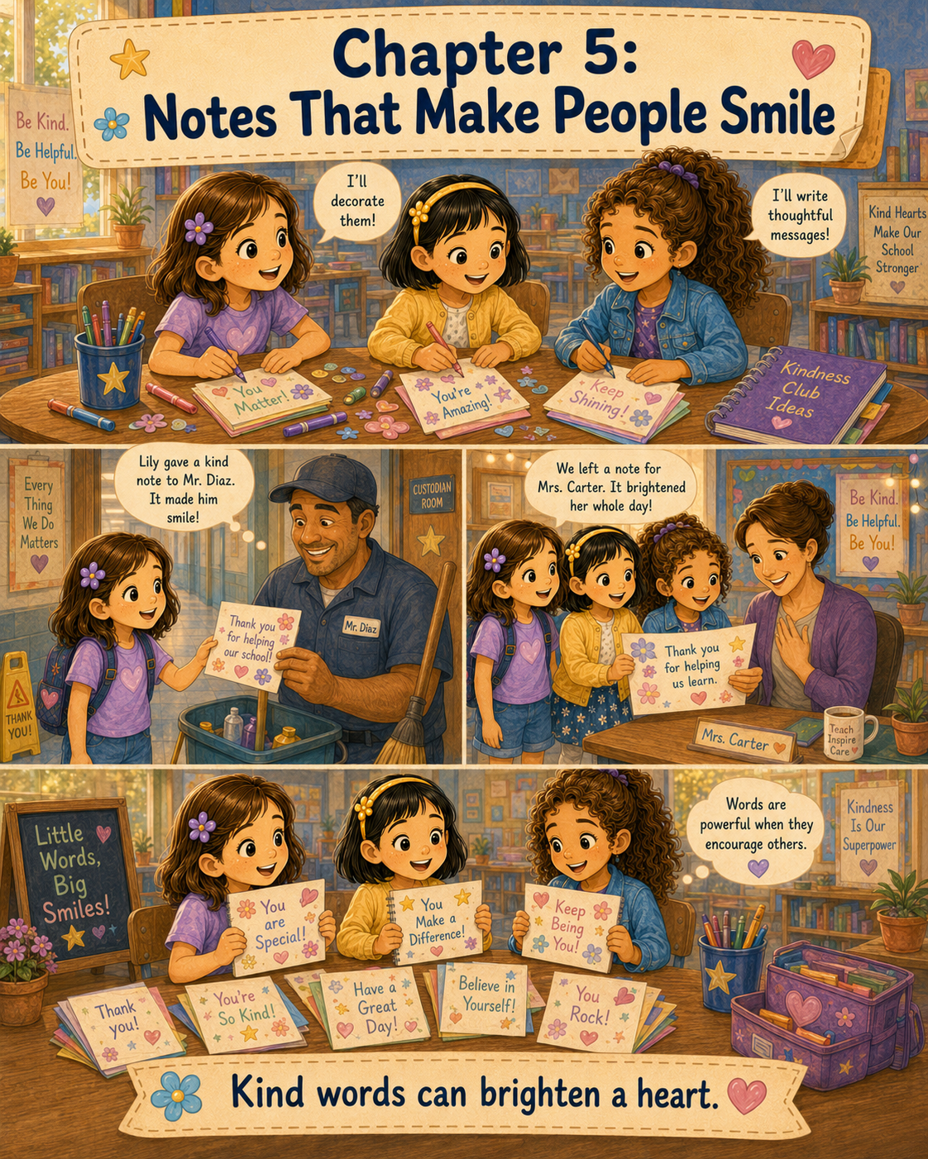

Chapter 5: Notes That Make People Smile
The next morning, Lily woke up with an idea already shining in her mind.
Notes.
Kind notes.
The night before, she had looked through her purple notebook again and again. She had read the first rule of the Kindness Club out loud to herself until she knew every word by heart.
Kindness must always be safe, helpful, and from the heart.
Then she had turned the page and written:
First Project?
For a long time, she had tapped her pencil against the paper, thinking.
The Kindness Club needed something simple for its first project. Something they could do at school. Something safe. Something helpful. Something from the heart.
Then Lily remembered Mary’s idea.
Mary wanted to write encouraging notes.
May wanted to draw cheerful pictures.
Lily wanted to help people feel included and appreciated.
Notes would let them do all three.
At breakfast, Lily carried her purple notebook to the kitchen table. Mom, Ann, was pouring orange juice, and Dad, Gary, was buttering toast.
“You brought the important notebook again,” Dad said.
Lily nodded. “The Kindness Club needs its first project.”
Mom set a glass of juice beside Lily’s plate. “That sounds exciting. What are you thinking?”
“Kind notes,” Lily said. “May can decorate them, Mary can help write them, and I can help deliver them.”
Dad smiled. “That sounds like teamwork.”
“I want the notes to make people smile,” Lily said. “Not just students, but teachers and school helpers too.”
Mom’s face softened. “That is a thoughtful idea.”
“Do you think it’s okay?” Lily asked. “It would be safe, right?”
Dad nodded. “As long as you follow school rules and ask your teacher before leaving notes around the school.”
Mom added, “And the notes should be kind to everyone. No secrets that leave people out.”
Lily wrote quickly in her notebook:
Ask Mrs. Carter first.
Kind notes for everyone.
No leaving anyone out.
Dad leaned over and read the words. “That sounds like a strong plan.”
Mom reached into a kitchen drawer and pulled out a small stack of blank index cards. “Would these help?”
Lily’s eyes widened. “Can I have them?”
“Of course,” Mom said. “They’re perfect for notes.”
Dad found a small rubber band and wrapped it around the cards. “For the official Kindness Club supply box.”
“We don’t have a supply box,” Lily said.
“Not yet,” Dad said with a grin.
Lily laughed and placed the cards carefully in her backpack beside her notebook.
At school, May and Mary were already at their table when Lily arrived. May was drawing little flowers on the back of her spelling worksheet. Mary was reading quietly, one finger moving under the words.
Lily hurried over.
“I have our first project,” she whispered.
May put down her pencil. “What is it?”
Mary closed her book. “Is it from the notebook?”
Lily nodded and pulled out the purple notebook. She opened it to the page that said First Project?
“Kind notes,” Lily said. “We can make notes for classmates, teachers, and school helpers. May can decorate them. Mary can write messages. I can help deliver them.”
May’s face lit up. “I love that!”
Mary smiled. “Encouraging notes were one of my ideas.”
“That’s why I thought of it,” Lily said. “But we have to ask Mrs. Carter first.”
Mary nodded seriously. “That follows the first rule.”
May held up one finger. “Safe.”
Mary held up another. “Helpful.”
Lily held up a third. “From the heart.”
The girls smiled at one another.
When Mrs. Carter rang the bell, Lily tucked the notebook away, but she could hardly wait for the right time to ask. The morning lesson was about reading, and Mrs. Carter read a story about a little boy who learned to share his umbrella on a rainy day. After the story, the class talked about how small choices can change someone else’s day.
Lily thought that sounded exactly like kind notes.
During morning work, Mrs. Carter walked around the room checking papers. When she came near Lily’s table, Lily raised her hand.
“Yes, Lily?” Mrs. Carter asked.
“May, Mary, and I started a Kindness Club,” Lily said.
Mrs. Carter smiled. “I heard a little about that yesterday. What a lovely idea.”
“We have a first rule,” Lily added.
May sat up proudly.
Mary folded her hands and said, “Kindness must always be safe, helpful, and from the heart.”
Mrs. Carter’s smile grew. “That is an excellent rule.”
Lily felt braver. “We wanted to ask if we could make kind notes for people. Classmates, teachers, and school helpers. We won’t put them anywhere unless you say it’s okay.”
Mrs. Carter looked pleased. “Thank you for asking first. That shows responsibility.”
“So we can?” May asked hopefully.
“Yes,” Mrs. Carter said. “But let’s make a few guidelines.”
Lily opened her notebook quickly.
Mrs. Carter spoke gently. “First, the notes must be kind and respectful. Second, they should not interrupt learning time. Third, if you give notes to classmates, make sure no one feels left out. And fourth, I will help you deliver notes to school helpers.”
Lily wrote each guideline as carefully as she could.
May whispered, “This is very official.”
Mary whispered back, “Good clubs need official things.”
Mrs. Carter continued, “You may work on the notes during quiet choice time this afternoon. I’ll put out extra paper, crayons, and markers.”
“Thank you,” Lily said.
Mrs. Carter leaned closer and lowered her voice kindly. “Words can be powerful, girls. A good word at the right time can stay in someone’s heart all day.”
Lily looked at May and Mary.
That sounded like the kind of project the Kindness Club should do.
All morning, the girls collected ideas. Whenever Lily thought of a message, she wrote it in her notebook. Whenever May thought of a picture, she sketched it in the margin. Whenever Mary thought of a sentence, she whispered it to Lily to write down.
By lunchtime, the list had grown.
Thank you for helping our school.
You are a good friend.
Your smile makes our class brighter.
Thank you for keeping our classroom clean.
You are important.
You did something kind today.
May drew tiny pictures beside each one. A flower. A heart. A star. A smiling sun. A little book. A pencil with wings.
At lunch, Emma sat with Lily, May, and Mary again. She noticed the purple notebook right away.
“What are you working on?” Emma asked.
“Our first Kindness Club project,” May said.
“Kind notes,” Mary explained.
Emma’s eyes brightened. “Can I help?”
Lily looked at May and Mary. They both nodded.
“Of course,” Lily said. “You can draw violets.”
Emma smiled. “I was hoping you would say that.”
After lunch and recess, Mrs. Carter announced quiet choice time.
“Today, the Kindness Club has asked to work on encouraging notes,” she told the class. “Anyone who would like to make a kind card may join them at the back table. Remember, kind words are for building people up.”
Several children looked interested.
May whispered to Lily, “Other people can join?”
Lily felt surprised, but happy. “I guess kindness can grow.”
Mary smiled. “Like the chalk town.”
Mrs. Carter placed colored paper, index cards, crayons, and markers on the back table. Lily, May, Mary, and Emma sat together. Soon, two more classmates joined them. Then another.
The table is filled with color.
May decorate the cards with flowers, stars, hearts, suns, and little smiling animals. She drew a cheerful yellow sun on one card and surrounded it with tiny orange rays.
“This one should go to someone who makes people feel warm inside,” she said.
Mary wrote slowly and carefully. Her letters were neat and round.
Thank you for helping us learn.
You make our school a better place.
You are appreciated.
Lily helped choose who the notes were for. She made a list so they would remember classmates, their teacher, the librarian, the nurse, the office secretary, the cafeteria workers, and the custodian.
“We can’t forget the people who help when no one is watching,” Lily said.
Mary nodded. “Sometimes those people need the most thanks.”
Emma drew small purple violets on a card for the school nurse.
“Because nurses help people feel better,” she said.
May drew a mop and bucket with a smiling face on a card for the custodian.
Lily giggled. “That bucket looks very happy.”
“It is happy because the floor is clean,” May said.
Mary wrote on the card:
Thank you for helping keep our school clean and safe.
Lily read the words and felt a warm feeling in her chest.
“That’s perfect,” she said.
When the cards were finished, Mrs. Carter came over to the table. “May I see what you’ve made?”
The girls spread out the notes.
Mrs. Carter picked up one that said:
Thank you for being patient with us.
She smiled softly. “This one is very kind.”
“That one is for you,” Lily said.
“For me?” Mrs. Carter asked, surprised.
May nodded. “I drew the flowers.”
Mary added, “I wrote the message.”
Lily said, “We all wanted you to have it.”
Mrs. Carter held the card close for a moment. “Thank you, girls. This brightens my day more than you know.”
Lily saw that Mrs. Carter’s eyes looked a little shiny, but she was smiling.
The girls looked at one another.
The notes were already working.
Before dismissal, Mrs. Carter helped them deliver some of the cards. They could not wander around the school alone, so Mrs. Carter walked with them during the last few minutes of the day.
First, they stopped at the library. Mary handed a note to Mrs. Bloom, the librarian.
Mrs. Bloom read it aloud softly. “Thank you for helping us find stories.”
She placed a hand over her heart. “That is beautiful. Stories are even better when shared with kind readers.”
Mary smiled proudly.
Next, they visited the school office. Lily handed a card to Mrs. Lane, the office secretary, who answered phones, helped visitors, and gave late passes to students.
Mrs. Lane read the card and laughed happily. “Well, this just made my afternoon.”
“What does it say?” May asked.
Mrs. Lane held it up.
Thank you for helping everyone who comes through the school doors.
“That is exactly what she does,” Lily said.
Mrs. Lane taped the card beside her computer. “Now I can see it every day.”
Then they walked down the hallway toward the cafeteria. The lunch workers were cleaning up after the busy lunch periods. Mrs. Carter thanked them for letting the girls stop by.
Emma handed them a card with purple flowers and a big red heart.
One of the cafeteria workers read it and smiled. “Thank you for making our lunches with care.”
Another worker said, “Well, isn’t that sweet?”
May whispered to Lily, “They smiled.”
Lily whispered back, “A lot.”
Finally, they found Mr. Harris, the custodian, near the end of the hallway. He was pushing a wide broom across the floor, gathering dust and tiny scraps of paper into a neat pile.
Mrs. Carter said, “Mr. Harris, the Kindness Club has something for you.”
Mr. Harris stopped sweeping and looked surprised. “For me?”
Lily nodded. “Yes.”
May held out the card with the smiling mop and bucket. Mary had written the message inside. Lily stood beside them, hoping he would like it.
Mr. Harris took the card and read it quietly.
Thank you for helping keep our school clean and safe. We notice your hard work.
For a moment, he did not say anything.
Then his face changed.
His eyes crinkled at the corners, and a smile spread slowly across his face.
“You notice, do you?” he asked.
Lily nodded. “We’re trying to.”
Mr. Harris looked at the card again. “Well, this is one of the nicest things I’ve received in a long time.”
May beamed. Mary smiled shyly. Emma rocked on her heels, looking pleased.
“We wanted you to know your work matters,” Lily said.
Mr. Harris carefully placed the card in the top pocket of his work shirt. “I’ll keep it right here for the rest of the day.”
As they walked back to Room 12, Lily felt quiet inside, but not in a sad way. It was a thoughtful quiet. She had seen how one small card could change someone’s face. A smile could appear. Shoulders could relax. Eyes could brighten.
Words really could be powerful.
When they returned to the classroom, Mrs. Carter gave the Kindness Club a few minutes to write in Lily’s purple notebook.
“What should we write?” May asked.
Lily opened to a new page and wrote the date.
Mary thought for a moment. “We should write what we learned.”
Emma said, “We learned that people like to be noticed.”
May added, “And drawings help.”
Mary added, “And words matter.”
Lily wrote all of it down.
Then, at the bottom of the page, she wrote:
Kindness Club Lesson:
Words can help someone feel seen, appreciated, and encouraged.
May looked at the word encouraged. “That’s a big word.”
Mary smiled. “It means helping someone feel stronger inside.”
Lily liked that.
Stronger inside.
At the end of the day, Lily packed her backpack with the purple notebook tucked safely inside. May still had a marker on one finger. Mary carried a few extra blank cards for tomorrow. Emma had drawn a tiny violet on the corner of Lily’s notebook page.
“Do you think we can make more notes?” May asked.
“Yes,” Lily said. “But we have to make sure no one is left out.”
Mary nodded. “Maybe next time we can make notes for the whole class.”
“And maybe for people in the community someday,” Emma said.
Lily smiled. “That would be a good project.”
When Lily met Mom and Dad outside, they could tell right away that something good had happened.
Dad leaned down. “That is a very happy face.”
Lily hugged him. “Our first project worked.”
Mom smiled. “The kind notes?”
Lily nodded quickly. “Mrs. Carter liked her card. The librarian smiled. The office lady taped hers by her computer. The cafeteria workers were happy. And Mr. Harris put his card in his pocket.”
Dad looked impressed. “Mr. Harris must have felt very appreciated.”
“He did,” Lily said. “I think maybe people don’t always know we notice what they do.”
Mom nodded. “That is why saying thank you matters.”
In the car, Lily told them every detail. She described May’s drawings, Mary’s neat words, Emma’s violets, Mrs. Carter’s shiny eyes, and Mr. Harris’s slow smile.
Dad listened carefully. “So, what did the Kindness Club learn today?”
Lily thought about the notebook page.
“We learned that words could help someone feel stronger inside,” she said.
Mom reached back and squeezed Lily’s hand. “That is a beautiful lesson.”
That evening, Lily sat at her desk and opened the purple notebook again. She read the first rule:
Kindness must always be safe, helpful, and from the heart.
Then she read the lesson for the day:
Words can help someone feel seen, appreciated, and encouraged.
Lily picked up her pencil and wrote one more sentence underneath:
A kind note may be small, but it can stay in someone’s heart for a long time.
She looked at the words and smiled.
The Kindness Club had completed its first project.
It had not been loud.
It had not fancy.
It did not need a stage or a prize.
It only needed paper, crayons, kind words, and caring hearts.
And because of that, the teacher’s day had brightened.
A custodian had smiled.
School helpers had felt appreciated.
Classmates had learned to notice.
And Lily had learned that sometimes the smallest notes could carry the biggest kindness.

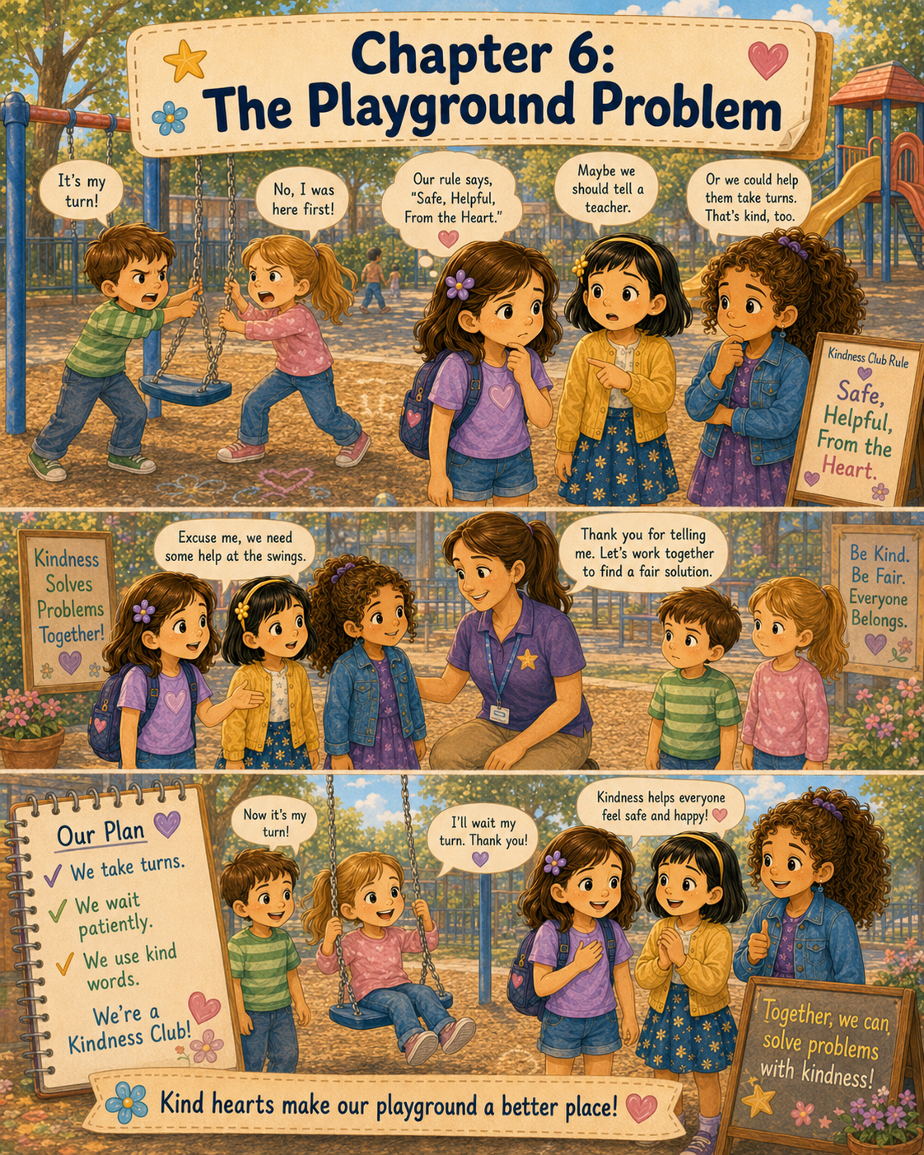

Chapter 6: The Playground Problem
By Friday morning, the Kindness Club felt like a real part of Lily’s school day.
It had started as an idea in her purple notebook. Then it had become a chalk sign on the playground. Then it had become kind notes for classmates, teachers, and school helpers. Now, every time Lily walked into Room 12, she wondered what kind of thing the club might notice next.
At breakfast, Lily sat at the kitchen table with her notebook open beside her cereal bowl. Mom, Ann, was packing her lunch, and Dad, Gary, was rinsing an apple at the sink.
“You are reading that notebook like it has a treasure map inside,” Dad said.
Lily looked up and smiled. “It kind of does.”
Dad raised his eyebrows. “A kindness treasure map?”
“Yes,” Lily said. “Except instead of finding treasure, we find ways to help.”
Mom set Lily’s lunchbox on the table. “That sounds like a very good kind of treasure map.”
Lily turned to the page where she had written the club’s first rule.
Kindness must always be safe, helpful, and from the heart.
She had decorated the page with little drawings: a shield for safe, two helping hands for helpful, and a heart for from the heart.
“I think this is still our most important rule,” Lily said.
Mom nodded. “It is a wise rule.”
Dad sat across from Lily. “And it is especially important when people have a problem.”
“What do you mean?” Lily asked.
“Well,” Dad said, “sometimes kindness is easy. A smile, a note, or inviting someone to sit with you can be simple. But sometimes kindness means helping when feelings are upset. That can be trickier.”
Lily thought about that. “Like if someone is angry?”
“Yes,” Dad said. “If someone is angry, hurt, or arguing, you must be careful. You can still be kind, but you may need an adult to help.”
Mom added, “Children should never feel like they have to solve every problem alone.”
Lily looked back at the rule. Safe. Helpful. From the heart.
“So, if there’s a problem,” Lily said, “kindness might mean getting help?”
“Exactly,” Mom said.
Dad smiled. “That is not tattling. That is being responsible.”
Lily nodded slowly. She had heard children say, “Don’t tell,” before. But Mom and Dad made it sound different. If someone needed help, getting an adult was part of kindness.
She picked up her pencil and wrote a new note in her purple notebook:
When a problem feels too big, ask an adult for help.
Dad leaned over to read it. “That belongs on the treasure map.”
Lily smiled and closed the notebook.
At school, Room 12 was full of Friday energy. Some students were excited because the week was almost over. Others were still sleepy from the early morning. Mrs. Carter stood near the door, greeting each student as they entered.
“Good morning, Lily,” she said.
“Good morning, Mrs. Carter,” Lily replied.
May was already at their table, drawing tiny stars on the edge of her paper. Mary was sorting her pencils by length. Emma was reading a book with a purple bookmark tucked inside.
Lily sat down and opened her backpack.
“I added something to the Kindness Club notebook,” she whispered.
May’s eyes brightened. “A new project?”
“Not exactly,” Lily said. “A reminder.”
Mary looked interested. “What kind of reminder?”
Lily opened the notebook and showed them the sentence.
When a problem feels too big, ask an adult for help.
Mary nodded. “That’s a good reminder.”
May leaned closer. “My mom says that too. Especially if someone is hurt.”
“Or if people are arguing,” Lily said.
Emma looked up from her book. “At my old school, two kids argued over a jump rope, and a teacher helped them make turns.”
“That sounds fair,” Mary said.
May tapped her pencil on the table. “Maybe we should add fair to the notebook.”
Lily wrote it underneath.
Kindness should also be fair.
Mrs. Carter rang her small bell, and the class quieted down.
“Good morning, class,” she said. “Today we are going to talk about problem-solving.”
Lily looked at May and Mary with wide eyes. It felt as if Mrs. Carter had somehow read their notebook.
Mrs. Carter wrote four words on the board:
Stop.
Breathe.
Listen.
Solve.
“When we have a problem,” Mrs. Carter explained, “it helps to stop before we act. Then we breathe so our feelings do not make all our choices for us. Next, we listen to one another. Finally, we look for a safe and fair solution.”
Lily copied the words onto a small piece of paper.
Stop.
Breathe.
Listen.
Solve.
Mrs. Carter gave an example of two students wanting the same blue marker. The class talked about sharing, taking turns, using another color, or asking a teacher for help.
“Problems happen,” Mrs. Carter said. “That does not mean someone is bad. It means we need to learn what to do next.”
Lily liked that sentence. Problems happened. People could learn.
The morning moved along with spelling practice, reading groups, and a math lesson. Lily tried to pay attention, but the words from the board stayed in her mind.
Stop.
Breathe.
Listen.
Solve.
At last, it was time for recess.
The class lined up, and Mrs. Carter reminded them to use safe feet in the hallway. Outside, the playground was bright and busy. A warm breeze moved through the trees, and sunlight shone across the swings, slides, and climbing bars.
May stretched her arms. “I’m glad it’s recess.”
Mary nodded. “My brain needed outside air.”
Lily laughed. “Mine too.”
Emma held a small piece of chalk. “Should we add to the chalk town?”
“Maybe after we swing,” May said. “I want to swing today.”
The girls walked toward the swings. There were six swings in a row, and most of them were already being used. Children pumped their legs, leaned back, and shouted happily as they rose higher.
One swing was empty.
May pointed. “There’s one.”
But before any of the girls could move toward it, two younger students ran to the swing at the same time.
One was a little boy in a red shirt. The other was a little girl with pink sneakers and a ponytail. They both grabbed the chains.
“I got here first!” the boy said.
“No, I did!” the girl answered.
The boy pulled the swing toward him. “I was closer!”
The girl held on tightly. “But I touched it first!”
Their voices grew louder.
Lily stopped walking.
May’s smile disappeared. “Oh no.”
Mary frowned. “They’re both upset.”
The boy tried to sit on the swing while the girl still held the chain. The swing twisted sideways.
“That’s mine!” he cried.
“No!” the girl shouted.
Lily felt her heart beat faster. She wanted to help, but she did not want to make the problem worse.
May leaned toward Lily. “Should we tell a teacher?”
Mary looked at the younger children. “Maybe we can help them take turns.”
Lily looked from May to Mary. Both ideas sounded kind. Telling a teacher would be safe. Helping them take turns would be fair.
Then the boy pulled again, and the girl stumbled one step forward.
Lily remembered the notebook.
When a problem feels too big, ask an adult for help.
She remembered Mom’s voice.
Children should never feel like they have to solve every problem alone.
She remembered Dad saying that getting help was not tattling when someone needed it.
Lily took a deep breath.
“I think we should ask an adult,” she said. “Then maybe we can help make a turn plan.”
May nodded quickly. “Good idea.”
Mary agreed. “Safe first.”
The girls looked around and saw Ms. Rivera, the playground teacher, standing near the basketball court. Lily walked over quickly, with May and Mary beside her.
“Ms. Rivera?” Lily said.
Ms. Rivera turned. “Yes, Lily?”
“There are two younger students arguing over a swing,” Lily said. “They both want it, and one of them almost fell.”
Ms. Rivera looked toward the swings right away. “Thank you for telling me. Let’s go help.”
Lily felt relieved. She had not solved the whole problem, but she had taken the safe first step.
When they reached the swing, the boy and girl were still holding the chains.
Ms. Rivera spoke calmly. “Everyone, stop for a moment, please.”
The boy and girl froze.
Ms. Rivera stepped close but kept her voice gentle. “Let go of the swing for just a minute. We need to make sure everyone is safe.”
The boy let go first. The girl let go next.
“Thank you,” Ms. Rivera said. “Now take one step back from the swing.”
They both stepped back, though neither looked happy.
Ms. Rivera crouched down to be closer to their height. “I can see that both of you wanted a turn. It is disappointing when we want the same thing at the same time.”
The girl crossed her arms. “I touched it first.”
The boy frowned. “I was running to it first.”
Ms. Rivera nodded. “You both feel like you were first. But pulling on the swing is not safe.”
Lily stood quietly beside May and Mary. She wanted to say something, but she waited.
Ms. Rivera looked at the Kindness Club girls. “Did one of you have an idea for helping?”
Mary glanced at Lily.
Lily looked at May.
May whispered, “Turns.”
Lily nodded and spoke carefully. “Maybe they could take turns. One person could swing first, and the other could count or wait. Then they switch.”
“That sounds fair,” Mary added.
May said, “We could help count pushes.”
Ms. Rivera smiled. “That is a helpful idea.”
The boy looked uncertain. “But who goes first?”
The girl pointed at herself. “Me.”
The boy shook his head. “No, me.”
Lily thought for a moment. This was the tricky part. A turn plan needed to feel fair to both.
Mary raised her hand a little, even though they were outside. “Maybe they could do rock, paper, scissors for the first turn.”
The boy looked interested.
The girl looked interested too, though she tried not to show it.
Ms. Rivera nodded. “That could work. Or I can choose. What do you both prefer?”
“Rock, paper, scissors,” the boy said.
The girl nodded. “Okay.”
Ms. Rivera stood between them. “Best one time. The winner gets the first turn for twenty pushes. Then the other person gets twenty pushes. After that, if anyone else is waiting, they get a turn too.”
“Twenty pushes?” the boy asked.
“Twenty safe pushes,” Ms. Rivera said. “Not too high, and no jumping off.”
The two younger students faced each other.
“Rock, paper, scissors, shoot!” they said.
The girl chose paper.
The boy chose rock.
“Paper covers rock,” Ms. Rivera said. “So you may have the first turn.”
The boy’s face fell.
Lily noticed right away. He looked as if he might start arguing again.
May stepped forward slightly. “I can count the pushes, and then it will be your turn.”
Mary added, “Twenty is not too long.”
The boy kicked at the mulch with his shoe. “Okay.”
The girl climbed onto the swing. Ms. Rivera made sure she was seated safely.
“Who will count?” Ms. Rivera asked.
“I will,” May said.
“I’ll help,” Lily said.
Mary stood near the boy. “You can count too, if you want. Then you’ll know when it’s your turn.”
The boy looked at Mary, then nodded.
May began counting each gentle push.
“One. Two. Three.”
Lily counted with her.
The girl’s upset face slowly changed. Her hands held the chains, and her ponytail moved back and forth as she swung. She was no longer shouting.
By the time May reached ten, the boy was counting too.
“Eleven. Twelve. Thirteen.”
Mary smiled at him. “You’re a good counter.”
The boy stood a little taller.
When they reached twenty, the girl slowed down and hopped off after the swing stopped.
“My turn,” the boy said.
Ms. Rivera held up one hand. “Say it kindly, please.”
The boy looked at the girl. “Can I have my turn now?”
The girl nodded. “Okay.”
She stepped away, and the boy climbed on.
This time, the girl helped count.
“One. Two. Three.”
Lily watched them carefully. The problem that had felt loud and twisty a few minutes earlier now seemed calmer. The swing moved back and forth. The children counted together. No one was pulling. No one was shouting.
May looked at Lily and smiled.
Mary whispered, “It worked.”
Lily whispered back, “Because we got help.”
When the boy’s twenty pushes were over, another younger child came to wait. Ms. Rivera helped them continue the turn plan.
“Thank you, girls,” Ms. Rivera said to Lily, May, and Mary. “You noticed a problem, asked an adult, and helped make a fair solution. That was responsible kindness.”
Responsible kindness.
Lily liked the sound of that.
The three girls walked away from the swings and sat on a nearby bench for a moment. They had not even had their own turns yet, but none of them seemed to mind.
May let out a breath. “That was a lot.”
Mary nodded. “The arguing made my stomach feel tight.”
“Mine too,” Lily said.
“I wanted to fix it,” May admitted. “But I didn’t know how.”
“I thought turns would help,” Mary said. “But I’m glad we didn’t try to do it alone.”
Lily opened her backpack, which she had brought outside because the purple notebook was inside. She pulled out the notebook and turned to a clean page.
“What should we write?” she asked.
May thought for a moment. “Kindness can help people share.”
Mary added, “Kindness can be fair.”
Lily wrote both sentences.
Then she paused.
“I think kindness also means knowing when to ask for help,” Lily said.
Mary nodded. “That might be the biggest lesson.”
May leaned over to look at the page. “Can we write ‘safe first’?”
“Yes,” Lily said.
She wrote:
Kindness Club Lesson:
When people are upset, kindness means staying safe, asking an adult for help, and finding a fair way to solve the problem.
May pointed to the words. “That is a long lesson.”
Mary smiled. “Some important lessons are long.”
Lily laughed.
At lunch, the girls told Emma what had happened.
Emma listened closely as she peeled the wrapper from her cheese stick.
“So you helped them share the swing?” she asked.
“With Ms. Rivera,” Lily said. “We asked her first.”
“That was smart,” Emma said.
May nodded. “The swing was twisting, and someone almost fell.”
Mary added, “If we had tried to solve it alone, they might not have listened.”
Emma looked thoughtful. “Sometimes younger kids listen better to teachers.”
“Sometimes older kids do too,” May said.
They all giggled.
After lunch, Mrs. Carter asked the class to gather on the rug. Ms. Rivera had told her about the playground problem.
“I heard that some students helped solve a problem safely at recess today,” Mrs. Carter said.
Lily looked down at her hands. She did not want everyone staring at her.
Mrs. Carter did not say their names right away. Instead, she wrote the words from the morning on the board again.
Stop.
Breathe.
Listen.
Solve.
“Today, some students remembered that problem-solving works best when we stay calm and ask for help if needed,” Mrs. Carter said. “That is something all of us can practice.”
Then she asked the class, “Why is it important to ask an adult for help when a problem feels unsafe?”
Ethan raised his hand. “Because someone could get hurt.”
Grace said, “Because grown-ups know how to help people calm down.”
Mary raised her hand. “Because kindness should be safe.”
Mrs. Carter smiled. “Exactly.”
Lily felt proud of Mary for saying it.
Mrs. Carter continued, “Kindness is not only about being nice when everything is easy. Sometimes kindness means helping people find peace when feelings are big.”
Lily thought about the boy and the girl on the swing. Their feelings were big. Very big. But with help, those feelings had become smaller.
The playground had felt peaceful again.
That afternoon, during quiet writing time, Lily wrote about recess in her journal.
She wrote:
Today I learned that kindness is not always quiet notes and smiles. Sometimes kindness is helping people stop arguing. Sometimes kindness is asking a grown-up for help. Sometimes kindness means making a fair plan.
She drew a picture of a swing with two children standing beside it, smiling and counting turns.
At the end of the school day, Lily slowly packed her backpack. She felt tired, but also proud.
May walked beside her to the cubbies. “Do you think the Kindness Club did a good job today?”
“Yes,” Lily said. “But not because we fixed everything ourselves.”
Mary joined them. “Because we remembered the rule.”
May held up one finger. “Safe.”
Mary held up another. “Helpful.”
Lily held up the third. “From the heart.”
Emma added from behind them, “And fair.”
The girls laughed.
Outside, Mom and Dad were waiting near the pickup area. Dad waved when he saw Lily.
“How was school?” Mom asked.
Lily hugged her. “There was a playground problem.”
Dad’s eyebrows lifted. “That sounds serious.”
“It was a little serious,” Lily said. “Two younger kids argued over a swing. They were pulling it, and one almost fell.”
Mom looked concerned. “What did you do?”
“We asked Ms. Rivera for help,” Lily said. “Then we helped them make a turn plan.”
Dad smiled. “That was a wise choice.”
“I remembered what you said,” Lily told him. “That getting help is not tattling if someone needs it.”
Dad nodded. “Exactly right.”
Mom brushed Lily’s hair away from her face. “I’m proud of you. It takes courage to step into a problem carefully.”
“We didn’t really step into it alone,” Lily said. “We stepped toward help.”
Mom smiled. “That may be even better.”
On the ride home, Lily told them about the swing, the counting, the rock-paper-scissors game, and the turn plan. She told them how the younger students had calmed down and how the playground felt peaceful afterward.
Dad listened and then said, “So what did the Kindness Club learn today?”
Lily looked out the window at the trees passing by.
“We learned that kindness could help solve problems,” she said. “But it has to be safe and fair.”
Mom nodded. “That is a lesson many grown-ups still need to remember.”
That evening, Lily opened her purple notebook at her desk. She read all the lessons the Kindness Club had written so far.
Make sure no one sits alone.
Notice, care, help.
Kindness must always be safe, helpful, and from the heart.
Words can help someone feel seen, appreciated, and encouraged.
And now:
When people are upset, kindness means staying safe, asking an adult for help, and finding a fair way to solve the problem.
Lily drew a small swing beside the new lesson. Then she drew three girls standing nearby with a teacher beside them.
She thought about May wanting to tell a teacher.
She thought about Mary wanting to help the children take turns.
She thought about how both ideas had worked together.
May had remembered safety.
Mary had remembered fairness.
Lily had remembered the club rule.
And Ms. Rivera had helped bring peace.
Lily closed the notebook and held it for a moment.
The Kindness Club was learning that kindness could be many things.
A smile.
An invitation.
A note.
A thank-you.
A fair turn.
A safe choice.
A peaceful solution.
Lily placed the notebook in her backpack for Monday.
The playground problem had not been easy, but it had taught them something important.
Kindness did not mean pretending problems were not there.
Kindness meant noticing the problem, caring about the people, and helping in the safest way they could.
And sometimes, the kindest words were simple ones.
“Let’s get help.”

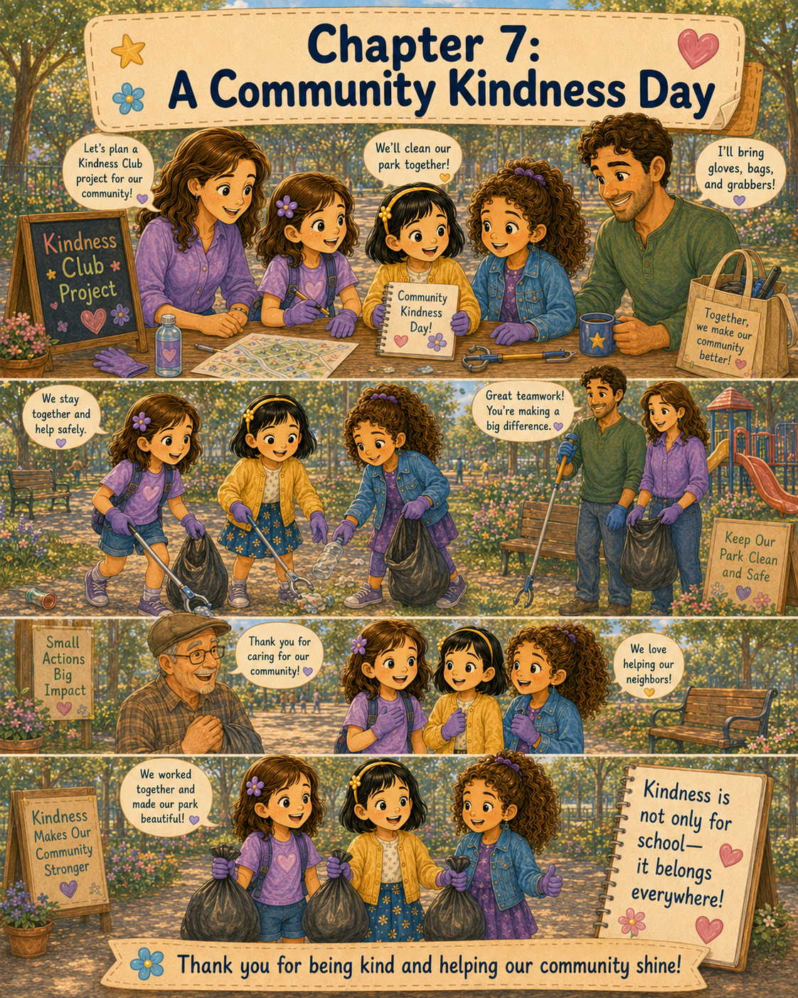

Chapter 7: A Community Kindness Day
On Saturday morning, Lily woke up to the sound of birds singing outside her window.
For a moment, she forgot it was the weekend. She rolled over, pulled her blanket up to her chin, and smiled because there was no school bell to think about, no spelling sheet waiting on her desk, and no rush to pack her backpack before breakfast.
Then she remembered something even better.
Today was the Kindness Club’s first community project.
Lily sat up quickly.
The Kindness Club had already done kind things at school. They had invited Emma to their lunch table. They had made encouraging notes for classmates, teachers, and school helpers. They had helped solve the playground problem by asking an adult for help and making a fair turn plan.
But today would be different.
Today, kindness was leaving the school building.
Today, Lily, May, and Mary were going to help at the park.
Lily hurried to get dressed. She chose comfortable pants, sneakers, and a shirt she did not mind getting a little dirty. Mom had told her the night before that helping in the community sometimes meant using your hands, your feet, and your patience.
When Lily came into the kitchen, Mom, Ann, was placing water bottles on the counter. Dad, Gary, was checking a small bag of supplies.
“Good morning, community helper,” Dad said.
Lily smiled. “Good morning.”
Mom looked her over. “Sneakers, comfortable clothes, hair pulled back. You look ready.”
“I am ready,” Lily said. Then she paused. “Mostly.”
Dad looked up. “Mostly?”
Lily sat at the table. “I’m excited, but I hope everything goes right.”
Mom placed a bowl of oatmeal in front of her. “It does not have to be perfect to be helpful.”
Dad nodded. “A good project needs planning, safety, and kind hearts. You already have those.”
Lily looked at the supplies on the counter. There were gloves, trash bags, hand wipes, snacks, and water bottles. Dad had also packed a small first-aid kit, even though Lily hoped they would not need it.
“Can I check the notebook?” Lily asked.
“Of course,” Mom said.
Lily brought her purple Kindness Club notebook to the table and opened it to the page they had written after school on Friday.
Weekend Kindness Project:
Pick up litter at Maple Street Park.
Adults must come.
Wear gloves.
Stay together.
Do not touch sharp or unsafe things.
Ask a grown-up if unsure.
Lily read the list twice.
Mom sat beside her. “That is a responsible plan.”
Dad pointed to the last line. “That one may be the most important.”
“Ask a grown-up if unsure,” Lily read aloud.
“Exactly,” Dad said. “Some litter is safe to pick up with gloves, like paper or empty water bottles. But some things should only be handled by adults.”
Lily nodded seriously. “No sharp things. No strange things. No touching anything that looks unsafe.”
Mom smiled. “That follows the Kindness Club rule.”
Lily knew the rule by heart now.
“Kindness must always be safe, helpful, and from the heart,” she said.
Dad held up a pair of gloves. “And today, kindness must also wear gloves.”
Lily laughed.
After breakfast, Lily helped Mom pack the car. Soon, they drove to Maple Street Park, where May and Mary would meet them with their families.
Maple Street Park was not very big, but Lily loved it. It had a playground, a walking path, several picnic tables, a grassy field, and tall trees that made shady spots in the afternoon. There was also a little pond where ducks sometimes floated like tiny boats.
When they arrived, May was already there with her mother. She wore a yellow cap and held a roll of trash bags in one hand.
“Lily!” May called.
Lily waved. “Hi, May!”
Mary arrived a few minutes later with her father. She carried a clipboard and a pencil.
Lily looked at the clipboard. “What’s that for?”
Mary smiled. “I thought we could keep track of what areas we clean. That way we don’t miss anything.”
May grinned. “That is very Mary.”
Mary looked pleased. “Thank you.”
Lily opened her purple notebook. “I brought the club notebook too.”
“Then we’re official,” May said.
Before they began, Ann gathered the girls near a picnic table. Gary stood beside her with the supplies.
“Before the Kindness Club starts its first community project,” Ann said, “we need to review the safety rules.”
The girls stood in a small circle.
Gary held up a pair of gloves. “Rule one: gloves stay on while picking up litter.”
“Gloves on,” Lily repeated.
May pulled her gloves onto her hands. “Mine are too big.”
Mary looked at May’s gloves, which were wrinkled at the fingertips. “They make your hands look like bear paws.”
May wiggled her fingers. “Kindness bear paws.”
Everyone laughed.
Ann continued, “Rule two: stay where an adult can see you.”
Mary wrote that on her clipboard.
Gary said, “Rule three: do not pick up anything sharp, broken, rusty, or strange. If you see something unsafe, call one of us.”
“Do not touch it,” Ann added.
Lily nodded. “Ask a grown-up if unsure.”
“Exactly,” Mom said.
Mary wrote that down too.
May raised her gloved hand. “Can we pick up paper?”
“Yes,” Gary said.
“Plastic bottles?” May asked.
“Yes, if they are empty and safe to grab,” Ann said.
“Snack wrappers?”
“Yes,” Gary said.
“What about banana peels?” May asked.
Mary made a face.
Ann smiled. “Let an adult know if it is messy. We can decide together.”
May nodded. “Kindness is more complicated than I thought.”
“Sometimes,” Gary said. “But that is why we plan.”
The adults divided the park into three safe areas: the picnic tables, the edge of the walking path, and the playground area. They agreed not to go near the pond without an adult right beside them.
Lily, May, and Mary started near the picnic tables.
At first, the park looked clean. The grass was green, the tables were empty, and the trees moved gently in the breeze. But when Lily looked more carefully, she noticed small pieces of litter hiding in plain sight.
There was a crumpled napkin under a bench.
A juice box straw wrapper near a tree.
A plastic bottle cap in the grass.
A snack bag caught beside a picnic table leg.
Lily picked up the napkin with her gloved hand and dropped it into the trash bag that May held open.
“That’s one,” May said.
Mary made a check mark on her clipboard. “Picnic table area started.”
Lily smiled. “You’re keeping very good records.”
“Someone has to,” Mary said.
May spotted a candy wrapper. “There’s another one!”
She picked it up and dropped it into the bag.
Soon, the girls were working like a team. Lily looked under the benches. May checked around the picnic tables. Mary marked their progress and picked up safe pieces of litter along the walking path. Ann and Gary stayed nearby, watching and helping when needed.
After a while, Lily stood up and looked around.
The picnic area already seemed better.
It was not a huge change. The trees were the same. The tables were the same. The grass was the same. But the small bits of litter were gone, and everything looked more cared for.
May noticed too. “It looks happier.”
Mary tilted her head. “Can a park look happier?”
“I think so,” May said. “It looks like someone loves it.”
Lily liked that.
A place could look loved.
They moved to the walking path next. A few people passed by as the girls worked. Some smiled. One woman walking a small brown dog said, “Thank you for helping keep the park clean.”
Lily felt her cheeks warm. “You’re welcome.”
The dog sniffed near May’s shoe.
May giggled. “I think he wants to join the Kindness Club.”
Mary looked at the dog. “Can dogs join clubs?”
“Maybe as honorary members,” Lily said.
May waved at the dog as it trotted away. “Goodbye, honorary member.”
The girls kept working.
Near the walking path, Lily found an empty water bottle lying in the grass. She picked it up and placed it in a separate bag Dad had brought for recyclables.
“Recycle bag,” Lily said.
Mary checked the paper on her clipboard. “Good.”
May found a fast-food cup, but the lid was cracked.
“Mr. Gary?” May called. “Is this safe?”
Gary walked over and looked at it. “Good job asking. I’ll take care of that one.”
May stepped back while Gary picked it up carefully.
Lily smiled at May. “You followed the rule.”
May nodded. “Ask a grown-up if unsure.”
Mary made another check mark. “Safety rule followed.”
As they worked, Lily noticed more than litter. She noticed the way people used the park. A father pushed a little girl on a swing. Two older children tossed a ball back and forth. A woman sat on a bench reading a book. A man walked slowly along the path, enjoying the shade.
The park belonged to all of them.
That made the project feel even more important.
When they reached the playground area, the girls found small scraps of paper, a broken crayon, and an empty cracker package near the slide. They stayed away from the swings while children were using them and waited until the area was clear before checking the ground nearby.
“This is like a treasure hunt,” May said.
“But for trash,” Mary added.
“A kindness treasure hunt,” Lily said.
May laughed. “Your dad would like that.”
Lily smiled. “He said the notebook was a kindness treasure map.”
Mary looked around the playground. “Then today we are following the map.”
The girls finished cleaning near the playground and carried their bags back to the picnic table, where the adults were waiting. The bags were not very full, but they were full enough to show that their work had mattered.
Ann handed each girl a water bottle. “You all did a wonderful job.”
Gary tied the trash bag closed. “And you followed the safety rules well.”
Mary looked at her clipboard. “We cleaned the picnic area, walking path, and playground.”
May held up her gloved hands. “And my kindness bear paws survived.”
Lily took a long drink of water and looked across the park.
It really did look better.
Not perfect. Not brand new. But better.
Cleaner.
Brighter.
More loved.
Just then, an older man walking along the path stopped near the picnic table. He wore a straw hat and carried a folded newspaper under one arm.
“Excuse me,” he said kindly. “Are you the young ladies who have been cleaning up the park?”
Lily looked at May and Mary, then nodded. “Yes, sir.”
“We’re the Kindness Club,” May said proudly.
Mary added, “With adult supervision.”
The man smiled. “Well, I come to this park almost every Saturday morning. I noticed what you were doing, and I wanted to say thank you.”
Lily stood a little taller.
“You’re welcome,” she said.
The man looked around the park. “Small actions like this make a place nicer for everyone. A clean bench, a clear path, a playground without wrappers on the ground—those things matter.”
Mary smiled. “That’s what we hoped.”
May pointed to Lily’s notebook on the table. “We write down what we learn.”
“That sounds wise,” the man said. “Then you may want to write this down: when you care for a place, you also care for the people who use it.”
Lily’s eyes widened.
That was a very good sentence.
She quickly opened her purple notebook and wrote it down.
When you care for a place, you also care for the people who use it.
“Thank you,” Lily said.
The man tipped his hat. “Thank you, Kindness Club.”
After he walked away, the girls stood quietly for a moment.
May was the first to speak. “I feel proud.”
“Me too,” Mary said. “But not show-off proud.”
Lily nodded. “A good kind of proud.”
Ann smiled. “That is the feeling of doing something helpful.”
Gary added, “Especially when you know it made a difference.”
The girls sat at the picnic table for a snack. Ann passed around apple slices, crackers, and cheese. May drew a quick picture of the park on the corner of Mary’s clipboard paper. Mary wrote the date at the top. Lily added the project to the notebook.
Community Kindness Day:
We picked up litter at Maple Street Park.
We wore gloves.
We stayed together.
We asked adults for help.
We helped make a shared place better for everyone.
Then she wrote the sentence from the man in the straw hat:
When you care for a place, you also care for the people who use it.
May leaned over the notebook. “That should be our lesson.”
Mary nodded. “It is a very good lesson.”
Lily wrote underneath:
Kindness Club Lesson:
Kindness is not only for school. It belongs in parks, neighborhoods, homes, and everywhere people share space.
May read it aloud and smiled. “Everywhere people share space.”
“That means almost everywhere,” Mary said.
Lily looked around the park again.
The playground.
The walking path.
The picnic tables.
The pond.
The benches.
The trees.
The people.
She thought about how the Kindness Club started in Room 12 with three girls and a notebook. Then it reached a lunch table. Then the hallway. Then the playground. Now it had reached Maple Street Park.
Kindness was growing.
Not loudly.
Not all at once.
But little by little.
Like a chalk town.
Like a flower shop filled with violets.
Like a note in a custodian’s pocket.
Like a swing moving peacefully because children learned to take turns.
Like a park that looked more loved because three girls and their families had cared enough to help.
When it was time to leave, Lily helped carry the recycling bag to the proper bin. Gary placed the trash bag in the park trash can. Ann checked to make sure everyone had washed or wiped their hands. May’s mother took a picture of the girls standing together with their gloves on, smiling proudly beside the picnic table.
“This should go in the Kindness Club notebook,” May said.
“I can print it,” her mother offered.
Mary held up her clipboard. “And I have the official record.”
Lily hugged her purple notebook. “This was a good first community project.”
“It was,” Mary said.
“What should we do next?” May asked.
Lily smiled. “Let’s think about it at school on Monday.”
On the drive home, Lily leaned back in her seat, tired in the best way.
Mom looked at her in the rearview mirror. “You’re quiet.”
“I’m thinking,” Lily said.
Dad smiled. “About the park?”
Lily nodded. “And the man with the straw hat. He said when we care for a place, we care for the people who use it.”
Mom nodded. “That is true.”
“I used to think kindness was mostly about helping one person,” Lily said. “Like inviting Emma to sit with us or giving Mr. Harris a note.”
Dad glanced back at her. “And now?”
“Now I think kindness can help places too,” Lily said. “And when places are better, people feel better.”
Mom smiled. “That is a big understanding.”
Lily looked out the window at the neighborhood passing by. She saw sidewalks, mailboxes, trees, yards, and people going about their day. She wondered how many little ways there were to show kindness in a community.
Picking up litter.
Holding a door.
Thank you, helper.
Planting flowers.
Helping a neighbor.
Sharing a smile.
Making room.
Noticing.
Caring.
Helping.
That evening, Lily taped a small leaf from Maple Street Park onto a page in her notebook. It had fallen onto the picnic table during snack time. Mom said it was okay to keep it because it was already loose.
Under the leaf, Lily wrote:
Our first Community Kindness Day.
Then she added:
Kindness belongs everywhere.
Lily looked at the words for a long time.
She thought about May’s cheerful drawings, Mary’s careful notes, Emma’s violets, Mom’s safety reminders, Dad’s supplies, and the neighbor who had thanked them.
The Kindness Club was still small.
But small did not mean unimportant.
A small note could make someone smile.
A small invitation could help someone feel included.
A small plan could solve a playground problem.
And a small group of children, with grown-ups helping, could make a park cleaner for everyone.
Lily closed the notebook and placed it on her desk.
On Monday, she would tell Mrs. Carter about the park.
She would tell Emma about the man in the straw hat.
She would tell May and Mary that their first community project had taught her something she would always remember.
Kindness was not only for school.
It belonged at lunch tables and playgrounds.
It belonged in classrooms and hallways.
It belonged in parks and neighborhoods.
It belonged anywhere someone could notice, care, and help.
And Lily knew the Kindness Club was just beginning to discover how far kindness could go.

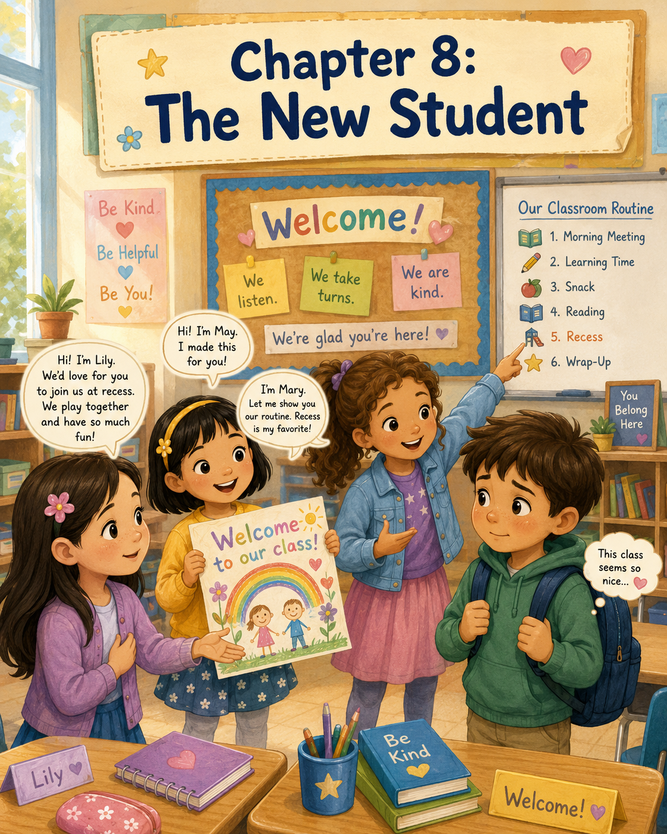

Chapter 8: The New Student
On Monday morning, Lily walked into her classroom with her backpack over one shoulder and her Turtle Points Logbook tucked carefully inside. She liked Mondays more than she used to. At the beginning of the school year, Mondays had made her stomach feel fluttery, like butterflies were trapped inside.
But now things felt different.
Now Lily knew where to hang her backpack. She knew which table was hers. She knew when the morning meeting began, where the pencils were kept, and how to line up for lunch. Best of all, she had May and Mary, and together they had started the Kindness Club.
Their club was not very big. It was just three girls, one notebook, and a promise to look for ways to be kind. But to Lily, it felt important.
That morning, as Lily placed her logbook in her desk, she noticed her teacher, Mrs. Carter, standing by the classroom door. Beside her was a boy Lily had never seen before.
He had brown hair that fell across his forehead and a blue backpack held tightly in both hands. His shoulders were a little hunched, and his eyes moved around the room quickly, looking at the desks, the bookshelves, the calendar, and all the children already talking with their friends.
Mrs. Carter clapped her hands gently.
“Good morning, class,” she said. “Before we begin, we have someone new joining us today.”
The classroom grew quiet.
“This is Noah,” Mrs. Carter continued. “His family just moved here, and today is his first day in our class. I know you will all help him feel welcome.”
Noah gave a very small wave.
“Hi,” he said softly.
Some children waved back. A few said hellos. Then Mrs. Carter showed Noah where to put his backpack and led him to an empty desk near the window.
Lily watched him sit down. He placed his hands flat on the desk and looked at the name tag Mrs. Carter had taped there for him. He did not open his pencil box. He did not look around for someone to talk to. He just sat very still.
Lily felt something tug inside her heart.
She remembered her own first day.
She remembered walking into the room and feeling like everyone else already knew what to do. She remembered not knowing where to sit. She remembered wondering if anyone would want to play with her at recess. She remembered how hard it had been to smile when she felt nervous inside.
Lily looked across the room at May and Mary. May was taking crayons out of her desk. Mary was writing the date at the top of her paper.
Lily leaned toward them and whispered, “I think Noah looks nervous.”
May looked over at Noah. Her smile faded into a thoughtful expression.
“He does,” May whispered.
Mary nodded. “Being new is hard.”
Lily touched the edge of her Turtle Points Logbook inside her desk. “Maybe the Kindness Club can help.”
May’s eyes brightened. “We can welcome him.”
Mary sat up a little taller. “We should do something kind before recess, so he knows he has friends here.”
Lily smiled. “Yes.”
During morning work, Mrs. Carter asked everyone to write three sentences about their weekend. Lily wrote about helping Ann and Gary set the table for Sunday dinner. May wrote about visiting her grandmother. Mary wrote about riding her bike with her brother.
Across the room, Noah stared down at his paper. His pencil rested in his hand, but he had not written anything yet.
Mrs. Carter walked quietly to his desk and spoke to him in a kind voice. Noah nodded, but he still looked unsure.
Lily wanted to help right away, but she knew Mrs. Carter had said the class should work quietly. So, she waited.
Waiting was not always easy. But Lily had learned that kindness worked best when it was patient.
After morning work, Mrs. Carter asked the class to place their papers in the basket and come to the carpet for the morning meeting.
Lily, May, and Mary sat together. Noah sat at the edge of the carpet, a little apart from everyone else.
Mrs. Carter smiled. “Today, let’s review our classroom routine for Noah and for anyone else who needs a reminder.”
She pointed to the chart on the wall.
“First, we begin with a morning meeting. Then we have reading time, math time, snack, science or social studies, lunch, recess, and afternoon activities.”
Noah looked at the chart, but Lily could tell it was a lot to remember all at once.
Mary leaned close to Lily and whispered, “I can explain the routine to him later.”
“That would help,” Lily whispered back.
May opened her desk folder and pulled out a blank piece of paper. “And I can make him a welcome picture.”
Lily felt proud of her friends. Each of them had noticed a different way of helping.
After the morning meeting, the class moved into reading time. Mrs. Carter gave everyone a story passage and asked them to read it with a partner. Lily was paired with May, and Mary worked with a girl named Emma.
Noah was paired with Mrs. Carter for his first day so she could help him learn where things were.
As Lily read, she kept glancing at Noah. He followed along carefully, but he still held his pencil too tightly. When he answered a question, his voice was barely louder than a whisper.
At snack time, the students returned to their desks. May quickly finished her crackers and took out her crayons.
“What are you drawing?” Lily asked.
“A welcome picture,” May said.
She drew a bright yellow sun in the corner, a rainbow across the middle, and three smiling children holding hands. At the top, she wrote in large, colorful letters:
Welcome to Our Class, Noah!
Then she added flowers, stars, and a tiny turtle in the grass.
“That’s perfect,” Lily said.
May smiled. “Do you think he’ll like it?”
“I think he will,” Lily answered.
Mary looked over the picture. “After snack, I’ll show him the routine chart. Sometimes it helps when another student explains things.”
Lily nodded. “And at recess, I’ll ask him to play with us.”
May looked at Lily. “What if he says no?”
Lily thought for a moment. “Then we can still be kind. We don’t have to push him.”
Mary nodded. “Kindness gives people room to feel comfortable.”
Lily liked that. She decided she would remember it.
When snack time ended, Mrs. Carter asked everyone to clean up. As the class moved around the room, May walked carefully toward Noah’s desk with the picture held in both hands.
“Hi,” May said.
Noah looked up, surprised.
“I made this for you,” May said. She placed the drawing gently on his desk. “We’re glad you’re here.”
Noah looked down at the picture. His eyes moved over the rainbow, the flowers, the smiling children, and the little turtle in the grass.
“For me?” he asked.
May nodded.
Noah touched the edge of the paper. “Thank you,” he said. His voice was still quiet, but this time Lily saw the smallest beginning of a smile.
Mary came over next.
“I’m Mary,” she said. “Do you want me to show you the classroom routine?”
Noah looked toward the chart on the wall. “I keep forgetting what comes next.”
“That happens to everybody,” Mary said kindly. “Come on. I’ll show you.”
Mary walked with him to the routine chart. She pointed to each line and explained it slowly.
“Right now we have finished the snack. Next is math. After that, we have lunch. Then recess. Recess is outside on the playground, unless it rains.”
Noah looked worried again. “Where do we line up?”
Mary pointed at the door. “Right there by the blue tape. Mrs. Carter calls tables one at a time.”
“Oh,” Noah said. “That helps.”
Mary smiled. “And if you forget, you can ask me.”
Noah looked at her. “Okay. Thanks.”
Lily watched from her desk. She could see that Noah was standing a little straighter now.
During math, Noah still seemed quiet, but he raised his hand once when Mrs. Carter asked a question. His answer was correct, and Mrs. Carter smiled.
“Excellent thinking, Noah,” she said.
A few children turned and smiled at him. Noah looked down, but Lily could tell he felt proud.
When lunch arrived, Lily, May, and Mary sat at their usual table. Noah sat two seats away, carefully opening his lunchbox. For a while, he ate silently.
Lily wondered if she should invite him closer, but he seemed busy with his food. She remembered what Mary had said: kindness gives people room to feel comfortable.
So Lily simply smiled at him when he looked up.
Noah gave a small smile back.
After lunch, the class lined up for recess. Noah stood near the back, still holding his backpack strap even though his backpack was hanging in the cubby.
Lily walked over to him.
“Hi, Noah,” she said.
“Hi,” he answered.
“We usually play near the big tree at recess,” Lily said. “Sometimes we play tag, and sometimes we make up adventure games. Would you like to play with us?”
Noah looked through the window toward the playground. Children were already running, laughing, and chasing one another.
“I don’t know,” he said. “I’m not very good at tag.”
“That’s okay,” Lily said. “We don’t have to play tag. We can show you the playground first.”
May joined them. “There’s a climbing wall, but we only climb as high as we feel safe.”
Mary smiled. “And there’s a quiet bench if anyone needs a break.”
Noah looked at all three girls. His fingers loosened from the strap he had been holding.
“Maybe I could just walk with you first,” he said.
“That sounds great,” Lily replied.
Outside, the playground was full of movement. Some children jumped rope. Others kicked a ball. A group of students played near the swings. The air smelled like grass and sunshine.
Lily walked beside Noah while May and Mary pointed things out.
“That’s the slide,” May said.
“And that’s where we line up when recess is over,” Mary added.
Lily pointed to a shady spot near the fence. “That’s where we sometimes collect leaves for art ideas. We don’t pull them off trees, though. We only use the ones that have already fallen.”
Noah looked interested. “I like drawing leaves.”
May gasped happily. “You do?”
Noah nodded. “At my old school, I drew a whole page of different leaves.”
“That’s really cool,” May said. “Maybe you can show us sometime.”
Noah’s smile grew a little bigger.
After they walked around the playground, Mary suggested an adventure game.
“We can pretend the big tree is a castle,” she said, “and the wood chips are a river.”
May added, “And the stepping stones are the only safe way across.”
Lily turned to Noah. “Do you want to be the map keeper?”
“What does the map keeper do?” he asked.
“You help decide where we go next,” Lily said.
Noah thought about it. Then he pointed toward the climbing wall. “Maybe that can be a mountain.”
Mary grinned. “Perfect.”
May clapped her hands. “The mountain of kindness!”
They all laughed, even Noah.
For the rest of recess, Noah stayed with them. He did not talk a lot at first, but little by little, he began to join in. He decided where the pretend river turned. He named a small patch of grass “Turtle Meadow.” He even laughed when May pretended to be a queen who had lost her crown in the wood-chip river.
When the whistle blew, Noah looked disappointed.
“Recess is over already?” he asked.
Lily smiled. “It goes fast when you’re having fun.”
As they lined up, Noah stood beside them instead of at the back of the line.
“Thanks for showing me around,” he said.
“You’re welcome,” Lily replied.
May smiled. “You can sit with us at lunch tomorrow if you want.”
“And I can remind you about the routine,” Mary added.
Noah looked at them. This time, his smile was not tiny. It was real.
“I’d like that,” he said.
Back in the classroom, Mrs. Carter asked everyone to take out their journals. The writing prompt was on the board:
Write about one kind of thing you noticed today.
Lily picked up her pencil and thought for a moment.
She could write about May’s welcome picture. She could write about Mary explaining the routine. She could write about Noah smiling at recess.
But then Lily thought about something deeper.
She remembered how nervous she had felt on her own first day. At the time, she had wished those nervous feelings would go away forever. But now she understood something important.
Because she remembered feeling afraid, she had noticed when someone else felt afraid too.
Lily began to write.
Today, a new student named Noah came to our class. He looked nervous, and I remembered how I felt on my first day. The Kindness Club welcomed him. May made him a picture. Mary helped him learn the routine. I invited him to play at recess. I think kindness means noticing how someone else might feel.
Lily paused and added one more sentence.
Sometimes the hard feelings we have had can help us understand other people.
When Mrs. Carter walked by, she stopped beside Lily’s desk and read the page quietly.
“That is a very thoughtful idea, Lily,” she said.
Lily smiled.
At the end of the day, the Kindness Club gathered for a few minutes near the cubbies.
“I think today should count for Turtle Points,” May said.
Mary nodded. “We helped someone feel welcome.”
Lily opened her logbook and wrote:
Kindness Club Act: Welcomed Noah, the new student.
What we learned: Remembering our own feelings can help us understand someone else’s.
May leaned over Lily’s shoulder. “That’s a good lesson.”
Mary smiled. “Maybe Noah will join us again tomorrow.”
Lily looked across the room. Noah was carefully placing May’s welcome picture into his folder so it would not bend. Before he left, he looked back at Lily, May, and Mary.
“Bye,” he said.
“Bye, Noah,” they called together.
As Lily walked out of the classroom, she felt happy in a quiet, peaceful way. The Kindness Club had not done anything big or loud. They had not won a prize or made an announcement.
They had simply noticed someone who needed a friend.
And sometimes, Lily thought, that was one of the kindest things of all.

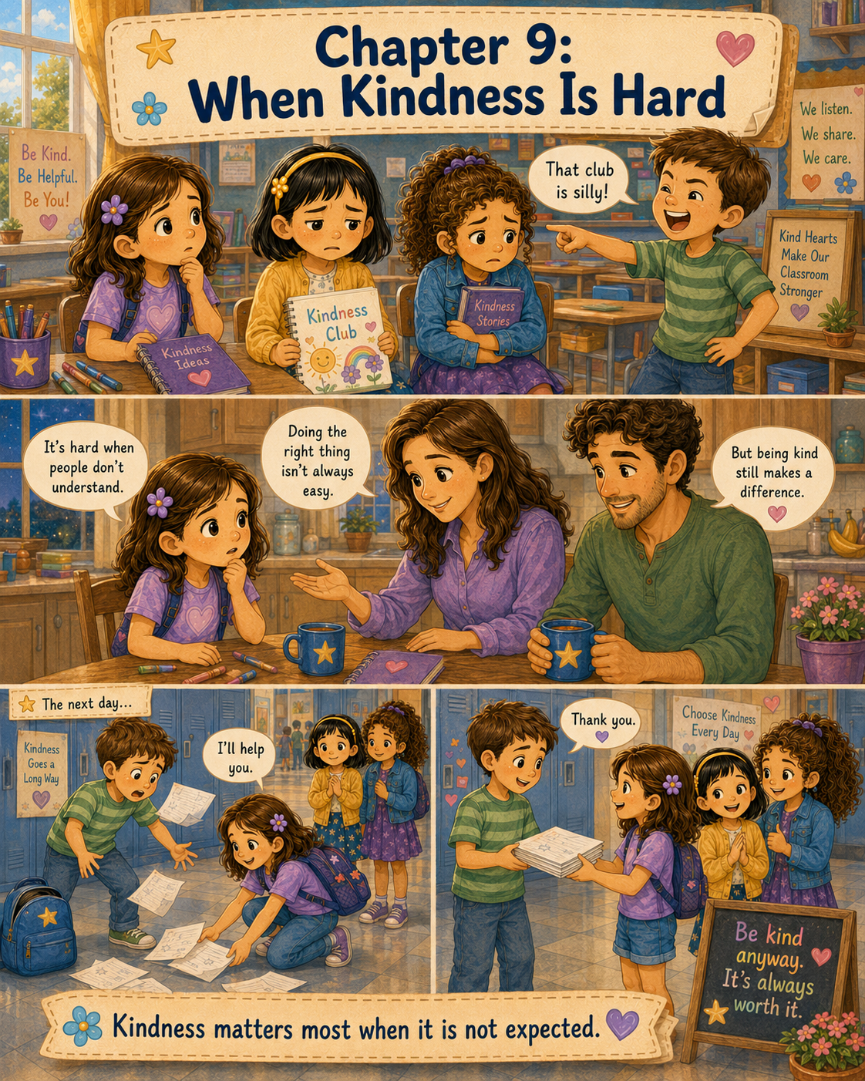

Chapter 9: When Kindness Is Hard
The Kindness Club had been going well.
Every day, Lily, May, and Mary looked for small ways to help. Sometimes they made kind notes. Sometimes they helped younger students at recess. Sometimes they picked up pencils, held doors, or invited someone to join a game.
Not every act of kindness was big. In fact, most of them were small.
But Lily was beginning to understand that small things could still matter very much.
On Tuesday morning, the three girls met near the bookshelf before class began. Lily had her Turtle Points Logbook open in her hands. May held a purple marker, and Mary had a list written neatly on notebook paper.
“We need another Kindness Club idea for this week,” Mary said.
May tapped the marker against her chin. “What about making thank-you cards for the lunch helpers?”
“That’s a good idea,” Lily said. “They work really hard.”
Mary wrote it down. “Thank-you cards for lunch helpers.”
“And maybe we could help clean the art table after painting,” May added.
Lily smiled. “That would be helpful.”
The girls were so busy planning that they did not notice a boy standing nearby. His name was Tyler. He was in their class, and he often liked to joke around with other students.
Tyler leaned against the bookshelf and looked at the open logbook.
“What are you doing?” he asked.
Lily looked up. “We’re planning Kindness Club ideas.”
Tyler frowned a little. “Kindness Club?”
May nodded. “We look for ways to help people.”
Mary held up her list. “This week, we might make thank-you cards for the lunch helpers.”
Tyler laughed.
It was not a happy laugh. It was the kind of laugh that made Lily’s cheeks feel warm.
“That’s silly,” Tyler said. “A Kindness Club? What do you do, walk around smiling at people all day?”
A few children nearby turned to listen.
May looked down at the marker in her hand.
Mary held her list closer to her chest.
Lily did not know what to say.
Tyler shrugged. “I don’t know why you keep doing that stuff. It’s weird.”
Then he walked away to join another group of students.
For a moment, Lily, May, and Mary stood very still.
The classroom sounds continued around them. Backpacks zipped. Chairs scraped against the floor. Students talked and laughed. But to Lily, everything seemed quieter than before.
May slowly put the purple marker into her pencil box.
“Maybe he’s right,” she said softly.
Lily looked at her. “What do you mean?”
May’s face turned pink. “Maybe people think we’re silly.”
Mary’s eyes looked hurt. “We were only trying to help.”
Lily closed the Turtle Points Logbook. Suddenly, it felt heavier than usual.
“I didn’t think anyone would laugh at us,” she said.
Mrs. Carter called the class to a morning meeting, so the girls did not have time to talk more. They took their places on the carpet, but Lily could not stop thinking about Tyler’s words.
Silly.
Weird.
Why do you keep doing that stuff?
During reading time, Lily read the same paragraph three times because her mind kept wandering. During math, she accidentally wrote the wrong number in the wrong box. At snack, she barely touched her crackers.
May was quiet, too. She did not draw flowers around the edge of her paper like she usually did.
Mary kept looking at her kindness list, then folding it smaller and smaller until it fit inside her desk.
At recess, the girls sat together on the bench near the playground fence.
Usually, this was where they planned adventures or looked for someone in need of a friend. But that day, none of them felt like playing.
May kicked one shoe lightly against the ground. “I felt embarrassed when Tyler laughed.”
“I felt hurt,” Mary said. “I know he was joking, but it did not feel funny.”
Lily twisted her fingers together. “Do you think we should stop?”
May looked up quickly. “Stop the Kindness Club?”
Lily shrugged. “Maybe. I don’t know. What if more people laugh?”
Mary stared at the playground. “I don’t want people to think we’re strange.”
“Me neither,” May said.
The three girls sat quietly.
Across the playground, Tyler was playing kickball with a group of students. He was laughing loudly, but now Lily felt nervous every time she heard him.
When the whistle blew, Lily walked back inside with a heavy feeling in her chest.
All afternoon, she tried to forget about it. She copied her spelling words. She listened to the science lesson. She packed her backpack at the end of the day. But Tyler’s words followed her like a shadow.
When Ann picked Lily up after school, she noticed Lily’s quiet face right away.
“How was your day?” Ann asked as they walked to the car.
Lily climbed into the back seat and buckled her seat belt. “It was okay.”
Ann looked at her through the rearview mirror. “Just okay?”
Lily nodded.
Ann did not push. She simply said, “We can talk when you’re ready.”
At home, Lily put her backpack by the kitchen table. Gary was making dinner, and the kitchen smelled like warm soup and bread.
“Hi, Lily,” Gary said. “How’s my favorite Kindness Club member?”
Lily’s eyes filled with tears before she could stop them.
Ann quickly sat beside her. “Oh, sweetheart. What happened?”
Lily wiped her eyes with the sleeve of her sweater. “Someone laughed at us.”
Gary turned the stove down and came to the table.
“At the Kindness Club?” he asked gently.
Lily nodded. “Tyler said it was silly. He said it was weird. May was embarrassed, and Mary was hurt, and I didn’t know what to say.”
Ann listened carefully.
Gary pulled out a chair and sat across from Lily. “That must have felt very hard.”
“It did,” Lily said. “Now I don’t know if we should keep doing it.”
Ann reached for Lily’s hand. “Why did you start the Kindness Club?”
Lily looked down. “Because we wanted to help people.”
“And have you helped people?” Ann asked.
Lily thought about the notes they had made. She thought about the younger students at the swings. She thought about Noah, the new student, smiling at recess.
“Yes,” Lily said. “I think we have.”
Gary nodded. “Then Tyler’s words do not erase the good things you’ve done.”
“But what if people laugh again?” Lily asked.
Ann’s voice was kind but steady. “They might.”
Lily looked surprised. She had expected Ann to say they would not.
Ann continued, “Doing the right thing is not always easy. Sometimes people do not understand it at first. Sometimes they tease what they do not understand. But that does not mean kindness is wrong.”
Gary leaned forward. “Courage is not only about doing big brave things. Sometimes courage is choosing to keep doing good, even when someone makes fun of you for it.”
Lily thought about that.
She had believed kindness would always feel warm and happy. She thought it would feel like smiles, thank-you notes, and playground games. But today, kindness had felt uncomfortable. It had made her cheeks hot and her heart sore.
“Does being kind mean I have to be friends with someone who laughs at me?” Lily asked.
Ann shook her head. “No. You do not have to let someone be unkind to you. You can have boundaries. You can tell an adult if teasing continues. But you can still choose not to answer unkindness with unkindness.”
Gary smiled gently. “Kindness does not mean being weak. Sometimes it takes a strong heart to stay kind.”
Lily was quiet for a long moment.
Then she asked, “What should I do tomorrow?”
Ann squeezed her hand. “You do not have to decide everything tonight. But maybe you can ask yourself one question.”
“What question?”
“What kind of person do you want to be, even when kindness is hard?”
That night, Lily wrote in her Turtle Points Logbook before bed.
Today, someone laughed at the Kindness Club. It made me feel embarrassed and unsure. Ann and Gary said doing the right thing is not always easy. I need to think about whether I will keep going.
Lily stared at the page.
Then she added one more sentence.
I think I want to keep going.
The next morning, Lily carried her logbook to school. Her stomach felt fluttery again, just like it had on the first day of school. But this time, she understood the feeling a little better.
She found May and Mary near the cubbies.
May looked nervous. “Are we still having the Kindness Club?”
Mary held her folded list in one hand. “I brought the lunch-helper card ideas, just in case.”
Lily took a deep breath. “I think we should keep going.”
May looked at her. “Even if Tyler laughs again?”
Lily nodded slowly. “Even then.”
Mary unfolded her list. “I talked to my mom last night. She said we should not stop doing good things just because someone else does not understand them.”
“My dad said something like that, too,” May said. “He said being kind is still worth it.”
Lily smiled. “Ann and Gary said kindness can be hard sometimes.”
May stood a little taller. “Then maybe today we practice hard kindness.”
Mary nodded. “Hard kindness.”
The words felt important.
The girls decided they would still make thank-you cards for the lunch helpers. During morning free time, they took out paper, crayons, and markers.
May drew trays, apples, and little smiling faces. Mary wrote careful messages.
Thank you for helping us at lunch.
Thank you for keeping our cafeteria clean.
Thank you for serving food with a smile.
Lily decorated the edges with stars and hearts. She tried not to look around to see if anyone was watching.
Tyler passed by once, but he did not say anything. Lily felt relieved.
Later that morning, Mrs. Carter asked Lily to take a stack of papers to the office. Lily liked helping, so she held the papers carefully and walked into the hallway.
The hallway was quiet except for the soft sound of footsteps and classroom voices behind closed doors.
As Lily turned the corner, she saw Tyler coming from the opposite direction. He was carrying a folder, a library book, and several loose worksheets. He looked like he was trying to balance too many things at once.
Then it happened.
His folder slipped.
Papers flew everywhere.
Some slid across the floor. One floated under the drinking fountain. Another landed near Lily’s shoes.
Tyler froze.
For a second, Lily froze too.
She remembered his laugh. She remembered the word silly. She remembered how May had looked down on her marker and how Mary had folded her list.
Lily could have kept walking.
She could have pretended not to notice.
She could have thought, He laughed at us, so why should I help him?
But then she remembered Ann’s question.
What kind of person do you want to be, even when kindness is hard?
Lily set her own stack of papers neatly on a nearby bench. Then she bent down and picked up one of Tyler’s worksheets.
Tyler looked at her in surprise.
“You don’t have to help,” he said.
“I know,” Lily answered.
She picked up another paper and smoothed the wrinkled corner.
Tyler crouched down and began gathering the rest. For a few moments, neither of them spoke.
Lily reached under the drinking fountain and pulled out the last worksheet. She handed it to Tyler.
“Here,” she said.
Tyler took it. His face looked different from the way it had yesterday. He was not laughing now.
“Thanks,” he said quietly.
“You’re welcome,” Lily replied.
Tyler placed the papers back inside his folder. He looked at Lily, then looked down at the floor.
“I guess that was kind of nice,” he said.
Lily did not know what to say, so she simply nodded.
Tyler shifted his feet. “I didn’t mean to make everybody feel bad yesterday.”
Lily looked at him. “It did feel bad.”
Tyler’s cheeks turned a little pink. “Yeah. I’m sorry.”
Lily held her papers against her chest. “Thank you for saying that.”
Tyler nodded. “I still don’t really get the club.”
“That’s okay,” Lily said. “It’s just about looking for ways to help.”
Tyler glanced at the folder in his hands. “Like picking up papers?”
Lily smiled a little. “Yes. Like that.”
For the first time that day, Tyler smiled back.
When Lily returned to the classroom, May and Mary hurried over to her desk.
“What took so long?” May whispered.
“Did something happen?” Mary asked.
Lily nodded. “Tyler dropped his papers in the hallway.”
May’s eyes widened. “Tyler?”
“What did you do?” Mary asked.
“I helped him pick them up,” Lily said.
May blinked. “Even after yesterday?”
Lily nodded. “It was hard. But it felt like the right thing to do.”
Mary smiled softly. “Hard kindness.”
“Hard kindness,” Lily repeated.
At lunch, the girls delivered their thank-you cards to the lunch helpers. One of the helpers, Mrs. Rosa, pressed a hand to her heart when she read hers.
“Well, this just made my day,” she said.
May beamed.
Mary smiled proudly.
Lily felt the warm feeling return, but now she understood it better. Kindness did not always begin with a warm feeling. Sometimes it began with a choice.
That afternoon, Tyler walked by their table. He paused for a moment.
“Those cards are nice,” he said.
May looked surprised. “Thank you.”
Mary smiled. “We made them for the lunch helpers.”
Tyler nodded. “That’s cool.”
Then he walked to his desk.
The girls looked at one another.
Lily did not think Tyler was ready to join the Kindness Club. He might never join, and that was okay. But something had changed.
Maybe he understood a little more than he had before.
At the end of the day, Lily opened her Turtle Points Logbook and wrote:
Kindness Club Lesson: Kindness matters most when it is not expected.
What happened: Tyler laughed at our club, but when he dropped his papers, I helped him pick them up.
What I learned: Being kind is easy when people are kind back. Real kindness is choosing to help even when it feels hard.
Lily looked at the words for a long time.
Then she drew a small turtle beside them. The turtle was moving forward slowly, one careful step at a time.
May leaned over and smiled. “That turtle looks brave.”
Lily looked at the little drawing. “I think it is.”
Mary added, “Maybe kindness is like that too. Slow, steady, and brave.”
Lily closed the logbook gently.
That afternoon, as she walked out of school, Tyler passed by with his backpack slung over one shoulder.
“Bye, Lily,” he said.
Lily smiled. “Bye, Tyler.”
It was not a big moment. There was no cheering, no announcement, and no reward.
But Lily felt proud.
The Kindness Club had kept going when it would have been easier to stop. May had been brave. Mary had been brave. Lily had been brave too.
And Lily understood something she would remember for a long time.
Kindness was not only important when it was easy.
Sometimes kindness mattered most when it was hard.

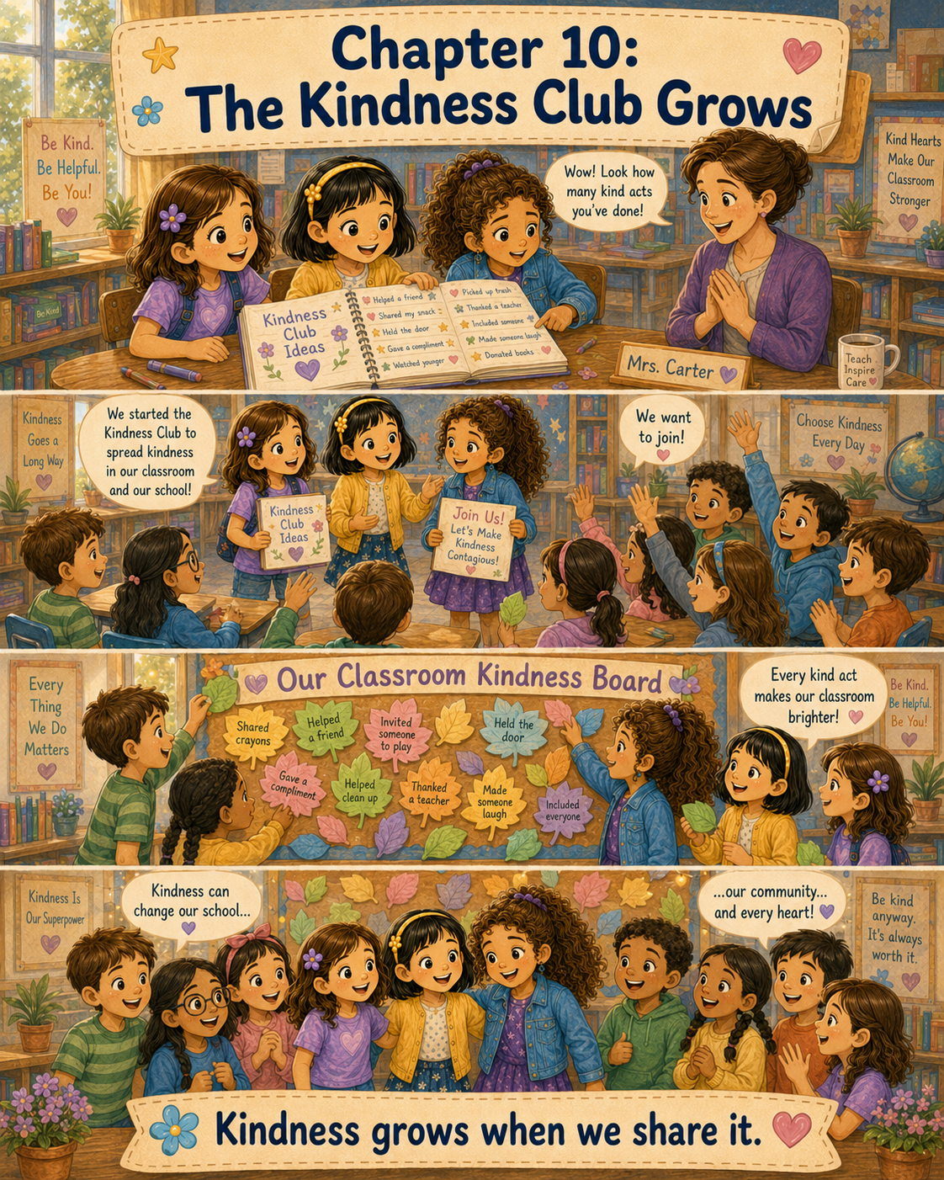

Chapter 10: The Kindness Club Grows
By the end of the first month of school, Lily’s classroom felt different from how it had been on the very first day.
The desks were the same. The bookshelves were the same. The calendar still hung beside the whiteboard, and the pencil sharpener still made the same buzzing sound in the corner. Every morning, backpacks still thumped into cubbies, chairs still scraped against the floor, and Mrs. Carter still greeted each student with a warm smile.
But something had changed.
Lily could feel it.
The classroom felt friendlier.
It felt softer.
It felt like a place where people were noticing one another.
Lily thought back to the first day of school, when her stomach had felt full of nervous butterflies. She remembered standing by the classroom door, unsure of where to go or who to talk to. She remembered seeing May and Mary for the first time. She remembered how one small invitation had helped her feel less alone.
Now, when Lily walked into the classroom, she did not feel alone at all.
“Good morning, Lily!” May called from their table.
“Come look at this,” Mary said, waving her over.
Lily hurried to her seat and placed her backpack beside her chair.
On the table was the Kindness Club notebook. It had started as a plain notebook with a blue cover, but now it looked special. May had decorated the front with flowers, stars, hearts, and a smiling turtle. Mary had added neat labels on the inside pages. Lily had written the club’s promise on the first page:
We will look for small ways to be kind.
We will help safely.
We will notice people’s feelings.
We will remember that kindness matters.
Lily loved that page.
It reminded her that the Kindness Club was not just something they talked about. It was something they tried to live each day.
May opened the notebook carefully. “Look how many pages we filled.”
Lily leaned closer.
There were pages about kind notes. Pages about helping younger students at recess. Pages about welcoming Noah, the new student. Pages about thank-you cards for lunch helpers. Pages about picking up pencils, sharing crayons, holding doors, and inviting classmates to join games.
Mary flipped to the newest page. “We only have three blank pages left.”
“Already?” Lily asked.
May nodded proudly. “We have done a lot of kindness.”
Mary smiled. “And we have learned a lot, too.”
Lily looked at the notebook and felt a warm glow in her chest. Some of the things they had done were easy. Some had fun. Some had even been hard.
She thought about Tyler laughing at the club. She thought about how embarrassed May had felt and how hurt Mary had looked. She thought about helping Tyler pick up his papers the next day.
That had not been easy kindness.
That had been brave kindness.
Just then, Mrs. Carter walked past their table. She paused when she saw the notebook.
“That looks like an important project,” she said.
“It’s our Kindness Club notebook,” May explained.
“We write down the kind things we do,” Mary added.
“And what we learn from them,” Lily said.
Mrs. Carter smiled. “May I see it?”
The girls looked at one another. Then Lily nodded and handed the notebook to their teacher.
Mrs. Carter opened it gently, as if it were a book from the library. She read the first page. Then she turned to the following pages. Her smile grew as she read.
“This is wonderful,” she said.
Lily sat a little taller.
Mrs. Carter looked at the girls. “You have been paying attention to people’s feelings. That is a very important skill.”
May smiled shyly.
Mary folded her hands on the table. “We try to notice when someone needs help.”
Mrs. Carter turned another page. “I can see that. You have helped classmates, younger students, school helpers, and even one another.”
Lily felt proud, but she also felt a little nervous. She was not used to Mrs. Carter reading their notebook.
Mrs. Carter closed it and handed it back. “Would the three of you be willing to share your Kindness Club idea with the class during the morning meeting?”
Lily’s eyes widened.
“With everyone?” May asked.
Mrs. Carter nodded. “Yes. I think your classmates would enjoy hearing about it.”
Mary looked excited, but Lily felt the butterflies return.
Speaking in front of the class was not her favorite thing.
“What would we say?” Lily asked.
“You can simply explain what the club is,” Mrs. Carter said. “Tell the class why you started it, what kinds of things you have done, and what you have learned.”
May looked at Lily. “We could show the notebook.”
Mary nodded. “And we could read the club promise.”
Lily took a deep breath. She remembered how the school year had started. She remembered not knowing anyone. She remembered how much one kind moment had helped her.
Maybe sharing the Kindness Club could help someone else, too.
“We can do it,” Lily said.
At the morning meeting, the class gathered on the carpet. Mrs. Carter stood beside the whiteboard.
“Today,” she said, “Lily, May, and Mary are going to share something they have been working on.”
A few students turned to look at them.
Lily’s heart began to beat faster.
May held the notebook in both hands. Mary stood beside her with the list of kind acts they had written. Lily stood on the other side, trying to remember to breathe slowly.
Mrs. Carter nodded encouragingly.
May began. “We started a Kindness Club after Lily came to our class.”
Lily looked at May and smiled.
Mary continued. “At first, it was just the three of us. We wanted to look for small ways to help people.”
May opened the notebook and showed the decorated first page. “This is our club promise.”
Lily read it aloud, her voice soft at first.
“We will look for small ways to be kind.
We will help safely.
We will notice people’s feelings.
We will remember that kindness matters.”
When she finished, the room was quiet.
Not the uncomfortable kind of quiet.
The listening kind.
Mary held up her list. “Some things we did were making welcome notes, helping younger students take turns, inviting Noah to play at recess, and making thank-you cards for the lunch helpers.”
Noah smiled from his spot on the carpet.
Lily noticed and felt happy.
May added, “Sometimes kindness is easy. Like drawing a picture or smiling at someone.”
Lily took another breath. “But sometimes kindness is hard, like helping someone even after they were not kind to you.”
Tyler looked down at his shoes for a moment. Then he looked back up.
Mrs. Carter smiled gently. “That is a very thoughtful lesson.”
Lily felt braver now.
“The Kindness Club helped us remember to notice people,” she said. “Sometimes someone looks quiet because they are nervous. Sometimes someone needs help but does not know how to ask. Sometimes one small kind thing can make the day better.”
For a moment, no one spoke.
Then Emma raised her hand. “Can other people join?”
May looked surprised. “You want to?”
Emma nodded. “I like making cards. I could help with that.”
Another student raised his hand. “I could help carry books when the library bins are full.”
A girl named Sophie said, “I could sit with someone who is alone at lunch.”
Noah raised his hand too. “I could help new students learn the routine, since I know what that feels like.”
Lily’s smile grew.
Mrs. Carter looked around the circle. “It sounds like many students have kindness ideas.”
Mary whispered, “The club is growing.”
May whispered back, “A lot.”
Tyler raised his hand slowly.
Lily turned to look at him.
Mrs. Carter called on him. “Yes, Tyler?”
Tyler shifted a little on the carpet. “I could help pick up papers if someone drops them.”
A few students giggled softly, but not in a mean way.
Tyler glanced at Lily. “And I guess I could help with the cards too.”
Lily smiled at him.
“That would be nice,” she said.
Mrs. Carter stood and walked to the whiteboard. “I have an idea. What if we create a classroom kindness board?”
The students began whispering excitedly.
“What is that?” someone asked.
Mrs. Carter explained, “It can be a place where anyone in our class can write down kind acts they notice or do. Not to brag, but to remind us that helpful actions matter.”
Mary’s eyes brightened. “Like our notebook, but for everyone.”
“Exactly,” Mrs. Carter said.
May clapped softly. “Can we decorate it?”
Mrs. Carter laughed. “I was hoping you would ask.”
After reading time, Mrs. Carter gave the class a large piece of bulletin board paper. At the top, she wrote:
Our Classroom Kindness Board
May drew flowers around the corners. Mary carefully made lines where students could post kindness notes. Lily drew a small turtle near the bottom with a trail of hearts behind it.
Noah colored the turtle’s shell green and brown. Emma drew a sun. Sophie added a border of tiny stars. Tyler colored some paper hearts, carefully staying inside the lines.
By lunchtime, the kindness board was hanging on the wall beside the classroom library.
Mrs. Carter handed out small slips of paper shaped like leaves.
“These will be our kindness leaves,” she said. “When you do something kind or notice someone else being kind, you may write it on a leaf and add it to the board.”
The class loved the idea.
Soon, the first leaves began to appear.
Emma wrote:
Sophie shared her crayons with me.
Noah wrote:
Mary helped me remember where to line up.
Tyler wrote:
Lily helped me pick up my papers.
When Lily saw Tyler’s leaf, she felt her cheeks grow warm, but this time it was not because she was embarrassed. It was because she felt glad.
May wrote:
The lunch helpers smiled when we gave them cards.
Mary wrote:
May made Noah feel welcome with her picture.
Lily thought for a while before writing her own leaf.
Then she carefully printed:
Kindness grows when we share it.
She placed it near the center of the board.
At recess, more students wanted to play together than usual. Some children still played tag. Some played pretend near the big tree. Some walked and talked. But Lily noticed that fewer students were alone.
When a younger child dropped a jump rope, Sophie picked it up.
When two students wanted the same ball, Noah suggested taking turns.
When Emma saw May sitting by herself for a moment, she asked if she wanted to join a drawing game.
Lily watched it all with amazement.
The Kindness Club had started so small.
Just three girls.
Just one notebook.
Just a few ideas.
Now it was spreading.
Not perfectly. Not every moment was kind. Students still argued sometimes. People still forgot to share. Feelings still hurt. But now the class had a way to remember.
They could try again.
They could notice.
They could choose kindness.
That afternoon, Mrs. Carter gave the class a few minutes to look at the kindness board before dismissal. The board already had twelve leaves on it.
“By the end of the month,” May said, “it might be full.”
“By the end of the year,” Mary said, “we might need a bigger board.”
Lily laughed. “Maybe a whole kindness wall.”
Mrs. Carter overheard and smiled. “That sounds like a wonderful problem to have.”
Before the final bell, Lily, May, and Mary stood together beneath the board.
May looked at the leaves. “Do you remember when it was just us?”
Mary nodded. “We were sitting under the tree at recess.”
“And we didn’t even know if the club would work,” Lily said.
May smiled. “It worked.”
Mary added, “It grew.”
Lily looked at her two friends. She thought about the first day of school again. She had walked into the classroom feeling nervous and unsure. She had not known then that May and Mary would become her friends. She had not known they would start a club. She did not know that one small idea could become something the whole class shared.
Her heart felt full.
At home that evening, Lily told Ann and Gary everything.
“The whole class wants to join,” Lily said as she sat at the kitchen table. “Mrs. Carter helped us make a kindness board, and everyone can add leaves to it.”
Ann smiled. “That is wonderful, Lily.”
Gary leaned back in his chair. “Sounds like the Kindness Club is becoming something bigger.”
“It is,” Lily said. “It started with May, Mary, and me. But now Noah wants to help new students. Emma wants to make cards. Sophie wants to sit with people who are alone. Even Tyler added a kindness leaf.”
Gary raised his eyebrows. “Even Tyler?”
Lily nodded proudly. “He wrote about the papers.”
Ann’s eyes softened. “That must have meant a lot.”
“It did,” Lily said.
Gary looked thoughtful. “Do you know what I think?”
“What?” Lily asked.
“I think kindness can change more than one person. It can change a classroom. Then maybe a school. Then maybe a whole community.”
Lily smiled. “That’s what it feels like.”
Ann touched the Kindness Club notebook, which Lily had placed on the table. “And how has it changed your heart?”
Lily was quiet for a moment.
She thought about being nervous. She thought about making friends. She thought about Noah’s shy smile, Tyler’s quiet thank-you, and the kindness leaves on the classroom board.
“I think,” Lily said slowly, “it helped my heart get braver.”
Ann smiled. “That is a beautiful thing.”
Before bed, Lily opened the Kindness Club notebook one more time. She turned to the last blank page.
At the top, she wrote:
The Kindness Club Grows
Then she added:
This month, we learned that kindness could begin with one small choice. A smile. A note. An invitation. A helping hand. When we share kindness, it grows. It can change a school, a community, and a heart.
Lily paused and looked at the words.
Then she drew three girls standing under a tree. One had a notebook. One had crayons. One had a list. Around them, she drew other children joining hands in a wide circle.
At the bottom of the page, she wrote:
Kindness belongs to everyone.
The next morning, Lily walked into class with her backpack over her shoulder and the notebook tucked safely inside.
May and Mary were waiting by the kindness board.
“Look!” May said.
Lily looked.
Someone had added a new leaf before school started.
It said:
Lily, May, and Mary helped our class remember to be kind.
Lily looked at May.
May looked at Mary.
Mary looked at Lily.
Together, they smiled.
The school year had begun with nervous feelings and two new friends. Now it had grown into something bigger than Lily ever imagined.
The Kindness Club was no longer just a club.
It was a reminder.
A reminder that kindness could start small.
A reminder that kindness could be brave.
A reminder that kindness could grow.
And most of all, it was a reminder that every person had the power to make the world around them a little better, one kind act at a time.

Epilogue
The kindness board in Room 12 did not stay empty for long.
Each week, more leaves, hearts, stars, and colorful notes appeared on it. Some were written by Lily, May, and Mary. Some were written by students who had joined the Kindness Club. Some were written quietly by classmates who did not say much but still noticed kind things happening around them.
One leaf said:
Noah helped me find my reading folder.
Another said:
Emma shared her crayons.
Another said:
Tyler held the door when my hands were full.
Lily loved reading the kindness board at the end of each day. It reminded her that kindness could be found in many places if people remembered to look for it.
The Kindness Club kept meeting too. Sometimes they planned projects. Sometimes they made cards. Sometimes they talked about problems and how to solve them in safe, helpful ways. Mrs. Carter helped them remember that kindness did not mean doing everything by themselves. It meant noticing, caring, and asking for help when help was needed.
May still loved drawing cheerful pictures. Her cards became brighter and more colorful with every project. Mary still loved writing thoughtful messages. Her words helped people feel seen, appreciated, and encouraged. Lily still loved helping people feel included. She looked for classmates sitting alone, new students feeling unsure, and quiet moments when someone needed a friend.
But the club no longer belonged only to Lily, May, and Mary.
It belonged to the class.
Before long, the kindness board became so full that Mrs. Carter had to add another sheet of paper beside it. Then the hallway outside Room 12 began to show signs of kindness too. Other teachers stopped to read the notes. Students from nearby classrooms asked questions. Even the principal smiled when she saw the colorful board.
“This is a wonderful reminder,” the principal said one afternoon. “Kindness helps make a school feel like a community.”
Lily smiled when she heard that word.
Community.
She remembered the day at the park when Ann and Gary helped the girls clean up litter safely. She remembered how proud she had felt when a neighbor thanked them. Back then, she had realized that kindness was not only for school.
Now she understood something even bigger.
Kindness could begin in one heart, grow between friends, spread through a classroom, and reach out into the world.
One Friday afternoon, Mrs. Carter gave each student a small paper heart.
“Today,” she said, “I want you to write one kind act you hope to do next.”
The room became quiet as pencils moved across paper.
Lily looked down at her heart. She thought about the first day of school, when her stomach had been full of butterflies. She thought about May and Mary, who had become her friends because of one small hello. She thought about Emma at the lunch table, Noah on his first day, Tyler in the hallway, and all the students who had helped the kindness board grow.
Then Lily wrote:
I will keep noticing people who need kindness.
She smiled at the words.
That was something she could do tomorrow.
And the next day.
And the day after that.
When school ended, Lily placed her paper heart on the kindness board. May placed hers beside it. Mary added hers too. Soon, the board was filled with promises for more kindness: sharing, helping, listening, including, thanking, and encouraging.
Lily stepped back and looked at all the colors.
“It’s beautiful,” May said.
“It’s more than beautiful,” Mary added. “It means people care.”
Lily nodded. “And it means kindness is still growing.”
As she walked out of Room 12, Lily felt the same brave feeling she had learned to carry with her from the beginning of the school year. She knew there would still be hard days. There would still be nervous feelings, mistakes, and moments when kindness was not easy.
But now Lily also knew the truth.
A kind choice could change a day.
A kind friend could change a heart.
And when people worked together, kindness could grow bigger than anyone expected.
Lily looked back once more at the classroom kindness board.
Then she smiled and walked forward, ready to keep spreading kindness wherever she went.

About the Author
www.scottMbooks.com

Scott Speicher brings a unique blend of life experiences to his writing. A U.S. military veteran, he carries the discipline, resilience, and perspective gained through service into every story he tells. After his military career, Scott built a successful path in marketing, where he developed a deep understanding of communication, storytelling, and audience engagement. For more than 15 years, he has also worked as a professional website designer, helping businesses and individuals create meaningful online presences.
Scott Speicher is a storyteller who enjoys creating gentle, heartfelt stories that help children notice the small moments that make life meaningful. Through warm characters and simple adventures, his books encourage young readers to slow down, care for others, and appreciate the quiet joys of everyday life. Scott believes that some of the most important lessons children learn come not from grand events, but from the ordinary moments shared with family, friends, and the animals they love.
Scott M. Speicher is the creator of ScottMBooks.com, a children’s book and educational resource website focused on helping young readers grow through meaningful stories and printable learning activities. His books encourage children to build reading confidence while learning important life lessons such as kindness, courage, responsibility, patience, friendship, compassion, and caring for others. Through stories like Lily and the Kindness Club, Scott hopes to inspire children, teachers, parents, and homeschool families to use reading to build both literacy skills and strong character.
Suitable for readers aged 4-10 and for family read-aloud sessions. Ideal for SEL, guidance, and service-learning.
