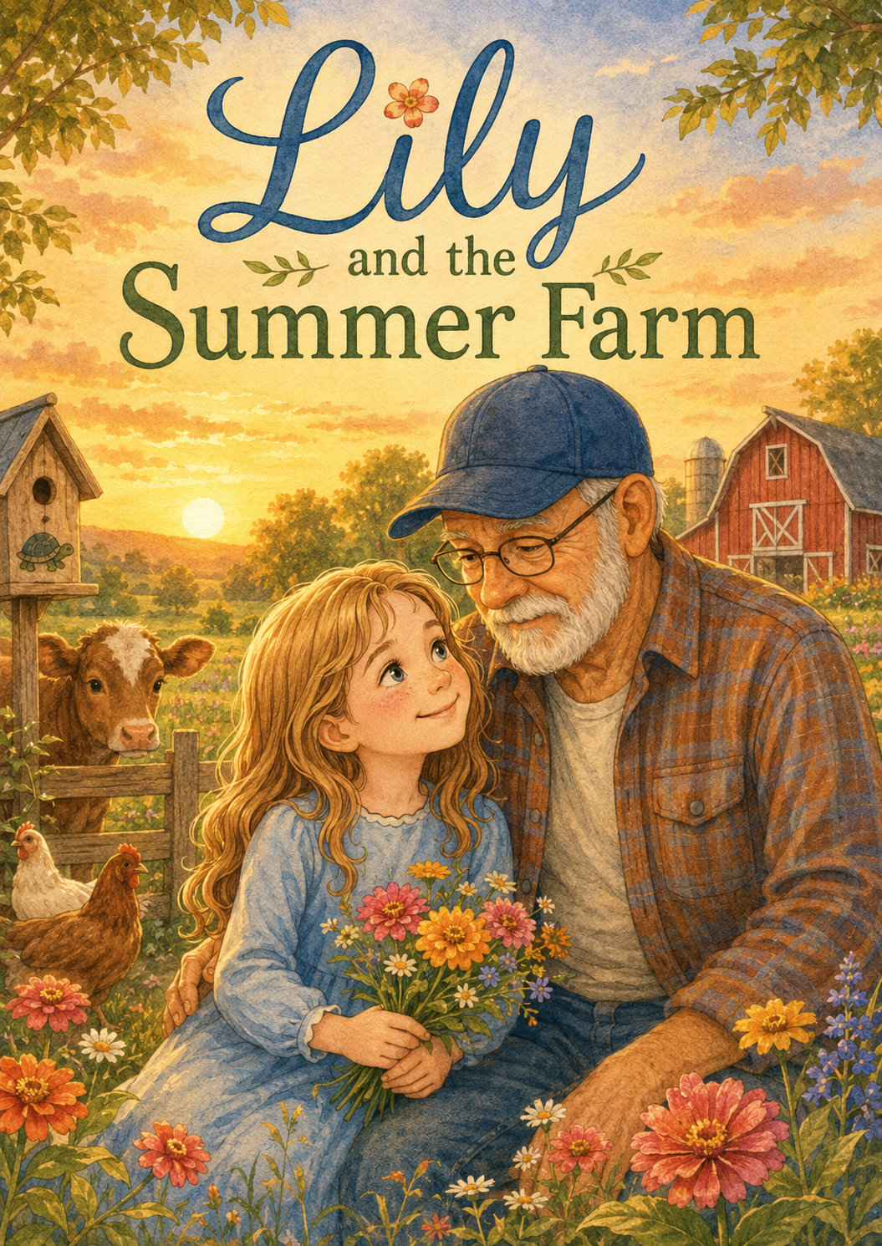
Lily and the Summer Farm
A Story of Responsibility, Courage, Compassion, and Kindness.

by
Scott Speicher

Copyright © 2026
Author: Scott M. Speicher
Portions of this book have been optimized by the program Grammarly
Edited by Grammarly and the Editorial team of Digital Scribblers
No part of this book may be reproduced or used, in any form or by any means, electronic or mechanical, without permission in writing from the author.
Some of the images are AI-generated using prompts and under the author's full control.

Preface
Lily and the Summer Farm is a story about growing—both in the garden and in the heart.
When Lily arrives at Grandpa Jim’s farm for the summer, she is not sure what to expect. The farm is peaceful and beautiful, but it is also full of reminders of Ben, whose kindness and love for small acts of care still live on in quiet ways. As Lily spends her days helping with animals, planting seeds, gathering vegetables, repairing what has been broken, and learning from Grandpa Jim, she begins to discover that the farm has many lessons to teach.
This story was written to remind young readers that responsibility does not mean being perfect. Courage does not always mean being fearless. Compassion can be as simple as staying close to someone who is scared. Kindness can look like helping a neighbor, caring for an animal, or keeping a memory alive through loving action.
Through Lily’s summer on the farm, children are invited to see how small choices can make a meaningful difference. A bucket filled with water, a seed planted in the soil, a frightened calf comforted in a storm, or a basket carried for someone in need can all become moments of growth.
At its heart, Lily and the Summer Farm is a gentle story about love, healing, patience, and the quiet ways we continue to grow after loss. It reminds us that even when someone we love is no longer beside us, the kindness they share can keep growing through the good things we choose to do.
May this book encourage children to try new things, care for others, notice small needs, and believe that every kind of act matters—one slow step at a time.

Table of Contents
Lily and the Summer Farm
Preface
An introduction to Lily’s summer at Grandpa Jim’s farm and the meaningful lessons she will discover. The preface sets the tone for a gentle story about responsibility, courage, compassion, kindness, and the quiet ways love and memories continue to grow.

Chapter 1: A Summer at Grandpa Jim’s Farm
Lily arrives at Grandpa Jim’s farm for the summer, unsure of what the days ahead will bring. The peaceful farm is filled with animals, gardens, wide-open fields, and quiet reminders of Ben. Grandpa Jim welcomes Lily warmly and tells her that the farm has a way of teaching lessons when a person is willing to listen.
Chapter 2: The First Morning Chores
Lily wakes early to help with her first farm chores. She learns to feed the chickens, fill water buckets, sweep the barn, and carefully gather eggs. At first, she worries about doing everything perfectly, but Grandpa Jim helps her understand that responsibility begins with showing up and trying her best.
Chapter 3: Clover Gets Loose
When the goat slips through a loose gate and wanders toward the edge of the pasture, Lily feels nervous. Grandpa Jim teaches her how to stay calm and guide Clover back safely without frightening her. Lily learns that courage does not always mean rushing in; sometimes it means thinking clearly and moving carefully.
Chapter 4: Seeds Beneath the Soil
Grandpa Jim gives Lily her own small row in the garden to care for throughout the summer. She plants seeds, waters them, pulls weeds, and waits patiently for signs of growth. As the first sprouts appear, Lily learns that some of the most important things grow quietly, little by little.
Chapter 5: The Calf in the Storm
During a summer thunderstorm, Lily notices Rosie, a young calf, trembling near the barn door. Even though Lily is frightened by the thunder herself, she stays nearby and speaks gently while helping Grandpa Jim guide the calf safely inside. The moment teaches her compassion and the importance of helping others feel safe.
Chapter 6: Trying Something New
Grandpa Jim invites Lily to ride along in the farm wagon as he delivers vegetables to neighbors. Lily feels unsure because she has never done anything like it before, but she decides to try. Along the way, she discovers that new experiences may feel uncomfortable at first, but they can lead to confidence and joy.
Chapter 7: The Broken Birdhouse
After a windy afternoon, Lily finds an old birdhouse broken on the ground near the fence. Grandpa Jim tells her that Ben once helped paint it, and Lily decides it should be repaired. With careful hands, she fixes the birdhouse, adds fresh straw, and learns that kindness can also mean caring for memories.
Chapter 8: Mrs. Miller’s Garden
When Grandpa Jim hears that Mrs. Miller needs help picking vegetables before the rain comes, Lily goes with him to lend a hand. She learns that helping others does not have to be grand or complicated. Sometimes kindness looks like carrying baskets, sharing time, and doing work no one asked you to do.
Chapter 9: The Farm Fair
Lily prepares a basket of vegetables, a drawing of the farm, and a handmade sign for the town farm fair. She worries that her work will not be as good as everyone else’s, but Grandpa Jim reminds her that effort matters more than prizes. At the fair, Lily feels proud because she tried something new and followed through.
Chapter 10: The Last Sunset of Summer
On her final evening at the farm, Lily sits beside Grandpa Jim as the sun sets over the fields. They talk about the animals, the garden, the lessons she learned, and the quiet ways Ben’s memory still lives on. Lily leaves the farm with a fuller heart, carrying responsibility, courage, compassion, and kindness.

Epilogue: One Slow Step at a Time
After returning home, Lily receives a letter and photographs from Grandpa Jim showing that her garden, Rosie, and the repaired birdhouse are still growing. Lily realizes that the farm’s lessons have followed her home. She learns that kindness, courage, and love can continue to grow anywhere, one slow step at a time.

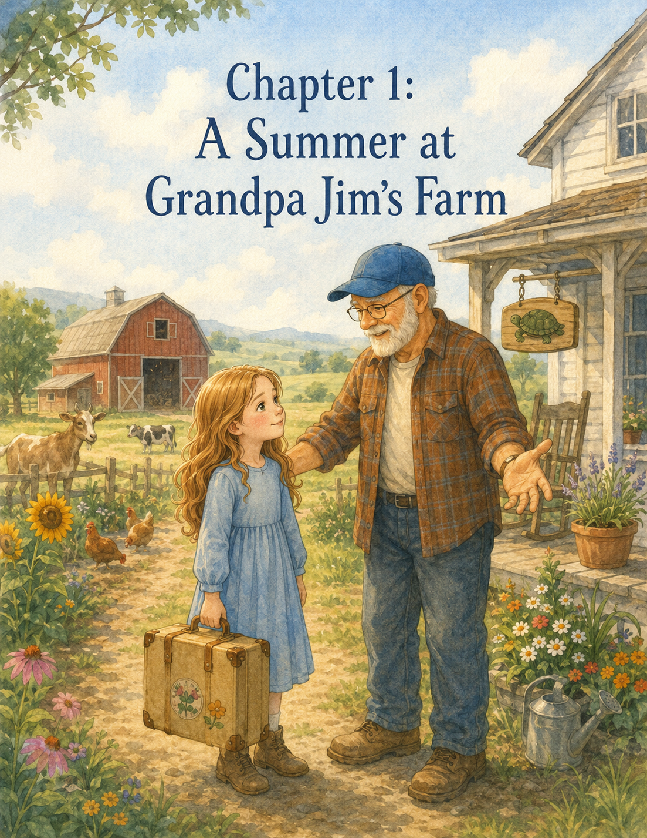

Chapter 1: A Summer at Grandpa Jim’s Farm
Lily pressed her forehead gently against the car window as the road changed from busy streets to quiet country lanes.
The houses grew farther apart. The sidewalks disappeared. Tall trees lined the road like green walls, and beyond them were fields that seemed to stretch all the way to the edge of the sky.
Lily held her backpack tightly in her lap.
Inside it were all the things she thought she might need for the summer: a notebook, colored pencils, two books, a flashlight, her favorite sweater, and a small, folded paper turtle she kept tucked inside the front pocket.
The paper turtle was a little wrinkled now. Its corners were soft from being opened and closed many times. But Lily still carried it with her whenever she went somewhere new.
It reminded her of Ben.
Ben had been her friend. He had been brave and kind and full of ideas that made ordinary days feel important. He loved turtles, stars, and logbooks, and helping whenever he could. Before he passed away, Ben had taught Lily that even small acts of kindness could matter more than anyone realized.
Now Lily was on her way to spend the summer at Grandpa Jim’s farm.
Grandpa Jim had been Ben’s grandfather, but he had become special to Lily, too. He had a gentle voice, silver-white hair, kind eyes behind his glasses, and hands that looked as if they had fixed fences, planted gardens, held turtles, and comforted children for many years.
Lily was excited to see him.
But she was also nervous.
She had never spent a whole summer on a farm before. She did not know how to feed chickens or gather eggs. She did not know what to do if a goat came too close. She had never planted vegetables in a real garden or woken up before the sun to help with chores.
Most of all, she did not know how it would feel to be in a place Ben had loved so much.
Her mother glanced at her from the front seat.
“Doing okay back there?” she asked softly.
Lily nodded, but her fingers curled around the paper turtle in her backpack pocket.
“I think so,” she said. “I just wonder what it will be like.”
Her mother smiled gently.
“Grandpa Jim said the farm is peaceful.”
Lily looked out the window at a long wooden fence running beside the road.
“Peaceful can still feel big,” she said.
Her mother reached back and gave Lily’s knee a small squeeze.
“It can,” she said. “But sometimes big places help our hearts grow a little, too.”
Lily thought about that as the car turned onto a gravel driveway.
The tires crunched over small stones. A wooden sign stood near the entrance, painted with careful green letters:
Maple Hill Farm
A painted turtle sat beneath the words.
Lily’s breath caught up for a moment.
“Ben painted that turtle,” her mother said quietly.
Lily looked closer as they passed. The turtle was small and simple, with a round green shell and tiny black eyes. One of the legs was a little crooked, but that somehow made Lily like it even more.
The driveway curved past a wide pasture where two brown horses lifted their heads from the grass. A red barn stood beyond them, its roof faded by sun and rain. Chickens wandered near a fenced yard, pecking at the ground as if they were searching for buried treasure. Rows of vegetables filled a garden beside the house, and sunflowers leaned over the fence, their yellow faces turned toward the light.
At the end of the driveway stood the farmhouse.
It was white with green shutters and a porch that wrapped around the front. A rocking chair sat near the door. Wind chimes moved softly in the breeze. Clay pots filled with flowers lined the steps.
And there, standing on the porch with one hand raised in a wave, was Grandpa Jim.
Lily opened the car door before her mother had even turned off the engine.
“Grandpa Jim!” she called.
Grandpa Jim stepped carefully down from the porch. He wore a blue plaid shirt, jeans, work boots, and a straw hat that had clearly seen many summers.
“Well, there she is,” he said warmly. “Miss Lily has come to run the farm.”
Lily laughed.
“I don’t know about running it,” she said. “I don’t even know what goats eat.”
Grandpa Jim’s eyes twinkled.
“That’s all right,” he said. “The goats will be happy to teach you. They have very strong opinions about food.”
Lily smiled, and some of the nervousness in her chest loosened.
Her mother unloaded Lily’s suitcase from the trunk. Grandpa Jim carried it easily, though Lily noticed he moved a little slower than she remembered. His steps were steady, but careful.
The farmhouse smelled like fresh bread, old wood, and lemon soap. Sunlight poured through the kitchen windows and landed in golden squares on the floor. A jar of wildflowers sat on the table. Beside it was a plate of oatmeal cookies covered with a towel.
“I made those this morning,” Grandpa Jim said. “Farm rule number one: guests should never arrive without cookies waiting.”
“I like that rule,” Lily said.
“There are many farm rules,” Grandpa Jim told her. “Some are about gates. Some are about boots. Some are about chickens who believe they own the porch.”
A loud cluck came from outside, as if one of the chickens agreed.
Lily giggled.
Grandpa Jim led her upstairs to a small bedroom at the end of the hall. The room had a white quilt on the bed, a wooden dresser, and a window that looked out toward the barn. A vase of daisies stood on the nightstand.
On the wall above the desk hung a small framed drawing.
Lily stepped closer.
It was a picture of a turtle crossing a road. The turtle had a tiny smile, and above it were the words:
Slow steps still count.
Lily knew right away that Ben had made it.
Grandpa Jim stood quietly in the doorway.
“He drew that one summer,” he said. “He was sitting right there at that desk. Said every turtle needed a good motto.”
Lily swallowed.
“It sounds like him.”
“It does,” Grandpa Jim said.
For a moment, neither of them spoke. Outside the window, a breeze moved through the trees. A horse gave a soft snort in the pasture. Somewhere below, Lily’s mother was setting dishes in the kitchen.
Lily touched the edge of the picture frame.
“I miss him,” she whispered.
Grandpa Jim came beside her and rested one hand gently on her shoulder.
“So do I,” he said. “Every day.”
Lily looked up at him. His eyes were kind, but she could see sadness there too. Not the kind of sadness that shouted. The quiet kind. The kind that stayed beside a person like a shadow.
“I was wondering if being here would make me feel sad,” Lily admitted.
Grandpa Jim nodded.
“It might, sometimes.”
Lily looked back at the turtle drawing.
“But it also feels nice,” she said. “Like he’s still part of this place.”
Grandpa Jim smiled softly.
“That’s because he is.”
After Lily unpacked, they went back downstairs for cookies and lemonade. Her mother stayed for a little while, talking with Grandpa Jim about the summer. Lily listened as they discussed chores, bedtime, rain boots, sunscreen, and whether Lily remembered to pack enough socks.
“I packed six pairs,” Lily said.
Grandpa Jim raised his eyebrows.
“Only six? On a farm, socks disappear faster than baby chicks.”
Lily looked worried until he chuckled.
“I’m teasing,” he said. “Mostly.”
When it was time for her mother to leave, Lily’s stomach tightened again.
Her mother hugged her tightly on the porch.
“You can call me every evening,” she said. “And if you need anything, Grandpa Jim and I are both here.”
Lily nodded into her mother’s shoulder.
“I’ll be okay,” she said, though her voice sounded smaller than she wanted it to.
Her mother kissed the top of her head.
“I know you will.”
Lily stood beside Grandpa Jim as the car rolled back down the gravel driveway. She waved until the painted turtle sign passed and disappeared beyond the trees.
Then everything felt very quiet.
Grandpa Jim did not rush her. He simply stood beside her on the porch, looking out over the farm.
The chickens clucked near the flower beds. A breeze moved through the tall grass. The barn door creaked softly. From somewhere in the pasture came the low, gentle sound of a cow.
“Well,” Grandpa Jim said after a while, “would you like the grand tour?”
Lily took a deep breath.
“Yes,” she said. “I think I would.”
They started with the chicken coop.
The chickens were busy and bossy, scratching at the ground and fluffing their feathers. One golden hen marched right up to Lily’s shoe and pecked at the lace.
“This is Henrietta,” Grandpa Jim said. “She believes all shoes are hiding corn.”
Lily stepped back.
“Is she going to bite me?”
“Not bite,” said Grandpa Jim. “Just inspect.”
Henrietta clucked loudly, as if giving her official opinion of Lily’s sneakers.
Next, they visited the barn. The air inside smelled like hay, dust, and animals. Sunlight slipped through cracks in the wooden walls, making bright stripes across the floor. Tools hung neatly on hooks. Bales of hay were stacked in the corner. A gray barn cat opened one green eye from a windowsill, decided Lily was not very interesting, and went back to sleep.
“That’s Marmalade,” Grandpa Jim said.
“But he’s gray,” Lily said.
“He was named by Ben when Ben was four,” Grandpa Jim explained. “At the time, all cats were Marmalade.”
Lily laughed, then smiled at the sleeping cat.
“Hello, Marmalade,” she whispered.
They walked past the stalls. Grandpa Jim introduced her to Daisy the cow, who had soft brown eyes and a pink nose. Then they visited the goats, Clover and Pickles.
Pickles tried to eat the corner of Grandpa Jim’s shirt.
“Pickles,” Grandpa Jim said firmly, “we have discussed this.”
Lily covered her mouth to hide a laugh.
Clover, the smaller goat, stepped closer and looked at Lily with curious eyes.
“She’s cute,” Lily said.
“She is,” Grandpa Jim replied. “She is also trouble wearing hooves.”
Clover bleated, sounding very proud of herself.
After the barn, they walked to the garden. It was larger than Lily expected. Rows of tomatoes, green beans, carrots, lettuce, cucumbers, and squash stretched across the soil. Bees moved lazily from flower to flower. A scarecrow wearing one of Grandpa Jim’s old hats stood in the middle, leaning slightly to one side.
“His name is Harold,” Grandpa Jim said.
“Does everything on the farm have a name?” Lily asked.
“Most things worth knowing do.”
Lily bent down to look at a tiny green tomato growing on a vine.
“It’s so small.”
“It won’t stay that way,” Grandpa Jim said. “Not if it gets what it needs.”
“What does it need?”
“Sun. Water. Good soil. Time. And someone willing to care for it even before it looks like much.”
Lily looked across the garden.
“That sounds like a lot.”
“It is,” Grandpa Jim said. “But good work often is.”
They walked beyond the garden to the pasture fence. The fields rolled away in soft green waves. In the distance, a line of trees marked the edge of the property. Birds dipped and glided in the sky. The sun had begun to lower, turning the clouds peach and gold.
Lily leaned her arms on the fence rail.
“It’s beautiful here,” she said.
Grandpa Jim leaned beside her.
“Ben used to say this was the kind of place where the sky had room to think.”
Lily smiled.
“That sounds like Ben too.”
They stood together in comfortable silence.
After a while, Grandpa Jim said, “Do you know what farms are good at teaching?”
Lily shook her head.
“How much there is to learn,” he said. “Animals teach patience. Gardens teach responsibility. Storms teach courage. Neighbors teach kindness. And quiet places teach us how to listen.”
Lily looked up at him.
“Listen to what?”
Grandpa Jim’s eyes moved over the fields, the barn, the garden, and the long road beyond the trees.
“To what matters,” he said. “The farm has a way of teaching lessons when a person is willing to listen.”
Lily thought about that.
She was not sure she knew how to listen to a farm. She knew how to listen to music, teachers, her mother, and sometimes her own worries. But listening to a farm sounded different.
Still, as the breeze moved through the grass and the chickens called from the yard, Lily wondered if maybe the farm had already begun.
That evening, they ate supper at the kitchen table. Grandpa Jim made vegetable soup, warm biscuits, and sweet corn from the garden. Lily helped set the table, carefully placing napkins beside each plate.
“First chore completed,” Grandpa Jim said.
“That counts as a chore?” Lily asked.
“Everything helpful counts.”
Lily liked that.
After supper, they washed dishes together. Grandpa Jim washed, and Lily dried. She was careful with the plates, especially the blue one with a tiny chip near the edge.
“That was Ben’s favorite plate,” Grandpa Jim said.
Lily held it gently.
“Why?”
“He said food tasted better on blue.”
Lily smiled down at it.
“Maybe he was right.”
When the dishes were finished, Grandpa Jim brought out a small notebook with a green cover.
“I thought you might like this,” he said.
Lily took it carefully. On the front, Grandpa Jim had written her name in neat letters:
Lily’s Summer Farm Journal
Inside, the pages were blank.
“For writing?” Lily asked.
“For anything,” Grandpa Jim said. “Things you learn. Questions you have. Animals you meet. Seeds you plant. Kindness you notice. Courage you find.”
Lily ran her fingers over the cover.
“I don’t know if I’ll have enough to write.”
Grandpa Jim chuckled.
“On a farm, the day usually gives you more than you expect.”
Before bed, Lily sat at the little desk in her room. The turtle drawing watched over her from the wall. Outside the window, the barn was dark except for one soft yellow light near the door. Fireflies blinked above the grass like tiny stars.
Lily opened her new journal to the first page.
For a while, she did not write anything.
Then she picked up her pencil.
Day One at Grandpa Jim’s Farm
She paused, thinking.
Then she added:
The farm is big, but not scary big. Quiet big. Ben is everywhere here, but not in a sad way. Maybe in a remembering way. Grandpa Jim says the farm teaches lessons if you listen. I don’t know what it will teach me yet.
Lily looked at the paper turtle she had placed beside the journal.
Then she wrote one more sentence.
I think I am ready to listen.
She closed the journal and climbed into bed.
The quilt was cool and soft. The room smelled faintly of daisies and clean sheets. Crickets chirped outside. Somewhere in the distance, an owl called once.
Lily looked at Ben’s turtle drawing above the desk.
Slow steps still count.
She whispered the words quietly to herself.
Then she turned onto her side and closed her eyes.
Tomorrow would bring morning chores, animals to meet, and things she had never tried before.
She was still a little nervous.
But now, beneath the nervousness, there was something else too.
A small feeling.
A beginning feeling.
Hope.

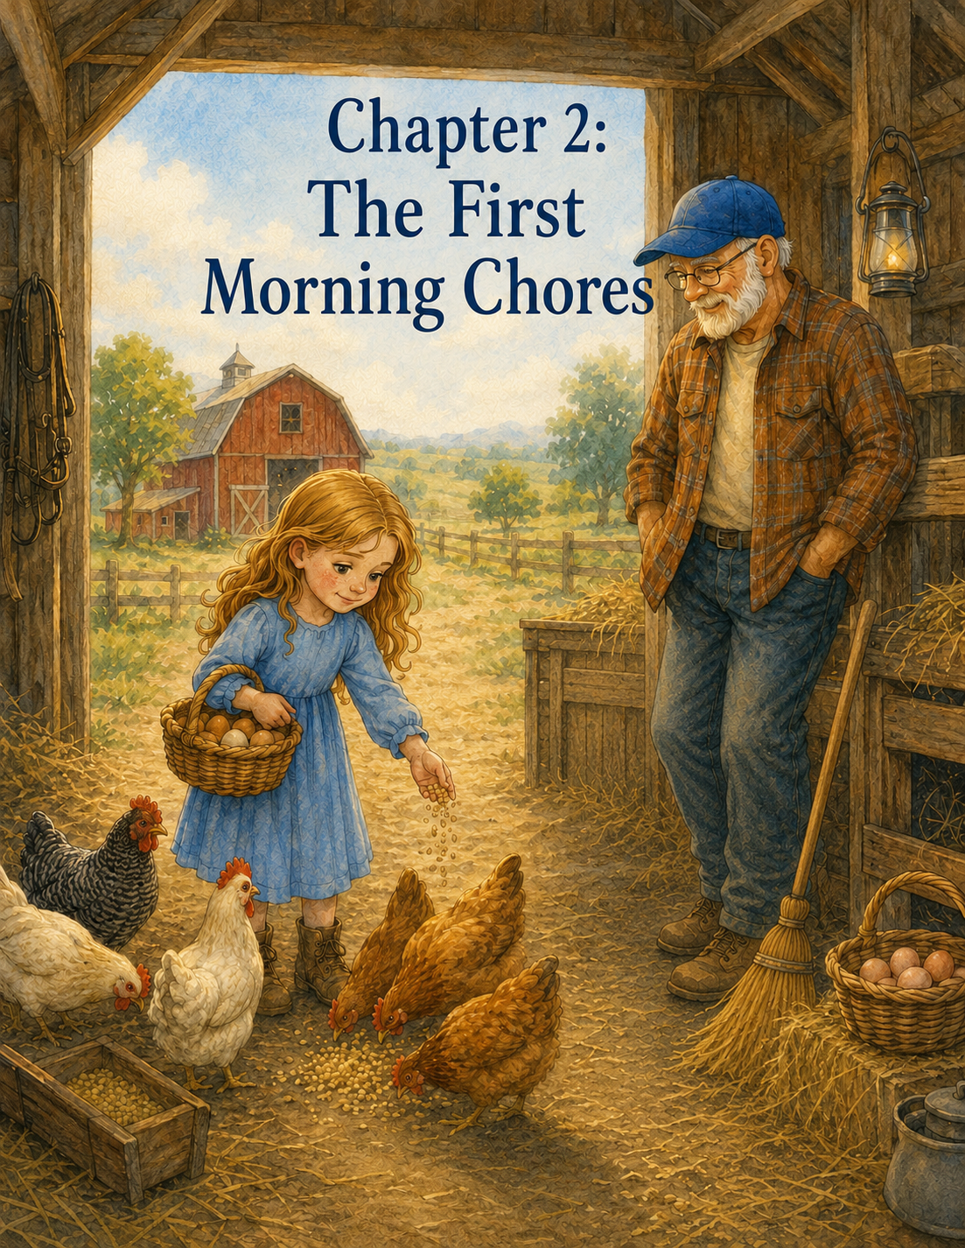

Chapter 2: The First Morning Chores
Lily woke up to a sound she did not recognize.
It was not her alarm clock.
It was not her mother calling from downstairs.
It was not a car passing outside her bedroom window or the hum of the refrigerator in the kitchen.
It was loud.
It was proud.
And it sounded very close.
“Cock-a-doodle-doo!”
Lily’s eyes popped open.
For a moment, she forgot where she was. The ceiling above her was white and slanted. A soft quilt was tucked around her. Morning light peeked through the curtains, turning the room pale gold.
Then she saw the framed turtle drawing above the desk.
Slow steps still count.
She remembered.
Grandpa Jim’s farm.
Lily sat up, rubbing her eyes.
The rooster called again from somewhere outside.
“Cock-a-doodle-doo!”
Lily frowned sleepily.
“That rooster does not have a snooze button,” she whispered.
She pushed back the quilt and climbed out of bed. The wooden floor felt cool beneath her feet. Outside the window, the sky was still soft and early, painted in streaks of pink and yellow. Mist hovered low over the pasture. The barn stood in the distance, quiet and red, with one yellow light glowing near the door.
For a moment, Lily just watched.
Everything looked different in the morning.
The farm did not feel as big as it had yesterday. It felt awake. The trees rustled gently. Birds hopped along the fence posts. A horse moved slowly through the pasture, its tail swishing in the cool air. Somewhere below, Lily could hear the soft clink of dishes and the low whistle of a kettle.
Then she heard Grandpa Jim’s voice from downstairs.
“Morning, Lily. The farm’s already waiting.”
Lily hurried to get dressed. She pulled on jeans, a soft blue T-shirt, and the old sneakers her mother said were good for getting dirty. Then she tied her hair back, grabbed her green Summer Farm Journal, and tucked the little paper turtle into her pocket.
When she reached the kitchen, Grandpa Jim was standing by the stove, flipping pancakes.
He wore a plaid shirt, work pants, and the same straw hat from yesterday, though it looked funny indoors. His glasses sat low on his nose, and his white beard caught the warm kitchen light.
“Good morning,” he said. “How did you sleep?”
“Good,” Lily said. Then she glanced toward the open window. “Until the rooster yelled at me.”
Grandpa Jim chuckled.
“That would be Walter.”
“Walter is very loud.”
“He considers that his gift to the world.”
Lily smiled and sat at the table. A glass of orange juice waited beside a small plate of sliced strawberries. The kitchen smelled like pancakes, coffee, and something warm and buttery.
Grandpa Jim set a plate in front of her.
“Farm rule number two,” he said. “Morning chores are easier with pancakes in your belly.”
“What was rule number one?” Lily asked.
“Guests should never arrive without cookies waiting.”
“Oh, right.” Lily took a bite of pancake. “I like the farm rules so far.”
“They get harder after breakfast,” Grandpa Jim said with a wink.
Lily paused with her fork halfway to her mouth.
“How hard?”
“Not too hard,” he said. “But chores are chores. Animals need care whether we feel sleepy or not.”
Lily looked down at her plate.
She wanted to be helpful. She really did. But she also did not want to mess anything up.
“What if I do something wrong?” she asked.
Grandpa Jim sat across from her and folded his hands around his coffee mug.
“Then we fix it,” he said simply.
“What if I drop the eggs?”
“Then we clean them up.”
“What if I feed the chickens too much?”
“Then they’ll think you’re the best person who ever lived.”
Lily giggled.
Grandpa Jim smiled, but his voice stayed gentle.
“Lily, responsibility does not mean doing everything perfectly the first time. It means showing up, paying attention, and trying your best.”
Lily thought about that.
Showing up sounded like a good way.
Trying her best sounded possible, too.
Perfect still sounded hard.
After breakfast, Grandpa Jim handed Lily a pair of small work gloves.
“They were Ben’s,” he said quietly. “He wore them when he helped me in the garden. I kept them in the mudroom.”
Lily held them carefully. The gloves were faded brown with green trim, soft from use. One finger had a small patch sewn over it.
“Are you sure?” she asked.
“I think he’d like knowing they were helping someone else learn.”
Lily slipped them on. They were a little big, but not too much.
“I’ll take good care of them,” she said.
Grandpa Jim nodded.
“I know you will.”
They stepped out onto the porch together.
The morning air was cool and fresh. Dew sparkled on the grass. The wind chimes near the door moved gently, making a soft, silvery sound. The rooster strutted across the yard as if he owned every blade of grass.
“That’s Walter?” Lily asked.
“That’s Walter.”
Walter was red and gold, with shiny feathers and a very serious walk.
He stopped, looked directly at Lily, and crowed again.
“Cock-a-doodle-doo!”
Lily covered her ears.
“Good morning to you, too,” she said.
Grandpa Jim laughed.
Their first stop was the chicken coop.
The coop was painted white with a small ramp leading down into a fenced yard. Chickens scratched in the dirt, bobbing their heads and clucking to one another. Some were brown, some were white, and one black hen had shiny green feathers that shimmered in the sun.
Grandpa Jim handed Lily a small metal scoop and pointed to a covered bin.
“Feed goes in the trough,” he said. “One scoop spread along the line. Not all in one pile, or the bossy hens will take more than their share.”
“Chickens can be bossy?” Lily asked.
“Very.”
As if to prove it, Henrietta marched over and clucked loudly at Lily’s shoes.
Lily recognized her from yesterday.
“Hello, Henrietta,” she said. “I remember you. Please don’t inspect my shoelaces today.”
Henrietta pecked once near Lily’s toe.
Grandpa Jim lifted an eyebrow.
“She makes no promises.”
Lily carefully opened the feed bin. The dry grain smelled earthy and sweet. She dipped the scoop inside, but it came out piled too high.
“Is this too much?” she asked.
“A little,” Grandpa Jim said. “Shake some back.”
Lily shook the scoop gently, but too much spilled back into the bin.
“Oh no,” she said. “Now it’s too little.”
Grandpa Jim leaned on the fence, smiling.
“Try again.”
Lily scooped once more. This time, she filled it almost to the top without spilling. She walked slowly to the trough and tipped the feed in a careful line.
The chickens rushed over.
Feathers fluttered. Feet scratched. Beaks pecked quickly at the grain.
“They really like breakfast,” Lily said.
“Most creatures do,” Grandpa Jim replied.
Lily watched as the chickens ate. Something about feeding them felt good. Simple, but important. They had needed food, and she had helped give it to them.
“What’s next?” she asked.
“Water buckets.”
Behind the coop was a row of metal buckets. Some were nearly empty. Others had bits of straw floating in them.
Lily wrinkled her nose.
“They drink from these?”
“They do,” Grandpa Jim said. “And they prefer fresh water, same as we do.”
He showed Lily how to carry the buckets to the pump near the barn. The first bucket was heavier than she expected, even without much water in it. It bumped against her leg as she walked, leaving a damp spot on her jeans.
At the pump, Grandpa Jim lifted the handle.
It creaked loudly.
“Want to try?” he asked.
Lily grabbed the handle with both hands and pushed it down. It barely moved.
She pushed harder.
The handle groaned, and a thin stream of water sputtered out.
Grandpa Jim waited patiently.
Lily pumped again and again. Finally, water rushed into the bucket with a bright splashing sound.
“I did it!” she said.
“You did.”
The bucket filled quickly.
Grandpa Jim showed her where to stop so it would not be too heavy to carry.
“Farm lesson,” he said. “Full is not always best.”
Lily tested the handle of the bucket. It pulled her arm downward.
“I see what you mean.”
She carried the bucket back with both hands, walking slowly. Water sloshed over the side and splashed on her shoe.
“Oh!” she cried.
“Wet shoes are part of farming,” Grandpa Jim said.
“Are dry shoes ever part of farming?”
“Occasionally. Usually after laundry.”
Lily laughed, even though her sock felt cold.
They filled three more buckets. Each one felt a little easier because Lily learned how much water she could carry without spilling. She learned to walk steadily instead of quickly. She learned to use both hands and keep her eyes on the path.
By the last bucket, she was only spilling a few drops.
Grandpa Jim noticed.
“You’re already learning,” he said.
Lily felt a warm glow inside her chest.
Next came the barn.
The barn looked different in the morning, too. Golden light streamed through the cracks between the boards. Dust floated in the air like tiny pieces of sunshine. Daisy the cow stood in her stall, chewing slowly, her big brown eyes watching Lily with calm interest.
Marmalade, the gray cat, stretched on a bale of hay.
“Good morning, Marmalade,” Lily said.
The cat blinked once.
“That is his version of a parade,” Grandpa Jim said.
Lily smiled.
Grandpa Jim handed her a broom almost as tall as she was.
“Think you can sweep the center aisle?”
Lily looked down at the barn floor. Bits of hay, straw, dust, and dirt were scattered everywhere.
“All of it?” she asked.
“All of that section,” he said, pointing. “Start small. Work your way forward. Don’t try to sweep the whole barn with one push.”
Lily held the broom firmly.
She began with a big sweep.
Too big.
Dust puffed into the air. Straw scattered sideways. A piece of hay landed on her shoulder.
She coughed.
Grandpa Jim covered a smile.
“Smaller strokes,” he said. “Let the broom do the work.”
Lily tried again. Shorter push. Then another. Then another.
The straw moved into a little pile.
“That’s better,” Grandpa Jim said.
Lily swept carefully. At first, the broom felt awkward. It scraped the floor, bumped against her shoe, and seemed determined to miss every piece of straw. But slowly she found a rhythm.
Push.
Sweep.
Gather.
Push.
Sweep.
Gather.
Daisy watched her the whole time, chewing as if offering silent advice.
When Lily finished the first section, she stepped back.
The aisle looked cleaner.
Not perfect.
But cleaner.
“I missed some pieces,” she said.
Grandpa Jim looked down.
“So you did.”
Lily’s shoulders sank.
“But you also swept most of it,” he said. “Responsibility is not quitting because a few pieces are left. It’s noticing them and finishing the job.”
Lily picked up the broom again.
This time, she swept the corners.
When she was done, Grandpa Jim handed her a dustpan. Together, they carried the pile outside and added it to a compost area near the garden.
“Even barn sweepings have a place,” Grandpa Jim said.
Lily wiped her forehead with her sleeve.
Farm chores were harder than they looked.
And breakfast felt like a long time ago.
“What chore is next?” she asked.
Grandpa Jim checked the sun.
“Egg gathering.”
Lily stood a little taller.
She had been waiting for this one.
They returned to the chicken coop. Inside, the nesting boxes lined one wall, filled with straw. The air was warm and smelled like feathers and hay. Several hens clucked from the yard outside. One white hen sat in a nesting box, looking deeply offended by the visitors.
“That’s Pearl,” Grandpa Jim whispered. “She takes her work seriously.”
Lily whispered back, “Do we ask her to move?”
“We wait.”
So they waited.
Pearl blinked.
Lily blinked back.
Pearl clucked.
Lily did not know if she should cluck too, so she stayed quiet.
Finally, Pearl stood, stepped out of the box, and walked away with great dignity.
Grandpa Jim gave Lily a small basket lined with a towel.
“Two hands,” he said. “Eggs are strong in some ways and fragile in others.”
Lily nodded solemnly.
She reached into the first nesting box.
There was an egg, warm from the straw.
Lily lifted it carefully and placed it into the basket as if it were made of glass.
“I got one,” she whispered.
“First farm egg of the summer,” Grandpa Jim said.
Lily smiled.
She checked the next box. Two brown eggs rested together in the straw. She picked up one, then the other, moving slowly.
By the fourth box, she was beginning to feel confident.
Maybe too confident.
She reached into a box without looking carefully and touched something soft and feathery.
A hen squawked.
Lily squealed and jumped back.
Grandpa Jim chuckled.
“That would be Beatrice.”
A brown hen stared at Lily from the box, her feathers puffed up.
“I’m sorry, Beatrice,” Lily said quickly. “I didn’t know you were in there.”
Beatrice clucked in a way that sounded like she would consider forgiving Lily later.
Grandpa Jim leaned closer.
“Good rule for nesting boxes,” he said. “Look before you reach.”
Lily nodded.
“Very good rule.”
They gathered eight eggs altogether. Lily carried the basket in both hands, walking more slowly than she had ever walked before.
Each step felt important.
Gravel crunched under her shoes. The eggs rested together in the towel. She could feel their weight, small but real.
At the porch steps, Walter strutted across her path.
“Excuse me,” Lily said. “Important delivery.”
Walter stopped and looked at the basket.
“No,” Lily told him. “These are not for you.”
Walter crowed loudly.
Lily nearly jumped, but she held the basket steady.
Grandpa Jim clapped softly.
“Well done.”
“I almost dropped them,” Lily said.
“Almost is not the same as did.”
Inside the kitchen, Lily placed the basket gently on the counter. Grandpa Jim took out each egg and set them into a carton.
“One cracked,” Lily said, noticing a tiny line along the shell.
Grandpa Jim picked it up and examined it.
“Just a hairline crack. We’ll use that one for lunch.”
“I’m sorry.”
“No need,” he said. “Eggs crack. Buckets spill. Brooms miss corners. Chickens complain. That’s a morning on the farm.”
Lily looked at him.
“But I wanted to do everything right.”
Grandpa Jim closed the carton and leaned against the counter.
“I know,” he said. “But doing everything right is not the same as doing something responsibly.”
Lily thought about the feed scoop, the sloshing buckets, the dusty barn, Beatrice in the nesting box, and the cracked egg.
“I made a lot of mistakes,” she said.
“You learned a lot of things,” Grandpa Jim said.
Lily was quiet.
That sounded better.
Grandpa Jim took two glasses from the cabinet and poured lemonade into each one.
“Come sit for a minute,” he said.
They carried their drinks to the porch. The late morning sun was warm now. The mist had lifted from the pasture. Chickens scratched under the bushes. Daisy mooed from the barn. Somewhere, Clover the goat bleated as if she had an important announcement.
Lily sat in the rocking chair, holding her glass with both hands.
Her arms felt tired.
Her shoes were wet.
There was a piece of hay stuck to her sleeve.
But she felt proud.
Grandpa Jim sat beside her.
“You showed up this morning,” he said. “That matters.”
“I was scared I’d do everything wrong.”
“And yet the chickens ate, the buckets were filled, the barn got swept, and the eggs made it to the kitchen.”
“One egg cracked.”
“One egg will become lunch.”
Lily smiled.
Grandpa Jim looked out across the yard.
“Responsibility begins long before a person feels ready,” he said. “Most of the time, you start by showing up. Then you listen. Then you try. Then you learn what to do better next time.”
Lily looked down at Ben’s old gloves on her hands.
The fingers were dusty now. A little wet too.
“Did Ben ever mess up chores?” she asked.
Grandpa Jim laughed softly.
“Oh, yes.”
Lily looked surprised.
“He did?”
“Once he gave the goats too much feed, and Pickles followed him around for the rest of the day like Ben was a walking restaurant.”
Lily giggled.
“Another time,” Grandpa Jim continued, “he tried to carry too many eggs at once. Lost three right there by the porch.”
“What did he do?”
“Felt terrible at first. Then he wrote in his logbook: ‘Farm lesson: hands can only hold what they can hold.’”
Lily looked toward the porch steps, imagining Ben standing there with broken eggs at his feet. She could almost hear him turning it into a lesson, the way he always did.
“I wish he were here,” she said softly.
Grandpa Jim nodded.
“So do I.”
The two of them sat quietly for a moment.
Then Grandpa Jim said, “But I think he’d be glad you wore those gloves today.”
Lily looked at the gloves again.
“I think so too.”
After their lemonade break, Grandpa Jim showed Lily how to rinse the feed scoop and hang the broom back on its hook. He told her every tool had a place because tomorrow morning, they would need to find it again.
“Chores are not finished until tools are put away,” he said.
“Another farm rule?” Lily asked.
“One of the important ones.”
Lily hung the broom carefully.
Before lunch, she went upstairs to wash her hands. When she looked in the mirror, she saw a smudge of dust on her cheek and a tiny piece of straw in her hair.
She did not look like she had slept late on summer vacation.
She looked like someone who had done work.
Real work.
After she cleaned up, she sat at the little desk by the window and opened her Summer Farm Journal.
The turtle drawing above the desk seemed to smile down at her.
Lily picked up her pencil and wrote:
Day Two: First Morning Chores
Then she paused, thinking about everything that had happened.
She wrote:
Walter the rooster is louder than any alarm clock. Chickens are bossy, especially Henrietta. Water buckets are heavier than they look. Sweeping is harder if you try to do too much at once. Always look before reaching into a nesting box because Beatrice may be inside.
Lily smiled and kept writing.
I wanted to do everything perfectly, but Grandpa Jim says responsibility begins with showing up and trying your best. I fed the chickens, filled water buckets, swept the barn, and gathered eggs. One egg was cracked, but Grandpa Jim said it would become lunch. Maybe mistakes can still be useful.
She tapped the pencil against her chin.
Then she added one more line:
Today I learned that responsibility is not about being perfect. It is about caring enough to try again tomorrow.
Downstairs, Grandpa Jim called, “Lily, lunch is ready.”
“What are we having?” she called back.
“Scrambled eggs.”
Lily laughed.
She closed her journal and slipped Ben’s paper turtle beside it.
Then she ran downstairs, tired and hungry and a little more confident than she had been when the rooster woke her that morning.
Outside, the farm kept moving.
The chickens kept scratching.
The goats kept bleating.
The garden kept growing.
And Lily, without even noticing it at first, had begun growing too.

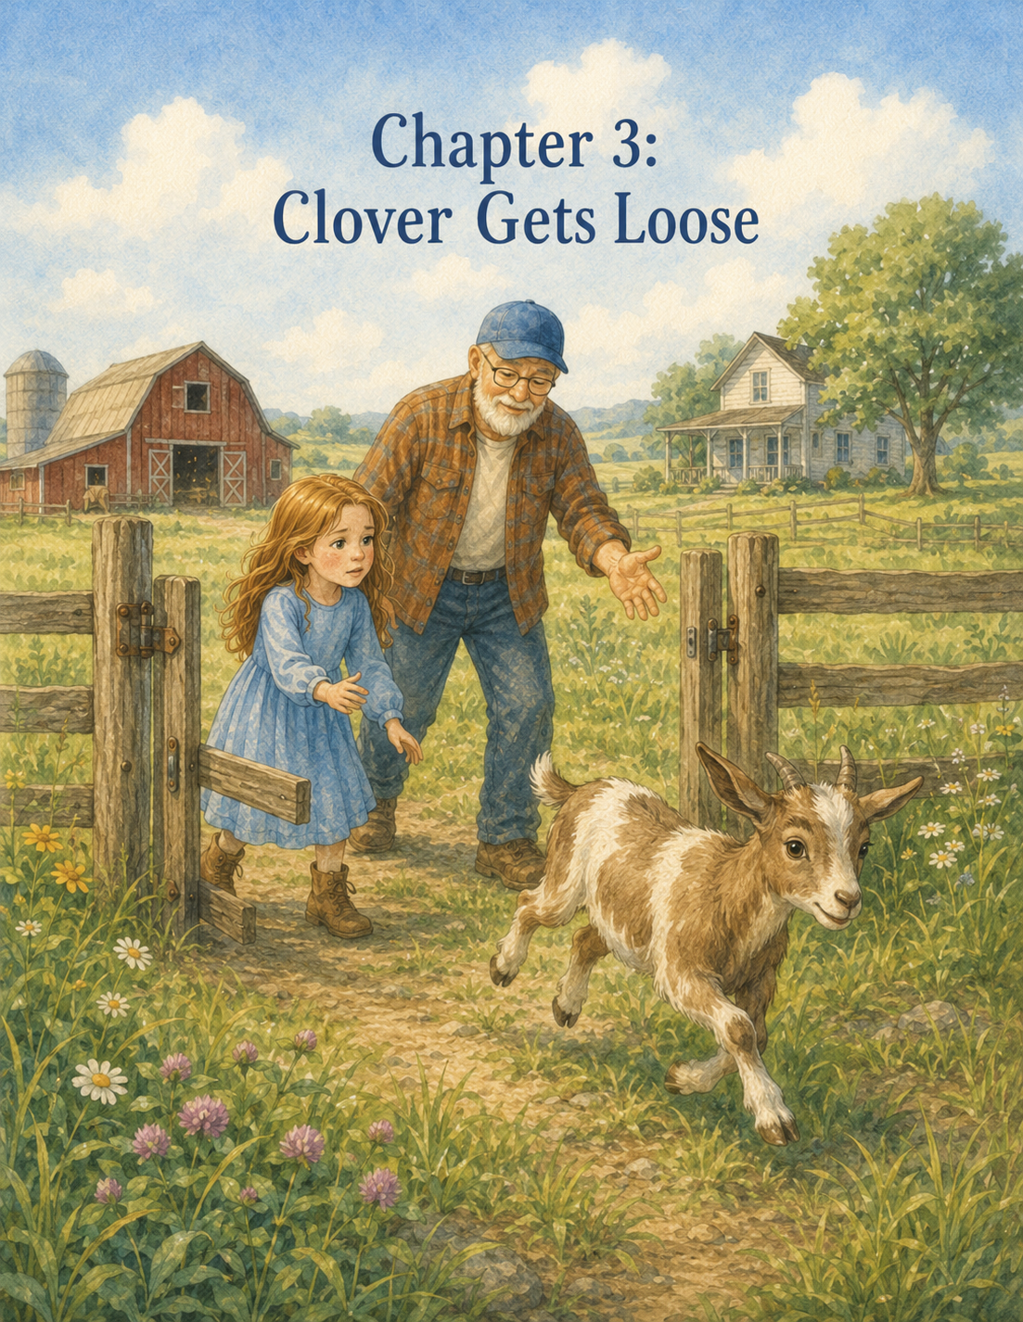

Chapter 3: Clover Gets Loose
Lily was beginning to learn that morning on Grandpa Jim’s farm did not stay quiet for very long.
They started quietly.
The sun rose slowly over the fields, turning the sky soft pink and gold. Mist floated above the pasture like a thin blanket. Birds called from the fence posts. The garden leaves sparkled with dew, and the barn stood warm and still in the early light.
But then Walter the rooster crowed.
The chickens clucked.
Daisy the cow mooed.
Pickles the goat bleated as if he had very important news.
And somewhere in the middle of all that noise, Grandpa Jim would call from the kitchen, “Morning, Lily. The farm is waiting.”
On her third morning at Maple Hill Farm, Lily woke before Walter had finished his second crow.
She smiled sleepily from beneath the quilt.
“I’m awake, Walter,” she whispered. “You don’t have to shout.”
Walter shouted anyway.
After breakfast, Lily slipped on Ben’s old work gloves. They were still a little big, but now they felt more familiar. The fingertips were soft from use, and the patched finger reminded her that the gloves had already helped with many jobs before they belonged to her for the summer.
Grandpa Jim noticed her looking at them.
“Ready for another morning of responsibility?” he asked.
Lily nodded.
“I think so.”
“That is a fine answer,” Grandpa Jim said. “Most farm mornings only require a person to think they are ready. The rest they learn as they go.”
They stepped out into the yard. The grass was damp beneath Lily’s sneakers, and the air smelled like hay, clover, and sunshine waiting to happen.
By now, Lily knew the first few steps of the morning routine. First came the chickens. One scoop of feed spread carefully along the trough. Not too much. Not too little. Not all in one place, or Henrietta would try to become queen of breakfast.
“Good morning, Henrietta,” Lily said as the golden hen hurried toward her shoes.
Henrietta clucked.
“No shoelaces,” Lily reminded her.
Henrietta pecked at the ground instead, which Lily decided was progress.
Next came the water buckets. Lily filled them at the pump, careful not to make them too heavy. She still spilled a little, but not nearly as much as the day before.
Grandpa Jim nodded approvingly.
“You are learning the art of the half-full bucket.”
“It is still heavy,” Lily said.
“Most useful things are.”
After the buckets were filled and the chickens were happy, they walked toward the barn. Daisy the cow was waiting in her stall, chewing as slowly as if she had all the time in the world. Marmalade the gray cat stretched across a sunny patch of hay, looking like he had invented naps.
Lily was just about to reach for the broom when she heard a sound from outside.
Bleeeat!
It was loud.
It was excited.
It was not coming from the goat pen.
Grandpa Jim stopped.
Lily stopped too.
They looked at each other.
“Was that Clover?” Lily asked.
Grandpa Jim tilted his head, listening.
Bleeeat!
This time, the sound came from farther away.
Grandpa Jim set down the feed pail he had been holding.
“That,” he said calmly, “was definitely Clover.”
Lily’s stomach tightened.
Clover was the smaller of Grandpa Jim’s two goats. She was white with tan patches, bright eyes, and a talent for looking innocent after doing something she should not have done. Pickles, the other goat, was noisy and greedy, but Clover was clever.
Grandpa Jim had already warned Lily that clever goats required careful gates.
They hurried outside.
At first, Lily did not see Clover. Pickles stood inside the goat pen, chewing near the fence. He looked perfectly content. The gate, however, was not perfectly closed. It hung open just a few inches.
“Uh-oh,” Lily said.
Grandpa Jim walked over and looked at the latch.
“Loose gate,” he said. “The hook didn’t drop all the way.”
“Did I do that?” Lily asked quickly.
Grandpa Jim shook his head.
“No. This gate has been sticking all week. I should have fixed it yesterday.”
Lily looked across the yard.
“Where did Clover go?”
As if answering, Clover popped her head up from behind a patch of tall grass near the pasture fence.
She had a mouth full of weeds.
For one second, she looked at Lily and Grandpa Jim.
Then she turned and trotted away.
“Clover!” Lily called.
Clover’s little tail flicked.
She did not come back.
Instead, she wandered toward the far edge of the pasture.
Beyond the pasture fence was a narrow dirt lane, and beyond that were trees, a shallow ditch, and the road leading away from the farm.
Lily’s heart began to beat faster.
“She’s going too far,” she said.
Grandpa Jim did not run. He did not shout. He did not wave his arms.
He simply picked up a small tin of grain from a shelf near the barn door and closed the goat gate behind Pickles.
“Come along,” he said.
Lily followed him through the pasture gate.
The grass brushed against her knees. Clover stood several yards away, happily nibbling at something beside the fence line.
“Should we run and grab her?” Lily asked.
Grandpa Jim shook his head.
“That would frighten her.”
“But what if she gets away?”
“Then running at her will help her get away faster.”
Lily swallowed.
She wanted to do something right away. Her feet felt jumpy. Her hands clenched inside the gloves. Clover looked small out there near the edge of the pasture, and the road felt much too close.
Grandpa Jim crouched slightly and held the grain tin low.
“Clover,” he called gently. “Come on, girl.”
The tin rattled softly.
Clover lifted her head.
Her ears perked.
For a moment, Lily thought she would come right back.
But then a butterfly fluttered past Clover’s nose.
Clover turned and followed it.
“Oh no,” Lily whispered.
Grandpa Jim stood still.
“Goats are curious,” he said. “Curiosity can make them forget what matters.”
“What do we do?”
“We help her remember without scaring her.”
Lily looked from Grandpa Jim to Clover.
“How?”
“We guide, not chase.”
Grandpa Jim pointed toward the fence. “I’ll stand here with the grain. You walk slowly around that way, toward the apple tree. Not too close. Just enough so she sees you and turns back toward me.”
Lily looked at the distance between herself and the apple tree.
It was not very far.
It only felt very far.
“What if I do it wrong?” she asked.
Grandpa Jim looked at her kindly.
“Then we adjust.”
“What if she runs?”
“Then we stay calm and try again.”
Lily took a breath.
Her chest felt tight, the way it had when she first arrived at the farm. But Grandpa Jim’s voice was steady. His calmness made the pasture seem a little less frightening.
“Remember,” he said, “slow steps.”
Lily looked down at her gloves.
Slow steps still count.
She nodded.
Then she began to walk.
The grass was wet against her sneakers. A grasshopper sprang out of her path, and Lily nearly jumped, but she kept going. She did not look directly at Clover for too long because Grandpa Jim had told her animals sometimes felt safer when people did not stare.
Clover chewed happily near the fence.
Lily moved slowly to the side, making a wide half-circle.
For a moment, Clover did not notice.
Then she lifted her head.
Her ears twitched.
Lily stopped.
Clover stared at her.
Lily stared at the ground near Clover’s hooves instead of her face.
“Hi, Clover,” Lily said softly. “You are not in trouble. But you are definitely in the wrong place.”
Clover took one step away from Lily.
Lily froze.
Her heart thumped.
Grandpa Jim’s voice came gently from across the grass.
“That’s all right. Hold there.”
Lily held still.
Clover looked toward Grandpa Jim.
He rattled the grain tin again.
“Come on, girl.”
Clover took one step toward the sound.
Then another.
Lily felt a tiny spark of hope.
But just then, Pickles bleated from the goat pen.
Clover turned her head.
Pickles bleated again, louder this time.
Clover trotted sideways, not toward Grandpa Jim, but along the fence.
Toward the far corner.
Toward a gap where the old rail sagged.
Lily saw it before Grandpa Jim said anything.
“There’s a space!” she cried.
Grandpa Jim’s eyes moved quickly to the fence.
“Lily,” he said, still calm but firmer now, “walk toward the corner. Not fast. Just steady. We need to turn her before she reaches that gap.”
Lily wanted to run.
Everything inside her said, Hurry!
But she remembered Grandpa Jim’s warning.
Running at Clover would scare her.
Shouting would scare her.
Trying to grab her would scare her.
Courage, Lily was beginning to learn, did not always feel loud. Sometimes it felt like keeping your feet slow when your heart wanted to race.
She walked toward the corner.
Steady.
Careful.
One step.
Then another.
Clover looked at the gap.
Lily’s mouth went dry.
“Clover,” Lily said softly, though her voice trembled. “Please don’t.”
Clover stepped closer to the sagging rail.
Lily moved a little to the side, just as Grandpa Jim had shown her, making herself part of a gentle wall.
Clover turned her head.
She saw Lily on one side.
She saw the fence behind her.
Then she saw Grandpa Jim ahead, holding the grain tin.
Grandpa Jim rattled it softly.
“There you go,” he said. “This way.”
Clover hesitated.
For one long second, nobody moved.
Not Lily.
Not Grandpa Jim.
Not Clover.
Even Pickles seemed to stop chewing.
Then Clover turned away from the broken fence and began walking toward Grandpa Jim.
Lily let out a breath she did not know she had been holding.
“Good girl,” Grandpa Jim said.
Clover walked three more steps.
Then she stopped to nibble a dandelion.
Lily almost laughed and almost cried at the same time.
Grandpa Jim smiled.
“Clover,” he said, “your timing is not helpful.”
He shook the grain tin again.
This time Clover seemed to remember breakfast. She trotted toward him, her ears bouncing.
Grandpa Jim backed up slowly, keeping the tin near his knee. Clover followed. Lily stayed where she was until Grandpa Jim gave her a small nod.
“Come along behind her now,” he said. “Slowly.”
Lily walked behind Clover, but not too close. She kept her arms down and her voice soft. Clover followed Grandpa Jim through the pasture, across the grass, and toward the goat pen.
Pickles was waiting at the fence, looking deeply offended that he had missed the adventure.
Grandpa Jim opened the gate wide.
Clover followed the grain tin inside.
Pickles rushed over.
Grandpa Jim stepped back out and latched the gate carefully. Then he lifted the hook, dropped it into place, and tugged twice to make sure it held.
Clover and Pickles both stuck their noses through the fence.
Grandpa Jim gave them each a small handful of grains.
Lily leaned against the fence rail; her legs suddenly felt wobbly.
“We did it,” she said.
“You did very well,” Grandpa Jim told her.
“I was scared.”
“I know.”
“I thought she might get through the fence.”
“She almost did.”
Lily looked at him. “You were so calm.”
Grandpa Jim rested one hand on the gate latch.
“Calm is not the same as not caring,” he said. “I cared very much. But Clover needed us to think clearly, not panic.”
Lily looked at Clover, who was now chewing as if nothing unusual had happened.
“She doesn’t even know she scared us,” Lily said.
“Probably not.”
“Goats should have more understanding.”
Grandpa Jim chuckled.
“And people should have stronger fences.”
Lily smiled, but her heart was still beating quickly.
Grandpa Jim walked over to the sagging rail near the pasture corner. Lily followed. Up close, she could see where one wooden board had loosened from the post, leaving a space just big enough for a determined goat to try something foolish.
“Clover could have gotten out here,” Lily said.
“Yes.”
“What if she had reached the road?”
Grandpa Jim looked at the lane beyond the pasture.
“That is why we stay watchful,” he said. “Farm life is beautiful, but it asks us to pay attention.”
He went to the barn and returned with a hammer, nails, and a short piece of board. Lily held the board in place while Grandpa Jim tapped the nails in carefully.
Tap.
Tap.
Tap.
The sound echoed softly across the pasture.
“Can I try?” Lily asked.
Grandpa Jim handed her the hammer.
“It is heavier than it looks,” he warned.
It was.
Lily gripped it with both hands and tapped the nail. The first tap barely moved it. The second tap bent it a little.
“Oh no,” she said.
Grandpa Jim straightened the nail with his fingers.
“Try again. Aim for steady, not strong.”
Lily took a breath and tapped.
This time, the nail went in.
Tap.
Tap.
Tap.
She worked slowly, and Grandpa Jim helped when the nail grew stubborn. When they were finished, the loose rail sat firm against the post.
Grandpa Jim shook it.
“Good,” he said. “Now Clover will need to find a different way to be trouble.”
“Please don’t say that where she can hear you,” Lily said.
They both looked toward the goat pen.
Clover was standing on top of a low wooden block, stretching her neck toward a leafy branch outside the fence.
Grandpa Jim sighed.
“She already has ideas.”
Lily laughed.
After the fence was fixed, they went back to the barn to finish the chores Clover had interrupted. Lily swept the aisle while Grandpa Jim checked Daisy’s feed. Marmalade watched from his hay bale throne.
Everything seemed ordinary again, but Lily felt different.
When she pushed the broom across the wooden floor, she thought about the pasture. She thought about Clover near the loose rail. She thought about how badly she had wanted to run.
But she had not run.
She had listened.
She had walked slowly.
She had helped.
That mattered.
Later that morning, after the barn was swept and the eggs were gathered, Grandpa Jim made lemonade and brought it to the porch. Lily sat in the rocking chair, turning her glass slowly between both hands.
Clover and Pickles grazed safely inside the goat pen. The repaired gate latch shone in the sunlight.
Grandpa Jim sat beside Lily and stretched his legs out with a quiet sigh.
“You had your first runaway goat lesson today,” he said.
“Do all farms have runaway goat lessons?”
“Only the interesting farms.”
Lily smiled.
Then she grew thoughtful.
“At first, I thought courage meant running after Clover really fast.”
Grandpa Jim nodded.
“A lot of people think courage has to move quickly.”
“But if I had run, she might have been more scared.”
“That’s right.”
“So courage was being slow?”
“Today it was.”
Lily looked out at the pasture.
“That feels strange.”
“Courage can look different depending on what is needed,” Grandpa Jim said. “Sometimes courage means speaking up. Sometimes it means stepping forward. Sometimes it means waiting. Sometimes it means staying calm enough to do the helpful thing.”
Lily sipped her lemonade.
“Even if you feel scared?”
“Especially then.”
The wind chimes moved gently above them. A bee drifted from one flowerpot to another. Walter strutted across the yard like he had personally solved the goat problem.
Lily looked down at Ben’s gloves.
“Did Ben ever have to get Clover back?”
Grandpa Jim smiled.
“Oh, more than once.”
“Was he scared?”
“The first time, yes. He was younger than you. Clover slipped out near the garden, and Ben ran straight after her.”
“What happened?”
“Clover thought it was a game. She ran faster. Ben ran faster. Pickles got excited and started bouncing around the pen. I had to stop everyone and start over.”
Lily laughed.
“What did Ben do after that?”
“He wrote a sign for the goat pen.”
“What did it say?”
Grandpa Jim’s eyes twinkled.
“Do not chase goats. They think it is fun.”
Lily laughed even harder.
“Is the sign still there?”
“Faded, but yes.”
Grandpa Jim led Lily around the side of the goat pen. There, nailed to a post, was a small wooden sign. The letters were pale from sun and rain, but Lily could still read them:
DO NOT CHASE GOATS.
THEY THINK IT IS FUN.
Below the words was a little painted goat with a mischievous smile.
Lily touched the sign gently.
“I love it,” she said.
“Ben had a way of turning mistakes into reminders,” Grandpa Jim said.
Lily looked through the fence at Clover.
“I think he would have laughed at us today.”
“He would have laughed with us,” Grandpa Jim said.
That sounded right.
After lunch, Lily went upstairs to her room. She was tired, but not the sleepy kind of tired. It was the kind of tired that came after doing something important.
She sat at the little desk beneath Ben’s turtle drawing and opened her Summer Farm Journal.
For a moment, she just held her pencil.
Then she began to write.
Day Three: Clover Gets Loose
She drew a small picture of Clover standing near the loose fence rail with a dandelion in her mouth. Then she wrote:
Today, Clover got out of the goat pen because the gate was loose. She wandered toward the edge of the pasture, and I got scared because there was a place in the fence where she might have slipped through. I wanted to run after her, but Grandpa Jim said we had to guide her, not chase her.
Lily paused and thought about Grandpa Jim standing calmly with the grain tin.
She kept writing.
I walked slowly even though I felt nervous. I helped turn Clover back before she reached the broken fence. Grandpa Jim says courage does not always mean rushing in. Sometimes it means staying calm, thinking clearly, and doing what needs to be done.
She tapped the pencil against the page.
Then she added:
Ben made a sign that says not to chase goats because they think it is fun. He was right.
Lily smiled.
Outside the window, Clover bleated from the pen.
Lily leaned closer to the glass.
“I am not chasing you,” she said softly.
Clover bleated again, as if disappointed.
Lily laughed and returned to her journal.
At the bottom of the page, she wrote one more sentence:
Today I learned that bravery can be quiet.
She looked up at Ben’s turtle drawing.
Slow steps still count.
This time, the words felt even truer.
Because today, slow steps had helped bring Clover home.

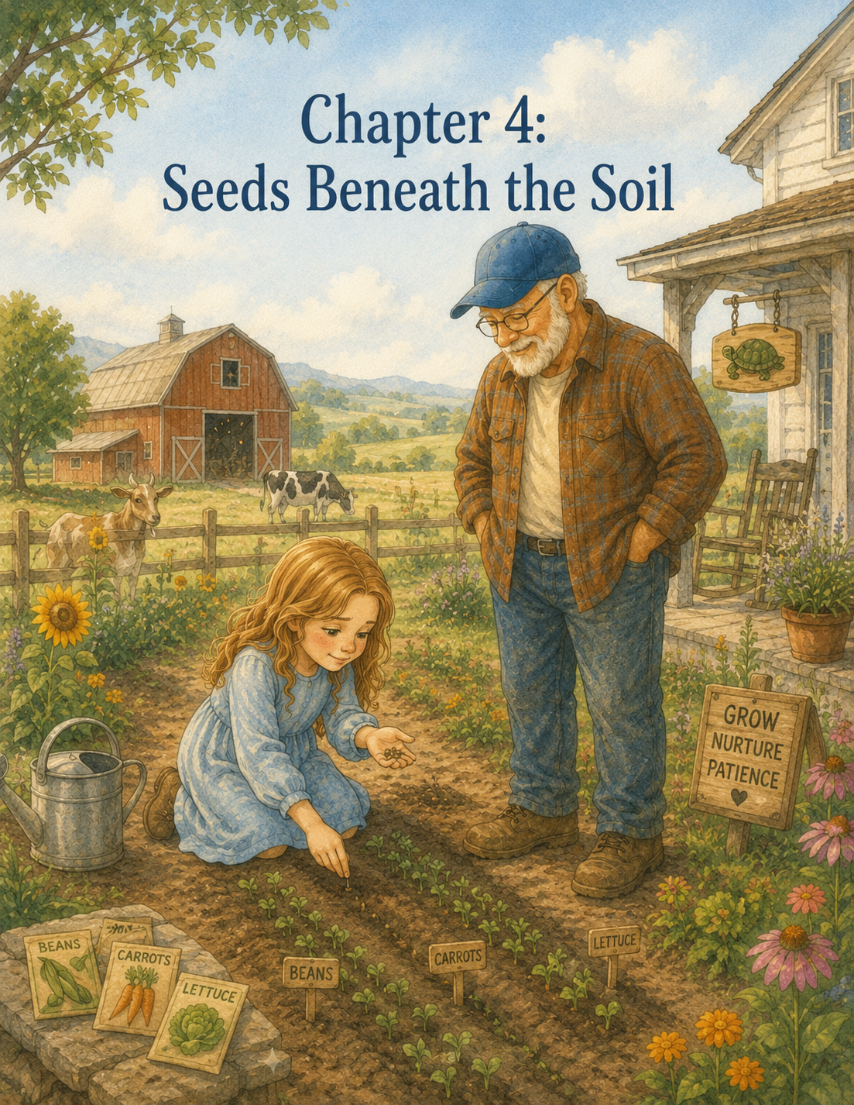

Chapter 4: Seeds Beneath the Soil
The morning after Clover’s great escape, Lily woke to the sound of rain tapping softly against the window.
Not a storm.
Not the loud, crashing kind of rain that made the windows shake and the barn doors rattle.
This rain was gentle.
It pattered on the roof, dripped from the porch, and made tiny silver trails down the glass. Outside, the pasture looked soft and gray. The red barn seemed darker in the wet morning light, and the garden beyond it looked greener than ever.
Lily sat up in bed and listened.
Walter the rooster still crowed, of course.
Apparently, rain did not stop Walter from making announcements.
“Cock-a-doodle-doo!”
Lily smiled sleepily.
“Good morning to you too,” she whispered.
She climbed out of bed and walked to the window. The flowers beside the porch bent under drops of rain. The sunflowers in the garden stood tall, their heads bowed slightly as if they were still waking up.
For a moment, Lily wondered if farm chores stopped when it rained.
Then she remembered something Grandpa Jim had said the day before.
Animals need care whether we feel sleepy or not.
She guessed they probably needed care whether it rained or not, too.
Lily got dressed in jeans, a yellow T-shirt, and her old sneakers. Then she slipped the little paper turtle into her pocket and pulled Ben’s work gloves from the top of the dresser.
The gloves had dried overnight, but they still had a faint smell of hay and earth. Lily liked that. They felt less like borrowed gloves now and more like part of her morning.
When she came downstairs, Grandpa Jim was standing at the stove, stirring oatmeal in a small pot.
“Morning, Lily,” he said. “Looks like the clouds decided to help with the watering today.”
“Do chores still happen in the rain?” Lily asked.
Grandpa Jim turned and smiled.
“Most certainly. But some chores change their order.”
Lily sat at the kitchen table. “What does that mean?”
“It means the chickens still need feed, Daisy still needs checking, and the goats still need to be reminded they are not in charge of the farm.”
“Clover especially,” Lily said.
“Clover especially,” Grandpa Jim agreed. “But after the rain lets up, I have a special job for you.”
Lily looked up.
“A special job?”
Grandpa Jim placed a bowl of oatmeal in front of her. It had brown sugar, cinnamon, and sliced apples on top.
“A garden job,” he said.
Lily stirred her oatmeal slowly.
She had seen the garden on her first day. She had helped carry a few tools past it yesterday after fixing Clover’s fence, but she had not worked in it yet. The garden looked peaceful from a distance, with neat green rows and flowers along the edges.
But Lily had already learned something about the farm.
Things that looked simple from far away were often harder up close.
“What kind of garden job?” she asked.
Grandpa Jim sat across from her.
“You are going to have your own row.”
Lily blinked.
“My own row?”
“Your own little stretch of garden to care for this summer. You’ll plant it, water it, weed it, and watch it grow.”
Lily looked toward the rain-streaked window.
“What will I plant?”
“That is up to you,” Grandpa Jim said. “I have bean seeds, carrot seeds, lettuce seeds, sunflower seeds, and a packet of zinnias if you want flowers.”
Lily thought about it.
She liked flowers.
But she also liked the idea of growing something they could eat.
“Could I plant more than one thing?” she asked.
Grandpa Jim’s eyes twinkled.
“A farmer’s question.”
“Is that a yes?”
“That is a yes, if the row is planned carefully.”
Lily smiled and took a bite of oatmeal.
After breakfast, they put on raincoats and went outside for the morning chores. The rain had softened to a mist, but everything was damp. The porch steps were slick, the grass was wet, and drops clung to the fence rails like tiny beads of glass.
The chickens looked displeased.
Henrietta stood under the edge of the coop roof, feathers puffed, clucking as if she had personally been offended by the weather.
“I agree,” Lily told her. “Wet mornings are not my favorite either.”
Walter strutted through the mud with great confidence, as if he had ordered the rain himself.
Lily fed the chickens, filled the water buckets, and helped Grandpa Jim check the barn. Daisy was warm and dry in her stall. Marmalade slept on a hay bale with his tail over his nose. Clover and Pickles stayed inside the goat pen, though Clover watched the gate latch with suspicious interest.
“Don’t even think about it,” Lily told her.
Clover bleated.
Grandpa Jim chuckled.
By the time the chores were finished, the rain had stopped. The clouds began to thin, and sunlight slipped through in pale yellow patches. The garden steamed gently as the wet soil warmed.
Grandpa Jim leaned his broom against the barn wall.
“Well,” he said, “looks like the garden is ready for us.”
Lily felt a little flutter in her stomach.
Not fear exactly.
More like the feeling she got before trying something new.
They walked to the garden shed. Grandpa Jim opened the door, and Lily peeked inside. Tools hung neatly on hooks: hoes, rakes, shovels, trowels, and watering cans. Seed packets sat in a wooden box on a shelf. A straw hat rested on a peg, and a pair of muddy boots stood near the door.
Grandpa Jim reached for a small hand trowel and a packet of wooden garden markers.
“These will be just your size,” he said.
Then he lifted down the wooden box of seeds.
Lily’s eyes widened.
There were so many packets. Some were wrinkled. Some were new. Some had pictures of bright vegetables and flowers on the front. Beans. Carrots. Radishes. Lettuce. Pumpkins. Zinnias. Sunflowers. Peas.
“It’s like a library,” Lily said.
Grandpa Jim smiled.
“It is. A seed library.”
Lily touched a packet of sunflower seeds.
“They don’t look like much now,” she said.
“No,” Grandpa Jim said. “Seeds rarely do.”
He took one from the packet and placed it in her palm. It was small, striped, and smooth.
“That little thing can become a sunflower taller than you,” he said.
Lily stared at it.
“This?”
“That.”
“How?”
Grandpa Jim picked up a packet of carrot seeds and shook it gently.
“That is one of the miracles of a garden. A seed knows what it is meant to become, but it still needs help getting there.”
Lily looked at the tiny sunflower seed in her palm.
“What kind of help?”
“Soil. Water. Sunlight. Room to grow. Protection from weeds. And patience.”
“Patience again,” Lily said.
“Farms are full of patience,” Grandpa Jim said. “They just don’t always tell you that at first.”
Lily chose carefully. She decided to plant green beans because Grandpa Jim said they grew well in summer. She chose carrots because she wanted to see if something could really grow underground where nobody could see it. And she chose zinnias because the flowers on the packet were bright pink, orange, and yellow.
Grandpa Jim led her to a small row near the edge of the garden.
“This can be yours,” he said.
The row looked like a plain strip of dark, damp soil. It was not very long, but to Lily it felt important.
“My own row,” she said softly.
“Your own row,” Grandpa Jim repeated. “But a garden row is a promise.”
Lily looked up.
“A promise?”
“When you plant seeds, you promise to care for what you cannot see yet.”
Lily looked back at the soil.
She had never thought about it that way.
Grandpa Jim knelt beside the row, moving slowly, and Lily knelt next to him. The earth smelled rich and clean from the rain. Grandpa Jim showed her how to gently crumble the soil with her gloved fingers, breaking up clumps and pulling away small stones.
“Seeds like soft soil,” he said. “It gives their roots room.”
Lily worked carefully.
The soil was cool through her gloves. A worm wiggled out from under a clump of dirt, and Lily jumped back.
Grandpa Jim laughed.
“That’s a friend.”
“That is a very surprising friend,” Lily said.
“Worms help the soil,” he explained. “They loosen it and make it healthier.”
Lily leaned closer, watching the worm disappear back into the earth.
“Sorry for screaming,” she whispered to it.
Grandpa Jim handed her the trowel.
They made three sections in a row. One for beans. One for carrots. One for zinnias.
“Different seeds need different depths,” Grandpa Jim explained. “Beans go a little deeper. Carrots stay closer to the top. Zinnias need space so they don’t crowd each other.”
Lily studied the seed packets.
“How do you remember all that?”
“I read the packets,” Grandpa Jim said.
Lily laughed.
“I thought farmers just knew everything.”
“Good farmers know to keep learning.”
That made Lily feel better.
Grandpa Jim helped her make a shallow line in the soil for the bean seeds. Lily placed each seed carefully into the row, one by one, leaving space between them.
“They look like tiny stones,” she said.
“But they are not stones,” Grandpa Jim said. “They are beginnings.”
Lily liked that.
Beginnings.
She covered the beans gently with soil and patted it down.
“Not too hard,” Grandpa Jim reminded her. “Seeds need covering, not squishing.”
Lily loosened her hands.
“Sorry, seeds.”
Next came the carrots.
The seeds were so tiny that Lily was afraid to breathe too strongly near them.
“How can something that small become a carrot?” she asked.
“The same way many small things become something bigger,” Grandpa Jim said. “A little at a time.”
Lily sprinkled the carrot seeds as carefully as she could. Some fell too close together, but Grandpa Jim told her that was all right.
“We can thin them later,” he said.
“What does this mean?”
“It means giving the strongest plants room to grow.”
Lily frowned a little.
“Do we have to pull some out?”
“Sometimes,” Grandpa Jim said gently. “In a garden, caring for one thing can mean making room for it. Not every seed will grow. Not every sprout will stay. But every seed still has its moment of trying.”
Lily looked down at the tiny carrot seeds.
That made her feel strangely quiet.
Finally, she planted the zinnias. Those seeds were flat and pointed, easier to hold than the carrot seeds. She planted them at the end of the row, imagining flowers standing there later in the summer like a colorful welcome sign.
When all the seeds were planted, Grandpa Jim gave her three wooden markers.
Lily wrote carefully on them with a black pencil:
Beans
Carrots
Zinnias
Then she pushed each marker into the soil.
The row still looked mostly empty.
Just damp dirt with three little signs.
Lily tilted her head.
“It doesn’t look like I did much.”
Grandpa Jim smiled.
“That is how planting often feels.”
“But we did a lot.”
“Yes.”
“But no one can see it.”
“Not yet.”
Lily sat back on her heels.
She was used to drawings, where a picture appeared as she worked. She was used to books, where each page turned into the next. She was used to chores, where a full water bucket or a clean barn aisle proved the job had been done.
But planting was different.
The work disappeared under the soil.
Grandpa Jim seemed to know what she was thinking.
“Some of the most important work happens where we cannot see it,” he said.
Lily looked at the row.
“Like roots?”
“Like roots.”
She thought about Ben.
She thought about the way he was not there in the way she wished he could be, but still somehow part of the farm. In the painted turtle sign. In old gloves. In the goat warning. In the drawing above her desk.
Maybe love had roots, too.
Maybe kindness did.
Maybe memories grew beneath the surface, even when you could not see them every day.
Grandpa Jim stood slowly and brushed soil from his knees.
“Now comes watering,” he said.
“But it rained.”
“It did. So today, we only give them a gentle drink. Seeds need moisture, but not a flood.”
He handed Lily a small green watering can.
She filled it halfway at the pump, remembering the lesson of the half-full bucket. Full was not always best.
Then she carried it back to her row and tipped it carefully.
At first, too much water poured out in one spot.
“Oh!” she said, lifting it quickly.
Grandpa Jim stepped closer.
“Try moving your arm back and forth, like rain.”
Lily tried again. This time, she sprinkled water in a soft pattern across the soil.
“Like rain,” she whispered.
The dark earth grew darker.
The markers stood straight.
Nothing sprouted.
Nothing changed.
But Lily knew something had begun.
Over the next few days, Lily visited her row every morning after chores.
At first, she expected something to happen quickly.
On the first day, nothing happened.
On the second day, nothing happened.
On the third day, still nothing happened.
Each morning she knelt beside the row, looking closely at the soil.
“Are you sure they’re growing?” she asked Grandpa Jim on the third morning.
“I am sure they are working,” he said.
“Working where?”
“Beneath the soil.”
Lily touched the dirt lightly.
“What are they doing?”
“Softening. Opening. Sending down roots. Reaching up, even before you can see them.”
Lily tried to imagine that.
Tiny seeds underground, working quietly.
It seemed impossible.
But then again, so did a sunflower taller than she was.
On the fourth morning, Lily found weeds.
Not big weeds.
Tiny weeds.
They looked harmless, like little green sprouts scattered between the markers.
Lily was excited at first.
“They grew!” she called.
Grandpa Jim came over and looked.
“Some did,” he said. “But not the ones we planted.”
Lily’s face fell.
“Those are weeds?”
“Most of them.”
“How can you tell?”
Grandpa Jim knelt beside her and pointed.
“See how these are popping up all over, not in the row where you planted? And these leaves look different from bean sprouts.”
Lily frowned at the little weeds.
“They came up before my seeds?”
“Weeds often do.”
“That doesn’t seem fair.”
“No,” Grandpa Jim said. “But it does teach us to pay attention.”
He showed Lily how to pinch the weeds gently near the bottom and pull them out roots and all. If she pulled too quickly, the tops broke off and the roots stayed behind.
“Then they grow back,” Grandpa Jim explained.
Lily pulled carefully.
Some weeds came out easily. Others held tightly to the soil.
“These are stubborn,” she said.
“Many unwanted things are.”
Lily glanced at him.
Grandpa Jim smiled, but there was a thoughtful look in his eyes.
“Worry can be like that,” he said. “So can impatience. If we only pull off what shows on top, it can grow back again. Sometimes we have to get down to the roots.”
Lily looked at the weed in her hand. Its little white roots dangled beneath the green leaves.
She thought about how impatient she had been, wanting the seeds to grow right away. She thought about how she had felt nervous when she first came to the farm, and how some of that nervousness still appeared when she tried new things.
Maybe she had roots beneath the soil, too.
Not bad roots.
Just hidden places where feelings grow.
By the end of the wedding, Lily’s knees were damp, her gloves were dirty, and her row looked neat again.
Still empty.
But neat.
That afternoon, the sun grew hot. Lily helped Grandpa Jim carry a basket of tomatoes from the older garden rows to the porch. Then she filled her watering can and returned to her own row.
“Another drink?” Grandpa Jim asked.
“The soil looks dry.”
He nodded.
“You noticed.”
That made Lily proud.
She watered gently, moving the can back and forth. She checked for new weeds and pulled two tiny ones near the carrot marker.
“Not today,” she told them.
On the fifth morning, something changed.
Lily had just finished feeding the chickens when she ran to check her row. She did not expect much. She had gotten used to seeing dirt.
But near the bean marker, the soil had cracked.
A small green curve poked through.
Lily froze.
Then she gasped.
“Grandpa Jim!”
He was near the tomato plants, tying a vine to a wooden stake.
“Come here!” Lily called. “Something happened!”
Grandpa Jim walked over, smiling as though he already knew.
Lily pointed.
“Look!”
The bean sprout was tiny. It was bent over like it was carrying the soil on its back. Two pale green leaves were folded together, not fully open yet.
“It’s growing,” Lily whispered.
“It is.”
“But yesterday there was nothing.”
“Yesterday, there was something,” Grandpa Jim said. “You just couldn’t see it yet.”
Lily stared at the sprout.
That seemed important.
Very important.
She crouched down close.
“Hello,” she whispered. “I’m Lily.”
Grandpa Jim chuckled softly.
“It may not answer, but it will appreciate the introduction.”
All that day, Lily thought about the sprout.
When she swept the barn, she thought about it.
When she gathered eggs, she thought about it.
When Clover bleated from the goat pen, Lily told her, “My beans are growing.”
Clover chewed a leaf and did not seem impressed.
By the next morning, two more bean sprouts had appeared. Then a tiny row of carrot green began to show, so thin and feathery that Lily almost missed it. A few days later, the first zinnia sprout pushed up near the flower marker.
Each sprout made Lily feel as if the farm had shared a secret with her.
The secret was this:
Just because you could not see something happening did not mean nothing was happening.
One evening, after supper, Lily and Grandpa Jim walked through the garden together. The sky glowed orange and pink above the fields. The air smelled like warm earth and tomato leaves.
Lily knelt beside her row. The bean sprouts stood taller now. The carrots were still tiny, but they were there. The zinnias had small green leaves reaching toward the evening light.
“I thought growing would be faster,” Lily said.
“Most people do.”
“I kept wanting to see something right away.”
Grandpa Jim leaned on his hoe.
“That is one reason gardens are good teachers.”
“What do they teach?”
“That daily care matters,” he said. “That patience is not doing nothing. It is doing the small things again and again while you wait.”
Lily thought about watering, weeding, checking the soil, and looking closely every morning.
“That sounds like responsibility.”
“It is.”
She touched one bean leaf gently with one finger.
“Responsibility is quiet sometimes.”
Grandpa Jim nodded.
“Very quiet.”
Lily looked across the farm. The barn. The pasture. The goat pen. The porch. The painted turtle sign by the driveway.
“Do people grow that way too?” she asked.
Grandpa Jim looked at her.
“What way?”
“Quietly. A little at a time. Where no one can see at first.”
Grandpa Jim’s face softened.
“Yes,” he said. “I believe they do.”
Lily watched a bee move from one yellow flower to another.
“I think maybe I’m growing that way.”
“I think maybe you are too.”
The words warmed Lily more than the sunset.
That night, Lily sat at the little desk in her room and opened her Summer Farm Journal. Ben’s turtle hung above her, steady and familiar.
She turned to a fresh page and wrote:
Day Four and More: Seeds Beneath the Soil
Then she drew three little garden markers: Beans, Carrots, and Zinnias. Beside them, she drew tiny sprouts pushing through the dirt.
She began to write.
Grandpa Jim gave me my own row in the garden. I planted beans, carrots, and zinnias. At first, it looked like nothing had happened. The seeds were underground, and I couldn’t see them growing. I kept checking every day, but the dirt looked the same.
Lily paused, remembering the first bean sprout.
Then she kept writing.
Grandpa Jim said seeds are working even when we cannot see them. They are opening, sending down roots, and reaching up. I think people might do that too. Sometimes courage, kindness, and patience grow inside us before anyone sees them.
She looked over at the paper turtle on the desk.
The moonlight touched its folded shell.
Lily wrote one more sentence:
Today I learned that growing up takes daily care, and some of the most important things grow quietly.
She closed the journal and climbed into bed.
Outside, the farm settled into its nighttime sounds. Crickets chirped. The barn light glowed softly. Somewhere in the distance, Clover bleated once, as if making sure everyone remembered she was there.
Lily smiled in the dark.
Tomorrow, the sprouts might be taller.
Or they might look exactly the same.
Either way, Lily would water them.
She would pull the weeds.
She would check the soil.
She would show up.
Because beneath the soil, quiet things were growing.
And beneath her own worries, hopes were growing too.

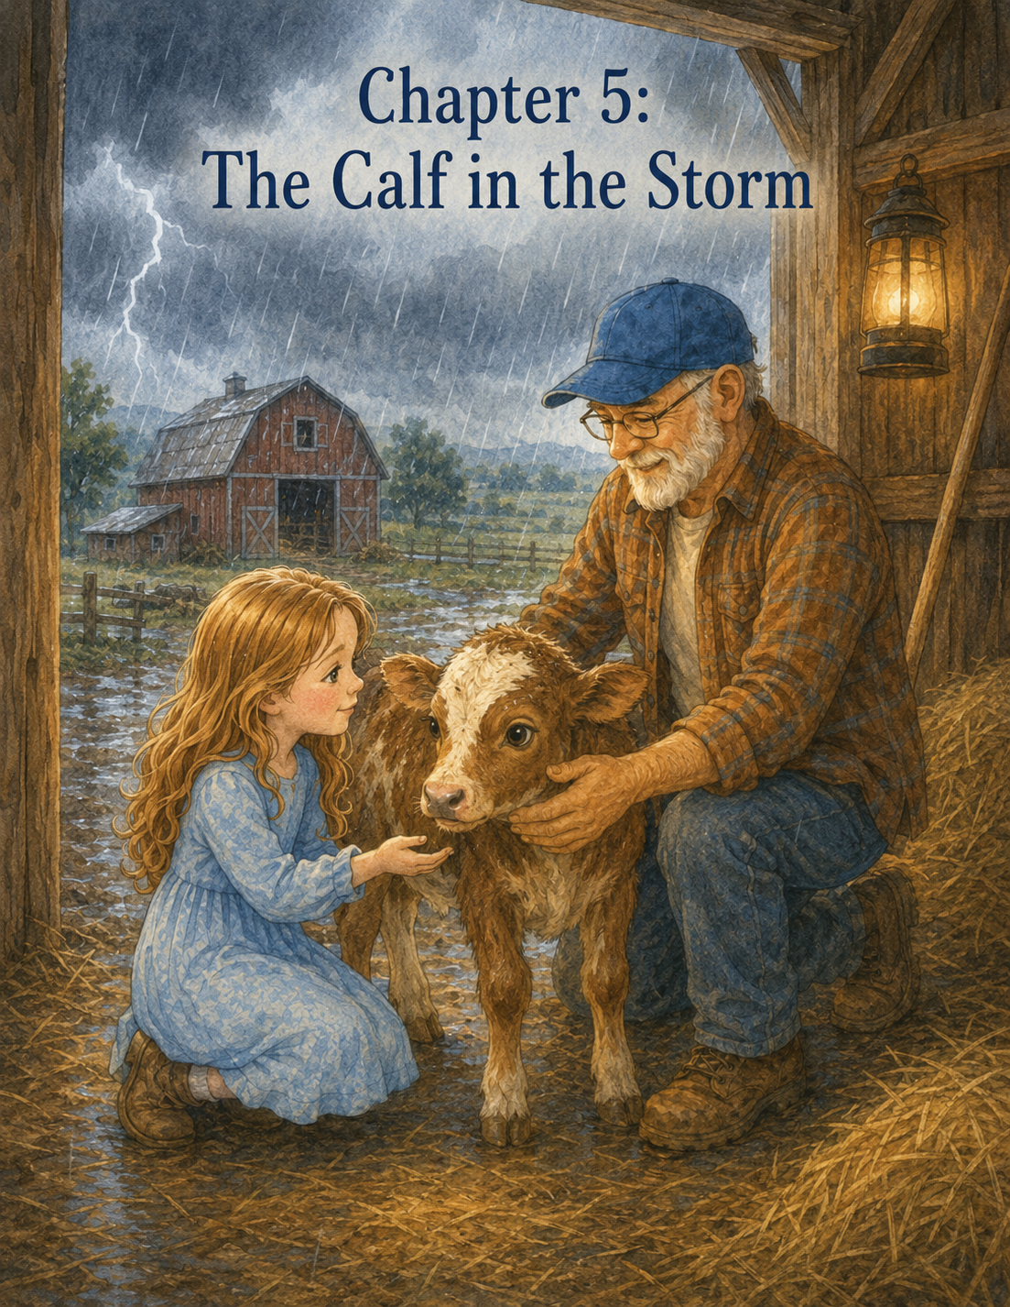

Chapter 5: The Calf in the Storm
By the middle of Lily’s first week at Maple Hill Farm, she had begun to know the rhythm of the days.
Walter crowed before the sun was fully awake.
Grandpa Jim made breakfast.
The chickens demanded feed as if they had not eaten in years.
The water buckets needed filling.
The barn aisle needed sweeping.
The eggs needed gathering.
Clover needed watching.
And Lily’s garden row needed checking.
Each day felt full, but not too full. Busy, but not rushed. Grandpa Jim never seemed to hurry on the farm, even when there was plenty to do. He moved with steady hands and careful steps, as if the animals, the soil, the weather, and the work all had their own time.
Lily liked that.
She liked the way mornings began with chores and ended with lemonade on the porch. She liked watching the bean sprouts unfold their leaves. She liked how the zinnias stood a little taller each day. She even liked the way Henrietta clucked at her shoes, though she still did not trust the hen near her laces.
But on Thursday afternoon, the farm felt different.
The air was heavy.
Too still.
The sky, which had been bright blue in the morning, had turned gray and low. Dark clouds gathered beyond the far pasture, piling up over the trees like mountains made of smoke.
Lily noticed it while she was kneeling beside her garden row, pulling tiny weeds from between the carrot sprouts.
The leaves on the tomato plants had turned over in the wind, showing their pale undersides. The chickens had gone quiet. Even Walter seemed less interested in making announcements.
Grandpa Jim stood near the barn, looking toward the sky.
“Storm’s coming,” he called.
Lily sat back on her heels.
“A big one?”
“Looks like it.”
She looked down at her garden row. The bean leaves trembled in the wind.
“Should I water the plants?”
Grandpa Jim smiled gently.
“I think the sky is about to take care of that.”
A low rumble rolled across the fields.
Lily froze.
Thunder.
It was far away, but deep enough that she felt it in her chest.
She had never liked thunder.
She did not mind the rain. She liked rainy windows, puddles, and the clean smell afterward. But thunder was different. Thunder sounded too big. It arrived without asking and filled up every corner of the air.
Another rumble came, closer this time.
Lily stood quickly and brushed dirt from her knees.
Grandpa Jim walked toward her with his hat pulled low against the wind.
“We need to make sure everyone is settled before it hits,” he said. “Can you help me?”
Lily swallowed and nodded.
“I think so.”
“That’s enough for now.”
They started with the chickens. Grandpa Jim checked the coop door while Lily scattered a little extra feed inside to encourage the hens to go in early. Henrietta complained loudly but followed the others up the ramp.
“Inside, Henrietta,” Lily said. “This is not a good time to be independent.”
The hen clucked as if offended, but she went in.
Walter strutted in last, shaking his red and gold feathers.
Grandpa Jim latched the coop securely.
“Good,” he said. “Now the goats.”
The wind picked up as they crossed the yard. It pushed Lily’s hair into her face and made the tall grass bend in waves. The first few raindrops fell, large and cold, spotting the dust near her shoes.
Clover and Pickles were standing near their shelter, ears twitching.
Pickles bleated when he saw Grandpa Jim.
Clover tried to nibble the edge of the shelter door.
“Clover,” Lily said, “storms are not for chewing.”
Grandpa Jim chuckled, but he moved carefully as he checked the gate latch.
“Good and tight,” he said. “Let’s make sure they have fresh hay inside.”
Lily helped carry two armfuls of hay into the goat shelter. Clover followed her in, more interested in the hay than the storm. Pickles bumped his head gently against Grandpa Jim’s leg, as if asking whether thunder could be postponed.
A flash of lightning flickered behind the clouds.
Lily stiffened.
A second later, thunder cracked across the sky.
Not a low rumble this time.
A sharp, cracking boom.
Lily dropped some hay.
Pickles jumped.
Clover backed into the corner.
Grandpa Jim looked at Lily.
“You all right?”
Lily nodded too quickly.
“Yes.”
Her voice did not sound very convincing.
Grandpa Jim did not point that out. He simply said, “Let’s get to the barn.”
They stepped out into the rain.
It was falling harder now, slanting sideways in the wind. The yard, bright and dry only minutes ago, had turned dark and shining. Drops bounced off the porch steps, splashed in the dirt, and ran down the side of the rain barrel.
Lily hurried beside Grandpa Jim, keeping her head down.
Another flash lit the sky.
Lily squeezed her eyes shut.
Boom!
She stopped in the middle of the yard.
Her heart thudded fast.
For one moment, she wanted to run straight to the farmhouse, up the stairs, under the quilt, and far away from the noise.
Grandpa Jim stopped too.
He did not tell her not to be scared.
He did not tell her thunder could not hurt her inside the barn.
He simply waited beside her in the rain.
“Loud one,” he said.
Lily opened her eyes.
“I don’t like thunder,” she admitted.
“I know.”
“How do you know?”
“Most people look up when they hear thunder,” Grandpa Jim said. “You look for somewhere safe.”
Lily wiped rain from her cheek.
“I know it’s just a storm. But it sounds scary.”
“Scary sounds can still be scary, even when we understand them.”
That made Lily feel a little better.
Then, from the direction of the barn, came a small, frightening sound.
No thunder.
Not a chicken.
Not a goat.
A high, trembling cry.
“Mmmmaaah.”
Lily turned.
Near the barn door, half-hidden by the rain, stood a young calf.
It was Daisy’s calf, a little brown-and-white one Grandpa Jim had introduced the day before. Her name was Rosie. She had long lashes, soft ears, and legs that still looked too thin for her body.
Rosie was not inside the barn where she belonged.
She was standing just outside the door, trembling.
Rain ran down her small back. Her ears flicked nervously. Her eyes were wide and dark.
Another rumble of thunder rolled through the sky.
Rosie jerked backward and let out another frightened cry.
Lily forgot, just for a moment, that she was scared too.
“Grandpa Jim,” she said, “Rosie’s outside.”
Grandpa Jim’s face changed.
He was still calm, but his eyes sharpened.
“She must have slipped out when the door blew open,” he said. “Daisy’s inside, but Rosie got turned around.”
Lily looked at the barn. One of the large doors had swung partly open in the wind. It banged softly against the frame.
Rosie stood near it but would not go in.
“She’s scared,” Lily said.
“Yes.”
“What do we do?”
“We help her feel safe enough to move.”
Lily looked at the space between them and the calf. Rain fell harder. Thunder rumbled again in the distance.
“Can’t we just push her inside?”
Grandpa Jim shook his head.
“A frightened calf is stronger than she looks. If we rush her, she may bolt.”
Lily knew what bolt meant.
Run suddenly.
Run without thinking.
Run somewhere unsafe.
She remembered Clover near the broken fence.
Guide, not chase.
Grandpa Jim took one step forward, then stopped.
“Rosie,” he called softly. “Easy, girl.”
Rosie backed away from the barn door.
Lily’s stomach tightened.
Grandpa Jim lowered his voice.
“Lily, stay beside me, but a little back. Keep your movements slow.”
Another flash of lightning spread across the sky.
Lily flinched.
The thunder followed quickly.
Boom!
Rosie cried out and turned in a small circle.
Lily’s own hands were shaking now. Rain dripped from her hair and slid down her neck. Her shoes squished in the mud.
But Rosie looked even more afraid.
Lily thought of how Grandpa Jim had talked to Clover. How he had stayed calm. How he had said that courage could mean doing what was needed even when fear was there.
This felt harder.
The thunder was not just near Rosie.
It was near Lily too.
Grandpa Jim moved one slow step closer.
“Easy,” he said. “Easy, Rosie.”
Rosie did not move toward him.
She looked from Grandpa Jim to the open barn door and then to the wide rainy yard, as if she did not know which way safety was.
Lily suddenly understood that feeling.
Sometimes, when fear was loud enough, even safe places could look confusing.
She reached into her pocket and touched the little folded paper turtle.
Slow steps still count.
Lily took a careful breath.
“Can I talk to her?” she asked.
Grandpa Jim glanced at her.
“You can.”
“What should I say?”
“Something gentle.”
Lily swallowed and stepped a little closer, still behind Grandpa Jim.
“Rosie,” she said softly.
The calf’s ears flicked.
Lily kept her voice low.
“It’s okay. The thunder is loud, but you’re not alone.”
Rosie blinked rain from her lashes.
Grandpa Jim took another slow step. Lily followed, her feet careful in the mud.
“You’re doing fine,” Grandpa Jim said quietly.
Lily was not sure if he meant Rosie or her.
Maybe both.
Rosie shifted her weight. The barn door banged again in the wind, and the calf jumped.
Lily saw the problem.
“The door is scaring her,” she said.
Grandpa Jim looked at the swinging door.
“You’re right.”
He held out his hand toward Lily.
“Can you stand here and keep talking to Rosie while I secure it?”
Lily’s eyes widened.
“You want me to stay here?”
“I’ll be just a few steps away.”
Thunder grumbled across the sky again.
Lily wanted to say no.
She wanted to say she was too scared.
But Rosie was trembling so hard Lily could see it from where she stood.
If Lily left, Rosie would still be afraid.
And maybe being brave did not mean feeling ready.
Maybe it meant staying because someone else needed you.
Lily nodded.
“I’ll try.”
Grandpa Jim moved slowly toward the door. Lily stood in the rain, facing Rosie.
Rosie stared back at her.
“Hi,” Lily said softly. “I’m still here.”
Rosie let out a small cry.
“I know,” Lily whispered. “I don’t like the thunder either.”
The wind blew rain into Lily’s face. She wiped it away with her sleeve.
“My heart is beating fast,” she told the calf. “Maybe yours is too.”
Rosie’s ears twitched again.
Behind them, Grandpa Jim caught the barn door and fastened it open with a hook so it would not swing. The banging stopped.
The quiet that followed was not quiet. Rain still fell. Thunder still rolled. Wind still moved through the trees.
But without the door banging, the barn entrance looked calmer.
Grandpa Jim came back slowly.
“Good noticing,” he said to Lily. “That helped.”
Lily felt a tiny spark of pride, but there was no time to hold onto it.
Rosie still had to get inside.
Grandpa Jim picked up a small bucket from just inside the barn door. He put a little feed in it and held it low.
“Rosie,” he called gently. “Come on, girl.”
Rosie looked at the bucket.
She took one small step.
Then stopped.
Another flash.
Lily braced herself.
Boom!
Rosie jumped sideways.
Lily did too.
But she did not run.
Instead, she spoke again.
“It’s okay, Rosie. I jumped too.”
Grandpa Jim smiled just a little.
“That was honest.”
Lily kept her eyes on Rosie.
“We can both be scared,” she said, “and still go inside.”
Rosie took another step towards the barn.
Then another.
Daisy mooed from inside.
It was a deep, gentle sound.
Rosie lifted her head.
“Mama’s in there,” Lily said. “Hear her? She’s waiting for you.”
Daisy mooed again.
Rosie moved toward the sound.
Grandpa Jim stepped backward slowly, leading with the bucket. Lily stayed to the side, not blocking Rosie, just helping make the path clear.
“Easy,” Grandpa Jim murmured.
“Good girl,” Lily whispered.
Rosie reached the barn doorway.
For a moment, she hesitated.
The barn was darker than the rainy yard, but it was dry. Warm. Safe.
Daisy mooed once more.
Rosie stepped inside.
Grandpa Jim moved with calm purpose, guiding her toward Daisy’s stall. Lily followed, keeping her voice soft.
“There you go,” she said. “You did it.”
Rosie hurried the last few steps to Daisy. Daisy lowered her head and nudged her calf gently, sniffing her rain-wet coat.
Lily stood near the stall door, soaked from head to toe.
Grandpa Jim closed the stall gate securely.
“Safe and sound,” he said.
Rosie pressed against Daisy’s side, still trembling a little, but calmer now.
Lily let out a long breath.
Then thunder cracked again overhead.
This time, inside the barn, it sounded softer.
Still loud.
But not as big.
Lily leaned against the wooden stall rail.
Grandpa Jim looked at her carefully.
“You all right?”
Lily nodded.
“I think so.”
“You stayed.”
“I wanted to run to the house.”
“I know.”
“But Rosie was more scared than I was.”
Grandpa Jim rested one hand on the rail beside her.
“That is compassion,” he said.
Lily looked at him.
“What is?”
“Noticing someone else’s fear, even while you have your own.”
Lily looked at Rosie. The calf was tucked close to Daisy now, her eyes half-closed as Daisy licked the rain from her forehead.
“I didn’t make the storm stop,” Lily said.
“No.”
“I didn’t make Rosie not scared.”
“No.”
“I just stayed.”
Grandpa Jim nodded.
“Sometimes staying is the kindest thing we can do.”
The rain drummed on the barn roof. Water trickled from Lily’s sleeves and dotted the floor near her shoes. Her hair was stuck to her cheeks. Her socks were definitely wet.
But something warm had settled inside her.
Not because the storm was over.
It was not.
The thunder still rolled.
The rain still fell.
The wind still rattled the old barn boards.
But Lily felt different than she had when the storm began.
She had been scared.
She was still scared.
But she had helped anyway.
Grandpa Jim walked to a peg near the door and took down two old towels. He handed one to Lily.
“Dry off a bit,” he said. “You look like a rain cloud with sneakers.”
Lily laughed and wrapped the towel around her shoulders.
“You look like a wet scarecrow,” she said.
Grandpa Jim looked down at his soaked shirt and muddy boots.
“That is a fair description.”
They stayed in the barn while the storm passed over the farm. Grandpa Jim checked the stalls, made sure the animals were settled, and closed the windows on the side where rain blew in. Lily helped spread fresh straw near Daisy and Rosie.
Rosie watched her with wide, gentle eyes.
Lily moved slowly.
“Don’t worry,” she whispered. “I remember. No rushing.”
When the worst of the storm had passed, the thunder moved farther away. The cracks became rumbles. The rumbles became murmurs. The rain softened until it sounded like fingers tapping the roof.
Grandpa Jim opened the barn door.
The farm outside looked washed clean.
Puddles shone in the yard. The garden leaves sparkled. The pasture grass bent beneath drops of rain. The air smelled fresh, like wet earth and hay.
Lily stepped to the doorway and looked out.
The sky was still gray, but at the edge of the clouds, a line of sunlight glowed.
“That was a big storm,” she said.
“It was.”
“Do you think my garden is okay?”
Grandpa Jim looked toward the rows.
“We’ll check.”
They walked through the damp yard together. Mud clung to Lily’s shoes. Water dripped from the fence rails. The chickens remained tucked safely inside their coop, muttering among themselves. Clover and Pickles peeked from their shelter, dry and curious.
“Everyone stayed in,” Lily said, glancing at Clover.
“This time,” Grandpa Jim said.
At Lily’s garden row, the bean plants bent under raindrops but had not broken. The carrots looked even greener. The zinnias stood small but steady.
Lily touched one bean leaf gently.
“They made it.”
“They did.”
“They look stronger after the rain.”
“Many growing things do,” Grandpa Jim said.
Lily looked back at the barn.
“Maybe Rosie will too.”
Grandpa Jim smiled.
“Maybe so.”
That afternoon, after dry clothes, warm soup, and a pair of thick socks, Lily went upstairs to her room. The storm had made the whole farmhouse feel cozy. Rain still tapped softly on the roof, but now it sounded peaceful rather than frightening.
She sat at the desk beneath Ben’s turtle drawing and opened her Summer Farm Journal.
For a while, she did not write.
She thought about the thunder.
She thought about Rosie’s wide eyes.
She thought about standing in the rain, speaking softly even though her own voice had trembled.
Then she picked up her pencil.
Day Five: The Calf in the Storm
She drew a small picture of Rosie standing near the barn door with rain falling around her. Then she wrote:
Today there was a thunderstorm. I wanted to run to the farmhouse because I'm scared of thunder. But Rosie the calf got stuck outside the barn, and she was trembling near the door. Grandpa Jim said we had to help her feel safe enough to move.
Lily paused and listened.
Far away, thunder rumbled one last time, so faint it almost sounded like a truck on a distant road.
She kept writing.
I talked to Rosie softly. I told her I was scared, too. Grandpa Jim fixed the barn door because it was banging and frightening her. Then we helped Rosie follow Daisy’s voice back inside. I did not make the storm stop, but I stayed with Rosie until she was safe.
Lily tapped the pencil gently on the page.
Then she wrote:
Grandpa Jim said compassion means noticing someone else’s fear, even while you have your own. I think compassion can be quiet. It can sound like a soft voice in a loud storm.
She looked up at Ben’s turtle drawing.
Slow steps still count.
The words seemed to belong to the day.
Slow steps through rain.
Slow words to a frightened calf.
Slow courage in a loud storm.
Lily added one final sentence:
Today I learned that kindness is not always fixing everything. Sometimes kindness is staying close, speaking gently, and helping someone feel safe.
She closed the journal.
Downstairs, Grandpa Jim called, “Lily, Rosie is ready for a visitor if you are.”
Lily smiled.
She tucked the paper turtle into her pocket and went down to the barn.
The rain had stopped completely now. A soft golden light stretched across the wet yard, and puddles reflected pieces of sky. The world smelled clean and new.
Inside the barn, Daisy stood calmly in her stall. Rosie rested in the fresh straw beside her, her coat dry and soft again.
Lily leaned on the stall door.
“Hi, Rosie,” she whispered.
Rosie lifted her head and blinked.
Then, very slowly, she stretched her small nose toward Lily’s hand.
Lily held still.
Rosie sniffed her fingers.
Her nose was warm and damp.
Lily smiled.
“You were brave today,” she said.
Grandpa Jim stood beside her.
“So were you.”
Lily looked up at him.
“I was scared.”
“Yes,” he said. “And you stayed.”
Rosie rested her head back against the straw.
Outside, the last drops of rain fell from the barn roof.
Drip.
Drip.
Drip.
Lily listened to the soft sound and thought about what Grandpa Jim had said.
Maybe courage helped you do what needed to be done.
But compassion helped you notice who needed you to do it.
And today, in the middle of a summer storm, Lily had learned both.

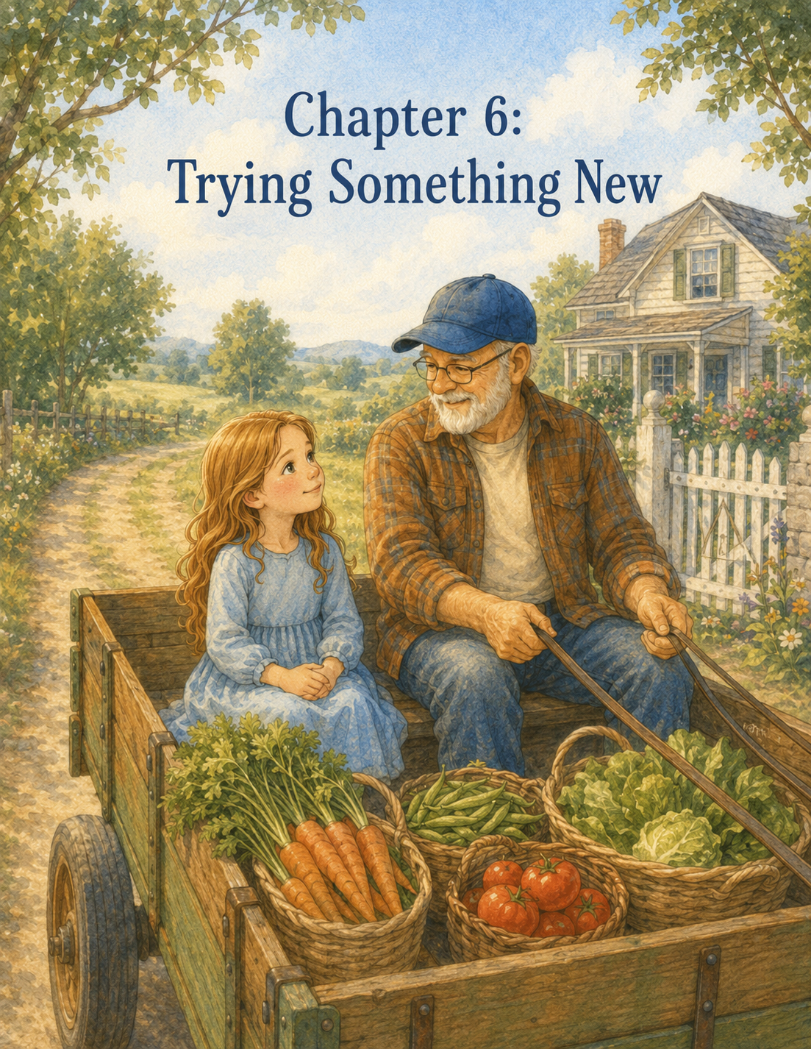

Chapter 6: Trying Something New
The morning after the storm, Maple Hill Farm looked bright and freshly washed.
The sky was clear blue, with only a few soft clouds drifting above the fields. Drops of rain still clung to the fence rails, the garden leaves, and the tall grass by the pasture. The puddles in the yard reflected the red barn, the white farmhouse, and Walter the rooster, who strutted proudly past them as if he had personally chased the storm away.
Lily stood beside her garden row after morning chores, looking closely at the plants.
The beans had grown taller overnight. Their leaves were open wide, catching the sunlight. The carrot tops looked feathery and delicate, like tiny green feathers. The zinnias were still small, but their leaves had become firmer since the rain.
“You made it through the storm,” Lily whispered to them.
Grandpa Jim came up behind her, carrying a basket of cucumbers.
“So did you,” he said.
Lily smiled.
“I was talking to the plants.”
“I know,” Grandpa Jim said. “But I was talking to you.”
Lily looked down at Ben’s old gloves on her hands. Yesterday, she stood in the rain and helped calm Rosie the calf during the thunderstorm. Even thinking about it made her feel proud and a little surprised at herself.
“I was scared,” she said.
“And still helpful,” Grandpa Jim replied.
Lily touched one bean leaf gently.
“I think the garden looks stronger after the rain.”
“Storms can do that,” Grandpa Jim said. “They shake things up, but they also water the roots.”
Lily thought about that while Grandpa Jim walked along the next garden row, checking tomatoes. Some were bright red and ready to pick. Others were still green, waiting for more sun. The squash leaves spread wide over the ground, and yellow blossoms opened like little trumpets.
“What are all the baskets for?” Lily asked.
Several empty baskets sat near the garden gate, lined up beside the fence.
“Today is delivery day,” Grandpa Jim said.
“Delivery day?”
He nodded. “Every Friday, I take fresh vegetables to a few neighbors. Some are too busy to garden. Some are older and can’t do as much as they used to. Some just enjoy a basket of farm vegetables.”
Lily looked at the baskets.
“That sounds nice.”
“It is. And today, I wondered if you might like to ride along.”
Lily looked up quickly.
“Ride along where?”
“To deliver vegetables. We’ll take the farm wagon down the lane to Mrs. Miller’s house first. Then we’ll stop by Mr. Alvarez’s place and the little farm stand near the road.”
Lily glanced toward the barn.
“The farm wagon?”
Grandpa Jim nodded toward the open barn doors.
Inside, near the side wall, sat a small green wagon with wooden sides and large black wheels. Lily had seen it before, but she had never paid much attention to it. It looked old but sturdy, with a bench in front and a flat space in back for baskets.
“It doesn’t go very fast,” Grandpa Jim said. “But it gets where it needs to go.”
Lily studied the wagon.
“Is it like a tractor?”
“Not quite. It’s pulled by the small farm cart tractor. Slow, steady, and loud enough to let everyone know we’re coming.”
Lily was quiet.
She had never ridden in a farm wagon before. She had ridden in cars, school buses, bicycles, and once a hayride at a fall festival. But that hayride had been crowded with other children and parents. This would be different. She would be riding with Grandpa Jim, carrying vegetables to neighbors she had never met, along a farm lane she did not know.
“What if I don’t know what to do?” she asked.
Grandpa Jim set the basket of cucumbers beside the others.
“Then I’ll show you.”
“What if I drop something?”
“Then we pick it up.”
“What if I say the wrong thing to the neighbors?”
Grandpa Jim looked at her kindly.
“Most neighbors are not looking for perfect words. They are looking for a kind hello.”
Lily twisted the edge of one glove.
“I’ve just never done anything like this.”
Grandpa Jim nodded.
“That is why it is called trying something new.”
Lily looked toward the wagon again.
Trying something new sounded exciting when it was only an idea. It sounded much harder when the new thing was sitting right in front of her, waiting.
Grandpa Jim did not rush her.
He picked a ripe tomato from the vine and placed it in a basket.
“New things can feel uncomfortable at first,” he said. “That does not mean we should never try them.”
Lily watched him add three more tomatoes.
“How do you know when to try and when not to?”
Grandpa Jim smiled.
“Well, that is a good question. If something is unsafe, we stop. If something is unkind, we don’t do it. But if something is simply new, or a little uncomfortable, sometimes the only way to grow is to give it a try.”
Lily thought about the first morning chores. She did not know how to feed chickens, fill buckets, sweep the barn, or gather eggs. Now those chores felt familiar.
She thought about Clover getting loose. She had been scared, but she had helped.
She thought about Rosie in the storm. She had wanted to run away, but she had stayed.
Maybe new things were not always as impossible as they seemed from the beginning.
Lily took a breath.
“I’ll ride along,” she said.
Grandpa Jim’s face warmed with a smile.
“Good. Then we’d better get these baskets packed.”
They spent the next hour gathering vegetables.
Lily carefully picked cucumbers from beneath prickly leaves. Grandpa Jim showed her how to twist them gently rather than pull hard. She filled one basket with shiny green cucumbers and another with tomatoes, red and round and warm from the sun.
They picked yellow squash, green beans, and a small bundle of carrots from an older row in Grandpa Jim’s garden. The carrots came out of the soil with a soft tug, their orange roots streaked with dirt.
“These are beautiful,” Lily said.
“Fresh carrots usually are,” Grandpa Jim replied.
He showed her how to brush away loose soil without breaking the tops.
They added small jars of homemade pickles from the pantry and a bunch of sunflowers tied with twine.
“Flowers too?” Lily asked.
“Vegetables feed the body,” Grandpa Jim said. “Flowers help feed the spirit.”
Lily liked that.
She placed the sunflowers carefully on top of one basket.
When everything was ready, Grandpa Jim helped Lily carry the baskets to the wagon. It took several trips. The baskets were heavier than they looked, especially the one full of tomatoes and cucumbers.
Lily lifted carefully with both hands.
“Remember,” Grandpa Jim said, “the work goes better when we don’t try to carry too much at once.”
“Like the water buckets,” Lily said.
“Exactly.”
At the barn, Grandpa Jim checked the wagon wheels and the hitch. The small green tractor sat in front, its paint scratched in places, its seat worn smooth. Grandpa Jim climbed on and turned the key.
The engine coughed.
Then rumbled.
Then came to life with a chugging sound, making Lily jump.
Grandpa Jim looked over his shoulder.
“Loud, isn’t it?”
“A little,” Lily said.
“It has a lot to say for such a small tractor.”
Lily climbed onto the wagon bench beside Grandpa Jim. The wooden seat was smooth and warm from the sun. She held onto the side rail as the tractor gave another rumbling cough.
“You ready?” Grandpa Jim asked.
Lily looked down at the driveway.
Past the farmhouse.
Past the painted turtle sign.
Past the fields she was still learning to know.
She was not completely ready.
But she was ready enough to try.
“Yes,” she said.
Grandpa Jim eased the tractor forward.
The wagon rolled behind it with a gentle bump.
Lily gripped the rail tightly.
The wheels crunched over gravel. The baskets shifted slightly but stayed in place. The farmhouse moved behind them. Walter strutted across the yard and crowed as they passed, as if announcing their departure.
“Thank you, Walter,” Grandpa Jim called.
The wagon rolled down the driveway toward the farm sign.
Lily looked at the painted turtle beneath the words Maple Hill Farm. Ben had painted that turtle, with its crooked little leg and round green shell.
As they passed, Lily touched the folded paper turtle in her pocket.
“Here we go,” she whispered.
The lane beyond the farm was narrow and shaded by trees. Sunlight flickered through the leaves, making moving patches of gold on the road. The air smelled like damp earth, wildflowers, and warm grass. Birds flew from fence post to fence post as the wagon rumbled by.
At first, Lily’s shoulders stayed tight. Every bump made her grab the rail harder. Every turn made her wonder if a basket would slide.
Grandpa Jim noticed.
“Wagons bounce,” he said. “They’re allowed.”
“I don’t want anything to fall.”
“That is thoughtful. But the baskets are packed well, and we are moving slowly.”
Lily looked back. The baskets were still neatly arranged.
She loosened one hand from the rail.
The wagon bumped again.
The baskets stayed.
She loosened her other hand just a little.
“This is not as scary as I thought,” she said.
“Most new things are bigger in our minds before we begin.”
They passed a field where cows grazed lazily beneath a tree. One lifted its head and watched them go by.
“Do they know you?” Lily asked.
“Probably. Or they recognize the sound of the tractor.”
“Do cows recognize tractors?”
“Cows recognize anything that might lead to food.”
Lily laughed.
Soon they reached a small white house with blue shutters and flower boxes beneath the windows. A stone path led to the porch. An elderly woman in a straw hat was sitting in a chair, shelling peas into a bowl.
Grandpa Jim slowed the tractor.
“First stop,” he said. “Mrs. Miller.”
Lily remembered Mrs. Miller from Grandpa Jim’s stories. She lived alone now, and Grandpa Jim often brought her vegetables when her own garden did not produce enough.
“What do I do?” Lily whispered.
“Carry the sunflower basket, if you can,” Grandpa Jim said. “And say hello.”
Lily’s stomach fluttered again.
The wagon stopped.
Grandpa Jim climbed down, then helped Lily step off. She lifted the basket with the sunflowers and vegetables. It was not too heavy, but she carried it carefully.
Mrs. Miller looked up at her peas.
“Well, Jim,” she called, “you brought sunshine with you today.”
Grandpa Jim smiled.
“That would be Lily.”
Lily felt her cheeks warm.
“Hello, Mrs. Miller,” she said.
Mrs. Miller’s face softened.
“Hello, dear. Aren’t you a welcome sight.”
Lily walked up the path and handed her the basket.
“These are from Grandpa Jim’s garden,” she said. Then she quickly added, “And I helped pick some of them.”
Mrs. Miller looked inside.
“Cucumbers, tomatoes, carrots, and sunflowers. My goodness. This is a beautiful basket.”
Lily smiled shyly.
“I didn’t grow most of it.”
“But you helped deliver it,” Mrs. Miller said. “That is no small thing.”
Grandpa Jim set another basket near the porch steps.
“How’s your knee today?” he asked Mrs. Miller.
“Stubborn,” she said. “Like the rest of me.”
Grandpa Jim chuckled.
Mrs. Miller turned back to Lily.
“Are you staying at the farm for the summer?”
“Yes, ma’am.”
“Then you are in for a good education. Farms teach more than schools sometimes.”
Lily smiled.
“Grandpa Jim says that too.”
“He’s right,” Mrs. Miller said. “But don’t tell him I said so. He’ll get proud.”
“I heard that,” Grandpa Jim said.
Mrs. Miller winked at Lily.
Before they left, she gave Lily a small paper bag.
“For the ride,” she said.
Inside were two warm biscuits wrapped in a napkin.
Lily’s eyes widened.
“Thank you.”
“Trying new things takes energy,” Mrs. Miller said.
Lily climbed back onto the wagon feeling a little braver than she had before.
“That went well,” Grandpa Jim said as they pulled away.
“She was nice.”
“Most folks are, when you come with tomatoes and sunflowers.”
Lily opened the paper bag and offered Grandpa Jim one biscuit.
He took it with a grateful nod.
The second stop was Mr. Alvarez’s farm. His house was smaller, painted yellow, with a bright red mailbox and rows of herbs growing beside the porch. Wind chimes made of old spoons hung from a tree and chimed softly in the breeze.
Mr. Alvarez came out wearing a wide hat and a green apron. He had flour on one sleeve.
“Jim!” he called. “You are just in time.”
“For what?” Grandpa Jim asked.
“Zucchini bread experiment number three.”
Grandpa Jim looked at Lily.
“We are brave people,” he said. “We accept.”
Mr. Alvarez laughed.
Lily helped carry a basket of squash and green beans to the porch. This time, saying hello felt a little easier.
“Hello,” she said. “I’m Lily.”
“Welcome, Lily,” Mr. Alvarez said. “Any helper of Grandpa Jim’s is a friend of mine.”
“I’m learning farm chores,” Lily said.
“That is excellent. Have you learned that goats are trouble?”
“Yes,” Lily said immediately.
The two men laughed.
Mr. Alvarez traded a small loaf of zucchini bread for the vegetables. He wrapped it in cloth and placed it carefully beside Lily on the wagon.
“Tell me what you think,” he said. “Be honest, but gentle.”
Lily nodded solemnly.
“I can do that.”
As they rode away, Grandpa Jim looked amused.
“Honest but gentle is good advice for many things.”
The wagon continued down the lane toward the farm stand near the road. By now, Lily had stopped gripping the rail so tightly. She noticed more things: dragonflies over the ditch, wildflowers along the fence, a rabbit darting into the grass, and the smell of sun-warmed leaves after rain.
The wagon still bounced.
The tractor still rumbled.
But the newness no longer felt quite so uncomfortable.
It felt like an adventure.
At the farm stand, Grandpa Jim and Lily arranged the remaining vegetables in wooden crates. Tomatoes in one. Cucumbers in another. Green beans in a basket. A jar sat on the counter with a handwritten sign:
Take what you need. Leave what you can.
Lily read it twice.
“What does that mean?”
Grandpa Jim placed a basket of carrots beside the sign.
“It means people who can pay, pay. People who need food but don’t have much money can still take some.”
Lily looked at the vegetables.
“Does that happen?”
“Yes.”
“And that’s okay?”
“That’s why the sign is there.”
Lily thought about it.
“So, the farm stand helps people, too.”
“It does.”
“Even if we don’t know who?”
“Especially then,” Grandpa Jim said.
Lily picked up a tomato and set it gently in the crate.
“That feels like kindness.”
“It is.”
The farm stand stood beneath a large oak tree near the road. Cars passed now and then, but the place felt peaceful. A breeze stirred the leaves above them. Lily helped arrange the vegetables, so the brightest tomatoes were in front.
“Presentation matters,” Grandpa Jim said.
“Because people like pretty vegetables?”
“Because care shows.”
Lily straightened the carrots.
“There.”
Grandpa Jim studied the stand.
“Very fine work.”
Lily beamed.
On the way back to Maple Hill Farm, the wagon seemed to move faster, though Grandpa Jim said it was going at the same slow speed.
Maybe Lily had changed instead of the wagon.
She sat upright on the bench, one hand resting lightly on the rail. The empty baskets bumped gently behind her. The loaf of zucchini bread sat between them, warm and fragrant.
“I’m glad I came,” Lily said.
Grandpa Jim smiled without looking away from the lane.
“I’m glad too.”
“At first, I wasn’t sure.”
“I noticed.”
“I thought I might do something wrong.”
“And did you?”
Lily considered this.
“I said hello.”
“You did.”
“I carried baskets.”
“Yes.”
“I helped at the farm stand.”
“You did.”
“And I didn’t fall out of the wagon.”
“A major success.”
Lily laughed.
The wagon turned back onto the gravel driveway. The painted turtle sign came into view again.
Maple Hill Farm
Lily looked at the little turtle Ben had painted.
“I think Ben would have liked delivery day,” she said softly.
Grandpa Jim’s expression grew tender.
“He did. He used to sit right where you’re sitting.”
Lily glanced at the bench beneath her.
“He did?”
“Oh yes. He liked delivering vegetables. Especially to Mrs. Miller, because she always had cookies or biscuits. He said it was important to help neighbors, but snacks made helping even better.”
Lily smiled.
“That sounds like him.”
Grandpa Jim drove the wagon past the farmhouse and stopped near the barn. The tractor engine sputtered, then went quiet. After the rumble stopped, the farm seemed wonderfully still.
Lily climbed down and helped carry the empty baskets back to the shed.
“They’re lighter now,” she said.
“That’s the nice thing about giving,” Grandpa Jim said. “You carry something out, and somehow you come back lighter too.”
Lily thought about that.
She did feel lighter.
Not because the baskets were empty.
Because she had tried something new and discovered it was not as frightening as she had imagined.
After lunch, Grandpa Jim cut slices of Mr. Alvarez’s zucchini bread. It was soft, sweet, and a little warm in the middle.
Lily took one bite and considered carefully.
“Honest but gentle?” Grandpa Jim asked.
Lily nodded.
“It is very good. Maybe a tiny bit too much cinnamon, but I like cinnamon, so I don’t mind.”
Grandpa Jim laughed.
“That is honest and gentle.”
Later that afternoon, Lily checked her garden row. The soil was still moist from the storm, so she only pulled a few small weeds. The bean plants leaned toward the sun. The carrot tops looked a little stronger. One zinnia leaf had opened wider than the others.
Trying new things, Lily thought, might be like planting seeds.
At first, everything happened beneath the soil. A person felt nervous. Unsure. Uncomfortable. Then, after one small step, something began to grow.
Maybe not confidence all at once.
Just a sprout of it.
That evening, after supper and dishes, Lily went upstairs to her room. The sky outside her window was glowing orange above the barn. Fireflies blinked in the grass near the fence.
She sat at her desk beneath Ben’s turtle drawing and opened her Summer Farm Journal.
Day Six: Trying Something New
She drew a little picture of the green farm wagon, with baskets of tomatoes and sunflowers in the back. Then she began to write.
Today Grandpa Jim invited me to ride along in the farm wagon to deliver vegetables. I had never done that before. I felt nervous because I did not know what to do or what to say. Grandpa Jim said if something is safe and kind but simply new, sometimes the only way to grow is to try it.
Lily paused and smiled, remembering Mrs. Miller’s biscuits and Mr. Alvarez’s zucchini bread.
She kept writing.
We delivered vegetables to Mrs. Miller and Mr. Alvarez. We also put food at the farm stand with a sign that said, “Take what you need. Leave what you can.” I learned that farms can help people even when no one is watching.
She tapped the pencil lightly against the page.
Then she wrote:
At first the wagon felt bumpy and strange. By the end, it felt fun. Maybe new things feel uncomfortable because our courage has not caught up yet. But when we try, confidence starts to grow.
Lily looked up at Ben’s turtle drawing.
Slow steps still count.
She wrote one more sentence:
Today I learned that trying something new can open the door to confidence and joy.
Downstairs, Grandpa Jim called, “Lily, do you want the last slice of zucchini bread?”
Lily closed the journal and stood quickly.
“Yes!”
She hurried down the stairs, then stopped halfway and smiled to herself.
A few days ago, everything on the farm had felt new.
Now, little by little, it was starting to feel like hers.
The chores.
The garden.
The animals.
The wagon.
The lessons.
And somewhere inside Lily, something quiet and bright was growing.
Confidence.
Not all at once.
Just one small ride at a time.

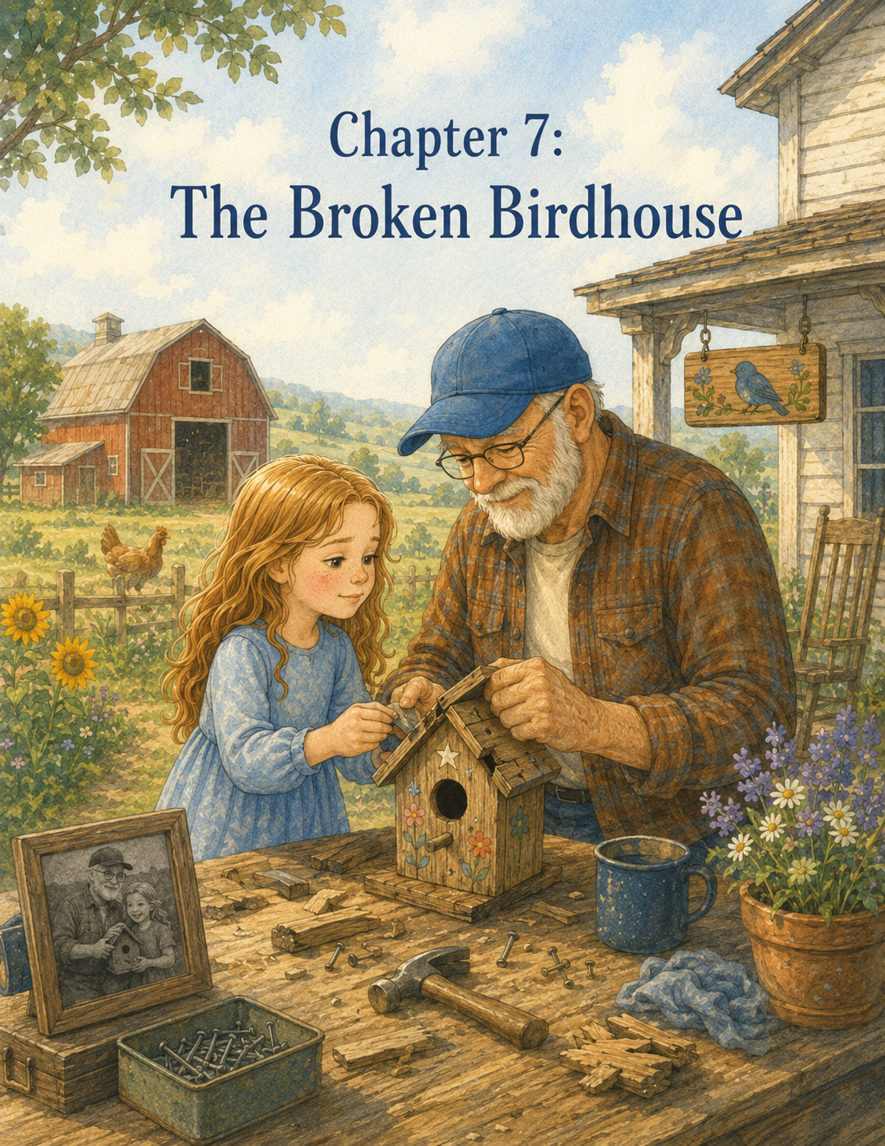

Chapter 7: The Broken Birdhouse
The wind came in the afternoon.
It did not arrive all at once.
At first, only a soft breeze moved through the garden, making the bean leaves flutter. Lily noticed it while she was kneeling beside her row, pulling two stubborn weeds from between the carrot tops.
The air felt warm against her face, but the breeze had a restless quality.
It tugged at her hair.
It lifted the corner of her shirt.
It bent the tall grass near the pasture fence.
Lily looked up at the sky. The clouds were white and high, moving quickly across the blue.
“Grandpa Jim?” she called.
Grandpa Jim was near the tomato plants, tying a heavy vine to a wooden stake.
“Yes, Lily?”
“Is it going to storm again?”
He looked up, studying the sky the way he often did. Lily had learned that Grandpa Jim could read the weather almost like reading a book. He noticed the color of the clouds, the direction of the wind, the stillness of the animals, and the way the leaves turned.
“Not a storm,” he said. “Just a windy afternoon.”
Lily pressed soil around the base of a bean plant.
“Is wind bad for the garden?”
“Sometimes,” Grandpa Jim said. “But a little wind can help plants grow stronger. It teaches their stems to stand firm.”
Lily looked at the bean plants. They were taller now, with little curling tendrils reaching toward the thin sticks Grandpa Jim had placed beside them.
“So even wind can teach something?”
Grandpa Jim smiled.
“Most things can, if we pay attention.”
Lily was beginning to believe that.
The farm had already taught her about responsibility, courage, patience, compassion, and trying new things. It had taught her that chickens could be bossy, water buckets were heavier than they looked, goats should not be chased, calves needed gentle voices, and zucchini bread could have just a little too much cinnamon and still be wonderful.
Now, apparently, the wind had something to say, too.
After the garden work was finished, Lily helped Grandpa Jim carry a basket of tomatoes to the porch. The wind pushed at them as they walked. It lifted dust from the path and shook the leaves of the big maple tree near the front fence.
A loose shutter on the farmhouse tapped softly against the siding.
Tap.
Tap.
Tap.
“Should we fix that?” Lily asked.
“I’ll tighten it before supper,” Grandpa Jim said. “It’s been meaning to remind me for weeks.”
Lily laughed.
“Things on a farm remind you loudly.”
“They do.”
Walter the rooster strutted across the yard, but a sudden gust ruffled his feathers so much that he stopped and shook himself. He looked deeply insulted.
Lily giggled.
“Walter doesn’t like the wind.”
“Walter prefers weather that respects his dignity,” Grandpa Jim said.
The wind grew stronger as the afternoon went on.
It rushed across the pasture in waves, bending the grass all in one direction. It made the barn door creak and the wind chimes dance wildly on the porch. It rattled the leaves in the trees until they sounded like soft applause.
Lily sat at the kitchen table helping Grandpa Jim sort green beans.
A pile of clean beans sat between them. Grandpa Jim snapped the ends off and dropped them into a bowl. Lily tried to do the same, but some of the beans bent instead of snapping.
“You have to listen for the sound,” Grandpa Jim said.
Lily held a bean between her fingers and pressed.
Snap.
“There,” she said.
“That’s it.”
The wind pushed against the kitchen window, making it hum.
Lily glanced outside.
“Do the animals get scared of wind?”
“Some do,” Grandpa Jim said. “But most of them know where to find shelter.”
“Rosie?”
“Rosie is inside with Daisy for now. She’s learning, but she still likes her mother close when the weather gets noisy.”
Lily nodded. She understood that feeling.
After the beans were sorted, Grandpa Jim asked Lily to help check the yard for anything that might blow away. They carried flowerpots closer to the porch wall, picked up an empty feed sack near the barn, and moved a small metal bucket into the shed.
Clover and Pickles stood inside their shelter, chewing hay and watching the wind.
“Clover,” Lily said, “this is not a good day for adventures.”
Clover bleated as if she disagreed.
Grandpa Jim checked the goat gate twice.
“Just in case,” he said.
By late afternoon, the wind began to settle. It did not stop completely, but the strong gusts softened. The trees no longer shook as hard. The porch chimes slowed from wild dancing to gentle ringing.
Grandpa Jim stood near the barn and looked around the yard.
“Well,” he said, “I think the worst of it has passed.”
Lily was glad. Wind made the farm feel busy in a way she could not quite follow. Everything moved. Everything rattled. Everything seemed to need attention.
She was about to go inside for lemonade when something near the fence caught her eye.
At the far edge of the yard, beneath the maple tree, something small and wooden lay in the grass.
Lily squinted.
“What’s that?”
Grandpa Jim turned.
“What’s what?”
Lily pointed. “By the fence.”
They walked across the yard together. The grass was still damp in the shaded places, and small twigs had fallen from the trees. When Lily reached the fence, she knelt down.
It was a birdhouse.
Or it had been.
The little wooden house lay on its side in the grass. Its roof had partly come loose. One corner was cracked. The perch had snapped off and lay a few inches away. Faded paint clung to the sides in patches of blue, yellow, and green.
Lily lifted it carefully with both hands.
“Oh no,” she said.
Grandpa Jim crouched beside her, moving slowly.
“Well now,” he said softly.
Lily looked at him.
“Was it from the tree?”
Grandpa Jim nodded and pointed to a low branch above them. A piece of old wire still dangled from it, swinging gently.
“The wind must have brought it down.”
Lily turned the birdhouse over in her hands.
It looked old.
Very old.
The paint was chipped, and the roof splintered near one side. On the front, beneath the little round opening, someone had painted tiny flowers. Most of them had faded, but Lily could still see one yellow petal and the curve of a red stem.
“Did you make this?” she asked.
Grandpa Jim did not answer right away.
His fingers touched the cracked roof lightly.
“Ben helped paint it,” he said.
Lily grew still.
The wind moved softly through the maple leaves above them.
“Ben did?”
Grandpa Jim nodded.
“He was smaller then. Maybe five or six. He wanted the birds to have a cheerful house. Said even birds deserved pretty walls.”
Lily looked down at the faded flowers again.
The little painted petals suddenly seemed much more important.
“He painted these flowers?”
“Some of them. I painted the roof, and he painted the sides. He wanted to add a turtle too, but I told him birds might get confused.”
Lily smiled a little.
“He probably said turtles and birds could be friends.”
Grandpa Jim chuckled quietly.
“He did say something very close to that.”
Lily ran one gloved finger over the painted flowers.
The birdhouse felt fragile, like something that had held many seasons inside it. Rain. Sun. Wind. Birds. Maybe even nests.
“Can we fix it?” she asked.
Grandpa Jim looked at the broken roof and cracked corner.
“I think so.”
“Really?”
“It will take some careful work.”
“I can be careful.”
“I know you can.”
Lily held the birdhouse closer.
“Then we should fix it.”
Grandpa Jim looked at her, and his expression softened.
“Why do you want to?”
Lily thought about the question.
At first, the answer seemed simple. The birdhouse was broken, so it should be repaired.
But there was more.
Because Ben had painted it.
Because it had fallen.
Because something that had once mattered still mattered.
“Because it was his,” Lily said. “And because birds might still need it. And because…” She paused, looking at the faded flowers. “Because memories shouldn’t just stay broken if we can help.”
Grandpa Jim’s eyes grew gentle behind his glasses.
“That is a very good reason.”
They carried the birdhouse to Grandpa Jim’s workbench inside the barn.
Lily had not spent much time at the workbench before. It stood against the far wall beneath a small window, with jars of nails, screws, hooks, and washers lined along a shelf. Tools hung neatly on a pegboard: hammer, pliers, screwdriver, hand saw, measuring tape, and a little brush with stiff bristles.
The bench smelled like sawdust and old wood.
Grandpa Jim laid the birdhouse on a soft cloth.
“First,” he said, “we look carefully.”
Lily leaned beside him.
“Before fixing?”
“Always. If we rush, we may miss what needs help.”
Lily studied birdhouses.
The roof had pulled away from one side. A nail stuck out crookedly. The front panel was still strong, but the back had a crack running down from the top. The perch was broken, but the hole where it had been attached remained.
“It needs a roof, a corner, and a perch,” Lily said.
Grandpa Jim nodded.
“And fresh wire to hang it safely.”
“And maybe new paint?” Lily asked.
He looked at the faded sides.
“Maybe a little. But not so much that we cover everything Ben painted.”
Lily nodded quickly.
“No. I don’t want to cover his flowers.”
Grandpa Jim took down a small hammer and a few thin nails. Then he found a scrap of wood that matched the roof.
“We can mend this side,” he said. “And glue the cracked back. For the perch, we’ll use a little dowel.”
“What’s a dowel?”
“A small round piece of wood.”
He showed her one from a jar near the window.
Lily picked it up.
“It looks like a tiny stick.”
“That is a fair description.”
They began with the roof. Grandpa Jim showed Lily how to hold the wood steady while he tapped the nail in.
Tap.
Tap.
Tap.
The sound was soft and careful, not like the louder hammering they had done on Clover’s fence.
“Birdhouse work is smaller work,” Grandpa Jim said. “Small work asks for gentle hands.”
Lily liked that.
When it was her turn, she held the hammer carefully. The first tap barely moved the nail.
“Too soft?” she asked.
“Soft is better than smashed,” Grandpa Jim said. “Try again, a little firmer.”
She tapped again.
This time, the nail slid into place.
Tap.
Tap.
Tap.
The roof began to hold.
Next came the cracked back panel. Grandpa Jim spread a thin line of wood glue along the crack and showed Lily how to press the pieces together without forcing them.
“Like this?” she asked.
“Exactly.”
They used a small clamp to hold the crack closed while the glue dried.
Lily wiped away the extra glue with a cloth.
Then Grandpa Jim drilled a tiny hole where the perch had broken off. Lily held the dowel carefully while he put a drop of glue at the end. Together, they slid it into place.
The birdhouse already looked better.
Not new.
But better.
Lily thought that might be the right kind of better.
A new birdhouse would not have felt the same. This one still had chipped paint and old marks. It still carried its history. It still looked like something Ben had touched.
“Can we put straw inside?” Lily asked.
“We can,” Grandpa Jim said. “Fresh straw would be nice.”
While the glue dried, they went to the clean straw bin. Lily gathered a small handful, but Grandpa Jim stopped her before she added it.
“Not too much,” he said. “Birds build their own nests. We just give them a start.”
Lily looked at the straw in her hands.
“How much?”
“Enough to say welcome. Not enough to tell them what to do.”
Lily smiled.
“That sounds like something for people, too.”
Grandpa Jim smiled back.
“It does.”
She placed a small amount of straw inside the birdhouse through the little round opening. Some pieces stuck out, and she gently tucked them in.
Then came the paint.
Grandpa Jim opened an old tin box filled with small jars of paint. There was blue, green, yellow, red, white, and brown. The labels were speckled and worn.
Lily chose yellow first.
“I can touch up the flowers,” she said. “Just the parts that are gone.”
Grandpa Jim gave her a tiny brush.
“Careful hands,” he reminded her.
Lily dipped the brush into the yellow paint and dabbed gently where one flower had faded almost completely. She did not paint over the old petals. She painted beside them, connecting broken bits of color.
Then she added a small green stem where the paint had disappeared.
Grandpa Jim watched quietly.
“Ben’s flowers are still there,” Lily said.
“They are.”
“I’m just helping them show again.”
“That is a beautiful way to put it.”
Lily worked slowly. She touched up two flowers and one little leaf. Grandpa Jim painted the repaired roof with a soft blue color that matched the old paint as closely as he could.
Then Lily noticed a small blank spot on the side.
“Could I add something new?” she asked.
Grandpa Jim looked at the spot.
“What would you add?”
Lily thought.
Not a turtle. Ben had wanted one, but Grandpa Jim had said birds might get confused. Still, Lily wanted something that felt like Ben.
She dipped the tiny brush into white paint and carefully painted a small star near the back corner.
Just one.
Not too large.
Not too bright.
Then she added a dot of yellow in the middle.
“For Ben,” she said softly.
Grandpa Jim did not speak for a moment.
When he did, his voice was gentle.
“He would like that.”
Lily set the brush down.
The birdhouse sat on the workbench in the afternoon light. Its roof was mended. Its perch was steady. Its flowers were brighter. A small white star rested near the back, new but not too new.
Lily felt happy and sad at the same time.
She was learning that those two feelings could sit together.
Like sunlight and shadow.
Like old paint and new paint.
Like remembering and moving forward.
They left the birdhouse to dry near the window.
While they waited, Grandpa Jim made lemonade, and they sat on the barn steps. The wind had softened to a breeze. It moved through the grass and carried the smell of hay and warm wood.
Lily looked toward the maple tree where the birdhouse had fallen.
“Did birds live in it before?”
“Oh yes,” Grandpa Jim said. “Wrens mostly. One year, bluebirds looked at it, but they chose the fence post house instead.”
“Do you remember when Ben painted it?”
Grandpa Jim smiled faintly.
“I do.”
“What happened?”
“He got more paint on his hands than on the birdhouse. He painted one flower with six petals, then decided flowers should not all have the same number of petals because that would be boring.”
Lily laughed.
“That sounds right.”
“He also painted one side upside down by accident.”
“Did he get upset?”
“For a minute,” Grandpa Jim said. “Then he said maybe birds liked surprises.”
Lily hugged her knees.
“I wish I could have seen him here when he was little.”
Grandpa Jim looked across the yard.
“I do too.”
The breeze moved between them.
For a while, neither of them spoke.
Then Grandpa Jim said, “It is good to talk about him.”
Lily looked at him.
“Sometimes I worry it will make people sad.”
“It might,” he said. “But not talking about someone we love can feel sad too. Memories need air, just like gardens need sun.”
Lily looked at the maple leaves moving above the fence.
“Memories need air,” she repeated.
Grandpa Jim nodded.
“And care.”
Lily thought about the birdhouse.
It had been lying broken in the grass. They could have thrown it away. They could have said it was too old, too cracked, too faded. But instead, they had carried it carefully, looked closely, repaired what was broken, and helped the old colors show again.
Maybe memories were like that too.
Not things to hide away.
Things to care for.
When the paint dried, Grandpa Jim attached a new wire to the top of the birdhouse. He tugged it gently to make sure it was strong.
“Ready?” he asked.
Lily nodded.
They carried the birdhouse back to the maple tree. The sun was lower now, casting long shadows across the grass. Walter pecked near the porch steps. Clover and Pickles watched from their pen, probably hoping the birdhouse was something edible.
Grandpa Jim brought a small ladder from the shed.
“I’ll hang it,” he said. “You stand back and tell me if it’s straight.”
Lily held the birdhouse while he climbed the first few steps. Then she handed it up carefully.
Grandpa Jim looped the wire over a sturdy branch and adjusted the house so it faced the open yard.
“How does it look?”
Lily stepped back.
“A little to the left.”
Grandpa Jim moved it.
“Now?”
“A little more.”
He moved it again.
“Now?”
Lily tilted her head.
“Perfect.”
Grandpa Jim climbed down and stood beside her.
The birdhouse swayed gently in the breeze. The blue roof caught the light. The faded flowers showed softly against the old wood. The little white star was just visible near the side.
It looked as if it belonged there.
Not because it was perfect.
Because it was cared for.
Lily smiled.
“I hope birds come back.”
“They may,” Grandpa Jim said. “And even if they take their time, the house is ready.”
A small brown bird landed on the fence, tilting its head.
Lily held her breath.
The bird looked at the birdhouse.
Then it flew away.
Lily sighed.
Grandpa Jim chuckled.
“Birds like to inspect before moving in.”
“Like Henrietta with shoes?”
“Something like that.”
Lily looked at the house again.
“I’m glad we fixed it.”
“So am I.”
“It felt important.”
“It was.”
That evening, after supper, Lily went upstairs to her room. Her hands still smelled faintly of paint and wood glue, even after washing them twice. She did not mind.
She sat at the little desk beneath Ben’s turtle drawing and opened her Summer Farm Journal.
The paper turtle rested beside the lamp.
Lily turned to a fresh page and wrote:
Day Seven: The Broken Birdhouse
She drew the birdhouse hanging from the maple tree. She colored the roof blue, the flowers yellow and red, and added one tiny white star near the side.
Then she began to write.
Today the wind knocked down an old birdhouse near the fence. It was cracked, and the roof was loose, and the perch had broken off. Grandpa Jim told me Ben helped paint it when he was little. He painted flowers because he wanted birds to have a cheerful house.
Lily paused and looked up at Ben’s drawing.
Then she wrote more.
I asked if we could fix it. Grandpa Jim said yes. We repaired the roof, glued the crack, added a new perch, and put fresh straw inside. I touched up some of Ben’s flowers but tried not to cover what he had painted. Then I added one small star for him.
Her pencil stopped.
She thought about what Grandpa Jim had said on the barn steps.
Memories need air.
And care.
Lily wrote carefully:
I learned that kindness is not only something we give to people and animals. Sometimes kindness means caring for memories. Sometimes it means fixing something old because love is still connected to it.
She rested her chin in her hand.
Then she added:
The birdhouse is not perfect, but it is ready again. Maybe people can be like that too.
Outside the window, the maple tree moved gently in the evening breeze. The repaired birdhouse hung from one of its branches, small and steady against the fading sky.
A bird landed on the roof.
Lily sat up quickly.
It was small and brown, with quick movements and bright eyes. It hopped once, then leaned toward the round opening.
Lily barely breathed.
The bird peeked inside.
Then it flew to the fence.
Then back to the roof.
Lily smiled so widely her cheeks hurt.
“Grandpa Jim!” she called.
Footsteps sounded on the stairs.
Grandpa Jim appeared in the doorway.
“What is it?”
Lily pointed out the window.
“A bird is looking at the house.”
Grandpa Jim stepped beside her.
Together, they watched as the little bird stood on the new perch.
For a moment, it stayed there, balanced and curious.
Then it slipped inside.
Lily covered her mouth with both hands.
“It went in,” she whispered.
Grandpa Jim’s eyes shone in the soft light.
“So it did.”
The birdhouse swayed gently on the branch.
Old wood.
New paint.
Fresh straw.
One small star.
A house repaired.
A memory cared for.
Love, still finding a place to land.

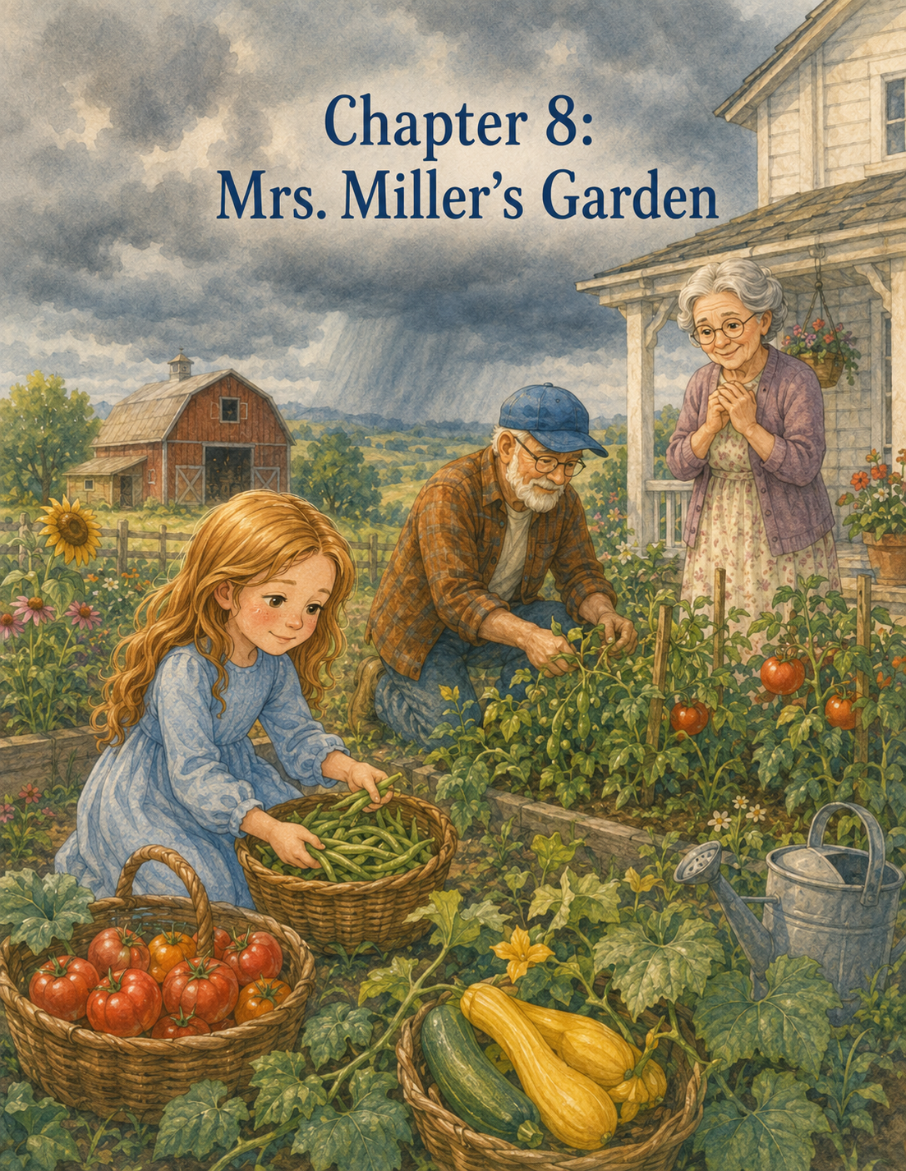

Chapter 8: Mrs. Miller’s Garden
On Saturday morning, the air felt warm before breakfast was even finished.
Lily noticed it as soon as she stepped onto the porch. The sun had barely climbed above the trees, but already the yard had glowed bright and gold. The grass sparkled with dew. The barn roof shone in the light. The garden leaves hung still, without even the smallest breeze to move them.
Walter the rooster stood on the fence rail and crowed loudly.
“Cock-a-doodle-doo!”
Lily looked up at him and sighed.
“Walter,” she said, “you sound very proud for someone who did not make the sun come up.”
Walter fluffed his feathers and crowed again.
Grandpa Jim came out of the farmhouse carrying two tin cups of water.
“I would not tell him that,” he said. “Walter is sensitive about his duties.”
Lily smiled and took one of the cups.
After nearly two weeks at Maple Hill Farm, she had begun to know the farm’s morning sounds: Walter’s crow, the chickens’ clucking, Daisy’s low moo, the creak of the barn door, the pump handle squeaking, and the soft rustle of leaves in the garden.
But this morning, the farm sounded different.
Quieter.
Waiting.
Grandpa Jim looked toward the sky. A line of gray clouds gathered far beyond the pasture, low and heavy.
Lily followed his gaze.
“Is it going to rain?”
“By afternoon,” Grandpa Jim said. “Maybe sooner.”
Lily took a sip of water.
“Another storm?”
“Not like the one with Rosie, I don’t think. But enough rain that folks will want their gardens picked before it comes.”
Lily looked toward her own garden row. The beans had grown taller, climbing their sticks with curling green arms. The carrots were still mostly hidden beneath the soil, but their tops were stronger now. The zinnias had begun to form tiny buds.
She liked checking them every morning. She liked seeing proof that slow care mattered.
“Should I pick anything from my row?” she asked.
“Not yet,” Grandpa Jim said. “Your plants still need time.”
Lily nodded.
Waiting had become easier, though not easy.
They finished the morning chores early. Lily fed the chickens while Grandpa Jim checked the barn. She filled the water buckets, swept the aisle, and gathered nine eggs from the nesting boxes.
Only one hen objected.
Beatrice.
Lily opened the nesting box and saw Beatrice sitting there, puffed up and serious.
“Good morning,” Lily said politely. “I will come back later.”
Beatrice clucked in a satisfied way.
Lily closed the box carefully.
When the chores were done, Grandpa Jim stood near the barn door, wiping his hands on a cloth. He looked again toward the darkening clouds.
Then the kitchen phone rang.
Lily heard it through the open farmhouse window.
Grandpa Jim turned.
“That will be someone needing something,” he said.
“How do you know?”
“Phones on farms have a way of ringing right when the weather changes.”
They went inside. Grandpa Jim picked up the phone from the wall in the kitchen.
“Maple Hill Farm,” he said.
Lily sat at the table and took off Ben’s old gloves. They were dusty at the fingertips and a little damp from the water buckets.
She listened quietly.
Grandpa Jim’s face softened.
“Well, now, Mrs. Miller,” he said. “No, no, don’t worry about that. We can come over.”
Lily looked up.
Grandpa Jim listened for a moment, nodding.
“How many rows?” he asked. “Beans and tomatoes? Some squash, too? All right. We’ll bring baskets.”
He glanced toward Lily.
“Yes,” he said gently. “I have a very capable helper here.”
Lily sat a little taller.
Grandpa Jim hung up the phone.
“Mrs. Miller needs help?” Lily asked.
“She does.”
“Is she okay?”
“She’s all right, but her knee is bothering her more today. She has vegetables ready in her garden, and she’s worried the rain will spoil some before she can pick them.”
Lily remembered Mrs. Miller from delivery day. The small white house with blue shutters. The flower boxes. The bowl of peas on the porch. The warm biscuits in the paper bag.
“She gave us biscuits,” Lily said.
“She did.”
“Then we should help.”
Grandpa Jim smiled.
“I thought you might say that.”
Lily reached for her gloves.
“What do we need?”
“Baskets, garden shears, and our willing hands.”
They gathered supplies from the shed. Grandpa Jim stacked three wide baskets in the back of the small farm wagon. Lily added a pair of garden shears, two cloths, and a jug of water.
“Should we bring flowers?” Lily asked.
Grandpa Jim looked at her.
“For Mrs. Miller?”
Lily nodded. “Maybe the rain and her knee made her morning not very happy.”
Grandpa Jim’s eyes warmed.
“That is a kind thought.”
Lily cut three bright sunflowers from the edge of Grandpa Jim’s garden, and he tied them together with a piece of twine. She laid them gently in the wagon beside the baskets.
As they climbed onto the wagon bench, thunder rumbled very far away.
Lily stiffened, but only a little.
Grandpa Jim noticed.
“Still far off,” he said.
“I know,” Lily replied.
She did know.
But knowing did not always keep thunder from sounding big.
Grandpa Jim started with the little tractor. It coughed, sputtered, and then rumbled to life. The wagon bumped forward down the gravel driveway.
As they passed the painted turtle sign at the entrance, Lily looked at the small crooked-legged turtle Ben had painted.
She touched the paper turtle in her pocket.
“Today we’re helping Mrs. Miller,” she whispered.
The ride to Mrs. Miller’s house felt shorter than it had on delivery day. Maybe because Lily knew the road now. Maybe because trying something once made it less new the next time.
The trees along the lane were still. Birds perched quietly on the fence posts. The air felt heavy and close, like the whole sky was holding its breath.
Mrs. Miller was waiting on her porch when they arrived.
She sat in her chair with one leg propped on a small stool. Her straw hat shaded her face, but Lily could see the relief in her smile.
“Well,” Mrs. Miller called, “if it isn’t my favorite farm rescue team.”
Grandpa Jim stopped the tractor and climbed down.
“Morning, Mrs. Miller.”
Lily carried the sunflowers up the path.
“These are for you,” she said.
Mrs. Miller’s hand went to her heart.
“Oh, Lily. Aren’t those beautiful?”
“I thought maybe your porch needed sunshine before the rain.”
Mrs. Miller took the flowers carefully.
“I believe it did. And so did I.”
Lily felt her cheeks grow warm.
Grandpa Jim lifted the baskets from the wagon.
“Now,” he said, “show us what needs picking.”
Mrs. Miller pointed around the side of the house.
“The beans are ready, and the tomatoes are almost too ready. The squash leaves are hiding more than I can reach today.”
Grandpa Jim looked at Lily.
“Sounds like a garden adventure.”
Lily smiled.
They followed the stone path around the house to Mrs. Miller’s garden.
It was smaller than Grandpa Jim’s but full and beautiful. Green bean plants climbed a wire fence. Tomato vines leaned heavily against wooden stakes, their branches full of red fruit. Yellow squash grew beneath large leaves close to the ground. A row of herbs filled the air with sharp, fresh smells—basil, rosemary, mint, and something lemony Lily could not name.
“Oh,” Lily said softly. “It’s lovely.”
Mrs. Miller, moving slowly with a cane, came to the garden gate.
“It has been my summer project for many years,” she said. “But some days the garden grows faster than I can.”
Grandpa Jim opened the gate.
“That is when neighbors come in handy.”
Mrs. Miller smiled.
“I suppose they do.”
Lily stepped carefully into the garden. The soil was dry and cracked in places, waiting for rain. Bees moved among the tomato flowers. A butterfly rested on a basil leaf.
Grandpa Jim set one basket near the beans and another near the tomatoes.
“All right,” he said. “We start with what needs picking first.”
“How do we know?” Lily asked.
Mrs. Miller pointed with her cane.
The tomatoes are deep red and soft but not mushy. Beans that are long but not bumpy with seeds. Squash about the size of your hand, maybe a little bigger.”
Lily looked at the garden.
There was more to notice than she expected.
Helping was not just about grabbing vegetables. It meant paying attention.
Grandpa Jim showed her how to pick green beans first. He held the vine gently with one hand and snapped the bean free with the other.
“If you pull too hard,” he said, “you can tear the plant.”
Lily nodded.
“Gentle hands.”
“Exactly.”
She picked her first bean carefully.
Snap.
It came loose cleanly.
She placed it in the basket.
Then another.
And another.
The bean plants were thick, and some beans hid behind leaves. Lily had to lift the vines carefully to find them.
“I found a big one,” she said.
Mrs. Miller laughed from the garden gate.
“They do like to hide. I think beans enjoy secrets.”
Lily smiled and kept working.
The sun grew warmer. Sweat dampened her forehead. She moved slowly along the fence, picking beans and placing them in the basket. Grandpa Jim worked on the other side of the row.
Soon, the bottom of the basket was covered.
Then half full.
Then nearly full.
Lily sat back on her heels.
“This is a lot of beans.”
“And each one counts,” Grandpa Jim said.
Lily looked across the garden to Mrs. Miller, who was watching from her chair near the gate. She looked tired, but happy.
“Mrs. Miller,” Lily called, “do you want the small ones too?”
“Not too small, dear. Let those have another day.”
Lily left the tiny beans on the vine.
Another day, she thought.
Just like her own carrots and zinnias.
Next came the tomatoes.
The tomato plants smelled sharp and green. Lily liked the smell. It clung to her gloves as she worked.
Grandpa Jim showed her how to twist each ripe tomato gently until it released from the stem.
“Hold it underneath,” he said. “Some are heavier than they look.”
Lily cupped a large tomato in her palm. Its skin was smooth and warm.
“This one looks perfect,” she said.
“Then it goes in the basket with care.”
She placed it gently on the cloth at the bottom.
They picked red tomatoes, orange tomatoes, and a few small cherry tomatoes that looked like bright little marbles. One tomato had split along the top from growing too quickly after the rain.
“Do we throw this one away?” Lily asked.
Mrs. Miller leaned closer.
“No, that one will still make fine sauce if I use it today.”
Lily set it in a separate bowl.
“Not perfect, but still useful,” she said.
Grandpa Jim looked at her.
“That lesson keeps coming back, doesn’t it?”
Lily smiled.
“It does.”
As they worked, thunder rumbled again.
Closer this time.
Lily looked up.
Dark clouds had moved over the trees. The bright morning had dimmed to a soft gray. Leaves began to stir as the first real breeze of the day pushed through the garden.
“We have some time,” Grandpa Jim said. “But not a lot.”
Lily felt the old nervousness rise in her chest.
The thunder was not as loud as the storm with Rosie, but it reminded her of it.
Mrs. Miller noticed.
“We don’t need every last vegetable,” she said kindly. “Only what we can gather safely.”
Grandpa Jim nodded.
“Safety first. Kindness does not ask us to be foolish.”
Lily took a breath.
“Then we should pick the squash next.”
“That sounds like a plan,” Grandpa Jim said.
The squash plants were the trickiest. Their leaves were large, prickly, and spread close to the ground. Yellow squash hid beneath them like little golden boats.
Lily crouched carefully.
“I see one.”
She reached under a leaf, then pulled her hand back.
“Ouch. It scratched me.”
“The leaves are rough,” Grandpa Jim said. “Move them gently from the stem side.”
He showed her how to lift the leaf without rubbing it too much. Then he used the garden shears to cut the squash from the vine.
“Can I try?” Lily asked.
Grandpa Jim handed her the shears.
“They are sharp, so slow and careful.”
Lily held the squash with one hand and placed the shears around the stem with the other.
Snip.
The squash came free.
“I did it!”
Mrs. Miller clapped lightly from her chair.
“Beautifully done.”
Lily placed the squash in the basket and looked for more.
There were many.
Some were bright yellow and smooth. Some were too small and stayed on the plant. One was enormous, hidden under three leaves.
Lily laughed when she found it.
“Grandpa Jim, look at this one!”
He leaned over.
“Well, that one was planning a quiet life of greatness.”
Mrs. Miller shook her head, smiling.
“That one is too big for frying, but it will make good bread.”
“Like Mr. Alvarez’s zucchini bread?” Lily asked.
“Almost,” Mrs. Miller said. “But perhaps with less cinnamon.”
Lily and Grandpa Jim exchanged a look and laughed.
The first raindrop fell onto Lily’s arm.
Then another.
Grandpa Jim looked up.
“All right. Let’s gather what we have and get to the porch.”
Lily picked up the bean basket. It was heavy, but she could carry it with both hands. Grandpa Jim lifted the tomatoes and squash.
Mrs. Miller stood slowly with her cane.
“I can carry the bowl of split tomatoes,” she said.
Lily looked at Grandpa Jim.
He gave the smallest nod.
Sometimes, Lily remembered, helping did not mean doing everything for someone. Sometimes it meant letting them do what they still could.
“That would help,” Lily said to Mrs. Miller.
Mrs. Miller smiled.
Together, they made their way back to the porch just as the rain began to fall steadily.
Grandpa Jim and Lily set the baskets near the door. Mrs. Miller lowered herself into her chair and placed the bowl of split tomatoes on a small table beside her.
The rain tapped on the porch roof.
Soft at first.
Then harder.
Lily watched it spill off the edge in silver streams.
“We made it,” she said.
“We did,” Grandpa Jim said.
Mrs. Miller looked at the baskets.
“My goodness. You gathered more than I hoped.”
Lily looked at the beans, tomatoes, and squash.
It did not seem like a grand thing. They had not done anything dramatic. They had not rescued a goat or calmed a calf in a storm. They had simply picked vegetables.
But Mrs. Miller looked at the baskets as if they were treasure.
“Thank you,” she said softly. “Both of you.”
Lily shifted her weight.
“It wasn’t hard.”
Mrs. Miller looked at her kindly.
“Many helpful things are not hard, dear. They just require someone to come.”
Lily thought about that.
Someone to come.
Someone to notice.
Someone to carry a basket.
Someone to share time.
Someone to do work that was needed, even when no one demanded it.
Grandpa Jim took off his hat and shook rain from the brim.
“Would you like these brought inside?”
Mrs. Miller nodded gratefully.
“If you wouldn’t mind.”
They carried the baskets into Mrs. Miller’s kitchen. It was small and bright, with yellow curtains, a round table, and shelves lined with jars. The kitchen smelled like mint tea and fresh bread.
Lily set the beans on the counter.
Mrs. Miller pointed to a basket near the pantry.
“Tomatoes can go there. Squash on the lower shelf. Beans by the sink, please.”
Lily followed each direction carefully.
When the vegetables were put away, Mrs. Miller made tea for Grandpa Jim and poured lemonade for Lily. She also brought out a plate of sugar cookies shaped like flowers.
“I made them yesterday,” she said. “Good helpers should not leave empty-handed.”
Grandpa Jim smiled at Lily.
“Mrs. Miller understands farm rules.”
Lily took a cookie.
It was sweet, soft, and buttery.
Rain fell outside the kitchen window. The garden blurred behind the glass, but Lily could still see the rows they had just picked. She imagined the bean vines, tomato plants, and squash leaves drinking the rain now that their heaviest fruit had been gathered.
Mrs. Miller sat at the table, her cane resting beside her chair.
“I used to pick that whole garden in an hour,” she said.
Grandpa Jim stirred his tea.
“You still grow a fine garden.”
“Yes,” Mrs. Miller said. “But I am learning that needing help is not the same as being helpless.”
Lily looked at her.
Mrs. Miller smiled gently.
“That is a hard lesson sometimes.”
Grandpa Jim nodded.
“For all of us.”
Lily thought of Rosie in the storm. Of Clover near the fence. Of her own first morning with the water buckets. Everyone needed help sometimes. Animals. Plants. People. Even birdhouses.
Maybe needing help was not something to be embarrassed about.
Maybe it was just another part of growing.
After the rain softened, Grandpa Jim said they should head back before the lane became muddy. Mrs. Miller wrapped some cookies in a napkin for Lily to take along.
At the porch, Lily turned back.
“Do you need anything else before we go?”
Mrs. Miller looked surprised, then pleased.
“No, dear. You have done plenty.”
Lily nodded.
“If more vegetables need picking, you can call us.”
“I will,” Mrs. Miller said. “Thank you, Lily.”
Grandpa Jim and Lily hurried to the wagon through the light rain. The empty baskets rattled softly in the back as they pulled away.
The ride home was cool and damp. Lily held the wrapped cookies in her lap. The rain had washed dust from the lane, and the leaves shone deep green. Water dripped from tree branches and sparkled on fence posts.
For a while, neither of them spoke.
Then Lily said, “Mrs. Miller looked really happy about the vegetables.”
“She did.”
“But we didn’t do anything big.”
Grandpa Jim glanced at her.
“What makes you say that?”
“I mean, we only picked beans and tomatoes and squash. We just carried baskets.”
Grandpa Jim smiled.
“Just is a word that makes kindness smaller than it is.”
Lily thought about that.
Just carried baskets.
Just shared time.
Just helped before the rain.
Just showed up.
Maybe those things were not so small after all.
Grandpa Jim continued, “Helping others does not always look grand or important from the outside. Sometimes it looks like simple work done with love.”
Lily looked down at the napkin of cookies.
“Mrs. Miller said many helpful things are not hard. They just require someone to come.”
“She is a wise woman.”
Lily smiled.
“I think so too.”
When they arrived back at Maple Hill Farm, the rain had nearly stopped. Grandpa Jim parked the wagon by the barn. Lily helped carry the empty baskets inside and wiped them dry with a cloth.
Then she went to check her garden row.
The beans stood fresh and bright from the rain. The carrot tops sparkled. The zinnias had tiny drops gathered on their leaves like clear beads.
Lily knelt beside them.
“I helped Mrs. Miller’s garden today,” she whispered. “But I didn’t forget you.”
She pulled one tiny weed from near the zinnias.
Even after helping somewhere else, there was still care to give at home.
That evening, after supper, Lily sat at the desk in her room. The farmhouse was quiet. Outside, the clouds had moved away, leaving the sky soft and lavender. The repaired birdhouse hung in the maple tree, and Lily could see the little brown bird sitting on its perch.
She opened her Summer Farm Journal.
Day Eight: Mrs. Miller’s Garden
She drew three baskets: one filled with green beans, one with tomatoes, and one with yellow squash. Then she added three sunflowers leaning beside them.
She began to write.
Today, Mrs. Miller needed help picking vegetables before the rain came. Her knee hurt, and she could not gather everything herself. Grandpa Jim and I rode over in the farm wagon with baskets. I brought her sunflowers because I thought her porch needed sunshine.
Lily smiled as she remembered Mrs. Miller’s face when she saw the flowers.
She kept writing.
We picked beans, tomatoes, and squash. I learned how to tell which vegetables were ready and which needed more time. Mrs. Miller helped carry a small bowl of tomatoes, and I learned that helping someone does not mean taking away what they can still do.
She paused.
That sentence felt important.
She continued.
At first, I thought we only did something small. We carried baskets and picked vegetables. But Grandpa Jim said “just” can make kindness smaller than it is. Mrs. Miller said helpful things often just require someone to come.
Lily looked up at Ben’s turtle drawing.
Slow steps still count.
Slow steps to the garden.
Slow hands picking beans.
Slow kindness, steady and simple.
She wrote one final sentence:
Today I learned that kindness does not have to be grand or complicated. Sometimes it looks like showing up, sharing time, and carrying baskets before the rain.
Lily closed her journal and placed the pencil beside it.
From downstairs, Grandpa Jim called, “Lily, Mrs. Miller’s cookies are waiting.”
Lily laughed.
“Coming!”
As she hurried down the stairs, she thought about the vegetables tucked safely in Mrs. Miller’s kitchen. She thought about the sunflowers on the porch. She thought about the way simple work could make someone feel less alone.
Outside, the farm settled into the evening.
The rain had passed.
The garden had been cared for.
And Lily was beginning to understand that kindness, like seeds beneath the soil, often grew quietly through small and faithful things.

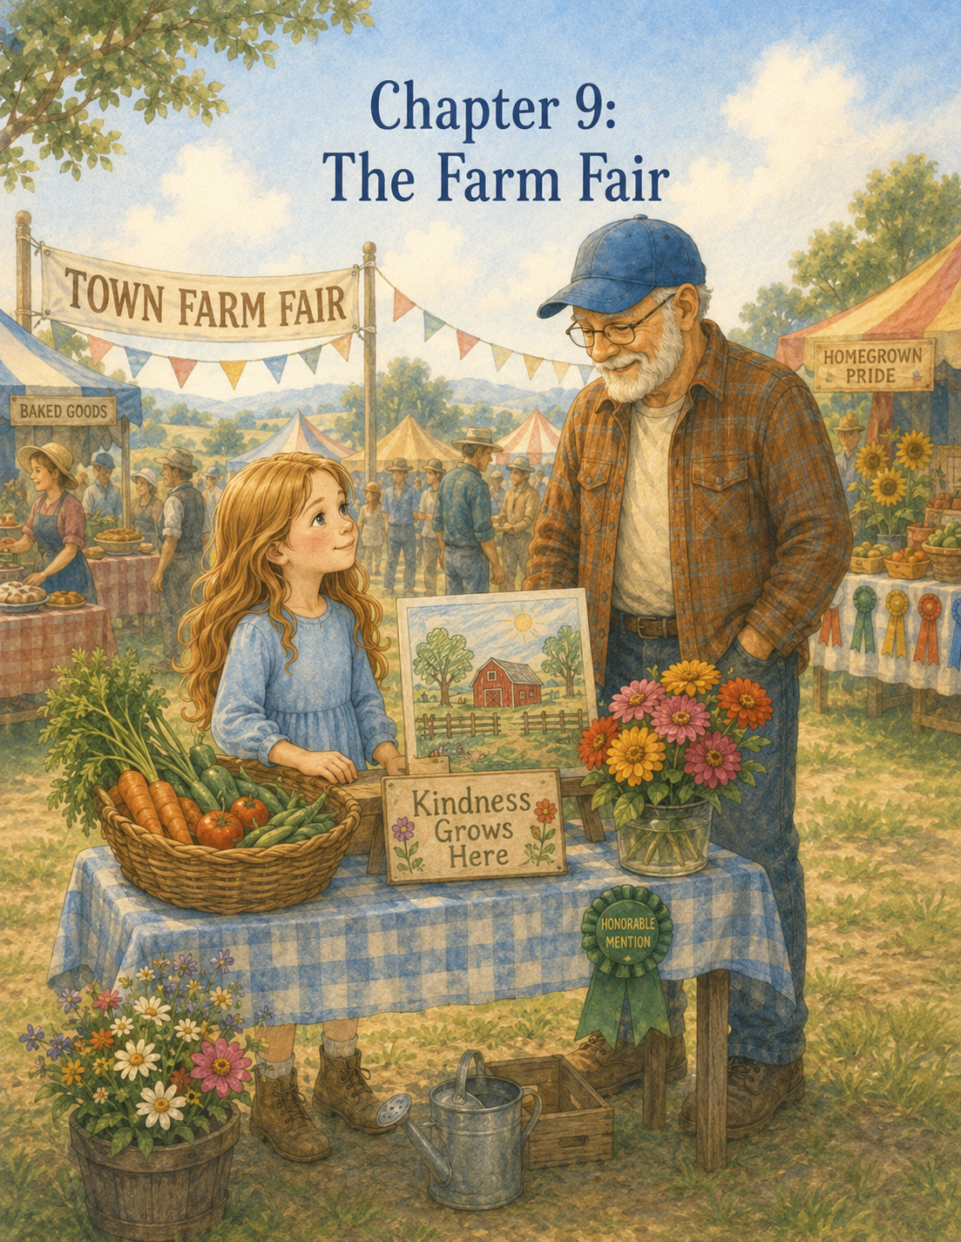

Chapter 9: The Farm Fair
The morning of the farm fair began with sunshine.
Not pale sunshine.
Not sleepy sunshine.
Bright, golden, all-over-the-fields sunshine.
It poured across Maple Hill Farm, turning the wet grass silver, the barn roof red, and the garden leaves bright green. The sky was wide and blue with only a few soft clouds floating lazily above the pasture.
Walter the rooster seemed to think the sunshine was his personal achievement.
“Cock-a-doodle-doo!”
Lily opened one eye.
Walter crowed again.
“Cock-a-doodle-doo!”
Lily pulled the quilt over her head.
“I know,” she mumbled. “It’s farm fair day.”
But even though she sounded sleepy, she was already awake.
Very awake.
Today was the town farm fair.
For the past week, everyone around Maple Hill Farm has talked about it. Mrs. Miller had mentioned her peach jam. Mr. Alvarez had said he was entering zucchini bread experiment number four. Grandpa Jim had polished jars of pickles, washed baskets, and chosen vegetables from his best rows.
And Lily had been invited to bring something too.
Three things, actually.
A basket of vegetables from her garden row.
A drawing of Maple Hill Farm.
And a small handmade sign.
At first, the idea sounded exciting. Lily imagined a cheerful fair with music, animals, ribbons, food, and children running between booths. She imagined people smiling at her vegetables and saying kind things about her drawing.
But the closer the farm fair came, the more worried she felt.
What if her vegetables looked too small?
What if her drawing was not as good as someone else’s?
What if her sign looked messy?
What if everyone else had perfect things, and hers looked like something made by a girl who had only spent part of one summer on a farm?
Lily sat up and looked at Ben’s turtle drawing above the desk.
Slow steps still count.
She wished slow steps also made nervous feelings go away.
They did not.
Her Summer Farm Journal lay open on the desk from the night before. Beside it were colored pencils, a small ruler, and the handmade sign she had been working on. The sign was painted on a piece of smooth wood Grandpa Jim had sanded for her.
In green letters, Lily had written:
Kindness Grows Here
Below the words, she had painted a little garden row with beans, carrots, zinnias, and a tiny turtle tucked near one corner.
The turtle had not been in her first plan.
But it had found its way there anyway.
Lily climbed out of bed, got dressed, brushed her hair, and tucked the folded paper turtle into her pocket. Then she picked up the sign and carried it carefully downstairs.
Grandpa Jim was in the kitchen packing biscuits into a cloth-lined basket.
He looked up and smiled.
“Well, good morning. There’s our farm fair artist.”
Lily held the sign against her chest.
“Do you think it’s too simple?”
Grandpa Jim wiped his hands on a towel.
“Let me see.”
Lily turned the sign around.
Grandpa Jim studied it carefully. He did not glance quickly and said it was nice. He looked at it the way he looked at garden rows, storm clouds, and loose fence boards—as if he wanted to see what was there.
“That,” he said at last, “is a very fine sign.”
Lily pressed her lips together.
“But the letters aren’t all the same size.”
“No.”
“And the turtle’s shell is crooked.”
“A little.”
“And the flower on the right looks like a fried egg.”
Grandpa Jim leaned closer.
“Well now,” he said, “it does have a certain breakfast quality.”
Lily groaned.
Grandpa Jim chuckled softly.
“Lily, handmade things are allowed to look handmade.”
“But what if everyone else’s signs are better?”
“Better how?”
“Straighter. Fancier. More like fair signs.”
Grandpa Jim rested both hands on the back of a chair.
“Is your sign trying to be the fanciest sign at the fair?”
Lily looked down at the painted words.
“I don’t know.”
“What did you want it to say?”
“That kindness grows here.”
“And does it say that?”
“Yes.”
“Then it has done its job.”
Lily was quiet.
Grandpa Jim picked up the biscuit basket and set it near the door.
“Effort matters more than perfect edges,” he said. “Especially when the effort comes from your heart.”
Lily wanted to believe him.
She mostly did.
But only mostly.
After breakfast, they began preparing for the fair.
The first job was choosing vegetables from Lily’s garden row.
Her beans were ready. Not all of them, but enough. Grandpa Jim had shown her how to check for pods that were long, smooth, and firm. Lily moved along the row carefully, lifting leaves and snapping beans free with gentle fingers.
Snap.
Snap.
Snap.
She placed each one in a small wicker basket lined with a blue cloth.
The carrots were trickier.
Most were still growing, but Grandpa Jim said a few could be pulled. Lily held the green tops near the soil and tugged gently.
The first carrot came out short and crooked.
Lily frowned.
“It’s bent.”
Grandpa Jim smiled.
“Most carrots are more interesting than grocery stores admit.”
The second carrot was longer, but it split into two little legs at the bottom.
Lily stared at it.
“This one looks like it’s running away.”
“Probably heard Clover was nearby,” Grandpa Jim said.
Lily laughed despite herself.
They chose three carrots. One straight, one short, and one that definitely looked like it had somewhere to go.
Then they cut a few zinnias from the end of Lily’s row. Bright pink. Orange. Yellow. They had finally bloomed, and Lily could hardly believe they had once been flat little seeds in her palm.
She added them to the basket beside the beans and carrots.
“Should flowers go with vegetables?” she asked.
Grandpa Jim nodded.
“They came from the same row. They belong.”
Lily looked at the basket.
It was pretty.
Not grand.
Not overflowing.
But pretty.
The beans curled softly along the cloth. The carrots still had a little soil in their lines, even after Grandpa Jim helped brush them clean. The zinnias made everything cheerful.
Lily touched one flower petal.
“I grew these.”
“You did,” Grandpa Jim said.
“Not all by myself.”
“No growing happens all by itself,” he said. “But you cared for them faithfully.”
Next, Lily brought her drawing downstairs.
It showed Maple Hill Farm at sunset. The farmhouse sat on one side, the red barn on the other. The garden stretched between them, and the maple tree stood near the fence with the repaired birdhouse hanging from its branch. She had added Daisy and Rosie near the barn door, Clover and Pickles by the goat pen, and Walter standing proudly in the yard.
At the end of the driveway, she had drawn the Maple Hill Farm sign.
And beneath the words, the little painted turtle.
Grandpa Jim leaned over the table.
“You included the birdhouse.”
Lily nodded.
“And Rosie.”
“Yes.”
“And Walter looks very proud.”
“He is.”
Grandpa Jim smiled. “You captured him well.”
Lily looked at the drawing. “The barn roof is a little crooked.”
“So is the real one, depending on where you stand.”
“The fence lines aren’t straight.”
“Few farm fences are.”
“And the turtle is small.”
Grandpa Jim tapped the paper gently.
“Small things can still matter.”
Lily looked up at him.
She knew he was talking about more than the turtle.
They packed everything carefully into the farm wagon: Grandpa Jim’s jars of pickles, baskets of tomatoes and squash, Lily’s vegetable basket, her drawing tucked safely between two pieces of cardboard, and her handmade sign wrapped in a towel.
Grandpa Jim added a small folding table and two wooden crates.
“Do we need anything else?” Lily asked.
“Hats,” Grandpa Jim said. “Fair sunshine is serious sunshine.”
Lily ran inside and returned with her straw hat. Grandpa Jim put on his old one.
Walter watched from the fence rail as they climbed onto the wagon bench.
“You are not invited,” Lily told him.
Walter crowed.
Grandpa Jim started the small tractor.
The engine sputtered, coughed, and then rumbled to life.
As they rolled past the farmhouse and down the gravel driveway, Lily felt the familiar bump of the wagon beneath her. Not long ago, riding in the wagon had felt new and uncomfortable. Now it felt steady. Almost comforting.
They passed the Maple Hill Farm sign, and Lily looked at Ben’s little painted turtle.
“Farm fair day,” she whispered.
The road to town wound past fields, fences, mailboxes, and shady trees. Lily saw Mrs. Miller’s house ahead. She was standing by the road with a covered basket and a jar wrapped in cloth.
Grandpa Jim slowed the tractor.
“Need a ride?” he called.
Mrs. Miller smiled.
“I thought you’d never ask.”
Grandpa Jim helped her climb onto the wagon bench beside Lily. Mrs. Miller held the basket carefully in her lap.
“Peach jam?” Lily asked.
“Peach jam,” Mrs. Miller said. “And one jar of strawberry-rhubarb, though I do not trust it as much.”
“Can jam be untrustworthy?”
“Certainly,” Mrs. Miller said. “Especially rhubarb.”
Lily laughed.
At Mr. Alvarez’s house, they stopped again. He came out carrying two loaves of zucchini bread wrapped in blue cloth.
“Experiment number four,” he announced.
Grandpa Jim looked serious.
“Should we be concerned?”
“Only slightly.”
Mr. Alvarez climbed into the wagon, and the little tractor pulled them all toward town.
The farm fair was held in a grassy field beside the community hall. When they arrived, Lily saw rows of tents and tables, bright flags, hay bales, food booths, flower displays, vegetable baskets, jars of jam, quilts, paintings, handmade crafts, and children carrying lemonade cups.
A small band played near the far end of the field.
The smell of popcorn, pies, grass, and sunshine filled the air.
Lily’s eyes widened.
“It’s bigger than I thought.”
Grandpa Jim stopped the wagon near a row of tables marked Farm and Garden Entries.
“Fairs usually are,” he said.
Suddenly, Lily’s basket felt very small.
She saw pumpkins bigger than her head. Sunflowers taller than Grandpa Jim. Baskets filled with perfect tomatoes, shiny peppers, and bright green cucumbers. A girl about Lily’s age carried a drawing of a horse that looked so real Lily almost expected it to swish its tail.
Lily swallowed.
Grandpa Jim began unloading their things.
“You all right?” he asked.
Lily nodded, but her voice came out small.
“Everyone’s things are really good.”
Grandpa Jim lifted the crate of pickles.
“They are.”
“My basket is little.”
“It is the size of what you grew.”
“My carrots are crooked.”
“They are honest carrots.”
“My drawing doesn’t look like that horse drawing.”
“No,” Grandpa Jim said. “Your drawing looks like Maple Hill Farm.”
Lily looked down.
“What if people think mine isn’t good enough?”
Grandpa Jim set the crate down and turned toward her.
“Good enough for what?”
“For the fair.”
“What did the fair ask you to bring?”
“Something I made or grew.”
“And did you?”
“Yes.”
“Did you care for your garden row?”
“Yes.”
“Did you work on your drawing?”
“Yes.”
“Did you make your sign with your own hands?”
Lily nodded.
“Then your work belongs here.”
She looked toward the long row of tables.
“But what if I don’t win anything?”
Grandpa Jim’s face softened.
“Ribbons are nice,” he said. “But they are not the reason we bring our work.”
“They’re not?”
“No. We bring our work to share it. To celebrate effort. To learn from others. To be part of the community.”
Lily held her basket closer.
“Effort matters more than prizes?”
Grandpa Jim smiled.
“Every time.”
Mrs. Miller, who had been arranging her jam jars nearby, leaned over.
“And besides,” she said, “crooked carrots have more personality.”
Mr. Alvarez nodded solemnly.
“Straight carrots are often too proud.”
Lily laughed, and the nervous knot in her stomach loosened a little.
Together, they set up the Maple Hill Farm table. Grandpa Jim placed his pickles and vegetables neatly on one side. Lily put her basket in the center. Then she carefully unwrapped her handmade sign and propped it against a small crate.
Kindness Grows Here
Mrs. Miller looked at it and smiled.
“That is lovely, Lily.”
“Thank you,” Lily said.
Mr. Alvarez studied the painted turtle.
“Excellent turtle.”
“It’s a little crooked.”
“Most excellent turtles are.”
Lily grinned.
Her drawing was displayed on a board with other children’s art. She pinned it carefully to the corner of the board. The horse drawing was there too, beautiful and detailed. Beside it were paintings of barns, flowers, dogs, tractors, and one very round pig.
Lily stepped back.
Her drawing looked different from the others.
But not bad.
Just hers.
The fair opened soon after.
People walked from table to table, stopping to admire vegetables, smell flowers, taste jams, and read signs. Children ran past with painted faces. Someone rang a bell near the pie contest. A baby goat in a small pen tried to eat a ribbon from a fence post.
“Clover would approve,” Lily said.
Grandpa Jim chuckled.
Throughout the morning, people stopped at the Maple Hill Farm table.
“What beautiful zinnias,” one woman said.
“Those beans look tender,” said an older man.
A little boy pointed to Lily’s carrots.
“That one has legs!”
Lily looked at his mother, worried.
But the boy laughed with delight.
“It’s the best carrot!”
Lily laughed too.
“It does look like it’s running.”
The boy’s mother smiled.
“Did you grow these?”
Lily nodded. “Grandpa Jim gave me my own row.”
“That’s wonderful,” the woman said. “A garden teaches patience.”
Lily smiled.
“I know.”
When people asked about the sign, Lily explained that she had painted it for the farm fair. She told them Grandpa Jim said kindness grew through small things, like helping neighbors, caring for animals, repairing broken birdhouses, and showing up when something needed doing.
An elderly man with a cane read the sign quietly.
Then he said, “That is a good thing to grow.”
Lily felt proud.
Not the loud kind of pride.
The warm kind.
The kind that sat quietly inside her.
Later, Grandpa Jim took Lily to see the rest of the fair. They visited the animal pens first. There were rabbits, chickens, sheep, and two calves. Lily stopped beside one calf with soft brown eyes.
“She reminds me of Rosie,” she said.
“This one looks calmer around crowds,” Grandpa Jim said.
“She probably hasn’t been caught outside in a storm.”
“Probably not.”
They looked at quilts stitched in bright patterns. They watched children race with sacks across the grass. They tasted like a tiny sample of honey from a local beekeeper.
Mr. Alvarez entered his zucchini bread on the baked goods table.
Mrs. Miller placed her peach jam beside several other jars with fancy labels.
Lily stood with Grandpa Jim near the judging table when the fair judges began placing ribbons. Blue, red, yellow, and white ribbons appeared beside vegetables, flowers, jams, pies, and crafts.
Her heart began beating faster again.
She had told herself she did not need to win.
Grandpa Jim had told her effort mattered more than prizes.
She believed that.
Mostly.
But a small part of her still hoped.
The judges stopped at the children’s art board. They looked at the horse drawing for a long time. Then they looked at a painting of sunflowers. Then at Lily’s drawing.
Lily held her breath.
One judge smiled and pointed at the repaired birdhouse in the picture.
Another judge nodded.
Then they moved on.
A blue ribbon went to the horse drawing.
A red ribbon went to the sunflower painting.
A yellow ribbon went to a drawing of a tractor.
Lily’s drawing did not get a ribbon.
Her stomach sank a little.
Grandpa Jim did not say anything right away. He simply stood beside her.
Lily stared at the art board.
The horse drawing was wonderful. She knew that. The sunflower painting was bright and beautiful. The tractor drawing had excellent wheels.
Still, her heart felt heavy.
“I didn’t win,” she said quietly.
“No,” Grandpa Jim said.
“I thought I didn’t care.”
“It is all right to care.”
Lily looked down at her shoes.
“Then why does it feel bad?”
“Because you worked hard. Wanting your work to be noticed is natural.”
Lily blinked quickly.
“I know the other drawings are better.”
Grandpa Jim knelt a little, so his eyes were closer to hers.
“Different,” he said. “Not better in every way.”
“But they got ribbons.”
“They did.”
Grandpa Jim pointed gently toward Lily’s drawing.
“Your picture tells a story. I saw the farm. I see the animals. I see the birdhouse we repaired. I see the turtle by the sign. I see care in the details. A ribbon does not decide whether your work has meaning.”
Lily looked at the drawing again.
She saw what he meant.
Her barn roof was crooked, and her fence lines wobbled. But there was Rosie near Daisy. Clover in the pen. The birdhouse is in the tree. The little turtle beneath the sign.
It was not just a picture of a farm.
It was a picture of her summer.
Mrs. Miller came over and squeezed Lily’s shoulder gently.
“I saw two people stop and point at your drawing,” she said.
“You did?”
“Yes. One said it looked like a place where good memories lived.”
Lily’s eyes lifted.
“They said that?”
“They did.”
That helped.
A lot.
A little later, the judges came to the vegetable baskets.
Grandpa Jim’s tomatoes earned a red ribbon.
Mrs. Miller’s peach jam won a blue ribbon, which made Mr. Alvarez cheer so loudly that people turned to look.
Mr. Alvarez’s zucchini bread earned a white ribbon.
“Fourth place,” he said proudly. “Experiment number four received fourth place. That feels appropriate.”
Lily laughed.
Then the judges reached the children’s garden entries.
There were baskets with bigger vegetables than Lily’s. Straighter carrots. More beans. Larger flowers. One basket had tiny potatoes arranged in a perfect circle.
Lily braced herself.
The judges looked at her basket.
One of them picked up the carrot with two little legs and smiled.
They read her entry card:
Lily — Maple Hill Farm
Beans, Carrots, and Zinnias
They whispered to each other.
Then they moved on.
Lily did not expect anything.
But a few minutes later, one judge returned and placed a small green ribbon beside her basket.
Lily stared at it.
The ribbon read:
Honorable Mention
Best Story Basket
Lily looked up at Grandpa Jim.
“What does that mean?”
Grandpa Jim smiled.
“It means your basket told them something.”
The judge turned to Lily.
“Is this yours?”
Lily nodded.
“I liked the mix,” the judge said. “Vegetables and flowers together. And that carrot there looks like it has quite an adventure ahead.”
Lily smiled.
“It does look like it’s running.”
“It made us smile,” the judge said. “That counts at a fair.”
Lily touched the green ribbon gently.
Not blue.
Not red.
Not first place.
But hers.
A ribbon for a basket that told a story.
Suddenly, winning felt different from what she had imagined. It was nice, but it was not the only thing. Even before the ribbon, people smiled at her carrots. Mrs. Miller had admired her sign. Someone had said her drawing looked like a place where good memories lived.
The fair had not been about proving she was the best.
It had been about sharing what she had grown, made, and learned.
Near the end of the afternoon, Lily stood beside the Maple Hill Farm table as the sun lowered over the fairgrounds. The band played a cheerful song. Children ran with sticky fingers and painted cheeks. The smell of popcorn drifted through the warm air.
Grandpa Jim packed the empty crates.
Mrs. Miller wrapped her blue ribbon carefully around her jam jar.
Mr. Alvarez held his white ribbon and said, “Next year, experiment number five will be unstoppable.”
Lily lifted her handmade sign.
Kindness Grows Here
She looked at the words and smiled.
“I’m glad I brought it,” she said.
Grandpa Jim set a crate into the wagon.
“I’m glad you did too.”
“I was worried it wasn’t good enough.”
“And what do you think now?”
Lily thought about that.
“It wasn’t perfect.”
“No.”
“But it belonged here.”
Grandpa Jim nodded.
“Yes, it did.”
Lily looked at the fair one more time.
“I think I belonged here too.”
Grandpa Jim’s eyes grew soft.
“You surely did.”
The ride home was quieter than the ride there. Everyone was tired in a happy way. Mrs. Miller held her jam basket. Mr. Alvarez held the leftover zucchini bread. Lily held her green ribbon in her lap, running her fingers over the words.
Best Story Basket
As the wagon rolled down the lane, she watched the fields pass by in the golden evening light.
When they reached Mrs. Miller’s house, she climbed down carefully and turned to Lily.
“You did beautiful work today,” she said.
“Thank you.”
“And not because of the ribbon,” Mrs. Miller added. “Because you showed up with something you made and let people see it. That takes courage.”
Lily smiled.
At Mr. Alvarez’s house, he gave Lily a small slice of zucchini bread wrapped in cloth.
“For the artist-gardener,” he said.
“Thank you,” Lily said. “It deserved the white ribbon.”
Mr. Alvarez bowed.
“A generous review.”
When Lily and Grandpa Jim finally turned into the driveway at Maple Hill Farm, the painted turtle sign welcomed them home.
Lily looked at the little turtle.
“Slow steps still count,” she said softly.
Grandpa Jim parked the wagon near the barn.
They unloaded the crates, the pickles, the sign, the drawing, and Lily’s basket. She placed the green ribbon carefully on top of the vegetables.
Then she carried everything to her room.
The farmhouse felt peaceful after the noise of the fair. Crickets chirped outside. The repaired birdhouse hung in the maple tree, and a little brown bird sat on the perch.
Lily sat at her desk and opened her Summer Farm Journal.
She placed the green ribbon beside the page.
Then she wrote:
Day Nine: The Farm Fair
She drew her basket of beans, carrots, and zinnias. She made sure to draw the carrot with legs. Then she drew a little green ribbon beside it.
She began to write.
Today was the town farm fair. I brought vegetables and flowers from my garden row, a drawing of Maple Hill Farm, and my handmade sign that said “Kindness Grows Here.” I was nervous because everyone else’s work looked so good. Some vegetables were bigger. Some drawings were straighter. Some signs were fancier.
Lily paused and looked at the handmade sign leaning against her dresser.
Then she kept writing.
Grandpa Jim told me effort matters more than prizes. At first, I wanted to believe that, but I still felt sad when my drawing did not get a ribbon. Then Mrs. Miller told me someone said my picture looked like a place where good memories lived. That made me feel proud.
She touched the green ribbon.
My vegetable basket got an honorable mention for “Best Story Basket.” The judge said my carrot looked like it was having an adventure. I learned that sharing your work matters, even if you do not win first place.
Lily thought about the fair. The music. The booths. The vegetables. The kind words. The nervous feeling that had slowly turned into joy.
She wrote one more sentence:
Today I learned that trying, finishing, and sharing something from your heart can feel even better than winning.
She looked up at Ben’s turtle drawing.
Slow steps still count.
Lily smiled.
Her summer had been full of slow steps.
Chores.
Seeds.
Storms.
Neighbors.
New things.
Broken Birdhouses.
And now, a farm fair.
None of it had been perfect.
But all of it had mattered.
Downstairs, Grandpa Jim called, “Lily, Mrs. Miller sent home one jar of peach jam for tomorrow’s biscuits.”
Lily laughed.
“Coming!”
She tucked the green ribbon carefully inside her journal, right beside the page she had written.
Then she ran downstairs, feeling tired, happy, and proud.
Not because she was the best.
Because she had tried.
Because she had followed through.
Because she had brought something small and honest into the world and let it be seen.
And that, Lily thought, might be one of the bravest things of all.

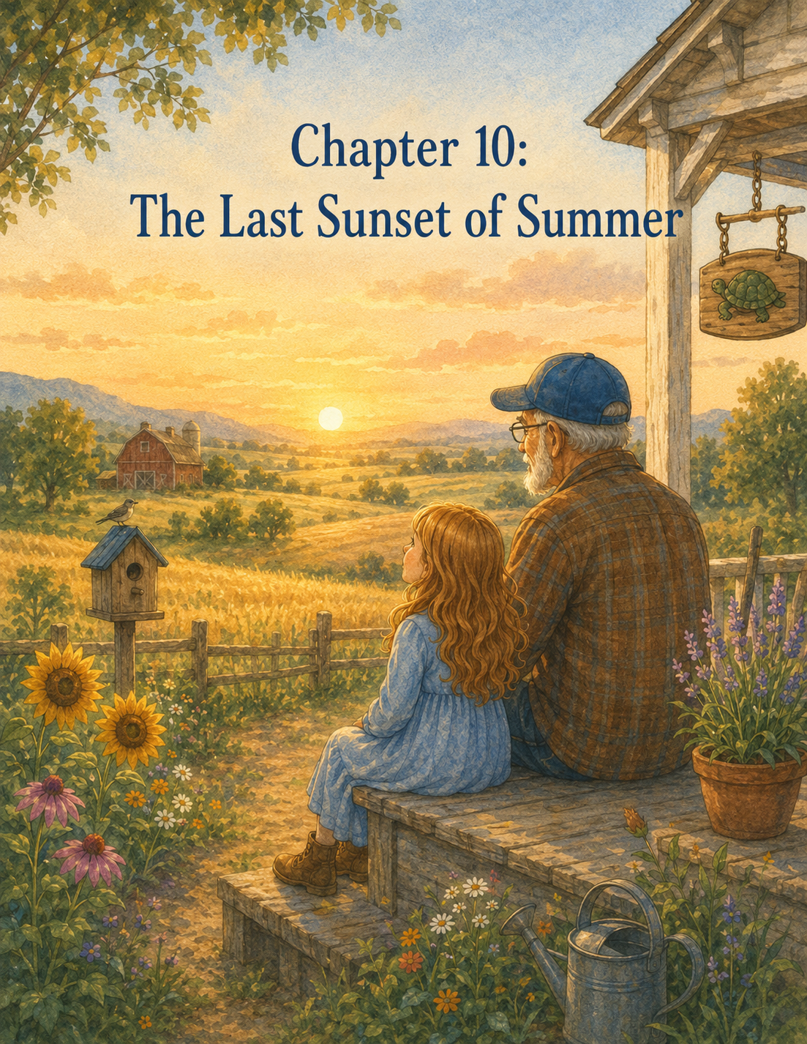

Chapter 10: The Last Sunset of Summer
The last day of summer at Maple Hill Farm arrived softly.
It did not announce itself with thunder or wind. It did not come rushing in with surprises or escaped goats or fair ribbons. It came quietly, with pale morning light spilling across Lily’s bedroom floor and the familiar sound of Walter the rooster crowing outside her window.
“Cock-a-doodle-doo!”
Lily opened her eyes.
For once, she did not groan.
She lay still beneath the quilt, listening.
Walter crowed again.
The chickens clucked in the yard. Somewhere near the barn, Daisy gave her slow morning moo. The wind chimes on the porch rang gently in the breeze. From the pasture came the soft sounds of animals waking.
Lily knew all of those sounds now.
On her first morning at Grandpa Jim’s farm, they had felt strange and unfamiliar. Now they felt like the beginning of a song she had learned by heart.
She sat up and looked across the room.
Ben’s turtle drawing still hung above the little desk.
Slow steps still count.
The words had watched over her all summer. They had been there when she first unpacked her suitcase, nervous and unsure. They had been there after her first morning chores, when she learned that responsibility was not about being perfect. They had been there after Clover got loose, after Rosie trembled in the storm, after seeds pushed through the soil, after the birdhouse was repaired, and after the farm fair ribbon was tucked inside her journal.
Lily swung her feet to the floor and stood by the window.
The garden was bright in the morning sun. Her row had changed so much that it hardly seemed like the same little strip of dirt Grandpa Jim had given her weeks before. The bean plants climbed their supports. The carrot tops spread thick and green. The zinnias stood proudly at the end of the row, blooming in pink, orange, yellow, and red.
The repaired birdhouse hung from the maple tree near the fence. A small brown bird landed on its perch, disappeared inside, then popped out again.
Lily smiled.
The birdhouse was being used.
The garden had grown.
The farm had kept teaching.
And today, Lily would begin packing to go home.
The thought made her chest feel full and heavy.
Not exactly sad.
Not exactly happy.
Both, somehow.
She dressed slowly, pulling on jeans, a soft green shirt, and the sneakers that no longer looked like city sneakers at all. They were scuffed, stained with soil, and marked by many mornings of real farm work.
Then Lily picked up Ben’s old gloves from the dresser.
She turned them over in her hands.
The gloves were still too big, but they fit her better than they had at the beginning. Or maybe she had simply grown used to them. The patched finger was darker now from soil and water. The palms held tiny marks from chores, garden work, and careful repairs.
Lily slipped them on.
“Last morning chores,” she whispered.
Downstairs, Grandpa Jim was already in the kitchen. He stood at the stove making pancakes, just as he had on her first morning. A plate of sliced peaches sat on the table, along with a small jar of Mrs. Miller’s blue-ribbon peach jam.
Grandpa Jim turned when he heard her.
“Well,” he said, “there she is. The finest summer helper Maple Hill Farm has had in a long while.”
Lily smiled, but her throat tightened a little.
“Even finer than Walter?”
Grandpa Jim looked serious.
“That is a dangerous comparison. Walter thinks highly of himself.”
As if he had heard his name, Walter crowed outside the open window.
Lily laughed.
Grandpa Jim set a plate of pancakes in front of her.
“Farm rule number one still stands,” he said. “Important days require a good breakfast.”
“I thought rule number one was guests should never arrive without cookies waiting.”
“That is arrival rule number one,” Grandpa Jim said. “Departure days get their own rules.”
Lily spread peach jam over one pancake.
“I don’t like departure rules.”
Grandpa Jim sat across from her.
“No,” he said gently. “They can be hard ones.”
Lily looked down at her plate.
“I’m excited to see Mom,” she said. “But I don’t want to leave the farm.”
Grandpa Jim nodded.
“That happens when a place becomes part of you.”
“Can a place do that?”
“Oh yes,” he said. “Some places leave mud on your shoes. Some leave lessons in your heart. The best ones do both.”
Lily looked under the table at her dirty sneakers.
“This farm did both.”
After breakfast, they went outside for morning chores.
The air was warm but not too hot. The sky was clear. A soft breeze moved through the grass. Everything looked ordinary, but to Lily it felt special because it was the last time she would do these chores before going home.
She carried the chicken feed to the coop.
Henrietta hurried toward her shoes.
“Good morning, Henrietta,” Lily said. “I’m leaving today, so please be polite.”
Henrietta pecked at the ground near Lily’s laces.
“That is close enough,” Lily said.
Grandpa Jim chuckled from the gate.
Lily spread the feed in a neat line along the trough, just as she had learned. The chickens gathered around, clucking and pecking. Walter strutted through them, his red feathers shining in the sun.
“You still think you are in charge,” Lily told him.
Walter crowed.
“I know,” she said. “You have mentioned it.”
Next came the water buckets. Lily carried them to the pump and filled each one only as much as she could manage. She remembered the first day she had sloshed water all over her shoes. Now she walked carefully, steadying the bucket with both hands.
A little water still splashed out.
But not much.
Grandpa Jim noticed.
“The art of the half-full bucket,” he said.
“I finally learned it.”
“You did.”
They brought fresh water to the chickens, then went to the barn.
Daisy stood calmly in her stall. Rosie, no longer the tiny trembling calf from the storm, stood beside her, taller now and steadier on her legs.
“Good morning, Rosie,” Lily said softly.
Rosie stepped forward and sniffed Lily’s gloved hand.
Lily smiled.
“You were the bravest calf I ever met.”
Grandpa Jim leaned on the stall gate.
“She had a good teacher that day.”
Lily looked at him.
“I didn’t teach her.”
“You helped her feel safe. That teaches plenty.”
Marmalade, the gray cat, stretched from his hay bale and gave a slow blink.
“Good morning, Marmalade,” Lily said.
The cat blinked again.
“I’ll miss your enthusiasm.”
Grandpa Jim laughed.
Lily swept the barn aisle with smooth, even strokes. She remembered how awkward the broom had felt at first, how hay had scattered, and dust had puffed into the air. Now she knew how to work in smaller sections, gathering straw into neat piles.
Push.
Sweep.
Gather.
Push.
Sweep.
Gather.
Responsibility, she had learned, was not always exciting. Sometimes it was simply doing what needed to be done because something or someone depended on you.
After the barn, they checked the goats.
Clover and Pickles trotted to the fence as soon as they saw Lily.
“Hello, trouble wearing hooves,” Lily said.
Clover bleated.
Pickles tried to nibble the fence post.
Grandpa Jim handed Lily a small scoop of feed.
“Careful,” he said. “Pickles still believes you may be a walking restaurant.”
Lily laughed and poured the feed into the trough.
Then she checked the gate latch.
Lift.
Drop.
Tug twice.
Just as Grandpa Jim had taught her.
“Secure,” she said.
Grandpa Jim nodded approvingly.
“Ben would be proud of that latch check.”
Lily’s hand rested on the gate.
She looked toward the small wooden sign Ben had painted years ago:
DO NOT CHASE GOATS.
THEY THINK IT IS FUN.
The letters were faded, but Lily could read them easily now. She had read them so many times that she almost knew them by memory.
“I think about that sign every time I see Clover,” Lily said.
“So do I.”
“It makes me laugh.”
“Me too.”
“But it also makes me miss him.”
Grandpa Jim was quiet for a moment.
“That is how memories often work,” he said. “They can make us smile and ache at the same time.”
Lily looked at the painted goat beneath the words.
“I used to think missing someone was only sad.”
“It can feel that way at first.”
“But here, missing Ben feels different. Still sad, but also…” She searched for the right word. “Warm.”
Grandpa Jim’s eyes softened.
“Love leaves warmth behind.”
Lily nodded.
She understood that now.
After chores, Lily went to her garden row.
Grandpa Jim followed with a basket.
“Today,” he said, “we harvest what is ready.”
Lily knelt beside the beans. The plants had grown thick and green, with pods hanging beneath the leaves. She picked them carefully, snapping each one from the vine.
Snap.
Snap.
Snap.
She placed them in the basket.
Then Grandpa Jim helped her loosen the soil around the carrots. Lily wrapped her fingers around the green tops and pulled.
The first carrot came out long and straight.
The second was short and round.
The third split into two legs, just like the farm fair carrot’s cousin.
Lily laughed.
“This one is running away too.”
“Your carrots seem adventurous,” Grandpa Jim said.
They picked several more, brushing off the soil and laying them in the basket. Then Lily cut a handful of zinnias. Their colors looked even brighter against the green beans and orange carrots.
“These came from seeds,” she said, almost to herself.
“They did.”
“They were so tiny.”
“And now?”
“Now they’re flowers.”
Grandpa Jim smiled.
“That is the patience of a garden.”
Lily looked at the row.
Some plants were still growing. Some beans were too small to pick. Some carrots needed more time. Some zinnia buds had not opened yet.
“What happens to the rest after I leave?” she asked.
“I’ll care for them,” Grandpa Jim said. “And I’ll send you pictures.”
Lily smiled.
“Promise?”
“Promise.”
She touched the soil lightly with one gloved finger.
At first, this row had looked like nothing. Just dirt and markers. Now it had given vegetables, flowers, a farm fair basket, and many lessons.
“It feels hard to leave it,” she said.
“That means you cared for it.”
Lily nodded.
She had cared.
That was why leaving felt hard.
They carried the basket to the farmhouse porch. Grandpa Jim set it on the table, and Lily arranged the zinnias in a jar of water.
“These are for Mom when she comes,” Lily said.
“She’ll like that.”
The rest of the morning was for packing.
Lily did not enjoy it.
Her suitcase sat open on the bed, looking too empty at first and then too full. She folded shirts, socks, and jeans. She packed her books, colored pencils, flashlight, sweater, and the green Summer Farm Journal. She placed the farm fair ribbon carefully between the pages so it would not bend.
On the desk, the paper turtle waited.
Lily picked it up.
It was more wrinkled than ever now. One fold had softened, and one corner was bent. But she loved it more than she had when she arrived.
She placed it inside the front pocket of her journal.
Then she looked at Ben’s turtle drawing on the wall.
Slow steps still count.
For the first time, she wondered if it should stay there.
It belonged to the room.
To the farm.
To Grandpa Jim.
To Ben.
Lily touched the frame gently.
“Thank you,” she whispered.
Downstairs, Grandpa Jim was tying a ribbon around a small bundle of zinnias.
“For your mother,” he said.
Lily carried her suitcase to the bottom of the stairs.
Grandpa Jim looked at it.
“Packed already?”
“Mostly.”
“That was brave.”
“Packing is not brave.”
“Leaving a place you love can be.”
Lily thought about that.
Maybe he was right.
By late afternoon, Lily’s mother had not arrived yet, so Grandpa Jim suggested one last walk around the farm.
“I would like that,” Lily said.
They began at the porch.
The wind chimes moved softly above them. The rocking chair creaked as the breeze nudged it. The flowerpots by the steps were fuller than they had been when Lily first arrived.
Then they walked to the chicken coop.
Henrietta scratched near the ramp. Walter watched them from the fence.
“Goodbye, chickens,” Lily said.
Henrietta clucked.
Walter crowed.
“I’ll take that as a goodbye,” Lily said.
They walked to the barn.
Daisy and Rosie lifted their heads when Lily stepped inside. Marmalade opened one eye from his hay bale.
Lily rested her hand on Daisy’s stall door.
“Goodbye, Daisy. Goodbye, Rosie.”
Rosie stepped closer, and Lily stroked the soft place between her ears.
“Don’t stand outside in storms anymore,” Lily whispered.
Rosie blinked.
Marmalade flicked his tail.
“And goodbye, Marmalade,” Lily said. “Try to be less excited about everything.”
The cat closed his eye again.
Grandpa Jim smiled.
They visited Clover and Pickles next.
Clover came to the fence and pushed her nose through the rails. Pickles followed, looking hopeful.
“I’m going to miss you,” Lily told Clover. “But please do not escape while I’m gone.”
Clover bleated.
“I mean it.”
Pickles tried to nibble Lily’s sleeve.
“Pickles, I am not food.”
Grandpa Jim laughed.
They checked the gate one last time.
Lift.
Drop.
Tug twice.
Then they walked to the maple tree.
The repaired birdhouse hung from the branch, steady and bright in the evening light. Its blue roof had weathered a little, and the flowers Lily had touched up still showed softly on the sides. The small white star she had painted for Ben rested near the back corner.
A bird chirped from inside.
Lily smiled.
“It’s a home again.”
“It is,” Grandpa Jim said.
“I’m glad we fixed it.”
“So am I.”
Lily looked at the little white star.
“Do you think Ben knows?”
Grandpa Jim did not answer quickly.
He looked up at the birdhouse, then went out toward the fields.
“I believe love has a way of reaching farther than we understand,” he said. “So yes, I think he knows.”
Lily let that thought settle gently inside her.
Then they walked to the garden.
The sun was lower now, casting golden lines across the rows. Bees moved lazily over the flowers. Tomato vines leaned heavily with fruit. The squash leaves spread wide. Lily’s row stood near the edge, green and alive.
She knelt beside it one more time.
“Goodbye, beans,” she said. “Goodbye, carrots. Goodbye, zinnias.”
Grandpa Jim stood quietly beside her.
“I know plants don’t understand goodbye,” Lily said.
“Maybe not in words.”
“But I still wanted to say it.”
“That is reason enough.”
Lily pulled one small weed near the carrots.
Grandpa Jim raised his eyebrows.
“Still caring for it on the last day?”
Lily smiled.
“Responsibility means showing up.”
“It does.”
She stood and brushed soil from her knees.
“Even when you’re leaving.”
“Especially then.”
They continued past the garden to the pasture fence. The fields stretched out before them, wide and peaceful. The sun hovered above the trees, turning the clouds peach, pink, and gold.
Grandpa Jim leaned on the top rail.
Lily climbed onto the lower rail and leaned beside him.
This was where they had stood on her first day. Back then, the farm had felt beautiful but big. Peaceful but strange. Full of Ben’s memory in a way that made Lily unsure whether she would feel comforted or sad.
Now the farm still felt full of Ben.
But Lily understood it differently.
Ben was in the painted turtle sign by the driveway.
In the old gloves.
In the goat sign.
In the turtle drawing above the desk.
In the birdhouse flowers.
In the stories Grandpa Jim told.
In the way the farm seemed to remember him without stopping its own life from growing.
Lily watched the sunset spread across the sky.
“I thought being here might make me miss Ben too much,” she said.
Grandpa Jim nodded.
“And did it?”
“Yes,” Lily said honestly. “But it also helped.”
“How?”
She thought for a long moment.
“It made him feel close. Not like he came back. I know he didn’t. But like the love he left behind is still doing things.”
Grandpa Jim’s eyes shone in the golden light.
“That is a very wise thing to say.”
Lily looked down at her hands.
She was still wearing Ben’s gloves.
“Do you want these back?” she asked.
Grandpa Jim looked at the gloves.
“They were Ben’s,” Lily said. “And they belong here.”
Grandpa Jim was quiet.
Then he said, “They were Ben’s. But this summer, they became yours too.”
Lily swallowed.
“I can keep them?”
“If you would like.”
Her fingers curled inside the gloves.
“I would.”
“Then take them home,” Grandpa Jim said. “Use them when something needs care.”
Lily nodded, blinking quickly.
“I will.”
The sun sank lower.
The fields glowed.
For a while, they did not speak.
Then Grandpa Jim said, “Tell me what the farm taught you.”
Lily smiled a little.
“That might take a long time.”
“We have until the sun goes down.”
So Lily began.
“The chickens taught me responsibility,” she said. “Because they needed food even when I was sleepy.”
Grandpa Jim nodded.
“The water buckets taught me not to carry too much at once.”
“A useful lesson.”
“The barn taught me that small strokes work better than trying to sweep everything at once.”
“Very true.”
“Clover taught me that courage can be quiet and slow.”
Grandpa Jim smiled.
“And goats think being chased is fun.”
“That too,” Lily said.
“Rosie taught me compassion,” she continued. “That someone else can be scared even when I’m scared too. And sometimes kindness is staying close.”
Grandpa Jim’s face softened.
“The garden taught me patience. And those things can be growing even when I can’t see them.”
“Yes.”
“The wagon taught me that trying new things can feel uncomfortable at first, but then they can become joyful.”
“Mrs. Miller’s garden?” Grandpa Jim asked.
“That helping does not have to be big. Sometimes it is carrying baskets before the rain.”
“The birdhouse?”
Lily looked toward the maple tree.
Those memories need care. And that fixing something old can be a way of keeping love alive.”
Grandpa Jim wiped one hand across his eyes, then looked out over the fields.
“And the farm fair?”
Lily smiled.
“That effort matters more than prizes. But ribbons are still nice.”
Grandpa Jim chuckled.
“Yes, they are.”
Lily looked at the setting sun.
“And Ben taught me slow steps still count.”
Grandpa Jim’s voice was quiet when he answered.
“He taught me that, too.”
The sky deepened to orange and rose. The first hints of purple appeared near the trees. A few birds crossed overhead, flying toward their evening nests.
Lily leaned her shoulder gently against Grandpa Jim’s arm.
“I don’t want summer to end.”
“No,” Grandpa Jim said. “Good summers are hard to leave.”
“Will I come back?”
“I hope so.”
“Next summer?”
“If your mother agrees, Maple Hill Farm will be waiting.”
Lily smiled.
That helped.
A car appeared at the far end of the driveway, headlights soft in the evening light.
Lily knew it was her mother.
Her heart jumped with happiness and sadness all at once.
Grandpa Jim straightened.
“Looks like your ride is here.”
Lily stayed at the fence for one more moment, watching the sun touch the edge of the field.
Then she turned toward the house.
Her mother hugged her tightly when she stepped out of the car.
“Oh, Lily,” she said. “Look at you. You look taller.”
“I don’t think I grew taller,” Lily said.
Grandpa Jim stood beside her, smiling gently.
“Maybe not in inches.”
Her mother looked from Lily to Grandpa Jim.
“That kind of summer?”
Lily nodded.
“That kind.”
They carried Lily’s suitcase to the car. Grandpa Jim placed the jar of zinnias on the back seat floor where it would not tip. Lily held her Summer Farm Journal in one arm and Ben’s old gloves in the other.
Her mother noticed the gloves.
“Are those coming home with us?”
Lily looked at Grandpa Jim.
He nodded.
“Yes,” Lily said. “They’re for when something needs care.”
Her mother smiled, though her eyes looked a little shiny.
Before getting into the car, Lily walked back to Grandpa Jim.
For a moment, she did not know what to say.
Thank you did not seem big enough.
Goodbye seemed too small.
So she hugged him.
Grandpa Jim wrapped his arms around her gently.
“You did good work this summer,” he said.
Lily pressed her face against his shirt.
“I’m going to miss you.”
“I’ll miss you too.”
“And the farm.”
“The farm will miss you.”
“Even Walter?”
Grandpa Jim chuckled.
“Especially Walter. He likes a good audience.”
Lily laughed, then pulled back.
“Will you send pictures of my garden?”
“I promise.”
“And Rosie?”
“Yes.”
“And the birdhouse?”
“Yes.”
“And if Clover escapes—”
“I will not send pictures of Clover escaping,” Grandpa Jim said. “I will prevent Clover from escaping.”
Lily smiled.
“That’s better.”
Grandpa Jim reached into his shirt pocket and pulled out a small folded piece of paper.
“I have something for you,” he said.
Lily opened it carefully.
Inside was a small drawing.
It showed a turtle walking beside a garden row. On its shell were tiny flowers, and above it Grandpa Jim had written:
Keep growing, one slow step at a time.
Lily held the drawing close.
“Did you make this?”
“I did,” he said. “With less skill than Ben, but a great deal of care.”
“I love it.”
“Then it did its job.”
Lily tucked the drawing into her journal.
The sun was almost gone now. The fields glowed with the last light of day.
Lily climbed into the car and buckled her seat belt. Her mother started the engine.
Grandpa Jim stood by the porch, raised one hand.
Lily rolled down the window.
“Goodbye, Grandpa Jim!”
“Goodbye, Lily!”
Walter crowed from the yard.
Lily laughed.
“Goodbye, Walter!”
The car rolled slowly down the gravel driveway.
They passed the barn.
The garden.
The maple tree with the birdhouse.
The goat pen.
The pasture fence.
Then they reached the sign at the end of the drive.
Maple Hill Farm
Beneath it was Ben’s painted turtle, small and green, with one crooked leg.
Lily pressed her hand to the window as they passed.
For a moment, the turtle seemed to move with her.
Then the car turned onto the country road, and the farm disappeared behind the trees.
Lily looked down at the journal in her lap.
Inside it were her summer lessons. Her drawings. Her farm fair ribbon. Her paper turtle. Grandpa Jim’s new turtle drawing.
Beside her were Ben’s gloves.
On the floor were the zinnias from her garden.
Her heart felt full.
Full of missing.
Full of remembering.
Full of gratitude.
Full of the farm.
Her mother glanced at her from the driver’s seat.
“Are you okay?”
Lily looked out at the sunset, now fading into soft purple and gold.
“Yes,” she said. “I’m sad to leave. But I’m okay.”
Her mother smiled gently.
“What was your favorite part?”
Lily thought about the chickens, Clover, Rosie, the garden, the wagon, Mrs. Miller, the birdhouse, the fair, Grandpa Jim, and the last sunset over the fields.
“I don’t think I can pick just one,” she said.
“That good?”
“That good.”
She looked down at Ben’s gloves and slid one hand inside.
They were still a little big.
But they felt right.
Lily thought about everything the summer had taught her.
Responsibility.
Courage.
Patience.
Compassion.
Kindness.
Trying new things.
Caring for memories.
Showing up.
Following through.
Growing quietly.
She had learned those lessons on the farm, but she knew now that she did not have to leave them there.
She could carry them home.
To her family.
To her school.
To her friends.
To animals that needed gentleness.
To people who needed help.
To moments when she felt afraid.
To places where kindness needed to grow.
Outside the car window, the first star appeared in the evening sky.
Lily smiled.
“Goodnight, Ben,” she whispered.
Then she opened her Summer Farm Journal to the very last page.
The car moved gently along the road as she wrote:
Last Day at Grandpa Jim’s Farm
She paused, thinking of the sunset.
Then she wrote:
I came to the farm unsure of what the summer would bring. I am leaving with dirty shoes, Ben’s gloves, flowers from my garden, and a heart full of lessons. Grandpa Jim says some places leave mud on your shoes and lessons in your heart. Maple Hill Farm did both.
Lily looked out the window as the sky darkened.
Then she added one final line:
I learned that love does not disappear. It grows quietly in the good things we keep doing.
She closed the journal and held it against her chest.
Behind her, the farm was out of sight.
But inside her, it was still there.
The garden.
The animals.
Grandpa Jim.
Ben’s memory.
The last sunset of summer.
And all the slow steps still to come.

Epilogue: One Slow Step at a Time
A few weeks after Lily returned home from Maple Hill Farm, a small envelope arrived in the mail.
It was addressed in Grandpa Jim’s careful handwriting:
Miss Lily
Keeper of Beans, Carrots, Zinnias, and Brave Things
Lily smiled before she even opened it.
Inside was a folded note, three photographs, and one dried zinnia pressed flat between two pieces of paper.
The first photograph showed Lily’s garden row. The beans had grown taller, twisting up their poles in green curls. The carrots were thicker now, their leafy tops spreading across the soil. The zinnias bloomed brightly at the end of the row, just as cheerful as Lily remembered.
The second photograph showed Rosie standing beside Daisy in the barn, a little taller and steadier than before.
The third photograph showed the repaired birdhouse hanging from the maple tree. A small brown bird sat proudly on the perch, and a few pieces of straw peeked from the round opening.
Lily held the picture close and smiled.
Then she read Grandpa Jim’s note.
Dear Lily,
Your garden is still growing. Rosie is getting braver every day. Clover has not escaped this week, though I would not call her trustworthy. The birdhouse has new residents, and Walter continues to believe the sun rises because he tells it to.
The farm misses you, and so do I.
Keep caring for what is in front of you. Keep trying new things. Keep showing kindness in small ways. That is how good things grow.
One slow step at a time,
Grandpa Jim
Lily read the note twice.
Then she taped the photographs above her desk at home. She placed the dried zinnia inside her Summer Farm Journal beside the green ribbon from the farm fair. Ben’s old gloves rested on the corner of her desk, ready for the next time something needed care.
At first, home felt different from the farm.
There were no chickens to feed in the morning. No barn aisle to sweep. No Clover to watch at the gate. No Rosie waiting in fresh straw. No garden row stretching beneath the wide country sky.
But little by little, Lily began to notice that the lessons from the farm had followed her.
When her mother needed help carrying groceries, Lily came without being asked.
When a classmate felt nervous about reading aloud, Lily sat beside her and whispered, “You can do it one slow step at a time.”
When a neighbor’s flowerpot tipped over in the wind, Lily helped scoop the soil back in and steady the plant.
When she felt afraid to try something new at school, she remembered the farm wagon and climbed aboard anyway.
And when she missed Ben, she did not push the feeling away.
She opened her journal.
She looked at the little paper turtle.
She remembered the painted sign at the end of Grandpa Jim’s driveway.
She remembered that love did not disappear.
It grew quietly in the good things people kept doing.
One afternoon, Lily sat at her desk and opened to a clean page in her journal. At the top, she wrote:
Things I Can Grow Here
Underneath, she made a list.
Kindness.
Responsibility.
Courage.
Compassion.
Patience.
Helping without being asked.
Trying new things.
Remembering with love.
Then she drew a tiny garden beneath the words. In the garden were beans, carrots, zinnias, a birdhouse, a calf, a goat, a basket of vegetables, and a small turtle walking slowly along the edge.
Lily colored the turtle’s shell green.
One leg came out a little crooked.
She smiled and left it that way.
Outside her window, the sun began to set. The sky turned soft gold, just like the last evening at Maple Hill Farm.
Lily slipped one hand into Ben’s old glove and rested it over her heart.
The farm was far away now.
But the lessons were not.
They were right there with her.
In her hands.
In her choices.
In the quiet kindness she could offer each day.
And as Lily looked at the golden sky, she understood something Grandpa Jim had been teaching her all summer.
A person did not need a farm to grow good things.
A person only needed a willing heart, careful hands, and the courage to begin.
One slow step at a time.

About the Author
www.scottMbooks.com

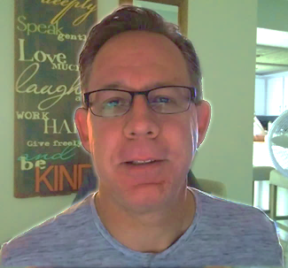
Scott Speicher brings a unique blend of life experiences to his writing. A U.S. military veteran, he carries the discipline, resilience, and perspective gained through service into every story he tells. After his military career, Scott built a successful path in marketing, where he developed a deep understanding of communication, storytelling, and audience engagement. For more than 15 years, he has also worked as a professional website designer, helping businesses and individuals create meaningful online presences.
Scott Speicher is a storyteller who enjoys creating gentle, heartfelt stories that help children notice the small moments that make life meaningful. Through warm characters and simple adventures, his books encourage young readers to slow down, care for others, and appreciate the quiet joys of everyday life. Scott believes that some of the most important lessons children learn come not from grand events, but from the ordinary moments shared with family, friends, and the animals they love.
Lily and the Summer Farm is a gentle children’s story about Lily spending the summer at Grandpa Jim’s farm, a place filled with animals, gardens, chores, and quiet memories of Ben. As Lily feeds chickens, plants seeds, comforts a frightened calf, helps a neighbor, repairs an old birdhouse, and enters the farm fair, she learns meaningful lessons about responsibility, courage, compassion, patience, and kindness. At its heart, the book is about growing after loss, carrying love forward, and discovering that even small acts of care can make a lasting difference.
Suitable for readers aged 4-10 and for family read-aloud sessions. Ideal for SEL, guidance, and service-learning.

