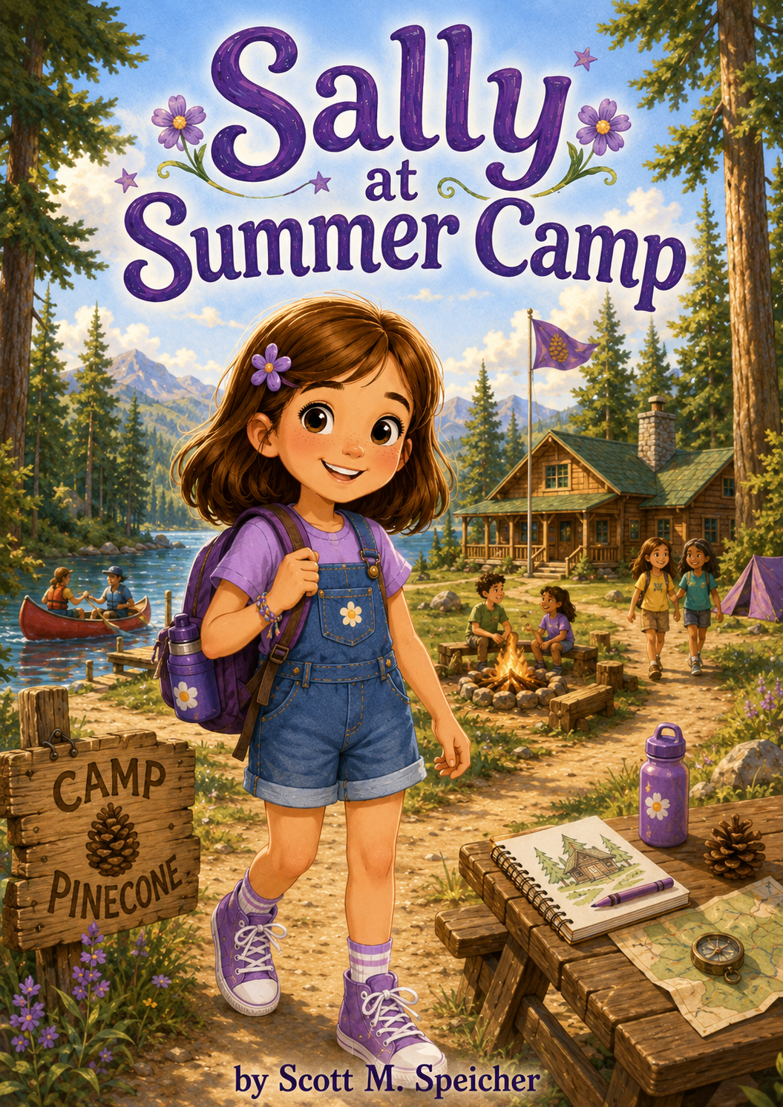
Sally at Summer Camp
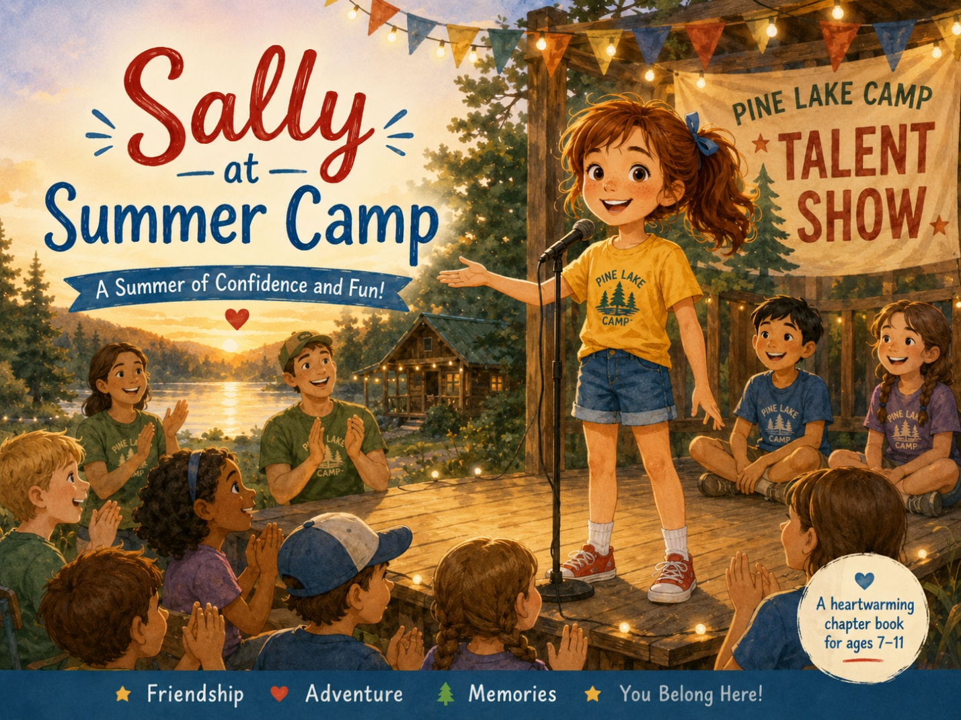

Copyright © 2026
Author: Scott M. Speicher
Portions of this book have been optimized by the program Grammarly.
Edited by Grammarly and the Editorial team of Digital Scribblers
No part of this book may be reproduced or used in any form or by any means, electronic or mechanical, without written permission from the author.
Some of the images are AI-generated via prompting and with full control by the author.

Preface
Every new adventure begins with a question.
For Sally, the question is simple but important: Am I ready? The school year has ended, summer has begun, and Camp Pinecone is waiting with tall trees, busy cabins, winding trails, friendship bracelets, canoes, campfire stories, rainy day surprises, and new friends she has not met yet. Sally is curious, creative, strong-willed, and brave—but even brave children can feel nervous when they step into an unfamiliar place.
In Sally at Summer Camp, Sally discovers that courage does not mean feeling fearless. Sometimes courage means walking into camp on the first day, trying a wobbly canoe, asking for help when the bracelet strings get tangled, sharing a story even when your voice feels small, or helping someone else feel ready to shine. Along the way, Sally learns that friendship can begin with kindness, teamwork grows through patience, and adventure often appears when plans change.
Camp Pinecone is becoming more than a place to play. It becomes a place where Sally learns to trust herself, notice others, try new things, and carry important lessons in her heart. Each day brings a new discovery about courage, friendship, creativity, kindness, and growing up.
May Sally’s summer camp journey remind young readers that they do not have to feel completely ready to begin. Sometimes the bravest thing they can do is take one careful step forward, stay curious, be kind, and discover what wonderful things can happen next.
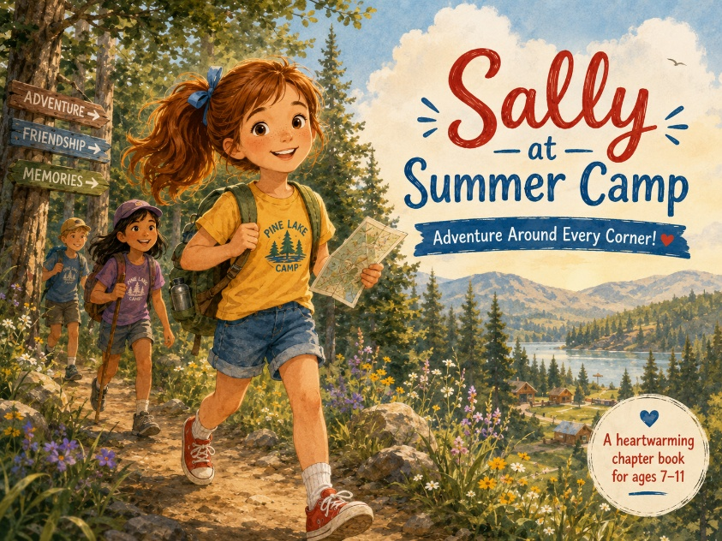

Table of Contents

Preface
An introduction to Sally’s summer camp journey, where she learns that courage does not mean feeling completely ready. Through new experiences at Camp Pinecone, Sally begins to discover friendship, kindness, teamwork, creativity, and confidence.
Chapter One: The Last Bell of School
The school year ends, and Sally feels both excited and nervous about the start of summer. When Mom tells her that summer camp will bring new adventures, Sally wonders if she is ready to meet new children, try unfamiliar activities, and step away from her regular routine.
Chapter Two: Welcome to Camp Pinecone
Sally arrives at Camp Pinecone with her backpack, water bottle, sketchbook, and plenty of questions. She meets her counselor, sees the cabins, and discovers a world filled with trails, trees, games, crafts, and surprises to explore.
Chapter Three: The Friendship Bracelet Mix-Up
During craft time, Sally tries to make a friendship bracelet, but the colors and strings do not turn out the way she planned. With help from another camper, she learns that friendship can begin with patience, kindness, and accepting help when things get tangled.
Chapter Four: The Canoe That Wobbled
Sally tries canoeing for the first time and feels unsure when the boat rocks beneath her. With encouragement from her counselor and teamwork from her canoe partner, Sally learns that courage means trying carefully, listening, and trusting others.
Chapter Five: The Trail Map Mystery
On a nature hike, Sally notices a confusing trail marker and helps the group slow down, look closely, and follow the map. Her curiosity and attention to detail help everyone find the right path, teaching her that strong leaders notice what others may miss.
Chapter Six: The Campfire Story Challenge
At the evening campfire, each camper is invited to share a story. Sally worries that her idea is not good enough, but when she tells a story about a brave little firefly, she discovers that creativity shines brightest when shared.
Chapter Seven: The Rainy-Day Cabin Adventure
A sudden summer storm keeps the campers indoors, and Sally feels disappointed that outdoor activities are canceled. Instead of letting the day feel ruined, she helps turn the cabin into an indoor adventure filled with games, drawings, stories, and kindness challenges.
Chapter Eight: The Lost Lunchbox
Sally finds a lunchbox left behind near the picnic tables and wants to solve the mystery of who owns it. By asking questions and helping another camper, she learns that doing the right thing can turn an ordinary moment into an act of kindness.
Chapter Nine: The Talent Show Surprise
The campers prepare for the end-of-week talent show, but Sally is not sure what her talent should be. With encouragement from her friends, she realizes that being curious, creative, brave, and supportive can be talents too.
Chapter Ten: The Summer Camp Promise
On the final day of camp, Sally looks back on everything she has learned: courage, friendship, teamwork, creativity, patience, and kindness. She promises to carry the lessons of Camp Pinecone into the rest of her summer, realizing that adventure continues wherever she chooses to grow.

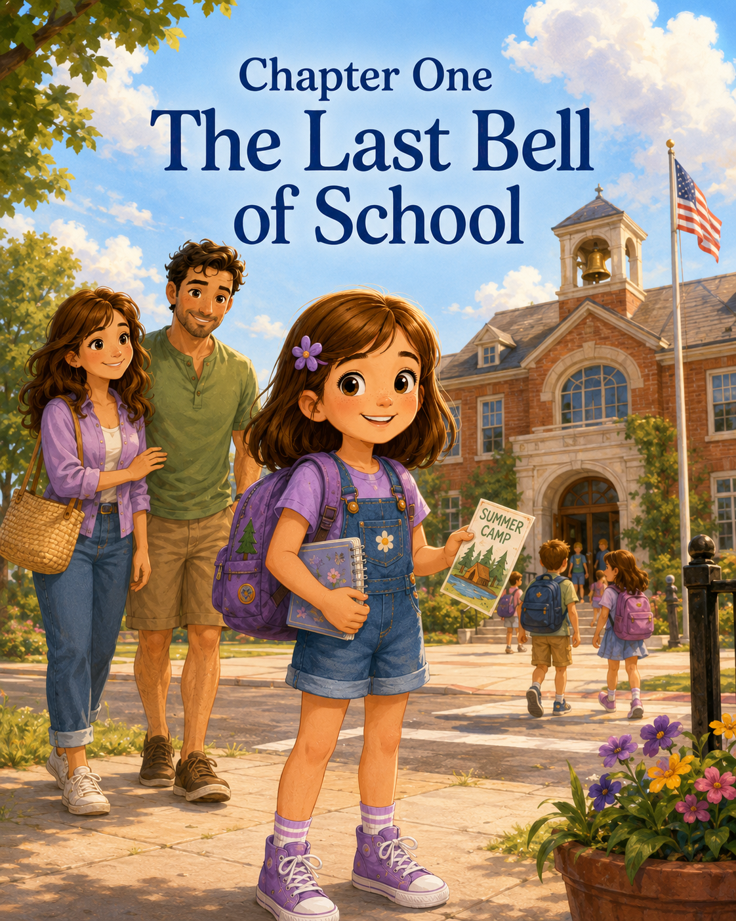
Chapter One: The Last Bell of School
Sally could feel the last day of school before it even began.
It was in the air.
It was in the hallway, where backpacks bounced against shoulders and sneakers squeaked faster than usual. It was in the classroom, where everyone talked a little louder, laughed a little easier, and watched the clock more than they watched the board. It was even in the pencils, which rolled across desks as if they were tired from a whole year of spelling words, math problems, and journal entries.
Sally sat at her desk with her purple flower clip tucked neatly in her brown hair and her hands folded on top of her notebook.
She was trying very hard to pay attention.
But the clock kept ticking.
Tick.
Tick.
Tick.
Only forty-three minutes until summer.
Forty-three minutes until no more spelling tests.
Forty-three minutes until no more lunch trays.
Forty-three minutes until no more raising her hand before asking a question.
Forty-three minutes until long mornings, warm afternoons, popsicles, sprinklers, bike rides, and adventures.
Sally loved adventures.
She loved looking for tiny things most people missed. She loved asking questions. She loved making plans. She loved being the first one to say, “Let’s go see.” Last summer, at the seashore, she had learned that the world was full of discoveries if you were brave enough to notice them.
Still, today felt different.
Because this summer would not only be a regular summer.
This summer, Sally was going camping.
She was looking forward to camp, but her anxiety was truly obvious
Camp was supposed to be a fun place, but meeting new friends was always a challenge for Sally.
A place with children she did not know yet. Counselors she had not met. Games she had not played. Trails she had not walked. Rules she had not learned. Lunch tables where she would have to decide where to sit.
Sally tapped one finger against her notebook.
She liked new things.
Mostly.
But she also liked knowing what came next.
At school, she knew the schedule. Morning work. Reading. Math. Recess. Lunch. Science or art. Pack up. Dismissal. She knew where the crayons were kept. She knew which bathroom stall had the door that stuck. She knew how long it took Mrs. Carter to say, “one more thing,” which usually meant three more things.
But the camp was unknown.
The unknown could be exciting.
Unknown could also make Sally’s stomach feel like a kite string with a knot in it.
Mrs. Carter stood at the front of the room holding a stack of bright paper certificates.
“Well, class,” she said, smiling in the soft, watery way teachers sometimes smiled on the last day, “we have had a wonderful year together.”
A few children cheered.
Mrs. Carter laughed. “Yes, I know. You are all very ready for summer.”
Sally smiled, but her fingers found the edge of her desk.
Mrs. Carter began handing out certificates. Each one had a student’s name and a special classroom award. Emma received the “Helpful Heart Award.” Marcus received the “Math Problem Solver Award.” Ava received the “Creative Thinker Award.”
Then Mrs. Carter looked at Sally.
“Sally,” she said, “please come up.”
Sally stood quickly, then made herself walk instead of hurrying. She liked awards, but she did not like everyone staring at her for too long.
Mrs. Carter handed her a certificate with purple stars around the border.
“This year,” Mrs. Carter said, “Sally showed us what it means to be curious, determined, and brave enough to try new things. She asks wonderful questions, notices details others might miss, and reminds us that learning can be an adventure.”
Sally looked down at the certificate.
Curious Explorer Award
Her cheeks grew warm.
The class clapped.
Sally smiled and returned to her seat, holding the certificate carefully so it would not bend.
Curious Explorer.
She liked that.
It sounded like someone who could go to camp.
Maybe.
After the awards, Mrs. Carter gave everyone time to clean out their desks. That was always one of the strangest parts of the last day of school. Things appeared that Sally had completely forgotten about: one purple crayon, two old spelling lists, a wrinkled drawing of a squirrel wearing sunglasses, three eraser pieces, and a library bookmark she was certain had been missing since February.
She sorted everything into piles.
Keep.
Recycle.
Maybe keep.
Ask Mom.
Her friend Emma leaned over from the next desk. “Are you excited for summer?”
“Yes,” Sally said.
Then she added, “Mostly.”
Emma tilted her head. “Mostly?”
Sally tucked the squirrel drawing into her folder. It seemed like the kind of thing that should not be thrown away without serious thought.
“I’m going to summer camp,” Sally said.
Emma’s eyes widened. “That sounds fun.”
“It does,” Sally said. “But I don’t know anyone there.”
“You’ll make friends,” Emma said.
Sally made a face. “People always say that.”
Emma shrugged. “Because you probably will.”
Sally wanted to believe her.
But making friends was not like finding shells. You could not just walk along the edge of a playground and pick up the right one. Friends had opinions and favorite games and seats at lunch tables. Friends sometimes already had other friends.
“What if everyone already knows each other?” Sally asked.
Emma thought about this. “Then you can ask a question.”
Sally looked at her. “A question?”
“You ask lots of questions,” Emma said. “You could ask, ‘What are you building?’ or ‘Can I play?’ or ‘What kind of bug is that?’”
Sally smiled a little. “I do ask good bug questions.”
“You do,” Emma agreed.
At the front of the room, Mrs. Carter clapped her hands gently.
“Class, please bring your cleaned-out folders to the back table. Then you may choose a book to take home for summer reading.”
Sally carried her folder to the table and looked over the books. There were books about animals, mysteries, space, dragons, friendship, and one about a girl who found a secret garden.
Sally chose the Secret Garden book.
It seemed like a summer kind of story.
When she returned to her desk, she slipped it into her backpack beside her certificate and her notebook.
Her notebook was not her school notebook. It was her special notebook.
The one that had once been labeled Sally’s Adventure Notes.
At the seashore, she had filled it with discoveries about waves, shells, crabs, kites, lighthouses, kindness, and courage. There were still some blank pages near the back. Sally had been saving them for something important.
Maybe camping would be important enough.
The clock ticked closer.
Ten minutes.
Then eight.
Then five.
The classroom grew wiggly.
Mrs. Carter stood by the door, smiling as if she were both happy and sad. “Before the bell rings, I want you to remember something. Summer is a wonderful time to rest, play, read, and explore. But wherever you go, keep being kind. Keep curious. Keep learning.”
Sally looked down at her certificate.
Curious Explorer.
Her stomach fluttered again.
This time, it felt a little less like fear and a little more like the beginning of something.
Then the bell rang.
Loud.
Bright.
Final.
Brrrrrrrrring!
The room burst into cheers.
Chairs scraped. Backpacks zipped. Children shouted goodbye. Mrs. Carter gave hugs and high-fives. Someone dropped a pencil box, and markers rolled everywhere. Someone else yelled, “Summer!” as if the whole school might not have noticed.
Sally stood slowly.
The last bell of school had rung.
The year is over.
Summer had officially begun.
She walked to Mrs. Carter, holding her backpack straps.
“Goodbye, Sally,” Mrs. Carter said, bending down a little. “I hope you have a wonderful summer.”
“I’m going to camp,” Sally said.
“That sounds exciting.”
Sally nodded. “And a little nervous.”
Mrs. Carter’s smile softened. “Both can be true.”
Sally looked up. “That’s what Mom says.”
“Your mom sounds wise,” Mrs. Carter said. “New places can feel big at first. But remember, you do not have to figure everything out on the first day. Just take one brave step, then another.”
Sally thought about the waves at the seashore.
One careful step.
Then another.
“I can do that,” she said.
“I know you can,” Mrs. Carter said. “You are a curious explorer, after all.”
Sally smiled and hugged her teacher goodbye.
Outside, the school sidewalk was full of children and grown-ups. Buses waited along the curb. Parents waved. Teachers stood near doors, calling goodbyes into the warm afternoon. The air smelled like sunshine, grass, and the beginning of summer.
Mom stood near the front walkway, smiling as soon as she saw Sally.
Mark stood beside her, holding a small bunch of purple flowers.
Sally ran over.
“Happy last day of school!” Mom said, wrapping her in a hug.
Mark held out the flowers. “For the graduate of another excellent school year.”
Sally took them and smiled. “I did not graduate. I just finished the grade.”
“Still flower-worthy,” Mark said.
Sally handed Mom her certificate.
Mom read it aloud. “Curious Explorer Award.”
Her eyes warmed. “That is perfect.”
Mark leaned over to see. “Very official.”
Sally stood a little taller. “Mrs. Carter said I notice details others might miss.”
“She is right,” Mom said.
They walked toward the car together. Sally held Mom’s hand for a moment, then let go so she could carry her flowers herself.
On the drive home, Mom asked about the last day. Sally told her about the awards, the old squirrel drawing, the secret garden book, and how someone had spilled markers everywhere after the bell.
Mark looked at her in the rearview mirror. “And how are you feeling about summer camp?”
Sally looked out the window.
The school disappeared behind them.
The streets looked brighter than usual, as if summer had painted everything with extra yellow. Kids rode bikes. A man mowed his lawn. A sprinkler clicked back and forth across a patch of grass. The world seemed wide open.
“I’m excited,” Sally said.
Mom waited.
Sally added, “And nervous.”
Mark nodded. “That makes sense.”
“What if I don’t know where to go?” Sally asked.
“Your counselor will help you,” Mom said.
“What if I don’t know anyone?”
“Then you’ll meet people,” Mark said. “One at a time.”
“What if they already have friends?”
Mom turned slightly in her seat. “Then you can be kind and curious. Those are good ways to begin.”
Sally was quiet.
Kind and curious.
She knew how to do those.
“What if I don’t like camp?” she asked.
Mom’s voice stayed gentle. “Then we talk about it. You do not have to pretend everything is perfect. But I do want you to give it a real chance.”
Sally nodded slowly.
Mark added, “Camp might feel unfamiliar at first. But unfamiliarity does not always mean bad. Sometimes it means undiscovered.”
Sally looked up. “Undiscovered?”
“Like a trail you have not walked yet,” Mark said. “Or a lake you have not seen. Or a craft project that has not become messy yet.”
Sally smiled. “Craft projects are supposed to become messy.”
“Exactly,” Mark said.
When they got home, Sally carried her backpack to her room. Her two bags were not packed yet, but her camp list was on her desk. Mom had printed it out and highlighted the important things.
Water bottle.
Hat.
Sunscreen.
Sneakers.
Lunch.
Extra socks.
Small backpack.
Notebook.
Sally tapped the word notebook.
Then she pulled out her Adventure Notes and turned to a fresh page near the back.
At the top, she wrote:
Sally at Summer Camp
Under it, she added:
Question #1: What if camp is scary?
She thought for a moment, chewing the end of her pencil.
Then she wrote:
Possible answer: Take one brave step and see what happens.
She looked at the sentence.
It was not a complete answer.
But it was the beginning.
Downstairs, Mom called, “Sally, snack is ready!”
Sally closed the notebook and placed it carefully in her camp backpack.
Then she looked at herself in the mirror. Purple flower clip. Brown hair. Curious eyes. A little nervous. A little excited. Still Sally.
“Curious Explorer,” she whispered.
The words helped.
The school year was over.
The last bell had rung.
The regular routine had ended, and something new was waiting.
Sally did not know yet who she would meet at camp. She did not know whether she would like canoeing, crafts, campfire stories, or hiking through the woods. She did not know if she would feel brave on the first day.
But she knew how to notice things.
She knew how to ask questions.
She knew how to try.
And that, Sally decided, was probably enough to begin.
So she opened her bedroom door, ran downstairs for a snack, and let summer come rushing in.

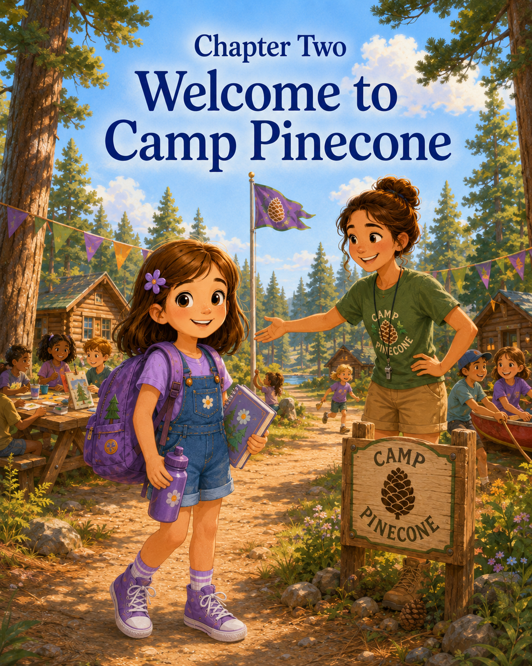

Chapter Two: Welcome to Camp Pinecone
Sally knew they were getting close to camp when the roads began to change.
The busy streets near her house slowly gave way to quieter roads lined with trees. Houses grew farther apart. Mailboxes stood at the ends of long driveways. The sidewalks disappeared. The air outside the car windows looked greener somehow, as if summer had spread itself across every leaf and branch.
Sally sat in the back seat with her camp backpack on her lap.
Inside it were her water bottle, sunscreen, a small towel, a snack, her sketchbook, colored pencils, and her Adventure Notes notebook. Mom had helped her pack everything the night before, but Sally had checked it twice that morning herself.
Maybe three times.
Mark said good explorers check their supplies.
Sally agreed.
But good explorers also sometimes checked because their stomachs felt fluttery.
Mom looked back from the front seat. “How are you doing?”
Sally tightened her arms around her backpack. “Fine.”
Mark glanced at her in the rearview mirror. “Fine like regular fine, or fine like ‘I have fourteen questions, but I am saving them’ fine?”
Sally frowned. “Maybe seven questions.”
Mom smiled gently. “Seven is manageable.”
Sally looked out the window. “What if I don’t know where to go?”
“The counselors will show you,” Mom said.
“What if I forget someone’s name?”
“Then you ask again,” Mark said. “People forget names all the time.”
“What if I don’t like the activities?”
“Then you try them carefully first,” Mom said. “You may surprise yourself.”
“What if there are bugs?”
Mark’s mouth twitched like he was trying not to laugh. “At a summer camp in the woods? I suspect there may be at least one bug.”
Sally gave him a serious look through the mirror. “One bug is acceptable. A swarm is different.”
“Agreed,” Mark said. “We will officially oppose swarms.”
Sally almost smiled.
Almost.
Then the car turned onto a gravel driveway. A wooden sign stood between two tall pine trees.
WELCOME TO CAMP PINECONE
The letters were painted green and yellow, and someone had drawn a smiling pinecone in the corner wearing a tiny camp hat.
Sally leaned forward.
“There it is,” Mom said.
Camp Pinecone was bigger than Sally expected.
Much bigger.
There was a wide grassy field where children were already running in circles around orange cones. Beyond that stood a row of wooden cabins with green doors and flower boxes under the windows. A flagpole rose near the center of camp, with the flag moving gently in the breeze. Farther back, Sally could see a craft pavilion with picnic tables, a trail sign pointing into the woods, and a sparkling blue lake peeking through the trees.
The car rolled slowly into the parking area.
Sally did not get out right away.
She watched children with backpacks and water bottles walking toward a check-in table. Some seemed excited. Some seemed sleepy. Some were already talking to friends. One boy wore a dinosaur hat. A girl carried a notebook covered with stickers. Another child had a lunchbox shaped like a rocket ship.
Sally wondered if any of them were nervous.
It was hard to tell from the outside.
Mom parked the car and turned around. “Ready?”
Sally looked at Camp Pinecone again.
The trees were tall. The cabins were unfamiliar. The lake glittered like it knew secrets. The camp sign seemed cheerful, but signs did not have to meet new people.
Sally took a deep breath.
“Ready enough,” she said.
Mom smiled. “Ready enough counts.”
They stepped out of the car, and warm summer air wrapped around Sally’s face. It smelled like pine needles, grass, sunscreen, and something sweet from the snack table near the pavilion.
Sally put on her backpack.
It felt heavier than usual.
Mark handed her the purple water bottle. “Essential expedition equipment.”
Sally clipped it to the side pocket. “Hydration is important.”
“Very,” Mark said.
Mom took Sally’s hand as they walked toward the check-in table. Sally let her. She was old enough to walk by herself, but this was the first morning, and the camp still felt very large.
At the table, a woman with curly gray hair and a bright Camp Pinecone shirt smiled at them.
“Good morning! Name?”
Sally stood a little taller. “Sally.”
Mom added Sally’s last name.
The woman checked a clipboard. “Ah, yes. Welcome, Sally. You’re in the Blue Jay group.”
Sally blinked. “Blue Jay?”
“That’s your camp group,” the woman explained. “Each group has a bird name. Blue Jays meet by Cabin Three.”
Sally looked around. “Where is Cabin Three?”
Before the woman could answer, another voice said, “Right this way.”
A young woman with a friendly smile stepped forward. She wore a green Camp Pinecone shirt, khaki shorts, and a whistle on a purple lanyard. Her name tag said:
MIA
Camp Counselor
Sally noticed the purple lanyard immediately.
Purple was a good sign.
“Hi, Sally,” Mia said. “I’m your counselor this week. I lead the Blue Jays.”
Sally studied her carefully.
Mia had warm brown skin, dark curly hair pulled into a ponytail, and kind eyes that looked directly at Sally without making her feel trapped. She knelt slightly so she was closer to Sally’s height.
“I hear this is your first day at Camp Pinecone,” Mia said.
Sally nodded. “Yes.”
“Excellent. First days are full of discoveries.”
Sally’s fingers loosened a little on her backpack straps.
That sounded like something she might have written in her notebook.
“I have a notebook for discoveries,” Sally said.
Mia’s eyes brightened. “Then you came prepared.”
Mom smiled. “She usually does.”
Mark added, “There may also be seven questions.”
Mia looked at Sally with interest. “Only seven?”
Sally liked her immediately.
“Maybe eight now,” Sally said.
“Wonderful,” Mia said. “Questions are welcome at Camp Pinecone. We just ask that you walk while asking them unless we are crossing the field. Then we watch our feet.”
Sally nodded seriously. “That is a reasonable rule.”
Mia stood. “Would you like to see Cabin Three?”
Sally looked at Mom.
Mom squeezed her hand. “We’ll walk with you.”
They followed Mia across the grass. Camp seemed even busier now that Sally was inside it. Children were carrying art boxes. A counselor was stacking foam balls into a large bin. Someone rang a small handbell near the pavilion. Birds chirped from the trees, and somewhere far away, a whistle blew.
Sally tried to notice everything.
The cabins had names carved on little wooden signs.
Cabin One: Cardinals
Cabin Two: Robins
Cabin Three: Blue Jays
Cabin Three had a green door and two small windows. A row of hooks stood outside for backpacks, and a chalkboard beside the door read:
WELCOME, BLUE JAYS!
Below is a list:
Morning Circle
Camp Tour
Trail Walk
Craft Time
Lunch
Games
Story Shade
Sally read the list twice.
The schedule helped.
A schedule was something to hold onto.
Mia pointed to the hooks. “This is where the Blue Jays keep their bags. Water bottles stay with you. Lunch goes in the cooler inside.”
Sally looked through the open cabin door.
Inside were wooden benches, cubbies, a first-aid box on a high shelf, a basket of books, and a table with markers and paper. The cabin smelled like wood and crayons.
It was not home.
It was not school.
But it did not seem unfriendly.
A girl with braids was sitting on one bench, tying her shoe. A boy in a dinosaur hat was looking closely at the cabin wall, where a beetle crawled near the window.
Sally pointed. “There is a bug.”
Mia looked. “Good observation. That is a beetle. He belongs outside, so I’ll help him relocate.”
The boy in the dinosaur hat nodded. “His name is probably Gerald.”
Sally looked at him.
“Probably?” she asked.
The boy shrugged. “Could be.”
Mia gently used a piece of paper to guide the beetle into a small cup, then carried it outside and placed it near a bush.
“No squishing?” Sally asked.
“No squishing,” Mia said. “At Camp Pinecone, we respect small creatures.”
Sally felt her shoulders relax a little more.
She knew about respecting small creatures.
She had once helped a brave little crab find its way back to the wet sand.
Mom must have been thinking the same thing because she smiled down at Sally.
Mia turned to the small group gathering near the cabin. “Blue Jays, this is Sally. Today is her first day.”
The girl with braids waved. “Hi.”
The dinosaur-hat boy said, “Hi. I’m Noah. That beetle was Gerald.”
“I’m Priya,” said the girl with braids.
Sally gave a small wave. “Hi.”
She wanted to say something interesting. Something friendly. Something that made her sound like a person who belonged to a camp.
Instead, she said, “I have a sketchbook.”
Priya smiled. “I like drawing.”
Sally looked at her. “What do you draw?”
“Animals mostly,” Priya said. “And sometimes dragons.”
Noah leaned forward. “Realistic dragons or silly dragons?”
Priya thought about it. “Both.”
Sally nodded. “That is the correct answer.”
Noah grinned.
Maybe Emma had been right.
Questions did help.
After check-in, Mom crouched in front of Sally. “We’re going to head out soon.”
Sally’s stomach fluttered again.
Already?
She had known Mom and Mark would leave. It was a camp. That was the point. But knowing something and watching it happen were not the same.
Mom touched Sally’s shoulder. “We’ll be back in two weeks.”
Mark held up two fingers. “And I expect a full explorer report.”
Sally swallowed. “What if I need you?”
“Mia has my number,” Mom said. “And you can always talk to her if something feels wrong.”
Mia nodded. “Absolutely.”
Sally looked at the cabin, the children, the field, the trail sign, and the trees.
Everything still felt new.
But not quite as huge as when they first drove in.
Mom hugged her. Sally held on a little longer than usual.
“I’m proud of you,” Mom whispered.
“For what? I haven’t done anything yet.”
Mom pulled back and smiled. “You came.”
Sally thought about that.
Maybe coming counted.
Mark gave her a gentle hug. “Remember, Curious Explorer: one brave step, then another.”
Sally nodded.
Mom and Mark walked back across the field toward the parking lot. Sally watched until they reached the car. Mom turned and waved.
Sally waved back.
Then the car drove away.
For one second, Sally felt the strange quiet space that comes after goodbye.
She gripped her water bottle.
Mia came to stand beside her, not too close.
“Ready for the Blue Jay morning circle?” she asked.
Sally looked at her.
Then at Cabin Three.
Then, at Priya, who was opening a sketchbook with a cover full of animal stickers. Noah was still checking the bushes, probably for Gerald.
Sally took a breath.
“Ready enough,” she said.
Mia smiled. “That counts.”
The Blue Jays gathered on a round rug inside the cabin. There were eight campers in all. Mia passed around a small wooden pinecone.
“This is our talking pinecone,” she explained. “When you hold it, you may share your name and one thing you are curious about at camp.”
The pinecone moved from camper to camper.
Priya said she was curious about the art pavilion.
Noah said he was curious about whether there were frogs near the lake.
A boy named Mateo asked if they would play capture the flag.
A quiet girl named Lily said she wanted to see the craft beads.
Then the pinecone came to Sally.
She held it carefully.
It was smaller than she expected, with little scales that fit against her fingers.
“I’m Sally,” she said. “I’m curious about…” She paused.
There were too many things.
The lake. The trails. The cabins. The crafts. The games. The possibility of frogs. Whether lunch would be loud. Whether she would know where to sit. Whether the camp will become easier by tomorrow.
She looked around the circle.
“I’m curious about all of it,” she said.
Mia smiled. “That is a very Blue Jay answer.”
Sally passed the pinecone to the next camper.
After morning circle, Mia led them on a camp tour. The Blue Jays walked in a line, though not a perfect line, because Noah kept slowing down to inspect leaves.
First, they visited the craft pavilion. Long picnic tables sat under a wooden roof. Bins of crayons, beads, string, glue, feathers, paper, and paintbrushes lined the shelves.
Sally’s eyes widened.
“This is a lot of supplies,” she whispered.
Priya stood beside her. “I know.”
Sally imagined friendship bracelets, painted rocks, paper lanterns, nature journals, maps, and maybe a sign for a camp adventure club.
The idea made her fingers itch for her sketchbook.
Next, they saw the game field. Orange cones stood in rows. A soccer ball rested near a tree. A big parachute was folded in a colorful pile.
Then came the nature trail entrance.
A wooden sign pointed into the trees.
PINE NEEDLE PATH
Below it, smaller signs showed pictures of a deer track, a bird, a leaf, and a magnifying glass.
Sally stepped closer.
“Do we get to go in there?”
“Yes,” Mia said. “With a counselor.”
“What lives in there?”
“Squirrels, birds, insects, maybe frogs near the low spots, and plenty of plants.”
“Are there snakes?”
“Sometimes,” Mia said calmly. “That is why we stay on the trail, watch where we step, and never reach into places we cannot see.”
Sally nodded. “Good rule.”
Mia pointed toward the far side of the camp. “And that is Pinecone Lake.”
The lake sparkled through the trees, blue and bright beneath the sun. A dock stretched a little way into the water. Several canoes rested upside down near the shore.
Sally stopped walking.
The lake was beautiful.
It was also big.
Not a big ocean.
But big enough.
“Do we go in boats?” she asked.
“Later this week,” Mia said. “With life jackets, counselors, and lots of safety practice.”
Sally looked at the canoes.
Her stomach did a small flutter, but her curiosity leaned forward.
Boats were new.
New could be scary.
New could also be undiscovered.
The tour ended beneath a wide oak tree with benches arranged in a half circle.
“This is Story Shade,” Mia said. “We come here when we need quiet, reading, storytelling, or a cool place to think.”
Sally loved it immediately.
Sunlight slipped through the leaves in golden patches. A bird hopped along a branch above them. The ground was covered in soft dirt and tiny acorn caps. It felt like the kind of place where ideas could gather.
Mia let the campers sit for a few minutes before the next activity.
Sally pulled out her Adventure Notes notebook.
Priya sat beside her. “Is that your discovery notebook?”
Sally looked surprised. “How did you know?”
“You said you were curious about all of it,” Priya said. “That sounded like someone with a discovery notebook.”
Sally considered this. “That is a good observation.”
“Thanks,” Priya said.
Sally opened the page she had started the day before.
Sally at Summer Camp
Underneath, she wrote:
Discovery #1: Camp Pinecone is bigger than it looks from the parking lot.
Then she added:
It has cabins, trails, games, crafts, a lake, a counselor named Mia, a talking pinecone, and possibly a beetle named Gerald.
Priya giggled.
Sally continued writing:
Camp still feels new, but not empty-new. More like full-new. Full of things I have yet to discover.
She paused, then looked around.
Noah was crouched near the edge of Story Shade, studying an acorn cap. Mateo was asking Mia about the game field. Lily was quietly tracing shapes in the dirt with a stick. Priya was drawing a dragon with wings shaped like leaves.
The camp no longer looked like a place where everyone already belonged, except Sally.
It looked like a place where everyone was finding their way into the day.
Sally wrote one more line:
Maybe new places become less scary after you learn their names. Cabin Three. Blue Jays. Pine Needle Path. Story Shade. Pinecone Lake.
Mia rang a small bell. “Blue Jays, next stop is our first camp game.”
Sally closed her notebook and put it safely into her backpack.
Priya stood beside her. “Do you want to walk with me?”
Sally looked at her.
A question.
A small invitation.
A beginning.
“Yes,” Sally said. “But I might ask more questions.”
Priya smiled. “That’s okay. I might answer some.”
Noah hurried over. “If it is about beetles, I can help.”
Sally laughed.
As the Blue Jays walked back toward the field, Sally felt the sun on her shoulders and the grass beneath her sneakers. She still missed Mom a little. She still wondered what the rest of the camp would be like. She still did not know all the rules, all the names, or all the paths.
But now she knew a few things.
She knew where her cabin was.
She knew her counselor was kind.
She knew Priya liked drawing.
She knew Noah named beetles.
She knew Camp Pinecone had more discoveries than she could fit on one page.
And she knew she had made it through the first goodbye.
That felt important.
Sally tightened the straps of her backpack and walked with the Blue Jays toward the open field.
Camp Pinecone was still unfamiliar.
But it was no longer just unknown.
It was waiting.

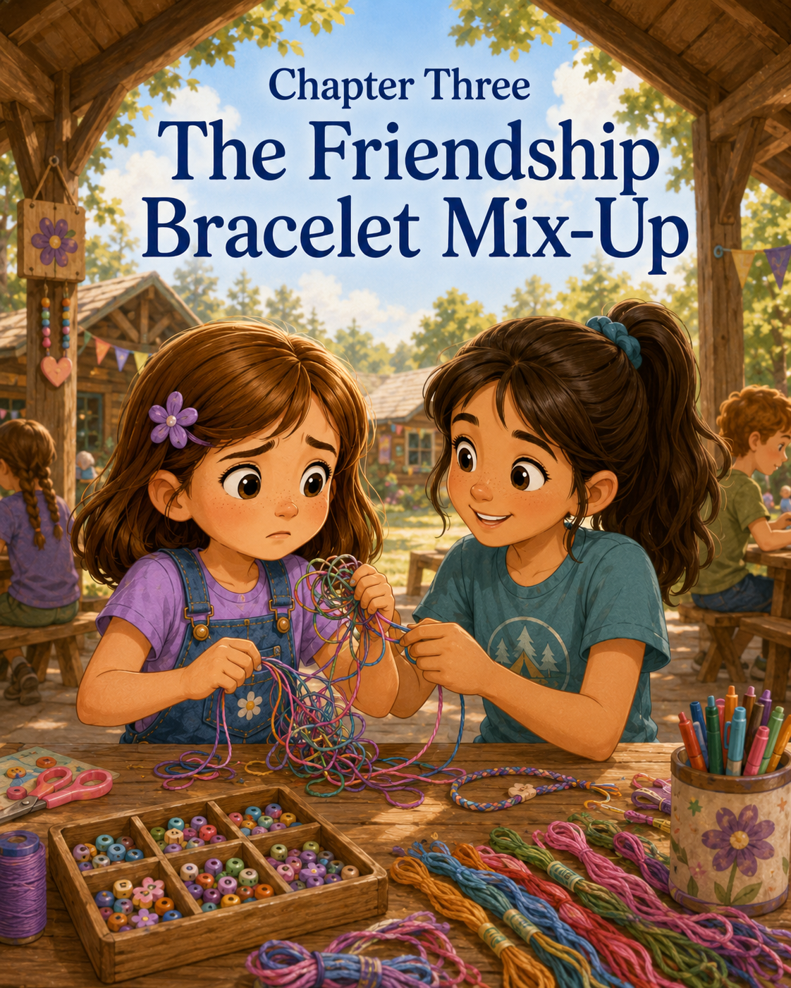

Chapter Three: The Friendship Bracelet Mix-Up
Sally had been looking forward to crafting since the camp tour.
The craft pavilion was one of the best places at Camp Pinecone. It had long wooden tables, shelves full of colorful supplies, jars of buttons, bins of yarn, stacks of paper, markers, beads, glue sticks, and little baskets labeled with neat handwriting.
Sally liked organized supplies.
Organized supplies meant possibilities.
After morning games, Mia led the Blue Jays across the grass toward the pavilion. The roof made a wide patch of shade, and the breeze carried the smell of pine needles, sunscreen, and freshly sharpened pencils. Sunlight blinked through the trees, making bright spots on the table like tiny golden coins.
“Today,” Mia said, holding up a bundle of colorful thread, “we’re making friendship bracelets.”
Several campers cheered.
Sally sat up straighter.
Friendship bracelets sounded important. Not just because they were pretty, but because they had the word friendship right in the name. Sally wondered if making one meant you were supposed to give it to someone. She wondered if you had to already have a friend first. She wondered if the colors had meanings. She wondered how tight the knots should be and whether a bracelet could accidentally become too small for a wrist.
Her seven camp questions were quickly becoming twelve.
Mia placed trays of embroidery floss in the center of each table. “You may choose three colors. We’ll start with a simple pattern. You can make one for yourself, for a friend, or for someone at home.”
Sally looked at the tray.
The colors were beautiful.
Red like strawberries.
Blue like the lake.
Green like pine trees.
Yellow like sunshine.
Orange like campfire sparks.
Purple like Sally’s flower clip.
Sally knew immediately that she wanted purple.
Purple was her color.
She picked up the purple thread and placed it in front of her. Then she chose blue because it reminded her of the ocean and the lake. For her third color, she selected yellow because it looked cheerful.
Purple, blue, and yellow.
Perfect.
Priya sat beside Sally and chose green, pink, and white.
Noah chose brown, green, and black.
“That looks like a beetle bracelet,” Sally said.
Noah grinned. “Exactly.”
Mateo chose red, blue, and orange because, according to him, “fast colors make faster bracelets.”
Sally was not sure bracelets could be fast, but she decided not to argue.
Mia showed them how to line up the strings, tie a knot at the top, and tape the knot to the table so the bracelet would stay still while they worked.
“Friendship bracelets take patience,” Mia said. “The first few knots may feel tricky, and that is okay. Go slowly.”
Sally nodded.
Slowly was fine.
She could go slowly.
She could be careful.
She could absolutely make a friendship bracelet.
Mia demonstrated the first knot. “Take the string on the far left. Loop it over the next string like the number four. Pull it under, then gently slide the knot upward. Do that twice on each string before moving to the next.”
Sally watched closely.
Number four.
Under.
Pull.
Slide.
That seemed understandable.
She picked up the purple string and looped it over the blue.
Number four.
Under.
Pull.
Slide.
The knot moved up the string.
Sally smiled.
It worked.
She did it again, then moved to the yellow string. Her purple knot sat neatly at the top.
“This is not too hard,” she said.
Priya glanced over. “Yours looks good.”
Sally sat a little taller. “I know.”
For the next few minutes, everything went well. Sally made purple knots across the blue and yellow strings. Then she moved to the blue string and began knotting across the others.
But then something strange happened.
The colors did not line up the way she had pictured.
In Sally’s mind, the bracelet was supposed to have neat stripes: purple, blue, yellow, purple, blue, yellow. Perfect little rows, like waves of color. But the thread twisted. The yellow slipped under the blue. The purple looped around the wrong string. One knot was too loose. Another was too tight.
Sally frowned.
She tugged the yellow string.
The knot tightened in the wrong place.
She tried to loosen it with her fingernail.
The thread frayed a little.
“No,” she whispered.
Priya looked over. “Are you okay?”
“Yes,” Sally said quickly.
She was not okay.
Her bracelet was becoming a tiny disaster.
She tried again. She pulled the blue string over the purple, but then she realized she was using the wrong side. She tried to reverse it, but the strings crossed over each other. She tugged one thread, then another. The bracelet twisted into a knotty clump near the tape.
Sally’s cheeks grew warm.
This was supposed to be craft time.
Craft time was supposed to be fun. Sally was good at making things. She drew pictures. She made beach art. She built sandcastles. She turned shells into stories. She had even helped create the Seashore Adventure Club symbol in the sand.
But this bracelet did not seem to know that Sally was creative.
It looked messy.
Very messy.
Priya leaned closer. “I think your blue string got wrapped around the yellow.”
“I know,” Sally said.
Her voice came out sharper than she meant.
Priya leaned back a little.
Sally looked down.
Now she felt bad and frustrated at the same time, which was worse than feeling only one thing.
Mia moved around the table, helping Mateo tighten his knots and showing Lily how to hold the strings apart.
Sally did not want to ask for help.
She wanted to fix it herself before anyone noticed.
She picked at the knot.
The threads tightened.
She pulled harder.
The tape popped off the table, and the whole bracelet slid into her lap.
Sally froze.
Noah looked over. “Whoa.”
Mateo said, “Your bracelet escaped.”
Sally pressed her lips together.
“It did not escape,” she said. “It fell.”
She grabbed the tape and tried to stick it back down, but the end of the bracelet was tangled and uneven. The purple string was now wrapped twice around the blue, the yellow had a loop in it, and the top knot looked like a tiny nest made by a confused bird.
Sally’s eyes stung.
She was not going to cry over a bracelet.
Absolutely not.
But her throat felt tight anyway.
Mia came beside her. “Looks like the strings got a little tangled.”
Sally stared at the table. “It’s ruined.”
“I don’t think it’s ruined,” Mia said gently.
“It is,” Sally said. “The colors are wrong, the knots are wrong, and now it looks like spaghetti.”
Noah leaned closer. “Kind of rainbow spaghetti.”
Priya gave him a look.
Noah sat back. “Not helpful?”
“Not very,” Priya said.
Mia smiled softly but did not laugh. “Sally, bracelet knots can usually be untangled. But we have to slow down.”
“I did slow down,” Sally said. “Then it got worse.”
“Sometimes when something gets tangled,” Mia said, “pulling harder makes the knot tighter.”
Sally looked at the bracelet.
That sounded familiar.
Not just for string.
Sometimes feelings worked that way too.
The harder she tried to force them into place, the tighter they became.
Mia knelt beside her chair. “Would you like help?”
Sally wanted to say no.
The word was right there.
No.
Because she could do it herself. Because she was strong-willed. Because she had already said the bracelet was not too hard. Because asking for help would mean admitting she did not know how to fix it.
But then she looked at Priya.
Priya was not laughing. She was not grabbing the bracelet. She was not acting like Sally had ruined everything. She was just sitting nearby with kind eyes and her own half-finished bracelet taped neatly to the table.
“I can help too,” Priya said quietly. “I get knots in mine all the time.”
Sally looked at her. “You do?”
Priya nodded. “Yesterday, I tied one so tight my counselor had to use a safety pin to loosen it.”
Sally blinked. “Really?”
“Really.”
Sally looked back at the bracelet in her lap.
Maybe needing help did not mean she was the only one who had trouble.
Maybe it just meant she was learning.
She took a slow breath.
“Okay,” she said. “But don’t pull too hard.”
Priya smiled. “I won’t.”
Mia placed the bracelet carefully on the table. “First, let’s separate the strings.”
She used the tip of a pencil to gently lift the yellow loop away from the blue string. Priya held the purple thread so it would not tighten. Sally watched closely, still frowning, but not as hard as before.
“See this loop?” Mia asked.
Sally nodded.
“That is where the knot turned backward. We can loosen it if we give the string space.”
She worked slowly.
Very slowly.
Sally wanted the knot fixed immediately. She wanted the bracelet to look perfect right now. But Mia did not rush. Priya did not rush either. They moved gently, lifting one loop, sliding one thread, smoothing one section.
The knot began to loosen.
Sally’s shoulders lowered a little.
“There,” Priya said. “The yellow is free.”
Sally picked up the yellow string and smoothed it between her fingers. “It looks wrinkly.”
“Wrinkly is okay,” Mia said. “It can still be part of the bracelet.”
Sally studied the tangled beginning. It still did not look like the picture in her head. The stripes were uneven. The first few knots were bumpy. One purple knot sat higher than the others.
“It’s not perfect,” Sally said.
Mia nodded. “Most handmade things are not perfect. That is part of what makes them handmade.”
Sally was not sure she liked that answer.
Priya held up her own bracelet. “Mine has a crooked part too.”
Sally looked. Priya’s bracelet did have one tiny place where the green thread dipped lower than the others.
“I didn’t notice,” Sally said.
“Exactly,” Priya said.
Sally almost smiled.
Mia taped Sally’s bracelet back to the table. “Would you like to keep going or start over?”
Sally stared at the bracelet.
Starting over sounded tempting.
A fresh set of strings. A clean knot. No mistakes. No rainbow spaghetti.
But the bracelet in front of her had already been through something. It had gotten tangled. It had been rescued. It had required patience. It had needed help.
Maybe that made it more of a friendship bracelet, not less.
“I’ll keep going,” Sally said.
Mia smiled. “Good choice.”
Priya pointed gently. “Purple goes next.”
Sally picked up the purple string. “Like the number four?”
“Right,” Priya said. “Over, under, pull gently.”
Sally made the knot.
Slowly.
Over.
Under.
Pull gently.
Slide.
The knot moved into place.
Not perfectly.
But correctly.
Sally did it again.
Then she moved to the next string.
Priya worked beside her, and every now and then she quietly said, “That one goes next,” or “Hold this string apart,” or “Not too tight.”
Sally did not feel bothered by it anymore.
In fact, it helped.
The bracelet grew row by row. Purple, blue, yellow. Purple, blue, yellow. Sometimes the colors wiggled. Sometimes the knots were uneven. But the pattern began to show.
Sally felt her frustration loosen, just like the knot had.
Noah leaned over again. “It does not look like spaghetti anymore.”
“Thank you,” Sally said.
“You’re welcome,” Noah said. “Now it looks like a bracelet that fought a spaghetti monster and won.”
Sally laughed.
So did Priya.
Even Mia laughed a little.
By the end of craft time, Sally’s bracelet was long enough to wrap around her wrist. It was not the neatest bracelet at the table. Lily’s was straighter. Mateo’s was brighter. Priya’s was smoother.
But Sally’s bracelet had a story.
Mia tied it gently around Sally’s wrist.
The purple, blue, and yellow threads rested against her skin. The first part was bumpy, but then the pattern settled into soft stripes.
Sally turned her wrist in the sunlight.
“I like it,” she said.
Priya smiled. “Me too.”
Sally looked at Priya’s bracelet. “Who are you making yours for?”
Priya shrugged shyly. “I was going to keep it. But maybe I’ll make another one later.”
Sally touched her bracelet.
Friendship bracelets could be for yourself, Mia had said. Or for a friend. Or for someone at home.
Sally thought about Mom. She thought about Mark. She thought about how they had helped her come to camp even though she had been nervous. She thought about Mrs. Carter calling her a curious explorer.
Then she looked at Priya, who had helped untangle the knot without making Sally feel foolish.
“Do you want to make matching ones tomorrow?” Sally asked.
Priya’s face brightened. “Really?”
“Yes,” Sally said. “But maybe easier colors.”
Priya laughed. “Colors are not the problem. Knots are the problem.”
“That is true,” Sally said. “But we will be prepared.”
Noah held up his beetle-colored bracelet. “I can make one for Gerald if we find him again.”
Mia smiled. “I’m not sure beetles wear bracelets.”
Noah looked thoughtful. “Maybe a tiny belt.”
Sally shook her head, but she was smiling.
After craft time, the Blue Jays carried their supplies back to the shelves. Sally carefully picked up extra bits of thread from the table so they would not fall on the ground. She placed the leftover pieces in the scrap basket.
Then she pulled out her Adventure Notes notebook.
The page before her had been about Camp Pinecone feeling full-new instead of empty-new. Today needed a new discovery.
She wrote:
Discovery #2: The Friendship Bracelet Mix-Up
Then she paused, thinking carefully.
Priya sat beside her, drawing a small dragon in the corner of her own sketchbook.
Sally wrote:
I tried to make a purple, blue, and yellow friendship bracelet. The colors got mixed up, and the strings turned into rainbow spaghetti. I got frustrated and almost gave up. Mia and Priya helped me untangle it. Pulling harder made the knot tighter. Going slowly helped.
She looked at her bracelet again.
Then she added:
Friendship can begin when someone is patient with you. It can also begin when you let someone help.
Sally read the sentence twice.
It felt true.
At the seashore, she had learned that treasures became more special when shared. At camp, she was beginning to learn that mistakes became easier when they were shared too.
Priya glanced over. “Can I see?”
Sally turned the notebook slightly.
Priya read the discovery and smiled. “I like that.”
Sally looked at her. “Thanks for helping.”
“You’re welcome,” Priya said. “Thanks for not giving up.”
Sally looked down at the bracelet again.
The bumpy beginning did not bother her as much anymore. In fact, it might have been her favorite part. It reminded her that the bracelet had not become beautiful because everything went perfectly.
It became special because someone helped.
Mia rang the small camp bell. “Blue Jays, time to head to lunch.”
The campers stood, gathered their water bottles, and began walking toward the picnic tables.
Priya looked at Sally. “Want to sit together?”
Sally smiled.
This time, she did not have to think so hard.
“Yes,” she said.
As they walked side by side beneath the pine trees, Sally’s bracelet brushed gently against her wrist. Purple, blue, yellow. A little crooked. A little bumpy. Strong enough to hold together.
Sally decided that was a good kind of friendship bracelet.
Maybe even the best kind.

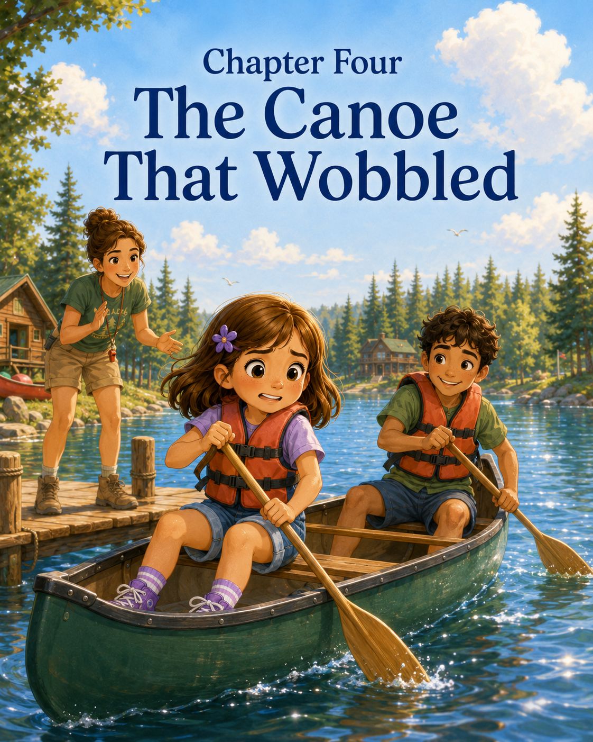

Chapter Four: The Canoe That Wobbled
Sally saw the canoes before Mia announced the activity.
They were lined up along the edge of Pinecone Lake, resting upside down on wooden racks beneath the trees. Some were red. Some were green. One was bright yellow, with scratches along the side that made it look as if it had already been on many adventures.
Sally had noticed them on the first day of camp.
Of course she had.
She had noticed the paddles stacked nearby. She had noticed the orange life jackets hanging on hooks. She had noticed the dock stretching out over the water. She had noticed how the lake changed color depending on the sky—blue in the morning, silver at lunch, and green near the shady trees.
But noticing canoes was different from getting into one.
That morning, the Blue Jays gathered beneath the oak tree at Story Shade after snack. Mia stood in front of them with a clipboard and a smile.
“Today,” she said, “we are going canoeing.”
Noah raised both hands in the air. “Yes!”
Mateo whispered, “Finally.”
Priya smiled, but she looked a little nervous too.
Sally sat very still.
Canoeing.
On the lake.
In a boat.
A boat that did not look very big from where she was sitting.
Mia continued, “Before anyone gets near the water, we are going to review safety rules. Canoeing can be fun, but it is also something we do carefully.”
Sally liked rules when something felt uncertain. Rules were like stepping stones across a stream. They did not make the stream disappear, but they helped you know where to put your feet.
Mia held up one finger. “Rule one: everyone wears a life jacket.”
She held up a second finger. “Rule two: we listen to counselors the first time.”
A third finger. “Rule three: no standing in the canoe.”
A fourth. “Rule four: paddles stay low and controlled.”
A fifth. “Rule five: if you feel nervous, you say so. We do not tease people for being careful.”
Sally looked up at that one.
If you feel nervous, you say so.
That was a rule?
A real camp rule?
She glanced at Priya, who gave her a small smile.
Mia pointed toward the lake. “We will stay close to the shore today. Each canoe will have two campers and one counselor nearby in the water area. No one is expected to be perfect. We are learning.”
Sally liked that word too.
Learning.
Not proving.
Not already knowing.
Learning.
The Blue Jays walked toward Pinecone Lake in a line. The path curved through the trees, where pine needles covered the ground and sunlight fell in patches. Sally carried her water bottle in one hand and held the strap of her backpack with the other, though they were not bringing backpacks into the canoes.
The lake appeared through the trees, shining wide and bright.
It was beautiful.
It was also water.
A lot of water.
Not ocean water, with crashing waves and salty foam, but still water that moved when the breeze touched it. Little ripples traveled across the surface like messages Sally could not read.
Mia gathered everyone near the life jacket hooks.
“Blue Jays, choose a jacket that fits snugly,” she said. “Then a counselor will check it.”
Sally chose a purple life jacket because purple was still her color, even at camp. She slipped her arms through the openings and pulled the straps across her chest. The jacket felt bulky and strange, like wearing a small pillow around her middle.
Mia checked the straps and tugged gently at the shoulders.
“Good fit,” she said.
Sally looked toward the canoes. “Do they tip over easily?”
Mia did not say, “No, never,” which Sally appreciated because she was fairly sure that would not be completely true.
“Canoes can wobble,” Mia said. “That is why we move slowly, stay seated, and work together. If we do those things, they are much steadier.”
Sally swallowed. “What if it wobbles anyway?”
“Then you take a breath, keep your body centered, and listen for directions.”
Noah, already wearing a green life jacket, bounced on his toes. “Can I be in the yellow canoe?”
Mia smiled. “We’ll assign canoes in a minute.”
Sally hoped she would not be in the yellow canoe.
Then she hoped she would.
The yellow canoe looked adventurous.
It also looked wobbly.
Mia paired the campers carefully. Noah went with Mateo in a red canoe. Lily went with another girl from their group. Then Mia looked at Sally and Priya.
“Sally and Priya, you two will be partners in the yellow canoe.”
Sally stared at the yellow canoe.
Of course.
Priya leaned closer. “We can do it together.”
Sally nodded, though her stomach had begun fluttering again.
The yellow canoe sat partly in the water, with its nose touching the shore and its back end floating near the dock. A counselor named Ben stood beside it, holding the side steady.
“Step in one at a time,” Ben said. “Keep your weight low. Hands on the sides. Sit right down.”
Priya went first.
She stepped carefully into the canoe, holding the sides the way Ben showed her. The canoe shifted a little, but not much. Priya sat on the front seat and looked back at Sally.
“Your turn.”
Sally stood at the edge of the water.
The canoe looked different from this close. Longer. Narrower. More boat-like than it had from the path. The lake lapped softly against its side.
Tap.
Tap.
Tap.
Like the water was knocking.
Sally placed one sneaker inside the canoe.
It moved.
Not a lot.
But enough.
Sally quickly pulled her foot back.
“I don’t like that,” she said.
No one laughed.
Mia stepped beside her. “The first wobble can feel surprising.”
“It moved when I stepped in.”
“It did,” Mia said. “Canoes float, so they respond when weight shifts. That does not mean something is wrong.”
Sally looked at the canoe again.
It had not tipped.
It had only moved.
Still, her heart was beating faster.
Priya stayed seated in the front, holding her paddle across her lap. “I’ll stay really still,” she said.
Sally looked at her.
Priya did look very still.
Like a statue wearing a life jacket.
Mia placed a steady hand near the canoe but did not rush Sally. “You can try again. One hand here, one hand there. Step into the middle, then sit down right away.”
Sally took a deep breath.
At the seashore, she had learned that courage could begin with one step toward the waves. At the lighthouse, she had learned that bravery could mean climbing one step at a time. At camp, maybe bravery meant one foot in a canoe.
She placed both hands on the canoe’s sides.
“One foot,” Mia said calmly.
Sally stepped in.
The canoe wobbled.
Her eyes widened.
“Sit,” Mia said.
Sally sat.
Fast.
The canoe rocked once, then steadied.
Sally gripped the sides with both hands.
Priya turned carefully. “You’re in.”
Sally looked down at her knees.
She was.
She was in the canoe.
She was not floating away.
She was not tipped over.
She was not in the lake.
She was sitting.
The canoe moved gently beneath her, but it did not feel quite as wild now that she was seated.
Mia smiled from the shore. “Good job. How are you feeling?”
Sally considered saying fine.
But Camp Rule Five said if you felt nervous, you could say so.
“Nervous,” Sally said.
Mia nodded. “That is okay. Nervous can ride in the canoe too, as long as it does not make the decisions.”
Sally thought about that.
Nervous could ride along.
But Sally would steer.
Counselor Ben handed Sally a paddle. “Hold it across your lap for now.”
The paddle was smooth and wooden, with a wide end shaped like a long leaf. Sally liked the feel of it. It made the canoe seem a little less like something happening to her and more like something she could learn.
Mia stood near the water’s edge. “Sally, Priya, we’ll start with simple teamwork. Priya will paddle on the left. Sally, you’ll paddle on the right. Dip the paddle in the water, pull back gently, then lift. No splashing.”
Noah called from the red canoe, “What about a little splashing?”
“No splashing,” Mia said without looking away.
Noah sighed dramatically.
Ben pushed the yellow canoe gently away from the shore.
The boat floated.
Sally’s hands tightened around the paddle.
The land was moving away.
Only a little, but still.
The canoe rocked under her as Priya shifted her paddle.
“Sorry,” Priya whispered.
“It’s okay,” Sally said quickly.
She was not sure it was okay, but she knew Priya had not done it on purpose.
Mia walked along the shallow edge nearby, watching them. “Small movements. Look where you want to go. Work together.”
Priya dipped her paddle into the water on the left side.
Sally dipped hers on the right.
“Pull,” Mia said.
They pulled.
The canoe turned slightly instead of going straight.
Sally frowned. “It’s going crooked.”
“That happens,” Ben said from nearby. “Try to paddle at the same time.”
Priya looked back. “Ready?”
Sally nodded. “Ready.”
“One, two, pull,” Priya said.
They paddled together.
The canoe moved forward.
Only a little.
But forward.
Sally looked at the water beside her. The paddle had made a swirl that spread into soft rings. A dragonfly skimmed over the lake ahead of them, blue and shining. The trees along the shore reflected upside down in the water.
It was beautiful from inside the canoe.
Different from looking at it from land.
“One, two, pull,” Priya said again.
They paddled.
The canoe glided farther.
Sally’s shoulders loosened.
“I think it’s working,” she said.
“It is,” Priya said.
Then a small ripple from Noah and Mateo’s red canoe reached them.
The yellow canoe rocked.
Sally gasped and grabbed the sides.
Her paddle knocked lightly against the canoe.
Priya froze.
The boat rocked again, then settled.
Sally’s heart thumped.
“I don’t like the wobble,” she said.
Mia’s voice came from nearby. “You handled it well.”
“I stopped paddling.”
“That was okay. You stayed seated, kept your body centered, and let the canoe settle.”
Sally looked at the water.
The wobble had passed.
The lake was still there. The canoe was still floating. Priya was still in front of her, very still again.
Sally took a breath.
“I thought courage meant feeling brave,” she said quietly.
Priya turned just enough to see her. “I don’t feel completely brave either.”
“You don’t?”
Priya shook her head. “No. But I like the dragonflies.”
Sally looked toward the blue dragonfly.
It landed on a reed near the shore.
Sally liked it too.
Mia smiled. “Courage does not mean you feel perfectly brave. Sometimes it means trying carefully while you are still learning.”
Sally repeated the words in her mind.
Trying carefully.
That felt possible.
Not fearless.
Careful.
“Ready to paddle again?” Priya asked.
Sally picked up her paddle.
“Yes,” she said. “But slow.”
“Slow,” Priya agreed.
“One, two, pull.”
They paddled.
This time, Sally watched the paddle enter the water. She felt the pull in her arms. She listened to the gentle drip when she lifted it out. She noticed how the canoe moved better when she and Priya worked together.
If Sally paddled too hard, the canoe turned.
If Priya stopped suddenly, the canoe slowed.
If both of them rushed, the boat wobbled more.
But when they listened, counted, and moved as a team, the yellow canoe glided smoothly across the lake.
Sally began to like the feeling.
A little.
The water made soft sounds against the side.
Lap.
Lap.
Drip.
The trees leaned over the shore as if they were watching. Birds called from somewhere high above. A turtle slipped from a log into the lake with a quiet plop.
Sally pointed. “Turtle!”
Priya turned. “Where?”
“By the log.”
Mia looked too. “Good eye, Sally.”
The turtle’s head popped up once, then disappeared beneath the water.
Sally smiled.
A turtle sighting felt like a good sign.
They paddled in a wide, gentle loop close to shore. The red canoe went ahead, then circled back. Noah waved his paddle in the air until Ben reminded him that paddles were not flags. Lily’s canoe moved slowly but steadily near the dock.
After a few more minutes, Mia called, “Blue Jays, start heading back toward shore.”
Sally was surprised to feel a tiny bit disappointed.
Already?
Then the canoe wobbled again, and she decided that already was also fine.
Priya looked over her shoulder. “Same count?”
Sally nodded. “One, two, pull.”
Together they guided the yellow canoe toward the dock. It bumped lightly against the shore, and Ben held it steady.
“Priya first,” he said.
Priya climbed out carefully.
Then it was Sally’s turn.
Getting out felt almost as tricky as getting in. The canoe shifted when she moved her foot, but she remembered what Mia had said.
Hands on the sides.
Weight low.
Move slowly.
She stepped onto the shore.
Solid ground.
Wonderful, unmoving, dependable ground.
Sally wanted to hug it.
Instead, she stood tall and handed her paddle to Ben.
Mia smiled. “How was your first canoe ride?”
Sally looked at the yellow canoe.
It had wobbled. It had rocked. It had made her nervous. But it had also carried her across the lake. It had shown her dragonflies, tree reflections, and a turtle on a log.
“It was scary,” Sally said.
Then she added, “But also good.”
Priya nodded. “Both.”
Mia smiled. “Both is a very honest answer.”
After everyone returned their life jackets and paddles, the Blue Jays gathered under a shady tree near the lake for water break. Sally drank half her bottle at once. Her arms felt tired, but in a proud way.
Priya sat beside her. “We made a good team.”
Sally looked at the lake. “We did.”
“The canoe went crooked at first.”
“Then we counted.”
“And then it went mostly straight.”
Sally smiled. “Mostly straight counts.”
Noah flopped down nearby. “Our canoe was faster.”
Mateo shook his head. “Our canoe went in a circle twice.”
Noah shrugged. “A fast circle.”
Sally laughed.
Then she pulled out her Adventure Notes notebook.
The page still had yesterday’s discovery about the friendship bracelet mix-up. She turned to a fresh space and wrote:
Discovery #3: The Canoe That Wobbled
She looked toward the lake and thought carefully before writing more.
I tried canoeing for the first time. The canoe moved when I stepped in, and I felt nervous. Priya was my canoe partner. Mia said nervous can ride in the canoe, but it does not have to make the decisions. We learned to paddle together by counting: one, two, pull.
She paused.
Then she added:
Courage does not mean feeling perfectly brave. Courage means trying carefully, listening, and trusting the people who are helping you.
Sally looked at the words.
They felt right.
Priya leaned over. “Can I read it?”
Sally nodded.
Priya read quietly, then smiled. “I like the part about nervous riding in the canoe.”
“Me too,” Sally said. “But next time, nervous has to sit in the back.”
Priya giggled. “Behind the snacks.”
“Exactly.”
Mia rang the small camp bell. “Blue Jays, time to head back for lunch.”
The campers stood and began walking away from Pinecone Lake. Sally looked back once.
The yellow canoe rested near the shore again, calm and quiet, as if it had not wobbled even once.
Sally knew better.
It had wobbled.
She had wobbled too.
But neither of them had tipped over.
As she walked beside Priya up the pine-covered path, Sally felt something new settle inside her. Not the loud, fearless kind of brave she used to imagine.
A quieter kind.
The kind that could wear a life jacket, hold a paddle, admit fear, and still move forward.
One, two, pull.
One, two, pull.
One careful try at a time.

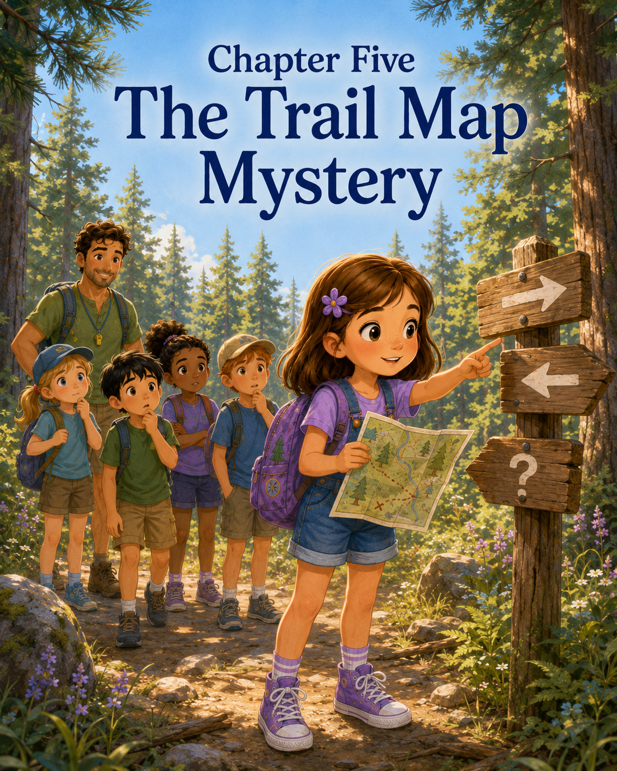

Chapter Five: The Trail Map Mystery
Sally loved maps.
She loved the lines, the symbols, the tiny pictures, and the way a whole place could fit on one folded piece of paper. A map made the world feel like a puzzle waiting to be solved.
So when Mia announced that the Blue Jays were going on a nature hike after morning snack, Sally sat up so quickly that her water bottle tipped over beside her.
Priya caught it before it rolled off the bench.
“Thanks,” Sally said.
Priya smiled. “Excited?”
Sally nodded. “Very. Trails need investigating.”
Noah, who was examining a pinecone as if it might be a rare fossil, looked up. “Do you think we’ll see animal tracks?”
“Maybe,” Sally said.
“Do you think we’ll see Gerald the beetle again?”
Sally thought about it seriously. “Gerald may have other appointments.”
Noah nodded. “True. Beetles are busy.”
Mia stood near the edge of Story Shade holding a clipboard, a small first-aid pouch, and a folded paper map. “Blue Jays, today we are hiking Pine Needle Path.”
Sally leaned forward.
A real map.
Mia unfolded it and held it where everyone could see. The map showed the cabins, the lake, the game field, the craft pavilion, and several trails curling into the woods. Pine Needle Path was marked with a green dotted line. It curved past something called Fern Hollow, crossed a small footbridge, then looped back toward camp.
“We will stay together,” Mia said. “We will walk, not run. We will stay on the marked path. We will not touch mushrooms, unknown plants, or wildlife. And if we are unsure where to go, we stop and check the map.”
Sally liked that last rule best.
“If we are unsure,” she repeated quietly, “we stop and check the map.”
Mia looked at her and smiled. “Exactly.”
The Blue Jays lined up near the trail sign after filling their water bottles. Sally wore her purple backpack with her Adventure Notes notebook tucked inside. She had packed her pencil, sketchbook, and magnifying glass too, just in case the hike required serious observation.
The entrance to Pine Needle Path began between two tall trees. A wooden sign pointed toward the woods, and beneath it was a smaller green marker shaped like a pinecone.
Sally noticed the marker right away.
“Green pinecones show the trail,” she said.
Mia nodded. “Good observation.”
Sally felt pleased.
The group stepped into the woods.
Almost immediately, camp sounded farther away. The shouts from the game field softened. The craft pavilion disappeared behind the trees. The air turned cooler and smelled like pine needles, bark, damp earth, and leaves warmed by the sun.
The trail was narrow but clear. Brown pine needles covered the ground like a soft blanket. Ferns grew along the edges. Small patches of sunlight moved across the path when the branches shifted above them.
Sally walked beside Priya, trying to notice everything at once.
A feather caught in a bush.
A trail of ants crossing a root.
A squirrel flicking its tail from a low branch.
A leaf shaped like a tiny green hand.
A stone that looked like a sleeping turtle.
Noah pointed at the dirt. “Tracks!”
Everyone stopped.
Mia crouched down. “Let’s look without stepping on them.”
Sally bent beside her. In the soft dirt near the edge of the trail were several tiny marks.
“Bird tracks?” Priya asked.
“Could be,” Mia said. “What do you notice?”
Sally studied them closely. “They are small. Three little lines in front. Maybe a bird hopped here after the rain.”
Noah whispered, “Or a tiny forest dinosaur.”
Mateo grinned. “Definitely dinosaur.”
Mia smiled. “Scientific possibility: bird. Camp possibility: tiny forest dinosaur.”
Sally opened her notebook and wrote:
Hike Discovery #1: Tiny tracks. Probably bird. Possibly forest dinosaur, according to Noah and Mateo.
They continued walking.
Every few minutes, they spotted another green pinecone marker nailed to a tree or painted on a small wooden post. Sally counted them in her head.
One.
Two.
Three.
Four.
At the fourth marker, the trail curved left toward a shady area where ferns grew thick and tall.
Fern Hollow.
Sally recognized it from the map.
The ferns were beautiful. They leaned over the trail like green feathers. A dragonfly floated between them, flashing blue in the light.
Priya stopped to sketch one quickly.
Mia waited. “Thirty-second nature sketch.”
Everyone liked that idea.
The campers pulled out pencils and small papers from Mia’s pouch. Sally drew a fern with careful little lines. Noah drew what he called “Gerald’s cousin hiding in a jungle.” Mateo drew a leaf that looked more like a lightning bolt.
When the thirty seconds were up, Mia tucked the drawings into her folder.
“These can go on our cabin wall later,” she said.
Sally liked the idea of the cabin becoming a place for their discoveries.
The trail continued past Fern Hollow and toward the little footbridge. The bridge crossed a narrow stream that whispered over smooth stones.
Sally stepped onto the bridge slowly.
It did not wobble like the canoe.
Good.
She leaned carefully over the railing, not too far, and watched the water move beneath her. A yellow leaf floated along, bumped into a rock, spun once, and kept going.
“Even leaves go on adventures,” Sally said.
Priya nodded. “That one is brave.”
Noah looked down. “It has no map.”
Sally smiled. “Maybe the stream is the map.”
After the bridge, the trail became a little wider. The trees opened slightly, and the sunlight grew brighter. Mia walked at the front, with the campers behind her in pairs.
Then they reached the fork.
Two paths stretched ahead.
One curved gently to the right, where the trees were spaced farther apart. The other went left, dipping into a shadier section with more ferns and roots.
Between the two paths stood a wooden post with a green pinecone marker.
But something looked wrong.
Sally stopped.
The marker was turned sideways.
Instead of pointing clearly left or right, the little wooden pinecone seemed to point somewhere in between, toward a bush.
Mia paused at the fork and looked at the post.
“Hm,” she said.
Mateo pointed right. “I think it goes this way.”
Noah pointed left. “No, the forest dinosaur would go that way.”
Priya looked at Sally. “Which way was on the map?”
Sally’s eyes narrowed.
She remembered the map showing Pine Needle Path looping back toward camp after the bridge. But she had only looked at it for a short time. The dotted line had curved—but had it curved right or left?
Mia unfolded the paper map again and held it open.
“Blue Jays,” she said calmly, “this is a good time to practice trail thinking. What do we do when something is confusing?”
Sally answered first. “Stop and check the map.”
“Exactly,” Mia said.
The group gathered around.
Mia held the map steady, but she did not immediately point out the answer. “What do you notice?”
Sally studied the map carefully. She looked at the footbridge symbol, then at the loop of Pine Needle Path. On the paper, after the bridge, the dotted trail curved right before circling back toward camp.
But the signpost marker looked sideways.
Sally looked up from the map and back at the trail.
Something else caught her attention.
On the right-hand path, a small green pinecone marker was visible farther ahead, nailed to a tree trunk. It was partly hidden by leaves, but Sally could see the edge of it.
On the left-hand path, there was no marker.
There were footprints, though. Several of them.
“People have gone left,” Mateo said.
Sally looked at the footprints. “Maybe they were not from our trail.”
Noah frowned. “But footprints mean path.”
“Not always,” Sally said. “At the beach, footprints went everywhere. That didn’t mean the ocean wanted us to follow all of them.”
Mia smiled slightly but stayed quiet.
Sally stepped closer to the signpost, careful not to leave the main trail. The marker was loose. Not falling off, but twisted a little on its nail. Wind, rain, or maybe someone bumping it could have turned it.
“I think the marker moved,” Sally said.
Priya looked closer. “It does look crooked.”
Sally pointed toward the right-hand path. “There’s another green marker on that tree.”
Everyone looked.
At first, no one saw it.
Then Priya said, “I see it!”
Noah shaded his eyes. “Oh. Behind the leaves.”
Mateo crossed his arms. “But the left path looks more adventurous.”
“That does not mean it is correct,” Sally said.
Mia nodded. “That is an important point.”
Sally looked at the map again. “The map shows the trail curving right after the bridge. The next marker is also on the right. The post marker is confusing because it turned sideways. So we should go right.”
Mia looked at the group. “What do the rest of you think?”
Priya nodded. “Right.”
Noah sighed. “The forest dinosaur will have to wait.”
Mateo looked at the left path one more time, then shrugged. “Right makes sense.”
Mia smiled. “Good trail work, Blue Jays. Sally noticed three important things: the map, the next marker, and the fact that the signpost looked twisted. Strong hikers do not just rush ahead. They slow down and observe.”
Sally felt warmth rise in her cheeks.
Not embarrassed warmth.
Proud warmth.
She had noticed something.
Something that mattered.
Mia took a small orange ribbon from her pouch and tied it gently near the confusing post—not on a plant, but around the wooden pole. “I’ll tell the camp director this marker needs fixing. For now, we know our path.”
The Blue Jays turned right.
As they walked, Sally kept watching for markers. She noticed every green pinecone now, even the ones partly hidden by leaves. The right-hand path curved exactly as the map had shown. Soon, they began seeing familiar parts of camp through the trees.
The lake sparkled between branches.
The flagpole appeared in the distance.
Then the roof of the craft pavilion came into view.
“We did it,” Priya said.
Sally smiled. “We followed the map.”
Noah looked back toward the woods. “And avoided the wrong trail.”
“Possibly avoided the forest dinosaur,” Mateo added.
Noah sighed. “We’ll never know.”
Mia led the group to a shady clearing near camp and gave everyone a water break. The campers sat on logs arranged in a circle. Sally took a long drink from her purple water bottle, then pulled out her notebook.
Her hand moved quickly.
Discovery #4: The Trail Map Mystery
She paused, then wrote:
On Pine Needle Path, we found a confusing trail marker after the footbridge. It pointed sideways because it was loose. Some people wanted to go left because there were footprints. But the map showed the trail curving right, and I noticed another green pinecone marker hidden ahead on the right path.
She looked toward the woods, where the trail disappeared behind the trees.
Then she added:
Strong leaders notice what others may miss. They do not rush. They slow down, look closely, ask questions, and help the group find the right path.
Priya read over her shoulder. “That sounds like you.”
Sally looked at her. “Me?”
“Yes,” Priya said. “You helped us.”
Sally felt shy and pleased at the same time. “I just noticed the marker.”
“That is helping,” Priya said.
Mia sat nearby and overheard. “Priya is right. Leadership is not always being the loudest person or the first person in line. Sometimes leadership is paying attention.”
Sally thought about that.
She had always liked being in charge. At the seashore, she had learned that being a leader did not mean doing everything herself. It meant helping everyone find their part.
Today, leadership had felt different again.
Quieter.
Like noticing a crooked marker.
Like asking what the map said.
Like helping the group slow down before choosing.
Sally looked at her notebook.
“I thought leaders had to know where to go,” she said.
Mia smiled. “Good leaders do not always know right away. But they know how to look for clues.”
Sally liked that answer very much.
After water break, the Blue Jays walked the last stretch back to Cabin Three. The path was familiar now. Sally recognized the tall tree with peeling bark, the patch of moss shaped like a mitten, and the bird tracks near the trail entrance.
When they reached the cabin, Mia clapped gently.
“Blue Jays, excellent hike. Before lunch, everyone tell me one thing you noticed.”
Noah said, “Possible dinosaur tracks.”
Mateo said, “A very twisty root.”
Priya said, “The ferns looked like feathers.”
Lily said quietly, “The stream sounded like whispering.”
Then Mia looked at Sally.
Sally thought for a moment.
“I noticed,” she said, “that the path can look confusing if you only look once.”
Mia nodded. “And what helps?”
Sally smiled.
“Looking again.”
Later, during lunch, Sally sat beside Priya at the picnic table. Noah was explaining how a forest dinosaur could probably disguise itself as a fallen log. Mateo was arguing that dinosaurs were not known for disguise. Lily was drawing the stream in the corner of her napkin.
Sally looked around at her camp group.
They had not known each other a few days ago.
Now they had made bracelets, paddled canoes, followed trails, and solved a map mystery together.
Camp Pinecone was beginning to feel less like an unknown place and more like a place with stories inside it.
After lunch, Sally added one more line to her notebook:
Camp Rule #4: When the way forward is confusing, do not panic. Pause, notice, and look again.
She underlined look again.
Then she drew a tiny green pinecone marker beside it, turned the right way.
That afternoon, when Mom picked her up, Sally gave the full explorer report.
She told Mom about Fern Hollow, the stream, the confusing marker, the hidden trail sign, and how the group chose the right path. Mark listened carefully from the driver’s seat.
“So,” he said, “you solved a trail map mystery?”
Sally nodded. “Yes.”
“Did you use a magnifying glass?”
“No.”
“A compass?”
“No.”
“A secret code?”
Sally smiled. “No. I used noticing.”
Mom looked back at her. “That may be the best tool of all.”
Sally leaned against her backpack and looked out the window as the trees of Camp Pinecone slipped behind them.
She had always known that noticing mattered.
But today, she had learned something new.
Noticing could help more than just herself.
It could help the whole group.
And that, Sally decided, made it a very important kind of courage.

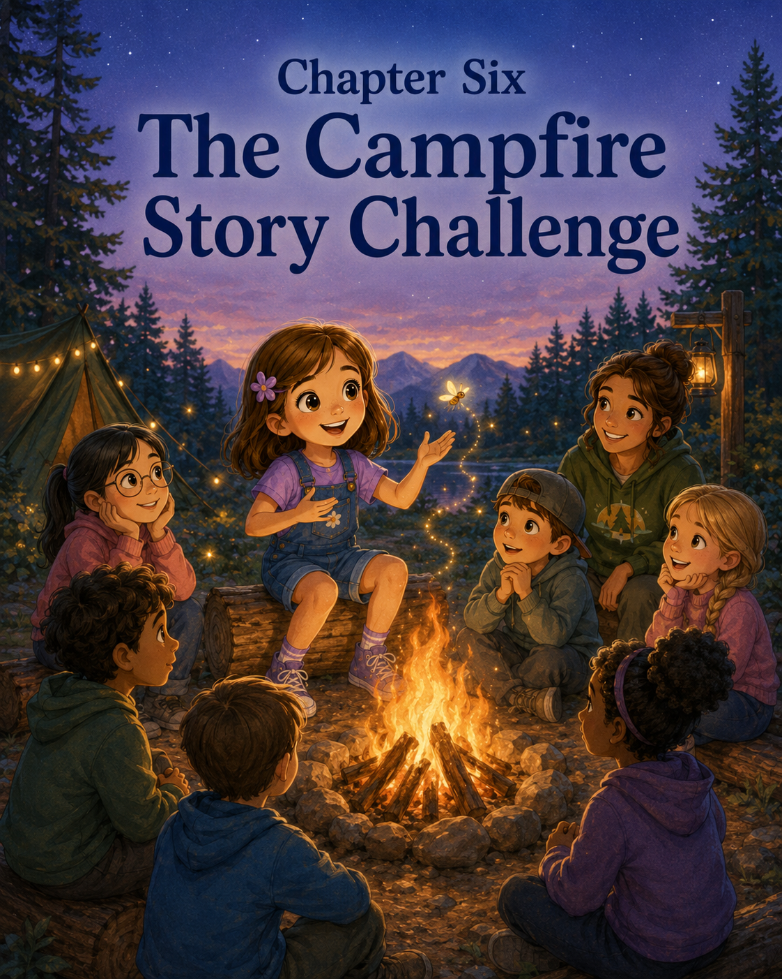

Chapter Six: The Campfire Story Challenge
Sally had never stayed at Camp Pinecone after dinner before.
Usually, Mom picked her up in the afternoon after closing circle. Sally would climb into the car with grass on her sneakers, pine needles in her backpack, and at least three new things to report. She would tell Mom and Mark about canoeing, craft time, trail markers, beetles, and whatever Noah had decided was probably a forest dinosaur.
But today was different.
Today was Family Campfire Night.
Mom and Mark had brought Sally back to camp after dinner, just as the sky was beginning to turn peach and gold. The air felt softer in the evening, cooler than the hot afternoon sun. Crickets had started chirping near the woods, and the cabins glowed warmly in the fading light.
Sally walked between Mom and Mark toward the campfire circle. She wore her purple hoodie over her camp shirt, and her Adventure Notes notebook was tucked under one arm.
The campfire circle sat at the edge of a clearing, not far from Pinecone Lake. Wooden benches curved around a stone fire pit. Counselors had already stacked logs in the center, and a few little flames were beginning to flicker and stretch upward.
Mia waved from one of the benches. “Blue Jays over here!”
Sally spotted Priya, Noah, Mateo, and Lily sitting together. Priya had a blanket folded across her lap. Noah was wearing his dinosaur hat, even though it was not especially cold. Mateo held a marshmallow stick, though no marshmallows had been given out yet. Lily sat quietly near Mia, drawing tiny stars in the dirt with a twig.
Sally hurried over.
“Hi,” Priya said. “I saved you a spot.”
Sally smiled. “Thanks.”
Mom and Mark sat a little farther back with the other families. Mom gave Sally an encouraging smile. Mark lifted one hand in a small wave.
The fire crackled softly.
Pop.
Snap.
Glow.
The flames were not very tall, but they made the whole clearing feel different. The trees around them became dark shapes. The sky above turned deeper blue. Smoke curled upward and carried the smell of wood and summer.
Sally liked it.
She also felt a little fluttery.
Not canoe fluttery.
Not lighthouse-stair fluttery.
This was a different kind.
Because Mia had announced that every camper would be invited to share something at the campfire. A song, a joke, a memory, a poem, or a short story.
Sally liked stories.
She liked making them up. She had imagined underwater kingdoms, brave turtles, secret shells, and tiny crab villages. Her notebook was full of discoveries that could become stories.
But telling a story in her own head was one thing.
Telling it out loud while everyone watched was another.
Mia stood near the fire pit and clapped gently for attention.
“Welcome to Family Campfire Night,” she said. “Tonight, campers may share a short campfire story, song, joke, or memory. Sharing is invited, not forced. We listen kindly, clap for everyone, and remember that courage looks different for each person.”
Sally liked that Mia always explained things clearly.
Still, her stomach fluttered.
Noah leaned over. “I’m telling a story about Gerald the beetle.”
Sally blinked. “The same Gerald from the cabin?”
“Yes,” Noah said. “But now he has a sword.”
“Of course he does,” Sally said.
Priya held up her sketchbook. “I drew a dragon story, but I’m not sure if I’ll tell it.”
Sally looked at her. “Why not?”
Priya shrugged. “Maybe it’s silly.”
Sally frowned. “Dragons are allowed to be silly.”
Priya smiled. “Then your story should be allowed too.”
Sally looked down at her notebook. “I don’t have one yet.”
That was not exactly true.
She had ideas.
Too many ideas.
A story about a canoe that wobbled.
A story about a lost trail marker.
A story about a friendship bracelet that turned into rainbow spaghetti.
A story about a pinecone that secretly listened to everything campers said.
But none of them felt good enough.
What if her story was too short?
What if it was boring?
What if Noah’s beetle-with-a-sword story was funnier?
What if Priya’s dragon story was better?
What if she forgot the middle?
What if everyone stared and waited and Sally’s words disappeared?
The fire snapped loudly, and Sally jumped a little.
Mia began with a short story about her first year as a camper, when she accidentally packed three flashlights and no socks. Everyone laughed. Then another counselor led a camp song with clapping. A younger camper told a knock-knock joke and forgot the punchline, but everyone clapped anyway.
That helped.
A little.
Then Mateo stood up.
He told a story about a soccer ball that rolled into the woods and came back covered in leaves, which meant it had probably joined a secret forest team. His story was short and funny, and everyone laughed when he bowed dramatically at the end.
Noah went next.
Gerald the beetle did, in fact, have a sword. He also had a tiny shield made from an acorn cap and was defending Cabin Three from an army of crumbs. Noah used his hands to show Gerald marching across the windowsill. By the end, half the Blue Jays were giggling.
Sally laughed too.
But her stomach tightened.
Noah’s story was good.
What if hers was not?
Mia looked toward the Blue Jays. “Anyone else from Cabin Three want to share?”
Priya looked down at her sketchbook.
Sally looked down at her notebook.
Lily, who had barely spoken all evening, slowly raised her hand.
Everyone turned gently toward her.
Lily stood beside Mia, holding her drawing in both hands. “I wrote a poem about the stream from our hike,” she said softly.
The clearing became quiet.
Lily read:
“The stream knows where to go,
even when the stones are in the way.
It turns,
it slips,
it sings,
and keeps moving.”
When she finished, there was one small quiet moment.
Then everyone clapped.
Not loud, silly clapping.
Warm clapping.
The kind that made the air feel safe.
Sally looked at Lily with new respect. Lily had been nervous. Sally could tell. Her voice had trembled a little at the start. But she had shared anyway.
And her poem was beautiful.
Priya leaned closer to Sally. “I think I might share my dragon now.”
“You should,” Sally said.
Priya stood next and told a story about a leaf-winged dragon who was afraid of campfires until it learned that small flames could give warmth and light. She showed her drawing at the end, and everyone clapped again.
Sally clapped hard.
Then Mia looked at her.
“Sally, would you like to share anything tonight?”
Sally froze.
The fire glowed.
The benches were full of campers and families.
Mom and Mark sat in the back, watching with gentle faces.
Sally’s hand tightened around her notebook.
“I don’t know,” she said.
Mia smiled kindly. “That is okay. You can pass.”
Passing would be easy.
No one would be upset.
No one would think she was strange.
No one would hear her story and decide it was not good enough.
But then Sally thought about the seashore. She had learned that sharing a shell’s story made the wonder bigger. She thought about the sandcastle team, where creativity grew stronger when everyone had a part. She thought about Priya helping untangle her bracelet, and the yellow canoe moving forward only when they paddled together.
Maybe stories were like that too.
Maybe they did not become real until they were shared.
Sally opened her notebook.
The blank page stared back at her.
She looked toward the woods. In the dim air near the edge of the clearing, a tiny light blinked.
Then another.
And another.
Fireflies.
Sally sat up a little straighter.
One small light floated near a tree trunk, blinking on and off as it moved through the shadows.
An idea came softly, like a spark.
“I think I have one,” Sally said.
Mia nodded. “Whenever you’re ready.”
Sally stood.
Her legs felt a little wobbly, but not as wobbly as the canoe. She walked to the front near Mia and turned toward the campfire circle.
Everyone looked at her.
Sally took a breath.
She thought about one brave step.
One careful paddle.
One crooked trail marker.
One tangled knot.
Then she began.
“Once,” Sally said, “there was a little firefly named Flicker.”
The clearing grew quiet.
“Flicker lived in a big forest with many other fireflies. Every night, the fireflies came out when the sky turned dark. They blinked and glowed and danced between the trees. Some made big bright flashes. Some blinked in perfect patterns. Some flew high above the bushes where everyone could see them.”
Sally glanced toward the woods, where the real fireflies continued blinking.
“But Flicker’s light was small.”
Noah leaned forward.
Sally continued. “It was not broken. It was not gone. It was just small. When Flicker blinked, his light looked like a tiny dot in the dark. He worried that no one would notice it. He worried that the bigger fireflies would laugh. He worried that his glow was not good enough to share.”
Sally’s voice grew steadier.
“One evening, the forest became very dark. Clouds covered the moon. The path to the firefly meadow disappeared in the shadows. A young moth got lost near the roots of an old pine tree.”
Priya pulled her blanket closer.
“The moth called for help, but the forest was noisy. Crickets chirped. Leaves rustled. An owl hooted from far away. The big fireflies were dancing high above the meadow, and they did not hear.”
Sally held up one finger.
“But Flicker heard.”
The campfire popped softly.
“Flicker wanted to help, but he was afraid. His light was so small. What if it was not bright enough? What if the moth could not see it? What if he tried and failed?”
Sally looked at Lily, then Priya, then Mom and Mark.
“Then Flicker remembered something his grandmother had told him: ‘A small light is still light.’”
Mom smiled from the back.
“So Flicker took a deep breath and blinked.”
Sally opened and closed her hand softly, like a tiny flash.
“Once.”
She blinked her hand again.
“Twice.”
And again.
“Three times.”
The younger campers watched closely.
“The moth saw the tiny light. ‘Is someone there?’ she called. Flicker blinked again. His light was small, but it was steady. He flew a little farther down the path. Blink. Blink. Blink.”
Sally moved one hand gently through the air.
“The moth followed. Flicker did not light the whole forest. He did not need to. He only lit the next little part of the path. Then the next. Then the next.”
Sally paused.
“Soon, the moth reached the meadow safely. The other fireflies gathered around. ‘How did you find your way?’ they asked.”
Sally smiled.
“The moth pointed to Flicker. ‘I followed his light.’”
Noah whispered, “Nice.”
Sally continued. “Flicker looked at his tiny glow. It did not seem tiny anymore. It had helped someone. It had mattered.”
She took one more breath.
“And from that night on, Flicker still had a small light. But he was no longer ashamed of it. Because he knew that even a small light can be brave when it is shared.”
Sally stopped.
For one second, the clearing was quiet.
Then everyone clapped.
Loudly.
Priya clapped with both hands above her blanket. Noah gave two thumbs up. Lily smiled. Mom had one hand over her heart. Mark wiped at one eye and then pretended he had smoke in it.
Sally’s cheeks warmed, but this time she did not mind.
Mia stepped beside her. “That was beautiful, Sally.”
Sally looked down at her notebook. “It just came from the fireflies.”
“Good storytellers notice what is already around them,” Mia said.
Sally returned to her seat beside Priya.
“That was really good,” Priya whispered.
“Thanks,” Sally said.
“I liked the grandmother firefly.”
“Me too,” Sally said.
Noah leaned over from the other side. “Gerald would be friends with Flicker.”
Sally smiled. “Probably.”
After all the stories were finished, the counselors handed out marshmallows for roasting. Mark helped Sally hold her roasting stick at the safe distance from the flames, and Mom reminded her not to wave it around.
Sally’s marshmallow turned golden on one side and black on the other.
“Half perfect, half campfire disaster,” Mark said.
Sally inspected it. “That seems about right.”
She ate it anyway.
Later, when the fire had burned lower and the sky was full of stars, Mia gave everyone a few quiet minutes before closing circle. Sally pulled out her Adventure Notes notebook and wrote by the glow of Mom’s small flashlight.
Discovery #5: The Campfire Story Challenge
She paused, then wrote:
At the campfire, everyone could share a story, poem, joke, or song. I wanted to tell a story, but I worried my idea was not good enough. Then I saw fireflies and told a story about Flicker, a brave little firefly with a small light. Everyone listened. Everyone clapped.
She looked toward the woods, where tiny lights still blinked in the darkness.
Then she added:
Creativity shines brightest when it is shared. Even a small idea can light the next part of the path.
Sally read the sentence again.
It felt like Flicker’s story.
It also felt like hers.
Mom sat down beside her. “May I read it?”
Sally handed her the notebook.
Mom read quietly and smiled. “That is one of my favorite discoveries.”
Mark leaned over. “Mine too.”
Sally looked at him. “You had smoke in your eye.”
“I did,” Mark said. “Very emotional smoke.”
Sally laughed.
Mia rang the small bell, and the Blue Jays gathered one last time around the dimming fire.
“What did we learn tonight?” Mia asked.
Noah raised his hand. “Beetles can defend cabins from crumbs.”
Mateo nodded. “Important.”
Priya said, “Dragons can be afraid of fire.”
Lily said softly, “Streams keep moving.”
Then Mia looked at Sally.
Sally thought about Flicker’s small light. She thought about standing in front of everyone with her legs feeling wobbly. She thought about how her story had seemed too small inside her notebook, but bigger once other people heard it.
“Stories do not have to be perfect,” Sally said. “They just have to be shared.”
Mia smiled. “That is a wonderful lesson.”
The fire crackled low.
The stars shone overhead.
The fireflies blinked at the edge of the trees like tiny lanterns.
As Sally walked back to the car between Mom and Mark, she looked over her shoulder at the campfire circle. The benches were empty now, but the warmth of the evening still seemed to stay there.
At the start of the night, Sally had worried her idea was not good enough.
But Flicker had taught her something.
Small lights mattered.
Small stories mattered.
Small brave moments mattered too.
And Sally, curious explorer and campfire storyteller, carried that little glow all the way home.

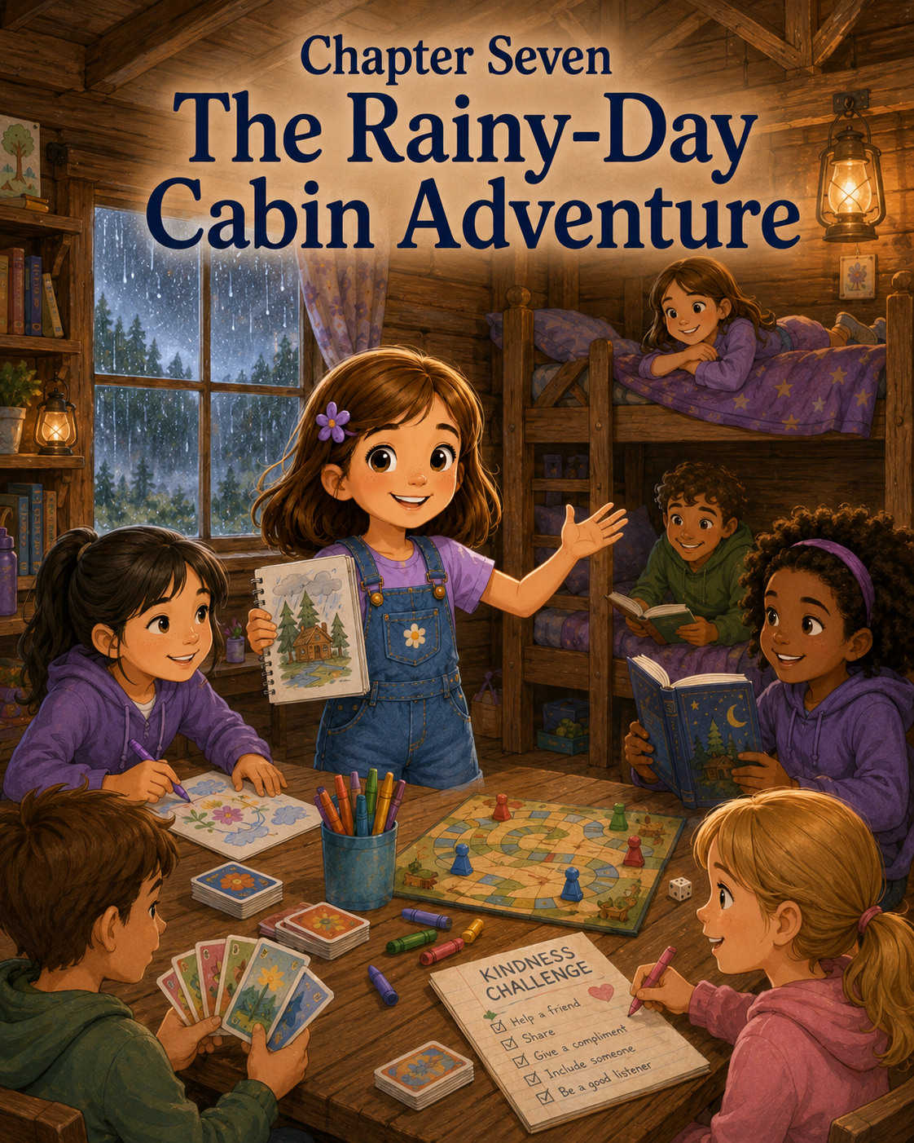

Chapter Seven: The Rainy-Day Cabin Adventure
Sally heard the thunder during morning circle.
At first, it was only a low rumble far beyond the trees. It rolled across Camp Pinecone like someone moving a heavy cart through the sky. The Blue Jays were sitting on the round rug inside Cabin Three, passing the talking pinecone and sharing what they hoped to do that day.
Noah had said he wanted to search for more beetles.
Priya wanted to finish her leaf-dragon drawing.
Mateo wanted to play capture the flag.
Lily wanted to visit Story Shade.
Sally had been waiting for her turn because she knew exactly what she wanted.
“I want to hike to Fern Hollow again,” she said when the talking pinecone reached her hands. “And maybe check the trail marker to see if it was fixed.”
Mia smiled. “That is a very Sally answer.”
Sally sat a little taller.
Then the thunder came.
Rumble.
Everyone grew quiet.
Noah looked toward the window. “Was that a storm?”
Mia stood and stepped to the cabin door. Outside, the sky had turned gray over the pine trees. A warm wind pushed through camp, making leaves twist and flutter. The flag near the field snapped sharply in the breeze.
Mia looked up for a moment, then came back inside.
“That was thunder,” she said calmly. “Blue Jays, we are going to stay inside until the storm passes.”
Sally stared at her.
“Inside?” Mateo asked.
“For how long?” Noah added.
Mia checked her phone, then looked at the group. “It may be a little while. The counselors are moving everyone into cabins and covered areas. Safety first.”
Sally looked out the window.
Rain had not started yet, but the trees were swaying. A few drops tapped against the glass.
Tap.
Tap.
Tap-tap.
Then the sky opened.
Rain poured down so suddenly that it looked like a silver curtain had dropped across Camp Pinecone. The game field blurred. The trail entrance disappeared behind sheets of water. The path to the craft pavilion became shiny and wet.
Sally’s shoulders sank.
No Fern Hollow.
No trail marker.
No outdoor games.
No Story Shade.
No looking for animal tracks near the footbridge.
She pressed her lips together.
“This ruins everything,” Mateo said.
Sally did not say anything, but she agreed.
The cabin felt smaller when everyone was stuck inside it. Backpacks hung on hooks. Sneakers squeaked against the wooden floor. Rain drummed on the roof so loudly that it sounded like a hundred tiny drummers were having a contest.
Mia clapped her hands gently. “All right, Blue Jays. Change of plans.”
Sally frowned.
She did not like change of plans.
Especially when the original plan included investigating.
Mia continued, “Storm days happen at camp. That means we adapt.”
Noah raised his hand. “Can we adapt outside?”
“Not during thunder,” Mia said.
Noah lowered his hand. “I suspected that answer.”
Priya hugged her sketchbook to her chest. “What do we do now?”
Mia looked around the cabin. “We’ll start with quiet reading and drawing while I check in with the other counselors.”
Quiet reading and drawing were not terrible.
But they were not a hike.
Sally took out her Adventure Notes notebook and opened to a clean page. She wrote:
Rainy Day Problem:
Outdoor activities canceled. Cabin feels too small. Trail mystery delayed.
She looked at the words and sighed.
Priya sat beside her. “Are you mad?”
“Not mad,” Sally said.
Priya raised one eyebrow.
Sally adjusted her answer. “Disappointed.”
“That’s a better word,” Priya said.
“It is still not a good feeling,” Sally said.
“No,” Priya agreed.
The rain pounded harder. A flash of lightning brightened the window for one quick second, followed by another rumble of thunder. Mia checked that everyone was away from the windows, then pulled the cabin door closed.
The Blue Jays settled on the rug, but the room buzzed with restless energy.
Noah tried to read a book about insects but kept looking out the window.
Mateo bounced a foam ball lightly against his knee until Mia gently took it and placed it on a high shelf.
Lily drew raindrops on a scrap of paper.
Priya sketched a dragon under an umbrella.
Sally stared at her notebook.
The day felt stuck.
Like a kite tangled in a tree.
Like a canoe that would not move.
Like a trail sign pointing nowhere.
Sally looked at the cabin walls. There were already some of their drawings taped up from earlier in the week: the fern sketches, a picture of Gerald the beetle, Priya’s leaf-winged dragon, and Sally’s drawing of the crooked trail marker turned the right way.
Camp Pinecone was still here.
The Blue Jays were still here.
Their imaginations were still here.
Only the weather had changed.
Sally sat up.
Maybe the adventure was not canceled.
Maybe it had moved indoors.
She looked at Priya’s dragon-under-an-umbrella drawing. “That dragon looks like it needs a story.”
Priya smiled a little. “It does?”
“Yes,” Sally said. “Why is it outside in the rain?”
Priya looked at the drawing. “Maybe it lost its cave.”
Noah looked up from his bug book. “Or maybe its cave flooded.”
Mateo leaned closer. “Or maybe it’s guarding treasure from storm goblins.”
Lily looked up quietly. “Maybe it is helping smaller animals stay dry.”
Everyone paused.
“That’s good,” Sally said.
Lily smiled shyly.
Sally turned to Mia, who had just finished checking messages with another counselor at the door.
“Mia,” Sally asked, “can we make an indoor adventure?”
Mia looked interested. “What kind of indoor adventure?”
Sally stood. “A rainy-day cabin adventure. Since we can’t go outside, we can turn the cabin into different places.”
Noah’s eyes brightened. “Like a bug research station?”
“Maybe,” Sally said.
Priya held up her sketchbook. “Or a dragon cave.”
Mateo pointed toward the benches. “Or a storm castle.”
Lily said softly, “Or a kindness shelter.”
Sally looked at her. “A kindness shelter?”
“For anyone who feels disappointed,” Lily said.
The cabin grew quiet for a moment.
Then Sally nodded. “That should be part of it.”
Mia smiled. “I like this idea. But we need indoor safety rules.”
Sally reached for her notebook. “I’ll write them.”
Mia counted on her fingers. “No running. No climbing on furniture. Voices at indoor level. Ask before using someone else’s supplies. Clean up each station before moving to the next.”
Sally wrote quickly.
Rainy-Day Cabin Adventure Rules
1. No running.
2. No climbing on furniture.
3. Use indoor voices.
4. Ask before using supplies.
5. Clean up each station.
6. Make room for everyone.
She added the last rule herself.
Mia read it and nodded. “Excellent addition.”
The Blue Jays began planning.
First, they turned one corner of Cabin Three into the Storm Castle. Mateo arranged cushions on the floor as castle stones, while Noah made a warning sign that said:
Thunder Dragons Nearby
Mia helped tape it safely to the wall.
Priya drew a dragon with rain dripping from its wings, and Lily added tiny animals huddled beneath the dragon’s tail, staying dry.
Sally looked at the drawing. “So the dragon is not scary?”
Lily shook her head. “It looks scary because it is big, but it is helping.”
Sally wrote that down:
Storm Castle Lesson: Sometimes big feelings look scary, but they may be trying to protect something small.
Next, they created the Bug Research Station near the bookshelf. Noah took charge, of course. Mia gave them magnifying glasses from the nature bin, and they examined pinecones, leaves, acorn caps, and a piece of bark that had been collected earlier in the week.
“No real bugs inside unless Mia says,” Sally reminded Noah.
Noah sighed. “Fine.”
He drew Gerald the beetle on an index card and placed it beside the bark.
“Gerald is our official indoor bug representative,” he said.
Sally approved.
Then Priya suggested an Imagination Art Table. The campers drew what they wished they could be doing outside. Mateo drew capture the flag in the rain, which Mia said looked exciting but unsafe. Priya drew the trail through Fern Hollow covered in sparkling raindrops. Lily drew a tiny cabin with warm light inside.
Sally drew Pine Needle Path with little puddles shaped like stars.
As she colored them purple, she realized she was not quite as disappointed as before.
The rain still fell.
The trail was still closed.
But the cabin had become busier, warmer, and more interesting.
After art, Lily placed a folded paper in the middle of the rug.
“What’s that?” Sally asked.
“A kindness challenge,” Lily said.
Mia tilted her head. “Tell us more.”
Lily looked a little nervous, but she unfolded the paper. “Maybe we can each do one kind thing before the storm ends.”
Sally’s eyes brightened.
Now this was an adventure.
“What kind of thing?” Mateo asked.
Lily shrugged. “Like helping someone clean up. Or sharing supplies. Or saying something encouraging. Or inviting someone into your game.”
Sally opened her notebook to a new page.
Rainy-Day Kindness Challenges
She wrote:
1. Help clean up without being asked.
2. Share a supply.
3. Encourage someone.
4. Invite someone in.
5. Listen to someone’s idea.
Mia looked around the cabin. “Blue Jays, this may be my favorite part of the rainy-day adventure.”
The kindness challenges began quietly.
Priya shared her purple pencil with Sally before Sally even asked.
Sally helped Mateo straighten the cushions in Storm Castle.
Noah told Lily her kindness shelter idea was “actually very excellent,” which made Lily smile.
Mateo invited Noah to add bug guards to the castle gate.
Lily helped Mia collect scraps from the art table.
Sally noticed something important: kindness made the cabin feel bigger.
Not physically bigger. The walls were still the walls. The rain still kept them inside. But when everyone helped, listened, and made space for one another, the room did not feel as crowded.
It felt like a place where something good was happening.
Mia gathered them back on the rug after lunch. The rain had softened, but thunder still rumbled far away.
“Since we’re still inside,” Mia said, “how about a story round?”
Sally smiled. “A campfire story without the campfire?”
“A cabin story,” Mia said.
The Blue Jays sat in a circle and took turns adding one sentence to a story. Mia began.
“Once there was a cabin in the woods that only became magical during thunderstorms.”
Priya added, “Inside the cabin lived a dragon who collected raindrops in jars.”
Noah said, “One jar had a beetle named Gerald in it, but with air holes.”
Mateo added, “The beetle knew where the storm treasure was hidden.”
Lily said, “But the treasure was not gold. It was a lantern that helped lost animals find shelter.”
Then it was Sally’s turn.
She thought for a moment.
“The campers followed the lantern through the rainy forest, not by running, but by helping one another take careful steps.”
Mia smiled.
The story went around and around the circle until the dragon, Gerald, the lantern, three lost squirrels, and a very polite storm goblin all found shelter in the magical cabin.
By the time the story ended, the rain had slowed to a gentle patter.
Tap.
Tap.
Tap.
Mia opened the cabin door and looked out. The air smelled fresh and clean. Water dripped from the pine branches. The field shimmered with puddles, and the trail entrance was still muddy, but the thunder had moved far away.
“Good news,” Mia said. “The storm is passing. We still won’t hike today because the trail needs to dry, but we can go outside for a short puddle walk on the paved path after cleanup.”
Mateo cheered.
Noah cheered.
Priya smiled.
Sally looked toward the window. Part of her still wished they had gone to Fern Hollow. But another part of her felt proud of Cabin Three.
The day had not gone as planned.
But it had not been ruined.
They cleaned up quickly. Cushions went back. Art supplies returned to baskets. Scraps went into recycling. The Gerald card was taped to the Bug Research Station shelf, where Noah said it belonged forever, or at least until Friday.
Before they went outside, Sally opened her Adventure Notes notebook.
She wrote:
Discovery #6: The Rainy-Day Cabin Adventure
Then she continued:
A summer storm canceled our outdoor activities. I felt disappointed because I wanted to hike to Fern Hollow. At first, the cabin felt small and boring. Then we made indoor adventure stations: Storm Castle, Bug Research Station, Imagination Art Table, Cabin Story Circle, and Rainy-Day Kindness Challenges.
She paused and listened to the last drops falling from the roof.
Then she added:
A day can change without being ruined. Sometimes adventure is not where you planned to go. Sometimes it is what you make with the people beside you.
Priya leaned over. “That’s a good one.”
Sally smiled. “Thanks.”
Lily looked at the page shyly. “Can you add the kindness shelter?”
Sally nodded at once.
She wrote:
Important note: Lily invented the Kindness Shelter. It helped.
Lily smiled.
When the Blue Jays finally stepped outside, the world looked washed clean. The air was cool and damp. Puddles shone on the path like little mirrors. The leaves sparkled. Pinecones had fallen near the cabin steps. The sky was still gray, but a soft yellow light was beginning to push through the clouds.
Sally walked beside Priya on the paved path.
Noah inspected a puddle and declared it “excellent frog possibility water,” though Mia reminded him not to step in it too deeply.
Mateo tried to hop over a tiny puddle and landed directly in the middle.
Lily laughed softly.
Sally looked back at Cabin Three.
Earlier that morning, it had seemed like the place where the day got stuck.
Now it looked different.
It looked like Storm Castle.
Bug Station.
Kindness Shelter.
Story Circle.
Art Pavilion.
Adventure Headquarters.
All inside one cabin.
When Mom picked Sally up that afternoon, Sally climbed into the car with damp sneakers and a full notebook page.
“How was camp?” Mom asked.
Sally thought about the storm, the disappointment, the cabin, the kindness challenges, and the story about the dragon with raindrop jars.
“It rained,” Sally said.
Mark looked at her in the rearview mirror. “Oh no. Did it ruin the day?”
Sally smiled.
“No,” she said. “It changed the day.”
Mom looked back with interest. “And what did you do with the change?”
Sally hugged her notebook to her chest.
“We made an adventure out of it.”
Mark grinned. “That sounds like Sally.”
Sally looked out the window as Camp Pinecone slipped behind the trees. Raindrops still clung to the glass, catching little pieces of light as the car moved.
She had learned at the seashore that waves could change the sand.
Today she learned storms could change a camp day.
But change did not always have to take the adventure away.
Sometimes, if you looked closely and invited others in, change could become the adventure.

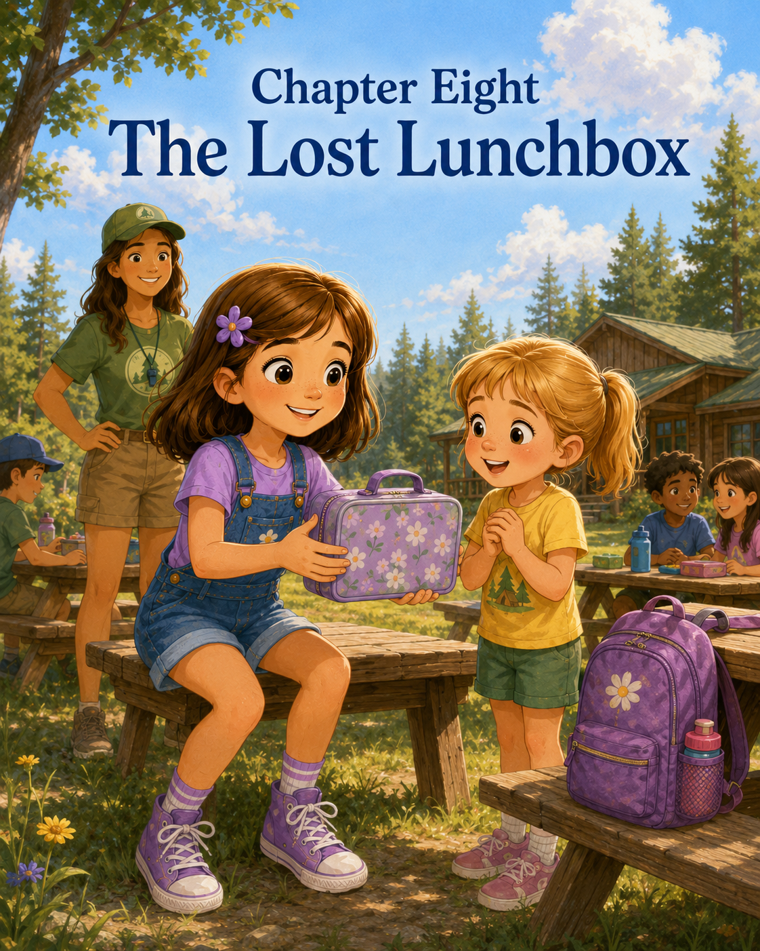

Chapter Eight: The Lost Lunchbox
Sally found the lunchbox after the Blue Jays finished eating.
It was sitting by itself at the end of the picnic table, tucked partly behind a water bottle crate and a stack of folded napkins. At first, Sally almost missed it. The table was messy from lunch, with sandwich crumbs, orange peels, empty juice boxes, and a few runaway carrot sticks scattered across the wood.
But Sally noticed things.
She noticed the way one corner of the lunchbox peeked out from behind the crate. She noticed the bright green zipper. She noticed the sticker on the front shaped like a smiling frog. She noticed that no one was sitting near it.
“Someone forgot this,” Sally said.
Priya looked over while closing her own lunch bag. “Maybe it belongs to one of the Blue Jays.”
Noah leaned across the table. “Does it have a name?”
Sally turned the lunchbox carefully without opening it. “I don’t see one on the outside.”
Mateo pointed. “Maybe we should look inside.”
Sally froze with one hand on the zipper.
Opening it would probably solve the mystery faster. There might be a name written on a napkin, or a note from a parent, or a snack container with initials on it.
But something about opening someone else’s lunchbox did not feel right.
Sally had learned this kind of feeling before. At the seashore, she had found Oliver’s red bucket and wanted to keep it. But then she realized it belonged to someone else. Returning it had felt better than keeping it.
This lunchbox was different, but the feeling was similar.
It belonged to someone.
And that someone might be looking for it.
“We should ask Mia first,” Sally said.
Noah nodded. “Good idea. Lunchboxes can have private sandwich information.”
Priya laughed. “Private sandwich information?”
Noah looked serious. “You never know.”
Sally carried the lunchbox carefully by its handle and walked over to Mia, who was helping Lily wipe down another picnic table.
“Mia,” Sally said, “I found this lunchbox by the napkin stack.”
Mia turned and looked. “Good noticing, Sally. Did you open it?”
Sally shook her head. “No. I thought we should ask first.”
“That was respectful,” Mia said. “Let’s see if there’s a name tag.”
She checked the outside pockets and the bottom. There was no name.
Mia looked toward the picnic area. Campers from several groups were finishing lunch. Some were lining up for water. Others were throwing away trash or packing their bags.
“It may belong to someone from another group,” Mia said. “We can solve this carefully.”
Sally’s eyes brightened.
“Solve it?” she asked.
Mia smiled. “Yes. A lost lunchbox mystery.”
Sally stood taller.
A mystery was exactly the kind of ordinary moment that could become an adventure.
“What should we do first?” she asked.
“What do good problem-solvers do?” Mia asked.
Sally thought about Pine Needle Path and the confusing trail marker.
“They slow down, look closely, and ask questions.”
“Exactly,” Mia said.
Sally opened her Adventure Notes notebook and turned to a clean page.
At the top, she wrote:
The Lost Lunchbox Mystery
Underneath, she added:
Clue #1: Green zipper. Frog sticker. Found near picnic tables after lunch. No name on outside.
Priya came over and looked at the lunchbox. “Maybe the owner likes frogs.”
Noah nodded. “Or maybe the frog is only a disguise.”
Sally gave him a look. “A lunchbox does not need a disguise.”
“It might if it is hiding,” Noah said.
Mateo grinned. “From lunch?”
Sally tried not to smile, but she did.
Mia held the lunchbox. “We will ask the nearby groups first. Sally, Priya, you may come with me. Noah and Mateo, please help clean the table with Lily.”
Noah sighed. “I wanted to investigate.”
“Cleaning is also helpful,” Mia said.
Noah picked up a napkin. “Fine. I will investigate crumbs.”
Sally, Priya, and Mia walked to the nearest picnic table where the Robin group was lining up.
Mia spoke to the counselor. “Did any of your campers lose a lunchbox?”
The counselor turned to the children. “Robins, is anyone missing a lunchbox?”
Several campers checked their bags.
A boy held up a blue lunchbox. “I have mine.”
A girl showed a pink one with stars.
Another camper said, “Mine has dinosaurs.”
No one claimed the frog lunchbox.
Sally wrote:
Clue #2: Not Robins.
Next, they checked with the Cardinals.
A counselor asked the group, and everyone began looking around. One child thought the lunchbox might be his until he opened his backpack and found his own tucked inside.
“Not mine,” he said.
Sally added:
Clue #3: Not Cardinals. One false alarm.
They walked past the water station toward the picnic table where the younger campers had eaten. Sally noticed a small boy standing near the edge of the grass, turning slowly in a circle. His eyebrows were pulled together, and his hands kept patting the sides of his backpack.
He looked worried.
Sally stopped.
Mia noticed her stopping. “What do you see?”
“That boy,” Sally said quietly. “He looks like he lost something.”
Priya looked too. “Maybe the lunchbox.”
Sally did not run over. She had learned that mysteries needed careful questions, not jumping to conclusions.
She walked closer with Mia beside her.
“Hi,” Mia said kindly to the boy. “Are you looking for something?”
The boy nodded, his lower lip trembling. “My lunchbox.”
Sally’s heart gave a little squeeze.
“What does it look like?” Mia asked.
The boy wiped one hand across his cheek. “It’s green. And it has a frog.”
Sally looked at Priya.
Priya smiled.
Mia held up the lunchbox. “Is this it?”
The boy’s face changed instantly.
His worried eyes grew wide, and his mouth opened in surprise.
“Froggy!” he cried.
He reached for it, then stopped and looked at Mia, as if remembering he should wait.
Mia smiled and handed it to him. “Here you go.”
The boy hugged the lunchbox against his chest. “I thought I lost it forever.”
Sally understood that feeling. She remembered Oliver hugging his red beach bucket the same way.
“What’s your name?” Sally asked.
“Eli,” the boy said.
“I’m Sally,” she said. “I found it near the picnic tables.”
Eli looked up at her. “You did?”
Sally nodded. “We didn’t open it.”
Eli hugged the lunchbox tighter. “Good. My mom put a note inside.”
Sally felt very glad she had not opened it.
“That belongs to you,” she said.
Eli nodded. “It’s my first camp lunchbox.”
His counselor hurried over just then, looking relieved. “Eli, you found it!”
“Sally found it,” Eli said.
The counselor smiled at Sally. “Thank you for helping.”
Sally shrugged a little, but she felt proud. “It was a mystery.”
Priya added, “Sally noticed he looked worried.”
Mia nodded. “That was the most important clue.”
Sally looked at Eli.
His eyes were no longer shiny with almost-tears. He was smiling now, still holding the lunchbox with both arms.
“Thank you,” he said.
“You’re welcome,” Sally said.
Eli unzipped the front pocket and pulled out a small folded note. He did not open it, but he checked that it was still there.
“My mom writes me one every day,” he said.
Sally’s smile softened. “That’s nice.”
Eli nodded. “Today’s has a frog joke.”
Noah, who had apparently finished investigating crumbs and wandered closer, appeared beside them. “What kind of frog joke?”
Eli looked at him seriously. “I can’t tell you until snack.”
Noah nodded. “Fair.”
Mia gently guided the Blue Jays back toward their cabin line. “Good work, everyone. Sally, would you like to finish your notes before we head to afternoon activities?”
Sally nodded quickly.
She sat on a bench near the picnic tables and opened her notebook.
She wrote:
Clue #4: Small boy near grass looked worried and was checking his backpack.
Clue #5: Boy said his lunchbox was green with a frog. His name is Eli. Mystery solved.
Then she paused.
The mystery had been simple. There were no secret maps, no hidden codes, no trail markers pointing the wrong way. Just a lunchbox left behind and a boy who missed it.
But it still mattered.
Especially to Eli.
Sally continued writing:
Important discovery: Doing the right thing can turn an ordinary moment into an act of kindness.
She looked at the words.
Then she added:
Sometimes helping starts by noticing who looks worried.
Priya sat beside her. “That’s true.”
Sally looked up. “You noticed it too?”
“After you did,” Priya said. “You’re good at seeing things.”
Sally smiled. “Mrs. Carter gave me the Curious Explorer Award.”
“That sounds right,” Priya said.
Noah sat on the bench across from them. “I helped clean crumbs.”
Sally nodded. “Also important.”
“Some crumbs looked suspicious,” Noah said.
Mateo came over with his water bottle. “Suspicious how?”
“Too many in one place,” Noah said. “Possibly a crumb meeting.”
Sally laughed.
The rest of the afternoon moved into game time, but Sally kept thinking about Eli and his frog lunchbox. During relay games, she noticed him across the field with the younger campers. The lunchbox sat safely near his counselor’s bag, and every so often Eli glanced back to make sure it was still there.
At snack, Eli came over with his counselor.
“I can tell the frog joke now,” he said.
Noah immediately sat up straighter.
Eli unfolded his note carefully and read, “What do frogs eat with their hamburgers?”
Noah leaned forward. “What?”
“French flies.”
Everyone laughed, even Mia.
“That is an excellent frog lunchbox joke,” Sally said.
Eli grinned. “My mom knows good jokes.”
Then he tucked the note back into the lunchbox pocket and zipped it closed.
Sally watched him return to his group.
The lunchbox was not special because it was green or because it had a frog sticker. It was special because it carried something from home. A note. A joke. A reminder that someone loved him enough to tuck a small smile inside his day.
Sally thought about Mom. She thought about Mark. She thought about Dad too, and how sometimes the things children carried were not only snacks and water bottles and pencils. Sometimes they carried feelings from home. Worries. Questions. Little pieces of comfort.
A lunchbox could matter.
A lot.
Before closing circle, Mia gathered the Blue Jays beneath the shade near Cabin Three.
“Today,” she said, “we had a small mystery. What helped us solve it?”
Mateo raised his hand. “Asking groups.”
Priya said, “Not opening the lunchbox.”
Noah added, “Respecting private sandwich information.”
Mia smiled. “Yes. Respecting privacy.”
Lily said quietly, “Sally noticed the boy looked sad.”
Sally looked down, suddenly shy.
Mia nodded. “That was very important. Kindness often begins with noticing.”
Sally’s eyes lifted.
That was almost exactly what Mom had once told her at the seashore.
Noticing is where kindness often begins.
Mia continued, “Leadership is not only helping during big moments. Sometimes it is helping with ordinary things. A lost lunchbox. A spilled supply box. A friend who needs a place to sit. Those moments matter too.”
Sally looked at her bracelet, still a little crooked on her wrist.
Ordinary things could become important.
A bracelet.
A canoe paddle.
A trail marker.
A rainy cabin.
A lunchbox.
At closing circle, the talking pinecone went around the group. Each camper shared one thing they had learned that day.
Noah said he learned that frog jokes were better than expected.
Mateo said he learned that relay games were harder after eating crackers.
Priya said she learned that asking questions helped solve mysteries.
Lily said she learned that lost things could make people feel lonely.
Then the pinecone came to Sally.
She held it carefully in both hands.
“I learned that when you find something that belongs to someone else, you should help it get back,” she said. “And sometimes the best clue is how someone feels.”
Mia smiled. “Beautifully said.”
When Mom picked Sally up that afternoon, Sally climbed into the car and immediately began her explorer report.
“We solved a mystery today,” she said.
Mark turned around from the front seat. “A camp mystery?”
“Yes,” Sally said. “A lost lunchbox.”
Mom smiled. “That sounds important.”
“It was,” Sally said. “It had a frog sticker and a note from Eli’s mom.”
“Did you find Eli?” Mom asked.
Sally nodded. “He looked worried. That was the clue.”
Mark looked at her thoughtfully. “You noticed the person, not just the lunchbox.”
Sally thought about that.
“Yes,” she said. “That was the mystery.”
Mom’s eyes softened. “That was also kindness.”
On the drive home, Sally opened her notebook across her lap and added one final line to the page:
Camp Rule #7: Look for what is lost, but also look for who is hurting. Helping both is kindness.
She underlined helping both.
Outside the car window, Camp Pinecone’s trees slipped behind them, green and golden in the afternoon sun.
Sally leaned back in her seat, tired in the good camp way.
She had not climbed a mountain that day.
She had not paddled across the lake.
She had not solved a secret code hidden in the woods.
She had found a lunchbox.
But to Eli, it had mattered.
And that made it an adventure worth remembering.

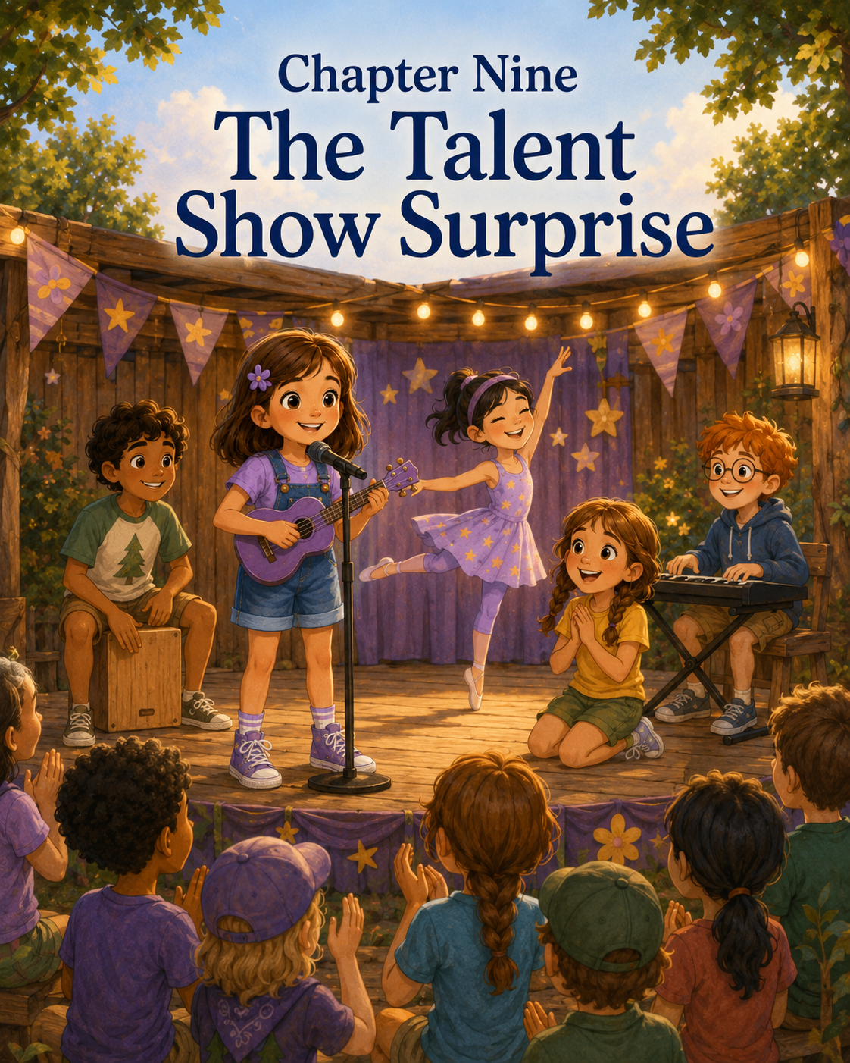

Chapter Nine: The Talent Show Surprise
Sally heard about the talent show during morning announcements.
The Blue Jays were gathered in Cabin Three, sitting on the round rug while Mia stood beside the chalkboard. Sunlight came through the windows in soft golden squares, and the cabin smelled faintly of crayons, pine needles, sunscreen, and yesterday’s rainy-day art supplies.
Mia smiled as she wrote two big words on the board:
Talent Show
Noah sat up so fast his dinosaur hat slipped over one eye.
“Talent show?” he asked.
Mia nodded. “Tomorrow afternoon, Camp Pinecone will have its end-of-week talent show. Every group may participate. Campers can sing, dance, tell jokes, perform a skit, read a poem, show artwork, do a simple magic trick, tell a story, or share another camp-appropriate talent.”
Mateo raised his hand. “Can I juggle pinecones?”
Mia tilted her head. “Can you juggle pinecones?”
Mateo paused. “Not yet.”
“Then maybe choose something safer,” Mia said.
Priya hugged her sketchbook. “Can we show drawings?”
“Absolutely,” Mia said.
Noah raised his hand. “Can Gerald the beetle have a talent?”
Sally looked at him. “Gerald is not actually here.”
“He could be represented,” Noah said.
Mia smiled. “Stuffed animals, drawings, and imaginary beetle heroes may appear in skits, as long as the campers are doing the performing.”
Lily raised her hand softly. “Can we do something together?”
“Yes,” Mia said. “You can perform alone, with a partner, or as a group.”
The cabin buzzed with excitement.
Priya whispered to Sally, “Maybe I’ll show my leaf-dragon drawings.”
Sally nodded. “You should. They’re really good.”
“What are you going to do?” Priya asked.
Sally opened her mouth.
Then closed it.
What was she going to do?
She looked around the cabin. Noah was already talking about a comedy act starring Gerald. Mateo was practicing a dramatic bow. Lily was quietly writing something in her notebook. Priya was flipping through her drawings, choosing the best ones.
Everyone seemed to have an idea.
Sally did not.
That surprised her.
Sally usually had many ideas. Too many, sometimes. Ideas followed her around like seagulls at the beach. She had ideas for stories, drawings, games, clubs, maps, and mysteries. She had created the Seashore Adventure Club. She had told a campfire story about Flicker the firefly. She had helped solve the trail map mystery and the lost lunchbox mystery.
But those did not feel like talents.
Not talent show talents.
Talent show talents sounded like singing beautifully or doing cartwheels or playing piano or telling jokes that made everyone laugh. Sally did not play piano. Her cartwheels leaned sideways. She could sing, but mostly in the car, and mostly when nobody was grading the sound.
“I’m not sure,” Sally said.
Priya looked surprised. “You’ll think of something.”
“Probably,” Sally said.
But she was not sure.
After morning circle, Mia gave the Blue Jays time to brainstorm. She passed out paper and pencils.
“At the top of your page,” Mia said, “write three things you enjoy doing. They do not have to seem like stage talents yet. Just start with what you enjoy.”
Sally wrote her name at the top of the page.
Then she stared at the blank space beneath it.
Things she enjoyed:
Asking questions.
Noticing things.
Writing discoveries in her notebook.
Making up stories.
Helping with mysteries.
Drawing sometimes.
Organizing ideas.
Exploring.
Being in charge, but in a leader way, not a bossy way. Mostly.
Helping others find their part.
She frowned.
Those were not exactly stage acts.
Noah leaned over. “I wrote beetle facts, beetle jokes, and beetle marching.”
Sally looked at him. “Beetle marching?”
Noah tapped two fingers across the table like tiny legs. “It needs work.”
Mateo held up his paper. “I wrote soccer tricks, funny voices, and balancing a spoon on my nose.”
Mia looked over. “No spoon-on-nose unless it is clean and safe.”
Mateo nodded solemnly. “Clean spoon.”
Priya had written drawing, storytelling, and making dragon maps.
Lily had written poem, quiet song, and helping backstage.
Sally looked at Lily’s list. “Helping backstage can be a talent?”
Lily nodded. “Somebody has to help people know when it’s their turn.”
Mia overheard and smiled. “Lily is right. Talent shows need performers, but they also need encouragers, helpers, organizers, sign makers, and audience members who listen kindly.”
Sally looked back at her own paper.
Organizers.
Helpers.
Encouragers.
That sounded closer.
But still, a small uncomfortable feeling sat in her chest.
She wanted to do something that counted.
Something that showed she belonged at Camp Pinecone.
Something that was not embarrassing.
The Blue Jays spent the next hour practicing possible acts under the shady trees near Story Shade.
Noah tried his Gerald comedy routine.
“Why did Gerald cross the cabin?” he asked.
Mateo shrugged. “Why?”
“To get to the crumbs on the other side.”
There was silence.
Then Mateo said, “It needs more crumbs.”
Noah nodded. “Good note.”
Priya spread her drawings on a bench. There were dragons with leaf wings, dragons curled around campfires, dragons sleeping under rainy cabin roofs, and one dragon carrying a tiny backpack.
Sally studied them. “You should tell the story of this one.”
Priya pointed to the backpack dragon. “That’s Maple. She’s going to camp for the first time.”
“She looks nervous,” Sally said.
“She is,” Priya said. “But she packed snacks.”
“Smart dragon,” Sally said.
Lily sat on a log with her notebook, reading her poem silently. Sally noticed that Lily kept stopping at the same line and erasing one word.
“What are you working on?” Sally asked.
“A poem about camp,” Lily said. “But I don’t know if it’s good.”
“Can I hear it?”
Lily hesitated, then nodded.
She read softly:
“Pine trees hold the morning light,
Cabins glow when rain falls gray,
Friends can make a strange new place
Feel more like home each day.”
Sally felt something warm in her chest.
“That’s very good,” she said.
Lily looked doubtful. “Really?”
“Yes. Especially the last two lines.”
Lily smiled a little. “Thanks.”
Sally liked helping people with their ideas.
She liked hearing the almost-finished parts and helping them become stronger. She liked noticing what was good and saying it out loud. She liked asking the question that made someone think of the next piece.
But was that a talent?
Later, during lunch, the talent show was all anyone talked about.
Mateo decided to do soccer foot taps instead of the spoon trick. Noah decided Gerald needed a sidekick. Priya decided to show three drawings and tell a short story about Maple the camp dragon. Lily decided she might read her poem, but only if she could stand near Mia.
Sally stirred her applesauce with her spoon.
“What are you doing?” Noah asked.
“Thinking.”
“About your talent?”
“Yes.”
“Maybe you can solve a mystery on stage,” Mateo said.
Sally looked up. “What mystery?”
Mateo thought. “Where did my extra cookie go?”
Noah quietly moved his hand away from Mateo’s lunch bag.
Mateo narrowed his eyes. “Noah.”
“What?” Noah said. “Mystery solved?”
Everyone laughed.
Sally smiled, but her smile faded quickly.
Priya noticed. “You don’t have to know yet.”
“The talent show is tomorrow,” Sally said.
“That is still time.”
“It does not feel like time.”
Priya tilted her head. “You told a story at the campfire. You could tell another one.”
“I could,” Sally said. “But Flicker’s story just came to me. What if another one doesn’t?”
“Then use your notebook,” Priya said. “It’s full of ideas.”
Sally looked down at her Adventure Notes notebook beside her lunchbox.
Priya was right. It was full.
The last bell of school.
Camp Pinecone.
The friendship bracelet mix-up.
The canoe that wobbled.
The trail map mystery.
The campfire story challenge.
The rainy-day cabin adventure.
The lost lunchbox.
Each one had taught her something.
Maybe there was a talent hidden in there somewhere.
That afternoon, Mia gathered the Blue Jays in Cabin Three.
“Let’s check in,” she said. “Who has chosen a talent?”
Most hands went up.
Sally’s stayed down.
Mia noticed, but she did not call attention to it. After the others shared, she sat beside Sally while the group began working on signs for the show.
“Still thinking?” Mia asked.
Sally nodded. “I don’t know what my talent is.”
Mia leaned back against the bench. “What do you think a talent is?”
“Something you’re good at,” Sally said.
“That is one answer.”
Sally looked at her. “There are others?”
“Sometimes a talent is something you practice. Sometimes it is something you enjoy. Sometimes it is a way you help people.”
Sally frowned thoughtfully. “A way you help people?”
Mia nodded. “I’ve watched you this week, Sally. You ask careful questions. You notice details. You help others feel brave. You encourage people when their ideas are still growing. Those are talents too.”
Sally looked toward the table.
Priya was coloring a sign that said Maple the Camp Dragon. Lily was rewriting her poem in neater handwriting. Noah was drawing Gerald with a microphone. Mateo was making a poster that said Soccer Tricks! Do Not Blink!
“I thought talents had to be something you perform,” Sally said.
“Some are,” Mia said. “But a talent show can also show who we are. Maybe your talent is helping the group shine.”
Sally thought about that.
Helping the group shine.
It sounded nice, but part of her wondered if it would be enough. Would people clap for that? Would it feel like doing anything?
Mia stood and picked up a blank poster. “Every show needs someone to introduce acts. Someone to help arrange the order. Someone to encourage nervous performers. Someone to notice what each person needs.”
Sally’s eyes widened a little.
“You mean like a host?”
“Exactly,” Mia said. “A host, helper, and encourager. You could also share one short discovery from your notebook at the beginning or end.”
Sally sat up straighter.
That felt different.
That felt like something.
She could help organize the Blue Jays’ part of the show. She could introduce the acts. She could make sure Lily did not have to stand alone. She could help Priya remember which drawing came first. She could make sure Noah did not spend too long explaining Gerald’s backstory. She could remind Mateo not to kick the soccer ball into the audience.
That was a lot of responsibility.
Sally liked responsibility.
“I could do that,” she said.
Mia smiled. “I think you could do it very well.”
Sally picked up her pencil. “We need an act order.”
She wrote:
Blue Jay Talent Show Plan
1. Sally introduction
2. Mateo soccer tricks
3. Noah and Gerald comedy
4. Priya’s Maple the Camp Dragon story
5. Lily’s camp poem
6. Sally closing discovery
Then she paused.
“What should my introduction say?”
Mia smiled. “What do you want people to know about the Blue Jays?”
Sally looked around the cabin.
Mateo was practicing foot taps outside. Noah was whispering to his Gerald drawing as if giving it stage directions. Priya was carefully arranging dragon sketches. Lily was tracing the words of her poem with one finger.
Sally wrote:
The Blue Jays learned this week that camp is full of surprises. Some are loud, some are quiet, some are tricky, and some help you discover courage you did not know you had.
She read it to Mia.
Mia’s eyes softened. “That is a beautiful opening.”
Sally smiled.
The next day, the talent show was held under the big pavilion because it gave everyone shade and enough space for families and campers to sit. The counselors hung paper stars, pinecone decorations, and handmade signs from each cabin group.
Sally’s stomach fluttered as the benches filled.
Mom and Mark arrived early and sat near the middle. Mom waved. Mark gave her two thumbs up.
Sally wore her purple flower clip and her friendship bracelet. The bracelet was still a little crooked at the beginning, but she liked that part now. It reminded her that beautiful things could begin with a tangle.
Mia gathered the Blue Jays behind the pavilion.
“Everyone ready?”
Mateo bounced on his toes. “Ready.”
Noah held his Gerald drawing. “Gerald is emotionally prepared.”
Priya clutched her dragon sketches. “Mostly ready.”
Lily held her poem with both hands. “A little nervous.”
Sally stepped closer to her. “Remember your stream poem? Everyone loved it.”
Lily nodded.
“And I’ll stand near you if you want,” Sally said.
Lily’s shoulders relaxed. “Please.”
Sally nodded. “Then I will.”
Mia looked at Sally. “Host, are we ready?”
Sally took a breath.
Host.
Helper.
Encourager.
Curious explorer.
“Yes,” she said. “Ready enough.”
When the Blue Jays were called, Sally walked to the front of the pavilion holding her notebook. For a moment, all the faces looked like one big blur of eyes and smiles.
Then she saw Mom.
Then Mark.
Then Mia.
Then Priya, Noah, Mateo, and Lily behind her.
She opened her notebook and read clearly:
“Hello. We are the Blue Jays from Cabin Three. This week, we learned that camp is full of surprises. Some are loud, some are quiet, some are tricky, and some help you discover courage you did not know you had. Today, we want to share a few of our talents with you.”
People clapped.
Sally stepped aside.
“First is Mateo with soccer tricks. Please do not blink, but also please stay seated.”
The audience laughed.
Mateo grinned and stepped forward. He tapped the soccer ball from foot to foot, balanced it briefly on one knee, and bowed so dramatically that he almost tipped over. Everyone clapped.
Sally checked the list.
“Next is Noah with a comedy routine starring Gerald the beetle.”
Noah walked up, holding his drawing of Gerald.
“Why did Gerald cross the cabin?” Noah asked.
This time, when he gave the crumb joke, people laughed. Especially the younger campers. Noah looked delighted.
Then came Priya.
Sally helped hold up the drawings while Priya told the story of Maple, the little dragon who went to camp with a backpack full of snacks and discovered that new places were easier with friends. Priya’s voice was quiet at first, but it grew stronger as she went on.
When the audience clapped, Priya whispered, “Thank you,” to Sally.
Sally smiled. “You did it.”
Then it was Lily’s turn.
Sally stood beside her, just as promised.
Lily read her poem about pine trees, rain, cabins, and friends who made strange places feel like home. Her voice trembled on the first line but steadied by the last.
The applause was soft and warm.
Lily smiled bigger than Sally had ever seen.
Then Sally returned to the front for the closing.
She looked down at her notebook.
Then she looked at her friends.
“I wasn’t sure what my talent should be,” she said. “I thought a talent had to be singing or juggling or doing tricks. But this week I learned that being curious can be a talent. Being creative can be a talent. Being brave enough to try can be a talent. Helping someone else feel ready can be a talent too.”
The pavilion grew very quiet.
Sally continued, “So today, my talent was helping my friends share theirs.”
For one second, nobody moved.
Then Mia began clapping.
Mom clapped.
Mark clapped.
The Blue Jays clapped.
Soon the whole pavilion was clapping, and Sally felt her cheeks grow warm in the happiest way.
Afterward, Mom hugged her tightly.
“That was wonderful,” she said.
Mark nodded. “Best host Camp Pinecone has ever had.”
Sally raised an eyebrow. “Have you seen all the Camp Pinecone talent shows?”
“No,” Mark admitted. “But I stand by my statement.”
Priya came over and hugged Sally from the side. “You helped me not forget the middle.”
Noah held up Gerald. “Gerald says your introduction was strong.”
Mateo added, “And you reminded me not to kick the ball too hard.”
Lily smiled shyly. “Thank you for standing with me.”
Sally looked at them all.
Her talent had not been the loudest.
It had not required music or cartwheels or a clean spoon balanced on her nose.
But it had mattered.
Later, during closing circle, Sally opened her Adventure Notes notebook and wrote:
Discovery #8: The Talent Show Surprise
She thought carefully, then added:
I did not know what my talent was. I helped organize the Blue Jays’ acts, introduced everyone, held Priya’s drawings, stood beside Lily, and helped my friends feel brave. I learned that being curious, creative, and brave can be a talent. Supporting others is part of the show.
She paused and smiled.
Then she wrote one more line:
Sometimes your talent is helping someone else’s light shine.
Sally looked at the words.
They reminded her of Flicker the firefly.
A small light shared.
A path made brighter.
A friend made braver.
As the Blue Jays packed up for the day, Sally touched the crooked beginning of her friendship bracelet and smiled.
At Camp Pinecone, she had learned that talents came in many shapes.
Some were loud.
Some were quiet.
Some stood on stage.
Some stood beside a friend.
And Sally was beginning to understand that helping others shine was one of the brightest talents of all.

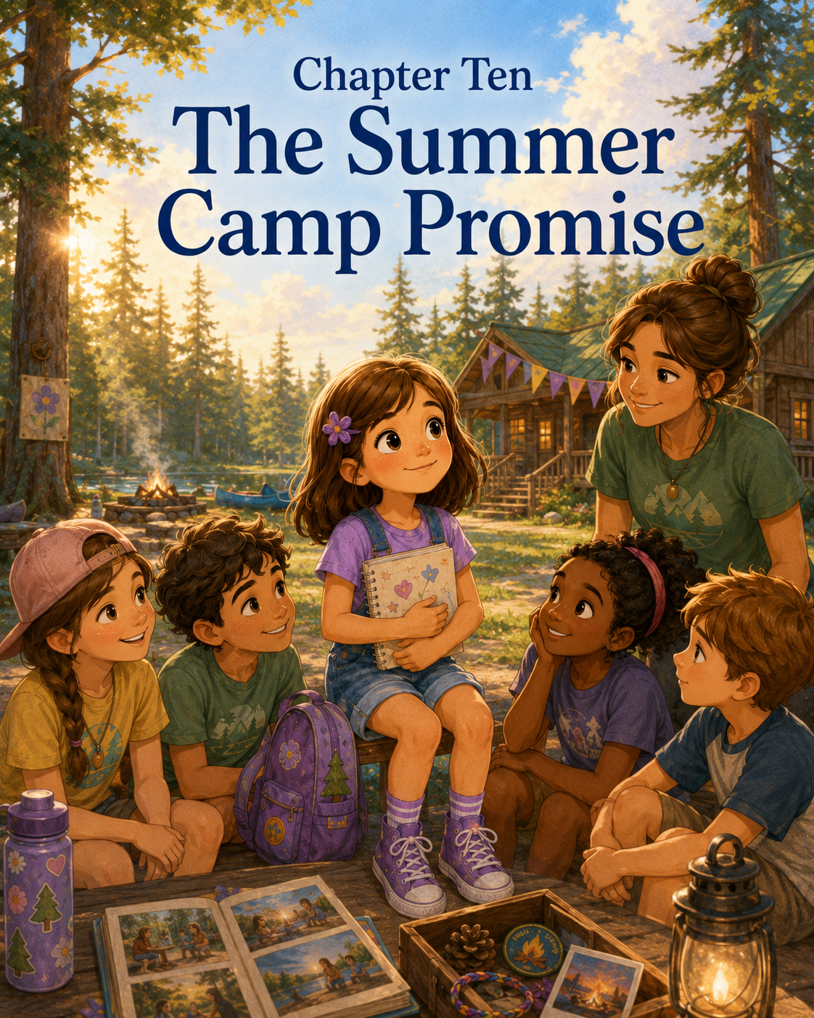

Chapter Ten: The Summer Camp Promise
On the final morning of Camp Pinecone, Sally packed her backpack more slowly than usual.
All week, she had packed it with the same things: water bottle, sunscreen, sketchbook, colored pencils, lunch, extra socks, and her Adventure Notes notebook. On Monday, everything had felt new and uncertain. She had checked her supplies three times because her stomach felt fluttery and because she did not yet know what Camp Pinecone would become.
Now, on Friday morning, her backpack felt different.
It felt like it carried a whole week inside it.
A friendship bracelet with a bumpy beginning.
A pinecone sketch from the trail hike.
A small drawing Priya had made of Maple the camp dragon.
A folded copy of Lily’s poem.
A little paper badge Mia had given her after the talent show that said Blue Jay Helper.
And her notebook, which was nearly full of camp discoveries.
Sally zipped the backpack and looked at it for a moment.
Today was the last day.
She had known it was coming. The calendar had said so. Mom had reminded her the night before. Mia had mentioned it at closing circle yesterday. Still, knowing something was coming did not always make it feel simple when it arrived.
Mom stood in the bedroom doorway, holding Sally’s purple water bottle.
“Ready for your last day?” she asked.
Sally took the bottle and clipped it to her backpack.
“Yes,” she said.
Then she added, “Mostly.”
Mom smiled softly. “Mostly is honest.”
Sally looked down at her sneakers. “I’m excited for the last day activities. But I don’t really want camp to be over.”
Mom came closer and sat on the edge of the bed. “That makes sense. You worked hard to get comfortable there.”
Sally nodded. “At first, Camp Pinecone felt too new. Now it feels like mine.”
Mom’s eyes warmed. “That is a big thing to discover.”
From downstairs, Mark called, “Final Camp Pinecone departure in five minutes! Snacks secured! Sunscreen secured! Emotional support granola bar secured!”
Sally rolled her eyes, but she smiled.
Mom noticed.
“You know,” Mom said, “when you first started camp, you wondered if you were ready.”
Sally remembered.
She had wondered if she would know where to go.
If she would make friends.
If the activities would feel too hard.
If she would miss Mom during the day.
If camp would stay unfamiliar forever.
But camp had not stayed unfamiliar.
It had unfolded, one day at a time.
Sally picked up her backpack. “I think I was ready enough.”
Mom kissed the top of her head. “Ready enough can take you a long way.”
The drive to Camp Pinecone felt shorter than it had on the first day. The trees still lined the road. The houses still grew farther apart. The gravel driveway still crunched beneath the tires.
But Sally did not hold her backpack tightly in her lap this time.
She watched for the sign.
When the wooden board appeared between the two tall pine trees, Sally read it silently:
WELCOME TO CAMP PINECONE
The smiling pinecone in the corner seemed almost like an old friend.
Mark parked the car, and Sally climbed out before he had fully turned off the engine.
“Someone is moving with confidence,” Mark said.
Sally adjusted her backpack straps. “I know where Cabin Three is.”
“That helps,” Mom said.
“It does,” Sally agreed.
At the check-in table, Mia waved.
“Good morning, Sally.”
“Good morning,” Sally said. “Last day.”
Mia nodded. “Last days are important.”
“Are they sad?” Sally asked.
“Sometimes,” Mia said. “And sometimes happy. Usually both.”
Sally thought about that.
Both seemed to happen a lot.
Excited and nervous.
Happy and sad.
Brave and scared.
Ready and unsure.
Maybe growing up was learning that two feelings could sit beside each other without pushing one away.
Mom hugged Sally before leaving.
“I’ll see you this afternoon for the closing celebration,” Mom said.
“Mark too?”
“Mark too.”
Mark gave Sally a serious salute. “I expect a final explorer report.”
Sally saluted back. “Prepare for a long one.”
“I would expect nothing less,” he said.
This time, when Mom and Mark walked away, Sally still felt a small tug in her chest, but it was not sharp like the first day. She knew where to go. She knew who would be waiting.
Priya stood near Cabin Three, waving both hands.
“Sally! I brought the finished Maple drawing.”
Noah ran over with his dinosaur hat slightly crooked. “Gerald may make an appearance at closing circle.”
Mateo bounced a soccer ball against his knee. “One final foot tap record attempt.”
Lily held a folded paper close to her chest. “I wrote a goodbye poem.”
Sally smiled at them.
On Monday, they had been campers she did not know.
Now they were her Blue Jays.
Morning circle felt different that day. The campers sat closer together on the rug, as if the cabin had become smaller in a cozy way. The drawings on the walls fluttered gently whenever the door opened. Gerald’s bug card was still taped near the bookshelf. The rainy-day kindness challenge list hung beside the window. The talent show sign leaned against the wall.
Mia sat with them and held the talking pinecone.
“Today,” she said, “we’ll spend time remembering what we learned this week. We’ll visit a few favorite camp spots, add one final page to our Blue Jay wall, and end with a closing celebration.”
Noah raised his hand. “Will there be snacks?”
“Yes.”
He lowered his hand. “Excellent.”
Mia passed the talking pinecone to Mateo first.
“Share one thing you learned at camp,” she said.
Mateo held the pinecone. “I learned that soccer tricks are harder in front of people, but still fun.”
He passed it to Noah.
“I learned that beetles deserve names,” Noah said. “And that crumbs are suspicious.”
Everyone laughed.
Priya held the pinecone next. “I learned that new places can become stories.”
Lily said softly, “I learned that quiet people can still share something.”
Then the pinecone came to Sally.
She held it carefully in both hands.
There were so many things she had learned that choosing only one felt impossible.
“I learned…” She paused. “I learned that I can do new things before I feel completely ready.”
Mia smiled. “That is a strong discovery.”
Sally passed the pinecone along, but her words stayed with her.
Before she felt completely ready.
That had been the whole week.
After morning circle, Mia led the Blue Jays on a memory walk through camp.
First, they stopped at the craft pavilion.
The tables were clean now, but Sally could still picture the colorful threads spread across them. She touched the bracelet on her wrist. Purple, blue, and yellow. Bumpy at the beginning. Strong after that.
“This is where my bracelet became rainbow spaghetti,” she said.
Priya smiled. “And then it became a bracelet again.”
Sally nodded. “With help.”
Mia looked at the group. “What did craft time teach us?”
Priya said, “Patience.”
Sally added, “And accepting help.”
Noah said, “And that beetle-colored bracelets are underrated.”
Next, they walked to Pinecone Lake.
The yellow canoe rested near the shore, upside down on the rack. It looked calm and harmless, as if it had never wobbled in its life.
Sally knew better.
She stood near the water and watched ripples move across the lake.
“I was nervous getting into that canoe,” she said.
Priya stood beside her. “Me too.”
“But we paddled together,” Sally said.
“One, two, pull,” Priya said.
Sally smiled.
Mia asked, “What did the canoe teach us?”
Mateo said, “Do not stand up.”
“That is true,” Mia said.
Sally looked at the water. “It taught me that courage does not mean feeling perfectly brave. It means trying carefully and trusting the people helping you.”
Mia nodded. “Beautifully remembered.”
Then they walked to the entrance of Pine Needle Path.
The trail marker had been fixed.
Sally noticed immediately.
The little green pinecone pointed clearly to the right now, no longer twisted toward the bush.
“It’s fixed!” she said.
Noah looked at it. “So no one will accidentally visit the forest dinosaur.”
Mateo sighed. “Too bad.”
Sally smiled and opened her notebook to make a quick note.
Trail marker fixed. Mystery officially closed.
Mia looked at the group. “And what did the trail map mystery teach us?”
Lily said, “To slow down.”
Priya said, “To look closely.”
Sally added, “And that strong leaders notice what others may miss.”
She felt shy saying it, but not embarrassed. It was true. She had learned that leadership could be quiet.
They stopped at Cabin Three next.
Mia opened the door and let everyone look around.
“This cabin held a lot this week,” she said.
Sally saw it all at once: morning circles, the talking pinecone, the bug rescue, the rainy-day adventure, the kindness shelter, the art table, the story circle, the talent show planning.
“When the storm came,” Sally said, “I thought the day was ruined.”
“What changed?” Mia asked.
Sally looked at Lily. “We made the cabin into an adventure.”
Lily smiled. “And a kindness shelter.”
“That was important,” Sally said.
The last stop was Story Shade.
The oak tree spread its branches wide above the benches. Sunlight slipped through the leaves and landed on the ground in shifting patches. This had become one of Sally’s favorite places at Camp Pinecone. It was where ideas slowed down enough to be heard.
Mia gave each camper a small card shaped like a pinecone.
“On this card,” she said, “write one promise you want to carry with you after camp.”
Sally held the card in her lap.
A promise.
That sounded bigger than a discovery.
Discoveries were things you found.
Promises were things you carried.
She looked around at her friends. Mateo was writing quickly. Noah was drawing a beetle before writing any words. Priya was staring thoughtfully at the trees. Lily was already writing in her neat, careful handwriting.
Sally tapped her pencil against the card.
What promise should she make?
She could promise to be brave. But brave did not mean never feeling afraid.
She could promise to be kind. But kindness could look different each day.
She could promise to try new things. But sometimes trying meant going slowly.
She could promise to keep noticing. That felt important.
She opened her Adventure Notes notebook and looked back over the pages from the week.
The Last Bell of School: Take one brave step.
Welcome to Camp Pinecone: New places become less scary after you learn their names.
The Friendship Bracelet Mix-Up: Let someone help.
The Canoe That Wobbled: Try carefully.
The Trail Map Mystery: Slow down and look again.
The Campfire Story Challenge: Share your small light.
The Rainy-Day Cabin Adventure: A changed day is not a ruined day.
The Lost Lunchbox: Notice who is hurting.
The Talent Show Surprise: Help others shine.
Sally smiled.
There it was.
Not one lesson.
All of them.
On the pinecone card, she wrote:
My Summer Camp Promise
I promise to stay curious, be kind, try carefully, accept help, help others shine, and remember that adventure can continue wherever I choose to grow.
She read it once.
Then again.
It felt right.
At lunch, everyone sat together at the Blue Jays’ table. Even the food seemed part of the final day: sandwiches, apple slices, crackers, and a special cookie shaped like a pinecone. Noah insisted his cookie looked like Gerald’s cousin. Mateo ate his before anyone could compare it to anything.
After lunch came the closing celebration.
Families gathered under the pavilion. Mom and Mark arrived and sat near the front, just as they had for the talent show. Sally waved, and this time she did not feel nervous about being seen.
Each camp group shared something from the week. The Robins sang a song. The Cardinals showed a poster of nature facts. The Blue Jays stood together while Mia introduced them.
“This week,” Mia said, “the Blue Jays learned that adventure is not only about where you go. It is about how you grow.”
Sally liked that sentence so much she wished she had written it.
Each Blue Jay read their pinecone promise aloud.
Mateo promised to try even when people were watching.
Noah promised to respect bugs, even suspicious ones.
Priya promised to keep turning new places into stories.
Lily promised to share her voice, even when it felt small.
Then Sally stepped forward.
She looked at Mom.
She looked at Mark.
She looked at Mia and the Blue Jays.
Then she read:
“I promise to stay curious, be kind, try carefully, accept help, help others shine, and remember that adventure can continue wherever I choose to grow.”
When she finished, the applause felt warm and gentle.
Mom wiped her eyes.
Mark leaned over and whispered something that made Mom laugh.
Mia gave each camper a small certificate. Sally’s said:
Camp Pinecone Blue Jay Award
For curiosity, kindness, courage, and helping others feel included
Sally held it carefully.
Another certificate.
Another piece of proof.
But this one felt different from the one Mrs. Carter had given her on the last day of school. That award had come before camp, when Sally wondered if she was ready. This one came after, when Sally knew she had tried.
At the end of the celebration, the Blue Jays stood together near Cabin Three.
Nobody seemed to know exactly how to say goodbye.
Noah held up his Gerald drawing. “Gerald says this is not goodbye. It is ‘see you in a crumb-free future.’”
Mateo laughed. “That is weirdly emotional.”
Priya handed Sally a folded paper. “For you.”
Sally opened it.
It was a drawing of Sally standing beneath the Camp Pinecone sign with her backpack, notebook, bracelet, and a tiny firefly glowing near her shoulder. At the bottom, Priya had written:
For Sally, who helps ideas shine.
Sally swallowed.
“I love it,” she said.
Lily gave Sally a copy of her goodbye poem. Mateo gave everyone high-fives. Noah drew a tiny beetle on the corner of Sally’s pinecone promise card.
“Now it is official,” he said.
Sally hugged Priya. Then Lily. Then Mia.
“Thank you,” Sally said to Mia.
“For what?”
Sally thought about the canoe, the trail, the campfire, the rainy day, the talent show, and all the times Mia had let her be nervous without making her feel small.
“For helping camp feel possible,” Sally said.
Mia’s smile softened. “You did a lot of that yourself.”
Mom and Mark walked over.
“Ready, camper?” Mom asked.
Sally looked back at Cabin Three.
The green door was open. The backpack hooks were emptying. The chalkboard still said Goodbye, Blue Jays! in Mia’s handwriting. The drawings on the wall fluttered in the breeze.
Sally felt sad.
And happy.
Both.
“I’m ready,” she said.
Then she added, “Mostly.”
Mark grinned. “A fine Camp Pinecone answer.”
As they walked toward the parking lot, Sally looked around one last time.
At the field where Mateo had practiced soccer tricks.
At the craft pavilion where her bracelet had tangled and then untangled.
At the lake where the yellow canoe had wobbled.
At Pine Needle Path where the marker now pointed the right way.
At Story Shade where her promise had been written.
Camp Pinecone was not ending exactly.
Not if she carried it with her.
In the car, Sally opened her Adventure Notes notebook and wrote one final entry for the week.
Discovery #9: The Summer Camp Promise
She paused.
The car rolled slowly down the gravel driveway. The Camp Pinecone sign came into view through the window.
Sally wrote:
Camp taught me courage, friendship, teamwork, creativity, patience, and kindness. I learned that new places can become familiar, mistakes can become stories, and friends can help you feel brave. I learned that adventure does not end when camp ends. It continues wherever I choose to grow.
She looked at the words for a long moment.
Then she added:
Final Camp Rule: Take what you learned with you. That is how an adventure keeps going.
Sally closed the notebook and held it against her chest.
As the car passed the wooden sign, she waved.
“Goodbye, Camp Pinecone,” she whispered.
Mom looked back. “You’ll miss it?”
Sally nodded. “Yes.”
Mark smiled gently. “That means it mattered.”
Sally thought about that.
It had mattered.
The first day had been unfamiliar. The last day was hard to leave. Somewhere in between, camp had become part of her.
The road curved away from the trees, back toward town, back toward home, back toward the rest of summer.
Sally did not know what adventures would come next.
Maybe bike rides.
Maybe library days.
Maybe visits with Dad.
Maybe afternoons with Mom and Mark.
Maybe new questions she had not thought of yet.
But she knew she would meet them differently now.
With curiosity.
With kindness.
With courage.
With patience.
With creativity.
And with the promise she had written beneath the trees.
Adventure did not end when camp did.
Sally smiled and looked out the window as sunlight flashed through the leaves.
It was only the beginning of the rest of the summer.

Epilogue
Sally did not leave Camp Pinecone the same way she had arrived.
On the first morning, she had stepped out of the car with her backpack held tightly in her hands, her purple water bottle clipped to the side, and a fluttery feeling in her stomach. Camp had seemed so big then—full of cabins, trails, games, counselors, and children she did not know. Sally had wondered if she was ready for all of it. Ready to meet new friends. Ready to try new things. Ready to spend the day away from the people and routines that felt familiar.
But Camp Pinecone had taught Sally something important: she did not have to feel completely ready to begin.
One day at a time, camp became less strange. The cabin became Cabin Three. The campers became the Blue Jays. The counselor became Mia. The lake became the place where Sally paddled a wobbly canoe. The trail became the place where she noticed the confusing marker. The craft table became the place where a tangled bracelet turned into a lesson about patience and help. The campfire became the place where Sally discovered that even a small story could shine.
By the end of the week, Sally’s backpack carried more than supplies. It carried memories. A friendship bracelet with a bumpy beginning. A drawing from Priya. A poem from Lily. Notes about Gerald the beetle, the yellow canoe, the rainy-day cabin adventure, the lost lunchbox, and the talent show where Sally learned that helping others shine was a talent too.
As Mom and Mark drove her home on the final day, Sally looked out the window and watched the trees of Camp Pinecone grow smaller behind them. She felt happy and sad at the same time. Happy because camp had been wonderful. Sad because it was over. But underneath both feelings was something new.
Confidence.
Sally had tried. She had asked questions. She had accepted help. She had helped others. She had made friends. She had discovered that courage could be quiet, kindness could be simple, and adventure could happen almost anywhere.
That night, Sally placed her Camp Pinecone certificate on her desk beside her Adventure Notes notebook. Then she opened to the last page and read the promise she had written beneath the trees:
I promise to stay curious, be kind, try carefully, accept help, help others shine, and remember that adventure can continue wherever I choose to grow.
Sally smiled.
Summer was not over.
There would still be long afternoons, bike rides, library visits, time with Mom and Mark, time with Dad, and new questions she had not even thought to ask yet. There would be days that felt easy and days that felt uncertain. There would be new places, new people, and new chances to be brave.
But now Sally knew what to do.
She could take one careful step.
She could ask one good question.
She could notice who needed help.
She could share one small light.
She could let others walk beside her.
Camp Pinecone had ended, but Sally’s adventure had not.
It was simply growing with her.

About the Author

ScottMBook.com


Scott Speicher brings a unique blend of life experiences to his writing. A U.S. military veteran, he carries the discipline, resilience, and perspective gained through service into every story he tells. After his military career, Scott built a successful path in marketing, where he developed a deep understanding of communication, storytelling, and audience engagement. For more than 15 years, he has also worked as a professional website designer, helping businesses and individuals create meaningful online presences.
Scott Speicher is a storyteller who enjoys creating gentle, heartfelt stories that help children notice the small moments that make life meaningful. Through warm characters and simple adventures, his books encourage young readers to slow down, care for others, and appreciate the quiet joys of everyday life. Scott believes that some of the most important lessons children learn come not from grand events, but from the ordinary moments shared with family, friends, and the animals they love.

Sally at Summer Camp is a heartwarming children’s story about courage, friendship, kindness, and trying new things. When the school year ends, Sally heads to Camp Pinecone feeling excited but nervous about meeting new kids and stepping away from her familiar routine. Through friendship bracelets, canoe rides, trail hikes, campfire stories, rainy-day cabin adventures, lost lunchboxes, and a talent show surprise, Sally discovers that bravery does not mean feeling fearless—it means taking one careful step forward. Along the way, she learns that friendship can begin with kindness, that teamwork takes patience, that creativity shines when shared, and that every new adventure helps her grow.

