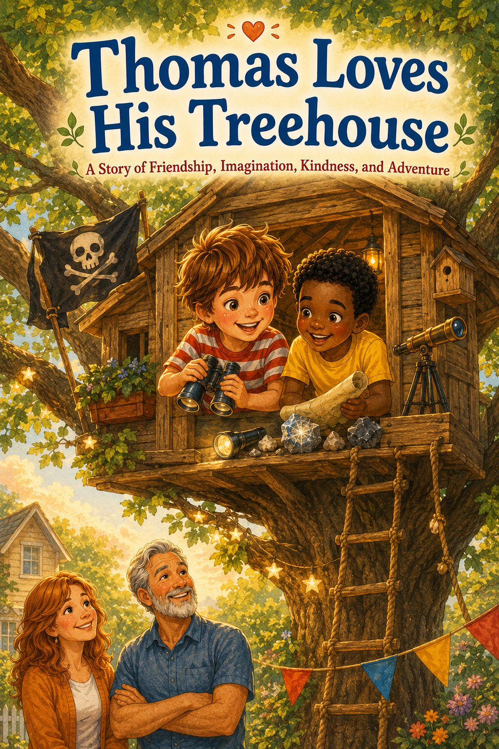
Thomas Loves His Treehouse
A Story of Friendship, Imagination, Kindness, and Adventure
by
Scott Speicher

Copyright © 2026
Author: Scott M. Speicher
Portions of this book have been optimized by the program Grammarly
Edited by Grammarly and the Editorial team of Digital Scribblers
No part of this book may be reproduced or used, in any form or by any means, electronic or mechanical, without permission in writing from the author.
Some of the images are AI-generated with prompting and full control from the author.

Table of Contents

Chapter One: The Treehouse in the Sky
Thomas’s dad finishes building the backyard treehouse, and Thomas and Leo learn that every great adventure begins with safety.
Chapter Two: The Pirate Flag Promise
The treehouse becomes a pirate ship, and Thomas and Leo learn that sharing leadership makes the adventure better.
Chapter Three: The Treasure of Kindness Island
A treasure hunt leads the boys to discover that the best treasure is doing kind and helpful things for others.
Chapter Four: Blastoff from Backyard Base
The treehouse becomes a rocket ship, and Thomas learns that bravery means encouraging a friend and waiting until everyone feels safe.
Chapter Five: The Moon Rock Mystery
Thomas and Leo collect moon rocks and create a Moon Museum, learning that discoveries are better when shared.
Chapter Six: The Jungle Lookout
The treehouse becomes a jungle lookout tower, and the boys learn that adventures grow bigger when kindness makes room for someone new.
Chapter Seven: The Knight of the Oak Castle
A rainy afternoon turns the treehouse into a castle, where Thomas and Leo learn that safe play matters.
Chapter Eight: The Stormy Sea Rescue
After a windy night, the boys find a fallen bird nest and learn that kindness also means caring for small creatures and the world around them.
Chapter Nine: The Great Treehouse Campout
Thomas and Leo enjoy an early evening campout and discover that a good friend helps you feel safe during big adventures.
Chapter Ten: The Adventure Club
Thomas and Leo create the official Treehouse Adventure Club and learn that the best adventures are the ones shared with others.
About the Book
Every child needs a place where imagination can climb a little higher.
For Thomas, that place is a treehouse tucked inside the branches of an old backyard oak tree. At first, it seems like the perfect place to play. But with his best friend Leo by his side, Thomas soon discovers that a treehouse can become almost anything—a pirate ship sailing across a sea of grass, a rocket ship blasting toward the moon, a jungle lookout tower, a castle in the clouds, and a cozy campout under the evening sky.
As each adventure unfolds, Thomas learns that the best kind of fun is not just about pretending. It is about friendship, kindness, sharing, safety, courage, and making room for others. Whether he is helping Leo feel brave, inviting a new friend to join, caring for a fallen bird’s nest, or learning that everyone deserves a turn to lead, Thomas begins to understand that imagination is even more powerful when it is shared.
Thomas Loves His Treehouse is a story for young readers who love adventure, make-believe, and the magic of ordinary places. It reminds children that a backyard can become a whole world, a simple treehouse can become a grand adventure, and a good friend can make every journey feel safer, kinder, and more fun.
May this story encourage children to dream big, play safely, share generously, and remember that the best adventures are the ones we take together.

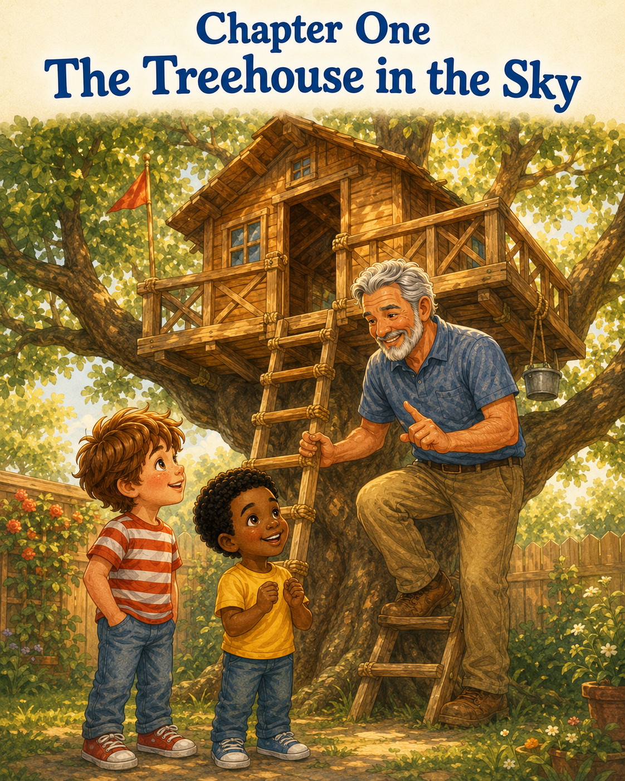

Chapter One: The Treehouse in the Sky
Thomas had been watching the backyard for three whole days.
He watched from the kitchen window while eating cereal. He watched from the sliding glass door while tying his sneakers. He watched from the porch steps with Tia the cat sitting beside him, flicking her striped tail as if she were supervising the whole operation.
In the middle of the yard stood the old oak tree.
Its branches stretched wide and strong, like giant arms reaching toward the sky. For years, Thomas had imagined what it would be like to climb into those branches and have a secret place all his own. A place for maps. A place for snacks. A place where he and Leo could plan important missions, look for birds, read books, and pretend the whole backyard was whatever they wanted it to be.
A jungle.
A pirate island.
A castle.
A rocket ship.
And now, at last, it was almost finished.
Thomas’s dad stood beneath the tree with a tool belt around his waist and a pencil tucked behind one ear. He gave one final twist to a silver screw, stepped back, and looked up at his work.
“Well,” Dad said, wiping his hands on a rag, “I think that does it.”
Thomas froze.
“Does what?” he asked, even though he already knew.
Dad turned and smiled. “The treehouse is ready.”
Thomas gasped so loudly that Tia jumped off the porch step and hurried into the bushes.
“It’s ready?” Thomas shouted.
From the side gate came another voice. “What’s ready?”
Leo came running into the backyard, his bright yellow shirt glowing in the morning sun. He stopped beside Thomas and looked up.
His mouth fell open.
High in the sturdy oak tree was the most wonderful thing Thomas had ever seen. The treehouse sat between the branches like a little wooden cabin in the sky. It had a small front railing, a slanted roof, two square windows, and a rope hanging from one side with a small bucket tied to the end. A wooden ladder led from the grass up to the entrance.
Thomas could hardly breathe.
Leo whispered, “It looks like a fort.”
Thomas shook his head slowly. “No,” he said. “It’s more than a fort.”
Dad raised an eyebrow. “Oh?”
Thomas stood a little taller. “It is our official adventure headquarters.”
Leo nodded at once. “Definitely.”
Thomas pointed up at the treehouse. “From there, we can plan missions, watch for wild animals, draw maps, spot clouds, and protect the backyard from pirates.”
“And aliens,” Leo added.
“And jungle tigers,” Thomas said.
“And snack emergencies,” Leo said seriously.
Dad laughed. “That sounds like a lot of responsibility for one treehouse.”
Thomas looked up at the little wooden doorway. His heart felt jumpy and bright, like it was bouncing on a trampoline. He wanted to climb the ladder right away. He wanted to look out the window. He wanted to see if the backyard looked different from up there.
He took one step toward the ladder.
Dad held up one hand.
“Hold on, explorer.”
Thomas stopped.
Leo stopped too.
Dad knelt down so he was eye level with both boys. His face was still smiling, but his voice had changed a little. It was the voice he used when something mattered.
“Before anyone climbs up,” Dad said, “we need to talk about the first rule of every adventure.”
Thomas blinked. “Bring snacks?”
Leo nodded. “That is important.”
Dad smiled. “Snacks are important. But not first.”
Thomas thought hard. “Use your imagination?”
“Also important,” Dad said. “But still not first.”
Leo raised his hand as if he were in school. “Don’t let pirates steal the map?”
Dad laughed. “That is probably rule number seven.”
He pointed gently to the ladder. “The first rule is safety.”
Thomas looked at the ladder. It did not look scary. It looked exciting.
Dad continued, “A treehouse is a wonderful place. But wonderful places still need careful people. You climb one person at a time. You use both hands. You don’t rush. You don’t push. You don’t lean too far over the railing. And you always watch out for each other.”
Thomas listened carefully.
Leo looked up at the ladder, then back at Dad. “So we can’t race to the top?”
“No racing,” Dad said.
“Can we pretend we’re racing?” Leo asked.
“You can pretend after you are safely inside,” Dad said. “On the ladder, you climb slowly.”
Thomas nodded. “Slow climbing. Both hands. One at a time.”
“That’s right,” Dad said.
“And no pushing,” Leo added.
“And no leaning over the railing,” Thomas said.
Dad smiled. “Good. Also, if anything feels wobbly or unsafe, you tell me or Mom right away. No fixing it yourselves. No testing it by jumping on it.”
Leo looked disappointed. “Not even a little jump?”
“Especially not a little jump,” Dad said.
Thomas laughed, but he understood. The treehouse was not just a toy. It was something Dad had worked hard to build. It was something they had to respect.
Dad stood and placed a hand on Thomas’s shoulder.
“Adventure is better when everyone comes home safe,” he said.
Thomas looked up at the treehouse again. The windows seemed to glow in the sunlight. A breeze moved through the oak leaves, making them whisper softly above his head.
He imagined the treehouse waiting for him.
Not just as a place to play.
As a place to begin.
“Okay,” Thomas said. “I’ll be careful.”
Leo nodded. “Me too.”
Dad stepped aside. “Then, Captain Thomas, you may climb first.”
Thomas’s eyes widened. “Really?”
“Really.”
Thomas walked to the ladder. He placed one hand on the side rail, then the other. The wood felt warm from the sun. He put one sneaker on the first step.
Then he paused.
Leo stood below, watching.
“You go slow,” Leo reminded him.
Thomas grinned. “I know.”
Step by step, Thomas climbed. He did not rush, even though his excitement wanted to race ahead of him. He kept both hands on the ladder. He looked at each step before moving to the next one. When he reached the top, he crawled carefully through the entrance and stood inside the treehouse for the first time.
For a moment, he said nothing.
The inside smelled like fresh wood and sunshine. The floor was smooth beneath his sneakers. A little shelf ran along one wall, perfect for notebooks and treasure maps. The windows were just the right size for looking out across the yard. The roof made the space feel cozy, like a tiny cabin tucked inside the leaves.
Thomas stepped to the window and looked out.
Everything was familiar, but different.
The patio looked smaller. The garden hose curled like a green snake. The flowerpots looked like tiny towers. The birdbath shimmered like a silver pond. Even Tia, peeking from the bushes, looked like a wild jungle cat.
Thomas turned back toward the ladder.
“Leo!” he called. “You have to see this!”
Dad looked up from the grass. “One at a time, remember?”
Thomas nodded. “I’m all the way in.”
Leo climbed next. He moved slower than Thomas expected, gripping the ladder tightly. When he reached the doorway, Thomas stepped back to give him room.
Leo crawled inside and stood up.
His face lit up.
“Whoa,” Leo whispered.
Thomas nodded proudly. “I know.”
Leo turned in a slow circle. “This is not just an adventure headquarters.”
Thomas looked at him. “What is it?”
Leo smiled. “It’s a sky house.”
Thomas liked that.
A sky house.
A place above the grass but below the clouds. A place where the world looked bigger and smaller at the same time.
Dad climbed halfway up the ladder and leaned his arms safely on the platform edge.
“So,” he said, “what do you think?”
Thomas looked around the treehouse, then at Leo, then out the little window toward the wide backyard.
“I think,” Thomas said, “this is where every adventure starts.”
Leo nodded. “And every adventure needs rules.”
Thomas turned to the shelf along the wall. “We should write them down.”
Dad smiled. “That sounds like a good idea.”
Thomas pulled his small notebook from his back pocket. He always carried one when something important might happen. And this was definitely something important.
He opened to a clean page and wrote at the top:
Treehouse Adventure Rules
Leo leaned over his shoulder. “Rule one: safety.”
Thomas wrote carefully.
1. Be safe.
Dad nodded. “Good start.”
Thomas added:
2. Climb slowly.
3. Take turns.
4. Watch out for each other.
Leo tapped the page. “Add snacks.”
Dad crossed his arms. “Snacks are allowed if they do not attract ants.”
Thomas wrote:
5. Snacks are allowed if they are safe snacks.
Leo looked satisfied.
Then Thomas paused. “We need one more.”
“What?” Leo asked.
Thomas looked out at the yard again. The leaves shifted around the windows, and the sunlight fell across the floor in golden patches.
He thought about all the adventures they would have here. Pirate ships. Rocket launches. Jungle lookouts. Castles. Secret clubs. Rainy-day reading. Maybe even a place to be quiet when the world felt too loud.
He wrote:
6. Share the adventure.
Leo smiled. “That’s a good one.”
Dad’s face softened. “That might be the best one.”
Thomas tore the page from his notebook and taped it to the wall with a piece of blue painter’s tape Dad had left on the shelf.
The rules hung there proudly.
Not fancy.
Not perfect.
But official.
Thomas stood in the middle of the treehouse with Leo beside him and Dad smiling from the ladder. The wind rustled the leaves, and somewhere nearby a bird chirped as if announcing the grand opening.
Thomas lifted one hand.
“I now declare this treehouse open for adventure.”
Leo raised both arms. “Adventure headquarters is ready!”
Dad chuckled. “Just remember—safe adventure.”
Thomas nodded. “Safe adventure.”
Leo nodded too. “Shared adventure.”
From below, Mom stepped out onto the porch holding a plate of sandwiches. “Shared adventure with lunch?”
Thomas and Leo looked at each other.
That was the best kind.
A few minutes later, they sat inside the treehouse with their backs against the wall, eating sandwiches from napkins and looking out across the yard. Dad stayed below, gathering his tools, while Mom waved from the porch. Tia the cat crept back from the bushes and settled beneath the tree, still pretending she had not been scared earlier.
Thomas took a bite of his sandwich and smiled.
The treehouse was real.
Not a dream. Not a drawing. Not a maybe-someday idea.
It was real wood, real windows, real sunshine, and real possibilities.
Leo looked at him. “What adventure should we do first?”
Thomas thought about it.
The treehouse could be a pirate ship. It could be a rocket. It could be a jungle tower. It could be a castle in the clouds.
But for now, it was something even better.
It was new.
It was theirs.
And it was waiting.
Thomas looked out at the backyard, where the grass moved in the breeze like a green ocean.
He smiled and said, “All of them.”

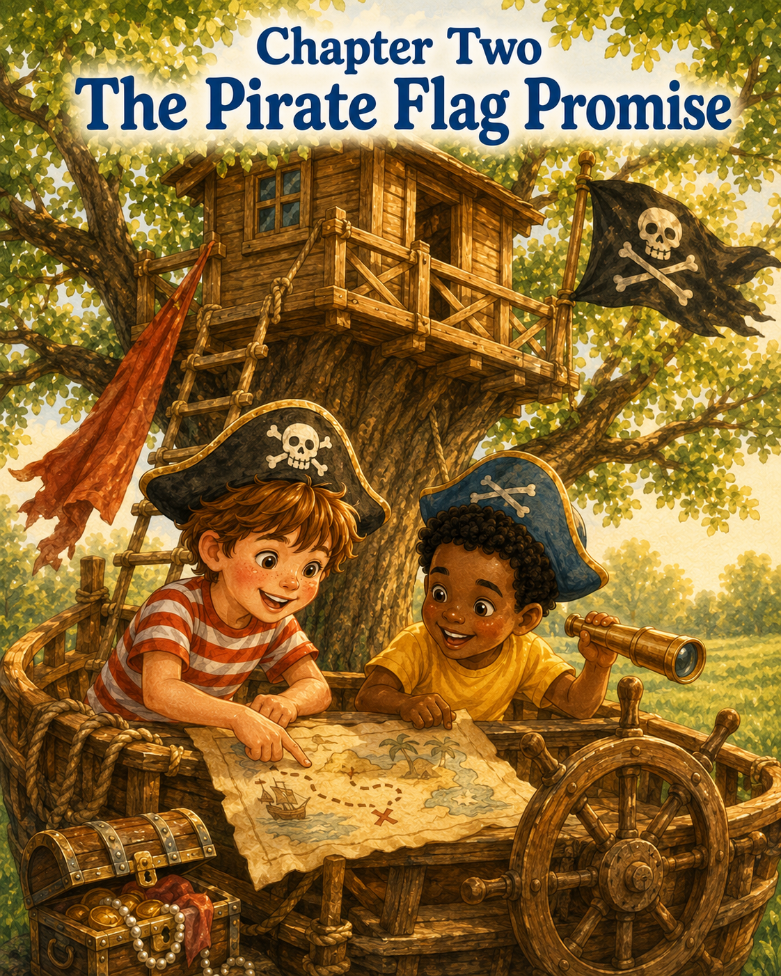
Chapter Two: The Pirate Flag Promise
The next morning, Thomas woke up with one thought in his head.
The treehouse.
He didn’t think about cereal.
He didn’t think about cartoons.
He didn’t even think about the missing blue sock that had somehow disappeared under his bed.
He sat straight up, looked out the window, and saw the old oak tree standing tall in the backyard. The treehouse rested in its branches, quiet and still, as if it had been waiting all night for him to return.
Sunlight slipped through the leaves and touched the little wooden railing. A breeze moved through the branches, making the whole tree seem to sway like a ship on gentle waves.
Thomas’s eyes widened.
A ship.
That was it.
Today the treehouse would not be a treehouse at all.
It would be a pirate ship.
Thomas leaped out of bed, pulled on his red-and-white striped shirt, and hurried downstairs. Tia the cat was sitting in the hallway, washing one paw as if she had been awake for hours and had already finished several important cat missions.
“Come on, Tia,” Thomas whispered. “We’re sailing today.”
Tia blinked at him.
That probably meant yes.
By the time Leo arrived, Thomas had already gathered supplies on the kitchen table. There was a brown paper grocery bag, a black marker, crayons, string, tape, two pencils, a ruler, and one very serious-looking cardboard tube from an empty roll of paper towels.
Leo stepped into the kitchen and stared at the pile.
“Are we building something?” he asked.
Thomas nodded. “A pirate flag.”
Leo’s face lit up. “For the treehouse?”
“For the ship,” Thomas corrected.
Leo looked toward the backyard. Then he smiled. “Of course. The treehouse is a ship now.”
Thomas picked up the brown paper bag and flattened it carefully on the table. “Every pirate ship needs a flag.”
“And a name,” Leo said.
“And a treasure map,” Thomas added.
“And treasure,” Leo said.
Thomas looked around the kitchen. On the counter sat a bowl of oranges, a stack of napkins, and Mom’s coffee mug.
“We’ll find treasure,” Thomas said. “Pirates always do.”
Mom looked up from the sink, smiling. “Pirates also clean up after themselves.”
Thomas nodded seriously. “We are tidy pirates.”
Leo picked up a crayon. “The tidiest pirates on the sea.”
Mom laughed and went back to rinsing a cup.
Thomas drew a large turtle in the middle of the paper bag. Leo added a pirate hat on the turtle’s head and an eye patch over one eye. Thomas drew two crossed pencils beneath it instead of bones, because pencils seemed friendlier.
At the top, Thomas wrote:
THE OAK TREE PIRATES
Leo tilted his head. “Needs something more.”
He took a red crayon and added a big heart beside the turtle.
Thomas studied it. “Pirates don’t usually have hearts on their flags.”
“These pirates do,” Leo said. “We’re not mean pirates.”
Thomas thought about that.
He liked it.
“Right,” he said. “We’re kindness pirates.”
Leo grinned. “We steal bad moods and replace them with good ones.”
Thomas laughed. “That’s going in the pirate code.”
When the flag was finished, they taped it to the cardboard tube and tied a piece of string around it. Thomas held it up proudly.
The turtle pirate smiled bravely from the crinkled brown paper.
It was perfect.
Outside, Dad was already in the backyard checking the ladder and railing, just like he had promised he would. He tugged gently on the ladder and pressed one hand against the side of the treehouse.
“Everything looks good,” he called. “Remember the rules?”
Thomas and Leo answered together.
“Climb slowly.”
“One at a time.”
“Use both hands.”
“Take turns.”
“Watch out for each other.”
Dad smiled. “Good. Safe pirates only.”
“Safe pirates are the best pirates,” Thomas said.
Leo held up the flag. “Permission to board?”
Dad stepped aside and made a sweeping gesture toward the ladder. “Permission granted.”
Thomas climbed first, carefully placing one foot after the other on the wooden steps. Even though he was excited, he remembered to move slowly. The flag was tucked under one arm, so he used his free hand and the ladder rail carefully.
When he reached the top, he crawled inside and turned around.
“Ready for First Mate Leo!”
Leo looked up. “First Mate?”
Thomas froze.
Leo’s eyebrows lifted.
Thomas smiled quickly. “I mean… Pirate Leo.”
Leo climbed up and joined him inside. Together, they tied the flag to a small hook Dad had placed near the window. The flag fluttered in the breeze, and for a moment, the treehouse truly did feel like a ship.
The oak branches became tall masts.
The leaves became sails.
The backyard grass rippled like green ocean waves.
The garden hose curled across the lawn like a sea serpent.
Tia the cat crept through the flowers like a mysterious island tiger.
Thomas leaned out the window—but not too far, because he remembered the rule—and pointed across the yard.
“Land ahead!”
Leo looked over his shoulder. “That’s the sandbox.”
“Today it is Sandy Shell Island,” Thomas said.
Leo nodded. “Good name.”
Thomas grabbed his notebook and opened to a blank page. “We need a map.”
The boys sat cross-legged on the treehouse floor. Thomas drew a large rectangle for the backyard. Then he added the patio, the flower beds, the oak tree, the sandbox, the garden, and the old birdbath.
Leo leaned in with a pencil. “The birdbath should be Mermaid Lagoon.”
Thomas wrote it down.
“And the shed is Skull Cave,” Leo said.
Thomas looked toward the shed. It had Dad’s rake leaning against it and a bag of potting soil by the door.
“Not very scary,” Thomas said.
“It could be scary,” Leo said. “If you’re a worm.”
Thomas nodded. “Skull Cave it is.”
They added a dotted line from the treehouse ship across the grass sea to Sandy Shell Island, around Mermaid Lagoon, past Skull Cave, and finally to the flowerpot near the fence.
Leo pointed to the flowerpot. “That’s where the treasure should be.”
Thomas drew a big X.
“Treasure Flower Island,” he declared.
Leo frowned. “That name doesn’t sound pirate enough.”
Thomas tapped his pencil against his chin. “Treasure Blossom Cove?”
Leo grinned. “Better.”
They looked at the map proudly.
It had crooked lines, smudged pencil marks, and one corner where Leo had accidentally drawn a cloud that looked like a potato. But to Thomas, it was a true pirate map.
He rolled it up and held it like an ancient scroll.
“I, Captain Thomas, will lead the crew to Treasure Blossom Cove.”
Leo sat up straighter. “Wait. Captain Thomas?”
Thomas blinked. “Yes.”
Leo crossed his arms. “I thought I was captain.”
“You can be first mate,” Thomas said.
Leo’s face fell a little. “But I helped make the flag.”
Thomas looked at the flag fluttering by the window. That was true.
“And I named Mermaid Lagoon,” Leo added.
That was also true.
“And Skull Cave,” he said.
Thomas looked at the map. “But the treehouse is in my yard.”
Leo looked down at his sneakers.
The adventure suddenly felt smaller.
For a moment, neither boy said anything. Outside, the wind moved through the oak leaves, and the pirate flag made a soft paper-fluttering sound.
Below the treehouse, Dad looked up from the patio where he was coiling an extension cord.
“Everything okay up there?”
Thomas didn’t answer right away.
Leo picked at a loose string on his shorts. “I just wanted to be captain too.”
Thomas held the map in both hands. He had imagined himself standing at the front of the ship, pointing bravely toward danger while Leo followed orders. But now that he looked at his friend’s face, that adventure didn’t feel as fun as he thought it would.
Dad climbed halfway up the ladder, keeping his feet steady and his hands on the rails.
“You know,” Dad said, “a good captain doesn’t just give orders.”
Thomas looked at him.
Dad continued, “A good captain listens. A good captain shares responsibility. And a very good captain knows when someone else has a good idea.”
Leo looked up.
Thomas looked down at the map again.
“But can a ship have two captains?” he asked.
Dad smiled. “Maybe not every ship. But this is your ship. You get to decide what kind of pirates you want to be.”
Thomas turned to Leo.
Leo still looked disappointed, but not angry. Thomas knew that feeling. It was the feeling of wanting to be part of something, not just standing nearby while someone else got all the important jobs.
Thomas took a deep breath.
“What if,” he said slowly, “we take turns being captain?”
Leo looked interested.
Thomas continued, “I can be captain for the first part of the voyage. Then you can be captain when we reach Mermaid Lagoon.”
Leo thought about it. “And I get to decide what happens there?”
“Yes,” Thomas said.
“And if we find a sea monster?”
“You lead the sea monster plan.”
Leo smiled a little. “What about Treasure Blossom Cove?”
Thomas looked at the X on the map. “We can both be captains when we find the treasure.”
Leo’s smile grew bigger. “Co-captains?”
Thomas nodded. “Co-captains.”
Dad tapped the treehouse railing gently. “That sounds like a strong crew.”
Leo held out his hand. “Pirate promise?”
Thomas placed his hand on top of Leo’s.
“Pirate promise,” he said.
Then Leo added, “And kindness pirates share the ship.”
Thomas nodded. “That should be another rule.”
He opened his notebook again and found the page from yesterday titled Treehouse Adventure Rules. Under the last rule, he wrote:
7. Share the adventure. Share the captain job too.
Leo read it and nodded proudly. “Official.”
The adventure began again, but this time it felt better.
Captain Thomas stood near the window and lifted the rolled-up map.
“Crew, we sail across the Grass Sea!”
Leo grabbed the cardboard tube beneath the flag like it was a telescope. “No storms ahead, Captain!”
Thomas pointed toward the sandbox. “Full speed to Sandy Shell Island!”
They climbed down one at a time, carefully and slowly, because even pirates had to follow ladder rules. Once their feet reached the grass, the backyard became the ocean.
They marched across the lawn, stepping over invisible waves.
Tia followed a few feet behind them, her tail high. Thomas decided she was the ship’s cat, which made her very important.
At Sandy Shell Island, Thomas dug gently in the sandbox and found three smooth stones, one plastic dinosaur, and a green bottle cap.
“Treasure?” Leo asked.
“Decoy treasure,” Thomas said. “Pirates must be clever.”
Then it was Leo’s turn.
He stood tall, placed one hand over his eyes, and looked toward the birdbath.
“I, Captain Leo, command the crew to Mermaid Lagoon!”
Thomas gave a sharp salute. “Aye, Captain Leo.”
Leo led the way, stepping around a puddle from yesterday’s watering can. When they reached the birdbath, a small brown bird fluttered onto the edge and dipped its beak into the water.
Both boys froze.
“Mermaid,” Leo whispered.
Thomas whispered back, “Disguised as a bird.”
They watched quietly until the bird flew away.
“That counts as a discovery,” Thomas said.
Captain Leo nodded. “Write it down.”
Thomas took out the map and added a tiny bird beside Mermaid Lagoon.
Next came Skull Cave, where they found Dad’s garden gloves, a cracked flowerpot, and a line of ants carrying something that looked like a crumb.
“Tiny pirate crew,” Leo said.
Thomas crouched closer. “They’re sharing the treasure.”
The boys watched the ants work together. No ant seemed to be the boss. They pushed and pulled as a team.
Thomas smiled. “Even ants know how to share.”
Leo looked at him. “Maybe they’re co-captains too.”
“Probably,” Thomas said.
Finally, they reached Treasure Blossom Cove. The flowerpot sat near the fence, bright with orange and purple blooms. Tucked behind it was a small tin lunchbox Thomas had hidden earlier that morning. He had nearly forgotten about it during the captain argument.
Leo gasped. “Actual treasure?”
Thomas grinned. “Open it.”
Together, they lifted the lid.
Inside were two granola bars, two stickers, and a folded note from Mom.
Leo picked it up and read aloud:
For the Oak Tree Pirates:
The best treasure is friendship.
Please bring the lunchbox back when you are done.
Love, Mom
Thomas looked at Leo.
Leo looked at Thomas.
“That is very Mom,” Leo said.
Thomas laughed. “It’s still treasure.”
They each took a granola bar and sat in the grass beside Treasure Blossom Cove. The treehouse flag fluttered high above them in the oak tree, and the sunlight warmed the tops of their heads.
Thomas chewed thoughtfully.
“Being captain together was more fun,” he said.
Leo nodded. “Because when I was captain, I saw the bird.”
“And when I was captain, we found Sandy Shell Island,” Thomas said.
“And when we were both captains, we found snacks,” Leo added.
“That might be the most important part,” Thomas said.
They both laughed.
After their snack, they climbed back up to the treehouse—one at a time, slow and careful. Thomas carried the lunchbox, and Leo carried the map.
Inside, they taped the treasure map to the wall beneath the rules. Then Thomas drew a small pirate flag in the corner of the page and wrote:
The Pirate Flag Promise:
A good adventure is better when everyone gets to help lead it.
Leo studied the words. “That sounds wise.”
Thomas nodded. “Pirates can be wise.”
“Kind pirates,” Leo said. “Safe pirates,” Thomas added.
“Snack pirates,” Leo finished.
Below them, Dad looked up from the yard. “How was the voyage?”
Thomas leaned safely near the window, keeping both feet on the floor.
“We found treasure!” he called.
Leo held up the map. “And we shared being captain!”
Dad smiled. “That sounds like a successful expedition.”
Thomas looked around the treehouse. The paper flag fluttered. The map hung on the wall. The rules were still there, waiting for the next adventure.
He had thought being captain meant being in charge.
But now he knew something better.
Being captain meant making sure everyone belonged on the ship.
Thomas sat beside Leo near the window and looked out across the backyard sea. The grass moved gently in the breeze, rolling green and gold beneath the afternoon sun.
The Oak Tree Pirates had completed their first voyage.
And the best part was not the flag.
Or the map.
Or even the treasure.
The best part was that the adventure had room for both of them.
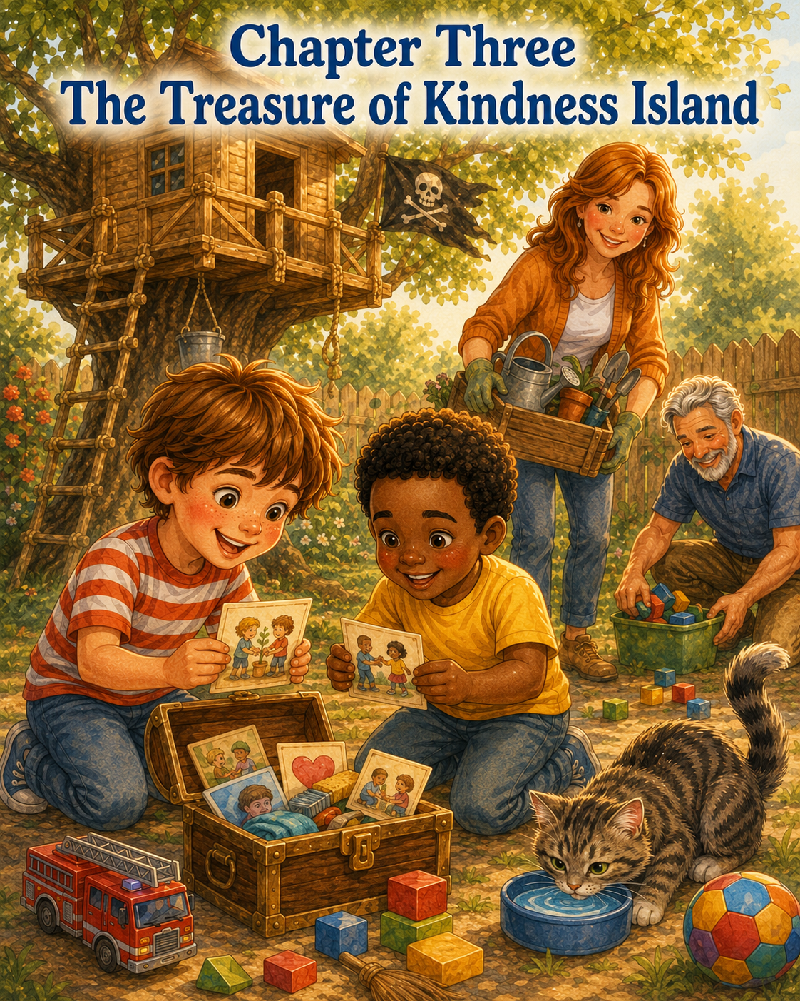
Chapter Three: The Treasure of Kindness Island
The pirate flag was still hanging from the treehouse window the next morning.
It fluttered proudly in the breeze, its brown paper edges curling just a little from the night air. The turtle with the pirate hat looked braver than ever, and the red crayon heart beside it seemed to shine in the sunlight.
Thomas stood beneath the oak tree with his hands on his hips.
Leo stood beside him holding the treasure map.
Tia the cat sat on the porch step, blinking in the morning light as if she had been invited to an important meeting but had not agreed to attend.
“Today,” Thomas announced, “we search for buried treasure.”
Leo unrolled the map with both hands. It was wrinkled now from yesterday’s adventure, but that made it look even more official. There was Sandy Shell Island, Mermaid Lagoon, Skull Cave, and Treasure Blossom Cove. The dotted line curved across the yard like a secret path only true explorers could understand.
Leo pointed to the big X near the flowerpot.
“We already found treasure there,” he said. “Granola bars and stickers.”
Thomas nodded. “That was practice treasure.”
Leo’s eyes widened. “There’s more?”
Thomas looked around the backyard as if someone might be listening. Then he lowered his voice.
“I think there is a hidden treasure we missed.”
Leo gasped. “A secret treasure?”
Thomas nodded. “The most secret kind.”
From the porch, Mom appeared carrying a basket of garden gloves, seed packets, and a small hand shovel.
“Good morning, pirates,” she said.
Thomas and Leo turned quickly.
“Good morning, Mom,” Thomas said.
Leo narrowed his eyes in a playful way. “Do you know anything about hidden treasure?”
Mom smiled. “Hidden treasure?”
Thomas stepped closer. “Possibly buried somewhere in the yard.”
Mom looked very serious. “Well, if there is hidden treasure, I hope it is found by careful pirates who remember to stay safe, share the adventure, and clean up anything they dig.”
Thomas glanced at Leo.
Leo whispered, “She definitely knows something.”
Mom only smiled and walked toward the garden.
Thomas watched her go. Then he looked back at the treehouse.
“We need supplies.”
Five minutes later, the boys were inside the treehouse, sitting cross-legged on the wooden floor. The morning sun slipped through the windows and painted bright squares on the wall. Their pirate flag flapped gently above them.
Thomas opened his backpack and emptied it carefully.
Inside were two pencils, his notebook, a magnifying glass, a toy compass, a small flashlight, a bag of pretzels, and the folded treasure map.
Leo added his own supplies: a red crayon, a blue crayon, two rubber bands, a plastic dinosaur, and one very smooth rock he said might be useful later.
Thomas looked at the rock.
“What is that for?”
Leo held it up proudly. “Pirate emergencies.”
Thomas nodded. That made sense.
Before they climbed down, Thomas pointed to the Treehouse Adventure Rules taped to the wall.
“Read them before every mission,” he said.
Leo stood up straight and cleared his throat.
“Rule one: Be safe. Rule two: Climb slowly. Rule three: Take turns. Rule four: Watch out for each other. Rule five: Snacks are allowed if they are safe snacks. Rule six: Share the adventure. Rule seven: Share the captain job too.”
Thomas nodded. “Excellent.”
Leo added, “And no jumping from the ship.”
“That should probably be rule eight,” Thomas said.
He wrote it quickly.
8. No jumping from the ship.
Then, one at a time, they climbed down the ladder carefully.
Dad was on the patio tightening a loose handle on the garden cart. He looked up as they reached the grass.
“Morning, captains,” he said. “What’s the mission today?”
“Treasure hunt,” Thomas said.
“Secret treasure,” Leo added.
Dad nodded as if this were very serious. “Then remember: no digging without permission, and if you find anything sharp, rusty, or strange, call an adult.”
Thomas nodded. “Safe pirates.”
“Careful pirates,” Leo added.
“Good pirates,” Dad said.
Thomas looked at Leo.
“Good pirates,” Thomas repeated.
That sounded important.
They began at Sandy Shell Island, which was still the sandbox, though Thomas felt it had become much more adventurous since receiving its official name.
Leo checked the map. “The first clue must be here.”
Thomas crouched and brushed the sand gently with one hand. Leo used the smooth rock to push aside a small pile near the corner.
“Careful,” Thomas said. “We don’t want to disturb ancient pirate ruins.”
Leo moved more slowly. “Right.”
For a few minutes, they found nothing but sand, a plastic shovel, and one tiny blue building block.
Then Thomas spotted something tucked beneath the edge of the sandbox.
A small card.
It was folded in half and decorated with a tiny turtle sticker.
Thomas picked it up.
Leo leaned close. “Read it.”
Thomas unfolded the card and read the words carefully.
Treasure Clue #1
A true pirate helps carry what is too heavy for someone else.
Leo blinked.
“That doesn’t sound like gold.”
Thomas turned the card over. There was another line on the back.
Look near the garden.
Both boys slowly turned toward Mom.
She was kneeling near the flower bed, trying to carry a heavy bag of soil from the garden path to the tomatoes. She tugged it a little, then stopped to adjust her grip.
Thomas looked at Leo.
Leo looked at Thomas.
“Treasure mission,” Thomas said.
They hurried across the grass—not too fast, because they had learned that rushing sometimes led to tripping. When they reached Mom, Thomas stood tall.
“Permission to help carry garden supplies?” he asked.
Mom looked up with a smile. “Permission granted.”
The bag of soil was too heavy for either boy alone, but together they each took one side. Mom held the middle and guided them carefully.
“One step at a time,” she said.
Thomas grunted. “This treasure is heavier than I expected.”
Leo’s face was serious. “Pirate work is not easy.”
They carried the soil to the garden bed and set it down with a soft thump. Mom brushed dirt from her hands.
“Thank you, boys. That helped a lot.”
Thomas felt something warm inside him. It was not exactly the same feeling as finding a sticker or a snack. It was quieter than that, but better.
Leo looked at the card again.
“A true pirate helps carry what is too heavy for someone else,” he read.
Thomas smiled. “We did that.”
Mom reached into her basket and pulled out another folded card.
Leo gasped. “You are the treasure keeper!”
Mom gave a mysterious shrug. “Maybe.”
Thomas took the new card and opened it.
Treasure Clue #2
A kind explorer notices who is thirsty.
Leo looked around. “I’m thirsty.”
Thomas laughed. “You always are.”
Then they heard a soft meow.
Tia was sitting beside the back door, staring at her empty water bowl with the disappointed expression of a queen whose servants had forgotten their duties.
Thomas pointed. “Tia!”
Leo placed one hand over his heart. “The ship’s cat requires water.”
They rushed inside with Mom’s permission. Thomas picked up Tia’s bowl and rinsed it carefully in the sink. Leo filled it with fresh water, trying not to splash too much on the floor.
He splashed a little anyway.
Thomas grabbed a towel and wiped it up.
“That might count too,” Leo said.
“Maybe,” Thomas said. “But don’t splash on purpose for extra points.”
Leo nodded. “That would be cheating.”
They carried the bowl back to the porch and placed it in Tia’s usual spot. Tia stepped forward, sniffed it, and began to drink.
Thomas crouched nearby. “You’re welcome, Captain Tia.”
Tia ignored him, which was how she usually said thank you.
Leo checked the back of the clue card. There was a tiny arrow drawn in blue crayon and the words:
Look near Skull Cave.
“The shed!” Thomas said.
They hurried toward Skull Cave, where Dad was sorting through a box of outdoor toys. A soccer ball, a jump rope, sidewalk chalk, toy trucks, and foam swords were scattered across the grass.
Leo whispered, “This looks like a dragon attacked.”
Dad heard him and smiled. “A dragon named Saturday Afternoon, probably.”
Thomas spotted another folded card tucked under the soccer ball.
He picked it up and read:
Treasure Clue #3
A brave heart keeps the path clear so no one gets hurt.
Thomas looked at the scattered toys.
Leo looked at the jump rope stretched across the walkway.
Dad raised one eyebrow.
Thomas nodded. “We know what to do.”
They got to work.
Leo gathered the toy trucks and placed them in the outdoor bin. Thomas rolled the soccer ball to the side of the porch. Together they wound the jump rope into a neat circle and stacked the foam swords where no one would trip over them.
Thomas picked up a tiny plastic airplane and frowned.
“This one belongs inside.”
Leo took the plastic dinosaur from his pocket and placed it beside the airplane. “Mine too.”
Thomas looked at him. “That was in your pocket.”
“It could still become a tripping hazard later,” Leo said.
Thomas decided that was fair.
When they were done, the walkway was clear, the toys were put away, and the backyard looked much safer.
Dad gave them a thumbs-up. “That was helpful. Someone could have stepped on that airplane.”
Thomas imagined Mom walking outside with lemonade and stepping on the sharp little wing.
He winced. “That would hurt.”
Leo nodded. “A pirate must protect the walkway.”
Dad handed them the next card.
Thomas opened it.
Treasure Clue #4
The best treasure is not always something you keep. Sometimes it is something you give.
Leo tilted his head. “Give?”
The back of the card said:
Return to the treehouse.
The boys looked up.
The pirate flag fluttered from the treehouse window.
Thomas felt a thrill of excitement.
“This is the final clue,” he said.
They climbed the ladder one at a time, moving carefully, using both hands. Thomas went first and waited inside. Then Leo climbed up and crawled through the doorway.
The treehouse felt different now. It was still their ship, still their headquarters, still their sky house. But now it also felt like the end of an important journey.
On the floor sat a small wooden box.
Thomas gasped.
“That wasn’t here before.”
Leo whispered, “Treasure.”
The box was simple and square, with a turtle sticker on the lid. Thomas sat down beside it. Leo sat across from him.
“Open it,” Leo said.
Thomas lifted the lid.
Inside were no gold coins.
No jewels.
No pirate rubies.
Instead, there were small cards tied together with green ribbon. Each one had a helpful task written on it.
Thomas picked up the first card.
Help someone carry something.
Leo picked up the next.
Give fresh water to a pet.
Thomas read another.
Clean up something before someone gets hurt.
Leo pulled out one with a little heart drawn in the corner.
Invite someone to play.
Thomas read the next.
Say thank you and mean it.
There were many more.
Share a toy.
Help set the table.
Pick up litter.
Read to someone younger.
Make someone laugh.
Be patient when waiting is hard.
Tell the truth, even when it is difficult.
Let someone else choose first.
Thomas held the cards in his hands.
“This is the treasure?” Leo asked.
At first, Thomas was not sure. He had been expecting something shiny. Something buried. Something pirates might hide in a cave.
Then he remembered Mom smiling when they carried the soil.
He remembered Tia drinking from her fresh bowl.
He remembered Dad’s walkway, clear and safe.
He remembered the warm feeling that came each time they helped.
Thomas looked at the cards again.
“I think so,” he said.
Leo picked up the card that said Invite someone to play.
“But we don’t get to keep treasure?”
Thomas thought about it. “Maybe we do. Just not in our pockets.”
Leo looked confused.
Thomas continued, “When you do something good, you kind of keep the feeling.”
Leo considered this. “Like invisible treasure?”
Thomas nodded. “Exactly.”
Leo smiled slowly. “Kindness treasure.”
Thomas grinned. “That’s what this is.”
They spread the cards across the treehouse floor like a deck of pirate treasure. Each one was different. Each one gave them something good to do. And the more Thomas looked at them, the more he understood.
Gold would just sit in a box.
Kindness treasure had to be used.
Thomas picked up his notebook and turned to a blank page.
At the top, he wrote:
Kindness Island Treasure Log
Leo leaned close. “Good title.”
Thomas drew a tiny island with a palm tree and a turtle wearing a pirate hat. Then he wrote:
Treasure Found Today:
1. Helped Mom carry garden soil.
2. Gave Tia fresh water.
3. Cleaned up toys so no one would trip.
Leo pointed to the page. “Add: worked as a team.”
Thomas wrote:
4. Worked as a team.
Leo nodded. “And no one fell off the ship.”
Thomas wrote:
5. No one fell off the ship. Important.
They both laughed.
From below, Mom called, “How is the treasure hunt going?”
Thomas leaned near the window, keeping his feet safely on the floor.
“We found the treasure!” he called.
“What was it?” Dad asked from the patio.
Thomas looked at Leo.
Leo smiled and called down, “Kindness!”
There was a pause.
Then Mom said, “That might be the best kind.”
Dad added, “And probably the safest to carry.”
Thomas looked around the treehouse. The pirate flag waved gently. The treasure map still hung on the wall. The kindness cards lay scattered across the floor, glowing in the soft morning light.
He picked up the card that said Invite someone to play.
At that exact moment, a small voice came from the fence.
“What are you doing?”
Thomas and Leo looked out the window.
Their younger neighbor, Sophie, stood on the other side of the fence holding a stuffed rabbit by one ear. She was watching the treehouse with wide, curious eyes.
Leo looked at Thomas.
Thomas looked at the kindness card in his hand.
Invite someone to play.
Thomas smiled.
“We’re searching for kindness treasure,” he called. “Want to help?”
Sophie’s face brightened. “Can I?”
Thomas glanced at Leo.
Leo nodded. “The more pirates, the better.”
A few minutes later, with Dad helping and everyone following the ladder rules, Sophie joined them in the treehouse. She held her stuffed rabbit in her lap and listened carefully as Thomas explained the treasure cards.
“This one says to share a toy,” Sophie said, picking up a card.
Leo looked at his smooth pirate emergency rock.
Then, slowly, he held it out.
“You can hold this,” he said. “It’s very useful in pirate emergencies.”
Sophie accepted it with both hands. “Thank you.”
Thomas smiled.
“That counts,” he said.
Leo sat up straighter. “It does?”
Thomas nodded and wrote it in the log.
6. Leo shared the pirate emergency rock.
Leo looked proud.
Sophie picked another card.
“Read to someone younger,” she said.
Thomas looked at Leo. “We could do that.”
Leo nodded toward Sophie. “She’s younger.”
Sophie hugged her rabbit. “I like stories.”
Thomas reached over to the small shelf where he had left a picture book the day before. It was about a brave little mouse who sailed across a pond in a teacup.
The three of them sat together on the treehouse floor while Thomas read aloud. Leo made ocean sounds whenever the mouse’s boat rocked. Sophie giggled every time he did.
Tia sat below the tree in the shade, clean water nearby, pretending not to listen.
When the story ended, Thomas added another line to the log.
7. Read a story to Sophie. Leo made excellent ocean sounds.
Leo bowed. “Thank you.”
The morning stretched into afternoon, and Kindness Island became the busiest place in the backyard.
They helped Mom put the hand shovel back in the garden basket.
They carried a cup of lemonade to Dad.
They picked up three fallen napkins that blew off the patio table.
They let Sophie choose the next pretend adventure.
They even made a small paper sign for the treehouse wall:
Kindness Treasure Rules
Find good things to do.
Do them with a happy heart.
Write them down so you remember.
Share the treasure.
Thomas taped the sign beneath the pirate map.
The treehouse was becoming more than an adventure headquarters.
It was becoming a place where ideas grew.
By the time Sophie went home for lunch, Leo’s smooth rock had been returned, the kindness cards were stacked neatly in the wooden box, and Thomas’s notebook had a whole page of entries.
Thomas and Leo sat by the treehouse window, tired but happy.
Leo looked at the wooden box. “Do you think kindness treasure runs out?”
Thomas shook his head. “I don’t think so.”
“Why not?”
Thomas looked out at the yard. The garden still needed watering. Tia would need food later. Someone might need help tomorrow. There would always be something to notice, something to share, something to make better.
“Because there is always something good to do,” Thomas said.
Leo thought about that.
Then he smiled. “That means we can find treasure every day.”
Thomas nodded. “Every day.”
The wind moved through the oak leaves, and the pirate flag fluttered above them like it agreed.
Yesterday, Thomas had thought treasure meant something hidden.
Today, he learned that the best treasure was not hidden at all.
It was in the small things.
A helping hand.
A full water bowl.
A clear path.
A shared rock.
A story read aloud.
A friend invited in.
Thomas closed the Kindness Island Treasure Log and placed it carefully on the shelf.
Then he looked at Leo.
“What should we do tomorrow?”
Leo picked up the toy compass and studied it as if it held the answer.
“Maybe,” he said, “the treehouse becomes a rocket ship.”
Thomas’s eyes widened.
A rocket ship.
That meant countdowns. Space missions. Moon rocks. Stars.
And probably more rules.
Thomas grinned.
“Tomorrow,” he said, “we blast off.”
Below them, Tia yawned and stretched in the shade.
The pirate flag fluttered one more time.
And inside the little treehouse in the sky, the treasure of Kindness Island waited patiently in its wooden box, ready for the next good thing.

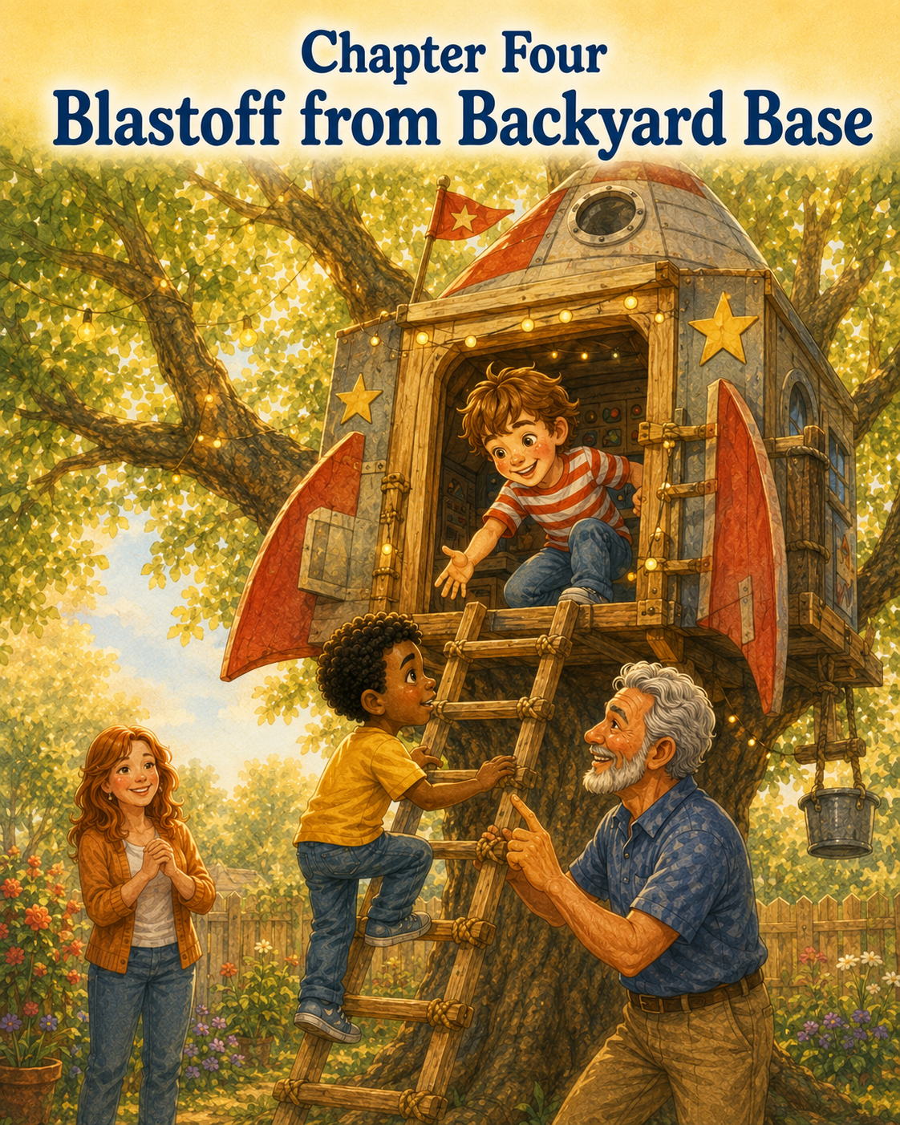
Blastoff from Backyard Base
The next morning, Thomas stood in the backyard wearing his red-and-white striped shirt, his green backpack, and a very serious expression.
Beside him, Leo wore his bright yellow shirt and held a cardboard box covered in buttons drawn with markers. Some buttons were red. Some were blue. One large green button in the middle had the words DO NOT PUSH UNLESS SPACE IS READY written above it.
Thomas stared at the cardboard box with wide eyes.
“What is that?” he asked.
Leo lifted it proudly. “The control panel.”
Thomas gasped. “For the treehouse?”
Leo shook his head. “For the rocket ship.”
Thomas looked up at the treehouse.
The pirate flag was still tied near the window, fluttering softly beneath the oak leaves. The treasure map still hung inside. The kindness cards were tucked safely in their wooden box on the shelf. But today, the treehouse was no longer a pirate ship.
Today, it was something much bigger.
It was a rocket ship.
Thomas looked at the old oak tree stretching toward the blue morning sky. Its branches reached up like launch towers. The treehouse sat high in the leaves like a space capsule waiting for countdown.
Thomas straightened his shoulders.
“Welcome to Backyard Base,” he said.
Leo nodded. “Mission Specialist Leo reporting for duty.”
Thomas gave a crisp salute. “Commander Thomas reporting for duty.”
From the patio, Dad looked up from his coffee. “Backyard Base, huh?”
Thomas nodded. “We are preparing for a moon mission.”
Dad raised one eyebrow. “Then I hope mission control remembers the safety rules.”
Thomas and Leo froze.
Then Thomas pointed up at the treehouse wall, even though Dad could not see it from the patio. “The rules are posted inside.”
Dad took a sip of coffee. “Good. But space missions need safety checks before launch.”
Leo looked at Thomas. “He’s right.”
Thomas opened his notebook and turned to a clean page.
At the top, he wrote:
Backyard Base Launch Checklist
Leo leaned over his shoulder.
“Number one,” Thomas said, “check ladder.”
Dad stood and walked over to the oak tree. He gently pulled on the wooden ladder, checked the side rails, and made sure each step was firm.
“Ladder secure,” Dad said.
Thomas wrote:
1. Ladder secure.
“Number two,” Leo said, “check rocket ship.”
Dad smiled and looked up at the treehouse platform. “Rocket ship appears stable.”
Thomas wrote:
2. Rocket ship stable.
“Number three,” Thomas said, “climb one astronaut at a time.”
Leo nodded. “With both hands.”
Thomas wrote:
3. Climb one astronaut at a time. Both hands. No rushing.
Dad gave an approving nod. “Excellent.”
Leo held up the cardboard control panel. “Number four: install important space technology.”
Thomas looked at Dad. “Can we bring this up?”
Dad inspected the cardboard box. “No sharp corners. Not too heavy. Approved.”
Leo hugged the control panel. “Space technology approved.”
Thomas added:
4. Space technology approved.
Then he drew a little rocket beside the words.
The mission was ready.
Thomas climbed first.
He placed both hands on the ladder and stepped carefully onto the first rung. Even though he wanted to scramble up as fast as a rocket blasting into the sky, he remembered that astronauts had to be careful before launch.
One step.
Then another.
Then another.
When he reached the top, he crawled safely inside the treehouse and turned around.
“Commander Thomas has entered the capsule,” he called.
Leo stood below with the control panel tucked under one arm.
“Mission Specialist Leo preparing to board,” he announced.
Thomas grinned. “Proceed with caution.”
Leo put one foot on the first step.
Then another.
He climbed slowly at first, just as they had practiced. But halfway up, he stopped.
Thomas waited.
Leo did not move.
“Leo?” Thomas called gently.
Leo kept both hands tight on the ladder. His yellow shirt looked bright against the brown wood and green leaves, but his face had changed. His smile was gone. His eyes were fixed on the ground below.
Dad stepped closer.
“You okay, Leo?” he asked.
Leo swallowed. “I think so.”
But his voice sounded very small.
Thomas leaned forward, then remembered not to lean too far. He sat back on his knees inside the treehouse doorway.
“You’re almost there,” Thomas said.
Leo looked up for just a second, then quickly looked back down. “It feels higher today.”
Thomas blinked.
The ladder was the same ladder. The treehouse was the same treehouse. The backyard was the same backyard. Yesterday Leo had climbed it. The day before he had climbed it too.
But today, something felt different for him.
Thomas thought about saying, “Come on, hurry up,” because the moon mission was waiting. The cardboard control panel needed to be installed. The countdown needed to begin.
But then he looked at Leo’s hands gripping the ladder.
They were holding tight.
Really tight.
Dad’s voice stayed calm. “You don’t have to rush, Leo.”
Leo nodded, but he still didn’t move.
Thomas looked down at his notebook, still open beside him. He could see the launch checklist. He could see the words he had just written:
No rushing.
He looked back at Leo.
Suddenly, Thomas understood that the rule was not only about climbing safely.
It was about people feeling safe too.
He took a slow breath.
“Mission Specialist Leo,” Thomas said in his best commander voice, “pause the launch.”
Leo looked up. “Pause it?”
Thomas nodded seriously. “The moon can wait.”
Dad looked up at Thomas and smiled a little.
Leo’s shoulders relaxed just a tiny bit.
Thomas continued, “No rocket launches until every astronaut feels ready.”
Leo looked at the ladder step beneath his sneaker. “What if I don’t feel ready?”
“Then we wait,” Thomas said.
He meant it.
The backyard became very quiet. A bird chirped from the fence. Tia the cat walked beneath the tree, looked up at Leo, and then sat down as if she had decided to supervise.
Leo looked down at Tia.
“Tia thinks I can do it,” he said.
Thomas smiled. “Tia thinks everyone should stay low to the ground.”
Leo laughed once. It was a small laugh, but it helped.
Dad stood beside the ladder. “You have choices,” he said. “You can climb one more step, or you can climb back down and try again later. Either choice is okay.”
Leo thought about that.
Thomas waited.
He did not tap his foot.
He did not sigh.
He did not say the moon mission would be ruined.
He just waited.
After a moment, Leo looked up again. “Can you talk to me while I climb?”
Thomas nodded. “Absolutely.”
“What should you say?”
Thomas thought carefully. “Space facts?”
Leo shook his head. “Encouraging things.”
Thomas sat a little straighter. “Right. Encouraging things.”
Leo took a breath.
Thomas spoke gently. “You are doing great. Your hands are on the rails. Your feet are steady. You don’t have to hurry. One step is still progress.”
Leo moved one foot to the next rung.
Thomas smiled. “That was a very good astronaut step.”
Leo moved one hand higher.
Dad stayed beside him, close enough to help if needed but not pushing.
Thomas kept talking.
“Mission Specialist Leo is brave.”
Leo looked up. “I don’t feel brave.”
Thomas thought for a moment.
Then he said, “Maybe brave does not mean you are not nervous. Maybe brave means you keep going carefully, even when you are nervous.”
Dad nodded. “That is exactly right.”
Leo took another step.
Then another.
Finally, he reached the top. Thomas scooted back to give him plenty of room. Leo crawled through the doorway and sat on the treehouse floor, holding the cardboard control panel in his lap.
For a second, nobody said anything.
Then Leo let out a long breath.
“I made it.”
Thomas grinned. “Mission Specialist Leo has entered the capsule.”
Dad clapped softly from below. “Well done.”
Leo looked at Thomas. “Thanks for waiting.”
Thomas shrugged, but he felt proud in a quiet way.
“That’s what commanders do,” he said.
Leo tilted his head. “They wait?”
Thomas nodded. “Good ones do.”
Inside the treehouse, the rocket ship was ready.
Thomas and Leo placed the cardboard control panel against the wall beneath the window. Thomas taped it in place with blue painter’s tape. Leo added a paper towel tube to the side and called it the “oxygen booster.” Thomas placed his notebook on the shelf and declared it the official space log.
The pirate flag came down for the day and was replaced with a new sign Thomas had made that morning.
It read:
BACKYARD BASE
MOON MISSION 1
Leo added a star beside the words.
Then they began the launch checklist again.
“Windows?” Thomas asked.
Leo looked through one square window toward the garden. “Clear.”
“Moon rocks container?”
Leo picked up an empty shoebox. “Ready.”
“Snack supply?”
Thomas checked his backpack. “Pretzels and apple slices.”
“Cat astronaut?”
They looked down through the window.
Tia sat beneath the tree, licking one paw.
Leo shook his head. “Cat astronaut has declined the mission.”
Thomas wrote that in the notebook.
Cat astronaut declined. Very independent.
Leo pointed to the big green button on the cardboard control panel.
“Can we push it?”
Thomas narrowed his eyes at the words: DO NOT PUSH UNLESS SPACE IS READY.
He looked out the window at the sky. A few white clouds drifted lazily above the oak tree.
“Space appears ready,” he said.
Leo sat beside the control panel. “Beginning countdown.”
Thomas straightened his back and held the toy compass like a communication device.
“Backyard Base to Rocket Treehouse,” he said. “Prepare for launch.”
Leo replied into the cardboard tube. “Rocket Treehouse ready.”
Thomas looked around the treehouse. The wooden walls became metal panels. The little shelf became a row of important space instruments. The windows became thick glass portholes looking out into the universe.
The leaves outside shimmered like green flames from a rocket engine.
The backyard below was no longer a yard.
It was Earth.
“Ten,” Thomas began.
Leo joined in. “Nine.”
“Eight.”
“Seven.”
“Six.”
“Check seatbelts,” Leo said suddenly.
They both pretended to buckle invisible seatbelts across their laps.
“Five,” Thomas continued.
“Four.”
“Three.”
“Two.”
“One.”
Leo pressed the big green button.
“BLASTOFF!”
The treehouse did not really move, of course.
But in Thomas’s imagination, it shook and rumbled and lifted away from the oak tree with a roar of fire and thunder. The grass below shrank into a tiny green square. The roof of the house became a red dot. The birdbath flashed like a silver lake.
Thomas leaned back against the wall. “We are leaving Earth!”
Leo grabbed the cardboard tube. “Engines full power!”
The leaves rustled outside as a breeze moved through the branches, making the treehouse creak softly.
“Space turbulence!” Leo cried.
Thomas held onto the floor with both hands. “Stay calm, Mission Specialist!”
Leo grinned. “I am extremely calm!”
He did not look nervous anymore.
Thomas noticed that.
The moon mission had finally begun, but something even better had happened first.
Leo had climbed when he was ready.
Not because Thomas rushed him.
Not because the adventure had to start right away.
But because someone waited.
Thomas looked at his friend, who was now pressing imaginary buttons and making rocket noises with complete confidence.
He smiled.
The treehouse sailed past clouds, stars, and invisible planets. Thomas spotted a dragon-shaped cloud and declared it a space creature. Leo checked the compass and said they were heading mostly toward the kitchen, which was probably near the moon.
They opened the shoebox and prepared for moon rocks.
“Moon landing in three,” Thomas said.
“Two,” Leo added.
“One.”
They both bounced slightly on the floor.
“Landing complete,” Thomas announced.
Outside the window, the backyard was still there. But now it looked different. The sandy patch near the fence became a crater. The garden stones became moon rocks. The flowerpots were strange alien towers. Dad, walking across the patio with his coffee mug, became a friendly space giant.
Leo waved through the window. “Greetings, space giant!”
Dad looked up and waved back. “Greetings, astronauts.”
Thomas picked up his notebook.
“We need to collect samples,” he said.
Leo hesitated and looked toward the ladder.
Thomas noticed right away.
“We can climb down when you’re ready,” Thomas said. “No rush.”
Leo looked at him, then smiled. “I’m ready. But maybe you can talk me down too?”
Thomas nodded. “Of course.”
They climbed down one at a time. Thomas went first and waited at the bottom. Leo followed slowly, carefully, holding both rails.
Thomas stood nearby.
“Steady hands,” he said. “Careful feet. One step at a time. Mission Specialist Leo is doing great.”
Leo reached the ground and smiled proudly.
“Landing successful,” he said.
Together, they searched the backyard for moon rocks. They chose only small stones from the garden path after asking Dad’s permission. Thomas found a gray one shaped like a potato. Leo found a white one with a sparkly stripe.
They placed them in the shoebox.
Then Leo found a flat brown leaf.
“Alien message,” he said.
Thomas inspected it. “Definitely.”
They carried their samples back to the treehouse, climbed carefully, and created a Moon Museum on the shelf.
Each rock received a name.
The gray potato-shaped rock became Moon Boulder One.
The sparkly rock became Star Stripe.
The brown leaf became Message from Planet Oak.
Thomas drew all three in his notebook.
Then he turned to a new page.
At the top, he wrote:
What We Learned on Moon Mission 1
Leo leaned close. “We learned that the moon has leaves.”
Thomas wrote:
1. The moon has leaves if it is near an oak tree.
Leo smiled. “We learned that Tia does not like space travel.”
Thomas wrote:
2. Tia declined the mission.
Then Thomas paused.
“What else?” Leo asked.
Thomas looked at the ladder through the doorway. He thought about Leo stopping halfway up. He thought about wanting to start the countdown right away. He thought about Dad’s calm voice and Leo’s hands gripping the rails.
Then he wrote:
3. Bravery can mean taking your time.
Leo read the sentence quietly.
Thomas added:
4. A good friend waits until everyone feels safe.
Leo looked at Thomas. His expression was soft now, not silly or space-explorer serious.
“That one is important,” Leo said.
Thomas nodded. “Maybe the most important.”
Leo picked up the red crayon and drew a small rocket beside the words.
Then he added two stick-figure astronauts standing together under it.
“One is Commander Thomas,” he said.
“And one is Mission Specialist Leo,” Thomas said.
Leo nodded. “Both made it to the moon.”
Thomas smiled. “Both.”
Below the treehouse, Mom stepped onto the porch.
“Lunch is ready, astronauts!”
Leo looked at Thomas. “Do astronauts eat grilled cheese?”
Thomas nodded. “After moon missions, yes.”
They packed away the control panel, placed the moon rocks carefully on the shelf, and taped the lesson page to the wall beside the adventure rules.
Then they climbed down slowly, one at a time.
No rushing.
No pushing.
No leaving anyone behind.
As they walked toward the house, Thomas looked back at the treehouse. The oak leaves shimmered around it in the sunlight, and for a moment, it really did look like a rocket ship resting after a long journey through space.
Leo walked beside him, holding the shoebox of moon samples.
“That was a good adventure,” Leo said.
Thomas nodded. “A very good one.”
Leo looked at the ladder. “I was nervous.”
“I know,” Thomas said.
“But you didn’t make fun of me.”
Thomas shook his head. “Of course not.”
Leo smiled. “You waited.”
Thomas smiled back. “That’s what friends do.”
They reached the porch, where the smell of grilled cheese floated through the open door.
Behind them, Backyard Base stood quiet and ready beneath the oak tree.
The rocket ship had returned safely to Earth.
And Commander Thomas had learned something bigger than space:
A real adventure does not begin when the countdown reaches one.
It begins when everyone feels brave enough to climb aboard.

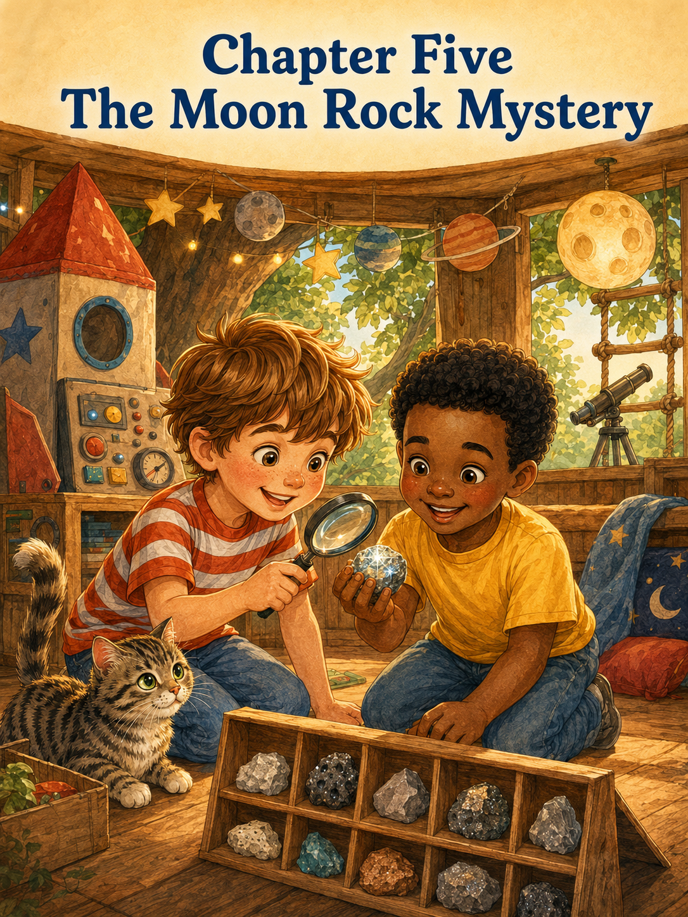
Chapter Five: The Moon Rock Mystery
The Moon Museum began with three small treasures on the treehouse shelf.
There was Moon Boulder One, which looked a little like a gray potato.
There was Star Stripe, the smooth white stone with a sparkly line across its middle.
And there was Message from Planet Oak, which was really a brown leaf, though Leo insisted it had been sent by aliens who lived in the highest branches of the tree.
Thomas had drawn each one carefully in his notebook. He labeled the page:
Moon Mission Discoveries
Leo had added stars around the title with a blue crayon. Some of the stars looked like stars. Some looked like spiders. One looked very much like a squashed blueberry, but Thomas said that was probably a rare moon crater.
The next morning, Thomas climbed into the treehouse with his green backpack bumping gently against his shoulders. He climbed slowly, using both hands, just like the rules said. Leo followed after him, holding a magnifying glass, a shoebox, and the cardboard control panel from yesterday’s rocket mission.
When Leo reached the top, he crawled safely inside and placed everything on the floor.
“Mission Specialist Leo has arrived,” he said.
Thomas saluted. “Commander Thomas welcomes you back to Backyard Base.”
Leo held up the magnifying glass. “Today we investigate the moon rocks.”
Thomas’s eyes widened. “A scientific mission?”
Leo nodded. “Very scientific.”
Thomas opened his notebook to a clean page and wrote:
Moon Rock Mystery Investigation
Then he underlined it twice because mysteries always deserved underlining.
The treehouse was no longer just a rocket ship today. It was a space laboratory. The shelf became the official display station. The window ledge became the inspection counter. The shoebox became the moon sample container. The cardboard control panel became a very important machine that beeped whenever Leo pressed one of the drawn-on buttons.
“Beep,” Leo said.
Thomas looked up. “What does that mean?”
Leo studied the control panel carefully. “It means the moon rocks are suspicious.”
Thomas leaned closer to the shelf. “Suspicious how?”
Leo held the magnifying glass over Moon Boulder One.
“It has bumps.”
Thomas nodded. “A lot of rocks have bumps.”
Leo moved the magnifying glass closer. “But moon bumps are different.”
Thomas thought about that. “True.”
He took the magnifying glass and examined Star Stripe. The sparkly line shimmered in the morning light. It was thin and silvery, like a tiny lightning bolt trapped inside the stone.
“This one looks important,” Thomas said.
Leo leaned in. “Maybe it came from a moon volcano.”
“Or a moon castle,” Thomas said.
“Or a moon dragon’s tooth,” Leo added.
Thomas looked at the rock again.
“That seems possible.”
Below the treehouse, Dad was working in the garden. He looked up when he heard them talking.
“What are you two discovering today?”
“Moon rocks!” Thomas called.
“Suspicious moon rocks!” Leo added.
Dad smiled. “Remember, scientists ask permission before moving things from the garden.”
Thomas nodded. “We only take loose rocks.”
“And nothing sharp,” Leo said.
“And no digging holes without asking,” Dad added.
Thomas wrote that in his notebook under a new section called Science Rules.
1. Ask before taking rocks.
2. Only collect loose rocks.
3. Nothing sharp.
4. No digging holes without asking.
5. Share the discoveries.
Leo read the last rule and nodded. “Good science.”
Thomas smiled. “Good explorers.”
They climbed down carefully, one at a time, carrying the shoebox between them once they were safely on the ground.
The backyard looked different during a science mission.
The garden path was not a garden path. It was the rocky surface of the moon.
The sandbox was not a sandbox. It was a crater field.
The birdbath was not a birdbath. It was a silver space lake.
Tia the cat was not just Tia. She was an unidentified furry life-form who refused to answer questions.
Thomas crouched near the garden path and picked up a small tan rock.
“This one is shaped like a turtle shell,” he said.
Leo inspected it with the magnifying glass. “Approved.”
Thomas placed it in the shoebox.
Next, Leo found a tiny black pebble near the edge of the patio.
“This one is from the dark side of the moon,” he announced.
Thomas looked at it carefully. “It is very dark.”
“Exactly,” Leo said.
Into the shoebox it went.
They moved slowly through the yard, choosing only small, safe stones that were already loose on the ground. Every time they found one, they examined it with the magnifying glass and gave it a special name.
A flat brown stone became Pancake Planet.
A round white pebble became Moon Marble.
A rough gray rock became Crater Crunch.
A tiny reddish stone became Mars Visitor, even though Thomas pointed out that Mars was not the moon.
Leo said visitors could come from anywhere.
Thomas agreed that this was true.
After a while, they reached the far corner of the yard near the fence. It was a place where leaves gathered after windy days and where tiny stones sometimes collected in the dirt. Thomas knelt down beside the fence post and gently moved aside a leaf.
Leo was crouched nearby when he suddenly gasped.
Thomas looked over. “What?”
Leo did not answer.
He reached down slowly and picked up something small between two fingers.
It was a stone.
But not like the others.
This one was smooth and shiny, almost black, with a bright silver sparkle across one side. When Leo turned it in the sunlight, it flashed like a tiny star.
Thomas’s mouth opened.
“Whoa,” he whispered.
Leo held it close to his chest. “I found the best one.”
Thomas leaned closer. “Can I see it?”
Leo pulled it back slightly. “Careful.”
“I’ll be careful.”
Leo hesitated, then placed the stone in Thomas’s palm.
It was cool and smooth. The silver sparkle caught the light again, and for a moment, Thomas imagined it had truly fallen from space, landing quietly in the corner of his backyard, waiting for the right explorers to find it.
“This is amazing,” Thomas said.
Leo nodded quickly and took it back. “It’s mine.”
Thomas blinked. “Yours?”
“I found it,” Leo said. “So I get to keep it.”
Thomas looked at the shoebox, then back at Leo. “But it should go in the Moon Museum.”
Leo held the stone tighter. “It can visit the museum.”
Thomas frowned. “Visit?”
Leo nodded. “Then I take it home.”
Thomas felt a pinch of disappointment.
The Moon Museum was supposed to be for the team. It was their space laboratory, their collection, their discoveries. Thomas had imagined the shiny stone sitting in the center of the shelf, the most important moon rock of all.
“But if you take it home,” Thomas said, “then it won’t be part of the museum.”
Leo shrugged. “I can bring it back sometimes.”
Thomas looked away.
The backyard suddenly felt less like the moon and more like an ordinary yard with a problem in it.
Leo noticed Thomas’s face. “What?”
Thomas kicked lightly at a blade of grass. “Nothing.”
“It’s not nothing,” Leo said.
Thomas sighed. “I thought the discoveries belonged to both of us.”
Leo looked down at the shiny stone.
“But I found this one.”
“I know,” Thomas said. “And you can be the one who discovered it. But explorers share discoveries. That’s what makes it a museum instead of just somebody’s pocket.”
Leo did not answer right away.
He turned the stone in his hand, watching the silver flash appear and disappear.
Thomas tried again.
“What if one scientist found a dinosaur bone and just kept it under his bed forever?”
Leo looked horrified. “That would be terrible.”
“Right,” Thomas said. “Because then nobody else could learn from it.”
Leo looked at the stone again.
Thomas softened his voice. “I’m not trying to take it away from you. I just think it should belong to the mission.”
Leo looked toward the treehouse.
The pirate flag was gone for now, but the Moon Mission sign still hung in the window. The treehouse waited above them, their space laboratory tucked safely in the branches.
“I really like it,” Leo said quietly.
“I know,” Thomas said.
Leo turned the stone over. “It’s the best moon rock.”
Thomas nodded. “That’s why it should be in the museum.”
Leo thought about it for a long moment.
Then he asked, “Could it have my name on the label?”
Thomas smiled. “Definitely.”
“And could it be displayed in the middle?”
“Yes.”
“And could I be in charge of cleaning it with a soft cloth?”
Thomas nodded. “Official Moon Rock Keeper.”
Leo’s face brightened a little. “That sounds important.”
“It is important,” Thomas said.
Leo looked down at the shiny stone one more time. Then, slowly, he placed it in the shoebox with the others.
“Okay,” he said. “It belongs to the mission.”
Thomas grinned.
“And to the museum,” Leo added.
“And to science,” Thomas said.
“And to me a little bit,” Leo said.
Thomas laughed. “A little bit.”
They carried the shoebox back to the treehouse. This time Leo climbed first, slowly and carefully, with Thomas holding the shoebox at the bottom until Leo was safely inside. Then Thomas climbed up with both hands and passed the box through the doorway.
Inside the treehouse, the real work began.
The Moon Museum needed to be organized.
Thomas cleared the shelf carefully and placed a piece of blue construction paper across it like a tablecloth. Leo arranged the stones from smallest to largest, then changed his mind and arranged them from least mysterious to most mysterious.
The shiny black stone went in the center.
Thomas opened his notebook and made labels for each discovery.
Moon Marble
Round and bright. Possibly from the Moon Ball Games.
Crater Crunch
Rough and bumpy. Found near the garden path.
Pancake Planet
Flat and brown. Not edible.
Mars Visitor
Probably lost.
Turtle Shell Stone
Looks like a tiny turtle shell. Very friendly.
Then he wrote the most important label of all:
Star Spark Stone
Discovered by Mission Specialist Leo.
Shared with the Moon Museum.
Official mystery rock.
Leo read the label twice.
“Can you add ‘very rare’?” he asked.
Thomas added:
Very rare.
Leo nodded. “Perfect.”
They taped the labels to the shelf beneath each stone. Then Leo used the magnifying glass to inspect the entire museum.
“Everything appears scientific,” he said.
Thomas wrote that down.
Museum inspection: Everything appears scientific.
Leo pressed a button on the cardboard control panel.
“Beep,” he said. “Museum approved.”
Thomas sat back on his heels and looked at the shelf. The stones were simple backyard rocks, but in the treehouse they looked special. Each one had a name. Each one had a story. Each one belonged.
Especially Star Spark Stone.
Sunlight slipped through the treehouse window and touched the shiny stone just right. The silver stripe flashed brightly, as if the rock were winking at them.
Leo smiled.
“It looks good there,” he said.
Thomas nodded. “It really does.”
For a while, they just sat quietly and admired the museum.
Then Mom came into the yard carrying a small basket of laundry. She looked up at the treehouse.
“How is the moon mission going?”
Thomas leaned safely near the window. “We opened a Moon Museum!”
Leo held up the magnifying glass. “And I found the rarest rock.”
Mom smiled. “That sounds exciting.”
“It is called Star Spark Stone,” Leo said. “I found it, but it belongs to the museum.”
Mom’s expression softened. “That was generous.”
Leo shrugged, but he looked pleased. “Explorers share discoveries.”
Thomas nodded. “So everyone can enjoy them.”
Dad walked over from the garden and looked up. “That sounds like something real scientists would say.”
Thomas’s chest filled with pride.
Leo whispered, “We are basically professionals.”
Thomas whispered back, “Basically.”
A little later, their neighbor Sophie came to the fence again, holding her stuffed rabbit.
“What are you doing today?” she called.
Thomas looked at Leo.
Leo looked at the Moon Museum.
For one tiny second, Thomas wondered if Leo would want to keep the museum secret. After all, it was their mission, their rocks, their special discovery.
But Leo stood up and waved.
“We made a Moon Museum!” he called. “Want to see the rarest rock?”
Sophie’s eyes widened. “Can I?”
Thomas smiled. “We’ll ask Dad to help you climb safely.”
Soon Sophie was inside the treehouse with them, sitting cross-legged in front of the shelf. Dad stayed nearby below, and Thomas made sure everyone followed the ladder rules.
Leo picked up the magnifying glass and handed it to Sophie.
“This is Star Spark Stone,” he said proudly. “I discovered it.”
Sophie looked through the magnifying glass. “It sparkles!”
Leo nodded. “It is very rare.”
Thomas pointed to the label. “It belongs to the Moon Museum.”
Sophie looked at Leo. “You don’t keep it in your room?”
Leo shook his head. “No. It’s for everyone.”
Thomas smiled.
Leo had said it like it was easy now.
Sophie studied the other rocks too. She liked Pancake Planet best because she thought it sounded like breakfast. Leo explained that it was not edible, and Sophie said she already knew that.
Then Sophie reached into her pocket and pulled out a tiny shell.
“I found this by our driveway,” she said. “Can it go in the museum?”
Thomas and Leo looked at each other.
It was not exactly a moon rock.
It was not even a rock.
But it was small and special, and Sophie was holding it like it mattered.
Leo took the shell gently and inspected it with the magnifying glass.
“It could be from an ancient moon ocean,” he said.
Thomas nodded. “Definitely.”
Sophie smiled.
Thomas made a label:
Moon Shell
Discovered by Sophie.
From an ancient moon ocean.
Probably magical.
They placed it beside Star Spark Stone.
The museum looked even better now.
That afternoon, the treehouse became very busy. Thomas, Leo, and Sophie gave tours of the Moon Museum to Mom, Dad, and even Tia, though Tia only sniffed the ladder and walked away.
Dad stood below while Thomas held up each rock from the window.
“This is Crater Crunch,” Thomas said. “Rough and mysterious.”
“This is Mars Visitor,” Leo added. “It is lost, but welcome.”
“This is Moon Shell,” Sophie said. “It came from an ancient moon ocean.”
Mom clapped after the tour.
Dad nodded very seriously. “Excellent scientific presentation.”
Tia yawned.
Leo looked down at her. “Tia is impressed inside.”
Thomas agreed.
When the tour was over and Sophie had gone home, Thomas and Leo sat inside the treehouse again. The afternoon sun had shifted, making the Moon Museum glow softly on the shelf.
Leo looked at Star Spark Stone.
“I still like it best,” he said.
Thomas smiled. “You can like it best.”
Leo thought about that. “And I still found it.”
“You did.”
“But now everyone can see it.”
Thomas nodded. “That makes it even more important.”
Leo smiled slowly. “Because now it has a bigger story.”
Thomas liked that.
He opened his notebook and turned to the page titled Moon Rock Mystery Investigation.
At the bottom, he wrote:
What We Learned:
A discovery is special when you find it.
A discovery becomes even better when you share it.
Leo leaned over his shoulder. “Add: museums need labels.”
Thomas wrote:
Also, museums need labels.
Leo nodded. “Very important.”
Then Thomas added one more line:
The best treasures do not always belong to one person. Some treasures belong to the team.
Leo read it quietly.
Then he picked up the red crayon and drew a small heart beside the sentence.
Outside, the oak leaves rustled in the warm breeze. The treehouse creaked softly, settled high above the grass like a little rocket ship that had returned from the moon with a shelf full of wonders.
Thomas looked at the Moon Museum.
There were rocks, a leaf, a shell, and a shiny stone that had almost become just Leo’s treasure.
Now it was everyone’s discovery.
Thomas felt happy about that.
The treehouse had been a pirate ship, a kindness island, a rocket ship, and now a museum in the sky. Each adventure had taught him something different.
Today, it taught him that sharing did not make a treasure smaller.
It made the story bigger.
Leo picked up the cardboard control panel and pressed the green button.
“Beep,” he said.
Thomas looked at him. “What does that mean?”
Leo smiled. “The museum is ready for tomorrow.”
Thomas looked around the treehouse, at the rules on the wall, the treasure map, the kindness cards, and the moon rocks lined up proudly on the shelf.
“What happens tomorrow?” he asked.
Leo lifted the magnifying glass and looked out the window toward the trees.
“Jungle mission,” he whispered.
Thomas grinned.
Below them, Tia stretched in the shade like a tiny tiger.
The Moon Museum sparkled quietly behind them.
And somewhere in the branches of the old oak tree, the next adventure was already waiting.

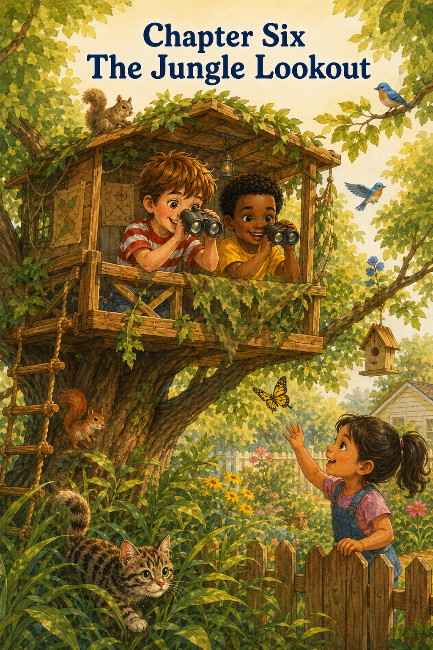
Chapter 6: The Jungle Lookout
The next day, the treehouse was no longer a rocket ship.
It was not a pirate ship either.
It was not Kindness Island, and it was not the Moon Museum, though the moon rocks still sat neatly on the shelf with their careful labels. Star Spark Stone gleamed in the middle, looking very proud of itself.
Today, the treehouse had become something new.
A jungle lookout tower.
Thomas stood at the base of the oak tree with binoculars around his neck, his red-and-white striped shirt bright in the morning sun. Leo stood beside him wearing his yellow shirt and carrying the magnifying glass, a notebook, and a peanut butter cracker tucked carefully in his pocket in case the jungle expedition lasted longer than expected.
Above them, the treehouse rested in the leaves like a wooden hut high above the forest floor. The branches stretched around it in every direction, and the green oak leaves made soft shadows that moved across the walls.
Thomas looked up and whispered, “The jungle is awake.”
Leo looked around the backyard. “I hear wild animals already.”
A bird chirped from the fence.
Thomas nodded seriously. “That was probably a tropical tree bird.”
A squirrel dashed along the top of the fence, stopped, flicked its tail, and disappeared into the neighbor’s yard.
Leo pointed. “And a stripe-tailed jungle jumper.”
Thomas opened his notebook and wrote it down at once.
Jungle Lookout Field Notes
Animal #1: Stripe-tailed jungle jumper. Fast. Suspicious. Excellent tail.
From the porch, Dad called, “Jungle explorers still follow ladder rules.”
Thomas and Leo answered together, “We know!”
Dad walked over with his coffee mug and smiled. “Let’s hear them.”
Thomas counted on his fingers. “Climb slowly. One person at a time. Use both hands. No leaning too far out. Watch out for each other.”
Leo added, “And no jumping from the ship.”
Thomas corrected him. “Tower.”
Leo nodded. “Right. No jumping from the jungle tower.”
Dad gave them a thumbs-up. “Then the lookout tower is open.”
Thomas climbed first, slow and careful. The binoculars bounced gently against his chest, so he held them with one hand only when both feet were steady. At the top, he crawled safely inside the treehouse and moved away from the doorway to give Leo room.
“Explorer Thomas has reached the lookout,” he called.
Leo climbed next, taking his time. Since yesterday’s rocket mission, he still moved carefully on the ladder, but his face looked calmer now. Thomas waited quietly until Leo reached the top.
When Leo crawled inside, Thomas smiled. “Nice climbing.”
Leo smiled back. “Steady feet.”
“Careful hands,” Thomas said.
“Official jungle method,” Leo added.
Inside the treehouse, they prepared the lookout tower. Thomas placed the binoculars near the window. Leo set the magnifying glass on the shelf beside the Moon Museum. They rolled up the pirate map and tucked it into the corner for another day.
Then Thomas made a new sign.
JUNGLE LOOKOUT TOWER
Do Not Disturb Unless You Are a Bird, Squirrel, Butterfly, Cat, or Approved Explorer
Leo read it and nodded. “That covers almost everyone.”
Thomas taped it to the wall.
The backyard looked different from the treehouse window. The grass below seemed thicker and greener, like a jungle floor. The bushes near the fence became tangled vines. The flowerpots were mysterious ruins. The birdbath shimmered like a hidden watering hole. The garden hose curled beneath the porch like a sleeping snake.
Thomas raised the binoculars.
“Scanning the eastern jungle,” he announced.
Leo leaned beside him, careful to keep both feet on the floor. “Any movement?”
Thomas slowly turned his head. “Yes. Near the hibiscus bushes.”
Leo grabbed the notebook. “What do you see?”
Thomas focused the binoculars. A robin hopped across the grass, pausing to tilt its head and peck at the ground.
“Red-chested ground hopper,” Thomas said.
Leo wrote it down.
Animal #2: Red-chested ground hopper. Hops. Pecks. Very serious about breakfast.
The robin hopped twice more, then flew to the fence.
Thomas lowered the binoculars. “The jungle is full of secrets.”
Leo nodded. “We should whisper.”
“Why?”
“So the secrets don’t run away.”
Thomas thought that was excellent advice.
For a while, they watched in quiet concentration. A butterfly floated over the flowers, opening and closing its wings like tiny painted doors. A blue jay landed on the birdbath and splashed water with great importance. Two squirrels chased each other along a branch so quickly that Leo said they were probably late for a squirrel meeting.
Thomas drew each discovery in the notebook.
The butterfly became Animal #3: Floating Flower Wing.
The blue jay became Animal #4: Loud Blue Splash Bird.
The squirrels became Animal #5 and #6: Racing Tree Acrobats.
Then came the most important jungle sighting of all.
Tia.
She emerged from the tall grass near the porch with slow, silent steps. Her gray striped body stayed low to the ground. Her tail flicked once. Her ears pointed forward. She moved carefully through the flowers, stopping every few steps to sniff the air.
Thomas gasped.
Leo leaned in. “What?”
Thomas handed him the binoculars. “Look near the garden.”
Leo raised them and immediately whispered, “Whoa.”
Tia crept past the garden hose and crouched beside a flowerpot. She looked exactly like a tiny tiger stalking through the jungle. Not a regular house cat. Not the same Tia who slept on laundry and knocked pencils off Thomas’s desk.
This was Jungle Tia.
Queen of the Backyard Wild.
Leo whispered, “She’s hunting.”
Thomas nodded. “Probably a leaf.”
Tia pounced.
A brown leaf jumped in the air.
The boys clapped their hands over their mouths to keep from laughing too loudly. Tia batted the leaf once, looked around as if to make sure no one had seen, and then strutted toward the shade beneath the tree.
Thomas wrote carefully:
Animal #7: Tiny Striped Jungle Tiger. Brave. Silent. Fierce. Attacked one leaf. Victory likely.
Leo looked at the note. “Add: do not insult her hunting skills.”
Thomas added:
Do not insult her hunting skills.
Below them, Tia sat in the shade and began washing one paw with great dignity.
“She knows we’re watching,” Leo said.
“She always knows,” Thomas replied.
The boys spent the rest of the morning making quiet observations from the lookout tower. They took turns with the binoculars. Thomas used them first for five minutes, then Leo used them for five minutes. Sharing the binoculars was not always easy, because every time Thomas handed them over, something interesting seemed to happen.
Once, he gave the binoculars to Leo, and at that exact moment, a butterfly landed on the railing outside the window.
“Don’t move,” Leo whispered.
Thomas froze.
The butterfly opened its orange wings.
Leo stared through the binoculars even though the butterfly was only a few feet away.
“It has tiny spots,” he whispered.
Thomas wanted the binoculars back. He wanted to see the spots too. His hands twitched a little.
But he remembered the pirate ship.
He remembered the Moon Museum.
He remembered that sharing did not make an adventure smaller.
So he waited.
When Leo finally handed him the binoculars, the butterfly was still there. Thomas looked through them and saw the delicate patterns on its wings—tiny dots, thin lines, and soft colors that looked as if someone had painted them with the smallest brush in the world.
“It’s beautiful,” Thomas whispered.
Leo smiled. “Worth waiting?”
Thomas nodded. “Worth waiting.”
The butterfly lifted into the air and floated away.
Thomas wrote:
Animal #8: Spotted Floating Flower Wing. Very delicate. Good at waiting lessons.
Leo pointed at the sentence. “The butterfly taught waiting?”
“Sort of,” Thomas said.
Leo nodded. “Jungle animals are wise.”
A little while later, Thomas noticed something near the fence.
Not an animal.
A person.
Their younger neighbor, Sophie, stood on the other side of the fence holding her stuffed rabbit. She was watching the treehouse with wide eyes. She wore purple sneakers and a shirt with a rainbow on it. Her fingers curled around the top of the fence as she stood on tiptoe, trying to see what Thomas and Leo were doing.
Thomas lowered the binoculars.
“Sophie is watching again,” he said.
Leo looked out the window. “Maybe she wants to see the jungle.”
Thomas looked around the treehouse. The lookout tower felt special. It was their place. Their adventure. Their field notes. Their binoculars.
For a second, Thomas imagined keeping it that way.
Just Thomas and Leo.
Just like always.
Then Sophie waved a small wave from the fence.
Thomas remembered the kindness card from the treasure box.
Invite someone to play.
He remembered how happy Sophie had looked when she joined the treehouse before. He remembered how she had added Moon Shell to the Moon Museum. Now the shelf looked better because of her.
Thomas turned to Leo.
“What do you think?” he asked.
Leo looked at Sophie, then at the binoculars. “The jungle is pretty big.”
Thomas nodded. “Bigger than two explorers?”
“Probably,” Leo said. “Especially if there are leaf tigers.”
Thomas smiled.
He leaned safely near the window and called, “Sophie!”
Sophie looked up.
“Do you want to join the jungle lookout?”
Her face brightened at once. “Can I?”
Thomas looked down at Dad, who was still on the patio. “Dad, can Sophie come up if we help her follow the rules?”
Dad walked closer and looked toward the fence. “If Sophie’s grown-up says yes, and everyone follows the ladder rules, then yes.”
A few minutes later, Sophie’s mom gave permission, and Dad opened the gate between the yards. Sophie came across the grass with her stuffed rabbit held tightly in one arm.
Thomas climbed down first so he could explain the rules from the ground.
“This is a jungle lookout tower,” he said. “But it is also a safe treehouse, so you have to climb slowly.”
Sophie nodded seriously.
“One person at a time,” Leo called from above.
“Both hands on the ladder,” Thomas added.
“No rushing,” Dad said.
“No jumping from the jungle tower,” Leo called.
Sophie looked up. “Why would I jump?”
Thomas shrugged. “We made the rule just in case.”
Dad stood beside the ladder while Sophie climbed. She moved carefully, placing one foot at a time. Thomas waited below, and Leo waited inside the treehouse doorway, giving her plenty of room.
When she reached the top, Leo helped guide her into the treehouse without pulling or rushing. Sophie crawled inside and sat on the floor, hugging her rabbit.
Her eyes grew wide.
“It looks different up here,” she said.
Thomas climbed back up after Dad said it was clear. When he crawled inside, Sophie was looking out the window.
“The grass looks like a forest,” she whispered.
Thomas smiled. “Exactly.”
Leo handed her the binoculars.
Sophie stared at them as if he had handed her a treasure chest. “I can use them?”
“Carefully,” Leo said. “They are official jungle equipment.”
Sophie nodded and raised them to her eyes.
At first, she pointed them at the sky.
“I see blue,” she said.
Thomas gently helped her lower them toward the yard. “Try near the birdbath.”
Sophie looked again. “I see a bird!”
“What kind?” Leo asked, grabbing the notebook.
Sophie studied it. “A small one. Brown. It is hopping like it lost something.”
Thomas looked at Leo. Leo looked at Thomas.
“That is a good description,” Thomas said.
Leo wrote:
Animal #9: Small Brown Lost-Something Bird. Discovered by Sophie.
Sophie smiled proudly.
Then her stuffed rabbit slipped from her lap and landed on the treehouse floor.
“Oh no,” she said. “Mr. Bunbun needs to be in the notes too.”
Thomas looked at the stuffed rabbit. It had one floppy ear and a blue bow.
“Is Mr. Bunbun a jungle animal?” he asked.
Sophie nodded firmly. “He is a rare jungle rabbit.”
Leo whispered to Thomas, “I have never seen one before.”
Thomas nodded. “Very rare.”
He wrote:
Animal #10: Rare Jungle Rabbit. Soft. Brave. Belongs to Sophie.
Sophie beamed.
For the next hour, the jungle lookout became busier and better. Sophie spotted tiny ants moving near the flowerpot. Leo said they were carrying supplies to their secret underground palace. Thomas saw a dragonfly skim past the birdbath like a tiny helicopter. Sophie noticed a feather caught in the grass that the boys had missed completely.
“You have sharp explorer eyes,” Thomas told her.
Sophie sat a little taller. “I do?”
Leo nodded. “Very sharp.”
Thomas realized something then.
If Sophie had stayed outside the fence, they never would have found the feather. They might not have noticed the ants. They would not have discovered the rare jungle rabbit at all.
The adventure had changed because she was part of it.
Not worse.
Not crowded.
Bigger.
Better.
More full of things to see.
At lunchtime, Mom brought out lemonade and apple slices. Dad helped pass them up in the treehouse bucket, which Thomas declared was now the Jungle Supply Lift.
Everyone got a turn pulling the rope. Thomas pulled up the napkins. Leo pulled up the apple slices. Sophie pulled up the lemonade cups, very carefully, with Dad guiding from below.
They sat in a circle on the treehouse floor, eating their snack while the breeze moved softly through the leaves.
Sophie looked around at the signs on the wall—the Treehouse Adventure Rules, the pirate map, the Kindness Treasure Rules, the Moon Museum labels, and now the Jungle Lookout Field Notes.
“You have a lot of adventures here,” she said.
Thomas nodded. “Every day is different.”
Leo added, “Yesterday we were on the moon.”
Sophie looked impressed. “Really?”
“Mostly pretend,” Thomas admitted.
“But also serious,” Leo said.
Sophie looked at the binoculars. “Can I come on other adventures?”
Thomas did not answer right away.
He looked at Leo.
Leo looked back.
Then Thomas thought about the kindness cards again. He thought about shared treasure and shared captain jobs. He thought about how Star Spark Stone looked better in the museum than it would have looked hidden in someone’s pocket.
Maybe adventures were like that too.
Maybe they were better when they were shared.
Thomas smiled. “Yes,” he said. “But you have to follow the rules.”
Sophie nodded quickly. “I will.”
“And sometimes Leo gets to be captain,” Thomas said.
“And sometimes Thomas gets to be commander,” Leo added.
“And sometimes,” Thomas said, “you can be the official animal spotter.”
Sophie’s eyes widened. “Really?”
Leo handed her the notebook. “You already found the Lost-Something Bird.”
Sophie held the notebook carefully.
Thomas felt a happy, warm feeling in his chest. It was the same kind of feeling he had when they gave Tia fresh water, or helped Mom in the garden, or invited Sophie into the treehouse the first time.
Kindness did not always feel loud.
Sometimes it felt like making room.
After lunch, Thomas wrote a new page in the notebook.
What We Learned from the Jungle Lookout
Leo leaned over his shoulder. Sophie leaned in from the other side, with Mr. Bunbun tucked under her arm.
Thomas wrote:
1. Birds are easier to see when you are quiet.
2. Squirrels are very fast and probably late for meetings.
3. Tia is a tiny jungle tiger.
4. Butterflies are worth waiting for.
5. Sophie has sharp explorer eyes.
Then he paused.
“What else?” Leo asked.
Thomas looked around the treehouse. It felt different now with three explorers inside. A little fuller. A little noisier. A little more alive.
He wrote:
6. Adventures grow bigger when kindness makes room for someone new.
Sophie read the line slowly. “Is that about me?”
Thomas nodded. “Yes.”
Leo added, “And Mr. Bunbun.”
Thomas wrote:
Also Mr. Bunbun.
Sophie giggled.
When the afternoon sun began to dip lower, Sophie’s mom called her home. Dad helped her climb down safely. Sophie waved from the grass, holding her stuffed rabbit in one hand.
“Can I come tomorrow?” she asked.
Thomas looked at Leo.
Leo shrugged happily. “Depends on the mission.”
Thomas smiled. “We’ll let you know.”
Sophie ran back toward her yard, and the gate closed behind her.
The treehouse grew quieter.
Thomas and Leo sat by the window, looking out over the backyard jungle. Tia stretched beneath the tree. A squirrel flicked its tail from the fence. The birdbath glimmered in the sun.
Leo picked up the binoculars and handed them to Thomas.
“Your turn,” he said.
Thomas looked through them and spotted Sophie in her yard. She was kneeling in the grass, showing Mr. Bunbun something near a flowerpot. Maybe an ant. Maybe a leaf. Maybe the start of her own adventure.
Thomas smiled.
“What do you see?” Leo asked.
Thomas lowered the binoculars.
“Another explorer,” he said.
Leo grinned. “Good sighting.”
Thomas wrote one last note in the field guide:
Animal #11: New Explorer. Friendly. Curious. Good at noticing. Welcome back anytime.
Then he closed the notebook and placed it on the shelf beside the Moon Museum.
The treehouse had been many things already.
A pirate ship.
A kindness island.
A rocket ship.
A moon museum.
A jungle lookout tower.
But today, it had become something even better.
A place where someone new could belong.
The oak leaves rustled around the little wooden house in the sky. The jungle grew quiet, but not empty. Thomas knew there would be more birds to spot, more squirrels to name, more butterflies to wait for, and more friends to invite.
He leaned back against the wall and smiled.
The treehouse was not getting smaller as more people joined.
It was getting bigger.
And so were the adventures.

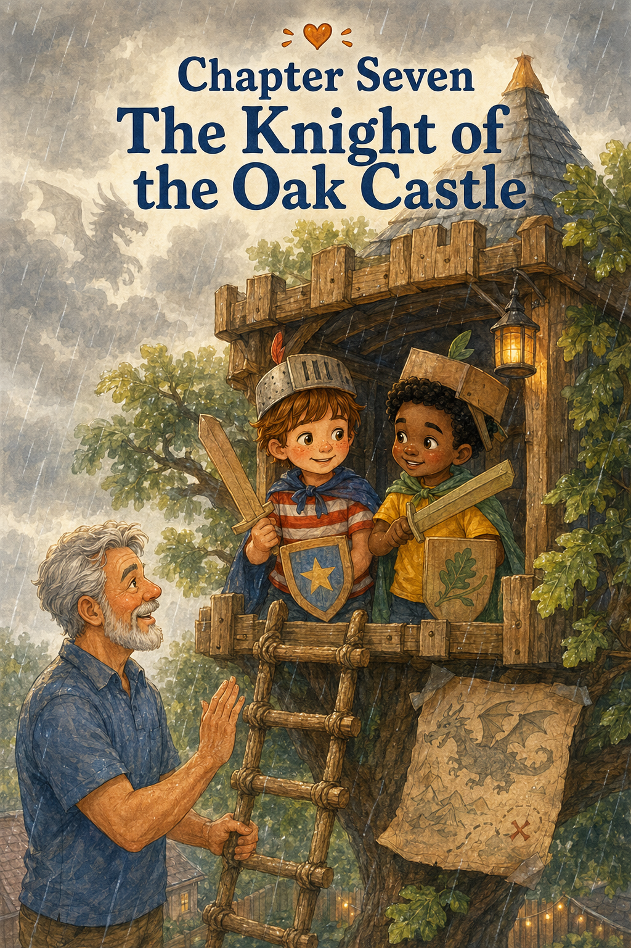
Chapter Seven: The Knight of the Oak Castle
The rain began just after lunch.
At first, it was only a soft tapping against the kitchen window, the kind of rain that made the house feel cozy and quiet. Thomas sat at the table, watching tiny drops slide down the glass in crooked races. Some went fast. Some slowed near the middle. One drop stopped completely, as if it had forgotten where it was going.
Outside, the backyard looked silver and green.
The grass bent under the rain. The flowerpots shone dark and wet. The birdbath filled with ripples. The old oak tree stood tall in the middle of it all, its leaves trembling beneath the soft shower.
And high in the branches sat the treehouse.
Thomas pressed his nose closer to the window.
“It looks like a castle,” he said.
Leo, who was sitting across from him coloring a picture of a dragon with purple wings and three tails, looked up.
“A castle?”
Thomas nodded. “Look at it. The tree is like a mountain, and the treehouse is at the top. The clouds are low. The rain is like mist.”
Leo pushed back his chair and hurried to the window.
His eyes widened.
“You’re right,” he whispered. “It’s not a treehouse today.”
Thomas smiled slowly. “It’s Oak Castle.”
Leo lifted his purple dragon drawing. “Then we need knights.”
Thomas stood at once. “Brave knights.”
“Very brave knights,” Leo said.
“Rainy-day knights,” Thomas added.
Dad looked up from the living room, where he was folding a blanket. “Rainy-day knights still follow safety rules.”
Thomas and Leo turned toward him.
Dad pointed gently toward the window. “The ladder is wet, so no climbing until I check it and say it’s safe. Wet wood can be slippery.”
Thomas looked disappointed for one second.
Only one.
Then he nodded. “Knights must wait for the royal safety inspection.”
Leo placed one hand over his heart. “We will wait with honor.”
Dad smiled. “Good.”
While Dad put on his rain jacket and went outside to check the treehouse, Thomas and Leo prepared their knight supplies. They did not use real swords, of course. Real swords were not allowed, and also they did not own any. Instead, they made pretend swords from soft cardboard tubes wrapped in paper.
Thomas made a silver one with red stripes.
Leo made a yellow one with blue stars.
Then they made shields from paper plates. Thomas drew a turtle on his shield, because turtles carried their own armor and therefore were excellent knight symbols. Leo drew a lightning bolt, because he said his knight was very fast and sometimes dramatic.
Mom gave them two old towels to use as capes.
Thomas tied his carefully around his shoulders.
Leo’s cape slipped sideways at once.
“You look like a knight who just escaped a laundry basket,” Thomas said.
Leo adjusted it proudly. “A very brave laundry knight.”
Dad came back inside with raindrops on his jacket.
“The ladder is damp,” he said, “but it is safe if you go slowly, hold both rails, and do not rush. I’ll stay nearby while you climb. Once you are inside, you stay inside until I help you down.”
Thomas nodded. “Careful climbing.”
“One at a time,” Leo added.
“No leaning over the railing,” Thomas said.
“And no wild swordplay near the ladder or windows,” Dad said.
The boys froze.
Leo glanced at his cardboard sword.
Dad continued, “Pretend swords stay low and slow. No swinging near faces. No chasing. No pushing. A brave knight protects people first.”
Thomas nodded seriously. “Protect people first.”
Leo repeated it too. “Protect people first.”
Dad opened the back door, and the smell of rain drifted into the house.
Outside, the world felt different. Cooler. Quieter. Softer. The oak tree dripped gently, and the leaves shivered above them like green flags.
Thomas climbed first. He moved slowly, because the ladder felt different when it was damp. His sneakers pressed carefully onto each step. Dad stood close below, watching. When Thomas reached the top, he crawled safely inside Oak Castle and moved away from the doorway.
“Sir Thomas has entered the castle!” he called.
Leo climbed next. He held the ladder tightly, taking each step with careful feet. Thomas waited inside, making sure there was plenty of room.
When Leo crawled in, his towel cape dragged behind him.
“Sir Leo has arrived,” he announced.
Dad looked up. “How is the castle?”
Thomas looked around.
The treehouse had changed again.
The wooden walls were no longer treehouse walls. They were castle stones. The windows were lookout towers. The shelf with the Moon Museum became a royal treasure room. The pirate map became an ancient kingdom map. The kindness cards in the wooden box became royal laws. The rain outside made the whole treehouse feel as though it floated in the clouds.
Thomas whispered, “It really is a castle.”
Leo looked through the window at the misty backyard. “The kingdom is covered in fog.”
Thomas lifted his cardboard sword carefully. “Then we must guard it.”
Leo raised his shield. “From dragons.”
At that exact moment, thunder rumbled softly in the distance.
Both boys froze.
Then Leo whispered, “The dragon heard us.”
Thomas felt a shiver of excitement run through him. It was not scary thunder, not close or loud, just a faraway growl rolling over the rooftops. But in Oak Castle, it sounded like a dragon waking beyond the hills.
Thomas opened his notebook and wrote:
Oak Castle Mission
Protect the kingdom from cloud dragons.
Keep friends safe.
Do not let the royal snacks get wet.
Leo leaned close. “Good. Snacks are important to the kingdom.”
Thomas nodded. “Very important.”
They began their watch at the window. Thomas peered through the rain and pointed toward the garden.
“Dragon tracks near the tomato plants.”
Leo looked carefully. “Those are puddles.”
“Dragon puddles,” Thomas said.
Leo accepted this at once.
Then Leo pointed toward the shed. “Dragon cave!”
Thomas lowered his voice. “The beast is hiding.”
A squirrel darted along the fence, paused beneath a wet branch, and shook its tail.
Leo gasped. “Dragon scout!”
Thomas wrote that down.
Dragon scout spotted near west wall. Furry. Fast. Probably nervous.
For a while, the knights guarded Oak Castle peacefully. They spoke in royal voices. They made plans to rescue villagers. They used the cardboard tube from the rocket control panel as a telescope. They declared the birdbath to be the Royal Lake and the sandbox to be the Desert of Lost Boots.
Then Leo stood in the middle of the treehouse and raised his cardboard sword.
“The dragon approaches!” he cried.
Thomas raised his shield. “Defend the castle!”
They began to pretend-battle.
At first, it was slow and careful. Thomas tapped Leo’s shield gently. Leo blocked with great drama and spun around once, making his towel cape twist behind him. Thomas laughed. Leo laughed too.
Then they got more excited.
Leo swung his cardboard sword higher.
Thomas ducked and stepped back.
Leo lunged forward with a loud “Huzzah!”
Thomas bumped into the wall.
The Moon Museum shelf rattled.
Star Spark Stone rolled slightly but did not fall.
Both boys stopped for one second.
Then Leo shouted, “The dragon is escaping!” and turned quickly.
His towel cape caught the edge of the wooden box of kindness cards.
The box slid halfway across the shelf.
Thomas grabbed for it.
Leo swung around again, and this time his cardboard sword came too close to Thomas’s shoulder.
“Hey!” Thomas said.
Below them, Dad’s voice came sharp and clear.
“Pause the adventure.”
The boys froze.
Dad stood at the bottom of the tree, looking up. His face was not angry, but it was serious.
“Both swords down,” he said.
Thomas lowered his cardboard sword.
Leo did the same.
Dad placed one hand on the ladder. “What happened to low and slow?”
Thomas looked at the floor.
Leo looked at his sideways cape.
“We got excited,” Thomas said.
Dad nodded. “I know. Adventures are exciting. But when pretend play gets too wild, someone can get hurt. The treehouse is a small space. There are walls, windows, shelves, and a ladder. You cannot swing and chase like you’re in an open field.”
Leo swallowed. “I almost knocked over the Moon Museum.”
Thomas looked at Star Spark Stone, still sitting close to the shelf’s edge.
“And I bumped the wall,” Thomas said.
Dad’s voice softened. “That is why safe play matters. Being brave does not mean being wild. A real knight protects the people in the kingdom, especially his friends.”
The rain tapped gently on the roof.
Thomas felt his excitement settle down into something quieter. He looked at Leo and noticed that his friend’s face looked worried.
“I didn’t mean to swing too close,” Leo said.
“I know,” Thomas said.
Dad looked up at them. “What do you think a good knight rule would be?”
Thomas thought carefully.
Leo sat down on the floor and rested his cardboard sword across his knees.
“No swinging near people,” Leo said.
Thomas nodded. “No chasing inside the castle.”
“And protect the treasures,” Leo added, looking at the Moon Museum.
Thomas picked up his notebook.
“We need a knight code,” he said.
Dad smiled a little. “That sounds wise.”
Thomas turned to a clean page and wrote at the top:
The Knight Code of Oak Castle
Leo sat beside him.
Together, they made the rules.
1. Protect the kingdom.
2. Protect your friends.
3. Keep swords low and slow.
4. No chasing inside the castle.
5. Watch where your body is going.
6. Protect the treasures on the shelf.
7. Never let adventure become careless.
Thomas read the last rule aloud.
“Never let adventure become careless.”
Leo nodded. “That’s the best one.”
Dad nodded from below. “I agree.”
Thomas tore the page carefully from the notebook and taped it to the wall beside the other treehouse rules. The treehouse was starting to look like a place full of important lessons. There were pirate promises, kindness treasure rules, moon mission notes, jungle field notes, and now the Knight Code of Oak Castle.
Leo looked at the wall. “This treehouse has a lot of rules.”
Thomas nodded. “Because it has a lot of adventures.”
“And adventures need rules,” Leo said.
“So they can keep going,” Thomas added.
They placed the cardboard swords on the floor in front of them and decided that, from now on, swordplay inside Oak Castle would be more like a slow-motion ceremony than a battle.
Thomas stood with his shield.
Leo stood with his shield.
They tapped their cardboard swords gently together.
“Clink,” Leo said.
Thomas smiled. “That was safe.”
“Very royal,” Leo said.
Then they invented a new game called Dragon Negotiation.
In this game, the dragon did not need to be defeated. The dragon needed to be understood.
Thomas became the Royal Dragon Listener. Leo became the Brave Knight of Snacks. The imaginary dragon, whose name was Sir Smoke-a-Lot, was not attacking the kingdom after all. He was upset because his cave was leaky and his tail was cold.
“So we should help him,” Leo said.
Thomas nodded. “Exactly. Knights help.”
Leo looked at his cardboard sword. “Then what is this for?”
Thomas thought about it. “Pointing at maps.”
Leo accepted that.
They spread the pirate map on the floor and drew a new section called Dragon Mountain. Then they added a dotted path from Oak Castle to the mountain, around the Royal Lake, and past the Garden of Muddy Boots.
“We can bring the dragon a blanket,” Leo said.
“And soup,” Thomas added.
“And maybe a towel cape,” Leo said.
Thomas looked at Leo’s cape, still sliding off one shoulder.
“I think we have one available.”
The boys laughed, but softly this time. Not wild laughter that made them bump into things, but quiet castle laughter, the kind that fit inside a rainy afternoon.
Outside, the rain grew steadier. It tapped on the roof, dripped from the leaves, and made tiny streams down the tree bark. The treehouse felt warm and safe, like a castle tucked inside a cloud.
Mom came out onto the porch wearing a raincoat.
“How are the knights?” she called.
Thomas leaned near the window, keeping both feet on the floor. “We made a knight code!”
Leo added, “And we are helping the dragon instead of fighting him.”
Mom smiled. “That sounds like very kind knights.”
Dad looked at the boys from beneath the tree. “And safe knights?”
Thomas and Leo answered together. “Safe knights!”
A few minutes later, Mom sent up a small basket using the treehouse bucket. Inside were two napkins, two small muffins, and a note written on a folded card.
Thomas opened the note.
For the Knights of Oak Castle:
A brave heart is gentle, too.
Love, Mom
Thomas read it aloud.
Leo looked thoughtful. “A brave heart is gentle too.”
Thomas nodded. “That should go in the Knight Code.”
He added it at the bottom.
8. A brave heart is gentle, too.
They ate their muffins while watching the rain fall over the kingdom. The backyard was quiet except for the patter of water and the occasional distant rumble of thunder. No dragons attacked. No treasures fell. No one bumped into the wall.
It was peaceful.
And somehow, it was still an adventure.
After snack, they checked the kingdom again. The Royal Lake was overflowing with rain rings. The Garden of Muddy Boots was getting muddier. Tia stood at the back door, looked at the rain, and made a face that clearly meant she would not be joining the mission.
“Tiny Jungle Tiger refuses wet kingdom duty,” Thomas said.
Leo wrote it in the field notes.
Then Sophie appeared at the fence under a bright pink raincoat, holding Mr. Bunbun under one arm. She waved through the drizzle.
Thomas waved back.
“Can she be part of Oak Castle?” Leo asked.
Thomas smiled. “She can be the royal messenger when it stops raining.”
Dad looked toward the fence. “Not while the ladder is wet and the rain is coming down harder. Today the castle is closed to new climbers.”
Thomas felt a little disappointed, but he understood.
Safety first.
He called to Sophie, “We’ll tell you about the dragon tomorrow!”
Sophie shouted back, “Was it scary?”
Leo called, “Not really! Just cold!”
Sophie seemed satisfied and ran back toward her house, splashing through puddles.
The boys spent the rest of the rainy afternoon making a dragon care plan. They drew a picture of Sir Smoke-a-Lot with a blanket, a bowl of soup, and very polite manners. They added him to the wall beside the Moon Museum labels.
Then Thomas wrote one more page in the notebook.
What We Learned in Oak Castle
Leo watched as Thomas wrote.
1. Rain can turn a treehouse into a castle.
2. Cardboard swords are still swords, so they must be used carefully.
3. Brave knights protect their friends.
4. Wild play can become unsafe if you stop paying attention.
5. Dragons might not be mean. They might just need help.
Thomas paused, then added the most important line.
6. The best knights are brave, kind, and careful.
Leo read it and smiled. “That sounds like us.”
Thomas nodded. “Most of the time.”
Leo looked at the cardboard swords resting quietly on the floor.
“We got a little too wild.”
“Yeah,” Thomas said. “But we fixed it.”
Leo nodded. “That counts.”
Thomas smiled. “It does.”
When the rain finally slowed to a mist, Dad helped them climb down one at a time. The ladder was damp, so they moved slowly, carefully, and without carrying too much at once. Thomas climbed first. Leo followed. Dad stayed close the whole time.
When their feet touched the grass, the world smelled like rain and leaves.
Thomas looked back up at the treehouse.
Oak Castle stood in the mist, quiet and proud.
The Knight Code was taped safely inside. The Moon Museum had survived. The kindness cards were still in their box. The cardboard swords rested against the wall, ready for another day—but only a careful one.
Leo stood beside Thomas and looked up too.
“Do you think Sir Smoke-a-Lot will come back?” he asked.
Thomas nodded. “Probably.”
“What if he brings another dragon?”
Thomas smiled. “Then we’ll help that one too.”
Dad placed a hand on each boy’s shoulder.
“That sounds like a good kingdom,” he said.
Thomas felt proud.
Not because they had defeated a dragon.
Not because they had swung their swords the fastest.
But because they had learned how to stop, listen, make a better rule, and keep the adventure safe for everyone.
The treehouse had become a castle in the clouds.
And Thomas had learned that a real knight does not just protect treasure or kingdoms.
A real knight protects the people playing beside him.
As they walked inside for dinner, Thomas looked back one more time.
The old oak tree dripped softly in the rain. The treehouse windows glowed with gray afternoon light. Somewhere inside, the Knight Code waited on the wall.
Protect the kingdom.
Protect your friends.
Never let adventure become careless.
Thomas smiled.
Tomorrow, the treehouse would become something new.
But Oak Castle had left its lesson behind.
And that lesson would stay.

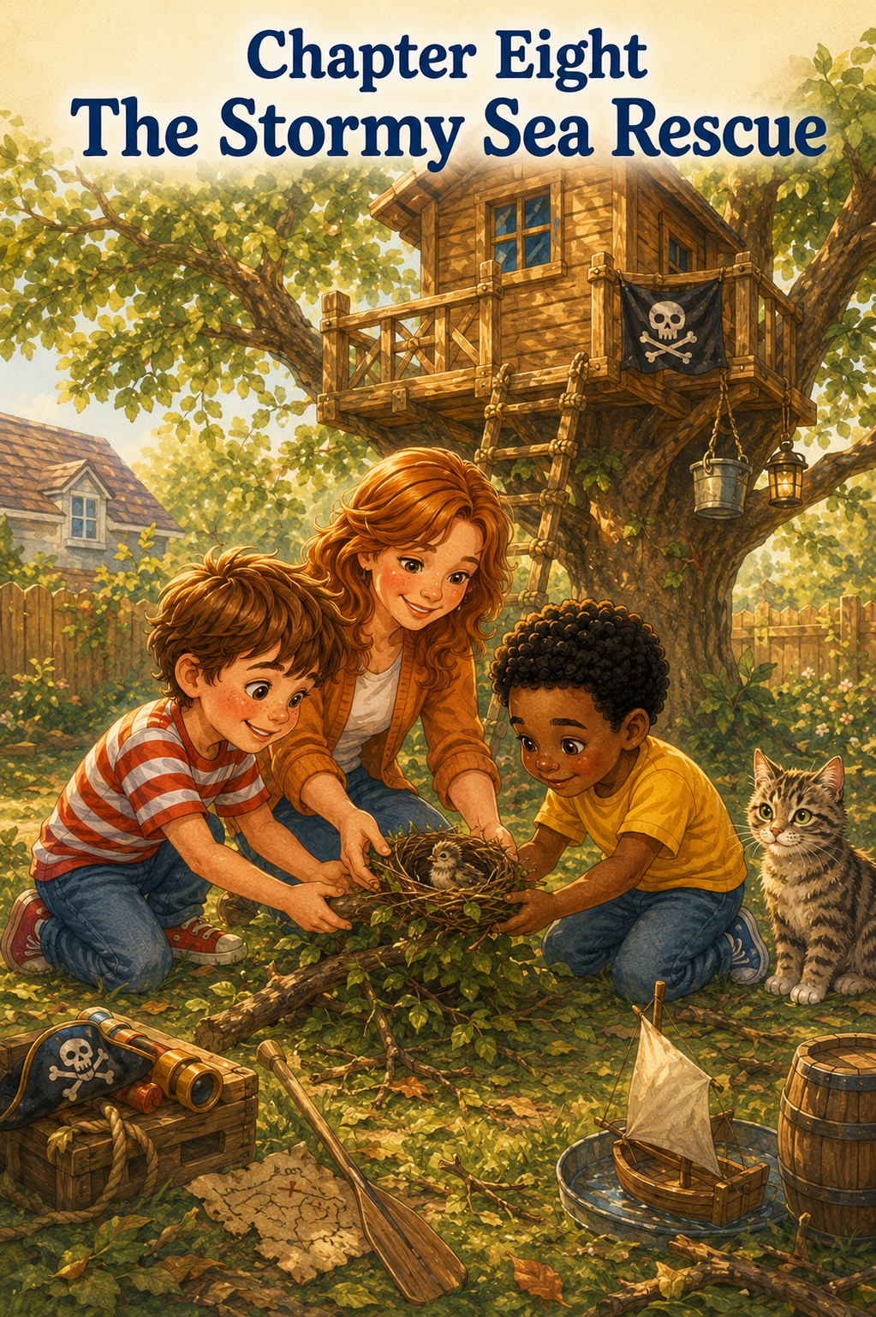
Chapter Eight: The Stormy Sea Rescue
The wind came during the night.
Thomas heard it before he opened his eyes. It rushed against the windows, rattled the branches, and made the old oak tree creak softly in the backyard. Rain tapped against the roof for a while, then stopped. The wind kept going, pushing through the dark like an invisible giant hurrying somewhere important.
Thomas pulled his blanket up to his chin and listened.
Whoooosh.
Rustle.
Tap-tap-tap.
A branch brushed against the side of the house. Somewhere down the hall, Tia the cat gave a soft, annoyed meow, as if the storm had interrupted one of her very important naps.
Thomas thought about the treehouse.
He imagined the pirate flag fluttering wildly. He imagined the treehouse swaying high in the oak tree like a ship on a stormy sea. He imagined waves of grass rolling beneath it and clouds racing overhead like gray sails.
By morning, the storm had passed.
The sky was bright again, washed clean and blue. Sunlight shone across the wet grass, and the whole backyard smelled like rain, leaves, and fresh earth. But the yard looked different. Twigs were scattered everywhere. Leaves covered the patio. A small branch lay across the garden path. The flowerpots were crooked, and the birdbath was full to the very top.
Thomas hurried to the kitchen window.
The treehouse was still there.
He let out the breath he hadn’t realized he was holding.
Dad walked in carrying a cup of coffee. “Checking on the ship?”
Thomas turned. “It survived the storm.”
Dad smiled. “The old oak is strong.”
A moment later, Leo came through the back gate wearing his yellow shirt, rain boots, and a serious face. He held the rolled-up pirate map under one arm.
“I came as soon as I could,” Leo said.
Thomas opened the back door. “The stormy sea hit Oak Castle.”
Leo looked across the yard. “This is no castle today.”
Thomas followed his gaze.
The wet grass shimmered in the sun. The leaves were scattered like seaweed. The treehouse stood high above them, quiet and brave.
Leo lifted the pirate map.
“Today,” he said, “the treehouse is a ship again.”
Thomas nodded. “A ship after a storm.”
Dad stepped onto the porch behind them. “Before any sailors climb aboard, I need to inspect the ladder and the treehouse.”
Thomas and Leo nodded at once.
“Safety first,” Thomas said.
“Storm inspection,” Leo added.
Dad walked across the yard and checked the ladder carefully. He tested each step, looked at the railing, checked the branches nearby, and made sure nothing sharp or loose had fallen onto the platform. Thomas and Leo waited below, shifting from foot to foot but not rushing him.
Finally, Dad looked down. “The ladder is safe if you climb slowly, but the yard has storm debris. Watch where you step. No running.”
“No running,” Thomas repeated.
“No sword fighting with sticks,” Dad added.
Leo looked at a long twig near his boot.
“I wasn’t going to.”
Dad raised an eyebrow.
Leo moved the twig aside with his foot. “Probably.”
Mom came out with a pair of garden gloves. “And if you find anything that belongs to an animal, you come get me. No touching nests, eggs, feathers, or anything sharp without an adult.”
Thomas nodded. “Animal things need grown-up help.”
“Exactly,” Mom said.
The boys began their storm patrol.
They decided the backyard was now the Stormy Sea, and the treehouse was the Brave Oak Ship. Thomas was Captain Thomas again, and Leo was First Mate Leo, though this time they agreed that if the mission became very serious, they would both be captains.
The pirate map had changed too.
Sandy Shell Island was covered in wet leaves.
Mermaid Lagoon, the birdbath, had nearly overflowed.
Skull Cave, the shed, had a trail of muddy footprints nearby. Dad said they belonged to him, but Leo said they might also belong to a storm monster wearing Dad’s shoes.
Thomas wrote that in his notebook.
Stormy Sea Patrol Notes
Possible storm monster footprints near Skull Cave. Looks like Dad. Investigation ongoing.
They picked up small sticks and placed them in a pile near the fence. They gathered wet leaves from the patio and carried them to the yard waste bin with Mom’s permission. They rescued the pirate flag, which had come loose and was hanging sideways from the treehouse window.
“It stayed with the ship,” Leo said proudly.
Thomas held it gently. “A loyal flag.”
They brought it inside to dry.
Then, as they walked near the base of the oak tree, Thomas noticed something in the grass.
He stopped.
Leo bumped lightly into his shoulder. “What is it?”
Thomas pointed.
Near the roots of the oak tree, half-hidden beneath leaves and tiny broken twigs, was a small bird nest.
It was round and delicate, woven from grass, pine needles, and thin brown stems. One side was bent, and a few pieces had come loose, as if the wind had shaken it from somewhere high above.
Thomas crouched down but did not touch it.
Leo crouched beside him.
“Is it a nest?” Leo whispered.
Thomas nodded. “I think so.”
Leo looked up into the oak tree. “It fell.”
The backyard suddenly felt quieter.
A squirrel chattered from the fence, and a bird called from a branch above them. Thomas looked carefully at the nest, searching for eggs or baby birds. He did not see any, but that did not make it feel less important.
“It looks broken,” Leo said.
Thomas swallowed. “We need Mom.”
He stood right away and called toward the porch. “Mom! We found something!”
Mom came quickly, wiping her hands on a towel.
“What did you find?”
Thomas pointed to the grass. “A bird nest. We didn’t touch it.”
Mom knelt beside them and looked carefully. “Good job not touching it first.”
Leo leaned close. “Are there babies?”
Mom studied the nest from all sides. “I don’t see eggs or baby birds. It may be an old nest, or it may have been knocked down after the birds were finished using it. But we still need to be gentle.”
Thomas looked up into the tree. “Can we put it back?”
Mom followed his gaze. “We can’t climb high into the branches, and we should not guess where it came from. But we can place it somewhere safe nearby, out of the walkway, where it won’t be stepped on or damaged more.”
Leo’s face brightened. “A rescue mission.”
Thomas nodded slowly. “Stormy Sea Rescue.”
Mom smiled. “Yes. But a careful rescue mission.”
She went inside and returned with a shallow cardboard tray and a pair of gloves. She gently lifted the nest into the tray while Thomas and Leo watched closely. The nest looked even smaller in the tray, like a tiny bowl made by the wind.
“Where should we put it?” Thomas asked.
Mom looked around the yard. “Somewhere sheltered. Not in the path. Not where Tia can easily reach it. Maybe near the shrubs by the fence, under that low branch.”
Thomas looked toward the bushes. The spot was shaded and quiet, tucked away from the busy part of the yard.
“That looks safe,” he said.
Leo nodded. “It can be a little harbor.”
Mom carried the tray carefully, and the boys walked beside her like guards protecting royal treasure. Tia appeared from the porch just then, stretching one paw forward.
Thomas pointed at her. “No, Tia. This is not for tiny jungle tigers.”
Tia sat down and blinked.
Leo whispered, “She looks suspicious.”
“She is always suspicious,” Thomas whispered back.
Mom placed the nest gently under the shrub, on top of a soft patch of dry leaves. She tucked a few small twigs around it so it would not roll. Then she stood back.
“There,” she said. “That is a safe place for now.”
Thomas looked at the nest.
It was not exactly fixed. It was still bent on one side. Some of the pieces still stuck out. But it was no longer in the middle of the yard where someone might step on it.
It had been noticed.
It had been cared for.
That felt important.
Leo took off his rain hat and held it against his chest. “Should we say something?”
Thomas thought about it. “Like a pirate rescue speech?”
Leo nodded solemnly.
Thomas stood a little straighter.
“Dear nest,” he began, “you were knocked down by the stormy sea, but the Brave Oak Crew found you.”
Leo added, “You are now safe in Harbor Bush.”
Thomas continued, “May you rest peacefully and not be bothered by cats.”
They both looked at Tia.
Tia looked away, as if she had no idea why anyone would accuse her of anything.
Mom covered her smile with one hand. “That was very respectful.”
Thomas felt proud.
The pirate adventure had changed. It had started with a stormy sea and a ship that survived the wind. But now it felt like something more serious and more meaningful. They were not just pretending to be rescuers.
They had actually helped.
Back at the treehouse, Dad helped them climb up one at a time after checking the ladder again. Thomas carried only his notebook. Leo carried the dried pirate flag. Once inside, they spread the flag on the floor and smoothed its wrinkled edges.
“The flag survived,” Leo said.
“So did the ship,” Thomas said.
“And the nest,” Leo added.
Thomas looked out the window toward the shrubs. He could just barely see the place where Mom had set the nest. The leaves moved gently around it.
He opened his notebook and wrote:
Stormy Sea Rescue Report
Leo sat beside him.
Thomas wrote slowly.
After the windy storm, the Brave Oak Crew found:
Leaves everywhere.
Twigs everywhere.
A sideways pirate flag.
A fallen bird nest near the oak tree.
Leo leaned over. “Add: possible storm monster footprints.”
Thomas added:
Possible storm monster footprints near Skull Cave. Still looks like Dad.
Then he continued.
Important rescue:
Found a fallen bird nest. Did not touch it. Got Mom. Moved it carefully to a safe spot near the shrubs. Protected it from feet, rain puddles, and Tia.
Leo nodded. “Especially Tia.”
Thomas added:
Especially Tia.
The boys looked out the window again.
A small bird landed on the fence, chirped twice, and flew away.
“Do you think that bird knows?” Leo asked.
“Knows what?”
“That we helped.”
Thomas watched the empty fence. “Maybe not.”
Leo looked a little disappointed.
Thomas thought of the nest sitting quietly under the shrub. He thought of the birds that might never know who moved it. He thought of how the yard looked better after they had picked up the storm debris, even though nobody had cheered or given them a medal.
“Maybe helping still counts even when nobody knows,” Thomas said.
Leo looked at him.
Thomas continued, “The nest is safer. That’s what matters.”
Leo nodded slowly. “Like kindness treasure.”
“Exactly,” Thomas said. “But for birds.”
Leo smiled. “Bird points.”
Thomas laughed and wrote in the notebook:
Bird Points = 1
Then he paused and added:
Kindness is not only for people.
Leo read the sentence quietly. “That’s good.”
Thomas wrote more carefully now.
Kindness can be for birds, turtles, cats, trees, flowers, and even the whole backyard. Taking care of small things counts too.
Leo picked up the green crayon and drew a tiny nest beside the words.
Then he drew two small birds above it.
Thomas looked at the drawing. “Nice.”
Leo added a pirate hat to one bird.
Thomas smiled. “Of course.”
The rest of the afternoon became a cleanup mission. The boys did not race or shout. They worked like careful sailors repairing a ship after a storm. They picked up safe twigs. They gathered leaves from the treehouse floor. They checked the Moon Museum to make sure no stones had rolled off the shelf. They retaped the pirate flag near the window after Dad helped them secure it properly.
Then they made a new sign for the treehouse wall.
Stormy Sea Rescue Rules
1. Look carefully after a storm.
2. Do not touch animal homes without an adult.
3. Help small creatures when you can.
4. Keep the yard safe for everyone.
5. Kindness belongs outdoors too.
Thomas taped it beside the Knight Code.
The treehouse wall was becoming crowded with signs and lessons from all their adventures. But Thomas liked it that way. Each piece of paper reminded him of something they had learned.
Pirates share leadership.
Treasure can be kindness.
Good friends wait until everyone feels safe.
Discoveries are better when shared.
Adventures grow when you make room for someone new.
Knights protect friends.
And now:
Kindness belongs outdoors too.
Mom called from the porch, “Would the Brave Oak Crew like lemonade?”
Leo leaned safely near the window. “Do pirates drink lemonade after rescue missions?”
Thomas nodded. “Only the best pirates.”
Dad sent the lemonade up using the treehouse bucket, along with two napkins and a small bowl of crackers. The boys sat inside the treehouse, drinking carefully and watching the yard.
The wind was gone now. The grass sparkled with leftover raindrops. The birdbath shone like a silver pond. The shrubs near the fence moved gently, guarding the nest in its new safe spot.
Thomas felt quiet in a good way.
Leo munched a cracker. “I thought today was going to be a pirate adventure.”
Thomas looked at the pirate flag. “It was.”
“But it became a rescue mission.”
Thomas smiled. “Pirates can rescue things.”
Leo thought about that. “Kindness pirates.”
“Stormy sea kindness pirates,” Thomas said.
Leo raised his lemonade cup. “To the Brave Oak Crew.”
Thomas touched his cup gently to Leo’s. “To the nest.”
“And to Harbor Bush,” Leo added.
They both drank.
A little later, Sophie appeared at the fence, holding Mr. Bunbun. “What happened to your yard?”
“Stormy sea,” Leo called.
Thomas pointed toward the shrubs. “We found a fallen bird nest.”
Sophie’s eyes widened. “Were there baby birds?”
“No,” Thomas said. “But we moved it somewhere safer with Mom’s help.”
Sophie looked toward the shrubs. “Can I see?”
Thomas glanced at Dad below.
Dad nodded. “From a distance.”
The boys climbed down carefully, and Dad opened the gate. Sophie came over, and Thomas led her near the shrubs, stopping several steps away.
“Don’t get too close,” Thomas said. “It’s resting.”
Sophie stood on tiptoe and looked. “It’s tiny.”
Leo nodded. “But it still matters.”
Thomas smiled at Leo.
That was exactly right.
Sophie hugged Mr. Bunbun. “Can I help with the rescue?”
Thomas looked around. Most of the twigs were already picked up, but a few leaves had blown onto the porch steps.
“You can help clear the porch,” he said. “So no one slips.”
Sophie nodded eagerly.
Together, the three children gathered leaves from the porch steps and placed them in the yard waste pile. It was a small job, but Thomas knew small jobs counted. Especially after storms.
When they finished, Sophie said, “Now the porch is safe.”
Thomas nodded. “That is part of the rescue too.”
Leo held up one finger. “Porch Points.”
Thomas laughed. “Definitely Porch Points.”
That evening, after Leo and Sophie had gone home, Thomas stood beneath the oak tree with Dad. The sky was turning soft orange and pink. The treehouse glowed warmly in the branches. The pirate flag fluttered again, straight and proud.
Thomas looked toward the shrubs.
“Do you think we did enough?” he asked.
Dad followed his gaze. “For the nest?”
Thomas nodded.
Dad was quiet for a moment. “You noticed it. You didn’t disturb it. You got help. You moved it somewhere safer. That is a lot.”
Thomas thought about that.
“But we didn’t put it back in the tree.”
“No,” Dad said. “Sometimes helping means doing what is safe and possible, not everything we wish we could do.”
Thomas looked up at him. “So it still counts?”
Dad smiled. “It absolutely counts.”
Thomas felt better.
Inside the treehouse, the Stormy Sea Rescue Rules were taped to the wall. The Moon Museum was safe. The pirate map was dry. The kindness cards waited in their little wooden box. And outside, under the shrubs, the fallen nest rested where no one would step on it.
The storm had made a mess.
But it had also given Thomas something to notice.
Something small.
Something fragile.
Something worth caring about.
That night, before bed, Thomas opened his notebook one more time. He drew the treehouse like a ship sailing over waves of grass. He drew the oak tree as a mast and the nest tucked safely in Harbor Bush.
Then he wrote:
Today I learned that kindness is not only something you give to people. Sometimes kindness means caring for a bird’s nest, cleaning up after a storm, giving animals space, and helping the world stay safe. Small creatures matter. Small homes matter. Small rescues matter too.
He closed the notebook and smiled.
Outside his window, the oak tree stood tall and quiet in the moonlight.
The storm was over.
The Brave Oak Ship was safe.
And somewhere in the backyard, beneath the gentle shelter of green leaves, one tiny nest had found a safer place to rest.

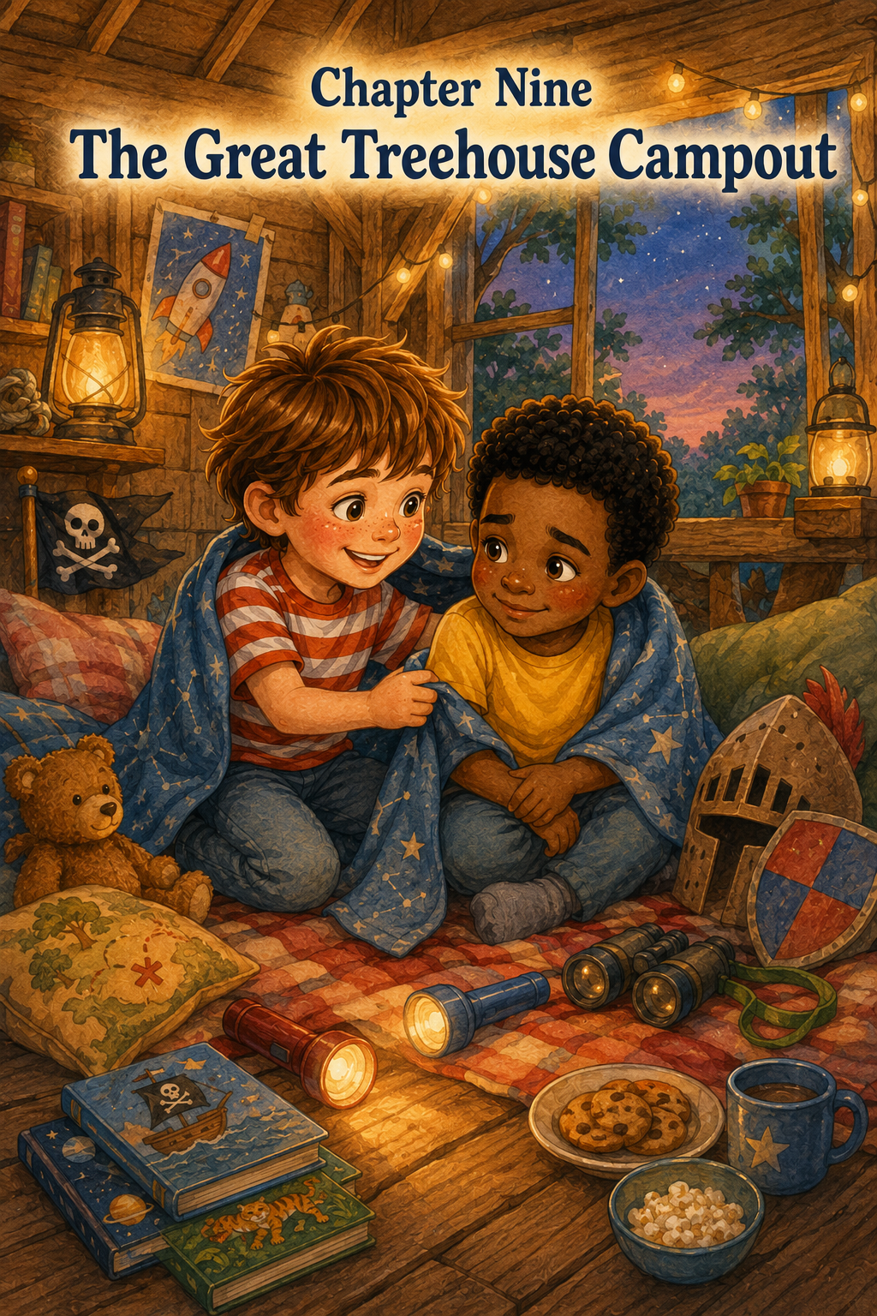
Chapter Nine: The Great Treehouse Campout
Thomas had been waiting all day for the sun to start going down.
Usually, he liked bright mornings best. Mornings were good for pirate maps, rocket launches, jungle missions, and discovering things before anyone else noticed them. But today was different.
Today, the best part would happen in the evening.
The Great Treehouse Campout.
Not a sleepover all night in the treehouse, because Mom and Dad had said they were not quite ready for that yet. But an early evening campout was allowed. Thomas and Leo could bring blankets, books, flashlights, snacks, and pillows up into the treehouse. They could stay until the stars started to show and the crickets began their nighttime music.
To Thomas, that sounded almost as good as camping in the woods.
Maybe better.
Because this campout had a roof, a tree, and a snack bucket.
By late afternoon, Thomas had lined up supplies on the back porch. There were two small flashlights, two folded blankets, one pillow shaped like a sleepy bear, one regular pillow, three picture books, two adventure books, a bag of pretzels, apple slices in a container, two granola bars, and a small notebook for recording important campout events.
Leo arrived carrying his own backpack and wearing his yellow shirt under a blue hoodie.
“I brought emergency campout supplies,” he announced.
Thomas looked at the backpack. “What kind?”
Leo opened it proudly. Inside were a flashlight, a comic book, a pack of crackers, a toy compass, and the smooth rock he called the pirate emergency rock.
Thomas nodded with approval. “Very prepared.”
Leo zipped the backpack. “You never know when a campout will need a rock.”
Dad stepped onto the porch and looked over the supplies. “That is quite a lot for one evening.”
Thomas held up his notebook. “This is an official campout.”
“Official campouts need inspections,” Dad said.
Mom came outside with a small lantern that ran on batteries. “And rules.”
Thomas smiled. “We know.”
Dad pointed toward the treehouse. “I checked the ladder earlier, but we’ll check it again before you climb. You each carry only one small thing at a time, or we send supplies up in the bucket. No climbing with your arms full.”
“No leaning out,” Mom added.
“No throwing anything down,” Dad said.
“No eating while climbing,” Mom said.
Leo looked at the pretzels. “Not even one?”
Mom gave him a look.
Leo nodded. “No eating while climbing.”
“And when we say campout is over,” Dad said, “you come down carefully, one at a time.”
Thomas and Leo nodded.
The Great Treehouse Campout was already teaching them something important: the more exciting an adventure was, the more carefully it needed to begin.
Dad checked the ladder, and then the supply lift began.
Thomas climbed first with only his notebook tucked safely in his back pocket. He used both hands and moved slowly. When he reached the top, he crawled inside and called, “Campout headquarters ready!”
Leo climbed next, just as carefully.
Then Dad tied the first blanket to the rope bucket and sent it up. Thomas and Leo pulled together, hand over hand, until the blanket reached the treehouse platform.
“Blanket delivery complete,” Thomas called.
Next came the pillows.
Then the flashlights.
Then the books.
Then the snack container.
Leo pulled up the last delivery and held the container carefully.
“Snack cargo has arrived safely,” he said.
Dad looked up from below. “Excellent. Please do not drop snack cargo on your mother.”
Mom stepped back. “Or anyone.”
Thomas and Leo arranged the inside of the treehouse for the campout. They spread the blankets across the floor, making a soft nest against one wall. The pillows went near the window. The books were stacked on the shelf beside the Moon Museum. The flashlights were placed in the center, ready for when the evening grew dim.
The treehouse looked cozy and magical.
The pirate flag still hung near one window. The Knight Code was taped to the wall. The Stormy Sea Rescue Rules fluttered slightly in the breeze. The Moon Museum stones glowed softly in the warm light. The kindness cards rested in their wooden box, and the jungle lookout notes were tucked into Thomas’s notebook.
Every adventure they had taken seemed to be sitting there with them.
Leo looked around and whispered, “It feels like the treehouse remembers everything.”
Thomas liked that.
“It does,” he said.
The sun began to lower behind the houses, turning the sky gold. The backyard looked calm and friendly. Long shadows stretched across the grass. The birdbath sparkled. Tia the cat sat beneath the oak tree, looking up as if she had been assigned to guard the campout from below.
Thomas leaned near the window, keeping both feet safely on the floor. “Tia is the night watch.”
Leo looked down. “She looks sleepy.”
“Sleepy guards are still guards,” Thomas said.
Leo accepted this.
They began the campout with snacks. Thomas passed Leo apple slices, and Leo passed Thomas pretzels. They made a rule that snacks tasted better in a treehouse. Then they made another rule that crumbs had to stay on napkins so ants did not invade the camp.
Thomas wrote both rules in his notebook.
Great Treehouse Campout Notes
1. Snacks taste better in a treehouse.
2. Crumbs must stay on napkins. Ants are not invited.
Leo looked serious. “Unless they are polite ants.”
Thomas thought about it. “Still not invited.”
After snacks, they started telling stories.
Thomas went first.
“Once upon a time,” he began, lowering his voice, “there was a pirate ship called the Brave Oak, sailing across the Green Grass Sea.”
Leo pulled his blanket up to his chin. “Was there treasure?”
“Of course,” Thomas said. “But not gold. Kindness treasure.”
Leo nodded. “The best kind.”
Thomas told a story about Captain Thomas and Captain Leo finding a chest full of helpful deeds. In the story, the pirates saved a lonely island, gave water to a thirsty jungle tiger, and shared their snacks with a dragon who had lost his way.
“That dragon sounds familiar,” Leo said.
“He might be related to Sir Smoke-a-Lot,” Thomas said.
Then Leo told a story about astronauts.
“Commander Thomas and Mission Specialist Leo blasted off from Backyard Base,” he began, shining his flashlight onto the ceiling. “They flew past the moon, past Mars, past a planet made completely of pancakes—”
“Pancake Planet,” Thomas said.
“Exactly,” Leo continued. “And when they landed, they found a moon rock so shiny that everyone wanted to keep it.”
Thomas smiled. “But the explorers shared it.”
Leo nodded. “Because the best discoveries belong in a museum.”
He pointed his flashlight toward the shelf, where Star Spark Stone sat in the middle of the Moon Museum.
The stone caught the light and flashed.
“See?” Leo whispered. “Still rare.”
Thomas laughed softly.
Next, they took turns telling jungle stories. Thomas told about a tiny striped jungle tiger who stalked through the grass and bravely attacked a dangerous leaf. Leo laughed so hard he had to press his pillow over his mouth.
Below them, Tia looked up.
“She knows,” Leo whispered.
Thomas nodded. “She always knows.”
Then they told knight stories. Leo spoke in a deep voice as Sir Smoke-a-Lot, the cloud dragon with a leaky cave and a cold tail. Thomas became Sir Thomas of Oak Castle, who brought blankets, soup, and careful rules to the mountain.
“No wild swordplay,” Thomas said in his knight voice.
“Never let adventure become careless,” Leo added.
The treehouse grew dimmer as the stories continued. The golden sky softened into pink, then lavender. The first cricket began chirping somewhere near the fence. A few porch lights blinked on in the neighborhood.
Mom came outside and looked up. “How are my campers?”
Thomas leaned toward the window safely. “Great!”
Leo waved his flashlight. “We have told four important stories.”
Dad stepped onto the porch beside Mom. “Any dragons?”
“One,” Leo said. “But he was helped.”
“Good,” Dad said. “Helpful knights are my favorite kind.”
Mom smiled. “We’ll let you stay a little longer. When the sky gets darker, we’ll bring you down.”
Thomas nodded. “Okay.”
At first, that felt fine.
But after Mom and Dad went back inside, the treehouse became quieter.
Not scary exactly.
Just different.
The daylight was almost gone now. The yard that had looked friendly and bright a little while ago was turning shadowy. The bushes near the fence looked darker. The garden hose looked more like a snake again. The old shed became a black square at the edge of the yard.
Thomas clicked on his flashlight.
Leo clicked on his too.
The two circles of light moved across the treehouse wall.
“This is cozy,” Thomas said.
Leo nodded. “Very cozy.”
But his voice sounded smaller than before.
Thomas looked at him. Leo was sitting with his knees pulled up, his blanket wrapped around his shoulders. He was not looking at the Moon Museum or the books or the window. He was looking down at his flashlight.
“Are you okay?” Thomas asked.
Leo nodded quickly. “Yeah.”
Thomas waited.
Leo tapped the flashlight against his knee. “I just…”
Thomas leaned closer. “What?”
Leo looked toward the darkening yard. “I know we’re still in your backyard. And I know your mom and dad are right inside.”
Thomas nodded.
Leo swallowed. “But I kind of miss home.”
Thomas did not laugh.
He did not say, “But we’re having fun.”
He did not say, “Don’t be silly.”
He remembered the rocket mission, when Leo had stopped halfway up the ladder and needed time to feel safe. He remembered learning that bravery did not mean pretending not to be nervous.
Sometimes bravery meant saying the truth.
Thomas looked at his friend wrapped in the blanket.
“That’s okay,” he said.
Leo looked up. “It is?”
Thomas nodded. “A campout can be exciting and still make you miss home.”
Leo let out a small breath. “I didn’t want to ruin it.”
“You’re not ruining it,” Thomas said.
The crickets chirped louder now, filling the quiet spaces between them.
Thomas looked down at his own blanket. It was soft and blue with stars on it. His grandmother had given it to him when he was little, and it always made him feel safe.
He held one side out to Leo.
“You can share mine,” Thomas said.
Leo blinked. “Really?”
Thomas nodded. “It’s a good safe blanket.”
Leo scooted closer, and Thomas spread part of the blue blanket over both of their laps. Leo kept his own blanket around his shoulders too, so now he looked like a very warm explorer.
Thomas picked up one of the picture books from the shelf.
“Want me to read?” he asked.
Leo nodded. “Yes, please.”
Thomas opened the book. It was about a bear who got lost on a camping trip but found his friends by following the sound of their singing. Thomas read slowly, using his flashlight to brighten the pages. Leo leaned beside him, quiet and still.
Halfway through the story, Leo said, “My mom sings sometimes when I can’t sleep.”
Thomas looked at him. “What song?”
Leo shrugged. “Just a soft one. I don’t know all the words.”
Thomas thought for a moment.
Then he began humming quietly.
Not a real song exactly. Just a soft tune, gentle and slow.
Leo smiled a little.
“That’s not it,” he said.
“I know,” Thomas said. “But it’s what I have.”
Leo leaned back against the wall. “It helps.”
Thomas kept humming for a few seconds more.
The treehouse did not feel as dark now.
The flashlight glowed on the book. The blue blanket covered both boys’ knees. The Moon Museum sparkled softly on the shelf. The pirate flag moved gently in the evening breeze. Tia still sat beneath the tree, watching the yard like a sleepy guard.
Everything felt safe.
Not because the shadows had disappeared.
They had not.
But because Thomas and Leo were together.
And because Thomas had remembered that a good friend helps you feel safe, even during a big adventure.
When the story ended, Leo looked better. His shoulders were not as tight, and his voice sounded more like himself.
“Thanks,” he said.
Thomas closed the book. “You’re welcome.”
Leo looked out the window. “I still miss home a little.”
“That’s okay,” Thomas said. “We can go down whenever you want.”
Leo thought about it.
“Maybe after one more story?”
Thomas smiled. “One more story.”
This time, they told a story together.
It was about two campers in a treehouse who heard a mysterious noise in the dark jungle below. At first, they thought it was a dragon. Then they thought it was a pirate ghost. Then they thought it was a moon creature searching for Star Spark Stone.
But in the end, it was only Tia, stepping on a dry leaf and pretending she had meant to do it.
The boys laughed, and below them, Tia flicked her tail.
“She really does know,” Leo said.
Thomas nodded. “Definitely.”
A few minutes later, Mom and Dad came outside again.
“The sky is getting dark, campers,” Mom called gently. “Time to come down.”
Leo looked at Thomas.
Thomas could tell he was ready.
“We’re coming,” Thomas called.
They packed carefully. First, they placed the books back on the shelf. Then they closed the snack container. Thomas tucked the notebook into his backpack. Leo held the flashlights while Dad sent the bucket up for supplies.
The blankets went down first.
Then the pillows.
Then the snacks.
Then the books they wanted to bring inside.
When it was time to climb down, Dad stood at the bottom of the ladder.
Thomas turned to Leo. “Do you want me to go first or wait up here while you go?”
Leo thought about it. “You go first. Then you can talk me down.”
Thomas nodded. “Good plan.”
Thomas climbed down slowly, using both hands. When he reached the grass, he looked up.
“Ready when you are,” he said.
Leo climbed down carefully, one step at a time.
Thomas spoke gently. “Steady feet. Careful hands. No rush. Mission Specialist Leo is doing great.”
Leo smiled halfway down. “This is not a rocket mission.”
“All good climbing gets encouragement,” Thomas said.
Dad smiled in the dark.
When Leo reached the ground, Mom wrapped both boys in the blankets that had come down in the bucket.
“How was the campout?” she asked.
Thomas looked at Leo.
Leo looked at the treehouse, then at Thomas.
“It was big,” Leo said.
Mom smiled. “Big?”
Leo nodded. “Big adventures can make you miss home a little.”
Thomas added, “But friends help.”
Dad looked at both boys. “That sounds like something worth remembering.”
Thomas pulled out his notebook and wrote by the porch light:
Great Treehouse Campout Lesson:
A good friend helps you feel safe, even during a big adventure.
Leo leaned over and read it.
“Add: blankets help too.”
Thomas wrote:
Blankets help too.
Leo nodded. “And books.”
Thomas added:
Books help too.
Mom touched Thomas’s shoulder. “That is a very good list.”
Before Leo went home, he folded Thomas’s blue blanket carefully and handed it back.
“Thanks for sharing your safe blanket,” he said.
Thomas hugged it to his chest. “Anytime.”
Leo smiled. “Maybe next time I’ll bring my own safe blanket.”
Thomas nodded. “Then we’ll have two.”
Leo’s mom arrived a few minutes later, and Leo ran to her with his backpack bouncing behind him. He waved from the driveway.
“See you tomorrow, Commander Captain Knight Explorer Thomas!”
Thomas laughed and waved back. “See you tomorrow, Mission Specialist First Mate Sir Leo!”
After Leo left, Thomas stood in the yard with Mom and Dad. The treehouse was dark now, except for a little moonlight resting on the railing. It looked quiet and peaceful, like it was sleeping after a long day of stories.
Thomas looked up at it.
The treehouse had been a pirate ship, a rocket ship, a jungle lookout, a castle, and a rescue boat after a storm.
Tonight, it had been a campout.
But more than that, it had been a place where someone could say, “I miss home,” and still belong.
Thomas held his blue blanket close.
He liked that best of all.
As he walked inside, the crickets kept singing, Tia slipped through the door behind him, and the old oak tree stood steady in the backyard.
The Great Treehouse Campout was over.
But the lesson stayed. The adventure was wonderful.
But friendship was what made it feel safe.

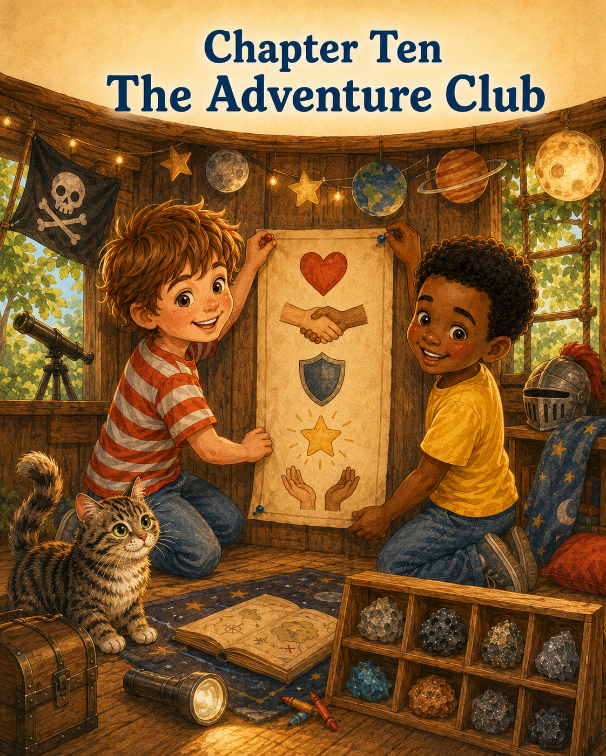
Chapter Ten: The Adventure Club
By Saturday morning, the treehouse looked like more than a treehouse.
Thomas stood beneath the old oak tree and stared up at it with a proud, thoughtful smile.
The little wooden house rested high in the branches, warm sunlight touching its roof and railing. The pirate flag hung near one window, patched with tape but still brave. Inside, the Moon Museum sat on the shelf with its carefully labeled stones. The treasure map was taped to the wall. The Knight Code hung beside the Stormy Sea Rescue Rules. The Jungle Lookout Field Notes were tucked into Thomas’s notebook, and the kindness cards waited in their wooden box.
The treehouse had been many things.
A pirate ship.
A kindness island.
A rocket ship.
A moon museum.
A jungle lookout.
A castle in the clouds.
A rescue boat after a storm.
A cozy campout under the evening sky.
But that morning, Thomas realized something important.
The treehouse was not special only because of what they pretended it to be.
It was special because of what happened inside it.
Leo came through the back gate carrying his backpack, a roll of paper, and a marker tucked behind one ear. He wore his yellow shirt and a grin that told Thomas he was ready for something big.
“What’s today’s adventure?” Leo asked.
Thomas looked up at the treehouse again.
“I’m not sure yet,” he said.
Leo blinked. “Not sure? You’re always sure.”
Thomas nodded slowly. “I know. But I was thinking.”
Leo stepped closer. “About pirates?”
“Sort of.”
“Rockets?”
“A little.”
“Dragons?”
“Maybe.”
Leo narrowed his eyes. “Snacks?”
Thomas smiled. “Always.”
Then he pointed up at the treehouse. “I think we need to make it official.”
Leo looked at the treehouse, then back at Thomas. “Official how?”
Thomas stood taller. “An adventure club.”
Leo’s face lit up. “A real club?”
“A real club,” Thomas said. “With members, rules, meetings, missions, and maybe snacks.”
Leo nodded quickly. “Definitely snacks.”
From the porch, Dad looked up from tying his shoes. “What kind of club?”
Thomas turned toward him. “The Treehouse Adventure Club.”
Dad smiled. “Sounds important.”
“It is,” Thomas said. “But first, we need to climb up and make the rules.”
Dad walked over and checked the ladder like he always did. He tested each rung, checked the railing, and looked around the base of the tree. Then he nodded.
“Ladder is safe. You know the rules.”
Thomas and Leo answered together.
“One at a time.”
“Climb slowly.”
“Use both hands.”
“No leaning too far.”
“Watch out for each other.”
Dad smiled. “Approved.”
Thomas climbed first, careful and steady. Leo followed, carrying only the rolled-up paper in one hand while keeping the other on the ladder. Dad sent the marker and a small tape roll up in the bucket.
Inside, the treehouse felt bright and familiar. Sunlight came through the windows. The wooden floor smelled faintly of pine, crayons, and yesterday’s pretzels. The walls were covered with signs from past adventures.
Thomas ran his fingers along the taped papers.
“Look at all of them,” he said.
Leo sat cross-legged on the floor. “We have a lot of rules.”
“We have a lot of lessons,” Thomas said.
That sounded better.
He pointed to the pirate promise. “We learned to share being captain.”
Leo nodded. “Because two captains are better when they listen.”
Thomas pointed to the kindness treasure rules. “We learned that helping is treasure.”
“And that Tia needs fresh water,” Leo added.
Thomas smiled. “That too.”
He pointed to the moon mission notes. “We learned that a good friend waits until everyone feels safe.”
Leo looked down at the ladder doorway. “That was a good lesson.”
“It was,” Thomas said.
Then he pointed to the Moon Museum. “We learned that discoveries are better when everyone gets to see them.”
Leo looked at Star Spark Stone. “Even rare ones.”
Thomas nodded. “Especially rare ones.”
They looked at the Jungle Lookout Field Notes next.
“We learned that adventures get bigger when someone new joins,” Thomas said.
Leo smiled. “Sophie has sharp explorer eyes.”
“And Mr. Bunbun is a rare jungle rabbit,” Thomas added.
They looked at the Knight Code.
“We learned that pretend play still has to be safe,” Leo said.
Thomas nodded. “And that brave hearts are gentle too.”
Finally, they looked at the Stormy Sea Rescue Rules and the campout notes.
“We learned that kindness is for birds and nests and yards,” Thomas said.
“And that blankets help when you miss home,” Leo added quietly.
Thomas looked at his friend. “Good friends help too.”
Leo smiled. “Yes, they do.”
For a moment, neither boy spoke.
The treehouse seemed to hold all their adventures quietly, as if the walls had been listening the whole time.
Then Thomas unrolled the paper across the floor.
At the top, in big letters, he wrote:
TREEHOUSE ADVENTURE CLUB
Leo leaned over his shoulder. “That looks official.”
Thomas handed him the marker. “You write the first rule.”
Leo’s eyes widened. “Me?”
Thomas nodded. “You’re a founding member.”
Leo looked very proud. He carefully wrote:
1. Be kind.
Thomas read it and nodded. “That is the best first rule.”
Leo handed the marker back.
Thomas wrote:
2. Share the adventure.
Leo pointed at the words. “Because no one wants to just stand there while someone else is captain forever.”
Thomas laughed. “Exactly.”
Then Leo wrote:
3. Stay safe.
He underlined it twice.
Thomas nodded. “Dad will like that one.”
Leo looked toward the window. “Mom too.”
Thomas wrote the next rule:
4. Use your imagination.
Leo smiled. “That is the fun rule.”
Thomas nodded. “Very important.”
Then they both thought for a moment.
“What should the last rule be?” Leo asked.
Thomas looked around the treehouse. He looked at the kindness cards, the Moon Museum, the rescue rules, and the blue blanket folded neatly in the corner from the campout.
Then he said, “Help when you can.”
Leo nodded slowly. “That belongs.”
Thomas wrote:
5. Help when you can.
They sat back and looked at the page.
TREEHOUSE ADVENTURE CLUB
1. Be kind.
2. Share the adventure.
3. Stay safe.
4. Use your imagination.
5. Help when you can.
Thomas felt something warm in his chest.
The rules were simple.
But they seemed to hold everything.
Pirates. Rockets. Dragons. Moon rocks. Bird nests. Campout blankets. Friends. Safety. Kindness. All of it.
Leo tapped the paper. “We need members.”
Thomas nodded. “We already have two.”
“And Sophie,” Leo said.
“And maybe Tia.”
Leo looked doubtful. “Tia does not follow rules.”
Thomas considered this. “Tia can be an honorary member.”
“That means she does not have to come to meetings?”
“Exactly.”
Leo nodded. “Honorary member.”
Just then, Sophie appeared at the fence, holding Mr. Bunbun by one floppy ear.
“What are you doing?” she called.
Thomas leaned safely near the window. “Starting the Treehouse Adventure Club!”
Sophie’s eyes widened. “Can I join?”
Thomas looked at Leo.
Leo smiled. “Rule two says share the adventure.”
Thomas called back, “Yes! Ask your mom, and Dad will help you climb.”
A few minutes later, Sophie crossed the yard with permission. Dad stood at the ladder while Thomas and Leo explained the club from above.
“You have to climb slowly,” Thomas said.
“And use both hands,” Leo added.
“And Mr. Bunbun has to ride in the bucket,” Thomas said.
Sophie looked concerned. “Will he be scared?”
Leo called down, “The bucket is very safe. It has transported snacks, blankets, and important space equipment.”
Sophie kissed Mr. Bunbun on the head and placed him gently in the bucket. Thomas and Leo pulled him up first. Then Sophie climbed carefully, one step at a time, with Dad nearby.
When she reached the top, Thomas helped her into the treehouse by making room, not by pulling. That was another thing he had learned: helping was sometimes about giving someone space.
Sophie sat on the floor and looked at the new sign.
“Treehouse Adventure Club,” she read slowly.
“You are our third member,” Thomas said.
Sophie smiled. “Is Mr. Bunbun fourth?”
Leo looked at Thomas.
Thomas looked at Mr. Bunbun.
“He can be a stuffed member,” Thomas said.
Sophie nodded. “He accepts.”
Thomas handed Sophie the marker. “You can add one thing to the club sign.”
Sophie looked surprised. “Anything?”
“One small thing,” Leo said. “Not a whole dragon.”
Sophie thought very carefully. Then she drew a small heart beside the words Be kind.
Thomas smiled. “Perfect.”
Leo drew a star beside Use your imagination.
Thomas drew a tiny turtle beside Help when you can.
The sign looked even better now.
Dad sent up a small snack basket with apple slices, crackers, and three napkins. Mom tucked in a folded note.
Thomas opened it and read aloud:
Dear Treehouse Adventure Club,
May your adventures be brave, kind, safe, and shared.
Love, Mom and Dad
Sophie smiled. “Your parents write good notes.”
Thomas nodded. “They do.”
Leo held up a cracker. “First official club snack?”
Thomas raised his apple slice. “To the Treehouse Adventure Club.”
Leo raised his cracker. “To adventure.”
Sophie raised her napkin because she had already eaten her apple slice. “To Mr. Bunbun.”
Thomas and Leo laughed.
After snack, they held their first official meeting.
Thomas opened his notebook and wrote:
Treehouse Adventure Club Meeting #1
“First order of business,” he said, “what should the club do?”
Leo raised his hand. “Go on adventures.”
Thomas wrote it down.
Sophie raised her hand. “Invite people.”
Thomas wrote that down too.
Leo raised his hand again. “Protect the Moon Museum.”
Thomas added it.
Sophie looked at Star Spark Stone. “And let visitors look with the magnifying glass.”
Leo hesitated for only one second. Then he nodded. “Yes. But carefully.”
Thomas wrote:
Museum visitors may look carefully.
Then Thomas added one more idea.
“Help when something needs helping.”
Leo nodded. “Like the nest.”
“Or Mom’s garden supplies,” Sophie said.
“Or when someone misses home,” Thomas added.
Leo looked at Thomas and smiled a small smile.
They kept writing.
The club could have reading days.
The club could have kindness missions.
The club could have nature lookout days.
The club could have safe pretend adventures.
The club could make maps.
The club could clean up the yard.
The club could help someone who felt left out.
The club could share snacks, but not with ants.
“Very important,” Leo said.
Thomas underlined it.
When the meeting was over, Thomas taped the official club rules to the center of the wall, where everyone could see them. The sign looked right there. It belonged above the pirate map, beside the Knight Code, near the kindness cards, and across from the Moon Museum.
The treehouse felt complete.
Not finished, exactly.
Thomas hoped it would never be finished.
But complete in a new way.
Like it finally knew what it was.
Later, they climbed down carefully and held the second part of their club meeting under the oak tree, because Tia had wandered over and refused to climb up.
“As honorary member,” Thomas said, “Tia should hear the rules.”
Leo stood in front of the cat and read from the sign.
“Be kind.”
Tia blinked.
“Share the adventure.”
Tia licked one paw.
“Stay safe.”
Tia yawned.
“Use your imagination.”
Tia looked toward the bushes.
“Help when you can.”
Tia stood, walked three steps, and sat directly on Thomas’s notebook.
Sophie giggled. “She is helping keep the notebook from blowing away.”
Thomas looked at Tia. “That counts.”
Leo nodded. “Honorary members have their own methods.”
The afternoon passed in the best possible way.
They played pirate ship for a little while, but this time Sophie got to be captain first. She led them to Sandy Shell Island, where they discovered a buried acorn that Leo said belonged to a squirrel king.
Then they played rocket ship, but before blastoff, Thomas asked, “Does everyone feel safe?”
Leo said yes.
Sophie said yes.
Mr. Bunbun said nothing, which Sophie said meant yes.
Then they counted down together.
They visited the Moon Museum, where Leo proudly explained Star Spark Stone again. He let Sophie hold the magnifying glass and even let Thomas move the rock slightly so the sunlight caught the sparkle.
They became jungle explorers and spotted three birds, one butterfly, and Tia disappearing under the porch like a tiny striped tiger.
They became knights of Oak Castle and helped an imaginary dragon find a dry cave.
Every adventure felt familiar, but different.
Because now they had a club.
And because everyone had a place in it.
As the sun began to lower, Mom called Sophie home. Dad helped her down the ladder, and Thomas handed Mr. Bunbun down in the bucket.
Sophie hugged her rabbit and looked up at the treehouse.
“Can the club meet again tomorrow?” she asked.
Thomas looked at Leo.
Leo grinned. “The club has many missions.”
Thomas nodded. “Tomorrow works.”
Sophie ran home happy.
Leo stayed a little longer. He and Thomas sat beneath the oak tree with Tia nearby and the evening light glowing through the branches.
Leo looked up at the treehouse. “Do you remember the first day?”
Thomas nodded. “When Dad finished building it?”
“You said it was our official adventure headquarters.”
Thomas smiled. “It still is.”
Leo was quiet for a moment. “It’s more than that now.”
Thomas looked up.
The treehouse was golden in the sunset. The little windows glowed softly. The pirate flag moved in the breeze. Inside, all their signs and treasures waited.
“What is it?” Thomas asked.
Leo thought carefully. “It’s where we learned stuff.”
Thomas nodded slowly.
Leo continued. “Like how to share. And wait. And not swing swords near people.”
“That was important,” Thomas said.
“And how to help nests,” Leo added.
“And how to let someone else join,” Thomas said.
“And how snacks taste better up there,” Leo said.
Thomas laughed. “That might be the biggest lesson.”
They sat quietly for a while.
Then Thomas opened his notebook one last time for the day. He turned to a clean page and wrote:
What I Learned from the Treehouse
Leo leaned close but did not interrupt.
Thomas wrote:
The treehouse is not just wood, nails, windows, and a ladder. It is a place where adventures begin. It is a place to imagine, share, help, listen, and stay safe. It is a place where friends can be pirates, astronauts, explorers, knights, rescuers, and campers. But the best part is not pretending to go far away. The best part is having people beside you.
He paused.
Then he added:
The best adventures are not the ones you take alone. They are the ones you share.
Leo read the words quietly.
“That should be in the club rules too,” he said.
Thomas nodded.
He tore out the page carefully, climbed up one more time with Dad watching, and taped it below the official Treehouse Adventure Club sign.
Then he climbed back down.
The treehouse wall was full now, but not too full.
There was still room.
Room for more maps.
More notes.
More discoveries.
More lessons.
More friends.
As the evening settled over the backyard, Thomas stood beside Leo, Mom, Dad, and Tia under the oak tree.
The treehouse waited above them, steady and safe.
Tomorrow, it might become a submarine. Or a mountain cabin. Or a jungle research station. Or a secret library. Or a spaceship heading past the stars.
Thomas did not know yet.
That was the wonderful thing.
There would always be another adventure.
But now he understood something he had not known on the first day.
A treehouse could lift you high into the branches.
Imagination could take you even higher.
But friendship was what made the adventure worth remembering.

Epilogue
The treehouse did not stop being magical after the Adventure Club began.
In fact, it seemed to grow more magical with every visit.
Some days, it was a pirate ship again, sailing bravely across the grass. Other days, it became a rocket ship, a jungle tower, a castle, a museum, or a quiet reading nook tucked inside the leaves. Thomas never knew exactly what it would become until he climbed the ladder, stepped onto the wooden floor, and let his imagination take the first step.
But now, something was different.
Before every adventure, Thomas, Leo, and Sophie looked at the rules on the wall.
Be kind.
Share the adventure.
Stay safe.
Use your imagination.
Help when you can.
They did not read them because they had to. They read them because the rules reminded them what made the treehouse special. It was not the wood or the roof or the rope bucket. It was not the pirate flag, the moon rocks, the blankets, or even the secret feeling of being up high among the branches.
It was the way everyone belonged.
Leo still brought the pirate emergency rock, just in case. Sophie brought Mr. Bunbun to nearly every meeting. Tia the cat remained an honorary member, though she never once attended a full meeting and often walked away during important announcements. Thomas kept the notebook on the shelf, ready for new maps, new discoveries, new club rules, and new lessons.
One evening, Thomas climbed into the treehouse just as the sun was beginning to set. Leo was beside him, and Sophie was sitting near the window with Mr. Bunbun in her lap. The sky was painted gold and pink, and the old oak tree swayed gently around them.
For a while, no one said anything.
They simply listened.
To the leaves.
To the birds.
To Tia rustling somewhere in the grass below.
To the quiet creak of the treehouse settling safely in the branches.
Thomas looked around at all the signs taped to the walls. Each one told a story. Each one reminded him of something they had learned together.
Pirates could share.
Explorers could wait.
Knights could be gentle.
Friends could help each other feel safe.
Kindness could be found in small things.
And adventures were always better when there was room for someone else.
Thomas smiled.
“What are you thinking?” Leo asked.
Thomas looked out the window at the backyard below. It was the same yard it had always been—the same grass, the same fence, the same flowerpots, the same old oak tree.
But now he knew better.
It was also an ocean, a kingdom, a moon, a jungle, a harbor, and a place where friendship could grow.
“I’m thinking,” Thomas said, “that we still have a lot of adventures left.”
Sophie hugged Mr. Bunbun. “What kind?”
Thomas looked at Leo.
Leo grinned.
“All kinds,” Thomas said.
And high above the backyard, in the little treehouse in the sky, the Adventure Club sat together beneath the warm evening light, ready for whatever tomorrow might become.

About the Author
www.scottMbooks.com

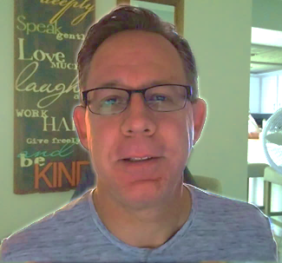
Scott Speicher brings a unique blend of life experiences to his writing. A U.S. military veteran, he carries the discipline, resilience, and perspective gained through service into every story he tells. After his military career, Scott built a successful path in marketing, where he developed a deep understanding of communication, storytelling, and audience engagement. For more than 15 years, he has also worked as a professional website designer, helping businesses and individuals create meaningful online presences.
Scott Speicher is a storyteller who enjoys creating gentle, heartfelt stories that help children notice the small moments that make life meaningful. Through warm characters and simple adventures, his books encourage young readers to slow down, care for others, and appreciate the quiet joys of everyday life. Scott believes that some of the most important lessons children learn come not from grand events, but from the ordinary moments shared with family, friends, and the animals they love.
Thomas Loves His Treehouse is a warm children’s story about imagination, friendship, kindness, sharing, and safe adventure. When Thomas’s dad finishes building a cozy treehouse in the backyard, Thomas and his best friend Leo discover that it is much more than a place to play. With a little imagination, the treehouse becomes a pirate ship, a rocket ship, a jungle lookout, a castle in the clouds, a moon museum, and a special clubhouse where every adventure teaches them something new.
As Thomas and Leo explore each make-believe world, they learn important lessons about taking turns, helping others, caring for small creatures, welcoming new friends, and making sure everyone feels safe. By the end of the story, Thomas realizes that the best adventures are not the ones you take alone, but the ones you share with friends.
Suitable for readers aged 4-10 and for family read-aloud sessions. Ideal for SEL, guidance, and service-learning.
