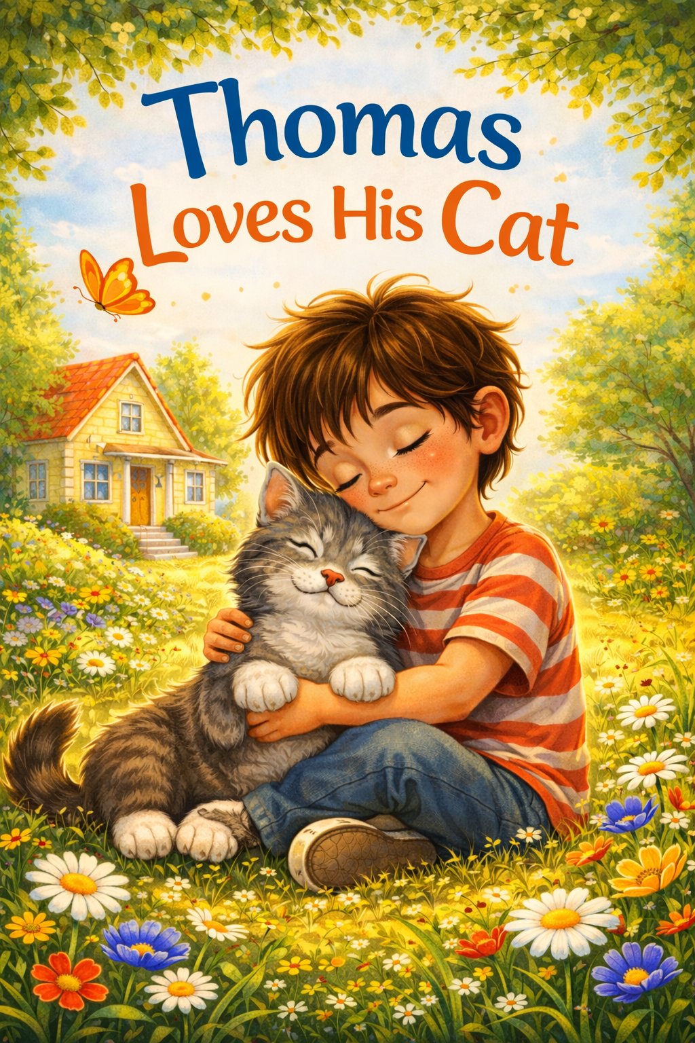

Thomas Loves His Cat

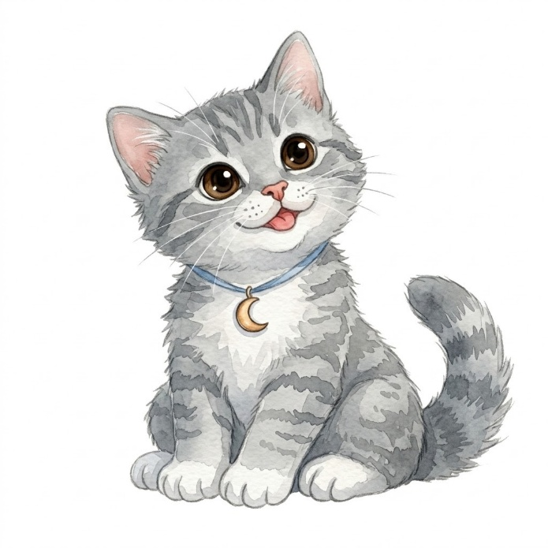

Copyright © 2026
Author: Scott M. Speicher
Portions of this book have been optimized by the program Grammarly.
Edited by Grammarly and the Editorial team of Digital Scribblers
No part of this book may be reproduced or used in any form or by any means, electronic or mechanical, without written permission from the author.
Some of the images are AI-generated via prompting and with full control by the author.

This book is dedicated to my childhood
friend Ben, who left us all too early

About The Book

Friendship often begins in the quietest ways—not with a shout, but with the soft patter of paws and a curious twitch of whiskers. In Thomas Loves His Cat, we follow a six-year-old boy named Thomas as he welcomes a tiny gray kitten named Whiskers into his home and his heart. Designed for young readers from preschool through early elementary school, this story explores the deep emotional connection and "backyard adventures" that form between a child and their first pet.
+4Author Scott M. Speicher draws from the belief that the most significant lessons in life are learned through ordinary moments shared with those we love. Whether it is the patience required to win over a shy kitten, the empathy felt when a friend is scared, or the simple comfort of a purr on a rainy afternoon, these experiences help children build a foundation of kindness and respect for all living things.
Through ten gentle chapters, readers will discover that love does not always require grand gestures. Instead, it is found in the softest, everyday moments: a shared window seat, a brave "mew" from under the refrigerator, or the steady warmth of a small protector watching over you in the middle of the night.
This book is a celebration of quiet companionship and the "rumbly" joy of a best friend’s purr. It is an invitation for parents, educators, and children alike to slow down, notice the small joys, and cherish the bonds that remind us we are never truly alone. Dedicated to the memory of a dear childhood friend, this story serves as a reminder that while we grow and the years pass, the lessons of kindness and trust remain forever.
Happy reading!

Thomas Loves His Cat

Table of Contents
Sometimes the most important friendships in our lives arrive quietly—on soft paws, with curious whiskers and gentle purrs. Thomas Loves His Cat is a story about the small, everyday adventures that happen when a boy and his cat share the world. From backyard discoveries to quiet moments at bedtime, Thomas and Whiskers remind us that friendship doesn’t have to be loud or grand to be meaningful. It can be found in laughter, patience, comfort on difficult days, and the simple joy of being together. This book celebrates the special bond between children and the animals who become their companions, teachers, and best friends.

- The Day Whiskers Came Home
- A Tiny Meow in the Kitchen
- Thomas and the Midnight Pouncer
- The Great Yarn Ball Chase
- Rainy Day Snuggles on the Couch
- Whiskers vs. the Wiggly Red Dot
- The Backyard Butterfly Adventure
- Hide-and-Seek with a Flicking Tail
- When Thomas Felt Blue
- Best Friends at Bedtime

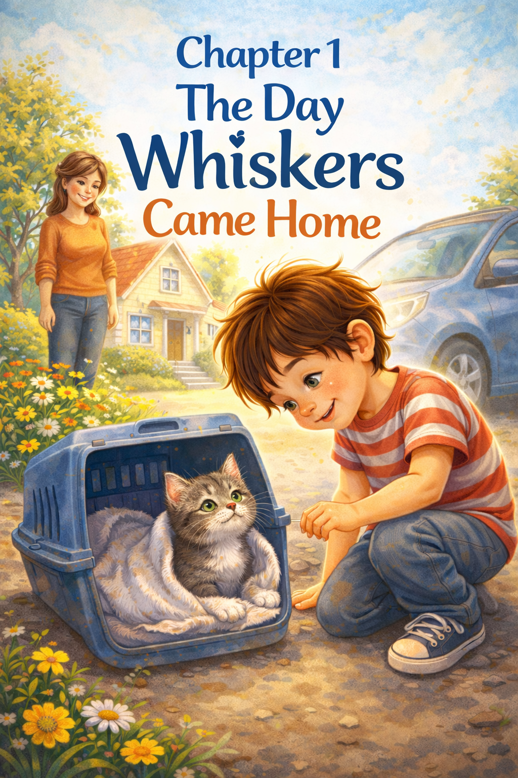
Chapter One

The Day Whiskers Came Home
Thomas had been waiting for this day for what felt like forever.
He stood by the front window, his nose almost touching the glass, watching the driveway. Every time a car drove past, his heart jumped.
“Not yet,” Mom said with a smile. “Be patient.”
But patience was hard when you were six years old and about to meet your very own cat.
At last,
“Shoes first!” Mom reminded him gently.
Thomas shoved his feet into his sneakers so fast he almost put them on the wrong feet. Then he hurried outside, bouncing on his toes.
A small blue car pulled into the driveway. Thomas gasped.
Inside the blue car was a little gray kitten with bright green eyes and the tiniest pink nose Thomas had ever seen. The kitten was tucked inside a soft blanket, peeking out with curious eyes.
“That’s him,” Mom said softly. “This is your kitten.”
Thomas knelt slowly. His excitement felt big and wiggly inside his chest, but he remembered what Mom had told him.
“Move gently. Speak softly.”
“Hi,” Thomas whispered. “I’m Thomas.”
The kitten blinked. Then—very quietly—he said, “Mew.”
Thomas’s smile stretched from ear to ear.
“I have a red ball you can chase. And a soft bed. And I’ll share my window seat with you.”
The kitten shifted in the blanket and stuck one tiny paw out toward Thomas.
Thomas carried the carrier inside as carefully as if he were holding a treasure chest. Mom opened the door, and the kitten stepped out onto the living room rug.
He froze. His ears twitched. His whiskers quivered.
Then he took one small step.
And another.
Thomas sat cross-legged on the floor, trying very hard not to bounce. The kitten waddled over and sniffed Thomas’s shoelace. Suddenly—pounce!
Thomas giggled. The kitten tumbled sideways, surprised by his own bravery.
“I think he likes you,” Mom said. Thomas thought so too.
After exploring under the couch, behind the curtains, and even inside Thomas’s empty backpack, the kitten finally curled up in Thomas’s lap. He was warm and soft and lighter than Thomas had imagined.
Thomas stroked the kitten’s silky fur. “You need a name,” he said thoughtfully.
The kitten blinked up at him, whiskers twitching again.
“That’s it!” Thomas exclaimed. “Whiskers! Because you have the best whiskers in the entire world.”
As if he agreed, Whiskers began to purr. It was a tiny, rumbly sound, like a little engine starting up.
Thomas had never heard anything so wonderful.
That night, Whiskers slept in a cozy bed beside Thomas’s own. But sometime after the lights went out, Thomas felt something warm hop gently onto his blanket.
Two green eyes blinked in the dark.
Thomas lifted the covers just a little. “You can stay,” he whispered.
Whiskers circled twice and curled up close.
Thomas smiled into the darkness. He knew something important had happened that day.
He didn’t just get a cat.
He has got a best friend.
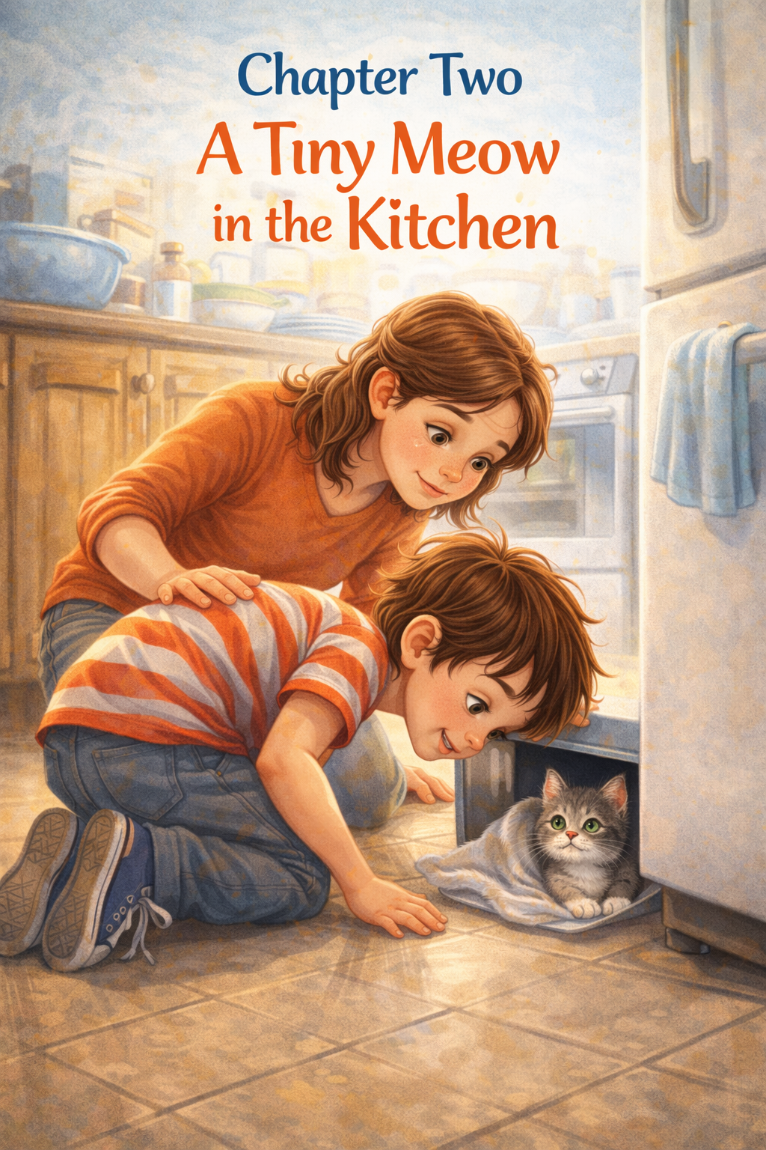

Chapter Two
A Tiny Meow in the Kitchen
The next day, the house was very quiet.
Too quiet.
Thomas sat at the kitchen table, swinging his legs while Mom stirred pancake batter in a big blue bowl. Usually, mornings were full of clinking spoons and humming and the soft patter of little paws following him everywhere.
But this morning?
No paws.
No swishing tails.
No whiskers brushing against his ankles.
Thomas frowned. “Mom… have you seen Whiskers?”
Mom flipped a pancake. “He was right behind you a minute ago.”
Thomas slid off his chair and peeked under the table.
“Whiskers?” he called softly.
Nothing.
He checked the living room. Under the couch. Behind the curtains. Even inside his backpack—just in case.
Still nothing.
Thomas’s chest felt tight. Whiskers was small. What if he got stuck somewhere? What if he was scared?
Then—
“Meeeeeew.”
It was faint. Tiny. Almost like a squeak.
Thomas froze.
“Mom!” he whispered loudly. “Did you hear that?”
Mom turned off the stove. “I did.”
They both stood very still.
“Mew.”
This time it was clearer.
“It’s coming from the kitchen,” Thomas said.
They walked slowly around the room. Thomas looked at the cabinets. The pantry. The space behind the trash can.
“Mew!”
Thomas dropped to his hands and knees.
The sound was coming from under the refrigerator.
Thomas’s eyes widened. “Oh no.”
He pressed his cheek to the cool tile floor and peeked underneath. In the shadows, two bright green eyes blinked back at him.
“Whiskers!” Thomas said, relieved, rushing through him so fast it made him dizzy.
Whiskers let out another tiny meow. He had chased something, maybe a dust bunny, and slid just a little too far underneath.
Mom knelt beside Thomas. “Let’s not scare him,” she said gently.
Thomas nodded. His heart was pounding, but he remembered what he had learned on the very first day.
Move gently. Speak softly.
“It’s okay, buddy,” Thomas whispered. “You’re not in trouble.”
Whiskers stretched one paw forward, but the space was tight.
Mom carefully pulled the refrigerator forward just enough to make room. Thomas reached slowly, sliding his hands under Whiskers’ soft belly.
The kitten was warm and wiggly and very ready to be rescued.
Thomas lifted him out and hugged him close—but not too tight.
Whiskers immediately buried his nose into Thomas’s shirt and began to purr. It was louder than usual, like a tiny motor that had just been fixed.
Thomas laughed, though his eyes felt a little watery.
“You scared me,” he said softly.
Whiskers looked up at him as if to say, I didn’t mean to.
Mom smiled. “Kittens are curious,” she said. “They like to explore.”
Thomas nodded. He understood. He liked exploring too.
He carried Whiskers to the table and sat back down. This time, Whiskers stayed curled in his lap while Thomas ate his pancakes.
Now and then, Thomas felt the steady rumble of purring against his legs.
After breakfast, Thomas made a new rule.
“No more exploring under the refrigerator,” he told Whiskers seriously.
Whiskers blinked.
Thomas grinned. “Okay. Maybe a little exploring. But I’m coming with you.”
And from that day on, whenever Thomas heard a tiny meow in the kitchen, he didn’t panic.
He listened.
Because sometimes, a small sound just meant someone tiny needed a little help—and someone who loved him very much was ready to answer.

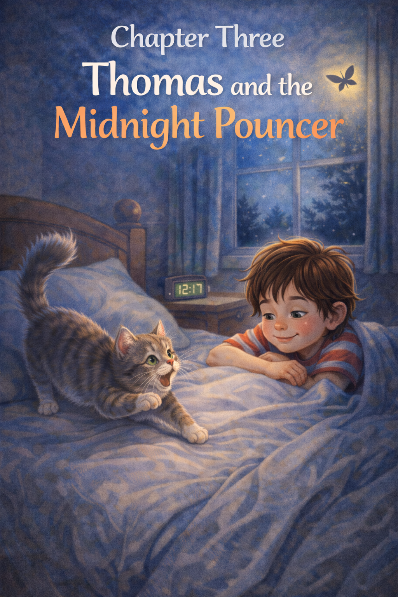
Chapter Three
Thomas and the Midnight Pouncer
Thomas was fast asleep when it happened.
The house was dark and quiet. The clock on his dresser glowed 12:17 in soft green numbers. Outside, the wind brushed gently against the window.
Inside, everything was still.
Until—
THUMP.
Thomas’s eyes flew open.
He lay very still, listening.
Scratch.
Rustle.
Tiny running footsteps.
Thomas pushed himself up on his elbows. “Whiskers?” he whispered into the dark.
Two bright green eyes flashed near the bedroom door.
Before Thomas could say another word—
Pounce!
A small gray blur launched onto the bed and landed right on Thomas’s blanket.
“Oof!” Thomas gasped.
Whiskers bounced once, then twice, then spun in a wild little circle. His tail puffed up like a feather duster. His eyes were wide and shining.
Thomas blinked. “What are you doing?”
Whiskers crouched low.
Wiggle. Wiggle.
Then—leap!
He attacked something invisible near Thomas’s pillow.
Thomas squinted.
At first, he didn’t see it. Then he noticed a tiny shadow flickering across the wall.
A moth.
It fluttered near the ceiling light, casting wiggly shapes around the room.
Whiskers saw it too.
The Midnight Pouncer had found his mission.
Thomas tried not to laugh. Whiskers never looked so serious. He crept across the blanket, belly low, paws stepping slowly.
Wiggle. Wiggle.
Leap!
He missed.
The moth fluttered higher. Whiskers skidded sideways and nearly tumbled off the bed.
“Careful,” Thomas whispered, reaching out just in time to steady him.
Whiskers regrouped. His ears tilted forward. His whiskers twitched.
Thomas pulled the blanket up to his chin and watched.
Leap!
Miss.
Leap!
Miss again.
Finally, the moth drifted toward the window and disappeared through a tiny crack near the screen.
The room went quiet.
Whiskers stood frozen on the bed, staring at the empty wall.
Thomas waited.
Slowly, Whiskers turned around and looked at him.
Thomas burst into soft giggles; he tried very hard to hold in.
“You almost had it,” he said kindly.
Whiskers walked back across the bed and flopped right onto Thomas’s chest, as if the whole adventure had been extremely exhausting.
His little heart was beating fast.
Thomas rested his hand gently on Whiskers’ back.
“You’re very brave,” he whispered. “Even if you didn’t catch it.”
Whiskers began to purr. Not the quiet daytime purr. This one was deeper. Proud.
After a moment, he kneaded the blanket twice, circled once, and curled up right under Thomas’s chin.
Thomas yawned.
The clock is now 12:29.
“That was exciting,” Thomas murmured.
Whiskers gave one last sleepy stretch and tucked his nose under his paw.
The Midnight Pouncer was off duty.
Thomas closed his eyes again, feeling the steady warmth and soft rumble against him.
And as he drifted back to sleep, he thought something very important:
Even in the middle of the night, it was nice knowing someone small and brave was always on watch.

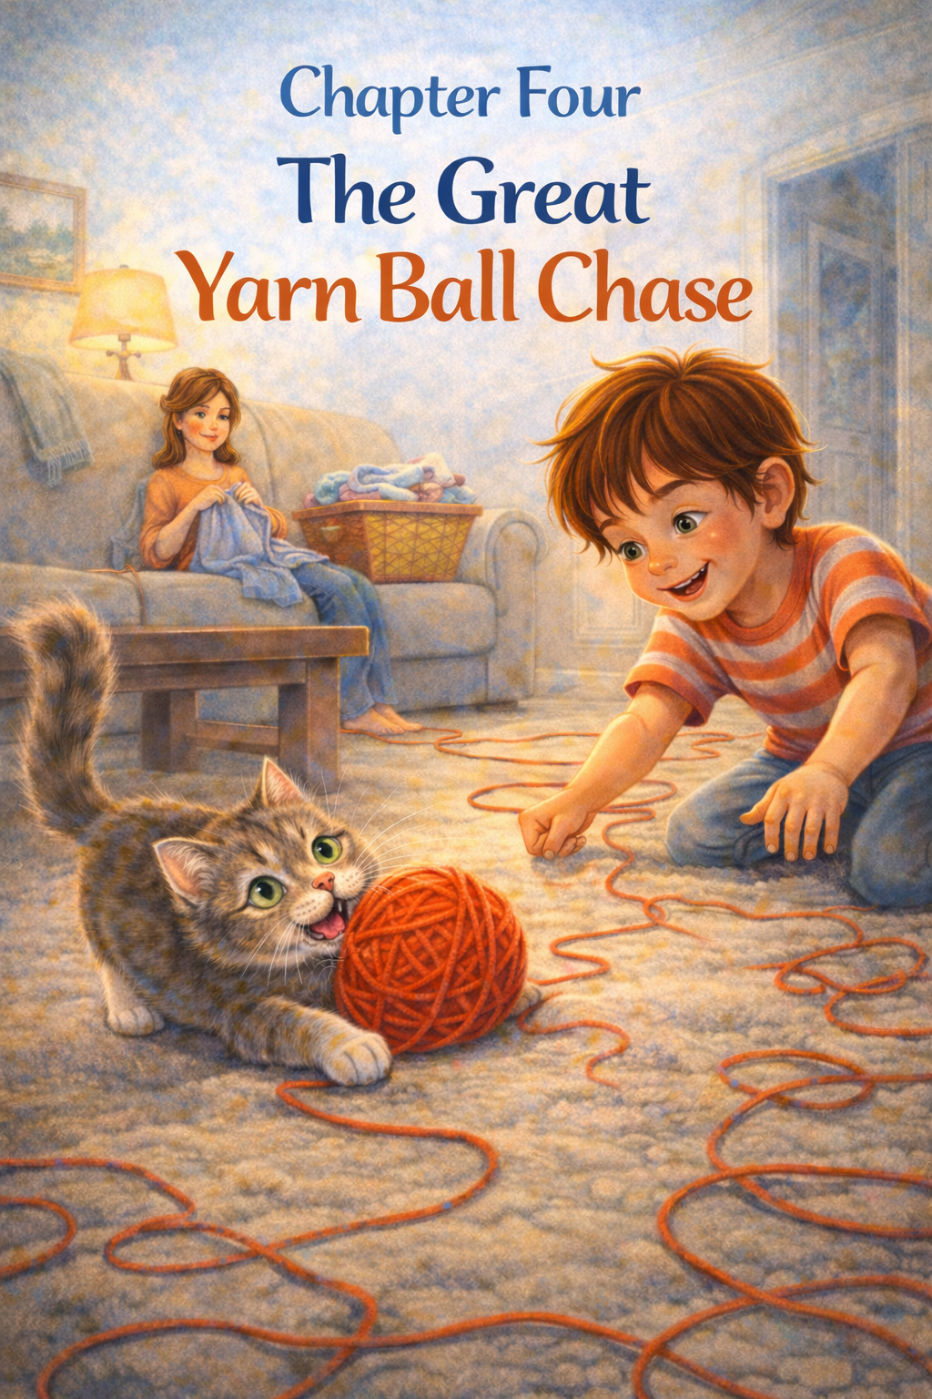

Chapter Four
The Great Yarn Ball Chase
It started with one little roll.
Thomas was sitting on the living room floor while Mom folded laundry on the couch. A basket of socks sat between them, and beside it was something new.
A bright red ball of yarn.
Thomas reached for it carefully. “What’s this for?”
“I’m fixing Grandpa’s scarf,” Mom said. “Please don’t unwind it.”
Thomas nodded very seriously.
Whiskers, however, had other plans.
From across the room, two green eyes locked onto the yarn.
Stillness.
Focus.
Tail twitch.
Thomas saw it happen in slow motion.
Whiskers crept forward, belly low, paws soft against the rug.
“Whiskers,” Thomas warned gently.
Too late.
Pounce!
The yarn ball popped out of Thomas’s hand and rolled across the floor as if it had suddenly come alive.
Whiskers bolted after it.
The ball bounced off the coffee table leg and changed direction.
Whiskers skidded, scrambled, and chased.
The yarn began to unravel behind one long red trail stretching across the living room like a wiggly crayon line.
“Uh oh,” Thomas breathed.
The ball rolled under a chair.
Whiskers dove after it.
The chair wobbled.
Thomas crawled quickly across the floor, trying to grab the loose yarn before it tangled around everything.
But the yarn had other ideas.
It looped around a table leg.
It wrapped around Thomas’s wrist.
It trailed straight into the hallway.
“Mom?” Thomas called, trying not to laugh.
Mom peeked over the couch—and froze.
For a moment, no one moved.
Then Whiskers burst out from under the chair with the yarn ball between his paws, looking wildly proud.
The red string was everywhere.
It zigzagged across the rug. It stretched toward the hallway. One end was still tied to the knitting needles on the couch.
Thomas couldn’t help it.
He laughed.
Whiskers pounced again, rolling onto his back and kicking the yarn with his back feet. The ball slipped free and rolled toward the kitchen.
“Not the kitchen!” Thomas shouted, scrambling after him.
The chase continued past the doorway, around the table, and back into the living room.
Finally, the yarn ball slowed.
Whiskers tackled it one last time and flopped on top of it, breathing fast, eyes bright with victory.
Silence filled the room.
Thomas looked around.
Red yarn. Everywhere.
Mom sighed—but there was a smile hiding at the corners of her mouth.
“Well,” she said calmly, “that was… energetic.”
Thomas crawled over and gently untangled a loop from around Whiskers’ paw.
“You are very good at chasing,” he told him.
Whiskers blinked as if to say, I know.
Together, Thomas and Mom began winding the yarn back into a ball. It wasn’t as neat as before. It now had little bumps and loose spots.
But somehow, that made it better.
When they finished, Thomas held the yarn up high.
“This time,” he said wisely, “we put it somewhere safe.”
Mom placed it on the highest shelf.
Whiskers sat below, staring up at it like it was a treasure on a mountain.
Thomas reached down and scratched behind Whiskers’ ears.
“You may have won the chase,” he said softly.
Whiskers purred.
“But the yarn,” Thomas added with a grin, “is winning the rematch.”
Whiskers’ tail flicked.
Thomas had a feeling the Great Yarn Ball Chase was not completely over.
Not even close.

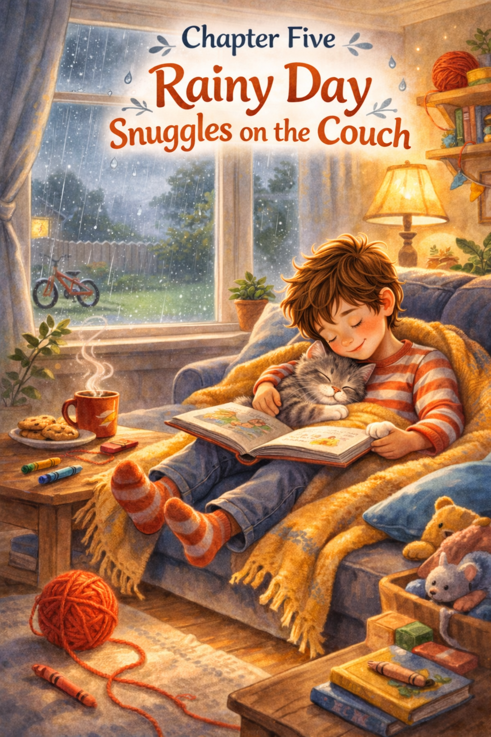

Chapter Five

Rainy Day Snuggles on the Couch
The rain started before breakfast.
Soft at first.
Tap… tap… tap…
By lunchtime, it was steady and gray outside the windows. The backyard looked blurry, like someone had smudged the world with a wet paintbrush.
Thomas pressed his forehead against the glass.
“I wanted to ride my bike today,” he said quietly.
The sky answered with louder patter against the roof.
Whiskers sat beside him on the windowsill; his tail wrapped neatly around his paws. He watched the rain with serious green eyes, as if trying to decide whether it was something he could chase.
A drop slid down the window.
Whiskers followed it with his head.
Another drop raced it.
Whiskers lifted one paw and tapped the glass.
Thomas smiled a little.
“Can’t catch that one,” he said.
The house felt smaller on rainy days. Quieter. Even the clock ticking in the hallway sounded louder.
Thomas wandered to the couch and flopped down with a sigh. “There’s nothing to do,” he mumbled.
Whiskers jumped up beside him.
Not pouncing.
Not chasing.
Just jumping.
He circled once. Twice. Then he settled against Thomas’s side like he had been planning it all along.
Thomas felt the warmth first.
Then the steady rumble of a purr.
He leaned back into the cushions. The couch was soft. The rain kept tapping against the windows. Somewhere in the kitchen, the dishwasher hummed.
Whiskers stretched one paw across Thomas’s arm.
It was a small thing.
But it didn’t feel small.
Thomas reached for the blanket draped over the back of the couch and pulled it over both of them. Whiskers didn’t move away. He tucked his nose under his paw and pressed closer instead.
The rain grew heavier.
The world outside looked far away now.
Thomas picked up his favorite book from the coffee table and opened it carefully. He read aloud in a quiet voice, just above a whisper.
Whiskers’ ears twitched at the sound of Thomas’s voice. His purr grew slower. Softer.
By the third page, Thomas’s own voice began to feel sleepy.
He paused and looked down.
Whiskers was completely still, eyes closed, breathing slowly and even.
Thomas smiled.
He rested his cheek gently on top of Whiskers’ soft fur. It smelled faintly like sunshine from yesterday and something warm and familiar that he couldn’t quite name.
The rain kept falling.
But it didn’t feel gloomy anymore.
It felt cozy.
Thomas closed his book without marking the page. He would remember where he left off.
He wrapped one arm loosely around Whiskers—not tight, just enough to feel the steady rise and fall of his tiny chest.
“Rain’s not so bad,” Thomas whispered.
Whiskers didn’t answer.
He just kept purring.
And for a long while, the only sounds in the house were rain on the roof, the soft hum of the dishwasher, and the quiet, comforting rhythm of two friends sharing a gray afternoon.

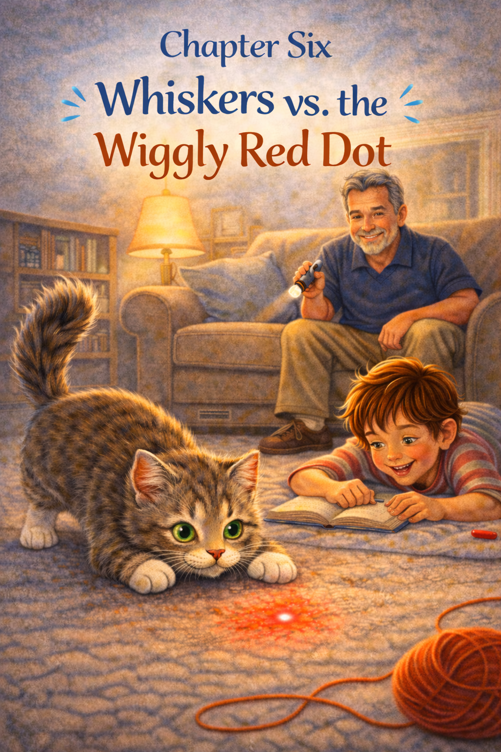

Chapter Six
Whiskers vs. the Wiggly Red Dot
It began after dinner.
Thomas was lying on his stomach in the living room, reading his favorite book. Whiskers was nearby, washing one paw very carefully, as if he had important grooming business to finish.
Dad walked in holding something small and silver.
“What’s that?” Thomas asked.
“A little flashlight,” Dad said with a grin. “But watch this.”
A tiny red dot appeared on the floor.
It was bright. Perfectly round. And completely still.
Whiskers froze mid-lick.
His head tilted.
The red dot wiggled.
Whiskers’ ears snapped forward.
The dot slid across the rug.
Whiskers dropped into a crouch so fast it looked like someone had gently folded him in half.
Wiggle. Wiggle.
Pounce!
The red dot disappeared.
Whiskers landed exactly where they had been and blinked at the empty carpet.
The dot reappeared behind him.
Thomas gasped. “Behind you!”
Whiskers spun around so quickly he almost tripped over his own tail.
The dot zipped toward the couch.
Whiskers bolted after it.
It darted left.
He skidded left.
It bounced off the wall.
Whiskers stared up in disbelief.
“Can he climb the wall?” Thomas whispered.
“Not quite,” Dad said, trying extremely hard not to laugh.
The dot slipped back down to the floor and scooted toward the hallway.
Whiskers chased with full determination.
He slid across the kitchen tile.
He leaped over a shoe.
He nearly bumped into the trash can.
The red dot stopped suddenly.
Whiskers crept closer, paw lifted carefully.
Slowly… slowly…
Tap!
The dot vanished again.
Whiskers looked up at Thomas, confused.
Thomas couldn’t stop giggling. “It’s tricky!”
The red dot appeared on Thomas’s shirt.
Whiskers stared at it.
Thomas stared back at Whiskers.
“Uh oh,” Thomas whispered.
Leap!
Whiskers landed squarely on Thomas’s chest. Not hard—but enthusiastic.
Thomas burst into laughter, falling onto his back as Whiskers searched for the disappearing dot.
“It’s magic!” Thomas declared.
The red dot danced one more time across the rug before Dad clicked the flashlight off.
Just like that—it was gone.
Whiskers stood very still in the middle of the room.
He checked the rug.
He checked the wall.
He even peeked under the coffee table.
Nothing.
Thomas sat up and scooped Whiskers gently into his lap.
“You almost had it,” he said kindly.
Whiskers panted a little, then began to purr, as if he had just completed a particularly important mission.
Dad smiled. “I think we’ve discovered his new favorite game.”
Whiskers’ tail flicked.
Thomas scratched behind his ears. “Tomorrow,” he whispered, “you’ll win.”
Whiskers blinked slowly, confidently.
Somewhere out there, the Wiggly Red Dot was waiting.
And so was the bravest little hunter in the living room.

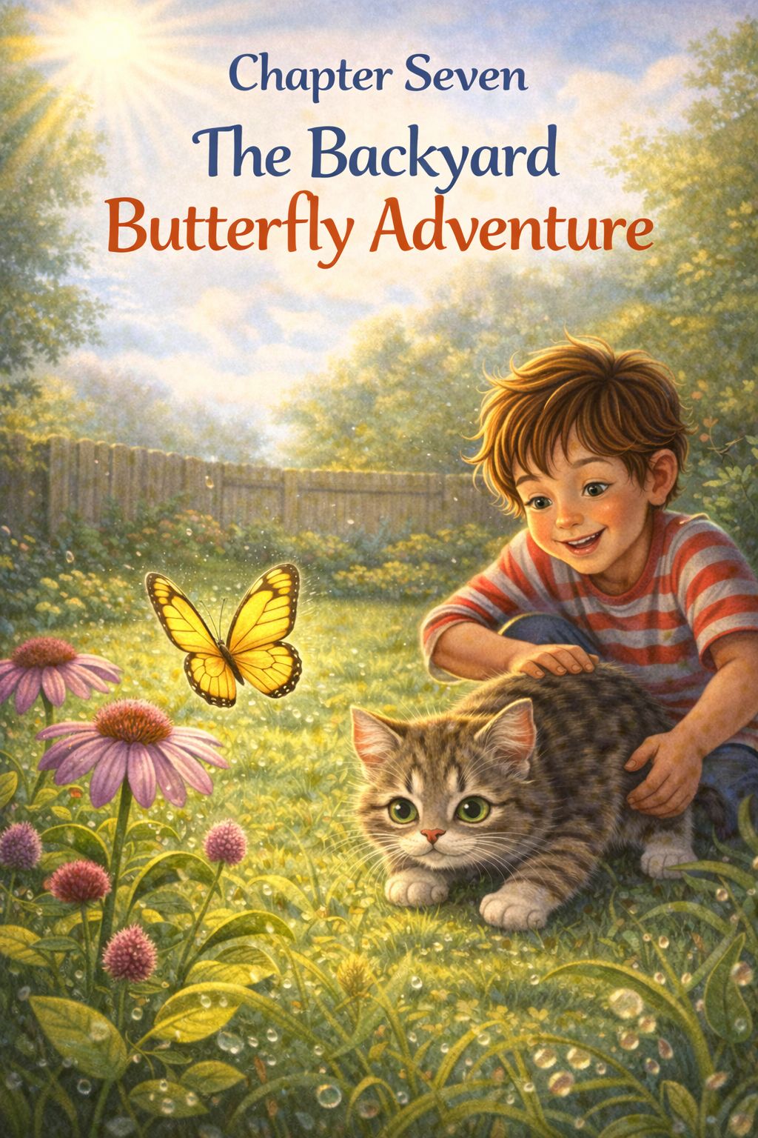

Chapter Seven

The Backyard Butterfly Adventure
The sun came back the next morning.
After days of rain, the backyard looked brand new. Drops of water clung to the grass like tiny diamonds. The air smelled fresh and green.
Thomas pushed open the back door. “You can come out,” he told Whiskers carefully. “But you stay close.”
Whiskers stepped onto the porch like a tiny explorer arriving in a new land.
Pause.
Sniff.
Tail up.
Thomas walked beside him, slowly. The grass brushed against Whiskers’ belly, and he lifted his paws higher with each step, as if the ground were tickling him.
A bird chirped from the fence.
Whiskers froze.
Thomas froze, too.
The bird fluttered away in a blur of wings.
Whiskers looked slightly offended.
“It’s okay,” Thomas said. “There’s plenty to see.”
And then—
A flash of yellow drifted across the yard.
Soft. Light. Floating.
Whiskers’ eyes locked on it instantly.
A butterfly.
It dipped toward a flower, then lifted again, moving in gentle zigzags through the air.
Whiskers crouched low.
Wiggle. Wiggle.
Thomas recognized that wiggle.
“Careful,” he whispered.
The butterfly fluttered closer.
Whiskers leapt.
Miss.
He landed in a patch of clover and blinked in surprise. The butterfly drifted upward, completely unbothered.
Thomas laughed softly. “It flies, remember?”
Whiskers regrouped. This time, he moved more slowly, stepping carefully through the grass. The butterfly dipped again, brushing near a purple flower.
Wiggle.
Leap!
Miss again.
But closer.
The butterfly floated higher, glowing in the sunshine.
Whiskers stood on his back legs for half a second, stretching as tall as he could, one paw reaching into the air.
It was almost beautiful.
Thomas felt something different then. Not laughter this time. Something quieter.
“Maybe we just watch,” he said gently.
Whiskers lowered himself back into the grass. His tail swished once. Twice.
The butterfly landed on a nearby flower, wings opening and closing slowly.
Whiskers crept closer—but this time, he didn’t jump.
He simply sat.
Thomas sat too, right beside him.
For a moment, it was just the three of them—the boy, the cat, and the butterfly—resting in the warm backyard sunshine.
The butterfly lifted off again, drifting toward the fence and disappearing into the trees beyond.
Whiskers watched until it was gone.
He didn’t chase.
He didn’t leap.
He just watched.
Thomas scratched gently under Whiskers’ chin.
“Good job,” he said softly.
Whiskers leaned into his hand and began to purr.
They stayed outside a little longer, exploring leaves, sniffing flowers, and listening to the world hum around them.
But the great butterfly hunt was over.
As they walked back toward the house, Thomas smiled to himself.
Not every adventure had to end with a catch.
Sometimes, the best part was simply being there—together—while something beautiful floated by.

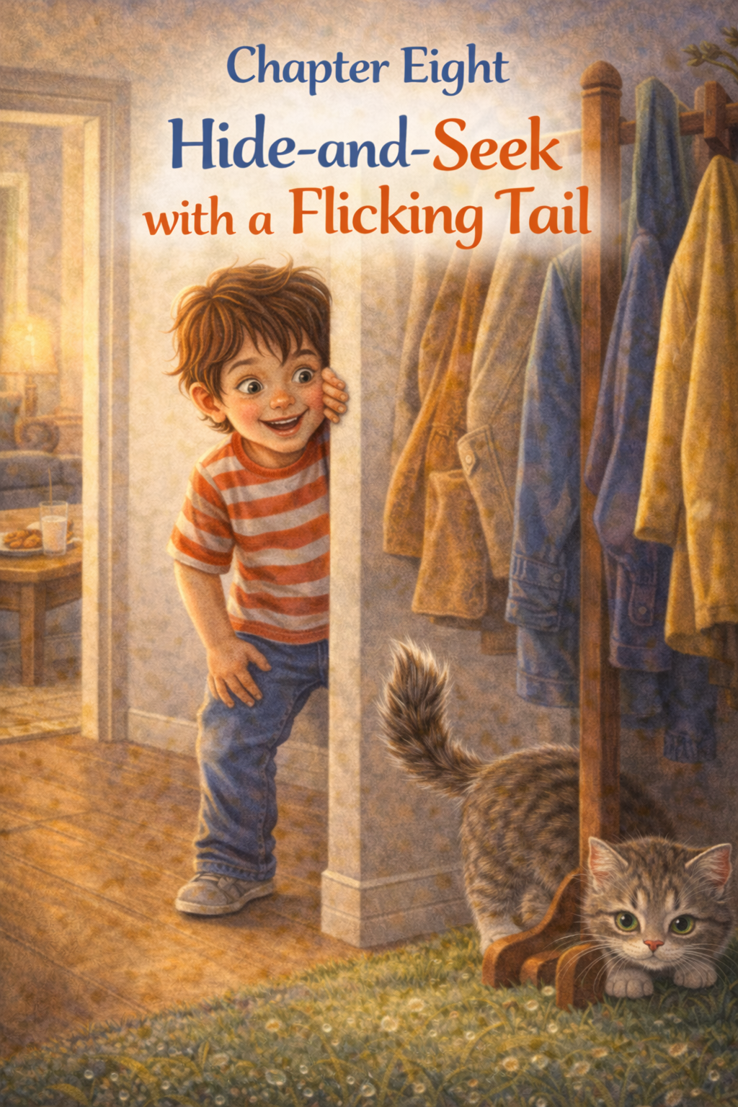

Chapter Eight
Hide-and-Seek with a Flicking Tail
It was noticeably quiet in the house.
Too quiet.
Thomas walked into the living room with his favorite snack and stopped.
“Whiskers?” he called.
No answer.
Usually, Whiskers came running at the sound of the snack bag crinkling. Usually, there was a soft thud of paws and a hopeful little face appearing around the corner.
But not today.
Thomas set the snack on the table.
“Okay,” he said slowly. “If you’re hiding… I’m going to find you.”
He checked the usual places first.
Under the couch.
Behind the curtains.
Inside the laundry basket (which had happened once before).
Nothing.
Thomas placed his hands on his hips. “You’re very good at this,” he admitted.
He walked down the hallway, peeking into each room.
His bedroom? Empty.
The bathroom? Empty.
Mom’s closet?
Thomas leaned closer.
Still nothing.
Then he saw it.
At the very edge of the hallway, just barely visible from behind the coat rack—
A flick.
A tiny gray flick.
Thomas’s eyes widened.
A tail.
Very still.
Very quiet.
Except for the very tip, which flicked back and forth like it had a mind of its own.
Thomas pretended not to notice.
“Hmmm,” he said loudly, looking in the opposite direction. “I guess Whiskers has disappeared forever.”
The tail flicked faster.
Thomas tiptoed closer, still facing away.
“Well,” he continued dramatically, “I suppose I’ll have to eat this snack all by myself.”
The tail froze.
Thomas spun around.
“Got you!”
Whiskers burst out from behind the coats in a flash of gray fur and excitement. He zoomed down the hallway, claws tapping happily against the floor.
Thomas laughed and chased after him.
“Now I hide!” Thomas declared.
He darted into the living room and ducked behind the couch, pulling his knees close and trying not to giggle.
Silence.
Then—
Soft footsteps.
Slow. Careful. Curious.
Thomas peeked through the tiny gap between the couch and the wall.
Whiskers was creeping forward, ears perked, whiskers stretched wide.
He paused.
Sniffed.
Took another step.
Thomas held his breath.
Whiskers’ head turned slightly… and then—
He spotted the very edge of Thomas’s sock.
Pounce!
Whiskers leaped around the couch and landed right on Thomas’s lap.
Thomas burst into laughter. “How did you know?”
Whiskers blinked, clearly proud of his detective skills.
They played three more rounds.
Thomas hid behind the curtains.
Whiskers hid inside a cardboard box.
Thomas found him by following the gentle flick of that not-so-sneaky tail.
Finally, both collapsed onto the rug, a little out of breath.
Thomas lay on his back, staring at the ceiling. Whiskers climbed onto his chest and settled there, tail finally still.
“You’re not very good at hiding your tail,” Thomas said softly.
Whiskers flicked it once in reply.
Thomas smiled and scratched gently under his chin.
“I’m glad you’re not too good at hiding,” he added.
Because finding Whiskers—again and again—might have been Thomas’s favorite part of the game.

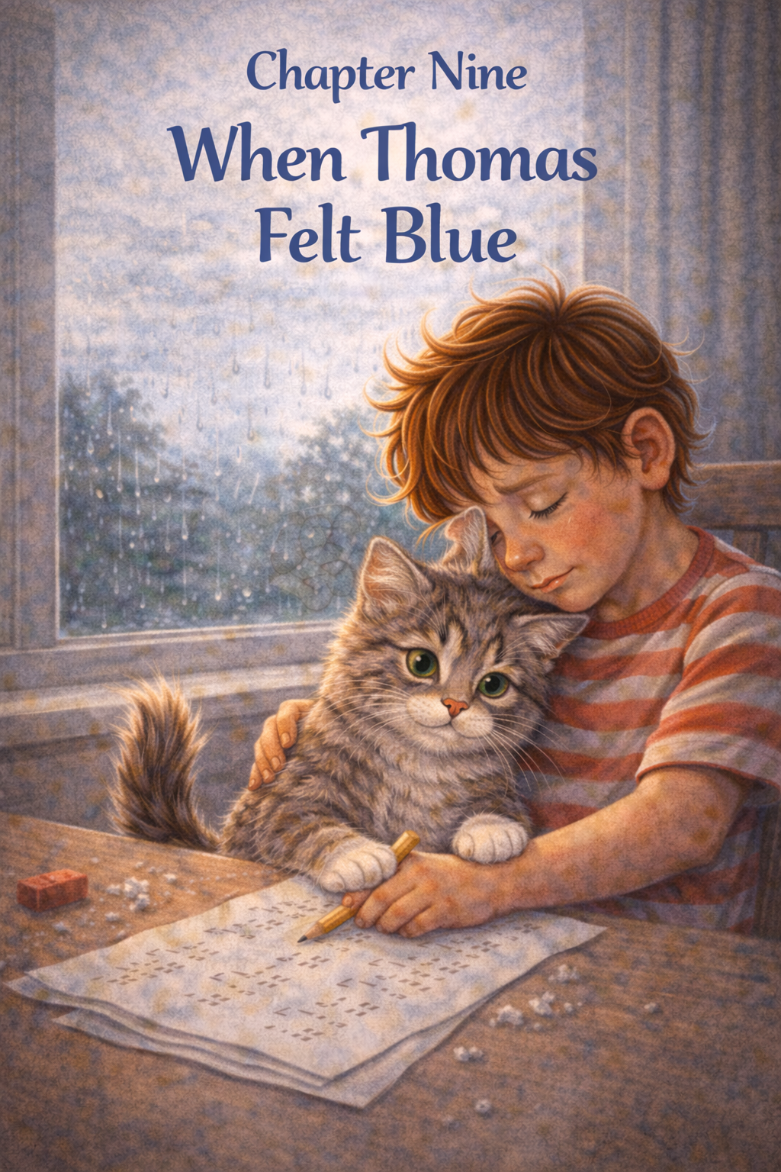
Chapter Nine
When Thomas Felt Blue
It was one of those days.
Nothing big had happened.
Nothing loud.
Nothing exciting.
But everything felt a little heavy.
Thomas sat at the kitchen table, staring at his homework. The numbers on the page didn’t make sense. He had erased the same answer three times.
His pencil made a scratchy sound.
His shoulders slumped.
Across the room, Whiskers watched from the windowsill.
Thomas let out a long sigh.
“I don’t get it,” he muttered.
The rain had come back, turning the sky the color of a gray sweater. Even the house felt quieter than usual.
Thomas pushed the paper away.
“I’m just bad at this,” he said softly.
From the windowsill came a small sound.
Mew.
Thomas didn’t look up.
Whiskers hopped down and walked across the floor. He didn’t pounce. He didn’t zoom. He walked straight to Thomas’s chair.
Then he jumped into his lap.
Thomas blinked in surprise.
Whiskers turned once, carefully, then sat facing him.
Green eyes. Steady. Calm.
Thomas swallowed.
“I messed up,” he whispered.
Whiskers reached out one paw and pressed it gently against Thomas’s arm.
Not a scratch.
Not a grab.
Just a touch.
Thomas felt something loosen in his chest.
“You don’t think I’m bad at it, do you?” he asked.
Whiskers tilted his head slightly.
Then he began to purr.
It wasn’t loud. It wasn’t playful.
It was slow and steady like a quiet engine that never quit.
Thomas rested his forehead lightly against Whiskers’ soft fur.
“I just wanted to get it right,” he said.
The purring didn’t stop.
After a minute, Thomas pulled the worksheet back toward him. The numbers still looked tricky. But they didn’t look impossible anymore.
Whiskers stayed right there, warm and solid in his lap.
Thomas tried the problem again.
Slowly this time.
When he finished, he checked it once… then twice.
It wasn’t perfect.
But it was better.
He smiled just a little.
“I guess it’s okay to try again,” he said.
Whiskers flicked his tail and kept purring.
Outside, the rain softened. The sky didn’t look quite as dark.
Thomas scratched gently behind Whiskers’ ears.
“Thanks,” he whispered.
Whiskers blinked slowly, as if to say, That’s what I’m here for.
And even though the day had started gray, it didn’t feel quite so blue anymore.

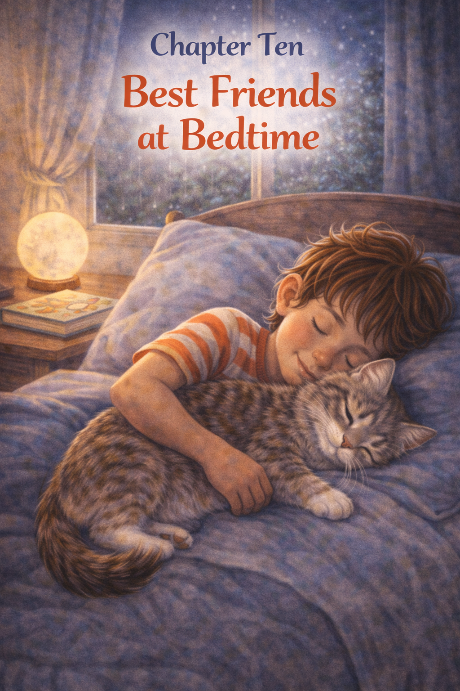

Chapter Ten
Best Friends at Bedtime
The house grew quieter as the sun slipped away.
Dinner dishes were washed.
The lights were dimmed.
The day felt finished.
Thomas brushed his teeth slowly, watching his reflection in the mirror. Behind him, in the hallway, two green eyes waited patiently.
“You are coming?” Thomas asked, mouth full of bubbles.
Whiskers blinked.
Thomas climbed into bed and pulled the blanket up to his chin. His room felt soft in the glow of the nightlight shaped like a small moon.
Whiskers jumped onto the mattress with a gentle bounce.
Not wild.
Not pouncy.
Just right.
Thomas opened his favorite book and read a few pages aloud, his voice growing quieter with each sentence. Whiskers lay beside him, eyes half-closed, tail resting across Thomas’s arm as if it belonged there.
When Thomas finished reading, he closed the book carefully and set it on his nightstand.
The room was still.
Outside, a cricket chirped.
Thomas turned onto his side.
“So,” he whispered into the dim light, “what was your favorite part of today?”
Whiskers answered with a soft purr.
“I liked it when you tried to chase your own shadow,” Thomas continued, smiling.
Whiskers stretched and bumped his head gently against Thomas’s hand.
Thomas scratched behind his ears.
“You’re a good cat,” he said.
Whiskers didn’t chase anything. He didn’t leap. He didn’t wiggle.
He scooted closer.
Thomas felt the warmth against his chest, the steady rhythm of breathing, the soft rise and fall that meant everything was calm and safe.
Sometimes Thomas wondered if Whiskers knew how much he mattered.
How much happier the house felt with tiny paws running through it.
How cozier the couch felt with a little gray curl on it.
How even hard days felt smaller with a soft purr nearby.
Thomas wrapped one arm loosely around him.
“You’re my best friend,” he whispered.
Whiskers answered the only way he knew how.
Purr.
Slow. Deep. Certain.
Thomas closed his eyes.
The moonlight slipped through the curtains, painting quiet shapes on the wall. The world outside kept turning, but inside the room, everything felt steady.
Safe.
Warm.
Two best friends, ending the day the same way they had begun together.


Epilogue
Years later, the garden still smelled the same in the mornings.
The sun rose gently over the little cottage, stretching warm light across the grass and the old wooden fence. Flowers still leaned toward the sky, bees still hummed lazily through the air, and the porch still creaked the way it always had.
And sometimes—if you looked carefully—you might see a boy sitting in that garden with a gray tabby cat curled beside him.
Thomas had grown taller, of course. His hair had changed a little, and his footsteps were longer now. But some things about him never really changed. He still liked quiet mornings. He still noticed the smallest things—ladybugs on leaves, clouds shaped like animals, and the soft rustle of wind through the flowers.
And he still loved cats.
Whiskers had grown older, too. His once-silky fur had a few silver strands, and he slept more than he used to. But when Thomas stepped outside each morning, Whiskers would still lift his head, stretch slowly, and pad across the grass to sit beside him.
Just like he always had.
Some friendships grow slowly, like gardens. They begin with small moments—shared sunshine, quiet afternoons, and gentle purrs. Over time, those moments become memories, and those memories grow even stronger.
A bond.
Thomas learned many things growing up. He learned how to care for others. He learned how to be patient and kind. He learned that sometimes the quietest companions teach the biggest lessons.
But the most important thing he learned was simple.
Love doesn’t have to be loud.
Sometimes love looks like a small gray cat waiting at the door.
Sometimes it sounds like a soft purr in the middle of the night.
And sometimes it feels like a warm friend curled up beside you, reminding you that you are never truly alone.
Even as the years passed, one thing remained certain.
Wherever Thomas went, and whatever adventures life brought him…
He would always be the boy who loved his cat. 🐾

Who’s This Book For?
Thomas Loves His Cat is written for young readers, typically those in preschool through early elementary school (approximately ages 3–8). The language, themes, and illustrations are designed to be accessible for children who are beginning to read on their own, while still being engaging for younger children who enjoy listening to stories read aloud by parents, caregivers, or teachers. Because of its gentle pacing and warm illustrations, the book works especially well as a bedtime story, a classroom read-aloud, or a shared reading moment between a child and an adult.
This story may be particularly meaningful for children who love animals, those experiencing their first pet, or those learning to build caring relationships with others. Parents, educators, and caregivers may also find the book helpful when introducing conversations about kindness, empathy, patience, and emotional connection. For children who sometimes feel lonely, uncertain, or overwhelmed by big emotions, the story gently shows how comfort and companionship can come from unexpected places.
Through Thomas’s experiences with his kitten, Whiskers, readers may discover several simple but meaningful lessons. The story encourages children to understand that friendship grows through patience and care, and that love does not always appear in grand gestures. Sometimes it is found in small everyday moments—playing together, offering comfort, or simply being present for someone who needs it. The book also helps young readers recognize the importance of treating animals with kindness and respect while developing empathy for others' feelings.
Ultimately, Thomas Loves His Cat reminds children that meaningful friendships can be quiet, gentle, and deeply comforting. By watching Thomas and Whiskers share their small adventures, readers learn that the strongest bonds are often built through kindness, trust, and the simple joy of spending time together.

About the Author
ScottMbooks.com

Scott Speicher brings a unique blend of life experiences to his writing. A U.S. military veteran, he carries the discipline, resilience, and perspective gained through service into every story he tells. After his military career, Scott built a successful path in marketing, where he developed a deep understanding of communication, storytelling, and audience engagement. For more than 15 years, he has also worked as a professional website designer, helping businesses and individuals create meaningful online presences.
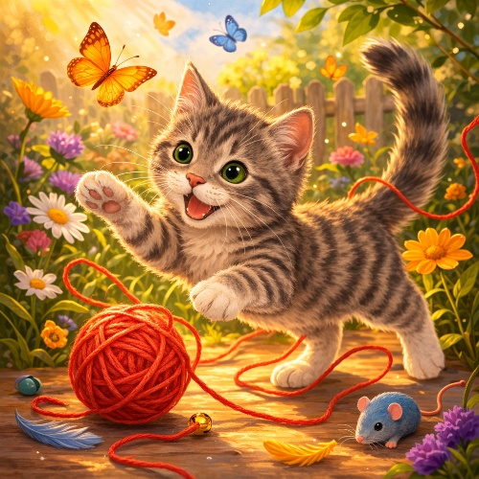
Scott Speicher is a storyteller who enjoys creating gentle, heartfelt stories that help children notice the small moments that make life meaningful. Through warm characters and simple adventures, his books encourage young readers to slow down, care for others, and appreciate the quiet joys of everyday life. Scott believes that some of the most important lessons children learn come not from grand events, but from the ordinary moments shared with family, friends, and the animals they love.
In Thomas Loves His Cat, Scott brings that belief to life through a tender story about friendship, patience, and the special bond between a child and a pet. Inspired by the comforting relationships many children form with animals, the story celebrates how kindness, empathy, and companionship can grow in the smallest of ways. Through Thomas and his curious cat Whiskers, readers are reminded that love often appears in the softest moments—a purr beside you, a quiet afternoon together, or the simple joy of being understood.
This book celebrates the special bond between children and the animals who become their companions, teachers, and best friends.
Suitable for readers aged 4-10 and for family read-aloud sessions. Ideal for SEL, guidance, and service-learning.

