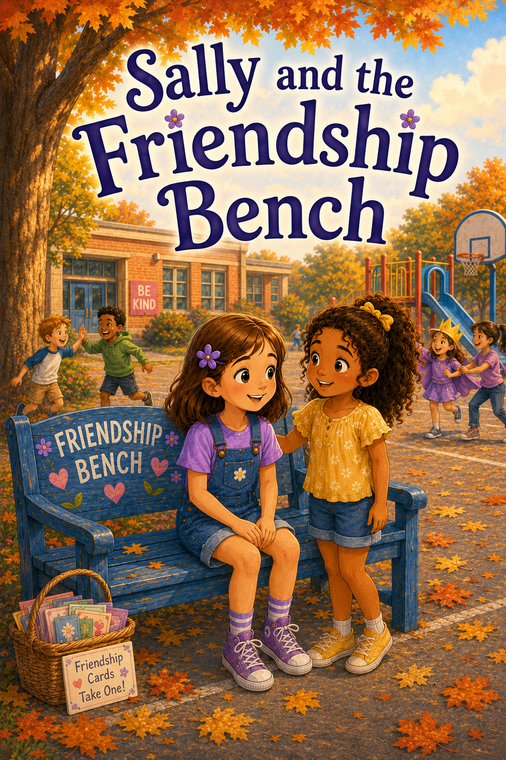
Sally and the Friendship Bench

Copyright © 2026
Author: Scott M. Speicher
Portions of this book have been optimized by the program Grammarly.
Edited by Grammarly and the Editorial team of Digital Scribblers
No part of this book may be reproduced or used in any form or by any means, electronic or mechanical, without the author's written permission.
Some of the images are AI-generated via prompting and with full control by the author.

Preface
Sally and the Friendship Bench

Every child wants to feel like they belong.
For Sally, recess has always been a time for games, laughter, chalk drawings, running feet, and friends calling each other’s names across the playground. But when a new blue bench appears beneath the maple tree, Sally learns that recess can also be a time when some children feel lonely, shy, left out, or unsure where they fit.
The bench is called the Friendship Bench. It is a special place where students can sit when they want someone to talk to, play with, or simply notice them. First, Sally thinks the bench is a wonderful idea. But she also wonders if children will be brave enough to use it—and if others will be kind enough to notice.
As Sally and her classmates learn how the bench works, they discover that friendship is more than playing together. Friendship means looking around. It means inviting others in. It means listening when someone feels sad, making room when a game seems full, using kind words during misunderstandings, and remembering that everyone sometimes needs friendship—even the helpers.
Through the Friendship Bench, Sally learns that kindness need not be perfect to matter. A simple hello, a gentle question, a quiet seat beside someone, or an invitation to join a game can help another child feel seen and welcome. She also learns that one person does not have to fix everything alone. When a class chooses to care together, the whole playground can begin to change.
May this story encourage young readers to notice others, speak kindly, include classmates, and remember that every child deserves to feel welcome.
Because everyone belongs here.

Table of Contents
Sally and the Friendship Bench
Preface
An introduction to Sally’s story and the important lesson that every child wants to feel noticed, welcomed, and included.
Chapter 1: The Quiet Spot on the Playground
Sally notices a new blue bench near the edge of the playground. Mrs. Carter explains that it is called the Friendship Bench, a place where students can sit when they want to talk to or play with someone. Sally wonders if children will be brave enough to use it.
Chapter 2: A Recess Without a Friend
At recess, Sally sees Emma Brooks standing alone by the fence while everyone else plays. Sally feels unsure at first, but she takes one small kind step and invites Emma to join a game.
Chapter 3: The First Bench Visitor
A younger student named Owen sits on the Friendship Bench with his head down. Sally learns that he is new to the school and misses his old friends. By listening and inviting him to teach a dinosaur game, Sally helps him feel welcome.
Chapter 4: When Helping Feels Hard
Sally sees Nora sitting on the bench but hesitates, unsure what Nora needs. With help from Mom, Mark, and Mrs. Carter, Sally learns that kindness does not have to be perfect—it just has to be caring.
Chapter 5: Maria Has an idea
Maria suggests creating friendship cards with cheerful messages like “You belong here” and “Want to play?” Sally and her classmates discover that kind words can help someone feel welcome.
Chapter 6: The Playground Promise
Sally, Maria, and their classmates create a playground promise so no one feels invisible at recess. They agree to look around, invite others to play, make room, listen, and use kind words.

Chapter 7: A Misunderstanding at Recess
Sally invites Tessa from the bench to play, but Caleb says the game is already full. Feelings are hurt, and Mrs. Carter helps the students learn how to solve problems with fairness, listening, and kindness.
Chapter 8: Sally Sits on the Bench
After a difficult morning, Sally feels left out when her friends choose a game she does not want to play. For the first time, she sits on the Friendship Bench and learns that everyone sometimes needs friendship—even helpers.
Chapter 9: The Friendship Bench Challenge
Mrs. Carter begins a weeklong Friendship Bench Challenge. Students earn kindness stars for inviting others, listening, sharing, helping, and including classmates. Sally learns that friendship means paying attention to how others feel.
Chapter 10: Everyone Belongs Here
Sally’s class celebrates how the Friendship Bench has changed recess. More students are playing together, new friendships have started, and the class learns that everyone belongs when people choose to notice, listen, and include.
Epilogue
The Friendship Bench remains on the playground as a lasting reminder that kindness grows when students keep noticing, caring, and making room for others.
Brief Book Description
Sally and the Friendship Bench is a warm children’s story about kindness, courage, inclusion, and belonging. When a bright blue Friendship Bench appears on the school playground, Sally and her classmates learn that some children need a little encouragement, a kind word, or someone willing to sit beside them. Through friendship cards, a playground promise, and many small acts of care, Sally discovers that friendship is not only about playing together—it is about noticing others, listening with patience, and helping every child feel welcome.

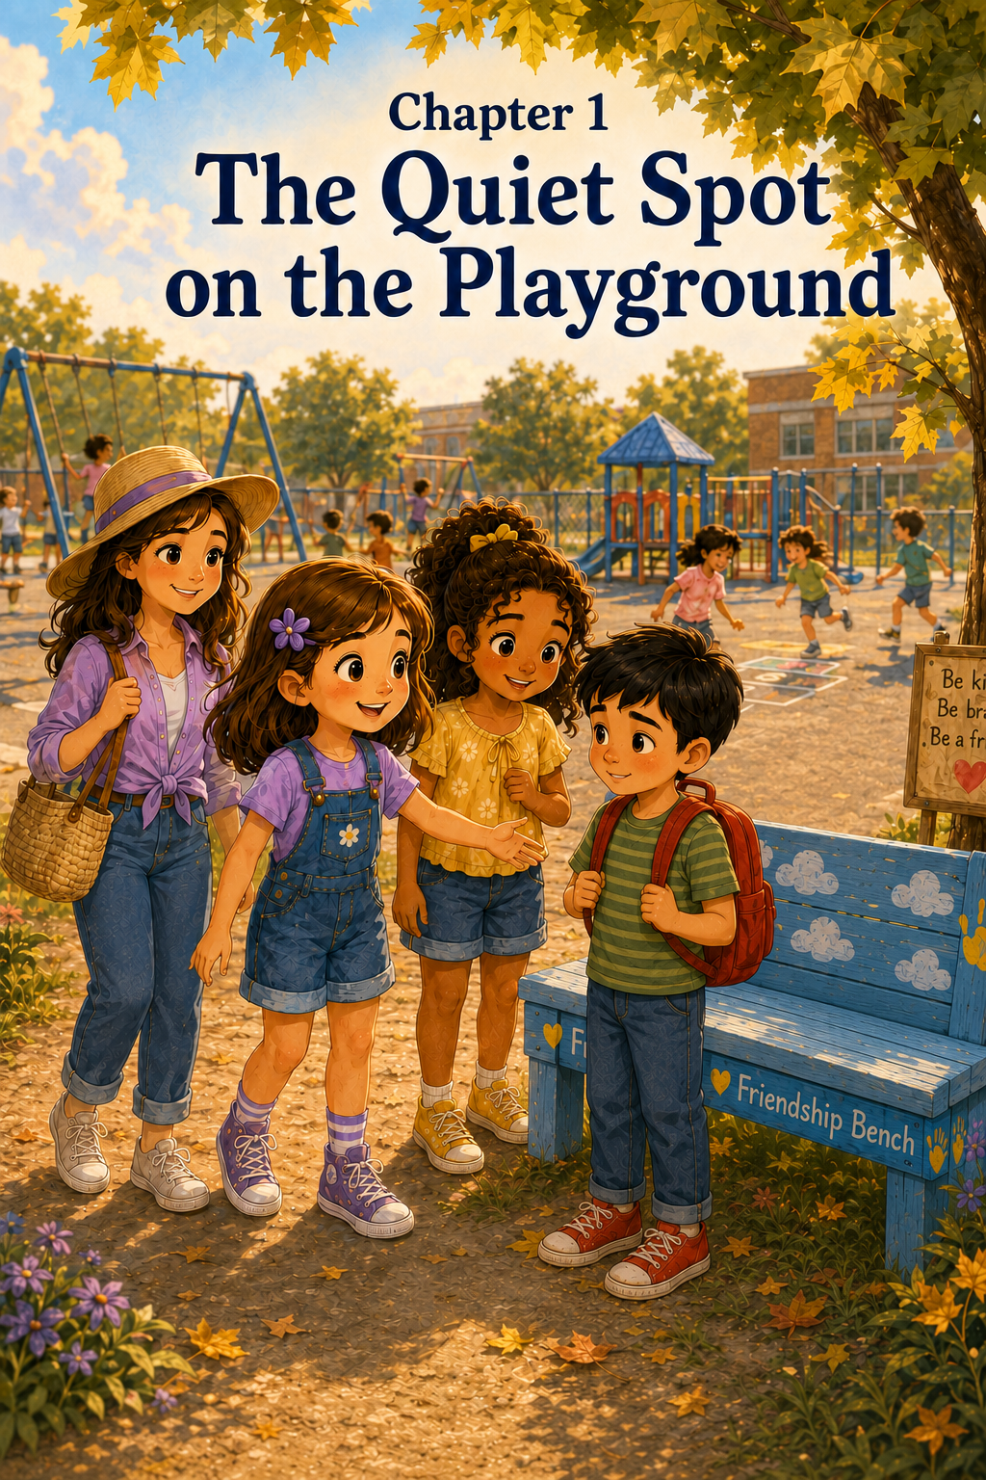Chapter 1: The Quiet Spot on the Playground
Sally first noticed the bench on Monday morning.
It sat near the edge of the playground, just beneath the shade of a young maple tree. The bench was painted a cheerful sky blue, with yellow handprints along the sides and tiny white clouds on the back. Across the front, in bright green letters, were the words:
Friendship Bench
Sally stopped walking.
Her purple backpack bumped gently against her shoulders as students hurried past her toward the school doors. Some children were talking about lunch. Some were comparing new pencils. A few were already laughing about what they planned to play at recess.
But Sally kept looking at the bench.
It had not been there on Friday.
On Friday, that spot had been empty except for a patch of grass, a few fallen leaves, and a little line of ants that marched near the fence. Now there was a whole bench sitting there as if it had always belonged.
Sally tilted her head.
“Friendship Bench,” she read quietly.
Her friend Maria walked up beside her. “What are you looking at?”
Sally pointed. “That bench.”
Maria looked across the playground. “Oh! That’s new.”
“I know,” Sally said. “Do you think we’re allowed to sit on it?”
Maria shrugged. “Maybe. It says friendship, so it sounds friendly.”
Sally smiled a little. Maria had a way of saying things that made sense and sounded funny at the same time.
Just then, the first bell rang.
“Come on,” Maria said. “We better go in.”
Sally followed Maria toward the school doors, but she looked back once more at the blue bench under the maple tree.
Something about it made her curious.
In Room 12, Mrs. Carter stood by the board with a smile. A large paper poster hung beside her desk, but it was covered with a sheet of yellow construction paper. That usually meant Mrs. Carter had a surprise.
Sally slid into her seat and placed her backpack carefully beside her chair. Around the room, students unpacked folders, sharpened pencils, and whispered guesses about the covered poster.
“Maybe it’s a new reading chart,” Emma whispered from the next desk.
“Maybe it’s a field trip announcement,” said Noah.
“Maybe it’s extra math,” Marcus said with a dramatic sigh.
Sally laughed. “I don’t think Mrs. Carter would cover extra math like a surprise.”
Mrs. Carter clapped her hands gently.
“Good morning, class.”
“Good morning, Mrs. Carter,” the class answered.
“I’m glad everyone is here today,” Mrs. Carter said. “This morning, we are going to talk about something new on our playground.”
Sally sat up straighter.
Maria looked over at her and smiled.
Mrs. Carter removed the yellow paper from the poster. On it was a drawing of the blue bench, with the words Friendship Bench written across the top.
Several students began whispering.
“I saw that!”
“It’s by the maple tree.”
“Can we sit there?”
“Is it only for recess?”
Mrs. Carter held up one hand, still smiling. “I’m happy so many of you noticed it. Yes, the bench is new. It was placed on our playground this weekend, and it has a very special purpose.”
Sally folded her hands on her desk.
Mrs. Carter pointed to the picture. “This is called a Friendship Bench. It is a place where a student can sit if they want someone to talk to, play with, or include them.”
The room grew quieter.
Sally looked around. Some children nodded as if they understood right away. Others looked a little unsure.
Mrs. Carter continued. “Sometimes, at recess, a student may not know who to play with. Sometimes a child may feel shy, lonely, like a new person, or left out. Sometimes a student may want to join a game but not know how to ask. The Friendship Bench helps us notice when someone might need a friend.”
Sally thought about that.
She remembered when Maria had first moved next door. Maria had stood near the moving boxes with her stuffed bunny tucked under one arm, looking out at a street she did not yet know. Sally had felt nervous about saying hello, but Mom had reminded her that it could be hard to be the new person.
A friendly hello had made a difference that day.
Maybe the Friendship Bench was like that.
A place for a friendly hello to begin.
Mrs. Carter walked to the front of the room and picked up a marker. “Now, the bench is not a place for teasing. It is not a place for ignoring people. And it is not a place where anyone should feel embarrassed.”
She wrote three words on the board:
Notice. Ask. Include.
“These are our three Friendship Bench words,” Mrs. Carter said.
Sally read them quietly to herself.
Notice. Ask. Include.
Mrs. Carter tapped the first word. “Notice means we pay attention. We look around the playground and see if someone might need a friend.”
Then she tapped the second word. “Ask means we use kind words. We might say, ‘Would you like to play?’ or ‘Do you want to walk with me?’ or ‘Are you okay?’”
Then she tapped the third word. “Include means we make room for others. Sometimes that means inviting someone into a game. Sometimes it means sitting beside them. Sometimes it means helping them find another friend or asking a teacher for help.”
Marcus raised his hand. “What if someone sits there but doesn’t want to play?”
“That is a good question,” Mrs. Carter said. “We never force someone to play. We ask kindly and listen to the answer. A person might only want to talk. Or they might need a quiet minute. Kindness means paying attention to what someone needs, not just what we think they need.”
Emma raised her hand. “Can anyone sit there?”
“Yes,” Mrs. Carter said. “Anyone may sit on the Friendship Bench. Sometimes even a child who has many friends can feel lonely for a moment.”
Sally looked down at her pencil.
That made sense.
Sometimes Sally felt lonely even when people were nearby. Sometimes she felt unsure even when she was with friends. Sometimes she wanted to join a game but did not know how to ask without feeling awkward.
She wondered if she would ever sit on the bench.
The thought made her stomach flutter.
Mrs. Carter placed the marker back on the tray. “Today at recess, I want everyone to notice the bench. You do not have to use it today. You do not have to solve every problem. But I do want you to begin thinking about what it means to be a good friend.”
Sally glanced at Maria.
Maria whispered, “I like it.”
Sally whispered back, “Me too.”
But even as she said it, Sally wondered something.
Would children really sit there if they felt lonely?
Would they be brave enough?
At recess, the playground was full of movement and noise. Sneakers rushed across the black top. Jump ropes slapped the ground. A soccer ball rolled toward the fence. Children climbed, laughed, shouted, chased, and called each other’s names.
Sally and Maria walked outside together.
The blue bench sat quietly under the maple tree.
For a few minutes, nobody went near it.
Sally watched while pretending not to watch. She saw two second graders run past it without stopping. She saw a group of children playing tag near the swings. She saw Marcus and Noah racing toward the soccer field.
The bench stayed empty.
Maria nudged Sally gently with her elbow. “Do you think anyone will use it?”
“I don’t know,” Sally said.
“It’s a good idea,” Maria said.
“It is,” Sally agreed. “But sitting there might feel scary.”
Maria looked at her. “Why?”
Sally kicked a tiny pebble with the toe of her purple sneaker. “Because then everyone might know you don’t have someone to play with.”
Maria was quiet for a moment.
Then she said, “Maybe that’s why everyone else has to be kind about it.”
Sally looked at the bench again.
Maria was right.
A Friendship Bench would only work if people treated it carefully. It was not magic. It could not make kindness happen all by itself. Students had to notice. Students had to ask. Students had to include.
Mrs. Carter’s three words came back to Sally.
Notice. Ask. Include.
Sally and Maria joined Emma near the Hopscotch squares. Emma had drawn a new pattern with sidewalk chalk, adding stars between the numbers.
“Want to play?” Emma asked.
“Yes,” Sally said.
The three girls took turns hopping through the squares. Sally tried to land carefully on one foot, but she wobbled on number six and nearly tipped sideways.
Maria laughed. “Careful!”
“I meant to do that,” Sally said, waving her arms dramatically.
Emma giggled. “That was very graceful.”
Sally was about to take another turn when she noticed something near the edge of the playground.
A boy from another class had stopped near the Friendship Bench.
He looked younger than Sally, maybe in first grade. He had a red backpack and a blue jacket tied around his waist. He stood beside the bench for a few seconds, staring at it.
Then he sat down.
Sally’s smile faded a little.
Maria saw him too.
Emma followed their gaze. “Someone’s on the bench.”
The boy stared at his shoes. Other children ran by, but no one stopped. A ball bounced near him, and a student grabbed it quickly before running away again.
Sally felt her heart tug.
She did not know the boy’s name.
She did not know what to say.
She did not know whether he wanted help or just to sit.
Her feet stayed still.
Maria looked at Sally. “Should we ask him?”
Sally swallowed.
The playground suddenly felt very large, just like Maria’s front yard had felt the day Sally first walked over to say hello. The bench was not far away, but it felt far. Sally wondered if the boy would be embarrassed. She wondered if she would say the wrong thing. She wondered if other children would look at her.
Then she remembered Mom’s words from when Maria moved in.
A friendly hello can make a big difference.
Sally took a deep breath.
“Maybe we can just start with hello,” she said.
Maria nodded. “That sounds good.”
Emma looked a little nervous too, but she came with them.
Together, the three girls walked toward the blue bench.
The boy looked up as they came closer. His eyes were wide, and he quickly looked down again.
Sally stopped a few steps away so she would not crowd him.
“Hi,” she said gently. “I’m Sally.”
The boy looked up again.
“I’m Daniel,” he said quietly.
Maria smiled. “I’m Maria. This is Emma.”
Emma gave a small wave.
Sally pointed toward the hopscotch squares. “We were playing hopscotch. Would you like to come play with us?”
Daniel looked over at the chalk squares. “I don’t know how.”
“That’s okay,” Sally said. “We can show you.”
“It’s easy,” Emma added. “Unless you are Sally on number six.”
“Hey,” Sally said, pretending to be offended.
Maria laughed.
Daniel smiled just a little.
It was not a big smile. It was not a loud smile. But it was there.
“Okay,” he said.
Sally felt something warm open in her chest.
The four of them walked back to the hopscotch game. Emma explained the rules, Maria showed Daniel where to stand, and Sally demonstrated how to hop through the squares without stepping on the lines.
This time, Sally made it all the way to number ten.
“See?” she said proudly. “I can be graceful.”
Daniel laughed.
When the recess bell rang, Daniel handed Sally the small stone they had used as a marker.
“Thanks for asking me to play,” he said.
“You’re welcome,” Sally said.
As they lined up to go inside, Sally looked back at the bench.
It was empty again.
But now it did not look lonely.
It looked like a quiet little place where something good had started.
Back in the classroom, Mrs. Carter asked everyone to sit on the rug.
“I noticed some kind choices at recess today,” she said.
Sally looked down at her hands, but she could feel Maria smiling beside her.
Mrs. Carter did not name anyone. She simply said, “Remember, class, friendship often begins when someone is brave enough to notice.”
Sally thought about Daniel’s small smile.
She thought about the blue bench under the maple tree.
She thought about how hard it could be to sit there and how important it was for someone else to walk over.
The Friendship Bench was a wonderful idea.
But Sally understood now that the bench was only the beginning.
The real friendship happened when someone chose to care.
And maybe tomorrow, Sally would be ready to notice again.

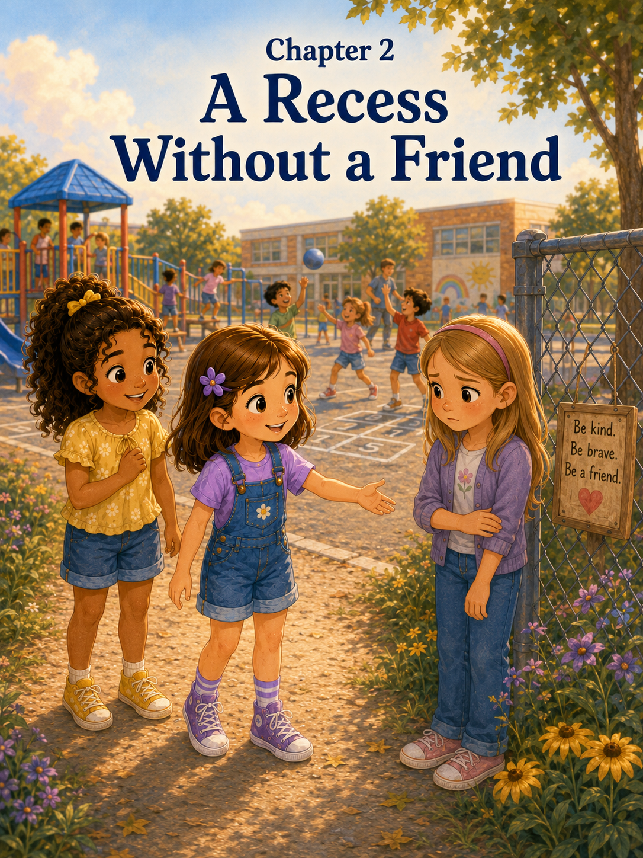Chapter 2: A Recess Without a Friend
The next morning, Sally thought about the Friendship Bench before she even reached the playground.
She thought about it while she brushed her teeth.
She thought about it while she packed her purple backpack.
She thought about it while Mom placed a sandwich, apple slices, and a small cookie into her lunchbox.
She even thought about it while Patches, her black-and-white puppy, chased one of his squeaky toys across the kitchen floor and slid sideways into the cabinet.
“Patches,” Mark said, laughing, “that cabinet was not in your way. You were in its way.”
Patches wagged his tail as if he fully agreed.
Sally smiled, but her mind was still on the blue bench under the maple tree.
Yesterday, Daniel had sat on the bench, and Sally, Maria, and Emma invited him to play hopscotch. It had felt good to help him, but it had also felt a little scary at first.
Sally did not know what to say.
She had not known if Daniel wanted help.
She had not known if he would feel embarrassed.
But starting with hello had worked.
At breakfast, Sally stirred her cereal slowly.
Mom noticed. Mom always noticed.
“You look thoughtful this morning,” Mom said.
Sally looked up. “I keep thinking about the Friendship Bench.”
“The new bench at school?” Mom asked.
Sally nodded. “A boy sat there yesterday. We invited him to play.”
“That was kind,” Mom said.
“It felt kind,” Sally said. “But it also felt hard.”
Mark leaned against the counter with his coffee mug. “Sometimes kind things do feel hard at first.”
Sally looked at him. “Why?”
“Because kindness often asks us to be brave,” Mark said. “It can feel uncomfortable to walk over, start a conversation, or include someone new. But that is often when kindness matters most.”
Sally thought about that.
Patches dropped his squeaky toy beside her chair and looked up hopefully.
Sally picked it up and tossed it gently across the kitchen. Patches raced after it, his paws slipping on the floor.
Mom smiled. “You do not have to fix everything for everyone, Sally. But you can notice. You can ask. You can include.”
Sally’s eyes widened a little. “That’s what Mrs. Carter wrote on the board.”
“Then Mrs. Carter is very wise,” Mom said.
Sally smiled and took another bite of cereal.
Notice.
Ask.
Include.
Those words followed Sally all the way to school.
When she arrived, the Friendship Bench was already waiting under the maple tree. Morning sunlight touched the blue paint, making the yellow handprints look bright and cheerful. A few leaves had fallen around the legs of the bench, and one acorn sat on the seat like a tiny round visitor.
Sally paused near the fence.
Maria came up behind her. “Checking on the bench?”
Sally nodded. “Kind of.”
Maria smiled. “Maybe it needs a good morning.”
Sally looked around to make sure nobody was listening. Then she whispered, “Good morning, Friendship Bench.”
Maria giggled.
The bell rang, and the girls hurried inside.
All morning, Sally tried to pay attention to her lessons. She really did.
Mrs. Carter reviewed spelling words. Sally wrote them neatly in her notebook.
The class practiced math facts. Sally solved most of them, though one problem tried very hard to trick her.
During reading time, Mrs. Carter read a story about a small bird who learned to share her nest with another bird during a storm. Sally liked the story, especially the part where the first bird scooted over even though she was worried there would not be enough room.
“Sometimes making room is the kindest part,” Mrs. Carter said when she finished reading.
Sally wrote that sentence in the corner of her notebook.
Making room is the kindest part.
By the time recess came, the class was full of energy. Chairs scraped back, sneakers shuffled, and students lined up at the door.
“Remember,” Mrs. Carter said before they went outside, “play kindly, listen carefully, and notice one another.”
Sally glanced at Maria.
Maria whispered, “Notice.”
Sally whispered back, “Ask.”
Emma, who was standing in front of them, turned around and smiled. “Include.”
The three girls grinned.
Outside, the playground burst into motion.
Noah and Marcus ran toward the soccer field. Ava and Grace hurried to the swings. A group of younger students began a game of tag. Several children started drawing with sidewalk chalk near the hopscotch squares.
Sally, Maria, and Emma walked toward the black top.
“What should we play today?” Maria asked.
“Hopscotch again?” Emma suggested.
Sally looked over at the chalk squares. “Maybe. Or four square.”
“I like four square,” Maria said. “But I am not very good at it.”
“That’s okay,” Sally said. “I am sometimes good and sometimes terrible.”
Emma laughed. “That is very honest.”
The girls started toward the four square court, but Sally slowed down when she noticed someone near the fence.
It was Emma.
Not her friend Emma beside her.
Another Emma.
Emma Brooks from their class.
Sally knew there were two Emmas in Room 12. Her friend Emma had curly hair and a purple lunchbox, and loved drawing stars all over everything. Emma Brooks had straight blonde hair, pink glasses, and usually wore sneakers with sparkly laces.
Today, Emma Brooks stood alone by the fence.
She was not sitting on the Friendship Bench.
She was not crying.
She was not waving for help.
She was just standing there, running one hand along the chain-link fence while everyone else played.
Sally stopped walking.
Maria noticed. “What is it?”
Sally nodded toward the fence. “Emma Brooks is by herself.”
Her friend Emma looked like she was too. “Maybe she just wants to stand there.”
“Maybe,” Sally said.
Emma Brooks looked across the playground. Her face was quiet, but not peaceful. She looked like she wanted to join something but did not know where to go.
Sally felt the familiar flutter in her stomach.
Yesterday, Daniel was sitting on the Friendship Bench. That made it easier to know he might want someone to ask him to play.
But Emma Brooks was not on the bench.
What if she wanted to be alone?
What if Sally walked over and made things awkward?
What if Emma said no?
What if she thought Sally was being nosy?
Sally looked at Maria. “Do you think we should ask her?”
Maria tilted her head. “Maybe.”
Her friend Emma said, “We could invite her to four square.”
Sally looked back at Emma Brooks.
The playground felt loud around her. A whistle blew from the soccer field. Someone shouted, “You’re it!” Chalk scraped against the ground. The swings squeaked back and forth.
But Emma Brooks still stood by the fence.
Sally remembered what Mrs. Carter had said.
Sometimes a student may not know who to play with.
Sometimes a child may feel shy, lonely, like a new person, or left out.
Sometimes a student may want to join a game but not know how to ask.
Sally also remembered what Mom had said that morning.
You do not have to fix everything. But you can notice. You can ask. You can include.
Sally took a slow breath.
“I’m going to ask her,” she said.
Maria smiled. “We’ll come with you.”
Sally nodded, but her feet still felt a little heavy as she walked across the playground.
When the girls got close, Emma Brooks looked over quickly, then looked back at the fence.
“Hi, Emma,” Sally said.
Emma Brooks turned around. “Hi.”
Sally suddenly could not think of what to say next.
Her mind felt blank.
She could ask, Are you okay? But what if Emma did not want to answer?
She could say, Why are you standing here? But that sounded too nosy.
She could say, Do you have anyone to play with? But that might make Emma feel embarrassed.
Sally squeezed her hands together and tried again.
“We’re going to play four square,” she said. “Would you like to play with us?”
Emma Brooks blinked. “Me?”
“Sure,” Maria said. “We need another person.”
Her friend Emma nodded. “And then we’ll have two Emmas, which means our team will be extra powerful.”
Emma Brooks smiled a tiny bit. “I’m not very good at four square”
“That’s okay,” Sally said. “Maria says she isn’t either.”
Maria laughed. “Thank you for telling everyone.”
“I said it kindly,” Sally said.
Emma Brooks looked from Sally to Maria to the other Emma. Her fingers still held the fence, but she did not look quite as lonely now.
“I guess I can try,” she said.
“Great,” Sally said, trying not to sound too excited.
The four girls walked to the four-square court. The ball was bright red and slightly bouncy in the wrong direction. Sally always thought four square balls had minds of their own.
Sally drew the lines again with chalk because part of the court had faded. Then she wrote numbers in each square.
“Here’s how we play,” Sally explained. “You bounce the ball into someone else’s square. If it goes out, you move to the first square. But we are playing friendly rules.”
“What are friendly rules?” Emma Brooks asked.
Maria held up one finger. “No yelling at people.”
Her friend Emma held up another finger. “No saying someone is bad at it.”
Sally held up a third finger. “And if someone is learning, we help.”
Emma Brooks looked relieved. “I like friendly rules.”
“Me too,” Sally said.
They began to play.
At first, Emma Brooks barely tapped the ball, and it rolled gently across the line.
“That’s okay,” Sally said. “Try bouncing it a little harder.”
Emma Brooks tried again. This time, the ball bounced up, hit the edge of Maria’s shoe, and rolled away.
Maria chased it. “The ball is escaping!”
The girls laughed.
A few minutes later, Emma Brooks bounced the ball perfectly into Sally’s square.
Sally missed it completely.
“Oh no,” Sally said, placing one hand over her heart. “I have been defeated.”
Emma Brooks giggled.
Her friend Emma clapped. “Good bounce!”
Emma Brooks stood a little taller.
They played for several rounds. Soon, Grace joined them. Then Ava came over after she finished on the swings. The game grew bigger and sillier. Sometimes the ball bounced correctly. Sometimes it bounced off shoes, knees, elbows, and once, somehow, Maria’s shoulder.
“That was not in the rules,” Maria said.
“It was a creative bounce,” Sally said.
Emma Brooks laughed again, louder this time.
Sally felt happy when she heard it.
After a while, the girls sat near the edge of the blacktop to rest. Emma Brooks tucked a strand of hair behind her ear.
“Thanks for asking me to play,” she said quietly.
Sally looked at her. “You’re welcome.”
Emma Brooks picked at a blade of grass near the blacktop. “I wanted to play something, but I didn’t know what. Everyone already looked busy.”
Sally nodded. “I feel that way sometimes too.”
“You do?” Emma Brooks asked.
“Yes,” Sally said. “Sometimes I don’t know how to join a game. Even when I want to.”
Maria sat beside them and nodded. “Me too. Especially if everyone already seems to know what they’re doing.”
Her friend Emma leaned back on her hands. “That happens to me when people are playing soccer. I never know where to stand.”
Emma Brooks smiled a little. “I thought I was the only one.”
Sally shook her head. “You’re not.”
For a moment, the girls sat quietly together.
The Friendship Bench was across the playground under the maple tree. It was empty today, but Sally looked at it anyway.
She had thought the bench would be the place where lonely feelings showed up.
But now she understood something new.
Sometimes lonely feelings did not sit on a bench.
Sometimes they stood by a fence.
Sometimes they waited at the edge of a game.
Sometimes they stayed quiet because a person was not sure how to ask.
The bench was helpful, but it was not the only place to notice someone.
Sally looked back at Emma Brooks.
“I’m glad you played with us,” she said.
Emma Brooks smiled. “Me too.”
The recess bell rang.
Everyone groaned.
“Recess is always too short,” Maria said.
“That is a true fact,” Sally said.
As they lined up, Mrs. Carter stood near the door, watching the class with her warm teacher’s smile.
When Sally reached the line, Mrs. Carter bent down slightly.
“I saw some good, including today,” she said softly.
Sally felt her cheeks warm. “We asked Emma to play.”
Mrs. Carter nodded. “That was thoughtful.”
“She wasn’t on the bench,” Sally said. “But she looked like she might want a friend.”
Mrs. Carter’s smile grew.
“That is exactly why noticing matters,” she said. “The Friendship Bench helps us, but kindness can happen anywhere.”
Sally liked that.
Kindness can happen anywhere.
Inside the classroom, the students washed their hands and settled into their seats. Mrs. Carter gave everyone a few minutes to write in their journals.
On the board, she wrote:
Today at recess, I noticed…
Sally opened her notebook and thought for a moment.
Then she began to write.
Today at recess, I noticed that someone can feel lonely even if they are not sitting on the Friendship Bench. Emma was standing by the fence. I felt nervous to ask her to play, but I did it anyway. She smiled. I learned that friendship can begin with one small kind step.
Sally looked at the sentence.
One small step.
That sounded right.
She added one more line.
Tomorrow, I want to keep noticing.
At the end of the day, Sally packed her backpack and walked outside with Maria and the two Emmas. Emma Brooks waved goodbye before heading toward the car line.
“See you tomorrow!” she called.
“See you tomorrow!” Sally called back.
Maria smiled at Sally. “You did a good thing today.”
Sally adjusted her backpack straps. “We all did.”
“That’s true,” Maria said.
Sally looked across the playground one more time. The Friendship Bench sat quietly under the maple tree, blue and bright and waiting.
Sally still wondered if children would be brave enough to use it.
But now she wondered something else too.
Maybe students did not always need to sit on the bench for friendship to find them.
Maybe friendship could begin wherever someone was brave enough to notice, kind enough to ask, and willing to make room.
And today, Sally learned that one small invitation could turn a lonely recess into the beginning of something better.
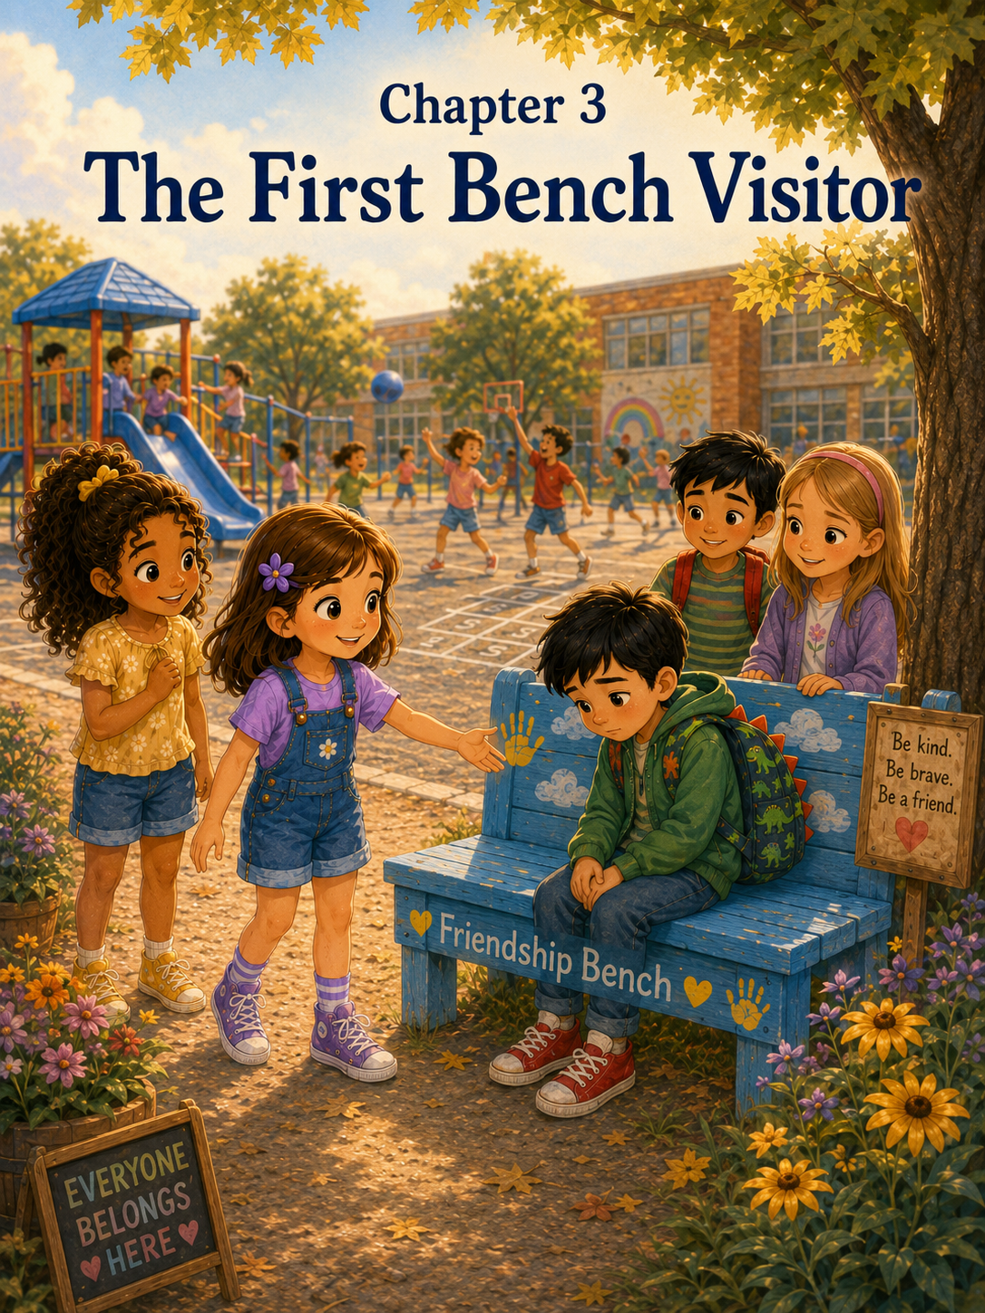
Chapter 3: The First Bench Visitor
On Wednesday morning, Sally walked into school thinking about the word notice.
It seemed like such a small word, but lately it felt important.
On Monday, Sally had noticed Daniel sitting on the Friendship Bench. She, Maria, and Emma had invited him to play hopscotch, and his small smile had made the whole bench feel less lonely.
On Tuesday, Sally had noticed Emma Brooks standing by the fence. Emma had not been sitting on the Friendship Bench, but she had looked like she wanted someone to ask her to play. Sally had invited her to join four square, and by the end of recess, Emma was laughing with everyone else.
Now it was Wednesday, and Sally wondered what she might notice today.
At breakfast, Patches sat beside her chair with his head tilted, watching every bite of toast as if toast were the most interesting thing in the world.
“You are not getting my breakfast,” Sally told him.
Patches wagged his tail.
Mark looked over his coffee mug. “Patches believes watching politely is a very good plan.”
“He is not watching politely,” Sally said. “He is watching hopefully.”
Mom laughed as she packed Sally’s lunchbox. “That sounds like Patches.”
Sally gave Patches a gentle pat on the head. “Maybe you should have a Friendship Bench too.”
Patches thumped his tail against the floor.
“What would Patches use a Friendship Bench for?” Mark asked.
“To find someone to throw his squeaky toy,” Sally said. “Or share toast.”
“Mostly toast,” Mom said.
Sally smiled, but then she grew thoughtful.
“Do you think it’s hard to sit on the Friendship Bench?” she asked.
Mom closed the lunchbox and looked at her. “I think it can be.”
“Why?” Mark asked gently, though Sally knew he was helping her think.
Sally pushed a crumb around her plate. “Because everyone can see you. And if you sit there, people know you want a friend.”
Mom sat beside her. “That does take courage.”
“What if no one comes?” Sally asked.
Mark’s smile faded a little. “Then that would feel lonely.”
Sally nodded.
Mom rested a hand on Sally’s shoulder. “That is why noticing matters so much. The bench is a signal, but people still have to care enough to respond.”
Sally looked down at Patches, who had placed one paw on her sneaker.
“Kindness has to move,” she said quietly.
Mom smiled. “Exactly.”
Sally carried those words with her all the way to school.
Kindness has to move.
When she arrived, the Friendship Bench sat in its usual place beneath the maple tree. A few yellow leaves had landed beside it, and the morning air felt cooler than it had earlier in the week. The blue paint still looked bright, and the words across the front were easy to read.
Friendship Bench
Sally paused for a moment.
“Good morning,” she whispered.
Maria walked up beside her. “Are we greeting the bench again?”
“Maybe,” Sally said.
Maria smiled. “Then good morning, Friendship Bench.”
The girls laughed softly, then hurried inside before the bell rang.
In Room 12, Mrs. Carter had the class begin the day with journal writing. On the board, she had written:
What makes someone a good friend?
Sally opened her notebook and tapped her pencil against the page.
A good friend is kind, she wrote.
Then she added:
A good friend notices when someone is alone.
She thought a little longer and wrote:
A good friend asks, “Do you want to play?” even when it feels a little scary.
Sally looked at the sentence and smiled.
It was true.
Across the room, Emma Brooks was writing carefully in her own notebook. When she looked up and saw Sally, she gave a small wave.
Sally waved back.
That made her feel warm inside.
Later that morning, Mrs. Carter asked a few students to share what they had written.
Emma raised her hand. “A good friend listens.”
“That is very important,” Mrs. Carter said.
Noah said, “A good friend doesn’t quit the game just because they don’t win.”
Mrs. Carter smiled. “That is a helpful one for recess.”
Everyone laughed, including Noah.
Then Emma Brooks raised her hand. Her voice was quiet at first, but it grew stronger as she spoke.
“A good friend makes room for someone else.”
Sally looked over at her.
Mrs. Carter nodded. “That is a beautiful answer, Emma.”
Emma Brooks smiled down at her notebook.
Sally felt proud of her. She wondered if yesterday’s four square game had helped Emma think of that.
Maybe one small invitation could grow into a new idea.
Maybe kindness really did keep going after the moment was over.
The morning moved along with spelling, reading, math, and a science lesson about plants. Sally liked the science lesson because Mrs. Carter let them look closely at bean seeds in small plastic bags with damp paper towels.
“Seeds do not look very exciting at first,” Mrs. Carter said. “But inside, something is beginning.”
Sally held her seed up to the light.
It looked small and ordinary.
But Mrs. Carter said it could grow.
Sally thought kindness might be that way too.
One hello.
One invitation.
One seat made open.
Small at first.
But maybe something was beginning.
By the time recess came, Sally was ready to stretch her legs. The class lined up at the door, and Mrs. Carter gave her usual reminder.
“Play safely, use kind words, and remember to notice one another.”
“Notice,” Maria whispered.
“Ask,” Sally whispered back.
“Include,” Emma added from behind them.
The playground was sunny and full of sound. Children ran toward the swings, the soccer field, the climbing bars, and the chalk buckets. A group of younger students hurried to the slide. Two boys carried a jump rope across the blacktop. Someone shouted, “Race you!” and took off running before anyone had agreed to a race.
Sally, Maria, Emma, and Emma Brooks walked toward the four square court.
“Friendly rules again?” Emma Brooks asked.
“Always,” Sally said.
Maria bounced the red ball. “Friendly rules and no mysterious shoulder bounces.”
“That was one time,” Sally said.
“It was yesterday,” Maria said.
“Exactly. Ancient history.”
The girls laughed and began their game.
For a few minutes, Sally forgot to look around. The ball bounced from square to square, sometimes neatly and sometimes wildly. Emma Brooks was getting better at aiming. Maria made up a dramatic victory dance whenever she stayed in the top square. Emma drew little stars in chalk near the corner while waiting for her turn.
Then the ball rolled past Sally and toward the edge of the playground.
“I’ll get it!” Sally called.
She jogged after it as it bumped over the blacktop and stopped near the grass. When Sally picked it up, she looked toward the maple tree.
Someone was sitting on the Friendship Bench.
Sally froze.
This time, it was a younger boy she did not know. He looked smaller than Daniel, maybe in kindergarten or first grade. He wore a green jacket and had a backpack with dinosaurs on it. His shoes were bright red, but one lace was untied.
He sat with his head down.
His hands were folded in his lap.
Children walked past him.
One student ran by chasing a ball. Another skipped past with a jump rope. Two older boys hurried toward the soccer field. Nobody stopped.
Sally held the red ball against her chest.
This was what the bench was for.
Someone was sitting there.
Someone was waiting.
But still, Sally felt nervous.
It was one thing to talk to Daniel after he sat on the bench. Maria and Emma had been right beside her. It was another thing to walk over by herself while the boy looked so sad.
Sally turned toward her friends. They were still at the four square court, waiting for the ball.
Maria cupped her hands around her mouth. “Sally, did the ball run away forever?”
Sally looked at the boy again.
Then she remembered Mom’s words.
The bench is a signal, but people still have to care enough to respond.
She remembered Mark’s words too.
Sometimes kind things feel hard at first.
Sally took a deep breath.
She walked back to her friends, but not to the four square court. She stopped beside Maria and quietly said, “Someone’s on the bench.”
The girls turned.
Emma Brooks saw him first. “He looks sad.”
Emma nodded. “Maybe he wants someone to ask him to play.”
Maria looked at Sally. “Should we go?”
Sally held the ball tighter. “Yes.”
This time, Sally did not want to wait too long. She still felt nervous, but she also felt something stronger.
The boy had been brave enough to sit on the bench.
Now someone else needed to be brave enough to walk over.
Sally, Maria, Emma, and Emma Brooks crossed the playground together.
As they got closer, the boy did not look up.
Sally slowed down so they would not rush toward him.
She remembered what Mrs. Carter had said.
Ask kindly.
Listen to the answer.
Do not force anyone.
Sally stopped a few steps away.
“Hi,” she said softly.
The boy’s head lifted a little, but not all the way.
Sally tried again. “My name is Sally.”
The boy looked up. His eyes were shiny, but he was not crying.
“I’m Owen,” he said.
Maria smiled gently. “Hi, Owen. I’m Maria.”
“I’m Emma,” said Emma.
“And I’m Emma too,” said Emma Brooks. “There are two of us.”
Owen looked confused for a second, and then his mouth made the tiniest smile.
Sally sat carefully on the other end of the bench, leaving space between them.
“Are you okay?” she asked.
Owen looked down at his red shoes. “I don’t know.”
Sally nodded slowly. She did not know exactly what to say, but she knew she should listen.
“That’s okay,” she said. “Sometimes I don’t know either.”
Owen rubbed one sleeve across his nose. “I’m new.”
Sally’s heart softened.
“New to our school?” she asked.
Owen nodded.
“Today?”
“This week,” he said. “But today is my first recess with the big playground.”
Maria sat on the grass near the bench. “The big playground can feel very big.”
“It is big,” Owen said quickly, as if he had been waiting for someone to understand. “At my old school, the playground was smaller. And I knew where everything was. And I knew people.”
Emma Brooks nodded. “I felt that way when I didn’t know what to play yesterday.”
Owen looked at her. “You did?”
“Yes,” Emma Brooks said. “I stood by the fence.”
Sally smiled at Emma Brooks.
That was brave to share.
Owen looked back at his hands. “I miss my old friends.”
The playground noise seemed to fade a little around them.
Sally thought about Maria moving into the house next door. She thought about how Maria had stood with her stuffed bunny and looked at a new street with wide eyes. She thought about the first time Sally walked over and said hello.
She also thought about how hard it must be to miss people who were not there.
“I’m sorry,” Sally said.
Owen shrugged, but his shoulders looked heavy.
“My friend Liam used to play dinosaurs with me,” he said. “We had a volcano game. Nobody here knows it.”
“I like dinosaurs,” Emma said.
Owen looked up quickly. “You do?”
Emma nodded. “Especially the long-necked ones.”
“Brachiosaurus,” Owen said.
Emma blinked. “Yes. That.”
Owen sat a little straighter. “The volcano game has plant eaters and meat eaters, but the volcano erupts, so they all have to get to the safe island.”
Maria’s eyes widened. “That sounds exciting.”
“It is,” Owen said. Then his voice grew smaller again. “But it needs more than one person.”
Sally looked at her friends.
Maria smiled.
Emma Brooks nodded.
Emma bounced a little on her toes.
Sally turned back to Owen. “Would you teach us?”
Owen stared at her. “Teach you the volcano game?”
“Yes,” Sally said. “We don’t know it yet, so you would have to be the expert.”
Owen blinked.
Then his face changed.
It did not become completely happy all at once, but a little light came into it.
“I could teach you,” he said.
“Great,” Sally said. “Where do we start?”
Owen stood up from the bench. He was still small, but he seemed taller now than he had a minute ago.
“We need a volcano,” he said.
Maria pointed to the slide. “Could that be the volcano?”
Owen studied it seriously. “Maybe. But it needs lava.”
Emma pointed to the red four square ball. “This can be lava.”
Sally held out the ball. “Very dangerous lava.”
Owen smiled. “And we need a safe island.”
Emma Brooks pointed to the chalk circle near the hopscotch squares. “That can be the island.”
Owen nodded. “Yes. But you have to get there before the lava rolls past.”
The girls followed him across the playground. As they walked, Sally noticed a few other younger children watching.
One little girl with pigtails stepped closer. “What are you playing?”
Owen looked at Sally, unsure.
Sally smiled at him. “You’re the expert.”
Owen took a breath. “Volcano dinosaurs,” he said. “You can play if you want.”
The girl grinned. “I want to be a fast dinosaur.”
“Gallimimus,” Owen said.
The girl shrugged. “Okay!”
Soon, two more children joined. Then Daniel came over from the swings.
“What’s this game?” Daniel asked.
“Volcano dinosaurs,” Sally said. “Owen is teaching us.”
Owen’s cheeks turned pink, but he looked pleased.
He explained the rules carefully. The slide was the volcano. The red ball was lava. The chalk circle was the safe island. Plant eaters had to help each other. Meat eaters had to run around the volcano twice before crossing the blacktop. If the lava rolled near you, you had to freeze until another dinosaur helped you.
“That is a lot of rules,” Maria whispered.
Sally whispered back, “He really knows his game.”
Maria smiled. “I like that.”
They began playing.
Owen rolled the lava ball gently at first. Children squealed and ran toward the safe island. Emma pretended to be a very tall dinosaur with a very serious neck. Maria became a triceratops who gave excellent advice. Emma Brooks decided she was a speedy dinosaur who rescued frozen dinosaurs from lava danger.
Sally was not sure what dinosaur she was, so Owen told her she could be a “kindness raptor.”
“I don’t think that’s a real dinosaur,” Sally said.
“It is in this game,” Owen said.
“Then I accept,” Sally said proudly.
The game grew louder and happier. Not too wild. Not unsafe. Just full of laughter and running and pretending.
Owen laughed when Daniel dramatically froze with one foot in the air.
“I have been lava-ed!” Daniel cried.
“Kindness raptor to the rescue!” Sally called, running over to unfreeze him.
By the time the recess bell rang, Owen was surrounded by children asking if they could play again tomorrow.
“Can we add a river?” one child asked.
“Can I be a flying dinosaur?” asked another.
“Can there be two volcanoes?” Daniel asked.
Owen looked overwhelmed for a moment, but this time it did not look like lonely overwhelmed. It looked like happy overwhelmed.
“Maybe tomorrow,” he said.
As the children lined up, Sally walked beside Owen.
“Thanks for teaching us your game,” she said.
Owen smiled down at his shoes, then looked up. “Thanks for asking me.”
Sally glanced toward the Friendship Bench.
It was empty now.
But it had done its job.
Not because it talked.
Not because it played.
Not because it magically made friends appear.
It had done its job because Owen had been brave enough to sit there, and someone had been willing to notice.
When they reached the classroom door, Mrs. Carter stood waiting.
“Owen,” she said warmly, “I saw a very exciting dinosaur game happening today.”
Owen smiled. “It was volcano dinosaurs.”
“That sounds wonderful,” Mrs. Carter said.
“Sally and her friends played,” Owen said. “And Daniel. And other kids too.”
Mrs. Carter looked at Sally with gentle eyes. “That sounds like a very welcoming recess.”
Sally felt her cheeks warm. “Owen taught us the game.”
“He was the expert,” Maria added.
Owen stood a little taller.
Inside the classroom, Mrs. Carter gave the students a few minutes to get water and settle down. Then she invited everyone to the rug.
“I want to talk about something I noticed at recess,” she said.
Sally wondered if Mrs. Carter would talk about the bench.
Mrs. Carter looked around the circle. “Today, someone used the Friendship Bench. That took courage. And other students noticed. That took kindness.”
The class grew quiet.
Mrs. Carter continued, “When someone is new, they may miss people and places from before. A new school can feel confusing. A new playground can feel very large. But when classmates take time to welcome someone, the new place can begin to feel a little safer.”
Sally glanced at Owen.
He was looking down, but he was smiling.
Mrs. Carter asked, “What are some ways we can help a new student feel welcome?”
Emma raised her hand. “Ask them to play.”
Maria said, “Let them teach us a game.”
Daniel said, “Tell them where things are.”
Emma Brooks said, “Make room for them.”
Sally raised her hand. “Listen when they miss their old friends.”
Mrs. Carter’s smile softened. “Yes, Sally. That is very important. Being welcoming does not mean pretending the old place did not matter. It means making room for both—what someone misses and what they are beginning to find.”
Sally liked that.
Making room for both.
After lunch, the class made welcome cards for new students who might join the school later in the year. Sally drew a small blue bench under a maple tree. Beside it, she drew a volcano with dinosaurs running toward a safe island.
On the card, she wrote:
You belong here. We can’t wait to learn your games.
At the end of the day, Sally packed her backpack and zipped it carefully.
Owen walked past her desk with his dinosaur backpack.
“See you tomorrow,” he said.
“See you tomorrow,” Sally said. “Are we playing volcano dinosaurs again?”
Owen nodded. “With two volcanoes.”
Sally laughed. “That sounds dangerous.”
“Only pretend dangerous,” Owen said.
“That’s the best kind,” Sally said.
On the way outside, Sally walked with Maria, Emma, and Emma Brooks.
“That was a good recess,” Emma said.
“It was,” Maria agreed.
Emma Brooks looked thoughtful. “I think the bench worked today.”
Sally looked across the playground.
The Friendship Bench sat quietly under the maple tree. The afternoon sunlight made its blue paint glow. It looked small compared to the playground, but Sally knew now that small things could matter.
A bench could help someone say, “I need a friend.”
A hello could help someone feel seen.
A game could help someone miss old friends and make new ones at the same time.
Sally smiled.
The Friendship Bench was no longer just a quiet spot on the playground.
It was becoming a place where courage and kindness could meet.
And today, because someone noticed, Owen’s new school felt a little less lonely.

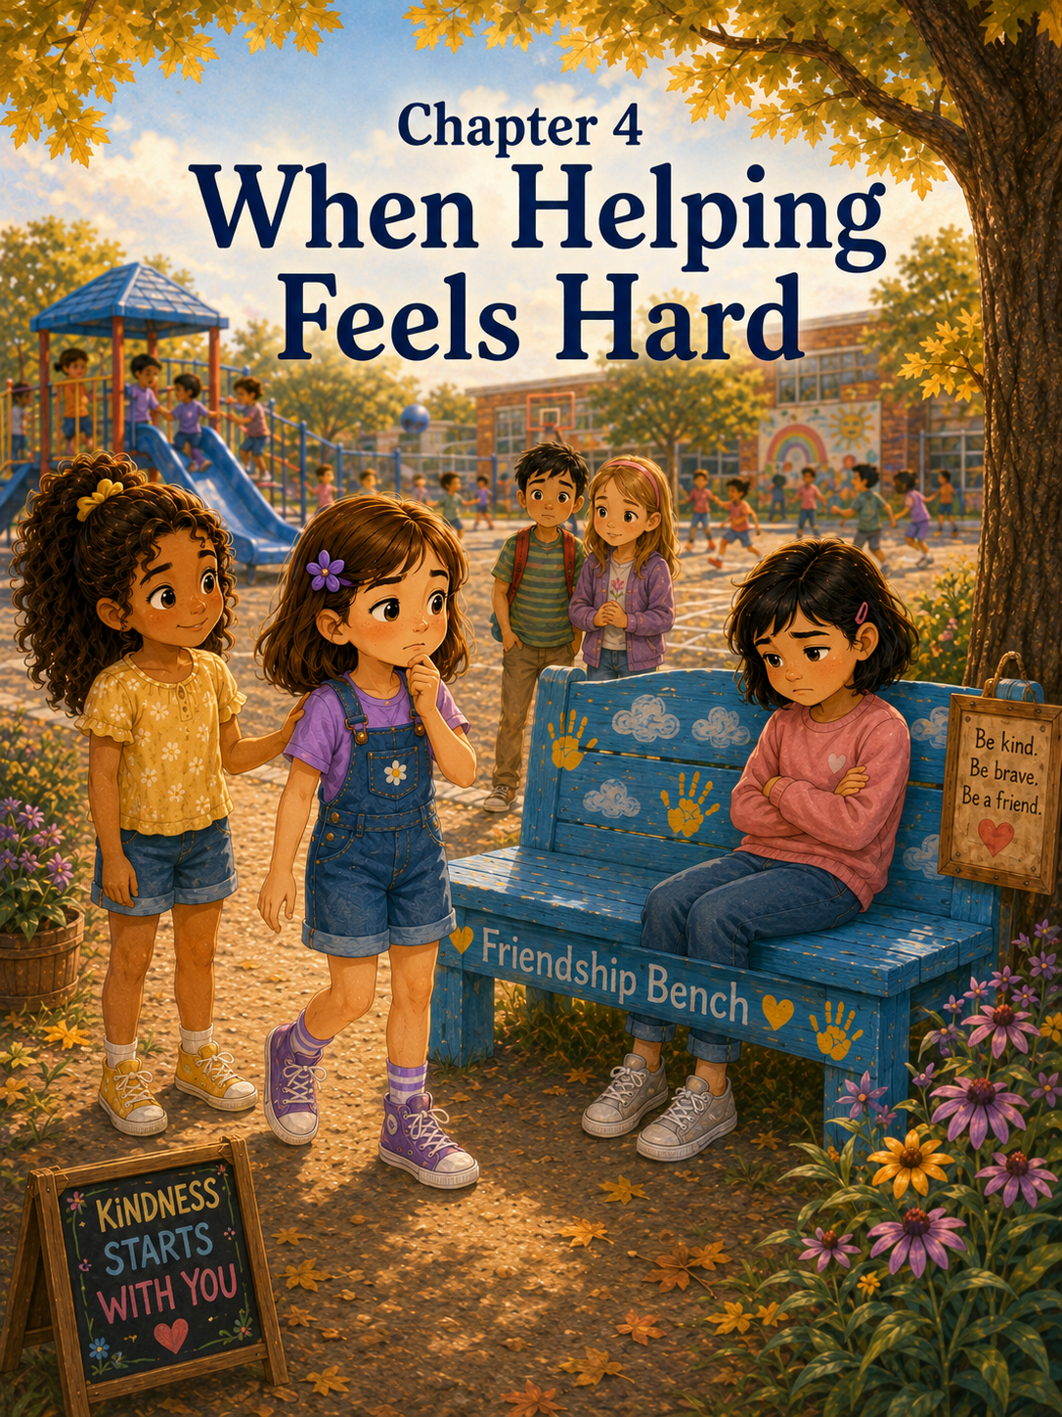Chapter 4: When Helping Feels Hard
By Thursday morning, Sally was beginning to feel like the Friendship Bench had changed the whole playground.
Not in a loud way.
Not in a way that made the swings swing higher or the soccer ball bounce straighter or the hopscotch chalk last longer.
It was different in a quieter way.
Students were looking around more.
They were noticing who stood alone.
They were asking, “Do you want to play?”
They were making room in games, even when the games were already busy.
Sally liked that.
She liked seeing Daniel smile when someone invited him to hopscotch. She liked seeing Emma Brooks join four square without standing by the fence first. She liked seeing Owen teach his volcano dinosaur game to half the playground, even though the rules seemed to grow more complicated every day.
On Wednesday, the game had one volcano.
By Thursday morning, Owen had announced there would be two volcanoes, a lava river, a safe island, and something called “the rescue cave.”
Sally did not fully understand the rescue cave, but Owen said it was very important.
At breakfast, Sally told Mom and Mark all about it.
“Owen sat on the Friendship Bench yesterday,” Sally said as she spread jelly on her toast. “He was new and missed his old friends. So we asked him to play, and then he taught us a dinosaur game.”
Mom smiled. “That sounds like a very kind recess.”
“It was,” Sally said. “And now everyone wants to play again.”
Mark leaned against the counter. “Sounds like Owen brought something special to the playground.”
“He did,” Sally said. “He knows a lot about dinosaurs.”
Patches, who had been lying under the table, suddenly lifted his head when Sally said dinosaurs, even though he had no idea what dinosaurs were.
Sally looked down at him. “You would not have survived with dinosaurs, Patches. You bark at the vacuum cleaner.”
Patches wagged his tail proudly.
Mom laughed and placed Sally’s lunchbox beside her backpack. “It sounds like the Friendship Bench is helping students notice one another.”
Sally nodded. “I think it is.”
She felt proud when she said it.
Not the bragging kind of proud.
More like the warm kind.
The kind that made her feel as if something good was happening and she had been part of it.
At school, Mrs. Carter began the morning by asking the class to share examples of kindness they had noticed that week.
Hands went up quickly.
Emma said, “Daniel helped me find the jump rope.”
Daniel said, “Sally and Maria asked Owen to play.”
Owen said, “Emma Brooks made room for me in line.”
Maria said, “People are starting to look around more at recess.”
Mrs. Carter wrote their answers on the board.
Then she turned to the class.
“These are wonderful examples,” she said. “But I want you to remember something important. Helping someone is not always easy. Sometimes we may feel unsure. Sometimes we may worry about saying the wrong thing. Sometimes we may not know what another person needs.”
Sally listened carefully.
Mrs. Carter continued, “Kindness does not mean we always know exactly what to do. Kindness means we care enough to try, listen, and learn.”
Sally liked that sentence, but she did not know yet how much she would need it.
The morning passed quickly. The class practiced spelling words, read a story about a lost puppy finding its way home, and worked on addition problems with carrying. Sally had to erase one math problem three times because her numbers leaned into each other like they were whispering secrets.
When recess finally came, everyone seemed ready to run.
The class lined up at the door.
“Remember,” Mrs. Carter said, “safe bodies, kind words, and watching eyes.”
Sally smiled. Watching eyes sounded funny, but she knew what Mrs. Carter meant.
Notice.
Ask.
Include.
Outside, the playground was bright with sunshine. A cool breeze moved through the maple tree, and the blue Friendship Bench sat beneath it with a few leaves scattered around its legs.
Owen ran past Sally immediately.
“Volcano dinosaurs!” he called. “We need herbivores!”
Maria looked at Sally. “Do you want to be a kindness raptor again?”
Sally laughed. “I think I have to. It is my official dinosaur job now.”
Emma Brooks joined them near the slide, where Owen was already explaining the new rules.
“This is the first volcano,” Owen said, pointing to the slide. “The climbing bars are the second volcano. The red ball is lava. The chalk circle is still the safe island, but now the rescue cave is over there by the tree.”
Emma raised her hand. “What happens in the rescue cave?”
“You rescue people,” Owen said, as if that should have been obvious.
Maria nodded seriously. “Of course.”
Sally tried not to giggle.
Soon the game began. Children ran from the volcano to the safe island, avoiding the rolling lava ball. Daniel froze dramatically whenever the lava came anywhere near him, even if it was at least six feet away.
“I have been lava-ed from a distance!” Daniel shouted.
“That is not a rule,” Owen called.
“It is for dramatic dinosaurs,” Daniel said.
Sally laughed so hard she almost forgot to rescue him.
For a while, recess felt easy.
Then Sally noticed the bench.
Someone was sitting there.
A girl.
Sally did not know her name, but she recognized her from another class. The girl had short dark hair, a pink sweatshirt, and silver sneakers. She sat very still on the Friendship Bench with her arms folded across her chest.
She was not crying.
She was not looking down.
She was looking straight ahead.
Sally stopped running.
The red ball rolled past her foot.
“Sally!” Owen called. “The lava!”
But Sally barely heard him.
She looked at the girl on the bench.
A few children walked past without stopping. One student glanced over, then kept going. Another child ran by chasing a soccer ball.
No one sat beside her.
No one asked if she wanted to play.
Sally felt that familiar tug in her heart.
She should go over.
That was what the bench was for.
She had helped Daniel. She had helped Emma Brooks. She had helped Owen.
But this time felt different.
The girl did not look shy like Daniel.
She did not look lonely like Emma Brooks.
She did not look sad like Owen.
She looked… annoyed.
Maybe angry.
Maybe like she did not want anyone near her.
Sally took one step toward the bench.
Then she stopped.
What if the girl did not want help?
What if Sally asked her to play and the girl snapped, “Leave me alone”?
What if Sally made things worse?
What if she said the wrong thing?
Maria came up beside her. “What are you looking at?”
Sally nodded toward the bench.
Maria saw the girl. “Oh.”
“She’s sitting there,” Sally said.
Maria nodded. “Yes.”
“But she doesn’t look like she wants anyone to talk to her.”
Maria was quiet for a moment. “Maybe she does. Maybe she doesn’t.”
“That is not helpful,” Sally said.
“I know,” Maria said. “Sorry.”
Sally watched the girl fold her arms tighter.
Emma Brooks joined them. “Should we ask her?”
Sally swallowed. “I don’t know.”
That was the truth.
She wanted to be kind.
She wanted to help.
But suddenly kindness felt like stepping onto a wobbly bridge.
Behind them, Owen called, “Kindness raptor! We need you!”
Sally turned back toward the game.
The girl was still on the bench.
Sally’s feet stayed in place.
Then the girl stood up.
She did not look at anyone. She walked quickly away from the bench and toward the far end of the playground. A moment later, she disappeared into the line near the water fountain.
Sally’s stomach sank.
She had missed it.
“She left,” Emma Brooks said softly.
Sally nodded.
Maria touched Sally’s arm. “Maybe she just needed a minute.”
“Maybe,” Sally said.
But she did not feel better.
For the rest of recess, Sally tried to keep playing volcano dinosaurs, but it was not the same. She ran when she was supposed to run. She rescued Daniel when he was “lava-ed” from across the playground. She laughed once when Patches came into her mind because Owen named a pretend dinosaur “Barkasaurus.”
But part of Sally kept looking toward the bench.
It was empty now.
Too empty.
When the bell rang, Sally walked inside quietly.
Mrs. Carter noticed. Of course she did.
During water break, she came over to Sally’s desk.
“You seem thoughtful,” Mrs. Carter said.
Sally looked down at her hands. “Someone sat on the bench today.”
Mrs. Carter pulled up a chair beside her. “I saw.”
“I was going to ask if she was okay,” Sally said. “But I didn’t.”
Mrs. Carter’s voice stayed gentle. “What stopped you?”
Sally picked at the corner of her notebook. “She looked like she might not want help. She looked upset. I didn’t know what to say.”
“That can feel hard,” Mrs. Carter said.
“I think I should have gone,” Sally whispered.
Mrs. Carter thought for a moment.
“Sally, it is good that you noticed. That matters. And it is also true that sometimes we are not sure what to do right away. Kindness takes practice.”
Sally looked up. “But what if she needed someone and I didn’t help?”
Mrs. Carter’s face softened. “Then you can try again next time. Helping does not have to be perfect.”
Sally repeated the words in her mind.
Helping does not have to be perfect.
Mrs. Carter continued, “There are many ways to help. Sometimes we invite someone to play. Sometimes we ask, ‘Would you like company?’ Sometimes we give someone space. Sometimes we tell a teacher, especially if someone seems very upset.”
Sally nodded slowly.
“I could have told you,” she said.
“Yes,” Mrs. Carter said. “That would have been a caring choice too.”
Sally felt a little better, but not completely.
“What was her name?” she asked.
“Her name is Nora,” Mrs. Carter said. “She is in Mrs. Allen’s class.”
“Nora,” Sally repeated.
Mrs. Carter smiled. “You may have another chance to be kind to Nora. Not because you must fix anything, but because you are learning to notice.”
That afternoon, Sally thought about Nora during silent reading.
She thought about Nora during handwriting.
She thought about Nora while packing her folder.
By the time Mom picked her up, Sally was quieter than usual.
Mom noticed before they even reached the car.
“Hard day?” Mom asked.
“Not exactly,” Sally said.
Once she buckled her seat belt, the whole story came out.
She told Mom about the girl in the pink sweatshirt.
She told her how Nora sat on the bench with her arms folded.
She told her how she wanted to help but felt too unsure.
She told her how Nora left before Sally said anything.
Mom listened the whole time without interrupting.
When Sally finished, she looked out the window.
“I think I failed the Friendship Bench,” she said.
Mom pulled into the driveway and parked the car. Then she turned around to face Sally.
“Oh, sweetheart,” Mom said. “You did not fail.”
“I didn’t help.”
“You noticed,” Mom said. “And you cared. That is not failure.”
Sally unbuckled slowly. “But caring didn’t do anything.”
Mom was quiet for a moment. “Caring is where kindness begins. But you are right that kindness often needs an action too. Sometimes the action comes right away. Sometimes we think about it and do better the next time.”
Inside the house, Patches greeted Sally as if she had been gone for three years instead of one school day. He wagged, wiggled, and tried to lick her chin while she knelt to pet him.
“Patches would never sit on a Friendship Bench,” Sally said.
Mark walked in from the hallway. “Why not?”
“He would jump on everyone and demand friendship immediately.”
Mark laughed. “That sounds accurate.”
At dinner, Sally told Mark about Nora too.
Mark listened carefully as he twirled spaghetti onto his fork.
“So,” he said, “you saw someone who might need help, and you weren’t sure what kind of help she needed.”
Sally nodded. “What if she wanted to be alone?”
“That is possible,” Mark said.
“What if she wanted someone to ask her to play?”
“That is also possible.”
Sally sighed. “That is the problem.”
Mark smiled gently. “Then maybe the best first step is not to fix it. Maybe the first step is simply to ask a question.”
Sally looked up. “Like what?”
“Something small,” Mark said. “‘Do you want company?’ or ‘Would you like to play, or would you rather sit for a minute?’ That gives the other person a choice.”
Mom nodded. “Kindness is not forcing help. Kindness is offering care.”
Sally thought about that as she pushed a noodle around her plate.
Offering care.
That sounded less scary than fixing everything.
“What if I say it wrong?” Sally asked.
Mark set down his fork.
“Then you try to be gentle and honest,” he said. “You can say, ‘I’m not sure what to say, but I wanted to check on you.’ That is caring.”
Sally looked at him. “That’s allowed?”
“Of course,” Mark said. “You don’t have to have perfect words to be kind.”
Mom reached across the table and squeezed Sally’s hand.
“Kindness does not have to be perfect,” she said. “It just has to be caring.”
Sally sat very still.
That felt important.
Kindness does not have to be perfect.
It just has to be caring.
After dinner, Sally took Patches into the backyard. The evening air was soft, and the sky was turning peach and purple. Patches sniffed every corner of the grass as if he had never seen the yard before.
Sally sat on the back step and watched him.
“Patches,” she said, “what would you do if someone was sitting on the Friendship Bench?”
Patches looked at her, then picked up a stick.
“You would bring them a stick,” Sally said. “That might not help.”
Patches wagged proudly.
Sally smiled.
Maybe Patches did not have perfect ideas either.
But he had a caring heart.
The next morning, Sally woke up with a plan.
Not a big plan.
Not a perfect plan.
Just a small one.
If she saw Nora again, she would not rush. She would not try to fix everything. She would not pretend she knew exactly what Nora needed.
She would start with something simple.
Hi. I’m Sally. Would you like company?
That was all.
At school, Sally told Maria the plan before class started.
Maria listened carefully.
“I like that,” Maria said. “It gives Nora a choice.”
“That’s what Mark said,” Sally replied.
Emma Brooks joined them at their desks. “What are we talking about?”
Sally explained.
Emma Brooks nodded. “Sometimes I want someone to ask me to play. But sometimes I want a quiet minute first.”
“Exactly,” Sally said.
Mrs. Carter began the morning with a kindness question on the board:
What can we do when helping feels hard?
Sally stared at the sentence.
Then she began to write.
When helping feels hard, I can take one small step. I can ask a kind question. I can listen. I can tell a teacher. I do not need perfect words. I just need to care.
Sally read it over.
It sounded true.
At recess, the playground was loud and busy as usual. Owen’s volcano dinosaur game now included a rescue cave, two volcanoes, and a rule about flying dinosaurs needing landing permission.
Sally joined for a few minutes, but she kept looking toward the bench.
For a while, it stayed empty.
Then, near the middle of recess, Nora walked across the playground.
She wore the same silver sneakers, but today her sweatshirt was yellow. She slowed near the Friendship Bench.
Sally’s heart began to thump.
Nora sat down.
Again, she folded her arms.
Again, children walked past.
Again, Sally felt unsure.
But this time, she remembered.
Kindness does not have to be perfect.
It just has to be caring.
Sally looked at Maria.
Maria gave her an encouraging nod.
Sally took one careful step.
Then another.
She walked to the Friendship Bench and stopped a few feet away.
Nora looked up.
Her face was guarded, but not unkind.
“Hi,” Sally said. “I’m Sally.”
Nora did not say anything for a moment.
Then she said, “I’m Nora.”
Sally nodded. Her hands felt a little sweaty.
“I saw you sitting here,” Sally said. “I wasn’t sure if you wanted to play or wanted a quiet minute.” She took a tiny breath. “Would you like company?”
Nora looked surprised.
Then she looked down at her shoes.
“I don’t know,” she said.
Sally nodded again. “That’s okay.”
She did not move closer.
She did not ask too many questions.
She did not try to pull Nora into a game.
She waited.
After a moment, Nora said, “I got in an argument with my friend.”
“Oh,” Sally said. “That feels bad.”
Nora nodded. “She said I couldn’t be the leader in our game because I was leader yesterday. But I had a new idea.”
Sally thought about Owen and all his new rules. She understood wanting to share an idea.
“That sounds frustrating,” Sally said.
Nora looked at her. “I wasn’t trying to be bossy.”
Sally sat carefully on the far end of the bench. “Sometimes people think I’m being bossy when I just have a plan.”
Nora glanced at her. “Really?”
“Yes,” Sally said. “I have a lot of plans.”
Nora smiled a little.
Sally smiled too.
They sat quietly for a moment.
Then Sally asked, “Do you want to go back to your friend? Or do you want to sit a little longer?”
Nora looked toward a group of girls near the swings.
“I think I want to sit a little longer,” she said.
“Okay,” Sally said.
So they sat.
They did not talk much.
They did not solve the argument.
They did not turn the moment into a big cheerful game.
But Sally stayed.
After a while, Nora took a deep breath.
“I might talk to her after recess,” she said.
“That sounds brave,” Sally said.
Nora nodded. “Maybe.”
When the bell rang, Nora stood.
“Thanks,” she said.
“For what?” Sally asked.
“For not making me play right away.”
Sally smiled. “You’re welcome.”
As they walked inside, Mrs. Carter caught Sally’s eye.
She did not say anything.
She simply smiled.
And Sally knew.
This had been kindness too.
Not the kind with running games and laughter and lots of children joining in.
This was quieter.
This was sitting beside someone without pushing.
This was asking a gentle question.
This was learning that help could look different for different people.
That afternoon, Sally wrote in her journal again.
Today I learned that helping feels hard when you do not know what someone needs. But I can still be kind. I can ask. I can listen. I can give space. I can stay nearby. Kindness does not have to be perfect. It just has to be caring.
Sally looked at the words and felt the warm kind of proud again.
Not because she had fixed everything.
She had not.
Not because she had said everything perfectly.
She had not.
But because she had tried with a caring heart.
And sometimes, Sally was learning, that was exactly where kindness began.

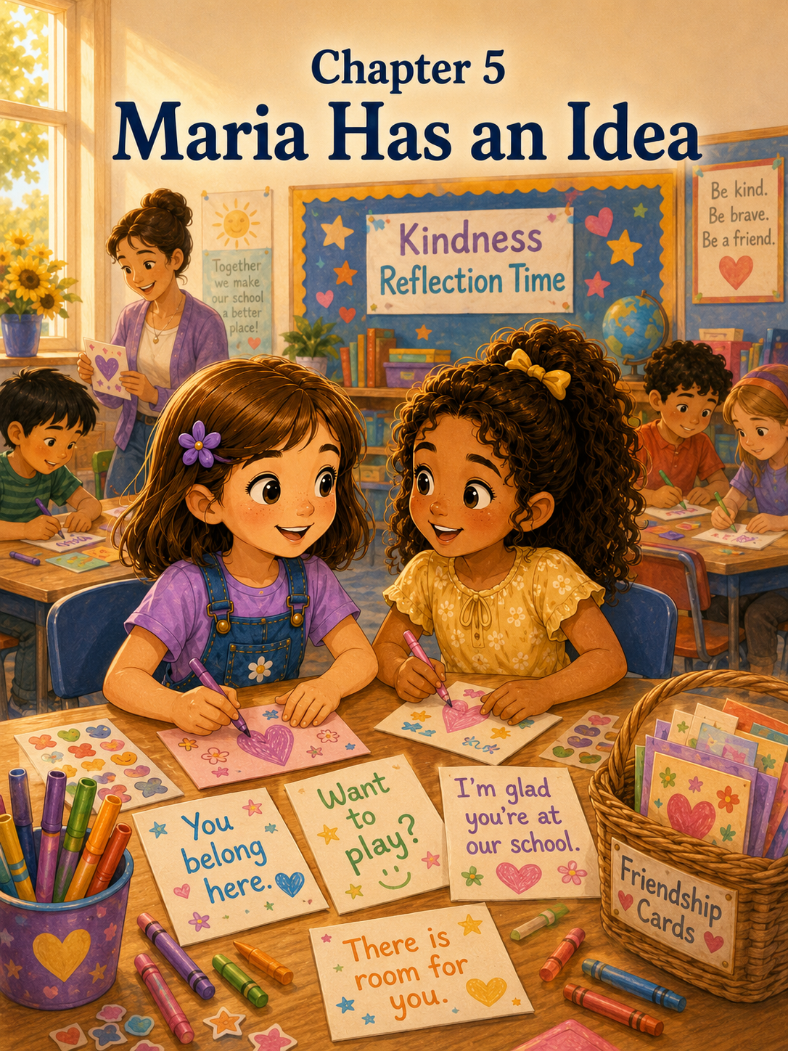Chapter 5: Maria Has an Idea
By Friday morning, Sally had learned that friendship could look many different ways.
Sometimes friendship looked like inviting someone to play hopscotch.
Sometimes it looked like asking a classmate to join four square.
Sometimes it looked like learning a new dinosaur game from someone who missed his old friends.
And sometimes, Sally had learned, friendship looked like sitting quietly beside someone on the Friendship Bench without trying to fix everything.
That last kind of friendship had surprised Sally.
Nora had not needed a game right away. She had not needed Sally to cheer loudly or gather a group or solve her problem. Nora had needed space, a gentle question, and someone willing to sit nearby.
Sally thought about that while she packed her backpack.
She placed her homework folder inside, then her library book, then her pencil pouch with the purple zipper. She checked to make sure her journal was there too. Lately, Mrs. Carter had been giving the class a few minutes to write about kindness and friendship, and Sally liked having her thoughts in one place.
Patches trotted into the room with one of Sally’s socks in his mouth.
“Patches,” Sally said, putting her hands on her hips, “that is not yours.”
Patches wagged his tail.
Sally reached for the sock, but Patches backed up and gave her a look that seemed to say, Are you sure?
“Yes, I’m sure,” Sally said. “You have toys.”
Patches dropped the sock and immediately picked up a squeaky bone instead.
“Better,” Sally said.
Mom appeared in the doorway. “Ready for school?”
“Almost,” Sally said. “I was thinking.”
Mom smiled. “About the Friendship Bench?”
Sally nodded. “Nora sat there again yesterday.”
“The girl you told me about?”
“Yes,” Sally said. “I asked if she wanted company. She didn’t want to play. She just wanted to sit for a little while.”
Mom’s face softened. “That was thoughtful of you.”
“I almost tried to ask her to play,” Sally admitted. “But then I remembered that kindness does not have to be perfect. It just has to be caring.”
Mom smiled. “That sounds like something important.”
“It is,” Sally said. “I think I’m learning that people need different kinds of friendship.”
Mom nodded. “That is a wise thing to learn.”
Sally zipped her backpack. “I wonder what will happen with the bench today.”
Mom kissed the top of her head. “Whatever happens, keep noticing.”
Sally smiled. “I will.”
At school, the Friendship Bench sat quietly under the maple tree, just as it had all week. The blue paint looked cheerful in the morning light. The yellow handprints seemed to wave at everyone who walked by.
Sally paused near the fence.
“Good morning, Friendship Bench,” she whispered.
Maria walked up beside her, holding a folder decorated with butterfly stickers.
“Still saying good morning to the bench?” Maria asked.
“Yes,” Sally said. “It’s polite.”
Maria giggled. “Good morning, bench.”
The girls walked inside together.
Room 12 felt especially happy that morning because it was Friday. Friday always made the classroom feel a little lighter. Even the pencils seemed less tired. Mrs. Carter had written the day’s schedule on the board, and near the bottom, in purple marker, were the words:
Kindness Reflection Time
Sally noticed them right away.
After morning announcements and spelling review, Mrs. Carter invited the class to sit on the rug.
“This week,” she said, “we have been learning how to use the Friendship Bench with kindness and care. We have talked about noticing, asking, and including. Today, I want us to think about something else.”
She wrote one word on the board:
Welcome
“What does it mean to help someone feel welcome?” Mrs. Carter asked.
Emma raised her hand. “It means letting them join your game.”
Daniel said, “It means saying hi.”
Owen said, “It means letting them teach you a game if they know one.”
Everyone smiled because Owen’s volcano dinosaur game had become very popular.
Emma Brooks raised her hand. “It means making room.”
Maria raised her hand next. “It means helping someone feel like they belong.”
Mrs. Carter’s smile warmed. “That is a beautiful way to say it, Maria.”
Sally looked at Maria and smiled too.
Mrs. Carter turned back to the board and wrote:
Welcome means helping someone feel like they belong.
Sally copied the sentence into her notebook. She liked how it sounded. It felt gentle and strong at the same time.
The rest of the morning moved along quickly. The class read a story about two children building a bridge out of blocks. At first, each child wanted to build the bridge their own way. One wanted tall towers. The other wanted a long road. But when they listened to each other, they built a bridge that was better than either idea alone.
“Working together can make an idea grow,” Mrs. Carter said.
Sally underlined that in her notebook.
Working together can make an idea grow.
At recess, Sally and Maria walked outside together. The playground was full of Friday energy. Children ran toward their favorite spots, calling names, making plans, and laughing in the sunshine.
Owen waved from near the slide. “Volcano dinosaurs today! We added a bridge over lava!”
Maria looked at Sally. “That sounds exciting.”
“And complicated,” Sally said.
They were about to join when Sally looked toward the Friendship Bench.
It was empty.
No one sat there.
No one stood nearby.
For a moment, Sally felt relieved. Then she felt something else.
“What happens when no one is sitting there?” Sally asked.
Maria tilted her head. “What do you mean?”
“I mean, the bench helps when someone sits on it,” Sally said. “But what about kids who are too nervous to sit there? Or kids who don’t know what it means? Or kids who just stand by the fence like Emma Brooks did?”
Maria looked across the playground thoughtfully.
“That is a good question,” she said.
Sally watched a group of younger students run past the bench without looking at it. A few children seemed to know what it was for, but others barely noticed it.
“I like the bench,” Sally said. “But maybe it needs help.”
Maria’s eyes brightened.
Sally knew that look.
Maria had an idea.
“We could make friendship cards,” Maria said.
“Friendship cards?” Sally asked.
“Yes,” Maria said. “Little cards with kind messages on them. We could give them to people who sit on the bench, or to new students, or to someone who looks unsure. The cards could say things like, ‘You belong here.’”
Sally’s face lit up. “That’s a wonderful idea.”
Maria smiled. “Or ‘Want to play?’”
“Or ‘I’m glad you’re at our school,’” Sally added.
Maria clapped her hands once. “Yes!”
Sally looked toward Mrs. Carter, who was standing near the blacktop watching students play.
“We should ask Mrs. Carter,” Sally said.
“Now?” Maria asked.
Sally nodded. “Before Owen turns us into lava dinosaurs.”
The girls walked over to Mrs. Carter.
“Mrs. Carter?” Sally asked.
“Yes, Sally?”
“Maria has an idea,” Sally said.
Maria looked suddenly shy. “Well, it’s just a small idea.”
Mrs. Carter smiled. “Small ideas can grow into wonderful things.”
Maria took a breath. “We were thinking about the Friendship Bench. Some people might be too nervous to sit there or might not know what to say. So maybe we could make little friendship cards with kind messages. We could use them to help people feel welcome.”
Mrs. Carter’s eyes softened. “Maria, that is a thoughtful idea.”
Sally added, “The cards could say things like ‘You belong here’ and ‘Want to play?’”
“And ‘I’m glad you’re at our school,’” Maria said.
Mrs. Carter looked toward the bench. “I like this very much. Cards can be a gentle way to start a conversation.”
“Can we make them?” Sally asked.
“I think we can,” Mrs. Carter said. “Let’s talk about it during Kindness Reflection Time this afternoon.”
Maria grinned.
Sally felt excited.
When they returned to the playground, Owen waved them over.
“You’re late,” he said seriously. “The volcano almost erupted without you.”
“That would have been terrible,” Sally said.
“We were talking to Mrs. Carter,” Maria explained. “About friendship cards.”
Owen frowned thoughtfully. “Can dinosaurs get friendship cards?”
“Maybe,” Sally said. “If they use kind words.”
Daniel ran up beside them. “Can my dinosaur get one that says, ‘Sorry you were lava-ed’?”
Maria laughed. “Maybe.”
The rest of recess passed quickly. Sally played volcano dinosaurs, but her mind kept filling with card ideas. She imagined colorful paper, cheerful drawings, and kind words that someone could hold in their hand.
At lunch, Sally sat with Maria, Emma, Emma Brooks, and Ava. Maria told them about the friendship card idea.
Emma loved it right away.
“I can draw stars on mine,” she said.
Emma Brooks smiled. “I want to make one that says, ‘There’s room for you.’”
Ava nodded. “That’s good.”
Sally opened her milk carton carefully. “Maybe we can make different kinds of cards. Some for inviting people to play. Some for sitting with someone. Some for welcoming new students.”
Maria took a bite of her sandwich and nodded. “And maybe some blank ones so students can write their own messages.”
“That’s a good idea,” Emma Brooks said. “Because sometimes you want to say something special.”
Sally looked around the lunch table.
The idea was already growing.
It was not just Maria’s idea anymore.
It was becoming everyone’s idea.
After lunch, Mrs. Carter announced Kindness Reflection Time.
The class cheered softly. They had learned that reflection time sometimes meant writing, sometimes talking, and sometimes making something with markers and paper.
Today, Mrs. Carter placed stacks of small index cards on each table. There were crayons, markers, stickers, and colored pencils in baskets.
“Maria and Sally brought me an idea at recess,” Mrs. Carter said. “They wondered if our Friendship Bench could have friendship cards. These cards can help us welcome others, invite someone to play, or remind a classmate that they belong.”
Students leaned forward with interest.
Mrs. Carter held up a blank card. “Before we begin, let’s talk about what these cards should be.”
She wrote on the board:
Kind
Helpful
Respectful
Not silly in a hurtful way
“These cards are not for teasing,” Mrs. Carter said. “They are not for jokes that make someone feel embarrassed. They are for kindness.”
Marcus raised his hand. “Can mine be funny if it’s still nice?”
“Yes,” Mrs. Carter said. “Gentle funny is fine.”
Owen raised his hand. “Can mine have a dinosaur?”
“Of course,” Mrs. Carter said.
Owen looked pleased.
Mrs. Carter wrote some sentence ideas on the board:
You belong here.
Want to play?
I’m glad you’re at our school.
There is room for you.
You can sit with us.
Would you like company?
You are not alone.
Come join us!
Sally read the messages slowly.
Some were cheerful.
Some were gentle.
Some felt like a hand reaching out.
Mrs. Carter continued, “You may use these messages or create your own. Think about what words might help someone feel seen, included, and safe.”
Sally picked up a card and a purple marker.
At the top, she wrote:
You belong here.
Then she drew the blue Friendship Bench under a maple tree. She added yellow handprints, green grass, and three smiling children standing nearby.
Maria sat beside her, drawing tiny hearts around the words:
Want to play?
Emma drew stars around:
There’s room for you.
Emma Brooks made a card that said:
I can walk with you.
Sally paused when she saw that one.
“I like that,” she said.
Emma Brooks shrugged shyly. “Sometimes walking feels easier than playing right away.”
Sally nodded. “That’s true.”
Across the room, Owen was drawing a dinosaur wearing a tiny backpack. His card said:
New friends are welcome.
Daniel leaned over to look. “Your dinosaur needs a hat.”
“It does not,” Owen said.
“It definitely does,” Daniel replied.
Mrs. Carter walked by and smiled. “Remember, kind suggestions.”
Daniel thought for a second. “Your dinosaur might enjoy a hat if it wants one.”
Owen considered that. “Fine. A small hat.”
The class laughed.
Soon, the room was full of quiet creativity. Markers moved across cards. Stickers peeled from sheets. Students asked each other for spelling help.
“How do you spell company?” Ava asked.
“C-O-M-P-A-N-Y,” Mrs. Carter answered.
“Like the sentence ‘Would you like company?’” Ava asked.
“Yes,” Mrs. Carter said. “That is a very caring question.”
Sally made another card. This one said:
Would you like to sit together?
She drew two children on a bench with space between them, because she remembered how Nora had needed space at first.
Maria looked at the card. “That’s a good one.”
“I thought of Nora,” Sally said quietly.
Maria nodded. “She might like that.”
Sally hoped so.
After everyone made several cards, Mrs. Carter gathered them into a small basket. The basket was light brown with a blue ribbon tied around one handle.
“We will keep this basket near the playground door,” Mrs. Carter said. “Before recess, students may choose a card if they think it might help someone feel welcome. But remember, the card is only part of kindness. Your voice, your actions, and your listening matter too.”
Sally looked at the basket.
It was full of colors, words, and drawings.
It made her happy.
But it also made her think.
The cards were not magic either, just as the bench was not. A card could not make friendship happen all by itself. Someone still had to give it. Someone still had to care. Someone still had to make room.
Still, the cards could help.
They could make the first words easier.
At the end of the day, Mrs. Carter gave each student one blank card to take home.
“Tonight,” she said, “you may make one more friendship card if you would like. Think carefully about what message someone might need to hear.”
Sally tucked her blank card carefully into her folder.
That evening, after dinner, Sally spread markers across the kitchen table. Patches lay under her chair, chewing his toy bone.
Mom washed dishes while Mark dried them.
“What are you working on?” Mom asked.
“A friendship card,” Sally said. “Maria had the idea.”
“She did?” Mark asked.
“Yes. For the Friendship Bench. We made cards at school today with kind messages.”
Mom smiled. “That sounds lovely.”
Sally looked down at her blank card. “I’m trying to decide what to write.”
“What messages did you already make?” Mom asked.
Sally counted on her fingers. “You belong here. Would you like to sit together? Want to play? I’m glad you’re at our school.”
“Those are wonderful,” Mom said.
Sally tapped the purple marker against her chin.
Then she thought about Daniel.
She thought about Emma Brooks.
She thought about Owen.
She thought about Nora.
They had all needed different things.
A game.
An invitation.
A chance to share.
A quiet place to sit.
Sally picked up her marker and wrote slowly:
I’m here if you need a friend.
She looked at the words.
They felt simple.
They felt true.
She decorated the card with tiny purple flowers, yellow stars, and a small drawing of the blue bench under the maple tree.
Mark leaned over to look. “That is a good message.”
Sally smiled. “It doesn’t make anyone play if they don’t want to.”
“No,” Mom said. “It offers care.”
Sally nodded. “That’s what kindness does.”
The next morning, Sally brought her card to school. Maria was waiting near the playground fence.
“I made one at home too,” Maria said.
She showed Sally a card decorated with butterflies. It said:
You are welcome with us.
Sally smiled. “That’s beautiful.”
“So is yours,” Maria said.
Together, they walked into Room 12 and placed their cards in the basket.
By recess, the basket was full again. Mrs. Carter let each student choose one card to carry outside if they wanted to.
Sally chose Maria’s butterfly card.
Maria chose Sally’s card that said:
I’m here if you need a friend.
The girls tucked the cards carefully into their pockets.
Outside, the Friendship Bench waited under the maple tree.
At first, no one sat there.
Then Daniel came by and asked Sally if she wanted to play hopscotch.
Then Owen called everyone to see his “volcano bridge.”
Then Emma Brooks invited Ava to four square.
The playground felt busy and bright.
But Sally noticed something near the swings.
A younger girl stood watching a group of students play. She did not look upset, but she looked unsure. Her hands held the straps of her backpack, even though backpacks were supposed to stay inside during recess. Maybe she had forgotten. Maybe she was new. Maybe she just did not know where to go.
Sally looked at Maria.
Maria saw the girl too.
Sally touched the card in her pocket.
“Should we?” Maria asked.
Sally nodded. “Together.”
They walked over slowly.
“Hi,” Sally said. “I’m Sally.”
“I’m Maria,” Maria added.
The girl looked at them. “I’m Lily.”
Sally smiled. “Are you new?”
Lily nodded. “Today.”
Maria pulled the card gently from her pocket and held it out.
“I made this,” she said. “It says, ‘I’m here if you need a friend.’”
Lily took the card and looked at it.
Her face softened.
Sally showed her the butterfly card. “And this one says, ‘You are welcome with us.’”
Lily smiled a little. “Thank you.”
“Would you like to play with us?” Sally asked. “Or we can show you where things are.”
Lily looked around the playground. “Could you show me where the water fountain is first?”
“Sure,” Maria said.
Sally nodded. “Then we can show you the Friendship Bench.”
“What’s that?” Lily asked.
Sally looked toward the blue bench under the maple tree.
“It’s a place that helps people find friends,” she said. “But you don’t have to sit there for us to help.”
Lily looked down at the card again.
“I like that,” she said.
Sally did too.
As they walked Lily toward the water fountain, Sally felt that warm proud feeling again. But this time, the proud feeling was shared.
Maria had the idea.
Mrs. Carter helped it grow.
The class made the cards.
Sally and Maria used them together.
Friendship, Sally was learning, did not grow best when one person tried to do everything alone.
Friendship grew when people worked together.
It grew with ideas.
It grew with listening.
It grew with little cards, gentle words, and brave first steps.
And sometimes, all it took was one message in someone’s hand to help them feel like they belonged.

Chapter 6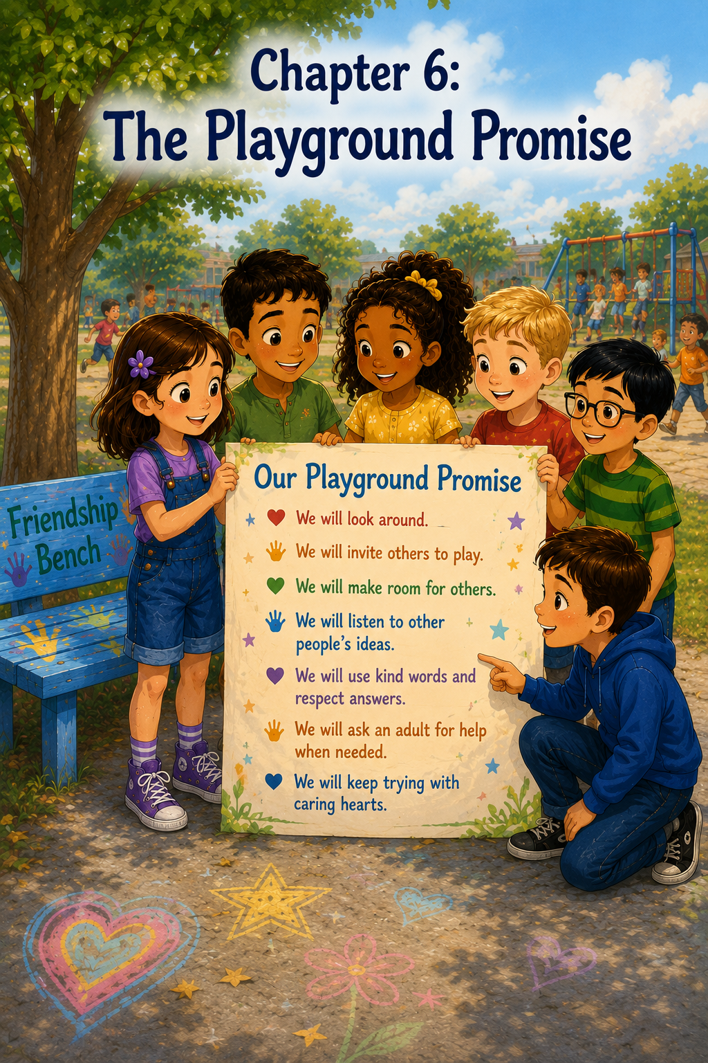:
The Playground Promise
By the next week, the Friendship Bench no longer looked like just a new bench on the playground.
To Sally, it looked like a reminder.
A blue, cheerful, quiet reminder under the maple tree.
Every time she saw it, she thought about Daniel’s small smile when he joined the game of hopscotch. She thought about Emma Brooks standing by the fence before she was invited into four square. She thought about Owen teaching everyone his volcano dinosaur game, even though he had missed his old friends. She thought about Nora needing quiet company instead of a loud game. She thought about Lily, the new girl, holding a friendship card as Maria showed her where the water fountain was.
The Friendship Bench helped.
But Sally was beginning to understand something important.
The bench could not notice people on its own.
It could not walk across the playground.
It could not say, “Would you like to play?”
It could not make room in a game.
It could not help someone feel included unless students chose to care.
On Monday morning, Sally stood near the fence before school and looked at the bench. A few maple leaves had fallen around it. One leaf sat right in the middle of the seat.
Maria walked up beside her. “Good morning, bench?”
Sally smiled. “Good morning, bench.”
Maria looked at her. “You sound thoughtful.”
“I am,” Sally said.
“About what?”
Sally pointed to the bench. “I think the Friendship Bench is good, but I don’t think it can do everything.”
Maria nodded slowly. “Because some people might not sit there?”
“Yes,” Sally said. “Or they might stand by the fence. Or walk around alone. Or pretend they’re fine when they aren’t.”
Maria looked across the playground. “Like Emma Brooks did.”
“And like Nora, who needed something different,” Sally added.
Maria was quiet for a moment. Then she said, “Maybe the bench needs helpers.”
Sally turned to her. “Helpers?”
“Not official helpers,” Maria said quickly. “Not like we wear badges and tell everyone what to do.”
Sally laughed. “That might be too much.”
“But maybe we can make a promise,” Maria said. “A playground promise.”
Sally liked the sound of that right away.
“What kind of promise?” she asked.
Maria thought for a moment. “A promise that no one should feel invisible at recess.”
Sally’s smile faded, but in a good way. A serious way.
Invisible.
That was the right word.
Sometimes children were not alone, but they felt unseen. They stood beside games. They walked near groups. They waited at the edge of laughter. Everyone passed by, but no one noticed.
“No one should feel invisible,” Sally repeated.
The first bell rang.
Maria picked up her backpack. “We should tell Mrs. Carter.”
Sally nodded. “And maybe Emma and Emma Brooks too.”
“And Owen,” Maria said.
“And Daniel,” Sally added.
Maria grinned. “And maybe Nora, if she wants.”
Sally smiled. “If she wants.”
They hurried inside.
Room 12 was busy with Monday morning sounds. Backpacks zipped. Chairs slid. Pencils sharpened. Students talked about weekends, soccer games, cartoons, pancakes, and one mysterious lost tooth that Marcus claimed had disappeared before the Tooth Fairy could find it.
Mrs. Carter stood by the door greeting everyone.
“Good morning, Sally. Good morning, Maria.”
“Good morning,” Sally said.
Maria took a breath. “Mrs. Carter, we have an idea.”
Mrs. Carter smiled. “That sounds promising.”
“It is a promise,” Sally said.
Mrs. Carter raised her eyebrows kindly. “Now I’m very interested.”
Maria looked at Sally, and Sally nodded for her to explain.
“We were thinking about the Friendship Bench,” Maria said. “It helps people, but only if other students notice.”
Sally added, “And some people might feel lonely but not sit on the bench.”
Maria continued, “So maybe our class could make a playground promise.”
Mrs. Carter tilted her head. “What would the promise be?”
Sally straightened a little. “That no one should feel invisible at recess.”
Mrs. Carter’s face softened.
“That is a very thoughtful idea,” she said. “Let’s talk about it during morning meeting.”
Sally felt a flutter of excitement.
During morning meeting, the class gathered on the rug. Mrs. Carter sat in her chair and held up the little basket of friendship cards.
“This week,” she began, “we have seen how small acts of kindness can change recess. Today, Sally and Maria brought me an idea about making a playground promise.”
Students turned to look at them.
Sally suddenly wished the rug would become a tiny door she could slip through.
Maria looked nervous too, but she smiled.
Mrs. Carter asked, “Would you like to share your idea?”
Sally swallowed. “We were thinking that the Friendship Bench works best when people notice each other.”
Maria added, “Because some people sit on the bench, but some people might be lonely somewhere else.”
“Like by the fence,” Emma Brooks said softly.
Sally looked over at her. Emma Brooks gave a small smile.
“Right,” Sally said. “So we thought maybe we could make a promise that no one should feel invisible at recess.”
The room grew quiet.
Not a bored quiet.
A thinking quiet.
Mrs. Carter wrote the words on the board:
No one should feel invisible at recess.
Owen raised his hand. “Does invisible mean like a superhero power?”
A few students giggled.
Mrs. Carter smiled. “That is one kind of invisible. But Sally and Maria mean feeling unseen, as if people do not notice you or include you.”
Owen nodded seriously. “That is not a good power.”
“No,” Mrs. Carter said gently. “It is not.”
Daniel raised his hand. “When I sat on the bench, I felt kind of invisible until Sally came over.”
Sally looked down at her hands. She felt shy, but also glad Daniel could say that.
Emma Brooks raised her hand next. “When I stood by the fence, I wanted to play, but I didn’t know how to ask.”
Nora, who had joined Room 12 for morning meeting because Mrs. Allen’s class was helping with the Friendship Bench project too, sat near the edge of the rug. She raised her hand slowly.
“Sometimes people think you want to play right away,” Nora said. “But sometimes you just want someone to ask if you want company.”
Mrs. Carter nodded. “That is an important reminder. Not everyone needs the same kind of help.”
Maria looked at Sally. Sally knew they were both thinking the same thing.
The playground promise needed to include listening.
Mrs. Carter turned back to the board. “Let’s build this promise together. What should students promise to do?”
Emma raised her hand. “Look around.”
Mrs. Carter wrote:
We will look around.
Daniel said, “Invite people into games.”
Mrs. Carter wrote:
We will invite others to play.
Emma Brooks said, “Make room.”
Mrs. Carter wrote:
We will make room for others.
Owen said, “Let people teach their games too.”
Mrs. Carter smiled and wrote:
We will listen to other people’s ideas.
Nora said, “Use kind words even if someone says no.”
Mrs. Carter wrote:
We will use kind words and respect answers.
Sally raised her hand. “Ask a teacher if someone seems really upset or if we don’t know how to help.”
Mrs. Carter nodded. “Excellent.”
She wrote:
We will ask an adult for help when needed.
Maria raised her hand. “And we should remember that nobody has to be perfect.”
Mrs. Carter added:
We will keep trying with caring hearts.
The class looked at the list.
It was longer than Sally expected.
But she liked it.
Mrs. Carter read it aloud:
“Our Playground Promise:
We will look around.
We will invite others to play.
We will make room for others.
We will listen to other people’s ideas.
We will use kind words and respect answers.
We will ask an adult for help when needed.
We will keep trying with caring hearts.”
“That is a very strong promise,” Mrs. Carter said.
Marcus raised his hand. “Can we sign it?”
Mrs. Carter smiled. “I think that would make it even stronger.”
The class cheered.
Mrs. Carter took a large sheet of poster paper from the cabinet. At the top, she wrote in bright blue marker:
Our Playground Promise
Then she carefully copied the class list underneath.
During writing time, each student came forward and signed the poster. Some wrote in neat letters. Some wrote in wobbly letters. Owen drew a tiny dinosaur beside his name. Emma added three small stars. Maria drew a butterfly. Sally drew a little purple flower beside hers.
When Nora signed, she paused before writing her name.
Then she added a tiny silver sneaker next to it.
Sally smiled.
By the time the poster was finished, it looked like something the whole class had built together.
Mrs. Carter taped it near the classroom door where everyone could see it before going outside.
“Before recess,” she said, “we will read our promise together.”
Sally felt excited, but also a little nervous.
Promises were important.
A promise was not just something nice to say.
A promise was something you had to try to do.
When recess came, the class lined up at the door. Mrs. Carter stood beside the poster.
“Let’s read it together,” she said.
The class read:
“We will look around.
We will invite others to play.
We will make room for others.
We will listen to other people’s ideas.
We will use kind words and respect answers.
We will ask an adult for help when needed.
We will keep trying with caring hearts.”
Sally felt the words settle into her.
Then Mrs. Carter opened the door.
Outside, the playground was already busy. Other classes were lining up near the blacktop. The swings moved back and forth. A group of older students ran toward the soccer field. The Friendship Bench waited under the maple tree.
At first, everyone ran toward their favorite games.
Owen called, “Volcano dinosaurs! Today there is a lava bridge and a rescue cave!”
Daniel shouted, “I volunteer to be lava-ed!”
“That is not the goal!” Owen called back.
Sally laughed, but before joining the game, she stopped.
She looked around.
Really looked.
Maria stopped beside her.
Emma, Emma Brooks, Daniel, and Owen noticed too.
For a moment, they all stood still in the busy playground.
“What are we doing?” Daniel whispered.
“Looking around,” Maria whispered back.
Sally saw Ava and Grace walking to the swings together. They seemed happy. She saw Marcus and Noah choosing teams for soccer. She saw Nora sitting with one friend near the chalk bucket, talking quietly. She saw Lily, the new girl, standing near the blacktop with her backpack finally left inside where it belonged.
Lily was not alone this time. She was talking with Emma Brooks.
That made Sally smile.
Then Sally noticed a boy near the basketball hoop. He bounced a ball once, but no one passed it back to him. He looked toward the soccer field, then toward the swings, then back at the basketball.
Sally did not know him well. His name was Caleb, and he was in another class.
She looked at Maria.
Maria nodded.
The promise had started.
Sally walked toward Caleb with Maria beside her.
“Hi, Caleb,” Sally said.
Caleb held the basketball against his side. “Hi.”
“Do you want to play something?” Maria asked. “We’re about to play volcano dinosaurs, but it’s very complicated.”
Caleb smiled a little. “I don’t really know how.”
“No one does,” Sally said. “Only Owen.”
From across the playground, Owen shouted, “That is true!”
Caleb laughed.
“Or,” Sally said, “we could play basketball for a few minutes if you want.”
Caleb looked surprised. “Really?”
Maria shrugged. “I’m not great at basketball.”
“I am also not great,” Sally said. “But we have friendly rules.”
Caleb smiled. “Okay.”
They played a simple passing game. Sally missed the ball twice. Maria bounced it off her own foot once. Caleb made a basket and grinned.
After a few minutes, Daniel came over.
“Can I play?” he asked.
“Of course,” Caleb said.
Then Emma joined. Then Marcus came over from soccer for a turn. Soon, the basketball game had enough players.
Sally stepped back and watched.
Caleb did not look invisible anymore.
Across the playground, Maria pointed toward the Friendship Bench.
A younger girl was sitting there, holding one of the friendship cards. Emma Brooks had already noticed. She walked over slowly and sat beside the girl, leaving space between them.
Sally smiled.
Someone else had noticed.
Near the swings, Ava waved to Lily and asked if she wanted a turn. Lily nodded and joined the line.
Someone else had included.
By the chalk bucket, Nora and her friend were drawing a sign that said:
Kind Words Welcome Here
Someone else had used a caring heart.
The playground felt different.
Not perfect.
There were still arguments over turns.
Someone still shouted too loudly when the soccer ball went out.
Daniel still got “lava-ed” in dramatic ways that Owen did not approve of.
But children were looking around more.
They were making room.
They were noticing.
At the end of recess, Mrs. Carter blew her whistle gently and called the class to line up.
As Sally walked toward the door, she looked back at the Friendship Bench.
For once, she did not think it looked lonely when it was empty.
She thought it looked ready.
Ready for anyone who needed it.
Ready for anyone brave enough to sit.
Ready for anyone kind enough to notice.
Inside the classroom, Mrs. Carter asked everyone to take out their journals.
On the board, she wrote:
How did we keep our playground promise today?
Sally picked up her pencil and began to write.
Today we made a playground promise. We promised that no one should feel invisible at recess. I learned that the Friendship Bench is important, but it works best when students look around and care. Maria and I invited Caleb to play basketball. Emma Brooks helped someone on the bench. Ava invited Lily to the swings. Nora used kind words with her friend. The playground was not perfect, but it was kinder.
Sally paused and thought.
Then she added:
A promise is something we practice.
She liked that sentence.
After writing time, Mrs. Carter invited students to share.
Caleb, who had joined their class for the reflection because Mrs. Allen thought the playground promise should spread, raised his hand.
“I liked when Sally and Maria asked me to play basketball,” he said. “I was going to just bounce the ball by myself.”
Sally felt her cheeks warm.
Emma Brooks said, “I helped a girl on the bench. She wanted to sit first, then play later.”
Nora said, “I used kind words with my friend. We took turns being leader.”
Owen raised his hand. “I let Daniel add one rule to volcano dinosaurs.”
Mrs. Carter smiled. “That sounds generous.”
Owen nodded. “But only one.”
Daniel raised his hand. “It was a good rule.”
“What was it?” Mrs. Carter asked.
Daniel sat up proudly. “If you are lava-ed dramatically, someone has to rescue you dramatically.”
Mrs. Carter pressed her lips together like she was trying not to laugh. “That does sound dramatic.”
The class giggled.
Mrs. Carter then looked around the room.
“I am proud of you,” she said. “Today you learned that friendship is not one person’s job. Kindness grows when many people choose to notice, ask, include, listen, and try.”
Sally looked at Maria.
Maria smiled.
Their idea had grown again.
First, there had been the bench.
Then the friendship cards.
Now the playground promise.
Each idea helped the next one become stronger.
That afternoon, Mrs. Carter made a copy of the Playground Promise for Mrs. Allen’s class. She said maybe other classes would want to make their own promises too.
Sally liked thinking about that.
Maybe the promise could spread past Room 12.
Maybe it could spread across the whole playground.
Maybe one day, no student would have to feel invisible for very long.
When school ended, Sally walked outside with Maria.
The Friendship Bench was quiet under the maple tree. The basket of friendship cards sat just inside the playground door, ready for tomorrow. The Playground Promise poster hung in the classroom window where the afternoon sun shined through the paper.
Maria looked at Sally. “Do you think we kept the promise?”
Sally thought about Caleb smiling after making a basket. She thought about Emma Brooks sitting beside the younger girl. She thought about Lily joining the swing line. She thought about Nora and her friend taking turns.
“Yes,” Sally said. “Not perfectly. But we tried.”
Maria nodded. “With caring hearts.”
Sally smiled. “That might be the most important part.”
As Sally climbed into Mom’s car, she looked back once more at the playground.
The bench was still there.
The promise was still there.
And now Sally understood something she had not understood at first.
A Friendship Bench could help a child ask for friendship.
But a playground promise could help everyone remember to offer it.
And that made the whole playground feel a little more like a place where everyone belonged.

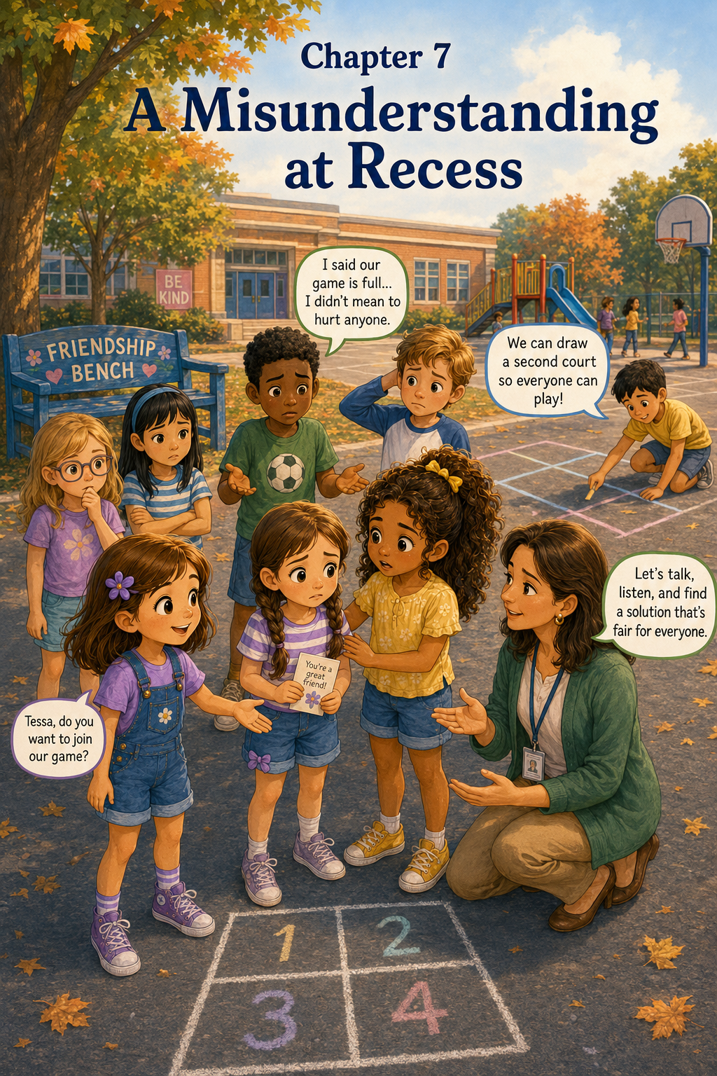Chapter 7: A Misunderstanding at Recess
By Tuesday afternoon, the Playground Promise poster had become one of the most important things in Room 12.
It hung near the classroom door where everyone could see it before going outside. The paper was covered with names, stars, flowers, butterflies, a tiny dinosaur, a silver sneaker, and Mrs. Carter’s neat blue letters.
Our Playground Promise
We will look around.
We will invite others to play.
We will make room for others.
We will listen to other people’s ideas.
We will use kind words and respect answers.
We will ask an adult for help when needed.
We will keep trying with caring hearts.
Sally read the promise every time she passed it.
Sometimes she read all of it.
Sometimes she only read one line.
That morning, the line she noticed most was:
We will make room for others.
It sounded simple.
Making room meant scooting over on the rug. It meant letting someone sit at the lunch table. It meant adding one more person to a game.
At least, Sally thought it sounded simple.
But by the end of recess, she would learn that making room could be harder than it seemed.
The morning began happily. Mrs. Carter gave the class time to finish their friendship cards. The basket near the playground door was getting full of colorful messages.
You belong here.
Want to play?
There is room for you.
I’m here if you need a friend.
You can sit with us.
Owen made a card with a green dinosaur holding a flower. It said:
Even dinosaurs need friends.
Daniel made one that said:
If you are lava-ed, I will rescue you.
Mrs. Carter looked at it for a moment and then said, “That is very specific, Daniel.”
Daniel nodded proudly. “It is for emergencies.”
Sally made a card with a purple border and tiny yellow stars. She wrote:
Come join us. We can make room.
She liked that one.
It felt warm and welcoming.
At lunch, Sally sat with Maria, Emma, Emma Brooks, and Ava. Maria had packed rice and chicken in a small container, and Sally had a peanut butter sandwich cut into triangles.
“Do you think other classes will make a Playground Promise?” Maria asked.
“I hope so,” Sally said.
Emma Brooks nodded. “Mrs. Allen’s class is talking about it today.”
Ava smiled. “Then maybe the whole playground will be kinder.”
“That would be nice,” Emma said. “But what if everyone wants to join the same game?”
Sally paused with her sandwich halfway to her mouth.
“That would be a lot of people,” Maria said.
Emma shrugged. “Sometimes games really do get full.”
Sally thought about that.
Can a game be full?
Maybe sometimes it could. A board game could have only four pieces. A small hopscotch square could not fit everyone at once. The swings had only so many seats.
But recess was big.
The playground was big.
Surely there was usually a way to make room.
When the afternoon recess bell finally rang, the class lined up by the door.
Mrs. Carter stood beside the Playground Promise poster.
“Before we go out,” she said, “let’s read one line together.”
She pointed to the sentence Sally had noticed earlier.
The class read aloud:
“We will make room for others.”
Mrs. Carter smiled. “Today, think about what that might look like. Making room does not always mean every person can do the exact same thing at the exact same time. But it does mean we try to be fair, kind, and thoughtful.”
Sally did not understand all of that yet, but she nodded anyway.
Outside, the playground was bright and breezy. The maple tree rustled above the Friendship Bench. A few children from Mrs. Allen’s class were already near the swings. Owen ran toward the slide, calling for volcano dinosaurs. Marcus and Noah hurried toward the soccer field.
Sally, Maria, Emma, Emma Brooks, and Ava walked toward the black top.
“Four square?” Emma asked.
“Yes!” Ava said. “But friendly rules.”
“Always friendly rules,” Sally said.
Emma drew the lines darker with chalk while Maria grabbed the red ball. Ava wrote the numbers in the squares. Emma Brooks made a tiny star near square four.
The game began.
At first, everything went smoothly. The ball bounced from square to square. Sally missed one bounce and moved to the first square. Maria tapped the ball too gently, and it rolled out of bounds. Emma Brooks laughed when the ball bounced over her foot and spun behind her.
Then Grace joined.
Then Daniel came over after being “lava-ed” too many times.
Then Caleb asked if he could play.
“Sure,” Sally said. “We’ll rotate.”
“What does rotate mean?” Daniel asked.
“It means we take turns going in and out,” Emma explained.
“That sounds fair,” Daniel said.
For a few minutes, it worked.
When someone missed the ball, they moved out, and the next person came in. Everyone got a turn. Some turns were short. Some turns were longer. Ava stayed in the top square for four whole rounds and looked very pleased with herself.
Then Sally saw someone sitting on the Friendship Bench.
It was a girl from Mrs. Allen’s class. Sally had seen her before in the hallway, but she did not know her well. She had brown braids, a striped shirt, and a small purple bow on one shoe.
The girl sat with her hands in her lap, looking toward the playground.
Sally stopped watching the ball.
The ball bounced right past her.
“Sally!” Daniel called. “You missed it.”
“Oh,” Sally said. “Sorry.”
She stepped out of the square.
Maria followed Sally’s gaze and saw the girl too.
“Someone is on the bench,” Maria said softly.
Sally nodded.
She looked at the four square game. It was already busy. But they had a rotation. They had friendly rules. Surely one more person could join.
Sally took one of the friendship cards from her pocket. It was the card she had made that morning.
Come join us. We can make room.
“That card is perfect,” Maria whispered.
Sally smiled, feeling a little nervous but mostly ready.
“I’ll ask her,” Sally said.
She walked over to the Friendship Bench slowly, just like Mrs. Carter had taught them.
The girl looked up as Sally approached.
“Hi,” Sally said. “I’m Sally.”
The girl held her hands together. “I’m Tessa.”
Sally smiled. “Would you like to play four square with us?”
Tessa looked toward the game. “I don’t know how.”
“That’s okay,” Sally said. “We can show you. We use friendly rules.”
Tessa looked at the card in Sally’s hand.
Sally held it out. “I made this today. It says, ‘Come join us. We can make room.’”
Tessa read the card quietly.
Then she smiled.
“Okay,” she said.
Sally felt happy as they walked back toward the four square court.
“Everyone,” Sally called, “this is Tessa. She’s going to play with us.”
Maria smiled. “Hi, Tessa.”
Emma waved. “We can teach you.”
But before Tessa could step closer, Caleb frowned.
“Wait,” he said. “The game is already full.”
Sally stopped.
Tessa stopped too.
The playground sounds seemed to get quieter around them.
Sally blinked. “We’re rotating.”
“I know,” Caleb said. “But there are already too many people waiting. If more people join, nobody gets enough turns.”
Daniel looked from Caleb to Tessa. “That might be true.”
Emma Brooks looked uncomfortable. “But we promised to make room.”
Caleb’s face turned red. “I’m not trying to be mean. I waited a long time for my turn.”
Tessa looked down at the card in her hand.
Sally’s stomach sank.
Come join us. We can make room.
The words suddenly felt too big.
Tessa took a small step backward. “It’s okay,” she said. “I don’t have to play.”
Sally’s heart squeezed. “No, you can—”
But Caleb interrupted. “I didn’t say she could never play. I just said the game is full right now.”
Maria looked worried. “Maybe we can make teams?”
Ava shook her head. “Four square doesn’t really have teams.”
“Maybe we can start another game,” Emma said.
“But I want to play this game,” Caleb said. “I just got here.”
Tessa’s eyes grew shiny.
“I should go,” she whispered.
She turned and walked quickly toward the water fountain.
Sally stood frozen.
That had gone wrong.
Very wrong.
She had tried to include Tessa.
Caleb had tried to be fair about turns.
Emma tried to help.
Maria had tried to solve it.
But Tessa’s feelings were still hurt.
Sally did not know what to do.
Part of her wanted to chase after Tessa. Part of her wanted to tell Caleb he should not have said that. Part of her wanted to hide behind the maple tree until recess ended.
The red ball bounced once in the middle of the four square court.
No one touched it.
Caleb looked down. “I didn’t mean to make her sad.”
Sally wanted to say something, but her words felt tangled.
Maria whispered, “Maybe we should get Mrs. Carter.”
Sally remembered the Playground Promise.
We will ask an adult for help when needed.
This was needed.
Sally nodded.
She walked quickly to Mrs. Carter, who was standing near the edge of the blacktop.
“Mrs. Carter?” Sally said.
Mrs. Carter looked down at her. “What happened?”
Sally took a breath. “I invited Tessa from the Friendship Bench to play four square, but Caleb said the game was full, and then Tessa felt hurt, and now I don’t know what to do.”
Mrs. Carter listened carefully.
“Thank you for telling me,” she said. “Let’s gather everyone.”
Sally walked back with Mrs. Carter. Maria, Emma, Emma Brooks, Ava, Daniel, and Caleb stood near the four square court. Tessa was still near the water fountain, wiping her eyes with her sleeve.
Mrs. Carter called gently, “Tessa, would you come join us for a moment?”
Tessa hesitated, but she came.
Mrs. Carter sat on the low wall near the blacktop so she could be at eye level with everyone.
“It sounds like we have a problem to solve,” she said. “And problems at recess happen. What matters is how we solve them.”
Caleb looked at Tessa. “I didn’t mean you couldn’t play forever.”
Tessa looked down. “It sounded like you didn’t want me.”
Caleb’s face fell.
Sally’s heart hurt for both of them.
Mrs. Carter nodded. “Thank you for explaining how it felt, Tessa. Caleb, can you tell us what you were trying to say?”
Caleb swallowed. “I waited for my turn. There were already lots of people. I thought if more people kept joining, I might never get to play.”
Mrs. Carter looked around the group. “So Tessa wanted to be included, and Caleb wanted the game to stay fair. Are both of those feelings important?”
Everyone nodded.
Sally nodded too.
She had not thought of it that way before.
Mrs. Carter continued, “Making room does not mean ignoring fairness. Fairness and kindness can work together, but we have to think carefully.”
Maria raised her hand a little. “Could we make a better rotation?”
“That is one idea,” Mrs. Carter said.
Emma said, “Or we could split into two games.”
Ava looked at the blacktop. “We have chalk. We could draw another court.”
Daniel bounced on his toes. “Two four square games!”
Caleb looked hopeful. “Then everyone gets more turns.”
Tessa looked up. “Could I be in the new game?”
Sally smiled. “Yes. I can help teach you.”
Mrs. Carter nodded. “That sounds like a fair and kind solution. Before you begin, though, I want us to practice words that make room without hurting feelings.”
She looked at Caleb gently.
“Instead of saying, ‘The game is full,’ what could someone say?”
Caleb thought hard.
“Maybe… ‘We have a lot of players, but we can start another game’?”
Mrs. Carter smiled. “That is much more welcoming.”
Emma Brooks added, “Or, ‘You can have the next turn after me.’”
Maria said, “Or, ‘Let’s figure out how to include everyone.’”
Sally looked at Tessa. “Or, ‘We’re glad you came over.’”
Tessa smiled a little.
Mrs. Carter stood. “Very good. Now let’s solve it.”
The students got to work.
Emma and Ava drew another four square court with chalk. Daniel wrote the numbers extra large. Maria helped Tessa practice bouncing the ball. Sally explained friendly rules again.
“No yelling,” Sally said.
“No saying someone is bad at it,” Emma Brooks added.
“And if someone is learning, we help,” Caleb said quietly.
Sally looked at him and smiled.
Tessa took her first turn. She bounced the ball carefully into Sally’s square. Sally tapped it back gently. Tessa missed it and looked worried.
“That’s okay,” Sally said. “Try again.”
“But I’m out, right?” Tessa asked.
“Friendly learning turn,” Maria said. “Everyone gets one.”
Caleb nodded. “That’s fair.”
Tessa tried again. This time, she hit the ball into Maria’s square.
Maria missed it completely.
“Oh no,” Maria said, laughing. “I have been defeated by a beginner.”
Tessa giggled.
The tight feeling in Sally’s chest loosened.
Soon, both games were going. Students rotated between the two courts. Some stayed in one game. Some switched after a few rounds. Caleb got more turns. Tessa learned how to play. Daniel tried to create “dramatic four square,” but Mrs. Carter reminded him that four square did not need lava.
“Not every game needs lava,” she said.
Daniel looked shocked. “Are you sure?”
Mrs. Carter smiled. “Very sure.”
By the time the recess bell rang, Tessa was smiling. Caleb walked over to her before they lined up.
“I’m sorry I said the game was full,” he said. “I didn’t mean to make you feel left out.”
Tessa held the friendship card Sally had given her. “It’s okay. I’m sorry I walked away.”
“You can play tomorrow,” Caleb said. “We have two courts now.”
Tessa smiled. “Okay.”
Sally watched them and felt relieved.
But she also felt thoughtful.
The problem had not been fixed by pretending nobody was hurt.
It had been fixed by listening.
Tessa explained how she felt.
Caleb explained what he meant.
Everyone worked together to make a fair plan.
Inside, Mrs. Carter had the class sit on the rug for a short reflection.
“Today we had a misunderstanding at recess,” she said. “Misunderstandings happen when people hear or feel something differently than someone meant it.”
Sally sat beside Maria and nodded.
Mrs. Carter continued, “Caleb was thinking about fairness. Tessa was hoping to be included. Sally was trying to welcome someone from the Friendship Bench. Everyone cared about something important, but the words came out in a way that hurt.”
Caleb looked down, but Mrs. Carter’s voice stayed kind.
“What helped solve the problem?” she asked.
Maria raised her hand. “We asked for help.”
Emma said, “We listened.”
Emma Brooks said, “We made another court.”
Tessa raised her hand slowly. “People explained what they meant.”
Caleb added, “And we found a way to make turns fair.”
Sally raised her hand. “We made room, but not by pushing someone else out.”
Mrs. Carter’s smile warmed. “That is an excellent lesson, Sally.”
She wrote on the board:
Making room means including others with fairness and kindness.
Sally copied the sentence into her journal.
Then she wrote underneath:
Today I learned that helping can get mixed up. I invited Tessa to play, but Caleb thought the game was too full. Tessa felt left out. Caleb felt worried about fairness. Mrs. Carter helped us listen and solve the problem. Making room does not mean someone loses their place. It means we work together so more people can belong.
Sally paused.
Then she added:
Kindness needs listening.
She liked that sentence.
At the end of the day, Tessa came to Room 12 with Mrs. Allen to return the extra red ball they had borrowed.
“Thanks for inviting me,” Tessa said to Sally.
“I’m glad you played,” Sally said.
Tessa held up the friendship card. “I’m keeping this.”
Sally smiled.
The card had not made everything perfect.
But it had helped start something.
As Sally walked outside with Maria, she looked toward the playground. The two four square courts were still drawn on the blacktop in chalk. One was a little crooked because Daniel had helped, but it worked.
The Friendship Bench sat quietly beneath the maple tree.
Sally thought about the line on her card:
Come join us. We can make room.
Now she understood those words better.
Making room was not always quick.
It was not always easy.
Sometimes it meant changing the game.
Sometimes it meant waiting your turn.
Sometimes it meant listening when feelings were hurt.
Sometimes it meant asking a teacher for help.
But when students worked together with fairness and kindness, there could be more room than they first imagined.
Sally smiled as the wind moved through the maple leaves.
The playground was still learning.
So was she.
And that was okay, because promises were something people practiced—one recess, one problem, and one kind solution at a time.

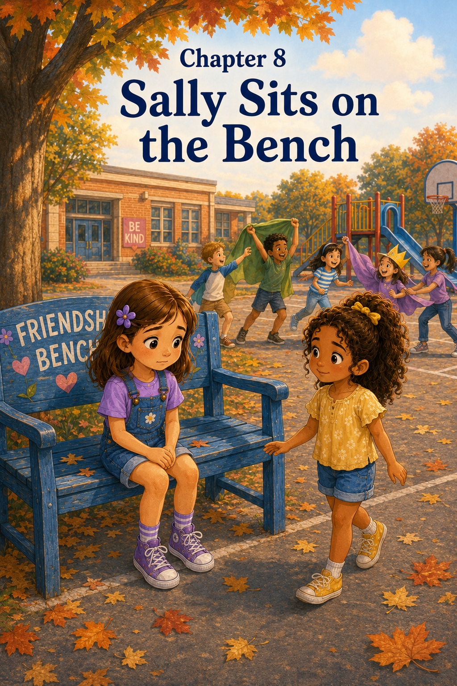Chapter 8: Sally Sits on the Bench
Wednesday morning did not begin the way Sally hoped.
First, she woke up late.
Not very late, but late enough that everything felt rushed. Her purple flower clip was missing from her dresser, her socks did not match at first, and Patches decided that the best time to chase his squeaky toy was exactly when Sally was trying to tie her shoes.
“Patches, please,” Sally said, pulling one shoelace tight. “I am already behind.”
Patches dropped the toy beside her foot and wagged his tail hopefully.
“I cannot play right now,” Sally told him.
Patches tilted his head as if this was the saddest news he had ever heard.
In the kitchen, Mom was packing Sally’s lunchbox while Mark looked for the permission slip Sally needed to return to school.
“I thought I put it in my folder,” Sally said, opening her backpack for the third time.
Mom checked the counter. “It might still be on the table.”
Mark lifted a stack of mail. “Found it.”
Sally hurried over and took the paper. “Thank you.”
She tried to tuck it neatly into her folder, but one corner bent.
Sally sighed.
Mom noticed. “Rough morning?”
“A little,” Sally said.
Mark gave her an encouraging smile. “The day can still get better.”
Sally hoped he was right.
But at school, the morning still felt bumpy.
During spelling, Sally mixed up two words she usually knew. During math, her pencil tip broke just as she was lining up her numbers. When Mrs. Carter asked the class to take out their library books, Sally realized she had left hers on the kitchen chair.
She stared into her backpack as if the book might magically appear.
It did not.
Mrs. Carter came over quietly. “That happens sometimes, Sally. You may choose a classroom book for today.”
Sally nodded. “Okay.”
Mrs. Carter’s voice was kind, but Sally still felt disappointed in herself.
By the time the class lined up for lunch, Sally felt like she had been carrying a little gray cloud around all morning.
At lunch, things improved for a while. Maria shared a funny story about her little cousin trying to put stickers on the family cat. Emma drew stars on her napkin. Emma Brooks told everyone she had practiced four square after school with her brother and was ready for a rematch.
Sally laughed, but not as much as usual.
Maria looked at her. “Are you okay?”
“I’m fine,” Sally said.
She was not exactly fine.
But she did not know how to explain the bent permission slip, the forgotten library book, the spelling mistakes, the broken pencil, and the feeling that her whole morning had been just a little wrong.
So she took a bite of her sandwich and tried to smile.
After lunch, Mrs. Carter gave the class a quiet reading time. Sally chose a book from the classroom shelf about a girl who rescued a lost puppy. She usually loved puppy stories, especially because they reminded her of Patches, but today the words seemed to wiggle on the page.
She read the same sentence three times.
When afternoon recess finally came, Sally felt relieved.
Recess would help.
Recess had running and fresh air and friends. Recess had the Friendship Bench, the Playground Promise, the friendship cards, and games that made people laugh. Recess would turn the day around.
Mrs. Carter stood beside the Playground Promise poster before opening the door.
“Today,” she said, “let’s remember this line.”
She pointed to the words:
We will use kind words and respect answers.
The class read it together.
Sally read along, but her voice was quieter than usual.
Outside, the playground was bright and warm. The maple tree rustled over the Friendship Bench. The chalk lines from the two four square courts were still faintly visible on the blacktop. Someone had drawn a tiny dinosaur near one corner.
Owen rushed past. “Volcano dinosaurs today! New rule! The rescue cave has a secret tunnel!”
Daniel gasped. “A secret tunnel?”
“Yes,” Owen said. “But only brave dinosaurs can use it.”
Maria laughed. “That sounds fun.”
Emma Brooks bounced on her toes. “I want to play.”
Emma nodded. “Me too.”
Sally hesitated.
She did not feel like being a dinosaur today.
She did not feel like running from lava or shouting rescue calls or learning three new rules from Owen. She felt tired from the bumpy morning. She wanted something quieter.
“Can we play four square instead?” Sally asked.
Maria looked toward Owen and Daniel, who were already gathering players. “Maybe later? We promised Owen yesterday we would try the secret tunnel game.”
Emma smiled. “Come on, Sally. It’ll be funny.”
“I don’t really want to play volcano dinosaurs today,” Sally said.
Emma Brooks looked at her kindly. “That’s okay. You can just watch until you feel like joining.”
But watching did not sound fun either.
Sally shifted her weight from one foot to the other. “I think I want to play something else.”
Maria looked unsure. “I’m sorry, Sally. I told Owen I’d play. Maybe after a few minutes?”
Sally nodded quickly. “Sure. That’s okay.”
She tried to sound cheerful.
But it did not feel okay.
Her friends ran toward the slide, where Owen was explaining the secret tunnel rule with wide, serious hand motions. Daniel was already pretending to be trapped by invisible lava. Emma was laughing. Emma Brooks was listening carefully. Maria turned once and gave Sally a small wave.
Sally waved back.
Then she stood alone.
For a moment, she looked around the playground.
Ava and Grace were on the swings. Marcus and Noah were playing soccer. Caleb and Tessa were using one of the four square courts with students from Mrs. Allen’s class. Nora was drawing with chalk near the fence.
Everyone seemed to know where to go.
Everyone seemed to have a place.
Sally knew that was not completely true. She had learned that people could feel lonely even in the middle of a busy playground. But today, it seemed true enough to make her chest feel tight.
She walked toward the chalk bucket, then stopped.
She walked toward four square, then stopped again.
She did not want to ask to join. She did not want to explain that she did not feel like playing the dinosaur game. She did not want anyone to think she was being difficult.
The Friendship Bench sat under the maple tree.
Sally looked at it.
For the first time, she wondered what it would feel like to sit there.
Her stomach fluttered.
She had helped other children on the bench. She had asked Daniel to play. She had listened to Owen. She sat beside Nora. She had invited Tessa.
But sitting there herself felt different.
What if people saw her?
What if someone thought, Sally doesn’t have a friend?
What if her friends noticed and felt bad?
What if no one came?
Sally looked back toward the volcano dinosaur game. Maria was pretending to cross the secret tunnel. Owen was shouting directions. Emma and Emma Brooks were laughing. They looked happy.
Sally wanted to be happy for them.
She was happy for them.
But she also felt left out.
Slowly, Sally walked to the Friendship Bench.
She sat down.
The blue seat felt warm from the sun. A few maple leaves rested near her sneakers. The playground sounded loud from where she sat, but also far away.
Sally folded her hands in her lap.
She looked down.
Now she understood.
Sitting on the Friendship Bench took courage.
It felt like telling the whole playground, I need someone.
Sally swallowed.
She did not like needing someone.
She liked being the helper. Helpers knew what to say. Helpers noticed other people. Helpers carried friendship cards and invited others to play. Helpers made room.
But today, Sally did not feel like a helper.
Today, she felt small and embarrassed and unsure.
A soccer ball rolled nearby. Marcus ran after it, grabbed it, and hurried back to the field without seeing her.
Two younger students skipped past, talking about snack time.
No one stopped.
Sally’s eyes began to sting.
Maybe she should just get up.
Maybe sitting here was silly.
Maybe she should go pretend to be a dinosaur, even though she did not want to.
She was about to stand when she heard footsteps.
“Sally?”
Sally looked up.
Maria stood a few steps away from the bench. Her face looked concerned, but not upset.
“Hi,” Sally said quietly.
Maria came a little closer. “Do you want company?”
Sally’s throat felt tight.
Those were the words Sally had used with Nora.
Now Maria was using them with her.
Sally nodded.
Maria sat on the other end of the bench, leaving a little space between them.
For a moment, neither girl said anything.
The maple leaves moved softly above them.
Then Maria said, “I noticed you weren’t by the game.”
Sally looked down at her shoes. “I didn’t want to play volcano dinosaurs today.”
“That’s okay,” Maria said.
“I know,” Sally said. “But everyone else did.”
Maria nodded slowly. “I should have noticed sooner.”
Sally shook her head. “You didn’t do anything wrong.”
“I still care,” Maria said.
That made Sally’s eyes sting again, but in a different way.
“I had a hard morning,” Sally admitted. “I woke up late. I forgot my library book. I made mistakes in spelling. My pencil broke. Everything felt wrong.”
Maria listened.
She did not interrupt.
She did not say, That’s not a big deal.
She did not say, Just come play.
She simply listened.
Sally continued, “Then at recess, I thought I would feel better. But everyone wanted to play the game I didn’t want to play. I know that’s fair. You can choose what you want to play. But I felt left out anyway.”
Maria nodded. “That makes sense.”
“It does?” Sally asked.
“Yes,” Maria said. “You can understand something and still feel sad about it.”
Sally had never thought of it that way.
She looked toward the volcano dinosaur game. Owen was now crawling through the “secret tunnel,” which seemed to be the space under the slide. Daniel stood nearby shouting, “The lava is emotionally nearby!”
Sally almost smiled.
Maria followed her gaze. “It is a very dramatic game.”
“It always is,” Sally said.
Maria smiled. “Do you want to play something quieter?”
Sally hesitated. “You don’t have to leave the game.”
“I know,” Maria said. “But I want to sit with you for a little while.”
Sally’s shoulders relaxed.
“Thank you,” she said.
Maria pulled a friendship card from her pocket. “I picked this one before recess.”
She handed it to Sally.
The card had butterflies around the edges. In Maria’s neat handwriting, it said:
You are welcome with us.
Sally stared at the card.
She had seen that card before. Maria had made one like it for Lily when Lily was new. Now Maria was giving it to her.
“But I’m not new,” Sally said softly.
Maria smiled. “You don’t have to be new to need reminding.”
Sally held the card carefully.
The words felt warm in her hands.
You are welcome with us.
Just then, Emma Brooks noticed them from the game. She whispered something to Emma, and both girls came over slowly.
“Do you want company too?” Emma Brooks asked.
Sally looked at Maria, then back at them. “Okay.”
Emma sat on the grass in front of the bench. Emma Brooks sat beside her.
“We didn’t know you felt left out,” Emma said.
“I didn’t say it,” Sally replied.
“That makes it hard to know,” Emma Brooks said gently.
Sally nodded. “I know.”
Emma picked at a leaf near her shoe. “We can play four square after this.”
“Or we can play something quiet now,” Emma Brooks said. “Maybe chalk drawing?”
Maria looked at Sally. “What do you want?”
Sally thought for a moment.
That question felt important.
Not What should you want?
Not What does everyone else want?
Just What do you want?
“I think I want to draw,” Sally said.
“Then let’s draw,” Maria said.
The girls walked together to the chalk bucket. Sally chose purple chalk. Maria chose yellow. Emma chose blue. Emma Brooks chose pink.
They found a quiet spot near the fence and began drawing a giant garden. Sally drew flowers. Maria drew butterflies. Emma drew stars in the sky above the flowers, even though it was daytime. Emma Brooks drew a winding path through the middle.
After a few minutes, Nora came over.
“That’s pretty,” she said.
“Want to help?” Sally asked.
Nora smiled. “Sure.”
She picked green chalk and drew leaves.
Then Tessa came over and added a small four square court beside the garden. Daniel ran over and drew a volcano in the corner.
“Does every picture need lava?” Maria asked.
Daniel thought about it. “Not every picture. But this one does.”
Sally laughed.
Soon the chalk drawing stretched across the blacktop. It had flowers, stars, butterflies, a path, a tiny bench, a volcano, a puppy that Sally said was Patches, and a dinosaur wearing a friendship bracelet because Owen joined and insisted dinosaurs could enjoy accessories.
By the time the recess bell rang, Sally felt lighter.
Not because the whole morning had disappeared.
It had not.
Not because her friends had chosen her game first.
They had not.
But because Maria had noticed.
And because Sally had been brave enough to sit on the bench.
Inside, Mrs. Carter noticed the chalk dust on everyone’s hands.
“That looks like a creative recess,” she said.
“It was,” Sally said.
Mrs. Carter’s eyes rested on Sally for a moment. “Would you like to write about it during journal time?”
Sally nodded.
After everyone washed their hands and settled into their seats, Mrs. Carter wrote on the board:
Everyone needs friendship sometimes.
Sally looked at the sentence for a long moment.
Then she opened her journal and began to write.
Today I sat on the Friendship Bench.
It felt strange because I am usually the one who helps other people there. I felt embarrassed at first. I wondered if anyone would come. Then Maria noticed me. She asked if I wanted company. She listened. Emma and Emma Brooks came too. We played something quieter, and I felt better.
Sally paused.
Then she wrote:
I learned that helpers need help too. Everyone needs friendship sometimes.
She looked at the words and felt a little surprised by them.
Helpers need help too.
That was true.
She had thought being a good friend meant always being ready to notice, ask, include, and care for others. But maybe being a good friend also meant being honest when you needed care yourself.
Mrs. Carter invited students to share if they wanted.
Sally raised her hand slowly.
Mrs. Carter nodded. “Sally?”
Sally’s cheeks warmed, but she spoke anyway.
“I sat on the Friendship Bench today,” she said.
The class grew quiet.
“I felt embarrassed because I thought I was supposed to be one of the helpers,” Sally continued. “But I felt left out, and Maria noticed. Then my friends sat with me. I learned that everyone needs friendship sometimes, even people who help others.”
Mrs. Carter’s smile was gentle.
“That is a very important lesson,” she said. “Thank you for sharing it.”
Maria smiled at Sally.
Emma gave her a thumbs-up.
Emma Brooks whispered, “That was brave.”
Sally smiled back.
At the end of the day, Sally brought Maria’s friendship card home. She placed it on her desk beside her purple flower clip, which Mom had found under the laundry basket.
That evening, while Patches curled up at her feet, Sally made a new friendship card.
This one had a blue bench, a purple flower, and four children drawing with chalk.
On the front, she wrote:
Even helpers need friends.
She looked at the card and smiled.
Tomorrow she would add it to the basket.
Because somewhere, someday, someone might need those words.
Maybe a new student.
Maybe a quiet student.
Maybe someone who missed old friends.
Maybe someone who had been helping others all week and suddenly needed help too.
Sally now understood that the Friendship Bench was not just for other people.
It was for everyone.
And that included her.

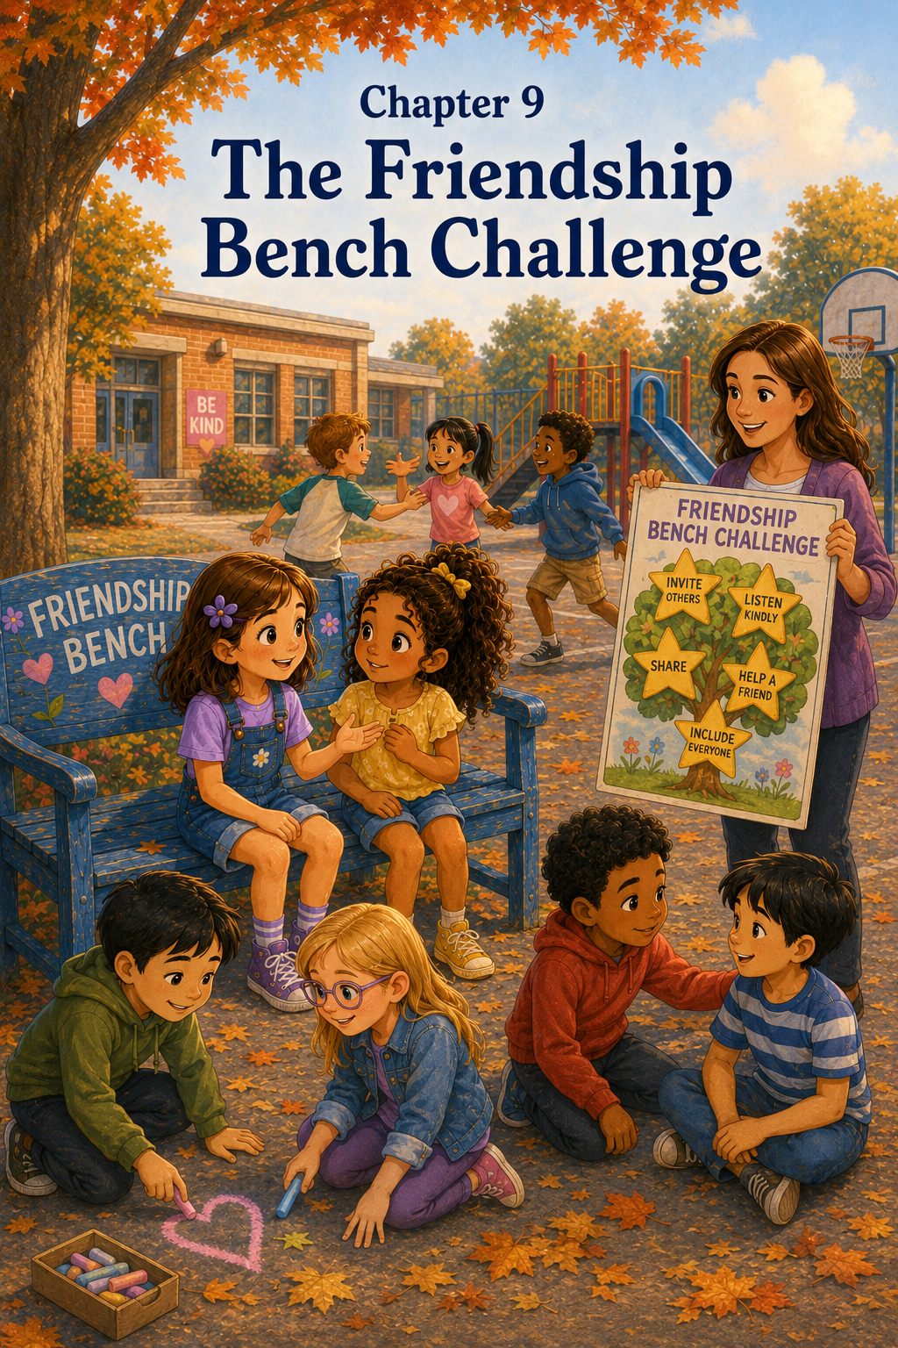Chapter 9: The Friendship Bench Challenge
On Thursday morning, Mrs. Carter had a surprise waiting at the front of Room 12.
It was not covered with yellow construction paper this time.
It was not hidden behind her desk.
It was right where everyone could see it.
A large poster hung on the whiteboard. At the top, in bright blue letters, it said:
The Friendship Bench Challenge
Underneath the title, Mrs. Carter had drawn a big tree with wide branches. The trunk was brown, the leaves were green, and the branches stretched across the poster like open arms. Beside the tree was a basket filled with small paper stars.
Sally stopped in the doorway.
“What’s that?” Maria asked, nearly bumping into her.
“I don’t know,” Sally said. “But it looks important.”
Emma hurried up behind them. “It has stars!”
Emma Brooks smiled. “You would notice the stars first.”
“I always notice stars first,” Emma said proudly.
Sally walked to her desk and placed her backpack beside her chair. Her morning had started much better than yesterday. She had woken up on time, found her purple flower clip right away, remembered her library book, and even managed to keep Patches from stealing her sock.
Still, she had not forgotten what happened on the Friendship Bench.
She had sat there.
Maria had noticed.
Her friends had listened.
And Sally had learned something she did not think she would forget.
Everyone needed friendship sometimes, even helpers.
Now, as she looked at the poster on the board, she wondered what Mrs. Carter was planning.
When the bell rang, Mrs. Carter greeted the class with a smile.
“Good morning, everyone.”
“Good morning, Mrs. Carter,” the class answered.
“I can tell many of you have noticed our new poster,” Mrs. Carter said.
Emma raised her hand before Mrs. Carter even asked for questions. “Are those stars?”
Mrs. Carter laughed softly. “Yes, Emma. They are kindness stars.”
Emma looked very pleased.
Mrs. Carter pointed to the poster. “Today we are beginning something called the Friendship Bench Challenge. It will last for one full school week.”
Owen raised his hand. “Is it a contest?”
“That is a good question,” Mrs. Carter said. “It is a challenge, but not the kind where one person wins and everyone else loses. This challenge is about helping our whole class grow in kindness.”
Sally liked that.
A challenge where everyone could grow sounded better than a challenge where only one person could win.
Mrs. Carter picked up one paper star. “Each time students show friendship in action, our class can add a kindness star to the tree.”
Daniel raised his hand. “What counts as friendship in action?”
Mrs. Carter smiled. “Let’s make a list together.”
She turned to the board and wrote:
Friendship in Action
“What are some things students can do at recess to show friendship?” she asked.
Maria raised her hand. “Invite someone to play.”
Mrs. Carter wrote:
Inviting others
Emma Brooks said, “Listening when someone talks.”
Mrs. Carter wrote:
Listening
Ava said, “Sharing.”
Mrs. Carter wrote:
Sharing
Caleb said, “Taking turns.”
Mrs. Carter wrote:
Taking turns
Nora raised her hand. “Giving someone space if they need it.”
Mrs. Carter nodded. “That is very important.”
She wrote:
Respecting space
Owen said, “Letting people add ideas to games.”
Mrs. Carter wrote:
Including ideas
Daniel raised his hand. “Rescuing people dramatically from lava.”
The class giggled.
Mrs. Carter pressed her lips together, trying not to laugh.
“That may count if it is part of a game and everyone is enjoying it,” she said. “Let’s write helping others.”
She wrote:
Helping others
Sally looked at the list.
Inviting others.
Listening.
Sharing.
Taking turns.
Respecting space.
Including ideas.
Helping others.
It was a good list.
But Sally thought there was something else.
She raised her hand.
“Yes, Sally?” Mrs. Carter asked.
“Paying attention,” Sally said. “Because sometimes someone needs a friend, but they don’t say it.”
Mrs. Carter’s smile softened.
“That belongs at the top,” she said.
She wrote:
Paying attention
Sally felt warm inside.
Mrs. Carter turned back to the class. “For the next week, we will try to notice friendship in action. When you see someone showing kindness, you may tell me or write it on a small note. We will add kindness stars to the tree. But remember, we do not do kind things only to get a star. The star helps us see what kindness looks like.”
Sally understood.
The stars were not the kindness.
They were reminders.
Like the Friendship Bench.
Like the friendship cards.
Like the Playground Promise.
The real kindness happened in what people chose to do.
Before recess, Mrs. Carter handed each student a small paper star.
“Keep this in your pocket,” she said. “At recess, look for one kind action. It can be something you do, or something you see someone else do. After recess, we will share a few examples and add stars to our tree.”
Sally held her star carefully.
It was yellow and small and light.
Maria leaned over. “What are you going to look for?”
“I don’t know yet,” Sally whispered. “Maybe someone including another person.”
Emma held her star up to the light. “I’m looking for sharing.”
Emma Brooks smiled. “I’m looking for someone listening.”
Owen looked at his star. “I’m looking for someone who respects volcano rules.”
Daniel whispered, “That might be too hard.”
Owen gave him a serious look.
At recess, the playground was busy and bright. The Friendship Bench sat under the maple tree. The basket of friendship cards rested near the playground door. The chalk lines of the two four square courts were fading, but still visible.
Sally placed her paper star carefully in her pocket.
She wanted to earn it honestly.
At first, she joined Maria, Emma, and Emma Brooks near the chalk bucket. They decided to draw another giant garden, like they had done when Sally sat on the Friendship Bench. This time, they added a path, a pond, and a tiny wooden bridge.
“Can I draw frogs?” Emma asked.
“Yes,” Sally said. “Gardens need frogs.”
“Do they?” Maria asked.
“This one does,” Emma said.
Sally laughed.
A few minutes later, Owen ran over.
“Volcano dinosaurs needs a map,” he announced.
“A map?” Maria asked.
“Yes,” Owen said. “The volcano world has become too large.”
Daniel appeared beside him. “It now has three volcanoes, two tunnels, a rescue cave, and a lava river.”
“That does sound like it needs a map,” Emma Brooks said.
Owen looked at their chalk drawing. “Can you draw the map over here?”
Sally looked at the garden.
She had just started drawing a purple flower bed. She did not really want the garden to become a volcano map.
Emma frowned. “But we’re drawing a garden.”
Owen’s face fell a little. “Oh.”
For a moment, Sally felt pulled in two directions.
She wanted to keep drawing the garden.
She also wanted to include Owen’s idea.
Then she remembered one of the Friendship in Action words.
Including ideas
Maybe they did not have to erase the garden.
Maybe they could make room another way.
“What if the volcano map goes beside the garden?” Sally suggested. “The garden can be the peaceful valley.”
Owen’s eyes widened. “A peaceful valley near the volcanoes?”
“Sure,” Maria said. “The dinosaurs can go there when they need rest.”
Daniel nodded. “Or snacks.”
Emma smiled. “And frogs.”
Owen thought about it carefully. “That could work.”
So they added the volcano map beside the garden. Owen drew mountains. Daniel drew a lava river that looked more like a wiggly noodle. Emma drew frogs on lily pads. Maria drew a bridge. Emma Brooks added signs that said Safe Path and Quiet Valley.
Sally drew a small Friendship Bench near the peaceful valley.
Owen noticed it. “Why is there a bench in the volcano world?”
“For dinosaurs who need friends,” Sally said.
Owen nodded. “That makes sense.”
Sally touched the star in her pocket.
Maybe this counted.
They had included Owen’s idea without losing their own.
After recess, the class gathered on the rug.
Mrs. Carter held the basket of paper stars. “Who noticed friendship in action?”
Emma raised her hand first. “Sally helped make room for Owen’s map without erasing our garden.”
Mrs. Carter smiled. “That sounds like including ideas.”
Emma placed her star on the tree.
Maria raised her hand. “Owen listened when we said we didn’t want to cover the garden.”
Owen looked surprised. “I did?”
Maria nodded. “You did.”
Mrs. Carter gave Owen a star to place on the tree too.
Owen stood a little taller.
Emma Brooks said, “Daniel helped me spell ‘quiet’ on the Safe Path sign.”
Daniel grinned. “I am excellent at Q words.”
Mrs. Carter raised an eyebrow. “That is good to know.”
Soon the tree had several stars on it. Not many yet, but enough to sparkle.
Sally watched them and smiled.
The Friendship Bench Challenge had begun.
The next day, the challenge continued.
At morning meeting, Mrs. Carter reminded the class that friendship was not only about inviting others to games.
“Friendship is also about patience,” she said. “Sometimes people need time to learn. Sometimes they need time to decide. Sometimes they need time to feel comfortable.”
Sally thought about Nora.
Nora had needed time.
At recess, Sally saw patience happen in a quiet way.
Tessa was trying to jump rope with Ava and Grace. The rope kept tapping her shoes before she could jump. Each time, Tessa stepped back and shook her head.
“I can’t do it,” Tessa said.
Ava held the rope handles. “You almost had it.”
“No, I didn’t,” Tessa said.
Grace looked impatient for a second. There were other students waiting for turns.
Sally watched from near the chalk bucket. She wondered if Grace would say, “Hurry up,” or “Let someone else try.”
Instead, Grace took a breath and said, “Do you want me to count slower?”
Tessa looked up. “Maybe.”
Grace nodded. “Okay. Ready? One… two… three… jump.”
This time, Tessa jumped over the rope.
Just once.
But once was enough to make her smile.
“I did it!” she said.
Ava cheered.
Grace smiled too. “See? Slower helped.”
Sally pulled the paper star from her pocket.
That was friendship in action.
After recess, Sally told Mrs. Carter what she had seen.
“Grace was patient with Tessa,” Sally said. “She counted slower.”
Mrs. Carter invited Grace to place a star on the tree.
Grace looked surprised. “It was just counting.”
“It was patient counting,” Sally said.
The class laughed, but kindly.
Mrs. Carter smiled. “Sometimes patient counting is exactly what kindness looks like.”
By the third day of the challenge, the tree had more stars.
Some stars were for big things, like Caleb helping a younger student find his teacher after recess.
Some stars were for small things, like Emma sharing blue chalk when someone else’s broke.
Some stars were for quiet things, like Nora sitting beside a student who needed space.
Some stars were for funny things, like Daniel making Owen laugh after their dinosaur game got too complicated and everyone forgot the rules.
Mrs. Carter said funny kindness counted too, as long as everyone felt happy and included.
On Friday, Mrs. Carter added something new.
“Today,” she said, “I want you to look for kindness that is not easy.”
Sally tilted her head.
Not easy kindness?
Mrs. Carter explained. “Sometimes it is easy to include a close friend. It is easy to share when you have plenty. It is easy to listen when you agree. But kindness becomes very meaningful when it takes effort.”
Sally thought about that all morning.
At recess, she found out what Mrs. Carter meant.
Maria and Sally were walking toward the four square courts when they saw two students arguing near the chalk bucket. One was Marcus. The other was a girl from Mrs. Allen’s class named Priya.
“I had the green chalk first,” Marcus said.
“But you put it down,” Priya said. “I thought you were done.”
“I wasn’t done,” Marcus replied.
Priya held the green chalk close to her chest. “I need it for my tree.”
“I need it for my soccer field,” Marcus said.
Sally slowed down.
She did not want to get involved.
Arguments made her stomach feel tight. She was afraid of choosing sides. She did not want Marcus to be upset with her. She did not want Priya to think she was bossy.
Maria looked at her.
Sally knew Maria was thinking the same thing.
Then Sally remembered the challenge.
Kindness that is not easy.
She took a small step closer.
“Could we help find a way to share?” Sally asked.
Marcus looked at her. “I had it first.”
Priya said, “But I’m using it now.”
Sally nodded. “It sounds like you both need green.”
Maria looked in the chalk bucket. “There’s no other green.”
Sally thought for a moment. “What if Priya uses it for her tree leaves first, and then Marcus uses it for the field? Or Marcus can use blue for the field while he waits and make it a rainy soccer field.”
Marcus frowned. “A rainy soccer field?”
Maria smiled. “That could be fun.”
Priya looked at Marcus. “I only need to draw leaves. It won’t take long.”
Marcus was quiet.
Then he sighed. “Okay. But can I have it after?”
Priya nodded. “Yes.”
Sally let out a breath she did not know she was holding.
It was not a huge problem.
It was not a Friendship Bench emergency.
But it had been hard for Sally to step in kindly without taking over.
After recess, Maria gave Sally her star.
“You should put this one on the tree,” Maria said.
Sally shook her head. “We both helped.”
Maria smiled. “Then we can tell Mrs. Carter together.”
They did.
Mrs. Carter listened and said, “That was problem-solving with fairness and patience.”
Sally and Maria placed two stars side by side on the tree.
By Monday morning, the Friendship Bench Challenge tree was full of stars.
There were stars on the branches, stars near the trunk, and a few stars floating around the edges because the branches ran out of room. Emma said the tree looked like it had grown a sky.
Mrs. Carter invited the class to sit on the rug for the final challenge reflection.
“This week,” she said, “you earned many kindness stars. But more importantly, you practiced many kinds of friendship.”
She pointed to the board, where she had written:
Friendship is…
“Let’s finish this sentence together,” she said.
Emma raised her hand. “Friendship is inviting someone.”
Mrs. Carter wrote it down.
Maria said, “Friendship is helping someone feel welcome.”
Emma Brooks said, “Friendship is listening.”
Owen said, “Friendship is letting other people add rules sometimes.”
Daniel nodded. “Even dramatic rules.”
Mrs. Carter smiled and wrote:
Friendship is sharing ideas.
Nora raised her hand. “Friendship is giving someone quiet space.”
Tessa said, “Friendship is being patient when someone is learning.”
Caleb said, “Friendship is making room fairly.”
Grace said, “Friendship is trying again after a misunderstanding.”
Sally listened to everyone.
Then she raised her hand.
Mrs. Carter looked at her. “Sally?”
Sally took a breath.
“Friendship is paying attention to how someone feels,” she said.
The room became quiet.
Mrs. Carter wrote Sally’s words on the board.
Friendship is paying attention to how someone feels.
Sally looked at the sentence.
That was what she had learned most.
At first, she had thought friendship was mostly about playing together. Laughing together. Sharing games. Sitting with someone at lunch. Inviting someone to join.
All of those things mattered.
But friendship was bigger than that.
Friendship was noticing when someone was standing alone.
It was listening when someone missed old friends.
It was giving space when someone needed quiet.
It was making room without pushing someone else out.
It was being patient when someone was learning.
It was caring enough to ask, “Do you want company?”
Mrs. Carter looked around the rug. “This week, did anyone learn something new about friendship?”
Sally raised her hand again.
“I learned that friendship is not only about having fun,” she said. “It is about paying attention, being patient, and caring about how others feel.”
Mrs. Carter smiled. “That is a beautiful lesson.”
Maria gave Sally a warm smile from across the rug.
After reflection time, Mrs. Carter gave each student one final paper star.
“This star is not for the poster,” she said. “This one is for you to keep. On it, write one friendship skill you want to keep practicing.”
Sally held her star and thought carefully.
She could write inviting.
She could write sharing.
She could write helping.
She could write listening.
All of them were important.
Finally, she picked up her purple pencil and wrote:
Pay attention.
Then, underneath, in smaller letters, she added:
Care about feelings.
She tucked the star into her journal.
That afternoon, at recess, the Friendship Bench was empty.
But Sally did not worry about it.
She looked around the playground and saw the challenge still working.
Emma Brooks invited Lily to draw with chalk.
Owen let Daniel add one dramatic rescue rule.
Grace counted slowly while Tessa practiced jumping rope.
Caleb moved the basketball game so a younger student had space to join.
Maria sat beside Nora for a quiet minute before they both walked to the swings.
Sally smiled.
The stars were still on the poster inside, but the real kindness had moved outside.
It was in the voices.
The choices.
The listening.
The patience.
The caring.
Sally walked toward Maria, who was waving her over.
“Want to play four square?” Maria called.
Sally grinned. “Yes.”
Then she paused.
Near the fence, Marcus was standing with a soccer ball under one arm, looking toward the four square court.
Sally called, “Marcus, do you want to play too?”
Marcus smiled. “Sure!”
Maria stepped aside. “We can make room.”
Sally laughed.
“Yes,” she said. “We can.”
And as they drew one more square with chalk, Sally knew the Friendship Bench Challenge had done more than fill a tree with stars.
It had helped fill the playground with noticing.
And that made every game, every bench, and every child feel a little more seen.

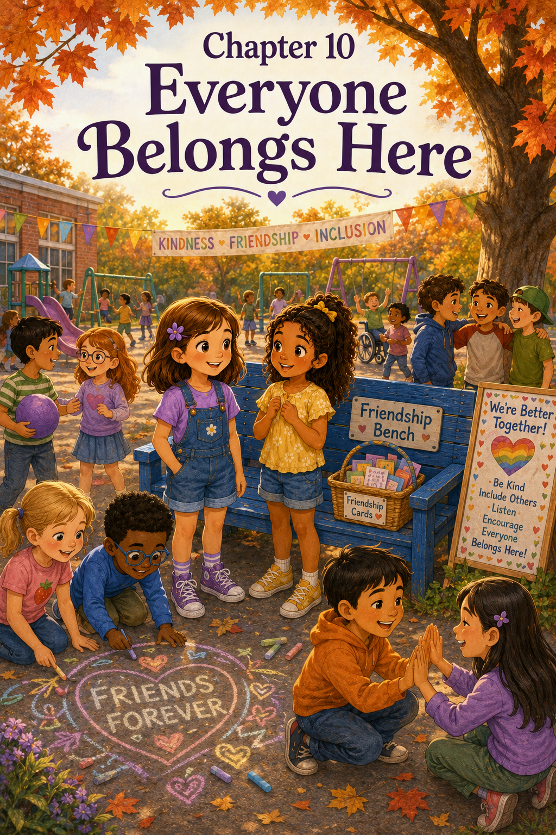Chapter 10: Everyone Belongs Here
Friday morning felt special before Sally even stepped into Room 12.
It was the last day of the Friendship Bench Challenge.
All week, the class had added kindness stars to the big tree poster whenever students invited others, listened carefully, shared supplies, helped solve problems, respected quiet space, and included classmates in games. The tree that had started with empty branches was now covered in yellow stars.
Some stars were neat.
Some were crooked.
Some had tiny hearts.
Some had names written carefully across them.
One had a dinosaur with sunglasses because Owen said kindness stars could have personality.
Sally liked that star very much.
When she walked into the classroom, Maria was already standing by the poster.
“Look at it,” Maria said softly.
Sally stepped beside her.
The tree looked full and bright, as if kindness had grown leaves of its own.
Emma hurried over with her backpack bouncing. “I counted the stars yesterday. There were forty-three.”
Emma Brooks joined them. “There are more now. Mrs. Carter added the ones from afternoon recess.”
“Forty-three is already a lot,” Maria said.
“It is,” Sally agreed.
But Sally knew the number was not the most important part.
The stars mattered because of what they stood for.
Daniel being invited into hopscotch.
Emma Brooks joining four square.
Owen teaching volcano dinosaurs.
Nora getting quiet company when she needed it.
Tessa joining a game after a misunderstanding.
Caleb learning that fairness and kindness could work together.
Lily being welcomed on her first day.
Maria noticing Sally on the bench.
Sally touched the edge of the poster gently.
Each star was a small story.
Mrs. Carter stood near her desk, arranging a stack of paper certificates. She smiled when she saw Sally looking at the poster.
“Good morning, Sally,” she said.
“Good morning,” Sally answered. “The tree looks different now.”
Mrs. Carter walked over and stood beside the students.
“It does,” she said. “What do you notice?”
Sally studied the poster.
“At first, it was just a tree,” she said. “Now it looks like everyone helped it grow.”
Mrs. Carter smiled. “That is exactly what happened.”
The bell rang, and the students settled into their seats. The classroom buzzed with Friday excitement. Everyone knew there would be a Friendship Bench Celebration that afternoon. Mrs. Carter had written it on the schedule in big blue letters:
Friendship Bench Celebration
Sally kept glancing at the words during spelling.
She looked at them during math.
She looked at them during reading.
She tried not to look at them during science, but she did anyway.
By the time lunch arrived, she could hardly wait.
At lunch, Sally sat with Maria, Emma, Emma Brooks, Nora, and Tessa. That was new. A few weeks ago, Sally mostly sat with Maria and Emma. Emma Brooks had sometimes sat with other students. Nora often sat quietly with one friend. Tessa had not known their group well at all.
Now the table felt fuller.
Not crowded.
Full in a good way.
Tessa opened her lunchbox and pulled out a small bag of grapes. “My mom said I could share.”
Emma smiled. “I love grapes.”
Nora looked at Tessa. “Do you want some of my crackers?”
“Sure,” Tessa said. “Thank you.”
Maria looked at Sally and smiled.
Sally knew what Maria was thinking.
Friendship had grown at the lunch table too.
Not just on the playground.
After lunch, the class lined up for recess. Mrs. Carter stood beside the Playground Promise poster.
“Before we go outside,” she said, “let’s read our promise one more time.”
The class read together:
“We will look around.
We will invite others to play.
We will make room for others.
We will listen to other people’s ideas.
We will use kind words and respect answers.
We will ask an adult for help when needed.
We will keep trying with caring hearts.”
Sally read every word carefully.
The promise felt different now than it had at first. At first, it had been something they hoped to do. Now it felt like something they had practiced.
Not perfectly.
But truly.
Outside, the playground was bright with sunshine. The maple tree waved gently over the Friendship Bench. The blue paint looked cheerful, and the yellow handprints seemed to shine.
For a moment, no one ran.
The class stood quietly near the door, looking around.
Mrs. Carter smiled. “Go enjoy recess.”
Then everyone scattered.
Owen hurried toward the slide. “Volcano dinosaurs! Final challenge version!”
Daniel ran after him. “Does it have dramatic rescue rules?”
“Obviously!” Owen called.
Emma and Emma Brooks went to the chalk bucket. Maria and Sally walked toward the four square courts, but they did not start playing right away.
They looked around.
Sally saw Lily near the swings with Ava and Grace. They were taking turns and laughing.
She saw Caleb showing a younger student how to bounce the basketball gently.
She saw Tessa and Nora drawing beside the fence. Tessa was making a flower, and Nora was adding leaves.
She saw Marcus standing near the soccer field, looking toward the four square court.
Sally waved. “Marcus, do you want to play?”
Marcus grinned. “Yes!”
Maria bounced the red ball. “Friendly rules?”
“Always,” Sally said.
They began a four square game, but after a few minutes, Sally noticed the Friendship Bench.
Someone was sitting there.
It was Daniel.
Sally blinked.
Daniel usually loved recess. He loved games, dramatic lava rescues, silly rules, and making people laugh. Seeing him on the bench surprised her.
Sally looked at Maria.
Maria looked back.
They both walked over.
Daniel sat with his elbows on his knees and his chin in his hands.
“Hi, Daniel,” Sally said gently. “Do you want company?”
Daniel looked up. “Maybe.”
Maria sat on one end of the bench. Sally sat on the other.
“What happened?” Maria asked.
Daniel sighed. “Owen said my dramatic rescue rule made the game too silly.”
Sally tried very hard not to smile, because Daniel looked serious.
“That probably hurt your feelings,” she said.
Daniel nodded. “I know I’m funny a lot. But sometimes I want people to like my ideas too.”
Sally’s heart softened.
That was important.
Sometimes children who made everyone laugh still needed to be listened to.
Maria said, “Do you want us to help you talk to Owen?”
Daniel thought for a moment. “Maybe. But I don’t want him to think I’m mad.”
“We can help you use kind words,” Sally said.
Daniel sat up. “Okay.”
The three of them walked toward Owen, who was drawing a lava river with chalk.
Owen looked up. “Are you coming back?”
Daniel shifted his feet. “I want to. But I felt bad when you said my rule was too silly.”
Owen’s face changed. “Oh. I didn’t mean you were too silly. I just meant the game was getting confusing.”
Daniel looked relieved, but still a little unsure.
Sally said, “Maybe you can both choose one rule. Owen can choose one serious rule, and Daniel can choose one dramatic rule.”
Maria nodded. “Fair and kind.”
Owen thought about it. “One dramatic rule?”
Daniel nodded. “One.”
“Fine,” Owen said. “But no emotional lava.”
Daniel sighed. “That was my best idea.”
Owen smiled a little. “Maybe emotional lava can be in tomorrow’s game.”
Daniel grinned. “Deal.”
Sally watched them run back to the slide together.
She smiled.
Even on the celebration day, friendship still needed practice.
Maybe that was the point.
When recess ended, Mrs. Carter called everyone inside for the Friendship Bench Celebration. The students washed their hands, got drinks of water, and gathered on the rug.
Mrs. Carter stood beside the kindness tree poster.
“Today,” she said, “we are celebrating what our class has learned from the Friendship Bench.”
The room became quiet.
“The bench began as a place where students could sit when they wanted someone to talk to or play with,” Mrs. Carter continued. “But this class helped it become something more. You created friendship cards. You wrote a Playground Promise. You practiced including others, listening, sharing, taking turns, respecting space, and solving problems with kindness.”
Sally looked around the rug.
Everyone looked proud.
Mrs. Carter picked up a small stack of cards. “I asked a few teachers and students to share what they noticed this week. Would you like to hear some?”
“Yes!” the class answered.
Mrs. Carter read the first card.
“I noticed more students inviting others into games at recess.”
She read another.
“I noticed children asking, ‘Do you want company?’ instead of assuming what someone needed.”
Sally smiled. That one made her think of Nora.
Mrs. Carter read another.
“I noticed students making room by starting a second game instead of telling someone they could not play.”
Tessa and Caleb looked at each other and smiled shyly.
Mrs. Carter read the last card.
“I noticed that the Friendship Bench helped children remember to see one another.”
Sally felt those words deep in her heart.
To see one another.
That was what the whole story had been about.
Mrs. Carter placed the cards down and turned to the class. “Now I want you to think about this question: How has recess changed?”
Emma raised her hand. “More people play together.”
Maria said, “People look around more before starting games.”
Emma Brooks said, “It feels easier to ask if I can join.”
Tessa said, “I felt welcome.”
Caleb said, “I learned that making room can still be fair.”
Nora said, “I learned that quiet friendship counts too.”
Owen said, “I learned that other people have good game ideas.”
Daniel raised his hand. “I learned that my dramatic ideas need limits.”
The class laughed, including Daniel.
Mrs. Carter smiled. “That is a helpful lesson.”
Then she looked at Sally.
“Sally, would you like to share something?”
Sally felt her cheeks grow warm.
She looked at Maria, who nodded encouragingly.
Sally took a breath.
“I learned that the Friendship Bench is not just about a bench,” she said. “It helps people ask for friendship, but we still have to notice. We still have to be kind. We still have to make room and listen.”
Mrs. Carter nodded.
Sally continued, “I also learned that I cannot fix everything by myself.”
The room stayed quiet.
“At first, I thought helping meant knowing exactly what to do,” Sally said. “But sometimes I didn’t know. Sometimes I said the wrong thing. Sometimes I needed help. And one day, I sat on the bench too.”
Maria smiled softly.
Sally looked around the rug.
“I think the bench works because everyone helps. Not just one person. Everyone.”
Mrs. Carter’s eyes were warm. “That is a beautiful reflection, Sally.”
Then Mrs. Carter held up the certificates from her desk.
“These are not awards for being perfect,” she said. “They are reminders that our class practiced kindness with caring hearts.”
She gave each student a small certificate that read:
Friendship Builder
Underneath, it said:
Thank you for helping make our playground a place where everyone belongs.
Sally held her certificate carefully.
Everyone belongs.
She liked those words best.
After the certificates, Mrs. Carter gave the class one final activity. Each student received a paper leaf. On the leaf, they wrote one sentence about friendship. Then they taped the leaves around the kindness tree.
Sally thought for a long time before writing.
Finally, she picked up her purple pencil and wrote:
Friendship grows when we notice one another.
Maria wrote:
Everyone should feel welcome.
Emma wrote:
Kind words can help someone smile.
Emma Brooks wrote:
There is room for one more.
Nora wrote:
Quiet kindness matters.
Owen wrote:
Friends listen to each other’s ideas.
Daniel wrote:
Friendship can be dramatic, but also kind.
Mrs. Carter laughed when she read Daniel’s leaf, but she taped it proudly beside the others.
When all the leaves were added, the poster looked even fuller than before. It had stars, leaves, names, pictures, and words from the whole class.
Mrs. Carter stepped back.
“This tree began as a poster,” she said. “Now it is a record of what you have learned together.”
Sally looked at the tree.
It was not perfect.
Some leaves overlapped.
Some stars were crooked.
The dinosaur star was almost sideways.
But somehow, that made it better.
It looked like the class.
Different students.
Different ideas.
Different needs.
All growing together.
At the end of the day, Mrs. Carter let the students walk outside for one final look at the Friendship Bench before dismissal.
The class gathered around it in a half-circle.
The bench sat quietly beneath the maple tree.
Mrs. Carter placed the basket of friendship cards beside it. “The challenge is ending today,” she said, “but the Friendship Bench will stay. The Playground Promise will stay. And I hope your kindness will stay too.”
Sally looked at the bench.
She remembered the first morning she saw it and wondered if anyone would be brave enough to use it.
Now she knew the answer.
Yes.
Daniel had been brave enough.
Owen had been brave enough.
Nora had been brave enough.
Tessa had been brave enough.
Sally had been brave enough too.
But the children who walked over had been brave in a different way.
Maria had been brave.
Emma and Emma Brooks had been brave.
Caleb had been brave enough to apologize.
Nora had been brave enough to explain what she needed.
Owen and Daniel had been brave enough to listen to each other.
Everyone had practiced courage in small ways.
Mrs. Carter asked, “What should we remember when we see this bench?”
For a moment, no one spoke.
Then Lily said, “That new people need friends.”
Tessa said, “That games can make room.”
Nora said, “That some people need quiet first.”
Daniel said, “That sitting there is brave.”
Maria said, “That noticing matters.”
Sally looked at the bench and then at her classmates.
“That everyone belongs here,” she said.
Mrs. Carter smiled. “Yes.”
The maple leaves moved gently above them.
A breeze passed over the playground.
For a moment, Sally imagined the bench listening.
Maybe that was silly.
A bench could not listen.
A bench could not care.
A bench could not make friends.
But it could remind people to listen, care, and make friends.
And that mattered.
When dismissal came, Sally walked toward Mom’s car with her certificate in one hand and her backpack over her shoulder. Maria walked beside her.
“You should be proud,” Maria said.
Sally looked at her. “We should all be proud.”
Maria smiled. “That’s true.”
Sally climbed into the car, and Mom turned around.
“How was the celebration?” Mom asked.
Sally held up her certificate.
Mom read it aloud. “Friendship Builder. Thank you for helping make our playground a place where everyone belongs.”
“That’s beautiful,” Mom said.
Mark looked back from the front seat. “Sounds like you made a big difference.”
Sally thought about that.
She thought about the bench, the cards, the promise, the stars, the leaves, the games, the misunderstandings, the quiet moments, and all the children who had learned to notice one another.
“I helped,” Sally said. “But I didn’t do it alone.”
Mom smiled. “The best kinds of kindness usually grow with others.”
Sally nodded.
That sounded exactly right.
At home, Sally placed her Friendship Builder certificate on her desk beside Maria’s card that said, You are welcome with us, and the card she had made that said, Even helpers need friends.
Patches trotted into her room with his squeaky toy and dropped it at her feet.
Sally laughed. “Do you need a friend too?”
Patches wagged his tail as hard as he could.
Sally picked up the toy and tossed it gently across the room. Patches chased it happily, his paws skittering on the floor.
Sally sat on the edge of her bed and smiled.
The Friendship Bench had taught her many things.
It taught her that a lonely child might sit on a bench, stand by a fence, or wait quietly at the edge of a game.
It taught her that kind words could open a door.
It taught her that helping could be hard and still be worth trying.
It taught her that fairness and kindness could work together.
It taught her that everyone sometimes needed friendship.
Even helpers.
Especially helpers.
Most of all, it taught Sally that belonging did not happen because of one bench or one card or one person.
Belonging happened when people noticed.
When people listened.
When people made room.
When people kept trying with caring hearts.
The next Monday, the Friendship Bench would still be there under the maple tree.
Students would still run, laugh, argue, share, forget rules, make up new games, and need reminders.
Not every recess would be perfect.
But Sally knew the playground was different now.
Because her class had learned something important.
Everyone belongs here.
And that was a promise worth keeping.
Epilogue
Sally and the Friendship Bench
The next week, the Friendship Bench still sat beneath the maple tree.
The blue paint still looked bright in the morning sun. The yellow handprints still seemed to wave at every student who passed by. The basket of friendship cards still waited near the playground door, filled with kind messages like You belong here, Want to play?, and I’m here if you need a friend.
But something about the playground felt different now.
It was not perfect. Children still disagreed about rules. Balls still rolled away. Turns still felt too short. Sometimes someone still felt shy, frustrated, or left out.
But now, more students noticed.
They noticed when someone stood alone by the fence.
They noticed when a new student looked unsure.
They noticed when a friend needed quiet company instead of a game.
They noticed when a group could make room for one more.
Sally noticed too.
But she no longer felt like she had to fix everything by herself. She had learned that kindness grows best when many people help. Maria, Emma, Emma Brooks, Daniel, Owen, Nora, Tessa, Caleb, Lily, and the rest of the class had all helped the Friendship Bench become more than a place to sit.
It had become a reminder.
A reminder to look around.
A reminder to ask gently.
A reminder to listen carefully.
A reminder that everyone needs friendship sometimes.
One afternoon, Sally saw a younger student sitting on the bench, holding a friendship card in both hands. Before Sally could walk over, Emma Brooks noticed and sat beside the student. A few moments later, Maria came too. Then Lily brought a piece of sidewalk chalk and asked if they wanted to draw.
Sally smiled from across the playground.
The promise was still working.
Later that day, Mrs. Carter asked the class what they wanted future students to know about the Friendship Bench.
Sally thought for a moment before raising her hand.
“I think they should know that the bench is not only for lonely people,” she said. “It is for brave people. It takes courage to sit there. And it takes kindness to notice.”
Mrs. Carter smiled. “That is a beautiful lesson, Sally.”
Sally looked around at her classmates.
She thought about the bench, the cards, the promise, the kindness stars, and all the small moments that had changed recess. None of them had seemed very big at first. A hello. An invitation. A quiet question. A seat beside someone. A game made wider. A problem solved with fair words.
But together, they had made the playground feel more welcoming.
As the final bell rang, Sally walked past the Friendship Bench on her way to Mom’s car. She paused for just a moment and touched the back of the bench gently.
“See you tomorrow,” she whispered.
Then she smiled.
Because Sally knew the Friendship Bench would be there again.
And so would the promise.
Everyone belongs here.

About the Author
www.scottMbooks.com
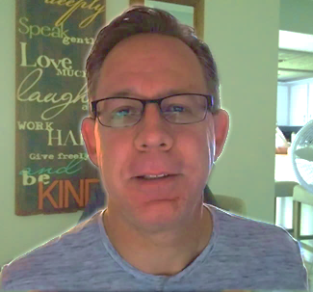
Scott Speicher brings a unique blend of life experiences to his writing. A U.S. military veteran, he carries the discipline, resilience, and perspective gained through service into every story he tells. After his military career, Scott built a successful path in marketing, where he developed a deep understanding of communication, storytelling, and audience engagement. For more than 15 years, he has also worked as a professional website designer, helping businesses and individuals create meaningful online presences.
Scott Speicher is a storyteller who enjoys creating gentle, heartfelt stories that help children notice the small moments that make life meaningful. Through warm characters and simple adventures, his books encourage young readers to slow down, care for others, and appreciate the quiet joys of everyday life. Scott believes that some of the most important lessons children learn come not from grand events, but from the ordinary moments shared with family, friends, and the animals they love.
Scott M. Speicher is the creator of ScottMBooks.com, a children’s book and educational resource website focused on helping young readers grow through meaningful stories and printable learning activities. His books encourage children to build reading confidence while learning important life lessons such as kindness, courage, responsibility, patience, friendship, compassion, and caring for others. Through stories like Lily and the Kindness Club, Scott hopes to inspire children, teachers, parents, and homeschool families to use reading to build both literacy skills and strong character.
Suitable for readers aged 4-10 and for family read-aloud sessions. Ideal for SEL, guidance, and service-learning.

