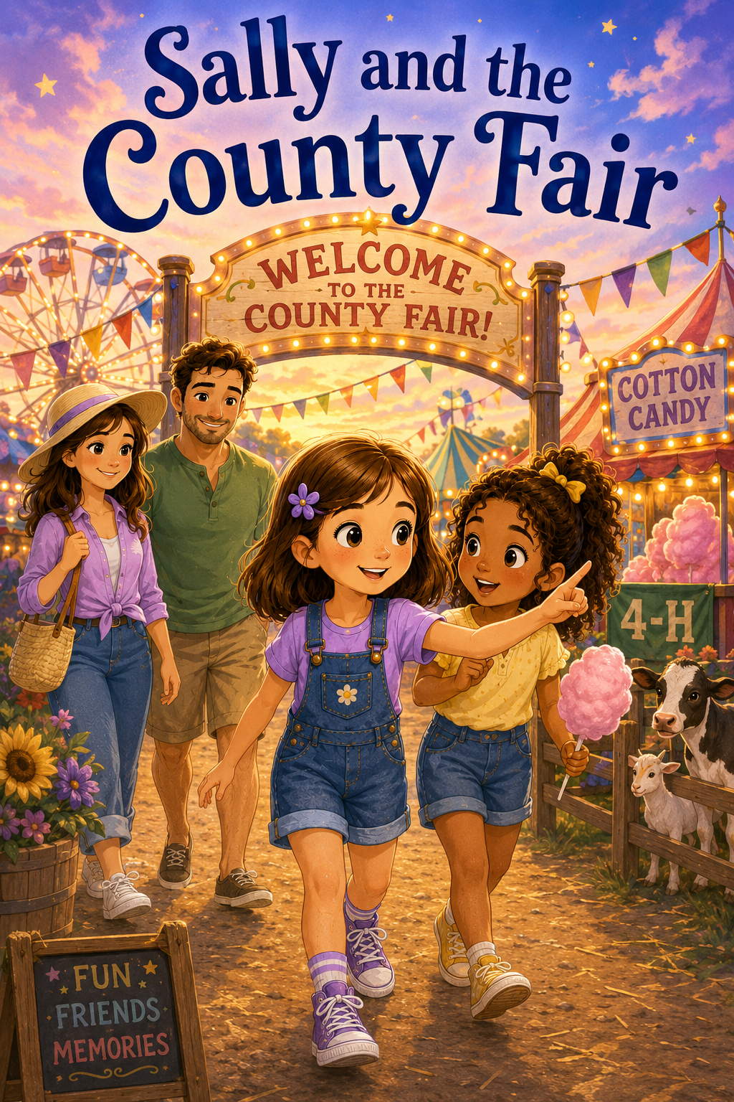
Preface
Sally and the County Fair
The county fair is a place filled with bright lights, cheerful music, colorful rides, tasty treats, friendly animals, and exciting surprises. But in Sally and the County Fair, the fair becomes much more than a fun day out. It becomes a place where Sally learns important lessons about friendship, courage, kindness, compassion, and welcoming someone new.
When Maria moves in next door, Sally has a choice to make. She can stay quiet and wonder about the new girl, or she can be brave enough to say hello. That one small act of kindness begins a friendship that grows throughout the story. As Sally invites Maria to the county fair, helps her feel comfortable, encourages her gently, shares with others, and listens to Maria’s stories, Sally discovers that friendship grows best when we make room for someone else.
This book reminds young readers that kindness does not have to be big to matter. Sometimes kindness is saying hello, inviting someone along, waiting patiently, giving someone space, sharing a prize, or listening carefully when a friend has something important to say. Through Sally and Maria’s day at the fair, children are encouraged to notice the feelings of others, try new things with courage, treat animals gently, and understand that everyone has a story worth hearing.
May this story help children see that every new friendship begins with a small brave step—and that when we open our hearts to others, ordinary days can become unforgettable adventures.

Table of Contents
Sally and the County Fair
Preface
An introduction to Sally’s heartwarming county fair adventure and the important lessons she learns about friendship, courage, kindness, compassion, and welcoming someone new.

Chapter 1: The Girl Next Door
Sally notices a moving truck next door and meets Maria, a kind but shy girl who has just moved into the neighborhood. Sally feels nervous at first, but she chooses to be welcoming. A simple hello becomes the beginning of a new friendship.

Chapter 2: An Invitation to the Fair
Sally’s mom and stepdad, Mark, tell her they are going to the county fair. Sally quickly thinks of Maria and asks if she can come along. Sally learns that including someone new can help them feel welcome and valued.

Chapter 3: Lights, Sounds, and First Impressions
Sally, Maria, Mom, and Mark arrive at the busy county fair. Maria is amazed by the lights, music, food stands, rides, and crowds, but she also feels a little overwhelmed. Sally notices and helps her friend feel safe and comfortable.

Chapter 4: The Carnival Game Challenge
Sally and Maria try carnival games for the first time. Sally hopes to win a prize but discovers the games are harder than they look. With encouragement from Mark, Mom, and Maria, Sally learns that trying your best and having fun matter more than winning.

Chapter 5: Maria’s Brave Ride
Maria sees a ride she wants to try but becomes nervous when it begins to spin and rise. Sally supports her without pressuring her. Maria learns that courage does not mean never feeling afraid—it means taking one small brave step when you are ready.

Chapter 6: The Kindness Prize
Sally wins a small stuffed animal at a carnival game and feels proud. Then she notices a younger child who is sad after losing. Sally chooses to give the prize away and discovers that generosity can bring a special kind of joy.

Chapter 7: The 4-H Barn
Sally and Maria visit the 4-H barn and meet children who care for goats, rabbits, chickens, sheep, and calves. They learn that caring for animals takes responsibility, patience, gentleness, and daily effort.

Chapter 8: The Nervous Little Goat
Inside the animal barn, Sally and Maria notice a small goat named Peanut who seems frightened by the fair noises. With help from a kind 4-H student, they learn to stay calm, speak softly, move slowly, and give animals space.

Chapter 9: A Fairground Discovery
Sally and Maria explore craft displays, garden exhibits, pies, artwork, student projects, and quilts. As Maria shares stories about her family traditions, favorite foods, and memories from her old home, Sally learns that friendship grows through listening and understanding.

Chapter 10: Fireworks and New Friends
As the fair ends, Sally, Maria, Mom, and Mark watch fireworks light up the night sky. Sally reflects on everything she has learned about courage, kindness, compassion, discovery, and friendship. She realizes the best part of the fair was opening her heart to a new friend.

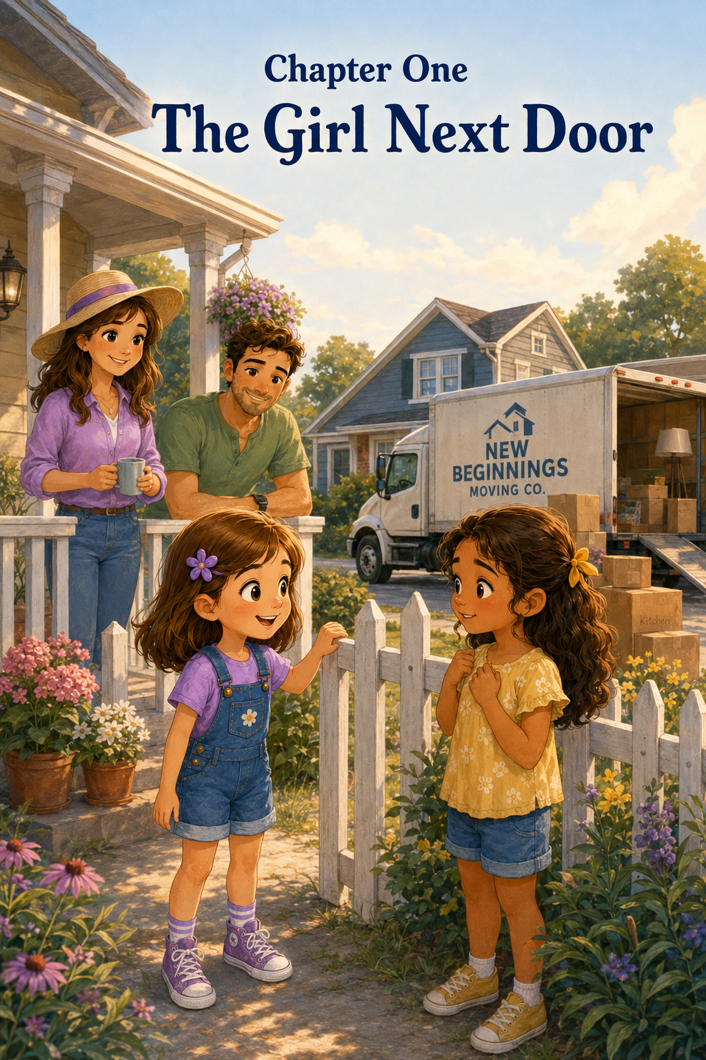Chapter 1: The Girl Next Door
Sally was sitting on the front porch with a picture book open across her lap when she heard a loud beep, beep, beep coming from the street.
She looked up.
A big moving truck was slowly backing into the driveway next door.
Sally blinked with surprise.
For weeks, the house beside hers had been quiet. The windows had been dark at night, the porch had been empty, and no one had played in the yard. Sometimes, when Sally looked over at the house, she wondered who might live there someday.
Now, someday had finally arrived.
“Mom!” Sally called through the screen door. “Someone’s moving in!”
Her mom came to the porch, wiping her hands on a kitchen towel. “That’s exciting,” she said with a smile. “It looks like we have new neighbors.”
Sally stood and held onto the porch railing. Two grown-ups were carrying boxes from the truck. A small gray car was parked near the curb. A stack of flowerpots sat beside the front steps.
Then Sally saw her.
A girl stepped out from behind the moving truck. She looked about Sally’s age. She had dark hair pulled back with a yellow ribbon, and she held a stuffed bunny tucked under one arm. The girl looked around at the yard, the house, and the street with wide eyes.
Sally wondered if the girl felt excited.
She wondered if the girl felt nervous.
Maybe she felt both.
The new girl glanced toward Sally’s porch. Their eyes met for one tiny second.
Sally smiled.
The girl gave a small smile back, then quickly looked down at her shoes.
Sally felt a flutter in her stomach.
She wanted to say hello, but suddenly the front yard seemed very wide. What if the girl did not want to talk? What if Sally said the wrong thing? What if the girl was too busy helping her family move?
Mom seemed to know exactly what Sally was thinking.
“It can be hard to be the new person,” Mom said gently. “A friendly hello can make a big difference.”
Sally nodded. She knew her mom was right.
Still, saying hello to someone new sometimes took courage.
Sally looked down at her book. Then she looked back at the girl next door. The girl was standing by the flowerpots now, watching her parents carry another box inside.
Sally took a deep breath.
“I think I’ll go meet her,” Sally said.
Mom smiled. “That sounds kind.”
Sally walked down the porch steps and across the grass. With every step, her heart beat a little faster. She brushed a wrinkle from her shirt and tried to think of what to say.
When she reached the edge of the yard, she stopped near the little white fence between the two houses.
“Hi,” Sally said softly.
The girl turned. “Hi.”
For a moment, neither girl said anything else.
A breeze moved through the trees. A cardboard box sat on the sidewalk with the word KITCHEN written on it in black marker. Somewhere inside the house, someone laughed.
Sally tucked her hands behind her back.
“I’m Sally,” she said.
The girl hugged her stuffed bunny a little closer. “I’m Maria.”
“That’s a pretty name,” Sally said.
“Thank you,” Maria answered. “Sally is pretty, too.”
Sally smiled again. This time, Maria’s smile stayed a little longer.
“Are you moving in today?” Sally asked.
Maria nodded. “We came this morning. Everything is still in boxes.”
“That happened when we moved once,” Sally said. “I couldn’t find my pajamas the first night, and I had to sleep in my clothes.”
Maria giggled.
Sally felt the nervous flutter in her stomach begin to settle.
“My books were packed in the wrong box,” Maria said. “I found spoons, towels, and one shoe, but no books.”
“One shoe?” Sally asked.
Maria nodded seriously. “Just one.”
Both girls laughed.
A woman carrying a lamp walked past them and smiled. “Maria, sweetheart, are you doing okay?”
“Yes, Mama,” Maria said. “This is Sally.”
Sally gave a little wave. “Hello.”
“It’s very nice to meet you, Sally,” Maria’s mother said. “Thank you for coming over to say hello.”
Sally felt warm inside. “You’re welcome.”
Maria’s mother carried the lamp inside, and the girls stood together by the fence.
“Do you like it here?” Maria asked.
Sally looked around her neighborhood. She saw the maple tree near the sidewalk, the row of mailboxes, the quiet street, and her own front porch where Mom was watching with a happy smile.
“I do,” Sally said. “There’s a park not too far away. And sometimes the ice cream truck comes on Saturdays. And Mrs. Jenkins down the street has a dog named Pickles.”
Maria’s eyes brightened. “A dog named Pickles?”
“Yes,” Sally said. “He’s little, but he barks like he’s very important.”
Maria laughed again.
Sally was glad.
She remembered what Mom had said. It could be hard to be the new person. Sally tried to imagine how Maria must feel, standing in a new yard, on a new street, with boxes everywhere and everything unfamiliar.
“Would you like to see the best tree in my yard?” Sally asked. “It has a branch shaped like a chair. You can sit on it, but only if a grown-up says it’s okay.”
Maria looked toward Sally’s yard. “Maybe later. I think I have to help unpack.”
“That’s okay,” Sally said quickly. “I can help too, if you want.”
Maria looked surprised. “Really?”
Sally nodded. “I’m good at carrying light things. Not lamps. Not heavy boxes. But pillows, maybe.”
Maria smiled. “We have lots of pillows.”
Just then, Mark stepped out onto Sally’s porch. “Everything okay over there?” he called.
“Yes!” Sally called back. “This is Maria!”
Mark waved. “Welcome to the neighborhood, Maria.”
“Thank you!” Maria called.
Maria’s father came out of the truck carrying a box that looked much too heavy. He set it down with a sigh. “Maria, could you take this little bag of towels inside?”
“I can help,” Sally offered.
Maria picked up one side of the bag, and Sally picked up the other. It was soft and lumpy and smelled like clean laundry. Together, the girls carried it carefully up the front steps.
Inside Maria’s new house, there were boxes everywhere. Some were stacked in the hallway. Some sat in the living room. A rolled-up rug leaned against the wall. The house smelled like cardboard, fresh paint, and a little bit like cinnamon.
“This is going to be my room,” Maria said, pointing down the hall.
“Do you know how you’ll decorate it?” Sally asked.
Maria’s face grew brighter. “I have butterfly curtains. And a purple bedspread. And a shelf for my books, when I find them.”
Sally grinned. “Books are important.”
“Very important,” Maria agreed.
They placed the towel bag in the hallway. Then Maria’s mother thanked them and gave each girl a small bottle of water from a cooler by the door.
The girls went back outside and sat on the front steps while the grown-ups continued carrying boxes.
For a little while, they did not say much. But now the quiet felt different. It no longer felt shy or uncomfortable. It felt peaceful.
Maria twisted the cap on her water bottle. “I was worried I wouldn’t know anyone here.”
Sally looked at her. “I felt nervous coming over.”
“You did?” Maria asked.
Sally nodded. “A little. I wanted to say hello, but I wasn’t sure what to say.”
Maria smiled softly. “I’m glad you did.”
“Me too,” Sally said.
A blue jay landed on the fence, tilted its head, and flew away again. The afternoon sun made golden spots on the grass. Across the street, a bicycle bell rang.
Sally thought about how strange it was that just a little while ago, Maria had been a girl she did not know. Now Maria felt like someone she wanted to know better.
“Do you like fairs?” Sally asked.
Maria’s eyes widened. “Fairs?”
“Yes,” Sally said. “Like rides and games and animals and cotton candy.”
“I’ve never been to a county fair,” Maria said.
Sally gasped. “Never?”
Maria shook her head. “But it sounds fun.”
“It is,” Sally said. “There are lights everywhere, and music, and games where you try to win prizes. Sometimes there are goats and rabbits and chickens too.”
Maria hugged her stuffed bunny. “I like animals.”
“Me too,” Sally said. “Maybe we can go to a fair someday.”
Maria smiled. “Maybe.”
At that moment, Sally’s mom walked across the grass carrying a small plate covered with napkins.
“I thought our new neighbors might like some cookies,” Mom said.
Maria’s mother came to the door. “That is so kind. Thank you.”
“They’re chocolate chip,” Sally said. “Mom makes the best ones.”
Mom laughed. “Sally may be a little bit biased.”
Maria’s mother invited them to set the cookies on the kitchen counter. Everyone thanked everyone else, the way neighbors do when a friendship is just beginning.
When Sally and Mom started back toward their own house, Maria followed them to the fence.
“Thanks for helping,” Maria said.
“You’re welcome,” Sally replied.
Maria looked down at her stuffed bunny, then back at Sally. “Do you want to come over tomorrow? Maybe we can look for my books.”
Sally’s face lit up. “Yes! And maybe after that, I can show you the tree branch shaped like a chair.”
Maria laughed. “Okay.”
Sally waved as she walked back to her porch. This time, Maria waved back with her whole arm.
Mom opened the screen door, but Sally paused before going inside. She looked once more at the house next door. It did not seem empty anymore. It seemed busy, bright, and full of possibility.
Sally felt proud of herself.
She had been nervous, but she had said hello anyway.
She had helped someone feel welcome.
And she had made a new friend.
That night, as Sally got ready for bed, she thought about Maria and the moving truck and the missing books and the one lonely shoe.
She smiled to herself.
Sometimes, Sally thought, being kind was as simple as crossing the yard.
And sometimes, a new friendship began with one brave hello.

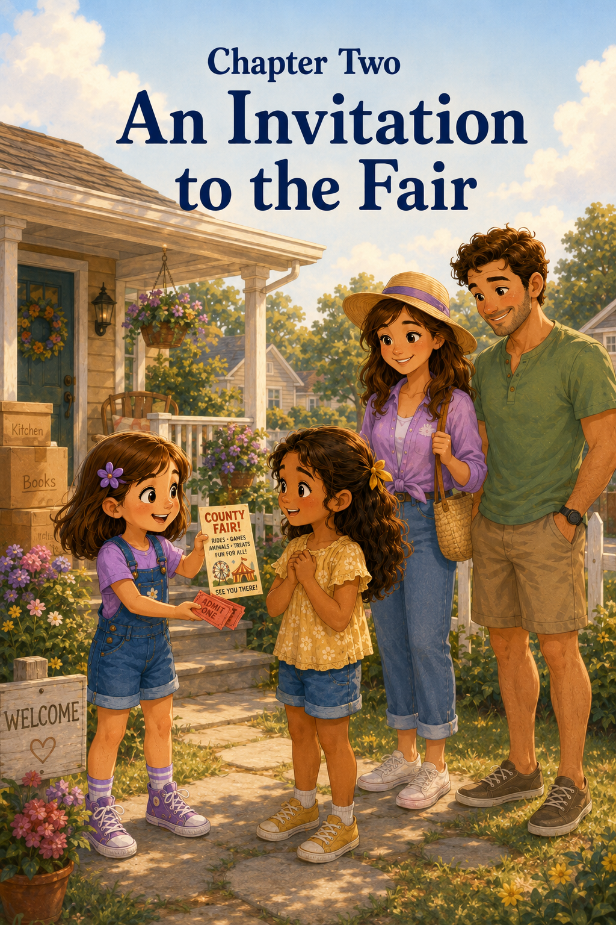Chapter 2: An Invitation to the Fair
The next morning, Sally woke up thinking about the house next door.
Yesterday, the house had been quiet and empty. Today, it had people inside. It had flowerpots on the porch, boxes in the hallway, and a girl named Maria who had butterfly curtains, a purple bedspread, and a missing box of books.
Sally smiled as she pulled on her socks.
She wondered if Maria had found her books yet.
She wondered if Maria’s one lonely shoe had found its match.
Most of all, she wondered if Maria would want to play again.
Downstairs, the kitchen smelled like warm toast and strawberry jam. Mom was standing by the counter packing lunches for the day, and Mark was sitting at the table with a cup of coffee and the morning newspaper.
“Good morning, sleepyhead,” Mark said, peeking over the top of the paper.
“I’m not sleepy,” Sally said, even though she yawned right after she said it.
Mom laughed softly. “That was a very sleepy yawn.”
Sally climbed into her chair at the kitchen table. “I was just thinking.”
“Thinking can make a person yawn?” Mark asked with a grin.
“Sometimes,” Sally said seriously. “Especially if it is important thinking.”
Mom set a plate of toast in front of her. “And what important thing are you thinking about?”
“Maria,” Sally said. “I hope she likes it here.”
Mom’s face softened. “That is kind of you, Sally.”
“She seemed nervous yesterday,” Sally said. “But also, nice. We helped carry towels. And she has a stuffed bunny. And she has never been to a county fair.”
Mark slowly lowered his newspaper.
“Did you say she has never been to a county fair?” he asked.
Sally nodded. “Never.”
Mark looked at Mom. Mom looked at Mark.
They both smiled.
Sally looked from one grown-up to the other. “What?”
Mom sat down across from Sally. “Well,” she said, “that is actually something we wanted to talk to you about.”
Sally’s eyes widened. “Is it about the fair?”
“It is,” Mark said.
Sally sat up straight in her chair. The county fair was one of her favorite things. Every year, the fair brought bright lights, spinning rides, music, animals, games, ribbons, sweet treats, and the smell of popcorn wafting through the air.
There were always so many things to see that Sally felt like her eyes had to hurry to keep up.
“What about the fair?” Sally asked.
Mom smiled. “Mark and I thought we could go this weekend.”
Sally gasped so loudly that her toast almost slipped off her plate.
“This weekend?” she asked.
“This Saturday,” Mark said. “If the weather is good.”
Sally clapped her hands. “Saturday! That’s only…” She paused and counted on her fingers. “That’s only a few days away!”
“That’s right,” Mom said.
Sally bounced a little in her chair. “Can we see the animals? Can we go on rides? Can we play the duck pond game? Can we get lemonade? Can we look at the quilts? Can we—”
Mark held up one hand, laughing. “Slow down, fair expert. I think we can do many of those things.”
“And maybe cotton candy?” Sally asked hopefully.
Mom gave her a gentle look. “Maybe one treat.”
“One very fluffy treat?” Sally asked.
“We’ll see,” Mom said.
Sally knew that “we’ll see” did not always mean yes, but it did not mean no either. That was good enough for now.
She imagined the fairgrounds glowing in the evening light. She imagined the colorful ride tickets in Mark’s hand. She imagined the little farm animals in the 4-H barn and the rows of homemade pies with ribbons beside them.
Then Sally thought of Maria.
The excitement in her chest gave way to a thoughtful one.
Maria had just moved to a new neighborhood. She did not know many people yet. Her house was still full of boxes. She had never been to a county fair.
Sally looked toward the kitchen window. From where she sat, she could see the side of Maria’s house. A curtain moved in the upstairs window.
“What is it?” Mom asked.
Sally turned back around. “Could Maria come with us?”
Mom and Mark looked at each other again, but this time they did not look surprised. They looked pleased.
“That is a thoughtful idea,” Mom said.
“I thought she might like it,” Sally said. “And maybe she would feel more welcome if she had something fun to do.”
Mark nodded. “Moving to a new place can feel lonely at first.”
“Did you ever move when you were little?” Sally asked.
“I did,” Mark said. “When I was about your age, my family moved to a new town. I remember standing on the sidewalk and watching kids ride bikes together. I wanted to join them, but I didn’t know how to ask.”
“What happened?” Sally asked.
“One boy rode over and asked if I wanted to play kickball,” Mark said. “It was a small invitation, but I still remember it.”
Sally thought about that.
A small invitation could stay in someone’s heart for a long time.
“Then I really want to invite Maria,” Sally said.
Mom reached across the table and squeezed Sally’s hand. “That sounds lovely. We should ask her parents first, of course.”
“Can we ask today?” Sally asked.
Mark glanced at the clock on the wall. “Maybe after breakfast. We can walk over together.”
Sally ate her toast quickly, but not too quickly, because Mom reminded her twice to chew. When breakfast was done, Sally helped clear the table. She put her plate carefully in the sink and wiped crumbs from her spot.
Then she hurried to the front window.
Next door, Maria’s front door was open. A rolled-up rug had disappeared from the porch, but there were still a few boxes near the steps. Maria’s father was carrying a bookshelf inside.
“I see them!” Sally said.
Mom came beside her. “Let’s give them a few minutes. Moving mornings can be busy.”
Sally nodded, but waiting was not easy.
She went to her room and looked at her small collection of treasures on the shelf. There was a smooth shell from the seashore, a painted rock from summer camp, and a tiny paper star she had made with Mom. She wondered what Maria’s favorite treasures were.
Maybe Maria liked books.
Maybe she liked animals.
Maybe she would like the fair so much that it would become one of her favorite memories.
A little while later, Mom called, “Sally, ready?”
Sally hurried downstairs.
Mark was waiting by the door. “Let’s go welcome our neighbors properly.”
Sally walked between Mom and Mark across the yard. She felt the same little flutter she had felt the day before, but this time it was different. Yesterday, she had been nervous to say hello. Today, she was excited to ask something kind.
Maria’s mother answered the door with a tired but friendly smile.
“Good morning,” Mom said. “I hope we aren’t interrupting.”
“Not at all,” Maria’s mother said. “We’re just trying to decide which box has the coffee mugs.”
Mark held up a hand. “A very important moving mystery.”
Maria’s mother laughed. “One of many.”
Sally peeked past the doorway and saw Maria sitting on the living room floor beside a half-open box. Books were stacked around her in small piles.
“Maria!” Sally said.
Maria looked up. Her face brightened. “Hi, Sally! I found my books!”
“And both shoes?” Sally asked.
Maria held up one foot, then the other. “Both shoes.”
Sally giggled.
Mom smiled at Maria’s mother. “We wanted to ask you something. We’re planning to take Sally to the county fair this Saturday, and Sally wondered if Maria might like to come with us.”
Maria froze with a book in her hands.
“The county fair?” she asked.
Sally nodded quickly. “There are rides and games and animals and lights and sometimes music. And food stands. And probably cotton candy, but Mom said maybe only one treat.”
Maria looked at her mother with hopeful eyes. “Could I go?”
Maria’s mother’s smile grew soft. “That is a very kind invitation.”
“We’d be happy to have her with us,” Mark said. “We’ll stay together the whole time.”
Mom nodded. “We can share all the details with you—what time we’re going, where we’ll be, and when we’ll come home.”
Maria’s mother looked at Maria. “Would you like to go?”
Maria hugged her book to her chest. “Yes, please.”
Sally’s heart felt like it jumped.
Maria was coming to the fair.
Sally tried not to bounce, but she bounced just a little.
Maria’s mother laughed gently. “Then I think that sounds wonderful.”
Maria stood up. “Thank you! Thank you so much!”
“You’re welcome,” Mom said.
Sally grinned. “I can show you everything. Well, not everything, because the fair is really big. But I can show you the best things.”
“What are the best things?” Maria asked.
Sally had to think about that because there were many best things.
“The lights are best,” Sally said. “And the animal barn. And the games. And the lemonade. And the rides, if you like rides. And maybe the pies, but mostly looking at them because they’re for judging.”
“What does judging pies mean?” Maria asked.
“It means people taste them and decide which one gets a ribbon,” Sally explained. “I think it would be a very delicious job.”
Mark chuckled. “Sally has always wanted to be a pie judge.”
“It is one of my important dreams,” Sally said.
Maria laughed.
Sally loved that Maria laughed more easily today.
Maria’s father came into the room carrying an empty box folded flat under one arm. “What’s this about the fair?”
Maria hurried to him. “Sally’s family invited me to go with them Saturday!”
“That sounds exciting,” he said. Then he looked at Mom and Mark. “Thank you for including her. That means a lot.”
Sally noticed the way he said it. His voice was warm, but there was something else in it too. Maybe relief. Maybe gratitude. Maybe grown-ups are also worried when children have to make new friends.
“We’re glad to,” Mom said.
Maria turned to Sally. “What should I bring?”
“Comfortable shoes,” Sally said right away. “And maybe a sweater if we stay until the fireworks. And maybe a brave heart.”
Maria tilted her head. “A brave heart?”
Sally nodded. “For trying new things.”
Maria looked a little nervous, but then she smiled. “I can bring that.”
Sally smiled back. “I’ll bring mine too.”
After Mom and Maria’s mother talked a little longer about times and phone numbers, Sally and Maria stepped onto the porch together.
The morning sun was bright, and the grass still looked damp from the sprinklers. A few birds hopped near the sidewalk, pecking at the ground.
“I can’t believe I get to go,” Maria said.
“I’m glad you can,” Sally replied.
“I was worried this weekend would just be more unpacking,” Maria said. “Everything still feels strange.”
Sally leaned against the porch railing. “It won’t feel strange forever.”
“How do you know?” Maria asked.
Sally thought carefully. “Because yesterday you were new, and today you’re my friend.”
Maria looked at Sally with a soft smile.
“Really?” Maria asked.
“Really,” Sally said.
Maria looked down shyly, but she was smiling. “Then I’m glad we moved here.”
Sally felt something warm bloom inside her chest.
She had not done anything big. She had not built a house, unpacked every box, or made Maria’s new room feel perfect. All she had done was say hello, help with towels, and invite Maria to come along.
But sometimes small, kind things make a big difference.
When Sally walked back home with Mom and Mark, she skipped once, then twice, then almost the whole way across the yard.
“I think someone is excited,” Mark said.
“I am,” Sally said. “But I’m not just excited for me. I’m excited for Maria, too.”
Mom smiled. “That is a wonderful kind of excitement.”
At lunch, Sally talked about the fair. In the afternoon, she drew a picture of a Ferris wheel with bright colored circles. Beside it, she drew two girls holding hands. One had light hair like Sally. One had dark hair with a yellow ribbon like Maria.
At the top of the paper, Sally wrote:
COUNTY FAIR FRIENDS
That evening, Sally taped the picture on her bedroom wall. She looked at it before climbing into bed.
The fair was still a few days away, but it already felt special.
Not just because of the rides.
Not just because of the games.
Not even because of the cotton candy that might or might not happen.
It felt special because Maria would be there.
Sally pulled her blanket up to her chin and smiled in the dark.
She was learning something important.
Friendship grows when we make room for someone else.
And sometimes, the kindest words a person can hear are simple ones:
Would you like to come with us?

Chapter 3: Lights, Sounds, and First Impressions
Saturday finally arrived.
All morning, Sally could hardly stay still.
She brushed her hair, tied her shoes, checked the weather through the window, and asked Mom three times if it was time to go yet.
“Not quite,” Mom said the first time.
“Almost,” Mom said the second time.
“Now,” Mark said the third time, holding up the car keys.
Sally jumped from her chair. “It’s fair time!”
Outside, Maria was waiting on her front steps with her mother. She wore comfortable sneakers, just like Sally had suggested, and her dark hair was tied back with the same yellow ribbon Sally had seen on moving day. She held a light sweater folded over one arm.
Sally waved. “Maria!”
Maria waved back, but Sally noticed her smile was a little shy.
Mom greeted Maria’s mother and promised they would stay together the whole time. Mark reminded everyone to wear their seat belts, and soon Sally and Maria were sitting side by side in the back seat of the car.
“Are you excited?” Sally asked.
Maria nodded. “Very excited.”
“Are you nervous?” Sally asked gently.
Maria looked at her, surprised. Then she nodded again, but only a little. “Maybe a tiny bit.”
“That’s okay,” Sally said. “Sometimes I feel nervous before something new, too.”
Maria smiled softly. “You do?”
“Yes,” Sally said. “But Mark says new things feel less scary when you do them with someone kind.”
From the front seat, Mark glanced in the mirror. “That sounds like something a very wise person would say.”
Mom laughed. “A very wise stepdad, maybe.”
The girls giggled.
As they drove closer to the fairgrounds, Sally began to see signs along the road.
COUNTY FAIR THIS WAY!
RIDES! GAMES! FOOD! ANIMALS!
WELCOME FAMILIES!
Maria leaned toward the window. “There are so many cars.”
“That means lots of people came,” Sally said. “The fair is very popular.”
When they turned into the parking field, Maria’s eyes grew wide. Rows and rows of cars sat on the grass. Orange cones marked the lanes. A man in a bright vest waved them forward. In the distance, Sally could already see the top of the Ferris wheel turning slowly against the blue sky.
“There it is!” Sally cried.
Maria pressed her hands to the window. “It’s huge.”
“And pretty at night,” Sally said. “It lights up in colors.”
Mark parked the car near a wooden fence. Mom handed each girl a small bottle of water.
“Before we go in,” Mom said, “let’s remember our fair rules.”
“Stay together,” Sally said right away.
“Hold hands or stay close in busy places,” Mark added.
“Use walking feet,” Mom said.
“And if anyone feels tired, nervous, or needs a break, we say so,” Mark said.
Maria looked at him. “That’s allowed?”
“Of course,” Mark said kindly. “Fun should still feel safe.”
Sally nodded. “We can take breaks. Sometimes the fair is loud.”
Maria looked relieved.
They walked from the parking field toward the entrance gate. With each step, the fair seemed to grow bigger and brighter.
Sally heard music drifting through the air. It was cheerful and bouncy, mixed with the jingling bells of carnival games and the hum of many voices. Somewhere nearby, children laughed. A ride made a whooshing sound as it spun in a wide circle. From farther away came the soft, low sound of a cow.
Maria stopped walking for a moment.
Sally stopped too.
Before them, the county fair spread out like a colorful little world.
Strings of flags fluttered overhead in red, blue, yellow, and green. Food stands lined the walkway, selling popcorn, lemonade, soft pretzels, roasted corn, funnel cakes, and cotton candy as fluffy as clouds. Carnival booths flashed with bright prizes hanging from every wall—stuffed bears, toy dinosaurs, sparkly balls, and giant rainbow fish.
The rides rose above the crowds like moving towers of color. The Ferris wheel turned slowly. A carousel spun gently with painted horses bobbing up and down. A small train carried children around a track, its little whistle blowing toot-toot! every time it passed.
Maria stared at everything.
“Wow,” she whispered.
Sally smiled. “I know.”
The air smelled sweet and salty all at once. Sally could smell buttered popcorn, fried dough, and warm cinnamon. She could also smell hay drifting from the animal barns and fresh grass from the fairground paths.
A group of teenagers walked past with paper plates full of curly fries. A little boy hurried by holding a balloon shaped like a puppy. A woman laughed as powdered sugar dusted the front of her shirt from a funnel cake.
Maria’s head turned left, then right, then left again.
“There’s so much,” she said.
“There is,” Sally agreed.
Maria took a small step closer to Sally.
At first, Sally was busy looking too. She wanted to point out the rides, the games, the barn, the ribbon tent, the lemonade stand, and the place where they sometimes sold caramel apples. But then she noticed Maria’s hand holding her sweater tightly.
Maria’s smile had become smaller.
Her eyes still looked amazing, but her shoulders had lifted near her ears. Every loud sound made her blink.
Sally remembered what Mom had said on moving day.
It can be hard to be a new person.
Maybe it's also hard to be in a new place.
Sally moved closer. “It’s loud, isn’t it?”
Maria nodded. “A little.”
“We don’t have to hurry,” Sally said. “We can stand here for a minute.”
Mom heard her and smiled. “That’s a good idea.”
Mark stepped to the side of the walkway, to a quieter spot near a fence. “Let’s let our eyes and ears catch up.”
Maria gave a tiny laugh. “My eyes and ears do need to catch up.”
They stood together and watched the fair from the side. Sally pointed slowly instead of quickly.
“That’s the Ferris wheel,” she said. “It moves gently. That one over there spins faster, so we don’t have to do that one unless we want to. The animal barn is past those blue flags. The games are along that row.”
Maria listened carefully.
“What’s that smell?” she asked.
Sally sniffed. “Which smell?”
“The sweet one.”
“Funnel cake,” Sally said. “Or cotton candy. Or both.”
Maria smiled a little bigger. “It smells like a birthday party.”
“With goats,” Mark added.
The girls burst into giggles.
That helped.
After a few minutes, Maria’s shoulders relaxed. She let go of her sweater and looked around again.
“Better?” Sally asked.
“Better,” Maria said. “Thank you for stopping.”
“You’re welcome,” Sally said. “Sometimes when there are too many things, I like to choose just one thing to look at first.”
Maria thought about that. “Then I choose the carousel.”
Sally looked toward the carousel. Painted horses moved in circles under a roof trimmed with lights. Some horses were white with golden saddles. Some were brown with red bridles. One was black with silver stars painted on its side.
“That’s a good first thing,” Sally said. “It’s pretty and not too noisy.”
Mom checked with Mark, then nodded. “The carousel sounds like a lovely place to begin.”
They walked together through the fairgrounds. Sally stayed beside Maria, not ahead of her. When the crowd grew thicker, Sally slowed down. When a group of laughing children rushed past, Sally gently moved closer so Maria would not feel bumped or lost.
“Do you want to hold hands?” Sally asked.
Maria looked at the crowd and nodded. “Just until we get there.”
Sally took her hand.
Maria’s hand was warm and a little nervous. Sally held it gently.
As they walked, Sally noticed things she had never noticed before. She noticed how loud the bell was when someone won a game. She noticed how quickly people moved when they were excited. She noticed that the fair could feel wonderful and too much at the same time.
Sally had been to the fair before, so everything felt familiar to her. But for Maria, it was all brand new.
That made Sally want to be extra careful.
They passed a stand where a man was selling lemonade in tall cups. Ice clinked as he poured. They passed a booth where children tossed rings over bottles. They passed another booth where rubber ducks floated in a little pool of water.
“I want to try that later,” Sally said.
“The duck game?” Maria asked.
“Yes. It’s one of my favorites.”
Maria smiled. “I like ducks.”
“Then we definitely have to try it.”
When they reached the carousel, the music became softer and sweeter. It played a tinkly tune that rose and fell like a lullaby. The horses moved slowly around and around, their painted manes shining under little bulbs of light.
Maria looked up at the carousel roof. “It’s beautiful.”
Sally nodded. “Do you want to ride it?”
Maria hesitated.
Sally waited.
She did not say, “Come on.”
She did not say, “Don’t be scared.”
She remembered how it felt to be nervous. She remembered how kind it felt when someone waited.
“We can just watch first,” Sally said.
Maria looked grateful. “Maybe we can watch one time.”
So they watched.
Children climbed onto horses with help from their parents. The worker checked the safety belts. Then the music started again, and the carousel began to turn. The horses rose and dipped, rose and dipped, like they were galloping through a dream.
Maria’s eyes followed a white horse with pink roses painted on its saddle.
“That one is my favorite,” she said.
“It looks friendly,” Sally said.
When the ride slowed and stopped, Maria took a deep breath.
“I think I want to try,” she said.
Sally’s face brightened. “I’ll ride beside you.”
Maria nodded. “Okay.”
Mom bought the tickets, and Mark helped the girls step onto the carousel platform. Maria chose the white horse with pink roses. Sally chose the horse next to it, a golden-brown one with a blue ribbon painted across its chest.
“Remember,” Mark said, “hold on with both hands.”
“We will,” Sally promised.
The music began. The carousel moved.
At first, Maria’s eyes widened, and she held the pole tightly. Sally watched her carefully.
“You’re doing great,” Sally said.
Maria looked over. Her hair ribbon fluttered as the carousel turned. Slowly, she smiled.
The horses rose and dipped.
The lights twinkled.
The music played.
Around them, the fair blurred into colors—red flags, yellow lights, blue signs, green trees, and smiling faces.
Maria laughed.
It was a small laugh at first, then a bigger one.
Sally laughed too.
When the ride ended, Maria climbed down with cheeks pink from excitement.
“I did it!” she said.
“You did,” Sally said. “And you picked a very good first ride.”
Maria looked back at the carousel. “I thought I would be too nervous.”
“It’s okay to be nervous,” Sally said. “You tried when you were ready.”
Mom put an arm around Sally’s shoulders. “That was very thoughtful of you, Sally.”
“What was?” Sally asked.
“You noticed how Maria was feeling,” Mom said. “And you helped her take her time.”
Sally looked at Maria, who was still smiling at the carousel.
“I just wanted her to feel happy here,” Sally said.
Maria turned back. “I do feel happy.”
Sally felt a warm glow inside, brighter than the fair lights.
They continued down the path together. The fair was still loud. It was still crowded. Bells still rang, music still played, and people still hurried from one colorful place to another.
But now Maria walked with a little more confidence.
Sally stayed beside her.
Not pulling.
Not rushing.
Just being there.
As they passed the lemonade stand again, Mark said, “I think our fair adventure has officially begun.”
“Where should we go next?” Mom asked.
Sally looked at Maria. “You can choose.”
Maria looked around at the games, the food stands, the rides, and the signs pointing toward the animal barns. She no longer looked quite so overwhelmed. She looked curious.
“Maybe the games,” Maria said.
Sally grinned. “Good choice.”
Together, the two girls walked toward the row of carnival booths, side by side under the bright fair flags.
And Sally understood something important.
A new place can feel big and loud and scary at first.
But with a kind friend nearby, it can start to feel like an adventure.

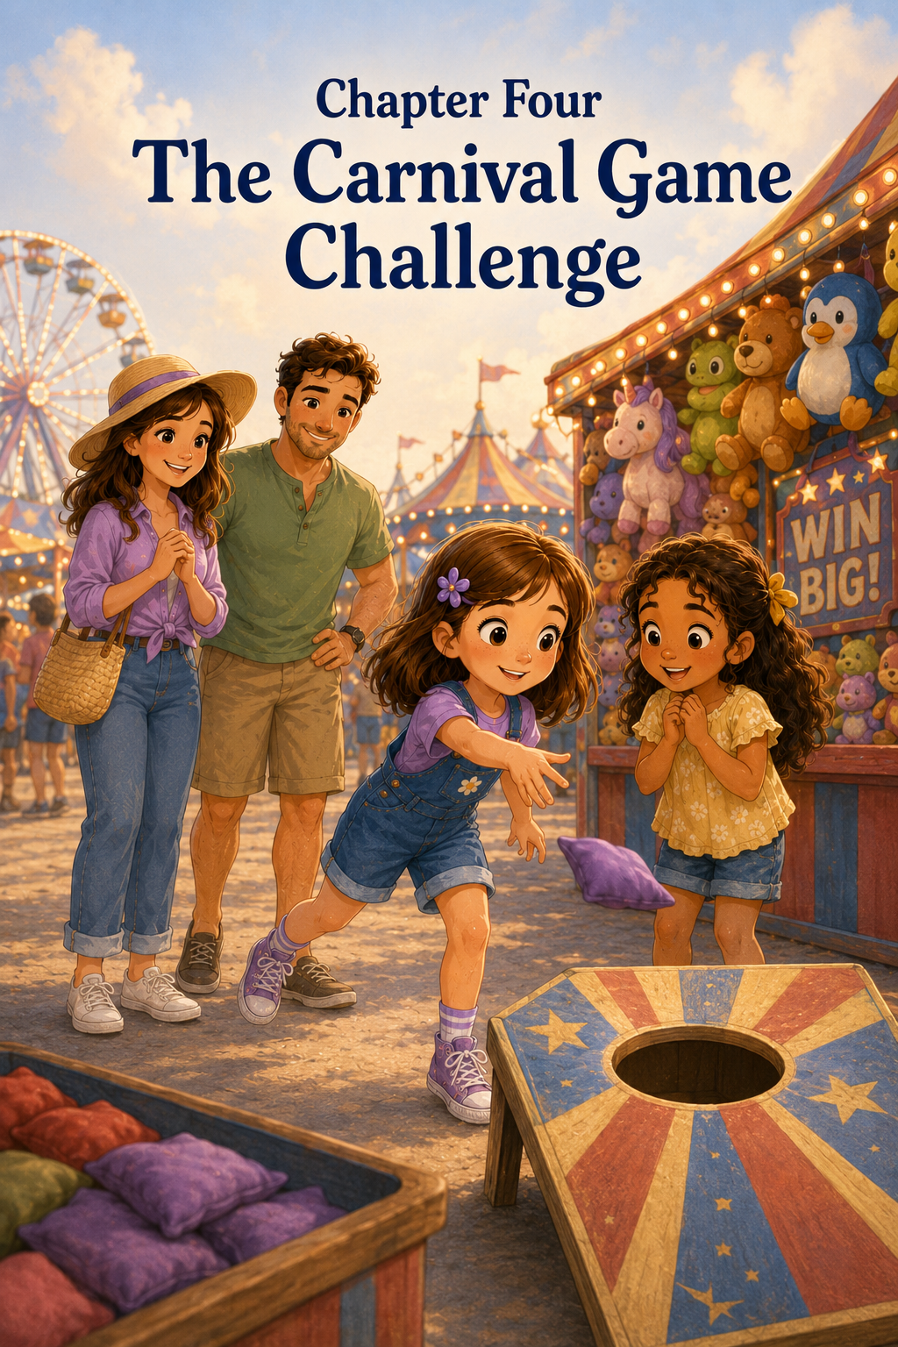Chapter 4: The Carnival Game Challenge
The row of carnival games looked like a rainbow made of prizes.
Stuffed bears hung from the tops of booths. Bright rubber balls bounced in baskets. Sparkly toy crowns, plastic whistles, fuzzy puppies, and giant smiling frogs filled the shelves. Everywhere Sally looked, there was something colorful waiting to be won.
Bells rang.
Children cheered.
A man in a striped shirt called, “Step right up! Three tries to win!”
Sally’s eyes grew wide.
“This is one of my favorite parts of the fair,” she told Maria.
Maria looked at all the booths. “There are so many games.”
“There’s the duck pond,” Sally said, pointing. “And the ring toss. And the basketball throw. And that one where you knock down the bottles.”
Maria watched a boy toss a ball at a stack of bottles. The ball hit the bottom bottle with a loud thunk, but only one bottle wobbled and fell.
“That looks hard,” Maria said.
“It can be,” Mark said. “Carnival games are meant to be challenging.”
Sally tilted her head. “But people still win.”
“They do,” Mom said. “But the fun is in trying.”
Sally nodded, although she was already looking at a prize hanging from one booth.
It was a small stuffed fox with a white-tipped tail and shiny black eyes. It hung from a hook near the front, looking as if it were waiting just for her.
Sally stopped walking.
“That one,” she whispered.
Maria followed her gaze. “The fox?”
“Yes,” Sally said. “Isn’t it cute?”
“It is very cute,” Maria agreed.
The booth was a beanbag toss game. Three wooden baskets stood at the back of the counter. Each basket had a different number painted on it. The closest basket was worth one point, the middle basket was worth two points, and the farthest basket was worth three points.
A friendly woman behind the counter smiled. “Want to try your luck?”
Sally looked at Mom.
Mom looked at Mark.
Mark reached into his pocket and pulled out a few tickets. “One game each,” he said. “Remember, win or lose, we keep a good attitude.”
“I will,” Sally promised.
Maria nodded too. “Me too.”
The woman handed Sally three small red beanbags. They were soft and square, filled with something that made them feel bumpy in her hand.
Sally stood behind the line painted on the ground.
She looked at the stuffed fox.
Then she looked at the baskets.
The first basket seemed close enough.
“I think I can do this,” Sally said.
“I think you can try,” Mom said with a gentle smile.
Sally took a deep breath, pulled her arm back, and tossed the first beanbag.
It flew through the air.
It sailed toward the basket.
It hit the rim, bounced once, and plopped onto the counter.
“Oh!” Sally said.
“So close,” Maria said.
“That was a good first try,” Mark added.
Sally picked up the second beanbag. She squeezed it in her hand and stared at the basket.
This time, she tried to toss it more softly.
The beanbag went up.
It came down.
It landed right in front of the basket.
Sally frowned. “Too soft.”
“That’s okay,” Mom said. “Now you know.”
Sally picked up the third beanbag.
This was her last chance.
She glanced at the stuffed fox again. She could almost imagine carrying it home. She could almost imagine setting it on her pillow. She could almost imagine telling everyone, “I won this at the fair.”
She tossed the final beanbag.
It flew farther than the others.
For one exciting second, Sally thought it might land in the basket.
But it bounced off the side and fell to the floor.
Sally’s shoulders drooped.
“No points,” she said quietly.
The woman at the booth gave her a kind smile. “That happens sometimes. These baskets are tricky.”
Mark patted Sally gently on the shoulder. “You gave it a good try.”
Sally tried to smile, but it did not feel like a real smile.
She had wanted to win.
She had wanted the fox.
She had wanted Maria to see her do well.
Instead, she had missed every single toss.
Maria stepped up for her turn. The woman gave her three blue beanbags.
“I’ve never done this before,” Maria said.
“Me either,” Sally said, though she was still disappointed.
Maria stood behind the line. She held the first beanbag carefully, as if she were not quite sure what to do with it.
“Just aim and toss,” Mark said.
Maria tossed.
The beanbag went sideways and landed near a painted wooden duck at the edge of the booth.
Maria covered her mouth and laughed. “That was not where I meant for it to go.”
Sally could not help laughing too. “It almost went to visit the duck pond.”
Maria tossed the second beanbag. It hit the front of the counter and slid backward.
“Oops,” Maria said.
“Carnival games are harder than they look,” Sally said.
Maria nodded. “A lot harder.”
She tossed the third beanbag.
This one went high in the air, came down near the closest basket, bounced off the rim, and landed inside.
Sally gasped. “Maria! You got one!”
Maria’s eyes grew wide. “I did?”
The woman behind the booth rang a small bell. Ding!
“One point,” she said. “Nice toss!”
Maria clapped her hands. “I got one point!”
Sally clapped too, but inside, a small, unhappy feeling pinched her.
Maria had made a basket.
Sally had not.
Maria had never played before.
Sally had tried so hard.
The woman handed Maria a tiny sticker shaped like a star. “One-point prize,” she said.
Maria smiled and placed the sticker carefully on her shirt.
“Look, Sally,” Maria said. “It’s a star.”
Sally nodded. “It’s nice.”
Mom looked at Sally’s face. “Are you all right?”
Sally shrugged a little. “I wanted to win something.”
“I know,” Mom said.
“I really wanted the fox,” Sally admitted.
Mark crouched down so he was closer to Sally’s height. “It’s disappointing when something doesn’t go the way you hoped.”
Sally nodded.
“But disappointment doesn’t have to decide what kind of day we have,” Mark continued. “You can feel disappointed and still choose to be cheerful.”
Sally looked at the beanbag baskets. “But I missed every time.”
“That means you were brave enough to try every time,” Mark said.
Maria touched the star sticker on her shirt. “And we had fun trying together, didn’t we?”
Sally thought about that.
She remembered Maria’s first beanbag flying sideways. She remembered laughing when it almost visited the duck pond. She remembered everyone cheering when Maria’s last beanbag landed in the basket.
That had been fun.
Maybe she had been so busy wanting the fox that she had forgotten to enjoy the game.
“I guess we did have fun,” Sally said.
Mom smiled. “Winning can be exciting, but it is not the only reason to play.”
“What are the other reasons?” Sally asked.
“To laugh,” Mom said.
“To learn,” Mark added.
“To try something new,” Maria said.
“And to cheer for each other,” Mom said.
Sally looked at Maria’s star sticker. This time, she smiled for real.
“You did a good job,” Sally said.
Maria beamed. “Thank you.”
Sally felt the little pinch inside her loosen.
They walked on to the next booth. This one had rows of floating rubber ducks in a small blue pool. Each duck had a number on the bottom. The sign said:
PICK A DUCK! WIN A PRIZE!
Sally’s eyes brightened. “This game is not about throwing.”
“That might be good news,” Mark said with a grin.
The worker behind the booth waved. “Everyone wins something at the duck pond!”
Sally looked at Mom hopefully.
Mom nodded. “All right. One duck each.”
Sally and Maria stepped up to the little pool. The ducks floated around in slow circles, bumping gently into one another.
“Which one should I pick?” Maria asked.
Sally studied the ducks carefully. “Maybe the one with the red beak.”
Maria reached for it, then paused. “No, I think this little yellow one in the corner looks lonely.”
She picked up the duck and showed the number on the bottom.
The worker smiled. “Number two! You win a pencil.”
He handed Maria a bright green pencil with tiny stars printed on it.
Maria grinned. “Now I have a star sticker and a star pencil.”
Sally reached into the water and picked up a duck with a blue mark on its wing.
“Number three,” the worker said. “You win a whistle.”
He handed Sally a small purple whistle on a string.
Sally turned it over in her hands. It was not the stuffed fox, but it was cheerful and shiny.
“Remember,” Mom said, “not inside the car.”
“Or inside the house,” Mark added.
“Or directly beside my ear,” Maria said.
Sally laughed. “I promise.”
They stepped away from the booth, and Sally hung the whistle around her neck. She felt happier now. Not because she had won a big prize, but because the game had been fun.
A little farther down the row, they saw the bottle knockdown game.
Sally watched another child toss a ball and miss.
“That game looks really hard,” Maria said.
Sally nodded. “Maybe we can just watch.”
Mark smiled. “Watching is part of the fair, too.”
They stood together as people tried to knock down the bottles. Some missed. Some knocked down one or two. One girl knocked down the whole stack, and everyone nearby clapped.
Sally clapped too.
“That was a great throw,” she said.
Maria looked at Sally. “You’re not sad anymore?”
“A little,” Sally said honestly. “I still liked that fox.”
Maria nodded. “It was a very nice fox.”
“But I think I like cheering too,” Sally said. “And maybe I can try again another time.”
“That sounds like good sportsmanship,” Mom said.
Sally stood a little taller. “Good sportsmanship means being kind even when you don’t win, right?”
“That’s right,” Mark said. “It also means celebrating when others do well.”
Sally looked at Maria’s star sticker. “Then I’m happy you got your star.”
Maria smiled. “And I’m happy you got your whistle.”
Sally lifted the whistle and pretended to blow it, but she did not make a sound.
“Thank you,” Maria said dramatically.
“You’re welcome,” Sally said, just as dramatically.
They both giggled.
As they continued through the carnival games, Sally noticed something different. Before, she had looked at every booth and wondered what she might win. Now she noticed the laughter, the bright colors, the silly tries, the cheers, and the way families clapped even when someone missed.
At one booth, a little boy tossed a ring and missed the bottles completely.
“I almost got it!” he shouted proudly.
His father laughed. “You almost got the next booth!”
Everyone laughed, including the boy.
Sally laughed too.
At another booth, two sisters tried to spray water into a target to make a plastic horse move across a track. One sister won, but the other jumped up and down cheering anyway.
Sally watched them and smiled.
“That’s what Mom meant,” she said.
“What?” Maria asked.
“Winning isn’t the only fun part.”
Maria nodded. “Trying together is fun too.”
Sally thought about the red beanbags, the blue beanbags, the duck pond, and Maria’s star sticker. She thought about how disappointed she had felt and how kind everyone had been while she felt that way.
She was glad Mark had reminded her to choose cheerfulness.
She was glad Maria had reminded her that they had fun together.
Most of all, she was glad she had not let one missed game spoil the whole fair.
Mark checked the time. “What do you girls think? Should we head toward the rides next?”
“The rides?” Maria asked.
Sally remembered that Maria had been brave on the carousel. She wondered what ride they might try next.
“Or we can get a snack first,” Mom said.
Sally’s stomach gave a tiny growl.
Maria heard it and giggled. “I think Sally voted for snack.”
“My stomach voted,” Sally said.
Mark nodded seriously. “We must respect the stomach vote.”
As they walked away from the carnival games, Sally glanced back one more time at the stuffed fox. It still hung from the booth, its white-tipped tail curled against the wall.
Sally still thought it was cute.
But she did not feel upset anymore.
She had not won the fox, but she had learned something better.
Games were not just about prizes.
They were about patience when things were hard.
They were about cheering for friends.
They were about laughing at silly tries.
And they were about doing your best, even when the beanbag bounced the wrong way.
Sally touched the purple whistle around her neck and smiled.
The county fair still had so much waiting for them.
And Sally was ready to enjoy it.

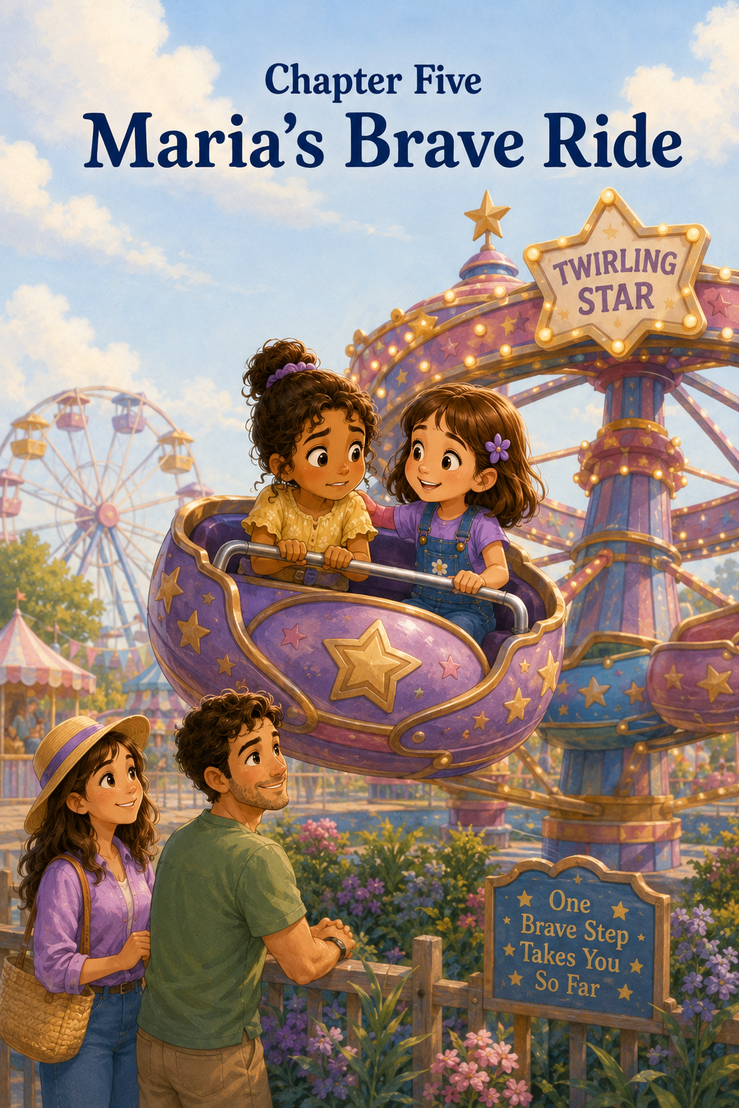Chapter 5: Maria’s Brave Ride
After the carnival games, Sally, Maria, Mom, and Mark followed the fairground path toward the rides.
The rides were easy to find.
They rose above the crowd like colorful towers, spinning and turning under the afternoon sky. Some moved slowly, like the Ferris wheel with its round seats drifting gently up and down. Others moved quickly, flashing with lights and music as they whirled in bright circles.
Sally walked beside Maria, her purple whistle bouncing softly against her shirt.
“That one is the little train,” Sally said, pointing. “It goes around the track by the fence. And that one is the carousel, but we already rode it. And that one over there is the giant slide.”
Maria looked up. “It is very giant.”
“It feels even taller when you’re at the top,” Mark said.
Sally grinned. “But it’s fun.”
Mom smiled. “Only if you’re ready for it.”
Maria nodded, but she did not answer. Her eyes were fixed on a ride just ahead.
It was shaped like a circle of bright seats hanging from metal arms. Each seat looked like a little flying basket with a safety bar across the front. When the ride began, the baskets lifted into the air and spun around in a wide circle. They did not go too high, but they rose enough that the riders’ feet dangled above the ground.
The sign above the ride read:
THE TWIRLING STAR
Tiny star-shaped lights blinked around the sign, even though it was not dark yet.
Maria stopped walking.
Sally stopped too.
“Do you like that one?” Sally asked.
Maria kept watching as the baskets spun through the air. A girl with pigtails laughed as her seat rose gently. A boy in a red shirt held both hands on the safety bar, smiling wide. The ride made a soft whirring sound, and cheerful music played from a speaker nearby.
“It looks fun,” Maria said.
“It does,” Sally said. “I’ve never tried this one before.”
Maria’s eyes widened. “You haven’t?”
Sally shook her head. “No. Last year I rode the Ferris wheel and the carousel, but not this.”
“Would you try it?” Maria asked.
Sally looked at the ride. The seats went up, then around, then down again. It looked exciting, but not too scary. At least, not from the ground.
“I think so,” Sally said. “Maybe.”
Maria smiled a little. “I think I want to try it too.”
“That sounds like a brave idea,” Mark said.
The ride slowed down and came to a stop. The children climbed out, laughing and talking. A fair worker opened the small gate for the next group.
Sally looked at Maria. “Do you want to get in line?”
Maria took one step forward.
Then the ride started again for the next riders.
The baskets lifted into the air.
The metal arms rose higher.
The seats spun around in a circle, faster than before.
Maria stopped.
Her smile faded just a little.
“Oh,” she said softly.
Sally noticed right away.
“What is it?” Sally asked.
Maria hugged her sweater against her stomach. “It looked smaller when it was stopped.”
Mark nodded kindly. “Rides can look different once they start moving.”
Maria watched the baskets swing outward as they turned. They were not wild or dangerous, but they did move quickly enough to make her take one small step back.
“I thought I wanted to,” Maria said. “But now I don’t know.”
Sally could feel the excitement around them. Children were lining up. Music played. The ride lights blinked. A boy nearby shouted, “That one is awesome!”
Sally wanted to ride it.
She also wanted Maria to ride with her.
But she remembered how kind it had felt when Maria had cheered for her during the games. She remembered how Mom had said fun should feel safe. She remembered how Maria had needed a little time when they first arrived at the fair.
So Sally did not tug Maria toward the line.
She did not say, “Come on, it’s not scary.”
She did not say, “Everyone else is doing it.”
Instead, Sally stood beside her friend.
“We can watch it one more time,” Sally said.
Maria looked relieved. “Would that be okay?”
“Of course,” Mom said. “There is no hurry.”
Mark pointed to a bench near the ride fence. “Let’s sit where we can see it.”
They sat together on the bench. Sally sat beside Maria. Mom sat on Maria’s other side, and Mark stood nearby with his hands in his pockets, watching the ride with them.
The Twirling Star spun around again. The seats rose and dipped. The children laughed as the wind blew their hair back.
Maria followed the ride with her eyes.
“It looks fun,” she said. “And scary.”
“Sometimes something can feel both ways,” Mom said.
Sally nodded. “Like meeting someone new.”
Maria looked at Sally and smiled. “Were you fun and scary?”
Sally giggled. “Maybe not me. But saying hello was.”
Maria laughed softly.
Mark crouched down in front of them. “Maria, you don’t have to ride it if you don’t want to. Choosing not to do something can be wise, too.”
Maria looked at him carefully. “It can?”
“Yes,” Mark said. “Being brave does not always mean doing the biggest thing. Sometimes it means listening to yourself and making a good choice.”
Mom nodded. “And sometimes bravery means taking one small step when you feel unsure.”
Maria looked back at the ride. “What would a small step be?”
Sally thought about it. “Maybe standing in line and watching one more time from closer.”
“That could be a small step,” Mom said.
“Or asking the worker how long the ride lasts,” Mark added.
“Or deciding to ride it, but knowing you can close your eyes if you need to,” Sally said.
Maria took a deep breath. “Would you sit beside me?”
“Yes,” Sally said right away. “The whole time.”
“And you won’t laugh if I get scared?”
Sally shook her head. “Never.”
Maria looked at Mom and Mark.
Mom smiled gently. “Whatever you decide, we will be proud of you for thinking carefully.”
Maria watched the ride slow down again. The seats lowered to the ground. The children climbed out, some laughing, some wobbling a little as they walked.
A little girl ran to her grandmother and shouted, “I did it!”
Maria listened.
Then she stood up.
“I think I want to take the small step,” she said.
Sally stood too. “The line?”
Maria nodded. “The line first.”
Together, they walked to the end of the short line. Sally stayed close, but she did not crowd Maria. Mom and Mark stood nearby where the girls could see them.
The line moved slowly. A few children ahead of them talked excitedly about which seat they wanted. Maria looked at the ride, then at Sally, then at the ride again.
“My stomach feels jumpy,” Maria whispered.
“Mine does too,” Sally admitted.
“It does?” Maria asked.
“Yes,” Sally said. “I’m excited, but I’m a little nervous too.”
Maria seemed surprised. “I thought you weren’t nervous because you’ve been to the fair before.”
“I’ve been to the fair,” Sally said, “but I haven’t been on this ride.”
Maria thought about that. “Then we can be brave together.”
Sally smiled. “Together.”
When they reached the front of the line, Mark stepped forward to speak with the fair worker.
“About how long is the ride?” Mark asked.
“Just a couple of minutes,” the worker said kindly. “It spins gently. The safety bar locks in place, and I check every seat before we start.”
Maria listened carefully.
The worker smiled at her. “First time?”
Maria nodded.
“You can sit with your friend,” the worker said. “Hold the bar, keep your feet inside, and enjoy the breeze.”
Maria looked at Sally.
Sally held out her hand.
Maria took it.
The worker opened the gate, and the girls stepped onto the ride platform. They chose a blue basket seat with yellow stars painted on the side. Sally climbed in first, then Maria slid in beside her. The worker lowered the safety bar and checked that it was locked.
Maria held the bar with both hands.
Sally held it too.
Mom waved from beside the fence. “We’re right here.”
Mark gave them a thumbs-up. “Take a deep breath.”
Maria took one.
Sally took one too.
The music began.
The ride gave a tiny jolt.
Maria’s eyes grew wide.
“It’s starting,” she whispered.
“I’m right here,” Sally said.
The basket began to move forward in a slow circle. At first, it stayed low to the ground. Sally could see Mom and Mark clearly. Mom smiled and waved again.
Then the ride began to rise.
Maria’s hands tightened on the bar.
Sally watched her friend’s face. “Do you want to look at Mom and Mark?”
Maria nodded quickly.
“There they are,” Sally said, pointing with her chin. “Right by the fence.”
Maria looked down and saw them. Mark waved with both hands, making a silly face that made his cheeks puff out like a balloon.
Maria laughed.
The seat rose a little higher and spun around the circle. The wind brushed Sally’s face. The fairgrounds stretched around them in bright colors. Sally saw the lemonade stand, the duck pond game, the carousel roof, and the tops of people’s heads moving below.
“We’re flying!” Sally said.
Maria made a small squeak.
Sally turned to her. “Good squeak or scared squeak?”
Maria thought about it as the basket dipped gently. “Both.”
“That’s okay,” Sally said. “You’re doing it.”
Maria kept her eyes on the fence where Mom and Mark stood. Each time the basket came around, Mom waved. Each time, Mark made a new silly face.
The first time, he puffed his cheeks.
The second time, he crossed his eyes.
The third time, he pretended his hat was blowing away, even though he was not wearing a hat.
Maria laughed harder.
“I think Mark is trying to be funnier than the ride,” Sally said.
“He might be winning,” Maria said.
The ride rose again. This time, Maria looked out across the fair instead of only at Mom and Mark.
“Oh,” she said.
Sally followed her gaze.
From up there, the fair looked different. The crowds did not seem as big. The booths looked like tiny painted houses. The flags fluttered like little ribbons. The Ferris wheel turned slowly in the distance, and the animal barn sat beyond the food stands with its red roof shining in the sun.
“It’s beautiful,” Maria said.
Sally smiled. “I know.”
Maria’s shoulders lowered. Her hands still held the bar, but not quite as tightly.
“I’m still nervous,” Maria said.
“But you’re doing it,” Sally reminded her.
Maria nodded. “I’m doing it.”
The basket dipped lower, then rose once more. This time, Maria laughed before Sally did.
The ride began to slow.
The music softened.
The baskets lowered toward the platform, and soon the Twirling Star came to a gentle stop.
The worker lifted the safety bar.
Sally climbed out first. Maria stepped down carefully, then stood very still for a moment.
Mom hurried over, smiling. “How do you feel?”
Maria looked at Sally. Then she looked at Mom and Mark.
Her smile grew bigger and bigger.
“I did it,” she said.
“You sure did,” Mark said proudly.
“I was scared,” Maria said. “But I did it anyway.”
“That is courage,” Mom said.
Maria looked back at the Twirling Star. “I thought bravery meant not being afraid.”
Mark shook his head. “Most brave people feel afraid sometimes.”
Sally nodded. “Bravery means you try when you’re ready.”
“And it helps when someone stays beside you,” Maria said.
Sally smiled. “I liked being beside you.”
Maria’s cheeks turned pink, but she looked happy. “Thank you for not making me go before I was ready.”
“You’re welcome,” Sally said. “Thank you for riding with me.”
Maria laughed. “I think we both helped.”
Mom put an arm around each girl. “That is what friends do.”
They walked away from the ride together, passing the bright sign with the blinking stars. Sally looked back once. The Twirling Star was starting again, lifting another group of children into the air.
It looked fun.
It looked a little scary.
It looked like something Maria had been brave enough to try.
As they followed the path toward the next part of the fair, Maria walked with her head a little higher. She still carried her sweater, and she still stayed close to Sally, but something had changed.
Maria looked proud.
Sally felt proud too.
Not because they had ridden the fastest ride.
Not because they had done something big and loud.
But because Maria had listened to her feelings, taken her time, and tried one small step.
Then another.
Then another.
That, Sally thought, was the best kind of brave.
Maria reached for Sally’s hand and gave it a happy squeeze.
“Where should we go now?” Maria asked.
Sally looked around at the fair—the games, the food stands, the lights, the music, and the long path leading toward the animal barns.
“I don’t know,” Sally said with a grin. “But whatever we choose, we’ll do it together.”
Maria smiled.
Together sounded just right.

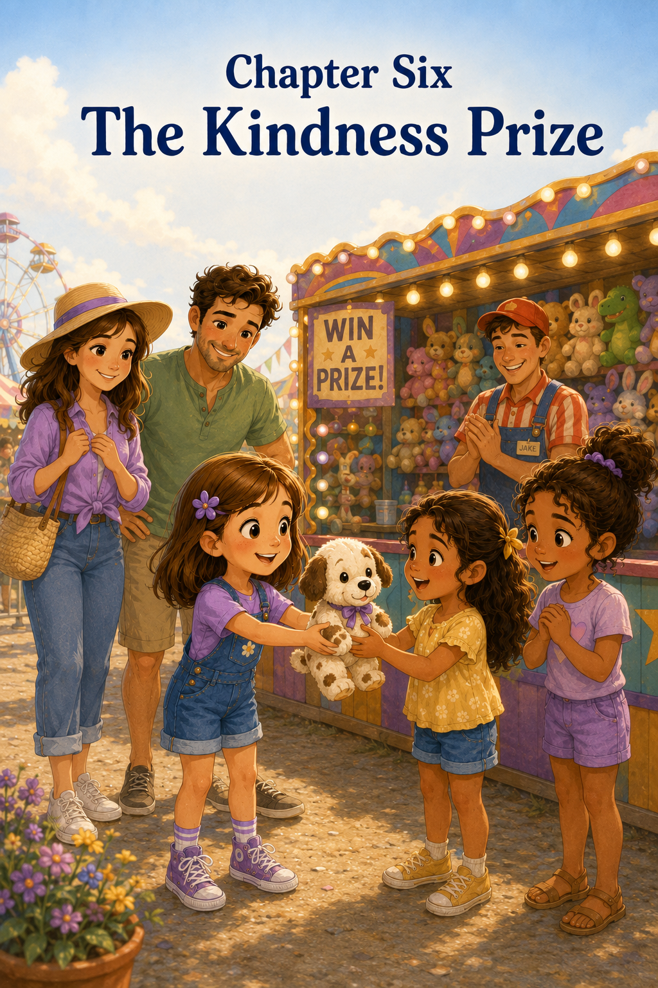Chapter 6: The Kindness Prize
After Maria’s brave ride on the Twirling Star, the fair seemed to sparkle even more than before.
Maria walked beside Sally with a proud smile still shining on her face. Sally could tell her friend was thinking about the ride, about how nervous she had felt, and about how wonderful it had been to try something new.
“You were really brave,” Sally said.
Maria smiled shyly. “I was scared at first.”
“That still counts,” Sally said. “Maybe it counts even more.”
Mark, who was walking just behind them, nodded. “I agree with Sally.”
Mom smiled. “Courage often begins with a nervous heart.”
Maria seemed to like that. She held her sweater against her chest and looked up at the colorful flags waving above the fairground path.
The sun was lower now, and the fair lights were beginning to glow. Strings of bulbs blinked around the game booths. The music sounded cheerful, and the smell of popcorn, lemonade, and warm funnel cake floated through the air.
Sally’s purple whistle bounced against her shirt as she walked. She had not blown it, because she had promised not to blow it near anyone’s ears. Still, she liked the way it looked. It reminded her of the duck pond game and how much fun she and Maria had already had.
Then Sally saw it.
A new game booth stood near the end of the row. It had bright red curtains, a striped awning, and shelves filled with small stuffed animals.
There were bears, puppies, kittens, rabbits, frogs, and little blue elephants with soft floppy ears.
But one stuffed animal caught Sally’s eye right away.
It was a small spotted puppy.
Its fur was white with black patches, and one black spot circled its left eye. Its ears were soft and floppy. A tiny red ribbon was tied around its neck.
Sally stopped walking.
“Oh,” she whispered.
Maria stopped beside her. “What is it?”
Sally pointed. “That puppy.”
Maria looked at the shelf. “It’s adorable.”
“It reminds me of a puppy I once saw in a picture book,” Sally said. “Look at its little face.”
The puppy seemed to be smiling right at her.
The booth sign said:
BALL TOSS!
KNOCK DOWN THREE CANS TO WIN!
Sally studied the game. Three silver cans were stacked in a small pyramid on a wooden shelf. Players had three softballs to try to knock them down.
Sally remembered the beanbag game from earlier. She remembered how badly she had wanted the stuffed fox. She remembered missing every single toss.
This game looked hard, too.
But the little spotted puppy looked so sweet.
Mark saw Sally staring at it. “Thinking about trying?”
Sally nodded slowly. “I know games are supposed to be for fun. And I know winning isn’t everything.”
“That’s true,” Mom said.
“But I think I’d still like to try,” Sally said.
Mom smiled. “Trying is perfectly fine.”
“As long as I keep a good attitude,” Sally added.
Mark grinned. “Now you’re thinking like a fair expert.”
Maria looked at Sally. “I’ll cheer for you.”
Sally smiled. “That helps.”
Mark handed Sally the tickets for one game. Sally stepped up to the counter. The fair worker, a cheerful older man with a straw hat, placed three soft yellow balls in front of her.
“Three throws,” he said kindly. “Knock down all three cans, and you pick a small prize.”
Sally looked at the puppy.
Then she looked at the cans.
She took a deep breath.
“You can do it,” Maria said.
“Try your best,” Mom added.
Sally picked up the first ball. It felt smooth and light in her hand. She planted her feet behind the painted line, just as Mark had shown her earlier.
She pulled her arm back and tossed.
The ball flew toward the cans.
It hit the very top can with a light ping!
The top can wobbled, tipped sideways, and fell.
“One!” Maria cheered.
Sally’s eyes widened. “I got one!”
“Nice throw,” Mark said.
Sally picked up the second ball. Her heart beat faster now. Maybe she could do it. Maybe this time she could win.
She aimed carefully at the two cans left on the shelf.
She tossed.
The ball hit the bottom corner of one can. Both cans shook, but only one fell.
Sally jumped a little. “Two!”
“One can left,” Mom said.
Sally looked at the final can. It sat in the middle of the shelf, shiny and still.
One ball.
One can.
One chance.
Suddenly Sally felt nervous.
The little spotted puppy waited on the prize shelf. Sally could almost feel its soft ears in her hands. She could almost imagine carrying it around the fair. She could almost imagine placing it beside her pillow at home.
But then she remembered the beanbag game.
She remembered the disappointment of missing.
She remembered Mark telling her that disappointment did not have to decide what kind of day she had.
Sally took another deep breath.
Even if I miss, she thought, I can still smile.
She lifted the last ball.
Maria whispered, “Come on, Sally.”
Sally tossed.
The ball sailed through the air.
For one second, everything seemed to slow down.
The music.
The laughter.
The lights.
The ball struck the final can right in the middle.
Ping!
The can flew backward and rolled off the shelf.
Sally gasped.
Maria clapped both hands over her mouth.
Mom laughed with delight.
Mark threw both arms into the air. “She did it!”
The fair worker rang a little bell. Ding, ding, ding!
“We have a winner!” he called.
Sally could hardly believe it. “I won?”
“You won,” the worker said. “Choose your prize.”
Sally pointed right away. “The spotted puppy, please.”
The worker lifted the small stuffed puppy from the shelf and handed it to her.
It was even softer than Sally had imagined.
She hugged it gently against her chest. Its red ribbon tickled her chin.
“Oh, I love it,” Sally said.
Maria leaned close. “It’s perfect.”
Sally beamed. She felt proud and excited, but not in a bragging way. She had tried again. She had stayed cheerful. And this time, she won.
Mom touched Sally’s shoulder. “You kept trying, and you kept a good attitude. That is something to be proud of.”
Sally smiled down at the puppy. “I’m going to name him Spotty.”
Mark tilted his head. “A fine name for a spotted dog.”
Sally giggled. “I know.”
She hugged Spotty again.
Just then, she heard a small sniffle behind her.
At first, Sally thought it was just part of the busy fair sounds. But then she heard it again.
A little girl, much younger than Sally, stood near the game booth with her grandmother. She had curly brown hair and a pink shirt with a glittery heart on the front. Her face was red, and her eyes were wet with tears.
“I tried and tried,” the little girl said. “But I didn’t win the puppy.”
Her grandmother bent down beside her. “I know, sweetheart. You did your best.”
“But I wanted that one,” the little girl whispered.
Sally followed the little girl’s eyes.
She was looking at the same shelf where Spotty had been.
There were still stuffed animals there, but no other spotted puppy.
Sally looked down at the soft toy in her arms.
Her happy feeling wiggled a little.
She had wanted this puppy so much.
She had worked hard to win it.
It was hers.
Sally held Spotty closer.
Maria noticed Sally looking at the little girl. “Is she okay?”
“I don’t think so,” Sally said quietly.
The little girl wiped her cheek with the back of her hand. “Maybe we can try again?”
Her grandmother looked at the ticket booth, then at the game. “We already used our game tickets for today.”
The little girl nodded, but her chin trembled.
Sally’s heart felt heavy.
She looked down at Spotty again. The stuffed puppy’s black button eyes seemed to look back at her.
I just won him, Sally thought.
She imagined bringing him home. She imagined telling everyone how she knocked down all three cans. She imagined putting him on her bed next to her favorite pillow.
Then she looked at the little girl again.
The little girl was trying not to cry now. She was being brave in her own small way, but Sally could see how disappointed she felt.
Sally knew that feeling.
She had felt it earlier with the stuffed fox.
She remembered the pinch in her chest.
She remembered how hard it was to smile when she had missed every toss.
Sally looked at Mom.
Mom did not say anything. She simply watched Sally with gentle eyes.
Mark did not say anything either.
Maria stood quietly beside her.
No one told Sally what to do.
That made the choice feel even more important.
Sally looked at Spotty one more time.
He was soft.
He was cute.
He was hers.
But maybe Sally thought he could make someone else happier than he could make me.
Her heart gave a little squeeze.
Sometimes kindness was easy, like saying hello.
Sometimes kindness was fun, like inviting a friend to the fair.
And sometimes kindness asks you to give up something you like.
Sally took a slow breath.
Then she walked over to the little girl.
“Hi,” Sally said softly.
The little girl looked up, surprised.
Sally held out the stuffed puppy. “Would you like this?”
The little girl stared at the puppy. “For me?”
Sally nodded. “I heard you wanted the spotted puppy. I think he would like to go home with you.”
The little girl’s eyes grew wide. “But you won him.”
“I know,” Sally said. “But I want you to have him.”
The grandmother pressed one hand gently over her heart. “That is very kind of you.”
The little girl looked at Sally, then at the puppy, then back at Sally again. “Are you sure?”
Sally felt one tiny tug inside her. It was her part that still wanted to keep Spotty.
But then she saw the little girl’s hopeful face.
The tug became softer.
“I’m sure,” Sally said.
The little girl took the puppy carefully, as if he were something precious. Then she hugged him tight.
“Thank you,” she whispered.
Sally smiled.
The little girl’s grandmother smiled too. “You made her day.”
The little girl lifted the puppy’s paw and made it wave. “His name is Button.”
Sally laughed. “That’s a good name.”
The little girl hugged Button again, and this time her tears were gone.
Sally walked back to Mom, Mark, and Maria.
Her arms felt a little empty without the stuffed puppy.
But her heart felt full.
Maria looked at her with shining eyes. “Sally, that was so kind.”
Sally looked down at her shoes. “I really liked him.”
“I know,” Maria said.
“I wanted to keep him,” Sally admitted.
Mom put an arm around Sally’s shoulders. “That is what made your choice generous.”
Mark nodded. “Giving something away when you do not care about it is easy. Sharing something special takes a big heart.”
Sally looked back at the little girl, who was now making Button the puppy dance in the air while her grandmother laughed.
Sally smiled.
“I think he made her happier,” Sally said.
Maria slipped her hand into Sally’s. “He made you happy too, just in a different way.”
Sally thought about that.
Maria was right.
Winning the puppy had made Sally excited.
Giving the puppy away made her feel warm and peaceful inside.
It was a quieter kind of happy.
A better kind of happy.
The fair worker behind the booth had seen what happened. He leaned over the counter and smiled.
“Young lady,” he said to Sally, “that was one of the kindest things I’ve seen all day.”
Sally blushed.
Then the worker reached behind the counter and picked up a tiny stuffed yellow duck. It was not as fancy as the spotted puppy, but it had a bright orange beak and a cheerful face.
“This one is for good sportsmanship and kindness,” he said. “No tickets needed.”
Sally looked at Mom.
Mom smiled. “You may accept it.”
Sally took the little duck. “Thank you.”
The worker tipped his straw hat. “You earned it.”
Maria touched the duck’s soft wing. “What will you name it?”
Sally thought for a moment.
“Sunny,” she said. “Because kindness feels sunny.”
Maria grinned. “That is perfect.”
Sally held Sunny the duck in one hand and Maria’s hand in the other as they walked away from the game booth.
The lights of the fair twinkled around them. The music played. Children laughed. Somewhere nearby, someone won a game, and a bell rang brightly.
Sally glanced back one last time.
The little girl waved Button’s paw at her.
Sally waved Sunny’s wing back.
Then she turned toward the path ahead.
She had come to the fair hoping to see rides, play games, and maybe win a prize.
She had won one.
Then she had given it away.
And somehow, that made the prize even more special.
Sally hugged Sunny gently and smiled.
She was learning that kindness did not have to be big to be important.
Sometimes, kindness was a small stuffed puppy.
Sometimes, it was noticing someone’s tears.
And sometimes, the best prize at the fair was the joy of making someone else smile.

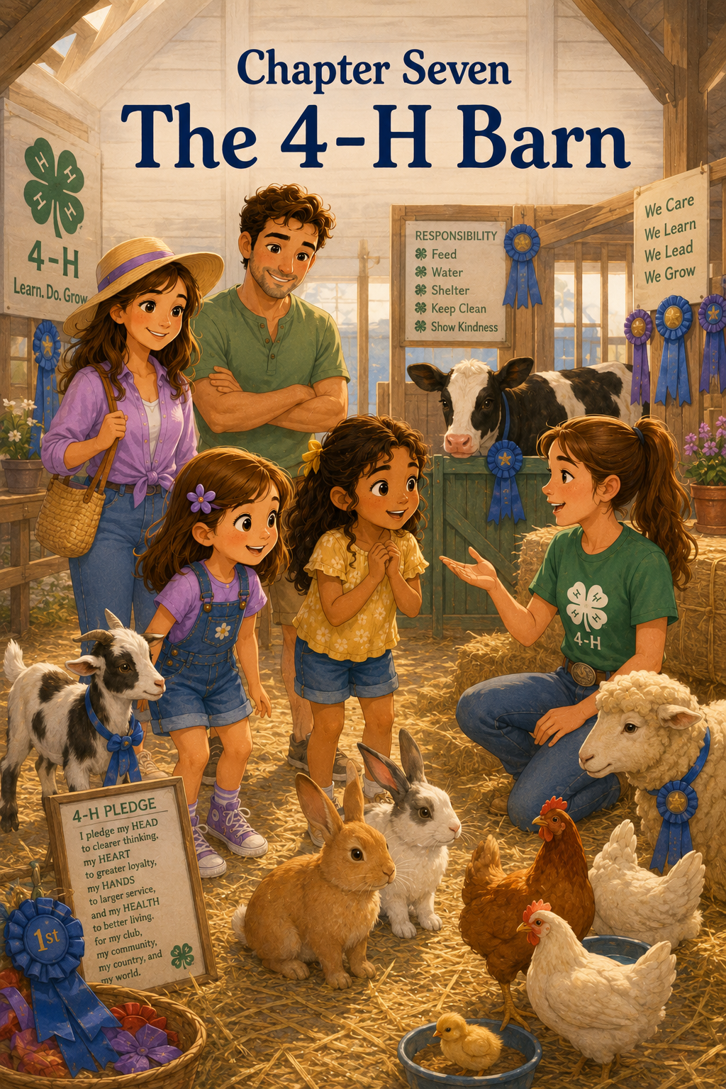Chapter 7: The 4-H Barn
After the excitement of the carnival games, Sally, Maria, Mom, and Mark followed a wide dirt path toward the animal barns.
The sounds of the fair began to change.
The carnival music grew softer behind them. The ringing bells and laughter faded into the distance. Ahead, Sally could hear different sounds—soft bleats, gentle clucks, low moos, and the rustle of straw under careful feet.
Maria looked around curiously. “Is this where the animals are?”
Sally nodded. “Yes. This is one of my favorite parts of the fair.”
Mark pointed to a large red barn with white trim. A sign above the open doorway read:
4-H LIVESTOCK EXHIBITS
Green flags fluttered on both sides of the entrance. Beside the door, colorful posters showed pictures of children brushing goats, feeding rabbits, and walking calves with ropes.
Maria slowed down to read one of the posters. “What does 4-H mean?”
Mom smiled. “It is a youth program where children learn by doing. Some children raise animals, grow plants, make projects, and learn skills they can use in life.”
“So the kids take care of the animals?” Maria asked.
“That’s right,” Mark said. “And caring for animals takes a lot of responsibility.”
Sally looked into the barn. “Can we go inside?”
“Of course,” Mom said. “But remember, we use quiet voices and calm hands around animals.”
“And we do not touch any animal unless someone says it is okay,” Mark added.
Sally nodded. “Because animals can get nervous too.”
Maria looked thoughtful. “Like people.”
“Exactly,” Mom said.
They stepped into the 4-H barn.
The air inside was warm and smelled like hay, wood shavings, and clean straw. Sunlight came through high windows, making golden stripes on the floor. Rows of pens lined both sides of the barn, each one holding animals that had been carefully fed, brushed, and cared for.
Above many of the pens were handmade signs with names written in bright letters.
CLOVER THE GOAT
DAISY THE CALF
MR. HOPPERS THE RABBIT
BUTTERCUP THE LAMB
Blue, red, and white ribbons hung from some of the pens. Sally noticed that the ribbons fluttered whenever a breeze came through the open barn doors.
Maria’s eyes widened. “There are so many animals.”
Sally smiled. “Wait until you see the rabbits.”
They walked first to a row of rabbit cages. Inside one cage sat a fluffy gray rabbit with long ears and a twitching nose. It looked like a soft cloud with whiskers.
Maria clasped her hands together. “Oh, it’s so cute.”
A girl wearing a green 4-H shirt stood nearby with a small brush in her hand. She looked a little older than Sally and Maria.
“His name is Mr. Hoppers,” the girl said.
Sally smiled. “That is a perfect name.”
“He likes to hop away when it is time for grooming,” the girl said with a laugh.
Maria leaned closer, but not too close. “Do you brush him every day?”
“Almost every day,” the girl said. “Rabbits need clean cages, fresh food, water, and gentle handling. They can be frightened by loud noises, so I have to move slowly.”
Sally looked at Mr. Hoppers. His nose wiggled very fast.
“He looks calm,” Sally said.
“He is now,” the girl explained. “But when we first got here this morning, he was nervous. I sat beside his cage and talked softly until he settled down.”
Maria looked at Sally. “That was kind.”
“It was patient,” Mom said.
The girl nodded. “Animals need patience.”
Sally liked the sound of that. Animals need patience. It sounded like something important.
They thanked the girl and moved farther into the barn.
Next, they came to the chicken area. Several chickens strutted inside roomy pens, clucking softly and scratching at the straw. One chicken had shiny black feathers that looked blue when the sunlight touched them. Another was white and fluffy, with feathers puffing around its head like a fancy hat.
Maria giggled. “That chicken looks like it is wearing a cloud.”
Mark leaned closer to read the sign. “Her name is Pearl.”
“Pearl is very stylish,” Sally said.
A boy in a green 4-H shirt was filling a small feeder with grain.
“Are these your chickens?” Mark asked.
“Yes, sir,” the boy said. “I’ve been raising them since spring.”
Sally watched him pour the grain carefully. “Do chickens eat every day?”
The boy smiled. “They sure do. Every morning and evening, I check their food and water. I also clean their bedding, collect eggs, and make sure they look healthy.”
“That sounds like a lot of work,” Maria said.
“It is,” the boy said. “But I like it. Taking care of animals teaches you to show up even when you’re tired.”
Sally thought about that.
Show up even when you’re tired.
She wondered if she would remember to feed chickens every morning and evening. She liked animals, but she also liked sleeping late on Saturdays.
“Do you ever forget?” Sally asked.
The boy shook his head. “I make a chart at home. My little sister helps me check it.”
“A responsibility chart,” Mom said. “That is a smart idea.”
The boy smiled proudly. “My chickens depend on me.”
Sally looked at Pearl, who was pecking calmly at her grain.
Depend on me.
Those words felt big.
They walked on to the goat pens. Goats were everywhere—brown goats, white goats, spotted goats, tiny goats, and one goat with long floppy ears that made Maria laugh.
A small brown goat poked its nose through the fence and sniffed Sally’s sleeve.
Sally froze.
The goat sniffed again.
Maria giggled. “I think it likes you.”
Sally whispered, “Or my sleeve.”
A 4-H student nearby laughed. She had freckles across her nose and a name tag that read EMILY.
“That’s Clover,” Emily said. “She likes to investigate everything.”
Sally stepped back gently. “Is it okay if she sniffed me?”
“That’s okay,” Emily said. “You stayed calm, and that helps.”
Maria looked at Clover. “Do goats need a lot of care, too?”
“Oh yes,” Emily said. “Every day I feed Clover, give her clean water, brush her coat, clean her pen, and practice walking with her. She must learn to trust me.”
Sally watched as Emily opened the pen and stepped inside. Clover walked over to her right away.
“How did you get her to trust you?” Sally asked.
“I spent time with her,” Emily said. “I didn’t rush her. I talked softly and learned what made her feel safe.”
Maria tilted her head. “Animals have feelings too, don’t they?”
Emily nodded. “They do. They can feel scared, calm, hungry, tired, curious, or happy. That’s why we have to pay attention.”
Sally looked at Clover’s gentle brown eyes.
She had always known animals needed food and water. But she had not thought as much about animals needing patience, quiet voices, and respect.
Emily picked up a soft brush and began brushing Clover’s side with slow strokes.
“Would you like to see how I groom her?” Emily asked.
“Yes, please,” Sally said.
Maria nodded eagerly.
Emily showed them the brush. “I always start slowly so she knows what I’m doing. I brush in the direction her hair grows. I watch her body, too. If she steps away or seems uncomfortable, I give her a break.”
“She gets breaks?” Sally asked.
“Of course,” Emily said. “Caring for animals means listening, even when they cannot talk.”
Sally thought that might be the most important thing anyone had said all day.
Listening, even when they cannot talk.
Mom looked at Sally and Maria. “That is compassion.”
“What exactly does compassion mean?” Maria asked.
Mom answered gently. “Compassion means noticing how someone else feels and caring enough to help.”
“Even animals?” Sally asked.
“Especially animals,” Mark said. “Because they depend on people to treat them kindly.”
Emily smiled. “That’s what 4-H teaches us. Responsibility and kindness go together.”
Sally repeated the words softly. “Responsibility and kindness go together.”
As they walked farther into the barn, they saw sheep with woolly coats, calves resting in clean straw, and more goats waiting calmly beside their young handlers. Some children were sweeping the floor. Others were filling water buckets. One child was carefully polishing a calf’s halter. Another was writing notes on a clipboard.
There were ribbons everywhere.
A blue ribbon hung above a sheep named Buttercup.
A red ribbon hung beside a rabbit cage.
A white ribbon was pinned near a display about chicken care.
Sally pointed to the ribbons. “Do the ribbons mean they won?”
“Yes,” Mark said. “The judges look at many things, like how healthy the animals are and how well the children care for and present them.”
“So it isn’t just about the animal looking pretty?” Maria asked.
“No,” Mom said. “It is also about hard work, knowledge, and care.”
They stopped near a calf named Daisy. Daisy was tan with large soft eyes and long lashes. A boy about twelve years old stood beside her, gently patting her neck.
“She’s beautiful,” Maria said.
“Thank you,” the boy said. “She’s been my project for months.”
“What do you have to do for her?” Sally asked.
The boy smiled. “A lot. I feed her, brush her, clean her stall, walk her, and make sure she has fresh water. I also learn about what keeps calves healthy.”
“Every day?” Sally asked.
“Every day,” the boy said. “Even when it rains. Even when I want to sleep in. Even when I have other things to do.”
Sally looked at Daisy, who blinked slowly and leaned her head closer to the boy.
“She trusts you,” Sally said.
The boy smiled proudly. “I hope so. I try to be gentle with her.”
Maria touched Sally’s arm. “He sounds like Emily with Clover.”
Sally nodded. “They all do.”
Every 4-H student they met talked about the same things in different ways.
Fresh water.
Clean bedding.
Healthy food.
Gentle hands.
Quiet voices.
Daily care.
Patience.
Trust.
Sally began to understand that caring for animals was not something you did only when it was fun or easy. It was something you did because the animals needed you.
Near the end of the barn, there was a display table covered with student projects. One poster showed the parts of a goat. Another explained what rabbits eat. A third had photographs of a girl feeding a lamb from the time it was tiny until it grew big enough for the fair.
Maria stopped at a poster titled:
WHAT MY ANIMAL TAUGHT ME
Under the title, a 4-H student had written:
My sheep taught me to be patient.
My rabbit taught me to be gentle.
My calf taught me to be responsible.
My goat taught me to stay calm.
Sally read the words twice.
Then she looked around the barn.
She saw children working carefully. She saw animals resting peacefully. She saw clean pens, full water buckets, brushed coats, and ribbons earned through effort.
“I thought the animal barn would just be fun,” Sally said.
“It is fun,” Mark said.
“But it’s more than that,” Sally continued.
Mom smiled. “What do you think it is?”
Sally thought about Mr. Hoppers, Pearl, Clover, Buttercup, and Daisy.
“It’s about taking care of something that depends on you,” she said.
Maria nodded. “And being kind even when animals don’t use words.”
“That is a very thoughtful way to say it,” Mom said.
Sally felt proud, but in a quiet way. Not the kind of proud she had felt when she won the stuffed puppy. This was different. This was the kind of proud that came from learning something important.
Emily, the girl with Clover, walked past carrying a bucket. Clover followed her from inside the pen with curious eyes.
“Thanks for teaching us about Clover,” Sally said.
“You’re welcome,” Emily replied. “Maybe someday you’ll join 4-H too.”
Sally smiled. “Maybe.”
Maria looked at Sally. “Would you want to take care of a goat?”
Sally looked at Clover, who had begun nibbling at a bit of hay.
“I think I would need a chart,” Sally said.
“And a lot of patience,” Maria added.
“And maybe sleeves that don’t smell interesting,” Sally said.
Maria laughed.
As they walked out of the barn, the bright fair seemed louder again. The music returned. The bells rang. The smell of popcorn drifted by. But Sally carried something quiet with her from the barn.
She thought about how animals needed food, water, clean spaces, and care.
She thought about how they needed gentleness too.
She thought about how compassion was not just feeling sorry for someone. It was paying attention. It was being careful. It was helping in the way that was needed.
Mom handed Sally her water bottle. “What did you think of the 4-H barn?”
Sally took a sip and looked back at the red barn doors.
“I liked it,” she said. “I liked the animals. But I think I liked learning about the kids too.”
Mark nodded. “They work very hard.”
“They do,” Sally said. “Every day.”
Maria looked thoughtful. “I didn’t know kindness could look like cleaning a pen or filling a water bucket.”
Sally smiled. “I didn’t either.”
Mom put a hand on each girl’s shoulder. “Kindness often looks like care.”
Sally looked back one more time.
Inside the barn, a goat bleated softly.
Sally waved, even though she was not sure Clover could see her.
Then she turned back toward the fairground path with Maria beside her.
The day had already taught Sally about welcoming a new friend, trying again, being brave, and sharing a prize.
Now the 4-H barn had taught her something else.
Compassion meant treating animals gently and respectfully.
Responsibility meant showing up every day.
And kindness, Sally was beginning to learn, could be found almost anywhere—even in a barn full of hay, ribbons, rabbits, chickens, goats, sheep, and calves.

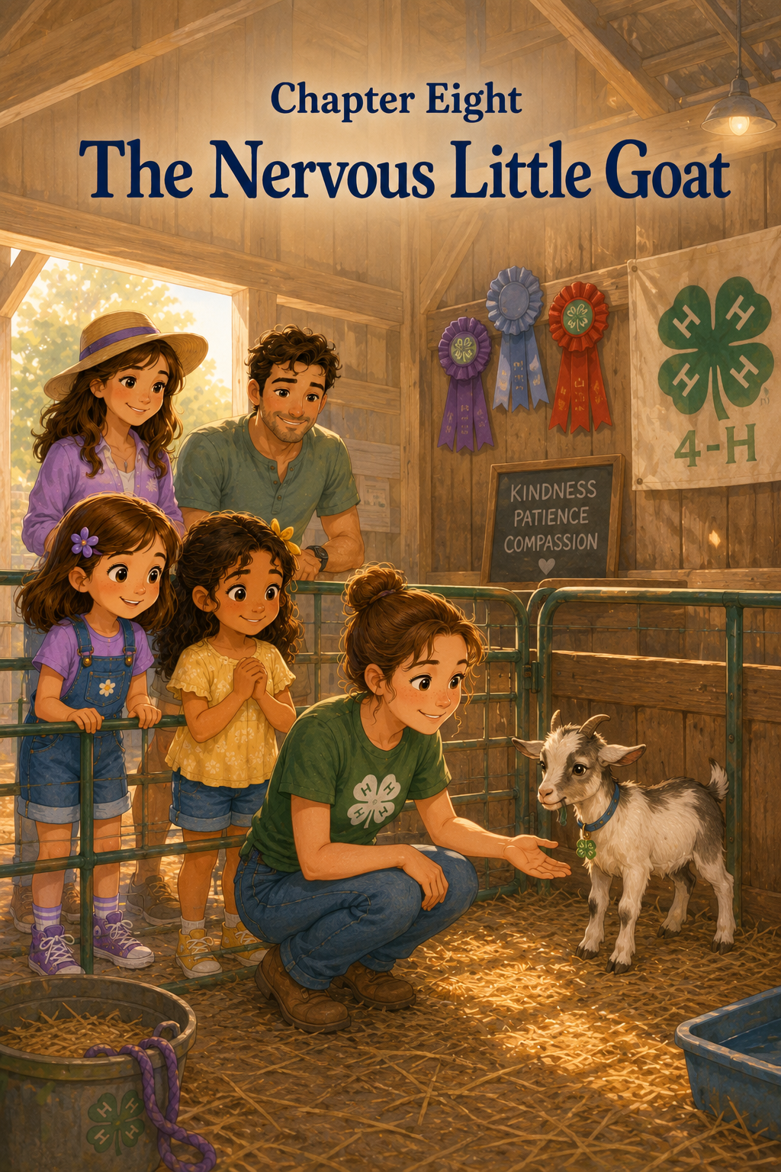Chapter 8: The Nervous Little Goat
Sally, Maria, Mom, and Mark had only taken a few steps away from the 4-H barn when Sally heard a soft sound behind them.
“Baa-aa.”
It was small and shaky.
Sally stopped.
Maria stopped too. “Did you hear that?”
Sally nodded and turned back toward the barn doors. “It sounded like a goat.”
From inside the barn came more fair sounds—children talking, animals shifting in their pens, water buckets clinking, and straw rustling under boots. But beneath all those sounds, Sally heard the little bleat again.
“Baa-aa.”
This time, it sounded worried.
Mom looked toward the barn. “Maybe we should check from a safe distance.”
Mark nodded. “We can look, but remember our animal rules.”
“Quiet voices,” Sally said.
“Calm hands,” Maria added.
“And we only touch if someone says it is okay,” Mark reminded them.
Sally and Maria nodded.
Together, they walked back into the 4-H barn. The warm smell of hay and clean straw wrapped around them again. The ribbons still fluttered above the pens, and the animals rested or nibbled quietly. But farther down the row of goat pens, near the corner of the barn, something seemed different.
A small white goat with brown spots stood pressed near the back of its pen. Its ears were low, and its eyes looked wide. Every time a loud noise came from outside the barn, the little goat stepped backward.
A bell rang from the carnival games.
Ding, ding, ding!
The goat jumped.
Maria’s hand moved to her chest. “Oh no. It’s scared.”
Sally felt her heart squeeze. “Poor little goat.”
The goat took another step back until its side touched the wooden wall of the pen. It did not look mean. It did not look silly. It looked frightened.
Sally remembered what Emily had told them about Clover in the last chapter: animals could feel scared, calm, hungry, tired, curious, or happy, and people had to pay attention.
“Can we help it?” Sally whispered.
“We need to ask first,” Mom said softly.
Just then, Emily, the 4-H student they had met earlier, hurried over carrying a small pail. Her freckled face looked concerned, but calm.
“Hi again,” Emily said quietly.
“Is the goat okay?” Maria asked.
Emily looked at the little goat. “That’s Peanut. He’s younger than Clover, and this is his first county fair. The noise is a lot for him.”
Peanut bleated again, then turned his head toward the corner.
Sally’s face softened. “He doesn’t understand what all the sounds are.”
“No,” Emily said. “To us, the fair sounds fun. To him, some of it feels big and scary.”
Maria looked down. “I felt that way when we first came in.”
Sally turned to her friend. “You did.”
Maria nodded. “The fair was bright and loud, and I didn’t know where to look first.”
Emily smiled gently. “That is a good way to understand Peanut. Sometimes animals need the same thing people need—patience, space, and someone calm nearby.”
Sally looked at Peanut again. He was still standing at the back of the pen, watching them.
“What should we do?” Sally asked.
“The first thing is not to rush him,” Emily said. “If everyone moves too quickly or talks too loudly, he may feel more afraid.”
Sally nodded.
“So we stay calm,” Maria said.
“Yes,” Emily said. “And we speak softly.”
“And move slowly,” Sally added.
Emily smiled. “Exactly.”
Mark stepped back a little. “We can give him more room.”
Mom placed a gentle hand on Sally’s shoulder. “That is a kind choice.”
Sally and Maria stepped back, too. They stood beside Mom and Mark near the walkway, leaving plenty of space between themselves and Peanut’s pen.
Emily lowered her voice until it sounded almost like a lullaby.
“Hi, Peanut,” she said. “You’re okay. I’m right here.”
Peanut flicked one ear.
Emily did not open the pen right away. She did not reach toward him. She simply stood where he could see her and waited.
Sally watched carefully.
Waiting felt like doing nothing, but Sally began to understand that sometimes waiting was doing something very important.
Peanut needed time.
A child outside the barn laughed loudly, and Peanut lifted his head again.
“It’s okay, Peanut,” Emily said softly. “That sound is outside. You’re safe in here.”
Maria whispered, “He looks like he wants to hide.”
“He might,” Emily said. “When animals are frightened, they may back away, freeze, or try to hide. That is why we never chase them or crowd them.”
Sally thought about how she had felt when she first went over to meet Maria. She had not wanted someone to push her or hurry her. She had needed one brave step at a time.
Maybe Peanut needed one calm moment at a time.
Emily slowly crouched near the outside of the pen. “I’m going to sit lower so I don’t seem so tall to him.”
Sally watched as Emily moved carefully, like every motion mattered.
Peanut’s ears twitched again.
“He noticed,” Maria whispered.
Emily nodded. “That’s good. He is watching. Now we let him decide what feels safe.”
Sally held her breath without meaning to.
Mom whispered, “You can breathe, sweetheart.”
Sally let out a quiet breath. “I just want him to feel better.”
“That is compassion,” Mom said.
Sally remembered that word.
Compassion meant noticing how someone else felt and caring enough to help.
Even animals.
Especially animals.
Peanut took one tiny step away from the wall.
Maria’s eyes brightened. “He moved.”
Emily smiled, but she did not move closer. “Good boy, Peanut. That’s it.”
Peanut lowered his head and sniffed the straw.
“He’s calming down?” Sally asked.
“A little,” Emily said. “His body is not as stiff now.”
“How can you tell?” Maria asked.
“His ears are not pinned so low, and he is sniffing instead of only backing away,” Emily explained. “Animals tell us things with their bodies.”
Sally looked closely.
Peanut still seemed nervous, but he did not look quite as frightened as before. His tail gave a tiny twitch. One hoof pawed gently at the straw.
A loud burst of music floated in from the fair path.
Peanut froze again.
Sally’s stomach tightened.
But Emily stayed calm.
“You’re okay,” Emily said. “That was just music. You’re safe.”
Sally noticed something important. Emily did not sound worried, even though she cared. Her voice was steady. Her hands were still. Her face was gentle.
“Does staying calm help him stay calm?” Sally asked.
“Yes,” Emily said. “Animals can notice our feelings. If I get upset, Peanut may feel more upset. If I stay calm, it helps him feel safer.”
Maria looked at Sally. “That’s like when you stayed close to me when we first got here.”
Sally smiled softly. “I wanted you to feel safe.”
“You helped,” Maria said.
Sally’s heart felt warm.
Emily picked up a small handful of hay from the pail beside her. She held it low, but not through the fence.
“I’m not going to push it toward him,” she explained. “I’m just letting him see it.”
Peanut looked at the hay.
He did not come forward.
Emily waited.
One minute passed.
Then another.
Sally’s feet wanted to wiggle, but she kept them still. Maria folded her hands together and watched quietly. Mom and Mark stood behind them, calm and patient.
Finally, Peanut took one small step.
Then another.
Then he stopped.
Emily smiled. “That’s brave, Peanut.”
Sally looked at Maria. Maria looked at Sally.
They both understood.
A small step could be brave.
Peanut stretched his neck forward. His nose twitched.
Emily placed the hay gently in a little feeding spot inside the pen, then slowly moved her hand away.
Peanut took another step.
Then he nibbled the hay.
Maria smiled so wide that her cheeks lifted. “He’s eating.”
Sally whispered, “He did it.”
Emily nodded. “Eating is a good sign. He feels safe enough to try.”
Peanut chewed slowly. His ears relaxed a little more. He still looked around when sounds came from outside, but he did not rush backward.
Sally felt like cheering, but she knew loud cheering would not help Peanut. So she made a tiny happy fist instead.
Maria saw and made one too.
Mark smiled. “Silent celebration.”
Mom nodded. “The perfect kind for a nervous little goat.”
Emily stood slowly, making sure not to startle Peanut. “Thank you for being so quiet and patient. That helped him.”
“We helped?” Maria asked.
“You did,” Emily said. “Giving an animal space is a kind way to help.”
Sally looked surprised. “Even though we didn’t touch him?”
“Especially because you didn’t touch him,” Emily said. “Sometimes people want to pet an animal because they love animals. But if the animal is scared, the kindest thing is to wait.”
Sally thought about that.
Kindness was not always doing what you wanted to do.
Sometimes kindness was noticing what someone else needed.
Peanut needed quiet.
Peanut needed space.
Peanut needed patience.
“He’s very sweet,” Sally said.
“He is,” Emily said. “He just needs time to get used to the fair.”
Maria tilted her head. “Will he be okay?”
“I think so,” Emily said. “I’ll stay with him for a while. Later, if the barn gets too noisy, we may move him to a quieter spot.”
“That sounds kind,” Mom said.
“Animals depend on us to pay attention,” Emily said. “They can’t say, ‘I’m scared’ with words, so we have to listen in other ways.”
Sally looked at Peanut. He was still nibbling hay. His little brown spots made him look as if someone had dotted him with a paintbrush. His eyes were softer now.
“I’m glad we came back,” Sally said.
“Me too,” Maria said.
Peanut lifted his head. For one gentle moment, he looked right at the girls.
Then he gave a small, quiet bleat.
“Baa.”
This one did not sound as shaky.
Sally smiled. “I think that was a thank-you.”
Maria giggled softly. “A goat thank-you.”
Emily laughed in a whisper. “Maybe it was.”
Before they left, Sally gave Peanut a little wave from far enough away that he would not feel crowded.
“Goodbye, Peanut,” she whispered. “You’re doing great.”
Maria waved too. “You’re brave.”
Peanut flicked one ear, as if he had heard them.
As Sally, Maria, Mom, and Mark walked out of the barn again, the fair sounds grew louder. Music played. Children laughed. A ride whooshed in the distance. But Sally did not rush toward the noise.
She looked back at the barn door.
“I keep thinking about Peanut,” she said.
Mom walked beside her. “What are you thinking?”
“That he was scared, but he couldn’t tell us with words,” Sally said.
“So we had to notice,” Maria added.
Mark nodded. “Noticing is an important part of kindness.”
Sally thought of Maria on their first day at the fair, holding her sweater tightly and looking overwhelmed. Sally had noticed that, too. She had stayed close. She had slowed down. She had helped Maria feel safe.
Now Emily had done the same thing for Peanut.
Maybe kindness looked different in different places.
At the game booth, kindness had looked like giving away a stuffed puppy.
At the ride, kindness had looked like not pressuring a friend.
In the barn, kindness looked like quiet voices, slow steps, and giving a frightened little goat enough space to breathe.
Maria reached for Sally’s hand. “I liked helping Peanut.”
“Me too,” Sally said.
“We didn’t do much,” Maria said.
Sally thought carefully. “Maybe we did. We stayed calm.”
Maria nodded. “And we waited.”
“And we listened, even though he couldn’t talk,” Sally said.
Mom smiled. “That is a very grown-up lesson.”
Sally did not feel grown-up. She still wanted lemonade. She still liked carnival games. She still wanted to see the craft displays and maybe the fireworks later.
But inside, she felt a little wiser than she had that morning.
She understood something new.
Fear was not always loud.
Sometimes fear looked like a girl holding her sweater in a busy fairground.
Sometimes fear looked like a friend standing quietly before a ride.
Sometimes fear looked like a little goat backing into the corner of a pen.
And kindness meant noticing.
Kindness meant slowing down.
Kindness meant helping someone feel safe, one gentle moment at a time.
Sally squeezed Maria’s hand.
“Ready to see what’s next?” Sally asked.
Maria smiled. “Yes. But slowly.”
Sally laughed softly. “Slowly is good.”
Together, they walked back into the bright, noisy, wonderful fair—carrying with them the quiet lesson of a nervous little goat named Peanut.

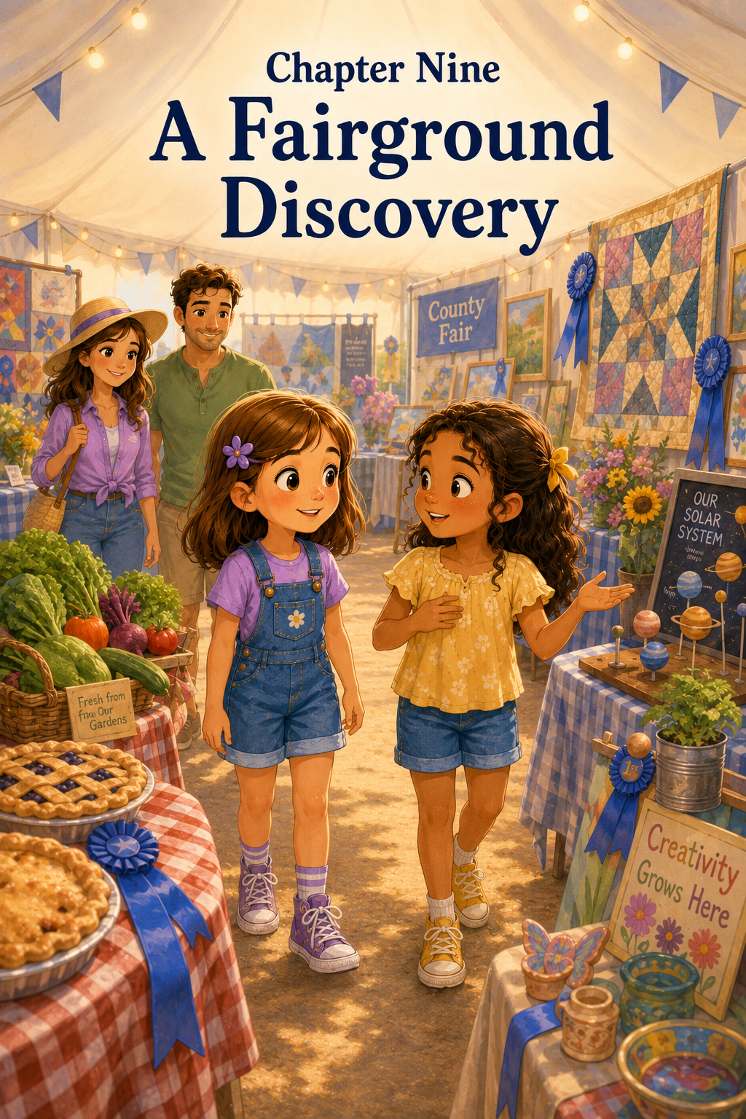Chapter 9: A Fairground Discovery
After visiting Peanut, the nervous little goat, Sally and Maria walked back into the busy fairgrounds with Mom and Mark close behind them.
The fair was still bright and noisy. Music floated from the rides. Bells rang at the game booths. People laughed as they carried lemonade, popcorn, and paper plates of curly fries. But Sally felt different now.
She still loved the fair.
She still loved the lights.
She still loved the games and the animals and the sweet smell of treats in the air.
But now she was noticing more.
She noticed a little boy helping his grandmother carry a bag. She noticed a 4-H student gently brushing straw from a lamb’s wool. She noticed Maria looking around with curious eyes, taking in each new sight as if she were collecting memories.
“Where should we go next?” Mark asked.
Sally looked ahead. A large white tent stood near the middle of the fairgrounds. Colorful banners hung from the top, and people were walking in and out carrying programs.
Mom pointed toward it. “That is the exhibit tent.”
“What’s inside?” Maria asked.
“All kinds of things,” Sally said. “Crafts, garden vegetables, pies, drawings, quilts, school projects, and ribbons.”
Maria’s eyes brightened. “Can we see it?”
“Of course,” Mom said.
They crossed the fairground path and stepped inside the exhibit tent.
Right away, the sounds changed.
Outside, the fair was loud and bouncy.
Inside, the exhibit tent was softer. People still talked, but their voices were quieter. Fans hummed in the corners. Tables stood in long rows, covered with colorful projects. The air smelled like sawdust, paper, flowers, and something sweet from the pie display nearby.
Sally took a slow breath. “It feels peaceful in here.”
Maria nodded. “It does.”
The first tables were filled with crafts. There were handmade birdhouses painted in cheerful colors. There were clay bowls, paper flowers, wooden cars, friendship bracelets, decorated picture frames, and tiny animals made from buttons and felt.
A blue ribbon hung beside a small painted birdhouse with sunflowers on the roof.
“That one won first place,” Sally said.
Maria leaned closer. “Look at all the tiny details.”
The birdhouse had a little painted door, green vines around the windows, and a red ladybug on one side.
“It must have taken a long time,” Maria said.
Mark nodded. “Good work usually does.”
Sally looked at the birdhouse carefully. “It makes me want to paint something.”
Maria smiled. “I like painting.”
“You do?” Sally asked.
Maria nodded. “At our old house, my grandmother and I painted flowerpots together.”
Sally turned toward her. “What kind of flowers did you plant?”
“Marigolds,” Maria said. “And basil too. My grandmother said basil makes the whole kitchen smell happy.”
Mom smiled. “That is a lovely way to say it.”
Maria’s face softened as she remembered. “Every summer, we planted herbs in little pots. Then we used some for cooking. My grandmother would let me pinch the basil leaves, and she would say, ‘Gentle hands make good food.’”
Sally smiled. “I like that.”
“Me too,” Maria said. “I miss helping her in the garden.”
Sally heard the quiet feeling in Maria’s voice. It reminded her that moving did not only mean coming to something new. It also meant leaving something behind.
“I’m sorry you had to leave your garden,” Sally said.
Maria looked at her. “Thank you. Maybe we can plant something at our new house.”
Sally’s eyes brightened. “Maybe we could plant marigolds.”
Maria smiled. “And basil.”
“And maybe one flowerpot with both,” Sally said.
Maria laughed softly. “My grandmother would like that.”
They walked to the next row of tables, where garden exhibits were arranged neatly on plates and in baskets. There were shiny red tomatoes, long green cucumbers, carrots with leafy tops, yellow squash, jars of honey, and pumpkins so round they looked like orange moons.
Blue, red, and white ribbons were placed beside many of them.
Sally pointed to a basket of peppers. “Those are bright.”
Maria nodded. “My dad makes stuffed peppers sometimes.”
“What are stuffed peppers?” Sally asked.
“They’re peppers filled with rice, vegetables, and sometimes meat,” Maria explained. “My dad bakes them with tomato sauce.”
Sally tried to imagine it. “Do they taste good?”
“Very good,” Maria said. “Especially when my mom makes rice on the side.”
“My mom makes spaghetti,” Sally said. “And Mark makes pancakes shaped like animals.”
Mark straightened proudly. “My turtle pancake is famous.”
Mom gave him a playful look. “Famous in our kitchen.”
“That still counts,” Mark said.
Maria giggled. “Can he make a goat pancake?”
Mark rubbed his chin. “That would be a challenge.”
“A Peanut pancake,” Sally said.
“Only if it is calm and gentle,” Maria added.
Everyone laughed.
They continued through the garden displays. Maria told Sally about helping her mother make soup on rainy days. Sally told Maria about making cookies with Mom and getting flour on the counter, the floor, and once even on Mark’s elbow.
“How did flour get on his elbow?” Maria asked.
Sally shrugged. “It was a very busy cookie day.”
Mark nodded solemnly. “A very dangerous cookie day.”
Mom laughed. “Only dangerous to the kitchen.”
At the far end of the garden section, they found the pie table.
Sally stopped so suddenly that Maria nearly bumped into her.
“The pies,” Sally whispered.
Rows of pies sat behind a clear barrier. Each one had a small card with its name. Apple pie. Blueberry pie. Peach pie. Cherry pie. Pecan pie. Sweet potato pie. Chocolate cream pie.
Some had golden crusts braided around the edges. Some had sugar sprinkled on top. Some had pretty cutout shapes baked into the crust.
A blue ribbon stood beside a tall apple pie with a flaky golden top.
Sally clasped her hands. “Being a pie judge still looks like a very important job.”
Maria leaned closer. “And delicious.”
“Very delicious,” Sally agreed.
Maria pointed to the sweet potato pie. “My aunt makes one like that.”
“Is it good?” Sally asked.
“It is my favorite,” Maria said. “At family dinners, she makes two because everyone wants a slice. She adds cinnamon and nutmeg. Sometimes she lets me sprinkle the spices.”
Sally listened carefully. “Do you have big family dinners?”
Maria nodded. “Sometimes. We all bring something. My uncle brings bread. My aunt brings pie. My cousins bring too much noise.”
“That sounds fun,” Sally said.
“It is,” Maria said. “At my old house, everyone lived closer. Now we are farther away.”
Sally looked at Maria’s face. Her friend was smiling, but her eyes looked a little sad.
Sally did not rush to change the subject. She remembered what she had learned from Peanut. Sometimes kindness meant being quiet and giving someone space. Sometimes it meant listening.
So Sally listened.
Maria looked at the pies for a moment longer. “I miss them.”
“I would miss them too,” Sally said.
Maria looked at her. “You would?”
“Yes,” Sally said. “Family dinners sound special.”
“They are,” Maria said. “But maybe we can still visit. And maybe they can visit us.”
“I hope they do,” Sally said.
Maria smiled a little. “Maybe my aunt will bring pie.”
“If she does,” Sally said, “I think Mark should be a judge.”
Mark looked delighted. “I accept this responsibility.”
Mom shook her head, smiling. “You are all very serious about pie.”
“Pie is serious,” Sally said.
“Very serious,” Maria agreed.
They moved on to the artwork section. Drawings and paintings covered tall display boards. Some showed barns and fields. Some showed pets, trees, houses, flowers, beaches, and families. One picture showed the county fair at night, with fireworks bursting above the Ferris wheel.
Sally stood in front of it. “That is beautiful.”
Maria nodded. “The colors look like they’re dancing.”
Sally looked at her. “That sounds like something an artist would say.”
Maria’s cheeks turned pink. “I like art.”
“Do you draw?” Sally asked.
Maria nodded. “Mostly flowers, houses, and animals. Sometimes I draw my family.”
Sally smiled. “I draw too. I drew a picture of us going to the fair.”
“You did?”
Sally nodded. “I taped it to my bedroom wall.”
Maria’s eyes widened. “You drew me?”
“Yes,” Sally said. “With your yellow ribbon.”
Maria touched the ribbon in her hair. “No one here has drawn me before.”
Sally suddenly felt shy. “I can show you sometime.”
“I’d like that,” Maria said softly.
They walked past a table of school projects. One display showed the life cycle of a butterfly. Another explained how bees make honey. Another had pictures of different kinds of seeds. There was even a student project about kindness, with paper hearts taped around the edges.
Maria stopped in front of it.
The title said:
SMALL ACTS CAN MAKE A BIG DIFFERENCE
Sally read the examples on the poster.
Invite someone to play.
Share a toy.
Help without being asked.
Listen when someone is sad.
Use gentle words.
Maria smiled at Sally. “That sounds like you.”
Sally blinked. “Me?”
“You invited me to the fair,” Maria said. “You stayed with me when I felt overwhelmed. You gave the puppy to the little girl. And you helped Peanut by being quiet.”
Sally looked down at her shoes. “I just tried to be kind.”
“That is why it sounds like you,” Maria said.
Sally felt warm inside, but she did not know what to say.
Mom, who had been listening, smiled gently. “Kindness often feels small when we do it, but it can feel very big to the person receiving it.”
Maria nodded. “It felt big to me.”
Sally looked up at her friend.
“It did?”
Maria nodded again. “When we moved here, I was worried I wouldn’t have anyone. Then you came over and said hello.”
Sally remembered that day—the moving truck, the flowerpots, the stuffed bunny, and the shy smile between them.
“I was nervous,” Sally said.
“I was too,” Maria said. “But then you helped me carry towels.”
They both laughed.
“Very important towels,” Sally said.
“Very important,” Maria agreed.
They walked slowly along the last row of displays. This section had handmade quilts hanging from tall racks. The quilts were full of colors and patterns—stars, squares, flowers, birds, and patchwork houses. Some looked bright and playful. Others looked soft and old-fashioned.
Maria stopped in front of a quilt made of many different fabrics. No two squares were exactly alike. Some were blue. Some were yellow. Some had flowers. Some had stripes. Somehow, all the pieces fit together into one beautiful design.
“That one is my favorite,” Maria said.
Sally studied it. “Why?”
Maria thought for a moment. “Because all the pieces are different, but they still belong together.”
Sally looked at the quilt again.
Blue beside yellow.
Flowers beside stripes.
Small squares beside large ones.
Different pieces.
One beautiful quilt.
“That reminds me of friendship,” Sally said.
Maria smiled. “It does?”
“Yes,” Sally said. “You and I are different. You like basil and sweet potato pie, and I like animal pancakes and chocolate chip cookies. You draw flowers, and I draw fair pictures. But we can still be friends.”
Maria’s smile grew. “Maybe being different gives us more to learn.”
Sally liked that. “Then we should ask each other lots of questions.”
“Okay,” Maria said. “What is your favorite fair food?”
Sally did not need to think long. “Cotton candy. But also lemonade. But also maybe funnel cake. That question is too hard.”
Maria laughed. “My favorite so far is the smell of funnel cake.”
“That is a very good answer,” Sally said. “What is your favorite animal?”
“Today?” Maria asked.
“Today,” Sally said.
“Peanut,” Maria said.
Sally smiled. “Mine too.”
Maria asked, “What do you like best about your house?”
Sally thought about her porch, her bedroom, her books, and the window where she could see Maria’s house.
“My front porch,” Sally said. “Because that’s where I first saw the moving truck.”
Maria smiled softly. “And me.”
“And you,” Sally said.
Then Sally asked, “What do you miss most about your old house?”
Maria was quiet for a moment.
“My grandmother’s garden,” she said. “And hearing my cousins outside. And knowing where everything was.”
Sally nodded. “It must be hard when everything changes.”
“It is,” Maria said. “But today feels better.”
“Because of the fair?” Sally asked.
Maria shook her head. “Because of you.”
Sally’s heart filled with a feeling that was hard to describe. It was happiness, but also tenderness. It made her want to be an even better friend.
“I’m glad you came,” Sally said.
“I’m glad you asked,” Maria replied.
Mom looked at Mark and smiled. Mark smiled back.
They did not interrupt.
They simply let the girls keep talking, because sometimes the best part of a fair was not a ride or a prize or a ribbon. Sometimes the best part was a conversation that helped two people understand each other better.
When they finally stepped out of the exhibit tent, the evening sky was beginning to soften into shades of peach and lavender. The fair lights shone brighter now. The Ferris wheel glowed in circles of red, yellow, blue, and green.
Sally looked back at the tent.
Inside, there were crafts, pies, vegetables, quilts, artwork, and projects. But Sally had discovered something even more special.
She had discovered pieces of Maria’s story.
Her grandmother’s garden.
Her aunt’s sweet potato pie.
Her family dinners.
Her love of art.
The things she missed.
The things she hoped for.
Sally reached for Maria’s hand. “Maybe someday you can teach me how to plant basil.”
Maria smiled. “And you can teach me how to make chocolate chip cookies.”
“Mom makes the best ones,” Sally said.
“I heard,” Maria replied.
“And maybe Mark can try a goat pancake,” Sally added.
Mark lifted one finger. “I make no promises about the shape of the goat.”
Maria laughed. “That’s okay. It can be a very creative goat.”
As they walked back into the bright fairground path, Sally felt grateful.
She had learned that fairs were full of discoveries.
Some discoveries were easy to see, like blue ribbons, painted birdhouses, giant pumpkins, and beautiful quilts.
But some discoveries happened quietly.
They happened when someone shared a memory.
They happened when someone asked a question.
They happened when someone listened with their whole heart.
Sally looked at Maria walking beside her.
The girl next door did not feel new anymore.
She felt like a true friend.
And Sally understood that friendship grew stronger when people made room for each other’s stories.
Different stories.
Different traditions.
Different favorite foods.
Different memories.
All fitting together, like the squares of a beautiful quilt.

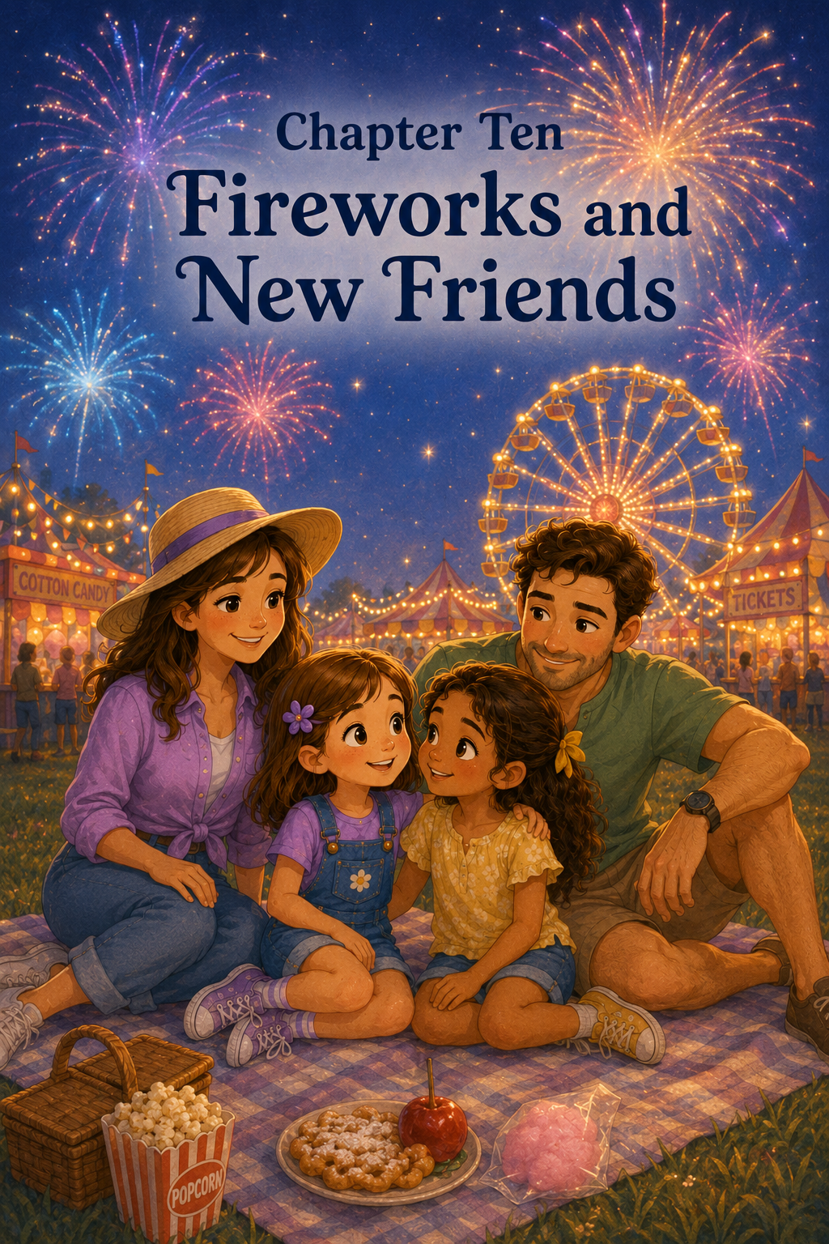Chapter 10: Fireworks and New Friends
By the time Sally, Maria, Mom, and Mark left the exhibit tent, the county fair had begun to glow.
The sky above the fairgrounds had turned a soft purple-blue, and the first stars were just beginning to peek through. Strings of lights twinkled along the food stands. The Ferris wheel shone in bright circles of red, yellow, green, and blue. Music floated gently through the evening air, mixing with laughter, footsteps, and the faraway sounds of the animal barn.
Sally held Sunny, her little stuffed yellow duck, close in one hand. With her other hand, she held Maria’s.
They had done so much.
They had walked through bright fairground paths, played carnival games, ridden rides, visited animals, helped a nervous little goat, explored craft displays, and learned new things about each other.
Sally’s feet were tired, but her heart felt wide awake.
Mark looked at his watch. “Well, fair adventurers, the fireworks should begin soon.”
Maria’s eyes lit up. “Fireworks?”
Sally turned to her quickly. “Have you seen fireworks before?”
“Yes,” Maria said. “But never at a county fair.”
“They’re beautiful here,” Sally said. “They light up over the Ferris wheel.”
Mom smiled. “We should find a good place to sit.”
They followed a path toward an open grassy area at the edge of the fairgrounds. Families were already gathering there with blankets, folding chairs, snacks, and sleepy little children leaning against their parents.
Mark spread a blanket on the grass beneath a large oak tree. Mom sat down first, then Sally and Maria settled beside each other. Mark sat behind them with his arms resting on his knees.
The air felt cooler now. A soft breeze carried the smell of popcorn and fresh hay. Somewhere behind them, someone laughed. Somewhere ahead, a baby clapped at the blinking lights of the Ferris wheel.
For the first time all day, the fair felt peaceful.
Maria leaned back on her hands and looked up at the sky. “I can’t believe how much we did today.”
Sally nodded. “It feels like we were here for a whole week.”
Mark chuckled. “That is how a good fair day feels.”
Mom handed each girl a small cup of lemonade. “One last treat before the fireworks.”
Sally took a sip. It was cold and sweet and a little bit tart.
“Thank you,” she said.
Maria held her cup with both hands. “Thank you for bringing me.”
Mom’s face softened. “We were happy to have you with us.”
Mark nodded. “You made our fair day even better.”
Maria smiled shyly and looked down at her lemonade.
Sally noticed that Maria did not look like the nervous girl from earlier in the day. She did not look overwhelmed by the sounds or unsure of where to stand. She looked comfortable, sitting on the blanket as if she belonged there.
Sally liked that.
She liked it very much.
The lights around the fairgrounds dimmed a little, and a voice came over the speaker.
“Ladies and gentlemen, boys and girls, our county fair fireworks will begin in just a few minutes.”
A happy cheer rose from the crowd.
Sally felt a flutter of excitement.
Maria scooted a little closer. “Do they get loud?”
“A little,” Sally said. “But they’re far away. If it feels too loud, you can cover your ears.”
Maria nodded. “Okay.”
Sally looked at her carefully. “And if you don’t like them, that’s okay too.”
Maria smiled. “You always say things like that.”
“Like what?” Sally asked.
“Things that make me feel like I don’t have to pretend,” Maria said.
Sally thought about that.
“You don’t have to pretend with me,” she said.
Maria’s smile became softer. “Good.”
For a moment, neither girl said anything. They watched the Ferris wheel turn slowly against the darkening sky.
Then Maria said, “This was one of the best days I’ve had since we moved.”
Sally felt something warm bloom inside her chest. “Really?”
Maria nodded. “At first, everything here felt new and strange. The house, the street, the neighborhood, even the sounds at night. But today felt different.”
“How?” Sally asked.
Maria thought for a moment. “It felt like maybe this place can be home too.”
Sally looked at her new friend and squeezed her hand gently.
“I’m glad,” Sally said.
Maria looked down at their hands. “I’m glad you came over to say hello.”
Sally smiled. “I was nervous.”
“You were?”
“I told you before,” Sally said. “The yard felt very wide.”
Maria laughed softly. “I was nervous too. I was standing there with my stuffed bunny, hoping someone nice lived next door.”
“And someone did,” Mark said from behind them.
Sally turned around. “Mark!”
“What?” Mark asked with a grin. “I am only reporting the truth.”
Mom laughed and put her arm around Sally. “It was kind of you to welcome Maria.”
Sally leaned into Mom’s side. “I’m happy I did.”
The first firework shot into the sky with a soft whistle.
Everyone looked up.
A golden burst opened above the fairgrounds like a giant flower made of light.
Maria gasped. “Oh!”
Another firework rose, then popped into bright red sparks. A third opened in blue and silver, scattering across the sky like glitter.
The crowd clapped and cheered.
Sally watched the colors reflect in Maria’s eyes. Her friend looked amazed, but not frightened. Sally still stayed close, just in case.
The fireworks continued.
Green stars burst above the Ferris wheel.
Purple lights sparkled and faded.
Silver trails fell gently through the night like glowing rain.
Sally held Sunny the duck against her lap and thought about the day.
She thought about Chapter 1 in her heart, even though she did not call it that—the day the moving truck came and she met Maria for the first time. She remembered the yellow ribbon in Maria’s hair and the way both girls had felt shy at the fence.
She thought about inviting Maria to the fair. It had seemed like a small thing at the time, just a simple question: Would you like to come with us? But now Sally understood that small invitations could make people feel included and wanted.
A red firework bloomed overhead.
Sally thought about arriving at the fair, with its bright lights and loud music and busy crowds. She remembered how Maria had held her sweater tightly and looked around with wide eyes. Sally was glad she had noticed. She was glad she had slowed down.
Sometimes being a friend meant paying attention.
A blue firework popped, then shimmered into tiny silver dots.
Sally thought about the carnival game challenge. She remembered missing the beanbags and feeling disappointed. She remembered Maria’s star sticker and Mark’s reminder that disappointment did not have to decide the whole day.
Sally smiled.
Trying mattered.
Cheering mattered.
Having fun together mattered too.
Another firework rose high, then burst into green and gold.
Sally thought about Maria’s brave ride on the Twirling Star. She remembered how Maria had watched the ride with nervous eyes. She remembered how Mom and Mark had explained that bravery did not mean never feeling afraid.
Bravery meant taking one small step when you were ready.
Sally looked at Maria, who was still watching the fireworks with a peaceful smile.
Maria had been brave that day.
A bright white firework lit the sky.
Sally thought about the spotted puppy she had won and given away. For a moment, she remembered how soft it had felt in her arms. She had wanted to keep it. She really had.
But then she remembered the little girl’s smile when she hugged the puppy close.
Sally looked down at Sunny the duck.
The spotted puppy had made the little girl happy.
Sunny reminded Sally that kindness could make her happy too.
A burst of pink sparks opened above them.
Sally thought about the 4-H barn. She remembered Mr. Hoppers the rabbit, Pearl the chicken, Daisy the calf, and Clover the goat. She remembered the children who fed, brushed, cleaned, and cared for their animals every day.
Responsibility was not just something people talked about.
Responsibility was something people did.
Every day.
Even when they were tired.
Even when no one was watching.
A soft golden firework spread across the sky.
Sally thought about Peanut, the nervous little goat. She remembered how he had backed into the corner of his pen and how Emily had stayed calm. She remembered learning that kindness sometimes meant quiet voices, slow steps, and giving someone space.
Fear did not always need pushing.
Sometimes fear needed patience.
Sometimes fear needed gentleness.
Sometimes fear needed a safe place to breathe.
Maria leaned closer. “What are you thinking about?”
Sally turned to her. “Everything.”
Maria smiled. “That is a lot to think about.”
“It is,” Sally said. “I thought the fair would just be rides and games and treats.”
Maria nodded. “Me too.”
“But it was more than that,” Sally said.
Maria looked at her. “What was it?”
Sally watched a purple firework bloom and fade.
“It was courage,” she said. “Like you on the ride.”
Maria smiled shyly.
“It was kindness,” Sally continued. “Like giving the puppy to the little girl.”
“And helping Peanut,” Maria added.
Sally nodded. “And responsibility in the 4-H barn.”
“And discovery in the exhibit tent,” Maria said.
Sally smiled. “I learned a lot about you there.”
Maria looked pleased. “I learned about you too. You like cotton candy, lemonade, cookies, drawing fair pictures, and being a very good friend.”
Sally laughed. “That is mostly true.”
“Mostly?” Maria asked.
“I also like funnel cake,” Sally said.
Maria giggled.
Mom looked down at the girls. “It sounds like the fair gave you both many memories.”
“It did,” Maria said.
Mark looked up as another firework burst in silver streaks. “The best fairs usually do.”
Sally leaned back on her hands. “I think my favorite part was not even a ride.”
“What was it?” Mom asked.
Sally thought carefully.
She had loved the carousel.
She had loved the Twirling Star.
She had loved the games, the exhibits, the animals, and the fireworks.
But none of those were her very favorite.
“My favorite part was having Maria here,” Sally said.
Maria turned to her.
Sally’s cheeks grew warm, but she kept going. “Because things are more fun when you share them with a friend.”
Maria’s eyes shone in the firework light. “That was my favorite part too.”
The two girls smiled at each other.
Above them, the fireworks grew brighter and faster. Red, blue, green, silver, purple, and gold filled the sky. The crowd clapped. Children cheered. The Ferris wheel glowed below like a circle of stars.
For the grand finale, fireworks burst one after another, so bright that the whole fairground seemed to sparkle. Sally covered one ear with her shoulder and laughed. Maria covered both ears but smiled the whole time.
When the last golden firework opened wide across the sky, everyone cheered.
Then the night grew quiet.
Little trails of smoke drifted above the fairgrounds. The stars returned. The Ferris wheel kept turning slowly, as if it did not want the night to end.
Maria let out a happy sigh. “That was beautiful.”
“It was,” Sally said.
Mark stood and stretched. “Time to head home, fair adventurers.”
Mom began folding the blanket. “We have two tired girls and one very tired stepdad.”
“I am not tired,” Mark said, then yawned.
Sally pointed at him. “That was a tired yawn.”
“It was an adventurous yawn,” Mark said.
Maria laughed.
They walked back through the fairgrounds together. The paths were still bright, but people were beginning to leave. Children carried prizes. Parents carried sleepy toddlers. Food stands were closing their windows. A few last songs played from the rides.
Sally looked around one more time.
The fair would be packed up soon. The booths would come down. The animals would go home. The lights would be turned off.
But Sally knew the day would stay with her.
Not in the fairgrounds.
In her heart.
At the car, Maria paused before climbing in. “Sally?”
“Yes?”
“Do you think we can do something together again soon?”
Sally smiled. “Definitely.”
“Maybe not something as big as the fair,” Maria said.
“That’s okay,” Sally said. “We can do small things too. Small things can be special.”
Maria smiled. “Like planting basil?”
“And marigolds,” Sally said.
“And maybe making cookies,” Maria added.
“And maybe drawing pictures,” Sally said.
Mark opened the car door. “And maybe eating goat-shaped pancakes, if I am feeling very brave.”
Maria laughed. “That sounds like your brave ride.”
“It might be,” Mark said.
On the drive home, Maria rested her head against the seat and watched the fair lights disappear behind them. Sally sat beside her, holding Sunny in her lap. Neither girl talked much. They were too full of the day.
When they pulled into the neighborhood, Maria’s house looked warm and welcoming. A porch light glowed beside the front door. The flowerpots were lined up neatly on the steps now.
Maria’s mother came outside to meet them.
“How was the fair?” she asked.
Maria climbed out of the car with a sleepy smile. “Wonderful.”
Sally got out too. “Maria was brave on a ride.”
“And Sally gave away a prize,” Maria said.
“And we helped a nervous goat,” Sally added.
“And we saw pies,” Maria said.
“Very important pies,” Mark said.
Maria’s mother laughed. “It sounds like quite a day.”
“It was,” Maria said. Then she turned to Sally. “Thank you for inviting me.”
Sally smiled. “Thank you for coming.”
For a moment, the girls stood by the driveway under the porch light. The night was quiet now, except for crickets singing in the grass.
Maria hugged Sally.
Sally hugged her back.
It was a quick hug, but it said many things.
It said, I’m glad we are friends.
It said, I’m glad you are here.
It said, Today mattered.
When Maria went inside, Sally walked across the yard with Mom and Mark. She looked back once and saw Maria waving from her doorway.
Sally waved until the door closed.
At home, Mom tucked Sally into bed. Sunny the duck sat on the pillow beside her.
“Did you have a good fair day?” Mom asked.
Sally nodded. “The best.”
“What did you learn?” Mom asked.
Sally thought about the question.
She had learned many things.
She had learned that new friends might feel shy at first.
She had learned that inviting someone could help them feel included.
She had learned that winning was fun, but kindness felt even better.
She had learned that courage could be small and still be real.
She had learned that animals needed gentle care.
She had learned that listening helped friendships grow.
Finally, Sally said, “I learned that kindness can happen anywhere.”
Mom smiled. “That is a beautiful lesson.”
Sally cuddled under her blanket. “And I learned that Maria is not just the girl next door anymore.”
Mom brushed Sally’s hair back from her forehead. “No?”
Sally smiled sleepily.
“She’s my friend.”
Mom kissed her goodnight and turned off the lamp.
In the quiet darkness, Sally thought once more about the fireworks blooming above the fair. She thought about Maria’s smile, Peanut’s soft bleat, the little girl hugging the spotted puppy, and the bright quilt made of many different pieces.
Sally closed her eyes.
The county fair had been full of lights, sounds, rides, ribbons, animals, and treats.
But the best thing Sally found there was something she could carry home without holding it in her hands.
A new friendship.
A kinder heart.
And the happy feeling of knowing that when you open your heart to someone new, you never know what wonderful adventures may begin.

Epilogue
Sally and the County Fair
The morning after the county fair, Sally woke up with tired feet, a happy heart, and Sunny the little yellow duck sitting beside her pillow.
For a moment, she stayed very still and remembered the night before—the glowing Ferris wheel, the sweet smell of lemonade, the soft sounds of the animal barn, and the fireworks blooming across the sky. It almost felt like a dream, except Sunny was real, and so were all the lessons Sally had carried home.
She had learned that being kind could begin with something small, like saying hello to the girl next door. She had learned that inviting someone along could help them feel welcome. She had learned that courage did not always roar loudly. Sometimes courage was a quiet voice saying, “I’ll try.” Sometimes courage was Maria stepping onto the Twirling Star even though her heart felt nervous.
Sally had also learned that prizes were not always meant to be kept. When she gave the spotted puppy to the younger child, her arms had felt empty for a moment, but her heart had felt full. She understood now that generosity could bring a joy even bigger than winning.
And then there were the animals.
Sally thought about the 4-H barn, where children cared for rabbits, chickens, goats, sheep, and calves with patience and responsibility. She thought about Peanut, the nervous little goat, and how Emily had taught them to stay calm, speak softly, move slowly, and give him space. Sally smiled when she remembered Peanut’s tiny bleat.
Kindness, she realized, was not only for people. Kindness was for animals too.
After breakfast, Sally carried Sunny downstairs and looked out the front window. Next door, Maria was sitting on her porch steps with a notebook in her lap. Her yellow ribbon was tied in her hair, just like it had been at the fair.
Sally hurried outside.
“Good morning!” Sally called.
Maria looked up and smiled. “Good morning!”
Sally ran across the grass, but slowed as she reached Maria’s porch. “What are you writing?”
Maria turned the notebook around. At the top of the page, she had written:
Things I Loved About the County Fair
Underneath were little drawings—a Ferris wheel, a goat, a blue ribbon, a slice of pie, fireworks, and two girls holding hands.
Sally’s face lit up. “That’s us!”
Maria nodded. “I didn’t want to forget.”
Sally sat beside her. “I don’t think I ever will.”
For a little while, the girls talked about their favorite parts. Sally loved the fireworks, the exhibits, and learning about the animals. Maria loved the carousel, the Twirling Star, Peanut the goat, and the way Sally had stayed beside her when everything felt new.
Then Maria smiled shyly. “But my favorite part was being invited.”
Sally looked at her friend. “My favorite part was having you there.”
The two girls sat quietly on the porch while the morning sun warmed the steps. The neighborhood did not feel quite the same as it had before Maria moved in. It felt brighter now, as if a new story had begun right next door.
“What should we do today?” Maria asked.
Sally thought for a moment. “Maybe we could draw pictures of the fair.”
“And maybe later,” Maria said, “we could plant marigolds and basil.”
Sally grinned. “And someday Mark can make a goat pancake.”
Maria laughed. “A very brave goat pancake.”
Sally laughed too.
As the girls went inside to get crayons and paper, Sally understood something important. The county fair was over. The booths would be packed away, the rides would stop spinning, and the lights would come down until next year.
But the friendship that began because of the fair was just starting.
Sally had opened her heart to someone new, and Maria had found a friend who made her feel welcome. Together, they had learned that kindness can be shared in many ways—with a hello, an invitation, a gentle word, a patient moment, a thoughtful question, or a helping hand.
And sometimes, the best adventures do not end when the day is over.
Sometimes, they continue in quiet, ordinary places—on front porches, across backyard fences, in shared notebooks, and in the happy promise of a new friendship growing stronger every day.

About the Author
www.scottMbooks.com

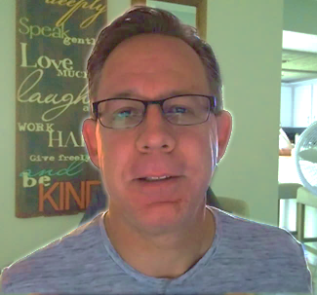
Scott Speicher brings a unique blend of life experiences to his writing. A U.S. military veteran, he carries the discipline, resilience, and perspective gained through service into every story he tells. After his military career, Scott built a successful path in marketing, where he developed a deep understanding of communication, storytelling, and audience engagement. For more than 15 years, he has also worked as a professional website designer, helping businesses and individuals create meaningful online presences.
Scott Speicher is a storyteller who enjoys creating gentle, heartfelt stories that help children notice the small moments that make life meaningful. Through warm characters and simple adventures, his books encourage young readers to slow down, care for others, and appreciate the quiet joys of everyday life. Scott believes that some of the most important lessons children learn come not from grand events, but from the ordinary moments shared with family, friends, and the animals they love.
In Sally and the County Fair is a heartwarming children’s story about friendship, courage, kindness, and welcoming someone new. When Sally meets Maria, the new girl next door, she invites her to join her family for a fun-filled day at the county fair. Together, the girls experience bright lights, carnival games, brave rides, 4-H animals, fairground discoveries, and fireworks under the night sky. Along the way, Sally learns that the best adventures are not just about where you go, but about the kindness you share and the friendships you build.
Suitable for readers aged 4-10 and for family read-aloud sessions. Ideal for SEL, guidance, and service-learning.

