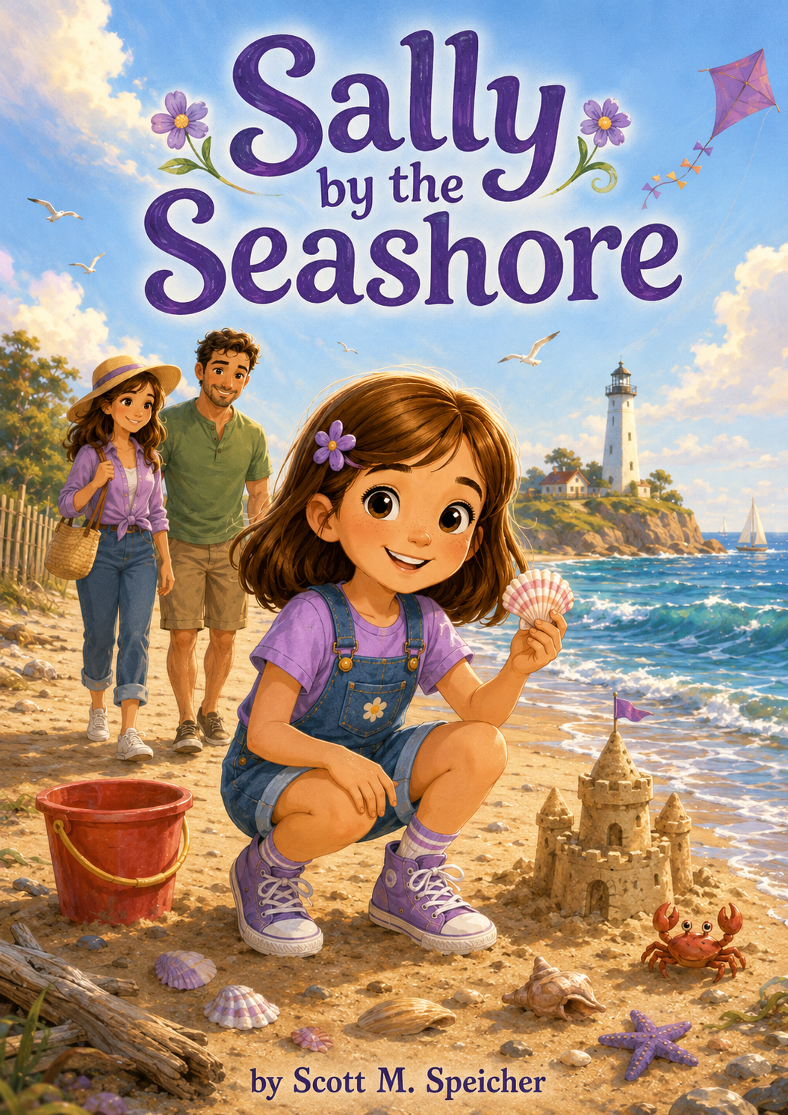
Sally by The Seashore
By
Scott M. Speicher

Copyright © 2026
Author: Scott M. Speicher
Portions of this book have been perfected by the program Grammarly
Edited by Grammarly and the Editorial team of Digital Scribblers
No part of this book may be reproduced or used, in any form or by any means, electronic or mechanical, without permission in writing from the author.
AI generated some images under the author's direction.

Preface
Every child carries questions in their heart—some small, some big, and some hard to explain.
For Sally, life has changed in ways she is still learning to understand. With her parents divorced, two homes to remember, and a new stepfather, Mark, gently trying to be part of her world, Sally sometimes feels caught between what used to be and what comes next. She is curious, strong-willed, creative, and full of adventure, but even brave children can feel unsure when life begins to shift around them.
When Sally visits the seashore with her mother and Mark, the ocean becomes more than a place to play. It becomes a place of discovery. Along the shoreline, Sally finds shells, builds sandcastles, helps a tiny crab, flies a stubborn kite, climbs a lighthouse, returns a lost bucket, creates beach art, and begins the Seashore Adventure Club. Each moment teaches her something important about courage, kindness, patience, sharing, and caring for the world around her.
Sally by the Seashore is a story about learning to move forward one careful step at a time. It reminds young readers that bravery does not mean never feeling afraid. Sometimes bravery means trying again, asking questions, helping when you can, and letting the people who love you walk beside you.
May Sally’s journey encourage children to stay curious, be kind, use their imagination, and discover that even when life feels as big as the ocean, there is always a new adventure waiting at the water’s edge.

Table of Contents
Preface
An introduction to Sally’s journey, her love of adventure, and the deeper lessons she discovers at the seashore about courage, kindness, imagination, and change.
Before the Waves
Before arriving at the beach, Sally struggles with the changes in her family after her parents’ divorce. With her supportive mother and stepfather Mark beside her, Sally begins to understand that even uncertain feelings can be part of an adventure.
Chapter One: The Girl Who Loved the Waves
Sally sees the ocean up close and feels both amazed and overwhelmed by its size and power. As she takes her first careful steps toward the waves, she learns that courage can begin with simply exploring something new.
Chapter Two: The Shell with the Secret
Sally finds a beautiful pink-and-white shell and imagines it came from a magical underwater kingdom. When another child admires it, Sally learns that sharing the wonder of a discovery can make a treasure even more special.
Chapter Three: The Sandcastle Team
Determined to build the biggest sandcastle she has ever made, Sally begins with her own plan. When other children join in, she discovers that creativity grows stronger when everyone has a part to build.
Chapter Four: The Brave Little Crab
Sally spots a tiny crab trapped in a footprint filled with water. With help from Mom and Mark, she learns that kindness means helping small creatures gently, carefully, and respectfully.
Chapter Five: The Message in the Bottle
A plastic bottle washes onto the beach, and Sally first imagines it might hold a pirate message. Instead, she discovers it is litter and turns the moment into a beach cleanup, learning that real heroes help protect the world around them.
Chapter Six: The Kite That Wouldn’t Fly
Sally’s bright purple kite keeps crashing into the sand, leaving her frustrated and ready to give up. With patience, encouragement, and help from friends, she learns that courage sometimes means trying again.
Chapter Seven: The Lighthouse Lookout
Sally climbs an old lighthouse with her family and feels nervous as the stairs rise higher and higher. Step by careful step, she reaches the top and learns that bravery means moving forward even when something feels scary.
Chapter Eight: The Lost Beach Bucket
Sally finds a small red beach bucket and wants to use it for her own shell collection. When she realizes it belongs to a younger child, returning it teaches her that doing the right thing can feel better than keeping something for herself.
Chapter Nine: The Seaside Art Show
Inspired by shells, stones, driftwood, seaweed, and everything she has discovered, Sally creates beach art in the sand. As other children join in, she learns that imagination becomes even more powerful when shared.
Chapter Ten: Sally’s Seashore Adventure Club
At the end of her beach adventure, Sally reflects on everything she has learned and starts the Seashore Adventure Club. Its simple rules—be curious, be kind, stay safe, use your imagination, and help when you can—show Sally that the seashore is more than a place to play; it is a place to learn, care, create, and grow.
Epilogue
A closing reflection on Sally’s journey and the lessons she carries home from the seashore: courage, kindness, curiosity, creativity, and the understanding that even big changes can lead to new discoveries.

Sally by the Seashore
Before the Waves
Sally did not like packing two bags.
One bag meant you were going somewhere fun. Two bags meant you were trying not to forget which things belonged at Mom’s house and which things belonged at Dad’s apartment.
Her purple backpack sat open on the bed, half-filled with seashell stickers, colored pencils, her sketchbook, and the small notebook she had labeled Sally’s Adventure Notes. Beside it was her overnight bag, the one with socks tucked into the side pocket and her favorite pajamas folded on top. Sally stared at both bags and frowned.
Ever since Mom and Dad had divorced, life felt like it had been divided into pieces. There were Mom days and Dad days. School folders that had to travel back and forth. Favorite books that were never in the right place. Toothbrushes in two bathrooms. Two bedrooms. Two sets of rules. Two calendars on the refrigerator—one at Mom’s house and one at Dad’s.
Everyone kept saying, “You’ll get used to it.”
Sally did not like that sentence.
She did not want to get used to missing someone all the time.
She missed Dad when she was with Mom. She missed Mom when she was with Dad. Sometimes, when she was quiet in the back seat of the car, she missed the old house too—the way things used to be, before grown-up voices got softer and sadder, before goodbye hugs started happening in driveways.
Mom knocked gently on the bedroom door. “Need help, sweetheart?”
Sally shrugged without looking up. “I can do it.”
Mom stepped inside anyway, but she did not take over. That was one thing Sally liked about her mother. Mom knew Sally was strong-willed, which was the grown-up way of saying Sally liked doing things herself.
Mom sat carefully on the edge of the bed. “You packed your sketchbook?”
“Yes.”
“Notebook?”
“Yes.”
“Purple hoodie?”
Sally paused.
Mom smiled and reached behind the pillow, pulling out the hoodie Sally had almost forgotten.
Sally took it and stuffed it into the bag. “I knew where it was.”
“I’m sure you did,” Mom said softly.
Sally zipped the bag with one hard tug. “Is Mark coming?”
Mom’s face changed just a little—not in a bad way, but in a careful way whenever Mark’s name came up. Mark was Mom’s new husband. Sally did not dislike him. That was the truth. He was kind. He made pancakes shaped like animals. He never tried to make Sally call him Dad. He helped fix her bike chain and always asked before moving her things.
But sometimes his kindness made Sally feel confused.
Because, like Mark, she felt a little like stepping onto a bridge, she wasn’t sure she was allowed to cross.
“Yes,” Mom said. “Mark is coming. He packed the beach umbrella and your bucket.”
Sally looked down at her hands. “Dad used to take me to the beach.”
Mom was quiet for a moment.
“I know,” she said.
Sally picked at a loose thread on the blanket. “What if Dad feels bad that we’re going without him?”
Mom moved closer, but she did not touch Sally right away. “Your dad loves you very much. And he wants you to have good days, even when you’re not with him.”
Sally wanted to believe that.
Most of her did.
But another part of her—the stubborn part, the worried part—still wondered if having fun in one place meant betraying someone in another.
Mom seemed to understand, even though Sally had not said it out loud.
“Loving your dad does not mean you have to stop enjoying your time here,” Mom said gently. “And caring about Mark does not take anything away from your dad.”
Sally looked up. “It feels like everything changed.”
Mom’s eyes softened. “It did.”
Sally had expected Mom to say, “Not everything,” or “It will be fine,” or one of those too-bright grown-up answers that tried to smooth over bumpy feelings.
But Mom did not.
She simply said, “It did.”
That made Sally’s throat feel tight.
Mom reached for her hand. This time, Sally let her take it.
“Change can feel like a big wave,” Mom said. “It can come in fast and make you feel unsteady. But you don’t have to stand in it alone.”
Sally looked at her. “Is that why we’re going to the ocean?”
Mom smiled a little. “Maybe. Or maybe because my favorite adventurer deserves a day at the seashore.”
From downstairs, Mark called, “Beach crew departing in ten minutes! Sunscreen has been located! Snacks have been secured!”
Sally rolled her eyes, but a tiny smile slipped out before she could stop it.
Mom noticed, but she did not tease her.
A few minutes later, Sally carried her purple backpack downstairs. Mark stood by the front door with the beach umbrella tucked under one arm and a cooler in the other hand.
“Explorer Sally,” he said, “your expedition vehicle awaits.”
Sally looked at him seriously. “Did you pack the shovel?”
Mark’s eyes widened in pretend alarm. “The shovel.”
Sally froze. “You forgot it?”
Mark reached behind his back and pulled out her blue-handled shovel. “An explorer must always inspect the assistant.”
Sally tried not to laugh. “You’re not my assistant.”
“Fair,” Mark said. “Temporary beach equipment manager?”
Sally considered this. “Fine.”
Mom picked up the towels. “That sounds official.”
The ride to the seashore took thirty minutes, though Sally counted every one of them. She watched houses turn into shops, shops turn into palm trees, and palm trees turn into glimpses of bright sky. In the back seat, she held her notebook in her lap and pressed one finger against the blank first page.
She wanted to write something brave.
Something adventurous.
Something that sounded like the beginning of a great journey.
But all she could think was:
I don’t know how to feel today.
So she wrote that.
Then she added:
Maybe that still counts as an adventure.
When the car finally turned into the beach parking lot, Sally smelled the ocean before she saw it. The air changed first—salty, warm, and alive. Gulls called overhead. The breeze pushed against the car windows. Somewhere beyond the dunes, the waves rolled and crashed, waiting.
Mark parked the car and began unloading the cooler and umbrella. Mom handed Sally her purple backpack.
“You ready?” Mom asked.
Sally looked toward the wooden walkway that led over the dunes.
She thought about Dad. She thought about Mom. She thought about Mark carrying her bucket and trying so hard to make things easy without pretending everything was simple. She thought about how her life sometimes felt split, like two shorelines with her standing in the middle.
Then she heard the ocean.
Whoosh.
Crash.
Fizz.
It sounded big.
Bigger than her worries.
Bigger than the hard changes.
Bigger than the questions, she did not yet know how to ask.
Sally tightened the straps of her backpack and lifted her chin.
“I’m ready,” she said.
And with Mom walking on one side and Mark carrying the beach umbrella on the other, Sally stepped onto the sandy path toward the seashore—not because everything felt easy, and not because everything was fixed, but because something new was waiting.
And Sally had always been curious enough to find out what came next.

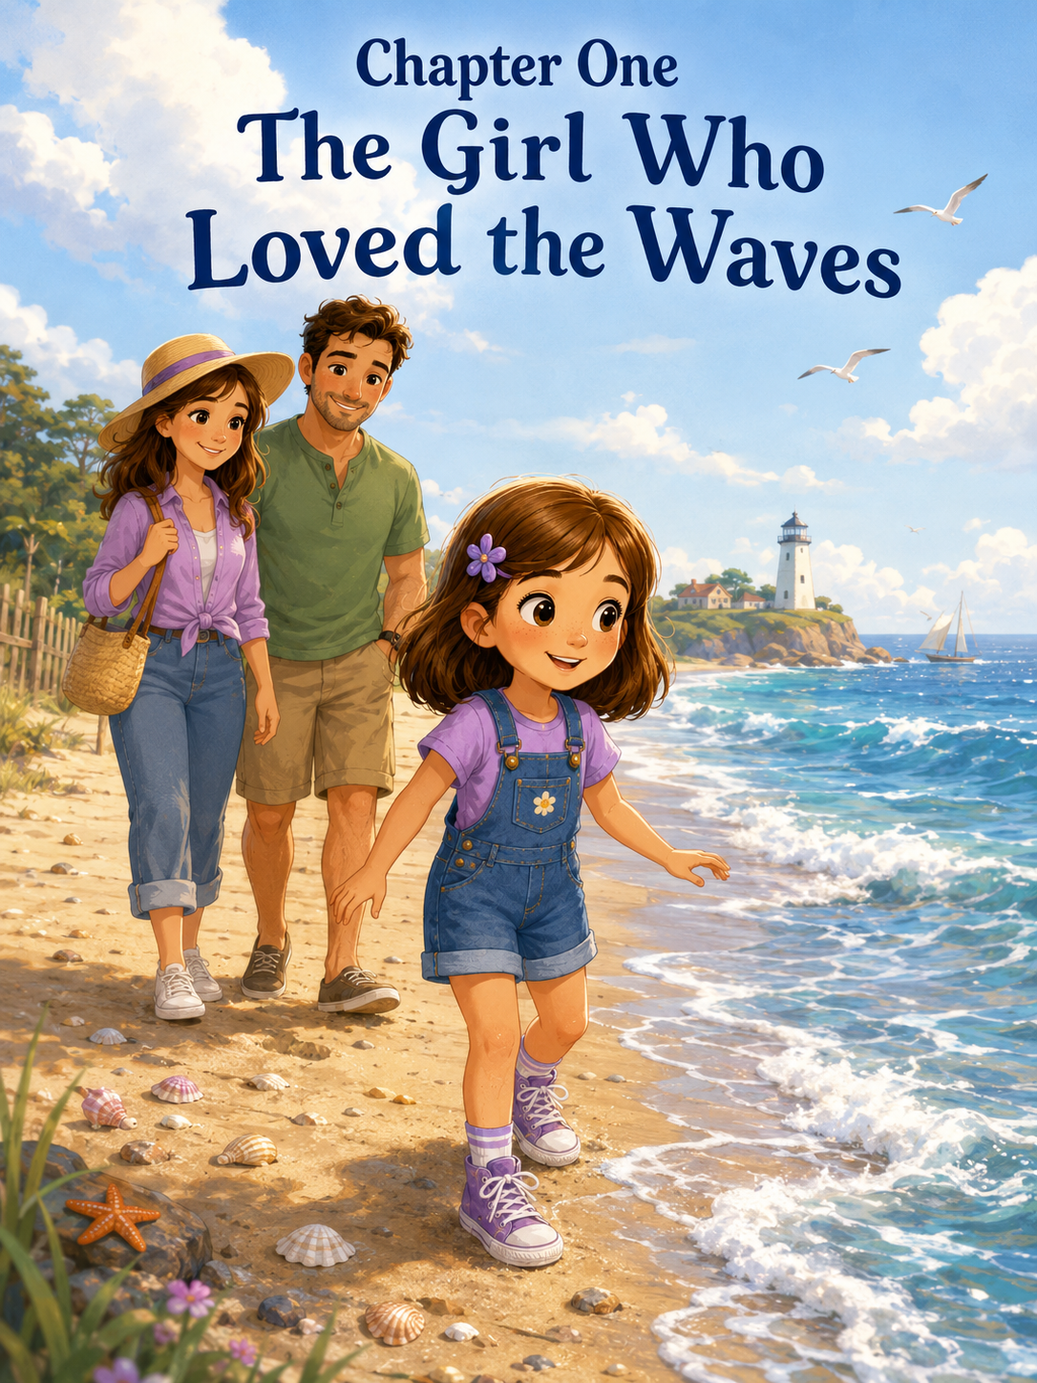Chapter One: The Girl Who Loved the Waves
Sally had been to the ocean before.
She had seen it in books with shiny blue covers. She had seen it in movies where waves rolled across the screen, and people ran barefoot through the sand. She had even drawn the ocean herself with blue crayons, purple shadows, and yellow suns smiling in the corner of the page.
But being at the ocean in real life was different.
Much different.
It was bigger than any picture.
It stretched so far that Sally could not see where it ended. The water shimmered under the morning sun, blue and silver and green all at once. Waves curled, lifted, and crashed onto the shore with a sound like the whole world taking a deep breath.
Whoooosh.
Crash.
Fizz.
Then the water slid back into the sea, pulling tiny shells and bubbles with it.
Sally stood at the edge of the beach with her purple sneakers planted firmly in the sand. Her brown hair moved in the salty breeze, and the little purple flower clip near her ear wiggled as if it were excited too.
Her mother stood beside her, smiling softly.
“Well?” Mom asked. “What do you think?”
Sally did not answer right away.
She was too busy looking.
A white bird skimmed low over the water. Farther down the beach, children carried buckets and shovels. A man tossed a yellow ball to a dog that splashed into the waves like it had been waiting its whole life for this exact moment.
Sally’s stepfather, Mark, came up behind them carrying a beach bag, an umbrella, and three towels stacked over one shoulder.
“I think the ocean made Sally quiet,” he said.
Sally turned around quickly. “I am not quiet.”
Mark grinned. “Good. I was worried.”
Sally put her hands on her hips. “I was observing.”
Mom smiled. “That sounds like Sally.”
Sally liked that word.
Observing.
It sounded important. Like something explorers did before they discovered a hidden cave or followed a trail through the jungle. Sally was very good at noticing things. She noticed when ants marched near the sidewalk. She noticed that clouds looked like animals. She noticed when grown-ups said, “Just a minute,” but really meant at least five.
And today, there was a lot to notice.
The ocean.
The waves.
The shells.
The long stretch of sand.
The strange smell of salt and seaweed.
The footprints that appeared and disappeared when the water reached them.
Everything felt new.
Everything felt possible.
Mark set the beach bag down. “Base camp?”
Sally looked at him. “Base camp?”
“For our seashore expedition,” he said. “Every adventure needs a base camp.”
Sally’s eyes brightened. “This is an expedition?”
“Absolutely,” Mark said.
Mom spread a towel over the sand. “An expedition with sunscreen.”
Sally made a face.
Mom held up the sunscreen bottle. “Even brave explorers protect their skin.”
Sally sighed. “Fine.”
She stood still while Mom rubbed sunscreen across her cheeks, arms, and nose. Mark placed the umbrella in the sand and twisted it until it stood tall and steady. Then he set down Sally’s small purple backpack, the one she had packed herself.
Inside were her sketchbook, crayons, a magnifying glass, a snack bag, and a notebook labeled:
Sally’s Adventure Notes
Mom had helped her write the title, but Sally had drawn the starfish and waves around it.
Once the sunscreen was finished, Sally picked up her notebook and looked toward the water again.
The waves rolled in.
Whoooosh.
Crash.
Fizz.
They seemed friendly from far away.
But up close, they looked bigger.
Sally watched one wave rush up the sand toward a little girl’s feet. The girl squealed and jumped backward. The water spread wide and thin before sliding back again.
Sally stepped closer.
Then she stopped.
The ocean was not like a bathtub. It did not stay still. It moved all the time, pushing forward, pulling back, whispering, roaring, sparkling, and changing shape every second.
Sally liked adventures.
She liked climbing playground ladders. She liked opening mystery boxes. She liked asking questions until adults gave very long answers. She liked being first to try new things, especially if someone said, “Maybe wait.”
But the ocean made her feel something she did not expect.
Small.
Not scared exactly.
Just small.
Mom noticed.
She always noticed.
“You don’t have to go close right away,” Mom said gently.
Sally lifted her chin. “I know.”
Mark stood beside them and looked toward the waves. “The ocean is powerful. It’s okay to respect it.”
Sally glanced at him. “Respect it?”
“Sure,” Mark said. “Being brave doesn’t mean pretending something is not big. It means paying attention and making careful choices.”
Sally looked back at the water.
Another wave rolled in and curled into white foam.
“What if it knocks me over?” she asked.
“Then we don’t go that far,” Mom said. “We start where the water is gentle. Right at the edge. And one of us stays beside you.”
Sally frowned thoughtfully.
She did not like feeling unsure. Sally liked decisions. She liked plans. She liked doing things herself. Being an only child meant she was used to making up her own games and choosing her own adventures. Sometimes Mom said Sally had enough imagination for three children. Sometimes Mark said she had enough determination for five.
Sally did not think that was a problem.
Determination helped.
But standing there, looking at the endless sea, Sally wondered if determination alone was enough.
A small shell washed up near her sneaker.
It was pale and smooth, with a tiny pink stripe across the middle.
The water came close, curled around the shell, and pulled back again.
Sally crouched quickly and picked it up before the next wave could take it away.
“I found treasure,” she said.
Mom leaned down. “That is beautiful.”
Mark crouched beside her. “First discovery of the expedition.”
Sally held the shell in her palm. It was smaller than a button and cool from the water. She turned it over with one finger.
“Where did it come from?” she asked.
“The ocean,” Mark said.
Sally gave him a look. “I know that.”
He laughed. “Fair enough.”
Mom smiled. “It may have been part of a little sea creature’s shell. After shells are empty, the waves carry them, smooth them, and bring them to shore.”
Sally looked out at the water again.
“So the ocean brought it here?”
“Yes,” Mom said.
Sally studied the shell. Suddenly, the ocean seemed a little less like one giant thing and more like many tiny mysteries moving together.
Shells.
Waves.
Birds.
Sand.
Foam.
Footprints.
Treasures.
Sally opened her notebook and carefully wrote:
Discovery #1: Tiny pink-striped shell. Brought by the ocean. Very mysterious.
Then she drew a quick picture of it.
Mark looked over her shoulder. “Excellent field note.”
Sally smiled.
A wave rolled up the sand and stopped a few feet away.
Sally watched the foam bubble and disappear.
“I want to see what else the ocean brings,” she said.
Mom held out her hand. “Then we’ll go together.”
Sally looked at Mom’s hand.
She was big enough to walk by herself. She knew that. But Mom’s hands were warm and steady, and the ocean was very large.
Sally took it.
Mark walked on Sally’s other side, close but not crowding her.
The three of them stepped toward the water.
The sand changed as they walked. Near the towels, it was dry and soft, sliding under Sally’s sneakers. Closer to the waves, it became darker and firmer, packed smooth by the water. Sally could see her footprints clearly now.
A wave rushed forward.
Sally stopped.
Mom stopped too.
Mark did not rush her.
The water spread thin across the sand and touched the very tips of Sally’s sneakers.
It was cold.
Sally gasped.
Then she laughed.
“It got me!”
Mom laughed too. “It did.”
The water slipped back, leaving shiny sand behind.
Sally looked down at her shoes. “Again.”
This time, when the next wave came, Sally did not step back. She squeezed Mom’s hand and watched the foam swirl around her soles. It tickled the sand and made a fizzing sound as it disappeared.
Whoooosh.
Fizz.
Sally smiled.
The ocean was still big.
But this little edge of it felt like something she could meet.
She took one step closer.
Then another.
Mark walked nearby, careful and calm. “Good exploring.”
Sally looked up at him. “I’m not scared.”
Mark nodded. “Maybe not. Or maybe a little. Either way, you’re doing it carefully.”
Sally thought about that.
Could she be curious and nervous at the same time?
Could she be brave even if she held Mom’s hand?
She watched a wave roll in, break apart, and slide gently toward her feet.
Yes, she decided.
Probably.
A tiny piece of seaweed brushed against her shoe, and Sally bent to inspect it.
“It looks like a green ribbon,” she said.
Mom nodded. “Seaweed.”
Sally wrote in her notebook:
Discovery #2: Seaweed ribbon. Slippery. Looks like something a mermaid might tie around a present.
Mark chuckled. “That is very specific.”
“Good observations are specific,” Sally said.
They walked slowly along the shore. Sally found a white shell shaped like a fan, a smooth gray stone, and a piece of driftwood that looked like a tiny dragon’s tail. She did not keep everything. Mom explained that some things were better left on the beach, where other people could enjoy them and small creatures could still use them.
Sally liked collecting treasures, but she also liked the idea of the beach having them.
So she made a small rule in her notebook:
Seashore Rule #1: Take only a few treasures. Leave some magic behind.
A little farther down the beach, Sally saw a cluster of children digging near the water. One child filled a bucket with wet sand. Another decorated a castle wall with shells. A third stood guard against the waves, shouting, “Here comes another one!”
Sally watched as a wave reached the castle moat and made everyone cheer.
“That looks fun,” she said.
“We brought your bucket,” Mom said.
“And your shovel,” Mark added.
Sally looked back at their umbrella. It seemed far away now, though it really was not.
She looked at the ocean.
Then at the children.
Then at the shell in her hand.
“I want to build something later,” she said. “But first I want to explore.”
Mom smiled. “Of course you do.”
Sally stepped forward again, this time without holding Mom’s hand.
Mom stayed close.
Mark stayed close too.
But Sally walked on her own.
The water rushed in and touched her sneakers. She did not jump back. She looked down and watched the foam wrap around her feet.
“I think the ocean is saying hello,” she said.
Mark nodded. “That sounds right.”
Sally lifted her hand and waved at the waves.
“Hello, ocean.”
A larger wave rolled in—not dangerous, but bigger than the others. Sally stepped back quickly, and Mom placed a steady hand on her shoulder.
“Good choice,” Mom said.
Sally looked up. “Because I noticed it was bigger?”
“Exactly.”
Mark added, “Explorers don’t just move forward. They watch, think, and choose.”
Sally liked that.
She wrote it down:
Seashore Rule #2: Brave explorers watch, think, and choose.
The morning grew warmer. Gulls called overhead. The sun sparkled on the water so brightly that Sally had to squint. She found tiny holes in the wet sand where bubbles popped up and vanished.
“What lives under there?” she asked.
“Maybe small clams,” Mom said. “Or little sand creatures.”
Sally crouched, fascinated.
“You mean there is a whole world under the sand?”
“Tiny worlds everywhere,” Mark said.
Sally looked around.
The beach was no longer only big.
It was full.
Full of things to discover.
The giant ocean had brought tiny shells. The wet sand held secret bubbles. The seaweed looked like ribbons. The waves could be loud and gentle. The shore was wide, but Sally did not feel as small anymore.
She felt awake.
Curious.
Ready.
A little girl nearby dropped a blue shovel and watched it slide toward the water. Sally noticed before anyone else did. The next small wave nudged it closer to the sea.
Sally hurried forward, but not too far. She waited for the water to pull back, then grabbed the shovel from the wet sand.
“Here,” she said, holding it out.
The little girl ran over. “Thank you!”
Sally smiled. “The ocean almost borrowed it.”
The girl giggled and ran back to her sandcastle.
Mom watched Sally with a soft smile. “That was kind.”
Sally shrugged, but she felt pleased. “I just noticed.”
“Noticing is where kindness often begins,” Mom said.
Sally thought that sounded important enough to write down later.
They walked back toward their umbrella when the sun climbed higher. Sally’s notebook was already filled with discoveries. Her sneakers were damp. Her cheeks were warm. Her pocket held three shells and one smooth stone, each chosen carefully.
At base camp, Mark handed her a water bottle.
“Explorer Sally,” he said, “report your findings.”
Sally sat on the towel, opened her notebook, and cleared her throat.
“I discovered that the ocean is very big,” she began.
Mom nodded seriously.
“And loud,” Sally continued. “And sparkly. And it brings presents, but you should not take all of them.”
“Excellent,” Mark said.
“I learned that seaweed can look like mermaid ribbon, shells can be mysterious, and sand might have tiny worlds under it.”
Mom smiled. “Anything else?”
Sally looked out at the waves.
They still rolled and crashed. They still stretched farther than she could see. They were still much bigger than she was.
But now they felt like an invitation.
Sally looked down at her notebook and wrote one more line.
Discovery #7: Courage can begin with one small step toward something new.
She stared at the sentence for a moment.
Then she added:
Even if you are holding your mom’s hand.
Mom read it over her shoulder and kissed the top of Sally’s head.
“That is one of my favorite discoveries,” she said.
Sally leaned against her for just a second, then sat up straight again.
She was still an adventurer.
Still curious.
Still strong-willed.
But now she knew something she had not known before.
Being brave did not mean rushing into the biggest wave.
It meant noticing.
Wondering.
Trying.
Stepping closer.
Knowing when to step back.
And letting people who loved you walk beside you.
Sally picked up her purple bucket and looked toward the sandcastle children.
“Ready for the next adventure?” Mark asked.
Sally grinned.
“The seashore is full of them,” she said.
Then she ran toward the wet sand, her flower clip bouncing in the breeze, her notebook tucked away in her backpack, and the wide blue ocean rolling beside her like a beautiful mystery she had only just begun to understand.

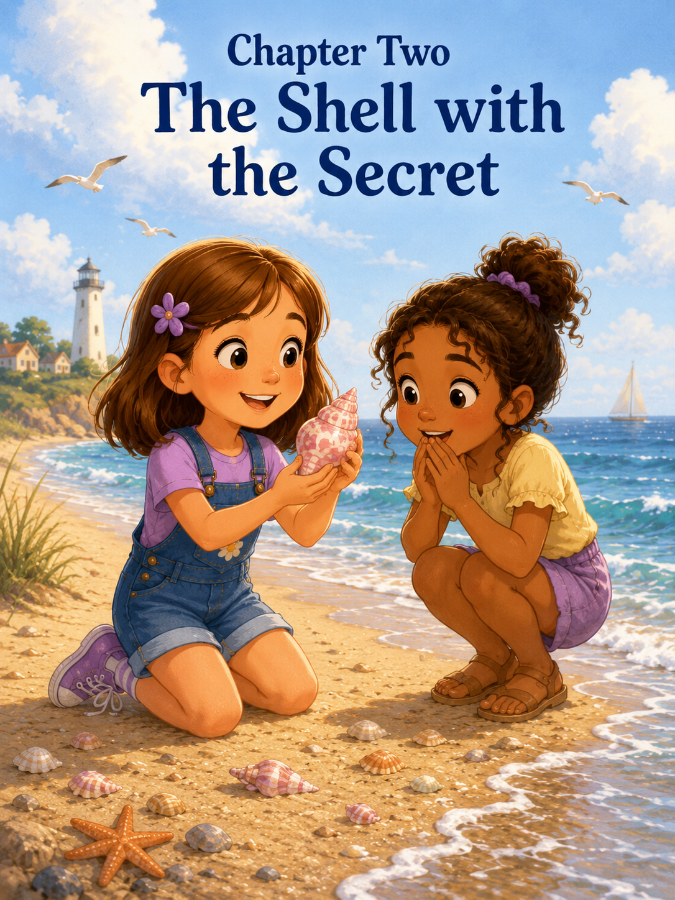
Chapter Two: The Shell with the Secret
Sally found the shell just after the tide began to slide back.
She had been walking along the wet edge of the sand, where the waves left behind thin lines of foam and tiny sparkling bubbles. Her purple sneakers were damp around the edges, and her notebook was tucked safely inside her backpack. Mom walked a little behind her, carrying a water bottle and watching the waves. Mark was farther up the beach, setting the umbrella more firmly in the sand because the ocean breeze kept trying to turn it inside out.
Sally liked this part of the beach best.
Not the dry sand, where towels and chairs and coolers made little camps everywhere. Not the water, which still felt enormous and powerful. But this in-between place, where the ocean reached out, left something behind, and then hurried away again.
It felt like a secret exchange.
The sea took footprints.
The sea left shells.
Sally crouched low when she saw something shining near a trail of seaweed.
At first, it looked like an ordinary shell. But when she picked it up and brushed away the sand, she forgot to breathe for a second.
It was beautiful.
The shell was small enough to fit in the center of her palm, but it looked as if someone had painted it with sunrise colors. Soft pink and creamy orange swirled together in curved lines. One edge was smooth, and the other had tiny ridges that felt like steps on a miniature staircase. When Sally held it up to the light, the orange seemed to glow.
“Mom,” Sally called, but not too loudly. This shell felt like something you should not shout about.
Mom came closer. “What did you find?”
Sally opened her hand.
Mom smiled. “Oh, Sally. That is lovely.”
“It’s not just lovely,” Sally said. “It’s important.”
Mark walked over with the umbrella, finally standing behind him. “Important shell discovery?”
Sally held it out, but not far enough for anyone to take it.
“Very important,” she said. “Maybe royal.”
Mark bent down to look. “Royal?”
Sally nodded. “From an underwater kingdom.”
Mom’s eyes warmed. “Tell us more.”
Sally looked back at the ocean. The waves rolled in blue and silver under the morning sun. Somewhere far beyond where she could see, there might be coral towers, glowing sea gardens, and fish wearing tiny golden crowns.
She could almost picture it.
“This shell belonged to a sea princess,” Sally said. “But not the kind who sits around all day. She was an explorer princess.”
“Of course,” Mom said.
“She rode on the back of a giant seahorse,” Sally continued, “and carried a pearl lantern through dark underwater caves.”
Mark nodded seriously. “Dangerous work.”
“Very dangerous,” Sally said. “One day, she found a hidden tunnel under the reef. Inside was a treasure room, but the treasure was not gold.”
“What was it?” Mom asked.
Sally looked at the shell in her palm. “Stories.”
Mark smiled. “A treasure room full of stories?”
“Yes,” Sally said. “Every shell had one. If you held it close, you could hear where it had been.”
She lifted the shell near her ear.
At first, all she heard was the roar of the real ocean, the wind, and a gull calling overhead.
But Sally’s imagination was very good at filling in the rest.
“I hear waves,” she whispered. “And maybe bells.”
“Underwater bells?” Mark asked.
Sally nodded. “For warning the kingdom when storms are coming.”
Mom sat down on the damp sand beside her. “What happened to the shell?”
Sally turned it over carefully. “The sea princess sent it away.”
“Why?” Mom asked.
“To find someone brave enough to listen,” Sally said.
She liked that sentence so much that she quickly pulled her notebook from her backpack and wrote it down.
Discovery #8: Orange-and-white shell. Possibly royal. Sent from an underwater kingdom to find someone brave enough to listen.
Then she drew the shell as carefully as she could. The swirls were hard to copy. They curved in a way that seemed to move while she looked at them. Sally pressed the orange crayon lightly at first, then darker near the center.
Mark watched her draw. “That is a good field sketch.”
“It is not just a sketch,” Sally said. “It is evidence.”
“Of course,” Mark said. “Evidence.”
Sally liked that Mark did not laugh when she said things like that. Sometimes grown-ups laughed at children’s ideas in a way that made the ideas feel smaller. Mark did not. He acted as if the underwater kingdom might be real, or at least real enough for the morning.
Sally slipped the shell gently into the front pocket of her backpack.
Mom noticed. “Keeping that one?”
Sally nodded at once. “Definitely.”
They continued down the beach. Sally checked the sand for more treasures, but none seemed as important as the orange-and-white shell. She found a broken clam shell, a tiny gray stone, and a piece of driftwood shaped like a bent finger, but she left them where they were.
The royal shell was enough.
A little farther down the shore, a group of children were building a sandcastle near the water. Their castle had three towers, a crooked wall, and a moat that kept filling up every time a wave reached it. One boy shouted orders while a younger girl decorated the towers with shells.
Sally slowed down.
The younger girl looked about six. She wore a blue swimsuit with yellow stars and had two braids tied with orange ribbons. She was carefully pressing small white shells into the side of the castle wall.
Sally watched her for a moment.
The girl looked up and saw Sally’s backpack pocket, where the orange-and-white shell peeked out slightly.
Her eyes widened.
“That shell is so pretty,” the girl said.
Sally’s hand moved to her backpack pocket.
“Thanks,” she said.
The girl stepped closer, wiping wet sand on her knees. “Where did you find it?”
“Over there,” Sally said, pointing behind her.
The girl looked down at the beach with hopeful eyes. “I haven’t found one like that.”
Sally nodded. “It’s rare.”
“How rare?”
Sally stood a little taller. “Very rare.”
The girl leaned closer. “Can I see it?”
Sally’s fingers tightened around the shell through the pocket fabric.
The shell was hers.
She had found it.
She had noticed it.
She had imagined its story.
She had written it in her notebook.
It was not just a shell anymore. It was the royal shell from the underwater kingdom, sent to find someone brave enough to listen.
And it had found Sally.
The girl waited.
Her face was open and hopeful.
Sally looked toward Mom, who stood a few steps away. Mom did not tell her what to do. She simply watched quietly, the way she did when Sally had to make a choice for herself.
Mark was looking at the sandcastle, pretending to study the moat, but Sally knew he was listening too.
Sally pulled the shell out of her pocket.
The girl gasped softly. “It looks like candy.”
“It is not candy,” Sally said quickly. “It is probably royal.”
The girl took one tiny step closer. “Royal?”
Sally held the shell carefully in both hands. “It came from an underwater kingdom.”
The girl’s eyes grew even wider.
“What kingdom?”
Sally glanced at the sea.
The story came back to her quickly, like a wave returning to shore.
“The Kingdom of Pearlwater,” Sally said.
The girl whispered the name. “Pearlwater.”
“There was a sea princess,” Sally continued. “But she was an explorer, not the sitting-around kind.”
“I like explorer princesses,” the girl said.
“Me too,” Sally said.
She looked down at the shell again. The orange swirls seemed brighter now that someone else was looking at them. The secret did not feel smaller because she had shared it.
It felt bigger.
The girl pointed, careful not to touch. “What are the lines?”
“Paths,” Sally said. “Underwater paths. They show where the shell traveled.”
The girl nodded seriously. “Maybe it went past sharks.”
“Probably,” Sally said. “But friendly sharks.”
“And mermaids?”
“Definitely.”
“And a sea turtle?”
Sally smiled. “A very wise sea turtle.”
The girl smiled back.
For a moment, the two of them stood there with the shell between them, the ocean rolling behind them, the sandcastle waiting beside them, and the whole story growing larger with every idea.
Then the girl asked the question Sally had hoped she would not ask.
“Can I hold it?”
Sally pulled the shell a little closer.
The girl quickly added, “I’ll be careful.”
Sally looked at the shell. It was small and delicate. What if the girl dropped it? What if sand scratched it? What if she decided not to give it back? What if the magic wore off because too many people touched it?
Sally’s thoughts crowded together like gulls over a dropped cracker.
She wanted to say no.
It would be easy.
It was her shell.
Her treasure.
Her secret.
Then she remembered something Mom had said the day before: Take only a few treasures. Leave some magic behind.
Sally had taken the shell from the beach.
Now she wondered if maybe magic was not only something you found.
Maybe it was something you shared.
She looked at the girl’s hands. They were sandy, but they were held out carefully, palms open, waiting.
“What’s your name?” Sally asked.
“Emma.”
“I’m Sally.”
“I know,” Emma said. “Your mom said it.”
Sally glanced at Mom, who smiled.
Sally took a deep breath. “Okay, Emma. You can hold it. But you have to sit down first.”
Emma immediately sat in the sand.
Sally sat across from her. “And hold it with two hands.”
Emma nodded.
“And don’t run.”
“I won’t.”
“And don’t put it in the moat.”
Emma looked offended. “I would never.”
Sally nodded. “Good.”
Very carefully, Sally placed the shell in Emma’s palms.
Emma held it as if it were a sleeping butterfly.
“It’s smooth,” she whispered.
Sally felt her shoulders relax.
Emma turned it slightly in the sun. “It really does look royal.”
Sally smiled despite herself. “I told you.”
Emma held it near her ear. “I hear the ocean.”
“That means it remembers where it came from,” Sally said.
Emma listened for another moment. “I think I hear bells too.”
Sally’s eyes widened. “Underwater bells?”
Emma nodded. “Warning bells. Maybe a storm is coming to Pearlwater.”
Sally leaned forward. “Then the explorer princess has to go back.”
“With the wise sea turtle,” Emma added.
“And the friendly shark guards,” Sally said.
Emma giggled.
The boy who had been shouting orders at the sandcastle came over. “What are you doing?”
Emma held up the shell. “It’s from Pearlwater.”
The boy frowned. “What’s Pearlwater?”
Sally stood. “An underwater kingdom.”
He looked at the shell. “Can it go on the castle?”
Sally almost said no immediately.
Emma looked at her, waiting.
The castle wall did look plain in the center. The shell would make it beautiful. It could become the royal doorway, or a secret window, or the place where the underwater princess left messages.
But if it went on the castle, a wave might come.
Someone might knock it off.
It might disappear.
Sally’s hand twitched.
“I don’t want to lose it,” she said.
The boy shrugged. “Okay.”
Emma looked disappointed, but she handed the shell back carefully.
Sally took it and held it tight.
For a few seconds, the story felt like it had stopped.
The shell was safe again.
But the wonder was smaller.
Sally looked at the sandcastle. The moat shimmered with water. The towers leaned slightly, but they were brave towers. Emma had decorated them with tiny shells. The boy had built a wall with his hands. Another child was shaping a doorway with a shovel.
The castle was not perfect.
But it was something they were making together.
Sally looked at the orange-and-white shell in her palm.
Maybe, she thought, a royal shell should have a kingdom.
Not forever.
Just for a little while.
“We can use it,” Sally said suddenly.
Emma looked up. “Really?”
Sally nodded. “But not near the water. It should go on the highest tower, away from the moat.”
The boy grinned. “Like a crown.”
Sally liked that.
“Yes,” she said. “Like a crown.”
Together, they knelt beside the sandcastle. Sally chose the tallest tower, the one farthest from the waves. She pressed the shell gently into the damp sand at the top. The orange-and-white swirls caught the sunlight.
Everyone leaned back.
The castle looked different now.
Not just bigger.
More magical.
Emma clasped her hands. “It’s the Pearlwater Castle.”
Sally smiled. “The summer palace.”
The boy added a small wall around the tower. “To protect the crown shell.”
Sally nodded. “Good idea.”
More children came over to look. Emma told them about Pearlwater. The boy added shark guards made from broken shells. Sally drew a winding road in the sand from the ocean to the castle gate. Someone else added a seaweed flag.
The story grew and grew.
Sally became the keeper of the shell’s history. Emma became the royal tower decorator. The boy became captain of the shark guards. Mark helped dig the moat deeper, though he said he was only an assistant moat engineer. Mom took a picture of the castle, the children, and the shell shining at the top.
Sally felt proud.
But not the same kind of proud as when she first found the shell.
This was better.
This was shared proudly.
After a while, the tide began to creep closer. Mom gently warned them that the waves would eventually reach the castle.
Sally looked at the shell. “We should rescue the crown.”
Emma nodded. “Before the ocean takes it back.”
Sally carefully lifted the shell from the tower and brushed off a little sand. Then she held it out to Emma.
Emma blinked. “Me?”
“You can hold it one more time,” Sally said.
Emma took it gently. “Thank you.”
Sally watched her admire it, and this time she did not feel worried. The shell had survived being shared. The story had survived, too. In fact, it had become much more exciting.
Emma handed it back.
“Are you keeping it?” she asked.
Sally looked at the shell.
She could keep it in her pocket. She could take it home. She could place it on her shelf and remember Pearlwater every time she saw it.
But then she looked at Emma.
An idea came to her.
She opened her notebook and carefully tore out a small blank corner from the back page. She drew the shell as quickly as she could and wrote:
The Shell with the Secret
From the Kingdom of Pearlwater
Then she handed the drawing to Emma.
“You can keep the story,” Sally said.
Emma’s face lit up. “Really?”
“Yes. And if you find another shell, it can be from Pearlwater too.”
Emma hugged the paper carefully against her chest. “I will.”
Sally placed the real shell safely back in her backpack pocket.
It still belonged to her.
But now, somehow, it also belonged to the story they had made together.
As Sally walked back toward base camp with Mom and Mark, she felt the shell bump lightly against her backpack.
Mark looked down at her. “That was generous.”
Sally shrugged. “I still kept it.”
Mom smiled. “You shared the wonder. That can be even harder.”
Sally thought about that.
She had not given away her shell. Not exactly.
But she had let someone else see it, hold it, imagine with it, and help build a kingdom around it.
That felt like giving something important.
Under the umbrella, Sally sat on her towel and opened her notebook again. She turned to the page with her shell drawing and added:
Discovery #9: Some treasures are special because you find them. But some treasures become more special when you share their story.
She looked at the sentence for a long time.
Then she added one more line:
The shell was mine, but the wonder got bigger when it became ours.
Mom read the words over her shoulder and smiled.
“That is a beautiful discovery,” she said.
Sally looked back toward the sandcastle. The waves were getting closer now. Pearlwater Castle would not last forever. Sandcastles never did.
But Emma was still holding the little paper drawing.
The story would last longer.
Sally touched the shell through her backpack pocket and looked out at the wide, sparkling sea.
The ocean had brought her a treasure.
But sharing it had brought her something else.
A new story.
A new friend.
And a secret that was better because it no longer had to belong to only one person.

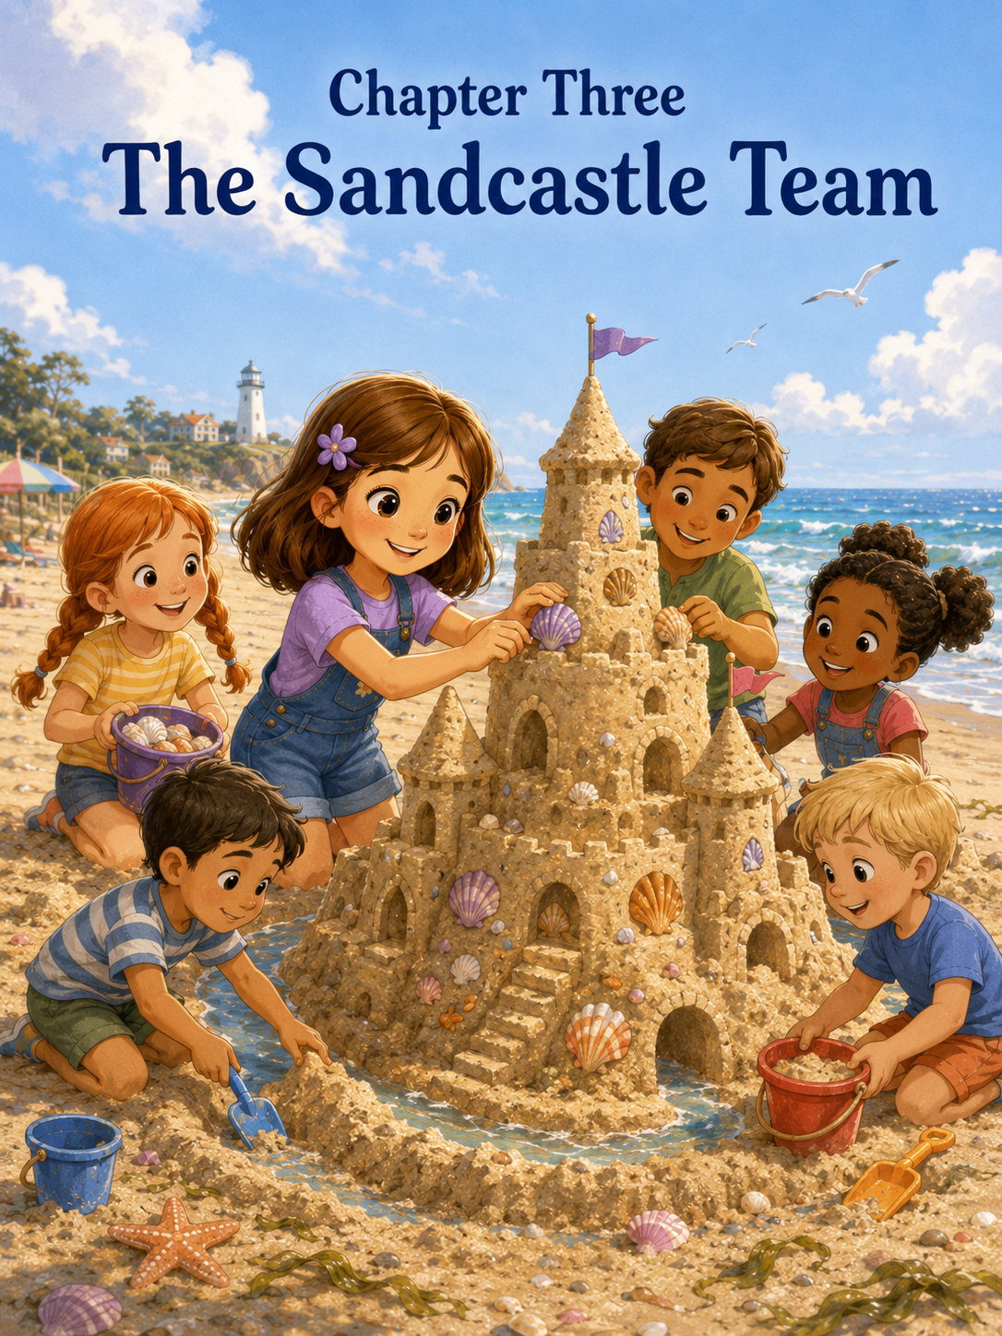
Chapter Three: The Sandcastle Team
Sally had built many sandcastles before.
She had built tiny castles in playground sandboxes, lopsided castles beside lakes, and one very dramatic castle in her backyard using a flowerpot, a soup spoon, and a bucket of dirt that Mom had not been entirely happy about.
But today was different.
Today Sally was at the real seashore, where the sand was soft, the waves were loud, and the beach stretched wide enough for the biggest castle she had ever imagined.
She stood near the edge of the wet sand with her blue-handled shovel in one hand and her purple bucket in the other. The orange-and-white shell from Pearlwater was tucked safely in her backpack pocket, and her notebook rested under the umbrella at base camp.
Sally narrowed her eyes at the open beach.
“This,” she announced, “is where I will build my greatest sandcastle.”
Mom looked up from spreading sunscreen across her arms. “That sounds ambitious.”
“It has to be,” Sally said. “Great castles are not small.”
Mark adjusted the beach umbrella and smiled. “What will this great castle include?”
Sally lifted her shovel like an architect pointing at invisible blueprints. “Four towers. Maybe five. A moat. A bridge. Seashell windows. A tunnel. A royal courtyard. And probably a secret room.”
“Probably?” Mark asked.
Sally nodded. “Every proper castle needs at least one secret room.”
Mom smiled. “Do proper castles also need water breaks?”
Sally sighed. “Yes.”
“Good,” Mom said. “Then the architect may begin.”
Sally marched to a smooth patch of wet sand, a safe distance from the water. Close enough that the sand was easy to shape, but not so close that the waves would gobble everything up right away. She had learned earlier that the ocean was beautiful, but it did not ask permission before changing things.
She set down her bucket and got to work.
First came the foundation.
Sally packed wet sand into the bucket, pressed it down with both hands, flipped the bucket upside down, and tapped the bottom three times.
Tap.
Tap.
Tap.
Then she lifted it.
A neat round tower stood in the sand.
Sally grinned.
“Tower one,” she said.
She made another. Then another. Then another.
Four towers rose in a crooked square. They were not the same height, but Sally decided real castles probably had uneven towers too. It made them look historic.
Next came the walls.
Sally scooped wet sand with her shovel and piled it between the towers. She patted it carefully, smoothing the sides with her palms. The first wall looked strong. The second wall looked even better.
Then the third wall collapsed.
It slid sideways in a heavy slump.
Sally stared at it.
“No,” she said.
The sand did not answer.
She scooped it back up and tried again. This time, she added more water and pressed harder.
The wall stood for three seconds.
Then it cracked down the middle and fell.
Sally frowned. “That was not part of the plan.”
Mark walked over carrying two water bottles. “Engineering trouble?”
Sally looked at the fallen wall. “The castle is being difficult.”
“Castles can be that way,” Mark said.
“I know how to build sandcastles,” Sally said quickly.
Mark held up one hand. “I believe you.”
Sally took a breath. She did not like it when things failed in front of people. Especially when she had already announced that something would be great.
Mom came closer and knelt beside the castle. “Wet sand can be tricky. Sometimes the base needs to be wider.”
Sally looked at the wall. “I wanted tall walls.”
“Taller walls need stronger bottoms,” Mom said.
Sally considered that. It made sense, even though she wished it did not.
She rebuilt the wall with a wider base. This time it stayed longer. Long enough for Sally to smooth one side and poke a tiny window into it with a seashell.
Then a small voice said, “Can I help?”
Sally turned.
Emma stood nearby, the little girl from the Pearlwater shell castle. Her orange ribbons bounced in the breeze, and she held a yellow bucket in both hands. Behind her stood an even younger boy with sandy knees and a red shovel.
Sally looked at her castle.
It was supposed to be her greatest sandcastle. Her plan. Her towers. Her secret room.
She liked Emma. But younger children sometimes stepped in the wrong place. They poured dry sand where wet sand should go. They decorated before the building was ready. They asked questions when architects were trying to concentrate.
Sally gripped her shovel.
“I’m still building the main structure,” she said.
Emma nodded. “I can build shells.”
The younger boy held up his red shovel. “I can dig.”
Sally looked at the crooked towers and the stubborn wall. The castle still needed a moat. It still needed more shells. It still needed a tunnel. It still needs a lot.
But letting other people help meant letting go of some of her plan.
That was hard.
Mom did not say anything. Mark took a sip of water and looked out at the ocean as if the decision were entirely Sally's.
Sally sighed.
“Okay,” she said. “But there have to be jobs.”
Emma smiled. “I like jobs.”
The little boy nodded very seriously, though Sally was not sure he knew what job he wanted yet.
Sally stood taller. “I am the chief castle designer.”
Emma nodded.
“You can be the shell designer,” Sally said.
Emma’s smile widened.
Sally looked at the little boy. “What’s your name?”
“Benji,” he said.
“You can be the moat digger.”
Benji gasped as if this were the greatest honor ever given to anyone. “I dig moats!”
“But not too close to the towers,” Sally said quickly. “If you dig under the walls, the whole castle falls.”
Benji nodded. “No under walls.”
Sally drew a line in the sand with her shovel. “Dig around here.”
Benji immediately dropped to his knees and began digging with great energy.
“Careful,” Sally said.
He slowed down a little.
Emma opened her bucket. Inside were shells of different shapes and colors—white chips, gray fans, tiny orange pieces, and one smooth shell that looked like a small moon.
“I found these,” she said.
Sally studied them. “They can be windows.”
“And flags,” Emma said.
“And stepping stones,” Sally added.
Emma nodded. “And maybe a doorbell.”
Sally blinked. “A shell doorbell?”
“For visitors,” Emma explained.
Sally thought about the idea. It was not in her original plan.
But it was creative.
“Fine,” she said. “One shell doorbell.”
Emma beamed.
The castle began to change.
Sally rebuilt the walls, making the bases wider and stronger. Emma pressed shells gently into the sides as windows. Benji dug the moat around the castle, stopping every few minutes to ask, “Here?” and Sally would say, “A little farther,” or “That’s perfect,” or “No, not inside the courtyard!”
Mark brought over another bucket of wet sand. “Supply delivery.”
Sally pointed to a spot near the towers. “Put it there, please.”
Mark obeyed. “Yes, Chief Designer.”
Sally liked that.
Mom helped gather small shells, but let the children choose where to go. She reminded them to keep the castle a safe distance from the waves and not to take shells containing living creatures.
“Empty shells only,” Mom said. “The beach belongs to animals too.”
Sally nodded. “Castle rule.”
Emma added, “Empty shells only.”
Benji held up something small and wriggly from the sand.
Mom came over quickly and gently. “That one stays on the beach, sweetheart.”
Benji placed it back carefully. “Not castle.”
“Right,” Sally said. “Not castle.”
Soon, two more children wandered over. One was a girl with curly hair who carried a green shovel. The other was a boy wearing a sunhat almost too big for his face.
“What are you making?” the girl asked.
“The biggest sandcastle,” Sally said.
“Can we help?”
Sally opened her mouth to say something careful and possibly bossy.
Then she looked at the castle.
It was already better because Emma had added shell windows. The moat was better because Benji had dug it with serious determination. Mark’s supply bucket helped. Mom’s shell rule had made them more careful.
Maybe more helpers would not ruin the castle.
Maybe more helpers would make it bigger.
Sally lifted her shovel. “We have jobs.”
The girl with the green shovel became the bridge builder.
The boy with the big sunhat became the smooth-stone collector.
Sally gave instructions, but this time she tried to listen too.
When Emma suggested a seashell path to the front gate, Sally almost said the castle did not need one. But then she pictured it.
A path would look wonderful.
“Good idea,” she said.
Emma looked pleased.
When Benji wanted to dig the moat deeper, Sally worried it might collapse the front wall. But Mark showed him how to scoop gently from the outside instead of digging straight down.
The moat grew wider without destroying anything.
When the bridge builder suggested using driftwood, Sally was not sure. She had imagined a sand bridge. But the piece of driftwood looked strong and interesting, like something from a castle in an adventure story.
“Okay,” Sally said. “Driftwood bridge approved.”
The castle became busier and busier.
Towers rose higher.
Shell windows sparkled.
The moat curved around the walls.
Smooth stones became a walkway.
A tiny courtyard appeared in the middle.
Emma made the doorbell.
Benji dug a small “dragon pond,” which Sally had not planned at all, but everyone liked it so much that she allowed it to stay.
The boy with the sunhat found a feather and asked if it could be a royal banner. Mom checked that it was safe to use, then nodded.
Sally placed it carefully beside the tallest tower.
The castle looked nothing like the one Sally had first imagined.
It looked better.
Not perfect.
Better.
It had more ideas than she could have thought of by herself. It had more hands, more stories, more laughter, and more surprises.
Sally stood back and stared.
Emma stood beside her. “It looks like Pearlwater has a beach castle now.”
Sally smiled. “A summer castle.”
Benji pointed at the moat. “My moat.”
“Yes,” Sally said. “Your moat.”
The bridge builder said, “My bridge.”
“The royal bridge,” Sally said.
The boy with the sunhat pointed. “My feather flag.”
“The royal feather flag,” Sally said.
Emma touched one of the shell windows. “My windows.”
Sally nodded. “And your doorbell.”
Emma grinned.
Mark looked at Sally. “And what part is yours?”
Sally looked over the whole castle.
At first, she wanted to say all of it. After all, it had been her idea. She had chosen the spot. She had started the towers. She had led the plan.
But that did not feel completely true anymore.
So she said, “The beginning.”
Mom smiled. “That’s an important part.”
“And the secret room,” Sally added.
Everyone turned to her.
“What secret room?” Emma asked.
Sally dropped to her knees near the back of the castle. She carefully dug a small tunnel beneath a wide wall, using both hands to support the sides. Mark helped by showing her how to pack wet sand around the top so it would not cave in.
The tunnel was small, just big enough for a shell to pass through. Sally placed the moon-shaped shell inside it.
“This is the secret room,” she said. “It holds the moon shell.”
Benji bent down and tried to look inside. “Secret.”
“Very secret,” Sally said.
Then she made one final decoration.
She took the orange-and-white shell from her backpack pocket—the special Pearlwater shell—and held it in her palm. Everyone grew quiet.
Emma recognized it at once.
“The secret shell,” she whispered.
Sally looked at the tallest tower.
Yesterday, it had been hard to let the shell become part of someone else’s imagination. Today, it felt easier. Not because it mattered less, but because Sally understood something now.
A treasure could still be hers and still help a story grow.
She pressed the shell gently into the top of the tallest tower.
“The castle crown,” she said.
Everyone clapped.
Even Benji, who had sand on both elbows.
Mom took a picture.
Mark stood beside Sally and looked at the finished castle. “Chief Designer, I think your project is a success.”
Sally folded her arms and studied the castle like a serious builder.
“The left wall is still a little crooked,” she said.
Emma tilted her head. “I like it crooked.”
“Why?”
“It looks like it survived an adventure.”
Sally looked again.
Emma was right.
The crooked wall made the castle look brave.
The moat made it look protected.
The shell windows made it look magical.
The driftwood bridge made it look welcoming.
The feather flag made it look proud.
And the Pearlwater shell on top made it look like a story had landed there.
The waves rolled in and out nearby, but the castle stood far enough back to last for a while. People walking past slowed down to look. One grown-up said, “What a beautiful castle.” A little boy asked if dragons lived there. Benji immediately told him about the dragon pond.
Sally stood a little taller.
Then she ran back to base camp, grabbed her notebook, and returned to the castle. She sat in the sand and wrote:
Discovery #10: The Sandcastle Team
I tried to build the biggest castle by myself. The walls kept falling. Then Emma helped with shells, Benji helped with the moat, and other kids helped with bridges, stones, and flags. The castle became better because everyone had a part.
She paused, thinking.
Then she added:
Creativity grows when you make room for other people’s ideas.
Mom read over her shoulder. “That is a wonderful discovery.”
Sally looked at the castle.
“I still like being in charge,” she admitted.
Mom laughed softly. “I know.”
“But maybe being in charge does not mean doing everything myself.”
Mark nodded. “What do you think it means?”
Sally watched Benji carefully repair one side of the moat. Emma was showing another child how to place shells gently, not too deep and not too loose.
Sally smiled.
“It means helping everyone find their part,” she said.
Mark’s eyes warmed. “That sounds like a very good leader.”
Sally liked the word leader.
It felt better than the boss.
The sun climbed higher, making the shells sparkle. The ocean kept rolling, the gulls kept calling, and the castle stood proudly in the sand with all its towers, windows, bridges, and secrets.
Sally had wanted to build the greatest sandcastle on the beach.
And she had.
But not because it was the tallest.
Not because it was perfect.
Not because she had made every part alone.
It was the greatest because it had grown beyond a single idea.
It had become a team.
And as Sally stood beside her new friends, watching the Pearlwater shell shine from the highest tower, she felt a new kind of pride.
The shared kind.
The kind that left room for everyone.

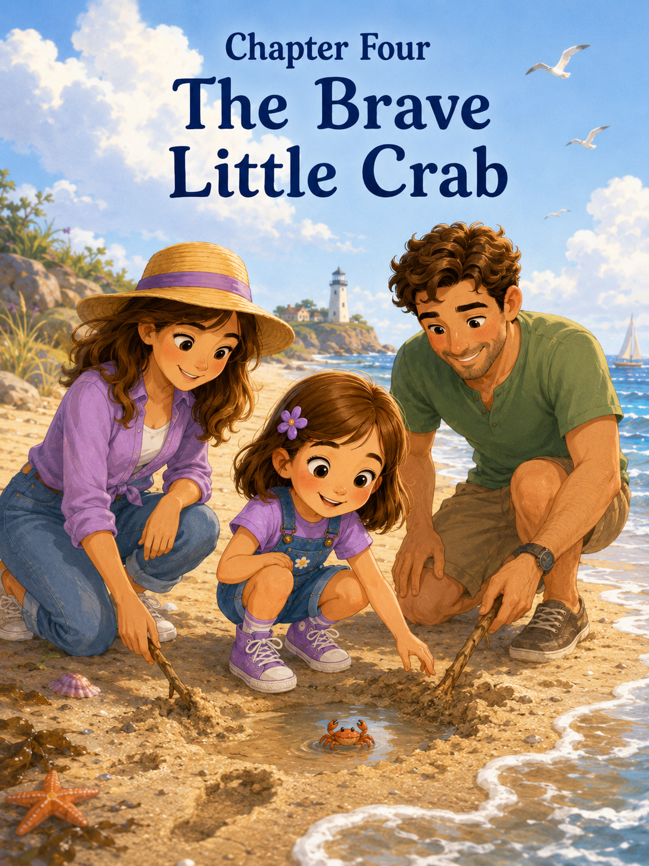Chapter Four: The Brave Little Crab
Later that day, on a walk down the beach, Sally noticed a crab because it moved sideways.
Most things on the beach moved forward or backward. Waves rolled forward and slipped backward. Children ran forward toward the water and backward when the foam chased their toes. Gulls hopped forward on their skinny legs before lifting into the air.
But this tiny creature moved sideways, like it had its own secret way of traveling through the world.
Sally was walking near the edge of the wet sand after finishing the great sandcastle with Emma, Benji, and the other children. Her purple bucket swung from one hand, and her blue-handled shovel dragged lightly behind her, leaving a long wiggly line in the sand.
Mom and Mark were nearby, folding towels and checking the beach bag. Sally could tell they were getting close to saying something like, “We should think about lunch soon,” which usually meant the adventure was about to be interrupted.
So, Sally decided to keep exploring while she still could.
She followed a trail of tiny bubbles near the waterline. The tide had pulled back a little more, leaving the sand shiny and smooth. Footprints dotted the beach—some large, some small, some deep, some already half-erased by the water.
That was when Sally saw it.
A shallow footprint near the edge of the wet sand had filled with seawater, making a tiny puddle no bigger than a cereal bowl. Inside it, a little crab was scrambling in circles.
Sally stopped so quickly that her shovel bumped into her heel.
The crab was pale brown, almost the color of the sand, with tiny legs that flickered quickly beneath its shell. It tried to climb up the side of the footprint, but the wet sand crumbled. It slid back down into the puddle and began circling again.
“Oh,” Sally whispered.
She crouched low.
The crab froze.
Sally froze, too.
For a moment, they stared at each other.
The crab lifted one tiny claw, as if it were saying, “This is my puddle, but I would very much like to leave.”
Sally’s heart gave a small squeeze.
“You’re stuck,” she said softly.
The crab moved sideways again, bumping against the sandy wall of the footprint.
Sally looked toward the ocean. The wet sand was only a few feet away. If the crab could get there, it might find its way back to where it belonged.
She reached for her shovel.
Then she stopped.
Mom had said not to pick up living things without an adult. Mark had said explorers watched, thought, and chose. And Sally had learned that the seashore belonged to small creatures too.
She wanted to help.
But she did not want to help the wrong way.
“Mom!” Sally called. “Mark! I found something!”
Mom looked up right away. “What is it?”
“A crab,” Sally said. “A tiny one. It’s stuck in a footprint.”
Mom and Mark came over carefully, stepping around the footprint so they would not cause the sides to collapse further.
Mark crouched beside Sally. “Well, look at that.”
Mom leaned closer but kept her hands to herself. “Good job calling us before touching it.”
Sally pointed. “It keeps trying to climb out, but the sand falls.”
The crab made another attempt, scrambling up the slope of the footprint. Again, the wall crumbled beneath it, and the crab slid back into the shallow water.
Sally frowned. “We have to save it.”
Mom nodded gently. “We can help, but we need to be careful.”
“Can I pick it up?” Sally asked.
“Let’s not pick it up unless we absolutely need to,” Mom said. “Small creatures can be frightened or hurt easily. Sometimes the best help is making the path safer and letting them move on their own.”
Sally looked at the crab. “So, we help without grabbing?”
“Exactly,” Mom said.
Mark picked up a small flat shell from the sand. “Maybe we can gently make one side of the footprint lower, like a ramp.”
Sally liked that idea immediately. “A crab ramp.”
“A very official crab ramp,” Mark said.
Sally set down her bucket and shovel. She leaned closer, but Mom placed a hand lightly on her shoulder.
“Slow movements,” Mom reminded her. “We don’t want to scare it more.”
Sally took a breath.
Slow movements.
Careful hands.
Respect the crab.
The crab shifted sideways in the puddle, its little legs moving like flickering eyelashes.
Sally studied the footprint. One side was closest to the ocean. If they smoothed that side down, the crab would have a path toward the wet sand.
“There,” she said, pointing. “That side leads to the water.”
Mark nodded. “Good observation.”
Mom smiled. “Explorer thinking.”
Sally felt proud, but she stayed focused. This was not a pretend rescue. This was a real one, and the crab was very small.
Mark used the flat shell to gently scrape a little sand from the side of the footprint. Mom showed Sally how to move slowly, taking only a tiny bit at a time so the whole edge would not collapse.
Then Sally took her turn.
She held the shell carefully and scraped the sand with light, gentle strokes. The wall became lower. Then smoother. Then more like a tiny ramp.
The crab moved away from her hand.
“It’s scared,” Sally whispered.
“It might be,” Mom said. “That’s why we give it space.”
Sally sat back on her heels.
For a few seconds, nothing happened.
The crab stayed very still in the puddle.
Sally wanted to rush it. She wanted to say, “Go on, little crab!” and wave her hand to guide it. But Mom shook her head slightly, and Sally remembered.
Gentle.
Careful.
Respectful.
So, she waited.
The ocean rolled in and out a few feet away.
Whoooosh.
Fizz.
A gull called overhead.
The crab lifted one tiny claw again. Then it moved sideways. Slowly at first, then faster. It reached the bottom of the sandy ramp and paused.
Sally held her breath.
The crab scrambled up.
This time, the sand did not collapse.
“It’s working,” Sally whispered.
The crab reached the top of the footprint and stood on the flat, wet sand.
Sally almost clapped, but Mom touched her arm gently.
“Quiet celebration,” Mom whispered.
Sally pressed both hands to her mouth and smiled behind them.
The crab moved sideways toward the ocean, leaving tiny, dotted marks in the sand. It stopped once, as if deciding which way to go, then scurried toward the darker wet sand near the waterline.
A small wave slid up the beach and stopped just short of it.
The crab kept moving.
The next wave reached farther. Water curled around the crab’s legs, and the little creature seemed to vanish for a second in the foam.
When the water slipped back, the crab was gone.
Sally stared at the spot.
“Did it make it?” she asked.
Mark nodded. “Looks like it.”
Mom smiled. “You helped it get back to where it needed to go.”
Sally looked down at the footprint puddle. It was just a footprint now, with one side carefully smoothed into a tiny path.
A few minutes earlier, it had been a trap.
Now it was a rescue site.
Sally picked up her notebook from her backpack and sat cross-legged in the sand. Her hand moved quickly across the page.
Discovery #11: The Brave Little Crab
Found trapped in a footprint puddle. Very tiny. Very sideways. Did not pick it up. Made a safe ramp with Mom and Mark. The crab escaped to the wet sand. Quiet celebration required.
She paused, thinking about the crab’s tiny claw lifted in the air.
Then she added:
Kindness does not always mean touching or taking over. Sometimes it means making a safe path and giving a small creature room to go.
Mom read over her shoulder. “That is a very wise discovery.”
Sally looked up at her. “I wanted to pick it up at first.”
“I know,” Mom said. “Wanting to help is good. Learning how to help gently is even better.”
Mark sat beside them in the sand. “That crab was lucky you noticed it.”
Sally looked toward the waterline. “It was brave.”
“It was,” Mark said.
“It kept trying,” Sally said. “Even when it slid back down.”
Mom nodded. “That is a kind of courage.”
Sally liked that. She wrote one more line.
The crab was small, but it was still brave.
A breeze lifted the corner of the page. Sally pressed it down with her fingers.
She thought about the ocean and how big it had seemed on the first day. She thought about the shell from Pearlwater and the sandcastle team. She thought about how many tiny worlds were hidden on the beach if you paid attention.
A crab in a footprint.
A shell with a story.
A castle is made better by many hands.
The seashore was not just big and beautiful.
It was full of small things that mattered.
Sally stood and brushed sand from her knees.
“Can we check for more footprint traps?” she asked.
Mom looked down at the beach. “For a little while. But we have to be careful not to disturb animals that are already safe.”
Sally nodded. “We only help if help is needed.”
Mark stood too. “That sounds like a good rule.”
Sally opened her notebook again and wrote:
Seashore Rule #3: Only help when help is needed and always be gentle.
Then the three of them walked slowly along the wet sand, looking carefully at footprints and puddles. Most were empty. A few held bits of seaweed. One had a tiny shell at the bottom that Sally left there because it looked like it belonged.
After a few minutes, Emma from the sandcastle team ran over.
“What are you doing?” Emma asked.
“Checking for trapped crabs,” Sally said.
Emma’s eyes widened. “Did you find one?”
“Yes,” Sally said. “We made a ramp.”
“A ramp?”
Sally pointed proudly toward the footprint behind them. “A crab ramp.”
Emma looked impressed. “Can I help?”
Sally was about to say yes right away, but then she remembered Mom’s words.
Only help when help is needed.
“First, you have to learn the rules,” Sally said.
Emma stood up straight. “Okay.”
Sally counted on her fingers.
“One: Don’t pick up crabs.”
Emma nodded.
“Two: Move slowly.”
Emma nodded again.
“Three: Ask a grown-up.”
Mom smiled.
“Four: Give small creatures space.”
Emma nodded very seriously. “Space.”
Together, Sally and Emma checked three more footprint puddles. They found no trapped crabs, but they did find a sand flea that hopped away so quickly that Emma squealed and Sally laughed.
“That one did not need rescuing,” Sally said.
“It rescued itself,” Emma said.
“Very fast,” Sally added.
Soon, Mom reminded Sally that it was time for lunch. Sally wanted to keep searching, but her stomach growled, making it difficult to argue.
Back at the umbrella, Mark handed her a sandwich wrapped in a napkin.
“For the crab rescuer,” he said.
Sally accepted it proudly. “I am also a crab ramp engineer.”
“Of course,” Mark said. “My mistake.”
Mom handed her a bottle of water. “And a careful nature helper.”
Sally took a bite of her sandwich and looked out at the water. The waves rolled, curled, and sparkled under the sun. Somewhere out there, or maybe hidden beneath the wet sand, the brave little crab was continuing its sideways journey.
Sally wondered where it would go next.
Maybe to a crab village.
Maybe to a shell cave.
Maybe to tell other crabs about the giant girl who made a ramp instead of grabbing.
That made Sally smile.
“What are you thinking?” Mom asked.
Sally swallowed her bite. “I think the crab will tell a story about me.”
Mark grinned. “What kind of story?”
Sally looked toward the place where the crab had disappeared.
“A story about a giant who learned to be gentle.”
Mom’s smile softened. “That sounds like a very good story.”
Sally opened her notebook one more time and drew a tiny crab standing at the top of a sandy ramp. She gave it two little eyes and one raised claw. Underneath, she wrote:
Some adventures are loud, like waves. Some are quiet, like helping a little crab find its way home. Both kinds count.
She closed the notebook and placed it beside her backpack.
Then she looked down at her hands.
They were sandy.
They were strong.
They were curious hands.
Adventure hands.
But today, Sally had learned they could also be careful hands.
And that mattered just as much.

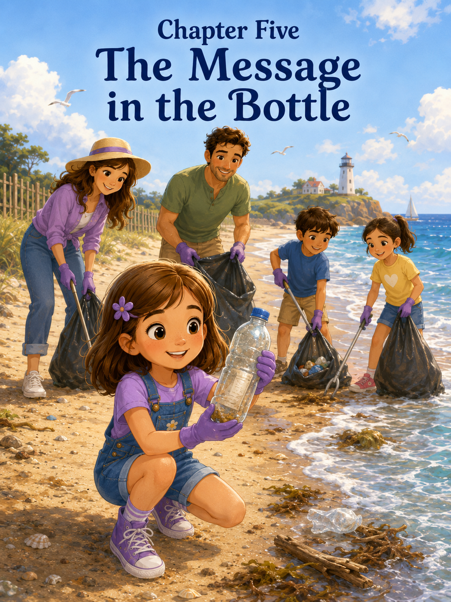Chapter Five: The Message in the Bottle
Sally saw the bottle washing ashore just after lunch.
She was sitting beneath the beach umbrella with Mom and Mark, finishing the last bite of her sandwich and watching the waves roll in. The seashore had already given her many things: an orange-and-white shell with a secret, a sandcastle team, and a brave little crab who had escaped from a footprint puddle by using a sandy ramp.
Sally had written all of it in her notebook.
Now she was ready for the next adventure.
The ocean seemed ready, too.
A wave curled and rushed up the beach, spreading white foam across the wet sand. When the water slipped back, something clear and crinkly rolled in the bubbles.
Sally sat up straight.
“What’s that?”
Mom looked over. “What do you see?”
Sally pointed. “A bottle.”
The bottle rolled once, bumped against a clump of seaweed, and stopped. It was a plastic bottle, cloudy from salt water, with its blue cap still screwed on tight. A bit of sand clung to one side.
Sally’s eyes widened.
“A message in a bottle,” she whispered.
Mark leaned forward. “A pirate message?”
“Maybe,” Sally said, already standing.
Mom reached for the sunscreen bottle. “Hat first.”
Sally sighed, grabbed her purple sunhat, and put it on quickly. “Pirates do not usually wait for hats.”
“Careful, pirates do,” Mom said.
Sally could not argue with that. She has learned a lot about careful adventures lately.
She walked toward the bottle with Mom and Mark beside her. Emma and Benji, who were still working near the sandcastle, noticed and hurried over too.
“What is it?” Emma asked.
“A message in a bottle,” Sally said.
Benji gasped. “Treasure map?”
“Maybe,” Sally said.
She crouched near the bottle but did not pick it up right away. After helping the little crab, she had learned that beach discoveries needed thinking first. Some things were treasures. Some things belonged to animals. Some things needed help from grown-ups.
“Can I touch it?” Sally asked.
Mom looked carefully. “It looks safe, but use two fingers and hold it away from your face. We’ll wash our hands after.”
Sally nodded. She picked up the bottle carefully and turned it over.
There was no rolled paper inside.
No pirate map.
No secret note.
No drawing of a skull island.
It was empty.
Sally frowned. “There’s no message.”
Mark knelt beside her. “Maybe the bottle itself is the message.”
Sally looked at him. “That does not sound very piratey.”
“No,” Mark said. “But it might be important.”
Mom pointed gently toward the ocean. “Plastic bottles do not belong in the sea. They can float for a long time. Animals may mistake them for food, or the plastic can break into smaller pieces that are dangerous.”
Emma looked worried. “A turtle could eat it?”
Mom nodded. “A turtle, a bird, a fish, or another sea animal might be hurt by it.”
Sally looked at the bottle again.
A few minutes earlier, it seemed exciting.
A mystery.
A pirate clue.
Now it looked different.
It looked like something that did not belong.
Sally imagined the brave little crab trying to climb around it. She imagined a sea turtle bumping into it. She imagined a bird pecking at the cap. She imagined waves carrying it farther and farther away until no one noticed it anymore.
Her fingers tightened around the bottle.
“That’s not fair,” she said.
Mark looked at her. “What isn’t?”
“The beach gives us shells and waves and crabs and sandcastles,” Sally said. “People should not give it trash.”
Mom’s face softened. “I agree.”
Benji pointed down the beach. “There’s another one.”
Everyone turned.
Near a patch of seaweed, a crumpled snack wrapper fluttered in the breeze.
Emma pointed the other way. “And a straw.”
Sally looked around more carefully. Now that she was noticing, she saw more than before. A bottle cap near a footprint. A piece of plastic near the dune grass. A napkin caught under a shell. Not a lot, but enough.
Enough to matter.
Sally stood up tall.
“This is a mission,” she declared.
Mark smiled slightly. “What kind of mission?”
Sally lifted the plastic bottle like evidence. “A beach rescue mission.”
Emma’s eyes brightened. “Like the crab rescue?”
“Bigger,” Sally said. “This time, we rescue the beach.”
Benji raised his red shovel. “I help!”
Mom held up one hand. “A beach cleanup is a wonderful idea, but we need rules.”
Sally nodded. “Of course.”
She opened her notebook and turned to a fresh page.
At the top, she wrote:
Beach Rescue Mission Rules
Mom spoke first. “Rule one: ask an adult before picking anything up.”
Sally wrote:
1. Ask an adult before picking anything up.
Mark added, “Rule two: do not touch sharp, rusty, sticky, or strange-looking items. An adult handles those.”
Sally wrote:
2. Do not touch sharp, rusty, sticky, or strange things. Get an adult.
Mom said, “Rule three: use a bag or bucket for safe litter. Wash hands afterward.”
Sally wrote that down.
Emma raised her hand. “Rule four: do not pick up shells with animals in them.”
“Good rule,” Sally said, writing it carefully.
Benji raised his shovel. “Rule five: no eating trash.”
Everyone looked at him.
Mom pressed her lips together, trying not to laugh. “That is definitely a rule.”
Sally wrote:
5. Do not eat trash. Very important.
Mark went to the beach bag and returned with a small trash bag and an extra bucket. Mom had a few napkins they could use to pick up safe items without touching them directly.
“This is not a huge cleanup,” Mom said. “Just a small area near our spot. We stay where we can see each other.”
Sally nodded. “Every big rescue starts small.”
Mark smiled. “That sounds like something worth writing down.”
Sally added it beneath the rules:
Every big rescue starts small.
Then the mission began.
Sally placed the empty plastic bottle into the trash bag first.
“One bottle removed from the ocean’s path,” she said.
Emma picked up the straw with a napkin after Mom said it was safe. “One straw removed.”
Benji found the bottle cap and dropped it into the bucket. “Tiny trash!”
Sally wrote tally marks in her notebook.
Bottle: 1
Straw: 1
Bottle cap: 1
They moved slowly along their section of the beach. Sally treated the cleanup like an expedition. The wet sand became the shoreline of a kingdom. The trash bag became the Hero Sack. The bucket became the Treasure Tub, except the treasure was really things that needed to leave the beach.
Mark found a plastic wrapper half-buried in the sand and carefully removed it.
“Wrapper,” he said.
Sally added another tally mark.
Mom spotted a piece of fishing line near some seaweed. She told the children to stand back while she picked it up.
“This is exactly why adults help,” Mom said. “Fishing line can tangle around birds, turtles, crabs, and fish.”
Sally looked at the thin line in Mom’s hand. It seemed so small. Almost harmless.
But then she remembered the crab in the footprint. Small things could matter. Small dangers could matter too.
She wrote:
Fishing line removed by Mom. Dangerous for animals. Important rescue.
Emma looked at the ocean. “Do animals know we’re helping?”
Sally thought about the little crab disappearing into the foam.
“Maybe not,” she said. “But they are safer anyway.”
Mark nodded. “That is a good reason to help.”
Benji ran toward a shiny object near the water, but Sally stopped him.
“Wait,” she said. “Mission rule.”
Benji froze with one foot in the air.
Mom came over and checked the object. It was only a clean piece of foil from a snack wrapper, but Sally felt proud that Benji had stopped.
“Good remembering,” she told him.
Benji grinned. “I am a beach hero.”
Sally looked at him carefully. He had sand on his cheeks, one shoelace untied, and his red shovel tucked under his arm like a sword.
“Yes,” she said. “You are.”
The cleanup continued.
A napkin.
Two more bottle caps.
A bit of blue plastic.
One snack wrapper.
A broken piece of a sand toy.
The trash bag grew heavier, but only a little. Their section of the beach began to look cleaner. Not perfect because the beaches were large, the wind was tricky, and people were not always careful. But better.
Sally liked it better.
Better counted.
A man walking by slowed down and smiled. “Doing a beach cleanup?”
Sally stood straighter. “Yes. We are rescuing the seashore.”
“That’s good work,” the man said.
Emma beamed.
Benji waved his shovel.
Mark gently tied the top of the trash bag. “I think this is enough for today.”
Sally looked around. “But there might be more.”
“There probably is,” Mom said. “But part of helping is knowing what you can do safely right now.”
Sally did not love stopping before everything was finished. Her strong-willed part wanted to clean the whole beach. All of it. Every wrapper, every bottle, every tiny piece of plastic.
But the sun was high, and Benji was getting tired, and the trash bag needed to go to the proper bin.
Sally took a breath.
“Okay,” she said. “We finish this mission by throwing it away.”
They carried the bag to the beach trash bin near the walkway. Mark held the bag, but Sally helped guide it. Together, they dropped it in.
Thump.
Sally smiled.
“That was the sound of a successful mission,” Mark said.
Emma clapped. Benji clapped too, though he was mostly clapping for the noise.
Back at the umbrella, Mom gave everyone hand wipes, then made sure they washed properly at the nearby rinse station. Sally scrubbed her hands carefully. A real beach hero, she decided, had clean hands after handling trash.
When they returned to base camp, Sally opened her notebook again.
She wrote:
Discovery #12: The Message in the Bottle
Found a plastic bottle washed up by the waves. Thought it might have a pirate message. It was empty, but Mark said maybe the bottle itself was the message. The message was: Help the beach.
She paused and looked out at the ocean.
The waves kept rolling.
Whoooosh.
Crash.
Fizz.
They looked the same as before, but Sally did not feel the same. She had come to the beach expecting the ocean to give her things: shells, stories, waves, mysteries, and adventures.
Today, she realized she could give something back.
She continued writing:
Started a small beach cleanup with Mom, Mark, Emma, and Benji. Removed plastic, wrappers, bottle caps, and fishing line. We did not clean the whole beach, but we made one part safer. That counts.
Emma sat beside her. “Can you write that I found the straw?”
Sally added:
Emma found the straw. Excellent beach helper.
Benji leaned over. “And tiny trash.”
Sally wrote:
Benji found tiny trash. Very heroic.
Benji looked satisfied and went to dig near the sandcastle.
Mom sat on the towel beside Sally. “How do you feel?”
Sally thought about it.
“Like a hero,” she said.
Mark smiled. “You should.”
“But not the cape kind,” Sally said.
“What kind?”
Sally looked at the trash bin near the walkway. Then she looked at the ocean, the sandcastle, the place where the crab had escaped, and the waves that kept bringing surprises to shore.
“The kind with a trash bag,” she said.
Mom laughed softly. “That is a very useful kind of hero.”
Sally wrote one more line in her notebook:
Real heroes do not always wear capes. Sometimes they carry trash bags and care about the world around them.
She underlined it twice.
Later that afternoon, Sally walked down to the water’s edge again. The tide had shifted. The sand was smooth in some places and bumpy in others. The ocean continued its secret exchange, taking footprints and leaving foam.
Sally searched for another bottle.
She did not see one.
Good, she thought.
Instead, she found a tiny white shell shaped like a fan. She picked it up, looked at it, then placed it back on the wet sand.
“Some magic stays here,” she whispered.
A wave came in and gently moved the shell a few inches.
Sally smiled.
The beach did not belong to her.
It did not belong to anyone.
It belonged to the crabs, the shells, the gulls, the fish, the turtles, the waves, and the children building castles in the sand. It belonged to everyone who cared for it.
Sally turned and ran back toward the umbrella, her purple flower clip bouncing in the sea breeze.
Behind her, the ocean rolled on—wide, wild, and beautiful. And thanks to one small rescue mission, it was a little cleaner than before.

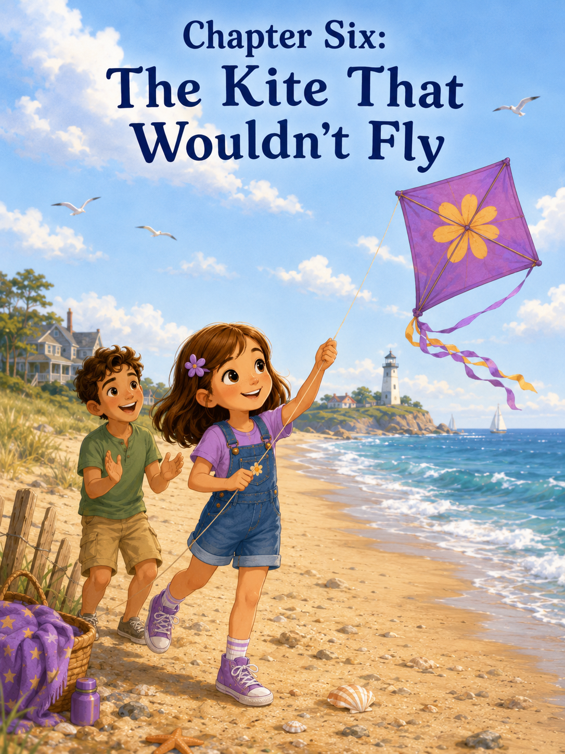Chapter Six: The Kite That Wouldn’t Fly
Sally brought the kite because she was certain the beach was the perfect place to fly it.
At home, the kite had never flown properly. It had bumped along the grass, tangled in a bush, and once made it halfway into the air before diving straight into Mom’s flower bed. But the beach was different. The beach had wind. Big wind. Real wind. Ocean wind that tugged at hats, lifted towels, and made umbrella edges flap like sails.
If a kite could not fly at the seashore, Sally decided, then maybe it was not really trying.
The kite was bright purple with silver stars across the top and a long ribbon tail that shimmered when the sun touched it. Sally carried it carefully under one arm as she walked across the sand with Mom and Mark. Her notebook was tucked in her backpack, and her blue-handled shovel bounced against her purple bucket.
Mark looked at the kite. “That looks like serious flying equipment.”
“It is,” Sally said. “This kite has been waiting for the right mission.”
Mom smiled. “And today is the mission?”
Sally looked at the waves, the open sky, and the breeze pushing her hair away from her face. “Definitely.”
Emma was already near the sandcastle area, drawing lines in the sand with a stick. When she saw the kite, she ran over with her orange ribbons bouncing.
“Is that yours?” Emma asked.
Sally held it up proudly. “Yes. It’s a sky explorer.”
Emma’s eyes widened. “Can I watch it fly?”
Sally stood a little taller. “Of course.”
Benji came over too, carrying his red shovel. “Does it go super high?”
“It will,” Sally said. “Maybe higher than the gulls.”
Mark raised an eyebrow. “Higher than the gulls?”
Sally nodded. “Almost.”
Mom handed Sally the spool of string. “Let’s start away from other people, umbrellas, and beach chairs.”
“Safety zone,” Mark said.
Sally pointed toward a wide-open stretch of sand. “There.”
They walked to a clear space where the beach opened wide, and the wind blew steadily from the water. The ocean rolled behind them, and gulls drifted overhead as if they had come to judge the flight.
Sally planted her feet in the sand.
“Ready?” she asked.
Emma nodded.
Benji lifted his shovel. “Blastoff!”
“This is not a rocket,” Sally said.
Benji lowered his shovel. “Kite-off.”
Sally liked that better.
Mark held the kite up while Sally backed away with the string. The purple fabric fluttered and snapped in the breeze.
“Wait for the pull,” Mark said. “When the wind catches it, walk backward slowly and let out a little string.”
“I know,” Sally said.
She did not mean for it to sound sharp, but it did. Sally was excited, and when she was excited, she sometimes wanted to do things herself before anyone finished explaining.
Mark did not seem upset. “Okay, Captain Kite.”
Sally smiled a little.
The wind tugged.
“Now!” Mark called.
He released the kite.
For one wonderful second, the purple kite rose into the air. Its silver stars flashed. Its ribbon tail danced.
Sally’s heart leaped.
Then the kite wobbled, tilted sideways, and nose-dived straight into the sand.
Whump.
Benji stared. “It crashed.”
Sally frowned. “I noticed.”
Emma hurried forward. “Maybe it needs another try.”
Sally picked up the kite and shook sand from its edge. “It will work this time.”
They tried again.
Mark held it up.
Sally backed away.
The wind tugged.
Mark released.
The kite lifted, dipped, twisted, and fell flat on its side.
Whump.
Sally pressed her lips together.
“Again,” she said.
They tried a third time.
This time Sally ran.
She ran hard, her sneakers kicking up sand behind her. The kite bounced once, lifted slightly, and dragged along the beach like a tired purple pancake.
Sally stopped.
The kite flopped over.
Benji tilted his head. “It is not good in the sky.”
Sally turned to him. “It is a kite. Kites are supposed to be good in the sky.”
Mom stepped closer. “Sometimes the wind has to be just right.”
“The wind is right,” Sally said. “Look at it.”
She pointed to the umbrella flapping behind them. She pointed to the waves, the blowing hair, the gulls floating above the shoreline.
“There is wind everywhere.”
Mark nodded. “There is wind, but it changes. Sometimes it gusts. Sometimes it drops. A kite needs a steady breeze, and we must work with it, not fight it.”
Sally looked at the kite lying in the sand.
She did not want to work with the wind.
She wanted the kite to fly.
Now.
She picked it up again and brushed it off harder than necessary. Sand sprayed from the ribbon tail.
“I can do it,” she said.
No one argued.
That made her feel a little worse.
For the next fifteen minutes, Sally tried everything.
She ran fast.
She ran slowly.
She held the string higher.
She held the string lower.
She told the kite, “Fly, please.”
Then she told it, “Fly right now.”
Then she said, “You are being very difficult.”
The kite did not seem sorry.
It crashed near a shell pile.
It crashed beside Mark’s sandals.
It crashed so close to Benji that he jumped backward and shouted, “Incoming purple!”
Finally, the kite spun in a half circle and landed upside down in the sand.
Sally stood still, breathing hard.
Her cheeks felt hot.
Her hands were tired from gripping the spool. Her legs were tired from running. Her patience was tiring too.
“I quit,” she said.
Mom’s face softened. “Sally—”
“No,” Sally said, sitting down hard in the sand. “It won’t fly. I tried everything. It’s impossible.”
Emma sat beside her carefully. “Maybe not impossible.”
Sally looked away. “You didn’t have to run with it.”
“No,” Emma said. “But I watched.”
Sally did not answer.
Mark picked up the kite and sat on the other side of her. “It can be frustrating when something doesn’t work after you try hard.”
Sally crossed her arms. “I don’t like being frustrated.”
“I know,” Mom said, sitting in front of her. “But frustration is part of learning.”
“I already learned that the kite falls,” Sally said.
Benji sat nearby and poked in the sand with his shovel. “It falls a lot.”
Emma gave him a look.
Benji added, “But maybe it can learn too.”
Sally looked at him despite herself. “Kites don’t learn.”
“Maybe kite flyers do,” Mark said gently.
Sally stared at the purple kite. Its silver stars are sandy now. Its ribbon tail lay in a twist. It looked less like a sky explorer and more like a tired beach towel.
Mom reached for the string and untangled a knot near the handle. “Trying again does not always mean doing the same thing again. Sometimes it means stopping, watching, and learning what needs to change.”
Sally did not want to admit that it sounded true.
So, she stayed quiet.
Mark pointed toward a boy farther down the beach flying a blue kite. It rose smoothly, dipped slightly, then climbed again. The boy was not running wildly. He was standing still, stepping backward only when the kite pulled.
“Look at him,” Mark said. “He’s waiting for the breeze before letting out more string.”
Sally watched.
The blue kite pulled upward. The boy let the string slide. Then he held steady.
“He isn’t chasing the wind,” Mom said. “He’s feeling it.”
Sally looked at the spool in her hand.
Feeling the wind sounded much harder than running.
Emma stood. “Maybe I can help hold the tail straight before it lifts.”
Sally looked up. “You want to help?”
Emma nodded. “If you want.”
Sally almost said she could do it herself.
That was the sentence sitting right on her tongue.
But then she remembered the sandcastle team. The castle had been better because everyone had a part. She remembered the beach cleanup. The mission had worked because everyone helped. She remembered the brave little crab and the sandy ramp. Sometimes helping did not mean taking over. Sometimes it meant making the path easier.
Maybe a kite needed a team too.
Sally took a breath.
“Okay,” she said. “But gently. The tail gets tangled.”
Emma smiled. “Gently.”
Mark stood and held the kite up again. Mom helped Sally unwind the string and smooth out the line. Emma held the ribbon tail, so it did not twist. Benji was given the important job of standing behind everyone and announcing if the kite looked like it was attacking.
“I am the crash watcher,” he said proudly.
Sally stood with the spool in both hands.
This time, she did not run right away.
She waited.
The wind pushed against her face, then softened. The kite fluttered in Mark’s hands. Sally watched the ribbon tail.
Nothing yet.
Then the breeze strengthened.
The kite tugged.
Sally felt it through the string—a gentle pull, then a stronger one.
“Now,” Mark said quietly.
He let go.
Emma released the tail.
Sally stepped backward slowly.
The kite rose.
Not high. Not yet.
But it rose.
Sally held her breath.
The purple kite wobbled, and for a terrifying second, it looked as if it might dive again.
“Steady,” Mom said.
Sally kept her hands firm but not tight.
The kite caught another breeze and lifted higher.
Benji shouted, “It is doing sky!”
Sally laughed.
“It is!”
The kite climbed above their heads. Its silver stars flashed in the sunlight. The ribbon tail streamed behind it, no longer tangled, no longer dragging through the sand. It dipped once, then pulled upward again.
Sally let out a little more string.
“Not too fast,” Mark reminded her.
“I know,” Sally said, but this time her voice was softer.
She knew now.
A little.
The kite rose higher.
Emma clapped. “Sally, look!”
Sally was looking.
She could not stop looking.
The kite that had crashed, flopped, and dragged itself through the sand was now flying above the beach, as it had always belonged in the sky.
The gulls circled nearby, but the purple kite held its place, bright and brave against the blue.
Sally felt something loosen inside her.
Not just happiness.
Relief.
Pride.
And a little bit of surprise.
She had almost quit before the best part happened.
The wind tugged again, and Sally adjusted the string carefully.
“I’m doing it,” she whispered.
Mom smiled. “You are.”
Emma stood beside her. “We are.”
Sally looked at her.
Emma was right.
Sally was holding the string, but Mark had held the kite. Mom had helped untangle the line, Emma had straightened the tail, and Benji had watched for crashes.
The kite was flying because Sally had tried again.
But also, because she had accepted help.
The purple kite danced higher.
For several minutes, they stood together watching it fly. Sally learned how to feel the pull of the string. When the kite dipped, she stepped backward. When it tugged upward, she let out a little more line. When the wind grew too strong, Mark helped her hold steady.
It was not as easy as Sally had imagined.
It was better.
Because now she understood it.
After a while, Sally carefully handed the spool to Emma.
Emma’s eyes widened. “Me?”
“You can try,” Sally said. “Hold tight, but don’t pull too hard.”
Emma took the spool with both hands. Sally stood beside her, ready to help.
The kite dipped.
Emma gasped.
“Step back,” Sally said.
Emma stepped back, and the kite lifted again.
“I did it!” Emma cried.
Sally grinned. “You did.”
Then Benji wanted a turn, so Mark helped him hold the spool while Sally gave very important instructions.
“Do not run into the ocean. Do not let go. Do not wrap the string around your arm. And do not yell at the kite unless it is an emergency.”
Benji nodded. “What is a kite emergency?”
Sally thought about it. “If it turns into a dragon.”
Benji looked up at the purple kite. “It might.”
“It probably won’t,” Sally said. “But stay alert.”
By the time the kite finally came down, Sally did not feel angry at it anymore. She helped Mark guide it gently onto the sand, where it landed softly rather than crashing. Emma collected the tail. Benji patted the kite as if it were a tired pet.
“Good sky,” he told it.
Sally laughed. “Yes. Very good sky.”
Back at the umbrella, Sally opened her notebook. The page was a little wrinkled from the damp air, but she smoothed it with her palm.
She wrote:
Discovery #13: The Kite That Wouldn’t Fly
Brought my purple kite to the beach. It crashed many times. I got frustrated and almost quit. Mom said trying again sometimes means stopping, watching, and learning what needs to change. Mark helped hold the kite. Emma helped with the tail. Benji watched for crashes. I waited for the right breeze, and then it fly.
She paused.
The ocean rolled in the background.
Whoooosh.
Crash.
Fizz.
The kite rested beside her; its purple fabric still sprinkled with sand.
Sally added:
Courage does not always mean getting it right the first time. Sometimes courage means trying again after you feel like giving up.
Mom read it and smiled. “That is a very strong discovery.”
Sally looked at the kite.
“I was mad at it,” she admitted.
Mark sat beside her. “That happens.”
“I thought if I ran faster, it would fly.”
“Sometimes running faster is not the answer,” Mark said.
Sally nodded. “Sometimes waiting is.”
Emma came over and sat near Sally’s towel. “Can we fly it again tomorrow?”
Sally looked at the kite, then at the sky.
The breeze was still there, moving gently across the beach.
“Yes,” she said. “But we’ll wait for the right wind.”
Benji flopped down in the sand nearby. “And I will watch for dragon emergencies.”
“Good,” Sally said. “Every kite team needs one.”
Later, as the afternoon sun turned the water silver, Sally carried the kite back toward the car. The ribbon tail trailed behind her, no longer tangled, no longer defeated.
She thought about how she had wanted the kite to fly simply because she told it to.
But the wind did not work that way.
Neither did courage.
You could not boss courage into appearing. You could not always run fast enough to make something work. Sometimes you had to stop, breathe, listen, accept help, and try again.
Sally looked back at the wide beach.
The seashore had taught her about waves, shells, teamwork, crabs, cleanup missions, and now wind.
It was becoming the best kind of classroom.
The kind without walls.
The kind of questions.
The kind where mistakes could turn into discoveries.
Sally held the kite close and smiled.
Tomorrow, it might fly even higher.
But today, it had flown high enough.

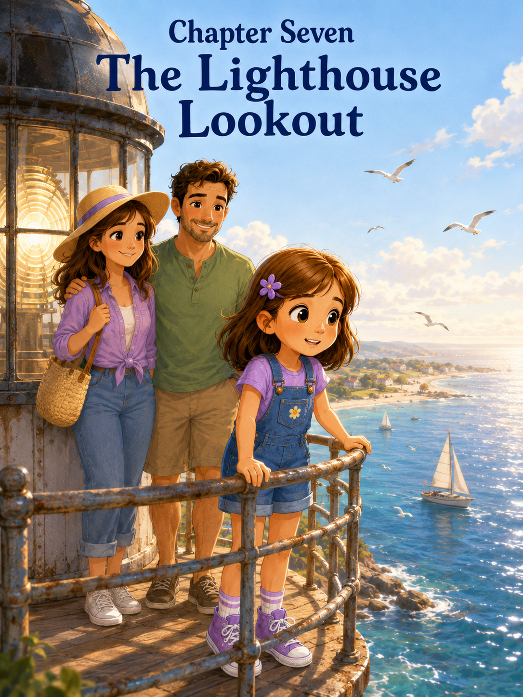Chapter Seven: The Lighthouse Lookout
Later that afternoon, Sally saw the lighthouse before she knew they were going there.
It stood at the far end of the beach, tall and white against the blue sky, with a red roof and a glass room at the very top. From where Sally sat under the umbrella, it looked almost like a giant watching over the ocean.
She had noticed it in the morning, of course.
Sally noticed everything.
She had noticed the way the lighthouse caught the sunlight. She had noticed the seagulls that circled above it. She had noticed the small path that curved through the dunes toward its front door. She had noticed people walking in and out, some pointing up at the top, some taking pictures, and some coming back down with windblown hair and excited faces.
But she had not known they were allowed to climb it.
Until Mark said, “How would you feel about visiting the lighthouse today?”
Sally looked up from her notebook so quickly that her purple flower clip slipped sideways in her hair.
“Inside it?”
Mom smiled. “Inside it.”
“To the top?”
“If it’s open and safe,” Mom said.
Sally closed her notebook at once. “Then yes.”
Mark laughed. “That was a very fast decision.”
“I am an adventurer,” Sally said, standing up and brushing sand from her knees. “Adventurers do not ignore lighthouses.”
Mom adjusted Sally’s flower clip. “Adventurers also wear sunscreen.”
Sally sighed. “Adventurers hear that a lot.”
A few minutes later, they packed a small bag with water bottles, Sally’s notebook, and the little fan-shaped shell she had found that morning. Sally wore her purple backpack and walked between Mom and Mark along the sandy path.
The lighthouse seemed to grow taller with every step.
From the beach, it looked friendly.
From the path, it looked enormous.
Its white walls rose high above them, smooth and bright. Small windows curved around its side, and the top seemed very far away. Sally tilted her head back until she almost lost her balance.
Mark put a steady hand near her shoulder. “Big, isn’t it?”
Sally nodded slowly. “Bigger close up.”
Mom looked down at her. “Still want to go in?”
Sally looked at the open doorway.
Inside, she could see the beginning of a spiral staircase.
It curved upward and disappeared.
Sally’s stomach gave a tiny flutter.
Not because she did not want to go.
She did.
But the staircase looked narrow. And tall. And twisty. It was not like the treehouse ladder, or the playground steps, or the dunes she had climbed on the way to the beach.
This was different.
This was a lighthouse.
Sally lifted her chin. “Yes,” she said. “I still want to.”
Inside, the lighthouse smelled like old wood, cool stone, and salty air. The walls were thick, and their footsteps sounded different, as if the building were quietly repeating them.
Tap.
Tap.
Tap.
A kind guide near the entrance smiled at them and explained the rules.
“Hold the railing. Walk slowly. Stay with your group. If you need to stop, move to the side and let others pass. No running. No leaning over the railing at the top.”
Sally listened carefully.
Mom looked at her. “Sound familiar?”
Sally smiled a little. “Safety rules.”
“Every good adventure has them,” Mark said.
Sally opened her notebook and quickly wrote:
Lighthouse Rule #1: Hold the railing.
Lighthouse Rule #2: One step at a time.
Lighthouse Rule #3: No rushing, even if the view is waiting.
Mark looked over her shoulder. “That third one is excellent.”
Sally tucked the notebook back into her backpack.
Then they began to climb.
At first, the steps were exciting.
They curved around and around the inside wall, each one lifting Sally higher. She kept one hand on the railing and counted in her head.
One.
Two.
Three.
Four.
A small window appeared in the wall. Sally stopped and peeked through it.
The beach looked different already. The umbrellas seemed smaller, like bright buttons scattered across the sand.
“Look,” Sally said. “Our umbrella is tiny.”
Mom leaned near the window. “It is.”
Mark looked too. “Base camp spotted from above.”
Sally smiled and kept climbing.
The staircase continued.
Around.
And around.
And around.
After a while, the exciting part began to feel harder. Sally’s legs grew tired. The air felt warmer. The railing felt smooth beneath her hand from all the people who had held it before her.
She looked up.
There were still more stairs.
Many more.
“How much farther?” she asked.
Mark glanced upward. “A little more.”
Sally did not like “a little more.” Grown-ups used it for all sorts of distances. Sometimes it meant five steps. Sometimes it meant twenty minutes.
Mom stopped beside her. “Do you need a break?”
Sally almost said no.
She was strong-willed. She did not like needing breaks. She especially did not like having to take breaks while other people were still climbing.
But her legs were tired, and her stomach had that fluttery feeling again.
Sally stepped carefully to the side of the landing near another small window.
“Maybe a short break,” she said.
Mom smiled gently. “Good choice.”
Mark handed her the water bottle. “Explorers take water breaks.”
Sally took a sip.
Through the window, she could see the ocean now. Not just the edge of it, but a wide piece of blue stretching out past the sand. A boat moved across the water, leaving a white trail behind it.
“It looks like a toy boat,” Sally said.
“Everything looks smaller from high up,” Mark said.
Sally looked down through the center of the spiral staircase.
That was a mistake.
The stairs curled below her like a shell, twisting lower and lower until they disappeared. For a second, Sally felt as if the whole lighthouse had grown taller while she was standing inside it.
She grabbed the railing tighter.
Mom noticed right away.
“You okay?”
Sally looked back at the wall. “I shouldn’t have looked down.”
Mark nodded. “That can make people feel wobbly.”
“I am not wobbly,” Sally said quickly.
Then she paused.
Her knees did feel a little wobbly.
“Maybe slightly wobbly,” she admitted.
Mom placed a gentle hand on her back. “We can go back down if you want.”
Sally stared at the steps above her.
Part of her wanted to say yes.
Going down would be easier. She could tell herself she had climbed part of a lighthouse. She could still write about it. She could still call it an adventure.
But another part of her—the curious part—wanted to see the top.
What did the beach look like from there?
How many boats could she count?
Could she see where the ocean touched the sky?
Could she see birds flying below her instead of above her?
The top mattered.
Sally took a slow breath.
“I want to keep going,” she said.
Mom studied her face. “Are you sure?”
Sally nodded. “I’m nervous, but I want to.”
Mark smiled softly. “That is a very honest kind of brave.”
Sally liked that.
An honest, kind of brave.
She put one hand firmly on the railing and faced the stairs again.
“One step at a time,” Mom said.
“One step at a time,” Sally repeated.
They climbed again.
This time, Sally did not look up too far or down too far. She looked at the step in front of her. Then the next one. Then the next.
She counted softly under her breath.
“One step. One step. One step.”
Mom stayed just behind her. Mark walked below them, close enough to help if needed.
Sally’s legs were still tired. Her stomach still fluttered now and then. But the steps kept passing beneath her feet.
One step.
Then another.
Then another.
At the next window, she stopped again.
This time, she did not look down the staircase. She looked out.
The beach had opened wider. She could see people walking along the shore, but they looked tiny, like little moving dots. She saw waves rolling in long white lines. She saw gulls gliding in the wind. She saw the sandcastle area, though the castle itself was too small to recognize.
“I can see so much,” Sally whispered.
Mom smiled. “And you are not even at the top yet.”
Sally felt the flutter in her stomach change.
It was still there.
But now it had excitement mixed into it.
They climbed the last stretch carefully. The stairs grew narrower near the top, and the light grew brighter. Sally could hear wind beyond the walls.
Then, suddenly, there were no more stairs.
They stepped into the lighthouse lookout.
Glass windows wrapped around the top, and the whole ocean seemed to spread out before them.
Sally forgot to be nervous.
For one bright moment, she only stared.
The beach stretched in both directions, curving gently along the shore. Umbrellas dotted the sand like colorful seashells. People walked beside the water, leaving footprints that looked like tiny stitches. Boats moved across the blue water, some close, some far away. Birds flew past the lighthouse windows, their wings catching the sun.
And the waves—
The waves were magnificent.
From the sand, the waves looked tall and loud and close. From the lighthouse, they looked like silver ribbons rolling toward shore one after another, never stopping, always beginning again.
Sally pressed her hands lightly against the safe inside railing.
“Wow,” she whispered.
Mark stood beside her. “Worth the climb?”
Sally nodded, still looking out. “Very worth it.”
Mom smiled. “You did it.”
Sally turned slowly, taking in every direction. She could see the dunes, the parking lot, the boardwalk, the beach, the boats, the sky, and the horizon.
The horizon amazed her most.
It was the place where the ocean and sky seemed to meet, though Sally knew they did not really touch. It looked like a secret line drawn across the world.
She pulled out her notebook and began writing quickly.
Discovery #14: The Lighthouse Lookout
The beach looks different from high up. People look tiny. Boats look like toys. Waves look like ribbons. Birds fly almost beside you. The ocean goes so far that it looks like it meets the sky.
She paused and glanced at the stairs they had just climbed.
Then she added:
The lighthouse felt tall and scary in the middle. I wanted to keep going, but I was nervous. I did not run. I did not pretend I was not scared. I climbed one step at a time.
Mom read over her shoulder, her eyes soft.
“That is a very important discovery,” she said.
Sally looked at the ocean again. “I thought brave meant not being afraid.”
“What do you think now?” Mark asked.
Sally considered the question.
She thought about her first steps toward the waves. She had held Mom’s hand, but she had still been brave.
She thought about sharing the Pearlwater shell. That felt hard too.
She thought about making room for other children to help with the sandcastle, helping the crab without touching it, cleaning up the beach, and trying again with the kite.
Every adventure had required a different kind of bravery.
Not all of them felt big and bold.
Some felt quiet.
Some felt careful.
Some felt like admitting, “I’m nervous, but I still want to try.”
Sally wrote one more line:
Bravery does not mean never feeling afraid. Bravery means moving carefully forward when something matters.
She underlined it.
Then she drew a tiny lighthouse beside the words.
A gull flew past the window, close enough that Sally could see the shape of its wings and the black tips of its feathers. It seemed to float in the wind without trying very hard.
“I wonder what it feels like to fly up here,” Sally said.
“Free,” Mom said.
“Windy,” Mark added.
Sally laughed.
They stayed at the top for several minutes. Sally counted six boats, nine gulls, three kites in the distance, and one person who appeared to be chasing a beach ball that did not want to be caught. She spotted the umbrella where they had left their towels. She even thought she could see the place where they had started the beach cleanup.
From up high, everything connected.
The shore where she had found the shell.
The sandcastle area where she had learned to build with a team.
The wet sand where the crab had escaped.
The stretch of beach where the purple kite finally flew.
The whole seashore seemed like one giant adventure map.
And Sally was in it.
When it was time to go down, Sally looked at the staircase and felt one last flutter.
Going down looked twisty too.
Mom noticed. “Same plan?”
Sally nodded. “One step at a time.”
Mark walked ahead this time, and Mom stayed behind her. Sally held the railing and moved slowly. She did not rush. She did not look too far down. She watched her feet and counted the steps when she needed to.
The climb down was easier than the climb up, but Sally was still proud when she reached the bottom.
Outside, the sunlight felt warmer after the cool lighthouse walls. The beach breeze rushed around her face, and the sound of the waves returned louder than before.
Sally looked back at the lighthouse.
From the ground, it was still tall.
Still enormous.
Still a little overwhelming.
But now it was also something else.
Something she had climbed.
Mark placed a hand over his eyes and looked up at the top. “Hard to believe we were way up there.”
Sally nodded. “I looked down at the whole beach.”
Mom smiled. “And what did you learn from the lookout?”
Sally hugged her notebook to her chest.
“That being scared does not mean you have to stop,” she said. “But it does mean you should go carefully.”
Mark nodded. “That is a strong lesson.”
Sally looked toward the ocean, where waves rolled in just as they had before. But after seeing them from above, they felt different. Not smaller exactly, but more understandable. They were part of something wide and beautiful and always moving.
Just like life, Mom might say.
Sally thought of that and looked down at her sneakers.
Life has felt big lately. Divided between homes. Full of changes she had not chosen. Sometimes it felt like looking up at a lighthouse staircase that went on forever.
But maybe she did not have to figure out the whole staircase at once.
Maybe she only needed the next step.
And then the next.
And then the next after that.
Sally opened her notebook one more time and added:
Seashore Rule #4: When something feels too big, take one careful step. Then take another.
She closed the notebook and smiled.
The lighthouse stood behind her, tall and steady.
The ocean rolled before her, wide and bright.
And Sally, curious and strong-willed as ever, stepped back onto the sandy path with Mom on one side and Mark on the other, already wondering what the seashore would teach her next.

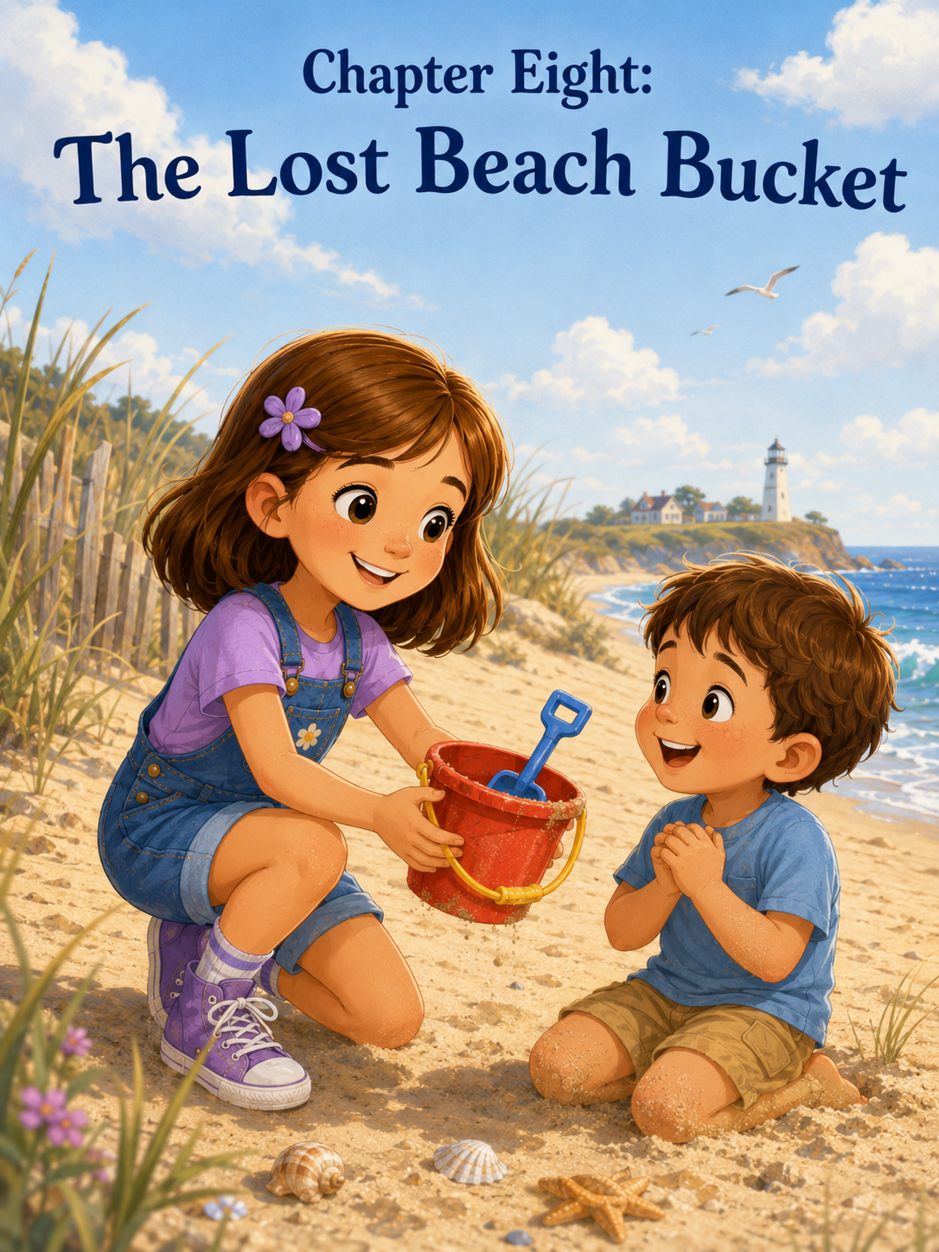Chapter Eight: The Lost Beach Bucket
On the way back from the lighthouse, Sally found the red bucket near the edge of the dunes.
It was sitting all by itself in the sand, tipped slightly to one side, as if someone had set it down for just a moment and then forgotten to come back. It was small, bright red, and shaped like a castle tower, with a yellow handle and a little blue shovel tucked inside.
Sally stopped walking.
Mom and Mark were farther back near the umbrella, packing away the snack containers after lunch. Emma and Benji were down by the water, using sticks to draw sea monsters in the wet sand. The beach was busy with families, towels, umbrellas, and children running from the waves, but no one seemed to be near the red bucket.
Sally looked around carefully.
No one claimed it.
No one was walking toward it.
No one shouted, “That’s mine!”
Sally crouched beside it.
“Well,” she whispered, “hello there.”
The bucket was just the right size. Not too big. Not too small. Perfect for carrying shells.
Sally picked it up and turned it in her hands. The plastic was warm from the sun, and a little sand had gathered inside the bottom. The blue shovel was sturdier, much sturdier than her own shovel, which had a crack near the handle from digging the moat around the great sandcastle.
Sally glanced toward the shoreline.
She had been wanting a special bucket just for shells. Her purple bucket was useful, but it was already full of beach things: her shovel, a towel corner, a smooth stone, and the extra ribbon from her kite. This red bucket could become her treasure bucket.
Her official shell collection bucket.
She could fill it with fan shells, tiny gray stones, pieces of driftwood, and maybe, if she was very lucky, another orange-and-white shell like the one from Pearlwater.
Sally stood and held the bucket against her hip.
“It might be abandoned,” she said to herself.
That sounded reasonable.
The beach was full of things people forgot. Flip-flops. Water bottles. Sunglasses. Sand toys. Once, Sally had seen a whole beach chair left beside a trash bin.
Maybe this bucket no longer belonged to anyone.
Maybe the ocean had placed it in her path like a gift.
A red bucket from the Kingdom of Lost Things.
Sally smiled at that idea.
She opened her notebook and almost wrote it down.
But before her pencil touched the paper, she heard a sound.
A small, shaky crying sound.
Sally looked up.
Near the walkway that led back toward the parking lot stood a little boy, younger than Benji, with sandy knees and a sunhat that had slipped crookedly over one eye. A woman knelt in front of him, speaking softly, but the little boy kept rubbing his face with both fists.
“I want my bucket,” he cried. “My red one.”
Sally froze.
Her hand tightened around the yellow handle.
The little boy sniffled hard. “It had my blue shovel.”
Sally looked down.
Red bucket.
Blue shovel.
Her stomach sank.
“Oh,” she whispered.
The bucket was not abandoned.
It was missed.
For one moment, Sally did not move.
She looked at the bucket again. It really was perfect. The yellow handle fit her hand. The little blue shovel was strong. She had already imagined what her shells would look like inside it, how she would carry it along the shore, and how it would become part of her seashore adventures.
She had found it.
But finding something did not always make it yours.
Sally knew that.
She did not love knowing it right then, but she knew it.
Mom had told her that empty shells could be kept, but living things belonged to the beach. Mark had said explorers watched, thought, and chose. The little crab had taught her to help gently. The beach cleanup had taught her that some things did not belong where they were found.
And now the red bucket was teaching her something too.
Sally looked at the little boy again.
His face was crumpled with sadness. The woman—probably his mother—was scanning the beach, one hand shading her eyes.
Sally could have pretended not to notice.
She could have carried the bucket back to her towel.
She could have told herself that someone else might find another bucket for him.
But the bucket was in her hand.
And the right thing was standing right in front of her.
Sally took a deep breath and walked toward them.
The little boy’s mother noticed her first.
Sally held up the bucket. “Is this his?”
The little boy stopped crying so suddenly that his mouth stayed open.
His eyes grew wide.
“My bucket!” he shouted.
He ran forward, then stopped shyly in front of Sally.
Sally held it out.
“I found it by the dunes,” she said. “The shovel is still inside.”
The little boy took the bucket with both hands and hugged it against his chest as if it were a long-lost friend.
“My blue shovel,” he said, peeking inside.
His mother smiled with relief. “Thank you so much. We’ve been looking everywhere.”
Sally shrugged a little. “It was just sitting there.”
“But you brought it back,” the mother said. “That was very kind.”
The little boy looked up at Sally. His cheeks were still wet, but now he was smiling.
A big smile.
The kind that changed his whole face.
“Thank you,” he said.
Sally looked at the red bucket in his arms.
She still liked it.
She still wished, a little, that she had one just like it.
But the wish felt smaller now.
The little boy’s smile felt bigger.
“You’re welcome,” Sally said.
“What’s your name?” he asked.
“Sally.”
“I’m Oliver,” he said. “This is my favorite bucket.”
Sally nodded. “I could tell.”
Oliver looked into the bucket again. “I’m collecting shell rocks.”
“Shell rocks?” Sally asked.
Oliver reached inside and pulled out a small broken shell stuck to a lump of sand. “Shell rock.”
Sally studied it carefully. “Interesting classification.”
Oliver looked proud, though he probably did not know what classification meant.
His mother laughed softly. “We’re still working on the difference between shells, rocks, and everything else.”
“Sometimes things can be both,” Sally said.
Oliver’s eyes widened. “Yes!”
Sally smiled.
She liked Oliver a little more after that.
Mom and Mark had seen what happened and were walking over now.
Mom’s eyes were warm. “You found the owner.”
Sally nodded. “It was Oliver’s.”
Mark looked at the bucket. “That is a fine bucket.”
Oliver hugged it tighter. “It’s mine.”
“Yes,” Sally said. “It is.”
Oliver’s mother thanked Sally again, then took Oliver’s hand. They started back toward their umbrella, Oliver holding the red bucket proudly at his side. After a few steps, he turned around and waved.
Sally waved back.
Mom stood beside her. “That was not easy, was it?”
Sally kicked gently at the sand with one sneaker. “I wanted to keep it.”
“I know,” Mom said.
“It was perfect for shells.”
Mark nodded. “It did look like a very good shell bucket.”
Sally glanced at him. “You saw it?”
“I saw you holding it,” Mark said. “I also saw you bring it back.”
Sally looked toward Oliver. He was now kneeling in the sand near his umbrella, showing the blue shovel to another child. He looked completely happy.
“I guess it was more perfect for him,” Sally said.
Mom smiled. “That is a very thoughtful thing to notice.”
Sally opened her notebook and sat down in the sand. She wrote:
Discovery #15: The Lost Red Bucket
Found a red bucket with a yellow handle and a blue shovel near the dunes. Wanted to keep it for shells. Then I saw a little boy crying because it was his favorite bucket. His name is Oliver. I gave it back.
She paused and looked at the page.
Then she added:
Doing the right thing can feel hard at first, especially when you want something. But Oliver smiled so big that it felt better than keeping the bucket.
Mark sat beside her. “That sounds like a very important discovery.”
Sally nodded. “It was.”
Mom looked toward the water. “What do you think you learned?”
Sally thought about it.
She had already learned so many things at the seashore.
Courage could begin with one small step toward the waves.
Treasures grew bigger when you shared their stories.
Creativity worked better with a team.
Kindness meant being gentle with small creatures.
Heroes sometimes carried trash bags.
Trying again mattered.
Bravery could mean climbing one step at a time.
And now—
Sally looked down at her empty hands.
“Just because something is special,” she said slowly, “doesn’t mean it is special for me.”
Mom nodded.
“And if it belongs to someone else, giving it back is better than pretending it doesn’t.”
Mark smiled. “That is honest and strong.”
Sally liked that.
Honest and strong.
She wrote another rule in her notebook:
Seashore Rule #5: If you find something that belongs to someone else, help it find its way home.
Then she drew a little red bucket beside the words.
It was a good drawing. Maybe not perfect, but good enough. She colored the handle yellow and the shovel blue. Then she added Oliver’s smile beside it, big and round like the sun.
A little while later, Sally walked along the beach again with her own purple bucket. It was not as special as the red bucket. It did not have a castle shape or a yellow handle. The crack near her shovel still bothered her a little.
But it was hers.
And it had already been part of many adventures.
It carried shells, seaweed ribbons, smooth stones, and sandcastle supplies. It sat beside her during beach cleanup. It had been there when the kite finally flew. It had waited patiently while she climbed the lighthouse.
Sally looked at it with new appreciation.
“You’re a good bucket too,” she told it.
Mom, walking nearby, smiled. “Did you just compliment your bucket?”
“Yes,” Sally said. “It deserved it.”
They walked toward the wet sand, where the waves washed up tiny pieces of shell. Sally crouched and picked up a small white fan shell. She turned it over, checked that nothing was living in it, and placed it into her purple bucket.
Clink.
It made a gentle sound at the bottom.
Then she found a gray pebble shaped like a heart.
Clink.
Then, a tiny orange shell that looked like a sunset.
Clink.
Soon, the purple bucket began to look like a treasure bucket after all.
Not because it was new.
Not because it was red.
Not because it had belonged to someone else.
Because Sally was filling it with her own discoveries.
Down the beach, Oliver laughed as he scooped wet sand into his red bucket. He looked up once and waved again.
Sally waved back.
This time, she did not feel the pinch of wanting what he had.
She felt glad.
Glad he had his bucket.
Glad she had hers.
Glad she had chosen the right thing, even when the wrong thing would have been easier to carry away.
That evening, as they packed up for the day, Sally placed her purple bucket carefully beside her backpack. Inside were three shells, two stones, and one feather Mom had said was okay to keep because it was clean and dry.
Mark lifted the bucket. “Nice collection.”
Sally nodded. “It turned out to be a good shell bucket.”
“I thought it might,” Mark said.
Mom brushed sand from Sally’s shoulder. “And you turned out to be a very good finder.”
Sally looked at her. “A finder?”
Mom nodded. “You found a bucket. Then you found its owner. That matters.”
Sally smiled.
She liked that even better than finding treasure.
On the ride home, Sally opened her notebook one last time. The car smelled faintly of sunscreen, salt air, and crackers. Her purple bucket sat on the floor by her feet, rattling softly whenever the car turned.
She wrote:
Today I learned that giving something back can feel like losing something for a minute. But then it can feel like gaining something better. Oliver got his favorite bucket back, and I knew I did the right thing.
She looked out the window as the beach road curved away from the sea.
The ocean had disappeared behind the dunes, but Sally could still hear it in her memory.
Whoooosh.
Crash.
Fizz.
A sound like something leaving.
It sounds like something returning.
Sally closed her notebook and rested it in her lap.
Some treasures you kept.
Some treasures you shared.
And some treasures became most special when you helped them find their way back home.

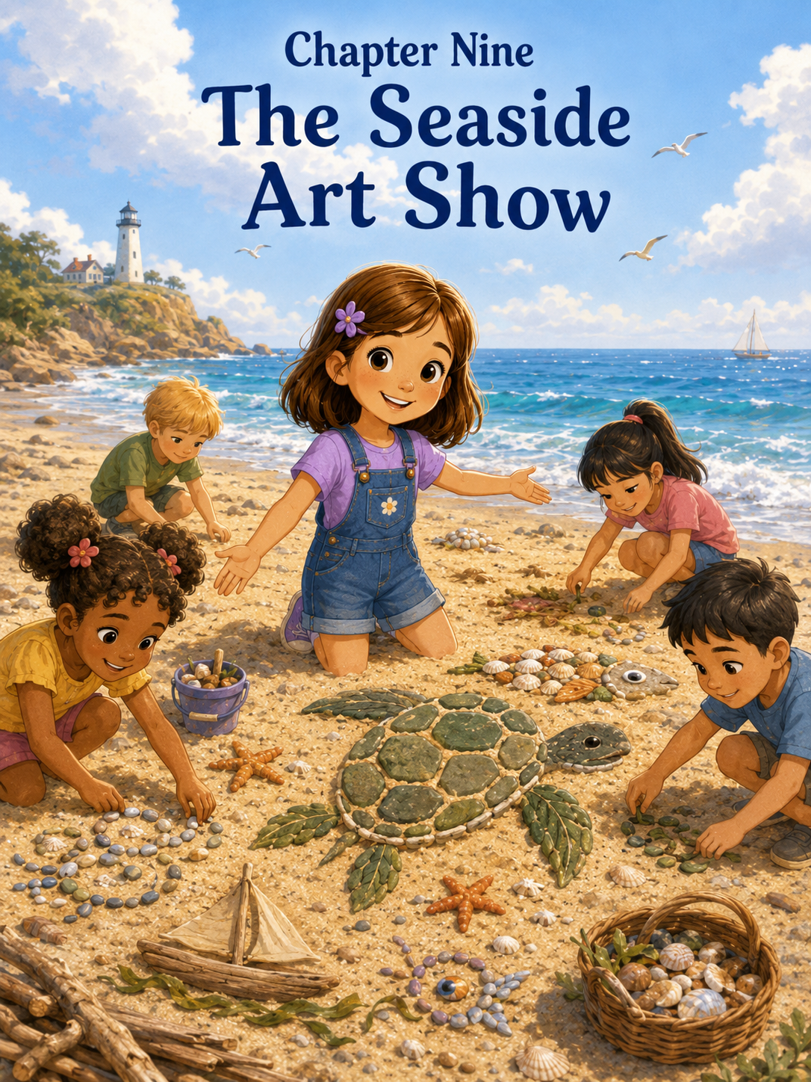Chapter Nine: The Seaside Art Show
Sally had been collecting ideas all week.
Not just shells.
Not just stones.
Not just little pieces of driftwood that looked like dragon tails, crooked fingers, or tiny boat oars.
Ideas.
She had collected the ocean’s silver waves, the orange-and-white shell from Pearlwater, the brave little crab in the footprint puddle, the purple kite rising into the sky, the tall lighthouse, Oliver’s red bucket, and the great sandcastle that had become better when everyone helped build it.
Now all those ideas were swirling around inside her head like gulls over the shoreline.
Later that day, Sally sat under the beach umbrella with her notebook open on her lap. Mom was reading beside her, and Mark was rinsing sand from the purple bucket.
Sally stared at the blank page.
Then she wrote:
Seaside Art Show
She underlined it once.
Then twice.
Then one more time because it felt important.
Mom glanced over. “Seaside Art Show?”
Sally nodded. “I’m going to make art on the beach.”
Mark looked up from the bucket. “What kind of art?”
Sally swept her arm toward the sand. “Beach art. With shells and stones and seaweed and driftwood. But not too much seaweed, because some of it smells suspicious.”
Mark nodded seriously. “A wise artistic choice.”
Sally stood and looked across the beach. The tide had pulled back, leaving a wide stretch of smooth wet sand near the water. It looked like a giant blank canvas.
A canvas that would not last forever.
That made it even more exciting.
Sally carried her purple bucket toward the waterline, but she moved carefully. She had learned many seashore rules by now. She did not take shells containing living creatures. She did not disturb animals. She did not pick up sharp or strange things without asking. She did not collect everything she saw, because the beach needed treasures too.
She gathered only a few things.
Three white shells.
Two smooth gray stones.
One piece of driftwood shaped like a crooked smile.
A strand of green seaweed.
A tiny orange shell that looked like a sunset.
A flat brown shell that reminded her of a turtle shell.
She placed them gently into her bucket.
Clink.
Click.
Swish.
Every sound felt like the beginning of something.
Emma came running over with her orange ribbons bouncing. “What are you doing?”
“Making art,” Sally said.
“What kind?”
Sally looked at the smooth sand. “I’m not sure yet.”
Emma blinked. “You don’t know?”
“Not exactly,” Sally said. “Sometimes art tells you what it wants to be.”
Emma looked impressed. “Mine usually just looks like blobs.”
“Blobs can become things,” Sally said.
Benji appeared behind Emma, carrying his red shovel. “Can I make a blob?”
“Maybe,” Sally said. “But first we need a plan.”
She knelt on the wet sand and used one finger to draw a large oval.
“This will be a sea turtle,” she said.
Emma’s eyes widened. “Like a real one?”
“Like a beach-art one.”
Benji crouched beside her. “Does it bite?”
“No,” Sally said. “It is made of sand.”
“Good,” Benji said.
Sally began with the turtle’s shell. She pressed smooth stones into the sand in a rounded pattern, then placed shells around the edge. The flat brown shell went in the center. She used small pieces of driftwood for the flippers and a tiny stone for the eye.
Emma added white shells along the turtle’s back.
Benji tried to add a large clump of seaweed directly on the turtle’s head.
Sally stopped him quickly. “That is too much.”
Benji looked disappointed. “It’s hair.”
“Turtles do not need seaweed hair,” Sally said.
Emma tilted her head. “Maybe this turtle does.”
Sally looked at the seaweed. Then at the turtle. Then at Benji’s hopeful face.
She was the artist. It was her idea. But she had learned something from the sandcastle team. Sometimes other people’s ideas looked strange at first, but they made the creation better.
“Fine,” Sally said. “But not on the head. It can be ocean grass near the turtle.”
Benji placed the seaweed beside the turtle’s front flipper.
“Seaweed grass,” he said proudly.
Sally studied it.
It actually looked good.
“Approved,” she said.
Benji beamed.
Soon, the turtle was finished. It lay in the sand as if it were slowly making its way toward the waves. Its shell sparkled with stones and shells, and the seaweed grass made it look like it had just come from an underwater meadow.
Sally stood and brushed sand from her knees.
“That,” she said, “is art.”
Emma clasped her hands. “It’s beautiful.”
Benji nodded. “It needs a name.”
Sally thought for a moment. “Shelly.”
Emma smiled. “Shelly the sea turtle.”
Benji leaned close to the turtle. “Hello, Shelly.”
A few children nearby came over to look.
One girl with curly hair pointed at the turtle. “Did you make that?”
Sally stood a little taller. “We did.”
The girl looked at the shells and stones. “Can I make something too?”
Sally looked at the smooth stretch of sand. There was plenty of room.
“What do you want to make?” she asked.
“A fish.”
Sally nodded. “Good choice.”
A boy in a green hat said, “I want to make a boat.”
Another child said, “I can make a star.”
Benji raised his shovel. “I make blob.”
Sally looked at Mom and Mark, who were watching from near the umbrella.
Mom smiled as if to say, " This is your choice.
Mark gave a small thumb-up.
Sally looked back at the children.
Her first thought was that too many people might make a mess. They might step on Shelly. They might use all the good shells. They might turn her art show into chaos.
But then she looked at the beach.
The sand was wide.
The ideas were many.
And Sally was beginning to understand that creativity did not shrink when other people joined in.
It spread.
“Okay,” she said. “But we need art show rules.”
The children gathered around.
Sally lifted one sandy finger.
“Rule one: Do not step on anyone’s art.”
Everyone nodded.
“Rule two: Only use empty shells and safe things from the beach.”
Mom called, “Excellent rule.”
“Rule three,” Sally continued, “if someone is making something, ask before adding to it.”
Emma nodded. “Because seaweed hair needs permission.”
Benji looked at the turtle. “Seaweed grass was allowed.”
“Yes,” Sally said. “Because we found the right place for it.”
“Rule four,” she said, “everyone gets to imagine.”
That rule felt like the most important one.
The seaside art show began.
The girl with curly hair made a fish from silver shells and smooth stones. Emma helped her find tiny shell pieces for scales. The boy in the green hat made a boat with driftwood sides and a seaweed rope. Sally showed him how to press wet sand around the bottom so the boat would not tip over.
Another child made a star with five long lines of shells.
Benji made his blob.
At first, the blob was just a pile of wet sand with two stones stuck on top. But Benji insisted it was a whale sleeping under a blanket. Sally looked again and decided she could almost see it.
“Maybe add a tail,” she suggested.
Benji added a piece of driftwood.
Suddenly, the blob looked much more like a whale.
“A sleeping whale,” Sally said.
Benji smiled proudly. “I told you.”
Sally laughed. “You did.”
More children came. Some built tiny shell flowers. Some made a sun with yellowish stones. Someone made a crab with twig legs. Someone else made a lighthouse, tall and wobbly, with a white shell at the top for the light.
Sally loved that one.
“That looks like the lighthouse lookout,” she said.
The child smiled. “I climbed it yesterday.”
“I did too,” Sally said. “It was scary in the middle.”
The child nodded. “I held the railing very tight.”
“Me too,” Sally said.
They both looked at the little sand lighthouse with understanding.
Mom came over with Sally’s notebook. “Would the art show director like to record the exhibit?”
Sally grinned. “Yes, please.”
She took the notebook and began writing.
Seaside Art Show Exhibits:
1. Shelly the Sea Turtle — shells, stones, driftwood, seaweed, and grass.
2. Silver Fish — made by a curly-haired girl and Emma. Very shiny.
3. Driftwood Boat — good seaweed rope.
4. Shell Star — excellent points.
5. Sleeping Whale Blob — improved with tail.
6. Tiny Lighthouse — brave climbing memory.
7. Twig-Leg Crab — may be related to the brave little crab.
Mark walked slowly around the sandy gallery with his hands behind his back like a museum visitor.
“Remarkable,” he said.
Sally narrowed her eyes at him. “Are you pretending?”
“Only partly,” Mark said. “This really is remarkable.”
Mom took pictures of each creation. She made sure to stand back so her shadow did not cover the art.
A few beach walkers stopped to look.
One older woman smiled. “What a wonderful art show.”
Sally felt her cheeks warm.
“Thank you,” she said. “It’s a seaside art show.”
“I can see that,” the woman said. “You all made something beautiful.”
Sally looked around.
The beach had changed.
The plain wet sand had become a sea turtle, a fish, a boat, a star, a whale, a lighthouse, a crab, and more. None of it would last forever. The tide would come in later. The wind would move the seaweed. The shells and stones would scatter back onto the beach.
But for right now, it is beautiful.
And everyone helped.
Then Emma came over holding the orange-and-white Pearlwater shell. Sally had let her hold it for a moment while they were working, but she had almost forgotten.
“Can this be part of the art show?” Emma asked.
Sally’s first instinct was to say no.
The Pearlwater shell was special. It had its own story. It was the shell with the secret. She had shared it before, but she kept it safe.
“What would you use it for?” Sally asked carefully.
Emma pointed to Shelly, the sea turtle. “Maybe it could be a heart.”
Sally looked at the turtle. There was a small open space in the center of the shell pattern. The orange-and-white shell would fit there perfectly.
But it would be in the sand.
Near other children.
Near the tide, though not too close.
Sally thought about it.
The shell had started as her secret. Then it had become part of Pearlwater Castle. Now it could become the heart of Shelly the sea turtle.
Maybe that was how special things worked.
They did not become less special by joining new stories.
They collected them.
“Okay,” Sally said. “But I’ll place it.”
Emma handed it to her carefully.
Sally knelt beside Shelly and pressed the orange-and-white shell into the center of the turtle’s back. The swirls glowed softly in the sunlight.
Everyone gathered around.
“It does look like a heart,” the curly-haired girl said.
Benji whispered, “Shelly has a secret heart.”
Sally smiled.
“Yes,” she said. “She does.”
For a while, the children simply admired what they had made. No one argued over whose art was best. No one stepped on anyone’s creation. If someone needed a shell, another child helped find one. If someone had an idea, there was room to try it.
Sally realized she had not made every piece.
She had not even thought of every piece.
But the art show had started because she had invited others to imagine with her.
That felt different from making something alone.
Different in a good way.
When the tide began creeping closer, Mark pointed toward the water. “The ocean may visit the art show soon.”
Some of the children looked worried.
“Will it ruin everything?” Emma asked.
Mom knelt beside them. “Beach art is temporary. That means it does not last forever. But that does not make it less special.”
Sally looked at Shelly, the sea turtle.
She carefully lifted the Pearlwater shell from the turtle’s back and tucked it safely into her backpack pocket.
Then she stood back.
The next wave slid closer, stopping a few feet away. The art was still safe.
For now.
Sally opened her notebook and wrote one more entry.
Discovery #16: The Seaside Art Show
I started making a sea turtle with shells, stones, driftwood, and seaweed. Then Emma, Benji, and the other children joined. We made fish, boats, stars, a whale, a lighthouse, and a crab. Everyone had ideas. The beach became an art gallery.
She paused.
Then wrote:
Creativity is not only about making something beautiful. It is about inviting others to imagine with you.
Mom read the words and smiled. “That may be one of your best discoveries yet.”
Sally looked around at the children, still adding final touches before the waves came in.
“I thought I was making one turtle,” Sally said.
Mark smiled. “You made a whole art show.”
“No,” Sally said thoughtfully. “We did.”
Mark’s smile grew. “Even better.”
As the tide moved in, the first little wave reached the edge of the shell star. The children watched quietly as water slipped between the points and carried one tiny shell a few inches away.
Benji waved. “Goodbye, art.”
Emma said, “Maybe the ocean wants to see it too.”
Sally liked that.
One by one, the waves reached the creations. The fish shimmered and softened. The boat leaned. The sleeping whale blob became a regular blob again. The tiny lighthouse stood bravely for three waves before tipping gently into the sand.
Shelly the sea turtle lasted the longest.
The water curled around her driftwood flippers and shell-stone back. For a moment, it looked as if she were swimming.
Then the next wave came and softened her edges.
Sally did not feel sad exactly.
She felt proud.
The art show was changing, but it had happened. They had made it. They had imagined it. They had shared it.
And Mom had pictures.
That helped too.
When the water slipped back, Sally picked up a smooth gray stone that had been part of Shelly’s shell. She held it in her palm for a moment, then placed it back on the wet sand.
“Goodbye, Shelly,” she whispered.
Emma stood beside her. “Do you think we can make another art show tomorrow?”
Sally smiled. “Yes.”
Benji lifted his red shovel. “More blobs?”
“More blobs,” Sally said.
“But with tails,” Emma added.
Benji nodded. “Important.”
Sally laughed, then looked out at the wide ocean. The waves rolled in, carrying away pieces of the art show and leaving the sand smooth again, ready for whatever came next.
That was the wonderful thing about the seashore.
It always gave you another blank place to begin.
Sally walked back toward the umbrella with her notebook under one arm and her purple bucket swinging from her hand.
She had come to the beach wanting adventure.
She had found courage, kindness, teamwork, patience, honesty, and now creativity.
But not the lonely kind of creativity.
The shared kind.
The kind started with one idea and grew bigger because others added their own.
Sally looked over her shoulder at the children still gathered near the water, pointing to where the art had been.
She smiled.
The tide had taken pictures in the sand.
But the imagination stayed.

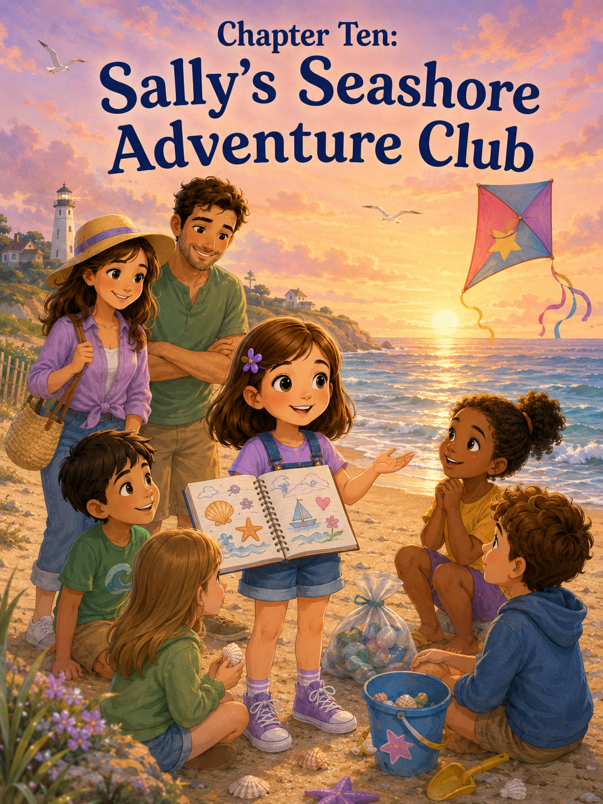Chapter Ten: Sally’s Seashore Adventure Club
By the afternoon at the beach, Sally’s notebook was almost full.
The corners of the pages were curled from the salty air. A few grains of sand were stuck between the pages. One corner had a tiny smudge of sunscreen, and another page had a faint purple crayon mark from when she drew the kite.
Sally loved every mark.
They were proof.
Proof that she had explored.
Proof that she had wondered.
Proof that she had been brave, even when she felt unsure.
Proof that the seashore had more lessons hidden in it than anyone could see from far away.
Sally sat under the beach umbrella with her purple backpack beside her and her notebook open across her knees. The ocean rolled in front of her, wide and blue and sparkling in the afternoon sun.
Whoooosh.
Crash.
Fizz.
The sound felt familiar now.
Throughout the day, the waves had seemed enormous. Sally had stood at the edge of the sand and felt small. She held Mom’s hand and took one careful step toward the water.
Now she knew the waves better.
She knew they could be loud and gentle at the same time. She knew they could bring shells, smooth stones, bits of seaweed, and sometimes things that did not belong, like plastic bottles. She knew they could smooth sandcastles flat and carry away beach art, but they also made space for new beginnings.
Mom sat beside her, folding a towel. “You’re very quiet.”
Sally looked up. “I’m thinking.”
Mark, who was shaking sand out of one of the beach chairs, smiled. “That usually means something important is about to happen.”
Sally did not answer right away. She turned the pages of her notebook slowly.
There was the first page, where she had written about not knowing how to feel. That was before the beach, before the waves, before she understood that an adventure could begin even when life felt confusing.
There was the tiny, orange-striped shell from earlier that day.
There was the drawing of the Pearlwater shell, the secret shell with soft pink-and-white swirls.
There was a plan for the giant sandcastle, with notes about towers, tunnels, shell windows, and teamwork.
There was the brave little crab, standing at the top of the sandy ramp Sally had helped make with Mom and Mark.
There were tally marks from the beach cleanup.
There was a purple kite, wobbly at first, then flying high.
There was the lighthouse, tall and steady, with a note written underneath:
Bravery means moving carefully forward when something matters.
There was the red bucket drawing, with Oliver’s big smile beside it.
There was Shelly the sea turtle from the Seaside Art Show, made of shells, stones, driftwood, and imagination.
Sally ran her fingers over the pages.
“I learned a lot here,” she said.
Mom stopped folding and looked at her. “You did.”
Mark sat down on the sand nearby. “What was your favorite discovery?”
Sally frowned thoughtfully.
That was not an easy question.
She liked the Pearlwater shell because it had started a story. She liked the sandcastle because everyone had helped. She liked the little crab because it had been brave even though it was tiny. She liked the kite because it had finally flown after crashing so many times. She liked the lighthouse because she had climbed all the way to the top, even with fluttery knees.
“I don’t know,” Sally said at last. “They all taught me something different.”
Mom smiled. “That sounds like a good answer.”
Just then, Emma came running over from the waterline. Her orange ribbons bounced in the wind, and she carried a small handful of shells.
“Sally!” she called. “Look what I found.”
Sally carefully examined the shells in Emma’s palm. Most were tiny white pieces, but one was shaped like a little wing.
“That one looks like it came from a sea butterfly,” Sally said.
Emma’s eyes widened. “A sea butterfly?”
“Probably rare,” Sally said.
Benji hurried after Emma with his red shovel, followed by Oliver carrying his red bucket with the yellow handle.
“I found a rock that looks like a potato,” Benji announced.
Oliver held up his bucket. “I found shell rocks.”
Sally smiled. The beach felt different now that she knew these children. At the beginning, they had been strangers. Now they were part of the adventure.
Emma sat beside Sally. “What are you writing?”
“I’m looking at everything I discovered,” Sally said.
Benji leaned over the notebook. “Is the crab in there?”
“Yes.”
“The kite?”
“Yes.”
“My blob whale?”
Sally turned to the Seaside Art Show page. “Right there.”
Benji grinned. “Good.”
Oliver pointed to the red bucket drawing. “That’s my bucket.”
Sally nodded. “That was an important discovery.”
Oliver hugged the bucket. “It is still my favorite.”
“I know,” Sally said.
The children gathered around Sally’s notebook, pointing at drawings and asking questions. Mom and Mark watched from nearby, smiling softly.
Sally suddenly had an idea.
It came the way her best ideas often came—quickly, brightly, and with the feeling that she should have thought of it earlier.
“We should start a club,” she said.
Emma’s face lit up. “A club?”
Benji dropped his potato rock. “What kind?”
Sally sat up straighter. “A Seashore Adventure Club.”
Oliver gasped. “With buckets?”
“With buckets if needed,” Sally said.
Emma clasped her hands. “What does the club do?”
Sally looked out at the ocean. The waves glittered, rolled, and whispered against the sand. Gulls circled overhead. A kite floated in the distance. A family walked along the shore, stopping now and then to look for shells.
“The club explores,” Sally said. “But carefully.”
Mark leaned forward. “That sounds promising.”
Sally opened her notebook to one of the last blank pages. At the top, she wrote:
Sally’s Seashore Adventure Club
Then she looked at the others.
“A real club needs rules.”
Benji raised his hand. “No eating trash.”
Sally paused. “That is a very good rule, but maybe not the first one.”
Emma raised her hand. “Be kind.”
Sally smiled and wrote:
1. Be kind.
Oliver held up his bucket. “Give back things that belong to other people.”
Sally nodded. “That belongs under kindness.”
She wrote a smaller note beneath the first rule:
Return lost things. Help others. Share the wonder.
Mark smiled. “Good rule.”
Mom looked at Sally. “What else?”
Sally thought about earlier in the day, when the ocean had felt too big, and she had still wanted to explore.
“Be curious,” she said.
She wrote:
2. Be curious.
Then she added:
Ask questions. Notice small things. Look closely.
Emma held up the shell shaped like a wing. “Like sea butterflies?”
“Exactly,” Sally said.
Benji raised his shovel. “Be safe.”
Mom nodded. “Very important.”
Sally wrote:
3. Stay safe.
Under it, she added:
Listen to grown-ups. Watch the waves. Do not touch sharp or strange things. Be gentle with animals.
Oliver looked into his bucket. “And don’t run into people with buckets.”
Sally considered this. “Also, important.”
She added:
Carry buckets carefully.
Mark looked at the page. “What about imagination?”
Sally smiled. “Definitely.”
She wrote:
4. Use your imagination.
Under it, she added:
A shell can become a secret. A sandcastle can become a kingdom. A kite can become a sky explorer.
Emma hugged her shells. “And a blob can become a whale.”
Sally wrote:
A blob can become a whale.
Benji looked proud.
Only one more rule seemed needed.
Sally looked toward the place where they had done the beach cleanup. She thought about the crab in the footprint, the fallen shell stories, the red bucket, the plastic bottle, and the art show washing away with the tide.
“Help when you can,” she said.
She wrote:
5. Help when you can.
Then she added:
Clean up safe litter. Help small creatures carefully. Include others. Leave the beach better when possible.
Sally sat back and read the rules aloud.
Sally’s Seashore Adventure Club
1. Be kind.
2. Be curious.
3. Stay safe.
4. Use your imagination.
5. Help when you can.
Everyone grew quiet for a moment.
Even Benji.
Then Emma whispered, “That sounds like a real club.”
“It is a real club,” Sally said.
Oliver raised his hand. “Can I join?”
“Yes,” Sally said.
Emma bounced on her knees. “Me too?”
“Yes.”
Benji lifted his shovel. “Me too?”
Sally nodded. “Yes, but no swinging the shovel.”
Benji lowered it. “Safe shovel.”
Mom laughed softly.
Mark looked at Sally. “What does the club do first?”
Sally looked around the beach.
There were so many possibilities.
They could look for shells, build another castle, fly the kite, clean up litter, draw beach art, watch birds, inspect tide pools from a safe distance, or make another crab ramp if a crab needed one.
But the first club mission should include everyone.
Sally stood and pointed toward the smooth sand near the waterline.
“First,” she said, “we make the club symbol.”
The children followed her to the wet sand. Sally chose a flat space where the tide would not reach too quickly. With her finger, she drew a large circle.
“This is the world,” she said.
Emma placed small shells around the edge.
“This is the seashore,” Emma added.
Benji used his shovel to make gentle wave lines.
“These are waves,” he said.
Oliver placed one shell rock in the middle. “This is a shell rock.”
Sally smiled. “Perfect.”
Then Sally drew five small shapes inside the circle: a heart, an eye, a small shield, a star, and a helping hand.
Emma pointed at the heart. “Kindness.”
“The eye is curiosity,” Sally said.
“The shield is safety,” Mark added from nearby.
“The star is imagination,” Mom said.
Oliver pointed to the hand. “Helping.”
Sally nodded. “That’s the club.”
The symbol was simple, but Sally loved it. It was made of sand, shells, stones, and everyone’s ideas.
Just like the best things at the beach.
Mom took a picture before the waves could change it.
After that, the Seashore Adventure Club held its first official mission: a careful shoreline walk.
The rules were simple. Stay where Mom and Mark could see them. Watch the waves. Do not touch living creatures. Ask before picking up anything unusual. Leave some treasures behind.
Sally carried her notebook.
Emma carried the shell shaped like a sea butterfly.
Benji carried his safe shovel.
Oliver carried his red bucket.
They walked along the shore, stopping to notice things they might have missed before.
A trail of bird footprints.
A shell shaped like a tiny fan.
A piece of driftwood that looked like a fish.
A sand bubble that popped just as Benji leaned close.
A gull feather that stayed on the beach because Mom said it was better left there.
A plastic wrapper caught near the dune grass, which Mark helped pick up safely.
Sally recorded it all.
Seashore Adventure Club Mission #1:
Noticed bird footprints, sea butterfly shell, fish-shaped driftwood, popping sand bubbles, and one wrapper removed by Mark. Everyone followed the rules. Excellent first mission.
When they returned to the umbrella, the sun had begun to lower. The light turned golden across the water, and the waves looked softer than they had in the bright afternoon.
Sally sat with her notebook in her lap.
Emma, Benji, and Oliver sat around her.
“What happens when you go home?” Emma asked.
Sally’s pencil stopped moving.
She had not wanted to think about that.
Going home meant leaving the ocean. It meant leaving the sandcastle place, the kite breeze, the lighthouse path, and the friends she had made. It also meant going back to regular life with two bags, two homes, two sets of routines, and feelings that did not always fit neatly anywhere.
Sally looked at Mom.
Mom’s expression was gentle.
Mark was quiet too.
Sally looked back at her friends. “The club can still exist.”
“How?” Oliver asked.
Sally thought for a moment.
“Because the rules work anywhere,” she said slowly.
Emma tilted her head. “Even not at the beach?”
Sally nodded. “You can be kind anywhere. You can be curious anywhere. You can stay safe, use imagination, and help when you can, anywhere.”
Benji looked at his shovel. “Can I still be in the club at home?”
“Yes,” Sally said. “But maybe don’t bring your beach shovel to dinner.”
Benji sighed. “Okay.”
Sally wrote a final note under the club rules:
The Seashore Adventure Club can travel in your heart, even when you leave the beach.
She looked at the sentence for a long time.
It was true.
The seashore had given her many adventures, but it had also given her something she could take with her.
A way to notice.
A way to care.
A way to try.
A way to share.
A way to be brave, one careful step at a time.
Mom sat beside her. “What are you thinking?”
Sally looked out at the ocean.
“I thought the beach was just a place to play,” she said.
Mom waited.
“But it’s not just that,” Sally continued. “It’s a place to learn things.”
Mark smiled. “What kind of things?”
Sally looked at the children around her. She looked at the shells, the bucket, the shovel, the notebook, and the waves.
“How to be brave. How to share. How to help. How to try again. How to make things with other people. How to care about small creatures and big places.”
Mom’s eyes softened. “That is a lot to learn from the sand.”
Sally smiled. “The sand is a good teacher.”
Mark laughed. “So is the ocean.”
“And crabs,” Benji said.
“And kites,” Emma added.
“And buckets,” Oliver said.
Sally nodded. “Especially buckets.”
The others laughed.
Soon it was time to pack up. Emma’s family called her from down on the beach. Benji’s grown-ups waved from near the walkway. Oliver’s mother came to collect him and his red bucket.
Before they left, Sally tore a clean page from the back of her notebook. She carefully copied the Seashore Adventure Club rules onto it.
Then she showed the page to everyone.
“I’ll make more copies when I get home,” she said. “But for now, we can remember them.”
They all read the rules together.
Be kind.
Be curious.
Stay safe.
Use your imagination.
Help when you can.
Emma hugged Sally goodbye. “I’m going to look for sea butterfly shells tomorrow.”
“Remember to leave some magic behind,” Sally said.
“I will.”
Benji waved his shovel. “I will make safe blobs.”
“Good,” Sally said.
Oliver lifted his red bucket. “I will carry buckets carefully.”
Sally smiled. “Excellent.”
One by one, her beach friends walked away.
Sally stood with Mom and Mark near the edge of the sand. The ocean glowed in the evening light. The tide was coming in now, washing over the place where they had drawn the club symbol.
The heart disappeared first.
Then the eye.
Then the shield.
Then the star.
Then the helping hand.
For a second, Sally felt sad.
But then she remembered the pictures Mom had taken. She remembered the rules in her notebook. She remembered that some things did not need to stay in the sand to be real.
The club was real because they had made it real.
The lessons were real because she had learned them.
The adventures were real because she had lived them.
Mark lifted the beach chair. “Ready, Explorer Sally?”
Sally looked at the ocean one more time.
She thought about the morning when she had stood far from the waves, unsure and overwhelmed. Now she stepped closer to the water’s edge. Not too close. Just close enough.
A gentle wave slid toward her sneakers and stopped just before touching them.
Sally smiled.
“Thank you,” she whispered.
Mom came beside her. “For what?”
Sally looked out at the wide blue sea.
“For everything,” she said.
Then she picked up her purple bucket, tucked her notebook safely into her backpack, and walked up the beach with Mom on one side and Mark on the other.
Behind her, the waves rolled in and out, smoothing the sand for the next child, the next question, the next discovery.
Sally did not know when she would come back to the seashore.
But she knew this:
She was leaving with more than shells.
She was leaving with courage.
Kindness.
Curiosity.
Creativity.
And a club that could go wherever she went.
The seashore had become part of her.
And Sally, strong-willed adventurer that she was, had become part of the seashore too.

Epilogue
Sally did not leave the seashore with the same girl who had arrived.
When she first stepped onto the sandy path, she carried more than her purple backpack and adventure notebook. She carried questions about change, family, and where she belonged. Life had felt divided between two homes, two sets of routines, and feelings that were sometimes too big to explain. But at the edge of the ocean, where the waves came in and slipped away again, Sally began to understand that change did not have to mean losing herself. Sometimes change could become a new shoreline—different, unfamiliar, but full of discoveries waiting to be found.
The seashore had taught Sally in quiet, surprising ways. A tiny crab showed her that small creatures can be brave. A stubborn kite taught her to try again. A lighthouse helped her see that courage can happen one step at a time. A lost bucket reminded her that doing the right thing can feel better than keeping something for herself. Shells, sandcastles, beach cleanups, and seaside art all showed her that kindness, curiosity, creativity, and courage could be practiced in ordinary moments.
When Sally returned home, her purple bucket held only a few shells and stones, but her heart carried much more. She carried the memory of Mom’s steady hand, Mark’s patient kindness, new friends made in the sand, and the sound of the waves reminding her that big feelings could come and go without washing her away.
Her notebook was nearly full, but Sally knew her adventures were not over. The Seashore Adventure Club did not have to stay at the beach. Its rules could travel with her anywhere:
Be curious.
Be kind.
Stay safe.
Use your imagination.
Help when you can.
Sally smiled as she placed her special shell on her shelf at home. It was not just a shell anymore. It was a reminder of everything she had learned.
The ocean was big.
Life was big too.
But Sally now knew she did not have to face either one all at once. She could take one careful step, ask one brave question, help in one small way, and discover one new thing at a time.
And wherever she went next, Sally would go as she had always been—curious, creative, strong-willed, and ready for adventure.

About the Author
www.scottMbooks.com

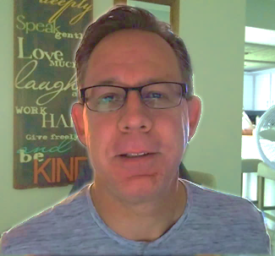
Scott Speicher brings a unique blend of life experiences to his writing. A U.S. military veteran, he carries the discipline, resilience, and perspective gained through service into every story he tells. After his military career, Scott built a successful path in marketing, where he developed a deep understanding of communication, storytelling, and audience engagement. For more than 15 years, he has also worked as a professional website designer, helping businesses and individuals create meaningful online presences.
Scott Speicher is a storyteller who enjoys creating gentle, heartfelt stories that help children notice the small moments that make life meaningful. Through warm characters and simple adventures, his books encourage young readers to slow down, care for others, and appreciate the quiet joys of everyday life. Scott believes that some of the most important lessons children learn come not from grand events, but from the ordinary moments shared with family, friends, and the animals they love.
In Thomas Loves His Bike, Scott brings that spirit to life through an encouraging story about confidence, patience, and the milestone of a child’s first bicycle. Inspired by the sense of wonder children feel when exploring their world, the story celebrates how safety, responsibility, and family support go hand in hand with adventure. Through Thomas and his trusty red, white, and blue bike, readers are reminded that the greatest journeys are built on careful preparation—a helmet buckled tight, the steadying support of training wheels, and the simple joy of a "ring-ting" bell on a sunny afternoon.
Suitable for readers aged 4-10 and for family read-aloud sessions. Ideal for SEL, guidance, and service-learning.

