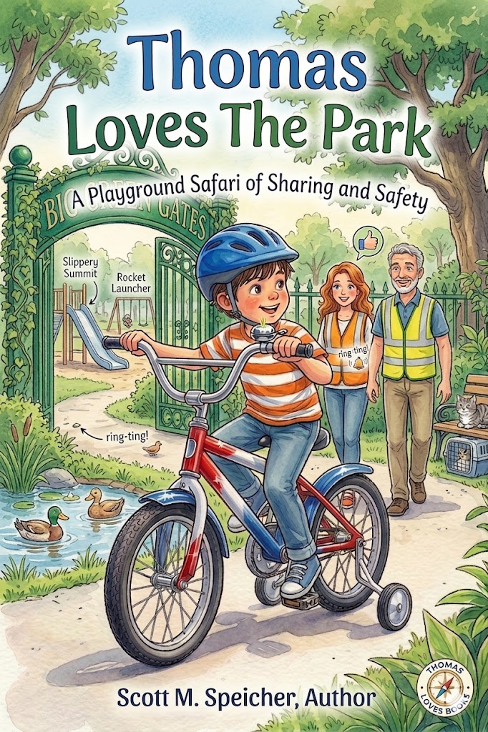
Thomas Loves the Park
By
Scott M. Speicher

Copyright © 2026
Author: Scott M. Speicher
Portions of this book have been perfected by the program Grammarly
Edited by Grammarly and the Editorial team of Digital Scribblers
No part of this book may be reproduced or used, in any form or by any means, electronic or mechanical, without permission in writing from the author.
AI generated some images under the author's direction.

About This Book

A New Kingdom to Explore
Join Thomas, a spirited young explorer with a big imagination, as he heads to the local park for a day of sun-drenched discovery. To Thomas, the park isn't just a collection of swings and slides—it is a vast, untamed kingdom waiting to be navigated with his "Big Blue Backpack" and his favorite red toy truck. Accompanied by his supportive parents and his watchful gray tabby cat, Whiskers, Thomas turns every familiar corner into a "Playground Safari" where adventure is found in every sandbox and puddle.
Lessons in Safety and Kindness
Building on the "Secret Codes" of the sidewalk, Thomas learns that being a true explorer means more than just having fun—it’s about being smart and kind to those around him. Whether he is conquering the "Slippery Summit" of the tall slide or practicing the "Space Bubble" rule on the swings, Thomas demonstrates how imaginative play and practical responsibility go hand in hand. Young readers will follow along as Thomas navigates social lessons, such as sharing treasure in the sandbox and caring for wildlife at the duck pond.
A Guide for Young Adventurers
Written by Scott M. Speicher, Thomas Loves the Park is specifically crafted for children aged 4 to 8. Through the series’ signature soft watercolor and pencil-style illustrations, the book provides a gentle, engaging way for families to discuss outdoor safety, environmental care, and the "down-to-earth" forgiveness that keeps friendships strong. It is a heartwarming addition to the Thomas collection that proves the smartest adventure of all is staying safe while exploring the world together.

Thomas Loves The Park
A Playground Safari of Sharing and Safety

Table of Contents

Chapter 1: The Big Blue Backpack
Chapter 2: Checking the Equipment
Chapter 3: The Path to the Park
Chapter 4: The Shared Sandbox
Chapter 5: The High-Flying Swings
Chapter 6: A Lesson in Animal Welfare
Chapter 7: The Great Jungle Gym Climb
Chapter 8: The Picnic Under the Oak Tree
Chapter 9: Helping a Fallen Friend
Chapter 10: The Sunset Ride Home

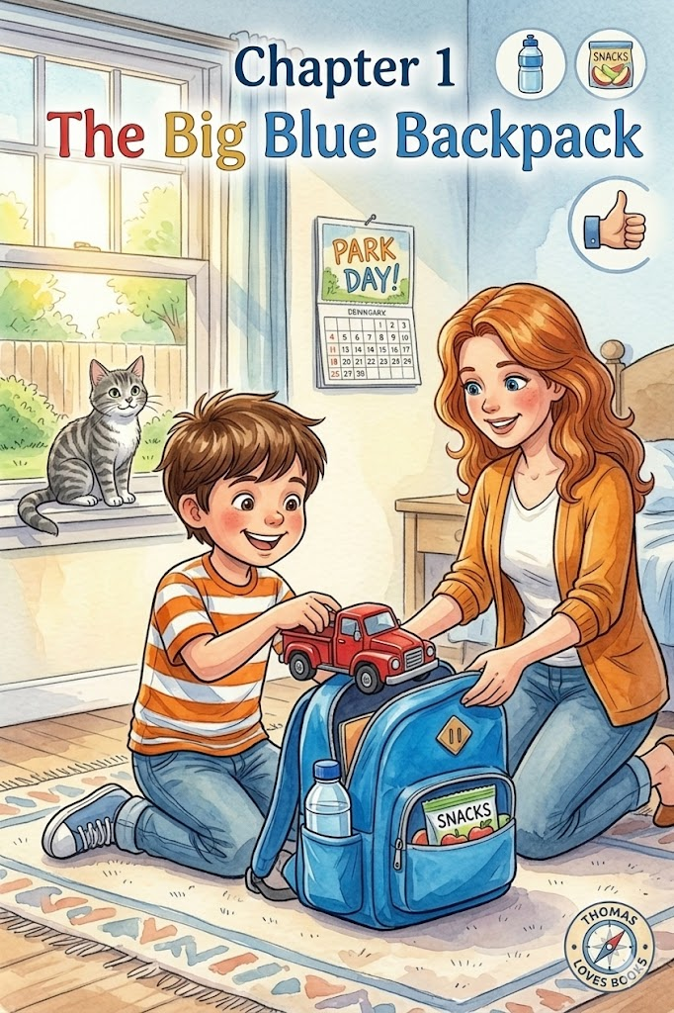
Chapter 1:
The Big Blue Backpack
The morning sun spilled across the floor like a soft wash of gold, and Thomas was already awake. He didn’t need an alarm clock today; his excitement felt big and wiggly inside his chest because it was finally Park Day.
Whiskers, our gray tabby cat, sat on the windowsill with his green eyes wide, watching as Thomas hopped out of bed. "Today is the big day, Whiskers!" Thomas whispered. "We’re going to the park!" Whiskers let out a soft meow, his whiskers twitching as if he were ready for a safari of his own.
The kitchen door opened, and Mom walked in with a warm smile. "Good morning, birthday boy," she said, though his birthday had passed; the nickname stuck because every day felt like a new gift lately. "Are you ready to get our gear together?"
"Ready, Mom!" Thomas shouted, his hair flopping over his eyes as he nodded.
They headed to the hall closet where the big blue backpack lived. Mom explained that every great explorer needs to be prepared before they ever leave the driveway. "Preparation is part of being a safe rider and a smart scout," she said gently.
Together, they laid out the supplies on the kitchen table:
- The Water Bottle: A sturdy bottle filled with cool water to keep the explorer hydrated.
- Healthy Snacks: A small container of sliced apples and granola to keep his energy up for the "Slippery Summit."
- The Favorite Truck: Thomas reached for his favorite toy truck—a bright red one that matched the colors of his brand-new bike.
Thomas carefully tucked each item into the blue backpack. He made sure the zippers were shut tight with a secure click, just like the strap on his blue helmet. He felt a surge of pride as he shouldered the bag. It was a little heavy, but it was the weight of a planned adventure.
"There," Mom said, giving the top of the backpack a light tap. "Now you have everything you need. A safe rider makes sure their path is clear, and a smart explorer makes sure their pack is ready".
Thomas looked at the door. The sun was warm, his pack was snug, and a whole new world of adventures was waiting just past the front door.
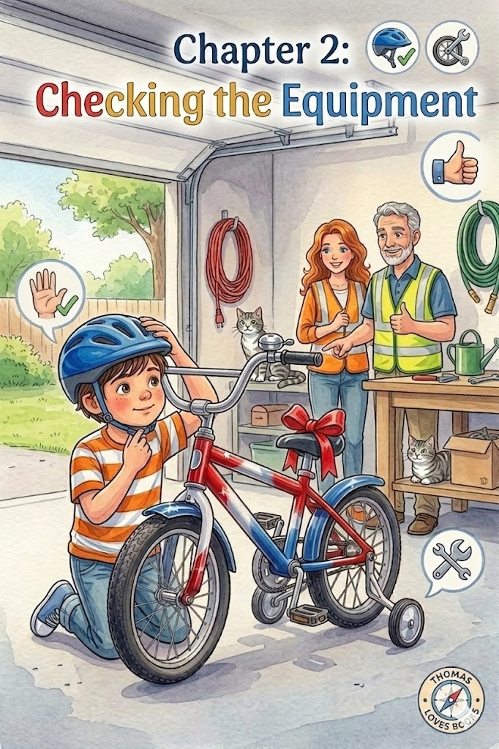
Chapter 2:
Checking the Equipment
With his big blue backpack securely on his shoulders, Thomas marched toward the garage. In his mind, he wasn't just walking across the driveway; he was entering the "Explorer’s Hangar," the place where all his great missions began.
Inside, the garage was tidy and quiet. Thomas headed straight for the "best spot"—the clear space next to the wall where his red, white, and blue bike stood waiting.
"Ready for the final inspection, Captain?" a voice asked. It was Dad, who was busy organizing some garden tools. He looked up with a clean-shaven face and a warm smile, his salt-and-pepper hair catching the light from the open garage door.
Thomas nodded solemnly. He knew that even the most excited adventurer had to follow the most important rule of the road: safety first. He reached for his blue helmet, which hung on its special hook.
"Helmet check!" Thomas announced. He placed the helmet on his head, ensuring it sat level and low—exactly two fingers' width above his eyebrows. He adjusted the side straps into a perfect 'V' shape around his ears and snapped the chin strap shut with a firm, secure click. He gave his head a little shake; the helmet didn't wobble at all.
"Perfect fit," Dad praised, giving Thomas a high-five. "Now, let’s look at your steed."
Thomas knelt next to his bike. He checked the tires to make sure they were firm and ready for the park trails. Then, he reached down to the right side of the rear wheel. He gave the training wheel a firm tug to confirm it was secure and steady.
"The right training wheel is tight, Dad!" Thomas said, his chest swelling with pride. He remembered Dad’s favorite lesson: "If you take care of your gear, your gear will take care of you".
With his helmet snug and his bike in tip-top shape, Thomas gripped the handlebars. Whiskers trotted into the garage, his green eyes watching as Thomas prepared to roll out. The "Playground Safari" was officially ready to begin.

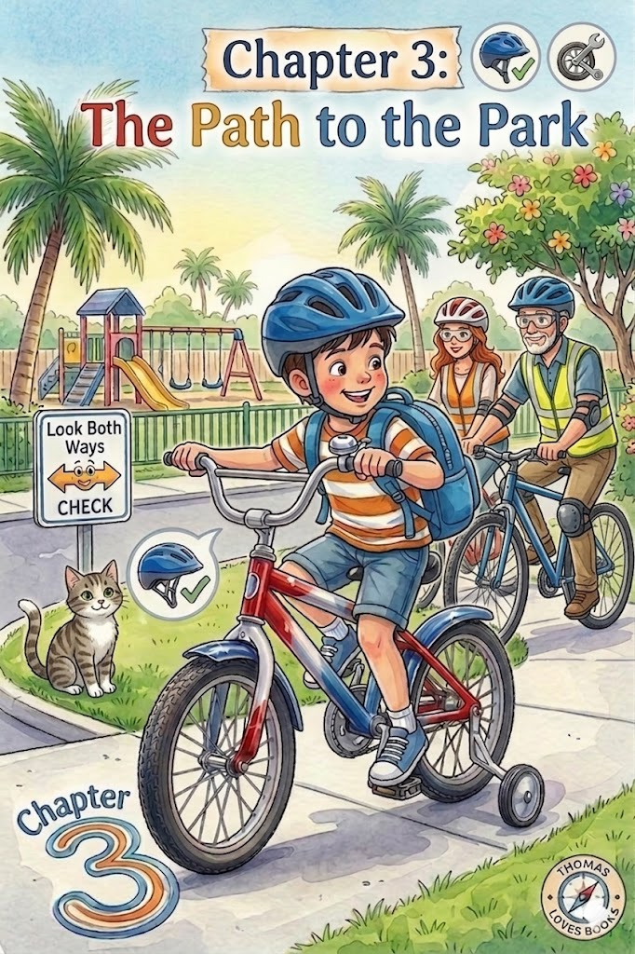Chapter 3:
The Path to the Park
The Florida sun was already high, turning the neighborhood into a shimmering landscape of gold and green. As Thomas pedaled his red, white, and blue bike down the driveway, the warm wind whistled through the vents of his snug blue helmet. He felt like a pilot preparing for takeoff, especially with his big blue backpack settled comfortably against his shoulders.
"Remember, lead explorer," Dad called out from the sidewalk, his salt-and-pepper hair catching the morning light, "the trail is only as safe as the scout who rides it".
Thomas nodded, his face set in a look of serious determination. He knew the first rule of the sidewalk safari: stay on the path. To Thomas, the gray concrete wasn't just a walkway; it was a narrow trail cutting through a vast, untamed jungle. The neatly trimmed hedges of his neighbors' yards were towering walls of emerald vines, and a distant lawnmower sounded just like the roar of a hidden jungle beast.
As he pedaled, his tires made a rhythmic shhh-shhh sound against the ground, and he could hear the steady click of his training wheel on the right side of his bike. It was a comforting sound that told him he was steady and strong.
Up ahead, he saw Mrs. Gable, the friendly neighbor, stepping out to her mailbox. Thomas remembered his "Secret Codes" for being a good communicator. He slowed his pace and reached out with his left thumb.
Ring-ting! Ring-ting!
Mrs. Gable looked up and waved a hand. "Good morning, Thomas! What a polite young man you are," she said with a bright smile. Thomas beamed and gave her a "happy wave" in return, feeling proud that he had alerted her to his presence without startling her.
Soon, the long stretch of sidewalk met the wide, open pavement of the first cross street. This was the "Great Concrete River," the place where the world of exploration met the world of the "metal beasts". Even though he was eager to reach the playground, Thomas knew that momentum wasn't as important as mastery.
He squeezed his brakes firmly, bringing the bike to a smooth, complete stop well before the curb. He didn't just slow down; he made sure his feet touched the ground. Mom and Dad stood beside him, watching as he prepared for the three golden steps.
"Stop, look, and listen," Thomas whispered to himself.
He turned his head far to the left, peering down the long, black asphalt. Then, he turned his head all the way to the right. Finally, he looked left one more time, just to be absolutely sure. He tilted his head, listening for the low hum of an engine or the rumble of tires that might be hidden around the corner.
The street was quiet, and the way was clear.
"Good eyes, Thomas," Mom praised, giving his helmet a light, affectionate tap. "A smart rider always checks twice because cars move much faster than bicycles."
Together, they walked their bikes across the street. Once his tires touched the concrete on the other side, Thomas hopped back onto his seat. He felt a surge of confidence. He wasn't just a boy on a bike anymore; he was a pro who knew that taking a moment to stop was the best way to keep the adventure going.
As the big green gates of the park finally came into view, Thomas adjusted his grip on the handlebars. He could see the tall slide and the swings in the distance. The "Playground Safari" was waiting, and thanks to his careful riding, he had arrived exactly as he intended: safe, smart, and ready for anything.

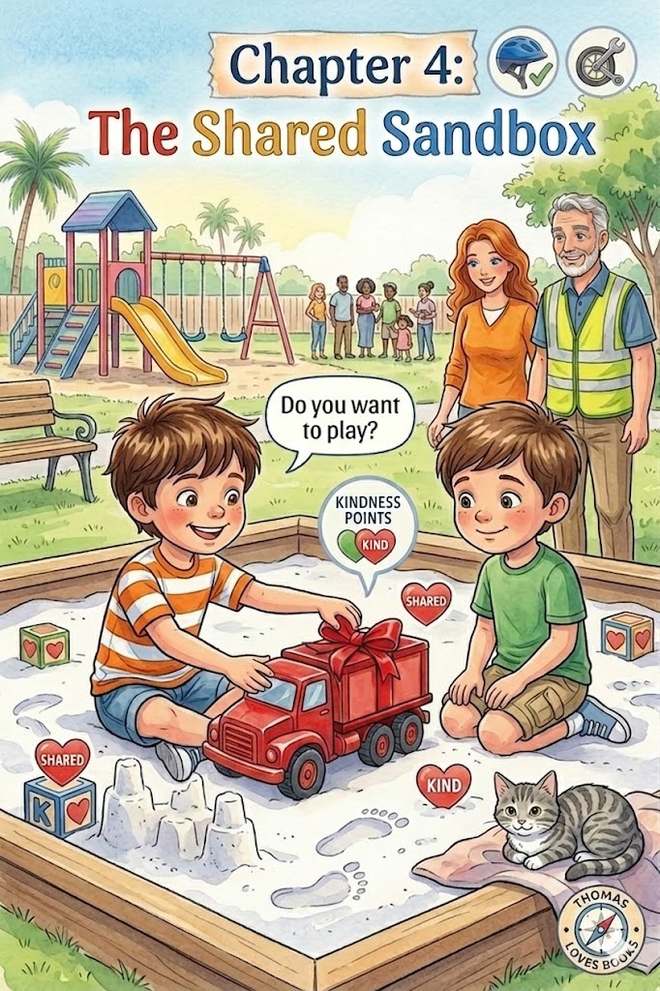Chapter 4:
The Shared Sandbox
The big green gates of the park finally stood before them, towering like the entrance to a magnificent hidden kingdom. Thomas pedaled his red, white, and blue bike through the opening, feeling the change in the ground as the smooth sidewalk gave way to the winding paths of the park. He carefully guided his bike to the "Explorer’s Outpost"—a wooden bike rack near the entrance—and came to a smooth stop.
"Mission reached!" Thomas announced with a grin.
He didn't just hop off and run; he followed his routine. He carefully unbuckled his snug blue helmet and hung it on the handlebars. Then he reached back to make sure his big blue backpack was still secure. Dad, his salt-and-pepper hair catching the Florida sun, gave him a thumbs-up of approval. Mom smiled as she helped Thomas lift the pack off his shoulders so he could retrieve his most important piece of equipment: the bright red toy truck.
Thomas headed straight for the "Great Desert"—the massive, sun-warmed sandbox nestled under the shade of a sprawling oak tree. To Thomas, the sandbox was a place of endless possibilities, where he could dig deep canyons and build towering mountains for his truck to conquer.
As he stepped into the soft, white sand, he noticed he wasn't alone. A boy about his age was sitting near the far edge of the wooden border. The boy, whose name was Sam, was wearing a green T-shirt and was playing alone. Sam was using a piece of a broken twig to draw jagged lines in the sand, watching as the wind slowly filled them back in.
Thomas sat down a few feet away and began to push his red truck through the dunes. Vroom-vroom! The wheels left deep, satisfying tracks in the sand. He imagined he was clearing a path for a rescue mission. Out of the corner of his eye, he saw Sam stop drawing and watch the truck. Sam looked a little lonely, and Thomas could see that he didn't have any shovels, pails, or vehicles to play with.
Thomas gripped his truck a little tighter. He really loved this truck. It was his favorite birthday surprise, and he had been looking forward to playing with it all morning. Part of him wanted to stay in his own corner of the desert and keep the adventure all to himself.
But then, Thomas remembered something special. At home, he had a "Turtle Points Logbook" where he and his parents tracked every time he did something helpful or kind for others. He remembered what Mom always said: "A true explorer doesn't just watch out for himself; he watches out for the whole neighborhood".
Thomas looked at the red truck, then back at Sam. He realized that a "Kindness Point" wasn't just a mark in a book; it was a feeling you shared with a friend.
"Hi," Thomas said, his voice steady and confident, just like when he signaled his turns. "I'm Thomas. Do you want to help me build a mountain road?"
Sam’s eyes lit up with a mix of surprise and joy. "I'm Sam. I don't have a truck today," he admitted quietly.
"That's okay," Thomas replied with a warm smile. "We can share mine. I'll be the lead scout, and you can be the master builder!"
Thomas pushed the red truck across the sand toward Sam. For a moment, his hands felt empty, but his chest felt big and wiggly with a different kind of excitement. Sam took the truck and began to scoop a deep trench, while Thomas used his hands to pile the sand into a tall peak.
Together, the two boys spent the next hour transforming the sandbox. They built a "Great River" for the truck to cross and a "Hidden Valley" where it could park for the night. They practiced their own "Secret Codes," calling out "Watch out for the mountain!" or "Bridge coming through!" to keep their play safe and organized.
Mom and Dad watched from a nearby bench, pride shining in their eyes. They saw that Thomas wasn't just learning how to ride a bike or pack a bag; he was learning the "down-to-earth" practice of being a good friend.
When it was finally time to head toward the swings, Thomas and Sam shook the sand off their sneakers.
"Thanks for sharing your truck, Thomas," Sam said as they walked toward the wooden border. "That was the best safari ever!"
Thomas grinned, tucked his truck back into his big blue backpack, and realized that Sam was right. The truck was great, but the fun was twice as big when he shared it. He had earned a "Kindness Point" in his heart, and he had gained something even better: a new friend to explore with.

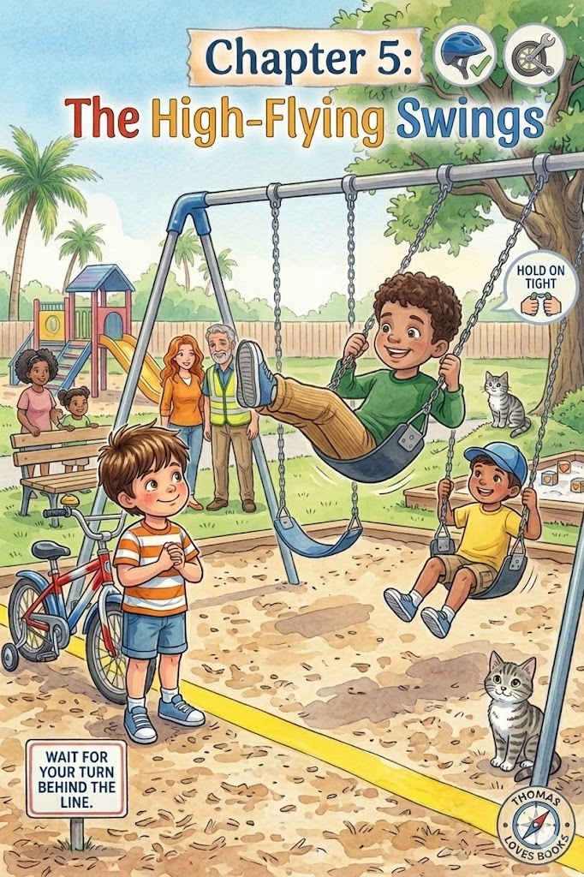Chapter 5:

The High-Flying Swings
With his big blue backpack resting on a nearby bench, Thomas turned his attention to the "Rocket Launchers"—the tall, silver swing set that stood at the edge of the playground. To Thomas, these weren't just swings; they were powerful engines capable of blasting him into the stars.
As he approached, he saw that every swing was already occupied. His best friend, Leo, was soaring back and forth on a bright green seat, his laughter echoing through the air. Thomas felt a tug of impatience; he wanted to launch into space right away.
But then, he remembered Mom’s warm smile and her favorite lesson: "Be patient, Thomas. Good things are worth the wait".
He noticed a bright yellow line painted on the woodchips a few feet in front of the swings. Thomas stopped exactly behind it. He knew this was the "Safety Border." If he stood too close, the "rockets" might accidentally bump into him as they zoomed past.
"Great job staying behind the line, Thomas!" Dad said, his salt-and-pepper hair catching the Florida sun as he stood nearby. "By waiting here, you’re keeping your Space Bubble wide and making sure everyone stays safe".
Thomas stood very still, his eyes tracking the movement of the swings. He watched Leo pump his legs to go higher and keep his hands firmly gripping the chains. Thomas realized that being a "pro" meant knowing when to move and when to stand still.
Finally, the girl at the end of the swing slowed down and hopped off. "Your turn, explorer!" she said with a friendly wave.
Thomas walked forward and took his seat. He didn't just start swinging; he followed his safety checklist.
- Sit Firmly: He made sure he was sitting centered on the seat, not standing or kneeling.
- Two-Hand Grip: He wrapped both hands around the cool metal chains, gripping them tightly.
- Space Check: He looked to his left and right to make sure his "Space Bubble" was clear of other explorers.
"Ready for liftoff?" Mom asked, giving him a gentle, steady push to get him started.
"Ready!" Thomas shouted.
He began to pump his legs—reaching them out toward the clouds and then tucking them back under the seat. With every pump, the "Rocket Launcher" flew higher. The wind whistled through his hair, and the ground below seemed to shrink away.
Whoosh! Whoosh!
In his mind, the park was gone. He was soaring past the Great Oak tree and heading straight for the moon. He felt light and brave, like a real astronaut navigating the stars. But even as he reached the highest point of his swing, he never let go. He kept his hands locked onto the chains, knowing that his "armor" of safety was what made it so fun.
"Look at me, Whiskers! I'm touching the sky!" Thomas called out. Whiskers, watching from the safety of his carrier near the bench, let out a soft meow and twitched his tail as if he were proud of his brave friend.
As the sun moved lower in the sky, Thomas decided it was time to return to Earth. He didn't jump off while the swing was still moving. Instead, he stopped pumping his legs and let the "rocket" slow down on its own. He waited until his sneakers touched the woodchips and the swing came to a complete, smooth halt.
"Mission success!" Thomas said, hopping off the seat.
He looked back at the yellow line, where another boy was now waiting for his turn. Thomas gave him a friendly thumb-up. He realized that the swings were a lot more fun when you knew how to wait, how to hold on, and how to keep everyone in the kingdom safe
The winding path of the park finally led Thomas to the most towering sight in the entire kingdom: the "Metal Mountain Range." To most people, it was just a jungle gym made of shiny bars and colorful platforms, but to Thomas, it was a series of jagged peaks and deep canyons that reached toward the clouds.
Thomas parked his red, white, and blue bike at the edge of the woodchips, carefully ensuring his "Space Bubble" was clear of the other children running nearby. He unbuckled his snug blue helmet and set it on the handlebars, then took a deep breath. Looking up at the highest bar, he felt a little flutter of nervousness in his chest.
"That's a very big mountain, Thomas," Dad said, stepping up beside him. "Every great explorer feels a little small when they face a new climb. But strength isn't just about how fast you can go; it's about how smart you can move."
"How do I get to the top without wobbling, Dad?" Thomas asked, gripping the straps of his big blue backpack.
"We use the Three Points of Contact rule," Dad explained. He pointed to the climbing ladder. "Imagine your hands and feet are like the hooks of a mountain climber. To stay steady, you must always have three parts of your body touching the mountain at the same time."
Thomas watched as Dad demonstrated on the lowest rung. "If you have two hands and one foot on the bars, you are steady. If you have two feet and one hand, you are steady. But if you try to move your hand and a foot at the same time, you might lose your balance."
Thomas stepped onto the first orange rung. One foot. He reached up and gripped the bars with both hands. One, two. "I have three points, Dad!" Thomas cheered.
He moved his second foot up. Now he had four points of contact. He felt as solid as the Great Oak tree. Slowly, he moved his left hand higher, keeping both feet and his right hand firmly gripped. He counted them out loud as he climbed: "One... two... three... steady. One... two... three... steady."
Halfway up, Thomas stopped. He looked down at the woodchips below. Suddenly, the ground seemed very far away. His hands felt a little sweaty, and the next bar looked just out of reach. He felt like turning back.
"Keep your eyes on the next grip, Thomas," Mom encouraged from the bottom, her warm smile giving him a boost of courage. "Don't look at the whole mountain. Just look at the next step."
Dad leaned closer to the bars. "This is the secret of the trail, Thomas. Whenever a journey feels too big—whether it's climbing a mountain or learning something new at school—you don't have to do it all at once. You just need to find your three points of contact. Find your focus, take one steady step, and then find your next one."
Thomas took a deep, shaky breath. He didn't look at the top of the gym, and he didn't look at the ground. He looked only at the shiny silver bar just inches above his head. He moved his right hand. One. He moved his left hand. Two. He stepped up with his right foot. Three. He was steady. He was strong.
With one final push, Thomas hauled himself onto the top platform. He stood tall, looking out over the entire park. From up here, he could see the duck pond shimmering like a blue jewel and his bike waiting patiently at the "Explorer's Outpost".
"I did it!" Thomas shouted, his voice echoing with pride.
"You certainly did," Dad said, reaching up to give Thomas a high-five. "And remember the lesson of the mountain: you were strong enough the whole time. You just had to be patient enough to take it one step at a time."
Thomas realized that being a "strong" explorer wasn't about being the biggest or the fastest. It was about having the focus to stay safe and the patience to keep moving, even when the climb felt steep.
As he prepared to descend the "Slippery Summit" slide, Thomas felt like a true veteran of the park safari. He knew that no matter how big the next mountain was, he had the tools to conquer it—one steady point at a time.

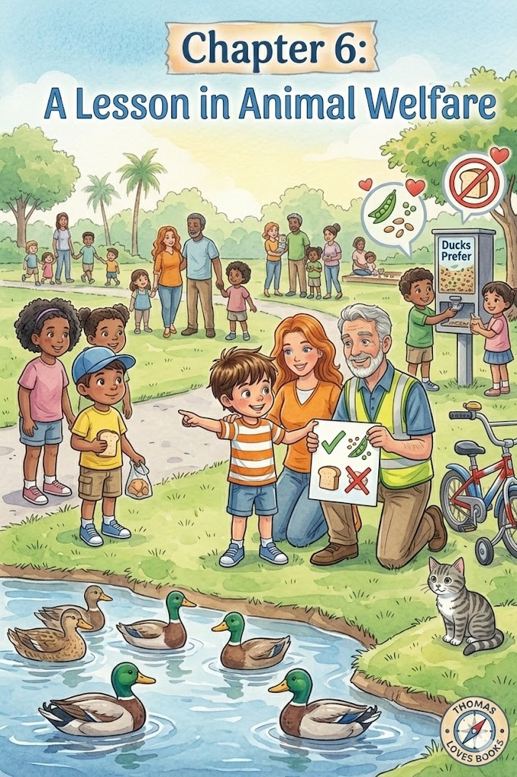Chapter 6:
A Lesson in Animal Welfare
The winding path of the park led Thomas toward the shimmering center of the kingdom—the "Great Inland Sea". As he pedaled his red, white, and blue bike, the silver bell gave a happy ring-ting! to a passing butterfly. Thomas brought his bike to a smooth, controlled stop near the wooden railing of the duck pond, remembering to keep his "Space Bubble" wide for a family of turtles sunning themselves on a nearby log.
He unbuckled his snug blue helmet and set it carefully on his handlebars. "Look, Mom!" Thomas whispered, pointing toward a group of mallards paddling near the reeds. "They’re having a meeting!"
But as they watched, Thomas noticed a group of people standing on the small stone bridge. They were laughing and tossing large chunks of white bread into the water. The ducks were scrambling over each other, splashing wildly to grab the floating pieces. Thomas felt a little tug of worry in his chest. He remembered the stories Dad told him about bird rehabilitation and how important it was to treat wildlife with the right kind of kindness.
"Mom," Thomas said softly, "should they be doing that? I remember we talked about how bread is like 'empty fuel' for their feathers".
Mom knelt beside him, her warm smile encouraging. "You have a very sharp eye, explorer. Tossing bread feels like sharing a treat, but it’s actually a mistake that can make the ducks very sick. Why don’t we help them understand?".
Thomas took a deep breath, feeling like a true "Neighborhood Scout". He walked toward the bridge, holding Mom’s hand. "Excuse me," Thomas said, his voice steady and polite, just like when he used his bell to greet neighbors. "Did you know that bread can give ducks 'wobbly wings'?"
The people on the bridge stopped and looked down at the small boy in the striped shirt. A girl about Thomas's age looked curious. "Wobbly wings?" she asked.
Mom stepped forward to help. "Thomas is right," she explained gently. "In the world of Animal Welfare, we learn that ducks need vitamins to grow strong, just like we do. Bread is like eating nothing but candy—it fills their tummies, leaving no room for the healthy grass and bugs they need. It can even lead to a wing problem called 'Angel Wing' that makes it hard for them to fly".
Thomas reached into his big blue backpack and pulled out a small, reusable container. "We brought some explorer snacks!" he said, showing them the contents. "Our duck friends much prefer frozen peas, oats, or special birdseed. It helps them stay strong for their long flights!"
The girl’s father looked at the bread in his hand and then at the ducks. "We didn't know we were hurting them," he said. "We just wanted to be their friends."
"The best way to be their friend is to keep them healthy," Thomas said with a wide smile. He offered to share some of his birdseed with the girl. Together, they tossed the tiny seeds into the water. Instead of a wild scramble, the ducks tilted their heads and began to forage naturally, their emerald-green feathers glistening in the bright Florida sunshine.
As they walked back to their bikes, Thomas felt a surge of pride even greater than the one he felt when he conquered the "Metal Mountain Range". He had used his voice to protect those who couldn't speak for themselves.
"You did a great job today, Thomas," Mom said, giving his shoulder a proud squeeze. "Understanding the difference between just being 'nice' and practicing true animal welfare is what makes you a great protector of the kingdom".
Thomas looked back at the pond. The ducks were peaceful, the water was clear, and he knew he had earned a very special "Kindness Point" in his heart. He realized that a real explorer doesn't just navigate the trail; they make sure every creature they meet stays safe and healthy along the way.

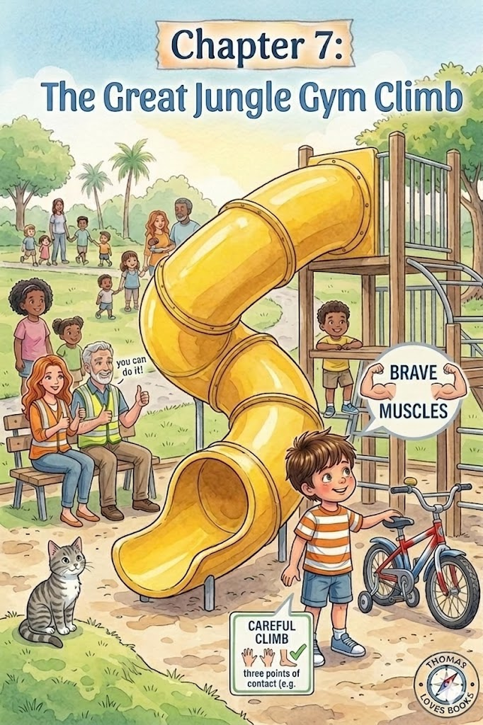Chapter 7:
The Great Jungle Gym Climb
The afternoon sun was warm on Thomas’s neck as he stood at the base of the "Giant’s Tongue"—the tallest, brightest yellow slide in the entire park. To a grown-up, it was just a piece of playground equipment, but to Thomas, it was a towering mountain peak that reached toward the clouds. He stood very still, his hands gripping the straps of his big blue backpack, feeling a little flutter of "tummy-butterflies".
"It looks much taller from down here, doesn't it, explorer?" Dad asked, kneeling beside him. Dad’s salt-and-pepper hair caught the light, and his clean-shaven face broke into a supportive smile.
Thomas nodded, his hair flopping over his eyes. "My legs feel a little bit like jelly, Dad."
"That’s okay," Dad said gently. "Even the bravest scouts feel like jelly sometimes. Courage isn't about not being scared; it’s about using your 'brave muscles' to move forward anyway. But remember: a brave explorer is always a careful one."
Before the climb could begin, Thomas followed his safety routine. He knew that while his blue helmet was perfect for riding his red, white, and blue bike, it wasn't for climbing on the jungle gym because the straps could get snagged. He carefully unbuckled it and handed it to Mom.
"Armor off, brave muscles on!" Thomas announced.
The Explorer's Climbing Rule: Three Points of Contact
To stay steady on the "Metal Mountain Range," an explorer must always have three parts of their body touching the ladder at the same time—like two hands and one foot, or two feet and one hand. This keeps your "Space Bubble" stable and your body safe.
Thomas reached out and gripped the first silver rung. One. He gripped with his other hand. Two. Then, he lifted his right foot and placed it firmly on the bottom step. Three. "I'm steady!" Thomas whispered.
He didn't look up at the very top, and he didn't look down at the woodchips. He focused only on the next rung. One step. One grip. He moved his "brave muscles" slowly and with purpose. He remembered what Mom always taught him about moving gently and being careful.
As he reached the middle of the ladder, the wind picked up, whistling through the bars. Thomas paused. His heart was thumping with big, wiggly excitement, but he kept his hands locked tight. He didn't rush. He waited until he felt steady before taking the next step.
"You’re doing it, Thomas!" Mom called out from below, her warm smile giving him a boost of "explorer energy". "One rung at a time!"
Finally, Thomas reached the very top platform. He hauled himself up and stood tall, looking out over the "Sidewalk Safari" path he had traveled to get here. From up here, he could see the duck pond shimmering like a blue jewel and the Great Oak tree standing proud in the distance. He felt like a king standing on his balcony.
He sat down at the top of the "Giant’s Tongue," making sure his feet were straight in front of him and his hands were gripping the side rails. He took a deep breath, feeling his "brave muscles" relax into a big, happy grin.
"Ready for the descent?" Dad asked from the bottom, waiting with open arms.
"Ready!" Thomas shouted.
With a little push, he zoomed down the slide. Whoosh! The wind rushed past his face, and for a second, he felt like he was flying. When his feet finally hit the woodchips at the bottom, he did a little victory dance.
"I used my brave muscles and my smart brain!" Thomas cheered.
Mom gave him a big hug. "That’s the best way to explore, Thomas. You showed that you can be courageous and physically careful at the same time".
Thomas looked back up at the tall yellow slide. It didn't look like a scary mountain anymore; it looked like a friend. He realized that when you take things one rung at a time, there isn't any mountain in the world you can't conquer.

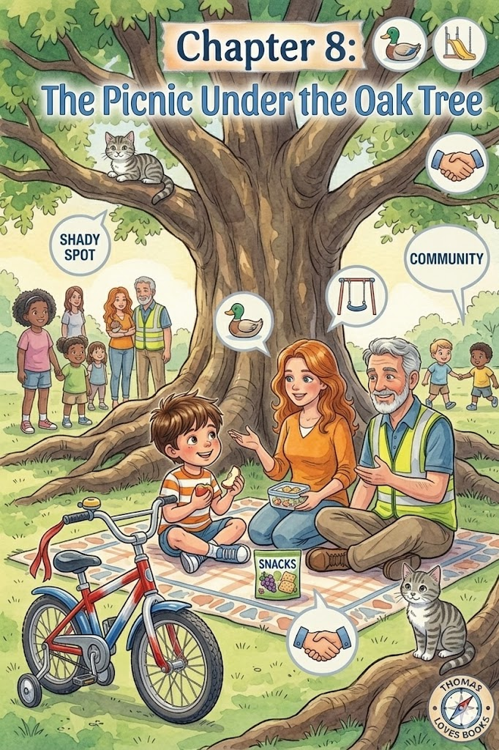Chapter 8:
The Picnic Under the Oak Tree
The afternoon sun was turning the neighborhood into a shimmering landscape of gold and green, and Thomas felt a pleasant tiredness in his legs. After his "High-Flying" adventure on the swings and his "Great Climb" up the slide, he was ready for a well-earned break.
"Look, Mom! The Great Oak!" Thomas pointed toward a tree so massive its branches seemed to touch the clouds. To Thomas, the tree was a giant guardian of the park, offering a vast canopy of shade that felt like a secret emerald tent.
They walked toward the tree, Thomas carefully guiding his red, white, and blue bike over the soft grass. He made sure his "Space Bubble" was wide enough so his tires didn't disturb a group of tiny blue flowers growing near the roots. Once they reached the deepest part of the shade, Thomas engaged his kickstand and unbuckled his big blue backpack.
Mom spread a soft blanket on the ground. Whiskers, the gray tabby cat, watched from his carrier with curious green eyes, his whiskers twitching as he sniffed the fresh, clover-scented air.
"Time for an explorer’s feast," Mom said with a warm smile.
Thomas reached into his pack and pulled out the containers they had prepared that morning:
- The Water Bottle: To stay hydrated after his trek.
- Healthy Snacks: Sliced apples and crunchy granola.
As they ate, the park felt peaceful. Thomas watched a group of children playing tag and a neighbor walking a golden retriever. He realized the park was like a big, moving team where everyone had a part to play.
"We’ve seen a lot of people on our safari today, haven't we?" Mom asked, tilting her head to watch a butterfly flutter past.
Thomas nodded, his hair flopping over his eyes. "We met Sam in the sandbox! I shared my red truck, and we built a giant mountain road together". He felt a surge of pride remembering how his "Kindness Points" made the desert adventure even better.
"And we helped the ducks stay healthy," Thomas added. He remembered the lesson on Animal Welfare and how proud he felt explaining that ducks need "superhero fuel" like peas and seeds instead of bread.
Mom took a bite of an apple and looked at the distant flower garden. "And don't forget Mrs. Gable and her missing treasure".
"The Case of the Missing Scarf!" Thomas cheered. "I used my 'scout eyes' to spot it. Being a Neighborhood Scout is a big job, Mom".
"It is a big job," Mom agreed softly, giving the top of his head a light, affectionate tap. "The park is a community, Thomas. That means it belongs to everyone—the ducks, the neighbors, and the explorers. When we use our eyes to observe and our hearts to be kind, we make the whole kingdom a better place".
Thomas leaned back against the sturdy trunk of the Great Oak. He watched a squirrel dart across the path and remembered to stay very still, just like he had at the duck pond. He realized that being a great adventurer wasn't just about how fast he could pedal; it was about the responsibility he felt when he watched out for the neighborhood around him.
The big blue backpack was lighter now that the snacks were gone, but Thomas’s heart felt full. He had learned that every person and animal he met was a part of his story. By being a quiet observer and a helpful friend, he wasn't just visiting the park—he was helping to take care of it.
With the sun beginning to dip lower, Thomas stood up and began to pack his gear. He didn't leave any crumbs or wrappers behind, knowing that a safe rider always keeps the path clear for everyone else.
"Ready for the final leg of the safari?" Mom asked.
"Ready!" Thomas said, reaching for his blue helmet.
The "Playground Safari" was almost over, but Thomas knew the lessons of the Great Oak would stay in his heart long after they reached home.

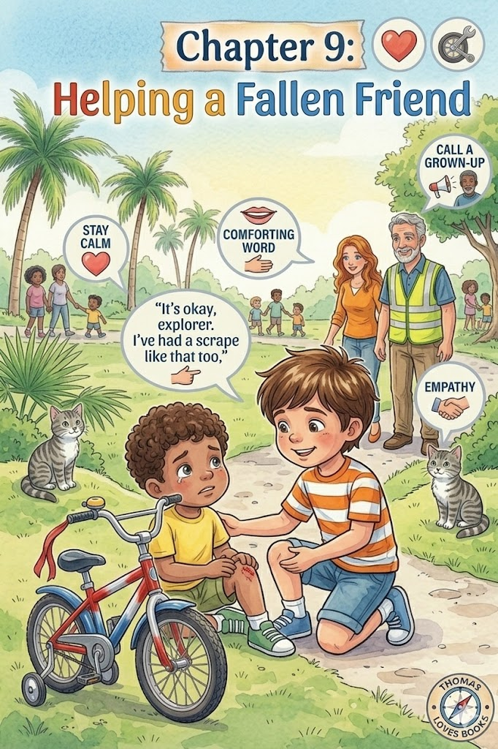Chapter 9:
Helping a Fallen Friend
The golden hour had arrived, painting the neighborhood in a beautiful canvas of burnt orange and soft violet. Under the Great Oak tree, Thomas carefully zipped his big blue backpack, making sure his water bottle and empty snack containers were tucked away securely. He didn't want any "trail litter" left behind in the kingdom.
"Ready to roll back to the Outpost, lead explorer?" Mom asked, smoothing out the picnic blanket.
"Ready, Mom!" Thomas replied. He reached for his snug blue helmet, clicking the chin strap shut with that familiar, secure sound. He gripped the handlebars of his red, white, and blue bike, feeling like a true veteran of the playground safari.
As they walked their bikes toward the park exit, Thomas kept his "scout eyes" moving. He watched the shadows grow long and thin across the sidewalk, remembering how his bike’s colors could start to look dull and gray in the gathering gloom. Suddenly, a flash of movement caught his eye near the park's central fountain.
A younger child—a boy who looked only three or four years old—was running happily toward a group of pigeons. In his excitement, the little boy didn't see a small, uplifted root near the edge of the path. His front sneaker caught the wood, and before he could stop himself, he went down with a dull thud and a sharp scrape against the pavement.
The park seemed to go very quiet for a second. The little boy sat on the concrete, his eyes wide and beginning to fill with tears. He looked at his knee, where a small, red scrape had appeared.
Thomas felt a sharp sting of memory. He remembered his own "High-Speed Recon Mission" when his front tire hit a patch of loose gravel and he ended up on the ground. He remembered how fast his heart had raced and how much he wanted to cry.
But then, he remembered what Dad always said: "The most important part of falling isn't the scrape, Thomas. It's staying calm".
Thomas didn't panic. He carefully set his bike down on its side—not dropping it, but placing it gently on the grass so it wouldn't be a trip hazard for others. He walked over to the younger child and knelt a safe distance away.
"Deep breaths, explorer," Thomas said softly, using the same calm voice Dad used when Thomas had his own wobbly knee. "It’s okay. I’ve had a scrape just like that before."
The little boy looked up, blinking back his tears. He saw Thomas’s friendly face and his sturdy blue helmet. He seemed to feel a little less scared because Thomas wasn't scared.
"It stings," the boy whispered.
"I know it does," Thomas replied with a comforting nod. "But you’re a brave rider. You just need a little help from the Big Scouts."
Thomas didn't try to move the boy or fix the scrape himself. He knew that some missions required the help of a grown-up leader. He stood up, stayed right where he was so the boy wouldn't feel lonely, and called out clearly.
"Mom! Dad! We need a medic at the fountain!"
Mom was already jogging over, carrying the small green first-aid kit she always kept in her bag. A woman, who was the little boy’s mother, came running from the nearby swings, her face full of worry.
"He just tripped, ma'am," Thomas explained calmly as the adults took over. "He’s being very brave."
Thomas watched as the boy's mother gathered him into a hug and Mom cleaned the scrape with a gentle wipe. Soon, a bright blue bandage—just like Thomas’s "Magic Band-Aid"—was pressed onto the boy's knee. The tears stopped, and a small, shaky smile returned to the boy's face.
"Thank you for staying with him, Thomas," the boy’s mother said, looking up with a grateful smile. "You were a real help."
As they walked back to their bikes, Thomas felt a surge of pride that was different from the excitement of the slide or the swings. It was a warm, steady feeling in his chest.
"You did exactly the right thing, Thomas," Mom said, giving his shoulder a proud squeeze. "A true explorer has empathy. That means you understood how he felt because you’ve been there too. And you knew that calling for a grown-up is the smartest way to handle a big problem".
Thomas hopped back onto his seat and gripped the handlebars. He felt like he had earned a very special "Kindness Point" for his Turtle Points Log Book. He realized that being a "Neighborhood Scout" wasn't just about following the rules—it was about being the kind of friend who stays calm and helps others find their way back to a smile.
Whiskers let out a soft, approving meow from his carrier, and Thomas gave his silver bell one last, happy ring-ting!. The mission was a success, not because he went fast, but because he knew how to stop and be a hero for a friend in need.

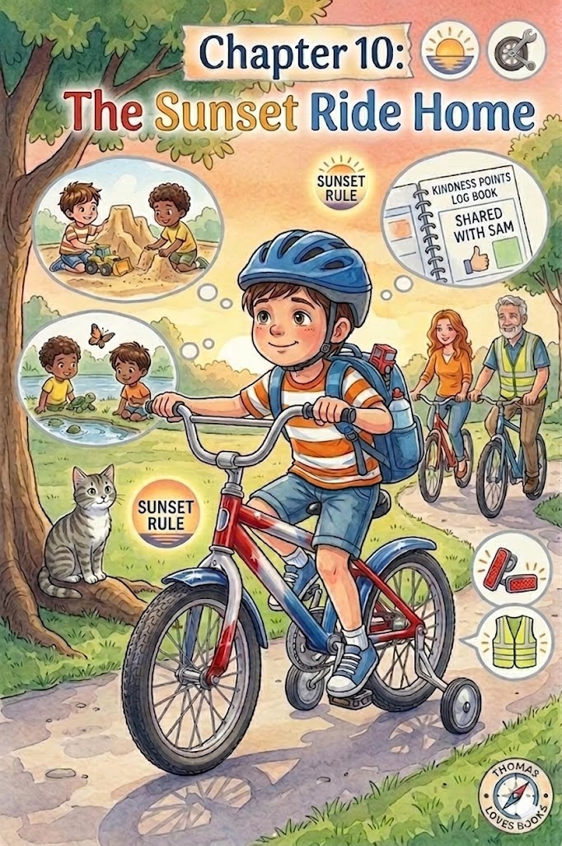Chapter 10:
The Sunset Ride Home
The Florida sky was beginning to transform into a beautiful canvas of burnt orange and soft violet. As the shadows of the Great Oak grew long and thin across the grass, Thomas noticed how the vibrant colors of the playground were starting to look dull and gray in the gathering gloom.
"Time to head back, explorer!" Dad called out, his voice carrying clearly through the cooling air. Thomas stood up from the picnic blanket and felt a pleasant tiredness in his legs—the kind of tired that comes after a day full of jungle safaris, sandbox missions, and brave climbs.
Before touching his pedals, Thomas followed the "Sunset Rule". He knew that when the sun starts to tuck itself into bed, it becomes much harder for neighbors and drivers to see a little explorer on a bike. Mom helped him zip up his bright yellow safety vest over his shirt, ensuring he would glow like a firefly in the dusk.
"Are the reflectors clean, Thomas?" Dad asked, kneeling by the red, white, and blue bike.
Thomas checked the small plastic circles on his spokes and the back of his seat. He even wiped a smudge of "jungle mud" off the chrome frame to make sure the light would bounce off it like a mirror. "Reflectors are ready, Dad! They’re my secret signal that says, 'Here I am!'".
With his big blue backpack snug on his shoulders and his favorite red truck tucked inside, Thomas pedaled out of the park gates. As he rode carefully along the sidewalk, his mind was busy with happy thoughts. He thought about his new friend, Sam, and how much fun they had building the mountain road in the sandbox.
"Next time," Thomas whispered to himself, "I’ll bring my toy bulldozer so Sam and I can make an even bigger canyon!" He began to plan his next visit—maybe they could explore the butterfly garden together or see if the turtles were still sunning themselves by the pond.
Even though he was tired, Thomas didn't forget his training. As he approached each street corner, he brought his bike to a smooth, complete stop. He turned his head far to the left, then all the way to the right, and left once more, listening for the low hum of engines in the twilight.
"The coast is clear," he announced, giving his silver bell a final, tired ring-ting! for the day.
When they finally pulled into the driveway, Thomas guided his bike over the lip of the garage and into the "best spot"—the clear space next to the wall, away from the path where people walked. He made sure the kickstand was down firm and steady so his trusty steed wouldn't tip over in the dark.
"If you take care of your gear, your gear will take care of you," Thomas said, repeating Dad’s favorite lesson as he placed his blue helmet on its special hook.
Mom gave him a warm hug. "You were a very safe rider today, Thomas. And a very kind friend, too".
Whiskers, the gray tabby cat, trotted out to meet them, his green eyes watching as the big garage door closed with a soft thud. As Thomas headed inside for dinner, he looked back at his bike, which sat peaceful and ready in its corner. He knew that with his family by his side and the rules of the road in his heart, every day was a chance for a new adventure.

Epilogue

As the stars began to twinkle over the quiet Florida neighborhood, Thomas sat at his small wooden desk, his messy chestnut hair still windswept from the ride home. He carefully opened his Kindness Points Log Book to the very last page.
With a bright orange crayon, he drew a big star next to the day's successes:
- Shared my red truck with Sam.
- Told the neighbors about the ducks’ special snacks.
- Used my "brave muscles" on the Big Slide.
Whiskers, the gray tabby, jumped onto the bed and let out a soft, green-eyed purr, as if she were checking his work. Thomas smiled, feeling the warmth of a day well-spent. He realized that the "Playground Safari" wasn't just about the swings or the slides—it was about how he treated the people and animals he met along the way.
Mom leaned against the doorway with a gentle smile, her auburn hair catching the hall light, while Dad—looking sharp and clean-shaven—carried in a fresh glass of water.
"Ready for sleep, Scout?" Dad asked.
"Ready," Thomas whispered, climbing into bed.
As the lamp was turned off, Thomas closed his eyes, already imagining where his red, white, and blue bike would take him tomorrow. With his big blue backpack and a heart full of kindness, he knew that every corner of his world was a kingdom waiting to be discovered.

The End (for now!)

About the Author
www.scottMbooks.com

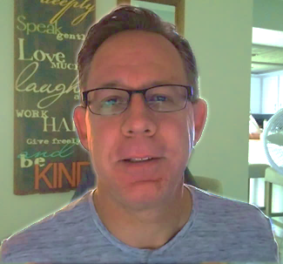
Scott Speicher brings a unique blend of life experiences to his writing. A U.S. military veteran, he carries the discipline, resilience, and perspective gained through service into every story he tells. After his military career, Scott built a successful path in marketing, where he developed a deep understanding of communication, storytelling, and audience engagement. For more than 15 years, he has also worked as a professional website designer, helping businesses and individuals create meaningful online presences.
Scott Speicher is a storyteller who enjoys creating gentle, heartfelt stories that help children notice the small moments that make life meaningful. Through warm characters and simple adventures, his books encourage young readers to slow down, care for others, and appreciate the quiet joys of everyday life. Scott believes that some of the most important lessons children learn come not from grand events, but from the ordinary moments shared with family, friends, and the animals they love.
In Thomas Loves the Park, Scott brings that belief to life through a tender story about friendship, patience, and the special bond between a child and his community. Thomas sets out for a day of mindful discovery. From sharing his favorite toy truck in the sandbox to educating others about animal welfare at the pond, he demonstrates how small acts of kindness make a big difference. He bravely conquers the "Big Slide" and helps a fallen friend, proving that empathy is the most important tool in an explorer’s kit. The journey ends with a safe ride home at sunset, leaving Thomas—and young readers—ready for the next adventure.
Suitable for readers aged 4-10 and for family read-aloud sessions. Ideal for SEL, guidance, and service-learning.

