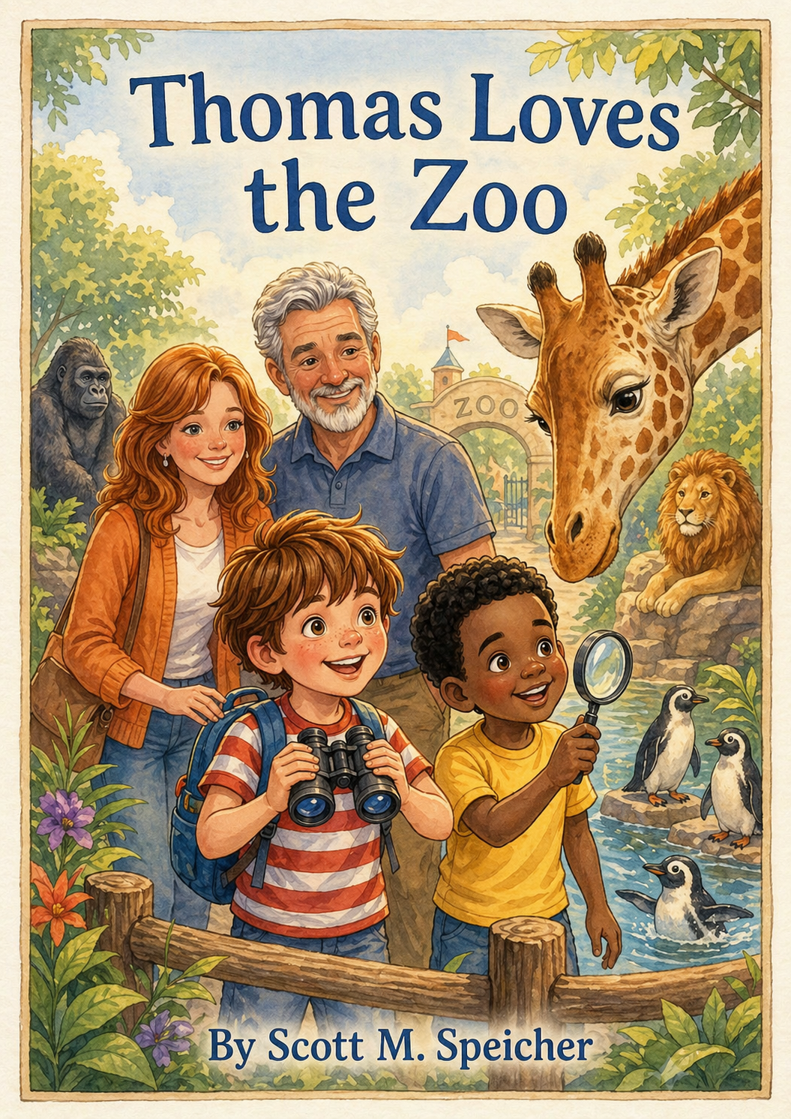Table of Contents
Chapters
- Preface: A Note from the Author
- Chapter 1: The Golden Ticket
- Chapter 2: The Tallest Hello
- Chapter 3: The Great Penguin Parade
- Chapter 4: Jungle Hide-and-Seek
- Chapter 5: The Peanut Butter Predicament
- Chapter 6: Roar Like a King
- Chapter 7: The Gift Shop Dilemma
- Chapter 8: Dreaming of Stripes
- Chapter 9: The Backyard Expedition
- Chapter 10: The Legend of Turtle Point
- Epilogue: The Explorer’s Legacy

About The Book
Every great journey begins with a single step, but for a child, it often begins with a single moment of wonder.
The story you are about to read, Thomas Loves the Zoo: The Big Discovery, is more than just a recount of a day spent looking at exotic animals. It is a celebration of the curiosity that lives within every child—the kind of curiosity that transforms a backyard into a jungle and a simple red striped shirt into a suit of armor.
As a writer, my goal has always been to weave essential life lessons into the fabric of adventure. Through Thomas’s eyes, we see that the world is a classroom without walls. Whether he is learning patience from a napping lion, the value of observation from a camouflaged lizard, or the quiet power of empathy through a shared moment with a gorilla, Thomas reminds us that growing up is the ultimate expedition.
This book is dedicated to the explorers who aren't afraid to ask "why," to the friends like Leo who make every discovery twice as fun, and to the parents who provide the "golden tickets" that spark a lifetime of learning.
So, grab your binoculars, straighten your lucky shirt, and prepare to see the wild world in a whole new way. The gates are open, the sun is high, and Thomas is ready to lead the way.
Scott M. Speicher

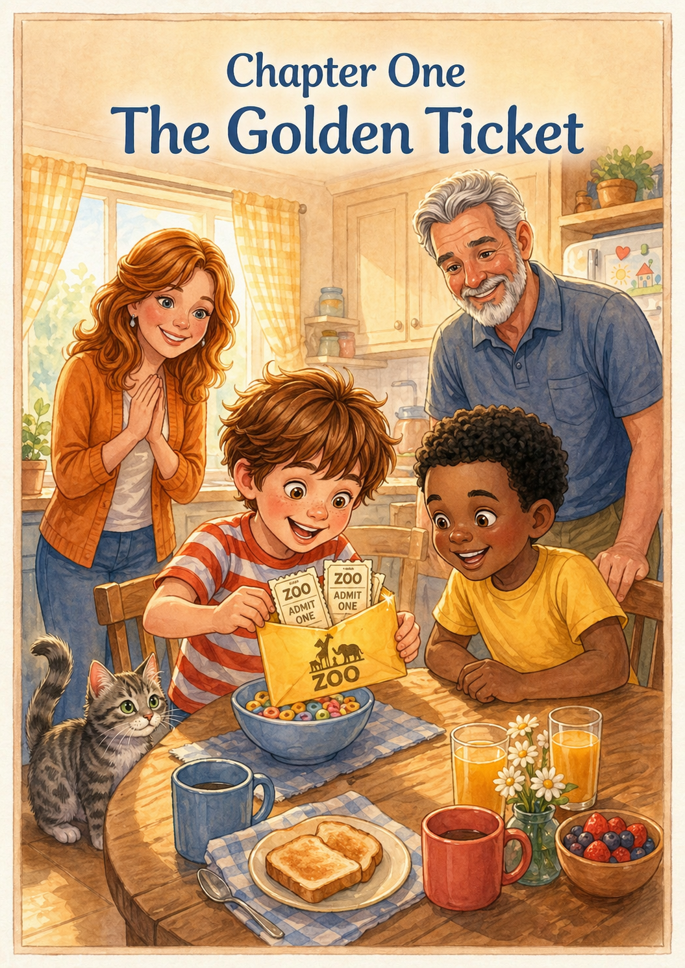Chapter 1: The Golden Ticket
The morning sun poked through the kitchen curtains, painting the walls in soft watercolors of orange and pink. Thomas sat at the breakfast table, swinging his legs with restless energy, while his friend Leo sat across from him, munching on a piece of cinnamon toast. Leo had slept over the night before, and the two were already deep in a debate about whether a shark could outrun a cheetah. The house smelled of maple syrup and adventure, but the biggest surprise was still hiding right under Thomas's cereal bowl.
"What's that yellow thing sticking out?" Leo asked, pointing a sticky finger toward the base of the bowl. Thomas frowned, tilted the blue ceramic dish, and pulled out a bright yellow envelope. His heart gave a little thump as he slid his thumb under the flap and pulled out two glossy tickets featuring the silhouette of a roaring lion. "The City Zoo!" Thomas shouted, his voice nearly waking the cat, Tia. Leo jumped up so fast his chair wobbled. "Today? We’re going today?"
Mom and Dad shared a knowing smile over their coffee mugs. "The expedition leaves in thirty minutes," Dad announced. The kitchen, usually a place for slow morning yawns, suddenly transformed into a buzzing headquarters. Thomas and Leo scrambled away from the table, their sneakers squeaking against the floorboards like a drumroll for the start of a great journey. They had to get ready, and a true explorer knows that preparation is the most important part of any mission.
The boys sprinted to Thomas’s room, where the floor was already a sea of discarded socks and comic books. "We need uniforms," Thomas declared, digging through his dresser with frantic determination. He finally emerged with his "lucky" red striped shirt, while Leo pulled on a bright yellow t-shirt that made him look like a stray patch of sunshine. Thomas checked himself in the mirror, smoothing out the stripes; he felt brave, observant, and ready to face any creature from a giraffe to a gorilla.
Next came the "Survival Kits." Thomas grabbed his green backpack and laid it flat on the bed like a doctor preparing for surgery. He carefully tucked in his binoculars—which were a bit dusty but still sharp—and his notebook with a fresh yellow pencil. Leo, meanwhile, was in charge of "Special Ops," packing a magnifying glass he’d found in the toy box and a small plastic compass that pointed mostly toward the kitchen. They worked with silent focus, knowing that a missing tool could mean the difference between a discovery and a disaster.
"Wait! The emergency energy!" Leo whispered, eyes wide. Thomas nodded solemnly and checked his secret desk drawer. He found a granola bar that was a little bit squished and a small bag of pretzels from the day before. He stuffed them into the side pocket of the bag right next to his water bottle. In the wild, he told Leo, you never knew when you might get stranded near the penguin pool without a snack.
"Thomas! Leo! The safari jeep is leaving!" Dad called out from the hallway. Thomas realized he had almost forgotten the map he had drawn of the zoo from memory the night before. He snatched the crumpled paper and shoved it into his front pocket, feeling the weight of the bag settle onto his shoulders. The straps dug in just the right amount—a sign that they were carrying everything an explorer could possibly need for a day in the savanna.
They took one last look around the room. Thomas gave his stuffed cat, Tia, a quick salute for luck, while Leo checked his shoelaces one last time to make sure they were tied in double knots. They looked at each other and nodded. They weren't just two boys in a bedroom anymore; they were a team, a duo of discoverers ready to map the unknown. With their chests puffed out, they marched toward the door, their backpacks jingling with the sound of plastic and promise.
In the living room, Mom was waiting with the sunhats and the car keys. "Got everything, Team Thomas?" she asked with a wink. Thomas patted his backpack, feeling the crinkle of the tickets inside his pocket. He felt a flutter of butterflies in his stomach—the good kind, the kind that meant a big discovery was waiting just around the corner. The front door swung open, letting in the warm South Venice breeze and the distant, imagined roar of a lion.
As they climbed into the backseat of the car, Thomas and Leo pressed their faces against the glass, watching their neighborhood fade away. The yellow tickets were tucked safely away, and the map was ready to be unfolded. Today wasn't just a Saturday; it was the day they would see the tallest necks and the fastest flippers in the world. As the car pulled out of the driveway, Thomas gripped his backpack straps and smiled—the first chapter of their big adventure had officially begun.

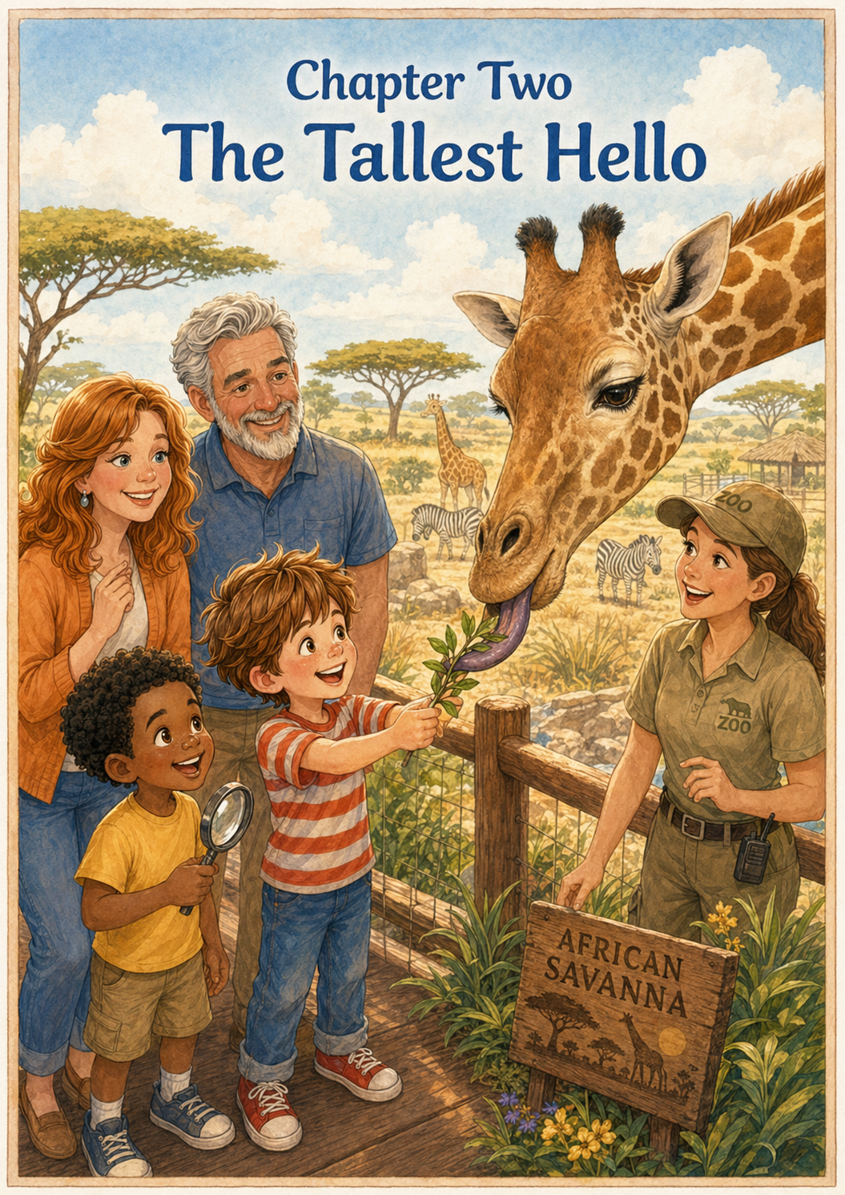Chapter 2: The Tallest Hello
The car had barely come to a halt in the gravel lot before Thomas and Leo were unbuckling their seatbelts with practiced, synchronized speed. The air outside the zoo gates was thick with the scent of sun-warmed hay and sweet kettle corn. Thomas gripped his backpack straps tightly, his red striped shirt standing out brightly against the sea of tourists, while Leo adjusted his yellow shirt, looking like a bright spark of energy at Thomas’s side. With Mom and Dad leading the way, the two friends marched through the turnstiles, their eyes darting left and right to take in the colorful banners fluttering in the Florida breeze.
Their first stop was non-negotiable: the African Savanna. Thomas had read about the vast plains, but seeing the enclosure in person felt like stepping into a giant painting. Leo pointed toward the horizon, his magnifying glass already out as if he could see the distant animals better. Thomas hurried toward the wooden observation deck, his binoculars swinging rhythmically against his chest. He didn't need the lenses just yet, though, because something very large and very spotted was already heading their way.
From behind a cluster of acacia trees, a long, elegant neck rose higher and higher. It was Stretch the giraffe, the undisputed king of the heights. Thomas and Leo stood as still as statues, their mouths hanging slightly open as the giant creature sauntered toward the railing with a slow, swaying gait. Up close, Stretch didn't just look big; he looked magnificent. His coat was a beautiful puzzle of deep orange-brown patches, looking just like the stone paths Thomas had seen in his neighborhood.
As Stretch reached the edge of the deck, he lowered his head, bringing his large, soulful eyes level with the boys' faces. Thomas could see the incredibly long, dark eyelashes protecting the giraffe's eyes. Leo nudged Thomas, whispering, "He’s as tall as a skyscraper!" Stretch let out a soft huff of air, a gentle sound that smelled faintly of chewed leaves and fresh outdoors. The two friends shared a wide-eyed look; they were officially face-to-face with a giant.
A zookeeper standing nearby offered Thomas a long, sturdy branch covered in bright green leaves. "Would you like to say hello?" she asked with an encouraging smile. Thomas took the branch with both hands, his heart thumping a steady beat against his ribs, while Leo leaned in close to watch the action. Thomas held the branch out over the railing, leaning forward just enough to be brave but staying safely behind the wood. He watched, mesmerized, as Stretch’s velvet-soft muzzle twitched in anticipation.
Then, the most amazing thing happened. From between Stretch's lips, a long, muscular tongue unfurled like a ribbon. Thomas let out a tiny gasp of surprise—the tongue wasn't pink like his or his cat Tia’s; it was a dark, swirly shade of purple! The tongue wrapped around the branch with incredible grace, stripped every single leaf off in one smooth motion, and vanished. "Did you see that, Leo? It’s purple!" Thomas whispered. Leo nodded vigorously, already reaching for his magnifying glass to inspect the bare twig Thomas was still holding.
Thomas quickly reached for the notebook in his front pocket, scribbling a messy purple circle next to a drawing of a long neck. He wanted to make sure he captured the exact color before he forgot. Leo helped him hold the page steady against the wind, acting as the perfect research assistant. This was exactly why they brought their kit; the world was full of secrets that you could only find if you looked very, very closely.
Stretch lingered for a moment, chewing his leaves with a funny, side-to-side motion that made his knobby horns—his ossicones—jiggle slightly. Thomas reached out and tentatively patted the air near the giraffe, imagining what the fur felt like. He guessed it would feel like a sturdy wool sweater, warm from the sun. He felt a strange sense of friendship with the giant; he and Leo were explorers of the savanna today, even if Stretch had the better view.
Mom snapped a photo of the boys, the camera clicking just as Thomas and Leo both gave Stretch a thumbs-up. The giraffe seemed to acknowledge the gesture with a slow blink before turning his head back toward the open field. He wandered off toward a group of other giraffes, his tail swishing at a stray fly. Thomas and Leo watched him go, both feeling a little taller themselves. They had faced the zoo's tallest resident and shared a meal, making for a very successful start to their mission.
As they began to walk toward the next exhibit, Thomas kept looking back over his shoulder. The savanna was a busy place, but Stretch remained the highlight of the horizon. Thomas adjusted his backpack, feeling the weight of his notebook and the memory of that purple tongue. He knew the day was only beginning, and Leo was already pointing toward the sound of splashing water. With a skip in their steps, the two friends followed the wooden path, ready for whatever waddled their way next. Giraffe

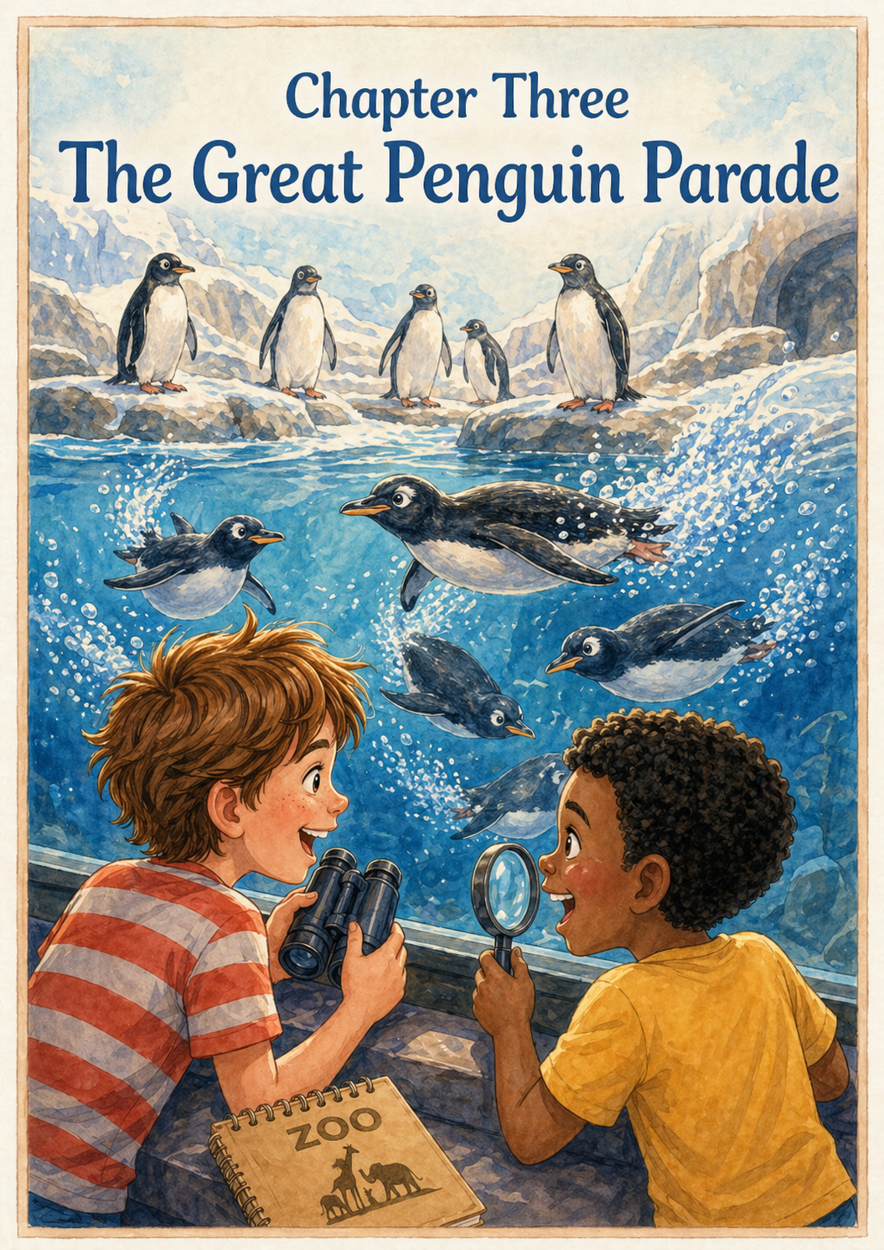Chapter 3: The Great Penguin Parade
The warm savanna air began to fade, replaced by a refreshing, salty mist that tickled Thomas’s nose. As they approached a large, rock-rimmed pool, a chorus of high-pitched chirps and splashes filled the air. Thomas and Leo knew exactly where they were before they even saw the sign. They hurried toward the thick glass walls of the penguin exhibit, their sneakers clicking excitedly on the wet pavement. Inside, the world was a frosty blue and white, a stark contrast to the golden Florida sun shining above them.
Dozens of small, feathered figures stood on the artificial ice, looking like a crowd of tiny gentlemen dressed in their finest black-and-white tuxedos. Thomas and Leo pressed their noses against the cool glass, watching as the birds huddled together, occasionally nudging one another with their orange beaks. On land, they seemed quite silly; they moved with a side-to-side shuffle, their flippers held out like little balance beams. Leo let out a snicker when one particularly round penguin tripped over a small pebble, gave a quick shake of its tail, and carried on as if nothing had happened.
"They look like they're wearing pajamas that are a little too tight," Leo whispered, pointing to a penguin that was trying to scratch its head with a flipper. Thomas nodded, noticing how their feathers were so sleek and oily that they looked almost like polished stone. He pulled out his notebook and quickly sketched a tuxedo shape, while Leo checked his compass to see if the "South Pole" was anywhere nearby. They wondered how these clumsy-looking birds could possibly be the daring explorers they had read about in their books back home.
Suddenly, a zookeeper appeared on a rocky ledge above the water, carrying a silver bucket filled with small, shimmering fish. The quiet atmosphere vanished instantly as the penguins erupted into a frenzy of excitement. With a series of loud squawks, the birds began to hop off the rocks and into the deep blue water. Thomas’s eyes widened as the "clumsy" birds transformed the moment they broke the surface. They weren't waddlers anymore; they were "black-and-white rockets" darting through the bubbles with incredible speed.
One penguin zipped right past Thomas and Leo’s faces, leaving a trail of silver bubbles in its wake. It moved so fast that it looked like a blur of motion, turning and twisting with the grace of a professional gymnast. Leo tried to follow it with his magnifying glass, but the bird was far too quick. Thomas followed it with his binoculars, amazed at how its wings—which looked so useless on land—acted like powerful oars in the water. The bird dove deep, snatched a fish, and shot back up to the surface like a cork popping out of a bottle.
Inspired by their energy, Thomas stepped back from the glass and decided he needed to try it for himself. He tucked his arms tightly against his sides, flattened his hands out like flippers, and began to shuffle his feet in a perfect imitation of the penguin waddle. Leo didn't hesitate for a second; he joined right in, flapping his arms and shuffling behind Thomas in a two-man penguin line. They tilted their heads back and forth, letting out small "honks" that made a nearby group of tourists burst into laughter.
"Look at us! We’re the Captains of the Parade!" Thomas announced his red striped shirt swaying as he waddled. Leo followed closely in his yellow shirt, looking like a very bright penguin indeed. They imagined they were walking across a giant ice floe in the middle of the ocean. In their minds, their lucky shirts were high-tech diving suits, and their backpacks were filled with secret Arctic research. They realized that being silly together was just as much fun as being serious explorers.
The zookeeper finished the feeding and explained to the crowd that these birds actually use their unique colors to hide from predators. Thomas and Leo leaned in, listening intently. They learned that their white bellies blend in with the bright sky when viewed from below, while their black backs blend with the dark ocean floor from above. Thomas quickly scribbled "Secret Camouflage" in his notebook, and Leo nodded solemnly, as if he had suspected this all along.
As the feeding frenzy died down, the penguins began to climb back onto the rocks, shaking the water from their feathers in a comical spray. They returned to their slow, rhythmic waddling, looking once again like the polite little birds they had been before lunch. Thomas and Leo watched them for a few more minutes, admiring how they could be two completely different things at once clumsy on the ground but masters of the sea. It was a good lesson: sometimes you just have to find the right place to truly shine.
Mom tapped Thomas on the shoulder, pointing toward the winding trail that led into the dark, leafy canopy of the rainforest. Thomas and Leo took one last look at their tuxedoed friends and gave them a crisp, penguin-style salute. They felt a surge of excitement for what came next, tucking their "Waddlers" sketches safely into their backpacks. With their flippers swinging at their sides, the two friends followed the path away from the ice and toward the mysterious shadows of the jungle, ready for a game of hide-and-seek.

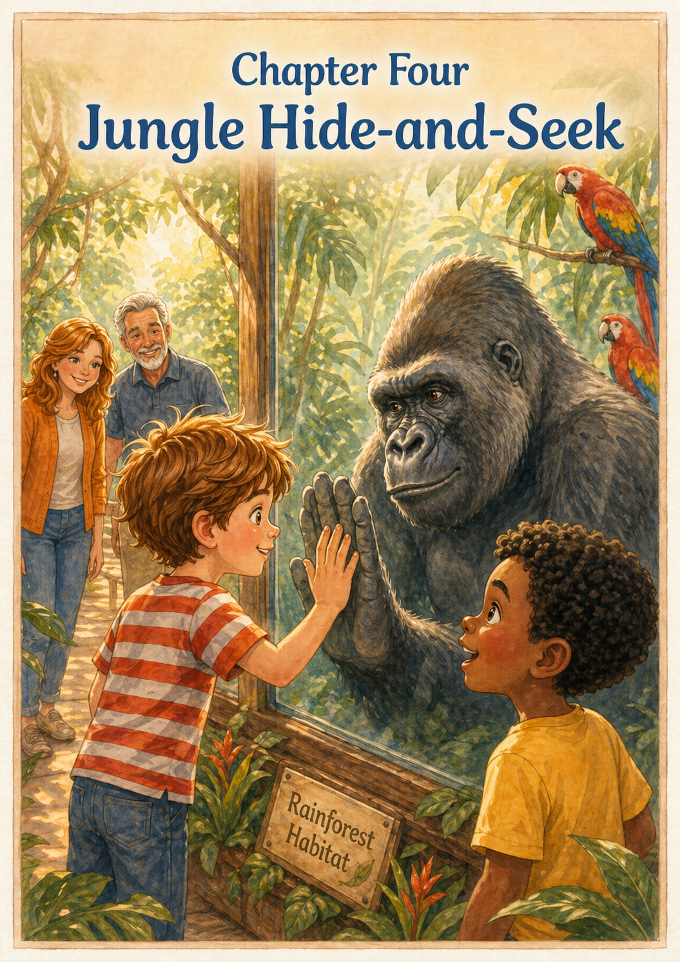Chapter 4: Jungle Hide-and-Seek
The bright, open sky disappeared as Thomas and Leo stepped into the tropical rainforest exhibit. The air here was thick and heavy, smelling of damp earth, blooming jasmine, and the misty spray of hidden waterfalls. Huge, emerald-colored leaves as big as umbrellas hung over the winding wooden path, casting long, swaying shadows. Thomas felt like he had been shrunk down to the size of a bug in a giant’s garden. He reached for his binoculars, adjusting the focus as he peered into the tangled vines. It was the perfect place for the world’s biggest game of hide-and-seek.
"Keep your eyes peeled, Thomas," Mom whispered, her voice barely audible over the constant hum of hidden cicadas. Thomas nodded solemnly, his red striped shirt a bright spot of color in the deep green gloom. He moved slowly, placing his feet carefully on the wooden planks to keep them from creaking. He knew that in the jungle, the best treasures didn't always want to be found. He scanned the branches, looking for anything that didn't quite match the shape of a leaf or the curve of a vine.
Suddenly, Thomas froze. High above, a flash of brilliant blue and gold darted through the canopy. He raised his binoculars and gasped as a pair of macaws landed on a sturdy branch. Their feathers were so vibrant they looked like they had been painted with neon markers. One parrot tilted its head, looking back at Thomas with a curious, intelligent eye before letting out a loud, raspy screech that echoed through the trees. Thomas quickly pulled out his notebook and used his brightest crayons to capture the "electric blue" of their wings.
Further down the path, the "hide" part of the game became much harder. Thomas spent five whole minutes staring at what looked like a pile of mossy stones near a trickling stream. It wasn't until one of the "stones" blinked that he realized he was looking at a group of well-camouflaged iguanas. Their scaly skin matched the grey and green of the rocks perfectly. "They're invisible!" Thomas whispered to Dad. He learned that being quiet and patient was the only way to win a game against a lizard.
The deeper they went, the quieter the jungle became. The path opened up into a large clearing with a massive glass wall that stretched from the floor to the ceiling. Behind the glass, the foliage was even thicker, with ancient-looking trees and soft piles of hay. Thomas stepped closer, his sneakers making no sound on the padded floor. He looked left and right, but at first, the enclosure seemed empty. He felt a small pang of disappointment, wondering if the biggest resident of the jungle was the best at hiding.
Then, he saw a movement in the shadows near the back. A massive shape, darker than the trees, slowly shifted. Out of the greenery stepped a silverback gorilla. He was magnificent, with broad shoulders and fur that shimmered like polished coal, turning to a misty silver across his back. The gorilla didn't beat his chest or roar; instead, he sat down heavily and picked up a piece of celery, looking very much like Thomas’s Grandpa sitting in his favorite armchair on a Sunday afternoon.
Thomas felt a strange pull toward the glass. He walked up until he was only inches away from the pane, looking directly into the gorilla’s deep, amber eyes. To his amazement, the gorilla didn't look away. Instead, he leaned forward slightly, resting his large, leathery hand against the glass right where Thomas’s hand was. The gorilla’s fingers were thick and strong, yet he moved with a gentleness that made Thomas feel completely safe. It was a silent, magical bridge between two very different worlds.
"He’s looking at my shirt, Dad," Thomas whispered, noticing the gorilla’s gaze lingering on his red stripes. For a long minute, neither of them moved. Thomas felt a warmth in his chest, a realization that even though they didn't speak the same language, they understood one another perfectly. This wasn't just an animal in a zoo; this was a friend who shared the same quiet curiosity about the world. It was the most important discovery of his expedition so far.
Eventually, the gorilla turned his attention back to his lunch, giving a soft grunt that sounded almost like a goodbye. Thomas stepped back, his heart feeling full and heavy in the best way possible. He took out his notebook and, instead of drawing the gorilla’s fur or his strength, he drew two hands touching on either side of a line. Underneath, he wrote in his neatest handwriting: "A Quiet Moment." He knew this was a memory he would keep much longer than any souvenir.
As they followed the "Exit" signs back toward the bright Florida sunshine, the jungle seemed to bid them farewell with one last screech from the macaws. Thomas adjusted the straps of his backpack, feeling a bit older and a lot wiser than when he had entered. He had learned that sometimes you have to look through the noise to find the beauty, and sometimes, the best part of an adventure is simply sitting still. With a lingering look back at the emerald leaves, he followed Mom and Dad toward the picnic area, his stomach starting to rumble for his own version of a jungle snack.

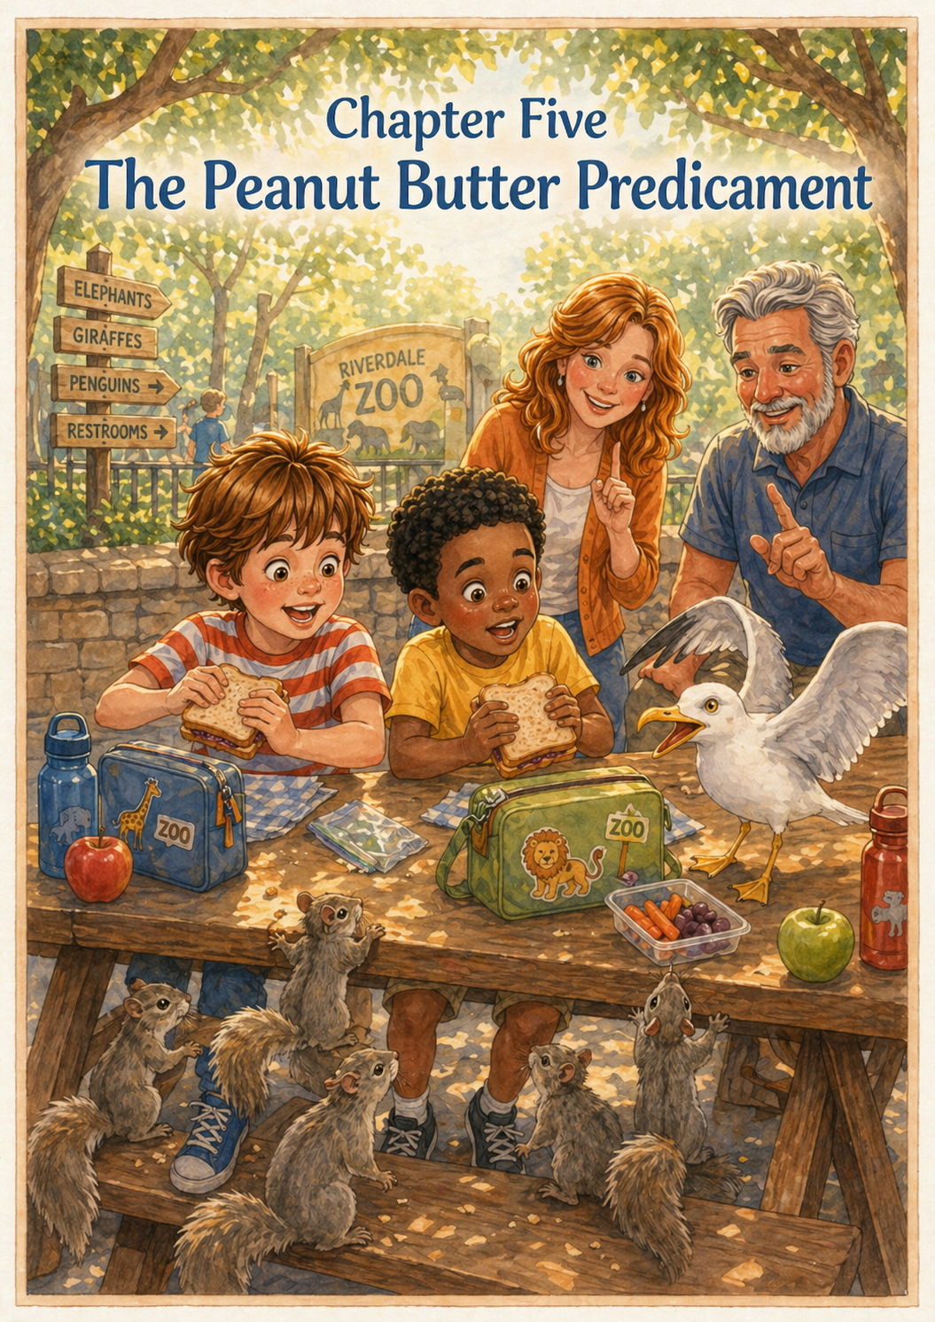Chapter 5: The Peanut Butter Predicament
The humid mist of the rainforest was replaced by the smell of toasted bread and salty fries as Thomas and Leo emerged into the bright afternoon sun. Thomas’s stomach let out a loud, insistent growl, and Leo’s stomach answered back with a rumble of its own. "Exploration sure is hungry work," Dad laughed, pointing toward a cluster of wooden picnic benches shaded by a sprawling oak tree. Thomas and Leo raced for the nearest table, their backpacks jingling and their water bottles rattling like a percussion section for their hungry parade.
Thomas climbed onto the bench, his red striped shirt glowing in the dappled sunlight, while Leo hopped up beside him in his bright yellow shirt. With the seriousness of two scientists opening a delicate specimen, they unzipped their bags. Thomas pulled out a brown paper sack containing a peanut butter and jelly sandwich wrapped in crinkly foil. Leo had a similar prize, but as they began to unwrap their lunches, they both noticed they were being watched by a very interested audience.
From the corners of the picnic area, a dozen furry heads popped up simultaneously. A squad of grey squirrels, their tails twitching like frantic metronomes, began a slow-motion march toward the boys' feet. They moved in short, jerky bursts, stopping to stand on their hind legs and sniff the air with tiny, wet noses. Thomas froze, his sandwich halfway to his mouth. "Don't move, Leo," he whispered. "The Peanut Butter Pirates have arrived." Leo gripped his sandwich tight, his eyes wide as a particularly plump squirrel inched closer to his sneaker.
The squirrels weren't the only competitors in this lunch-room arena. High above on a wooden fence post, a large seagull with bright yellow eyes kept a steady watch. It tilted its head, eyeing the corner of Leo's sandwich with intense concentration. Suddenly, with a loud, raucous squawk, the bird took flight, circling just a few feet above their heads. Both boys ducked, shielding their food with their arms. They realized that while the zoo animals were behind glass, these "free-range" residents were much bolder.
"Now, boys, remember what the signs say," Mom cautioned, opening her own salad. "If we feed them, they forget how to find their own food." Thomas looked down at the lead squirrel, who was now so close he could see its long, silvery whiskers. It looked quite pathetic, holding its tiny paws together as if it were begging. Leo leaned over and whispered to the squirrel, "Sorry, buddy, it’s for your own good," but he made sure to keep his crusts far away from the edge of the table.
They took large, defiant bites of their sandwiches, making sure to keep their elbows tucked in tight. The seagull landed on the opposite end of the long picnic table, letting out another demanding cry. It began to strut toward them, its orange feet clicking against the wood like a tiny soldier. Thomas stood his ground, maintaining firm eye contact with the bird. "This is a private lunch, Mr. Seagull," he said firmly. Leo added a "shooing" motion with his free hand, though he was careful not to let go of his bag of pretzels.
The squirrels weren't giving up easily, though. One managed to snag a single fallen potato chip from under the bench and performed a victory dance just out of reach. Thomas and Leo watched as the squirrel nibbled the edges of the chip with lightning-fast teeth. It was a lighthearted reminder that in the zoo, everyone was looking for a snack. Thomas decided to create a "fortress" by standing their paper bags up as a barrier between them and the persistent birds.
To distract themselves from the begging eyes, Thomas pulled out his notebook and flipped to a fresh page. He began to sketch the squirrel, giving it an oversized tail and a tiny pirate hat. Leo helped by describing the squirrel's "sneaky" movements. They titled the page "The Lunchtime Heist," noting how the animals used teamwork and cuteness as their primary weapons. Even a lunch break was an opportunity for the duo to practice their observation skills.
As they finished the last bites of their crusts, Thomas and Leo carefully crumpled up their foil and paper bags. They made sure not to leave a single crumb behind, sliding their trash into the nearby bin with a satisfying thud. The seagull, realizing the buffet was officially closed, let out one final, disappointed squawk and took off toward the dolphin stadium. The squirrels, too, seemed to lose interest, scampering back to the safety of the oak tree to look for acorns instead of sandwiches.
Thomas and Leo took long drinks from their water bottles, feeling refreshed and ready for the second half of their journey. They had successfully navigated the Peanut Butter Predicament without breaking any zoo rules. Thomas brushed the crumbs off his red striped shirt and Leo straightened his yellow one, both feeling a sense of accomplishment. With their "Survival Kits" repacked and their stomachs full, the two friends led the way back to the main path, their eyes searching for the next golden discovery.

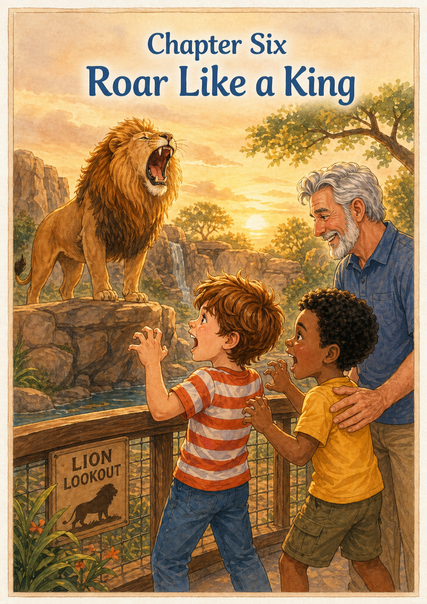Chapter 6: Roar Like a King
The afternoon sun had begun its slow descent, casting long, honey-colored shadows across the winding stone paths. Thomas felt a slight pull of tiredness in his legs, but Leo was already pointing excitedly toward the "Lion Lookout" sign. Thomas adjusted the straps of his green backpack, his red striped shirt glowing in the warm light, while Leo’s yellow shirt seemed to catch every stray beam of sun. They had been waiting for this moment all day. In their minds, the lions weren't just animals; they were the golden guardians of the zoo, and they wanted to hear them speak.
As they reached the massive rock formation that served as the lions' den, a heavy silence hung over the area. Thomas and Leo leaned against the wooden railing, peering across the deep, dry moat toward the grassy ledges. To their disappointment, the King of the Jungle seemed to be off duty. Two lionesses were sprawled out like giant, tawny housecats, and the male lion, with a mane as thick and tangled as a briar patch, was sound asleep with his paws tucked under his chin.
"They're just napping," Thomas whispered, his shoulders slumping just a little. Leo pulled out his magnifying glass, jokingly trying to see if he could spot a lion snoring from across the moat. They watched for a few minutes, but the lions remained as still as the boulders around them. Thomas pulled out his notebook and drew a small, sleeping lion with "ZZZ" bubbles floating above its head. He and Leo realized that even kings need a nap after a long day in the Florida sun.
Just as Dad suggested, they moved on to the reptile house, a sudden change swept through the air. The birds in the nearby trees fell silent, and Leo nudged Thomas, pointing at the male lion. The great beast stirred, his massive chest expanding as he took a deep, rattling breath. He stood up slowly, stretching his front paws forward in a way that reminded Thomas exactly of how his cat, Tia, woke up from a sunny spot on the rug.
Then, it happened. The lion threw back his head, opened his mouth wide, and let out a roar that seemed to start in the very center of the earth. It wasn't just a sound; it was a vibration that Thomas and Leo could feel in the soles of their sneakers. ROAR-UMPH! ROAR-UMPH! The sound bounced off the rock walls and echoed across the entire park, making several nearby tourists jump. It was the loudest, bravest noise the two friends had ever heard.
Thomas and Leo stood frozen, their eyes wide and their hearts racing. They didn't feel scared; they felt inspired. As the final echo faded, Thomas took a deep breath, puffed out his chest until his red stripes were taut, and let out a roar of his own. Leo didn't miss a beat, joining in with a roar that was just as loud. Their "mini-roars" weren't nearly as deep as the lion's, but they stood tall, feeling a surge of strength that made them feel much bigger than two boys in colorful shirts.
"Whoa, you two! You’ve got some lungs on you," Dad said, giving them both a playful pat on the back. Thomas grinned at Leo, feeling a sense of pride. They realized that bravery wasn't about how big you were, but about finding your own voice. The lion hadn't roared to be mean; he had roared to say, "I am here." Thomas decided that he and Leo wanted the world to know they were here and ready for anything the day could throw at them.
Thomas quickly turned back to his notebook, crossing out the "ZZZ" bubbles and drawing jagged lines around the lion's mouth to represent the sound. Leo helped him color in the mane with a bright orange crayon. They titled the page "The Big Voices," noting how one sound had changed the whole mood of the afternoon. It was a discovery about confidence—sometimes you have to speak up to be heard.
The male lion paced the edge of his rock for a moment, his golden eyes scanning the horizon as if he were checking on his kingdom. He looked regal and powerful, but also calm. Thomas and Leo watched him with a new kind of respect. They had seen height, speed, and gentleness today, but the lion had shown them the power of a strong spirit. Thomas adjusted his backpack, feeling like his "Survival Kit" now included a little bit of lionhearted courage.
As they finally turned to leave, Thomas and Leo gave one last, quiet roar toward the rocks. They felt like they were walking a little straighter, their steps more confident on the path. The sun was dipping lower, and the gift shop was just around the corner, marking the beginning of the day's final challenge. But with the echo of the King's roar still ringing in their ears, the two friends knew they could handle whatever choice lay ahead. They were explorers, a team, and—for today at least—a pair of lions.

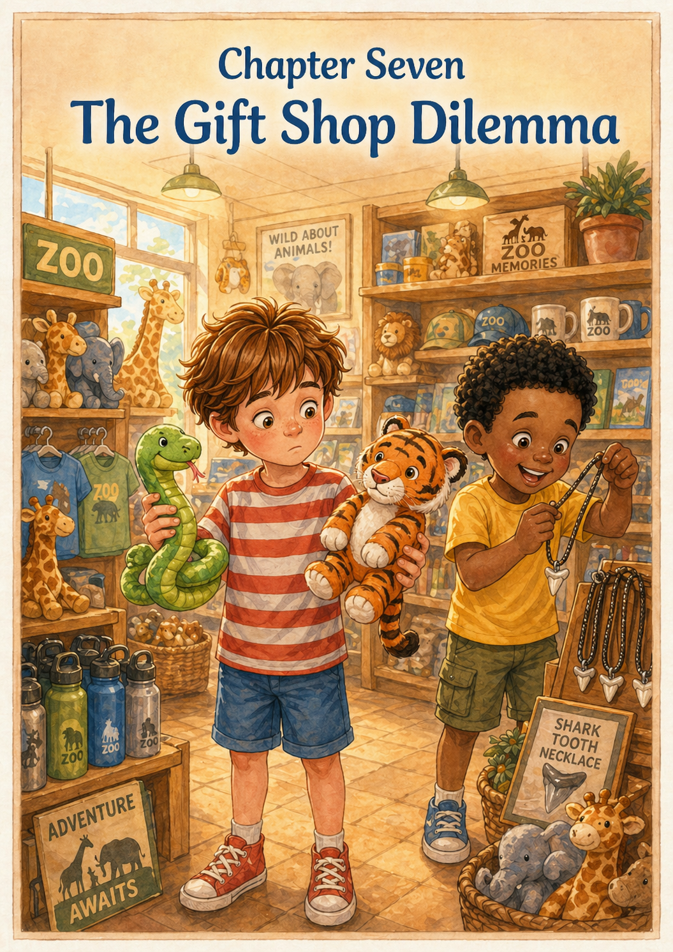Chapter 7: The Gift Shop Dilemma
The exit path led the boys directly into a sparkling cave of wonders known as the Zoo Gift Shop. The air here was cool and smelled of brand-new plastic, fuzzy fabric, and sweet vanilla candles. Row after row of shelves were packed with every animal imaginable, from tiny glass dolphins to giant plush elephants. Thomas felt a familiar flutter of excitement in his chest, but he also felt the weight of a big decision. His parents had told him he could choose just one souvenir to take home, and for an explorer who loved everything he’d seen today, this was the hardest mission yet.
Leo, standing beside him in his bright yellow shirt, was already hovering over a display of prehistoric treasures. "Look at this, Thomas!" Leo called out, waving a plastic dinosaur that made a loud screech when he squeezed its tail. Thomas smiled, but he remained focused. He began his patrol of the aisles, his red striped shirt reflected in the shiny surfaces of the toy displays. He moved slowly, his hands tucked behind his back to prevent any accidental "souvenir avalanches." He needed something that didn't just look cool, but something that captured the magic of the discoveries he and Leo had made together.
In the first aisle, Thomas found a long, wiggly rubber snake painted in bright neon green and black. It was perfectly stretchy and felt delightfully squishy in his hands. He pulled it long and watched it snap back into a coil. "This would be great for the backyard jungle," he thought, imagining his cat, Tia, stalking through the grass toward it. It was a fun toy, and it reminded him of the camouflaged lizards they had hunted for in the rainforest. He held onto it tightly, thinking his search might already be over.
But then, in the very next aisle, Leo pointed toward a shelf overflowing with soft, orange-striped tigers. Thomas reached out and touched the fur of the one in the front. It was incredibly soft, like a cloud made of velvet. Unlike the rubber snake, which felt cold and wiggly, the tiger felt warm and sturdy. It had kind, amber-colored eyes that reminded him of the gentle gorilla they had met, and a proud expression that brought back the memory of the lion’s mighty roar. Thomas felt a sudden tug at his heartstrings.
The "Dilemma" had officially begun. Thomas stood in the middle of the aisle, the rubber snake draped over his left arm and the plush tiger tucked under his right. Leo leaned in, looking at both. "The snake is way better for pranks," Leo argued, poking the green rubber. Thomas nodded, but he looked down at the tiger's stitched-on smile. He thought about the car ride home and the stories he wanted to tell. The snake was a great toy, but the tiger felt like a "forever friend"—a silent partner who would listen to all his secrets about purple tongues and rocket penguins.
Thomas paced back and forth, his sneakers squeaking on the linoleum floor as he weighed his options. He remembered Dad saying that a good choice is one you’ll still be happy with when the sun goes down and you’re back in your own bed. He looked at Leo, who was now considering a shark-tooth necklace. Thomas realized that while Leo loved the fast and flashy things, Thomas wanted something that felt like the heart of the zoo. Making a decision was like solving a puzzle; you had to find the piece that fit your heart, not just your hands.
He pulled out his notebook one last time, flipping back through the sketches he and Leo had made all day. He saw the "Quiet Moment" with the gorilla and the "Big Voices" of the lions. The tiger seemed to fit those memories perfectly. With a determined nod, Thomas walked back to the snake bin. He carefully laid the rubber toy back among its brothers, giving it a little pat as a way of saying "maybe next time." Leo watched him, curious. "You sure, Thomas?" Thomas squeezed the soft tiger and nodded. "Yeah. This is the one."
He felt a strange sense of relief as he walked away, clutching the plush tiger even closer. The choice was made, and the weight on his shoulders seemed to lift. He and Leo had navigated the hardest part of the gift shop safari and came out with exactly what they needed. Leo finally decided on his shark-tooth necklace, and together they marched up to the checkout counter, where a kind clerk with a turtle name tag was waiting.
Thomas reached into his front pocket and pulled out the coins he had been saving in his piggy bank for weeks. He counted them out one by one onto the counter—clink, clink, clink—feeling a surge of pride as the total matched the price on the tag. The clerk offered to put the tiger in a bag, but Thomas shook his head and handed the tiger to Leo to hold for a second while he zipped up his backpack. "He doesn't need a bag," Thomas said. "He’s part of the team now."
As they walked back out into the late afternoon air, Thomas felt the soft fur of the tiger against his arm. He had named him "Stripe" in his head already. He looked at Leo, who was proudly wearing his new necklace. The gift shop was behind them, and the day was coming to a close, but Thomas wasn't sad. He and his best friend had a piece of the zoo to take home—a reminder that the world was full of wonder if you were brave enough to go looking for it. He adjusted his backpack, Leo straightened his yellow shirt, and they headed toward the parking lot, ready for the final chapter of their big adventure.

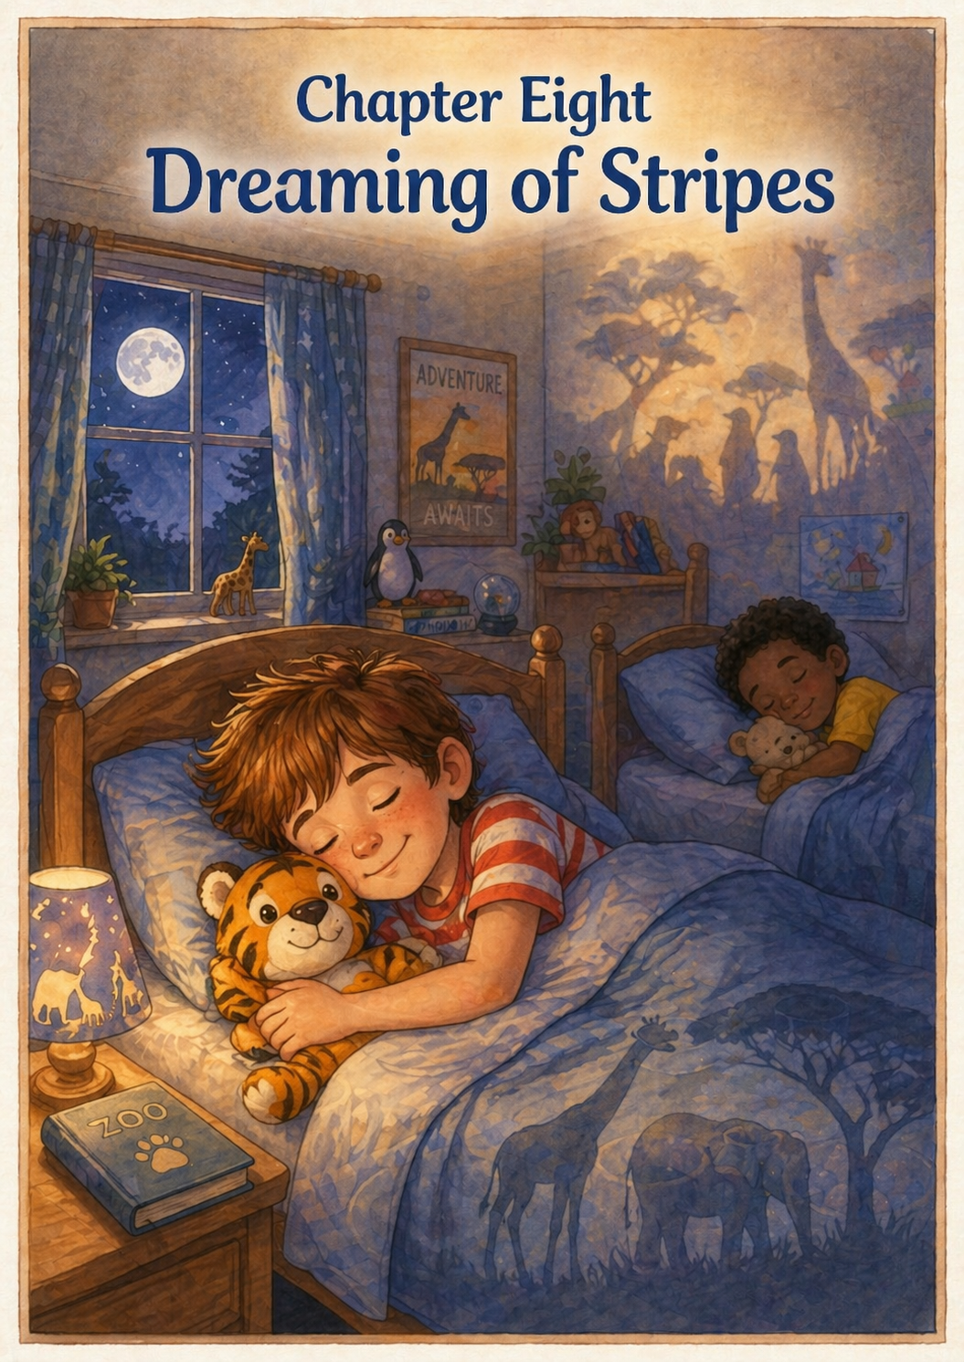Chapter 8: Dreaming of Stripes
The golden Florida sun had finally dipped below the horizon, leaving the sky a deep, velvety purple that reminded Thomas of Stretch the giraffe’s tongue. As they walked to the car, the gravel crunched rhythmically under their tired feet—a much slower pace than the excited sprint they had started that morning. Thomas climbed into his seat, carefully settling his new tiger, Stripe, onto his lap. Leo hopped in beside him, his yellow shirt looking a bit rumpled from a day of adventure, the plastic shark-tooth necklace clicking softly against his chest.
As Dad pulled out of the zoo parking lot, the hum of the tires on the road acted like a gentle lullaby. The bright banners and towering gates of the zoo grew smaller in the rear-view window, but the backseat was silent, filled with the peaceful exhaustion that only comes after a very successful mission. Thomas rested his head against the cool glass of the window, watching the streetlights flicker past like glowing jungle eyes. He felt the weight of his green backpack at his feet, heavy with his binoculars and the notebook full of "Gold Star Discoveries."
Leo’s head began to nod, his chin dropping toward his chest before he snapped back awake for a second, looking around with sleepy eyes. "We saw a lot today, didn't we, Thomas?" he murmured, his voice trailing off. Thomas nodded, reaching out to adjust the strap of Leo’s bag so it wouldn't slip. They had been a team all day—through the savanna, the ice, and the rainforest—and even now, as the energy of the day faded, they were together. Thomas gave Stripe a little squeeze, feeling the soft velvet fur against his palm.
The car turned onto their familiar street, and the shadows of the oak trees stretched across the driveway like the long fingers of the silverback gorilla. Thomas’s eyes grew heavy, and his grip on his notebook loosened just a bit. In the quiet of the car, the sounds of the day began to swirl together in his mind: the splash of the "rocket" penguins, the rustle of the bamboo in the rainforest, and the distant, powerful vibration of the lion’s roar. He wasn't just a boy in a red striped shirt anymore; he was a keeper of great secrets.
By the time Dad turned off the engine, Leo was fast asleep, his breathing deep and even. Mom leaned back to give them a quiet smile. "Time to go inside, explorers," she whispered. Thomas blinked, feeling a little bit like he was waking up from a dream even though he hadn't quite fallen asleep yet. He tucked his notebook into his bag and made sure Leo’s shark-tooth necklace was tucked safely inside his shirt so it wouldn't snag.
Inside the house, everything felt quiet and still. Thomas climbed into his own bed, the sheets feeling crisp and cool. He placed Stripe on the pillow right next to him, where the plush tiger could keep a watchful eye on the room. Through the window, the moon hung in the sky like a giant, glowing coin. Thomas thought about his notebook and all the drawings he had made—the purple circles, the tuxedo shapes, and the two hands touching the glass. He realized that the zoo hadn't stayed behind at the gates; he had brought the best parts of it home in his heart.
Leo was tucked into the spare bed across the room, already drifting back into a deep slumber. Thomas watched the shadows on the wall, which seemed to shift and change into the shapes of acacia trees and rocky cliffs. He realized that a "Survival Kit" wasn't just for the zoo; it was for every day. Being observant like a giraffe, brave like a lion, and gentle like a gorilla were lessons he could use right here in South Venice.
As his eyelids finally fluttered shut, the walls of his bedroom seemed to melt away. In his dreams, the backyard grass grew tall and golden, stretching out into a vast savanna where the neighborhood dogs were transformed into friendly cheetahs. He saw himself and Leo, still wearing their lucky red and yellow shirts, leading a parade of penguins through the garden. They were the Head Zookeepers of a world where every corner held a new discovery.
Stripe sat tall on the pillow, his amber eyes reflecting the soft moonlight. Thomas’s hand stayed curled around the tiger’s paw, a silent promise of more adventures to come. The "Golden Ticket" day had come to an end, but the story was far from over. In the quiet night, Thomas finally drifted off to sleep, a small, tired smile on his face as he dreamed of stripes, stars, and the wonderful, wild world that was waiting for him tomorrow.
The house was still, the explorers were resting, and for one little boy in a red striped shirt, the whole world was a jungle full of friends.

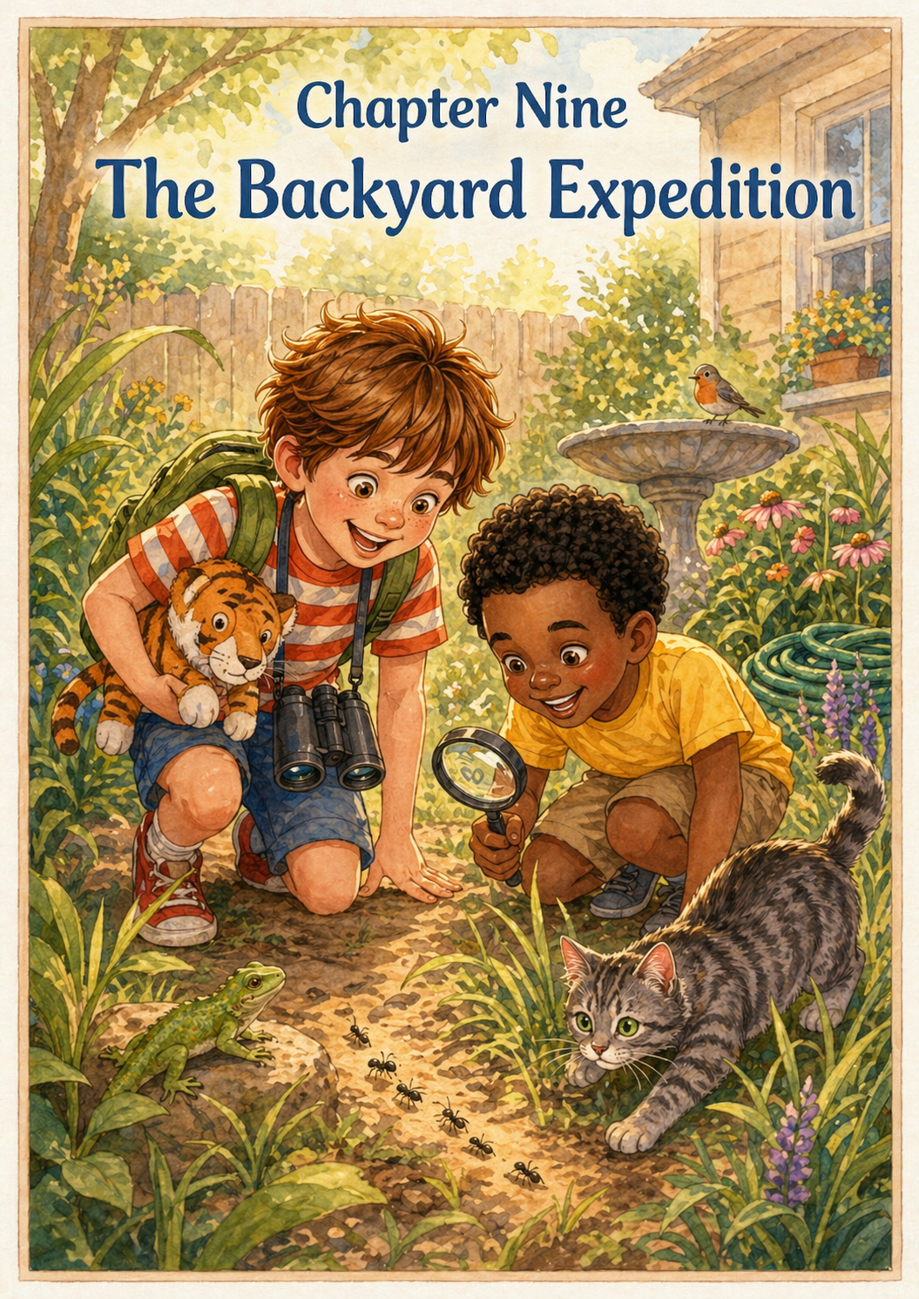Chapter 9: The Backyard Expedition
The next morning, the sun rose over South Venice not as a regular Sunday sun, but as a bright spotlight on a brand-new mission. Thomas and Leo were awake before the smell of bacon even reached the hallway. They weren't in the savanna anymore, but as they stepped out into the backyard, they realized the adventure hadn't ended at the zoo gates. Thomas wore his red striped shirt, now a little rumpled but still full of "lucky" energy, and Leo followed close behind in his yellow shirt, his shark-tooth necklace clinking against his chest. Stripe the tiger was tucked under Thomas’s arm, ready to act as the official guide for the day’s backyard trek.
"According to my calculations," Leo said, holding his plastic compass flat in his palm, "the Great Garden Desert starts right past the patio." Thomas nodded, adjusting his binoculars. Through the lenses, the tall blades of grass looked like a dense, emerald jungle, and the garden hose snaking across the lawn resembled the long, green body of a rainforest serpent. They weren't just playing; they were applying everything they had learned from the giants they met the day before.
They reached the edge of the birdbath, which Thomas decided was the "Oasis of the Blue Jays." He pulled out his notebook, already half full of zoo sketches, and started a fresh page titled Home Expedition. "We have to be quiet," Thomas whispered, mimicking the gentle movements of the silverback gorilla. "If we move too fast, we'll scare away the local wildlife." They sat perfectly still, watching as a small brown lizard scurried across a rock. Thomas noted how it used "Secret Camouflage," just like the penguins and the iguanas.
Leo crawled through a patch of clover, his magnifying glass hovering over a trail of ants. "Thomas, look! A tiny parade!" he called out. They watched as the ants worked together to move a cracker crumb, a perfect display of the teamwork they had seen during the "Lunchtime Heist" at the zoo. Thomas realized that you didn't need a golden ticket to find something amazing; you just needed to be an observer. He sketched the ants, giving them tiny backpacks to match his own.
Suddenly, a low rumble came from the back porch. It wasn't the chest-shaking roar of the King of the Jungle, but it was the familiar, hungry meow of Thomas’s cat, Tia. She stepped out into the sun, stretching her paws forward and letting out a wide yawn. Thomas and Leo shared a look and burst into giggles. "Look, Leo! It’s the Miniature Lion of Venice!" Thomas said. He puffed out his chest and let out a soft "Rawr!" in Tia’s direction, feeling that surge of lionhearted confidence all over again.
They spent the afternoon mapping the "Unknown Territories" behind the hibiscus bushes. They found a "Gully of the Golden Stones" (which Mom called the drainage ditch) and a "Forest of Whispering Pines." Every time they faced a "dilemma"—like whether to climb the low branch of the oak tree or stay on the ground—Thomas thought about his choice in the gift shop. He chose the path that felt like a "forever adventure," and Leo was right there to help him balance.
As the afternoon shadows grew long, the two friends sat under the oak tree, leaning against the sturdy trunk just like the lions back at the lookout. Stripe the tiger sat between them, his amber eyes catching the light. Thomas flipped through his notebook, looking at the drawings of Stretch’s purple tongue and the gorilla’s hand. He realized that the zoo had given him a new way to see his own home. Everything was more colorful, more interesting, and definitely more exciting when you looked at it like an explorer.
"Do you think the penguins are practicing their rockets right now?" Leo asked, looking up at the sky. Thomas imagined the "black-and-white rockets" zooming through the blue water while he sat in the green grass. "I bet they are," Thomas replied. "And I bet Stretch is reaching for the very top leaf." He felt a sense of peace knowing that while he was here in his backyard, his wild friends were safe in theirs, and they were all connected by the stories he was writing.
Mom appeared at the back door with two glasses of cold lemonade. "How is the expedition going, boys?" she asked. Thomas stood up, brushed the grass off his lucky red stripes, and gave her a crisp, professional salute. "We’ve discovered three new species of ants and a secret lizard path," he reported proudly. Leo held up his shark-tooth necklace, which had survived the jungle trek without a scratch. They weren't just kids in a yard; they were discoverers of everyday life.
As the sun began to set for the second time since their big trip, Thomas and Leo headed back inside, their hearts as full as their notebooks. The "Thomas Loves..." series had gained a new chapter, one about how the world is a wonderful place no matter where you are. Thomas tucked Stripe under his arm and followed Leo into the house, already thinking about what they would discover tomorrow. The zoo trip was a memory, but the spirit of the explorer stayed at home.

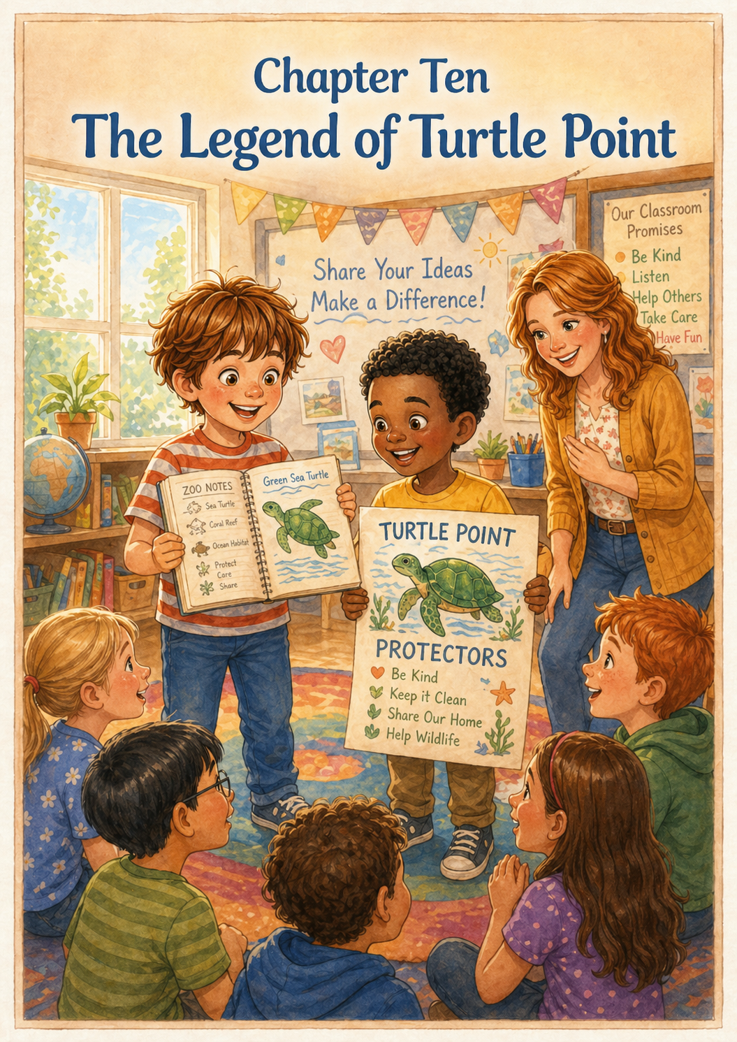Chapter 10: The Legend of Turtle Point
Monday morning arrived with a special kind of excitement. It was the first day of school since the big trip, and Thomas and Leo were on a mission to share their discoveries. Thomas had carefully packed his notebook in his green backpack, and he made sure his red striped shirt was crisp and clean. Leo, still wearing his shark-tooth necklace, met him at the end of the driveway. They didn't just walk to the bus stop; they marched like explorers returning from a distant land, ready to report their findings to the rest of the crew.
When they reached the classroom, Thomas headed straight for the "Share and Tell" rug. He pulled out his notebook and showed his classmates the drawing of the "Quiet Moment" with the gorilla and the "Purple Ribbon" tongue of Stretch the giraffe. The other children leaned in, their eyes wide with wonder. Thomas explained that being an explorer wasn't just about seeing big animals; it was about learning how to be a good friend to the world. Leo stood beside him, acting as the official "Artifact Specialist," showing off his necklace and explaining the speed of a rocket penguin.
"But the most important thing we learned," Thomas told the class, his voice steady and confident like the lion’s roar, "is that we have to protect the animals we love." He reached into his bag and pulled out a small, hand-drawn chart he had worked on with Leo that morning. It featured a drawing of a sea turtle with a bright green shell. "We’re starting a new club," Leo announced. "It’s called the Turtle Point Protectors!"
Thomas explained their plan: for every act of kindness or every piece of litter they picked up around the school, they would earn a "Turtle Point." He wanted to take the stewardship lessons he had learned at the zoo and bring them into his own world. The class cheered, and even their teacher, who usually preferred quiet mornings, gave them a big thumbs-up. Thomas felt a surge of pride; he had found a way to make his "Big Discovery" help others.
At recess, the "Expedition Team" grew from two to ten. Thomas and Leo led their friends around the playground, not just to play tag, but to look for ways to care for their "school savanna." They spotted a stray juice box near the swings and quickly moved it to the bin, earning the first Turtle Point of the day. Thomas realized that when you work together, even a small group of friends can make a big sound, just like the lion’s echo in the den.
As they sat on the benches to catch their breath, Leo looked at Thomas and grinned. "We're like the zookeepers of the playground, Thomas!" Thomas nodded, looking down at his red stripes. He felt like he was exactly where he was supposed to be. He pulled out a new sheet of paper and drew a picture of a turtle, a lion, and a giraffe all standing together. Underneath, he wrote: Everyone has a place in the story.
The afternoon sun warmed the blacktop as the bell rang, signaling the end of the day. As Thomas and Leo walked home, they talked about their plans for the "Summer Reading Program" they wanted to start. They imagined a logbook where kids could track their kindness points and their animal facts. Thomas knew that his "Thomas Loves..." series was growing into something much bigger than just a book; it was becoming a way of life for him and his friends.
When they reached Thomas's front porch, Leo gave his shark-tooth necklace a final pat. "See you tomorrow, Head Zookeeper?" Leo asked with a wink. Thomas laughed and gave him a high-five. "See you tomorrow, Specialist Leo!" As Thomas stepped inside, he saw Stripe the tiger waiting for him on the sofa. He sat down and opened his notebook to the very last page, where he had left plenty of room for future adventures.
He realized that the "Golden Ticket" hadn't just opened the gates to the zoo; it had opened his eyes to the magic in his own backyard, his school, and his friendships. Every person he met and every animal he observed was a chapter in a much larger book. He picked up his yellow pencil and drew a small heart next to the drawing of his and Leo’s backpacks. The zoo trip was a memory he would always treasure, but the lessons he learned would stay with him forever.
As the house grew quiet and the evening breeze began to rustle the hibiscus bushes outside, Thomas leaned back and closed his eyes. He could still hear the distant, imaginary roar of the lion and the splash of the penguins. He was Thomas, the boy in the red striped shirt, the protector of turtles, and the friend of giants. With Stripe by his side and a world full of discoveries waiting for him, he knew that the best chapters were still yet to be written.

This zoo adventure has been a great journey for Thomas and Leo! Do you think Thomas should bring Stripe the tiger to the first meeting of the Turtle Point Protectors?

Epilogue: The Explorer’s Legacy
A few weeks had passed since the golden tickets first appeared under the cereal bowl, but the spirit of that Saturday lived on in every corner of Thomas’s world. If you were to walk through his neighborhood today, you might notice something different. On the sidewalk, there were no stray wrappers; in the park, the birds seemed a little bolder; and on the playground, a group of children wore handmade badges shaped like turtles. The "Turtle Point Protectors" had grown from a duo into a small army of kindness, led by a boy in a red striped shirt and his best friend in yellow.
Inside Thomas’s room, the green backpack sat by the door, always packed and ready for the next "Top Secret" mission. His notebook, once filled with blank pages, was now a thick treasure chest of memories. There were smears of purple crayon from Stretch’s tongue, a smudge of blue from the penguin pool, and a very special page—now slightly wrinkled from being handled so much—showing two hands pressed against a pane of glass. Stripe the tiger sat in the place of honor on the bed, his amber eyes reflecting the afternoon light, a silent witness to every new story Thomas drafted.
Thomas sat at his small wooden desk, the same yellow pencil from the zoo held firmly in his hand. He wasn't just sketching anymore; he was writing. He realized that the "Big Discovery" wasn't just about animals in an enclosure—it was the discovery that the world is a giant, living book, and he was one of its authors. Every time he helped Leo learn a new skill, or shared his lunch with someone who forgot theirs, he was adding a line to a story about being brave, gentle, and wise.
From the kitchen, the familiar scent of Mom’s baking drifted in, and he could hear the distant rumble of Dad’s laughter as he talked to Grandpa on the phone. Thomas looked at Stripe and gave him a knowing nod. He knew that one day, he might travel to the real African Savanna or the actual icy shores of the South Pole. But for now, he was happy right here. He had his friends, his lucky shirt, and the knowledge that adventure doesn't require a ticket—it only requires an open heart and a pair of observant eyes.
He turned to the very last page of his notebook, which was still white and waiting. In his neatest handwriting, he wrote a final note to himself: The world is big, but I am big enough to care for it. He closed the book with a satisfying thump and stood up, ready to head outside. Leo was already waiting at the fence, waving his magnifying glass toward a particularly interesting-looking butterfly. The sun was shining, the "savanna" was calling, and Thomas knew that as long as he kept looking, the magic of the zoo would never truly end.

About the Author
www.scottMbooks.com


Scott Speicher brings a unique blend of life experiences to his writing. A U.S. military veteran, he carries the discipline, resilience, and perspective gained through service into every story he tells. After his military career, Scott built a successful path in marketing, where he developed a deep understanding of communication, storytelling, and audience engagement. For more than 15 years, he has also worked as a professional website designer, helping businesses and individuals create meaningful online presences.
Scott Speicher is a storyteller who enjoys creating gentle, heartfelt stories that help children notice the small moments that make life meaningful. Through warm characters and simple adventures, his books encourage young readers to slow down, care for others, and appreciate the quiet joys of everyday life. Scott believes that some of the most important lessons children learn come not from grand events, but from the ordinary moments shared with family, friends, and the animals they love.
In Thomas Loves His Birthday: The Big Discovery, Scott M. Speicher brings that belief to life through a heartwarming story that transforms a festive celebration into a series of grand adventures centered on leadership and responsibility. Thomas sets out for a day of mindful discovery as each gift he opens becomes a gateway to learning valuable life skills. From constructing a magnificent fortress with a steady hand to leading a prehistoric jungle expedition in the backyard, he demonstrates how curiosity and a calm mind make a big difference. He bravely practices the "Astronaut Safety Rule" and shares his soccer goals with Leo, proving that kindness and preparation are the most important tools in a hero’s kit. The journey ends with a final mission to his cozy blanket fort at sunset, leaving Thomas—and young readers—ready to dream of the next great adventure right at home.
Suitable for readers aged 4-10 and for family read-aloud sessions. Ideal for SEL, guidance, and service-learning.

