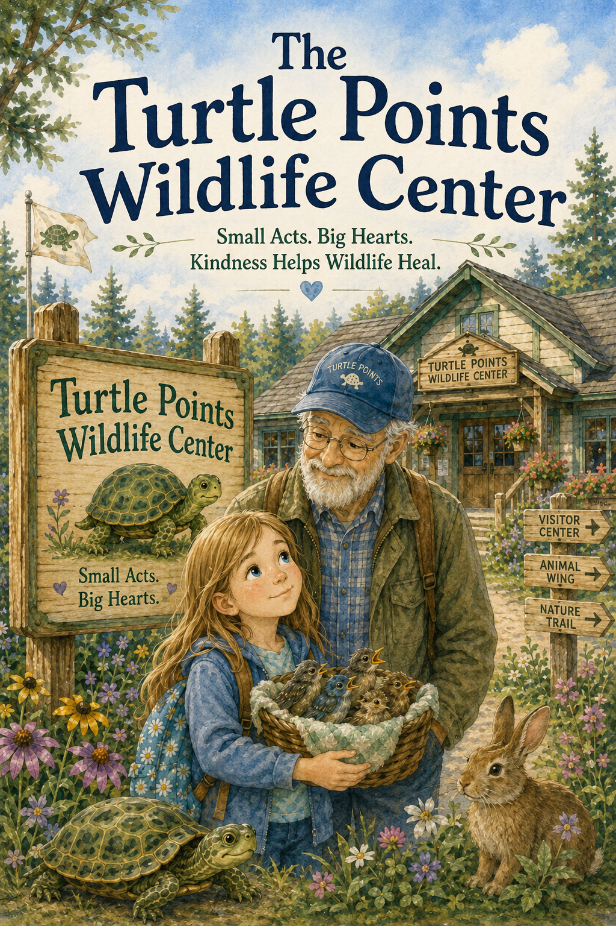
Lily and the Summer Farm
Small Acts. Big Hearts. Kindness Helps Wildlife Heal.
by
Scott Speicher

Copyright © 2026
Author: Scott M. Speicher
Portions of this book have been optimized by the program Grammarly
Edited by Grammarly and the Editorial team of Digital Scribblers
No part of this book may be reproduced or used, in any form or by any means, electronic or mechanical, without permission in writing from the author.
Some of the images are AI-generated using prompts and under the author's full control.

Preface
Some kindness begins with one small moment.
For Ben, it began with a turtle in the road, a worried heart, and the belief that helping something smaller than himself mattered. His Turtle Points Logbook became more than a notebook. It became a way to notice the good, remember the helpers, and show that even the smallest act of care can leave a lasting mark.
The Turtle Points Wildlife Center continues that mission through Lily, a young volunteer who wants to help animals in need but must first learn what it means to truly help. At the wildlife center, Lily discovers that kindness is not always loud, exciting, or easy to see. Sometimes kindness is folding towels, washing bowls, making a quiet sign, listening to safety rules, giving a frightened animal space, or waiting patiently while trained adults do careful work.
As Lily helps at the center each week, she learns that wild animals need respect, safety, and gentle care. Turtles, baby birds, rabbits, and other creatures all have stories worth noticing. Some arrive scared or injured. Some need quiet rooms and soft bedding. Some grow strong enough to return to nature. Each one teaches Lily that caring for wildlife is not about keeping animals close—it is about helping them heal so they can go home.
This story is also about how one child’s kindness can grow into something bigger. Ben’s Turtle Points mission began with one boy and one turtle, but through Grandpa Jim, Lily, caring volunteers, and a whole community, that mission continues. It becomes a wildlife center, a Things That Count board, a junior kindness program, and a reminder that compassion can be passed from one heart to another.
May this book encourage young readers to notice the world around them, respect animals and nature, listen to trusted adults, and understand that safe kindness always matters. Whether helping a friend, caring for the environment, or learning how to protect wildlife from a safe distance, every child can discover that small acts, done with a big heart, truly count.

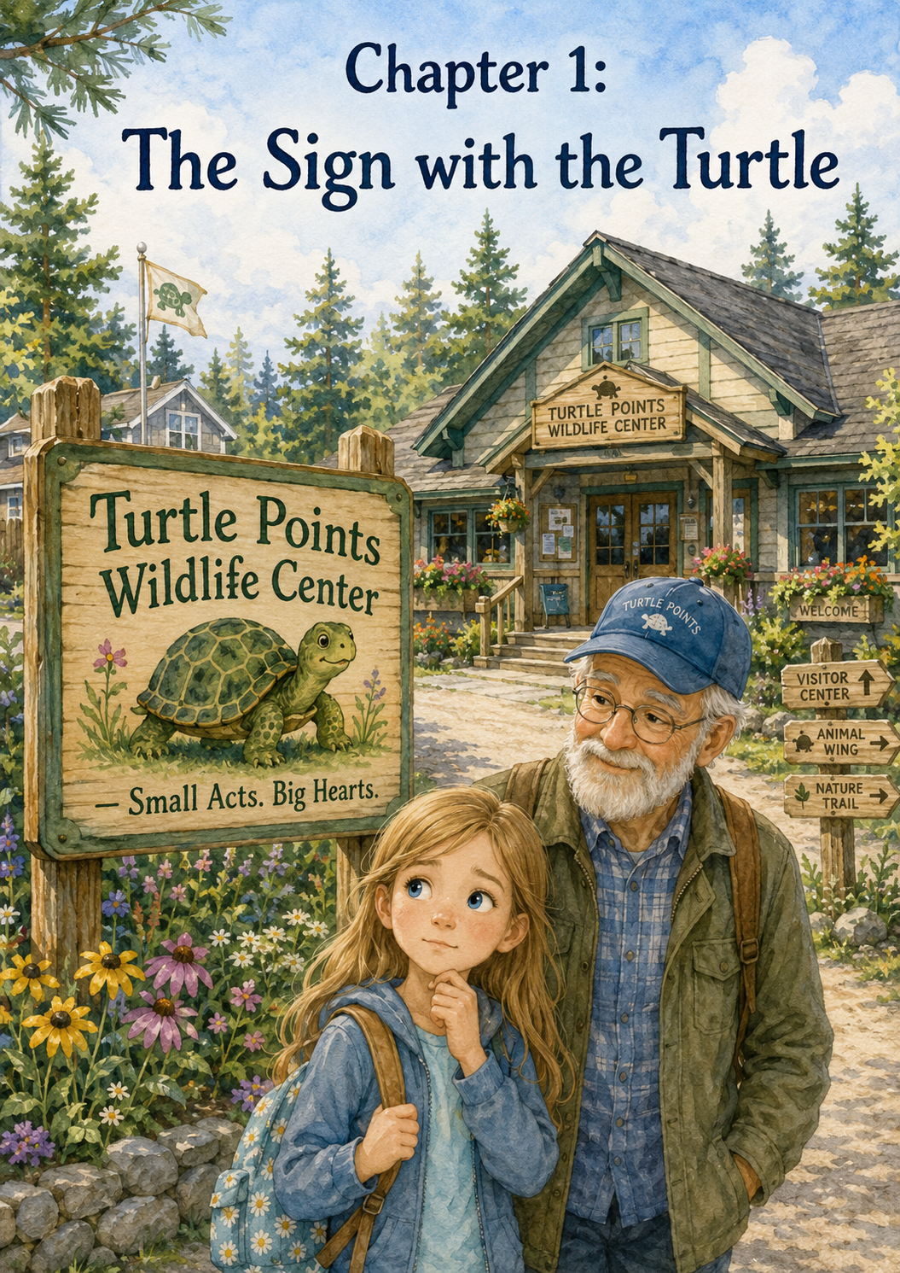Chapter 1: The Sign with the Turtle
The road to the Turtle Points Wildlife Center curved between tall pine trees, wild grass, and patches of bright yellow flowers. Sunlight slipped through the branches and danced across the windshield of Grandpa Jim’s old truck. Lily sat in the passenger seat with her hands folded tightly in her lap.
She had been quiet for most of the ride.
Grandpa Jim noticed.
He always noticed.
“You doing all right over there, Lily?” he asked, keeping his eyes on the road.
Lily nodded, but her nod was small. “I think so.”
Grandpa Jim smiled gently. He wore his blue cap, the one he always wore when he worked outside, and his glasses rested low on his nose. His white-gray beard moved a little when he smiled.
“You think so?” he asked.
Lily looked out the window. “I’m excited,” she said. “But I’m nervous too.”
“That makes sense,” Grandpa Jim said. “First days can feel that way.”
Lily watched a bird fly from one tree to another. “What if I don’t know what to do?”
“Then you’ll learn.”
“What if I make a mistake?”
“Then someone will help you fix it.”
“What if I’m not good at volunteering?”
Grandpa Jim gave a soft chuckle. “Lily, nobody becomes good at helping all at once. Helping is something you practice.”
Lily thought about that.
She wanted to help. She really did. Ever since Mom had told her about the new volunteer program at the Turtle Points Wildlife Center, Lily had imagined herself carrying tiny towels, filling little bowls, and helping animals feel safe. She had pictured turtles, birds, rabbits, and squirrels. She had pictured kind volunteers in green shirts and quiet rooms where animals could rest.
But now that the first day was really here, her stomach felt fluttery.
It was almost the same feeling she had on the first day of school.
A little excited.
A little scared.
A little unsure.
Grandpa Jim turned down a gravel driveway. The tires crunched softly beneath them. Ahead, Lily saw a small wooden building with wide windows and flower boxes along the front. A white fence stretched along one side of the property. Behind it were trees, shrubs, and shaded outdoor enclosures.
Then Lily saw the sign.
It stood near the entrance, painted in warm green and blue letters. At the top was a turtle with kind eyes and a bright shell. The turtle looked like it was slowly walking forward, one careful step at a time.
Beneath the turtle were the words:
Turtle Points Wildlife Center
Small Acts. Big Hearts.
Grandpa Jim slowed the truck and pulled into a parking spot.
Lily did not move right away.
She kept looking at the sign.
The painted turtle seemed familiar, even though she knew it was only a picture. Its little face reminded her of every story she had ever heard about Ben and his turtles. It reminded her of the Turtle Points Logbook, the one Ben had carried almost everywhere. It reminded her of road shoulders, grassy ditches, careful hands, and Grandpa Jim’s stories about a boy who believed that kindness counted.
Grandpa Jim turned off the truck.
“Well,” he said softly, “there it is.”
Lily swallowed. “The sign has a turtle.”
“It does.”
“Do you think Ben would have liked it?”
Grandpa Jim was quiet for a moment. His eyes moved from the sign to the trees behind it.
“Yes,” he said at last. “I think Ben would have loved it.”
Lily looked at him. “Because of the turtle?”
Grandpa Jim smiled, but his smile was a little sad around the edges. “Because of the turtle,” he said. “And because of what it means.”
Lily opened her door and stepped carefully onto the gravel. The air smelled like pine needles, fresh dirt, and something clean, like soap from inside the building. Somewhere nearby, a bird chirped. Farther away, Lily heard the soft sound of water moving, maybe from a small creek or pond behind the center.
Grandpa Jim came around the truck and stood beside her.
Together, they walked toward the sign.
Up close, Lily could see that the turtle’s shell had tiny painted stars on it. Around the edge of the sign were small handprints in different colors. Some were big adult handprints. Some were small children’s handprints. At the bottom, someone had painted a row of little footprints that looked like turtle tracks.
Lily reached out but did not touch the sign. She just held her hand near it.
“Small Acts. Big Hearts,” she read quietly.
Grandpa Jim nodded. “That’s what this place is about.”
Lily looked at him. “Was Turtle Points only about turtles?”
Grandpa Jim took a deep breath. “At first, Ben thought it was.”
He leaned one hand gently against the fence post beside the sign.
“Your friend Ben loved turtles,” Grandpa Jim said. “He had a way of spotting them when nobody else did. A little bump near the road. A shape in the grass. A shell half-hidden in the dust. He noticed things other people might have missed.”
Lily smiled a little. “Because he was looking.”
“That’s right,” Grandpa Jim said. “Ben was always looking. And when he saw something that needed help, he wanted to do something.”
“But he had to be safe,” Lily said.
Grandpa Jim’s eyes softened. “Yes. He learned that too. Helping should never mean running into danger. Ben had a big heart, but big hearts still need careful feet.”
Lily nodded. She had heard that before. Mom had said it. Dad had said it. Grandpa Jim had said it many times.
Kindness should be safe.
Kindness should be thoughtful.
Kindness should not put someone else in danger.
Grandpa Jim looked back at the turtle on the sign. “Ben started with turtles, but the real mission was bigger than that.”
“What was the real mission?” Lily asked.
Grandpa Jim bent down a little, so his eyes were closer to hers.
“The real mission,” he said, “was noticing who needed help and doing one kind thing when you could.”
Lily let the words settle inside her.
Noticing who needed help.
Doing one kind thing.
That sounded simple, but Lily knew simple things could be important. A kind hello could help someone feel brave. A shared seat could help someone feel included. A soft voice could help a scared animal feel calm.
“Is that why they named the center Turtle Points?” she asked.
Grandpa Jim nodded. “The people who started this center knew Ben’s story. They remembered his logbook and how he wrote down the small things that counted. They wanted a place where the community could keep that spirit going. Not by rescuing animals from roads alone, and not by doing unsafe things, but by helping the right way.”
“With adults,” Lily said.
“With trained adults,” Grandpa Jim added.
Lily looked at the building. Through one window, she could see shelves with towels and bottles. A woman in a green volunteer shirt walked past carrying a clipboard. Near the front door was a small table with a basket of folded gloves and a sign that said:
Welcome, Volunteers! Please check in first.
Lily’s stomach fluttered again.
“What if I’m too little to help much?” she asked.
Grandpa Jim rested a hand on her shoulder. “You are not too little to learn. You are not too little to care. And you are not too little to do small jobs with a big heart.”
Lily looked down at her shoes. A tiny pebble sat beside her toe. She nudged it gently with the side of her sneaker.
“What kind of jobs do volunteers do?” she asked.
“All kinds,” Grandpa Jim said. “Some wash bowls. Some fold towels. Some clean carriers. Some make signs. Some help keep rooms quiet. Some write notes. Some organize supplies. Some answer phones. Some drive rescue boxes, but only trained adults do that part.”
Lily looked up quickly. “I don’t have to pick up wild animals, right?”
“No,” Grandpa Jim said firmly. “You do not pick up wild animals. Not birds, not squirrels, not rabbits, not turtles, not anything. Wildlife can be scared or hurt, and scared animals do not always understand that someone is trying to help.”
Lily felt relieved.
“So I can help without touching them?”
“Absolutely,” Grandpa Jim said. “Sometimes the best helping is quiet helping.”
Lily thought about that. Quiet helping did not sound very exciting at first, but then she imagined a frightened bird resting in a soft towel because someone had folded it. She imagined a turtle drinking from a clean bowl because someone had washed it. She imagined a rabbit calming down because someone had remembered to close the door gently.
Maybe quiet helping mattered a lot.
The front door opened, and a woman stepped outside. She had silver hair pulled back in a ponytail and wore a green shirt with the Turtle Points Wildlife Center logo on the pocket. The same turtle from the sign smiled from the shirt.
“You must be Lily,” the woman called warmly.
Lily stood a little straighter.
Grandpa Jim smiled. “Morning, Ms. Harper.”
“Good morning, Jim,” she said. “It’s good to see you.”
Ms. Harper walked over to Lily and held out her hand. “Welcome to your first volunteer day.”
Lily shook her hand carefully. “Thank you.”
Ms. Harper’s hand was warm and gentle. “We’re happy to have you here. Grandpa Jim has told us you have a kind heart.”
Lily felt her cheeks grow warm. “I want to help.”
“That’s the best place to start,” Ms. Harper said.
Lily glanced back at the sign. “I like the turtle.”
Ms. Harper smiled. “That turtle means a lot to us. It reminds us to go slowly, help carefully, and remember that small acts can make a big difference.”
“That sounds like Ben,” Lily said softly.
Ms. Harper’s smile grew tender. “Yes. It does.”
For a moment, all three of them looked at the sign.
The wind moved gently through the trees. The painted turtle seemed to be taking one slow step forward, just like the real turtles Ben used to help. Lily imagined Ben with his logbook, writing down names, numbers, and little notes about each rescue. She imagined him saying that kindness counted extra.
A small ache passed through her heart, but it was not only sadness.
It was sadness mixed with hope.
“Do you think,” Lily asked, “that helping here counts as Turtle Points?”
Grandpa Jim looked at Ms. Harper, and Ms. Harper looked at Grandpa Jim.
Then Grandpa Jim smiled.
“Oh, Lily,” he said, “I think Ben would say this counts for a lot.”
Lily smiled too.
The fluttery feeling in her stomach did not disappear completely, but it changed. It felt less like fear now and more like the start of something important.
Ms. Harper opened the front door wider. “Ready to come inside?”
Lily took one more look at the sign.
Turtle Points Wildlife Center
Small Acts. Big Hearts.
She touched the strap of her backpack and took a breath.
“I’m ready,” she said.
Grandpa Jim walked beside her as they started toward the door.
“Remember,” he said, “one careful step at a time.”
Lily nodded.
One careful step.
One small act.
One big heart.
And just like that, Lily stepped into the Turtle Points Wildlife Center for the very first time.

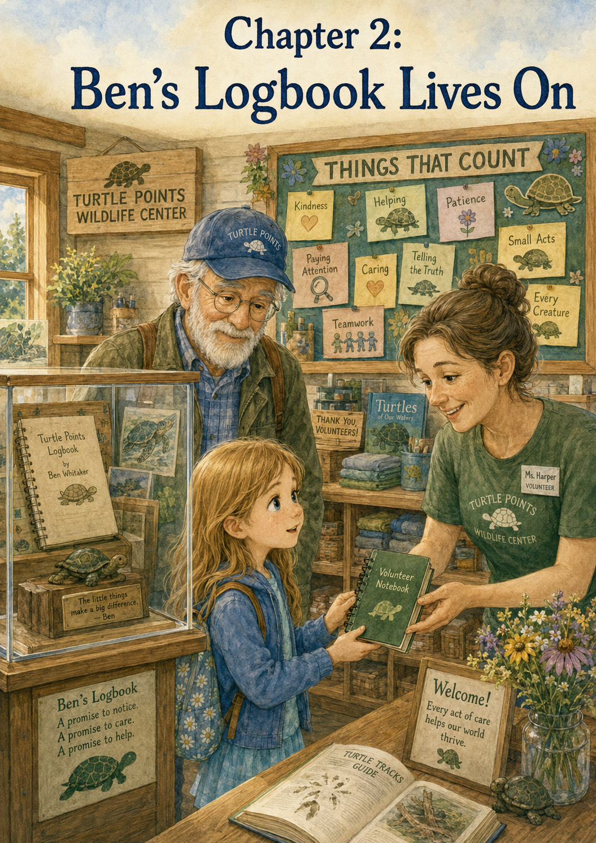Chapter 2: Ben’s Logbook Lives On
Inside the Turtle Points Wildlife Center, everything seemed softer than Lily expected.
The front room was neither as loud as a doctor’s office nor as busy as a school hallway. It was calm and warm, with sunlight coming through the windows and landing in bright squares on the floor. There were shelves filled with towels, gloves, clipboards, small bottles, and neatly labeled bins. A desk stood near the front door where volunteers signed in. On one wall hung photographs of turtles, birds, rabbits, squirrels, and other animals that had been helped by the center.
Lily stepped inside slowly.
Grandpa Jim walked beside her, and Ms. Harper held the door open.
“Welcome to the heart of the center,” Ms. Harper said. “This is where every volunteer starts.”
Lily looked around. “It smells clean.”
Ms. Harper smiled. “Clean is very important here. Clean towels, clean bowls, clean hands, clean spaces. Those things help animals heal.”
Lily nodded as if she understood, though she had not thought much about clean towels being part of animal rescue before.
She had imagined dramatic rescues. A bird with a hurt wing. A turtle in need of help. A tiny rabbit tucked into a soft blanket. She had not imagined shelves of folded cloths or bottles of soap.
But then she remembered what Grandpa Jim had said outside.
Sometimes the best help is quiet help.
Lily followed Ms. Harper past the front desk. A volunteer in a green shirt was writing something on a clipboard. Another volunteer carried a basket of towels through a side door. Somewhere farther inside the building, Lily heard the faint sound of water running.
Ms. Harper stopped in front of a wall near the hallway.
“This,” she said, “is one of the most important places in the whole center.”
Lily looked up.
At first, she thought it was only a display case. It had a wooden frame and clear glass doors. Inside were several carefully arranged items: a copy of a worn spiral notebook, a few turtle drawings, a green pencil, a small carved turtle, and a picture of a boy with a gentle smile.
Lily knew the boy right away.
“Ben,” she whispered.
Grandpa Jim stood quietly beside her.
The picture showed Ben holding a notebook against his chest. He looked younger than Lily remembered from some of the stories, but his smile was the same soft smile Grandpa Jim always described. In the photograph, Ben’s hair was a little messy, his eyes were bright, and the notebook cover had green letters across the front.
Lily leaned closer.
The words on the notebook said:
TURTLE POINTS — OFFICIAL LOGBOOK
Her throat felt tight.
“I’ve heard about this,” she said.
Grandpa Jim nodded. “You have.”
“Ben wrote down every turtle?”
“Every turtle he could,” Grandpa Jim said. “He gave them names, wrote where he found them, and sometimes wrote what he thought they might be feeling.”
Lily looked at the turtle drawings inside the display case. One turtle had stars around its shell. Another had a speech bubble that said, “Slow and safe wins the race.” A third turtle wore a tiny smile and had the name “Miss Maple” written beneath it.
Lily smiled. “Miss Maple.”
Grandpa Jim chuckled softly. “That was one of his favorites.”
Ms. Harper pointed to a card beside the notebook. “This display holds a copy of Ben’s logbook, not the original. The original is kept safely by his family. But this copy helps every volunteer remember why this center exists.”
Lily read the card carefully.
Ben believed small acts of kindness mattered.
The Turtle Points Wildlife Center carries his mission forward through safe helping, gentle care, and community kindness.
Lily read the words twice.
Small acts of kindness mattered.
She thought about the sign outside. Small Acts. Big Hearts.
It all connected.
“Did Ben know this center would exist?” Lily asked.
Grandpa Jim’s face grew quiet. “No,” he said softly. “Not like this. But I think he knew kindness could keep going.”
Ms. Harper nodded. “His story inspired a lot of people. Some people started kindness notebooks. Some started classroom boards. Some helped turtles. Some helped other people. And eventually, a group of volunteers said, ‘What if we built a place where safe helping could keep growing?’”
Lily turned back to the display case.
“So the center grew from the logbook?”
“In a way,” Ms. Harper said. “It grew from what the logbook taught people.”
“What did it teach them?” Lily asked.
Grandpa Jim answered this time.
“That nothing kind is too small to count.”
Lily looked down at her own hands. They suddenly felt important, even though they were small.
Ms. Harper moved a few steps to the right. “And this is our Things That Count board.”
Lily followed her and stopped in front of a large bulletin board covered in paper turtle shapes, leaf shapes, and little note cards. Across the top, in bright green letters, were the words:
THINGS THAT COUNT
The board was full.
Some notes were written by adults in neat handwriting. Others were written by children with big, uneven letters. Some had stickers. Some had tiny drawings. Some were simple. Some were longer.
Lily read one near the top.
Washed six feeding bowls before morning care.
Another said:
Refilled the towel basket without being asked.
Another:
Called a trained rescuer when a baby bird was found. Did not touch it.
Another:
Helped release a healed turtle at Willow Creek.
One note, written in purple crayon, said:
Used a quiet voice in the bird room.
Lily smiled.
“That one sounds like something I could do,” she said.
Ms. Harper smiled back. “Exactly.”
Lily kept reading.
Cleaned a carrier after a squirrel went home.
Thanked Ms. Rosa for staying late.
Picked up litter near the walking path.
Reminded visitors that wild animals need space.
Folded towels for the rabbit room.
Made a get-well card for Maple the turtle.
Lily’s eyes stopped on the name Maple again.
“Is Maple here?” she asked.
“Not yet,” Ms. Harper said. “That note is from another turtle we helped last spring. But turtles often come through the center. Some are hurt, some are weak, and some are simply in the wrong place and need trained adults to help them safely.”
Lily looked at the board again. “These are all Turtle Points?”
Ms. Harper tilted her head thoughtfully. “We don’t use points exactly the way Ben did. We don’t want children to think kindness is only about numbers. But we do believe in keeping track of what matters.”
Grandpa Jim nodded. “Ben started with points, but he learned something bigger.”
“What?” Lily asked.
“That helping is not about getting credit,” Grandpa Jim said. “It is about leaving the world gentler than you found it.”
Lily thought about that.
The words felt like something that should be written down.
Ms. Harper reached into a basket on a nearby table. Inside were small notebooks with green covers. Each notebook had the Turtle Points Wildlife Center logo on the front.
She picked one up and handed it to Lily.
“For you,” she said.
Lily stared at it. “For me?”
“For your volunteer notes.”
Lily took it carefully with both hands, the way someone might hold a baby bird or a glass ornament.
The notebook was smaller than Ben’s logbook, but it looked important. A turtle was printed on the front, walking slowly beneath a line of stars. Under the turtle were the words:
My Turtle Points Volunteer Notebook
Lily ran her fingers gently across the cover.
“What do I write in it?” she asked.
“Anything that helps you remember what you learn,” Ms. Harper said. “Animals you meet. Jobs you do. Safety rules. Questions you have. Kind acts you notice. Things that count.”
Lily opened the notebook. The first page was blank except for three lines at the top.
Name:
First Volunteer Day:
My Helping Goal:
Lily looked at Grandpa Jim.
He smiled. “Looks like it’s waiting for you.”
Lily pulled a pencil from the cup on the table. It was green, just like the letters on Ben’s logbook. She wrote her name carefully on the first line.
Name: Lily
Then she wrote the date.
For the third line, she paused.
My Helping Goal.
That sounded big.
Lily bit the corner of her lip.
She wanted to write something good. Something brave. Something Ben would have liked. She wanted her helping goal to sound important enough for the first page.
Maybe:
Save lots of animals.
But she was not trained to save animals.
Maybe:
Be the best volunteer.
But she did not know how to be the best volunteer yet.
Maybe:
Never make mistakes.
But Grandpa Jim had already told her mistakes could happen and helpers could fix them.
She looked up at the Things That Count board. Her eyes landed on the purple crayon note again.
Used a quiet voice in the bird room.
Then another note.
Did not touch the baby squirrel. Told an adult.
Then another.
Folded towels for the rabbit room.
Small things.
Safe things.
Helpful things.
Lily lowered her pencil to the page and wrote:
My Helping Goal: Today I begin helping safely.
She looked at the sentence.
It was not fancy.
It was not dramatic.
But it felt true.
Grandpa Jim leaned over gently. “That’s a good first entry.”
“You think so?” Lily asked.
“I know so.”
Ms. Harper read it and smiled. “That may be one of the most important goals a volunteer can have.”
Lily felt a tiny warm glow in her chest.
Ms. Harper handed her a small sticker shaped like a turtle shell. “Every new volunteer gets one for their first notebook entry.”
Lily placed the sticker in the corner of the page. It looked like a little green promise.
Just then, a volunteer came through the hallway carrying an empty animal carrier. She set it on a cleaning table and began wiping it down.
Lily watched.
“Was there an animal in there?” she asked.
“A dove,” Ms. Harper said. “She was released this morning.”
“Released?”
“That means she was healthy enough to go back to the wild.”
Lily looked at the empty carrier. “So even cleaning that is part of helping?”
“Yes,” Ms. Harper said. “If the carrier is clean, it is ready for the next animal who needs it.”
The volunteer looked up and smiled. “And there is always a next animal.”
Lily looked at her notebook again.
Maybe she could write that down later.
Ms. Harper pointed to the Things That Count board. “Would you like to add your first note?”
Lily froze. “Already?”
“If you want to.”
“But I haven’t done anything yet.”
Grandpa Jim’s eyes twinkled. “Are you sure?”
Lily looked confused. “I only wrote in my notebook.”
Ms. Harper picked up a blank paper turtle from a tray below the board. “You came here even though you felt nervous. You listened. You learned. You wrote a safe helping goal. That counts.”
Lily stared at the paper turtle.
It was light green with a tiny shell pattern. There was space in the middle for writing.
“What should I write?” she asked.
“What do you want to remember?” Ms. Harper asked.
Lily thought for a moment.
Then she wrote slowly:
I learned that helping safely counts.
She added her name at the bottom.
—Lily
Ms. Harper gave her a pushpin shaped like a leaf. Lily stood on tiptoe and pinned the turtle near the bottom of the board, where there was still some empty space.
She stepped back.
Her turtle note looked small compared to all the others.
Very small.
But it was there.
Grandpa Jim stood behind her. “What do you think?”
Lily looked at Ben’s display case, then at the Things That Count board, then at her own notebook in her hands.
“I think,” she said slowly, “that small things look bigger when they are all together.”
Ms. Harper smiled. “That is one of the secrets of this place.”
Lily looked around the room again. The towels. The gloves. The clipboards. The notebooks. The board filled with notes. The display case holding Ben’s story.
She understood now that the Turtle Points Wildlife Center was not only a building for animals.
It was a place for remembering.
A place for learning.
A place where kindness had a job to do.
Lily held her notebook close to her chest.
Ben’s logbook had started with turtles.
Now there were paper turtles on a board, volunteer notebooks in a basket, and people writing down the quiet good they did each day.
Maybe Ben’s logbook had not really closed.
Maybe it had simply become many notebooks.
Many hands.
Many careful steps.
Ms. Harper gently clapped her hands once. “Ready for your first volunteer tour?”
Lily took a deep breath.
This time, the fluttery feeling in her stomach felt smaller.
“Yes,” she said. “I’m ready.”
Grandpa Jim opened the hallway door, and Ms. Harper led the way.
Before Lily followed, she glanced back one more time at the display case.
Ben’s smiling picture looked back at her from beside the copy of his logbook.
Lily whispered so quietly that only she could hear it.
“I’ll help safely.”
Then she stepped into the hallway, her new volunteer notebook tucked under her arm.
Behind her, the Things That Count board waited for more notes.
More names.
More small acts.
And more big hearts.

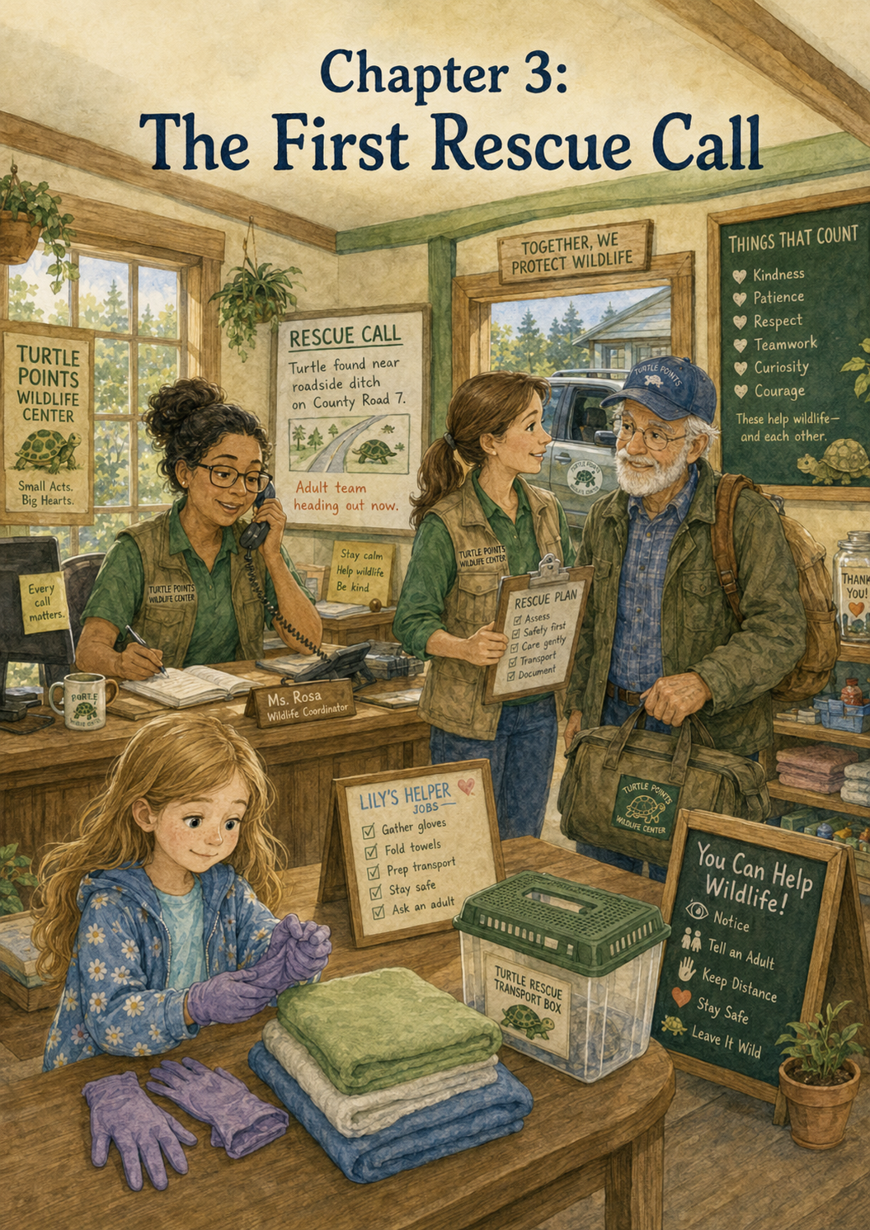Chapter 3: The First Rescue Call
Lily had just finished writing her first note in her new volunteer notebook when the phone rang.
It was not a loud ring, but it seemed to make the whole front room pause.
The volunteer at the desk, Ms. Rosa, reached for the phone with one hand while keeping her other hand on a clipboard. She wore a green Turtle Points Wildlife Center shirt, just like Ms. Harper, and her gray hair was pulled into a neat bun.
“Turtle Points Wildlife Center,” Ms. Rosa said warmly. “This is Rosa. How can we help?”
Lily stood beside the Things That Count board with her notebook held against her chest. Grandpa Jim was talking quietly with Ms. Harper near the hallway, but both of them turned when they heard Ms. Rosa’s voice change.
“Yes,” Ms. Rosa said. “You did the right thing by calling.”
Lily looked up quickly.
Those words sounded important.
Ms. Rosa reached for a yellow rescue form and began writing.
“Can you tell me where you are?” she asked. “A roadside ditch? Near Willow Creek Road? Is the turtle in the road now or off to the side?”
Lily’s heart gave a jump.
A turtle.
A real turtle.
She looked at Grandpa Jim.
He had heard it too.
Ms. Rosa listened carefully, nodding even though the person on the phone could not see her.
“All right,” she said. “Please do not try to pick it up. Stay away from the road. Keep yourself safe first. If you can watch from a safe place, that is helpful, but do not step into traffic and do not touch the turtle. We will send trained volunteers.”
Lily’s fingers tightened around her notebook.
A turtle near a roadside ditch.
It sounded just like Ben’s stories.
In her mind, she pictured Ben spotting a shell near the road and calling out to Grandpa Jim to stop the truck. She pictured the old Turtle Patrol, the one Grandpa Jim had told her about so many times. Ben had noticed turtles that other people missed. He had cared when something small and slow needed help.
Now there was another turtle.
A turtle that might need Turtle Points help.
Lily took one step toward the front door.
Then another.
Grandpa Jim noticed.
“Hold on there, Lily,” he said gently.
Lily stopped, but her whole body felt ready to move.
“Shouldn’t we go?” she asked.
Ms. Harper turned toward her. Her face was kind, but serious.
“The trained rescue team will go,” Ms. Harper said.
“But it’s a turtle,” Lily said. “Near a road.”
“I know.”
“What if it gets hurt?”
“That is why we are going to help the right way.”
Lily looked from Ms. Harper to Grandpa Jim. “I can help. I’m a volunteer now.”
Grandpa Jim walked closer and knelt so his eyes were level with hers.
“You are a volunteer,” he said. “And that means you help by following the safety rules.”
Lily’s face felt warm. She had not meant to break a rule. She only wanted to help.
“But Ben helped turtles near roads,” she said quietly.
Grandpa Jim’s expression softened. For a moment, he looked toward the display case where Ben’s logbook sat behind glass.
“Yes,” he said. “Ben did help turtles. And I was with him. But we also learned something very important.”
“What?”
Grandpa Jim put one hand gently on her shoulder.
“A turtle can be helped again,” he said. “A child hurt in a road might not get another chance.”
Lily grew very still.
The room felt quieter after that.
Ms. Harper stepped beside Grandpa Jim. “That is why our first rule is always safety. Children never approach roads, ditches, injured wildlife, or unsafe places without trained adults.”
“I wasn’t going to run into the road,” Lily said softly.
“I believe you,” Ms. Harper said. “But when we care about something, our hearts can sometimes move faster than our feet should.”
Grandpa Jim nodded. “Ben had a fast heart too.”
Lily looked down at her shoes.
She did not want to have a fast heart if it meant being unsafe.
Ms. Rosa hung up the phone and brought the yellow rescue form to Ms. Harper.
“Box turtle,” Ms. Rosa said. “Caller says it’s near the ditch along Willow Creek Road. Not in traffic right now, but close enough to be dangerous. The caller is waiting in a driveway across the road, away from traffic.”
Ms. Harper read the form quickly. “Good. Rosa, call Mr. Finch and ask him to meet us with the field kit. Jim, can you drive?”
Grandpa Jim stood. “Of course.”
Lily looked up. “Can I come?”
The adults exchanged a quiet glance.
Ms. Harper shook her head gently. “Not on this call.”
Lily’s shoulders dropped.
“But I want to help.”
“You will,” Ms. Harper said. “Right here.”
Lily blinked. “Here?”
“Yes. Every rescue call has more than one part. The trained adults go to the unsafe place. The center team prepares what the animal may need when it arrives.”
Grandpa Jim smiled. “That means we need you, Lily.”
“You do?”
“We do,” Ms. Harper said. “We need gloves, soft towels, a small transport box, intake forms, and a quiet recovery space. We need someone careful to help gather those things.”
Lily looked down at her notebook, then back at Ms. Harper.
“I can do that.”
“I know you can.”
Ms. Harper pointed toward a shelf near the supply table. “First, we need two pairs of clean gloves from the blue bin. Only adults will use them for handling, but they still need to be ready.”
Lily set her notebook on the table and hurried to the shelf. She did not run. She remembered that the center was a quiet place, so she walked quickly but carefully.
The bins were labeled in neat black letters.
CLEAN TOWELS
GLOVES
FEEDING DISHES
INTAKE FORMS
SMALL CARRIERS
Lily found the blue bin marked GLOVES and picked out two pairs. She carried them back with both hands.
“Good,” Ms. Harper said. “Now we need three soft towels. Not the large bath towels. The small folded ones.”
Lily turned back to the shelves. The towel basket was stacked high with white and pale green cloths. She picked three small towels and held them against her chest.
The towels were soft.
She wondered if the turtle would feel them.
Maybe not the way people felt blankets, but maybe the turtle would feel that something careful had happened.
Like Ben had once said in Grandpa Jim’s story, maybe the turtles just felt safe.
Lily placed the towels beside the gloves.
“What next?” she asked.
Ms. Harper handed her a small plastic box with air holes on top. “This is a rescue transport box. We use it to keep the animal safe and still while we bring it back. Can you check that the inside is clean?”
Lily looked carefully inside. “It looks clean.”
“Good. Now place one towel flat in the bottom.”
Lily folded one towel carefully and placed it inside the box. She smoothed the corners with her fingertips.
“Like this?”
“Perfect.”
Ms. Rosa came back from the desk. “Mr. Finch is on his way. He has the field kit.”
Grandpa Jim picked up his truck keys. “I’ll pull around.”
Lily watched him walk toward the front door. A part of her still wanted to follow.
Her feet almost stepped forward again.
But she stopped herself.
Safe helping is real helping, she thought.
She repeated the words in her mind.
Safe helping is real helping.
Ms. Harper lifted the prepared transport box. “You helped get this ready. That matters.”
Lily nodded, but she still felt a little disappointed.
Grandpa Jim paused at the door and turned back. “Lily?”
“Yes?”
“Ben’s mission was never about being the first one to touch the turtle.”
Lily looked at him.
“It was about caring enough to help,” he said. “Today, this is how you help.”
Then he stepped outside.
Through the window, Lily watched Grandpa Jim move the truck to the front of the center. A few minutes later, another volunteer arrived in a tan vest with a kit bag over one shoulder. Ms. Harper handed him the transport box and spoke to him in a calm, careful voice.
Lily could not hear every word, but she heard some.
“Roadside ditch.”
“Caller waiting safely.”
“Use the shoulder only if traffic is clear.”
“No children on site.”
“Check for shell injury.”
“Bring back for intake.”
The words sounded serious.
Rescue was not just a kind idea. It was a careful plan.
Grandpa Jim climbed into the truck. Mr. Finch got in beside him, and the truck slowly pulled away.
Lily stood at the window until it disappeared around the pine trees.
The front room felt different after they left.
Not empty exactly.
Waiting.
Ms. Rosa returned to the desk and wrote the time on the yellow rescue form. “Now we prepare for intake.”
“What is intake?” Lily asked.
“That is what happens when an animal arrives,” Ms. Rosa said. “We record where it was found, what kind of animal it is, who brought it in, what condition it seems to be in, and what care it may need.”
Lily picked up her notebook again. “Ben wrote things down too.”
“He did,” Ms. Rosa said. “His logbook helped him remember every turtle as someone special. Our intake forms help us care for each animal the right way.”
Lily liked that.
Ben had written names and feelings.
The center wrote locations and care notes.
Both kinds of writing mattered.
Ms. Rosa gave Lily a blank practice form. “You can help by learning what information matters. This one is just for practice.”
Lily sat at the small volunteer table and looked at the form.
Animal Type:
Location Found:
Found By:
Safety Notes:
First Care Needed:
She filled in the first line carefully.
Animal Type: Turtle
For location, she wrote:
Near Willow Creek Road
For safety notes, she paused.
Then she wrote:
Children stay away from roads. Adults help.
Ms. Rosa looked over her shoulder and smiled. “That is an excellent note.”
Lily felt a little better.
While they waited, Ms. Harper showed Lily the quiet recovery room where the turtle might rest. The room was small and clean. There were covered bins, soft cloths, shallow dishes, and a sign on the door that read:
Quiet Area — Healing Animals Resting
Lily whispered, even though there were no animals inside yet.
“Will the turtle be scared?” she asked.
“Maybe,” Ms. Harper said. “Most wild animals are scared when they are around people. They do not understand we are trying to help.”
“So we have to be calm?”
“Yes. Calm is kindness here.”
Lily wrote that in her notebook.
Calm is kindness.
She underlined it once.
Then she added:
Waiting can be helping too.
She underlined that twice.
Waiting was harder than gathering towels. Waiting made her imagination run around in circles. She wondered if Grandpa Jim had found the turtle yet. She wondered if cars were passing too close. She wondered if the turtle was hurt. She wondered if Ben would have been brave or worried or both.
Maybe both.
Ms. Rosa seemed to know what Lily was thinking.
“The first rescue call is always hard,” she said.
“Because you don’t know what is happening?”
“That’s part of it,” Ms. Rosa said. “But also, because you learn that helping does not always mean being where the action is. Sometimes helping means preparing. Sometimes it means waiting. Sometimes it means trusting the people who are trained.”
Lily nodded slowly.
She had never thought of trust as a volunteer job.
About twenty minutes later, tires crunched outside.
Lily looked up.
Ms. Harper stepped into the hallway. “They’re back.”
Lily stood, but she did not run to the door. She remembered the rules. She stayed behind the yellow line painted on the floor near the intake table.
Grandpa Jim came in first. His face was calm, but his eyes found Lily right away.
“She’s safe,” he said.
Lily let out a breath she had not realized she was holding.
Mr. Finch came in behind him, carrying the transport box with both hands. Inside, beneath the towel, Lily could see the round shape of a turtle shell.
The turtle did not move much.
Lily whispered, “Oh.”
Ms. Harper motioned for everyone to speak softly. She and Mr. Finch carried the box to the intake table.
“Found near the ditch,” Mr. Finch said. “Not in the road when we arrived, but very close. No visible shell crack from the outside, but she needs a full check.”
“Good work,” Ms. Harper said.
Lily stayed behind the line.
She wanted to see more, but she did not step forward.
The turtle’s head peeked out just a little. Its dark eyes blinked once, then pulled back.
“She’s scared,” Lily whispered.
“Probably,” Grandpa Jim said softly.
“What happens now?”
“Ms. Harper will check her. We will keep her quiet. If she needs a wildlife veterinarian, we will call one. If she only needs rest and observation, she will stay here until they know what is best.”
Lily watched Ms. Harper put on gloves. Mr. Finch wrote notes on the intake form. Ms. Rosa recorded the time.
Everyone had a job.
No one rushed.
No one shouted.
No one acted like kindness had to hurry.
Lily looked at the towel she had placed inside the box. The turtle was resting on it.
“I helped with that,” she whispered.
Grandpa Jim smiled. “You did.”
Ms. Harper carefully checked the turtle while Lily watched from a safe distance. She looked at the shell, the legs, the eyes, and the way the turtle moved. Then she placed the turtle into a quiet, clean container with another soft towel.
“She seems frightened but stable,” Ms. Harper said. “We will let her rest and keep observing.”
“Does she have a name?” Lily asked.
Ms. Harper looked over. “Not yet. We usually wait until intake is finished.”
Grandpa Jim rubbed his beard thoughtfully. “Maybe Lily should help choose one later.”
Lily’s eyes widened. “Me?”
“If Ms. Harper says it’s all right.”
Ms. Harper smiled. “We will see. First, we let our new guest rest.”
Lily nodded.
Rest first.
Names later.
That seemed like another rule worth remembering.
After the turtle was settled in the quiet room, Ms. Harper invited Lily back to the Things That Count board.
“Every rescue call gets a note,” she said. “Would you like to write today’s?”
Lily picked up a blank paper turtle from the tray. Her hand shook just a little, but not because she was scared.
Because it mattered.
She wrote:
Gathered towels, gloves, and a rescue box for a turtle near Willow Creek Road. Helped safely.
Then she added:
Safe helping is real helping.
She signed her name at the bottom.
—Lily
Grandpa Jim handed her a leaf-shaped pushpin. Lily pinned the note near her first one.
The two notes looked small on the board.
But she remembered what she had said before.
Small things looked bigger when they were all together.
Lily opened her volunteer notebook and wrote a new entry.
Rescue Call #1
A turtle was found near a roadside ditch. I wanted to go, but I learned that children do not approach roads or injured wildlife. Trained adults help at unsafe places. I helped by gathering gloves, towels, and a rescue box. The turtle came back safely. Safe helping is real helping.
She paused, then added one more line.
Ben’s mission must be carried out carefully.
Grandpa Jim read the sentence over her shoulder. His eyes grew shiny, but he smiled.
“That’s just right,” he said.
Lily looked toward the quiet room where the turtle rested.
She had not touched the turtle.
She had not gone to the road.
She had not been in the truck when the rescue happened.
But she had helped.
She had listened.
She had prepared.
She waited.
She had followed the rules.
And now a frightened turtle was resting on a clean towel because many people had done their small parts.
Lily held her notebook close.
For the first time that day, she felt like a real volunteer.
Not because she had rushed forward.
Because she had learned to slow down.
Just like the turtle on the sign.
One careful step at a time.

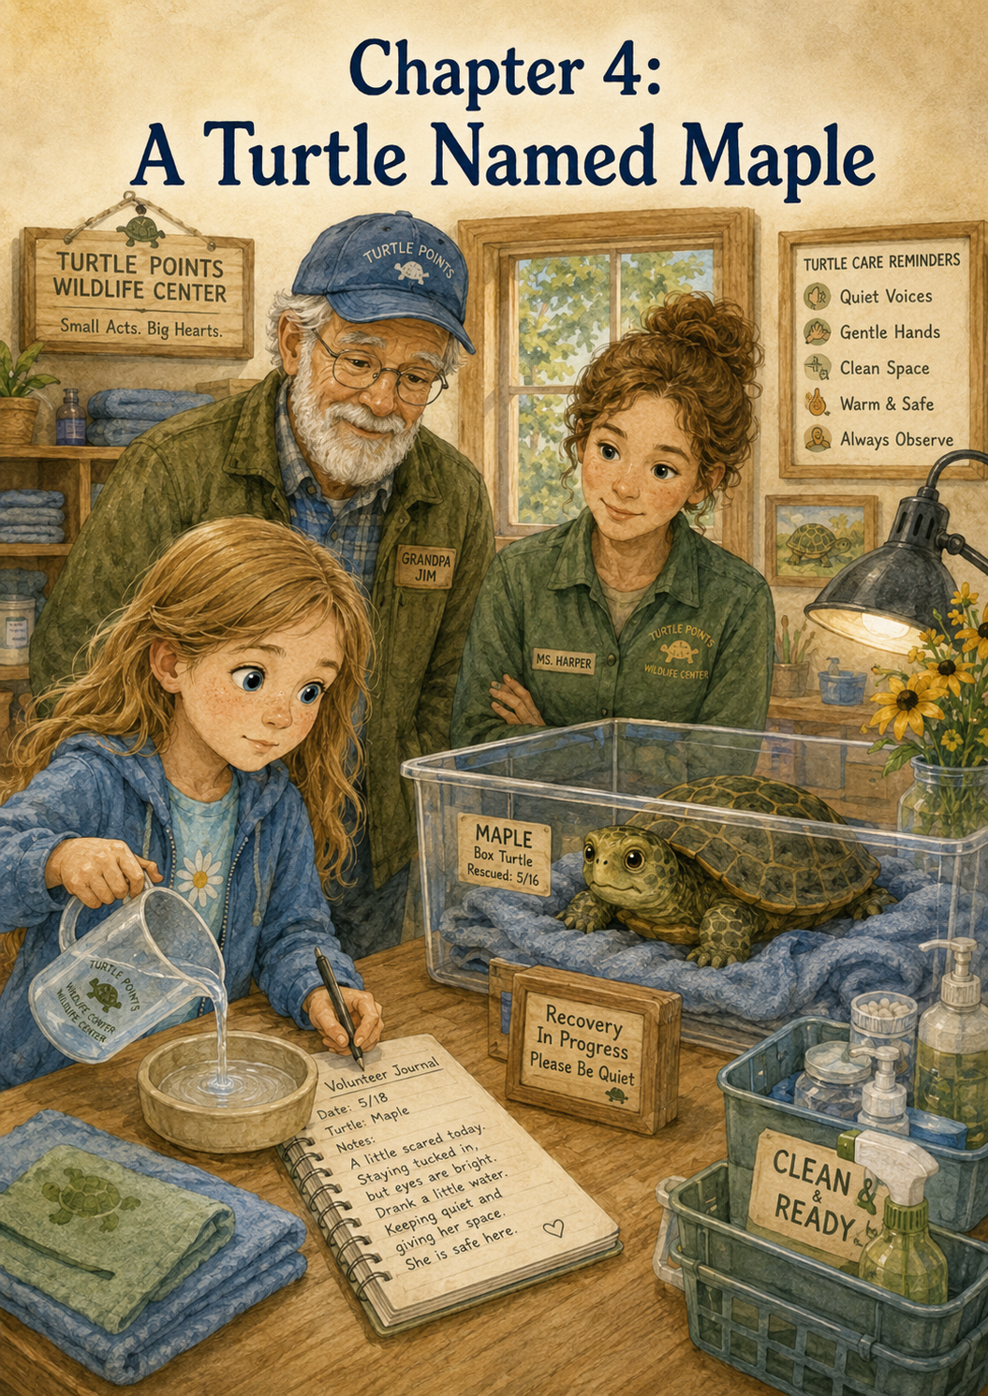Chapter 4: A Turtle Named Maple
The turtle rested in the quiet room.
Lily stood just outside the doorway, holding her volunteer notebook against her chest. A small sign hung on the door:
Quiet Area — Healing Animals Resting
Ms. Harper had explained that animals needed calm after a rescue. They did not understand phones, trucks, doors, people, voices, or clipboards. They only knew they were somewhere new, somewhere strange, and maybe somewhere a little frightening.
So Lily waited.
She did not tap on the door.
She did not whisper too loudly.
She did not ask him to touch the turtle.
She simply stood beside Grandpa Jim and listened to the soft sounds of the center around her.
A towel basket rustled in the hallway. Water ran in a sink nearby. Ms. Rosa’s pencil moved across an intake form at the front desk. Somewhere outside, a bird called from the trees.
Everything felt careful.
That was the word Lily kept thinking about.
Careful.
At Turtle Points Wildlife Center, even kindness moved carefully.
Ms. Harper stepped out of the quiet room, pulling off her gloves and dropping them into the proper bin.
“She is resting now,” Ms. Harper said.
Lily looked up quickly. “Is she okay?”
“She seems frightened, but stable. Her shell does not appear badly cracked, but we will keep watching her closely. Sometimes animals hide how hurt or scared they are.”
Lily frowned a little. “Why would they hide it?”
“In the wild,” Ms. Harper explained, “animals often try not to look weak. It helps protect them. So we have to be patient, gentle, and observant.”
Lily opened her notebook and wrote:
Animals may hide when they are hurt or scared. Helpers must be patient and watch carefully.
Grandpa Jim leaned over just enough to see the page. “That is a good note.”
Lily smiled a little. She liked it when Grandpa Jim said that.
Ms. Harper looked at the notebook, too. “Very good. A careful volunteer writes down what she learns.”
Lily stood a little taller.
“Can I see the turtle?” she asked. “From far away?”
Ms. Harper nodded. “Yes. From the doorway. Quietly.”
Lily followed her back to the door. Grandpa Jim stayed behind her. Inside the room, the lights were soft. A small container sat on a low table, lined with a clean towel. A shallow water dish rested nearby, and a folded cloth created a shaded corner.
The turtle sat partly tucked into her shell. Only the tip of her nose and one dark eye showed.
Lily’s voice dropped to a whisper. “She looks scared.”
“She probably is,” Ms. Harper whispered back.
“Does she know we are helping?”
“Maybe not. Not in the way people know. But if we are calm and gentle, she can begin to feel safer.”
Lily thought about what Ben had once said in Grandpa Jim’s stories. Maybe turtles did not understand words, point systems, or logbooks. Maybe they did not know someone was saving them.
But maybe they could feel that something kind had happened.
Maybe safe felt like kindness.
The turtle blinked once.
Lily smiled softly. “Hello,” she whispered. “You’re safe now.”
Ms. Harper did not correct her. Grandpa Jim did not say anything either.
The turtle pulled her head in a little more, but Lily did not mind.
She was not there to make the turtle like her. She was there to help the turtle rest.
Ms. Harper led Lily back into the hallway.
“She will need a name for our center notes,” Ms. Harper said. “We use names carefully here. They help children and volunteers remember the animal, but we also remember that wild animals are not pets. Their real home is outside.”
Lily nodded. “So the name is just for the story while she is here?”
“That is a good way to say it,” Ms. Harper said.
Grandpa Jim rubbed his beard. “I have a thought.”
Lily looked at him. “What?”
Grandpa Jim’s eyes moved toward the display case in the front room, where Ben’s logbook copy rested behind glass.
“When Ben rescued turtles, he gave them names,” Grandpa Jim said. “One of the turtles he wrote about was named Miss Maple.”
Lily’s eyes widened. “I saw that name yesterday.”
“Yes,” Grandpa Jim said. “Miss Maple was one of his road turtles. He liked the name because the turtle was found near Birchfield Road, where maple leaves used to blow across the shoulder in the fall.”
Lily tried to picture it: Ben crouching near tall grass, Grandpa Jim nearby, a turtle slowly disappearing into the weeds, maple leaves tumbling over the roadside.
“She was one of his Turtle Points?” Lily asked.
“She was,” Grandpa Jim said.
Ms. Harper smiled gently. “Then perhaps this turtle could be Maple, in honor of Ben’s old rescue.”
Lily looked toward the quiet room.
“Maple,” she said softly.
The name felt warm. It felt like trees and shade and slow steps through grass.
“I like it,” Lily said.
“Then Maple it is,” Ms. Harper said.
Lily opened her notebook again and wrote in careful letters:
The rescued turtle’s name is Maple, in honor of Ben’s turtle Miss Maple.
She paused, then added:
Every animal has a story worth noticing.
That sentence made her stop for a moment.
She had not planned to write it. It had simply appeared in her mind and moved down through her pencil.
Grandpa Jim saw it.
His face softened.
“Ben would have liked that,” he said.
Lily looked at the words again.
Every animal has a story worth noticing.
She thought about Maple near the roadside ditch. Maple had been close to danger, but someone had noticed. Someone had called. Adults had gone with the right supplies. Lily had helped prepare the rescue box. Now Maple was resting in a quiet room with a soft towel and clean water.
That was a story.
Maybe not a long story yet.
But a story.
Ms. Harper led Lily to the supply table. “Now that Maple is settled, we have some volunteer jobs.”
Lily brightened. “What can I do?”
“First, we need fresh water dishes for the turtle room. Shallow ones. Turtles should be able to reach water safely without tipping too far.”
Lily followed Ms. Harper to a shelf lined with clean dishes. Some were deep. Some were flat. Some were for birds, some for rabbits, and some for reptiles.
Ms. Harper pointed to the turtle dishes. “Choose two from this stack.”
Lily picked up two shallow dishes. They were smooth and heavy enough not to slide easily.
“Like these?”
“Exactly.”
Ms. Harper showed her how to rinse them one more time, even though they were already clean. Lily washed her hands first, then carefully rinsed the dishes with warm water and placed them on a clean towel to dry.
Water splashed lightly against the sink.
Lily liked the simple sound.
It made her feel useful.
Next, Ms. Harper gave her a stack of soft cloths from the dryer basket.
“These need folding,” she said. “Not too thick, not too loose. We use them for lining carriers or making shaded corners.”
Lily carried the clothes to a small table and sat down. Grandpa Jim sat across from her and picked up one of the cloths, too.
“I thought I was the volunteer,” Lily teased.
Grandpa Jim smiled. “Old grandpas can fold towels too.”
Lily giggled quietly.
Together, they folded.
One cloth.
Then another.
Then another.
Each one became a neat rectangle.
At first, Lily thought towel folding was too simple to matter. But then she remembered Maple resting in the quiet room. Maple had a towel beneath her shell because someone had folded it. The rescue box had been ready because someone had prepared it. The water dish was clean because someone had washed it.
Small jobs connected to bigger kindness.
Lily wrote that in her notebook, too:
Small jobs connect to bigger kindness.
Grandpa Jim read it and nodded.
“That sounds like a Turtle Points rule,” he said.
Lily smiled. “Maybe we should make a list.”
“A list of what?”
“Turtle Points Wildlife Center rules.”
Grandpa Jim’s eyes twinkled. “I think Ben would approve.”
Lily turned to a fresh page and wrote at the top:
Things Lily Is Learning
Under it, she made a list.
- Helping safely counts.
- Calm is kindness.
- Waiting can be helping too.
- Every animal has a story worth noticing.
- Small jobs connect to bigger kindness.
She looked at the list with satisfaction.
“That is a very good beginning,” Grandpa Jim said.
Ms. Harper came back from the quiet room holding Maple’s intake clipboard.
“Would you like to help record Maple’s arrival in your notebook?” she asked.
Lily nodded eagerly.
Ms. Harper sat beside her. “Remember, your notebook is not the official medical record. It is your volunteer learning notebook. So you can write what you noticed and what you helped with.”
Lily wrote:
Maple arrived after being found near a roadside ditch. She looked frightened but safe. Ms. Harper checked her shell. I helped fill water dishes and fold soft cloths. Maple is resting in the quiet room.
She stopped and looked at Ms. Harper.
“Is that okay?”
“That is excellent,” Ms. Harper said. “You included what happened, how Maple seemed, what the adults did, and how you helped.”
Lily looked pleased.
Then she added one more line.
I did not touch Maple because wild animals need trained helpers. I helped from a safe distance.
Ms. Harper smiled even bigger. “That may be the best line on the page.”
Lily felt proud, but not in a loud way.
It was a quite proud.
The kind that made her want to keep doing her best.
Later that morning, Ms. Harper let Lily place a new note on the Things That Count board.
This time, Lily chose a paper turtle with a brown shell and green legs.
She wrote:
Helped prepare water dishes and soft cloths for Maple the turtle.
Then she thought for a moment and added:
Maple looked frightened but safe.
She pinned it near her other notes.
The board was beginning to feel less like something that belonged to other volunteers and more like something Lily was part of.
Grandpa Jim stood beside her.
“You know,” he said, “Ben used to write what he thought the turtles might be feeling.”
Lily looked at him. “Really?”
Grandpa Jim nodded. “He called them Turtle Thoughts.”
Lily loved that immediately.
“Turtle Thoughts,” she repeated.
She hurried back to her notebook and opened to Maple’s page. Under her entry, she wrote:
Turtle Thought: Maple might be thinking, ‘This place is strange, but it is quiet. I think I can rest here.’
Lily read it aloud softly.
Grandpa Jim pressed his lips together, the way he did when he was trying not to feel too much all at once.
“That sounds just like something Ben might have written,” he said.
Lily looked down at the page.
She did not want to copy Ben exactly. She wanted to honor him. She wanted to keep the mission going in her own way.
“Do you think it’s okay that I write Turtle Thoughts too?” she asked.
Grandpa Jim sat beside her.
“I think Ben would be glad,” he said. “Not because you are doing it the same way, but because you are seeing the animals the way he did.”
“How did he see them?”
Grandpa Jim looked toward the quiet room.
“As worth stopping for,” he said. “Worth naming. Worth noticing. Worth helping.”
Lily’s pencil rested on the page.
Worth stopping for.
Worth naming.
Worth noticing.
Worth helping.
Those words felt important too, but she decided not to write them yet. Some words needed to stay in your heart for a while before they went on paper.
After lunch, Ms. Harper checked Maple again. Lily watched from behind the yellow line. Maple seemed a little less tucked in than before. Her head came out farther, and one front foot shifted against the towel.
“She moved,” Lily whispered.
“She did,” Ms. Harper said. “That is a good sign.”
“Does that mean she’s better?”
“It means she is alert. We still need to watch her, but I am pleased.”
Lily smiled. “Good job, Maple.”
Grandpa Jim chuckled softly. “Encouraging turtles now, are we?”
“Maybe encouragement counts,” Lily said.
“Oh, it definitely counts,” Grandpa Jim said.
Ms. Harper laughed quietly. “At this center, kind words are welcome, as long as they are spoken softly.”
So Lily leaned just a little closer, still behind the line, and whispered, “You’re doing great, Maple.”
Maple blinked.
That was all.
But to Lily, it felt like enough.
At the end of the volunteer day, Lily sat on the bench outside the center with Grandpa Jim. The sign with the turtle stood near the entrance, glowing in the late-afternoon sun.
Turtle Points Wildlife Center
Small Acts. Big Hearts.
Lily opened her notebook one last time.
She read over the page about Maple.
“Grandpa Jim?”
“Yes?”
“Do you think Maple knows she has a name?”
Grandpa Jim thought for a moment. “Maybe not the way we do.”
“But does it still matter?”
He looked at her kindly. “It matters because of what the name does inside us.”
“What do you mean?”
“When we name something, we remember it is not just a thing,” Grandpa Jim said. “Ben named turtles because he saw them as little lives with little stories. Naming them helped him care carefully.”
Lily looked down at her notebook.
Maple was not just a turtle.
Maple was a rescued turtle who had been frightened near a roadside ditch. Maple had traveled in a safe box, rested on a soft towel, blinked from inside her shell, and reminded Lily that every animal had a story.
Lily closed the notebook gently.
“I’m glad we named her Maple,” she said.
“Me too,” Grandpa Jim said.
The wind moved through the trees, and a few leaves skittered across the gravel driveway.
Lily watched them tumble near the sign.
For a second, she imagined Ben’s old Miss Maple somewhere in the tall grass of a country road, moving slowly toward the woods. Then she imagined this new Maple resting safely inside the center.
Two turtles.
Two stories.
One kindness mission still growing.
Lily held her notebook close.
Today she had learned that a name could be a promise.
A promise to notice.
A promise to remember.
A promise to care.
And Maple’s story was just beginning.
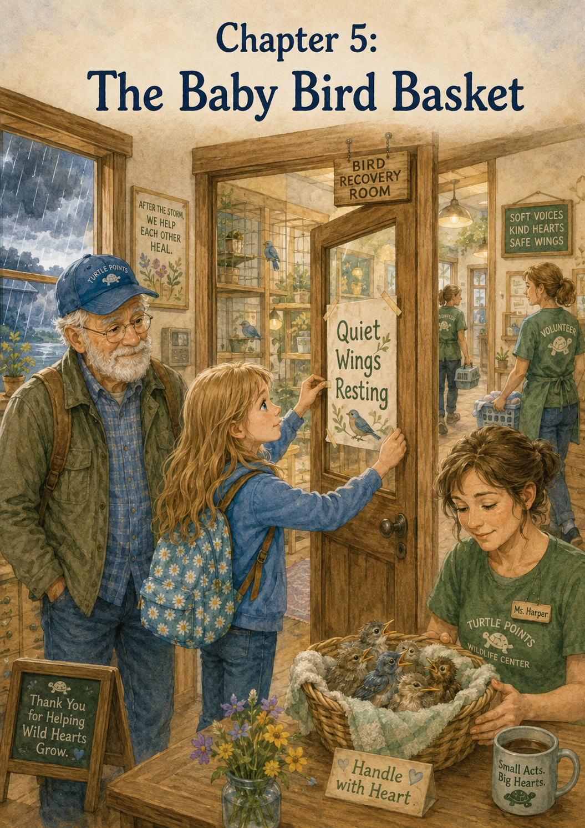Chapter 5: The Baby Bird Basket
The next week, Lily arrived at the Turtle Points Wildlife Center with her volunteer notebook already in her hands.
She had carried it in the truck the whole way there, resting it on her lap like something important. Grandpa Jim had smiled when he saw it.
“Notebook ready?” he asked.
Lily nodded. “Notebook ready.”
“Heart ready?”
Lily touched her chest the way he had taught her. “Heart ready.”
“Careful, feet ready?”
Lily looked down at her sneakers and smiled. “Careful feet ready.”
Grandpa Jim chuckled. “Then I’d say you’re prepared.”
The morning was gray and damp after a night of heavy rain. Puddles rested in the gravel driveway, and drops of water still clung to the leaves on the bushes near the entrance. The sign with the painted turtle stood bright against the cloudy sky.
Turtle Points Wildlife Center
Small Acts. Big Hearts.
Lily stopped to read the sign like she did every time now. She liked the way the turtle looked as if it were taking one slow, brave step forward.
Inside, the center felt busier than usual.
Volunteers moved carefully from room to room. Ms. Rosa answered the phone at the front desk. Ms. Harper was speaking quietly with a man in a rain jacket who held a damp cardboard box. A basket of clean towels sat on the table, and the Things That Count board already had three new notes pinned near the top.
Lily slipped off her raincoat and hung it on the hook by the door.
“What happened?” she whispered to Grandpa Jim.
“Storms can make busy mornings for a wildlife center,” he said softly.
Lily looked toward the man with the box. “Because animals get hurt?”
“Sometimes,” Grandpa Jim said. “Sometimes nests fall. Sometimes animals get separated from safe places. Sometimes people find wildlife and need to know what to do.”
Ms. Harper noticed Lily and waved her over.
“Good morning, Lily,” she said. “I’m glad you’re here today.”
Lily stood a little taller. “Good morning, Ms. Harper.”
Ms. Harper looked serious, but not frightened. “We have a special case this morning. A family found a small nest that fell during last night’s storm. They did the right thing and called us before touching the birds too much.”
Lily’s eyes widened. “Birds?”
“Baby birds,” Ms. Harper said.
The man in the rain jacket carefully lifted the lid of the cardboard box. Inside was a small woven basket lined with a soft cloth. Tucked inside the cloth were tiny baby birds, their little bodies huddled close together.
Lily held her breath.
They were smaller than she expected.
Their heads looked too big for their bodies. Their feathers were not fully grown yet, and their eyes were closed or only partly open. Their beaks made tiny movements, opening and closing as if they were asking the air for help.
“Oh,” Lily whispered.
Ms. Harper gently lowered the lid again, leaving room for air. “They are very fragile.”
Lily’s heart squeezed. “Are they okay?”
“We are going to do everything we can,” Ms. Harper said. “But baby birds need special care. Warmth, quiet, careful feeding, and trained hands.”
“I can help,” Lily said quickly.
Then she stopped herself.
She remembered Maple. She remembered the turtle near the road. She remembered that wanting to help was not the same as knowing how.
“I mean,” Lily said more carefully, “I can help safely.”
Ms. Harper smiled. “That is exactly the right way to say it.”
The man in the rain jacket looked relieved. “My daughter wanted to feed them with a spoon,” he said. “But my wife told her we should call first.”
“That was the right choice,” Ms. Harper said. “Baby birds can be harmed by the wrong food or too much handling. Calling trained helpers is one of the best things a family can do.”
Lily opened her notebook and wrote:
Baby birds need trained helpers. Do not feed them unless a wildlife expert says to.
She underlined the words trained helpers.
Ms. Harper carried the basket toward a quiet room near the back of the center. Lily followed, but she stayed a few steps behind. Grandpa Jim followed too, moving slowly so his boots would not squeak too loudly on the clean floor.
At the doorway, Ms. Harper stopped.
“This is the bird room,” she said. “For today, only trained volunteers will go inside. The babies need warmth and quiet right away. Too many people can make it harder for them.”
Lily nodded, though a tiny part of her felt disappointed.
She wanted to see the baby birds again.
She wanted to help them feel safe.
She wanted to do something big enough to matter.
Ms. Harper must have noticed Lily’s face, because she knelt beside her.
“I know it can be hard when you want to be close to the animals,” she said. “But with baby birds, quiet can be just as important as food.”
“Quiet helps?” Lily asked.
“It does. Their tiny bodies are already working hard. Loud noises, bright lights, and too much movement can make them more stressed. A calm room helps them rest.”
Lily looked at the closed door.
“So if I help keep the room quiet, I’m helping them?”
“Yes,” Ms. Harper said. “Very much.”
Lily thought about the Things That Count board. She remembered one note she had read on her first day.
Used a quiet voice in the bird room.
At the time, it seemed like one of the smallest notes on the board.
Now it seemed much bigger.
Ms. Harper pointed to a small table in the hallway. On it were blank paper signs, markers, tape, and a basket of clothespins.
“We need a sign for this door,” she said. “Would you like to make one?”
Lily’s face brightened. “Yes.”
Ms. Harper handed her a piece of pale blue paper. “It should remind everyone to be quiet and move gently.”
Lily carried the paper to the table. Grandpa Jim sat beside her and watched as she chose a dark blue marker.
At first, Lily did not know what to write.
She wanted the sign to sound kind, not bossy.
She wrote the first word slowly.
Quiet
Then she paused.
“What should come next?” she asked.
Grandpa Jim rubbed his beard. “What are the birds doing?”
“Resting,” Lily said.
“And what do they have?”
Lily thought about their tiny bodies and soft, unfinished feathers. “Wings,” she said.
Grandpa Jim smiled. “There you go.”
Lily wrote:
Quiet Wings Resting
She added smaller words underneath:
Please use soft voices and careful feet.
Then she drew three tiny birds sleeping in a nest. She gave them round heads, small beaks, and little curved lines for wings. Around the edges, she drew soft clouds and a few raindrops, because the storm had brought them there.
When she finished, she held it up.
Grandpa Jim smiled. “That is a fine sign.”
Ms. Harper came back into the hallway and read it. Her face softened.
“Quiet Wings Resting,” she said. “That is beautiful, Lily.”
Lily felt her cheeks warm.
“Can I hang it?”
“You may.”
Ms. Harper gave her a piece of tape. Lily walked carefully to the bird room door and placed the sign right in the center. She pressed the corners flat with her fingertips.
Then she stepped back.
The hallway looked different now. The sign seemed to ask everyone to slow down.
A volunteer carrying a tray of small cloths walked by, saw the sign, and immediately lowered her voice.
“That’s a good reminder,” the volunteer whispered.
Lily smiled.
The baby birds were inside the room, and she was outside the room.
But somehow, she had helped.
For the next hour, Lily stayed busy with quiet jobs.
Ms. Harper showed her how to fold small cloths for the bird room. They were much smaller than Maple’s turtle towels, almost like handkerchiefs. Lily folded each one carefully and stacked them in a neat pile.
Ms. Rosa asked Lily to refill the basket of clean gloves near the bird room door. Lily counted ten pairs and placed them in the basket without letting them fall on the floor.
Grandpa Jim helped her wipe down the hallway table with a clean cloth, making sure the sign-making supplies were neat again.
None of the jobs were exciting.
No one clapped.
No one said, “Lily saved the day!”
But every time a volunteer walked quietly past the sign, Lily felt something warm inside.
Maybe exciting was not the only way helping could feel.
Maybe careful felt good, too.
After a while, Ms. Harper came out of the bird room. She closed the door gently behind her.
“The babies are warm now,” she said. “They are being watched closely.”
Lily stood up. “Did they eat?”
“A trained bird rehabilitator gave them special care,” Ms. Harper said. “They will need a strict feeding schedule, but only trained helpers can do that.”
Lily nodded. “Because the wrong food could hurt them.”
“Exactly.”
“Even if someone is trying to be kind?”
“Especially then,” Ms. Harper said gently. “Good intentions still need good information.”
Lily liked that sentence, but it was a little long. She wrote in her notebook:
Kindness needs learning.
Then she added:
Baby birds need warmth, quiet, and trained care.
Ms. Harper looked over her shoulder. “That is a very good note.”
Lily glanced at the bird room door. “Do they have names?”
“Not yet,” Ms. Harper said. “Sometimes we name a group together while they are here. But we also remember that they are wild birds. The goal is to help them grow strong enough to live outside.”
“Like Maple,” Lily said. “The goal is to help them go home.”
“That’s right.”
Lily looked back at her sign.
Quiet Wings Resting.
“Could we call them the Quiet Wings?” she asked.
Ms. Harper smiled. “For your notebook, yes. That is a gentle name.”
Lily opened to a fresh page and wrote:
The Quiet Wings
Underneath, she wrote:
A basket of baby birds came after the storm. Their nest fell, and they needed help. I could not feed them because they need trained care. I made a sign for the door and helped keep the hallway calm.
She paused.
Then she wrote the sentence that had been growing in her mind all morning.
Quiet kindness counts too.
She looked at it for a long moment.
Quiet kindness counts too.
It was not as exciting as a rescue truck pulling up to the center. It was not as dramatic as a turtle near a road. It was not as visible as releasing an animal back into the wild.
But it mattered.
Grandpa Jim leaned over and read the sentence. He nodded slowly.
“That one belongs on the board,” he said.
Lily looked up. “You think so?”
“I know so.”
Ms. Harper reached for a paper bird shape from a tray beneath the Things That Count board. Most of the shapes were turtles and leaves, but there were birds too, with wide wings and rounded bodies.
“Would you like to write it?” she asked.
Lily took the paper bird carefully.
On one wing, she wrote:
Made a Quiet Wings Resting sign.
On the other wing, she wrote:
Quiet kindness counts too.
In the middle, she signed:
—Lily
She pinned the bird to the board near her turtle notes.
It looked small at first.
But then she noticed how its wings stretched outward, touching the space near other notes.
Folded towels for the rabbit room.
Called for help instead of touching a baby squirrel.
Washed bowls before morning care.
Used soft voices near healing animals.
All the notes seemed to belong together.
Quiet acts.
Careful acts.
Helpful acts.
Things that counted.
Later that morning, a group of younger visitors came through the front room with a parent volunteer. They were there to drop off donated paper towels and cleaning supplies. One little boy pointed down the hallway.
“Can we see the baby birds?” he asked.
His voice was loud with excitement.
Lily looked at Ms. Harper.
Ms. Harper gave her a small nod.
Lily walked over to the group, holding her notebook close.
“There are baby birds resting,” she said politely. “They need quiet right now.”
The boy’s eyes widened. “Are they sleeping?”
“Maybe,” Lily said. “Or maybe they are just trying to feel safe. They came after the storm.”
“Can I peek?”
Lily shook her head gently. “Not today. The trained helpers are caring for them. But you can help by being quiet in the hallway.”
The boy looked disappointed for a second. Then he looked at Lily’s sign.
“Quiet Wings Resting,” he read slowly.
Lily nodded. “That’s their sign.”
The boy lowered his voice to a whisper. “I can be quiet.”
His little sister whispered too. “Me too.”
Their parent smiled gratefully. “Thank you, Lily. That was a helpful explanation.”
Lily felt a small burst of pride.
She had not fed the birds.
She had not held them.
She had not even gone into the room.
But she had helped protect their quiet.
Grandpa Jim, who had been watching from near the front desk, gave her a thumbs-up.
Lily smiled back.
When lunchtime came, Lily and Grandpa Jim sat outside on the bench near the entrance. The storm clouds were beginning to break apart, and pieces of blue sky showed through. The wet grass sparkled in the sunlight. A robin hopped near the fence, tilted its head, and pulled a worm from the soft ground.
Lily watched it closely.
“Do you think the baby birds will be okay?” she asked.
Grandpa Jim took off his cap and rested it on his knee. “I hope so.”
“That means you don’t know.”
“No,” he said honestly. “With wildlife, helpers do their best. Sometimes animals heal. Sometimes they don’t. But the care still matters.”
Lily looked down at her sandwich, but she was not very hungry.
“I wish I could do more.”
Grandpa Jim nodded. “I know.”
“It feels like making a sign is not enough.”
“Is that what you think?”
“Maybe,” Lily said.
Grandpa Jim was quiet for a moment. Then he pointed toward the sign near the entrance.
“What does that say?”
Lily looked up. “Small Acts. Big Hearts.”
“That’s right.”
“I know,” Lily said. “But some acts are really small.”
Grandpa Jim leaned back on the bench. “Ben used to think that way sometimes too.”
“He did?”
“Oh yes. Some days he wanted to save every turtle on every road. He wanted to fix everything all at once. But he learned that a small act done with care can be exactly what is needed in that moment.”
Lily thought about the hallway sign.
Because of that sign, volunteers had lowered their voices. Visitors had slowed down. A little boy had learned that being quiet could help baby birds rest.
Maybe the sign was small.
But it had changed the hallway.
“Do you think Ben would have written down something like this?” Lily asked.
Grandpa Jim smiled softly. “He might have written, ‘Protected baby birds with a quiet sign. Bonus points for good handwriting.’”
Lily giggled.
Then she opened her notebook and added a Turtle Thought.
Bird Thought: We are tiny, and the world is loud. Thank you for making one quiet place.
She read it aloud to Grandpa Jim.
He looked away toward the trees for a moment, then back at her.
“That is a beautiful Turtle Thought,” he said.
“But they’re birds.”
“Then it’s a Bird Thought.”
Lily smiled. “Ben would have liked Bird Thoughts?”
“I think Ben would have liked any thought that helped someone care more.”
After lunch, Lily helped Ms. Rosa organize donated cleaning supplies. There were rolls of paper towels, bottles of gentle soap, trash bags, and boxes of tissues. Lily sorted them by type and placed them on the correct shelves.
A volunteer named Mr. Finch came in from the side door, carrying an empty laundry basket.
“Who made the bird room sign?” he asked.
Lily raised her hand a little. “I did.”
Mr. Finch smiled. “Good work. That sign helped us keep the hallway calm. The baby birds are resting better now.”
Lily’s eyes widened. “Really?”
“Really.”
The simple word filled Lily with happiness.
Resting better.
That was enough.
Before leaving for the day, Lily asked Ms. Harper if she could check the Things That Count board one more time.
The paper bird was still there.
Made a Quiet Wings Resting sign.
Quiet kindness counts too.
Lily touched the edge of the board gently, not moving the note.
“Will they stay on the board?” she asked.
“For a while,” Ms. Harper said. “Then we save many of them in the center scrapbook.”
“A scrapbook?”
Ms. Harper nodded. “Ben had his logbook. We have center records, volunteer notebooks, and scrapbooks. We keep track of the good so we remember what kindness looks like.”
Lily liked that.
Kindness had many shapes.
A logbook.
A paper turtle.
A hallway sign.
A folded cloth.
A soft voice.
A quiet room.
On the ride home, Lily was quieter than usual, but this time it was not because she felt nervous. It was because she was thinking.
Grandpa Jim let her think.
The truck rolled past wet fields and dripping trees. The road shone in patches where the sun touched the puddles. Lily watched the roadside carefully, the way Ben used to do in Grandpa Jim’s stories.
She did not see a turtle.
But she saw a branch that had fallen in the grass.
She saw a puddle shaped like a heart.
She saw a bird sitting on a fence post, shaking rain from its feathers.
Finally, she said, “Grandpa Jim?”
“Yes, Lily?”
“I learned something today.”
“What did you learn?”
“Not every act of kindness feels exciting.”
Grandpa Jim nodded.
Lily looked down at her notebook. “Some kindness is just being quiet. Or waiting. Or making a sign. Or folding cloths.”
“That’s true.”
“But those things still help.”
“They do.”
Lily opened her notebook to the page about the Quiet Wings and read the sentence again.
Quiet kindness counts too.
Then she closed the notebook and held it against her chest.
At the Turtle Points Wildlife Center, a basket of baby birds rested in a quiet room because caring adults knew what to do.
And because Lily had learned what she could do.
Not the biggest job.
Not the loudest job.
But a careful job.
A kind job.
A job that counted.

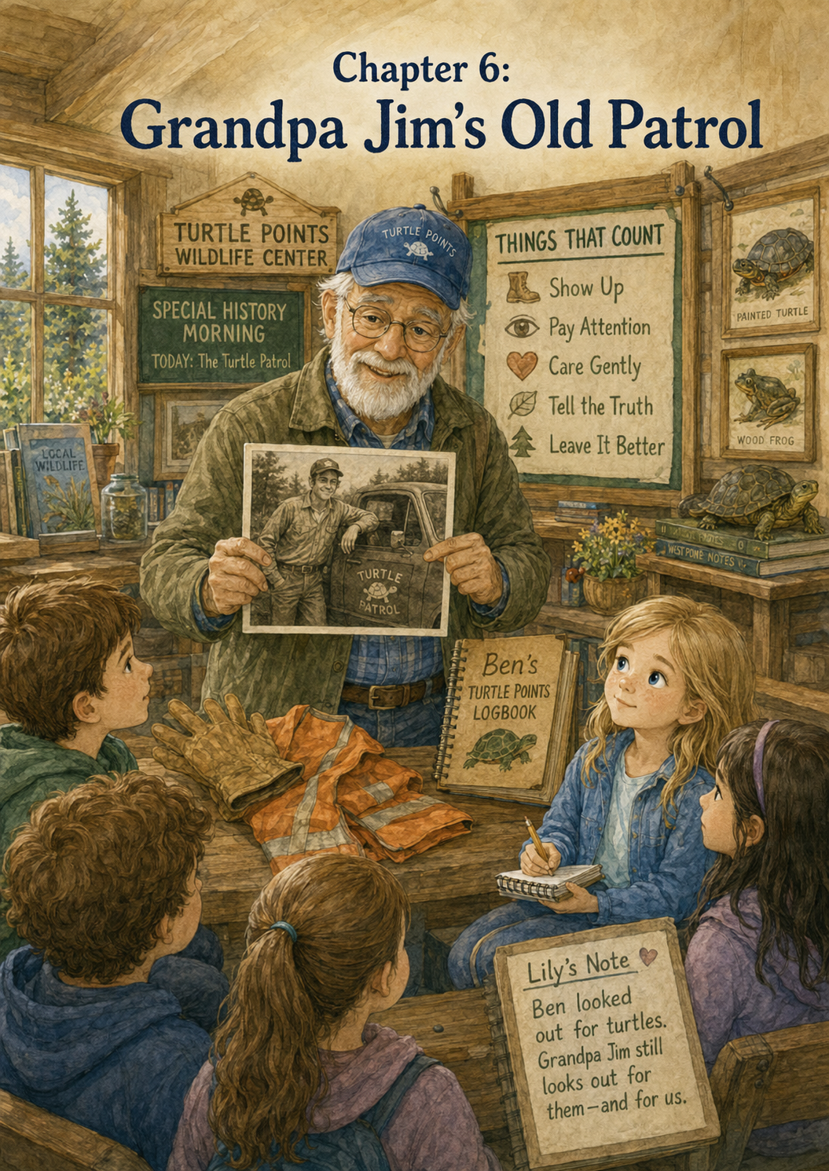Chapter 6: Grandpa Jim’s Old Patrol
Saturday morning at the Turtle Points Wildlife Center began with sunshine.
The rain from the week before had finally passed, leaving the world bright and clean. The grass around the center looked greener than usual, and the trees seemed to sparkle where drops of water still clung to the leaves. Birds called from the branches, and somewhere near the back fence, a squirrel darted across the ground with its tail held high.
Lily stepped out of Grandpa Jim’s truck with her volunteer notebook tucked under one arm.
She had filled several pages now.
There was a page for Maple the turtle.
A page for the Quiet Wings.
A list called Things Lily Is Learning.
And a few pages with Turtle Thoughts and Bird Thoughts, because Grandpa Jim had said Ben would have liked any thought that helped someone care more.
Lily paused by the sign near the entrance, the way she always did.
Turtle Points Wildlife Center
Small Acts. Big Hearts.
The painted turtle seemed to smile at her.
“Good morning,” Lily whispered to it.
Grandpa Jim came around the truck, carrying a small cardboard box.
“What’s in there?” Lily asked.
Grandpa Jim looked down at the box and smiled gently. “Something for Ms. Harper.”
“Supplies?”
“Sort of.”
Lily tilted her head. “What kind of supplies come in an old shoebox?”
Grandpa Jim chuckled. “Memory supplies.”
That made Lily even more curious.
Inside the center, Ms. Harper was setting up chairs in the front room. Ms. Rosa was taping a large sheet of paper to the wall beside the Things That Count board. At the top of the paper, she had written:
Turtle Points History Morning
Lily read the words slowly.
“History morning?” she asked.
Ms. Harper smiled. “Today, Grandpa Jim is going to tell some of our young volunteers how Turtle Points began.”
Lily’s eyes widened. “He is?”
Grandpa Jim rubbed the back of his neck. “Looks like I got volunteered to talk about volunteering.”
Ms. Harper laughed. “You are the best person for the job.”
Soon, several children and parents arrived. Some of the children were Lily’s age. A few were younger. They sat in folding chairs facing the front of the room. A small table had been set up with Ben’s copied Turtle Points Logbook, photographs, paper turtle shapes, and a basket of pencils.
Lily sat in the front row with her notebook open.
Grandpa Jim stood beside the table. He wore his blue cap, glasses, work shirt, and the gentle expression he always had when he talked about Ben.
For a moment, he looked at the children.
Then he looked at the display case where Ben’s logbook rested.
Then he began.
“Before this building was here,” Grandpa Jim said, “before there were green volunteer shirts, rescue forms, intake rooms, or supply shelves, Turtle Points started with one boy, one turtle, and one roadside.”
The room grew quiet.
Lily held her pencil still.
“Ben was very good at noticing things,” Grandpa Jim continued. “Some people look out a truck window and see trees, grass, fences, and roads. Ben saw all of that too, but he also saw the little things. A shell near the white line. A turtle in the ditch. A slow traveler trying to cross a place that was much too dangerous.”
A younger boy raised his hand. “Did Ben save lots of turtles?”
Grandpa Jim smiled. “He saved quite a few. But the important part was not the number.”
The boy looked surprised. “It wasn’t?”
“No,” Grandpa Jim said. “The important part was that Ben cared enough to stop and help safely.”
Lily wrote in her notebook:
Turtle Points began with noticing.
Grandpa Jim picked up the cardboard box he had carried inside and placed it on the table.
“Ben and I used to drive the back roads together,” he said. “We called it Turtle Patrol.”
A few children smiled at the name.
“Turtle Patrol?” one girl repeated.
“That was Ben’s name for it,” Grandpa Jim said. “Our job was to watch for turtles that needed help. But we had rules. We slowed down. We pulled off only when it was safe. We checked for traffic. We never treated the road like a playground. Helping a turtle should never mean putting a person in danger.”
Lily nodded.
She knew that lesson well now.
Safe helping is real helping.
Grandpa Jim opened the shoebox. Inside were an old pair of work gloves, a folded orange safety vest, a small flashlight, and a faded photograph.
He held up the gloves first.
“These were some of my old turtle gloves,” he said.
A little girl leaned forward. “Did turtles bite?”
“Some turtles can,” Grandpa Jim said. “And some are strong, scared, or hurt. That is why trained adults do the handling. Children can help by watching from a safe place, calling an adult, gathering supplies, writing notes, or staying calm.”
Ms. Harper nodded from the side of the room. “That is one of the most important lessons we teach here.”
Grandpa Jim held up the orange vest. “This was for being seen near the road. Bright colors matter. Careful parking matters. Grown-up judgment matters.”
Then he held up the photograph.
Lily leaned forward.
The picture showed a younger Grandpa Jim standing beside his truck. Next to him was Ben, smaller than Lily remembered from the stories, holding his logbook against his chest. The two of them were smiling. Behind them, tall grass waved along the edge of a quiet country road.
Lily’s heart tightened.
“He looks happy,” she whispered.
Grandpa Jim heard her.
“He was happy on Turtle Patrol,” he said softly. “Out there, he did not feel like a sick kid. He felt like a helper. A rescuer. A boy with a mission.”
No one spoke for a moment.
Even the younger children seemed to understand that those words mattered.
Grandpa Jim set the photograph carefully on the table.
“Ben kept a logbook,” he continued. “He named the turtles. He wrote where they were found. He wrote what happened. Sometimes he even imagined what the turtles might be thinking.”
“Turtle Thoughts,” Lily said.
Grandpa Jim smiled at her. “Exactly. Turtle Thoughts.”
A boy in the second row asked, “Why did he name them?”
Grandpa Jim looked at the copied logbook. “Because names helped him remember that each turtle was more than just another turtle. Each one was a life. Each one had a story. Each one was worth noticing.”
Lily looked down at her notebook and thought of Maple.
Maple had been frightened but safe.
Maple had rested on a soft towel.
Maple had blinked from inside her shell.
Maple had a story.
Grandpa Jim continued. “Ben used to count Turtle Points. At first, he thought of them like marks in a notebook. But over time, Turtle Points became something bigger. They became a way to notice kindness.”
Ms. Harper stepped forward and pointed to the Things That Count board. “That is why we have this board. We do not count points like a game. We record helpful acts so we remember what kindness looks like.”
Lily looked at the board.
Her notes were still there.
I learned that helping safely counts.
Gathered towels, gloves, and a rescue box for a turtle near Willow Creek Road.
Helped prepare water dishes and soft cloths for Maple the turtle.
Quiet kindness counts too.
They were small notes, but now Lily understood them better. They were not just about what she had done. They were part of a much longer story.
A story that had begun before her.
Grandpa Jim picked up a paper turtle from the basket.
“When Ben and I were on Turtle Patrol, it was mostly just us,” he said. “One truck. One logbook. A pair of gloves. A careful stop on the roadside.”
He looked around the room.
“But Turtle Points has grown. Now look at this place.”
Everyone looked around.
They saw the supply shelves.
The clean towel baskets.
The rescue forms.
The phone at the front desk.
The Things That Count board.
The quiet hallway.
The display case.
The green volunteer shirts.
The children sitting in folding chairs, listening.
Ms. Harper smiled. “Now we have trained rescuers, wildlife helpers, intake procedures, safe transport boxes, recovery rooms, community donations, and volunteers who know that helping must be done the right way.”
Grandpa Jim nodded. “Ben’s soft heart helped start something. But it took a community to help it grow.”
Lily liked that sentence.
She wrote:
A soft heart can start a mission. A community can help it grow.
She looked at the words for a long time.
They felt like something that belonged on the wall.
After Grandpa Jim finished talking, Ms. Harper invited the children to ask questions.
A small boy raised his hand. “Can kids go on Turtle Patrol?”
Ms. Harper answered carefully. “Children should never go near roads or wildlife without trained adults. But children can learn how to help safely. If you see an animal in danger, the best thing to do is tell a responsible adult and call a trained wildlife helper.”
Grandpa Jim added, “Ben loved turtles, but if he were here today, I think he would want every child to remember this: no turtle rescue is worth a child getting hurt.”
Lily wrote that down too.
A girl with braids raised her hand. “What can kids do here?”
Ms. Harper smiled. “Lots of things. You can help fold towels, organize supplies, make quiet signs, write thank-you notes, collect donations, learn about animal habitats, pick up litter with adult supervision, and teach others when to call for help.”
The girl looked pleased. “I can fold towels.”
“That counts,” Lily said softly.
The girl looked over at her and smiled.
After the questions, Ms. Harper handed each child a paper turtle. “Write one safe way you can help wildlife or your community.”
The room filled with the soft sounds of pencils scratching paper.
Lily looked at her own paper turtle.
She thought about writing:
I can help turtles.
But that was too simple.
She thought about:
I can volunteer.
That was true, but not all children could come to the center every week.
Finally, she wrote:
I can notice what needs help and ask a trained adult what to do.
Then she added a tiny turtle with careful feet.
Grandpa Jim came over and looked at her paper.
“That is a very wise turtle,” he said.
Lily smiled. “It has careful feet.”
“The best kind.”
When the children finished, they pinned their paper turtles around the Things That Count board. Soon the wall was full of new promises.
I can call an adult.
I can keep my dog away from baby birds.
I can throw trash away so animals do not get hurt.
I can use a quiet voice near resting animals.
I can donate paper towels.
I can learn before I touch.
Lily read that last one twice.
I can learn before I touch.
“That one is good,” she said.
Ms. Harper nodded. “Very good.”
Grandpa Jim stood beside Lily and looked at all the paper turtles.
“Ben would have liked this,” he said.
Lily looked up at him. “Do you miss Turtle Patrol?”
Grandpa Jim took a deep breath.
“Yes,” he said honestly. “I miss those mornings. I miss Ben sitting beside me, tapping the dashboard when he spotted something. I miss the way he’d name a turtle before we even got back in the truck.”
Lily was quiet.
Grandpa Jim smiled gently. “But I don’t miss the danger of the roads. I don’t miss worrying about traffic or whether we had enough supplies. This center is safer. Smarter. Bigger than our old patrol.”
“Do you think Ben would understand that?”
“I do,” Grandpa Jim said. “Ben’s heart was brave, but it was also learning. I think he would be proud that Turtle Points grew into something that teaches children to help carefully.”
Lily looked toward the hallway where Maple was resting in the quiet room.
Then she looked toward the bird room, where the Quiet Wings were being cared for by trained helpers.
The center helped more than turtles now.
It helped birds, rabbits, squirrels, and other animals too. It helped people learn. It helped children understand safety. It helped the community work together.
It was like Ben’s logbook had turned into a building.
After the History Morning ended, Lily helped Ms. Rosa collect pencils and stack chairs. Grandpa Jim folded the old safety vest and placed it back in the shoebox. Ms. Harper returned the copied logbook to the display table.
Lily picked up the faded photograph of Ben and Grandpa Jim.
“Can I look at this one more time?” she asked.
Grandpa Jim nodded.
Lily held the picture carefully by the edges.
Ben’s smile looked bright, but gentle. He stood beside Grandpa Jim like he belonged there. Like he had a job. Like his small hands and soft heart were enough to matter.
“He was proud,” Lily said.
“He was,” Grandpa Jim replied.
“I feel proud too,” Lily admitted.
Grandpa Jim looked at her.
“Of what?”
Lily thought about it.
She was proud of Maple’s water dish.
Proud of the Quiet Wings sign.
Proud of her notebook.
Proud that she had stayed behind the line during the rescue call.
Proud that she had learned not to rush.
But there was something else too.
“I’m proud to be part of something Ben started,” she said.
Grandpa Jim’s eyes grew shiny.
“So am I,” he said.
Lily handed the photograph back to him, and he tucked it safely inside the shoebox.
Before leaving for the day, Lily opened her volunteer notebook to a fresh page.
At the top, she wrote:
Grandpa Jim’s Old Patrol
Then she began her entry.
Today Grandpa Jim told us about Turtle Patrol. Before the Wildlife Center existed, he and Ben drove quiet country roads looking for turtles who needed help. They used gloves, watched for traffic, and tried to help carefully. Now the Turtle Points Wildlife Center continues that mission with trained volunteers, rescue supplies, quiet rooms, safe rules, and community support.
She paused and looked up at the Things That Count board.
Then she wrote:
Ben’s soft heart helped start something that grew bigger. I am proud to help carry it forward.
She added one more line.
One careful step at a time.
Lily drew a small turtle at the bottom of the page. This turtle wore a tiny orange safety vest and walked beneath a row of stars.
Grandpa Jim leaned over. “That turtle looks prepared.”
“He is,” Lily said. “He knows the rules.”
Grandpa Jim laughed softly. “Good turtle.”
As they walked outside, the afternoon sun warmed the gravel driveway. The painted turtle sign stood near the entrance, just as it had that morning. But somehow, it looked different to Lily now.
Before, the sign had reminded her of Ben.
Now it reminded her of Ben, Grandpa Jim, the old patrol, Maple, the Quiet Wings, Ms. Harper, Ms. Rosa, Mr. Finch, the children with paper turtles, and every volunteer who had ever done one small job with a big heart.
The mission had not stayed in one notebook.
It had not stayed on one road.
It had grown.
Grandpa Jim opened the truck door for Lily.
She climbed in and held her notebook on her lap.
As they drove away, Lily watched the center grow smaller in the side mirror. The sign was the last thing she saw.
Small Acts. Big Hearts.
Lily smiled.
Ben’s Turtle Patrol had once been one truck on a country road.
Now it was a whole center full of helpers.
And Lily was one of them.

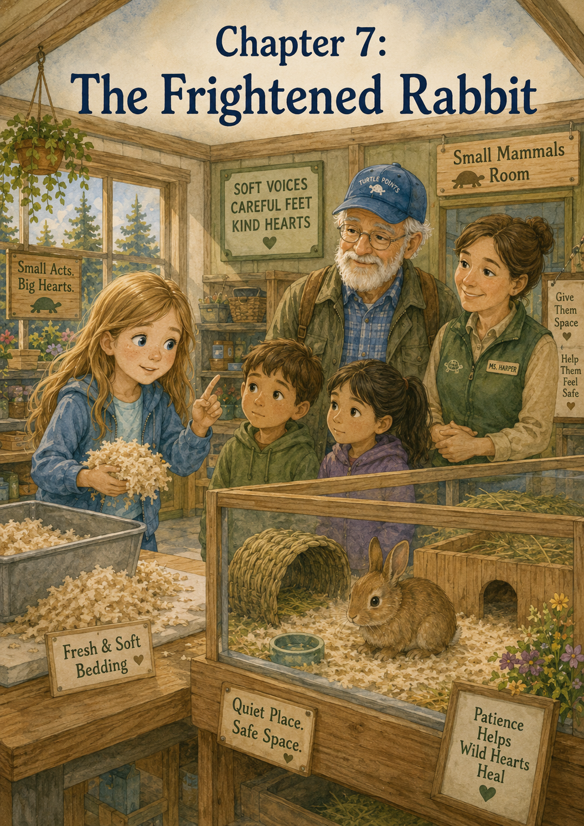Chapter 7: The Frightened Rabbit
The Turtle Points Wildlife Center was quiet when Lily arrived the following Saturday.
Not empty, quiet.
Listening quietly.
The kind of quiet that made every small sound feel important.
The front door gave a soft chime when Grandpa Jim opened it. Lily stepped inside with her volunteer notebook tucked under her arm. She looked first at the Things That Count board, the way she always did now.
There were new notes pinned beside hers.
Washed bowls before morning care.
Donated soft blankets for the recovery rooms.
Called the center before touching a baby animal.
Used quiet feet near the bird room.
Lily smiled when she saw that one.
Quiet feet.
She liked that.
Her own paper bird was still there, too.
Quiet kindness counts too.
She touched the corner of her notebook and felt proud all over again.
Ms. Rosa sat at the front desk, writing on a clipboard. Ms. Harper stood near the hallway speaking quietly with Mr. Finch. Everyone seemed calm, but Lily noticed something different in their faces.
They were focused.
Careful.
“Good morning, Lily,” Ms. Rosa said in a soft voice.
“Good morning,” Lily whispered back.
Grandpa Jim hung his cap on the hook beside the door, then noticed Lily whispering.
“Looks like you remembered the center voice,” he said.
Lily nodded. “Animals might be resting.”
“That’s right.”
Ms. Harper walked toward them with a gentle smile. “I’m glad you are here today, Lily. We have a new animal in the small mammal room.”
Lily’s eyes widened. “What kind?”
“A young rabbit,” Ms. Harper said. “She was found alone near the edge of a yard early this morning.”
“A baby rabbit?”
“Young, but old enough to move around some,” Ms. Harper said. “She is very frightened.”
Lily felt her heart tug.
A frightened rabbit sounded so small and helpless.
“Can I see her?” Lily asked.
“From a safe distance,” Ms. Harper said. “And only if we stay very quiet.”
Lily nodded quickly.
“I can be quiet,” she said.
Grandpa Jim smiled. “She has had practice.”
Ms. Harper led them down the hallway. Lily passed the bird room door, where her sign still hung:
Quiet Wings Resting
Please use soft voices and careful feet.
The words reminded her to slow down.
She stepped more carefully.
When they reached the small mammal room, Ms. Harper stopped outside the door.
“Before we go in, we need to talk about rabbits,” she said.
Lily opened her notebook at once.
Ms. Harper smiled. “You are ready.”
Lily held her pencil over the page.
“Wild rabbits scare easily,” Ms. Harper explained. “They are prey animals, which means many animals in nature hunt them. Because of that, they are very alert. Loud noises, sudden movements, and too much attention can make them panic.”
Lily wrote:
Wild rabbits scare easily. Move slowly. Speak softly. Give space.
Ms. Harper nodded. “Excellent.”
“Can I pet her?” Lily asked, though she already thought she knew the answer.
Ms. Harper shook her head gently. “No. She is not a pet. She is a wild animal. We want her to stay wild so she can return to nature when she is ready.”
Lily wrote that too:
Wild animals are not pets. Helping means respecting what they are.
Grandpa Jim leaned over and read the sentence.
“That is a very grown-up note,” he whispered.
Lily felt pleased.
Ms. Harper opened the door just a little.
Inside, the room was dimmer than the hallway. A small enclosure sat on a table, partly covered with a light cloth to make it feel sheltered. A shallow dish of water rested nearby, and a bundle of soft bedding was tucked into one corner.
At first, Lily did not see the rabbit.
Then something moved.
A tiny shape crouched in the shadow of the cloth. The rabbit’s fur was soft brown, almost the color of dry leaves. Its ears lay close to its body, and its dark eyes looked wide and shiny.
Lily’s breath caught.
“She looks so scared,” she whispered.
“She is,” Ms. Harper said softly. “Everything is new to her. The sounds, the smells, the room, the people. She does not know we are trying to help.”
Lily wanted to step closer. She wanted to say, “It’s okay,” and somehow make the rabbit understand. She wanted to hold it gently and keep it warm.
But then the rabbit pressed deeper into the bedding.
Lily stopped moving.
She remembered the baby birds.
She remembered Maple.
She remembered that kindness did not always mean getting closer.
Sometimes kindness meant giving space.
Lily took one careful step backward.
Ms. Harper noticed and smiled.
“That was a kind choice,” she whispered.
“I didn’t want to scare her more,” Lily said.
“That is exactly right.”
They stepped back into the hallway and closed the door softly.
Lily let out a slow breath. “I wanted to comfort her.”
“I know,” Ms. Harper said.
“But I think being too close would make her more afraid.”
“Yes,” Ms. Harper said. “That is something many helpers have to learn. We comfort people and animals in different ways. A person might want a hug. A wild rabbit wants quiet, space, and safety.”
Grandpa Jim nodded. “Helping means thinking about what the other one needs, not just what we want to give.”
Lily looked down at her notebook.
That sounded important.
She wrote:
Helping means thinking about what the other one needs.
Then she added:
The rabbit needs space, quiet, and patience.
Ms. Harper pointed to a shelf beside the small mammal room. “Would you like a job that helps her?”
“Yes,” Lily said.
“We need fresh bedding prepared. The trained helpers will place it inside later, but you can help get it ready.”
Lily followed Ms. Harper to a clean table. There was a bin of soft bedding material, a stack of small cloths, and a basket labeled:
SMALL MAMMAL SUPPLIES
Ms. Harper showed Lily how to fill a small container with the right amount of bedding.
“Not packed too tightly,” Ms. Harper explained. “She needs to nestle into it. Think soft, not stuffed.”
Lily carefully lifted the bedding with both hands. It felt light and fluffy. She placed it into the clean container and gently loosened it with her fingers.
“Like this?”
“Perfect,” Ms. Harper said. “Now we prepare two more.”
Lily worked slowly. She did not rush. The bedding floated a little when she moved it, so she learned to use careful hands. Grandpa Jim stood nearby, holding a trash bag for any loose pieces that fell.
“Teamwork,” he said.
Lily smiled. “Quiet teamwork.”
“The best kind for rabbits.”
When the bedding was ready, Ms. Harper placed the containers on the supply cart. “This will help when the rabbit’s space needs fresh bedding later.”
Lily looked toward the closed door. “Does she have a name?”
“Not yet,” Ms. Harper said. “We usually wait. But for your notebook, you may write ‘the frightened rabbit’ for now.”
Lily opened to a new page and wrote:
The Frightened Rabbit
Under the title, she wrote:
A young rabbit came to the center after being found alone. She looked scared and stayed tucked in the corner. I wanted to comfort her, but I learned that frightened wildlife needs space, quiet, and patience. I helped prepare fresh bedding.
She paused.
Then she wrote the sentence that came from somewhere deep inside her heart.
Sometimes helping means giving someone room to feel safe.
Lily looked at the words.
They felt true.
She read them quietly to Grandpa Jim.
His eyes softened.
“That sounds like something Ben would have understood,” he said.
“Because of the turtles?” Lily asked.
“Because of fear,” Grandpa Jim said gently. “Ben knew what it felt like to be scared. He also knew how much kindness mattered when someone was afraid.”
Lily thought about Ben in the hospital stories Grandpa Jim had told her. Ben with his logbook. Ben making other children laugh. Ben writing down little acts of kindness even when he was tired.
“Did Ben get scared?” Lily asked.
Grandpa Jim looked toward the Things That Count board at the end of the hall.
“Yes,” he said softly. “He was very brave, but brave people can still be scared.”
Lily nodded slowly. “So when he helped someone feel less afraid, that counted extra?”
Grandpa Jim smiled, though his smile was tender. “I think Ben would say kindness counts extra when it helps someone feel less alone.”
Lily wrote that down too.
Kindness counts extra when it helps someone feel less alone.
A little while later, a small group of visitors arrived at the center. They were dropping off donated towels and cleaning supplies. Two children came with their mother, and one of them, a boy in a red shirt, noticed the hallway sign that said:
Small Mammal Room — Quiet Please
“What’s in there?” he asked loudly.
Lily saw Ms. Rosa look up from the desk.
The boy took a step toward the door.
Lily remembered how the rabbit had pressed into the bedding. She remembered those wide, frightened eyes.
She walked over carefully.
“There is a young rabbit resting in there,” Lily said.
“A rabbit?” the boy said. “Can I see?”
“Not right now,” Lily said gently. “She is very scared. Loud sounds and too many people can make her more afraid.”
The boy frowned. “I just want to look.”
“I know,” Lily said. “I wanted to look too. But Ms. Harper taught me that wild rabbits need quiet, space, and patience.”
The boy’s sister, who looked a little younger, whispered, “Space means don’t go close.”
Lily smiled at her. “That’s right.”
The boy looked at the closed door again. “So how can I help?”
Lily liked that question.
“You can help by using a soft voice in this hallway,” she said. “And maybe you can put a note on the Things That Count board.”
The boy seemed to think about that.
Then he lowered his voice. “Okay.”
His mother smiled at Lily. “Thank you for explaining that.”
Lily felt a warm glow in her chest.
She had helped the rabbit without even going inside the room.
Ms. Harper came out of the office and gave Lily a small nod. It was the kind of nod that said, Well done.
The children wrote a note together on a paper leaf.
We used soft voices so the rabbit could rest.
Lily helped them pin it to the Things That Count board.
The younger girl added a tiny rabbit drawing at the bottom.
Lily loved it.
After the visitors left, Ms. Harper invited Lily to peek into the small mammal room again from the doorway.
“Very quietly,” she said.
Lily nodded.
Inside, the room felt peaceful. The rabbit was still in the enclosure, but she was not pressed quite as far into the corner. One ear had lifted. Her nose twitched gently.
Lily barely breathed.
“She moved,” Lily whispered.
“She is beginning to calm,” Ms. Harper said.
“Because of the bedding?”
“That helped.”
“Because of the quiet?”
“That helped too.”
“Because we gave her space?”
“Yes,” Ms. Harper said. “All of those things helped.”
Lily looked at the rabbit.
The rabbit did not know Lily’s name. She did not know about the Things That Count board. She did not know about Ben, his logbook, Maple, the Quiet Wings, or Grandpa Jim’s old Turtle Patrol.
But maybe she knew the room was quiet.
Maybe she knew no one was chasing her.
Maybe she knew she had a place to hide.
Maybe that was enough for now.
Lily stepped back from the doorway.
“Good job being brave,” she whispered.
Then she added quickly, “Quietly brave.”
Ms. Harper smiled. “That is a lovely thing to say.”
Back in the front room, Lily chose a paper rabbit shape from a small tray Ms. Rosa had placed near the board. It had long ears and a round body.
“What will you write?” Grandpa Jim asked.
Lily already knew.
She wrote:
Prepared fresh bedding for a frightened rabbit. Reminded visitors to speak softly.
Then she wrote below:
Sometimes helping means giving someone room to feel safe.
She signed it:
—Lily
She pinned it beside the visitors’ note.
The two rabbit notes looked good together.
One was from Lily.
One was from children she had helped teach.
That made Lily think of Grandpa Jim’s History Morning. Ben’s soft heart had started something, and the community had helped it grow. Now Lily had taught someone else one small piece of that mission.
Soft voices.
Careful feet.
Room to feel safe.
Later that afternoon, Lily sat at the volunteer table and added more to her notebook.
Rabbit Thought: I am small, and everything feels big. Thank you for not coming too close. Thank you for letting quiet wrap around me.
She read it aloud to Grandpa Jim.
He nodded slowly.
“That one gets to the heart of it,” he said.
Lily looked at him. “Do you think Ben would have written Rabbit Thoughts?”
“I think Ben would have written thoughts for every creature if he had enough pages.”
Lily laughed softly. “His logbook would have been huge.”
“Oh, it already felt huge,” Grandpa Jim said. “Not because of the pages. Because of what was inside it.”
Lily understood.
A notebook could be small and still hold big things.
At the end of the day, Ms. Harper gave Lily one last update.
“Our rabbit is calmer now,” she said. “She is still frightened, but she has eaten a little and settled into the bedding.”
Lily’s face brightened. “She ate?”
“A little,” Ms. Harper said. “For a frightened rabbit, that can be a good sign.”
Lily felt like clapping, but she did not. She remembered where she was.
Instead, she smiled quietly.
On the way out, Lily stopped at the Things That Count board.
There were many notes now.
Turtles.
Birds.
Leaves.
A rabbit.
Some were about rescues. Some were about cleaning. Some were about quiet voices. Some were about calling trained helpers. Some were about patience.
Lily looked at her rabbit note.
Sometimes helping means giving someone room to feel safe.
She thought about how often people rushed in when someone was scared. They wanted to fix it quickly. They wanted to talk, touch, hold, explain, move, and do.
But the rabbit had taught her something different.
Sometimes helping meant stepping back.
Sometimes caring meant being patient.
Sometimes love looked like a quiet room and a soft place to hide.
Grandpa Jim stood beside her. “Ready to head home?”
Lily nodded.
They walked outside together into the soft afternoon light. The sign near the entrance glowed in the sun.
Turtle Points Wildlife Center
Small Acts. Big Hearts.
Lily looked at the painted turtle and imagined Ben smiling at the rabbit note on the board.
“Grandpa Jim?”
“Yes?”
“Do you think making someone feel less afraid is one of the biggest kinds of kindness?”
Grandpa Jim thought for a moment.
“I do,” he said. “Fear can make the world feel very lonely. Kindness makes it feel less lonely.”
Lily held her notebook close.
She thought of Maple resting on a towel.
The Quiet Wings sleeping behind a sign.
The frightened rabbit tucked into fresh bedding.
And Ben, who had believed kindness counted.
Maybe kindness counted in points.
Maybe it counted in notebooks.
Maybe it counted on boards and paper turtles and paper birds and paper rabbits.
But today, Lily thought kindness also counted in something quieter.
A twitching nose.
A lifted ear.
A frightened animal beginning to calm down.
As Lily climbed into Grandpa Jim’s truck, she opened her notebook one more time and added a final sentence to the day’s page.
Today I learned that kindness does not always move closer. Sometimes kindness steps back and gives fear room to rest.
She closed the notebook gently.
Then Grandpa Jim started the truck, and they drove away from the center, one careful mile at a time.

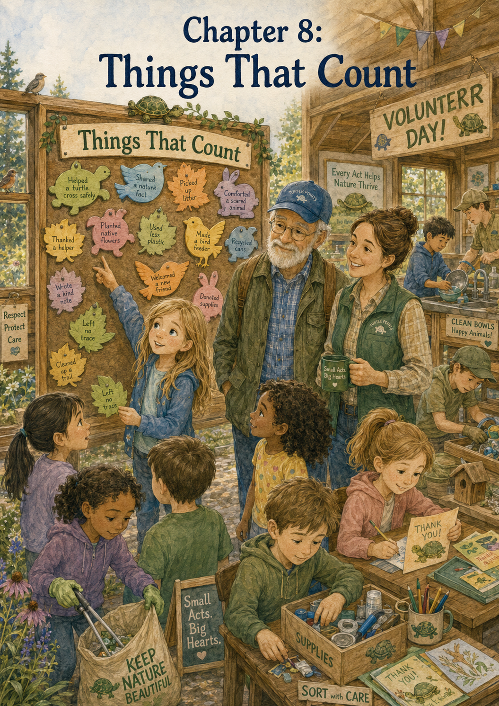Chapter 8: Things That Count
The Turtle Points Wildlife Center looked different on Volunteer Day.
When Lily and Grandpa Jim pulled into the gravel driveway, there were more cars than usual. A folding table stood near the entrance with a green tablecloth stretched across it. On the table were name tags, pencils, paper turtles, paper leaves, and a big jar filled with crayons.
A bright sign leaned against the table.
Welcome to Turtle Points Volunteer Day!
Small Acts. Big Hearts. Things That Count.
Lily smiled as she read it.
“Looks like a busy day,” Grandpa Jim said.
Lily nodded, but she did not feel nervous the way she had on her first day. She had been coming to the center for several weeks now. She knew where the towel baskets were. She knew how to use a quiet hallway voice. She knew that baby birds needed trained care, rabbits needed space, and turtles needed safe helping.
She was still learning, but the center no longer felt strange.
It felt like a place where her heart knew where to stand.
Inside, Ms. Harper was greeting families near the front desk. Ms. Rosa was helping children write their names on stickers shaped like turtle shells. Mr. Finch carried a box of donated paper towels toward the supply room.
The Things That Count board had been moved to the front of the room for everyone to see.
Lily stopped in front of it.
The board was covered with notes now. Turtles, leaves, birds, and rabbits spread across it in bright colors. Some notes were written by adults. Some were written by children. Some had careful handwriting, and some looked wobbly and large.
Lily found her own notes right away.
I learned that helping safely counts.
Helped prepare water dishes and soft cloths for Maple the turtle.
Quiet kindness counts too.
Sometimes helping means giving someone room to feel safe.
She ran her eyes over the words and felt a small glow of pride.
Not loud pride.
Quiet pride.
The kind of pride that came from knowing she had tried her best.
Ms. Harper walked over and placed a gentle hand on Lily’s shoulder.
“Good morning, Lily,” she said. “I have a special job for you today.”
Lily looked up. “You do?”
“I do. Since you have been learning so much, I wondered if you would help younger visitors understand the Things That Count board.”
Lily blinked. “Me?”
“Yes,” Ms. Harper said. “You know the board well. You have added to it. You have learned that not all helping looks the same.”
Lily glanced at Grandpa Jim.
He smiled. “Sounds like someone trusts you.”
Lily held her notebook closer. “What do I say?”
“Tell the truth,” Grandpa Jim said. “That always works best.”
Ms. Harper nodded. “You can explain that the board is a place where volunteers write down helpful acts. Big or small. Quiet or busy. Exciting or ordinary. If it helps, it counts.”
Lily took a deep breath.
“I can try,” she said.
“That is all any good volunteer does,” Ms. Harper said. “Tries with care.”
Soon, children began gathering near the board. Some were younger than Lily. A few were about her age. One boy wore a shirt with a dinosaur on it. A girl with curly hair carried a stuffed fox under one arm. Two brothers stood shoulder to shoulder, whispering and pointing at the paper animal shapes.
Ms. Harper clapped softly to get everyone’s attention.
“Friends,” she said, “this is Lily. She volunteers here each week. Today, she is going to help explain our Things That Count board.”
Several children turned to look at Lily.
Lily felt her stomach flutter.
Just a little.
She looked at Grandpa Jim, who gave her a small nod.
Then she looked at the board.
That helped.
The board was full of reminders. It made her feel less alone.
Lily stepped forward.
“This is the Things That Count board,” she began. “It is where volunteers write down helpful things they do at the wildlife center.”
The boy in the dinosaur shirt raised his hand before Lily could say more.
“Do you write down when you rescue animals?” he asked.
“Yes,” Lily said. “Sometimes.”
“That’s the best one,” he said. “Rescues count the most.”
A few children nodded.
“My dad said someone brought in a turtle from a road,” another boy said. “That is a big thing.”
“It is,” Lily said. “But it isn’t the only thing that counts.”
The children looked at her with uncertain faces.
Lily pointed to one of the notes.
“This one says someone washed feeding bowls.”
The dinosaur-shirt boy frowned. “That’s just washing dishes.”
Lily smiled a little because she had thought something like that once too.
“It feels that way,” she said. “But clean bowls help animals stay healthy. If a turtle or rabbit drinks from a dirty bowl, it could get sick. So washing bowls helps.”
The boy looked at the note again.
“Oh,” he said.
Lily pointed to another.
“This one says someone folded towels. That may seem small too. But Maple the turtle rested on a clean towel after she was rescued.”
The girl with the stuffed fox looked interested. “Who is Maple?”
“A turtle who came here after she was found near a roadside ditch,” Lily said. “She was scared, and the towel helped make her space soft and safe.”
The girl hugged her fox. “Then towels count.”
“They do,” Lily said.
One of the brothers pointed to Lily’s bird note. “What does quiet kindness mean?”
Lily looked at the paper bird and smiled.
“A basket of baby birds came after a storm,” she said. “They needed trained helpers, warmth, and a quiet room. I couldn’t feed them, but I made a sign that said ‘Quiet Wings Resting’ so people would use soft voices near the door.”
The brother lowered his voice. “Like this?”
Lily nodded. “Exactly like that.”
The other brother whispered too. “Quiet counts.”
Lily smiled. “Yes. Quiet counts.”
Ms. Harper stood nearby with her hands folded, listening.
Grandpa Jim leaned against the wall near the display case, his blue cap in his hands. Lily could see that he was proud, though he was trying not to show it too much.
A younger child raised her hand. “What if I don’t know how to help animals?”
“That’s okay,” Lily said. “The trained adults know how to care for the animals. Kids can help in safe ways.”
“Like what?” the child asked.
Lily looked at the board and began counting on her fingers.
“You can refill supplies. You can fold towels. You can help pick up litter outside with an adult. You can make thank-you cards for volunteers. You can use a soft voice. You can listen to safety rules. You can tell an adult if you see an animal that might need help.”
The dinosaur-shirt boy raised his hand again. “Can picking up trash really help wildlife?”
“Yes,” Lily said. “Animals can get hurt by trash. They can step on it, eat it, or get stuck in it. So picking up litter safely helps protect them.”
“With gloves?” he asked.
“With gloves and an adult,” Lily said.
Grandpa Jim smiled from the wall. “Good answer.”
The children began looking at the board differently now.
Not as if they were searching only for the biggest rescue.
As if every note had a story.
Ms. Rosa brought over a tray of blank paper shapes.
“Each visitor can choose a turtle, leaf, bird, or rabbit,” she said. “Then you may write one helpful thing you do today.”
The children crowded around the tray.
“I want a turtle!”
“I want a bird!”
“Can I have a rabbit?”
“I’m choosing a leaf because I’m picking up litter outside!”
Lily helped pass out pencils and crayons. She walked from child to child as they thought about what to write.
The girl with the stuffed fox chose a paper rabbit. She wrote:
I used a soft voice near the animal rooms.
“That’s a good one,” Lily said.
The girl smiled. “So I don’t scare anybody.”
The dinosaur-shirt boy chose a paper turtle and wrote:
I helped wash three bowls.
He looked up at Lily. “That counts now, right?”
“It always counted,” Lily said. “Now you know why.”
He grinned.
The two brothers shared a paper bird and wrote:
We walked with quiet feet in the hallway.
One little girl wrote:
I gave paper towels to the center.
Another child wrote:
I listened to the rules before helping.
Lily paused when she saw that one.
“That is very important,” she said.
The child looked surprised. “It is?”
“Yes,” Lily said. “Listening to the rules keeps people and animals safe.”
The child smiled and drew a tiny heart beside the words.
After everyone added a note, Ms. Harper divided the visitors into small groups for volunteer activities. Lily helped with the supply table. She showed children where to place donated items: paper towels on one shelf, tissues in a bin, clean cloths in a basket, and sealed gloves in a labeled box.
Some children wanted to rush.
Lily reminded them gently, “Careful hands.”
Some children wanted to peek down the hallway.
Lily pointed to the signs and said, “Animals are resting today.”
Some children asked if they could hold a turtle.
Lily shook her head kindly. “Wild animals are not pets. Trained helpers care for them.”
The more Lily explained, the more confident she felt.
She was not bossing.
She was teaching.
And teaching felt like another kind of helping.
Later, Lily went outside with Grandpa Jim, Ms. Harper, and a small group of families for the litter pickup. Everyone wore gloves. Adults carried bags. Children stayed on the walking path and away from the road.
Ms. Harper reviewed the rules before they began.
“We stay together,” she said. “We do not pick up sharp objects. We do not touch anything unsafe. We tell an adult if we are unsure. We protect nature by helping carefully.”
Lily looked at the children. “Helping safely counts,” she added.
The dinosaur-shirt boy nodded seriously. “I know.”
They walked along the path near the center’s fence. Lily found a crumpled paper wrapper and picked it up with her gloved hand. The girl with the stuffed fox found a plastic bottle cap. One of the brothers found a piece of string and asked an adult before touching it.
“Good asking,” Grandpa Jim said.
The brother beamed.
By the time they finished, the bag was not full, but it held enough trash to matter.
Lily looked at it and thought about animals walking through the grass. A rabbit. A turtle. A bird searching for food. A squirrel darting near the fence.
A cleaner path meant a safer place.
That counted.
Back inside, everyone washed their hands. Then Ms. Rosa brought out thank-you cards for the children to decorate.
“Who are these for?” one child asked.
“For the volunteers who clean, drive, answer phones, wash laundry, prepare food, and help animals heal,” Ms. Rosa said.
The children sat at the tables and colored. Some drew turtles. Some drew birds. Some drew hearts. The dinosaur-shirt boy drew a bowl with sparkles around it and wrote:
Thank you for washing animal dishes.
Lily loved that.
“You really understand the bowl thing now,” she said.
He nodded. “Bowls are bigger than they look.”
Lily laughed softly. “Yes. They are.”
By afternoon, the Things That Count board was nearly full.
Paper turtles climbed up one side.
Birds stretched across the middle.
Leaves filled the corners.
Rabbits hopped along the bottom.
There were notes about washing bowls, picking up litter, refilling supplies, sorting paper towels, decorating thank-you cards, listening to safety rules, using quiet voices, and staying with adults outside.
The board looked like kindness had bloomed all over it.
Ms. Harper gathered everyone around.
“Look at what you did today,” she said.
The children stared at the board.
Some looked surprised.
Maybe each child had thought their own note was small. But together, the board looked big.
Very big.
Ms. Harper continued, “A wildlife center does not run on one big rescue. It runs on many careful acts. Every towel folded, every bowl washed, every rule followed, every quiet voice, every phone call, every donation, and every thank-you matters.”
Lily looked at Grandpa Jim.
He was looking at the board with shiny eyes.
She knew he was thinking about Ben.
She was too.
Ben’s logbook had once been full of turtle names, rescue notes, and little acts of kindness. Then the idea had grown into a classroom board called Things That Count. Now it had grown again into a wildlife center board filled by a whole community.
Turtle Points were not only points anymore.
They were reminders.
Reminders to notice.
Reminders to care.
Reminders to help safely.
Reminders that kindness could spread from one person to another.
Lily opened her notebook and wrote:
Today the Things That Count board filled up with notes. Some children thought only big rescues counted, but they learned that small jobs matter too. Washing bowls, picking up litter, refilling supplies, making thank-you cards, and listening to safety rules all help. Ben’s idea keeps growing.
She paused.
Then she added:
Turtle Points are no longer just points in a notebook. They are reminders that kindness can spread through a whole community.
She read the sentence quietly to herself.
It felt like the most important thing she had written all day.
Grandpa Jim came over and sat beside her.
“What did you learn today?” he asked.
Lily looked at the board before answering.
“I learned that kindness gets bigger when people share it.”
Grandpa Jim smiled. “That is a very good lesson.”
“Do you think Ben knew that would happen?”
Grandpa Jim thought for a moment.
“I think Ben hoped kindness would keep going,” he said. “But I don’t know if he imagined all this.”
Lily looked around the room.
Children were showing their parents the notes they had written. Ms. Rosa was carefully taping thank-you cards to the volunteer wall. Mr. Finch was carrying donated supplies to the storage room. Ms. Harper was answering questions from a family who wanted to come back another day.
All because of one idea.
One logbook.
One boy who believed small kindness counted.
Lily looked down at her notebook.
“I wish he could see it,” she said softly.
Grandpa Jim’s voice was gentle. “Maybe, in some way, he can.”
Lily looked up at him.
Grandpa Jim nodded toward the board. “And even if he can’t see it the way we do, we can still carry it forward.”
Lily closed her notebook.
“I think that’s what the board does,” she said.
“What do you mean?”
“It helps us carry it.”
Grandpa Jim smiled. “Yes, Lily. I think it does.”
Before Volunteer Day ended, Ms. Harper gave Lily one last paper turtle.
“This one is for you,” she said. “Write something you want everyone to remember.”
Lily held the turtle shape in her hands.
There were so many things she could write.
Safe helping counts.
Quiet kindness counts.
Small jobs matter.
Kindness needs learning.
Give frightened animals room to feel safe.
She thought about all of them.
Then she wrote:
When everyone does one small kind thing, the whole community helps.
She signed her name at the bottom.
—Lily
Ms. Harper helped her pin it at the very top of the board.
Everyone could see it there.
Grandpa Jim placed his hand gently on Lily’s shoulder.
“That one belongs up high,” he said.
Lily smiled.
As the families left, the center slowly grew quiet again. Chairs were folded. Crayons were gathered. The supply table was cleared. The thank-you cards were stacked neatly. The floor was swept.
But the Things That Count board stayed full.
It looked bright and alive, as if every note was still whispering its small kindness into the room.
On the ride home, Lily leaned her head against the truck window and watched the trees pass by.
Grandpa Jim drove quietly for a while.
Then he asked, “Tired?”
“A little,” Lily said.
“Good tired?”
Lily smiled. “Volunteer Day tired.”
“That’s a special kind.”
Lily nodded. “Grandpa Jim?”
“Yes?”
“Do you think Turtle Points are still Turtle Points if they are not about turtles?”
Grandpa Jim chuckled softly. “I think Turtle Points were never only about turtles.”
Lily thought about that.
She had heard him say something like it before, but now she understood it better.
Turtle Points were about noticing.
Helping.
Learning.
Caring.
Doing what you could, where you were, with safe hands and a kind heart.
Lily looked down at her notebook and touched the cover.
Ben’s logbook had started with turtles.
Now the mission had paper birds, paper rabbits, paper leaves, and a whole room full of helpers.
Lily smiled as the truck turned onto the road home.
Kindness had grown again.
And tomorrow, there would be more things that counted.

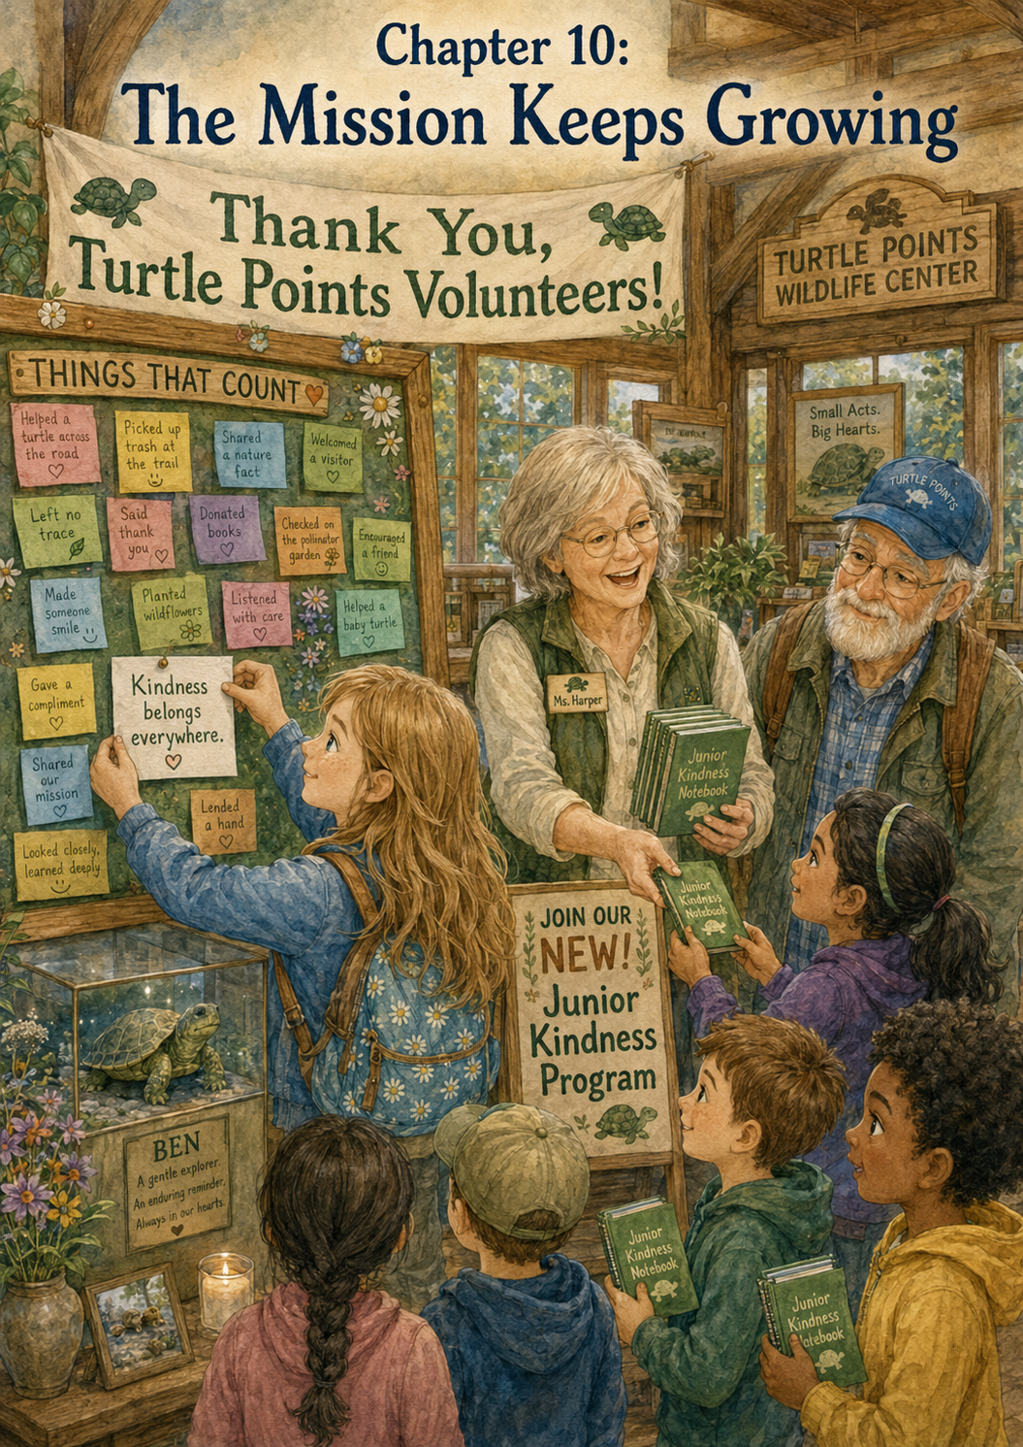Chapter 9: Release Day at Willow Creek
The morning of Maple’s release day felt different from every other morning Lily had spent at the Turtle Points Wildlife Center.
It was not louder.
It was not busier.
It was not even brighter.
But something in the air felt full.
Full of waiting.
Full of hope.
Full of goodbye.
Lily knew Maple was ready because Ms. Harper had said so the day before. Maple had been watched carefully for several weeks. She had rested in the quiet room, eaten well, moved strongly, and passed every check the trained volunteers needed her to pass. Her shell looked strong. Her eyes were clear. Her legs pushed with steady turtle determination.
Maple was ready to go home.
Lily had been happy when she heard the news.
Then, almost at the same time, she had felt sad.
She had written both feelings in her notebook.
Maple is ready to be released. I feel happy because she is strong. I feel sad because I will miss her. I think both feelings can fit in the same heart.
Now, as Grandpa Jim drove toward the center, Lily held her notebook tightly in her lap.
“You’re quiet this morning,” Grandpa Jim said.
Lily looked out the window. The sun had just begun to rise over the trees, turning the sky soft pink and gold.
“I’m thinking about Maple,” she said.
Grandpa Jim nodded. “That makes sense.”
“I’m glad she gets to go home.”
“I know.”
“But I’ll miss checking on her.”
“I know that too.”
Lily turned toward him. “Is it strange to feel happy and sad at the same time?”
Grandpa Jim smiled gently. “Not strange at all. Some of the most important moments feel that way.”
Lily thought about that.
Important moments could feel mixed.
Like the first day at the center, when she had felt excited and nervous.
Like seeing frightened animals, when she had felt worried and hopeful.
Like reading Ben’s old Turtle Points stories, when her heart had felt both heavy and warm.
Maybe release day was another mixed-up heart day.
When they arrived at the Turtle Points Wildlife Center, Ms. Harper was already outside with Mr. Finch and Ms. Rosa. A transport box sat on a small table near the door. It had air holes on top and a soft towel folded carefully inside.
Lily recognized the towel right away.
She had folded it.
“Good morning, Lily,” Ms. Harper said.
“Good morning,” Lily answered softly. Then she looked at the box. “Is Maple inside?”
“Not yet,” Ms. Harper said. “We will bring her out when we are ready to leave.”
Lily nodded.
She looked at the sign near the entrance.
Turtle Points Wildlife Center
Small Acts. Big Hearts.
Today, those words felt bigger than usual.
Small acts had helped Maple reach this day. The rescue call. The gloves. The towel. The water dish. The quiet room. The careful checks. The notes. The patience. The volunteers. The waiting.
All those small acts had become one big moment.
Ms. Harper gathered the volunteers near the front table.
“Today is a special day,” she said. “Maple is strong enough to return to her natural home near Willow Creek. We will travel together, but everyone must remember the rules.”
Lily opened her notebook.
Ms. Harper smiled when she saw the pencil ready.
“Release day rules,” Ms. Harper said. “We stay with the group. We do not wander near the water alone. We use quiet voices. We do not touch Maple. We let trained adults handle the transport box. We watch from a safe distance. And most importantly, we remember that release is about the animal, not about us.”
Lily wrote quickly.
Release is about the animal, not about us.
That sentence made her pause.
She thought she understood.
It meant release day was not about getting the best picture.
Not about standing closest.
Not about being the one to carry Maple.
Not about making Maple turn back or stay longer.
It was about helping her go home.
Ms. Harper continued. “Maple may move quickly, or she may move slowly. She may pause. She may hide. She may head straight for the grass or toward the water. We will not rush her.”
Grandpa Jim smiled. “Turtles have their own schedules.”
Lily smiled too. “One careful step at a time.”
“That’s right,” Grandpa Jim said.
Ms. Harper went into the quiet room. When she returned, she carried Maple gently in gloved hands and placed her inside the transport box.
Lily stood very still.
She could see Maple’s shell through the air holes. It looked brown and green, with little marks and patterns that reminded Lily of leaves, mud, and sunshine.
“Hello, Maple,” Lily whispered. “Today you get to go home.”
Maple did not answer, of course.
But Lily liked to think she was listening in her turtle way.
Mr. Finch carried the transport box to the center van. Grandpa Jim helped Lily climb into his truck, and they followed the van down the road toward Willow Creek.
The drive was not long, but Lily noticed everything.
The tall grasses beside the road.
The fence posts.
The blue sky opening wider above them.
The patches of wildflowers near the ditch.
A bird flying low over a field.
The roads looked different to Lily now. Before volunteering at the center, a road was just a road. A way to get somewhere. But now she thought about turtles, frogs, birds, rabbits, squirrels, and all the small lives moving through the world around people.
She thought about Ben watching roads with careful eyes.
She thought about Turtle Patrol.
She thought about how the Wildlife Center had grown from one boy noticing one turtle into a whole community learning to help safely.
When they reached Willow Creek, Grandpa Jim parked in a small gravel area away from the road. Ms. Harper, Mr. Finch, and Ms. Rosa stepped out of the van. Everyone moved slowly and calmly.
The creek was beautiful.
Water slipped over smooth stones and curved around the roots of old trees. Tall grass grew along the bank. Wildflowers nodded in the breeze. Dragonflies hovered above the water like tiny blue-green helicopters. The air smelled like damp earth, leaves, and sunshine.
Lily took a deep breath.
“This is a good turtle place,” she whispered.
Grandpa Jim looked around. “It sure is.”
Ms. Harper carried the transport box toward a grassy area near the creek bank. Everyone followed, but they stopped several steps back when Ms. Harper raised her hand.
“This is close enough,” she said gently.
Lily stood beside Grandpa Jim. Her heart beat quickly.
Ms. Harper knelt near the grass. Mr. Finch opened the transport box carefully. For a moment, nothing happened.
Maple stayed inside.
Lily held her breath.
Then Maple’s head appeared.
Slowly.
Carefully.
Her eyes blinked in the sunlight. One front foot touched the towel. Then the other. She paused at the edge of the box, as if she were trying to understand the wide world waiting for her.
Lily wanted to say something.
She wanted to cheer.
She wanted to whisper, “Go, Maple, go!”
But she remembered the release day rules.
Quiet voices.
Safe distance.
Release is about the animal, not about us.
So Lily stayed still.
Maple took one step out of the box.
Then another.
Her shell lifted and lowered as she moved through the grass. She did not hurry. She did not seem to care that everyone was watching. She simply went at her own turtle pace.
One careful step.
Then another.
Grandpa Jim leaned close to Lily and whispered, “That’s how Ben liked to watch them go.”
Lily kept her eyes on Maple. “Slowly?”
“Patiently,” Grandpa Jim said. “He always wanted to make sure they kept going in the right direction.”
Maple moved toward the creek bank, then turned slightly toward a patch of tall grass.
“She’s going into the grass,” Lily whispered.
“That may be where she feels safest,” Ms. Harper said softly.
Maple pushed through the green blades. For a moment, Lily could see only her shell. Then only the back edge of her shell. Then there was nothing but moving grass.
Maple disappeared into the Creekside world.
Lily blinked.
She was gone.
Not gone in a sad way.
Gone in the right way.
For a few seconds, no one spoke.
The creek kept moving. The grass kept swaying. A dragonfly landed on a reed. Somewhere above them, a bird sang.
Lily felt tears gather in her eyes.
Grandpa Jim noticed.
He did not say, “Don’t cry.”
He did not tell her to be happy instead.
He just rested a gentle hand on her shoulder.
“She’s home,” he said.
Lily nodded. A tear slipped down her cheek, but she was smiling.
“I’m happy,” she said. “But I’m sad too.”
“That’s love,” Grandpa Jim said softly. “Love is glad when something gets what it needs, even when you miss it.”
Lily looked at the place where Maple had disappeared.
She thought about all the days Maple had spent at the center. The quiet room. The water dish. The soft cloths. The careful checks. The notes on the board. Lily’s Turtle Thoughts.
She had wanted Maple to get better.
Now Maple was better.
That meant goodbye.
Ms. Harper stood and carried the empty transport box back toward the group.
“Maple did very well,” she said. “That was a good release.”
Lily looked at the empty box.
It looked strange without Maple inside.
“Will she be okay?” Lily asked.
“She is strong,” Ms. Harper said. “This is her habitat. She knows how to be a turtle better than we ever could.”
Lily liked that answer.
Maple knew how to be a turtle.
The center’s job had never been to make Maple belong to people. The center’s job had been to help Maple return to where she already belonged.
Lily opened her notebook, but for a moment, she did not write.
She listened instead.
To the creek.
To the wind.
To Grandpa Jim’s quiet breathing beside her.
To the world Maple had returned to.
Then she wrote:
Released Maple today. One turtle. One promise kept.
She looked at the sentence.
It was short, but it held a lot.
Ms. Rosa stepped beside her. “That is a beautiful entry.”
Lily smiled. “It feels like a Turtle Points entry.”
Grandpa Jim’s eyes shone. “It certainly does.”
Lily added another line:
Wildlife rescue is not about keeping animals forever. It is about helping them heal so they can go home.
She underlined go home.
Then she drew a small turtle walking into tall grass.
Under the drawing, she wrote:
Maple Thought: Thank you for helping me rest. I know the way from here.
Grandpa Jim read it and looked toward the creek.
“I think that may be my favorite Turtle Thought yet,” he said.
On the way back to the Wildlife Center, Lily felt quieter than she had on the ride there. But this quiet felt peaceful.
The sadness was still there, but it did not feel heavy. It felt like a soft place inside her heart where Maple’s story would stay.
When they returned to the center, Ms. Harper placed the empty transport box on the cleaning table.
“What happens now?” Lily asked.
“Now we clean the box,” Ms. Harper said. “So, it is ready for the next animal.”
Lily looked at the box.
The next animal.
There was always another call. Another frightened creature. Another quiet room. Another towel to fold. Another water dish to fill. Another chance to help safely.
“Can I help clean it?” Lily asked.
“You may help wipe the outside,” Ms. Harper said. “I will handle the rest.”
Lily washed her hands, put on the gloves Ms. Harper gave her, and carefully wiped the outside of the transport box. It felt like finishing Maple’s chapter and preparing for the next one at the same time.
Afterward, she walked to the Things That Count board and chose a paper turtle.
This one was dark green, almost the color of Willow Creek grass.
She wrote:
Maple was released at Willow Creek today. We helped her heal so she could go home.
Then she added:
One turtle. One promise kept.
She pinned it near the top of the board.
For a moment, Lily simply stood there, looking at it.
The board was full of rescues, quiet voices, clean bowls, folded towels, thank-you cards, safe choices, and patient waiting. Now it also held a goodbye.
A good goodbye.
Grandpa Jim stood beside her.
“Ben used to watch turtles disappear into the grass,” he said. “He always looked proud when they made it.”
“Did he ever feel sad when they left?”
Grandpa Jim smiled. “Sometimes. But he knew the grass was where they belonged.”
Lily nodded.
“I understand that now.”
Ms. Harper came over with a small photograph she had taken from a safe distance. It showed Maple near the grass, just before she disappeared.
“For the center scrapbook,” Ms. Harper said. “And we can print one for your notebook if you’d like.”
Lily smiled. “Yes, please.”
“That way,” Ms. Harper said, “you can remember her release day.”
Lily looked at the photo.
“I think I’ll remember even without the picture,” she said. “But I’d still like one.”
At the end of the day, Lily and Grandpa Jim sat on the bench outside the center. The afternoon sun warmed the wooden seat. A soft breeze moved through the trees.
Lily opened her notebook and read the day’s entry one more time.
Released Maple today. One turtle. One promise kept.
She rested her finger under the sentence.
“Grandpa Jim?”
“Yes?”
“Do you think Ben would have counted today as a Turtle Point?”
Grandpa Jim looked toward the sign.
Small Acts. Big Hearts.
“I think,” he said slowly, “Ben would have counted every careful step that helped Maple get home.”
Lily thought about that.
The rescue call.
The transport box.
The towel.
The water dish.
The quiet room.
The soft voices.
The checks.
The waiting.
The drive to Willow Creek.
The moment Maple stepped into the grass.
So many careful steps.
So many things that counted.
Lily closed her notebook.
A turtle had gone home today.
And Lily had learned that sometimes kindness means saying goodbye when goodbye is the best gift you can give.
She leaned against Grandpa Jim’s arm and looked at the painted turtle on the sign.
One turtle.
One promise kept.
And somewhere near Willow Creek, Maple was moving through the grass, exactly where she belonged.

Chapter 10: The Mission Keeps Growing
The last Saturday of Lily’s first volunteer season arrived with a soft breeze and a sky full of white clouds.
It did not feel like an ending at first.
The Turtle Points Wildlife Center looked the same as it always did. The painted turtle sign still stood near the entrance. The gravel still crunched under Grandpa Jim’s truck tires. The flower boxes still held bright yellow blooms. The pine trees still swayed gently above the roof.
But Lily knew this day was special.
Ms. Harper had called it a “season wrap-up,” which meant the volunteers would look back at the animals they had helped, the lessons they had learned, and the work still ahead.
Lily stepped out of Grandpa Jim’s truck with her volunteer notebook in her hands.
It was not empty anymore.
The green cover was a little bent at the corners. A turtle sticker sat on the front, and inside were pages filled with notes, lists, drawings, and thoughts.
There was Maple’s page.
There was the Quiet Wings page.
There was the Frightened Rabbit page.
There was the Volunteer Day page, where Lily had written that kindness gets bigger when people share it.
And there was the release day entry, the one she had read more than once.
Released Maple today. One turtle. One promise kept.
Lily held the notebook close and looked at the sign.
Turtle Points Wildlife Center
Small Acts. Big Hearts.
“Good morning,” she whispered to the painted turtle.
Grandpa Jim came around the truck. “Still greeting the sign?”
Lily smiled. “It feels polite.”
Grandpa Jim chuckled. “I think Ben would have approved.”
Lily looked at him. “Do you think Ben talked to signs too?”
“No,” Grandpa Jim said, rubbing his beard. “But he talked to turtles, clouds, road maps, and once a very stubborn milkshake machine.”
Lily laughed. “A milkshake machine?”
“It wouldn’t give him extra whipped cream.”
“That sounds serious.”
“Oh, it was,” Grandpa Jim said. “He gave it a very stern talking-to.”
Lily laughed again, and the warm sound seemed to float toward the center door.
Inside, the front room was decorated with paper turtles, leaves, birds, and rabbits. A banner stretched across the wall above the Things That Count board.
Thank You, Turtle Points Volunteers!
The board was fuller than Lily had ever seen it.
Notes overlapped in bright layers. Some were pinned neatly. Others tilted to one side. Some had drawings of animals, hearts, trees, stars, and little hands. A few notes were written in careful grown-up letters. Many were written in children’s handwriting.
Lily stepped closer.
She saw notes she remembered.
Used soft voices so the baby birds could rest.
Washed bowls before morning care.
Prepared fresh bedding for a frightened rabbit.
Helped sort donated supplies.
Picked up litter with adult supervision.
Listened to safety rules before helping.
Released Maple at Willow Creek.
Lily touched her notebook.
The board looked like her notebook had grown into a wall.
Ms. Rosa stood near the front desk, organizing a stack of certificates. Mr. Finch carried a basket of clean towels toward the hallway. Ms. Harper was placing a small wooden box on the table beside Ben’s display case.
“Good morning, Lily,” Ms. Harper said warmly.
“Good morning,” Lily answered.
Ms. Harper looked at the notebook in Lily’s hands. “That notebook has been busy.”
Lily smiled. “It has a lot in it now.”
“That means your heart has been paying attention,” Ms. Harper said.
Lily liked that.
Her heart had been paying attention.
At the beginning of the season, Lily had worried she would not know how to help. She had thought volunteering might mean doing big, exciting things. She imagined carrying animals, rushing to rescues, and saving the day.
But the center had taught her something different.
Helping was not always exciting.
Sometimes helping was folding towels.
Sometimes it was making a quiet sign.
Sometimes it was staying behind a safety line.
Sometimes it was giving a frightened rabbit space.
Sometimes it was saying goodbye to a turtle at Willow Creek.
All of it counted.
Grandpa Jim stood beside the display case, looking at the copy of Ben’s Turtle Points Logbook. Lily walked over and stood beside him.
Ben’s picture smiled from behind the glass. His logbook rested open to a copied page filled with turtle names, notes, and small drawings.
Lily looked from Ben’s logbook to her own notebook.
“They look different,” she said.
Grandpa Jim nodded. “They do.”
“But they are kind of the same.”
“How so?” he asked.
Lily thought for a moment.
“Ben wrote down turtles and kindness,” she said. “I wrote down turtles and birds and rabbits and kindness.”
Grandpa Jim smiled softly. “That sounds the same to me.”
Lily looked at Ben’s picture. “His mission got bigger.”
“It did,” Grandpa Jim said.
“Do you think he would be surprised?”
Grandpa Jim’s eyes stayed on the photograph. “Maybe. But I think he would be glad.”
Ms. Harper called everyone together near the front room.
Volunteers, parents, children, and community helpers gathered around the Things That Count board. Some wore green Turtle Points shirts. Some wore name tags shaped like turtle shells. Some were there for the first time, and some had been helping for years.
Lily stood beside Grandpa Jim.
Ms. Harper smiled at the group.
“Today, we are celebrating the end of another volunteer season,” she began. “This season, our center answered rescue calls, cared for injured and frightened wildlife, released animals back into safe habitats, collected supplies, cleaned rooms, taught safety lessons, and welcomed many new helpers.”
Everyone clapped softly.
Lily clapped too.
Ms. Harper continued. “But today is not only about the animals. It is also about the people who chose to help carefully.”
She turned toward the Things That Count board.
“This board reminds us that every act of kindness matters. Some acts are easy to see, like a release day at Willow Creek. Other acts are quiet, like washing bowls, folding towels, using soft voices, or calling trained adults instead of touching wildlife. But all of those acts help.”
Lily looked at her notes on the board.
Her first note seemed small now, but she remembered how big it had felt the day she wrote it.
I learned that helping safely counts.
Ms. Harper picked up the small wooden box from the table. “This season, we also collected some of our favorite notes from the board and placed copies in the Turtle Points scrapbook.”
She opened the box and lifted out a green book. The cover had a turtle painted on it, walking beneath stars.
Turtle Points Wildlife Center Scrapbook
Things That Count
Ms. Harper turned a few pages so everyone could see.
There were photographs of volunteers sorting supplies. A picture of Lily’s Quiet Wings sign. A photo of children picking up litter with adults. A picture of Maple near the grass at Willow Creek. A copy of Lily’s note that said:
One turtle. One promise kept.
Lily’s cheeks grew warm.
“That’s yours,” Grandpa Jim whispered.
Lily nodded, too shy to speak.
Ms. Harper closed the scrapbook gently. “Ben’s first Turtle Points Logbook helped people see that small acts of kindness mattered. Today, this scrapbook helps us remember that the mission continues.”
The room grew quiet.
The kind of quiet that felt full, not empty.
Then Ms. Harper looked at Lily.
“And one of our young volunteers has helped remind us of that again and again this season.”
Lily looked behind her, wondering for one silly second if there was another young volunteer standing there.
But everyone was looking at her.
Grandpa Jim’s hand rested gently on her shoulder.
Ms. Harper smiled. “Lily, would you come up here?”
Lily’s stomach fluttered.
She walked to the front slowly, holding her notebook in both hands.
Ms. Harper knelt beside her so they were closer in height. “When you first came to the center, you wrote, ‘Today I begin helping safely.’ Since then, you have helped prepare supplies, made signs, taught younger visitors, wrote thoughtful notes, and reminded others that kindness belongs in careful hands.”
Lily swallowed. “I just did little jobs.”
Ms. Harper’s smile grew. “That is exactly why they mattered.”
Grandpa Jim looked down at the floor for a moment, then back up. His eyes looked shiny.
Ms. Harper handed Lily a small certificate.
Turtle Points Junior Volunteer
Awarded to Lily for Safe Helping, Kindness, Patience, and Care
Lily stared at it.
“Thank you,” she whispered.
Everyone clapped.
The sound was gentle, but to Lily it felt big.
Not because she wanted attention.
But because the certificate reminded her that her small jobs had mattered.
Ms. Harper stood again and addressed the group. “And now, we have something new to share.”
The room quieted.
“This year, because of the interest from children and families, the Turtle Points Wildlife Center will begin a Junior Kindness Program.”
Lily looked up quickly.
“A junior program?” she whispered.
Ms. Harper nodded. “Children will be able to learn safe ways to care for animals, nature, and their community. They will not handle wildlife or go into unsafe rescue situations, but they will learn how to help responsibly.”
Ms. Rosa held up a folder. On the front was a turtle, a bird, a rabbit, and a leaf.
Junior Kindness Program
Learn. Notice. Help Safely.
Ms. Harper continued. “The program will include wildlife safety lessons, nature clean-up days with adults, supply drives, thank-you cards for volunteers, quiet room signs, habitat learning, and Things That Count notebooks.”
Lily’s eyes widened. “Notebooks?”
“Yes,” Ms. Harper said. “Every junior helper will receive a small notebook, like yours.”
Lily looked down at her own notebook.
It suddenly felt even more important.
Ms. Harper turned to her. “Lily, we would like you to help us start the program.”
Lily blinked. “Me?”
“Yes,” Ms. Harper said. “You can help welcome new children, explain the Things That Count board, and remind them what you learned.”
Lily felt surprised, proud, and nervous all at once.
“What if I don’t know everything?” she asked.
Ms. Harper smiled. “You do not need to know everything. You only need to remember the first lesson.”
Lily knew it right away.
“Helping safely counts,” she said.
“Exactly.”
Grandpa Jim smiled. “That sounds like a strong beginning.”
Lily looked at the Junior Kindness Program folder. She imagined children sitting at the table with notebooks of their own. She imagined them writing their first entries. She imagined them learning not to touch wild animals, not to run near roads, and not to think only big rescues mattered.
She imagined paper turtles filling the board again.
More notes.
More names.
More kind hearts.
Ben’s mission growing wider and wider.
Ms. Harper handed Lily a blank paper turtle.
“We saved one final space on the Things That Count board for you,” she said. “Would you like to add the closing note for the season?”
Lily took the paper turtle carefully.
It was pale green with a golden shell. Around the edges, someone had drawn tiny stars.
She carried it to the table and sat down.
Everyone waited quietly, but not in a way that made her feel rushed.
Lily held the pencil over the paper.
What should the final note say?
She thought of Ben and his logbook.
Grandpa Jim and the old Turtle Patrol.
Maple’s frightened eyes and slow walk into the grass.
The baby birds resting behind the Quiet Wings sign.
The rabbit tucked into fresh bedding.
The children washing bowls and picking up litter.
The volunteers answering phones and folding towels.
The Things That Count board filling with small acts.
The Junior Kindness Program waiting to begin.
Then Lily knew.
She wrote three words:
Kindness belongs everywhere.
She signed her name at the bottom.
—Lily
Ms. Harper helped her pin it at the center of the board.
Not at the top.
Not at the bottom.
Right in the middle, where every note seemed to point toward it.
Everyone looked at the words.
Kindness belongs everywhere.
Grandpa Jim stepped closer. “That is the right note,” he said softly.
Lily looked up at him. “It feels like Ben’s mission.”
Grandpa Jim nodded. “It is.”
After the celebration, people shared lemonade and cookies in the front room. Children looked at the scrapbook. Volunteers talked about the next season. Parents asked questions about the Junior Kindness Program.
Lily helped Ms. Rosa pass out small green notebooks to the first children who wanted to join.
One little girl held hers tightly and asked, “What do I write first?”
Lily smiled.
She remembered asking that same question.
“You can start with a helping goal,” Lily said.
“What kind?”
“Something safe and kind.”
The little girl thought very hard. Then she wrote:
I will learn how to help animals safely.
Lily nodded. “That is a very good first entry.”
The girl looked pleased. “Does it count?”
“It definitely counts,” Lily said.
A boy nearby asked, “Can I write about picking up litter?”
“Yes,” Lily said. “With adult supervision.”
Another child asked, “Can I write about being quiet near animals?”
“Yes,” Lily said. “Quiet kindness counts too.”
Grandpa Jim watched from beside the display case.
Lily noticed him smiling.
She walked over when the children had finished writing.
“You look happy,” she said.
“I am,” Grandpa Jim replied.
“Because of the program?”
“Because of all of it,” he said. “Because Ben’s idea is still moving.”
Lily looked at the Things That Count board.
“Like a turtle,” she said. “Slow, but still moving.”
Grandpa Jim laughed softly. “Exactly like a turtle.”
Lily looked at Ben’s photograph in the display case.
She wondered what he would think of all this. A wildlife center. A scrapbook. A junior program. Children writing safe helping goals. Maple’s release photo. A board full of kindness notes.
She hoped he would smile.
She thought he would.
Before leaving, Lily asked Ms. Harper if she could visit Maple’s empty recovery space one last time.
“Of course,” Ms. Harper said.
The quiet room was clean and ready for the next animal. Maple’s towel was gone. Her water dish had been washed and put away. The space looked empty, but not lonely.
Lily stood in the doorway.
“Goodbye, Maple’s room,” she whispered. “Get ready to help someone new.”
Grandpa Jim stood behind her.
“There will always be someone new,” he said.
“That makes me happy and sad too,” Lily said.
Grandpa Jim nodded. “That means your heart is working.”
Lily smiled.
On the way back to the front room, she passed the bird room and remembered the tiny beaks of the Quiet Wings. She passed the small mammal room and remembered the frightened rabbit’s lifted ear. She passed the supply shelves and remembered how ordinary towels and bowls could become part of something kind.
Every corner of the center held a lesson now.
At the front door, Ms. Harper gave Lily one last gift: a small turtle charm attached to a green ribbon.
“For your notebook,” she said.
Lily clipped it to the spiral binding. The charm rested against the cover, tiny and bright.
“Thank you,” Lily said.
“Thank you,” Ms. Harper replied. “You helped us remember the heart of Turtle Points.”
Outside, the late-afternoon sun shone through the trees. The breeze moved gently around the sign.
Turtle Points Wildlife Center
Small Acts. Big Hearts.
Lily stood in front of it for a long moment.
Grandpa Jim waited beside her.
“I used to think this place was about animals,” Lily said.
“It is,” Grandpa Jim said.
“But it’s about people too.”
“Yes,” he said. “It helps animals heal, and it helps people learn how to care.”
Lily touched the turtle charm on her notebook.
“And it’s about Ben.”
Grandpa Jim’s voice grew soft. “Always.”
Lily looked at the painted turtle. It still looked as if it were taking one slow step forward.
“I’m glad his mission didn’t end,” she said.
Grandpa Jim rested a hand on her shoulder. “So am I.”
They walked to the truck, but Lily turned back once more before climbing in.
The center stood behind them, full of clean towels, quiet rooms, notebooks, rescue supplies, careful rules, kind volunteers, and a board that said kindness belonged everywhere.
Lily smiled.
Ben’s Turtle Points mission had not ended.
It had grown.
One rescue.
One notebook entry.
One safe choice.
One quiet sign.
One folded towel.
One released turtle.
One kind heart at a time.
As Grandpa Jim started the truck, Lily opened her notebook to the last page of the season and wrote one final entry.
Today I learned that kindness keeps growing when people keep sharing it. The Turtle Points mission belongs to Ben, Grandpa Jim, the volunteers, the animals, the community, and now the junior helpers too. I will keep helping safely, noticing carefully, and remembering that kindness belongs everywhere.
She drew a turtle at the bottom of the page.
Then she added wings.
Then rabbit ears.
Then a little leaf.
Grandpa Jim glanced over. “That is quite a creature.”
Lily grinned. “It’s a Turtle Points animal.”
“What does it do?”
Lily looked out the window as the center grew smaller behind them.
“It carries kindness,” she said.
Grandpa Jim smiled.
The truck rolled down the road, past tall grass, pine trees, and the golden light of evening.
And somewhere behind them, on the Things That Count board, Lily’s final note waited for the next helper to read it.
Kindness belongs everywhere.

Epilogue: One More Thing That Counts
A few weeks after Lily’s first volunteer season ended, a small envelope arrived in Grandpa Jim’s mailbox.
It was pale green, with a turtle sticker pressed carefully in the corner.
Grandpa Jim brought it to the kitchen table and smiled when he saw Lily’s name written across the front.
“For you,” he said.
Lily looked up from her snack. “For me?”
Grandpa Jim nodded and handed it to her.
Lily opened the envelope slowly. Inside was a photograph from the Turtle Points Wildlife Center. It showed the Things That Count board covered with paper turtles, birds, leaves, rabbits, and notes from volunteers.
Right in the middle was Lily’s final note:
Kindness belongs everywhere.
Behind the photograph was a handwritten message from Ms. Harper.
Dear Lily,
Thank you for helping us begin the Junior Kindness Program. Your notebook, your careful questions, and your kind heart helped remind everyone that small jobs matter. The first group of junior helpers has already started writing in their notebooks. They are learning to help animals, nature, and their community safely—one careful step at a time.
Ben’s Turtle Points mission is still growing. Thank you for helping carry it forward.
With gratitude,
Ms. Harper
Lily read the note twice.
Then she handed it to Grandpa Jim.
He put on his glasses, read the message, and stayed quiet for a long moment.
“She’s right,” he said softly.
Lily looked at him. “About what?”
Grandpa Jim tapped the note gently with one finger. “About carrying it forward.”
Lily looked down at her volunteer notebook. It sat beside her on the table, its green cover bent at the corners and the little turtle charm clipped to the spiral. Inside were stories about Maple, the Quiet Wings, the frightened rabbit, Volunteer Day, and Willow Creek.
At first, Lily had thought the notebook was just for remembering what she did.
Now she understood it was also for remembering what kindness could become.
One person could notice.
One person could help safely.
One person could write it down.
Then someone else could read it, learn from it, and try a kind act too.
That was how Turtle Points kept growing.
That afternoon, Lily and Grandpa Jim walked to the edge of the yard where wildflowers grew along the fence. A butterfly moved from blossom to blossom, and a bird called from a nearby tree.
Lily held her notebook and sat beside Grandpa Jim on the wooden bench.
“Do you think Maple is still at Willow Creek?” Lily asked.
Grandpa Jim smiled. “Maybe. Or maybe she has found a muddy bank, a shady log, or a quiet place all her own.”
“I hope she remembers us.”
Grandpa Jim looked toward the trees. “She may not remember us the way people remember. But that’s all right. We did not help Maple so she would remember us. We helped her because she needed help.”
Lily nodded slowly.
That was something the Wildlife Center had taught her.
Kindness did not always ask to be noticed.
Sometimes kindness was a clean towel.
Sometimes it was a quiet room.
Sometimes it was a safety rule.
Sometimes it was letting go.
Lily opened her notebook to a fresh page. At the top, she wrote:
After the First Season
Then she began to write.
The Turtle Points Wildlife Center taught me that helping is not always big or loud. Sometimes helping is folding towels, making signs, washing bowls, giving space, listening to adults, or waiting patiently. Maple went home. The baby birds rested. The rabbit grew calmer. The children learned to help safely. Ben’s mission kept growing.
She paused and looked at Grandpa Jim.
“What should I write next?” she asked.
Grandpa Jim smiled. “What does your heart say?”
Lily thought for a moment.
Then she wrote:
I used to think Turtle Points were only about turtles. Now I know they are about kindness. They are about noticing who needs help and doing the right thing safely. They are about remembering that small acts can become something big when people share them.
Lily looked at the page and smiled.
Grandpa Jim leaned over to read it.
“That’s a fine epilogue,” he said.
“What’s an epilogue?” Lily asked.
“It’s the part after the story,” Grandpa Jim said. “The part that shows the story is still going in some way.”
Lily looked toward the yard.
The butterfly lifted into the air. The bird in the tree sang again. Far away, beyond the roads and fields, Willow Creek moved quietly over stones.
Lily closed her notebook and held it to her chest.
“Then this is not really the end,” she said.
Grandpa Jim shook his head. “No. Not really.”
Lily smiled.
Because somewhere, a junior helper was writing a first notebook entry.
Somewhere, a child was learning not to touch wild animals, but to call a trained adult.
Somewhere, a volunteer was washing bowls.
Somewhere, someone was picking up litter with gloves and supervision.
Somewhere, a frightened animal was resting in a quiet room.
And somewhere in the tall grass near Willow Creek, Maple was moving slowly through the world, one careful step at a time.
Lily looked up at the sky and thought of Ben.
His Turtle Points mission had started with one turtle on one road.
Now it lived in notebooks, classrooms, volunteer days, wildlife rooms, community helpers, and children learning to care safely.
Lily opened her notebook one last time and added a final line at the bottom of the page:
The road keeps going, and so does kindness.
Then she drew a small turtle beneath the words.
The turtle was walking forward.
Slowly.
Carefully.
Still carrying the mission.

About the Author
www.scottMbooks.com

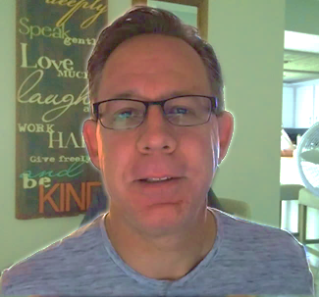
Scott Speicher brings a unique blend of life experiences to his writing. A U.S. military veteran, he carries the discipline, resilience, and perspective gained through service into every story he tells. After his military career, Scott built a successful path in marketing, where he developed a deep understanding of communication, storytelling, and audience engagement. For more than 15 years, he has also worked as a professional website designer, helping businesses and individuals create meaningful online presences.
Scott Speicher is a storyteller who enjoys creating gentle, heartfelt stories that help children notice the small moments that make life meaningful. Through warm characters and simple adventures, his books encourage young readers to slow down, care for others, and appreciate the quiet joys of everyday life. Scott believes that some of the most important lessons children learn come not from grand events, but from the ordinary moments shared with family, friends, and the animals they love.
The Turtle Points Wildlife Center is a heartwarming children’s eBook about Lily, a young volunteer who learns how kindness, patience, and safe helping can make a difference for injured and frightened wildlife. Inspired by Ben’s original Turtle Points mission, Lily helps at a community wildlife center where trained volunteers care for turtles, baby birds, rabbits, and other animals until they are ready to return to nature. Through small jobs like folding towels, making quiet signs, preparing supplies, and writing in her volunteer notebook, Lily discovers that every act of kindness counts—and that Ben’s mission continues to grow one rescue, one notebook entry, and one kind heart at a time.
Suitable for readers aged 4-10 and for family read-aloud sessions. Ideal for SEL, guidance, and service-learning.

