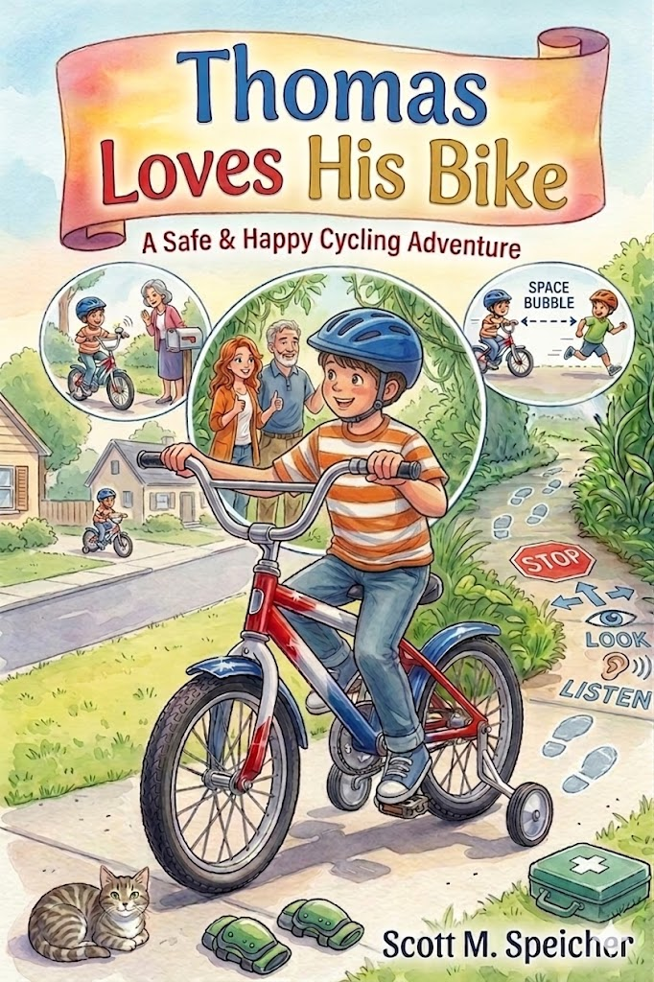
Thomas Loves His Bike
By
Scott M. Speicher

Copyright © 2026
Author: Scott M. Speicher
Portions of this book have been perfected by the program Grammarly
Edited by Grammarly and the Editorial team of Digital Scribblers
No part of this book may be reproduced or used, in any form or by any means, electronic or mechanical, without permission in writing from the author.
AI generated some images under the author's direction.

About This Book

The journey toward independence often begins on two wheels, marking a milestone filled with both exhilaration and new responsibilities. In Thomas Loves His Bike, we meet a young explorer whose birthday surprise—a vibrant red, white, and blue bicycle—becomes the catalyst for a series of gentle adventures right in his own neighborhood. Through Thomas’s eyes, a simple sidewalk is transformed into a vast "Sidewalk Safari," where everyday obstacles like driveways and puddles become opportunities to practice the focus and care required of a true adventurer.
At its heart, this story is designed to weave essential safety lessons into the fabric of imaginative play. From the "Space Bubble" rule for riding with friends to the "Explorer’s Secret Codes" of hand signals, Thomas learns that the greatest part of any journey is arriving home safely. These lessons are not just rules to follow, but tools that empower children to communicate with their community and take pride in their growing maturity and mastery of the road.
This book is a celebration of the small, meaningful moments shared among a child, his family, and his faithful companions, such as Whiskers the cat. It serves as a reminder that kindness, patience, and a watchful eye for others are just as important as the helmet on one's head. Whether it’s navigating the "Great Inland Sea" of a backyard puddle or finding the perfect spot in the garage to tuck a bike in for the night, Thomas shows us that every ride is a chance to learn, grow, and appreciate the world around us.

Thomas Loves His Bike
A Safe and Happy Cycling Adventure

Table of Contents

Chapter 1: The Birthday Surprise with Two Wheels
Chapter 2: The Sidewalk Safari
Chapter 3: The Shiny Silver Bell
Chapter 4: Stop, look, and Listen at the Corner
Chapter 5: The Puddle That Looked Like a Lake
Chapter 6: Hand Signals and Happy Waves
Chapter 7: The Race to the Park
Chapter 8: Twilight and the Glowing Lights
Chapter 9: The Wobbly Knee and the Magic Band-Aid
Chapter 10: The Best Spot in the Garage

Safety Lessons

Ch. 1 - Always wear a properly fitted helmet before getting on the bike.
Ch. 2 - Staying on the sidewalk and watching out for neighbors' driveways.
Ch. 3 - Using a bell or voice to alert pedestrians when passing
Ch. 4 - Stopping completely at every street corner and looking both ways.
Ch. 5 - Avoiding slippery wet leaves and deep puddles that might hide bumps or holes.
Ch. 6 - Basic hand signals for turning left, right, and stopping
Ch. 7 - Keeping a safe distance from other riders to avoid "tangled tires."
Ch. 8 - The importance of reflectors and wearing bright colors when riding near dusk.
Ch. 9 - Why we wear elbow and knee pads, and how to stay calm if we fall.
Ch. 10 -Taking care of equipment by putting the bike away so no one trips over it.

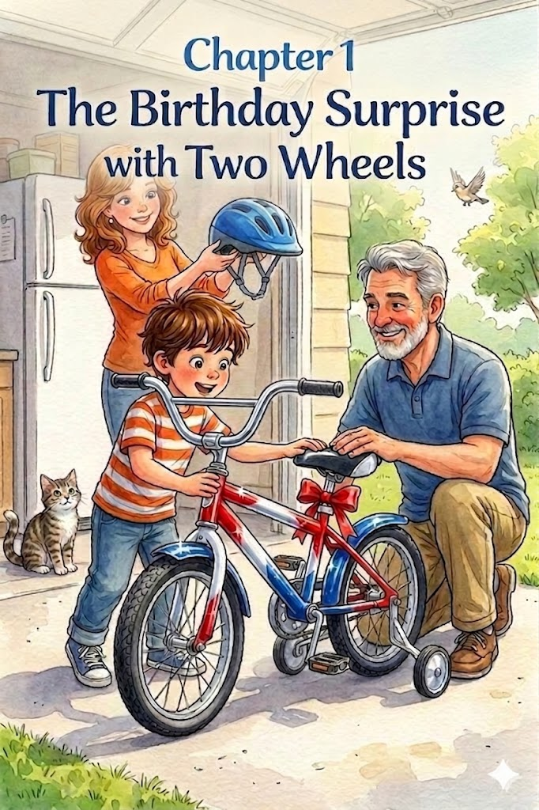
Chapter One
The Birthday Surprise with Two Wheels
Thomas had been waiting for this day for what felt like forever. He stood by the front window, his nose almost touching the glass, watching the driveway just like he had on the day Whiskers first came home.
"Not yet," Mom said with a warm smile, placing a hand on his shoulder. "Be patient, Thomas. Good things are worth the wait".
But patience was hard when you were turning a year older, and there was a secret hiding in the garage. Thomas bounced on his toes, his excitement feeling big and wiggly inside his chest. Even Whiskers seemed to know something was happening; the gray tabby cat sat on the windowsill, his green eyes watching Thomas's every move.
Suddenly, the door to the kitchen opened, and Dad walked in. He wasn't carrying a small silver flashlight or a ball of yarn this time. He was wearing a big, mysterious grin.
"Okay, Birthday Boy," Dad said, kneeling to Thomas’s level. "Are you ready for your surprise?"
Thomas nodded so hard his hair flopped over his eyes. "I'm ready, Dad!"
"Shoes first!" Mom reminded him gently, just like she always did. Thomas shoved his feet into his sneakers, making sure they were on the right feet this time.
Together, they walked out to the driveway. Dad led the way to the garage and slowly lifted the big door. Thomas gasped.
There, standing tall and proud, was a brand-new bike. It sparkled in the morning sun with bright red, white, and blue paint. It had a shiny silver bell on the handlebars and two small training wheels in the back to help him stay steady.
"It's beautiful!" Thomas whispered, reaching out to touch the cool metal frame.
"It's yours, Thomas," Dad said, patting the seat. "Happy Birthday."
Thomas’s smile stretched from ear to ear. He wanted to hop on and pedal as fast as he could, but then he saw Mom holding something else—a bright blue helmet with a sturdy chin strap.
"Wait a second, explorer," Mom said softly. "Before the wheels turn, we have to make sure your noggin is safe."
Dad reached into a colorful gift bag and pulled out a sturdy, matching blue helmet. He knelt next to Thomas, explaining that the most important part of riding was keeping your head safe. As he placed the helmet on Thomas’s head, he showed him how to keep it level—not tilted back like a hat, but sitting straight and low, just two fingers' width above his eyebrows.
Mom helped adjust the side straps until they formed a perfect 'V' shape around his ears, then snapped the chin strap shut with a firm, secure click. She explained that a helmet only works if it’s properly fitted, snug enough that it wouldn't wobble, but comfortable enough to breathe.
Thomas remembered what Mom always taught him about being careful and moving gently. He stood very still while she fitted the helmet. "There," Mom said, tapping the top of the helmet. "Safety first, then the fun begins."
Thomas gripped the handlebars. He felt like a real adventurer. Whiskers trotted out of the house and sniffed the tires, his whiskers twitching with curiosity.
"I have a red, white, and blue bike, Whiskers!" Thomas told his friend happily. "And I’m going to be the safest rider in the whole neighborhood."
With Mom on one side and Dad on the other, Thomas took his first seat on the new bike. The sun was warm, his helmet was snug, and a whole new world of adventures was waiting just past the driveway.

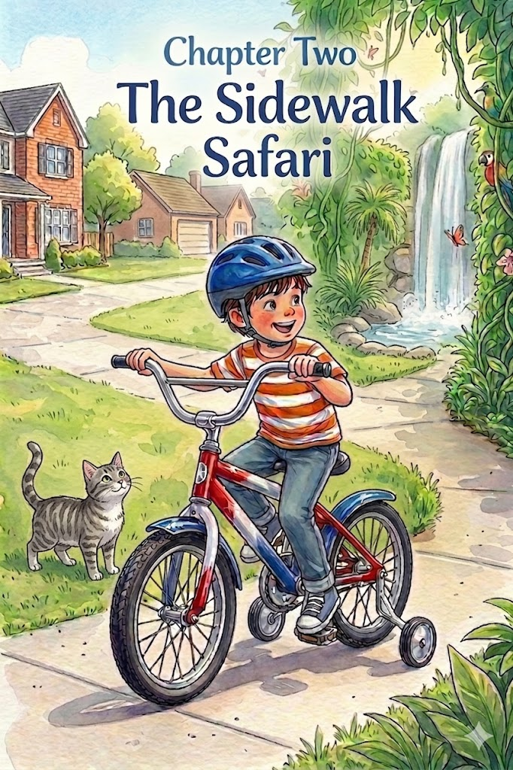

Chapter 2:

The Sidewalk Safari
The afternoon sun turned the neighborhood into a shimmering landscape of gold and green. Now that he had practiced with his parents, Thomas felt ready for his first solo mission. He adjusted his blue helmet, ensuring it sat level and snug just as he had been taught. With a determined breath, he pushed off, his red, white, and blue bike humming as the training wheels clicked against the concrete.
In Thomas’s mind, the familiar sidewalk was no longer just a path of gray stone; it was a narrow trail cutting through the heart of a vast, untamed jungle. The neatly trimmed hedges of the neighbors’ yards became towering walls of emerald vines, and the spray from a nearby sprinkler was the misty breath of a hidden waterfall.
"Steady now," Thomas whispered to himself, gripping the handlebars firmly. He was a lone explorer on a mission, and he knew that a good explorer always followed the trail's rules.
The first rule was simple but vital: stay on the path. Thomas kept his tires centered on the sidewalk, knowing that the road beyond the curb was like a deep, dangerous canyon where the "metal beasts"—the cars—roamed. To stay safe and successful on his safari, he had to keep his wheels firmly on the concrete.
As he approached Mr. Henderson’s house, Thomas saw a challenge ahead: the Great Concrete River. To anyone else, it was just a driveway, but Thomas knew better. Driveways were the trickiest part of the jungle because they were where the trail met the world of cars.
He slowed his pedaling, his heart thumping with a mix of caution and excitement. Just as Mom and Dad had shown him, he brought his bike to a complete halt before the edge of the driveway. He turned his head all the way to the left, then all the way to the right, checking for any movement or the sound of an engine.
The "river" was still. No cars were backing out, and none were turning in.
"All clear," he announced to the empty air. He reached out and gave his silver bell a triumphant ring-ting!, before pedaling across the driveway with a burst of speed.
As he continued his safari, Thomas felt a surge of pride. He was navigating the wild world all by himself, but he wasn't being reckless. He watched every garage door and every dip in the curb with the sharp eyes of a scout. He realized that being a great adventurer wasn't just about how fast he could go; it was about knowing how to watch out for the neighborhood around him.
Whiskers, who had been watching from the safety of the porch, let out a soft meow as Thomas looped back toward home. Thomas grinned, his helmet still perfectly in place, knowing he had conquered the sidewalk safari while being the smartest, safest rider on the trail.

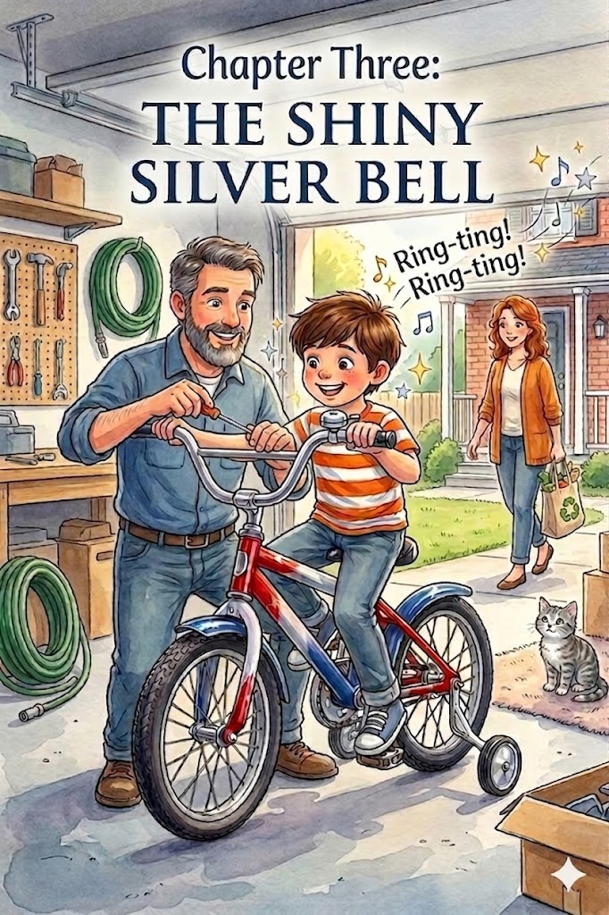Chapter 3:
The Shiny Silver Bell
The jungle safari had been a grand success, but Thomas felt his red, white, and blue bike was missing one final touch to make it a true explorer’s vehicle. He spent the morning polishing the chrome until it gleamed like a mirror. Just as he was admiring his reflection, Dad walked out to the driveway with a small, cardboard box and a screwdriver tucked into his pocket.
"Every great captain needs a way to signal their crew," Dad said, pulling out a brand-new, oversized silver bell. It was polished to a high shine and had a sturdy thumb lever that looked ready for action.
With a few quick turns of the screwdriver, Dad secured the bell right next to Thomas's left thumb. "Go ahead, give it a whirl."
Ring-ting! Ring-ting! The sound was clear and bright, echoing off the garage door. Thomas grinned, the sound making his chest swell with pride.
"It’s perfect!" Thomas cheered. He was ready to head back out to the sidewalk, but Mom stepped off the porch to join them.
"Now, Thomas, that bell isn't just for making music," she explained, adjusting his helmet to make sure it was still sitting two fingers above his eyebrows. "It’s actually a way to talk to the people around you. When you’re riding on the sidewalk, you’ll meet neighbors walking their dogs or friends playing in their yards. Since your bike is quiet, they might not know you’re coming."
Thomas nodded seriously. He hadn't thought about how quiet his tires were on the concrete.
"When you see someone ahead of you," Dad added, "you give that bell a friendly ring from a little distance away. It’s like saying, 'Hello! I’m coming through!"
Thomas practiced as he pedaled down the block. Up ahead, he saw Mrs. Gable checking her mailbox. He remembered what Mom and Dad had told him. He didn't want to startle her, so he slowed his pace and pushed the lever. Ring-ting! Mrs. Gable looked up and waved with a big smile. "Thank you, Thomas! What a lovely bell."
But the lesson didn't stop there. As he neared the corner, he saw a group of kids walking toward the park. They were taking up most of the sidewalk, chatting and laughing. Thomas knew the bell was a great start, but sometimes people needed to know exactly where he would pass.
"On your left!" Thomas called out clearly, his voice steady and confident just as his parents had coached him.
The kids stepped to the right, leaving him a clear path. Thomas pedaled past, giving them a friendly wave. He realized that using his bell and his voice wasn't just about being loud; it was about being polite and keeping everyone safe. By the time he looped back to his own driveway, Thomas felt like a true professional. He wasn't just a boy on a bike anymore; he was a communicator, making sure the sidewalk was a happy, safe place for everyone.

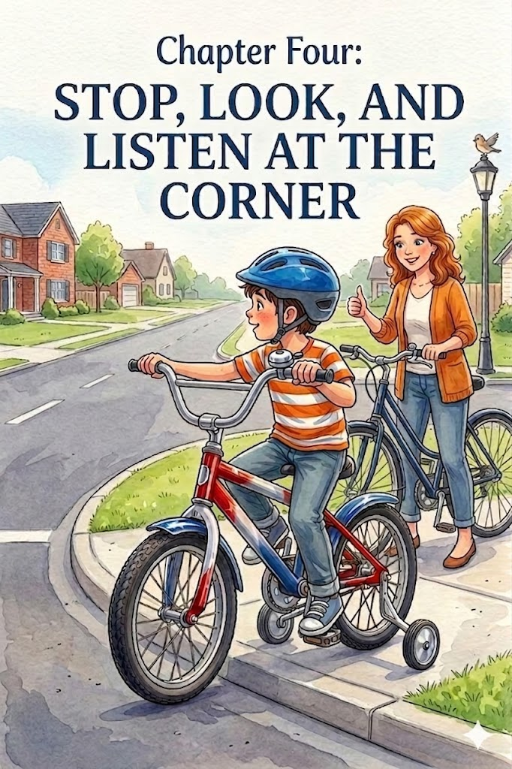Chapter 4:

Stop, look, and listen at the Corner
The afternoon was perfect for a longer trek, and today, Thomas had a destination in mind. At the very end of the block stood the Great Oak, a tree so massive its branches seemed to touch the clouds. Thomas adjusted his snug blue helmet, feeling the familiar comfort of the chin strap against his skin.
"Ready for a real expedition, Thomas?" Mom asked, hopping onto her own bike. Thomas nodded eagerly, his red, white, and blue frame sparkling as he pedaled down the familiar sidewalk safari.
As they approached the end of the block, the sidewalk didn't just continue—it met the wide, open pavement of the cross street. Thomas felt the urge to keep up the momentum, but Mom raised her hand, signaling a halt. "Whoa there, lead explorer! We’ve reached the edge of the map."
Thomas squeezed his brakes, bringing his bike to a smooth, complete stop well before the curb. Even though he couldn't see any cars, he didn't budge. He knew that a rolling stop wasn't enough; his feet had to touch the ground to show he was in total control.
"This is the most important part of the journey," Mom said, standing her bike up beside him. "The street is for the cars, and the sidewalk is for us, but the corner is where we have to be the smartest."
Together, they practiced the three golden steps of the corner: Stop, look, and listen.
Thomas turned his head far to the left, peering down the long stretch of road. Then, he turned his head all the way to the right. Finally, he looked to the left one more time. He didn't just use his eyes; he tilted his head to listen for the low hum of an engine or the rumble of tires on the asphalt. The street was quiet, and the way was clear.
"Good eyes, Thomas," Mom praised. "Even if the road looks empty, we always check twice. Cars can move much faster than bicycles, and we want to make sure they see us just as clearly as we see them."
With the coast clear, Thomas and Mom walked their bikes across the street together. Once they reached the other side, Thomas hopped back onto his seat and pedaled toward the Great Oak. He felt a new sense of mastery. He wasn't just riding a bike; he was navigating the neighborhood like a pro, knowing that taking a moment to stop, look, and listen was the best way to keep the adventure going.

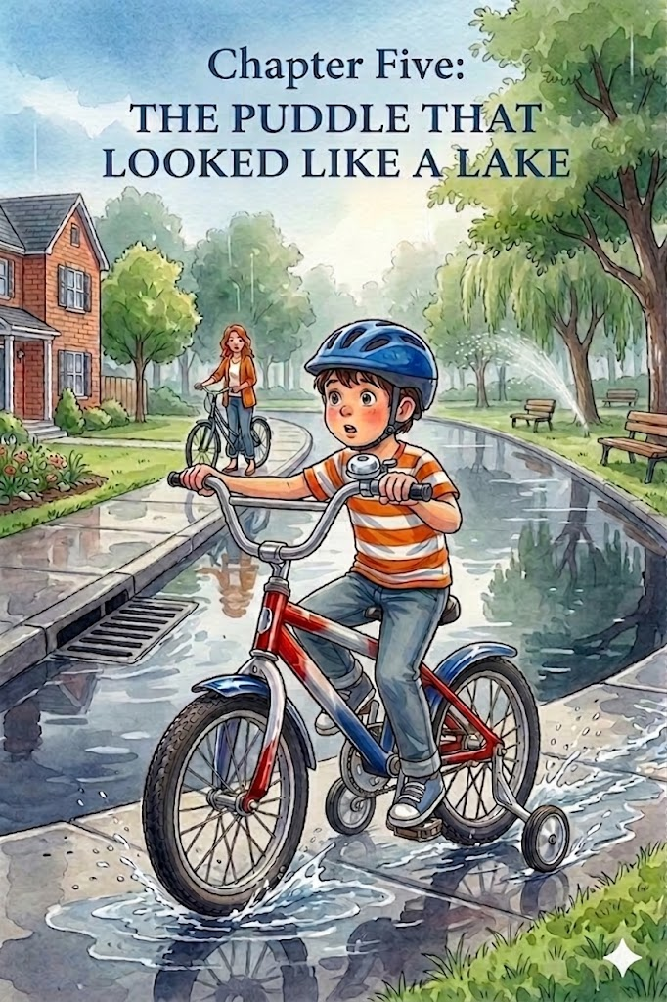Chapter 5:
The Puddle That Looked Like a Lake
The clouds had been heavy and charcoal-gray all morning, finally letting loose a rhythmic drumming of rain that kept Thomas inside for hours. He had spent the time at the window with Whiskers, watching the raindrops race each other down the glass. But as the afternoon arrived, the storm broke, leaving the world smelling of wet earth and fresh air. The sun peeked through the clouds, turning every hanging droplet on the trees into a tiny, flickering diamond.
Thomas couldn't wait any longer. He checked his blue helmet, making sure it was sitting level and snug—two fingers above the eyebrows, just like Mom and Dad had taught him. He zipped up his light jacket, gripped his red, white, and blue handlebars, and headed out for a post-rain expedition.
The sidewalk safari was different today. The concrete was darker, and the "jungle" was dripping. As he pedaled, his tires made a satisfying shhh-shhh sound against the damp ground. He felt like a captain navigating a misty coastline. But as he rounded the corner toward the park, he saw it: the Great Inland Sea.
A massive puddle had formed where the sidewalk dipped near a large drain. It was wide, dark, and perfectly still, reflecting the sky like a giant mirror. To Thomas, it looked less like a puddle and more like a vast, mysterious lake blocking the only trail forward.

Thomas slowed his bike, his heart racing with a mix of excitement and hesitation. His first instinct was to pedal as fast as he could and blast right through the center. He could already imagine the spectacular twin plumes of water spraying out from his tires, soaking his sneakers, and making him feel like a high-speed jet boat. It looked like the ultimate birthday adventure.
However, as he coasted to a stop at the "shoreline" of the puddle, he remembered a conversation he had with Dad earlier that morning while they watched the rain.
"Water can be tricky, Thomas," Dad had warned. "It’s not just about getting your socks wet. Puddles are like masks—they hide what’s underneath."
Thomas peered into the dark water. He couldn't see the bottom at all. Was the concrete smooth under there? Or was there a deep pothole waiting to swallow his front tire and send him tumbling? Perhaps a sharp rock or a piece of broken glass was lurking beneath the surface, ready to pop his brand-new tires.
He leaned his bike to the side and looked at the edges of the puddle. Piles of wet, soggy leaves had gathered near the curb, looking like heaps of slippery seaweed. Mom had mentioned those, too. "Wet leaves are like ice for bike tires," she said. "If you try to turn or brake on them, your wheels might just slide right out from under you."

Thomas stood there for a long moment, the silver bell on his handlebars glinting in the soft light. He really wanted that big splash. He could almost hear the whoosh of the water. But then he looked at his red, white, and blue bike—his pride and joy—and thought about how much it would hurt to take a spill because he was being reckless.
"A real explorer doesn't just charge into the unknown," Thomas whispered to himself. "A real explorer finds the safest way around the obstacle."
He decided to take the "Overland Route." Instead of plunging into the center of the lake, he carefully dismounted his bike. He walked onto the grass, making sure to step firmly and avoid the slick, muddy patches. He steered clear of the mounds of wet leaves, keeping his tires on the solid turf until he had successfully bypassed the giant puddle.
Once he was back on the dry part of the sidewalk, he hopped back onto his seat and looked back at the "lake." He didn't feel like he had missed out on the fun. Instead, he felt a surge of pride. He had encountered a major hazard on his safari and used his brain to navigate around it.
He gave his silver bell a triumphant ring-ting! and pedaled onward. He knew that being a safe rider meant knowing when to splash and when to stay dry. As he headed toward home, he couldn't wait to tell Mom and Dad how he had conquered the Great Inland Sea by being the smartest explorer in the neighborhood.

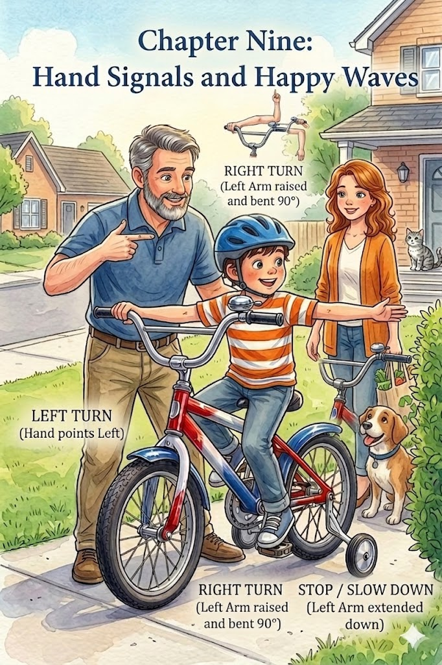Chapter 6:
Hand Signals and Happy Waves
The neighborhood was bustling as Thomas rolled his red, white, and blue bike down the driveway. It seemed like everyone was outside enjoying the sunshine—neighbors were watering their lawns, and a few older kids were playing catch further down the street. Thomas felt like a true veteran of the sidewalk safari, but Dad had one more set of "secret codes" to teach him before he ventured toward the busier corner.
"An explorer needs to be a good communicator, Thomas," Dad said, walking alongside as Thomas pedaled slowly. "Your bell tells people you’re there, but your arms tell them where you’re going next. We call these hand signals."
Thomas slowed to a halt, resting one foot on the ground. He watched closely as Dad stood in front of him to demonstrate. "Think of your left arm like a pointing arrow," Dad explained. "If you want to turn left, you stretch your left arm straight out to the side. It’s like you’re telling the world, 'That way, please!'"
Thomas practiced, extending his left arm toward the green hedges. He felt like a pilot signaling for a turn.
"Now, for a right turn, it’s a little different," Dad continued. "You still use your left arm, but you bend it at the elbow, so your hand points straight up to the sky, like you’re making an 'L' shape." Thomas copied the move, reaching his fingers toward the clouds.
"And the most important one," Mom added, stepping out to join them, "is how to tell someone you’re slowing down or stopping. You put your left arm out and bend it down, so your hand points toward the ground."

📡 The Explorer's Secret Codes
Thomas spent the next hour practicing his signals until they felt as natural as ringing his silver bell. He learned that these signals weren't just for cars; they were for everyone on the sidewalk.
- Left Turn: Left arm straight out.
- Right Turn: Left arm bent upward at a 90-degree angle.
- Stop or Slow: Left arm bent downward at a 90-degree angle.
"The trick," Mom reminded him, "is to signal before you turn. That way, everyone around you has time to see what you’re doing."
Thomas felt like a professional as he set off down the block. When he reached the intersection of the sidewalk and the park path, he saw a neighbor walking a golden retriever. Thomas didn't just stop; he lowered his left arm to signal a halt. Then, as he prepared to head toward the swings, he held his left arm straight out to show his left turn.
The neighbor smiled and gave him a thumbs-up. "Great signaling, Thomas!"
Thomas beamed. He realized that using hand signals made him feel like a part of a big, moving team. It wasn't just about him and his bike anymore; it was about moving safely together with everyone in the neighborhood. He spent the rest of the afternoon practicing his "happy waves" and his "secret codes," feeling more confident with every signal he gave. By the time he headed back home for dinner, Thomas knew he wasn't just a rider—he was a communicator who knew exactly how to share the road.

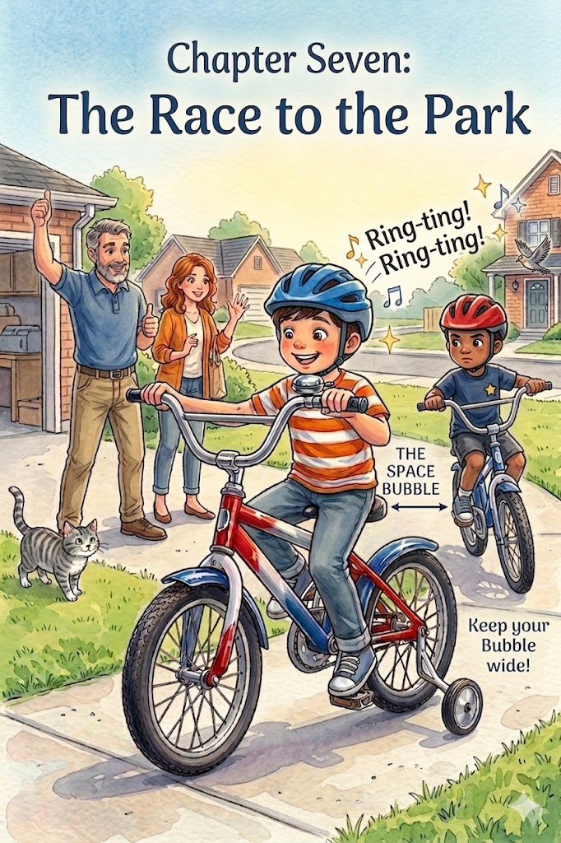Chapter 7:
The Race to the Park
The afternoon sun was high in the sky when Thomas’s best friend, Leo, pulled up to the driveway on a bright blue bike. Thomas’s red, white, and blue bike seemed to sparkle in response, the silver bell catching the light.
"Hey, Thomas! Happy birthday!" Leo shouted, his own helmet buckled tight. "Want to see who can get to the big oak tree by the park first?"
Thomas’s heart did a little flip of excitement. A race! He looked over at Mom and Dad, who were sitting on the porch. Dad stood up and walked down to the edge of the grass. "A race sounds like fun," Dad said, "but remember, even the fastest racers have to be the smartest riders."
Mom nodded, joining them. "The most important rule for racing with a friend is the 'Space Bubble.' You have to keep enough distance between your bikes so that your tires never get tangled."

🛡️ The Space Bubble Rule
Dad showed the boys how to measure a safe distance. He explained that if Thomas was riding behind Leo, he should be able to see Leo’s back tire and still have plenty of room to stop if Leo hit the brakes suddenly.
"If you get too close," Mom warned, "your front tire could clip his back tire. We call that 'tangled tires,' and it usually ends with both racers on the ground. Keep your bubble wide, especially when you're turning!"
Thomas and Leo promised to keep their distance. They lined up their front tires at the edge of the driveway.
"On your mark," Dad called out. "Get set," Mom added. "GO!"
The boys took off, their legs pumping hard. Thomas felt the wind rushing past his helmet, his red, white, and blue frame humming with speed. He really wanted to pass Leo, but as they approached the first curve in the sidewalk, he remembered the Space Bubble.
Leo slowed down slightly to navigate the turn, and Thomas felt himself getting closer. Instead of crowding him, Thomas squeezed his brakes just a little, keeping a full bike-length between them. He watched Leo’s back tire carefully, making sure there was no chance of a tangle.
"On your left!" Thomas shouted as they reached a straight stretch of the sidewalk. He used the lesson from his silver bell to let Leo know he was moving up. He didn't swerve in front of Leo; instead, he stayed in his own lane on the sidewalk, giving Leo plenty of room to breathe.
As they reached the shadow of the Great Oak, they both coasted to a stop, their breathing heavy but their smiles wide.
"You won by a hair!" Leo laughed, leaning on his handlebars.
"Maybe," Thomas said, giving his silver bell a victory ring-ting!. "But we both won because nobody crashed."
Thomas realized that racing was even more fun when you weren't worried about bumping into your friends. By keeping a safe distance and respecting the "Space Bubble," he and Leo could be fast, fierce, and—most importantly—safe explorers of the neighborhood.

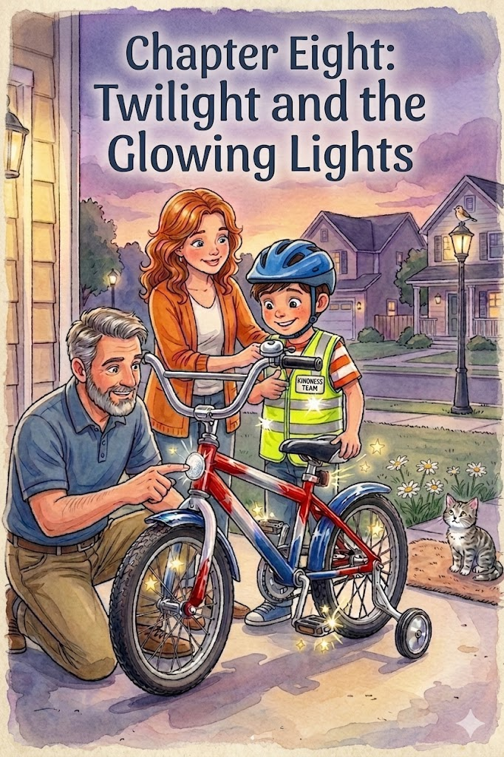Chapter 8:
Twilight and the Glowing Lights
The sky was beginning to transform into a beautiful canvas of burnt orange and soft violet. Thomas had been out exploring all afternoon, but as the shadows of the oak trees grew long and thin across the sidewalk, he noticed something strange. His bike, which usually sparkled like a jewel in the midday sun, was starting to look dull and gray. The vibrant red, white, and blue paint seemed to fade into the gathering gloom.
"Time to head back, Thomas!" Dad called out from the porch, his voice carrying clearly through the cooling air.
Thomas pedaled toward the house, noticing that the streetlights were beginning to flicker to life. As he pulled into the driveway, Mom met him with a bright yellow vest in her hands.
"Did you notice how quiet the neighborhood got?" Mom asked, helping him zip up the neon-colored vest over his shirt. "When the sun starts to tuck itself into bed, it becomes much harder for neighbors and drivers to see a little explorer on a bike. Even a bike as bright as yours can hide in the shadows."
Dad knelt by the wheels and pointed to the small, plastic circles attached to the spokes and the back of the seat. "These are your reflectors, Thomas. They don't make their own light, but when a car's headlight or a streetlamp shines on them, they reflect that light like a mirror. It’s like a secret signal that says, 'Here I am!'"
Thomas leaned in close, watching how the reflectors caught the glow from the porch light. He realized that while he could see just fine in the twilight, other people might not see him at all.
"That’s why we have the Sunset Rule," Mom explained gently. "When the colors start to fade from the trees, we put on our bright colors and make sure our reflectors are clean. Being seen is just as important as being able to see."
Thomas looked down at his glowing yellow vest and the silver reflectors on his pedals. He felt like a firefly, ready to navigate the dusk safely. He gave his bell one last ring-ting! For the day, happy to know that even when the sun went down, he had the tools to stay visible and bright. With his "glowing armor" on, he parked his bike in the garage, knowing he had mastered yet another lesson of the road.

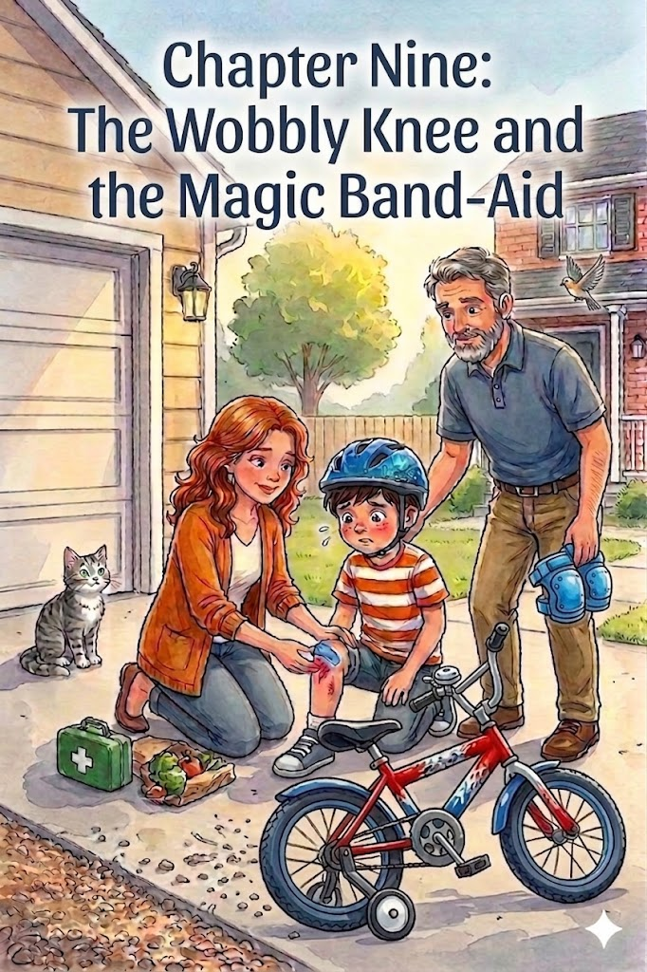Chapter 9:
The Wobbly Knee and the Magic Band-Aid
The afternoon was going perfectly until Thomas decided he was ready for a "High-Speed Mission." He was pedaling his red, white, and blue bike down the driveway, feeling the wind whistle through the vents of his snug blue helmet. He saw a squirrel dart across the path and, in a moment of excitement, he tried to make a sharp, banking turn toward the grass.
But he was going just a little too fast. His front tire hit a patch of loose gravel, and before he could ring his bell or call out, the bike gave a sudden wobble. Down he went with a dull thud and a scrape against the pavement.
For a second, the world was very quiet. Thomas sat on the concrete, his bike lying on its side beside him. He felt a sharp sting on his knee and a throaty tightness in his chest that usually meant tears were coming.
"Deep breaths, explorer," Dad said, calmly jogging over from the garage. He didn't look panicked, which helped Thomas feel a little less scared. Mom was right behind him, carrying a small green first-aid kit.
"Let’s check the armor," Mom said gently, kneeling. Thomas looked at his knee. He had a small scrape where his skin had met the road.
"This is exactly why you need elbow and knee pads," Dad explained as he helped Thomas stand up. "Just like your helmet protects your brain, pads act like a second skin. They take the scratch, so your knees don't have to." He showed Thomas how the thick plastic on a pad would have slid across the gravel rather than against his skin.
Mom cleaned the scrape and pressed a bright blue bandage—the "Magic Band-Aid"—onto his knee. "The most important part of falling isn't the scrape, Thomas. It's staying calm. When you fall, you take a deep breath, check your body, and see if you’re okay to keep going. If you stay calm, your brain can help your body heal faster."
Thomas took a long, shaky breath and looked at his bike. It was scratched, but still sturdy. He looked at his knee, now decorated with its blue badge of courage.
"I think the mission can continue," Thomas said, his voice becoming steady again.
Dad straightened the handlebars and gave Thomas a high-five. "That’s the spirit. Every great rider has a tumble now and then. It just means you’re learning where the limits are."
With a final check of his helmet strap and a gentle push from Mom, Thomas climbed back onto his seat. He pedaled a little slower this time, feeling wiser and braver. He knew that even if he wobbled, he had the gear to protect him and the heart to get back up again.

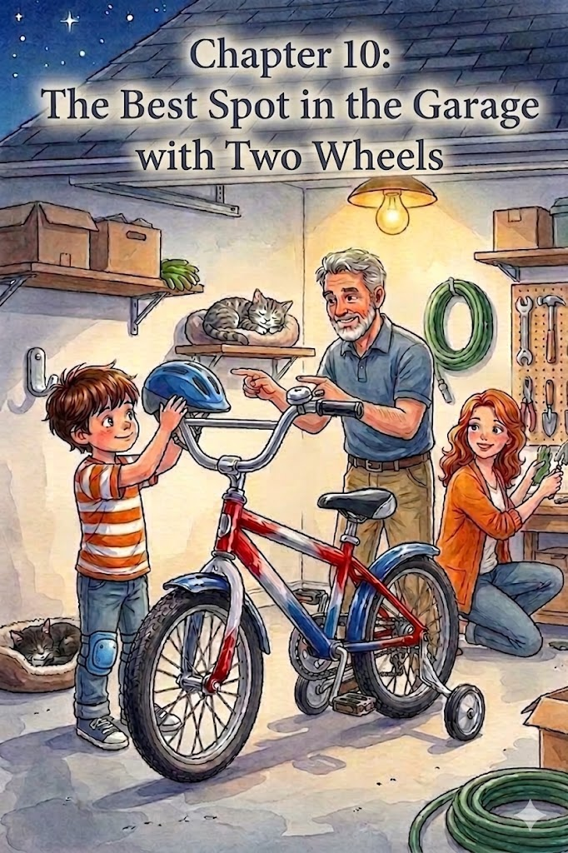Chapter 10:

The Best Spot in the Garage
The stars were beginning to twinkle in the clear night sky, and the neighborhood had grown quiet. Thomas felt a pleasant tiredness in his legs, the kind that comes after a day full of jungle safaris, races to the Great Oak, and brave adventures. He pedaled his red, white, and blue bike up the driveway one last time, the silver bell giving a tiny, tired ting as he bumped over the lip of the garage.
Mom and Dad were already in the garage, tidying up the gardening tools. Mom smiled as she saw Thomas come to a smooth stop. "The explorer has returned," she said softly. "Ready to tuck your trusty steed in for the night?"
Thomas nodded. He carefully unbuckled his blue helmet, feeling the cool air hit his forehead. He didn't just drop the helmet on the floor; instead, he placed it on its special hook on the wall. He remembered what Dad had said: "If you take care of your gear, your gear will take care of you."

A Place for Everything
Dad stepped over and pointed to a clear space right next to the wall, away from the door and the path where people walked. "This is the best spot in the garage, Thomas. Do you know why?"
Thomas thought about it. "So, it doesn't get lonely?"
Dad laughed gently. "That’s a nice thought, but it’s actually about safety even when you aren't riding. If we leave the bike in the middle of the floor, someone might trip over it in the dark. A safe rider makes sure their path is clear for everyone else, too."
Thomas carefully guided his bike into the designated spot. He made sure the kickstand was down firm and steady, ensuring the bike wouldn't tip over. He even grabbed a soft cloth and wiped a smudge of "jungle mud" off the chrome frame, making it shine for tomorrow’s journey.
"Good job, Thomas," Mom said, hugging him. "You treated that bike with as much care as you treat Whiskers."
As they walked back into the house, Thomas looked back over his shoulder. His bike looked peaceful in its corner, right next to the shelf where his knee pads and elbow pads were neatly stacked. He knew that by putting everything away properly, he was already getting ready for his next big adventure.
Just like Whiskers was curled up in his favorite bed in the kitchen, Thomas’s bike was tucked in and safe. With the garage door closing with a soft thud, Thomas headed off to bed, dreaming of red, white, and blue wheels and the many miles of sidewalk yet to be explored.

Epilog:
A Season of Discovery
As the weeks turned into months, the red, white, and blue bike became more than just a birthday gift; it became Thomas’s favorite way to see the world. The shiny chrome eventually gathered a few more "badges of honor" in the form of tiny scratches, and the tires were now well-acquainted with every crack and pebble on the sidewalk, but Thomas’s pride in his bike never faded.
Every morning, the ritual remained the same. Before his feet ever touched the pedals, Thomas would reach for his blue helmet. He would check the level, tighten the strap until he felt that familiar, secure click, and give Mom and Dad a thumbs-up. He had learned that being a great rider wasn't about how fast he could go or how loud his bell could ring—it was about the responsibility he felt when he stayed on the path, watched the corners, and kept his friends safe.
Whiskers still watched from the windowsill, though sometimes the brave tabby would venture as far as the porch steps to see Thomas return from a "safari." Thomas would always pull into the garage, guide his bike to its special spot, and tell his cat about the day's adventures—the neighbors he’d greeted with a friendly ring-ting, the "Great Rivers" he had crossed safely, and the sunset rides where his reflectors glowed like stars.
As Thomas grew taller and his legs grew stronger, Dad eventually suggested it might be time to think about taking the training wheels off. Thomas looked at his bike and then at his parents. He wasn't afraid. He knew that even without the extra wheels, he had everything he needed to stay steady: a sturdy helmet, a sharp eye for the road, and the confidence of a true explorer.
The garage door would close every night on a bike that was tucked in and ready, but for Thomas, the journey had just begun. With his family by his side and the rules of the road in his heart, there wasn't a sidewalk in the world he couldn't conquer.

About the Author
www.scottMbooks.com

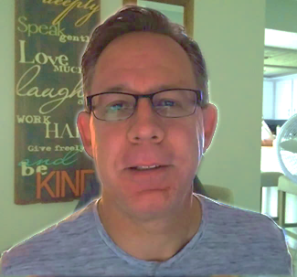
Scott Speicher brings a unique blend of life experiences to his writing. A U.S. military veteran, he carries the discipline, resilience, and perspective gained through service into every story he tells. After his military career, Scott built a successful path in marketing, where he developed a deep understanding of communication, storytelling, and audience engagement. For more than 15 years, he has also worked as a professional website designer, helping businesses and individuals create meaningful online presences.
Scott Speicher is a storyteller who enjoys creating gentle, heartfelt stories that help children notice the small moments that make life meaningful. Through warm characters and simple adventures, his books encourage young readers to slow down, care for others, and appreciate the quiet joys of everyday life. Scott believes that some of the most important lessons children learn come not from grand events, but from the ordinary moments shared with family, friends, and the animals they love.
In Thomas Loves His Bike, Scott brings that spirit to life through an encouraging story about confidence, patience, and the milestone of a child’s first bicycle. Inspired by the sense of wonder children feel when exploring their world, the story celebrates how safety, responsibility, and family support go hand in hand with adventure. Through Thomas and his trusty red, white, and blue bike, readers are reminded that the greatest journeys are built on careful preparation—a helmet buckled tight, the steadying support of training wheels, and the simple joy of a "ring-ting" bell on a sunny afternoon.
Suitable for readers aged 4-10 and for family read-aloud sessions. Ideal for SEL, guidance, and service-learning.

