
Thomas Loves His Birthday
The Big Discovery
By
Scott M. Speicher

Copyright © 2026
Author: Scott M. Speicher
Portions of this book have been refined by Grammarly and illustrated by Gemini AI.
Edited by Grammarly and Gemini Developer
No part of this book may be reproduced or used, in any form or by any means, electronic or mechanical, without permission in writing from the author.
AI generated some images under the author's direction.
About This Book

About the Book: Thomas Loves His Birthday: The Big Discovery
Thomas Loves His Birthday: The Big Discovery is a heartwarming children's story that transforms a festive birthday party into a series of grand adventures. The book follows Thomas, a spirited young boy, as he discovers that each gift he opens is not just a toy, but a gateway to learning valuable life skills.
Set against the backdrop of a single, exciting birthday celebration, the story moves through ten engaging chapters. From the living room floor to the backyard depths and the edges of the neighborhood, Thomas and his friends—Leo, Jeff, and Tim—explore the world around them while practicing kindness, safety, and responsibility.

Core Themes and Learning
Each chapter is carefully crafted to weave simple life skills into high-energy play:
- Responsibility & Care: Thomas learns that being a "rescue commander" or an "engineer" means keeping his play area organized and looking out for others.
- Patience & Persistence: Whether he is building a magnificent fortress or flying a blue kite, Thomas discovers that a steady hand and a calm mind lead to the best results.
- Safety First: Through the "Astronaut Safety Rule" and the "Sunset Rule," readers learn the importance of preparation and following household boundaries.
- Teamwork & Kindness: Thomas emphasizes sharing goals and helping friends, showing that everyone wins when we play with compassion.

Meet the Crew
- Thomas: The adventurous "Engineer in Chief" who leads his friends with quiet courage and creativity.
- Whiskers the Cat: Thomas's faithful, soft gray co-pilot and "fluffy supervisor" who observes every mission with wide, curious eyes.
- Leo: Thomas’s loyal friend who joins him in every expedition, from prehistoric jungles to lunar landings.
Thomas Loves His Birthday is more than just a birthday story; it is a celebration of curiosity and the big difference even the smallest hero can make right at home.
Tia.
Thomas Loves His Birthday
The Big Discovery

Table of Contents

Chapter 1: The Red Fire Truck with the Loud Siren
Chapter 2: The Building Blocks of a Great Castle
Chapter 3: The Dinosaur with the Realistic Roar
Chapter 4: The Silver Spaceship and the Moon
Chapter 5: The Blue Kite That Touched the Clouds
Chapter 6: The Wooden Train and the Living Room Tracks
Chapter 7: The Super-Soft Soccer Ball
Chapter 8: The Busy Tool Bench and the Plastic Hammer
Chapter 9: The Giant Flashlight and the Living Room Fort
Chapter 10: The Best Spot on the Toy Shelf

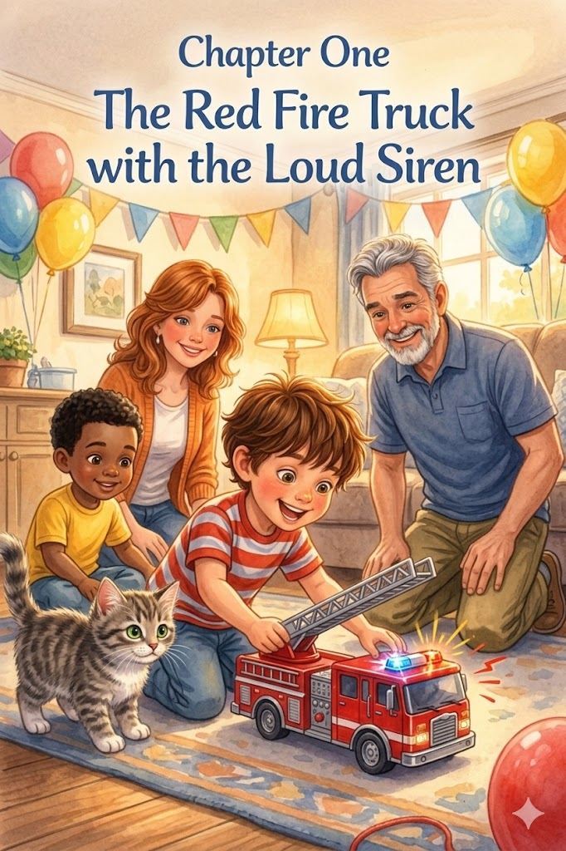Chapter 1:
The Red Fire Truck with the Loud Siren
The living room was filled with a crinkle of colorful paper as the birthday party started. Thomas sat on the rug with Leo, his eyes bright with anticipation as he reached for a large rectangular box. With a quick tug, the wrapping fell away to reveal a shiny new red fire truck with a chrome ladder and real rubber tires. Thomas let out a cheer, and Leo leaned close, marveling at the bright lights that began to flash as Thomas touched the buttons for the first time.
Instead of just looking at the toy, Thomas immediately transformed the room into a bustling rescue scene. He climbed to his feet, taking command of the mission as the siren began its loud, wailing cry. "Attention! Emergency at the sofa!" he called out. He began navigating the truck through "cushion mountains" and across the deep blue "rug rivers" to save his favorite action figures from an imaginary fire. Beside him, Whiskers the gray tabby cat trotted along as a faithful co-pilot, her ears twitching at every siren blast.
As the boys maneuvered through the room, Thomas’s Dad knelt down to watch the operation. He noticed the intensity in Thomas’s face as he directed Leo to clear a path through some stray wrapping paper. Taking a quiet moment, Thomas’s Dad said, "Remember, Thomas, a great leader doesn't just make the most noise; they make sure their team knows exactly what to do so everyone stays safe during the rescue."
In the excitement of the mission, Thomas moved too quickly and bumped into a small side table, causing a tray of party snacks to wobble dangerously. While Leo froze, worried the snack might fall, Thomas remembered his role. He took a deep breath, just as he’d seen real firefighters do, and used his hands to steady the table before anything could fall. He stayed calm, even with the siren still wailing in his other hand.
Watching his son handle the near-accident, Thomas’s Dad offered the first life lesson of the day: "Being a leader means being the first one to step up when things get shaky. It’s not just about steering the truck; it’s about taking responsibility for the whole room and keeping your head clear when things get busy." He gave Thomas an encouraging nod, proud of his quick thinking.
Leo helped Thomas reorganize the rescue route, and they worked together to move the toys to "safety" behind the armchair. They realized that by slowing down and thinking ahead, they could navigate the trickiest parts of the cushion mountains without causing a single spill. Thomas realized that the fun of the fire truck wasn't just in speed, but in the successful teamwork with his best friend.
Thomas’s Dad leaned in again to offer a second perspective on their progress. "Quick thinking is a great tool, but thinking clearly is even better," he told the boys. "When you react with a steady hand instead of a panicked shout, people will always look to you to find the way out of a tough spot, whether it's a mountain or a living room."
As the imaginary fire was finally extinguished and the toys were declared safe, the two boys sat back on the rug to catch their breath. Thomas hugged Whiskers, feeling a sense of pride in his first major mission. The high-energy adventure had shown them that even the smallest hero can make a big difference, and that being a leader starts with how you treat those right at home.
For the final lesson, Thomas’s Dad looked at the two friends. "The most important part of any mission is staying calm under pressure," he said warmly. "If you can keep your head when things get loud, you’ll find that you have the power to save the day, no matter how big the cushion mountains seem to be."

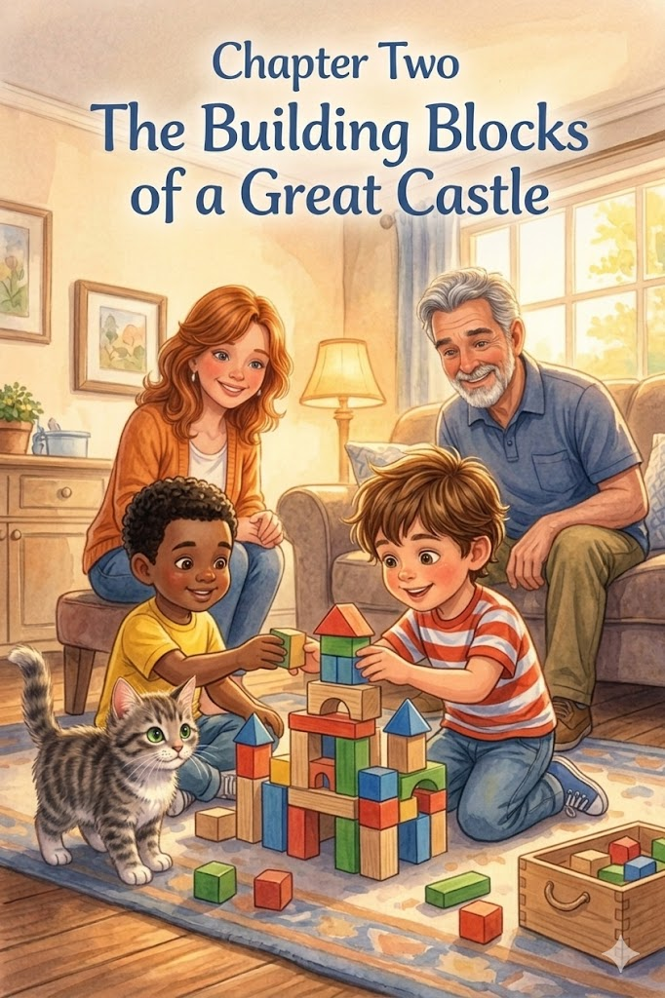Chapter 2:
The Building Blocks of a Great Castle
The living room was quiet and cozy as Thomas reached for his next birthday gift, a heavy box that rattled with a promising wooden sound. With Leo watching eagerly and Mom and Dad smiling from the sofa, Thomas tore away the paper to reveal a set of smooth, multi-colored building blocks. "A fortress!" Thomas exclaimed, his imagination already sketching out stone walls and high parapets. He and Leo immediately carried the box to the center of the rug to begin their next big project.
Thomas spent the quiet afternoon focused on constructing the most magnificent fortress the house had ever seen. He quickly learned that building something truly great takes more than just stacking blocks as high as they can go; it requires a steady hand and a great deal of patience. Leo helped sort the colors, but Thomas took the lead, carefully aligning each piece to ensure the structure felt like a real castle.
As the boys worked, Thomas discovered that a tall tower needs a strong, wide base to keep it from wobbling or falling over. He spent extra time laying out a thick perimeter of rectangular blocks, creating a heavy foundation that could support the weight of the higher floors. He showed Leo how to overlap the bricks, ensuring there were no weak spots in their new kingdom.
Thomas’s Dad leaned forward from his chair, watching the boys work with such focus. "You see that, Thomas? You’re building a foundation that can hold anything," he said, offering the first life lesson. "In everything you do, whether it’s a castle or a friendship, a leader knows that taking the time to build a strong, wide base is the only way to reach the highest peaks safely."
Nearby, Whiskers the cat sat with wide eyes, watching the blocks reach higher and higher. She acted like a tiny, fluffy supervisor, her head tilting back and forth as Thomas added a balcony and a drawbridge. Her presence added a sense of calm to the room, reminding the boys to move slowly and carefully so they wouldn't disturb their "overseer" or the delicate tower.
Just as they reached for the final golden spire, a slight shift in the rug caused the tower to sway. With a sudden clatter-crash, the magnificent fortress tumbled into a heap of wooden rubble. Leo gasped, looking disappointed at the mess on the floor, but Thomas didn't let out a frustrated shout. Instead, he remembered the mission and stayed quiet.
Watching his son’s reaction, Thomas’s Dad knelt down to help sort the blocks. "The tower falling isn't the end of the story, boys," he said warmly. "When things tumble down, it doesn't mean you failed; it just means you've found a way to make the next version even stronger. A leader doesn't quit when things get wobbly; they just take a breath and try a new way."
Thomas took a deep breath and started over, realizing that "wobbly" starts were just a natural part of the process. He and Leo began rebustay, this time using even more blocks for the base to make sure the towers stayed upright. They worked with a newfound rhythm, enjoying the challenge of making the second version even better than the first.
Through this hands-on lesson, Thomas realized that the best results come to those who take their time and build with care. Later that morning, the new fortress was taller and sturdier than before. As the small group of four admired the work, Thomas felt a sense of pride, knowing that patience and a steady hand were the most important tools in his toy box.

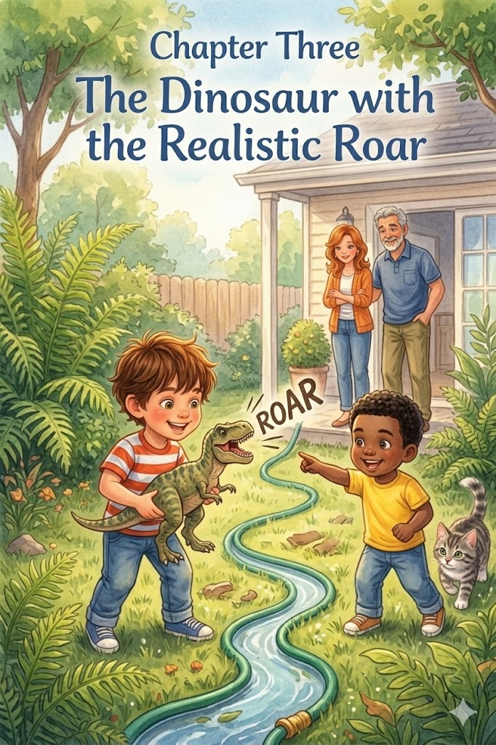Chapter 3:
The Dinosaur with the Realistic Roar
The birthday celebration shifted toward the glass doors leading to the backyard, but first Thomas reached for a brightly wrapped gift with a "Do Not Shake" sticker. With Leo watching closely and his parents leaning in to see, Thomas tore away the paper to reveal a massive, scaly T-Rex toy. He pressed a small button on its side, and a realistic roar echoed through the room. Thomas’s eyes lit up as he realized this was the perfect tool for his next mission, and the small group of four headed outside to begin the expedition.
Thomas turned the backyard into a vast prehistoric jungle filled with ancient mysteries. Armed with his new dinosaur, he set off across the lawn to track down "hidden fossils" and "giant footprints" left by long-forgotten creatures. Leo followed close behind, holding a magnifying glass as they scanned the "jungle floor" for clues, while Mom and Dad watched from the patio, enjoying the boys' boundless energy.
Whiskers, the soft gray cat, acted as the explorer's companion, following close behind the boys. He swished his tail through the tall grass like a tiny, domestic tiger, occasionally pausing to sniff at a "prehistoric" leaf. Having Whiskers nearby made the journey feel even more like a real wildlife trek, as he stayed alert for any imaginary threats lurking in the garden.
As Thomas ventured into the "deepest parts" of the yard where the shrubs grew thick and shadows gathered, he practiced quiet courage. The unknown parts of the garden seemed a bit daunting at first, but Thomas discovered that the unknown isn't so scary when you approach it with curiosity. He used the dinosaur’s roar to signal his presence, feeling bolder with every step he took into the "wilderness."
Observing the boys' hesitation near the thick hedges, Thomas’s Dad walked over to join them. "You see how the shadows look like secret caves?" he asked, pointing toward the bushes. "A leader knows that fear is just a sign that you’re about to discover something new. When you lead with curiosity instead of worry, you’ll find that the scariest places often hold the best rewards."
The ordinary bushes transformed into giant ferns, and the garden hose snaking across the grass became a winding, treacherous river. This imaginative discovery taught Thomas that his mind could turn any afternoon into a grand adventure. He and Leo carefully "hopped" over the hose, making sure not to wake the "river monsters" they imagined were sleeping beneath the water.
Watching them navigate the obstacles, Thomas’s Dad offered another life lesson. "Your imagination is like a superpower, Thomas. It can change the world around you without you ever leaving your own home. If you can see the excitement in your own back door, you’ll never be bored a day in your life, no matter where you go."
The boys eventually found their "fossils"—a collection of interesting smooth stones and a stray bird feather—and felt a deep sense of accomplishment. They had explored the farthest reaches of their world and come back with treasures to show for it. Thomas realized that being an explorer wasn't about the distance you traveled, but the way you chose to look at the path in front of you.
For the final lesson of the chapter, Thomas’s Dad looked at the two young explorers as they headed back to the patio. "The biggest adventures aren't found on a map; they’re found in your own heart," he said warmly. "Embrace your sense of wonder every single day, and you’ll find that life is full of magic, right in your own backyard."

Chapter 4:
The Silver Spaceship and the Moon
With daylight still pouring through the windows, Thomas reached for his wrapped present. With Leo, Mom, and Dad watching, he tore open the crinkly silver paper to reveal a sleek, silver spaceship with glowing blue thrusters and a cockpit that opened with a satisfying hiss. "To the moon!" Thomas cheered, lifting the heavy vessel high. Even though it was still daytime, the birthday party shifted into high gear as the boys transformed the bedroom into a cosmic playground for a mission to the stars.
Thomas turned his gaze toward the sky visible through his window, imagining the blue fading into the deep black of space. With his shiny silver spaceship, he prepared for a journey that required both imagination and a clear plan for his "lunar landing." Leo took his post as Mission Control at the desk, while Thomas prepared the ship on the bed, which had become a vast, cratered moon surface waiting for its first visitor.
Before the engines could roar to life, Thomas’s Dad introduced the Astronaut Safety Rule. "Every great adventurer knows that being brave means being prepared," he said, offering the first life lesson. "A 'Pre-Flight Check' isn't just a list; it’s a promise to your team. In life, a leader always checks their gear and their plan before they reach for new heights, because staying safe is the first step to success."
Whiskers, the soft gray cat, padded across the blankets to join the mission, serving as the brave co-pilot for their trek across the stars. She settled into the "navigation station" at the foot of the bed, her eyes following the movement of the silver ship. Having his trusty crewmate by his side gave Thomas the confidence to steer through the "asteroid belt" of pillows scattered across the floor.
As they neared the moon, the "lunar landing" became a test of focus. Thomas had to navigate the ship with a steady hand, ensuring the craft's silver legs touched down softly on the bed. Leo gave a thumbs-up from Mission Control, and the boys felt the thrill of a successful arrival, even as the bright afternoon sun continued to shine outside.
Watching the boys celebrate their landing, Thomas’s Dad pointed out the window toward the faint, pale outline of the moon still visible in the daylight sky. "Getting there is a big win, Thomas, but a leader always keeps an eye on the way home," he coached. He showed the boys how to use familiar landmarks and "daytime constellations" like the sun and the horizon to guide them. "Much like learning to navigate your neighborhood, you have to know how to use the world around you to find your way back to Earth."
Through this cosmic adventure, Thomas practiced using his surroundings as a guide to bring his silver ship back safely. He realized that the unknown parts of the galaxy weren't so intimidating when he had a clear plan and knew how to stay safe. This chapter emphasizes that true bravery in exploration comes from being prepared and knowing your route, whether you’re in deep space or your own bedroom.
As the spaceship "splashed down" safely on the rug, the boys sat back, exhausted but triumphant. They had traveled millions of imaginary miles while the sun was still high, proving that adventure doesn't have to wait for nightfall. Thomas hugged his silver ship, feeling a deep sense of pride in his "Pre-Flight Check" and his teamwork with Leo and Whiskers.
For the final lesson of the chapter, Thomas’s Dad looked at the small group. "The sky isn't the limit when you're prepared for the journey," he said warmly. "Reach for the stars, but always keep your feet grounded in safety and your eyes on the path home. That’s how a small hero becomes a legendary explorer."

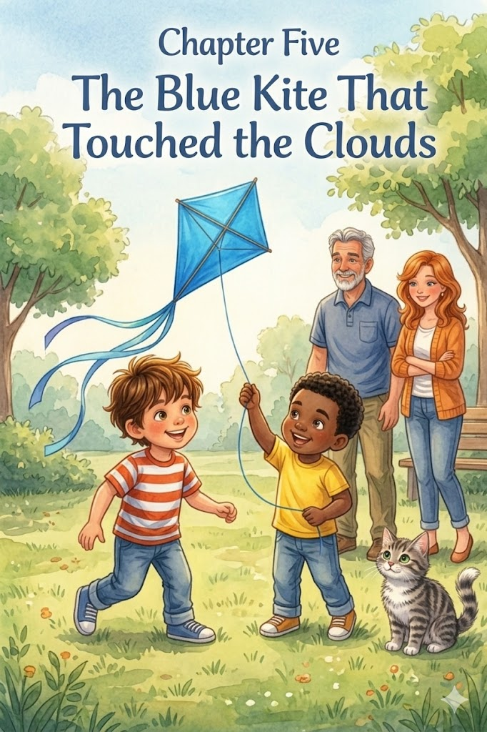Chapter 5:
The Blue Kite That Touched the Clouds
The afternoon breeze had picked up perfectly, prompting Thomas to reach for a long, thin package leaning against the patio door. With Leo, Mom, and Dad watching with interest, Thomas carefully slid out a bright blue diamond-shaped kite with long, fluttering ribbons. "This is going to reach the clouds!" he declared. The small group of four headed out to the open area of the yard, the blue fabric snapping eagerly in the wind as Thomas prepared for his newest mission.
On this breezy afternoon, Thomas aimed to reach the very edges of the sky. He quickly discovered that soaring high above the trees required more than just a strong breeze; it took focus, coordination, and a deep understanding of how the world moved around him. Leo stood ready to hold the kite up, waiting for Thomas’s signal, while Mom and Dad found a spot on the grass to watch the "launch."
Before Thomas started running, he practiced watching the wind. He learned to "read" the air by watching how the grass rippled, and the oak tree's leaves turned their silver sides out. Thomas’s Dad stepped beside him, observing the environment together. "A leader doesn't just rush into things, Thomas," he said, offering the first lesson. "They watch the world around them first. If you understand the timing of the world, you’ll know exactly when to let your dreams take flight."
With a sudden gust, Thomas gave the word, and Leo tossed the blue kite upward. It caught the air and surged toward the clouds. Thomas felt the sudden, powerful tug on the line and practiced the essential lesson of keeping a firm grip on the string. He realized that his own steadiness was the only thing keeping the kite from drifting away into the unknown, and he planted his feet firmly in the soil.
Watching his son struggle against a particularly strong pull, Thomas’s Dad offered a steadying hand on Thomas’s shoulder. "Having a firm grip isn't just about strength; it's about commitment," he coached. "In life, when things start to take off, you have to stay grounded and hold tight to what matters. Your steadiness is what allows the things you love to soar safely."
Whiskers, the soft gray cat, acted as the furry ground crew, sitting nearby with her tail swishing in rhythmic pulses. She watched the blue diamond dance against the clouds, her head tracking the "big bird" in the sky with intense focus. Having his faithful companion watching the line gave Thomas an extra sense of pride as he expertly played the string out further.
Much like his other adventures, Thomas found that the best way to enjoy the heights was to stay calm, clear, and focused on the task at hand. When the kite began to dive, he didn't panic; he remembered his "Pre-Flight" lessons and calmly adjusted his position, pulling back until the blue wings found the steady air once again.
Thomas’s Dad smiled as the kite stabilized high above the treetops. "The higher you go, the more important it is to keep a cool head," he told the boys. "When you’re reaching new heights, don't let the excitement make you forget the basics. Stay calm, stay clear, and you’ll find that the sky is a very friendly place."
As they eventually began to wind the string back in, Thomas felt a quiet pride in mastering a new skill with patience and a steady hand. He had learned that the joy of the outdoors was even better when shared with friends and a wise guide. He tucked the blue kite under his arm, already looking forward to the next time the grass rippled, and the clouds called his name.
For the final lesson of the chapter, Thomas’s Dad looked up at the vast blue sky. "Mastering a skill takes time, but the view from the top is always worth the effort," he said warmly. "Take pride in the work you put in today. A leader who knows how to handle the wind will never be blown off course."

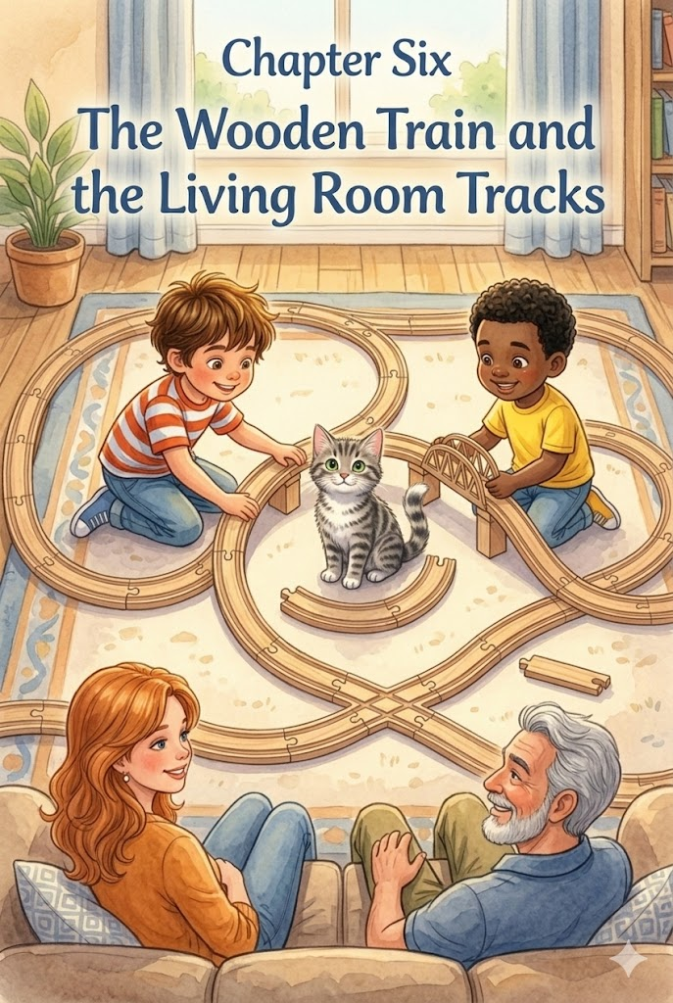Chapter 6:
The Wooden Train and the Living Room Tracks
Back inside, Thomas sat on the floor and pulled the heavy box toward him. With a rhythmic clatter, he emptied it to reveal a set of smooth wooden tracks and brightly painted engines and cars. Leo cheered as they began to snap the pieces together, and Thomas took his place as the "Engineer in Chief." The birthday party had now entered its next phase: designing an elaborate network of rails that would wind from the sofa to the bookshelf, turning the living room into a grand transit system.
As Thomas began laying the curves, he quickly discovered that a great railway requires more than just speed; it needs a clear path and a careful plan. He looked at the long line of track and realized it was headed straight for the middle of the floor where everyone walked. Remembering his responsibility, he redirected the line so it hugged the wall, practicing the important lesson of clearing the rails to avoid making his "railway" a tripping hazard for Mom or Dad.
Watching the boys adjust the route, Thomas’s Dad offered the first life lesson of the morning. "A leader always considers the people around them, Thomas," he said, nodding at the cleared path. "When you’re building something big, you have to make sure it doesn't get in the way of others. True success is creating something great that everyone can enjoy without it causing a problem for anyone else."
Whiskers the cat quickly found the moving wooden cars fascinating. She began batting at the red caboose as it zipped by, eventually deciding to sit right in the middle of the "Grand Station" like a giant, purring mountain. Thomas and Leo giggled, deciding to build the tracks around her, incorporating the "Mountain of Whiskers" into their imaginary world.
By practicing how to keep his play area organized, Thomas realized that being a good leader means looking out for the people around him and respecting the shared spaces of his home. He made sure all the spare blocks and bridge supports were tucked neatly back into the bin so no one would step on them, showing a level of mindful play that impressed his parents.
Thomas’s Dad knelt down to help connect the final loop. "Being organized isn't just about being neat," he told the boys. "It’s about being prepared. When your space is clear, your mind is clear, and you can focus on the fun instead of the mess. A leader who respects their home is a leader people can trust."
Through this winding adventure, Thomas found that the most successful journeys are those where the path is clear, and everyone is invited to come along for the ride. He and Leo took turns pushing the freight cars over the bridges and under the chairs, feeling a deep sense of pride in the orderly world they had created together.
Thomas’s Dad watched the tiny train click-clack along the baseboards. "The best journeys are the ones that are planned with kindness," he said warmly. "When you take care of the path, the path takes care of you. Keep looking out for your team and your family, and you’ll always find the right way forward."
As the train finally pulled back into the station for the day, the small group admired the vast, organized network. Thomas tucked the last engine into its spot, knowing that the real magic of being an Engineer was making sure the way was safe for everyone. They all sat together on the sofa, happy and content, knowing that every great mission started with a clear track and a thoughtful heart.


Chapter 7:
The Super-Soft Soccer Ball
As the afternoon sun began to mellow, Thomas reached for a brightly colored mesh bag. With Leo watching eagerly, Thomas pulled out a super-soft soccer ball, patterned with vibrant pentagons and light enough to play with near the house without a worry. "Time for the big match!" Thomas cheered. The small group of four headed back out to the grassy stretch of the yard, the soft ball tucked under Thomas’s arm as he prepared for a mission centered on teamwork and sportsmanship.
Thomas and Leo began their practice with a series of gentle passes, the soft ball thudding quietly against their sneakers. While the game was full of excitement, Thomas quickly discovered that the true joy of sports comes from how you treat the people on the field. They set up two orange cones as a goal, and the backyard was instantly transformed into a world-class stadium.
As they played, Thomas and Leo practiced playing fair. They learned that following the rules and being honest made the game better for everyone. When a particularly high kick sent the ball past the flowerbed, Thomas showed quiet courage by admitting the ball was "out of bounds" before Leo even said a word. He realized that the game was only fun if everyone respected the rules.
Watching from the sidelines, Thomas’s Dad gave a nod of approval. "A leader knows that winning without honesty isn't really winning at all, Thomas," he said, offering the first life lesson. "When you play fair, you show people that you value the person you’re playing with more than just the score on the board. Integrity is the strongest muscle an athlete has."
Instead of trying to score every point himself, Thomas practiced sharing the goal. He took his turn as the goalie, crouched and ready, so that Leo had a chance to practice his big kicks too. They cheered for each other’s successes, turning the competition into a shared celebration of their growing skills. Thomas found that seeing his friend succeed felt just as good as scoring a goal himself.
Whiskers, the soft gray cat, pounced and swished his tail from the sidelines, acting as a playful referee. Every time the ball rolled nearby, he would give it a gentle pat with a paw, ensuring the "players" stayed on their toes. Having their furry referee nearby kept the mood light and reminded the boys that the most important part of the afternoon was having fun together.
During a fast-paced dribble, Leo tripped on a tuft of grass and tumbled softly onto the lawn. Thomas immediately stopped the ball and reached out a hand to help his friend up, embodying the teamwork and kindness he had practiced in his other adventures. He realized that a small act of compassion—like helping a friend after a tumble—was far more important than finishing a play.
Thomas’s Dad walked over as the boys brushed off the grass. "The way you treat your teammates and your friends when they fall is what people will remember long after the game is over," he told them. "A great leader doesn't leave anyone behind. Kindness is the heartbeat of every great team, and it’s what makes you a champion in the real world."
Through this backyard match, Thomas realized that when friends stand side by side and play with kindness, everyone comes out a winner. They finished the game with a round of high-fives, the soft soccer ball held between them. Thomas felt a deep sense of pride, not in the goals he scored, but in the friendship he had strengthened through fair play and respect.
For the final lesson of the chapter, Thomas’s Dad smiled at the two tired but happy boys. "In every game you play, remember that the person across from you is your friend first and a competitor second," he said warmly. "When you lead with kindness and play with a fair heart, you’ll find that the best victories are the ones you share together."

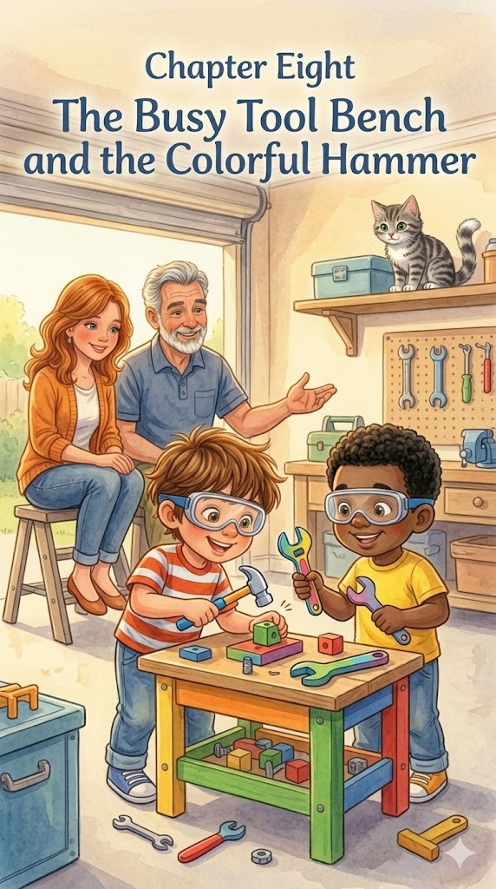
Chapter 8:
The Busy Tool Bench and the Colorful Hammer
The morning sun reflected off the garage floor as Thomas pulled his penultimate gift from its wrapping—a sturdy, colorful tool bench equipped with a colorful hammer, a wrench, and a set of bright yellow bolts. Leo cheered, and the boys quickly moved the bench to a corner of the garage where the "real" work happened. The birthday party had turned into a construction site, and Thomas was eager to help with the day's repairs. While Mom and Leo watched, Thomas prepared his workspace, eager to prove he could handle the responsibility of a builder.
Thomas quickly discovered that "fixing" things required a steady hand and a lot of focus. He spent the morning practicing how to tap his wooden blocks back into place with his colorful hammer, ensuring every "nail" was flush with the surface. He and Leo worked together to "tighten" the bench's legs, learning that building something strong takes more than just strength—it requires precision and a clear plan.
Following his favorite safety rules, Thomas made sure he was prepared before the first hammer fell. He put on his "official" play goggles and made sure he was staying a safe distance from the heavy equipment stored on the higher shelves. Thomas’s Dad, working on a real project nearby, watched with pride. "Being a leader means knowing that safety always comes first," he said, offering the first lesson. "The best builders in the world are the ones who respect their tools and their environment. When you protect yourself and your team, you ensure the job gets done right."
Whiskers, the soft gray cat, found a high, safe shelf to watch the progress. She sat tucked away from the noise, blinking slowly as she supervised the team from above. Her calm presence reminded the boys to keep the garage organized, and they made sure to tuck their screws and bolts neatly into the tool tray so no one—especially a curious cat—would trip over them.
As they worked on a particularly tricky "engine repair" for the red fire truck, Thomas realized that the most important part of the job was the kindness and patience shared between him and Dad. When a bolt wouldn't quite fit, Thomas didn’t get frustrated; he waited for a bit of help, turning a morning of hard work into a morning of shared fun. He saw that even a "master builder" sometimes needs a partner.
Thomas’s Dad leaned over to help Thomas align a plastic beam. "Patience is just as important as a hammer," he coached. "A leader knows that building something with heart is better than building something quickly. When you take the time to do it together, the things you make will last much longer than if you tried to do it all alone."
Through this hands-on adventure, Thomas found that with a bit of help and the right tools, he can build a world filled with both strength and heart. He and Leo finished their repairs, standing back to admire their "fixed" toys. Thomas felt a deep sense of accomplishment, knowing that he had contributed to the safety and upkeep of his home through his careful work.
Thomas’s Dad patted him on the shoulder as they began to clean up the workspace. "The strength of a building comes from the care you put into every small part," he said warmly. "It’s the same with people. When you build with kindness and focus, you create a foundation that nobody can shake. Keep working hard and keep working together."
As the tools were tucked back into their slots, the small group felt satisfaction of a job well done. Thomas held his hammer, knowing that being a builder was about more than just fixing things—it was about building a better world, one small tap at a time. They headed back toward the house, ready for the final mission of the day, with hearts as sturdy as their new construction.

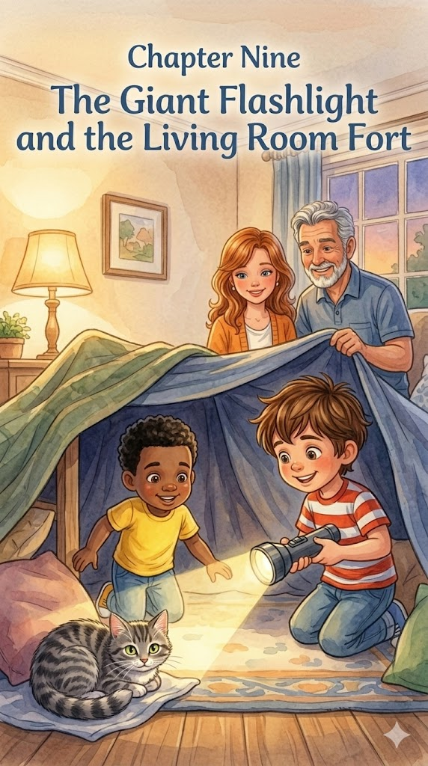
Chapter 9:
The Giant Flashlight and the Living Room Fort
As the birthday party drew to a close and the sun finally began to set, Thomas reached for one final gift tucked behind the sofa. With Leo, Mom, and Dad watching with tired smiles, Thomas pulled out a sturdy, heavy-duty flashlight with a wide lens and a comfortable grip. He clicked the switch, and a powerful beam of light cut across the darkening room, illuminating the far wall. "The ultimate explorer's tool!" Thomas whispered, his eyes widening as he realized this was the perfect way to end his big day of missions.
With the evening shadows growing longer, Thomas and Leo used a pile of blankets and pillows to construct a cozy "Base Camp" in the center of the living room. They draped sheets over the armchairs to create "shadowy canyons" and hidden tunnels beneath the furniture. The birthday party had transformed into a quiet, high-stakes expedition, where the mission was to find a place to rest after a long day of adventuring in the sun.
Thomas took his place at the front of the tunnel, holding his new flashlight steady. He learned that a leader’s job is to provide light for others, and he made sure to sweep the beam slowly across the floor so Leo could see exactly where to crawl. He didn't rush ahead; instead, he stayed back until his friend was safely inside the fort, ensuring that the path was clear of any stray toy blocks or "canyon" walls.
Watching the beam of light dance inside the blanket fort, Thomas’s Dad leaned down to peer through the fabric entrance. "A real leader doesn't just find their own way through the dark, Thomas," he said, offering the final life lesson of the day. "They use whatever light they have to make sure the people following them feel safe and sure of their steps. When you light the way for a friend, you make the whole world a little brighter."
Whiskers the cat, ever the faithful companion, curled up at the very entrance of the fort, acting as the Midnight Guardian. Her glowing eyes reflected the flashlight's beam, and her calm, steady purr provided a sense of security for the weary explorers as they settled into their sleeping bags. Having their furry protector at the door made the "shadowy canyons" feel like the safest place in the world.
As the mission began to wind down, Thomas practiced the important lesson of a gentle goodnight. He turned the flashlight to its lowest setting, realizing that every great hero needs rest to prepare for tomorrow’s journey. He and Leo took deep breaths, letting the excitement of the fire truck, the castle, and the prehistoric jungle settle into happy memories. They realized that knowing when to stop is just as brave as knowing when to go.
Observing his son’s peaceful face, Thomas’s Dad whispered another perspective into the fort. "Rest is the fuel for your next adventure, boys. A leader knows that you can't take care of your team if you don't take care of yourself first. Taking a moment to be still is how you grow the strength you'll need for the challenges waiting for you tomorrow morning."
Inside the soft glow of the blankets, Thomas and Leo began reflecting on kindness, sharing their favorite moments from the party. They talked about the "lava" spill they cleaned up together and the way they shared the soccer goal. These stories reinforced the idea that the best part of any adventure wasn't the toys or the roars, but the kindness and friendship they had shared through every single mission.
Through this quiet evening expedition, Thomas discovered that even when the lights go out, the lessons of leadership, safety, and heart stay bright. He clicked off the flashlight, feeling the warmth of his home and the love of his small family and best friend. As he drifted toward sleep, he knew that his big day had been a success, not because of the presents, but because he had learned how to be a hero right where he was.

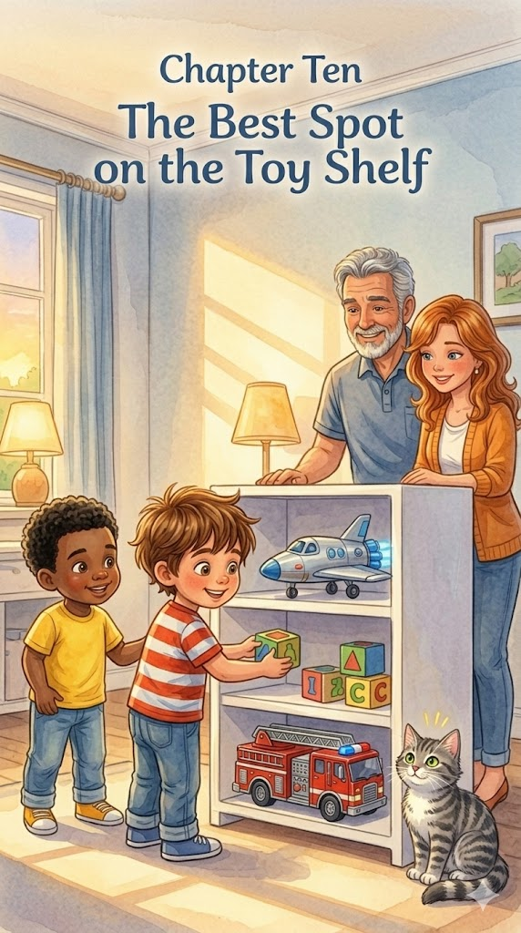
Chapter 10:
The Best Spot on the Toy Shelf
As the golden stripes of the evening sun began to stretch across the floor, Thomas realized that his big birthday adventure was finally winding down. He looked around the living room and his bedroom at the wonderful tools and toys he had used to save the day, build empires, and explore the stars. He remembered that taking care of his new treasures was just as important as playing with them, and he set out on one final mission: to make sure every toy was right where it belonged.
The first part of the cleanup began in the garage, where the "expedition" had faced the prehistoric jungle and the construction site. He and Leo worked together to move the orange soccer cones and the soft ball back into their mesh bag, making sure the driveway was as clear as a fresh map.
Watching the boys handle the equipment with such respect, Thomas’s Dad offered the first life lesson of the evening. "A leader knows that the mission isn't over until the gear is stowed away," he said warmly. "When you take care of your tools, you’re showing respect for the work you did today. Being a responsible owner is a form of quiet courage that keeps the magic of your adventure alive for a long time."
Back in his room, Thomas started the "Toy Shelf Mission." He found the "best spot" for his new building blocks, stacking the bins neatly so they wouldn't tip over. He placed the silver spaceship on the top shelf where its glowing thrusters could be seen, but its wings wouldn't be bumped. He learned that keeping his space organized prevented his toys from becoming "wobbly" or broken, preserving them for many more lunar landings.
Thomas’s Dad knelt down to help slide the red fire truck into its "garage" under the bed. "Organization is how you prepare for the future, Thomas," he coached. "When everything has a place, you’re always ready to jump into action the moment a new emergency arises. A clear room leads to a clear mind, and a clear mind is a hero's best asset."
Whiskers, the soft gray cat, padded along behind the boys as they worked, swishing her tail in approval. She acted as the final inspector for the newly cleared "rescue routes" on the rug, sniffing the corners to make sure every stray block was accounted for. Having the fluffy supervisor on the trail made the work feel like a game, and the boys moved with a steady, peaceful rhythm.
By following the rules of his home and putting things back where they belonged, Thomas discovered a deep sense of pride. He realized that showing kindness to his things was the best way to make sure they were ready for the next surprise his story might hold. He and Leo stood back to look at the tidy room, which felt just as magical as it had when the floor was covered in wrapping paper.
Thomas’s Dad placed a hand on Thomas’s shoulder and looked at the two friends. "Responsibility is the foundation of leadership," he said. "The care you showed today proves that you're ready for even bigger missions. When you respect your home and your belongings, you create a space where everyone feels welcome and safe."
As the last toy was tucked away and the final light was dimmed, the small group shared a quiet moment of satisfaction. The birthday party had ended, but the lessons of the day—leadership, safety, and heart—remained firmly in place. Thomas and Leo climbed into the bunk bed, feeling like true heroes, ready to dream of the next great adventure that would surely begin right at home.

Epilogue:
A Day of Big Discoveries
As the final lights of the birthday celebration dim, Thomas sits quietly with his family and best friend, Leo, reflecting on a day that was much more than just a party. Each gift opened throughout the day—from the roaring dinosaur to the silver spaceship—served as a gateway for Thomas to discover essential life skills that he will carry with him long after the wrapping paper is gone. Through ten chapters of high-energy play, he has transformed from a simple birthday boy into a thoughtful leader who understands that true adventure is built on a foundation of heart and care.
The "Big Discovery" Thomas made today includes several key lessons that define a small hero:
- The Power of Patience: Whether constructing a magnificent block fortress or mastering the flight of a blue kite, Thomas learned that a steady hand and a calm mind lead to the most enduring results.
- Leadership Through Kindness: By sharing his soccer goals with Leo and using his giant flashlight to light the way for others, Thomas proved that a great leader always looks out for their team first.
- The Strength of Responsibility: From clearing train tracks to avoid tripping hazards to performing a "Hero's Reset" of his toy shelf, Thomas discovered that respecting his home and his belongings keeps the magic of his world alive.
- Safety and Preparation: Through the "Astronaut Safety Rule" and his garage "workshops," he realized that being brave means being prepared and following the rules that keep everyone safe.
With Whiskers the cat curled up nearby as the "fluffy supervisor" of his dreams, Thomas realizes that the greatest gift he received wasn't found in a box. It was the realization that curiosity, compassion, and a bit of courage can turn any ordinary day into a grand expedition. As he drifts off to sleep, Thomas is ready for whatever new surprises tomorrow might hold, knowing he has everything he needs to save the day right at home.

About the Author
www.scottMbooks.com


Scott Speicher brings a unique blend of life experiences to his writing. A U.S. military veteran, he carries the discipline, resilience, and perspective gained through service into every story he tells. After his military career, Scott built a successful path in marketing, where he developed a deep understanding of communication, storytelling, and audience engagement. For more than 15 years, he has also worked as a professional website designer, helping businesses and individuals create meaningful online presences.
Scott Speicher is a storyteller who enjoys creating gentle, heartfelt stories that help children notice the small moments that make life meaningful. Through warm characters and simple adventures, his books encourage young readers to slow down, care for others, and appreciate the quiet joys of everyday life. Scott believes that some of the most important lessons children learn come not from grand events, but from the ordinary moments shared with family, friends, and the animals they love.
In Thomas Loves His Birthday: The Big Discovery, Scott M. Speicher brings that belief to life through a heartwarming story that transforms a festive celebration into a series of grand adventures centered on leadership and responsibility. Thomas sets out for a day of mindful discovery as each gift he opens becomes a gateway to learning valuable life skills. From constructing a magnificent fortress with a steady hand to leading a prehistoric jungle expedition in the backyard, he demonstrates how curiosity and a calm mind make a big difference. He bravely practices the "Astronaut Safety Rule" and shares his soccer goals with Leo, proving that kindness and preparation are the most important tools in a hero’s kit. The journey ends with a final mission to his cozy blanket fort at sunset, leaving Thomas—and young readers—ready to dream of the next great adventure right at home.
Suitable for readers aged 4-10 and for family read-aloud sessions. Ideal for SEL, guidance, and service-learning.

